Book Title:
Metal Organic Frameworks and Their Derivatives for Energy Conversion and Storage

Chapter 15: Emerging 3D printing of MOFs and their derivatives

Gwendolyn Jia Hao Lim *ª, Madhavi Srinivasan ^{a,b}, Ady Suwardi ^{c,d}, Danwei Zhang *^{c}

ª School of Materials Science & Engineering, College of Engineering, Nanyang Technological University, 50 Nanyang Ave, Singapore 6ok39798.
^{b} Energy Research Institute, Nanyang Technological University, Research Techno Plaza, 50 Nanyang Drive, Singapore 637553.
^{c} Institute of Materials Research and Engineering, Agency for Science, Technology and Research (A*STAR), 2 Fusionopolis Way, Singapore 138643.
^{d} Department of Materials Science and Engineering, College of Design and Engineering, National University of Singapore, 9 Engineering Drive 1, Singapore 117575.

*: Corresponding Authors
Email: gwendolyn.lim@ntu.edu.sg , zhang_danwei@imre.a-star.edu.sg

Rapid development and improvement of energy-related materials is required to address the ever-growing increase in energy demand around the world. Metal-organic-frameworks (MOFs) are a class of porous crystalline materials, composed of metal ions/clusters and organic linkers. This class of inorganic-organic hybrid materials has attracted immense attention due to their high surface area, structure tunability, highly ordered pores and uniform metal sites. [1] Possessing these properties allow MOFs to be applied in many fields including batteries, catalysis, carbon captures, utilization and storage (CCUS) and wastewater treatments. Its popularity as an emerging material is further enhanced through its facile yet efficient synthesis methods (e.g., hydro/solvo-thermal, sol-gel, electrochemical processes) that merits high product yield. Beyond crystalline MOFs, non-crystalline MOFs such as amorphous MOFs, MOF liquids and MOF glasses have been reported and reviewed. [2-6]

To form bulk structures from MOF powder, pelletization (or granulation) is commonly used. However, the pressing pressure of pelletization processes has been a key issue in MOF research. [7] This compaction method of MOF powders reduces porosity and may potentially decrease the active sites for adsorption applications. High-pressure crystallographic studies have been extensively studied to examine the pressure-driven structural responses exhibited by various MOFs. [8-12] It is important that careful optimization of pelletization pressure is conducted in order not to compromise on the MOF’s physical and chemical properties. With the consideration for retaining its properties, the density of MOF pellets may be low, resulting in increased brittleness. To minimize high pressure applied directly to highly crystalline MOFs, binders or solvents can be incorporated during the compaction process. Binders can be categorized into organic binders (e.g., poly(vinyl alcohol) (PVA), polyvinyl butyral (PVB), methyl cellulose (MC), graphite) and metal oxide-based binders (e.g., alumina, silica). Binders improves the mechanical stability of the pellet via physio-chemical interactions with the MOF powder. Binders such as graphite enhances thermal and electrical conductivity. These properties are attractive for MOFs in electrochemical applications. However, in this wet pelletization process, binders block pores and reduce surface area for adsorption applications. Mechanochemistry is an alternative method to shape MOF structures.

Despite the burgeoning amount (more than 90000) of MOFs synthesized [13], its Lab-to-Market transition remains a challenge. Despite a similar increase in reported 3D-MOF synthesis of MOF papers (shown in Figure 1), a key driver in pushing the frontiers of MOF material research to commercialization lies in the ability to shape them into efficient structures. It is with the aim of advancing MOFs into industrial readiness value that this chapter is written. In this chapter, we summarize the progress made in the field of additively manufactured MOFs. AM techniques will be described in detail and the challenges in shaping of MOFs will be highlighted and explained. The benefits and disadvantages of 3D-MOF to traditional MOF fabrication methods will be discussed in terms of scalability, processability and functionality. Lastly, we conclude with our perspectives on the commercial readiness and utilization of 3D-MOFs in the market.

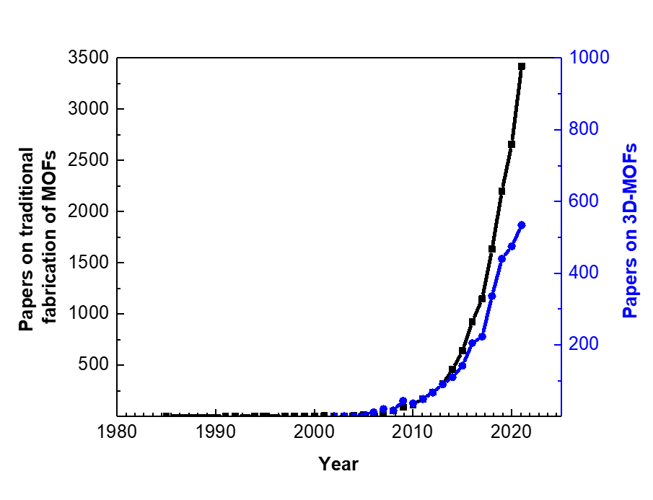
Figure 1. Trend of published papers on traditional fabrication and synthesis of MOFs and published papers on 3D-MOFs until Year 2021. Data retrieved from Web of Science Core Collection, accessed June 2022. Search input for traditional fabrication of MOFs: Topic=(MOF) AND Topic=(fabricat* OR synthesi*) NOT Topic=(3D print* OR additive manufactur* OR 3D). Search input for 3D-MOFs: Topic=(MOF) AND All fields=(3D print* OR additive manufactur* OR 3D)

The simplistic resultant MOF architectures obtained from traditional fabrication processes such as pelletization/granulation, dip-coating and thin film technology severely restricts the translation from research to commercial value and industrial utilization of MOFs. 3D printing technology, i.e., additive manufacturing (AM), is a bottom-up manufacturing technology capable of rapidly fabricated geometrically complex architectures with minimal material wastage and low cost.[14-19] 3D printing offers the ability to shape crystalline MOF powder into customizable 3D MOF architectures which greatly increases its potential in device usage for industrial applications. Over recent years, 3D printing technology has been successfully employed to fabricate various energy or power storage devices with outstanding features such as being form factor-free and having high shape conformability. In addition to material efficiency, micro and macro structural efficiency can be optimized with 3D printing technology.

The process of 3D printing begins with the construction of a virtual three-dimensional model of the object to be printed. Generally, a computer-aided design (CAD) software is used to create the 3D design models and once achieved, the model would need to be converted into the STL file format (derived from STereoLithography), which converts the information of the 3D model surfaces into a list of coordinates of triangulated sections. Usually, the STL file format is universally recognized and can be read by most 3D printer softwares, which then converts the data into a G-code file through a “slicing process”. This slicing procedure will generate several 2D cross section layers of the 3D model according to custom settings by the user. Ultimately, the 3D printer will start to deposit the set material layer-by-layer of the 2D cross section layers successively on top of the other, until the desired 3D object is fabricated.[20, 21] Several 3D printing technologies can be divided into several categories according to their technical process: (1) Extrusion of material (e.g. direct ink writing (DIW), fused deposition modelling (FDM), (2) powder bed fusion (e.g. selective laser sintering (SLS), selective laser melting (SLM), electron beam melting (EBM), (3) vat polymerization (e.g. stereolithography (SLA), digital light processing (DLP), two-photon lithography (TPL)), (4) material jetting (e.g. inkjet printing (IJP), aerosol jet printing (AJP), electric-field driven (EFD) jetting), (5) laminated object manufacturing (LOM), (6) binder jetting and (7) directed energy deposition (DED) (see Figure 2).[18, 22, 23]
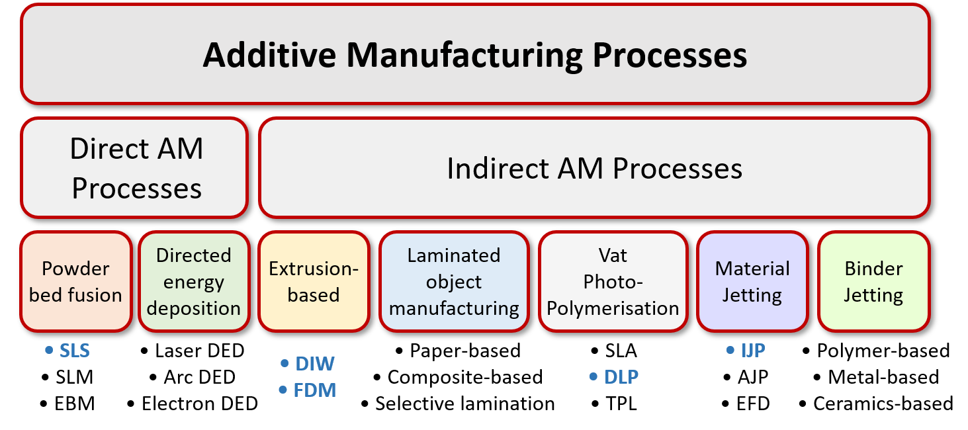
Figure 2. Classification of Additive Manufacturing (AM) processes into Direct and Indirect Processes. Printing techniques which are more suitable for 3D-printed MOFs are highlighted in blue and will be elaborated in the following section.

In Direct AM processes, material powder is melted by a high power-density laser to form a solidified 3D part. [24] Typically, these processes are used to form dense net-shape 3D metal or ceramic structures. Microscopically, pores are usually undesirable as they could lead to defects and component failure for structural applications. In an Indirect AM process, binders are added to the material powder to form a slurry. This slurry (or ‘feedstock’) is then shaped using AM processes such as material extrusion and material jetting. In lab-scale research, indirect AM processes are found to be favored for 3D printing of MOFs as micro pores are often tuned during the post printing heat treatment stage. Polymeric binder is removed during the thermal debinding stage of the post printing heat treatment process. During this initial binder burnout phase, voids are left in the 3D part forming a porous and brittle structure. To provide sufficient mechanical strength to an otherwise brittle 3D-MOF structure, deliberate optimization of the binder burnout and sintering parameters is needed. For maximum active sites of the 3D-MOF structure, complete binder burnout is necessary. A prolong sintering duration will lead to lateral shrinkages and densified 3D-MOF structures while a short sintering duration will allow neighboring MOF agglomerates to undergo sufficient necking for increased mechanical rigidity while maintaining a high degree of porosity. Alternatively, micro porosity can also be induced during MOF powder preparation stage. Although mechanochemistry is an established synthesis method used in pharmaceutical and metallurgical industries, it has only been applied to the field of MOFs since 2006. In 2006, Pichon and colleagues pioneered the development of solvent-free mechanochemical synthesis method of microporous highly crystalline MOFs. [25] This discovery gave rise to the study of porous MOF powders achievable via dry and wet mechanochemical techniques. Macroscopically, AM technologies enhances geometrical complexities of MOF structures for customized industrial applications. Design intricacies can be tailored via various complex micro lattice structures, which offer high strength while maintaining a high surface area. This is especially important for gas sorption, gas separation, and catalysis applications, whereby good mechanical strength is necessary to withstand pressure exerted by the reactor in which gas flows.

2. 3D Printed Metal Organic Frameworks and their Derivatives for Energy Storage and Electrochemical Applications

In recent years, five representative technologies (i.e., DIW, FDM, SLS, DLP and IJP) have proven their abilities to fabricate energy storage modules made up of MOF materials. Based on the MOF/MOF-based derived material and the desired energy storage module, suitable 3D printing techniques were chosen based on the feature size of the final products and processability to meet specific design and performance requirements. Herein, 3D printing techniques can be applied to fabricate components for energy storage applications using Metal Organic Frameworks (MOFs) and their derivatives. These five 3D printing technologies are elaborated in the following section. Energy storage and electrochemistry applications can benefit from the use of 3D printing technologies as they facilitate the construction of conductive electrodes or substrates with complex special shapes or compositions to be used for redox and catalysis.

2.1. 3D Printed Metal Organic Frameworks and their Derivatives via Direct Ink Writing (DIW)
Direct ink writing (DIW), also commonly known as robocasting, is a unique extrusion-type deposition technique that fabricates 3D objects via a computer-controlled translation stage that moves an ink-deposition nozzle to generate the geometrically patterned structure. It is generally a filamentary-based approach to fabricate 3D structures. It is a powerful tool in manufacturing 3D complex structures that includes space-filling objects and architectures with high aspect ratio walls and spanning architectures. The mono- or multi-nozzle array can move horizontally on a 2-axis plane, while the platform usually moves vertically downwards after each new layer is deposited with the help of a CAD software. The printed resolution is usually determined by a combination of the nozzle diameter, applied pressure and characteristics of the extrusion ink. A viscoelastic ink must first be created, which exhibits characteristic rheology properties that includes the yield stress (σ_{y}), elastic/storage (G’) and viscous/loss (G”) moduli and viscosity (ƞ). The yield stress behaviour is an important property in controlling the volumetric flow rate and recovery behaviour of the ink after deposition, and determination of printing ability after material yielding. Recovery in this case indicates the ability to flow after yield and recover similar or an identical yield stress as before, and it is important to have a certain level of yield stress to prevent the extruded material from deforming after deposition. A yield stress material behaves like a solid under a minimal or low applied stress and begins to flow like a liquid after a certain level of stress is applied. Viscosity is rheological parameter that represents the intermolecular interactions in the ink. It is evaluated as a ratio of shear stress to shear rate and can be easily quantified and manipulated.[16, 18, 21, 26] Inks with low viscosities do not sustain a certain shape and easily flows, thus not having enough yield stress to support the entire 3D architecture after the ink extrusion. For those inks with extremely high viscosities, they can easily block the nozzle and require substantially higher printing pressures. Therefore, an ink made up of material with an optimised viscosity and elastic behaviour (usually determined by G’ and G”) is favourable for DIW, particularly exhibiting shear-thinning behaviour, whereby the viscosity decreases with increase in shear rates. An ideal material will initially tend towards a sporadic equilibrium that is resulted from particle and intermolecular interactions with restorative effects from random Brownian motion. Under higher shear rates and stresses that are high enough to overcome these interactions, the materials are then induced to rearrange into parallel layers, polymers are then stretched out and aligned with the flow direction, while aggregated particles can be broken down while droplets are deformed elliptically. This is termed as the flow-induced orientation, and consequently, the intermolecular/interparticle interactions decreases while the free space between the dispersed constituents, resulting in the large drop in viscosity.[27] After which, when the applied stress/shear is removed, the material is expected to retain its shape almost immediately via its intrinsic yield stress, which will benefit fabrication of the 3D architecture. A self-standing 3D object is usually fabricated, but a post-treatment process may be necessary to reinforce it and improve its functional or mechanical properties via steps of drying, heating, or sintering.

3D printing technologies will definitely continue to evolve due to the implementation of new concepts and for the fabrication of faster, cheaper, and more defined printing systems, as well as to fabricate 3D objects or components in a new and novel way different from classical forming methods. In the classical case of 3D printing of MOFs, Thakkar et. al developed inks for DIW with MOF loadings a high as 80 and 85 wt% respectively to 3D print MOF-74(Ni) and UTSA-16(Co) monoliths for adsorptive performance in CO₂ removal from air as seen in Figure 3(a).[28] In general, a coating approach upon a particular substrate does not provide a high adsorbent loading per unit volume of the bed, therefore the performance of coated monoliths pales in comparison with their powder counter parts. Therefore, self-standing monoliths consisting of a large weight fraction of MOF powders (preferably >80 wt%) mixed with a suitable binder or additives would be preferred. 3D printing via DIW would be beneficial in this case due to the versatility of the system to incorporate unique MOF powders. Adsorption experiments in this case showed that upon exposure to 5000 ppm (0.5%) CO₂ at 25 °C, the MOF-74(Ni) and UTSA-16(Co) monoliths can adsorb CO₂ with uptake capacities of 1.35 and 1.31 mmol g⁻¹, respectively, which are 79% and 87% of the capacities of their MOF analogues under the same conditions.

In another unique case of DIW, colloidal gels containing only ethanol and Cu₃(BTC)₂ (BTC = 1,3,5-benzenetricarboxylate) (HKUST-1) nanoparticles were used directly as an ink for the DIW of pure densely packed and self-standing MOF monoliths.[29] Figure 3(b) displays the digital image of the DIW 3D printed MOF monoliths and the corresponding SEM images, showing densely packed MOF nanoparticles. For use in practical applications, MOF powders usually need to be shaped into monoliths that can be easily handled. However, classical shaping and densification processes typically reduce the functionality (e.g. level and distribution of porosity, accessible and obtainable surface area etc.) and limitations of the shapes of monoliths that can be produced by conventional manufacturing methods. DIW has helped in advancing shaping MOF monoliths as it allows the fabrication of multiple self-standing complex parts, however a key challenge still stands where the MOF material must be made into an ink/slurry with ideal rheological properties. These slurries are usually created by mixing the active materials with a solvent, dispersant, and polymeric binders in which these matrix materials may affect and block access of the functional pores of the MOF materials. Through a unique formulation and synthesis for a pure MOF gel that can be used as a DIW medium at room temperature, producing densely packed monoliths that maintain the important intrinsic properties (porosity, accessible surface area) of the MOF, Lim et. al fabricated pure and dense monoliths of HKUST-1 with exceptionally high BET surface area of 1134 m² g⁻¹, and a high mesopore volume. The monoliths were then used for methane storage, potentially introducing a new technique to produce and manipulate active material for gas storage applications for energy.

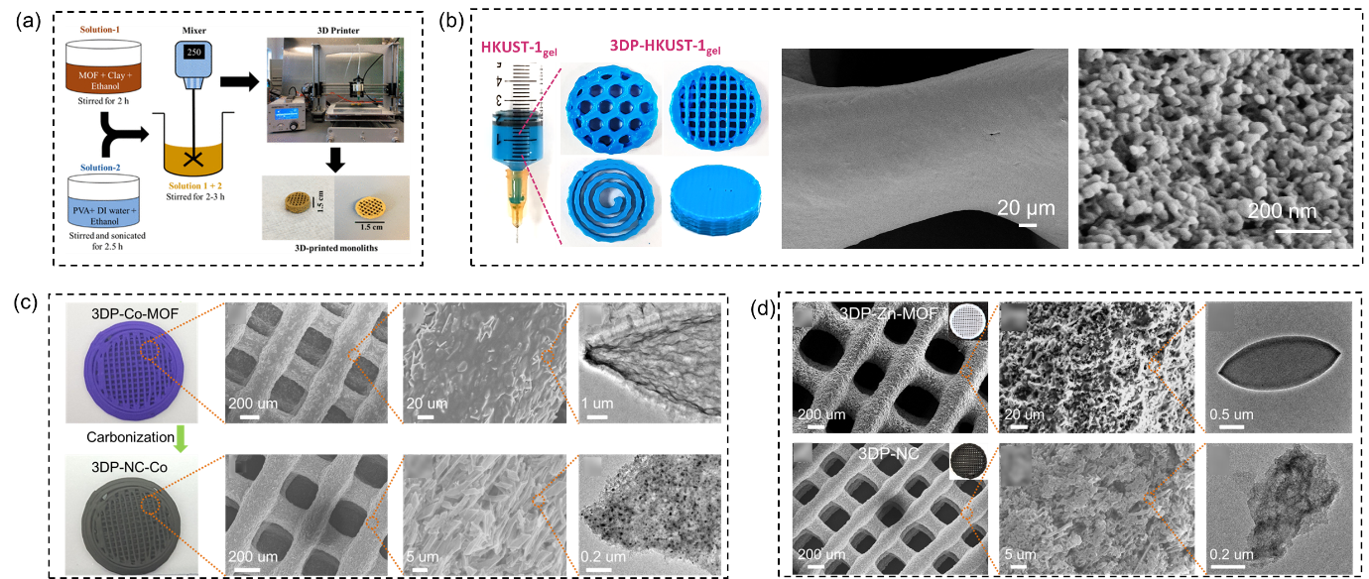
Figure 3. (a) Schematic of the 3D-printed MOF monolith preparation procedure. Reproduced with permission.[28] Copyright 2017, the American Chemical Society. (b) Digital images of HKUST-1_{gel} loaded into a syringe and the different 3D printed structures. The corresponding SEM image of a single filament from a dried 3DP-HKUST-1_{gel} monolith and SEM image of HKUST-1 nanoparticles within the dried 3DP-HKUST-1_{gel} monolith. Reproduced with permission.[29] Copyright 2019, the American Chemical Society. (c) Digital images of the conversion of 3DP Co-MOF-derived framework. The upper row consists of SEM images and TEM image of 3DP-Co-MOF. The bottom row consists of SEM images and TEM image of 3DP-NC-Co. Reproduced with permission.[30] Copyright 2019, WILEY-VCH Verlag GmbH & Co. KGaA, Weinheim. (d) Top row shoes the typical SEM image of 3DP-Zn-MOF. Inset is a digital photo. TEM image of a Zn-MOF leaf is also shown, and scale bar is 0.5 μm. The bottom row is a typical SEM image of 3DP-NC. Inset is a digital photo. TEM image of 3DP-NC is shown respectively, and scale bar is 1 μm. Reproduced with permission.[31] Copyright 2020, Elsevier B.V.

In some cases, polymeric binders found in the fabricated ink for DIW can be converted during post-processing treatments into a functional framework that complements the MOF or MOF-based derived active materials instead of remaining passive in the ink matrix. Lyu et. al developed a self-standing and hierarchically porous carbon framework with Co nanoparticles embedded within via DIW of cobalt-based metal–organic framework (Co-MOF, specifically ZIF-L Co, ZIF= zeolitic imidazolate framework), followed by appropriate post-processing treatment of annealing.[30] The designed 3D cathode for lithium-oxygen (Li-O₂₎ batteries is prepared via DIW of a self-supporting printable ink made up of the pre-synthesized Co-MOF and Pluronic F127 hydrogel to form the 3D printed Co-MOF component (3DP-Co-MOF). After drying, the 3DP-Co-MOF framework is annealed in nitrogen atmosphere, and the 3D architecture is well preserved after carbonization as seen in Figure 3(c), where even the MOF micro-flakes were well preserved. Polymeric Pluronic F127 was simultaneously converted into conductive carbon that holds the Co-MOF-derived carbon flakes together that would make up the catalyst framework. The novel self-standing framework possesses good conductivity and necessary mechanical stability, along with high porosity that promotes efficient deposition of lithium peroxide (Li₂O₂) particles and facilitate their decomposition due to the confinement of insulating Li₂O₂ within the pores and the presence of Co electrocatalysts. This 3DP framework thus enhances the specific capacity and energy of the cell, providing an effective approach to increase the practical specific energy for Li–O₂ batteries in the potential future.

In another similar example, DIW was used to construct a novel N-doped carbon framework derived from zinc-based MOF (Zn-MOF). The same precursor of Pluronic F127 hydrogel system is used to fabricate the ink with Zn-MOF powders, before 3D printing the bulk structure. After post-treatment and annealing, a hierarchically porous structure (micro-, meso-, and macro-pores) and a large specific surface area (869 m² g⁻¹) novel N-doped carbon framework was obtained due to the removal of zinc during annealing at a temperature above 900°C (Figure 3(d)).[31] The MOF-derived N-doped carbon framework was then used for Li anode host. Functioning as the Li host, the large sized microchannels built by 3D printed filaments would help accommodate a massive Li deposition and suppress the volume change of Li metal. The high surface area dissipates high current densities to achieve a high-rate capability. The lithiophilic N-doped carbon surface enables a uniform nucleation for Li to inhibit the unwanted dendrite growth. Therefore, DIW of MOFs in this case would help increase the functionality of the intrinsic materials and also fabricate 3D complex material that would improve the overall battery performance.

2.2 3D Printed Metal Organic Frameworks and their Derivatives via Fused Deposition Modelling (FDM)
Invented in 1989,[32] FDM is currently the most widespread 3D printing technology popular among even hobbyists, employed for fast prototyping, toys and customisation of creative objects due to its affordability and simple operation. It utilizes a layer-by-layer deposition mechanism of thermoplastic filaments heated to their semi-molten state at the dispenser nozzle tip before extrusion. The extruded materials are then rapidly solidified on the cooler build-platform to form a uniform solid layer and a 3D architecture can then be fabricated by deposition of multiple solidified layers on top of each other. The 3D object can be created by moving the platform vertically while moving the nozzle along the X-Y axis according to the designed CAM/CAD software.

In comparison to DIW, FDM has a more limited range of printable materials. Commonly used thermoplastic materials include polylactic acid (PLA), acrylonitrile butadiene styrene (ABS), polycarbonate (PC), polyamide (PA) and thermoplastic urethane (TPU). Materials for FDM must also be in the form of a solid filament with a specific width and length. This limits the fabrication of certain materials as applicability in energy storage electrodes would require specified active materials with high electrical conductivity or functionality that intrinsically do not come in a filamentary form fit for FDM.[21, 33] Consequently, active materials incorporated within the thermoplastic polymer matrix are usually fabricated into composite filaments before using it for 3D printing. This may limit the original functionality of the active material to a certain extent, but individual research studies are still subjected to investigations. Similar to DIW, a self-standing 3D object is usually fabricated, but a post-treatment process may be necessary to modify it and improve its functional or mechanical properties. Nevertheless, FDM is independent on the rheological state of the ink/filament, but it relies on the construction of the composite thermoplastic filaments instead.

The formation of the thermoplastic composite filament containing the MOF active material is crucial for FDM-based 3D printing of 3D components. A research team from the American University produced acrylonitrile-butadiene-styrene (ABS)-ZIF-8 and ABS-HKUST-1 composites and successfully 3D printed these materials into several complex geometries (Figure 4(a)).[34] ABS is one of the most used materials in thermoplastic 3D printing, and therefore for FDM 3D printing, it is used as the polymer matrix containing the active MOF material. In this case, the cavities within the MOF structures (ZIF-8 and HKUST-1) are desirable for hydrogen storage, a self-standing component containing these MOFs must be fabricated for practical application. More complicated shapes and geometries are suited for applications with high flow rates and the ability for uptake of hydrogen. One of the major drawbacks of using FDM printing is that there was some MOF degradation via compounding and humidity during the incorporation process, which render the entire 3D component less functional. Nevertheless, hydrogen gas (H₂) was still observed to be adsorbed by the MOF structures within a 3D printed ABS composite and that it shows no further degradation from humidity once the composite was completed. Future optimization of the stability of the MOF within these thermoplastic matrices can be done following this work.
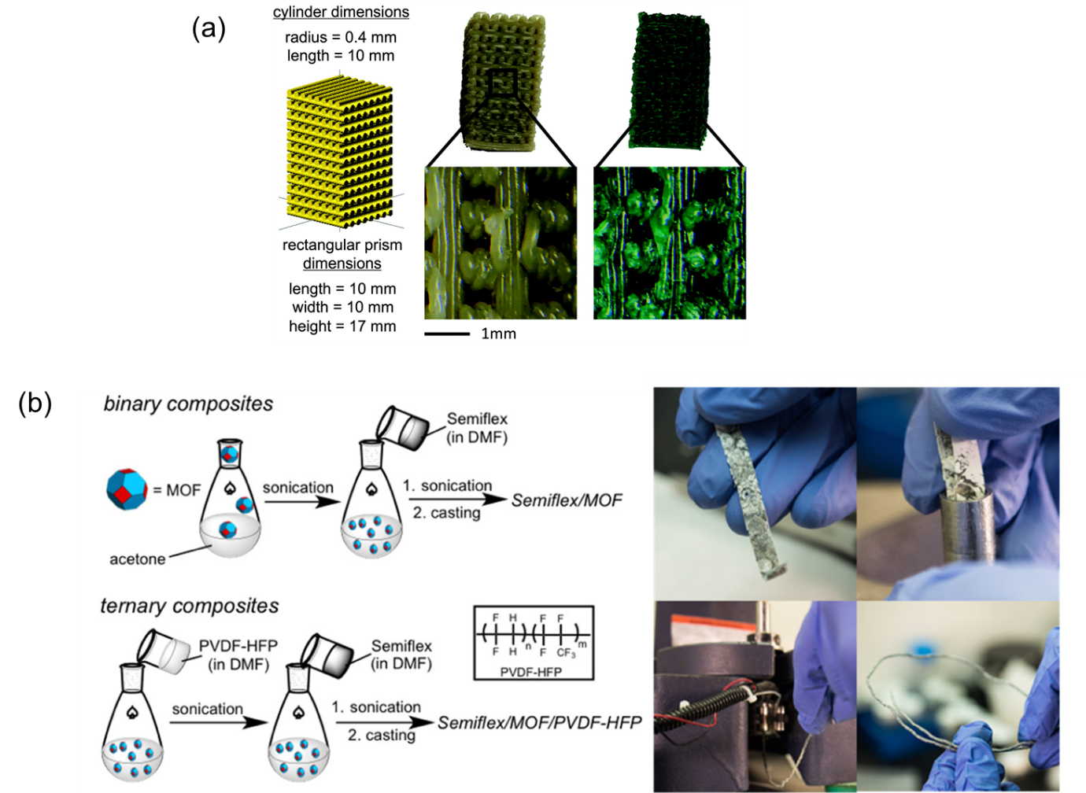
Figure 4. (a) 3D printed MOF-ABS composites: Schematic on the left shows the designed print geometry and dimensions. The digital image in the middle shows the full printed acrylonitrile butadiene styrene (ABS)-ZIF-8 composite and the magnified version at the bottom. The digital image on the right shows the full printed ABS-HKUST-1 composite and the magnified version. Reproduced with permission[34]. Copyright 2018, Mary Ann Liebert, Inc. (b) Schematic of solution processes to yield binary (Semiflex only) and ternary (Semiflex/PVDF-HFP) MOF composite thick films. On the right shows the Semiflex–MOF composite films cut, fed into a heated barrel, pressed to facilitate extrusion, and extruded into a feedstock material for FDM. .Reproduced with permission.[35] Copyright 2018, the American Chemical Society.

In another similar energy and gas storage work, ZIF-8 MOF active material was incorporated homogeneously into both poly(lactic acid) (PLA, named PLA/ZIF-8) and thermoplastic polyurethane (TPU, named Semiflex/ZIF-8) matrices at high loadings (up to 50% by mass), extruded into filaments, and utilized for FDM 3D printing.[35] The fabrication schematic is seen in Figure 4(a) and the corresponding digital images are displayed as well. 3D printed PLA/MOF composites display a large surface area (531 m² g^{–1}) and hierarchical pore features, whereas flexible TPU/MOF composites achieve a high surface area (706 m² g^{–1}). This work uniquely employs a simple post-treatment process of the 3D components by submerging the Semiflex/ZIF-8 samples into methyl alcohol (CH₃OH) for at least 48 h before activation in a low heated vacuum oven. This contributed significantly to the increase in absorption of CO₂ for the Semiflex/ZIF-8 3D composite. This proved that the printing of MOF-thermoplastic composites will obstruct the functional pores of the MOF material. Therefore, it is important to expose obstructed pores after FDM 3D printing of MOF composites for the feasibility of FDM 3D printed MOF in practical applications.

2.3 3D Printed Metal Organic Frameworks and their Derivatives via Selective Laser Sintering (SLS)
SLS is a laser powder bed fusion 3D printing technology that mainly utilise a powder bed containing loose active powders as feedstock. The 3D printing system consists of a laser supply source, scanning system, roller, powder supply platform, and a sintering platform. The active material powders are bound together either by using liquid binders or by pure powder fusion using thermal energy provided by a high-powered laser beam. Powder fusion can occur with different particle binding mechanisms namely solid-state sintering, chemically induced binding, liquid phase sintering (partial melting), and full melting (in this case it will be considered as SLM instead). Individual solid layers when a controlled scanning laser beam rasters through the powder bed. The powder then heats up, and sintering and/or calcination occurs for bulk joining or conversion into functional materials. A new layer of powder is then spread over the previous layer to repeat the layer-by-layer building process until the 3D component is formed. [36-39] In some cases, a binder is used for hold the powder compactly. Polymers such as polyamide and polycaprolactone (PCL) also function as laser sintering materials. [40] Post-processing heat treatments are generally required in these cases to remove the organic binder so that the desired functional and mechanical properties can be obtained.

In SLS, the energy density equation is the most significant parameter that is responsible for the 3D printing process and printed component property. It is the amount of energy stored in a given system or region of space per unit volume:

$$ED= \frac{P}{v.d} × \frac{d}{h}$$

Where ED is energy density, P is the laser power, d is laser beam diameter, v is scan velocity and h is the hatch spacing. It is noted that the hatch spacing, laser scanning speed, laser power and preheat temperatures are key process parameters in determining the component properties of SLS printed 3D printed objects.[41, 42] Laser power P is the input power determined as the ratio of total permissible power for the requirement of a given material and layer thickness. Laser scanning speed is the rate at which the laser beam is moved along the profile lines. It affects the maximum energy at a point of material and the total required time to complete a product significantly. Hatch spacing is also referred to as scan spacing, where is it the distance between two consecutive laser beams. Lastly, preheating temperature is a significant parameter in affecting final component property in SLS. A higher-power laser beam source is needed to melt the powders if they are not preheated in advanced. Higher preheating helps to reduce the temperature gradient between the sintered and non-sintered layers, which ultimately contributes to reduction of thermal stress and elimination of distortion.

SLS has been a unique concept in the fabrication of MOF monoliths. It is mentioned that lasers can usually induce high local heating of temperature over 2500 °C, thus causing the C-O, C=O or C-N bonds to break, followed by recombination of these compositions to produce certain gaseous products.[43, 44] The resulting temporary reducing atmosphere around the MOF sample can reduce the metal ions to form metal particles while the aromatic segments can rearrange to form graphitic carbon structures.[45, 46] Laser-treatment of MOFs can be done to fabricate uniformly structured derivatives whereby metal nanoparticles are coated by a porous carbon shell, mainly due to the focused laser source and rapid carbonization process in air. The laser-induced treatment strategy is superior in avoiding particle aggregation as compared to conventional high-temperature annealing and sintering process.

While bulk MOF structures are still subjected to on-going research investigations, SLS is currently used onto MOF materials to convert non-conducting species into active electrode materials along with the desired patterns directly embedded or written on substrates. It is previously studied that MOFs can absorb laser energy; therefore they are subjected to photothermal phenomena, enabling the conversion to their derived metal nanoparticles and metal/carbon composites. Zhang et. al employed such a laser system for the direct carbonization of MOFs to fabricate the laser-induced MOF-derived carbon (LIC-MOF).[47] These LIC-MOF can be easily patterned into an interdigitated electrode for micro-supercapacitors. MOFs were first deposited on the substrate via drop-casting. By the CO₂ laser irradiation on MOFs, the interdigitated electrodes made from LIC-MOFs are accurately patterned as shown schematically in Figure 5(a). Six representative MOFs (ZIF-8, ZIF-67, MOF-199, MIL-53-NH₂, MIL-88B-NH₂, and Ni-BDC-TED) with different metal ions, secondary building units, and morphology were deliberately chosen to produce their derived LIC-MOFs for further investigation. In particular, MOF-199 with Cu and ZIF-67 with Co allow to form LIC-(MOF-199) and LIC-(ZIF-67) with ordered mesoporous and network structure after laser sintering, respectively. A core–shell structured composite (MOF-199@ZIF-67) can be created, and the team prepared micro-supercapacitors with a 12-interdigited electrodes based on its derived carbon (LIC-(MOF-199@ZIF-67)) by SLS. By demonstrating 12 different interdigitated electrodes would indicate that such a technique can be readily scaled up for the fabrication of micro-devices.

In another similar strategy, SLS has been used to prepare multifunctional materials from MOFs, especially carbon-based materials for electrochemical water-splitting applications. A laser-induced annealing (LIA) strategy was used to carbonize MOFs on conductive substrates, employing a focused CO₂ laser under ambient conditions (Figure 5(b)) .[44] 12 types of MOFs ( Fe-based: MIL-101(Fe), PMo₁₂@MIL-101(Fe), NH₂-MIL-101(Fe), MIL-100(Fe), and MIL-88B(Fe); ZIFs: ZIF-67, ZIF-8, and ZIF-67/ZIF-8; Ni-based: Ni-BDC and NiFe-BDC; Cu-based: HKUST-1 and PMo₁₂@HKUST-1) were synthesized and obtained in powder form, then loaded onto both sides of a conductive substrate. Eight different types of substrates were selected for study, which includes nickel foam, copper foam, nickel foil, iron foil, copper foil, carbon cloth, carbon paper, and laser-induced graphene on polyamide sheet. Subsequently, both sides of the obtained MOF/substrate films were irradiated by a focused CO₂ laser under ambient conditions to prepare LIA-MOFs in a few minutes without any binders. Electrochemical performances for water splitting were desirable where LIA-MIL-101(Fe) achieves a current density of 50 mA cm⁻² at an ultralow overpotential of 225 mV for OER while LIA-Ni-BDC exhibits good HER performance with an overpotential of 146 mV at −10 mA cm⁻². An optimized LIA-Ni-BDC||LIA-MIL-101(Fe) electrolyzer was fabricated, demonstrating an excellent overall water splitting performance.

It is noted that low energy density sintering from the laser-sintering/treatment process would create a porous structure. Taking advantage of the unique characteristics of the SLS process, ZIF67-PA12 (Polyamide 12, PA12/Nylon12) nanocomposite powder was used in the powder-bed fusion process to create a high porosity complex CO₂ absorption architecture. ZIF67-PA12 nanocomposite powders were formed uniquely by an in-situ hydrothermal synthesis method, whereby the MOF-based ZIF-67 crystals would grow uniformly on the surface of PA12 polymeric particles.[48] The final powders were collected using filtering, washing followed by drying in the oven before processing using SLS. A 4.2W low energy density CO₂ laser was employed to laser sinter the prepared powders. Figure 5(c) displays the schematic of the steps in using SLS for fabrication. Among all the SLS created components, the 2%ZIF67-PA12 porous part exhibited the highest CO₂ absorbent capacity of 3.02 and 4.89 cm³/g at 298 K and 273 K at 1 bar, respectively. The good dispersion of ZIF-67 crystals throughout the polymeric matrix and sufficient exposed ZIF-67 sites for CO₂ absorption by design of a porous lattice laser-sintered component allows for the high CO₂ adsorption performance. Nevertheless, the simple process of laser-sintering MOF composite powders into complex structures can easily allow a variety of MOFs to be created into complex structures for existing and new applications.
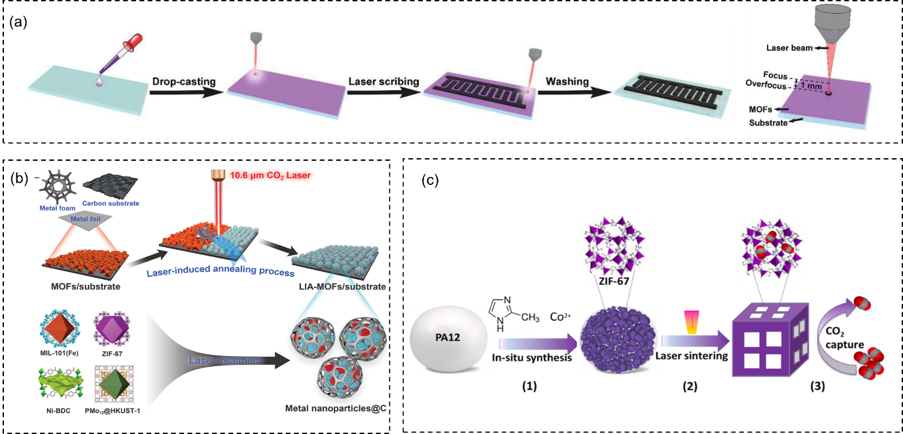
Figure 5. (a) Schematic illustration of the fabrication process of LIC-MOF-based micro-supercapacitors (MSCs) and demonstration of the over-focused laser beam on the surface of MOFs. Reproduced with permission.[47] Copyright 2021, WILEY-VCH Verlag GmbH & Co. KGaA, Weinheim. (b) Schematic representation of laser-induced annealing (LIA) of MOFs on conductive substrates. Laser-induced annealing of different MOFs into patterns of their corresponding structures on nickel foam. Reproduced with permission.[44] Copyright 2021, WILEY-VCH Verlag GmbH & Co. KGaA, Weinheim. (c) Schematic illustration of (1) the fabrication of ZIF67-PA12 nanocomposite powders; (2) laser sintering of the prepared powders into a porous component; (3) CO₂ capture application of laser-sintered component. Reproduced with permission.[48] Copyright 2021, Elsevier B.V.

2.4 3D Printed Metal Organic Frameworks and their Derivatives via Digital Light Processing/Projection (DLP)
Digital light processing or digital light projection (DLP) technique is in fact a mask-based stereolithography, in which an integral or basic image is transferred to the photopolymerizable liquid surface by exposing the light source through a patterned mask for each layer. A typical DLP based 3D printer consists of three critical components: the light projection system, the print platform and the photocurable resin or precursor.[49] A patterned light field is concentrated at the interface between the substrate and the liquid resin through optics. Digital micromirror devices (DMDs) are used due to their higher resolution in DLP optics. A DMD is a chip that comprises of a rectangular array of numerous microscopic mirrors that correspond to the pixels in the image to be displayed. The micromirrors function as ultra-fast light switches can be individually rotated and actuated by electrostatic forces by ±10–12° to an ‘on’ or ‘off’ state. Incident light beams are reflected accordingly to pass through or deviate away from the mirror lens, allowing the pixels to project brightly or appear dark on the respective printing substrate.[50, 51] The entire 3D object can be printed in a layer-by-layer fashion from different multiple exposures of the light projection. The assembly of different layers is controlled by the vertical movement of the printing platform. Interfacial photochemical reactions are initiated by the photons from the light and solidify the precursor resin, and each light exposure is able to cure a layer thickness depending on the input process parameters. The resins include photoinitiators, monomers or oligomers that will react and form photocurable cross-linked polymers. It is increasingly popular to use the photo-polymerizable resin and reactants to form the polymer matrix to fabricate composite or even ceramic materials. In addition, excellent feature resolution can be obtained up to several micrometers. Therefore, these remarkable properties of DLP technology have been attractive to the 3D printing industries, and further improvements and modifications have been explored for fabricating parts with even higher precision and speed.[52]

The general DLP process depends on localised photopolymerization of monomers and oligomers, along with the presence of suitable photoinitiators.[53] This can enable the fabrication of MOF-containing 3D objects. Halevi and team focused on the formation of MOF-containing 3D polymeric flexible objects, while aiming to preserve the adsorption capacity of embedded MOF and increases the hydrolytic stability of the MOF significantly.[54] A water-sensitive Cu-BTC was selected as a model MOF compound, while gas adsorption investigations were conducted in aqueous solutions to determine functionality retention of the MOF in the DLP 3D printed object as seen in Figure 6(a). The embedding of the MOF within the polymer significantly increases its hydrolytic stability while retaining the MOF's activity, which will be advantageous for gas adsorption and storage purposes. This is through the critical selection of monomer mixture that will enable the formation of a stable MOF-dispersion within the matrix, without the addition of a dispersing agent that may block the surface of the MOF particles and block their adsorption sites. With a combination of monomers phenoxyethyl acrylate and poly(2-phenoxyethyl acrylate), a cross-linker polyethylene glycol (600) diacrylate, a couple of photo-initiators and an optimal MOF concentration, complex and flexible 3D structures could be formed with the hydrolytically stable, typical blue color of the MOF (Cu-BTC@polymer) for promising applications.

Another way to exploit the DLP for the printing of complex 3D structures and to improve the functionality of the structure is to obtain porous MOF-based carbon materials by pyrolyzation. A photopolymer composition containing two MOFs, Ni-BTC and ZIF-8 as functionalizing fillers is used for DLP 3D printing of the complex geometry so that the derived structure can be used as a potential nickel-based catalyst.[55] A photocurable resin was prepared with a combination of 2-phenoxyethyl acrylate and trimethylolpropane triacrylate monomers and a couple of photoinitiators namely bis(2,4,6-trimethylbenzoyl)-phenylphosphineoxide and 1-hydroxy-cyclohexyl-phenyl-ketone. 5 wt% of Ni-BTC and 5 wt% ZIF-8 were incrementally added into the photocurable resin, and the resin was sonicated for a few minutes to produce a homogeneous dispersion for DLP 3D printing. 3D-printed objects were then pyrolyzed under flow of H₂ and Ar. Holes would be left by the boiled zinc on the surface of the pyrolyzed object, but nickel will remain upon the pyrolysis process that happened at 950 °C. The steps are displayed schematically in Figure 6(b). A 3D complex porous microstructure is then obtained, and the calculated surface area for CO₂ adsorption was very high 859 m²/g. The nickel particles that are embedded within the carbon structres can be potentially used as electrocatalysts and functional ferromagnets.

It is interesting to discuss and note that MOFs can also be utilized as photocatalysts in polymerization of certain polymers. In recent years, reversible deactivation radical polymerization (RDRP) techniques have attracted much attention as a versatile method for the preparation of polymeric materials. Photocontrolled RDRP (photoRDRP) processes includes photoinduced atom-transfer radical- polymerization (photoATRP) and photoinduced electron transfer-reversible addition-fragmentation chain transfer (PET-RAFT) polymerization.[56-59] They utilize visible light irradiation to initiate and control polymerization in a photocurable resin. Zhang et.al synthesized four porphyrinic Zr-MOFs (Figure 6(c)), each composed of Zr clusters and 5,10,15,20-(tetra-4-carboxyphenyl) porphyrin (TCPP) organic ligands as photocatalysts to convert photon energy into chemical energy for polymerization to initiate under different wavelengths according to the photocatalyst absorption spectrum.[60] The organic ligand porphyrins have dominant and strong photo-reductant properties, thus highly facilitating the conversion of triplet oxygen into singlet oxygen under light irradiation. MOF-525 (Zn) had superior polymerization kinetics in comparison to the other Zr MOFs (Zn), which was attributed to enhanced dispersion and light penetration arising from its small size, and most importantly it has the most efficient singlet oxygen generator, agreeing with polymerization kinetics.
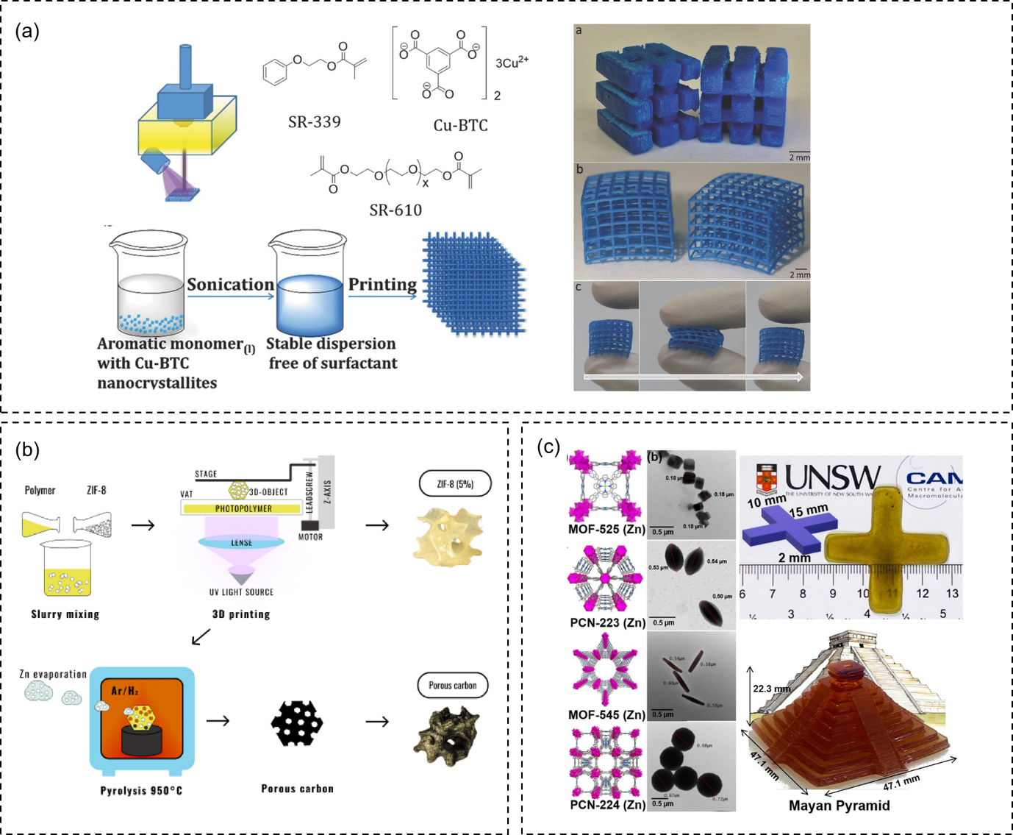
Figure 6. (a) Schematic representation of DLP printing: the stage descends into the resin bath; the UV light is projected onto the DLP mirror array and creates the desired image. The light then initiates the polymerization reaction to fabricate the polymer layer on the stage. The process is repeated again according to the number of layers to form the 3D object. The polymeric resin is formed by firstly dispersing the Cu-BTC crystals in the aromatic monomer. After which, the photoinitiator is added and the formulation is printed with the DLP printer. The monomer used is SR-339; the crosslinker used isSR-610; and the MOF fabricated is Cu-BTC. The right digital image show 3D-printed models of Cu-BTC@polymer and 3D-printed nets of Cu-BTC@polymer. The image also demonstrates the flexibility of the 3D-printed object before, during, and after compression. Reproduced with permission.[54] Copyright 2017, WILEY-VCH Verlag GmbH & Co. KGaA, Weinheim. (b) The proposed approach to 3D-printed porous carbon objects: new porous carbon materials obtained by 3D printing from photopolymer compositions with zinc- and nickel-based metal–organic frameworks, ZIF-8 and Ni-BTC, followed by high-temperature pyrolysis. Reproduced with permission.[55] Copyright 2021, MDPI. (c) Schematic representation of crystal structures of porphyrinic Zr-MOFs (Zn), including MOF-525 (Zn), PCN-223 (Zn), MOF-545 (Zn) and PCN-224 (Zn). The polyhedron denotes the Zr clusters, green wires Zn, fuchsia Zr, grey C, blue N, red O atoms; hydrogen atoms are omitted for clarity. The corresponding TEM images of porphyrinic Zr-MOFs (Zn); scale bar is 0.5 μm. The digital image shown on the left of a 3D printed geometrical model of a blue cross with reaction ratios of [PEGDA]: [BTPA]: [TEOA]=400:1:20 by using MOF-525 (Zn) as photocatalysts under green light irradiation (λ_{max}=565 nm, 0.2 mW cm⁻²). The digital image of the model of the Mayan Pyramid is also shown via photopolymerization 3D printing using MOF-525 (Zn) and EB as co-catalysts with reaction stoichiometry of [PEGDA]:[DMA]:[BTPA]:[TEOA]:[EB]=400:0:1:20:0.01. (PEGDA = Poly(ethylene glycol) diacrylate, BPTA = 2-(n-butyltrithiocarbonate)-propionic acid, TEOA = Triethanolamine, DMA = N,N-dimethylacrylamide, EB = Erythrosin B). Reproduced with permission.[60] Copyright 2020, WILEY-VCH Verlag GmbH & Co. KGaA, Weinheim.

2.5 3D Printed Metal Organic Frameworks and their Derivatives via Inkjet Printing (IJP)
Inkjet printing (IJP) is a commonly used and representative deposition technique that can directly propel droplets of ink through a nozzle onto a paper or any suitable substrate. Currently, there are two main types inkjet technologies based on the generation of droplets: continuous (CIJ) and drop-on-demand (DOD) inkjet printing.[61, 62] In CIJ, a continuous stream of fluid is passed through a tip and breaks up into small droplets through Plateau-Rayleigh instability. The charged droplets are then guided by deflector plates to either land on the substrate for deposition or the gutter for the recollection of unused and unwanted droplets. For DOD technology, individual drops can be generated when required for jetting, and create patterns as designed by programming the position of the printhead. The DOD technique can be further subdivided into thermal and piezoelectric DOD, on the basis of distinguishing the mechanism by which a drop is ejected. For thermal DOD, there is a thin film heater in the ink reservoir, whereby the ink is heated upon immediate contact to above its boiling point. Therefore, a vapor bubble will be formed around the thin film when a current is passed through the heater, and the bubble will collapse when the current is taken away. The rapid formation and collapse of such vapor bubbles will generate the pulse pressure required for ink-jetting. On the other hand, in piezoelectric DOD, the pressure pulse is generated by the deflection of the piezoelectric actuator. By generating a droplet on demand, the DOD provides a more economical ink delivery and provides more flexibility in pattern design than CIJ.[62]

However, in comparison to other extrusion-based 3D printing techniques, there are more considerations and constraints for the ink formulation to be printed in IJP. These properties can be sub-divided into the various process for the formation of the ink droplet: the flight of droplet, the interaction of droplet and substrate and the solidification of the droplet. For the droplet to be generated, the viscosity and surface tension of the near-liquid ink must be considered. When the viscosity is too high, the droplet cannot be ejected due to viscous kinetic energy dissipation at the nozzle. The surface tension of the liquid droplet also represents the energy barrier for the liquid to overcome and form a separate droplet from the bulk stream. Rheological properties must be tuned accordingly for a good print. [63, 64]
For flight of a droplet, satellite droplets are problematic for precise 3D printing of a component. The surface tension and viscosity of the ink cannot be too thin where the ligament tail of the droplet that is formed breaks up to form many satellite droplets. Even when these satellite droplets eventually merge with the main droplet before impact, in the unfortunate case when they do not, they will eventually affect the resolution and accuracy of the print.

After the deposition of the droplet on the substrate, the final diameter of the droplet determines the limit of resolution concerning the print. The final contact diameter (d_{con}) has a direct linear relationship with the in-flight droplet diameter (d₀), and it largely relies on the contact angle (ϴ) of the droplet. The determining equation is shown below:

$$d_{con}= d_{0}\sqrt[3]{\frac{8}{\tan{\frac{θ}{2}(3+ \tan^{2}{\frac{θ}{2})} }}}$$

Hence, an “ink-phobic” substrate will provide a small final contact diameter, and a higher resolution of the print. Solidification of the final print in general would depend on evaporation of the ink solvent (if a solution is used). The Marangoni effect may happen to the droplet when there are different evaporation rates in the droplet itself, especially along the contact line. This is due to the difference in mass transfer along an interface between two fluids because of a gradient of the surface tension in the droplet. Therefore, fabricating ink of suitable viscosities and rheological properties are of importance in IJP.[63]

IJP is a technique which can precisely control liquid deposition effectively for patterns, is commonly used to fabricate patterned thin films. It is advantageous as it has a rapid fabricating rate, large-area deposition without contamination, and wide processability of CAD information. Among a variety of MOFs, porphyrinic MOFs (constructed from porphyrinic/metalloporphyrinic organic linkers) have high redox activities, and therefore have been proposed as attractive candidates in recent years for various electrochemical applications such as CO₂ reduction, reduction of carbon tetrachloride, and electrochemical nitrite sensors.[65-67] Su et.al synthesized MOF-525 crystals of different sizes and dispersed them in dimethylformamide (DMF) to form stable inks for inkjet printing.[68] Inkjet printed MOF-525 thin films are composed of five different crystal sizes and fabricated respectively onto indium tin oxide (ITO) substrates (Figure 7(a)). The printed MOF thin films are then applied for electrocatalytic nitrite oxidation. The thin films of MOF-525 with various thicknesses created by adjusting the number of layers printed as seen in Figure 7(b), and the thin film can exhibit a smooth surface without microscopic cracks after 10 layers of printing. The thin films printed with a smaller crystal size exhibits a better electrocatalytic activity toward nitrite oxidation, and printing process in this study can be further extended to print thin film patterns of any MOF suspension with good colloidal stability, trending towards a possibility for more electrochemical applications.
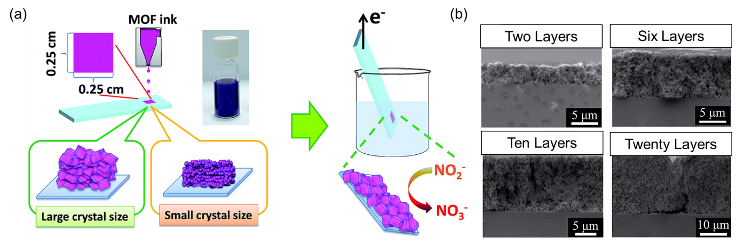

Figure 7. (a) A schematic illustration of the ink-jet printing process and electrochemical characterizations. (b) Cross-sectional SEM images of the inkjet printed M1.35 (1.35 g of benzoic acid in MOF) thin films with two layers, six layers, ten layers, and twenty layers. Reproduced with permission.[68] Copyright 2016, Elsevier B.V.

3. Advantages and Disadvantages with processing methods in relation to industrial applications
In terms of processability, when utilising conventional functional materials, 3D printing processes have significant advantages as compared to conventional manufacturing processes.[69-71] In contrast to conventional subtractive manufacturing processes whereby large amount of materials would need to be removed, 3D printing can utilise raw materials by building parts precisely to the dimensions, layer-by-layer in a more efficient fashion. Excess materials can often be reused with minimal processing. In terms of resource efficiency, conventional manufacturing processes require supplementary resources such as jigs, fixtures, cutting and remoulding tools, and coolants in addition to the main machining tool. 3D printing would not require these supplemental resources. 3D printing technologies have the potential to reduce lifecycle material mass and energy usage relative to conventional subtractive manufacturing by eliminating engineered remnants and reducing the use of harmful supporting process inputs. In addition, pollution of environmental systems is much less common in 3D printing as compared to conventional systems. For example, 3D printing requires no cutting fluids as compared to conventional machining, which contributes greatly to the manufacturing waste streams. Therefore, components can be fabricated by small manufacturers with less hazards and pollution that are accessible by customers, presenting an opportunity for an improved and more efficient supply chain dynamics. However, the energy usage and consumption of 3D printing processes and post printing treatments is still debatable when compared to the energy consumed during conventional manufacturing processes. Excess energy consumption may occur in the equipment warm-up and cool down stages. The build process may consume minimal energy however, when the entire operating procedure is considered, the overall energy consumption may be as much as conventional manufacturing processes.[71]

In terms of functionality, components with complex geometries and features can be made in a single piece without tooling constraints. There is not a need to sacrifice component functionality for ease of manufacturing. Therefore, with 3D printing, it is feasible to build a single part with varying mechanical properties (i.e., flexible in one part, stiffer in another area) through multi-material 3D printing, creating new opportunities for design innovations. In production flexibility, 3D printing machines are straightforward and do not require costly set ups, therefore relatively economical in small batch production. Therefore, production can be easily catered to customer demands. Moreover, the issues of production bottlenecks are significantly reduced as complex parts can be produced in a one-step process. With the free design capabilities, highly porous yet robust 3D MOFs is well suited in various applications in gas storage and separation, batteries and wastewater treatments. Furthermore, the high volumetric and gravimetric uptakes of 3D printed MOFs is exceptionally relevant in the applications of hydrogen and natural gas vehicles.

Even though there are substantial benefits, 3D printing poses its own set of problems and are less advantageous as compared to conventional manufacturing process in several ways, especially in terms of scalability. Firstly, MOFs are purposefully synthesized with controlled miniaturization. [72] As compared to their bulk analogs, there are merits to achieving high complexity in MOFs on an atomic scale such as high surface to volume ratio, colloidal stability and anisotropic properties. Therefore, due to its lightweight characteristics and precise synthesis methods, upscaling its fabrication process requires an energy intensive production line with large amounts of solvents and precursors needed. Secondly, fabrication challenges may also occur when printing industrial-scale MOF structures. Large sized objects often require long periods of time to complete the entire build process. Imperfections and defects are more significant in components fabricated by 3D printing due to its layer-by-layer fabrication method. Structures fabricated via extrusion-based methods usually possess rougher and more ribbed surface finishes, and higher porosity. The poor adhesion between each stacked filament layer can act as microstructural weak points for structural failure as compared to traditional manufacturing.

4. Conclusions and Outlook
At present, 3D printing of MOFs is mainly confined to small scale lab-based demonstrations. There is a pressing need to increase economies of scale of 3D printed MOFs for the industry. Comparing the various 3D printing techniques, direct AM methods that produce net-shape structures (i.e., PBF, DED and vat photopolymerization) are more well-accepted in industries such as aerospace, automotive and the biomedical sectors. Their relatively faster printing speeds coupled with minimal post printing heat treatment steps and their net-shape structures are able to provide an accurate design to production 3D structure that can be used readily. As such, to obtain mechanically robust hierarchical 3D-MOF structures for harsh environment industrial applications, the above 3D Printing methods (namely PBF, DED and vat photopolymerization) should be thoughtfully considered to advance the field of industrial-ready MOF structures. However, relative to the commercialization of MOFs and MOF derived materials especially for energy storage, there are still important issues to be resolved before their integration into broad and larger scale industrial applications.[73] At the laboratory scale (mg/g scale), optimization in terms of energy use, chemical toxicity and fabrication processes are usually neglected, and research focus is mainly placed on obtaining pure, and well-crystalline compounds and accessing their properties. Scaled up optimisation must be done at the industrial level, synthesis parameters and cost of material and equipment must be taken into account, and most importantly, performance of the material obtained at large scale should be as close as possible to that of the small-scale sample.

The current cost of MOF fabrication is relatively high, only being affordable for small scale research. Therefore, when coupled with the issue of lack of economies of scale in 3D printing, the field of 3D printing of MOFs for energy storage applications is not yet a mature one in economic terms due to additional customizability costs, even smaller scale production and costs of set-up and equipment. Despite recent efforts in MOFs research for energy storage, their wide-scale and large-scale applications and development of applicable MOF-enabled products for practical use is limited by commercial availability and costs. Several international companies such as BASF via Sigma-Aldrich (Germany), MOF Technologies Ltd. (UK), Strem Chemicals Inc. (USA) and MOFapps (Norway), Promethean Particles (UK) produce MOF products in limited amounts commercially, and they usually sell expensive.[74] The possibility for MOFs to reach reasonable competitive prices and their potential to reach the market for large-scale applications must be attained before using 3D printing processes in their fabrication to curb the overall high costs of production. Until then, production parameters can be capped at low-cost conventional manufacturing methods in order to fabricate and utilise them when integrated into components for use.

3D MOFs hold immense potential as an advanced energy conversion and storage system. With the ever-growing demand for energy across the globe, the time is ripe for the research of MOFs to venture into the development of economically feasible larger-scale manufacturing processes. Firstly, to do so, careful selection of the AM technique is required for mechanically robust, complex 3D MOFs produced on a large scale. For this to be realized, direct AM techniques are more advantageous due to their near-net shape fabrication technique which can save energy on the post processing front whilst having the capabilities to produce strong and lightweight 3D MOF structures. Secondly, the overall cost of MOF needs to be significantly lowered for industries to place deliberation on MOFs as an industrially ready material for energy storage. Cleaner and greener MOF synthesis routes also need to be explored to reduce the adverse environmental impact which is a vital consideration for large scale production. With these challenges solved, the gradual road towards 3D MOFs for industrial scale energy conversion and storage is certain.

References
[1] W. Zhu, A. Li, Z. Wang, J. Yang, Y. Xu, Metal–Organic Frameworks and Their Derivatives: Designing Principles and Advances toward Advanced Cathode Materials for Alkali Metal Ion Batteries, Small 17(22) (2021) 2006424.
[2] J. Fonseca, T. Gong, L. Jiao, H.-L. Jiang, Metal–organic frameworks (MOFs) beyond crystallinity: amorphous MOFs, MOF liquids and MOF glasses, Journal of Materials Chemistry A 9(17) (2021) 10562-10611.
[3] R. Gaillac, P. Pullumbi, K.A. Beyer, K.W. Chapman, D.A. Keen, T.D. Bennett, F.-X. Coudert, Liquid metal–organic frameworks, Nature Materials 16(11) (2017) 1149-1154.
[4] Y. Wang, H. Jin, Q. Ma, K. Mo, H. Mao, A. Feldhoff, X. Cao, Y. Li, F. Pan, Z. Jiang, A MOF Glass Membrane for Gas Separation, Angewandte Chemie International Edition 59(11) (2020) 4365-4369.
[5] T.D. Bennett, A.L. Goodwin, M.T. Dove, D.A. Keen, M.G. Tucker, E.R. Barney, A.K. Soper, E.G. Bithell, J.-C. Tan, A.K. Cheetham, Structure and Properties of an Amorphous Metal-Organic Framework, Physical Review Letters 104(11) (2010) 115503.
[6] T.D. Bennett, A.K. Cheetham, Amorphous Metal–Organic Frameworks, Accounts of Chemical Research 47(5) (2014) 1555-1562.
[7] G.K.H. Shimizu, How Much Pressure Is Too Much Pressure for a MOF?, Chem 3(6) (2017) 924-925.
[8] I.E. Collings, A.L. Goodwin, Metal–organic frameworks under pressure, Journal of Applied Physics 126(18) (2019) 181101.
[9] K.J. Gagnon, C.M. Beavers, A. Clearfield, MOFs Under Pressure: The Reversible Compression of a Single Crystal, Journal of the American Chemical Society 135(4) (2013) 1252-1255.
[10] K.W. Chapman, G.J. Halder, P.J. Chupas, Pressure-Induced Amorphization and Porosity Modification in a Metal−Organic Framework, Journal of the American Chemical Society 131(48) (2009) 17546-17547.
[11] G.W. Peterson, J.B. DeCoste, T.G. Glover, Y. Huang, H. Jasuja, K.S. Walton, Effects of pelletization pressure on the physical and chemical properties of the metal–organic frameworks Cu3(BTC)2 and UiO-66, Microporous and Mesoporous Materials 179 (2013) 48-53.
[12] I. Majchrzak-Kucęba, A. Ściubidło, Shaping metal–organic framework (MOF) powder materials for CO2 capture applications—a thermogravimetric study, Journal of Thermal Analysis and Calorimetry 138(6) (2019) 4139-4144.
[13] S.M. Moosavi, A. Nandy, K.M. Jablonka, D. Ongari, J.P. Janet, P.G. Boyd, Y. Lee, B. Smit, H.J. Kulik, Understanding the diversity of the metal-organic framework ecosystem, Nature Communications 11(1) (2020) 4068.
[14] B. Elder, R. Neupane, E. Tokita, U. Ghosh, S. Hales, Y.L. Kong, Nanomaterial patterning in 3D printing, Advanced Materials 32(17) (2020) 1907142.
[15] K. Fu, Y. Yao, J. Dai, L. Hu, Progress in 3D printing of carbon materials for energy‐related applications, Advanced materials 29(9) (2017) 1603486.
[16] H. Li, J. Liang, Recent development of printed micro‐supercapacitors: printable materials, printing technologies, and perspectives, Advanced Materials 32(3) (2020) 1805864.
[17] Y. Lin, Y. Gao, F. Fang, Z. Fan, Recent progress on printable power supply devices and systems with nanomaterials, Nano Research 11(6) (2018) 3065-3087.
[18] Z. Lyu, G.J.H. Lim, J.J. Koh, Y. Li, Y. Ma, J. Ding, J. Wang, Z. Hu, J. Wang, W. Chen, Design and manufacture of 3D-printed batteries, Joule 5(1) (2021) 89-114.
[19] E. Pomerantseva, F. Bonaccorso, X. Feng, Y. Cui, Y. Gogotsi, Energy storage: The future enabled by nanomaterials, Science 366(6468) (2019) eaan8285.
[20] B. Berman, 3-D printing: The new industrial revolution, Business horizons 55(2) (2012) 155-162.
[21] A. Ambrosi, M. Pumera, 3D-printing technologies for electrochemical applications, Chemical Society Reviews 45(10) (2016) 2740-2755.
[22] A. Standard, Standard terminology for additive manufacturing technologies, ASTM International F2792-12a (2012).
[23] S. Moylan, J. Slotwinski, A. Cooke, K. Jurrens, M.A. Donmez, An additive manufacturing test artifact, Journal of research of the National Institute of Standards and Technology 119 (2014) 429.
[24] F. Azam, A.-M. Abdul-Rani, K. Altaf, T.V.V.L.N. Rao, H. Zaharin, An In-Depth Review on Direct Additive Manufacturing of Metals, IOP Conference Series: Materials Science and Engineering 328 (2018) 012005.
[25] A. Pichon, A. Lazuen-Garay, S.L. James, Solvent-free synthesis of a microporous metal–organic framework, CrystEngComm 8(3) (2006) 211-214.
[26] X. Tian, J. Jin, S. Yuan, C.K. Chua, S.B. Tor, K. Zhou, Emerging 3D‐printed electrochemical energy storage devices: a critical review, Advanced Energy Materials 7(17) (2017) 1700127.
[27] S.A. Abtahi, G.J. Elfring, Jeffery orbits in shear-thinning fluids, Physics of Fluids 31(10) (2019) 103106.
[28] H. Thakkar, S. Eastman, Q. Al-Naddaf, A.A. Rownaghi, F. Rezaei, 3D-printed metal–organic framework monoliths for gas adsorption processes, ACS applied materials & interfaces 9(41) (2017) 35908-35916.
[29] G.J.H. Lim, Y. Wu, B.B. Shah, J.J. Koh, C.K. Liu, D. Zhao, A.K. Cheetham, J. Wang, J. Ding, 3D-Printing of pure metal–organic framework monoliths, ACS Materials Letters 1(1) (2019) 147-153.
[30] Z. Lyu, G.J.H. Lim, R. Guo, Z. Kou, T. Wang, C. Guan, J. Ding, W. Chen, J. Wang, 3D‐printed MOF‐derived hierarchically porous frameworks for practical high‐energy density Li–O2 batteries, Advanced Functional Materials 29(1) (2019) 1806658.
[31] Z. Lyu, G.J.H. Lim, R. Guo, Z. Pan, X. Zhang, H. Zhang, Z. He, S. Adams, W. Chen, J. Ding, 3D-printed electrodes for lithium metal batteries with high areal capacity and high-rate capability, Energy Storage Materials 24 (2020) 336-342.
[32] S.S. Crump, Inventor; Google Patents, assignee, Apparatus and method for creating three-dimensional objects patent US 5121329 (1992).
[33] D. Popescu, A. Zapciu, C. Amza, F. Baciu, R. Marinescu, FDM process parameters influence over the mechanical properties of polymer specimens: A review, Polymer Testing 69 (2018) 157-166.
[34] M. Bible, M. Sefa, J.A. Fedchak, J. Scherschligt, B. Natarajan, Z. Ahmed, M.R. Hartings, 3D-printed acrylonitrile butadiene styrene-metal organic framework composite materials and their gas storage properties, 3D Printing and Additive Manufacturing 5(1) (2018) 63-72.
[35] K.A. Evans, Z.C. Kennedy, B.W. Arey, J.F. Christ, H.T. Schaef, S.K. Nune, R.L. Erikson, Chemically active, porous 3D-printed thermoplastic composites, ACS applied materials & interfaces 10(17) (2018) 15112-15121.
[36] D.L. Bourell, Sintering in laser sintering, JOM 68(3) (2016) 885-889.
[37] A. Kafle, E. Luis, R. Silwal, H.M. Pan, P.L. Shrestha, A.K. Bastola, 3D/4D Printing of polymers: Fused deposition modelling (FDM), selective laser sintering (SLS), and stereolithography (SLA), Polymers 13(18) (2021) 3101.
[38] D.I. Stoia, E. Linul, L. Marsavina, Influence of manufacturing parameters on mechanical properties of porous materials by selective laser sintering, Materials 12(6) (2019) 871.
[39] J.P. Kruth, P. Mercelis, J. Van Vaerenbergh, L. Froyen, M. Rombouts, Binding mechanisms in selective laser sintering and selective laser melting, Rapid prototyping journal (2005).
[40] A. Muzaffar, M.B. Ahamed, K. Deshmukh, T. Kovářík, T. Křenek, S.K.K. Pasha, Chapter 4 - 3D and 4D printing of pH-responsive and functional polymers and their composites, in: K.K. Sadasivuni, K. Deshmukh, M.A. Almaadeed (Eds.), 3D and 4D Printing of Polymer Nanocomposite Materials, Elsevier2020, pp. 85-117.
[41] A. Pilipović, T. Brajlih, I. Drstvenšek, Influence of processing parameters on tensile properties of SLS polymer product, Polymers 10(11) (2018) 1208.
[42] M. Castoro, S. Kumpaty, Impact of laser power and build orientation on the mechanical properties of selectively laser sintered parts.
[43] J. Zhang, M. Ren, Y. Li, J.M. Tour, In Situ Synthesis of Efficient Water Oxidation Catalysts in Laser-Induced Graphene, ACS Energy Letters 3(3) (2018) 677-683.
[44] Y.-J. Tang, H. Zheng, Y. Wang, W. Zhang, K. Zhou, Laser-Induced Annealing of Metal–Organic Frameworks on Conductive Substrates for Electrochemical Water Splitting, Advanced Functional Materials 31(31) (2021) 2102648.
[45] R. You, Y.Q. Liu, Y.L. Hao, D.D. Han, Y.L. Zhang, Z. You, Laser fabrication of graphene‐based flexible electronics, Advanced Materials 32(15) (2020) 1901981.
[46] L.R. Mingabudinova, A.S. Zalogina, A.A. Krasilin, M.I. Petrova, P. Trofimov, Y.A. Mezenov, E.V. Ubyivovk, P. Lönnecke, A. Nominé, J. Ghanbaja, Laser printing of optically resonant hollow crystalline carbon nanostructures from 1D and 2D metal–organic frameworks, Nanoscale 11(21) (2019) 10155-10159.
[47] W. Zhang, R. Li, H. Zheng, J. Bao, Y. Tang, K. Zhou, Laser‐assisted printing of electrodes using metal–organic frameworks for micro‐supercapacitors, Advanced Functional Materials 31(14) (2021) 2009057.
[48] B. Chen, R. Davies, H. Chang, Y. Xia, Y. Zhu, O. Ghita, In-situ synthesis of Metal Organic Frameworks (MOFs)-PA12 powders and their laser sintering into hierarchical porous lattice structures, Additive Manufacturing 38 (2021) 101774.
[49] Z. Chen, Z. Li, J. Li, C. Liu, C. Lao, Y. Fu, C. Liu, Y. Li, P. Wang, Y. He, 3D printing of ceramics: A review, Journal of the European Ceramic Society 39(4) (2019) 661-687.
[50] Y.-S. Lu, L.-Y. Tsai, K.-C. Huang, C.G. Tsai, C.-C. Yang, J.A. Yeh, Three-dimensional illumination system using dielectric liquid lenses, Opt. Express 19(S4) (2011) A740-A746.
[51] D. Dana, M.D. Walter, S. John, Emerging digital micromirror device (DMD) applications, Proc.SPIE, 2003.
[52] M. Hofmann, 3D printing gets a boost and opportunities with polymer materials, ACS Publications, 2014.
[53] X. Xu, J. Yang, W. Jonhson, Y. Wang, A. Suwardi, J. Ding, C. Guan, D. Zhang, Additive manufacturing solidification methodologies for ink formulation, Additive Manufacturing 56 (2022) 102939.
[54] O. Halevi, J.M.R. Tan, P.S. Lee, S. Magdassi, Hydrolytically Stable MOF in 3D‐Printed Structures, Advanced Sustainable Systems 2(2) (2018) 1700150.
[55] A.I. Cherevko, I.A. Nikovskiy, Y.V. Nelyubina, K.M. Skupov, N.N. Efimov, V.V. Novikov, 3D-Printed Porous Magnetic Carbon Materials Derived from Metal–Organic Frameworks, Polymers 13(22) (2021) 3881.
[56] M. Chen, M. Zhong, J.A. Johnson, Light-controlled radical polymerization: mechanisms, methods, and applications, Chemical reviews 116(17) (2016) 10167-10211.
[57] B.S. Tucker, M.L. Coughlin, C.A. Figg, B.S. Sumerlin, Grafting-from proteins using metal-free PET–RAFT polymerizations under mild visible-light irradiation, ACS Macro Letters 6(4) (2017) 452-457.
[58] B. Cabannes-Boué, Q. Yang, J. Lalevée, F. Morlet-Savary, J. Poly, Investigation into the mechanism of photo-mediated RAFT polymerization involving the reversible photolysis of the chain-transfer agent, Polymer Chemistry 8(11) (2017) 1760-1770.
[59] K. Parkatzidis, N.P. Truong, M.N. Antonopoulou, R. Whitfield, D. Konkolewicz, A. Anastasaki, Tailoring polymer dispersity by mixing chain transfer agents in PET-RAFT polymerization, Polymer Chemistry 11(31) (2020) 4968-4972.
[60] L. Zhang, X. Shi, Z. Zhang, R.P. Kuchel, R. Namivandi‐Zangeneh, N. Corrigan, K. Jung, K. Liang, C. Boyer, Porphyrinic Zirconium Metal–Organic Frameworks (MOFs) as Heterogeneous Photocatalysts for PET‐RAFT Polymerization and Stereolithography, Angewandte Chemie International Edition 60(10) (2021) 5489-5496.
[61] B. Derby, Inkjet printing of functional and structural materials: fluid property requirements, feature stability, and resolution, Annual Review of Materials Research 40 (2010) 395-414.
[62] J. Yeo, J.J. Koh, F. Wang, Z. Li, C. He, 3D Printing Silicone Materials and Devices, Silicon Containing Hybrid Copolymers (2020) 239-263.
[63] N. Reis, B. Derby, Ink jet deposition of ceramic suspensions: Modeling and experiments of droplet formation, MRS Online Proceedings Library (OPL) 625 (2000).
[64] P.C. Duineveld, M.M. De Kok, M. Buechel, A. Sempel, K.A.H. Mutsaers, P. Van de Weijer, I.G.J. Camps, T. Van de Biggelaar, J.-E.J.M. Rubingh, E.I. Haskal, Ink-jet printing of polymer light-emitting devices, SPIE, pp. 59-67.
[65] O.K. Farha, A.M. Shultz, A.A. Sarjeant, S.T. Nguyen, J.T. Hupp, Active-Site-Accessible, Porphyrinic Metal−Organic Framework Materials, Journal of the American Chemical Society 133(15) (2011) 5652-5655.
[66] D. Feng, Z.-Y. Gu, J.-R. Li, H.-L. Jiang, Z. Wei, H.-C. Zhou, Zirconium-Metalloporphyrin PCN-222: Mesoporous Metal–Organic Frameworks with Ultrahigh Stability as Biomimetic Catalysts, Angewandte Chemie International Edition 51(41) (2012) 10307-10310.
[67] W. Morris, B. Volosskiy, S. Demir, F. Gándara, P.L. McGrier, H. Furukawa, D. Cascio, J.F. Stoddart, O.M. Yaghi, Synthesis, Structure, and Metalation of Two New Highly Porous Zirconium Metal–Organic Frameworks, Inorganic Chemistry 51(12) (2012) 6443-6445.
[68] C.-H. Su, C.-W. Kung, T.-H. Chang, H.-C. Lu, K.-C. Ho, Y.-C. Liao, Inkjet-printed porphyrinic metal–organic framework thin films for electrocatalysis, Journal of Materials Chemistry A 4(28) (2016) 11094-11102.
[69] S.H. Huang, P. Liu, A. Mokasdar, L. Hou, Additive manufacturing and its societal impact: a literature review, The International Journal of Advanced Manufacturing Technology 67(5) (2013) 1191-1203.
[70] M. Attaran, The rise of 3-D printing: The advantages of additive manufacturing over traditional manufacturing, Business horizons 60(5) (2017) 677-688.
[71] M. Gebler, A.J.M.S. Uiterkamp, C. Visser, A global sustainability perspective on 3D printing technologies, Energy policy 74 (2014) 158-167.
[72] J. Wang, I. Imaz, D. Maspoch, Metal−Organic Frameworks: Why Make Them Small?, Small Structures 3(1) (2022) 2100126.
[73] J. Ren, X. Dyosiba, N.M. Musyoka, H.W. Langmi, M. Mathe, S. Liao, Review on the current practices and efforts towards pilot-scale production of metal-organic frameworks (MOFs), Coordination Chemistry Reviews 352 (2017) 187-219.
[74] M.I. Severino, E. Gkaniatsou, F. Nouar, M.L. Pinto, C. Serre, MOFs industrialization: a complete assessment of production costs, Faraday Discussions 231 (2021) 326-341.

