Accelerated design and fabrication of thermal protection coating via high-throughput experiments and machine learning
Zhiyun Ye^{1#}, Ke Li^{4#}, Guoliang Chen^{1, 2}*, Yongchun Zou^{1, 3}**, Shuqi Wang¹, Zhao Wang^{1, 5}, Shuang Yu¹, Yaming Wang¹***, Dechang Jia¹, Yu Zhou¹
1. Institute for Advanced Ceramics, Harbin Institute of Technology, Harbin 150001, China
2. School of Energy Science and Engineering, Key Laboratory of Aerospace Thermophysics, Ministry of Industry and Information Technology, Harbin Institute of Technology, Harbin 150001, China
3. Center of Analysis and Measurement, Harbin Institute of Technology, Harbin 150001, China
4. Institute of Materials Research and Engineering (IMRE), Agency for Science, Technology and Research (A*STAR), 2 Fusionopolis Way, Innovis #08-03, Singapore 138634, Republic of Singapore
5. BYD Auto Industry Company Limited, Basic Science Research Institute, Shenzhen, 518083, China
#Zhiyun Ye and Ke Li contributed equally.
*Corresponding author: chenguoliang@hit.edu.cn (G. Chen)
**Corresponding author: zouyongchun@hit.edu.cn (Y. Zou)
***Corresponding author: wangyaming@hit.edu.cn (Y. Wang)
ABSTRACT: For the engineering applications of thermal protection materials (TPMs), the demand targets are often multiple such as high-temperature oxidation, hot corrosion, high temperature/speed ablation, etc., which is a challenging problem for developing a tailored property by an efficient and economical method. In this work, using modified silicide-based coating as the model materials, a hybrid model for the design of TPMS with tailored properties is developed through the high-throughput experiments combined with the machine learning (ML) method. Among the four data sets, XGboost model has the smallest bias in the predicted values, the largest coefficient of determination (R2) value, and the smallest mean square error (MSE). Our work exemplifies the potential of high-throughput experiments and ML-assisted design in advancing the discovery and development of novel TPMS.
Keywords: Thermal protection materials, Silicide-based coating, High-throughput experiments, Machine learning

Introduction
As aerospace technology rapidly advances, the working environment of aerospace hot end components is becoming more and more severe, usually facing a series of extreme service challenges such as high-temperature oxidation, hot corrosion, high temperature/speed ablation, etc., which leads to a global emphasis on the development of a new generation of thermal protection materials (TPMs) [1-4]. However, the traditional empirical approaches to discovering new materials, characterized by trial and error, are inherently time-consuming and resource-intensive, especially for the TPMs facing multiple service environments [5, 6]. In recent years, the fusion of machine learning (ML) techniques with materials science has ushered in a paradigm shift. ML, with its prowess in deciphering intricate patterns from voluminous data, offers an innovative pathway to expedite the discovery process and optimize experimental conditions [7, 8]. By harnessing the predictive capabilities of ML algorithms, researchers can now sift through vast combinatorial spaces of material properties and synthesis conditions, honing in on promising candidates with unprecedented speed and precision [9, 10]. This synergy between ML and materials science not only catalyzes the discovery of novel materials with tailored properties but also paves the way for a more sustainable and efficient research ecosystem [11-13]. Nevertheless, the research of ML on TPMs is still in its infancy, and huge amounts of TPMs with tailorable properties have not been well explored so far because of the absence of a definite material system and corresponding preparation processing.
Inspired by the concepts of materials genetic engineering, ML assisted by high-throughput experiments is a high-efficiency method for the new TPMs prediction, accelerating the innovation of aerospace technology [14, 15]. Nowadays, the applied thermal protection coating on substrate alloy is considered to be the most effective method to prevent the weakening of mechanical properties at extreme high temperature environment [16]. Among them, silicide coating is the most widely used thermal protection coating in metallurgy, aerospace and nuclear industries, due to its high melting temperature, good thermal conductivity, and moderate coefficient of thermal expansion (CTE) and density, as well as easy to be obtained [17-19]. Especially, it can continuously form a stable/dense SiO₂ glass film layer with low oxygen permeability in high-temperature environments, which further reduces the inward oxygen flux from the external environment to the inner coating, thereby improving the oxidation inhibition properties [20]. However, the thermal protection performance of single silicide coating reaches a bottleneck and cannot meet the increasing demand for a higher harsh environment with increasing the engine thrust to weight ratio, because its nature to achieve thermal protection properties is achieved by using itself as a sacrificial media, lacking the extra media (like oxygen and molten salt) consuming phase [21, 22]. Therefore, it is urgent to develop the modified silicide coating for super thermal protection performance which could demand the meeting of different service environments, and ML prediction is undoubtedly an efficient screening method that saves time and costs.
On another note, it is evident that plasma electrolytic oxidation (PEO) is a simple and efficient in-situ formation method for forming strongly adherent modified silicide coating with enhanced high temperature protection performance, since it can pre-fabricate dense SiO₂ film layer on silicide coating to reduce the inward diffusion of oxygen [23, 24]. Moreover, PEO method is also considered a preparation process of thermal protection coating characterized by simplicity and strong designability, since it can fabricate new coatings with altered chemical compositions and customized functionalities with the addition of functional particles (such as silicide, carbide, and oxide particles) into the electrolyte of the PEO process [25-27]. It should be mentioned that this special PEO process is characterized by high voltage and high temperature, due to the locally unique environment of rising electrolyte temperature and high-frequency discharge field. The special phenomenon during this process that the instant and dense spark discharges are formed at the coating/electrolyte interface and leads to the directional migration, deposition, and sintering of nanoparticles, is discovered by the research group of Y. M. Wang from Harbin Institute of Technology and named it as liquid-plasma-assisted particle deposition and sintering (LPDS), which is different from traditional PEO [28]. The previous works [29-32] of Y. M. Wang’s group have proven that LPDS method is a viable route for designing TPMs by tailoring the unique process conditions and enabling the mass introduction of different nanoparticles and the formation of a bilayer structure, further achieving the improvement of high-temperature protection performance (oxidation resistance, hot corrosion resistance, anti-ablation, thermal radiation, etc.). Nevertheless, LPDS phenomenon is the result of multiple factors coupling, including particle size, particle concentration, electric field intensity, zeta potential, solution temperature, etc [33]. It is a so huge workload of obtaining the optimal processing parameters for excellent thermal protection coatings due to the vast combination space of so many process parameters, despite the formation process is simple and economical. Therefore, the innovation of ML assisted by high-throughput experiments undoubtedly provides a promising path for selection of the modified silicide-based thermal protection coatings with tailored properties through LPDS method, which is more efficient and precise, as well as the field that no researchers have ever been involved in before.
In this work, we establish a high throughput prediction model based on the ML strategy to accelerate the design of high-performance TPMs. As an innovative preparation method of modified silicide-based coating, LPDS enables the effective generation of dual-structure by introducing the nanoparticle, which can achieve a tailored property. During LPDS process, the dense NbSi₂ layer prepared by the halide-activated pack cementation method is selected as the substrate silicide coating, as well as the ZrC nanoparticle possessed a high melting point, excellent high-temperature oxidation resistance, and ablation resistance is selected as the ML model materials.Through the accelerated platform, the modified silicide-based coating with outstanding high-temperature performance is identified, and key interpretable descriptors during the synthesis process, namely, applied voltage, particle size and concentration, and processing time, are determined to decode the correlation between the associated outputs and thermal protection property. The detailed procedures are shown in Fig. 1. Firstly, we fabricated 122 LPDS samples using the high-throughput experiments, and simultaneously defined the four descriptors and associated outputs through orthogonal experiments. Subsequently, the construction of ML models is based on the analysis of the correlation coefficient between the processing parameters and associated outputs. Ultimately, the prediction and validation of LPDS-coatings suggested by the trained ML model, are conducted via experimental verification. This work reveals the great promise of machine learning to assist optimization of LPDS-coatings and is expected to accelerate design of other TPMs.
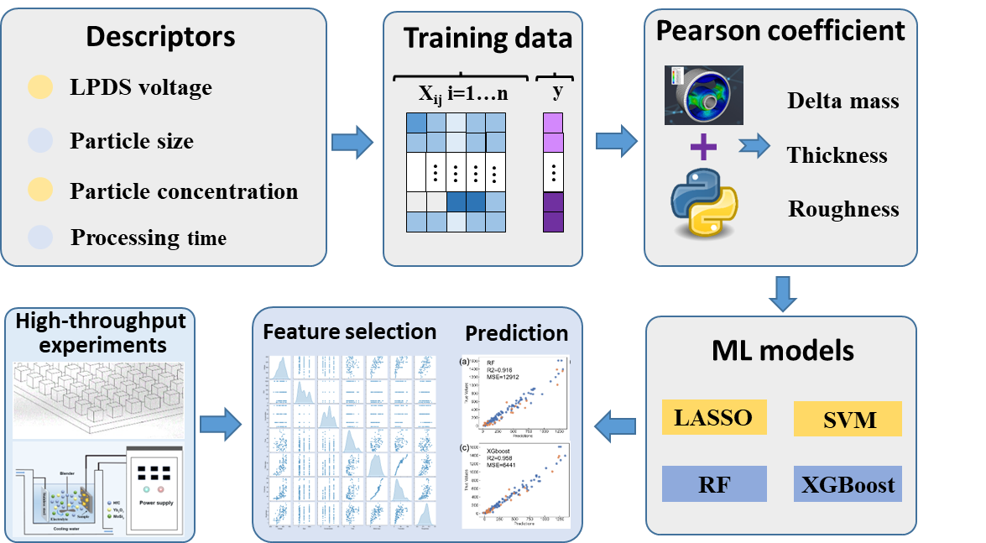
Fig. 1. Optimal feature selection and prediction of LPDS-coating based on four ML models.

2. Materials and methods

2.1 Material preparation
In our study, the modified silicide-based coating was constructed applying a two-step strategy, i.e., the preparation of silicide inner layer and particle deposition outer layer. Firstly, the commercial niobium alloy (Nb521), one of the most commonly used high-temperature alloys for hot-end components in the aerospace field, was selected as the substrate to form the NbSi₂ inner layer (~ 100 μm) by the halide-activated pack cementation (HAPC) method, which could obtain the dense coating with free defects. The detailed experimental procedure of the NbSi₂ layer has been reported in our previous work [30]. Subsequently, 122 samples with different particle deposition layers were constructed on the NbSi₂ layer through the LPDS method under the combinations of different parameters. Specifically, in order to simplify the ML model, single component ZrC particle with different particle sizes (30 nm, 100 nm, 500 nm, and 1 μm) was selected as the additive to form the particle deposition layer, since it can act as the oxygen-consuming phase and form the robust ZrSiO₄ skeleton at high-temperatures. During the LPDS process, the high-throughput experiments are carried out in the basic electrolyte including Na₂SiO₃ (15 g/L), (NaPO₃)₆ (6 g/L), and NaOH (1.2 g/L), based on the different combinations of experiment parameters. The variable parameters are as follows: particle size of 10 nm ~ 1 μm, particle concentration of 5 g/L ~ 30 g/L, applied voltage of 450 V ~ 650 V, and processing time of 5 min ~30 min. Moreover, the anionic surfactants were added to the used electrolyte to improve the dispersion of particles, and the electrolyte temperature was controlled in a range of 60-90 ℃ by using the cooling water.

2.2 High temperature oxidation test
Oxidation tests of the LPDS-coating and NbSi₂ coating were both applied in a muffle furnace (KSL-1700X) for 60 mins, 120 mins, and 180 mins, respectively. All the samples are put in an Al₂O₃ crucible and then placed in the muffle furnace, heating up to 1500 ℃ at a heating rate of 4 ℃/min, then holding for different times and taking it out. After oxidation, the thickness of the oxide scale and residual NbSi₂ layer were calculated from the cross-section SEM image of the coating to evaluate the high-temperature oxidation resistance.

2.3 Characterization of LPDS-coatings: microstructural analysis, phase content, delta mass, thickness and roughness
The structural characterization of the prepared LPDS-coatings was carried on a scanning electron microscope (SEM, Helios Nanolab600i, FEI, U.S.A.) equipped with an energy dispersive spectrometer (EDS), as well a transmission electron microscope (TEM, Talos F200x, FEI, U.S.A.). The phase component of different LPDS-coatings was identified from X-ray diffraction data obtained from the X-ray diffractometer (XRD, Empyrean, PANalytical, Netherlands), and the content of different phase within the coatings was confirmed from the Jade quantitative analysis. The changes in quality (delta mass) of samples before and after LPDS treatment was quantitatively measured by a high-accuracy balance (CPA225D, Sartorius, Germany) with an accuracy of 0.01 mg. The thickness of the coatings was measured by calculating the average of several locations, and the samples coated with different coatings were cut along the center. The roughness of the coatings was examined with an optical 3D profiler (Contour GT-X, Bruker, Germany).

2.4 Machine learning framework
In the process of assembling our dataset for machine learning model development, we collated various input parameters, referred to as descriptors, and their associated outputs. The four descriptors — LPDS voltage, particle size, particle concentration in electrolyte, and processing time — were chosen as significant indicators for our ML models. Our objective was to achieve a produced coating with a dense structure, significant thickness, and minimal roughness. Consequently, the formula representing the change in mass before and after LPDS, multiplied by thickness and divided by roughness, was employed as our output variable to denote material performance. Our comprehensive dataset encompasses a broad spectrum of synthesis parameters, consisting of data from 122 unique experiments. Least Absolute Shrinkage and Selection Operator (LASSO), Support Vector Machine (SVM), Random Forest (RF), and eXtreme Gradient Boosting (XGboost), which are particularly adept at handling limited datasets. Developed using the scikit-learn package in Python, these models were trained on 80% of the available data, validated against the subsequent 20%, and meticulously optimized to minimize the mean-squared error for the k value, adopting a 5-fold cross-validation approach.

3. Results and discussion

3.1 Description selection during the LPDS process
The preparation of LPDS-coatings is a result of multi factor coupling, involving a series of feature selection such as voltage, processing time, particle size, pulse frequency, etc. Therefore, selecting the most relevant parameters or variables that can represent response of coating grow and thermal protection performance is an urgent task, which play decisive roles in the performance of ML models. Empirically, it is widely acknowledged that a superior thermal protection coating usually possesses a dense structure, significant thickness, and minimal roughness, i.e., the delta mass, thickness, and roughness of LPDS-coatings are considered as the outputs associated with the significant input descriptors. Consequently, the orthogonal experiments have been carried out for the description selection during the LPDS process firstly, as shown follow.
Fig. 2a shows the XRD patterns of LPDS-coating at different particle sizes (30 nm, 100 nm, 500 nm, 1 μm) and concentrations (5 g/L, 10 g/L, 20 g/L, 30 g/L,), both of them consist of ZrC (JCPDF No.97-061-9150), t-ZrO₂ (JCPDF No.97-009-3032), and m-ZrO₂ (JCPDF No.97-001-8190). Among them, ZrO₂ is the result of in-situ oxidation of ZrC particles during the LPDS process, due to the instantaneous high temperature (3 × 10³ ~ 3 × 10⁴ K [34]). Meanwhile, the phase transition from t-ZrO₂ to m-ZrO₂ (1170 ℃) co-occurs due to the fast cooling rate of the molten pool [35]. Furthermore, the corresponding surface morphology and cross-sectional morphology of LPDS-coatings at different particle sizes and concentrations are shown in Fig. S2-S4. On the one hand, as for the LPDS-coatings prepared under the condition of 30 nm and 5 g/L, amounts of melt bumps are observed on the surface of the coatings, with micropores randomly distributed on the large bumps, and a large surface undulation. As the concentration increases, amounts of nanoparticles accumulate to fill the pits, and the micropores on the large bumps are also filled, gradually transforming into a cluster structure. When the particle size increases to 100 nm, a large number of raised structures are also produced at a low concentration. Huge amounts of particles are gradually attached to the raised surface as the concentration increases, indicating that more ZrC particle is involved in the growth of the coating (confirmed by the EDS points result in Table S1). On the other hand, the cross-sectional SEM images show a dense/uniform microstructure without obvious pores under the condition of the same electrical parameters and different particle sizes/concentrations. However, it can be observed that the LPDS-coatings show an increased thickness with the increased particle concentrations under the same particle size. Similarly, the particle size also shows a significant effect on the thickness of LPDS-coatings, i.e., there exists a distinctive coating thickness with the addition of different particle sizes of ZrC (under the same concentration of 30 g/L, the thicknesses are 53 μm (30 nm), 64 μm (100 nm), 73 μm (500 nm) and 49 μm (1 nm), respectively). Undoubtedly, particle size and concentration are two crucial descriptors affecting the microstructure and coating thickness of LPDS coatings.
Electrical parameters (main applied voltage and processing time) are another critical descriptor during the LPDS process, which usually dominates the critical process condition for the occurrence of LPDS phenomenon. Fig. 2b depicts the XRD patterns of LPDS-coatings prepared at different particle sizes and electrical parameters, showing a similar result between different electrical parameters. Nevertheless, the color of the specimen gradually deepens as the voltage rises, and the macroscopic completely transforms into black (see Fig. S5) when the voltage reaches 600 V, implying the deposition of huge amounts of the ZrC nanoparticles. As shown in Fig. S6, discharge micro-regions connected into sheets are observed when the applied voltage reaches 400 V, accompanied by the phenomenon of fine Zr-containing particles embedded in the coating. When the applied voltage increases to 600 V, amounts of particles are driven towards the anode by a strong electric field, involving the growth of the coating. In this stage, the strong and intensive discharge induces the ejected molten oxide containing ZrC/ZrO₂ to accumulate to form a raised oxide, which gradually increases in number with time. Based on the cross-sectional SEM images of LPDS-coatings (Fig. S7), it can be determined that high voltage promotes particle deposition and sintering and leads to the rapid growth of coating. The thickness of the coating is ~40 μm when the processing time reaches 10 min, and increases to ~74 μm when the processing time extends to 30 min. The fitting equation between coating thickness (μm) and processing time (min) can be expressed as: h₁ = 3.72t + 2.73 (1-10 min) and h₂=1.70t + 21.67 (10-30 min).

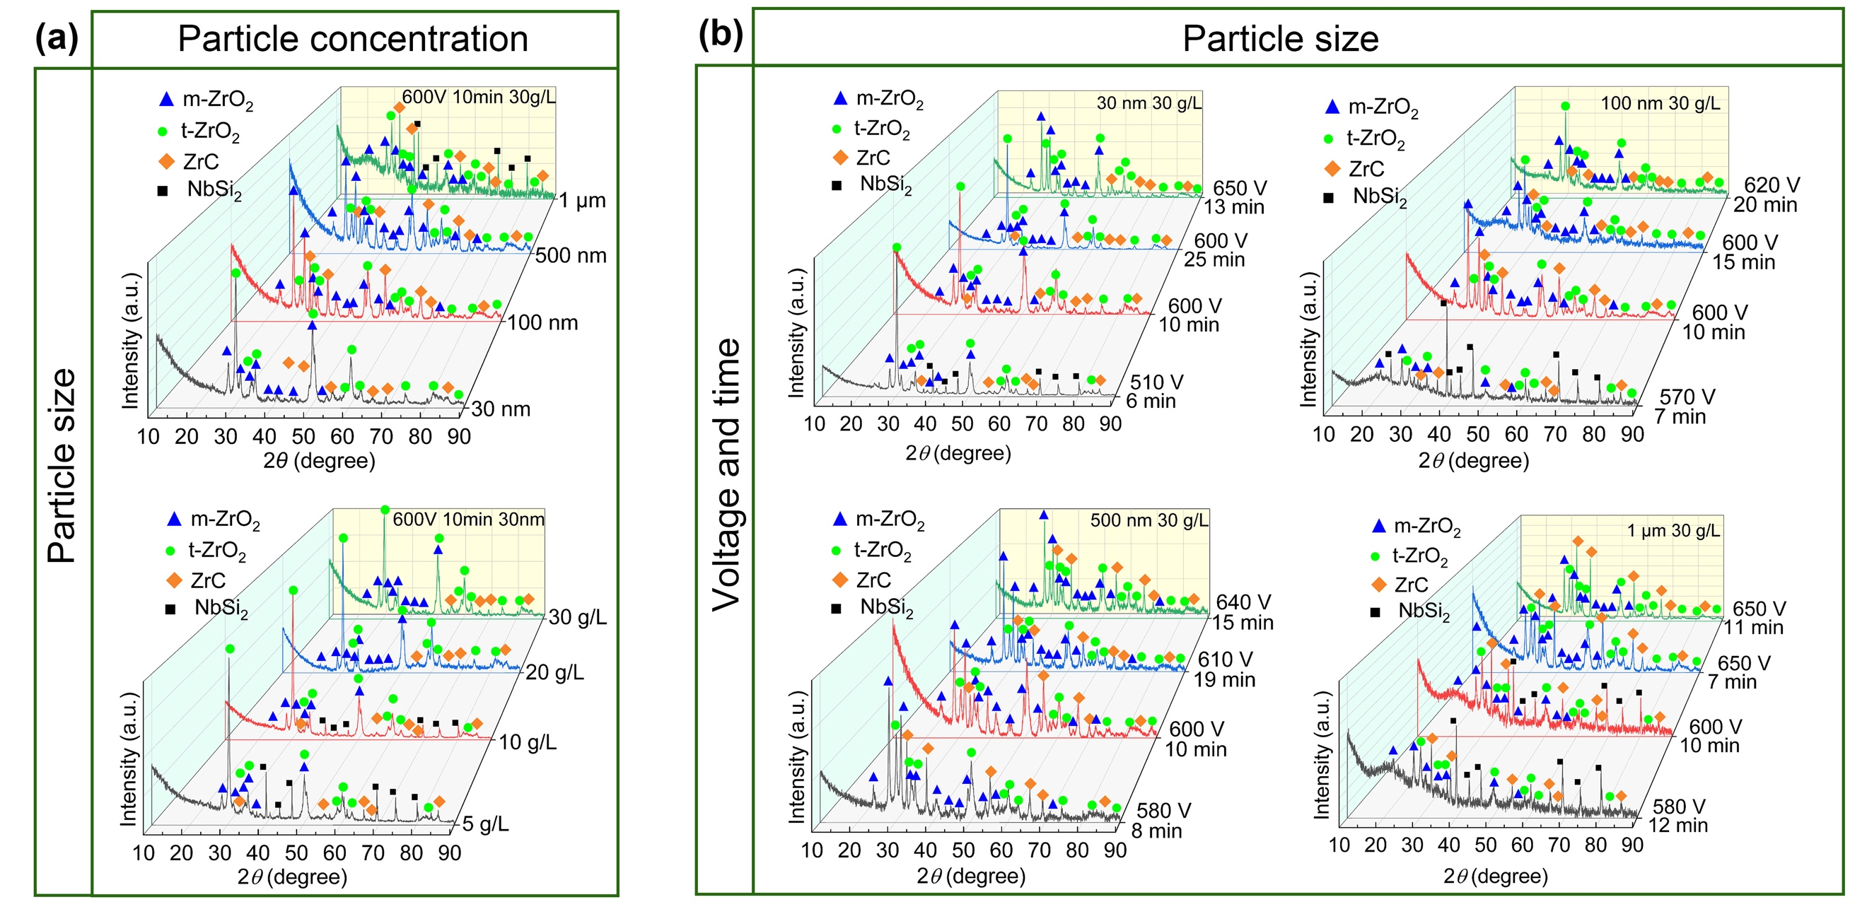
Fig. 2. XRD patterns of LPDS-coatings. (a) correlation between the particle size and concentration; (b) correlation between the electrical parameters and particle size.
For another, the phase content graphs within the LPDS-coatings prepared at different voltages and times in electrolytes with different particle sizes are provided in Fig. 3. The main phase within LPDS-coating is t-ZrO₂ when the particle size of added-ZrC is 30 nm (Fig. 3a), showing a slight increase in the m-ZrO₂ phase with increasing voltage and time, while the content of ZrC always remains the lowest. As the particle size of ZrC increases to 100 nm (Fig. 3b), the contents of t-ZrO₂ and m-ZrO₂ within coating are ~ 50 wt.% and 30 wt.%, as well as the ZrC is ~ 10 wt.%. As the particle size continued to increase (500 nm and 1 μm), m-ZrO₂ dominated the main phase and the proportion of ZrC increased, especially under the condition of a voltage of 600 V and processing time of 10 min, where 41.6 wt.% of ZrC is retained in the coating (Fig. 3c and d). It is worth noting that lots of micro-molten pools are formed on the anode surface under the action of transient intensive spark discharge, leading the ZrC particles to be rapidly oxidized and generating ZrO₂. After that, the residual ZrC and molten oxides are rapidly cooled by encountering a cold electrolyte, resulting in the sintering of ZrC-ZrO₂ ceramic on the anode surface. Undoubtedly, small size (<100 nm) particles are easily oxidized compared to the particles with large size, that’s the reason why a low content of ZrC is obtained within the LPDS-coating by adding the ZrC particle with a size of 30 and 100 nm. Moreover, for the same particle size, a high voltage for a long time will promote a more extensive transformation from t-ZrO₂ to m-ZrO₂. It could be attributed that the high voltage induces more intense and intensive discharge for a long time, making the high-frequency and strong electric field in the microregion repeatedly penetrate the ceramic film layer [36].
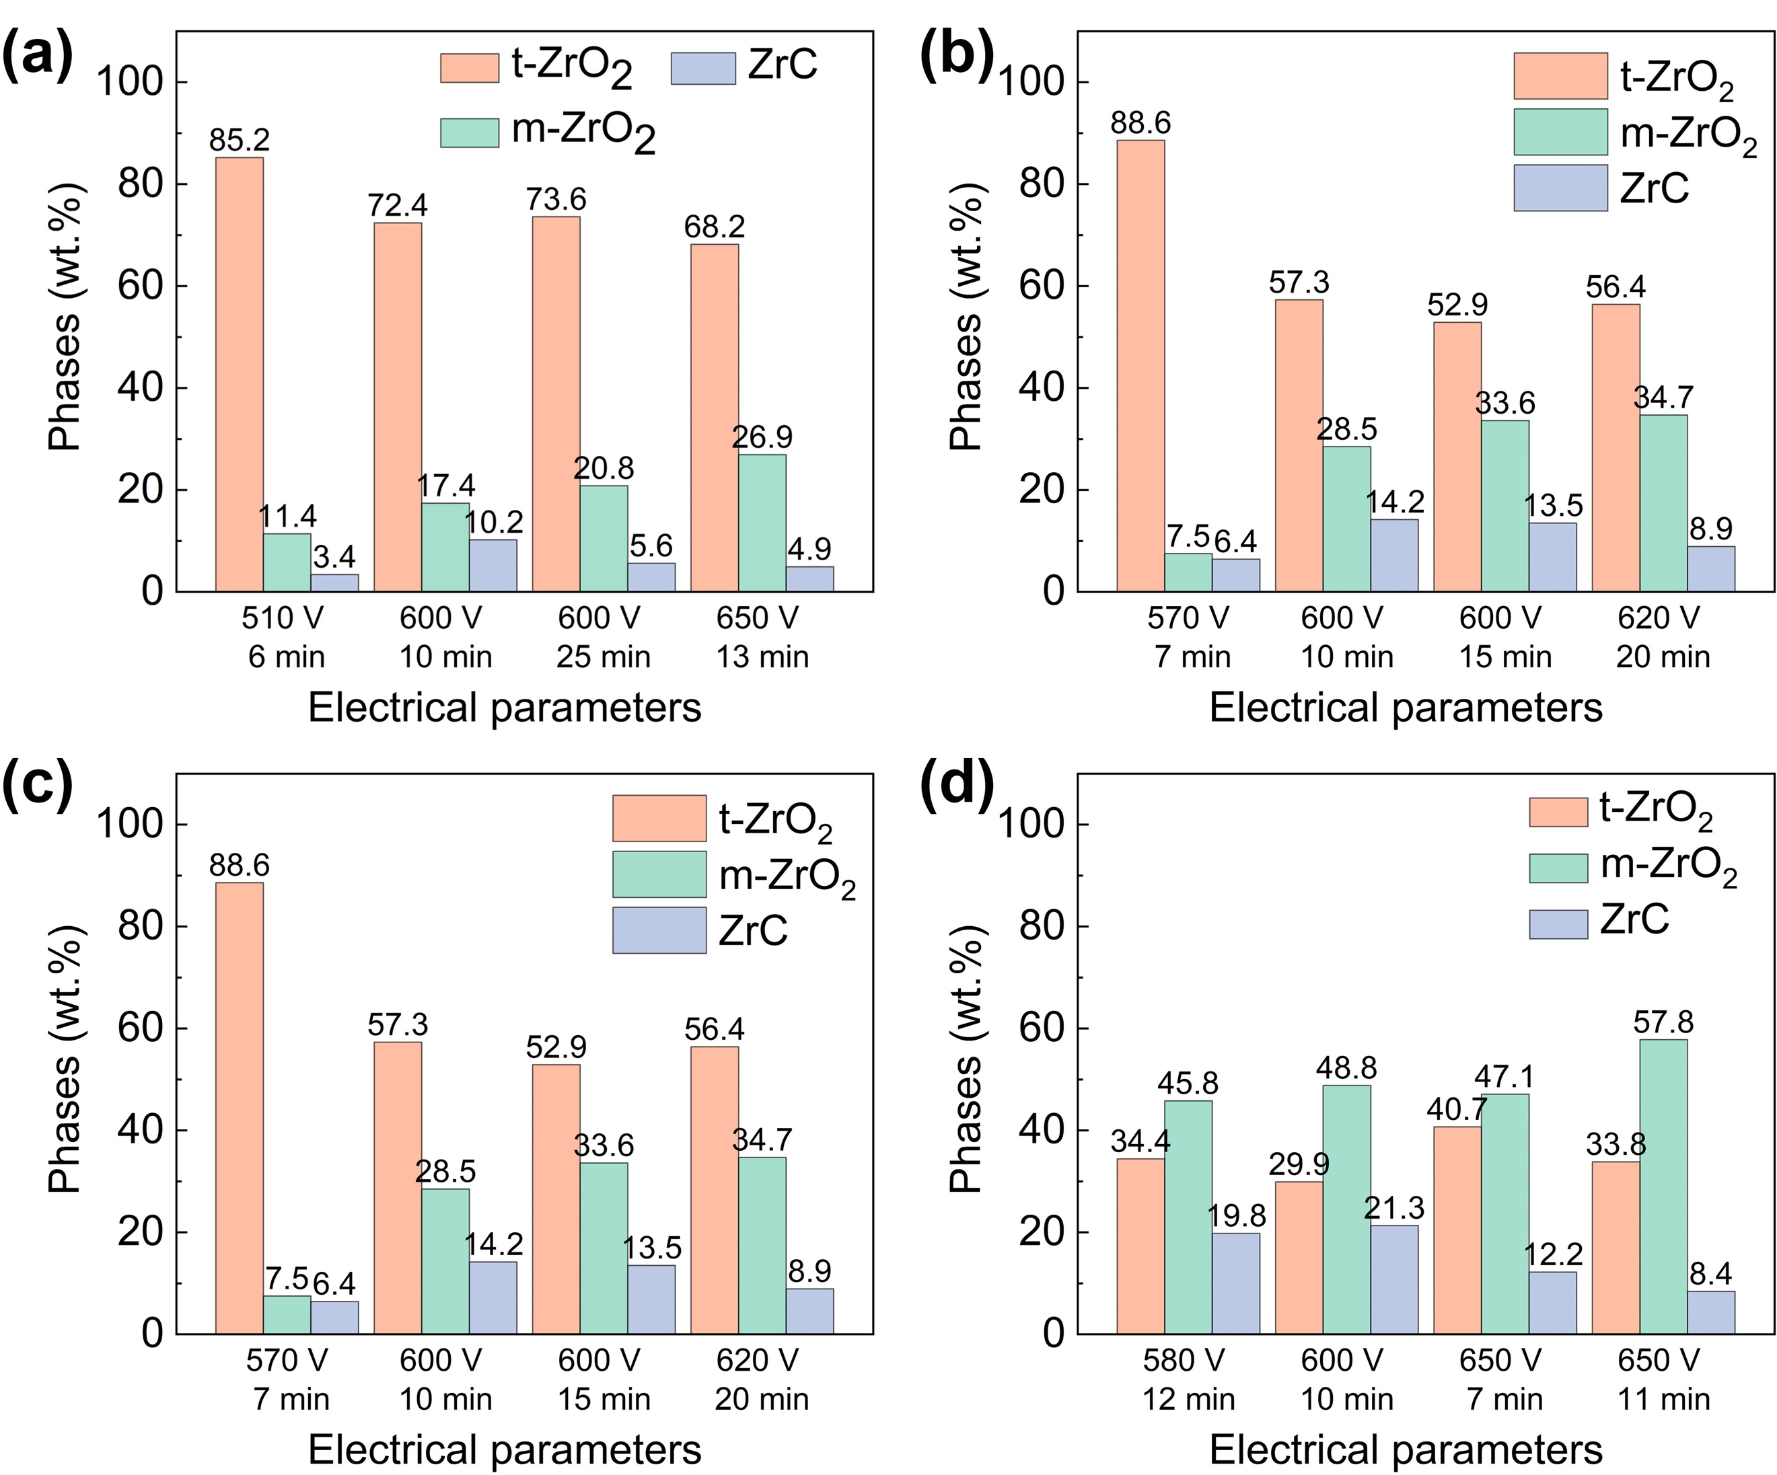
Fig. 3. Physical phase content graph of LPDS-coatings prepared at different voltages and times in electrolytes with different particle sizes at a concentration of 30 g/L (a) 30 nm ZrC; (b) 100 nm ZrC; (c) 500 nm ZrC and (d)1 μm ZrC.
The roughness data of LPDS-coatings prepared under different particle sizes and concentrations is illustrated in Fig. 4. The roughness of LPDS-coating shows a positive correlation with the size of the added-particle when the particle concentration is 30 g/L, excluding other influencing factors (Fig. 4a). The summary of LPDS-coatings’ roughness results is listed in Fig. 4b, both of them demonstrate that there exists a strong correlation between the roughness of LPDS-coatings and particle sizes/concentrations. It is evident that the four experimental parameters (i.e., LPDS voltage, particle size, particle concentration in electrolyte, and processing time) related to the synthesis process of LPDS-coating are the most relevant parameters associated with the delta mass, thickness, and roughness of coatings, which is proven by the results of orthogonal experiment. Therefore, in our ML models, four experimental parameters are screened as significant input descriptors.
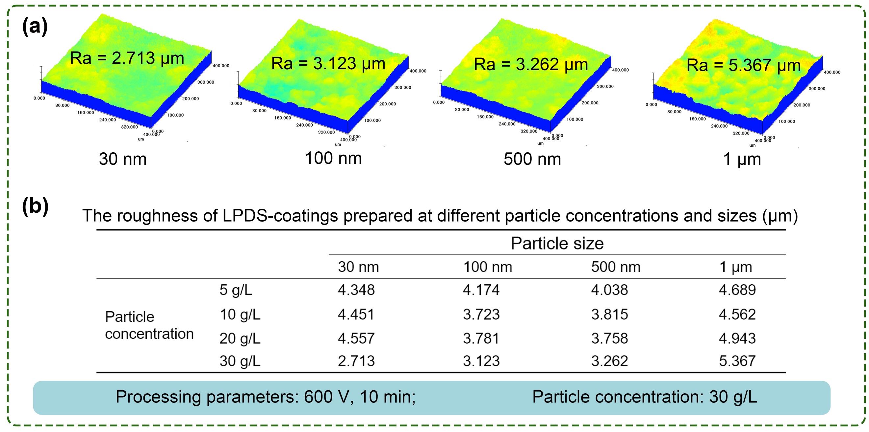
Fig. 4. The roughness of LPDS-coatings. (a) 3D surface profile of coatings prepared at different particle size; (b) summary of the roughness results under different concentrations and particle sizes.

3.2 The correlation between four descriptors based on high-throughput experiments
As a common ML procedure, training datasets are often collected from experimental designs tailored to generate comprehensive data for model training. While high-throughput experimental design holds significant potential and is increasingly being explored, it is currently underutilized in high-temperature oxidation research, including for the generation of datasets envisaging ML applications [37]. In our work, we aim to obtained the optimized LPDS-coating with the excellent thermal protection performance among a series of process parameter combinations. Firstly, the training datasets are built by conducting 122 experiments in the laboratory with different combinations of the selected descriptors, and the summary of the descriptors and initial data set for machine learning is presented in Table. S5. As shown in Fig. 5, the heat map of Pearson’s correlation coefficient matrix among the descriptors shows the correlation coefficient plot of the processing parameters (including electrical parameters, particle size, and concentration), delta mass, thickness, and roughness for all samples. The original scattering matrix of correlation for descriptors is shown in Fig. S8. The scatter diagram in the matrix unit shows the correlation of two descriptors, while the histogram on the diagonal represents the frequency distribution of each descriptor. Evidently, applied voltage shows the strongest correlation with the descriptors of roughness, thickness, and delta mass, and the corresponding correlation coefficients are 0.68, 0.66, and 0.73, respectively. Additionally, the correlation coefficients for the effect of concentration on the thickness and delta mass are 0.34 and 0.31, respectively, showing a weaker effect compared with applied voltage. Moreover, the correlation coefficient between processing time and roughness is 0.34, while the correlation coefficient between processing time and thickness/delta mass is 0.54/0.5. As for the correlation coefficient between particle size and associated outputs, corresponding to the roughness is only 0.18, while the correlation coefficients for thickness and delta mass are 0.035 and 0.026, respectively, indicating that the particle size possesses a weak effect on the growth of LPDS-coatings. On the contrary, the correlation between the outputs of thickness and delta mass is high (0.96), which can predict the stability of the coating growth during the LPDS process. Therefore, the descriptors selection of four experimental parameters (i.e., the delta mass, thickness, and roughness of LPDS-coating) is dependable due to the strong correlation with the associated outputs, implying that the prediction of the high-performance LPDS-coating is foreseeable.
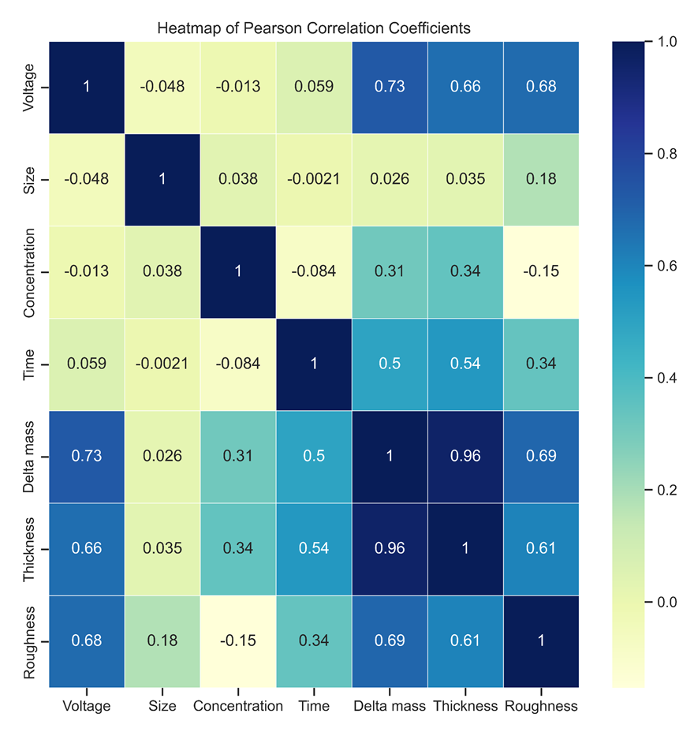
Fig. 5. The heat map of Pearson’s correlation coefficient matrix among the descriptors.

3.3 Predictions from different machine learning models.
For this investigation, we shortlisted models that have demonstrated efficacy in addressing other materials-centric challenges characterized by small data volumes, notably LASSO, SVM, RF, and XGboost [38]. Each algorithm’s hyperparameters were meticulously calibrated to minimize the mean-squared error, adopting a k-value grounded in 10-fold cross-validation. The hyperparameters introduced varied contingent on the specific ML algorithm under consideration. For instance, in LASSO, the primary tuning focus was the λ (lambda) parameter. SVM entailed adjustments in C and gamma parameters, while RF required optimization of parameters such as the number of trees, the maximum features and splits per tree. In the context of XGboost, parameters like the number of estimators, features per tree, tree depth, learning rate, and sample count per tree were finetuned to enhance model convergence.
Following the comprehensive hyperparameter optimization, we derived four optimal machine learning models, each representing LASSO, SVM, RF, and XGboost. Subsequent evaluations were conducted on a reserved 20% test dataset. Performance Metrics and Validation: Our machine learning models were evaluated using several performance metrics to ensure their robustness and accuracy. These metrics include: Mean Squared Error (MSE): Provides a measure of the differences between predicted and observed values, giving higher weight to larger errors; R-squared (R²): Indicates the proportion of the variance in the dependent variable that is predictable from the independent variables. To validate our models, we employed a combination of cross-validation and a hold-out test set. Specifically, we used k-fold cross-validation (with k=5) to ensure that the model’s performance is consistent across different subsets of the data. Additionally, a separate test set, which was not seen by the model during training, was used to assess the generalizability of the model. This dual approach helps in mitigating overfitting and provides a more accurate estimate of the model’s predictive performance.
It is recognized that no singular algorithm universally excels across all problem domains [39]. Consequently, in this study, both elementary (LASSO, SVM) and advanced computational models (RF, XGboost) were deployed. The prediction results of the output value from different machine learning models are presented in Fig. 6a. Evaluation of the output value prediction results of different machine learning models is performed on the reserved 20% test dataset. Blue dots represent the training dataset and orange dots represent the test dataset. Among the four data sets, XGboost model has the smallest bias in the predicted values, the largest coefficient of determination (R2) value, and the smallest mean square error (MSE). RF and SVM models are also able to effectively predict the growth of coating with coefficients of determination greater than 0.9. The coefficients of determination for the LASSO model are 0.754, and the data has a poor correlation with the scatter matrices. The prediction accuracies of the four models are XGboost > RF > SVM > LASSO. This diversified approach was necessitated by the potential complexity underlying the relationships between various synthetic parameters and experimental outcomes, despite the dataset’s limited size.
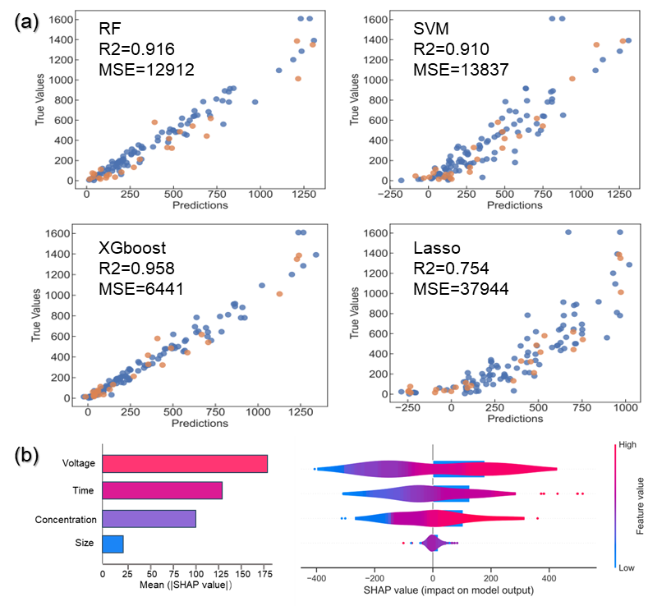
Fig. 6. (a). Predictions results of the output value from different machine learning models. RF, SVM, XGboost and Lasso. (Blue dots represent the training data set, and orange dots represent the test data set). (b). Summary plot for SHAP analysis (XGboost model )
In light of optimization input ranges for each descriptor, the resultant material performance for the 56,784 unique combinations has been systematically projected. A selection of the top five combinations, ascertained by the zenith of their predicted output values, are earmarked for empirical validation. Table 1 delineates both the optimal descriptors and the consequent empirical findings. These experimental outcomes underscore the efficacy of the machine learning model in directing the selection of synthesis parameters to enhance material properties.
Table 1
Machine learning suggests experiment conditions with the top 5 highest output values.
 | Voltage  (V) | Particle size  (nm) | Processing time  (min) | Particle concentration  (g/L)
1 | 600 | 500 | 15 | 23
2 | 600 | 500 | 19 | 23
3 | 600 | 500 | 18 | 23
4 | 600 | 500 | 17 | 23
5 | 600 | 500 | 16 | 23
To achieve a nuanced quantitative comprehension of the material synthesis system, and to demystify the complex interrelationship between the descriptors and output encapsulated within the XGboost model, we employed SHapley Additive exPlanations (SHAP) to elucidate the influence of these descriptors on the model's output. SHAP provides a comprehensive framework for deciphering machine learning models by leveraging additive feature importance metrics, which align impeccably with intuitive human understanding [39, 40]. Fig. 6b depicts the evaluation of the four descriptors via the SHAP values. The ordinate showcases the hierarchical significance within the predictive model, while the abscissa provides a consolidated metric, the SHAP value, reflecting the impact of a specific descriptor. Each horizontal display integrates the descriptor's attributions to the outcome via a violin plot. Herein, the red segment signifies elevated feature values, while the blue connotes diminished ones. Notably, voltage emerges as the paramount determinant of the material's output value, succeeded by concentration and time, which shows a good agreement with the result of Pearson’s correlation coefficient matrix (Fig. 5).

3.4 Effectiveness of the trained ML model via experimental verification

3.4.1 Preparation of LPDS-coating based on the prediction of ML model
To prove the accuracy and efficiency of our established combination of descriptors of LPDS-coatings, two sets of parameters are selected for prediction and compared with the experimental results. The first parameter of 10 g/L, 30 nm, 570 V, and 18 min is randomly selected, and the second parameter of 23 g/L, 500 nm, 600 V and 18 min is the experiment condition with one of the top 5 highest output value, which is suggested by machine learning. As a result, the first set of predicted delta mass, thickness and roughness is 28.13 mg, 32 μm and 4.958 μm, respectively, while the second set of predicted values is 62.08 mg, 94 μm and 3.961 μm, respectively. The corresponding surface and cross-sectional morphology of LPDS-coatings prepared as the random parameters and predicted parameters are shown in Fig. 7. There exists similarity of the LPDS-coatings prepared under the two processes, i.e., the uniform distribution of Zr element and the absence of a double-layer structure, which are consistent with the prior research [41], showing the reliability of our ML model. As shown in Fig. 7a, the surface of the coating prepared by the first set of parameters possesses a huge number of pores, and the associated outputs are a thickness of ~ 34 μm, a delta mass of 29.12 mg, and a roughness of 5.305 μm. On the contrary, the surface of the coating prepared by the second set of parameters is dominated by amounts of nanoparticles (Fig. 7c), showing a lower porosity, while the associated outputs are a thickness of ~ 90 μm, a delta mass of 59.76 mg, and a roughness of 4.015 μm. Both the two sets of predicted values are close to the experimentally tested values, which proved that the accuracy of the XGboost model is high.
Moreover, we provide the TEM analysis of the particle deposition outer layer prepared by the second set of parameters, as shown in Fig. 8. LPDS-coating shows a fine microstructure and the main constituent elements are Zr, O, and C demonstrated by the EDS mappings and point scanning results, as well as small amounts of Si and Nb (Fig. 8d and h). Moreover, it can be observed that three distinct crystalline phases are sintered and interwoven with each other, marked as areas I, II, and III, respectively. As shown in Figs. 8(e-f), the areas I, II, and III are identified as a m-ZrO₂ phase with a crystal plane spacing of 0.363 nm, a ZrC phase with a crystal plane spacing of 0.234 nm, and a t-ZrO₂ phase with a crystal plane spacing of 0.257 nm, respectively. ZrC particles are partially oxidized to t-ZrO₂ under the action of micro area transient high-frequency strong discharge, as well as the part of t-ZrO₂ undergoing a phase transition to m-ZrO₂ during the condensation process. Thus, the rapid oxidation and condensation of ZrC particles assisted by a liquid phase plasma allows the three phases to be sintered together to form a ZrC-ZrO₂ outer layer, further resulting in the multilayer thermal protective coating.
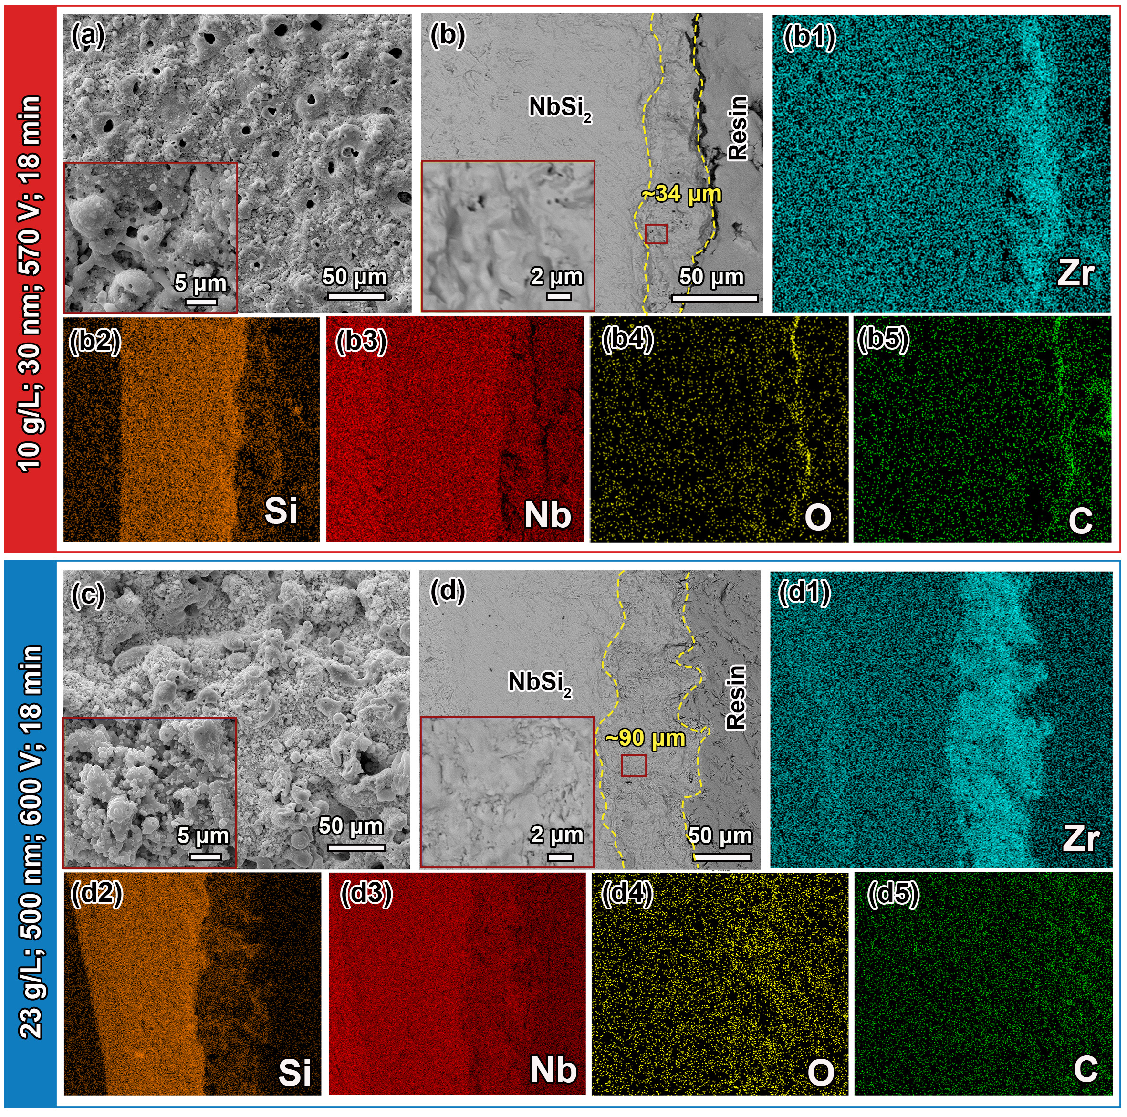
Fig. 7. Surface and cross-sectional morphology of LPDS-coatings prepared as the random parameters and predicted parameters. (a, b) random parameters of 10 g/L, 30 nm, 570 V, 18 min; (c, d) predicted parameters of 23 g/L, 500 nm, 600 V, 18 min.
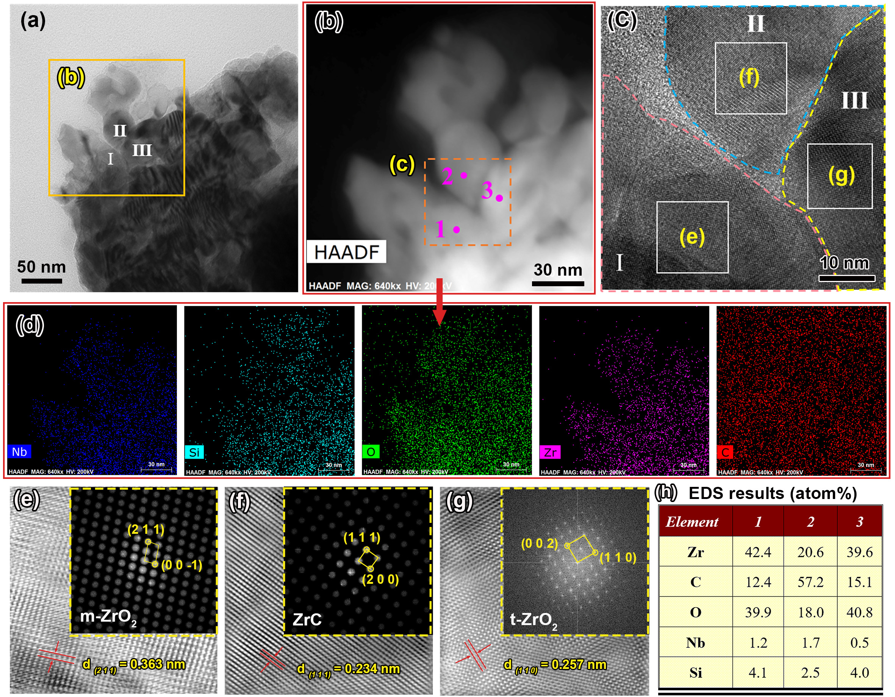
Fig. 8. TEM analysis of the as-prepared outer LPDS-coating under the condition of 23 g/L, 500 nm, 600 V and 18 min. (a) STEM image; (b) HAADF-STEM image corresponding to the marked area in Fig. 8(a); (c) HRTEM image; (d) EDS compositional mappings corresponding to Fig. 8(b); (e-g) the SAED patterns and calculated interplanar spacing corresponding to m-ZrO₂, ZrC, and t-ZrO₂, respectively. (h) EDS results of the marked points in Fig. 8(b).

3.4.2 High temperature thermal protection performance of the predicted LPDS-coating
For engineering applications, the evaluation of coatings for thermal protection performance based on the model prediction is still not enough, despite the empirical outputs suggested by the ML model being consistent with the experimental result. Therefore, oxidation test at 1500 ℃ is employed to verify the thermal protection performance of the LPDS-coatings prepared by the above predicted set of parameters, as well as the design ability of our ML model. Moreover, the high temperature oxidation test of single NbSi₂ coating without LPDS treatment is also carried out as a reference.
As shown in Fig. 9a, the sample coated with a single NbSi₂ coating shows fatal destruction when exposed to air for 120 mins at 1500 ℃, while the sample coated with LPDS-coating prepared by the parameter suggested from the ML model (23 g/L, 500 nm, 600 V and 18 min) remains an undamaged structure, even the oxidation time extends to 180 mins. It is undoubtedly that a single NbSi₂ coating shows a limited protection action under the temperature of 1500 ℃, and our LPDS-coating possesses significantly improved thermal protection performance. Fig. 9b depicts the XRD patterns of LPDS-coating after oxidation at different time. A weak peak of ZrO₂ is detected when the oxidation time reaches 60 mins, and the coating surface is mainly composed of ZrSiO₄, SiO₂, and Nb₂O₅, which shows a similar result with our previous research [28] that the oxidation test of NbSi₂/Nb₂O₅-SiO₂/ZrSi₂ coating at 1200 ℃ for 100 h. It means that an accelerated oxidation reaction of the ZrC is achieved in a short time (< 60 mins), subsequently the production of a ZrSiO₄ new phase has dominated this stage, exhibiting the strongest diffraction peak. With the extension of oxidation time to 120 mins, ZrO₂ is depleted and the oxidation of NbSi₂ has dominated this stage due to the sustained inward oxygen flux, accelerating the dense glass layer to be formed and covered on the coating surface. The increased intensity of the SiO₂ peak and decreased ZrSiO₄ peak have demonstrated this oxidation phenomenon, as well as confirmed by an obvious glass glaze layer on the morphology of LPDS-coating. After 180 mins of oxidation test, there exist few phase changes obtained from the weak intensity change of the diffraction peaks, implying a slow oxidation rate of LPDS-coating is achieved due to the formation of the dense glass layer. For another, the silicide layer thickness is an important indicator for evaluating the high-temperature thermal protective performance of silicide-based coating, and the thicknesses change of residual NbSi₂ layer and oxide scale of our LPDS-coating vs oxidation time are shown in Fig. 9c. After 180 mins of oxidation time, the thickness of the residual NbSi₂ layer remains ~85% of the initial thickness, despite the thickness of the oxide scale reaching 92 μm and exceeding the residual NbSi₂ layer. Moreover, the growth rate of the oxide scale is slower during the later oxidation stage, implying that a dense SiO₂ oxygen barrier layer is formed and significantly reduces the inward oxygen flux.
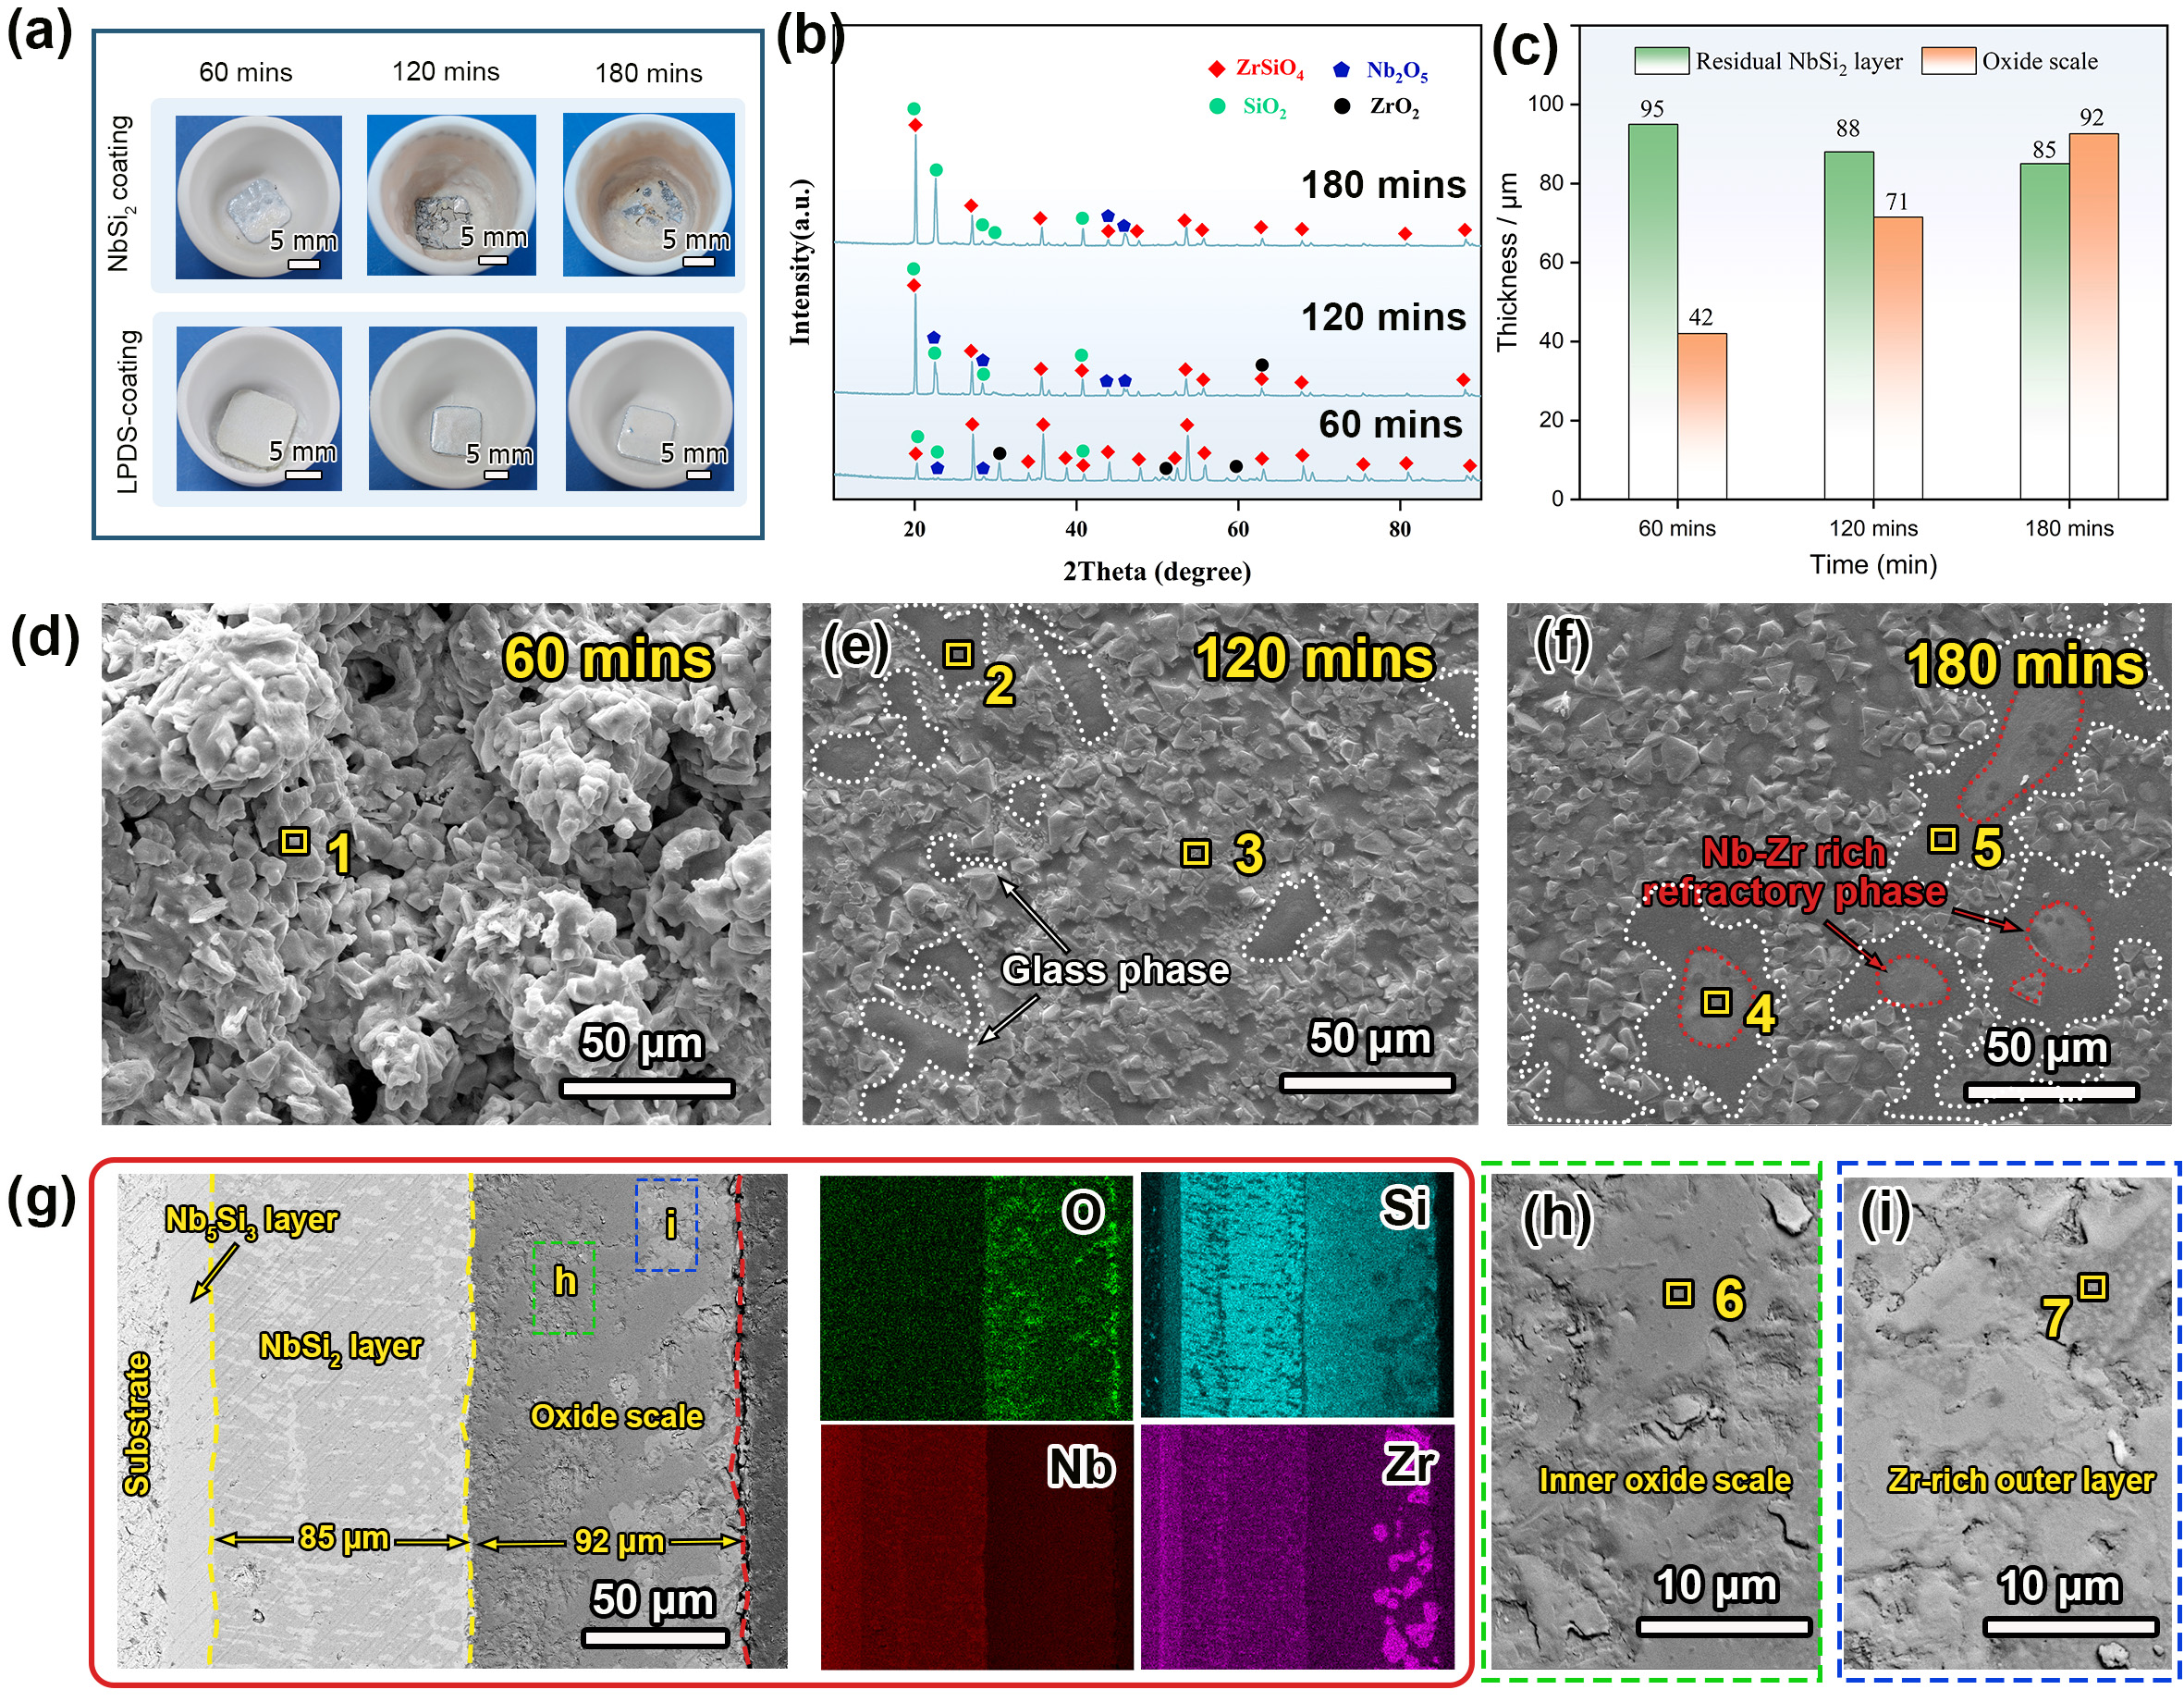
Fig. 9. Oxidation behavior analysis and microstructures of LPDS-coating after oxidation at 1500 ℃ in the air. (a) Morphologies of coatings before and after oxidation; (b) XRD patterns of LPDS-coating subjected to varying oxidation times; (c) The residual NbSi₂ layer and oxide layer thickness of oxidized samples as a function of oxidation time; (d, e, f) Surface morphologies of LPDS-coating after oxidation time of 60 mins, 120 mins, and 180 mins, respectively; (g) Cross-sectional morphologies of LPDS-coating after oxidation for 180 mins and the corresponding EDS maps; (h, i) high magnification SEM image in Fig. 9g.
Figs. 9d-e describe the surface morphologies of the LPDS-coating after oxidation for 60 mins, 120 mins, and 180 mins, respectively. As shown in Fig. 9d, huge amounts of fine particles are observed after the oxidation time of 60 mins, which is speculated as the mixed particles of SiO₂, Nb₂O₅, and ZrSiO₄, as well as a small number of ZrO₂ based on the XRD pattern and EDS scanning points result listed in Table 2. With the extension of oxidation time (Fig. 9e), the surface coating’s pores disappear, accompanied by the production of some flat SiO₂ structures confirmed by the EDS scanning points result. It can be described as the stage of the formation of the dense glass layer, since the glass phase generated by the continuous oxidation of NbSi₂ is connected into a dense glass network. When the oxidation time reaches 180 mins, not only more the glass phase areas are obtained but also some Nb-Zr rich refractory phase are observed in the surface coating, according to the elemental analysis (Table 2). It should be mentioned that these refractory phases are the oxide scale skeleton with high melting point (mainly is sintered ZrSiO₄ and Nb₂O₅ phases), which is transformed from the ZrC particles deposition layer during the high temperature oxidation process. Simultaneously, the glass phase generated by the oxidation of NbSi₂ fills the gaps within the oxide scale skeleton, forming the dense oxygen barrier layer and reducing the oxidation rate of NbSi₂ layer, which is also the reason for the slow consumption rate of NbSi₂ layer in the later stage of oxidation. The cross-sectional SEM image of the LPDS-coating after 180 mins of oxidation time is shown in Fig. 9g. The coating exhibits an obvious three-layer structure including a Nb₅Si₃ layer, the residual NbSi₂ layer and the oxidation reaction outer layer. The thickened Nb₅Si₃ layer is a result of different diffusion rates between Si and Nb at high temperatures, which is undoubtedly beneficial to avoids the drastic concentration change on both sides of the coating/substrate interface and alleviate the thermal stress at the interface [42]. To our delight, the thickness of residual NbSi₂ layer remains 85 μm, despite the thickness of the oxidation reaction outer layer reaching 92 μm, showing an excellent protection action of the oxidation reaction outer layer. According to the EDS maps and EDS scanning points results corresponding to the Fig. 9g, the oxidation reaction outer layer can be divided into the inner oxide layer (Fig. 9h) and Zr-rich outer layer (Fig. 9i), with a dense structure free of pores and cracks. The inner oxide layer is composed of Nb₂O₅ and SiO₂, while the Zr-rich outer layer includes ZrSiO₄, Nb₂O₅, and SiO₂. In substance, the superior oxidation resistance of the LPDS-coating at 1500 ℃ can be ascribed to two aspects: on the one hand, partial ZrSiO₄ can dissolve into SiO₂, enhancing the viscosity of glassy silica layer, which is necessary for the oxide scale in the coating system that contains Zr [43]. The viscosity increase would lead to a drop of oxygen diffusion coefficient and oxygen diffusion difficulty in molten silica which was dissolved by zirconium [44]. On the other hand, the formation of the ZrSiO₄-SiO₂ skeleton layer not only provide a large thermal stress tolerance of the oxide scale, but also accelerate the Zr-Si-O film layer with low oxygen diffusion coefficient to be formed [45]. As a result, the oxide scale with increased viscosity, high thermal stability, and a low oxygen diffusion coefficient is covered on the NbSi₂ surface during the high temperature oxidation process, and there no voids or cracks are formed with the oxide scale due to the higher volatilization temperature.
In summary, based on the experimental parameters of one of the top 5 highest output values suggested by machine learning, our prepared LPDS-coating shows a superior oxidation resistance at 1500 ℃, which is a promising TPM for an extremely high-temperature service environment in the air. There is no doubt that our ML model based on the selected four descriptors is a promising path for selection of the modified silicide-based thermal protection coatings, which is efficient and precise.
Table 2
The elemental analysis of the marked sites in Fig. 10.
 | EDS results of positions (atom%)
 | Nb | Si | O | Zr
1 | 13.4 | 38.4 | 20.8 | 27.4
2 | 17.9 | 63.8 | 6.4 | 11.9
3 | 16.4 | 32.0 | 13.2 | 38.4
4 | 52.8 | 6.1 | 20.1 | 21.0
5 | 15.6 | 64.9 | 12.2 | 7.3
6 | 26.5 | 15.1 | 48.9 | 9.5
7 | 7.4 | 19.1 | 22.4 | 51.1

4. Conclusions
In conclusion, we have established an efficient selection and prediction model of LPDS-coatings by combining high-throughput experiments and the ML approach. The application of the ML model enables the rapid identification of processing parameters that influence the delta mass, coating thickness, and roughness of LPDS-coating, as well as the accurate prediction of the synthetic parameters of the LPDS-coating with the superior thermal protection performance. For the LPDS-coating, the thermal protection performance is governed macroscopically by synthetic parameters, and four formation ability descriptors (LPDS voltage, particle size, particle concentration in electrolyte, and processing time) are defined based on the high-throughput experiments (122 LPDS samples are fabricated). Four optimal machine learning models (LASSO, SVM, RF, and XGboost) are obtained after comprehensive hyperparameter optimization, and the prediction accuracies of the four models are XGboost > RF > SVM > LASSO based on the evaluations of a reserved 20% test dataset. According to the SHAP analysis, voltage emerges as the paramount determinant of the material’s output value, succeeded by concentration and time. In addition, the accuracy and efficiency of our ML model are verified by a comparison of the consistency between ML’ suggested output value and high throughput experimental results. Furthermore, the high-temperature oxidation resistance of the LPDS-coating predicted by ML is evaluated from the perspective of engineering applications, showing superior thermal protection performance as expected. Overall, our work provides an example of designing and preparing LPDS-coating with tailorable performances under the aid of ML, which can effectively facilitate the devolvement of the LPDS-ed thermal protection coating and is expected to accelerate the design of other TPMs.

Declaration of Competing Interest
The authors declare that they have no known competing financial interests or personal relationships that could have appeared to influence the work reported in this paper.

Acknowledgments
The partial supports from the NSFC Grant nos. U21B2053, 52071114, 52301085, and 523B2010, China Postdoctoral Science Foundation (2023M730843), Heilongjiang Touyan Team Program, Heilongjiang Postdoctoral Science Foundation (No. AUGA4110012623, AUGA4110004823), and Research start-up Fund by HIT are gratefully acknowledged.

References
- Z.B. Li, L.-M. Peng, Microstructural and mechanical characterization of Nb-based in-situ composites from Nb-Si-Ti ternary system, Acta Mater. 55 (2007) 6573-6585.
- L. Su, L. Jia, K. Jiang, H. Zhang, The oxidation behaviour of high Cr and Al containing Nb-Si-Ti-Hf-Al-Cr alloys at 1200 and 1250ºC, Int. J. Refract. Met. Hard Mater. 69 (2017) 131-137.
- L. Li, X. Guo, Microstructure and oxidation resistance of Ti modified Si-Mo coating on Nb-Si based ultrahigh temperature alloy, Corros. Sci. 220 (2023) 111293.
- J. Kuang, P. Zhang, Q. Wang, Z. Hu, X. Liang, B. Shen, Formation and oxidation behavior of refractory high-entropy silicide (NbMoTaW)Si₂ coating, Corros. Sci. 198 (2022) 110134.
- K.T. Butler, D.W. Davies, H. Cartwright, O. Isayev, A. Walsh, Machine learning for molecular and materials science, Nature 559 (2018) 547-555.
- Y. Zhang, C. Wen, C. Wang, S. Antonov, D. Xue, Y. Bai, Y. Su, Phase prediction in high entropy alloys with a rational selection of materials descriptors and machine learning models, Acta Mater. 185 (2020) 528-539.
- K.A. Brown, S. Brittman, N. Maccaferri, D. Jariwala, U. Celano, Machine learning in nanoscience: Big data at small scales, Nano Lett. 20 (2020) 2-10.
- S.M. Moosavi, K.M. Jablonka, B. Smit, The role of machine learning in the understanding and design of materials, J. Am. Chem. Soc. 142 (2020) 20273-20287.
- M.I. Jordan, T.M. Mitchell, Machine learning: Trends, perspectives, and prospects, Science 349 (2015) 255-260.
- Y. Liu, X. Zhang, Metamaterials: a new frontier of science and technology, Chem. Soc. Rev. 40 (2011) 2494-2507.
- E. Anuoluwa; A. Olanrewaju, M. Bodunrin, O. Ajiteru, A. Martha, E. Makhatha, E. Asmatulu, Discoveryand prediction capabilities in metal-based nanomaterials: An overview of the application of machine learning techniques and some recent advances, Adv. Eng. Inform. 52 (2022) 101593.
- H. Wei, S. Zhao, Q. Rong, H. Bao, Predicting the effective thermal conductivities of composite materials and porous media by machine learning methods, Int. J. Heat Mass Transfer 127 (2018) 908-916.
- W. Huang, P. Martin, H.L. Zhuang, Machine-learning phase prediction of high-entropy alloys, Acta Mater. 169 (2019) 225-236.
- A. Kilic, O. Abdelaty, Muhammad Zeeshan, A. Uzun, R. Yildirim, Damla Eroglu, Selection of ionic liquid electrolytes for high-performing lithium-sulfur batteries: An experiment-guided high-throughput machine learning analysis, Chem. Eng. J. 490 (2024) 151562-151562.
- ‌Y. Zeng, M. Man, C.K. Ng, Z. Aitken, K. Bai, D. Wuu, Jing Jun Lee, Si Rong Ng, F. Wei, P. Wang, D. Cheng, Y.W. Zhang, Search for eutectic high entropy alloys by integrating high-throughput CALPHAD, machine learning and experiments, Mater. Des. (2024) 112929-112929.
- ‌J. Lv, W. Li, T. Li, L. Guo, Y. Fu, J. Li, J. Zhang, Y. Zhang. Ablation behavior of high-entropy boride (Hf-Zr-Ta-Ti)B₂ coating fabricated via supersonic atmospheric plasma spraying for carbon/carbon composites, Compos. Part: B Eng. 270 (2024) 111137.
- L. Sun, Q. Fu, J. Sun. Effect of SiO₂ barrier scale prepared by pre-oxidation on hot corrosion behavior of MoSi₂-based coating on Nb alloy, Corros. Sci. 176 (2020) 109051.
- S. Liu, H. Shen, J. Xu, X. Zhou, J. Liu, Z. Cai, X. Zhao, L. Xiao, Preparation of a tantalum-based MoSi₂-Mo coating resistant to ultra-high-temperature thermal shock by a new two-step process, J. Mater. Sci. Technol. 81 (2021) 117-22.
- C. Wei, S.B. Zhang, Z.W. Wang, C. Zheng, B. Peng, C. Li, Y. Zhang, X.Q. Li, L.F. Cheng, Preparation and interfacial layer microstructure of multilayer heterogeneous composite. Compos. Part: B Eng. 243 (2022) 110128.
- C. Wang, W. Shao, W. Wang, C. Zhou, Oxidation behaviour of a Ge-modified silicide coating on an Nb-Si based alloy in the moderate temperature range, Corros. Sci. 163 (2020) 108249.
- Y.D. Choi, J.K. Yoon, G.H. Kim, W.Y. Yoon, J.M. Doh, K.P. Hong, High temperature isothermal oxidation behavior of NbSi₂ coating at 1000-1450°C, Corros. Sci. 129 (2017) 102-114.
- L. Li, X. Guo, Y. Qiao, Formation and oxidation resistance of MoSi₂ coating for Nb-Si based alloy prepared by slurry sintering method, J. Alloys Compd. 938 (2023) 168456-168456.
- Y.C. Zou, Y.M. Wang, Z.D. Sun, Y. Cui, T. Jin, D.Q. Wei, J.H. Ouyang, D.C. Jia, Y. Zhou, Plasma electrolytic oxidation induced ‘local over-growth’ characteristic across substrate/coating interface: effects and tailoring strategy of individual pulse energy, Surf. Coat. Technol. 342 (2018) 198-208.
- M. Kaseem, S. Fatimah, N. Nashrah, Y.G. Ko, Recent progress in surface modification of metals coated by plasma electrolytic oxidation: Principle, structure, and performance, Prog. Mater. Sci. 117 (2021) 100735.
- S. Wang, L. Wen, Y. Wang, Y. Cheng, Y. Cheng, Y. Zou, Y. Zhu, G. Chen, J. Ouyang, D. Jia, Y. Zhou, One-step fabrication of double-layer nanocomposite coating by plasma electrolytic oxidation with particle addition, Appl. Surf. Sci. 592 (2022) 153043.
- Z.Y. Li, Z.B. Cai, Y. Ding, X.J. Cui, Z.B. Yang, M.H. Zhu, Characterization of graphene oxide/ZrO₂ composite coatings deposited on zirconium alloy by microarc oxidation, Appl. Surf. Sci. 506 (2020), 144928.
- S. Wang, Y. Wang, Y. Zou, Y. Wu, G. Chen, J. Ouyang, D. Jia, Y. Zhou, A self-adjusting PTFE/TiO₂ hydrophobic double-layer coating for corrosion resistance and electrical insulation, Chem. Eng. J. 402 (2020), 126116.
- Z. Wang, Y. Wang, S. Wang, Y. Zou, G. Chen, L. Wen, J. Ouyang, D. Jia, Y. Zhou, ZrSi₂/SiO₂-Nb₂O₅/NbSi₂ multi-layer coating formed on niobium alloy by HAPC combined with LPDS: Microstructure evolution and high temperature oxidation behavior, Corros. Sci. 206 (2022) 110460-110460.
- ‌Z. Wang, Y. Wang, S. Wang, Y. Zou, G. Chen, L. Wen, G. Zhang, L. Zhao, J. Ouyang, D. Jia, Y. Zhou, Design and preparation of MoSi₂/SiO₂-Nb₂O₅/NbSi₂ multilayer coating on Nb alloy: Microstructure and hot corrosion behavior, Corros. Sci. 209 (2022) 110733-110733.
- ‌Z. Ye, Y. Zou, S. Wang, G. Chen, Z. Wang, L. Wen, G. Zhang, L. Zhao, Y. Wang, Y. Zhou, Microstructure evolution and oxidation/ablation behaviors of NbSi₂/Nb₂O₅-SiO₂/HfC-HfO₂ multilayer protective coating at 1200 °C and 1800 °C, Corros. Sci. 230 (2024) 111908-111908.
- ‌Z. Ye, S. Wang, Y. Ge, G. Chen, Y. Zou, Z. Wang, L. Wen, G. Zhang, L. Zhao, Y. Wang, Y. Zhou, Multilayer synergistic design of NbSi₂/Nb₂O₅-SiO₂/MoSi₂ ceramic coating on niobium alloys for multiple thermal protection properties, J. Eur. Ceram. Soc. 44 (2024) 2471-2485.
- ‌Z. Ye, S. Wang, Y. Wang, Y. Ge, Y. Zou, Z. Wang, X. Zhao, L. Wen, G. Zhang, L. Zhao, Y. Zhou, Enhanced hot corrosion resistance and thermal radiation property of NbSi₂/Nb₂O₅-SiO₂/SiC ceramic coating for niobium alloys thermal protective system, Surf. Coat. Technol. 479 (2024) 130485-130485.
- ‌Z. Wang, Y. Wang, S. Wang, Y. Zou, G. Chen, L. Wen, G. Zhang, L. Zhao, J. Ouyang, D. Jia, Y. Zhou, Enhanced high-temperature oxidation resistance of HfSi2-modified silicon based multilayer ceramic coating on Nb alloy prepared by a novel strategy, J. Eur. Ceram. Soc. 43 (2023) 4717-4730.
- K. Mojsilović, N. Tadić, U. Lačnjevac, S. Stojadinović, R. Vasilić, Characterization of Al-W oxide coatings on aluminum formed by pulsed direct current plasma electrolytic oxidation at ultra-low duty cycles, Surf. Coat. Technol. 411 (2021) 126982.
- W. Qian, Z. Zhang, S. Wang, Z. Guo, Y. Chen, Md Ariful Islam, Q. Zhao, H. Li, Y. Liu, H. Zhan, Enhancing the toughness of nano-composite coating for light alloys by the plastic phase transformation of zirconia, Int. J. Plast. 163 (2023) 103555-103555.
- ‌E. Bousser, A. Rogov, P. Shashkov, A. Gholinia, N. Laugel, T.J.A. Slater, P.J. Withers, A. Matthews, A. Yerokhin, Phase transitions in alumina films during post-sparking anodising of Al alloys, Acta Mater. 244 (2023) 118587-118587.
- H. Meng, R. Yu, Z. Tang, Z. Wen, H. Yu, Y. Chu, Formation ability descriptors for high-entropy diborides established through high-throughput experiments and machine learning, Acta Mater. 256 (2023) 119132-119132.
- X. Liao, M. Liao, C. Wei, Z. Huang, W. Duan, X. Duan, D. Cai, Laurent Gremillard, Z. Yang, D. Jia, Y. Zhou, A process-structure-property model via physics-based/data-driven hybrid methods for freeze-cast porous ceramics in Si₃N₄-Si₂N₂O case system, Acta Mater. 269 (2024) 119819-119819.
- H.Y. Fu, K. Li, C.F. Zhang, J.H. Zhang, J.Y. Liu, X. Chen, G.L. Chen, Y.Y. Sun, S.Z. Li, L. Ling, Machine-learning-assisted pptimization of a single-atom coordination environment for accelerated fenton catalysis, ACS Nano. 17 (2023) 13851-13860.
- D. Fryer, I. Strümke, H. Nguyen, Shapley values for feature selection: The good, the bad, and the axioms. IEEE Access 9 (2021) 144352-144360.
- ‌Z. Wang, S. Wang, Y. Wang, Y. Zou, G. Chen, L. Wen, G. Zhang, L. Zhao, J. Ouyang, D. Jia, Y. Zhou, Microstructural evolution and ablation behaviors of NbSi₂/SiO₂-Nb₂O₅/X (X=MoSi₂, MoSi₂-Yb₂O₃, MoSi₂-Yb₂O₃-ZrC) multilayer coatings on Nb alloy in different ablation environments, Ceram. Int. 50 (2024) 10497-10514.
- K. Fan, J. Sun, L. Guo, Y. Zhang, Q. Fu, Static water vapor corrosion behavior of MoSi₂/Mullite composite coating on Nb based alloy at 1500°C, Corros. Sci. 200 (2022) 110234.
- Y. Ren, Y. Qian, J. Xu, J. Zuo, M. Li, Ultra-high temperature oxidation resistance of ZrB₂-20SiC coating with TaSi₂ addition on siliconized graphite, Ceram. Int. 15 (2019) 15366-74.
- X. Zhang, Y. Zhang, L. Guo, B. Liu, Y. Wang, H. Li, H. Li, J. Sun, Ablation resistance of ZrC coating modified by polymer-derived SiHfOC ceramic microspheres at ultrahigh temperature, J. Mater. Sci. Technol. 182 (2024) 119-131.
- ‌Z. Zhao, K. Li, W. Li, L. Zhang, Cyclic ablation behavior of C/C-ZrC-SiC-ZrB₂ composites under oxyacetylene torch with two heat fluxes at the temperatures above 2000 °C, Corros. Sci. 181 (2021) 109202-109202.

