Machine learning discovery of a new cobalt free multi-principal-element alloy with excellent mechanical properties
Ling Qiao ª ^{b}, R.V. Ramanujan ^{b}, Jingchuan Zhu ª
ª
School of Material Science and Engineering, Harbin Institute of Technology, Harbin 150001, Heilongjiang, China
^{b}
School of Material Science and Engineering, Nanyang Technological University, 50 Nanyang Avenue, 639798, Singapore

Abstract
In the present study, the machine learning (ML) method was utilized to construct a composition–structure–property model incorporating physical features. To enhance the predictive accuracy, the volume fraction of the two phase microstructure was merged into the dataset serving as the physical constraint for the input variables. The physical features, the chemical composition and the temperature difference between the initial and final melting temperatures were selected as the input and output variables, respectively. To deal with the small sample data, the generalized regression neural network (GRNN) was selected and applied with optimization algorithms e.g., fruit fly optimization algorithm (FOA) and particle swarm optimization (PSO). The performance of the GRNN, FOA-GRNN and PSO-GRNN models were compared. As a result, the PSO-GRNN model was the most promising model and could be utilized to search for new multi-principal elements alloy (MPEAs) with targeted properties. Based on the ML results, a novel Fe2.5Ni2.5CrAl MPEA was designed and synthesized for experimental characterization. The DSC analysis shows that the developed alloy possesses narrower melting range and the predicted value is in excellent agreement with experiments with a relative error below 10%. The designed alloy possesses a typical dual-phase structure (FCC+BCC/B2) and exhibits exceptional mechanical properties with superior plasticity at the cast condition. This property improvement is due to solid solution strengthening and nanoparticles strengthening effects. Our proposed alloy can be a promising choice for selected high performance applications.

1. Introduction
In recent years, high-entropy alloys (HEAs), or multi-principal-element alloys (MPEAs), which was proposed by Yeh et al. and Cantor et al. [1], [2], has attracted wide attention in the field of materials research. The HEAs are usually comprised of single phase solid solutions of body- or face-centered cubic (BCC or FCC) crystal structure or two phase BCC+FCC structures and consist of five or more multi-principal elements each with a concentration typically ranging from 5 to 35 atomic percent (at.%) [3], [4]. High hardness and wear resistance [5], [6], good strength and ductility [7], [8], [9], [10], excellent work hardening ability [11], [12], great corrosion and oxidation resistance [13], [14], [15], [16], [17], [18] have been achieved in some MPEAs. A huge multi-component phase composition space is available which can produce unique mechanical properties. By means of chemical composition optimization, an exceptional microstructure can be developed to achieve superior properties.
Like the conventional materials, the strength–ductility paradox also exists for most MPEAs: the alloy tends to lose ductility with increasing strength [19]. Although multi-component superalloys often possess good stability and mechanical properties at high temperatures, the poor ductility at room temperature need to be addressed urgently. By analyzing the phase structure observed in the reported MPEAs, the FCC phase is typically ductile but possesses a poor strength. On the other hand, the BCC phase possesses a high strength at room-temperature but poor creep resistance at elevated temperatures [20]. In addition to the FCC and BCC phases, the Laves phase also exists in some MPEAs. It is challenging to tune the microstructure and properties since the phase transformations in the Laves phase are influenced by the changes in temperature. The Laves phase usually shows poor ductility [21] at room temperature. Thus, the composition and the phases play a crucial role in the final mechanical properties of the MPEAs.
Due to the diversity of alloying elements, several calculation methods have been utilized to identify novel compositions which can possess the microstructure and mechanical properties, e.g., the CALPHAD method [22], [23], DFT calculation [24], [25], molecular dynamics simulation [26], etc. Motivated by the emergence of artificial intelligence, the machine learning (ML) is an efficient technique for composition optimization, it can unearth the internal relations from the given data [27], [28], [29], [30], [31], [32]. For example, Fang et al. [27] proposed an approach combining high-throughput simulations with machine learning approach to design medium entropy alloys with promising mechanical properties over a wide range of elemental compositions. This method can help to obtain the relationship between composition and mechanical properties, and also suggest new alloys which can display the desired performance. Lu et al. [30] constructed a hardness prediction model based on the support vector machine (SVM) with five features as the inputs, e.g., the average deviation of the atomic weight (ADAW), the average deviation of the column (ADC), the average deviation of the specific volume (ADSV), the valance electron concentration (VEC), and the mean melting point (Tm). Through inverse projection and high-throughput screening, several optimized compositions were synthesized and indeed exhibited ultra-high hardness. ML methods have often proved to be successful in predicting the properties of HEAs. By constructing the component-phase structure–property model, optimized combination of alloy elements can be deduced and the target performance can be predicted to accelerate the discovery of new alloys.
Recently, Tan et al. [33] proposed that the narrow melting range can improve the high temperature stability, as well as the mechanical properties at elevated temperature. As known, it is easy to produce the defects such as porosity and hot cracking during the high-temperature casting processes, which is detrimental to the mechanical properties of the alloy. According to [34], the hot cracking is prone to initiate in the semisolid state, in which the liquid and solid phases coexist, hence a narrow melting range (the difference in temperature between the solidus and liquidus temperatures) is preferred to effectively avoid the generation of hot cracking. Besides, [35] indicated that a very narrow liquidus–solidus temperature range can decrease the segregation in the alloy, resulting in high hardness and compression strength. Thus, it is of great significance to predict the melting range. Considering the cost of materials, developing the Co-free MPEAs has attracted extensive attentions. In the present study, CALPHAD calculations combined with machine learning methods were utilized to discover new non-equiatomic alloy compositions in the Al–Cr–Fe–Ni alloy system. As the previous literatures reported [36], [37], the physical features occurring in metallurgical process plays an essential role in the properties of metallic materials. Hence, for the AlCrFeNi based MPEAs, mass fraction of the phases have been incorporated in the ML model. Instead of the conventional trial and error method or experiences of domain experts, our method can construct the relationship between the alloy composition and the melting range, and guide alloy design in other MPEAs system.
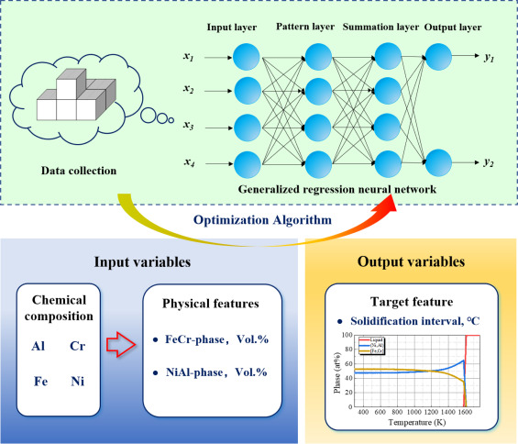
- Download: Download high-res image (766KB)
- Download: Download full-size image
Fig. 1. Schematic diagram of composition optimization via machine learning.
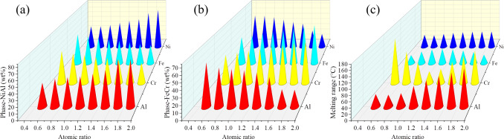
- Download: Download high-res image (571KB)
- Download: Download full-size image
Fig. 2. The alloying effect on the content of (a) Ni–Al phase (b) Fe–Cr phase and (c)melting range.
2. Methodology
2.1. Calculation method
To search for the composition in AlCrFeNi based MPEAs, the results of CALPHAD calculations were coupled with the ML approach to predict the relationship between the composition and melting range. The ML procedure can be divided into four steps: (1) database construction (2) training and testing (3) model estimation (4) prediction. It is necessary to construct a reliable dataset. Herein, the CALPHAD method was utilized to construct the dataset, and some results obtained from DSC experiments were included in the initial dataset. The training data include 47 sets and another 10 sets were utilized for the testing. A dual phase structure is assumed for the AlCrFeNi based MPEAs [38], [39] when performing the thermodynamic calculations. The volume fraction of two phases was incorporated into the ML model as the physical constraint. Thus, the alloy composition and the phase volume fraction were denoted as input variables, the melting range denote the output variables. Prior to the ML process, the inputs and outputs were normalized to eliminate dimensional differences between the parameter ranges and to enhance the accuracy of the ML model, as expressed in Eq. (1).(1)X′=X−0.95Xmin1.05Xmax−0.95Xminwhere X is the actual experimental data, Xmin and Xmax are the minimum and maximum value of X, respectively, and X′ is the normalized value of the X.
Over the past few years, a very wide variety of algorithms have been proposed and used in materials field. Owing to its nonlinear mapping and generalization ability, the generalized regression neural network (GRNN) exhibits good predictive performance for small database samples [40], [41]. Hence, GRNN was utilized to produce a complex non-linear input/output fitness function to estimate the melting range of AlCrFeNi based MPEAs. Then, several representative optimization algorithms such as the fruit fly optimization algorithm (FOA) and the particle swarm optimization (PSO) algorithm, were utilized to search for the optimized parameters. The flow chart of the physical features guided ML design is depicted in Fig. 1. Cross validation and the bootstrap method were employed to address the issue of overfitting. Then ML model with the best predictive performance was selected to provide accurate prediction in the subsequent researches.
2.2. Experimental method
The designed MPEAs ingots were prepared by vacuum arc melting techniques with a mixture of high purity (> 99.9%) metals (Al, Cr, Fe and Ni) under a high purity argon environment. The ingots were melted at least five times to obtain the chemical homogeneity. Determination of the crystal structures of the as-cast alloys was performed by a Xray diffractometer (XRD, XPERT diffractometer with Cu radiation target) with the 2θ scan from 10∘ to 110∘. Microstructural characterization was carried out by scanning electron microscopy (Zeiss Merlin Compact SEM) techniques. Prior to examination, the specimens were carefully mechanically ground, polished and cleaned with ethanol. Besides, the transmission electron microscope (TEM, talosf 200) was used for further identification of phase structure and phase composition.
To measure the melting range (MR), the solidus and liquidus temperatures, a QMS403D-Is 50 calorimeter was used to perform differential scanning calorimetry (DSC). The scans can be obtained with temperatures ranging from 25 °C to 1500 °C during heating process at a rate of 10 °C/min under argon-flow and then was cooled down to room temperature. To estimate the mechanical properties of the designed alloy, the compressive tests were carried out on AG-X Plus 250kN/50kN Electronic Universal Testing Machine. The samples with height of 6 mm and diameter of 4 mm were extracted from the as-cast ingots. For the compressive tests at room temperature, the initial strain rate was determined as 0.5 mm/min. While at elevated temperature, the compressive tests were carried out with the strain rate of 2.0 mm/min at the temperature was of 400 °C, 600 °C and 800 °C. Before testing, the samples were placed in preheated furnace and held for 5 min.
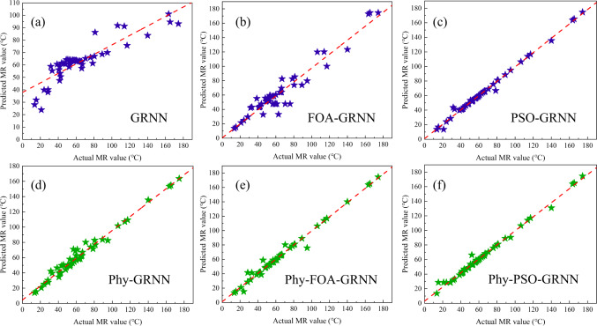
- Download: Download high-res image (642KB)
- Download: Download full-size image
Fig. 3. Regression analysis on the training results to predict MR value by (a) GRNN (b) FOA-GRNN (c) PSO-GRNN and physics coupled model (d) Phy-GRNN (e) Phy-FOA-GRNN (f) Phy-PSO-GRNN.
3. Results and discussion
3.1. Data collection and alloying effect
As known, the alloy elements play a significant role in the microstructure as well as properties of the MPEAs. Recognizing this, CALPHAD method was employed to systematically investigate the alloying effects on the phase fraction and melting point. Considering the case of AlCrFeNi-based MPEAs, Fig. 2 presents the alloying effect on the volume fraction of dual phase and melting range. According to the reported literatures, the dual phase composed of Ni–Al rich phases and Fe–Cr rich phases formed in AlCrFeNi-based alloy system. From Fig. 2(a), it can be deduced that the volume fraction of the Ni–Al rich phase increases with the higher concentration of Al and Ni, Fe and Cr can decrease the formation of the Ni–Al rich phases. For the Fe–Cr rich phases, Fig. 2(b), the results show that the Fe and Cr increase volume fraction of the Fe–Cr rich phase, while hindering the formation of the Ni–Al rich phase. Accordingly, the volume fraction of the phases can be tuned by adjusting the alloy composition.
For the high temperature applications, the melting point is a dominant factor. In this case, the melting of the MPEAs exhibits a temperature range between the solidus and liquidus temperatures. Fig. 2(c) presents the alloying effect on the MR in AlCrFeNi-based MPEAs. From this plot, the MR was expanded with an increase in Al and Ni content. With the higher Cr content, the MR initially decreased and subsequently increased. Higher Fe content initially increases MR, the MR decreases with a further increase of Fe content. Particularly among the studied alloy system, Al and Ni have a lower melting point of 660 °C and 1453 °C respectively, while Cr and Fe have a relatively high melting point of 1857 °C and 1538 °C, respectively. An increase of Fe and Ni elements increased the melting point of alloy. The MR can be tailored through the reasonable composition selection.
3.2. Machine learned results
The present work provides an appropriate ML model for the discovery of new MPEAs. The conventional composition–property relationship presented in the literature, integrated with the physical characteristics significantly increased the prediction accuracy.
For PSO-GRNN, the PSO algorithm is used to find the optimal spread value of GRNN model to get a higher predictive performance. Suppose that there is a population of n particles X=(X1,X2,…,Xn) in a D-dimensional search space. The ith particle is described as Xi=[xi1,xi2,…,xiD]T, which is the position of the ith particle in the D-dimensional search space. Based on the objective function, the fitness value of each particle position Xi can be calculated. The velocity of the ith particle can be determined as Vi=[vi1,vi2,…,viD]T. Pi=[pi1,pi2,…,piD]T is the individual extremum. Vi=[pg1,pg2,…,pgD]T represents the global extremum of the population. For each iteration, the particle updates its own speed and position through individual and global extremum, where the updating law is as follows [42]:(2)vidk+1=wvidk+c1r1(pidk−xidk)+c2r2(pgdk−xidk)(3)xidk+1=xidk+vidk+1where w is the inertia weight. d=1,2,…,D. i=1,2,…,n. k is the number of current iterations. r1 and r2 are random numbers in [0, 1]. c1 and c2 are acceleration factors. If the termination condition is met, the loop is terminated; otherwise, the loop continues.
For FOA-GRNN, FOA is employed to optimize the spread value of GRNN. The steps are as follows [43]:
(i) The location of fruit fly swarm is randomly initialized as (X,Y). Then set the population size and the number of iterations.
(ii) The direction and distance of individual fruit fly are randomly given as(4)Xi=X+randomvalue(5)Yi=Y+randomvalue
(iii) The distance from the individual fly to the origin is computed as(6)Li=Xi+Yi
Then, the smell concentration judgment value S is obtained(7)Si=1/Li
(iv) The smell concentration judgment function is constructed as(8)Smelli=Function(Si)
(v) Find out the fruit fly with the highest smell concentration in the swarm.(9)[bestSmellbestIndex]=max(Smell)
(vi) The optimal smell concentration value and the X and Y coordinates are retained. Then, the fruit fly swarm will fly to this location.(10)bestSmell=Smellbest(11)X=X(bestIndex)(12)Y=Y(bestIndex)
(vii) Repeat steps (ii)-(v) for iterative optimization. Also, judge whether the smell concentration is better than that of the previous iteration. If so, go to the step (vi).
(viii) The optimal smell concentration Smellbest is employed as the optimal spread value of the GRNN model for prediction.
In this paper, 52 samples are used as the training dataset, 14 samples are utilized as the training dataset. Fig. 3 presents the regression analysis on the training results obtained from different ML models. Regarding the ML model without integrating physical features, Fig. 3(a) (b) and (c) (c) depict the results of the GRNN, FOA-GRNN and PSO-GRNN algorithms, respectively. As Fig. 3(a) illustrates, a clear deviation can be detected between the experimental values and the predicted values, indicating a poor predictive performance. By adoption of FOA and PSO algorithm optimization, the desirable parameters of GRNN can be estimated to predict the MR, which significantly reduces the errors and improves the efficiency of the GRNN model. From Fig. 3(b), the data points are evenly distributed on both sides of the asymptote. A comparison with the FOA-GRNN model reveals that the PSO algorithm shows better performance in optimization of the GRNN model, as Fig. 3(c) illustrated. The predicted value is consistent with the actual value. The training results of the physics coupled GRNN, FOA-GRNN and PSO-GRNN model are plotted in Fig. 3(d) (e) and (f). By integrating the physical features into the model, especially the PSO-GRNN model, the prediction of the networks was clearly improved compared with the model without integrating physical features. It can be observed that most data points are distributed evenly across the asymptotic line, which implies that the predicted value agrees well with the actual value.
It is well known that the predictive performance on the testing set (not included in training set) plays a more important role in deciding the final ML model. To select the best performing model, Fig. 4 presents the relative error (RE) distribution of the testing results obtained by the different models. As Fig. 4(a) and (b) illustrate, a large RE can be observed for the GRNN and FOA-GRNN model, the RE within ±20% can only achieve 35.7% and 21.4%, respectively. Through the optimization by PSO algorithm, the predictive performance has been improved where the RE within ±20% can achieve 42.9% and the RE within ±40% was found to be 71.4%. Fig. 4(d) (e) and (f) show that, the model which was coupled with the physical properties shows better performance compared with the model using only alloy elements as the input variable. For the GRNN model, the RE within ±40% was more than 71.4%. The RE obtained from the FOA-GRNN and PSO-GRNN model significantly reduced and the RE within ±40% was more than 85.7%. It can be deduced that the volume fraction of the phases played a considerable role in the ML model.
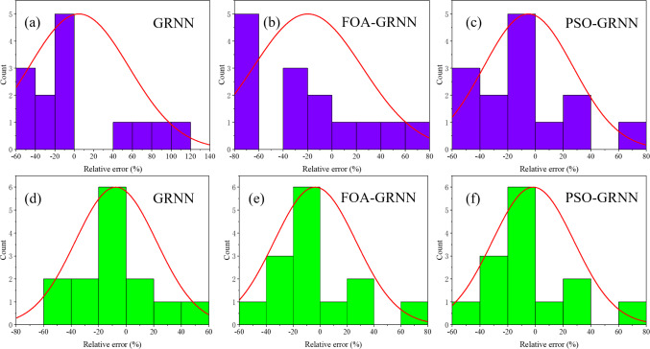
- Download: Download high-res image (544KB)
- Download: Download full-size image
Fig. 4. The relative error distribution of testing results by (a) GRNN (b) FOA-GRNN (c) PSO-GRNN and physics coupled model (d) Phy-GRNN (e) Phy-FOA-GRNN (f) Phy-PSO-GRNN.
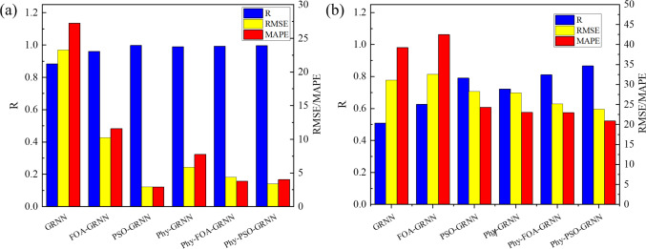
- Download: Download high-res image (383KB)
- Download: Download full-size image
Fig. 5. The quantitative evaluation index for (a) training sets and (b) testing sets.
To quantitatively evaluate the developed model, the correlation coefficient (R2), root mean square error (RMSE) and mean absolute percentage error (MAPE) are introduced as Eq. (2)–(4).(13)R=∑i=1N(Ei−E¯)(Pi−P¯)∑i=1N(Ei−E¯)2∑i=1N(Pi−P¯)2(14)RMSE=1N∑i=1N(Ei−Pi)2(15)MAPE(%)=1N∑i=1N|Ei−PiEi|×100%where, E is the experimental value, P is the predicted value, E¯ and P¯ are the average value of E and P, respectively, and N is the number of samples. Fig. 5 presents the quantitative evaluation index for the training sets and the testing sets. Better performance can be derived from a higher R value closer to 1 and lower RMSE and MAPE. Fig. 5(a) shows that the physics coupled ML models perform better among the developed models during the training process. The R value obtained from the GRNN model was 0.884 which increases to 0.989 when integrating the physical feature of dual phase fraction. A significant reduction of RMSE and MAPE value from 23.28 and 27.23 to 5.86 and 7.77 was observed, respectively. Furthermore, the performance of GRNN model optimized by the FOA and the PSO algorithm was enhanced, the R value increases from 0.884 to 0.96 and 0.997, respectively. The PSO-GRNN model not only possesses the higher R value but also exhibits lower RMSE and MAPE value of 2.93 and 2.92. For the testing results illustrated in Fig. 5(b), the higher R value and lower RMSE and MAPE values were obtained for the physics coupled ML models. Integration of physical feature can not only expand the input information, but also enhance the dataset quality. By comparing the FOA and PSO optimization algorithm, the PSO algorithm is superior to search for the optimal parameters of GRNN model which can further increase the prediction reliability. As such, the newly developed physics coupled PSO-GRNN model possesses better generalization ability and high prediction accuracy according to the above evaluation criteria, and is selected to predict the MR of the Al–Cr–Fe–Ni based MPEAs in subsequent work.
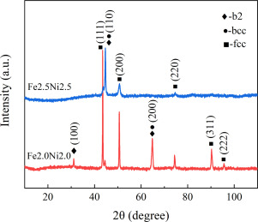
- Download: Download high-res image (268KB)
- Download: Download full-size image
Fig. 6. XRD analysis of Fe2.5Ni2.5CrAl and Fe2Ni2CrAl MPEAs.
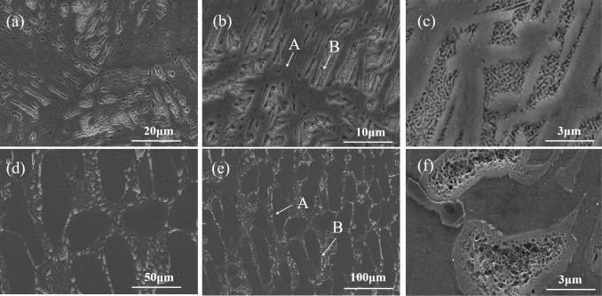
- Download: Download high-res image (1MB)
- Download: Download full-size image
Fig. 7. Microstructural characterization of (a)(b)(c)Fe2Ni2CrAl and (d)(e)(f)Fe2.5Ni2.5CrAl MPEAs.
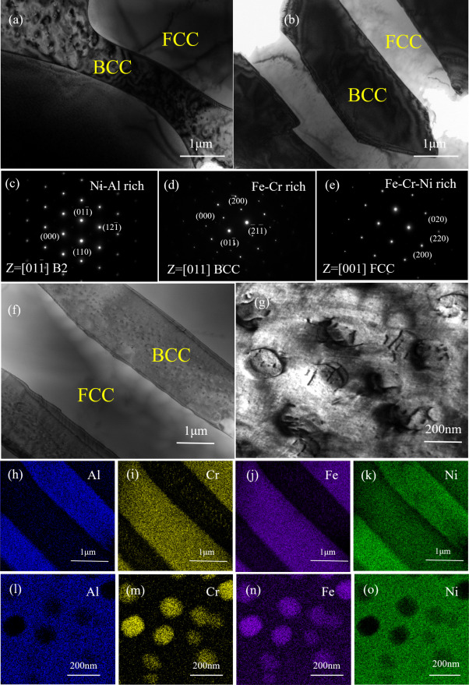
- Download: Download high-res image (3MB)
- Download: Download full-size image
Fig. 8. TEM characterization of Fe2.5Ni2.5CrAl MPEAs (a)(b) The typical phase structure; (c)–(e) SAED patterns; (f) The phase structure; (g) High magnified image of the B2 phase with large amount of particles embedded; (h)–(k) The EDS mapping analysis of (f); (l)–(o) The EDS mapping analysis of (g).
The great capability of PSO-GRNN model allows us to determine the optimum alloy composition via reverse optimization. The mean square deviation between the output value of the training sample and the actual value is utilized as the fitness function to find the optimal spread value. After optimization, the Fe2.5Ni2.5CrAl alloy was designed and the composition is summarized in Table 1. In the following section, the optimized alloy was synthesized to perform a microstructural and property evaluation.
Table 1. Composition of the optimized alloy (at.%).
MPEA | Alloying elements
Empty Cell | Al | Cr | Fe | Ni
Fe2.5Ni2.5CrAl | 14.28 | 14.28 | 35.71 | 35.71
3.3. Experimental validation
The attractive predictive performance of the developed ML model coupled with the relevant physical features, implies that this well-trained model can be utilized to predict the solidification interval of the Al–Cr–Fe–Ni MPEAs system with the aim to achieve enhanced mechanical properties. In this section, with the optimized composition, the Fe2.5Ni2.5CrAl alloy is synthesized and a series of experiments were obtained for phase and microstructural characterization as well as to obtain the mechanical properties. To demonstrate the superiority of the designed alloy, the Fe2Ni2CrAl alloy, proposed by Lu et al. [44], was also prepared and characterized to compare with the Fe2.5Ni2.5CrAl alloy. To eliminate the influence of process conditions, the melting and casting technique was the same as the Fe2.5Ni2.5CrAl alloy. This allows us to validate the developed composition–structure–property model.
3.3.1. XRD analysis
The XRD patterns of the Fe2.5Ni2.5CrAl and the Fe2Ni2CrAl alloy are given in Fig. 6. The diffraction peaks corresponding to the FCC, BCC and B2 crystal structure can be observed in both alloys. The formation of the B2 phase was explored by the minor diffraction peak in the Fe2Ni2CrAl MPEA. The Fe2Ni2CrAl MPEA samples are primarily composed of the FCC phase, as well as a disordered BCC (A2) phase and an ordered BCC (B2) phase. Due to the A2 and B2 phases having very similar lattice parameters, the diffraction peaks of (110), (200) and (220) overlapped in the XRD patterns. While in the Fe2.5Ni2.5CrAl MPEA, the minor diffraction peak (100) was not detected and it mainly consists of the FCC and BCC phases.
3.3.2. Microstructure
Fig. 7 presents the SEM images of Fe2.5Ni2.5CrAl and Fe2Ni2CrAl MPEA samples. As the low-magnification SEM image illustrated in Fig. 7(a) and (d), the two alloys present different morphologies. The microstructure of the Fe2Ni2CrAl sample shows two distinctive areas (region A and B), as shown in Fig. 7(b). The phase separation can be observed within the grains as well as a high content of strip-like phases. Fig. 7(c) presents high-magnification images of the Fe2Ni2CrAl MPEA, indicating that the alloy was composed of a densely distributed plate-like morphology, which is regarded as a typical microstructure of eutectic alloys. The enlargement of region B in Fig. 7(c) shows bright and dark sections of network-like phases which is attributed to the spinodal decomposition. This network-like microstructure exhibits overlapping disordered BCC (A2) and B2 Bragg reflections in the XRD analysis. On the other hand, from Fig. 7(d), grains with distinct grain boundaries were observed for the Fe2.5Ni2.5CrAl alloy. At a higher magnification image, Fig. 7(e) reveals that the Fe2.5Ni2.5CrAl alloy exhibits two kinds of regions with different contrast, i.e., a dark region marked as A and the light gray region marked as B. Part of the area shown in Fig. 7(e) is provided in Fig. 7(f) which shows clearly the bright and dark sections of the interconnected microstructures. EDS point analysis was carried out on the two distinct zones (region A and B) to measure their chemical compositions, the results are summarized in Table 2.
The EDS results tabulated in Table 2, it shows inhomogeneous chemical elemental distribution in the as-cast alloy. Regarding the prepared two alloys, region A contains more Fe and Cr as well as a relatively high content of Ni, while the region B was rich in Al and Ni. The presence of elemental Fe, Cr and Ni favors the formation of FCC phases, otherwise, greater content of Al and Ni gives preference for the formation of ordered BCC (B2) phases. Accordingly, the network-like phases in the Fe2Ni2CrAl alloy may correspond to the ternary FCC+B2+BCC eutectics. The phases in the light region A exhibited a FCC structure, while the phases in the dark region show B2 and BCC structures.
Table 2. EDS analysis results for chemical composition (at.%) of studied alloys.
Alloy | Location | Chemical composition (at.%)
Empty Cell | Empty Cell | Al | Cr | Fe | Ni
Fe2Ni2CrAl | Nominal | 16.67 | 16.67 | 33.33 | 33.33
Fe2Ni2CrAl | A | 11.51 | 20.28 | 38.61 | 29.59
Fe2Ni2CrAl | B | 24.35 | 12.00 | 24.78 | 38.87
Fe2.5Ni2.5CrAl | Nominal | 14.28 | 14.28 | 35.72 | 35.72
Fe2.5Ni2.5CrAl | A | 11.79 | 17.03 | 38.35 | 32.83
Fe2.5Ni2.5CrAl | B | 29.54 | 9.42 | 21.17 | 39.87
To identify the phase structure in-depth, Fig. 8 presents the results of phase structure and phase distribution analysis of the as-cast Fe2.5Ni2.5CrAl alloy. From the TEM micrographs Fig. 8(a) and (b), it can be observed that the eutectic microstructure is primarily composed of two alternating phases. The selected-area’s electron diffraction (SAED) pattern of the Ni–Al-rich region corresponding to the B2 phase and the Fe–Cr rich region as well as the Fe–Cr–Ni rich regions are displayed in Fig. 8(c) - (e). It can be further confirmed from the SAED pattern that the eutectic structure is a mixture of FCC+BCC/B2 eutectic structure. In particular, the strip-like phases have an FCC structure, and the spinodal phases exhibited a BCC structure. Taking the alternating phases illustrated in Fig. 8(f) as an example, the EDS mapping analysis were plotted in Fig. 8(h)–(k). The bright strip phases are rich in Fe–Cr–Ni corresponding to the FCC structure, the dark spinodal phases are rich in Ni–Al corresponding to the BCC structure. Fig. 8(g) presents a magnified image of the BCC structure, revealing a large amount of spherical particles with a diameter of several nanometers distributed in the B2 phase matrix. According to the EDS mapping analysis illustrated in Fig. 8(l)–(o), in the spinodal structures, the spherical particles are rich in Fe and Cr and poor in Ni and Al. It can be inferred that the spherical particles possess the disordered BCC structure and the matrix exhibits the ordered B2 structure. Accordingly, this near-eutectic MPEAs with many nanoparticles may play an important role in enhancing mechanical properties.
3.3.3. DSC analysis
In the present work, a DSC analysis is carried out to determine the melting peaks of the Fe2Ni2CrAl and Fe2.5Ni2.5CrAl MPEAs. Fig. 9 presents the DSC curves of the two prepared alloys with an integration of the phase change peaks. According to the DSC curves, some typical physical characteristics such as the initial and final melting temperatures can be obtained to determine the MR. The relevant physical parameters of the two alloys were summarized in Table 3. Presumably, the curve measured during the heating process corresponding to the Fe2Ni2CrAl sample indicates that the alloy began to melt at 1326.2 °C and completed at 1367.5 °C consequently with the MR of 41.3 °C. For comparison, the Fe2.5Ni2.5CrAl alloy melts within a narrower temperature interval between the solidus and liquidus temperatures of 1347.1 and 1378.9 °C, respectively. Regarding the purpose of performing experiments in this study, the predicted value of MR by the ML model is provided to further demonstrate its reliability. As Table 3 illustrates, the calculated MR via the CALPHAD method was 28.44 and 13.57 °C for Fe2Ni2CrAl and Fe2.5Ni2.5CrAl alloy, respectively, the RE was 31.1% and 57.3%, respectively. The predicted value from the ML model was 32.5 and 28.7 °C for Fe2Ni2CrAl and Fe2.5Ni2.5CrAl alloy, respectively. The RE of 8.8% and 9.7% is significantly reduced compared with the CALPHAD method. Thus, the predictive performance of our ML model can be confirmed and the physics coupled PSO-GRNN model can be utilized in AlCrFeNi based MPEAs.
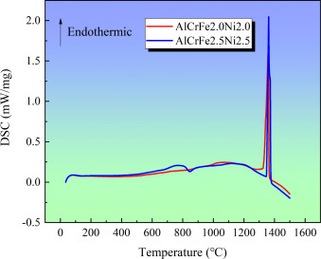
- Download: Download high-res image (308KB)
- Download: Download full-size image
Fig. 9. DSC analysis of Fe2.5Ni2.5CrAl and Fe2Ni2CrAl MPEAs.
Table 3. DSC results of prepared alloys and a comparison between the actual value and the predicted value.
MPEAs | Ts (°C) | Tf (°C) | MR (°C) | ML-MR (°C) | RE1 (%) | CAL-MR (°C) | RE2 (%)
Fe2.0Ni2.0 | 1326.2 | 1367.5 | 41.3 | 32.5 | 8.8 | 28.44 | 31.1
Fe2.5Ni2.5 | 1347.1 | 1378.9 | 31.8 | 28.7 | 9.7 | 13.57 | 57.3
3.3.4. Mechanical properties
Fig. 10 shows the engineering stress–strain curves of the as-cast Fe2Ni2CrAl and Fe2.5Ni2.5CrAl alloy. For better understanding, the fracture strength and the corresponding strain are summarized in Table 4. The room temperature compressive tests showed that in the engineering stress–strain condition, the Fe2Ni2CrAl alloy yields a fracture strength of 2272.03 MPa with a strain of 50.30%. For our designed Fe2.5Ni2.5CrAl alloy, the compressive stress–strain curves illustrated in Fig. 10(b) show the higher fracture strength of 2314.73 MPa with a plastic strain of 50.13%. For comparison, the strength of AlCrFeNi based MPEAs enhanced from 2272.03 MPa to 2314.73 MPa via our proposed alloy design concept without the sacrifice of plasticity. Given that, it is extremely surprising that an as-cast alloy can possess such exceptional plasticity although the compressive strength of this alloy was not particularly high. Fig. 11 shows the compressive strain versus ultimate compressive strength for the reported as-cast MPEAs in the engineering stress–strain condition [45], [46], [47], [48]. A few MPEAs in the as-cast condition show a much larger compressive strength, however, it is achieved at the expense of plasticity. As an example, owing to the spinodal decomposition microstructure composed of the B2 and BCC phases, the AlCoCrFeNi alloy, which is the most typical HEAs family, is brittle at room temperature. By comparing with AlCrFeCoNi HEAs [45], which possesses a compressive strength of 2004.23 MPa associated with a plastic strain of 32.7%, the Fe2.5Ni2.5CrAl alloy exhibits a fairly desirable combination of high strength and large plasticity. This enhancement of mechanical properties can be attributed to the BCC hard nanoparticles embedded in a B2 matrix. As a result, the Co-free Fe2.5Ni2.5CrAl alloy is not only cost saving, but also can be considered as one of the best performing among reported as-cast HEAs. The superior plasticity of our Fe2.5Ni2.5CrAl alloy demonstrated that the room temperature brittleness of MPEAs can be addressed.
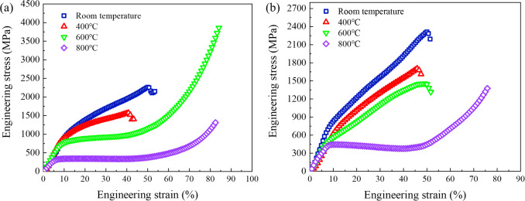
- Download: Download high-res image (575KB)
- Download: Download full-size image
Fig. 10. The engineering stress–strain curves of (a) Fe2Ni2CrAl and (b) Fe2.5Ni2.5CrAl alloy.
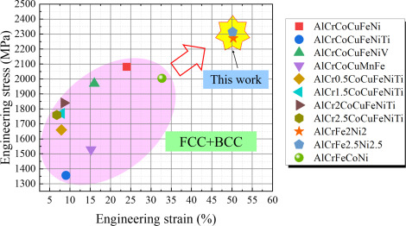
- Download: Download high-res image (518KB)
- Download: Download full-size image
Fig. 11. The comparison between the reported as-cast MPEAs and the prepared alloy in this work.
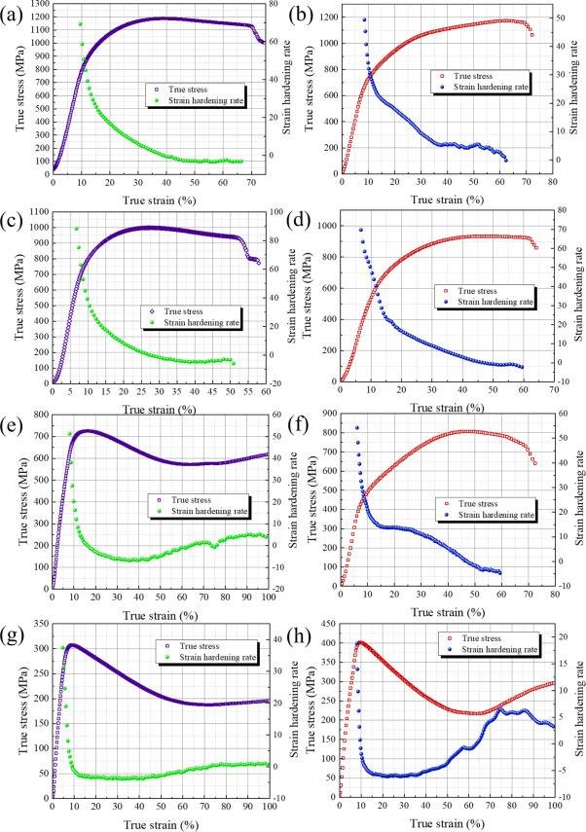
- Download: Download high-res image (2MB)
- Download: Download full-size image
Fig. 12. The true stress–strain curves and strain hardening rate of (a)(c)(e)(g) Fe2Ni2CrAl and (b)(d)(f)(h) Fe2.5Ni2.5CrAl alloy at various temperature. (a)(b) Room temperature (c)(d) 400 °C (e)(f) 600 °C (g)(h) 800 °C.
To evaluate the mechanical properties at high temperature, the compressive stress–strain curves of the prepared alloys at (400 °C, 600 °C and 800 °C) are also listed in Fig. 11. It is clearly observed that both the alloys display the decreased plasticity at 400 °C. This effect can be attributed to medium-temperature temper-brittleness, which is a typical feature occurring in some conventional metallic materials. The Fe2Ni2CrAl alloy shows the strength of 1572.52 MPa with the plastic strain of 40.81%. Fortunately, the designed Fe2.5Ni2.5CrAl alloy possesses enhanced strength of 1706.73 MPa as well as higher plastic strain of 46.04%. As the temperature rises to 600 °C, the Fe2.5Ni2.5CrAl alloy displays reasonably high strength of 1456.87 MPa, as well as an exceptional plastic strain of 49.5%. Particularly when the temperature continues to increase to 800 °C, the Fe2.5Ni2.5CrAl alloy behaves similarly with Fe2Ni2CrAl alloy. Both the prepared alloys for the compressive strength test show a high strain and without fractured. By comparing with the Fe2Ni2CrAl alloy, the designed Fe2.5Ni2.5CrAl alloy with narrow MR exhibits much higher strength at elevated temperature. Besides, the high temperature mechanical properties of the as-cast Fe2.5Ni2.5CrAl alloy can also be comparable with Ti-based alloy and nickel-based superalloy [49]. As can be seen from the above, the mechanical properties of the Fe2.5Ni2.5CrAl alloy are rather unexpected for as-cast alloy, since it has superior plasticity at room temperature and maintain reasonably high compressive strength at elevated temperatures. Hence, it can be deduced that the narrow MR can result in better mechanical properties and our model can be utilized for the discovery of new MPEAs.
Table 4. The mechanical properties of Fe2.5Ni2.5CrAl and Fe2Ni2CrAl MPEAs.
Sample | Temperature (°C) | Fracture strength (MPa) | Plastic strain (%)
Fe2.5Ni2.5CrAl | 20 | 2314.73 | 50.13
Fe2.5Ni2.5CrAl | 400 | 1706.73 | 46.04
Fe2.5Ni2.5CrAl | 600 | 1456.87 | 49.5
Fe2.5Ni2.5CrAl | 800 | Not fracture | Not fracture
Fe2Ni2CrAl | 20 | 2272.03 | 50.3
Fe2Ni2CrAl | 400 | 1572.52 | 40.81
Fe2Ni2CrAl | 600 | Not fracture | Not fracture
Fe2Ni2CrAl | 800 | Not fracture | Not fracture
As can be noted from Fig. 10(a) and (b), both the alloys showed significant work hardening (WH) where the flow stress increased from ∼600–700 MPa upon yielding to ∼2300 MPa at the end of the plastic strain ∼0.5. The work hardening behavior of the Fe2Ni2CrAl and Fe2.5Ni2.5CrAl alloy is further analyzed. Fig. 12 shows the true stress–strain curves and the corresponding work hardening curves for both alloys at tested temperatures. From the plot, the strain hardening rate (ɛθ=dσ/dɛ) is identified to consist of three stages as deformation proceeds with a change in the slope of θ. Similar tendencies can be observed that the values of θ undergoes rapid drop in the stage I of WH during the early stages of deformation. Then in stage II, the value of θ decreased slowly. The value of θ at higher plastic strain or flow stress (stage III) shows a high sensitivity to temperature change. At temperatures below 400 °C, the value of θ remained stable followed by a negative slope in stage II. When the temperature increases to 600 °C, a curve having a greater negative slope can be observed at higher plastic strain. With further increase of temperature to 800 °C, the WH curve shows a transition from a negative slope in stage II to a positive slope in stage III after plastic strain. In general, these transitions in the slope of the curve can be attributed to a change in the deformation mechanism. After undergoing a short elastic–plastic transition, the twinning and dislocation slip are both involved in the plastic deformation [50]. Owing to the dual phase strengthening and second phase strengthening, the as-cast Fe2.5Ni2.5CrAl MPEA shows significantly high work hardenability. Accordingly, a unique combination of mechanical properties, including high compressive strength, large plastic strain and great strain hardening, can be achieved via our alloy design scheme.
3.3.5. Strengthening mechanism
To understand the mechanical properties in depth, the strengthening mechanism of Fe2.5Ni2.5CrAl alloy was analyzed, as Fig. 13 illustrated. Alloys with a BCC-type structure can possess higher strength than a FCC-type structure, while, the FCC-type structure have better plastic formability. Thus, more attention has been paid to dual-phase or multi-phase MPEAs. In the present work, the as-cast Fe2.5Ni2.5CrAl alloy are composed of the FCC phase as well as the BCC/B2 phase. Such a two phase strengthening mechanism has been reported in eutectic or near-eutectic MPEAs [51], [52], which motivated us to obtain a combination of high strength and good ductility. In addition to the formation of a Fe–Cr–Ni rich FCC phase and a Fe–Cr rich BCC phase, the extra atoms of Fe can dissolve in the Ni–Al rich B2 phase to produce a strong solid solution strengthening. This can help to achieve the desirable strength and superior plasticity.
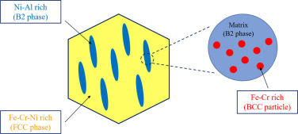
- Download: Download high-res image (222KB)
- Download: Download full-size image
Fig. 13. The schematic diagram of strengthening mechanism.
From the phase structure plotted in Fig. 8, a large content of spherical particles were homogeneously dispersed in a B2 phase matrix. As a major strengthening mechanism for structural materials, the second phase strengthening effects [53] of the nanoparticles play a crucial role in the mechanical properties of the Fe2.5Ni2.5CrAl alloy. Owing to the Orowan mechanism [54], the larger nanoparticles can block dislocation motions when subjected to compressive stress, preventing the fracture and increase plasticity. Just like the strengthening effect of γ′ nanoparticles in Ni-based superalloys [55], larger nanoparticles can play an effective role in strengthening the alloy at elevated temperatures. While the particle shear strengthening mechanism plays a major role with respect to the smaller nanoparticles [56]. As a result, the formation of nanoparticles which produces combined strengthening effects contributes to the high compressive strength and plasticity of alloy.
4. Conclusion
In present work, a potential workflow that couples relevant physics into ML process was proposed to optimize composition of the multi-principal elements alloy. Besides the alloy elements, the physical features of volume fraction of dual phase which was captured from CALPHAD method were incorporated into the dataset. To select the most desirable algorithm, GRNN, FOA-GRNN and PSO-GRNN models were utilized to predict MR of Al–Cr–Fe–Ni based MPEAs. By comparing the predictive performance, the ML model coupled physical features predicted the targeted outputs characteristics which emphasizes the importance of physical variables to construct an accurate ML model. According to the performance indicators, the physics coupled PSO-GRNN model exhibits the most desirable predictive accuracy to establish the composition–structure–property relations.
To verify the reliability of the developed model, a non-equiatomic Fe2.5Ni2.5CrAl MPEA was successfully designed and prepared based on the ML results. The DSC analysis shows that the developed alloy possesses a desirable narrow MR and the predicted MR is in excellent agreement with experiments with the relative error below 10%. The Fe2.5Ni2.5CrAl alloy exhibits a mixture of FCC, disordered BCC and ordered B2 crystal structures, as well as Fe–Cr-rich nanoparticles dispersed in a B2 matrix. Owing to the dual phase strengthening, the Fe2.5Ni2.5CrAl alloy displayed good compressive mechanical properties at room and elevated temperatures, superior to many conventional alloys and HEAs. The exceptional plasticity overcomes the brittleness of conventional superalloys at room temperature. This work provides a promising ML approach and CALPHAD method to acquire the desired properties through a reasonable compositional design.
CRediT authorship contribution statement
Ling Qiao: Resources, Writing – original draft, Writing – review & editing, Validation, Formal analysis, Investigation. R.V. Ramanujan: Conceptualization, Validation, Methodology, Supervision, Project administration. Jingchuan Zhu: Conceptualization, Methodology, Supervision, Project administration.
Declaration of Competing Interest
The authors declare that they have no known competing financial interests or personal relationships that could have appeared to influence the work reported in this paper.
Acknowledgments
This work is supported by AME Programmatic Fund by the Agency for Science, Technology and Research, Singapore under Grants No. A1898b0043 and A18B1b0061 and the China Scholarship Council . Thanks Prof. Raju for lighting my present and future!
Data availability
The raw/processed data required to reproduce these findings cannot be shared at this time as the data also forms part of an ongoing study.
References
- [1]
Yeh J.W., Chen S.K., Lin S.J., Gan J.Y., Chin T.S., Shun T.T., Tsau C.H., Chang S.Y.
Nanostructured high-entropy alloys with multiprincipal elements-novel alloy design concepts and outcomes
Adv. Eng. Mater., 6 (2004), pp. 299-303
Google Scholar
- [2]
Cantor B., Chang I.T.H., Knight P., Vincent A.J.B.
Microstructural development in equiatomic multicomponent alloys
Mater. Sci. Eng. A, 375–377 (2004), pp. 213-218
View PDFView articleView in ScopusGoogle Scholar
- [3]
Zhang Y., Yang X., Liaw P.K.
Alloy design and properties optimization of high-entropy alloys
JOM, 64 (2012), pp. 830-838
CrossrefView in ScopusGoogle Scholar
- [4]
Zhang Y., Zuo T.T., Tang Z., Gao M.C., Dahmen K.A., Liaw P.K., Lu Z.P.
Microstructures and properties of high-entropy alloys
Prog. Mater. Sci., 61 (2014), pp. 1-93
View PDFView articleGoogle Scholar
- [5]
Cai Y.P., Wang G.J., Ma Y.J., Cao Z.H., Meng X.K.
High hardness dual-phase high entropy alloy thin films produced by interface alloying
Scr. Mater., 162 (2019), pp. 281-285
View PDFView articleView in ScopusGoogle Scholar
- [6]
Joseph J., Haghdadi N., Annasamy M., Kada S., Hodgson P.D., Barnett M.R., Fabijanic D.M.
On the enhanced wear resistance of CoCrFeMnNi high entropy alloy at intermediate temperature
Scr. Mater., 186 (2020), pp. 230-235
View PDFView articleView in ScopusGoogle Scholar
- [7]
Wu Shiyu, Qiao Dongxu, Zhao Hongliang, Wang Jun, Lu Yiping
A novel NbTaW0.5 (Mo2C)x refractory high-entropy alloy with excellent mechanical properties
J. Alloys Compd., 889 (2021), Article 161800
View PDFView articleGoogle Scholar
- [8]
Liu J., Guo X., Lin Q., et al.
Excellent ductility and serration feature of metastable CoCrFeNi high-entropy alloy at extremely low temperatures
Sci. China Mater., 62 (2019), pp. 853-863
CrossrefView in ScopusGoogle Scholar
- [9]
Zhou Shichao, Liaw Peter K., Xue Yunfei, Zhang Yong
Temperature-dependent mechanical behavior of an Al0.5Cr0.9FeNi2.5V0.2 high-entropy alloy
Appl. Phys. Lett., 119 (2021), Article 121902
View in ScopusGoogle Scholar
- [10]
Xia Songqin, Zhang Yong
Deformation mechanisms of Al0.1CoCrFeNi high entropy alloy at ambient and cryogenic temperatures
Mater. Sci. Eng. A, 733 (2018), pp. 408-413
View PDFView articleView in ScopusGoogle Scholar
- [11]
Qiao Ling, Aorigele, Lai Zhonghong, Zhu Jingchuan
A promising new class of multi-component alloys with exceptional mechanical properties
J. Alloys Compd., 847 (2020), Article 155929
View PDFView articleView in ScopusGoogle Scholar
- [12]
Jiang Hui, Qiao Dongxu, Jiao Wenna, Han Kaiming, Yiping Lu, Liaw Peter K.
Tensile deformation behavior and mechanical properties of a bulk cast Al0.9CoFeNi2 eutectic high-entropy alloy
J. Mater. Sci. Technol., 61 (2021), pp. 119-124
View PDFView articleView in ScopusGoogle Scholar
- [13]
Wang W., Qi W., Xie L., Yang X., Li J., Zhang Y.
Microstructure and corrosion behavior of (CoCrFeNi)95Nb5 high-entropy alloy coating fabricated by plasma spraying
Materials, 12 (2019), p. 694
CrossrefView in ScopusGoogle Scholar
- [14]
Parakh Abhinav, Vaidya Mayur, Kumar Nitish, Chetty Raghuram, Murty B.S.
Effect of crystal structure and grain size on corrosion properties of AlCoCrFeNi high entropy alloy
J. Alloys Compd., 863 (2021), Article 158056
View PDFView articleView in ScopusGoogle Scholar
- [15]
Qiao Ling, Bao Aorigele, Wang Yuan, Liu Yong, Lai Zhonghong, Zhu Jingchuan
Thermophysical properties and high temperature oxidation behavior of FeCrNiAl0.5 multi-component alloys
Intermetallics, 126 (2020), Article 106899
View PDFView articleView in ScopusGoogle Scholar
- [16]
Shi Xiaoqian, Yang Wei, Cheng Zhaohui, Shao Wenting, Xu Dapeng, Zhang Yong, Chen Jian
Influence of micro arc oxidation on high temperature oxidation resistance of AlTiCrVZr refractory high entropy alloy
Int. J. Refract. Met. Hard Mater., 98 (2021), Article 105562
View PDFView articleView in ScopusGoogle Scholar
- [17]
Wang Luntao, Mercier Dimitri, Zanna Sandrine, Seyeux Antoine, Laurent-Brocq Mathilde, Perrière Loïc, Guillot Ivan, Marcus Philippe
Study of the surface oxides and corrosion behaviour of an equiatomic CoCrFeMnNi high entropy alloy by XPS and ToF-SIMS
Corros. Sci., 167 (2020), Article 108507
View PDFView articleView in ScopusGoogle Scholar
- [18]
Qi Wu, Wang Wenrui, Yang Xiao, Xie Lu, Zhang Jiaming, Li Dongyue, Zhang Yong
Effect ofZr on phase separation, mechanical and corrosion behavior of heterogeneous CoCrFeNiZrx high-entropy alloy
J. Mater. Sci. Technol., 109 (2022), pp. 76-85
View PDFView articleView in ScopusGoogle Scholar
- [19]
Ma E.
Unusual dislocation behavior in high-entropy alloys
Scr. Mater., 181 (2020), pp. 127-133
View PDFView articleView in ScopusGoogle Scholar
- [20]
Wang Mingliang, Lu Yiping, Wang Tongmin, Zhang Chuan, Cao Zhiqiang, Li Tingju, Liaw Peter K.
A novel bulk eutectic high-entropy alloy with outstanding as-cast specific yield strengths at elevated temperatures
Scr. Mater., 204 (2021), Article 114132
View PDFView articleView in ScopusGoogle Scholar
- [21]
Zhao Y., Wang M., Cui H., Zhao Y., Song X., Zeng Y., Gao X., Lu F., Wang C., Song Q.
J. Alloy. Compd., 805 (2019), pp. 585-596
View PDFView articleView in ScopusGoogle Scholar
- [22]
Guo L., Gu J., Gong X., et al.
CALPHAD aided design of high entropy alloy to achieve high strength via precipitate strengthening
Sci China Mater, 63 (2020), pp. 288-299
CrossrefView in ScopusGoogle Scholar
- [23]
Wu Mingxu, Wang Shubin, Huang Haijun, Shu Da, Sun Baode
CALPHAD aided eutectic high-entropy alloy design
Mater. Lett., 262 (2020), Article 127175
View PDFView articleView in ScopusGoogle Scholar
- [24]
Qiao Ling, Lai Zhonghong, Liu Yong, Bao Aorigele, Zhu Jingchuan
Modelling and prediction of hardness in multi-component alloys: A combined machine learning, first principles and experimental study
J. Alloys Compd., 853 (2021), Article 156959
View PDFView articleView in ScopusGoogle Scholar
- [25]
Gao Yu, Qiao Linjing, Wu Dongting, Zhang Yongang, Zou Yong
First principle calculation of the effect of Cr, Ti content on the properties of VMoNbTaWMx (M=Cr, Ti) refractory high entropy alloy
Vacuum, 179 (2020), Article 109459
View PDFView articleView in ScopusGoogle Scholar
- [26]
Zhang Liang, Qian Kun, Huang Jun, Liu Mao, Shibuta Yasushi
Molecular dynamics simulation and machine learning of mechanical response in non-equiatomic FeCrNiCoMn high-entropy alloy
J. Mater. Res. Technol., 13 (2021), pp. 2043-2054
View PDFView articleView in ScopusGoogle Scholar
- [27]
Li Jia, Xie Baobin, Fang Qihong, Liu Bin, Liu Yong, Liaw Peter K.
High-throughput simulation combined machine learning search for optimum elemental composition in medium entropy alloy
J. Mater. Sci. Technol., 68 (2021), pp. 70-75
View PDFView articleCrossrefGoogle Scholar
- [28]
Qiao Ling, Liu Yong, Zhu Jingchuan
A focused review on machine learning aided high-throughput methods in high entropy alloy
J. Alloys Compd., 877 (2021), Article 160295
View PDFView articleView in ScopusGoogle Scholar
- [29]
Qiao L., Liu Y., Zhu J., Wang Y.
Phase prediction of high carbon pearlitic steel: An improved model combining mind evolutionary algorithm and neural networks
Adv. Eng. Mater. (2021), Article 2100204
View in ScopusGoogle Scholar
- [30]
Yang Chen, Ren Chang, Jia Yuefei, Wang Gang, Li Minjie, Lu Wencong
A machine learning-based alloy design system to facilitate the rational design of high entropy alloys with enhanced hardness
Acta Mater., 222 (2022), Article 117431
View PDFView articleView in ScopusGoogle Scholar
- [31]
Zhao D.Q., Pan S.P., Zhang Y., Liaw P.K., Qiao J.W.
Structure prediction in high-entropy alloys with machine learning
Appl. Phys. Lett., 118 (2021), Article 231904
View in ScopusGoogle Scholar
- [32]
Bhandari Uttam, Rafi Md. Rumman, Zhang Congyan, Yang Shizhong
Yield strength prediction of high-entropy alloys using machine learning
Mater. Today Commun., 26 (2021), Article 101871
View PDFView articleView in ScopusGoogle Scholar
- [33]
Peng C., Zhu D., Li K., Du X., Zhao F., Wan M., Tan Y.
Research on a low melting point Al-Si-Cu (Ni) filler metal for 6063 aluminum alloy brazing
Appl. Sci., 11 (2021), p. 4296
CrossrefView in ScopusGoogle Scholar
- [34]
Giraud E., Suery M.
Mechanical behavior of AA6061 aluminum in the semisolid state obtained by partial melting and partial solidification
Metall. Mater. Trans. A, 41 (2010), pp. 2257-2268
CrossrefView in ScopusGoogle Scholar
- [35]
Poulia A., Georgatis E., Mathiou C., Karantzalis A.E.
Phase segregation discussion in a Hf25Zr30Ti20Nb15V10 high entropy alloy: The effect of the high melting point element
Mater. Chem. Phys., 210 (2018), pp. 251-258
View PDFView articleView in ScopusGoogle Scholar
- [36]
Shen Chunguang, Wang Chenchong, Wei Xiaolu, Li Yong, van der Zwaag Sybrand, Xu Wei
Physical metallurgy-guided machine learning and artificial intelligent design of ultrahigh-strength stainless steel
Acta Mater., 179 (2019), pp. 201-214
View PDFView articleView in ScopusGoogle Scholar
- [37]
Peng J., Yamamoto Y., Hawk J.A., et al.
Coupling physics in machine learning to predict properties of high-temperatures alloys
Npj Comput. Mater., 6 (2020), p. 141
View in ScopusGoogle Scholar
- [38]
Chen X., Qi J.Q., Sui Y.W., He Y.Z., Wei F.X., Meng Q.K., Sun Z.
Effects of aluminum on microstructure and compressive properties of Al-Cr-Fe-Ni eutectic multi-component alloys
Mater. Sci. Eng. A, 681 (2017), pp. 25-31
View PDFView articleGoogle Scholar
- [39]
Wen Z., Zhao Y., Tian J., et al.
Computation of stability, elasticity and thermodynamics in equiatomic AlCrFeNi medium-entropy alloys
J. Mater. Sci., 54 (2019), pp. 2566-2576
CrossrefView in ScopusGoogle Scholar
- [40]
Qiao Ling, Wang Zibo, Zhu Jingchuan
Application of improved GRNN model to predict interlamellar spacing and mechanical properties of hypereutectoid steel
Mater. Sci. Eng. A, 792 (2020), Article 139845
View PDFView articleView in ScopusGoogle Scholar
- [41]
Qiao Ling, Liu Yong, Zhu Jingchuan
Application of generalized regression neural network optimized by fruit fly optimization algorithm for fracture toughness in a pearlitic steel
Eng. Fract. Mech., 235 (2020), Article 107105
View PDFView articleView in ScopusGoogle Scholar
- [42]
Chen D.D., Lin X.M.
A strategy to control microstructures of a Ni-based superalloy during hot forging based on particle swarm optimization algorithm
Adv. Manuf., 7 (2019), pp. 238-247
CrossrefGoogle Scholar
- [43]
Pan W.T.
A new fruit fly optimization algorithm: Taking the financial distress model as an example
Knowl-Based. Syst., 26 (2012), pp. 69-74
View PDFView articleView in ScopusGoogle Scholar
- [44]
Dong Yong, Gao Xiaoxia, Lu Yiping, Wang Tongmin, Li Tingju
A multi-component AlCrFe2Ni2 alloy with excellent mechanical properties
Mater. Lett., 169 (2016), pp. 62-64
View PDFView articleView in ScopusGoogle Scholar
- [45]
Wang Y.P., Li B.S., Ren M.X., Yang C., Fu H.Z.
Microstructure and compressive properties of AlCrFeCoNi high entropy alloy
Mater. Sci. Eng. A, 491 (1–2) (2008), pp. 154-158
View PDFView articleView in ScopusGoogle Scholar
- [46]
Li B.S., Wang Y.P., Ren M.X., Yang C., Fu H.Z.
Mater. Sci. Eng. A, 498 (2008), pp. 482-486
View PDFView articleView in ScopusGoogle Scholar
- [47]
Wang Z., Wang X., Yue H., Shi G., Wang S.
Mater. Sci. Eng. A, 627 (2015), pp. 391-398
View PDFView articleCrossrefGoogle Scholar
- [48]
Li A., Ma D., Zheng Q.
J. Mater. Eng. Perform., 23 (2014), pp. 1197-1203
CrossrefView in ScopusGoogle Scholar
- [49]
Sims C., Stoloff N., Hagel W.
Superalloys II
(first ed.), Wiley, New York (1987)
Google Scholar
- [50]
Rohatgi A., Vecchio K., Gray G.T.
The influence of stacking fault energy on the mechanical behavior of Cu and Cu-Al alloys: deformation twinning, work hardening, and dynamic recovery metall
Mater. Trans. A, 32 (2001), p. 135
CrossrefView in ScopusGoogle Scholar
- [51]
Ma Yue, Hao Jiamiao, Jie Jinchuan, Wang Qing, Dong Chuang
Coherent precipitation and strengthening in a dual-phase AlNi2Co2Fe1.5Cr1.5 high-entropy alloy
Mater. Sci. Eng. A, 764 (2019), Article 138241
View PDFView articleView in ScopusGoogle Scholar
- [52]
Li Z., Pradeep K., Deng Y., et al.
Metastable high-entropy dual-phase alloys overcome the strength–trade-off
Nature, 534 (2016), pp. 227-230
CrossrefView in ScopusGoogle Scholar
- [53]
He J.Y., Wang H., Huang H.L., Xu X.D., Chen M.W., Wu Y., Liu X.J., Nieh T.G., An K., Lu Z.P.
A precipitation-hardened high-entropy alloy with outstanding tensile properties
Acta Mater., 102 (2016), pp. 187-196
View PDFView articleView in ScopusGoogle Scholar
- [54]
Courtney T.H.
Mechanical Behavior of Materials
(second ed.), Long Grove, Waveland (2005)
Google Scholar
- [55]
Reed R.C.
The Superalloys: Fundamentals and Applications
Cambridge University Press, Cambridge (2006)
Google Scholar
- [56]
Wang Q., Ma Y., Jiang B., Li X., Shi Y., Dong C., Liaw P.K.
A cuboidal B2 nanoprecipitation-enhanced body-centered-cubic alloy Al0.7CoCrFe2Ni with prominent tensile properties
Scr. Mater., 120 (2016), pp. 85-89
View PDFView articleView in ScopusGoogle Scholar

