Unraveling the Hall-Petch to Inverse Hall-Petch Transition in Nanocrystalline High Entropy Alloys under Shock Loading

Wanghui Li¹†, Meizhen Xiang²†, Zachary Howard Aitken¹, Shuai Chen³, Yilun Xu¹, Xinyu Yang¹, Qingxiang Pei¹, Jian Wang⁴, Xiaoyan Li⁵, Guglielmo Vastola¹, Huajian Gao⁵*, Yong-Wei Zhang*

¹ Institute of High-Performance Computing (IHPC), Agency for Science, Technology and Research (A∗STAR), 1 Fusionopolis Way,#16-16 Connexis, Singapore 138632 Singapore, Republic of Singapore.
² National Key Laboratory of Computational Physics, Institute of Applied Physics and Computational Mathematics,
Beijing, 100088, China.
³ Materials Genome Institute, Shanghai University, Shanghai 200444, China.
⁴ Mechanical and Materials Engineering, University of Nebraska–Lincoln, Lincoln, NE 68588, USA.
⁵ Center for Advanced Mechanics and Materials, Applied Mechanics Laboratory, Department of Engineering Mechanics, Tsinghua University, Beijing 100084, China.

Abstract
The transition from Hall-Petch (HP) to inverse Hall-Petch (IHP) behaviors associated with grain size reduction has been recognized for over two decades. However, the underlying mechanisms for such transition in high entropy alloys (HEAs) under dynamic loading, in which abundant deformation mechanisms could be activated either sequentially or simultaneously, remain unclear. Here, we investigate the HP to IHP transition in nanocrystalline CoCrFeMnNi HEAs under shock loading by examining their deformation mechanisms and flow stresses using large-scale molecular dynamics (MD) simulations. It is found that this transition is strongly dependent on the shock pressure as a result of the complex interplay among multiple competing deformation mechanisms, including the hardening mechanisms such as dislocations interactions and grain boundary (GB) blocking, as well as the softening mechanisms like phase formation, amorphization, GB thickening, and grain rotation. Moreover, there exist a critical shock pressure which corresponds to the largest critical grain size for the HP-IHP transition. Below the critical shock pressure, the critical grain size increases with pressure due to a stronger hardening effect in grain interior (GIs), while above the critical pressure, the critical grain size first decreases and then undergoes a pressure-insensitive plateau before further decrease due to softening effects in GIs. A theoretical model that includes different deformation mechanisms is proposed for the first time to capture the shock pressure-dependent HP-IHP transition. Our work provides valuable guidance for optimizing the grain size of nanocrystalline HEAs for applications involving dynamic loadings.

Keywords: Hall-Petch and Inverse Hall-Petch; Shock loading; Flow stress; High Entropy Alloy; Hierarchical deformations

1 Introduction
Understanding the mechanical behavior of materials under extreme conditions has become increasingly important in recent years, owing to a growing demand for high-strength and high-hardness materials that can serve as critical structural components under extreme conditions, including high-pressure, ultralow and ultrahigh temperature, and high strain rates, among others.
Grain refinement strengthening, often known as the Hall-Petch (HP) strengthening, has been widely adopted to strengthen polycrystalline metals and alloys (Huang et al., 2018). However, when the grain size falls to a few or tens nanometers, the role of grain boundary (GB) in mediating plasticity becomes more significant, which results in a phenomenon known as “smaller is weaker” (Rupert et al., 2009), commonly referred to as the inverse Hall-Petch (IHP) phenomenon (Hu et al., 2017). The HP-IHP transition can be attributed to a change in the dominant deformation mechanism. In large grains, plasticity is primarily governed by dislocations-based mechanisms within the grains. However, as grain size decreases, GB-mediated plasticity, which includes processes such as grain coarsening and GB sliding, becomes increasingly influential and eventually dominates at the nanoscale (Li et al., 2009; Wang et al., 2022; Yamakov et al., 2004).
The HP and IHP relationships in materials at ambient pressure and temperature have been extensively studied over the past two decades (Figueiredo et al., 2023; Hahn and Meyers, 2015; Naik and Walley, 2020). However, due to the rising demands of materials for applications under extreme conditions, there is a growing interest in exploring the effects of pressure or temperature on the HP and IHP relationships. For example, Zhou et al. (Zhou et al., 2020) recently demonstrated that the pressure can suppress GB migration and diffusion, thus extending the range of the HP relationship down to 3 nm. Sun et al. (Sun et al., 2019) reported that temperature can significantly influence the Hall-Petch slope and friction stress of materials.
It is worth noting that much of the existing theoretical research on HP and IHP relationships has largely focused on quasi-static loading conditions and has typically considered the effects of pressure or temperature separately (Coppieters et al., 2020). However, from a more fundamental point of view, deformation mechanisms in polycrystalline alloys/metals including dislocation-based plastic activities and GB-mediated plastic activities, along with phase transformation, can be rate-dependent and simultaneously influenced by both pressure and temperature.
Material behavior under shock loading is considerably more complex compared to conventional quasi-static loading. Upon shock loading, materials experience an initial high strain-rate at the wavefront, accompanied by rising pressure and temperature(Branicio et al., 2013; Wang et al., 2014). Subsequently, the material behind the shock wavefront reaches a steady state characterized by hydrodynamic high pressure and temperature. Material responses behind the shock wavefront not only depend on the internal microstructure (e.g., grain size, crystal orientations, etc.) (Guo et al., 2022; C. Li et al., 2022; P. Li et al., 2022; Li et al., 2021, 2020; Wu et al., 2024; Xiang et al., 2018, 2017), but also on the external loading conditions (e.g., pressure, temperature and strain rate, etc.) (Bringa et al., 2005; Huang et al., 2019; Tramontina et al., 2014; Wang et al., 2015).
With increasing shock intensity, a series of plastic deformation events and even phase transformation can be triggered(Wang et al., 2015). Notably, the hydrodynamic pressure and temperature generally have opposite effects, with pressure inducing a hardening effect while temperature leading to a softening effect. In spite of rapid progresses in this field, a couple of important questions remain largely unexplored: 1) How do these coupled factors (pressure, temperature, and strain rate) cooperatively influence the HP and IHP relationships in nanocrystalline materials under shock loading? 2) How does the grain size dependence of material strength differ in response to a shock loading compared to a quasi-static loading? Addressing these questions would significantly advance our understanding of materials behavior under extreme conditions.
High-entropy alloys (HEAs), initially proposed independently by Yeh et al. (Yeh et al., 2004) and Cantor et al. (Cantor et al., 2004), have gained tremendous attention(Bai et al., 2022; Cao et al., 2021; Chandan et al., 2022; Dong et al., 2023) due to their exceptional mechanical properties such as high strength, high ductility, high hardness, high fatigue resistance, as well as high thermal stability(Chu et al., 2024; Ding et al., 2018; He et al., 2021; L. Liu et al., 2024; Wang et al., 2024, 2020). Moreover, HEAs also demonstrate remarkable strength, ductility, and high damage tolerance across a wide range of temperatures (10 K to 1373 K)(Kawamura et al., 2021; L. Li et al., 2022; Wang et al., 2019; Zou et al., 2017). Such remarkable mechanical properties were attributed to a multitude of deformation mechanisms (George et al., 2019; Y. X. Li et al., 2023; C. Liu et al., 2024; Ming et al., 2019). For example, in the case of CoCrFeMnNi HEAs, cooperative deformation mechanisms come into play, particularly at ultralow temperatures and/or high pressures. These mechanisms include dislocation slip, partial dislocations, stacking faults, deformation twinning, phase transformation, shear banding, etc(Fang et al., 2019b; Kaushik et al., 2021; Li et al., 2023; Wang et al., 2024). These diverse mechanisms work in tandem before transitioning into inhomogeneous deformation (Naeem et al., 2020). The cooperation of these different deformation mechanisms results in an extraordinary level of complexity. The HP and IHP relationships of CoCrFeMnNi HEA under quasi-static loading have been previously investigated (Sun et al., 2019). For example, Jones et al. (Jones et al., 2020) reported a low friction coefficient as evidence of IHP behavior in nanocrystalline CoCrFeMnNi HEA. However, it is worth noting that previous studies primarily focused on the understanding of grain size-dependent material strength and deformation mechanisms under quasi-static loading.
The dynamic behavior of HEAs has been studied experimentally by using different methods(Fu et al., 2022; Sun et al., 2023; Xie et al., 2021; Zhang et al., 2020a), including split-Hopkinson bar (SHPB) and light-gas-gun as well as laser shock facilities. These methods have allowed researchers to subject HEAs to high pressures and a wide range of strain rates (Albertazzi et al., 2017). In SHPB experiments, both dynamic tension and compression tests have shown that the strength and ductility increase simultaneously. This phenomenon is attributed to extensive occurrence of deformation twinning (He et al., 2018) and dislocations (Qiao et al., 2021). In addition, it has been observed that the strength increases with strain rate (Shabani et al., 2019), indicating a positive strain-rate sensitivity (Foley et al., 2020; Soares et al., 2019). Moreover, HEAs exhibit remarkable resistance to dynamic shearing owing to their exceptional strain-hardening ability and moderate thermal-softening effect (Z. Li et al., 2018). In dynamic shearing experiments, dense structures consisting of stacking faults, deformation twins, and phase transformation from FCC to HCP and amorphous structures have been observed (Zhao et al., 2021). In light-gas gun plate impact experiments, Jiang et al. (Jiang et al., 2016) studied the shock response of FCC CoCrFeMnNi HEA. They reported a relatively high Hugoniot elastic limit (HEL) and high phase transition pressure, which can be attributed to its intrinsic chemically disordered structures. Deformation twinning was found to be activated in the unrecrystallized stretched domains initially while the dislocation density increased considerably in the fine recrystallized domains in heterogeneously structured CoCrFeMnNi HEA during shock loading (N. B. Zhang et al., 2022). Phase transformations, including FCC to HCP and FCC to BCC structures, have also been observed in shocked Cr₁₀Mn₁₀Fe₆₀Co₁₀Ni₁₀ HEA (Yang et al., 2022). In laser shock experiments(Fu et al., 2022), both CoCrFeMnNi HEA (Thürmer et al., 2022) and CrCoNi MEA (Zhao et al., 2023) have shown high spall strength under high-power laser shock at elevated strain rates. These experiments have revealed extraordinary work hardening and fracture toughness of FCC HEAs and MEAs at elevated strain-rates due to interplay of stacking faults and other mechanisms. Overall, these dynamic experiments have provided valuable insights into the mechanical response of HEAs under extreme loading conditions, shedding light on their unique properties and potential applications in high-stress environments.
In addition to experiments, simulations and modeling of HEAs have played a significant role in understanding the deformation mechanisms in HEAs(Dai et al., 2022; Gupta et al., 2022; Hua et al., 2021; Schneider et al., 2020; Smith et al., 2020; Wu and Shao, 2023; X. Zhang et al., 2022; Zhang et al., 2023). The nucleation and evolution of dislocations, phase transition and even amorphization in MEAs/HEAs have been revealed at nanoscale using MD simulations(Hua et al., 2021; Jiang et al., 2022; Xie et al., 2022). These works not only enrich the understanding of material behavior of HEAs, but also reveal the complexity and diversity in the deformation mechanism and failure behavior of HEAs.
Clearly, the activity of all these deformation mechanisms in HEAs is intricately related to the microstructure and loading conditions (Fang et al., 2019; JIAN and REN, 2024; Peng et al., 2021; Romero et al., 2022). It is noted that under shock loading conditions, there has been limited exploration of the coupled effect between grain boundary-mediated plasticity mechanisms and various deformation mechanisms inside grains. In particular, the transition from HP to IHP under shock loading remains largely unknown. Here, we address this issue by conducting large-scale atomistic simulations on nanocrystalline CoCrFeMnNi HEAs under shock loading. Our work not only reveals the multiple deformation mechanisms in nanocrystalline CoCrFeMnNi HEAs in a wide range of shock intensity, but also provides a comprehensive explanation for the varying grain size-dependences exhibited by these deformation mechanisms. Of particular significance is our extension of the HP and IHP relationships from quasi-static loading to shock loading conditions. This extension takes into account the influences of multiple hardening and softening mechanisms. Importantly, a theoretical model that includes these different deformation mechanisms is proposed to predict the shock pressure-dependent HP-IHP transition. Our present work provides valuable guidance for the design and optimization of nanocrystalline alloy/metals for applications under extreme conditions.

2 Materials and Methods
2.1 Model construction
Equiatomic, random CoCrFeMnNi HEA models are created by starting with a pure Ni sample, followed by substituting the Ni atoms randomly with Co, Cr, Fe, and Mn elements. For construction of nanocrystalline samples, the Voronoi-construction method is used. A wide range of grain size ranging from ~2 nm to ~22 nm is adopted. To ensure geometrical similarity, the mass centers of grains are scaled consistently with grain size. For each nanocrystalline sample, the dimensions along the transverse X- and Y-directions are 3 times the grain size while that the along loading Z-direction is ~110 nm to ensure sufficient propagation of the shock wave. Therefore, the size of the nanocrystalline sample varies from 6 × 6 × 110 nm³ to 66 × 66 × 110 nm³, containing up to 50 million atoms.

2.2 MD simulation of shock loading
Large-scale MD simulations are performed using LAMMPS (Thompson et al., 2022) to investigate the shock response of nanocrystalline CoCrFeMnNi HEAs. A recent second nearest neighbor modified embedded-atom method (2NN MEAM) potential (Choi et al., 2018) for CoCrFeMnNi is adopted in the current simulations. This potential was fitted to basic properties of unary and binary elemental combinations appropriate for the CoCrFeMnNi alloy. Properties including lattice parameters of binary solid solutions, enthalpies of formation, and enthalpies of mixing as a function of binary composition are considered in this interatomic potential. Besides, this potential also includes a set of ternary parameters describing how the presence of the third element of dissimilar type screens the interatomic interaction between atomic pairs.
The validity of the interatomic potential has been checked by calculating equilibrium properties including lattice constant and stacking fault energy as well as shock Hugoniot data and comparing to experimental data. For example, by calculating the atomic energy as a function of lattice constant (see Fig.SS1 in Supplementary Material), it is found that the minimum energy achieves at a lattice constant of ~ 3.6 Å which agrees quite well with the experimental measurement of 3.59 Å. (Bhattacharjee, et al.,2014). Moreover, the calculated average intrinsic stacking fault (ISF) energy for CoCrFeMnNi HEA is ~ 16.7431 mJ/m² at 0 K (Li et al., 2023a), which is close to the reported work (Patriarca et al., 2016), and is slightly lower than the room-temperature ISF energy between 20 and 30 mJ/m² (Zaddach et al., 2013) as the ISF energy usually decreases with decreasing temperature. Furthermore, the calculated stacking fault energies for sub-systems are also have good accuracies. Taking CoCrFeNi as example, the average ISF energy is ~ 27.577 mJ/m² which show good agreement with the previous measurement (~30 mJ/m²) (Zaddach et al., 2013). In addition, the calculated Hugoniot data obtained from this interatomic potential show reasonable agreement with the experiments (Li et al., 2023a). Therefore, this interatomic potential is suitable for the simulations in current work.
Prior to shock loading, the simulated systems under the NPT ensemble are relaxed and equilibrated at 1 K for 30 ps. Then, a virtual piston wall impacts the sample at a prescribed velocity. Periodic boundaries are applied along the x-, and y-directions and a free surface is applied along the z-direction. A planar shock loading along the z-direction is generated by moving the piston from left to right. More details about the model setting can be found in our previous work (Feng et al., 2022; Li et al., 2023a, 2021, 2020, 2019, 2018a, 2017). During the shock loading, an NVE ensemble is maintained. A timestep of 1 fs is used in all MD simulations in this work. The shock wave keeps propagating along z direction for 23 ps, which is long enough to obtain the Hugoniot state behind the shock wavefront. The virial stress definition is used, where the stress tensor component for atom i is:
$σ_{αβ}=-\frac{1}{Ω_{i}}[m_{i}v_{i,α}v_{i,β}+\frac{1}{2}\sum_{n=1}^{N_{p}}{\left(r_{1α}F_{1β}+r_{2α}F_{2β}\right)+\frac{1}{3}}\sum_{1}^{N_{a}}{r_{1α}F_{1β}+r_{2α}F_{2β}+r_{3α}F_{3β}}]$ (1)
where $Ω_{i}$, $m_{i}$ and $v_{i}$ are the atomic volume, mass, and velocity of atom i, respectively. The first term is a thermal kinetic energy contribution, in which the binned center-of-mass translational velocity has been subtracted. In the second term, n loops over the $N_{p}$ pairwise neighbors of atom i, and the third term is for the $N_{a}$ angular (three-body) interactions that involve atom i. In these terms, $r_{1}$, $r_{2}$ and $r_{3}$ are the positions of atoms in the pairwise or three-body interactions, and $F_{1}$, $F_{2}$, and $F_{3}$ are the resulting pairwise or three-body forces on those atoms.
The temperature is calculated by averaging among a group of atoms and subtracting the local center-of-mass velocity along the shock direction.
$T=\frac{1}{2Nk_{b}}\sum_{i=1}^{N}{m_{i}(v_{i,x}^{2}+v_{i,y}^{2})}$ (2)
where $k_{b}$ is Boltzmann's constant, $m_{i}$ is the atomic mass of atom i, and $v_{i,x}$ ; $v_{i,y}$ are components of the particle velocity.

2.3 Microstructure characteristics
Binning analysis along the loading direction is adopted to analyze the shock response in the MD simulations. The components of stress tensor, particle velocity, temperature, and density are averaged in each bin. OVITO (Stukowski, 2010) is used in all visualizations of atomic structures. Many analysis techniques including Common Neighbor Analysis (CNA) (Stukowski, 2012), Dislocation Analysis (DXA) (Stukowski et al., 2012), Polyhedral template matching (PTM) (Larsen et al., 2016), Grain segmentation, planar faults identification, et al., are applied to describe plasticity and phase transformation in the samples. These simulation techniques enable bridging of the gap between experimental characterization and MD simulations.
To do the statistical analysis of the fractions of ISF, TB, HCP phase and other HCP-like atoms, one should first identify all HCP-structured atoms. The Polyhedral template matching (PTM) method (Larsen et al., 2016) which allows identification of the local crystalline structure of simple condensed phases in OVITO is employed to detect the HCP-structured atoms. The PTM algorithm identifies local crystalline order by matching the local atomic neighborhood to the templates of the structural types determined (e.g. FCC structure in our work). The templates use a mixture of nearest neighbors, and neighbors of neighbors. In addition, the interatomic distance and local lattice orientations using the PTM method as calculated as well. Basing on this analysis of PTM, one can further identify different planar defect types in FCC crystal. These planar defects include stacking faults, coherent twin boundaries etc. These planar defects have in common that they are made of hcp-like atoms arranged on parallel {111} planes of the FCC crystal. By checking the distance between neighbour HCP-structured layers, one can identify coherent TB containing only one HCP layer, ISF containing of two HCP layers and HCP phase containing three or more HCP layers.

3 Results
3.1 HP and IHP relationships of flow stress in nanocrystalline HEA under shock loading
Large-scale nanocrystalline equiatomic CoCrFeMnNi samples with grain size ranging from 2 to 22 nm containing up to 50 million atoms are constructed. With decreasing grain size, the fraction of atoms in GBs increases considerably, especially when the grain size falls below 10 nm. In parallel, the fraction of atoms in grain interiors (GIs) decreases continuously. Such change is in good agreement with the prediction using relation $f_{GB}={2δ}/d$(Li et al., 2020) (Fig. S1 in Supplementary Materials), where $δ≅0.52$ nm represents the thickness of GB and $d$ signifies the grain size. Furthermore, it is important to note that the initial mass density is directly proportional to the fraction of atoms present in GIs.
A representative microstructure of a shocked CoCrFeMnNi HEA is given in Fig. 1A. In the simulation, a nanocrystalline sample with a grain size of 20 nm is subjected to shockwave loading using a “piston” method, which effectively replicates a one-dimensional dynamic strain compression process (Li et al., 2021; Li et al., 2023a). As a result of this shock loading, a large amount of microstructure changes is observed within the HEA. The corresponding shock profiles are given below the microstructure model in Fig. 1B. In this case, a particle velocity of 1.25 km/s is applied, generating a steady shock stress ($σ_{33}$) of 64 GPa along the loading direction, denoted as Z. In the one-dimensional strain compression case, there are also nonzero stress components along the lateral directions, denoted as${ σ}_{11}$ and$σ_{22}$ along the X and Y axes, respectively. The hydrodynamic pressure is calculated using P=-($σ_{11}+σ_{22}+σ_{33}$)/3; and the von Mises flow stress is calculated using $σ_{flow}=\sqrt{\frac{{(σ_{11}-σ_{22})}^{2}{+(σ_{22}-σ_{33})}^{2}+{(σ_{33}-σ_{11})}^{2}}{2}}$. Notably, when $σ_{11}=σ_{22}$, which holds for isotropic nanocrystalline materials under uniaxial strain, the flow stress can be simplified as $σ_{flow}=σ_{33}-σ_{11}$.
In the shock profiles, we can identify the shock wavefront where both particle velocity ($U_{P}$) and the corresponding shock stress ($σ_{11}$, $σ_{22}$, $σ_{33}$) increase sharply up to a point known as HEL as shown in Fig. 1B. After reaching the HEL, the shock stress continues to increase, but at a lower rate within a plastic regime. Finally, it levels off to a steady state, as indicated in the left regions of the dash-dotted line in Fig. 1B. Notably, the estimations of the strain rates in the shock profile reveal that the material experiences significant changes in strain rate. The strain rate in the shockwave front initially increases sharply to an extremely high level, and then decreases significantly, and finally vanishes in the steady state region, while hydrodynamic high pressure is maintained in the steady region. Corresponding to the strain rate variations, the flow stress also exhibits distinct behavior. It increases initially to a maximum value, then decreases significantly, and finally levels off in the steady state region. This change of the flow stress is attributed to shear relaxation occurring behind the shock wavefront (Dupont and Germann, 2012). Here, we focus on the flow stress in the steady state region, as it represents the yield strength behind the shock wavefront. Further examination of the deformation mechanisms for the shear relaxation will be discussed shortly.

Fig.1. Microstructure, shock profile and flow stress of nanocrystalline CoCrFeMnNi HEA under shock loading. A A representative microstructure in a simulation sample under shock. B Typical shock wave profiles of particle velocity (U_{P}), longitudinal stress ($σ_{33}$), transversal stresses ($σ_{11}$,$σ_{22}$) and von mises flow stress ($σ_{flow}$) behind the wavefront, respectively. The strain-rate along the length of the sample is also displayed. C Flow stress as a function of grain size at 9 GPa, 18 GPa, 23 GPa, 28 GPa 38 GPa and 49 GPa of the shock pressure, respectively. D Flow stress as a function of shock pressure for 4 nm, 8 nm, 12 nm, 16 nm, and 20 nm grain-sized nanocrystalline samples, respectively. The solid spheres represent measurements in MD simulations while the solid lines represent the predictions. The shock pressure is in a range of ~9 GPa to ~64 GPa, while the grain size of the nanocrystalline sample varies from 2 nm to 22 nm. The full data can be found in Fig. S2 in Supplementary Materials.

In Fig. 1C, we present the flow stresses for different shock pressures as a function of grain size, highlighting the influence of grain size on the material. Notably, the flow stress is significantly affected by the grain size. For a given shock pressure, we observe a distinct trend in which the flow stress initially increases as the grain size decreases, exhibiting a HP relationship. However, after reaching a maximum, the flow stress starts to decrease as the grain size continues to decrease, indicating an IHP relationship. It is important to note that while the slopes in the HP or IHP relationships may be relatively small in some cases, the transition from HP to IHP relationships is consistently observed across all shock pressures investigated here. Fig. 1D provides a complementary view displaying the flow stresses of nanocrystalline HEAs with various grain sizes as a function of shock pressure and underscoring the impact of shock pressure on the behavior of the material. With increasing shock pressure, the critical grain size at which the transition occurs shows an interesting trend. Initially, with increasing shock pressure, this critical grain size shifts toward larger grain sizes and then gradually shifts back toward smaller grain sizes. Additionally, it is important to mention that the slopes of the HP and IHP relationships vary for different shock pressures, demonstrating an intricate relationship between shock pressure and flow stress behavior of the material. Notably, the critical shock pressure for the largest grain size for HP-IHP transition is different from the critical shock pressure for maximum flow stress. Actually, the maximum flow stress is obtained when the shock pressure is about 18 GPa, while the critical shock pressure for the largest grain size for HP-IHP transition is around 14 GPa. These two different critical pressures are key findings in our work, highlighting the complex interplay between shock pressure, grain size, and material behavior, particularly regarding the HP-IHP transition. Note that, we don’t expect that the two critical shock pressures can be quantitatively reproduced by experiments, due to that experiments and MD simulation may be different in several aspects including loading method and sample microstructure. However, we believe that the MD simulations do provide valuable insights and can inspire more experimental investigations on microstructural effects on shock responses of HEA.
Further analysis reveals that when the shock pressure is below 18 GPa, the rate of increase in flow stress varies among samples with different grain sizes. Specifically, it increases with increasing grain size and reaches its peak rate at a grain size of around 16 nm. Afterward, there is a slight decrease for samples with grain sizes larger than 16 nm. However, when the shock pressure is higher than 18 GPa, the overall rate of decrease in flow stress becomes more pronounced for samples with larger grain sizes. Notably, the higher shock pressure corresponds to larger compression-induced strains. One can obtain the shock-induced strain through the measurement of densities in the steady-state region using the equation $ε={(ρ-ρ_{0})}/{ρ_{0}}$. Considering that the incipient plastic deformation is already observed at a shock pressure of ~9 GPa, the increased flow stress is attributed in part to the strain-hardening effect. Under one-dimensional strain shock loading, there is a hydrodynamic high pressure behind the shock wavefront. This hydrodynamic pressure contributes to the increase in material strength due to the confinement effect, resulting in pressure-induced hardening. Therefore, the increase of the flow stress within a shock pressure of 18 GPa is attributed to both strain-hardening and pressure-induced hardening effects. However, when the shock pressure is higher than 18 GPa, the decrease in flow stress is mainly due to strain softening and temperature-rise induced thermal softening. These complex interactions between shock pressure, strain, and temperature play a crucial role in shaping the response of the material subjected to extreme loading conditions.
Based on the above analyses, we see that the flow stress behind the shock wavefront is intricately shaped by the interplay of multiple factors, including strain hardening and hydrodynamic-pressure induced hardening, as well as strain softening and temperature rise-induced thermal softening. It is important to note that these coupled effects are further influenced by the grain size of the material, resulting in varying HP and IHP relationships for the flow stress. Furthermore, Fig. 1C and D also highlights the extraordinary strength that nanocrystalline HEAs can achieve behind the shock wavefront. These findings underscore the existence of optimal grain sizes that can be selected for the development of HEAs tailored for impact-resistant applications.

3.2 Hierarchical deformation mechanisms under shock loading
Fig. 2 shows the deformation microstructure in nanocrystalline CoCrFeMnNi HEA under different shock compressions. The sample possesses a grain size of 20 nm. Fig. 2A displays the evolution of microstructure in the same cross-section under four shock pressures (~14, 18, 28, and 49 GPa, respectively). Stacking faults that are bounded by partial dislocations are the primary form of plasticity in the GIs. These stacking faults originate from the emission and propagation of Shockley partial dislocations from the GBs. The atoms in the stacking faults are identified as HCP structured atoms initially in an FCC lattice. With increasing shock pressure, the denser HCP atoms indicate that more stacking faults are produced in the GIs, and the thickness of the GBs increases as indicated by the arrow in Fig. 2A. Fig. 2B displays the grain-scale 3D visualizations of the dislocations. Note that, only dislocations in deformed FCC structure are considered, because the dislocations are primarily from deformed FCC structure rather than HCP phase. Therefore, the dislocations within HCP phase are reasonably ignored. Within the selected grain G1 as labeled in Fig. 2A, the dislocation distribution is clearly observable. As the shock pressure increases, more dislocations are generated within the material. Notably, despite this increase, a majority of the dislocations observed continue to be Shockley partial dislocations. Fig. 2C presents the different forms of HCP structured atoms: ISF (brown atoms), TB (blue atoms), and HCP phase (cyan atoms). With increasing shock pressure, the HCP phase becomes more significant. The accumulation of SFs preceded the HCP phase, and HCP growth is accompanied by a rapid increase of SFs (He at al., 2021). Thus, our simulations show clearly that the development of the HCP phase is mainly driven by SFs.
Fig. 2D gives a quantitative estimation of dislocation density as a function of shock pressure. Fig. 2E gives the fractions of different structured atoms as a function of shock pressure. The corresponding flow stress of the selected sample as a function of shock pressure is also plotted in Fig. 2D and E for reference. To further quantify the atoms adopting ISF, TB, HCP configurations and other HCP-like atoms, the fractions of ISF, TB, HCP phases and other HCP-like atoms are defined as the ratio between the number of atoms in the corresponding phases and the total number of HCP-structured atoms. Fig. 2F displays the fraction of ISF, TB, HCP phase and other HCP-like atoms as a function of shock pressure. The density of Shockley partial dislocations increases significantly when the shock pressure is higher than 18 GPa, and the fraction of corresponding HCP structured atoms increases significantly as well. More importantly, among the HCP structured atoms, the fraction of ISF atoms increases initially with increasing shock pressure and then reaches a maximum value at a shock pressure of ~18 GPa. Subsequently, it decreases monotonously, while the HCP phase increases significantly when the shock pressure is higher than 18 GPa. The fraction of HCP phase atoms surpasses that of ISF atoms when the shock pressure is very high (e.g. > 49 GPa in the sample with a grain size of 20 nm). As for the fraction of TB atoms, it decreases initially and then increases slightly with increasing shock pressure. The fraction of TB atoms is notably smaller than those of ISF and HCP phase atoms, which can be attributed to the extremely small grain size, as smaller grain sizes tend to lead to higher twinning stresses (Chen et al., 2003; Zhu et al., 2012). As the shock pressure increases, there is a noticeable overall increase in the number of atoms adopting HCP structure. However, it is important to recognize that there is a competitive interplay of deformation mechanisms among ISF, HCP phase, and TB in response to the changing conditions. The flow stress is found to have a positive correlation with the fraction of ISF. An increase in flow stress corresponds to an increase in the fraction of ISF, while a decrease in flow stress corresponds to a decrease in the fraction of ISF, which is associated with the significant increase in the HCP phase. Hence, the strain hardening effect in GI is attributable to stacking fault interactions. A larger fraction of stacking faults leads to increasing stacking fault interactions, which, in turn, enhances the flow stress. Conversely, the strain softening effect in GI is due to the formation of HCP phase, which significantly releases the flow stress or shear stress behind the wavefront of a strong shock. Additionally, the thickening of GB, as indicated by the arrow in Fig. 2A, contributes to shear relaxation and softening as GB thickening results in a larger fraction of GBs within the material. This is evidenced by the rising fraction of other atoms, mainly referring to amorphous atoms found within the GBs. These intricate interactions between stacking faults, phase transformations, and GB behavior collectively influence the response of the material under shock loading.
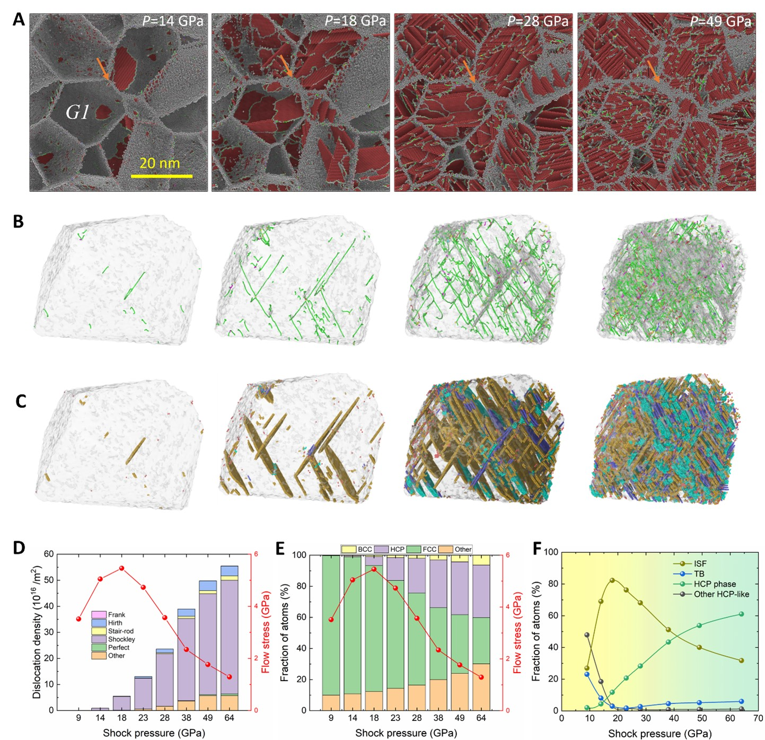
Fig. 2. Deformed microstructure in nanocrystalline CoCrFeMnNi HEA with a grain size of 20 nm under different shock loadings. A Cross-section showing the grain boundaries and HCP atoms bounded by dislocations. Shock pressures of 14 GPa, 18 GPa, 28 GPa, and 49 GPa are selected, respectively. The FCC-structured atoms are removed for clarity. The red atoms in HCP structure belong to the stacking faults and blue atoms are in BCC structure, while the atoms in grey are in grain boundaries or disordered regions inside the grains. B The selected grain, G1, with only dislocations shown. C The selected grain G1 with only HCP atoms in the form of intrinsic stacking faults (ISF), twin boundaries (TB), and HCP phase as well as other HCP-like atoms. D The dislocation density as a function of shock pressure and corresponding flow stress. E The fraction of different structured atoms as a function of the shock pressure and corresponding flow stress. F The fraction of atoms in ISF, TB and HCP phase as well as other HCP-like atoms as a function of shock pressure.

Fig. 3. The deformation mechanisms in nanocrystalline CoCrFeMnNi HEA under shock loading. A Illustrations of the HCP-atom-layer-based ISF, TB and HCP phase transformation. B The L-C dislocation lock. C and D The Hirth dislocation lock. E and F The slice showing the initial grain boundaries and deformed grain boundaries in the sample with a grain size of 6 nm, respectively. The GB thickening and GB bending are observed in shock compressed samples as indicated by the ovals. G A selected slice showing shear strain in the sample with a grain size of 6 nm under shock loading. The GBs have a relatively large shear strain while the grain interiors have a negligibly small shear strain, indicating the sliding behavior of GBs. H A selected slice showing the misorientation in grains. Grains with misorientation indicate grain rotations. The GB atoms are colored in black for reference.

Fig. 3 summarizes the deformation mechanisms in GIs and GBs under shock loading. The occurrence of HCP structured atoms is associated with plastic deformation in GIs (Fig. 3A). Shockley partial dislocations nucleate from GBs and propagate through the grain interior, leaving behind stacking faults. The HCP structured atom layers are in different forms of microstructures. Specifically, the ISFs consist of two HCP-structured atom layers, single HCP-structured atom layers form coherent TB and multiple HCP-structured atom layers form HCP phase. Although Shockley partial dislocations are the majority, we can still observe some other dislocations. For example, Lomer–Cottrell (L-C) locks comprising two stacking faults connected by a stair-rod dislocation are observed (Fig. 3B). Two stacking faults bounded by partial dislocations glide on intersecting {111} planes, where the leading partials form a new partial with new Burgers vector (e.g. $\frac{a}{6}\left[011\right]$ according to the reaction $\frac{a}{6}\left[\overline{2}11\right]+\frac{a}{6}\left[211\right]=\frac{a}{6}\left[011\right]$). Hirth locks are also detected (Fig. 3C and 3D), following the reaction $\frac{a}{6}\left[1\overline{2}\overline{1}\right]+\frac{a}{6}\left[121\right]=\frac{a}{3}\left[100\right].$ These sessile dislocation configurations also contribute to the strain hardening effect. Fig. 3E shows the initial GBs in a selected slice along the loading direction in nanocrystalline samples with a grain size of 6 nm, while Fig. 3F shows the corresponding deformed GBs subject to shock loading.
It is observed that the thickness of the GBs increases under shock loading. GB thickening might be due to thermally induced diffusion of amorphous atoms in the GBs, and pressure-induced amorphization within the vicinity of the GBs. Moreover, GB bending is also observed under shock loading. On one hand, GB bending may be attributed to different diffusion rates along the GBs; on the other hand, local deformations like stacking faults cause unbalanced stresses across two neighboring grains, which could result in GB bending. Nevertheless, GB thickening and GB bending are competing deformation mechanisms, with the former reducing the shear resistance of GBs, causing a strain softening effect, and the latter increasing the shear resistance of GBs, leading to a strain hardening effect. Furthermore, GB activities are expected to prevail in small nano-grain sized samples. Fig. 3G displays the shear strain field in a 6nm grain sized nanocrystalline sample under a shock loading of ~18 GPa. The shear strain is mainly observed in GBs rather than in grain interiors, indicating GB sliding in nanocrystalline sample. Besides, Fig. 3H shows the misorientation of grains for the same sample as shown in Fig. 3G. The misorientation measures the difference of the crystal orientation between the shocked sample and unshocked sample. Thus, the grains with some misorientation indicate that grain rotations have taken place in the shocked nanocrystalline sample. Very small grains can slide and rotate relative to each other rather than undergoing extensive internal deformation. Notably, the misorientation is not evenly distributed, which may indicate the occurrence of both grain shearing and grain twisting in the plastic flow resulting from the shock.

3.3 Grain-size dependence of deformation mechanisms
Regardless of grain sizes, these nanocrystalline HEAs reach the highest flow stresses roughly at 18 GPa of the shock pressure. The stacking faults and their interlacement are responsible for the enhanced flow stress. However, the maximum flow stress is grain size-dependent. Fig. 4 shows the deformation microstructure in nanocrystalline CoCrFeMnNi HEA with different grain sizes subject to the shock compression of ~18 GPa. Fig. 4A shows a cross-section in a steady state region. Four grain sizes (6 nm, 10 nm, 16 nm and 20 nm) are selected for analysis. The cross-sections in different grain sized samples also demonstrate good geometrical similarity in our models. Compared to the samples with smaller grain sizes such as 6 and 10 nm, there is an increased number of HCP atom layers (red atoms in Fig. 4A) in samples with larger grain sizes such as 16 nm and 20 nm. However, a comparison between samples with grain sizes of 16 nm and 20 nm shows that there may be a decrease in the quantity of HCP atoms in some grains. For example, the grain G2 has HCP atom layers in 16 nm grain sized sample but not in 20 nm grain sized sample (Fig. 4A), although the grain G3 shows a continuous increase in the quantity of HCP atoms. Fig. 4B displays the dislocation distribution in grain G3. Similarly, Shockley partial dislocation remains the majority. Fig. 4C presents the different forms of HCP atom layers including ISF, TB, HCP phase, etc. In the selected grain, most of the HCP atoms are in the form of ISFs, and its fraction increases with increasing grain size. The fraction of HCP phase increases slightly for 16 nm and 20 nm grain sized samples. To quantify the deformation mechanisms, Fig. 4D gives the dislocation density of different types of dislocations as a function of grain size. The total dislocation density with a majority of Shockley partial dislocation increases with slight fluctuations. Fig. 4E shows the fraction of different structured atoms as a function of grain size. The fraction of HCP atoms is relatively low compared to that of FCC atoms and other disordered atoms, indicating a small degree of plastic deformation, and it increases continuously with increasing grain size. On the contrary, the fraction of other atoms decreases monotonously. The corresponding flow stress as a function of grain size in the case of ~18 GPa shock pressure is also plotted for reference in Fig. 4D and 4E, respectively. Fig. 4F details the fraction of HCP atoms in the form of ISF, TB, HCP phases and other HCP-like atoms. The fraction of ISF atoms is the largest in this case. It initially increases to a maximum value with grain size increasing to 14 nm and then decreases slightly. Correspondingly, the fraction of HCP phase atoms remains at a relatively low level within grain size of 14 nm. Above 14 nm, however, there is an obvious increase. As for the fraction of TB and other HCP-like atoms, they show a monotonous decrease with increasing grain size. It is interesting to note that the flow stress roughly shows a positive correlation with the fraction of ISF, while the formation of HCP phase is responsible for the decrease of flow stress. The flow stress shows a maximum value at around a grain size of 14 nm in this case. It decreases with decreasing grain size from 14 nm to 2 nm, showing an IHP relation, and also with increasing grain size from 14 nm to 22 nm, showing the conventional HP relationship. It is worth mentioning that even in the IHP regime, the slope of the IHP relationship varies, indicating a varying grain size sensitivity. This suggests a complexity in the IHP and HP relations under dynamic loading conditions.

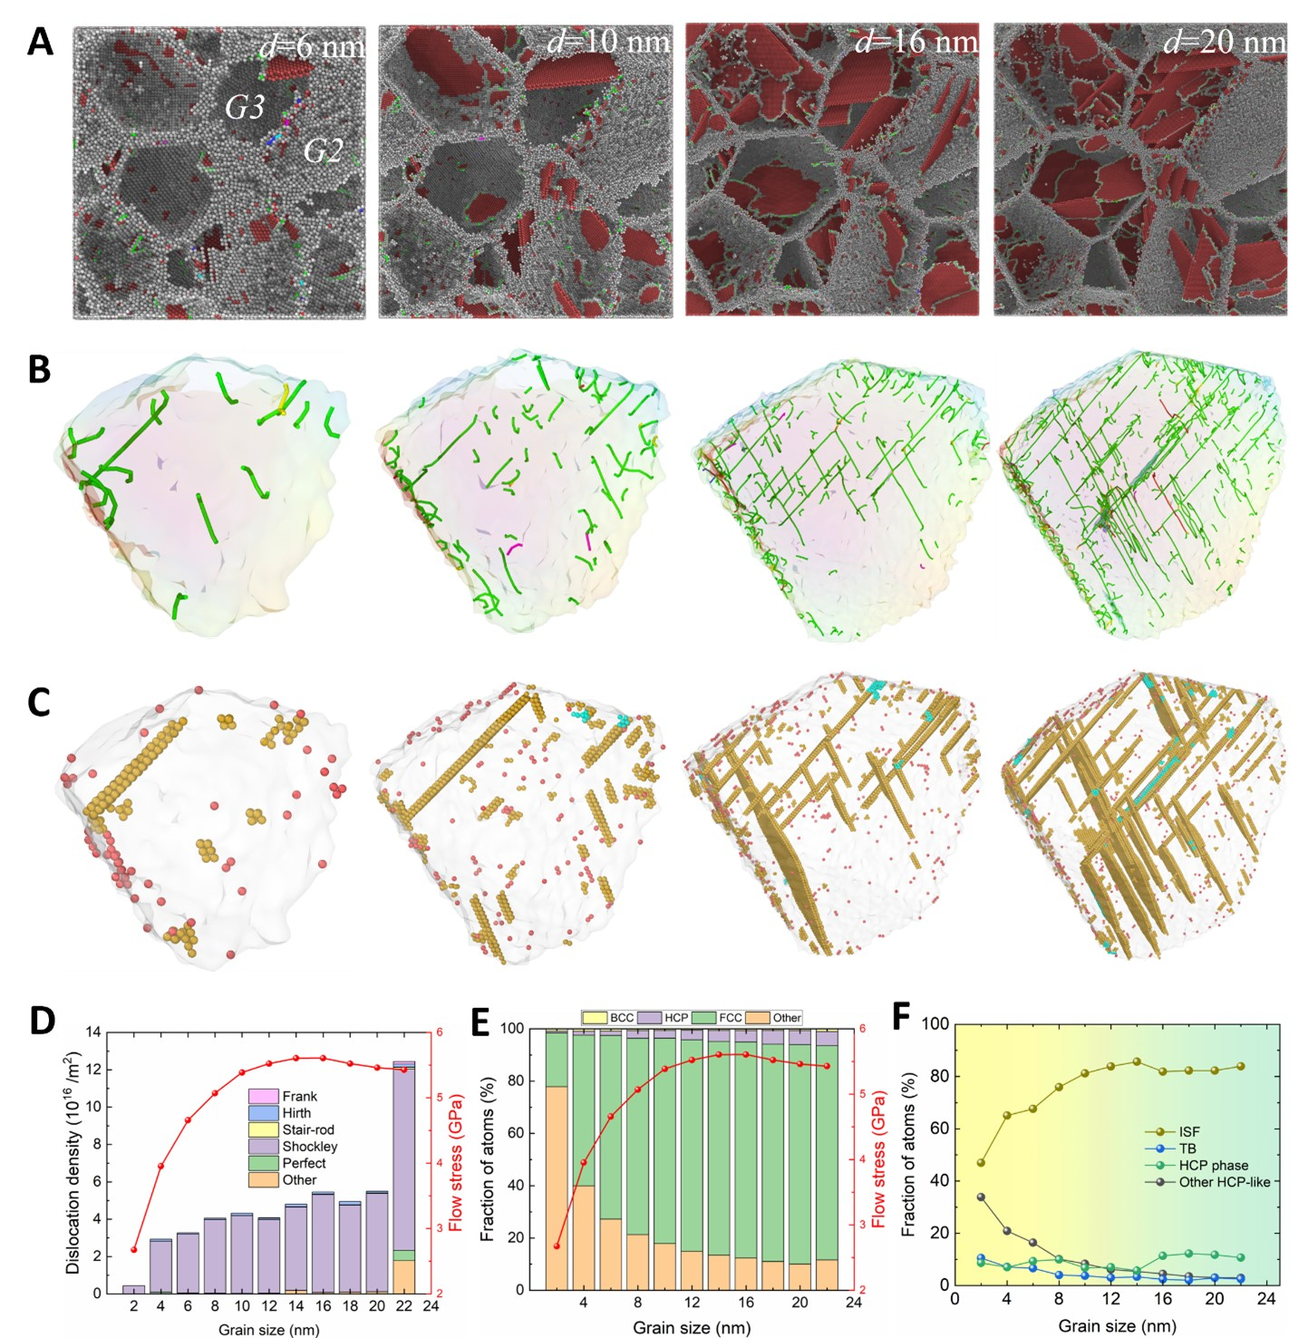
Fig. 4. Deformation mechanisms and microstructure in nanocrystalline CoCrFeMnNi HEA with different grain sizes subjected to a shock compression of ~18 GPa. A Cross-section showing the grain boundaries and HCP atoms bounded by dislocations. Grain sizes of 6 nm, 10 nm, 16 nm, and 20 nm are selected. The FCC-structured atoms are removed for clarity. The red atoms in HCP structure belong to the stacking faults and blue atoms are in BCC structure, while the atoms in grey are in grain boundaries or disordered area inside the grains. B A selected grain G2 with only dislocations shown. C The selected grain G2 with only HCP atoms in the form of intrinsic stacking fault (ISF), twin boundary (TB), and HCP phase as well as other HCP-like atoms. D Dislocation density as a function of grain size and the corresponding flow stress. E The fraction of different structured atoms as a function of grain size and the corresponding flow stress. F The fraction of atoms in the form of ISF, TB and HCP phase as well as other HCP-like atoms as a function of grain size.

Phase transformation becomes significant when the nanocrystalline CoCrFeMnNi HEA is subjected to strong shock loading. Fig. 5 shows the deformation microstructure of HEAs under a shock pressure of ~49 GPa. Four samples with grain sizes of 6 nm, 10 nm, 16 nm, and 22 nm are displayed for illustrations. The cross-sections shown in Fig. 5A demonstrate that a large number of HCP atoms are present in this case. Almost all grains in the cross-sections undergo severe plastic deformation. Fig. 5B shows dislocation distribution in a selected grain. The number of dislocations increases with increasing grain size, although Shockley partial dislocations remain the majority. Correspondingly, all the HCP atoms are differentiated in the form of ISF, TB, HCP phase and other HCP-like atoms, as shown in Fig. 5C. It is clearly observed from the figure that the amount of HCP phase becomes comparable with that of ISFs, demonstrating that the structural phase transformation from FCC to HCP becomes dominant under strong shocks.
To provide further quantitative insights, Fig. 5D shows the dislocation density as a function of grain size. Although Shockley partial dislocation has the largest fraction, the Hirth dislocation and “other” type dislocations become considerable as well, which increase gradually with increasing grain size. Fig. 5E displays the fraction of different structured atoms as a function of grain size. It is seen that the fraction of HCP atoms increases with increasing grain size. On the contrary, the fraction of other disordered atoms decreases with increasing grain size. Notably, the fraction of other disordered atoms reaches ~83% at a grain size of 2 nm, which is much higher than at other grain sizes. Interestingly, the fraction of BCC structured atoms shows a very weak dependence on grain size in this case. Moreover, the fraction of FCC structured atoms is less than 40% and decreases with decreasing grain size, which also demonstrates that most of atoms in the sample are involved in the severe plastic deformation. Fig. 5F details the fractions of ISF, TB, HCP phase and other HCP-like atoms. For the ISF, its fraction increases initially when the grain size increases from 2 nm to 4 nm and then stabilizes with slight fluctuations until the grain size exceeds 10 nm. The fraction of ISF decreases to a relatively low level for grain sizes larger than 14 nm. For the HCP phase, the corresponding fraction increases with fluctuations as the grain size increases. Importantly, there is a critical grain size of 12 nm, above which the fraction of HCP phase becomes larger than that of ISF. As for the TB, its fraction decreases monotonously with increasing grain size, albeit with a small slope.

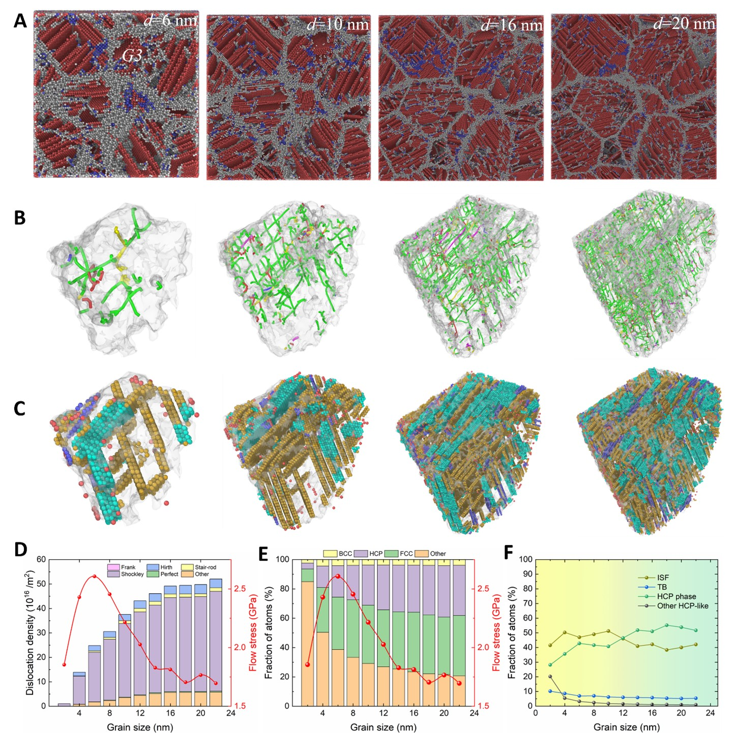Fig. 5. Deformation mechanisms and microstructure in nanocrystalline CoCrFeMnNi HEA with different grain sizes subjected to a shock compression of 49 GPa. A Cross-section showing the grain boundaries and HCP atoms bounded by dislocations. Grain sizes of 6 nm, 10 nm, 16 nm, and 20 nm are selected. The FCC-structured atoms are removed. The red atoms in HCP structure belongs to the stacking faults and blue atoms are in BCC structure, while the atoms in grey are in grain boundaries or disordered area inside the grains. B The selected grain G3 with only dislocations shown. C The selected grain G2 with only HCP atoms in the form of intrinsic stacking fault (ISF), twin boundary (TB), and HCP phase as well as other HCP-like atoms. D dislocation density as a function of grain size and the corresponding flow stress. E The fractions of different structured atoms as a function of grain size and the corresponding flow stress. F The fractions of atoms in the form of ISF, TB and HCP phase as well as other HCP-like atoms as a function of grain size.

4 Discussion
4.1 Multi-competing hardening and softening effects
The shock response of nanocrystalline CoCrFeMnNi HEAs has been shown to depend on both their internal microstructure and external loading conditions. The flow stress behind the shock wavefront is influenced partly by the interplay of grain size, shock pressure, shock-induced temperature rise as well as strain. With increasing shock intensity, the flow stress initially increases and then decreases regardless of the grain size. For a given grain size, with increasing shock pressure, more stacking faults bounded by Shockley partial dislocations are nucleated. These stacking fault layers are identified to be in HCP structure and appear in the form of ISF, TB, and HCP phase. The dominant deformation mechanisms vary from ISFs to HCP phase formation in GIs with increasing shock intensity. Increasing shock intensity also results in GB thickening accompanied with GB bending. Due to limited deformation capacity in small GIs, the nanocrystalline samples with small grains also show GB sliding accompanied with grain rotation in some grains. Therefore, both the GI deformation and the GB activities are responsible for shock relaxation behind the shock wavefront. However, the ISFs and their interlacement in the grain interior and GB bending contribute to strain hardening, while the formation of HCP phase, GB thickening, GB sliding, and grain rotation contribute to strain softening.
Under one-dimensional strain shock loading, there is an increase in both hydrodynamic pressure and temperature behind the shock wavefront as the shock intensity increases. The hydrodynamic pressure typically exhibits a confinement effect, resulting in an increase in material strength due to induced hardening, while the temperature rise tends to have a softening effect. Therefore, there are several competing effects working cooperatively within the material subjected to one-dimensional strain shock loading, including the hardening effects arising from hydrodynamic pressure, ISF interlacement, and GB bending, and the softening effects arising from HCP phase formation, GB thickening, GB sliding, and grain rotation. Furthermore, these competing effects are intrinsically interconnected and exhibit a strong dependence on grain size, particularly with regard to ISF-related strain hardening and HCP phase-related strain softening. For a given shock pressure below ~18 GPa, the ISFs are the dominant deformation mechanism. The fraction of ISF atoms increases to a maximum value as the grain size increases to a critical value with respect to the maximum flow stress, showing an IHP relationship. For shock pressures higher than ~18 GPa, HCP phase formation becomes more significant, and dominates the decrease in flow stress. The fraction of HCP phase generally becomes larger with fluctuations as the grain size increases, thus responsible for the HP behavior where the flow stress decreases with increasing grain size. Notably, in cases of strong shock loading, although the grain size-dependent HCP phase formation and ISF interlacement are significant, the thickening, bending and sliding of GBs, and the rotation of grains are non-negligible. GB thickening is more significant in samples with smaller grain sizes, which is responsible for the IHP relationship, where the flow stress decreases with decreasing grain size. Thicker GBs not only promote the emission of Shockley partial dislocations, which contributes to the decrease of the critical grain size, but also promote the activities of GB deformation itself. It is also worth mentioning that the IHP behavior of the nanocrystalline metals/alloys could be even more complicated. From a logical perspective, any deformation that weakens the GBs, for example, easier transmission of SFs to GBs (Ding et al., 2023), easier nucleation of cavities at GBs (Zhang et al., 2020b), might lead to a breakdown of HP regime. Oppositely, deformations that enhance the GBs can suppress the IHP behavior. Grain boundary segregation in HEAs is an important feature. Previous work (Li et al., 2023a) has already revealed the segregation behavior in CoCrFeMnNi HEA. Comparison between the random solid solution (RSS) model and the chemical short-range ordering (SRO) model of CoCrFeMnNi HEA has shown that the fraction of Cr increases in GBs followed by Mn which is in excellent agreement with recent experimental observations (Maldonado et al., 2023) in bulk CoCrFeMnNi HEA where Cr strongly segregates to the GBs along with the weak segregation of Mn, implying co-segregation of Cr and Mn to the GBs. Additional MD simulations on SRO model under different shock loadings (see Fig. S4 in Supplementary Material) show that SRO can enhance the flow stress of a nanocrystalline HEA compared to the RSS model when the shock pressure is not very high, while it causes almost no difference for cases of high shock pressures. Thus, it is reasonable to deduce that GB segregation leads to an improvement of the GB strength in nanocrystalline CoCrFeMnNi HEA. From this perspective, GB segregation can lead to a decrease in the critical grain size for HP-IHP transition. Moreover, the flow stress is thought to be influenced by initial temperature as well. On one hand, a higher initial temperature results in lower flow stress due to thermal softening effects. On the other hand, increasing temperature also increase the stacking fault energy. Additional MD simulations of nanocrystalline CoCrFeMnNi HEA under shock loading with an initial temperature of 300 K (see Fig.S5 in Supplementary Material) show that the flow stresses at 300 K are lower than those at 1 K indicating that increasing temperature would reduce the strength of the nanocrystalline HEA mainly due to the softening effect. Such softening effects are more pronounced in larger grain-sized samples. Thus, higher initial temperature can lead to a decrease in the critical grain size for HP-IHP transition.
Overall, our work reveals that, for a given grain size, nanocrystalline CoCrFeMnNi HEA undergoes a transition from strain hardening to strain softening with increasing shock intensity. This transition is driven by the competing influence of rising hydrodynamic pressure and elevated temperature, coupled with distinct deformation mechanisms. Conversely, for a given shock intensity, the flow stress shows a transition from HP to IHP behaviors. This transition occurs because dominant deformation mechanisms shift from favoring partial dislocation-mediated plasticity (at relatively lower shock pressure) or phase transformation-mediated plasticity (at high shock pressure) to favoring grain boundary-dominated plasticity. Moreover, we find that the critical grain size for the transition from HP to IHP is pressure-dependent. It increases initially and then decreases significantly with increasing shock intensity, which is attributed to the complex interplay of multi-competing effects, where both high pressure and high temperature act in opposing softening and hardening regimes, respectively.

4.2 Analytical models for flow stress
The strength of the nanocrystalline HEAs is influenced by both GIs and GBs. Generally, when dislocation generation and motion is dominant within the GIs in alloys/metals, the shear strength of the materials is largely determined by GIs. Conversely, when dislocation activity in GIs become too energetically costly, GB activities become dominant and the stress required to deform grain boundaries becomes the determinant for the maximum strength of the material (Chandross and Argibay, 2020). Therefore, it is reasonable to assume that the strength of the nanocrystalline HEAs is determined by the minimum of the strength of the GI and that of the GB, i.e.,
$σ_{flow}=min⁡\{σ_{GI},σ_{GB}\}$ (3)
The effectiveness of such measurement of strength has also been demonstrated by Bringa et al., (Bringa et al., 2005). However, in their models for calculating the flow stress, only pressure-induced hardening effect and grain-size dependence are considered. Based on our fundamental understanding revealed here, the flow stress is an outcome of the complex interplay of various grain size-dependent and pressure-dependent hardening and softening effects. The flow stress is, at the very least, a function of shock pressure, shock-induced temperature, strain, as well as grain size. The transition from HP to IHP behaviors indicates the change in the dominated deformation mechanisms from GI deformations to GB activities. For the strength of the GI in nanocrystalline HEAs, we assume that it follows the classical HP relationship:
$σ_{GI}=σ_{0}+\frac{K(T)}{\sqrt{d}}$ (4)
where $σ_{0}$ is the initial friction stress, $d$ is the grain size. Notably, the slope in the HP relation is temperature-dependent. This assumption is reasonable because experimental studies have successfully reported the strengths of HEAs including CoCrFeMnNi are proportional to$d^{-1/2}$ (Liu et al., 2013).
In general, the flow stress can be assumed to have a linear relationship with temperature and pressure, similar to the classical Steinberg–Cochran–Guinan model (Steinberg et al., 1980). Furthermore, because strain hardening and softening are important in determining the flow stress, we propose the following equation to consider the temperature softening, pressure hardening, and strain hardening and softening as well as grain size dependence:
$σ_{GI}=\left(σ_{0}+\frac{K(T)}{\sqrt{d}}\right)*(1-\frac{T-T_{0}}{T_{m}-T_{0}})*\left(1+λ*P\right)*\left(1+{C_{1}ε}^{A_{1}-1}{*e}^{-B_{1}ε^{A_{1}}}\right)$ (5)
where the first multiplier gives the grain size dependence of the strength, the second multiplier denotes the temperature softening effect, the third multiplier represents the shock pressure hardening effect and the fourth multiplier implies the coupling strain hardening (${C_{1}ε}^{A_{1}-1}$) and strain softening effects ($e^{-B_{1}ε^{A_{1}}}$). In the eq. (5), the $σ_{0}=$ 0.2875 GPa, K(T)= 676.65-0.39*T initialized from references (Liu et al., 2013; Sun et al., 2019); T is the temperature; $T_{m}$ is the melting point 1680 K at zero pressure, $λ$ is the pressure coefficient and can be estimated as 0.02 /GPa (Coppieters et al., 2020), P is the shock pressure. A1, B1, C1 are the strain hardening- and softening-related material constants. As there are currently no analytical models to determine these material parameters, they could be reasonably determined by fitting the data from a large grain sized sample (e.g. $d$ = 22 nm) as this case is always in the HP regime in the current work (see Fig. S3A in Supplementary Materials). Notably, previous studies have reported that the Hugoniot pressure and temperature as a function of volume change has no clear dependence on the grain size (Sichani and Spearot, 2015; Yang et al., 2018). The average strain and average temperature primarily depend on shock pressure rather than grain size. Thus, taking the average strain and average temperature as solely dependent on pressure in our model is a reasonable and acceptable assumption.
For the strength of GBs at ambient pressure and temperature, we adopt the amorphization model without any adjustable parameters to predicts the peak strength of polycrystalline metals (Chandross and Argibay, 2020) as follows:
$σ_{GB}=L\frac{ρ_{L}}{M}*{\left(\frac{d-δ}{d}\right)}^{3}$ (6)
Similarly, when considering the coupling effect of temperature softening, pressure hardening, and strain softening and strain hardening, the following equation is assumed:
$σ_{GB}=\left(L\frac{ρ_{L}}{M}*{\left(\frac{d-δ}{d}\right)}^{3}\right)*(1-\frac{T-T_{0}}{T_{m}-T_{0}})*\left(1+λ*P\right)*\left(1+{C_{2}ε}^{A_{2}-1}{*e}^{-B_{2}ε^{A_{2}}}\right)$ (7)
where the parametrization in amorphization model is obtained from reference (Jones et al., 2020). Specifically, L=16.2 kJ/mol is the heat of fusion; $ρ_{L}≅$ 7200 kg/m³ is the liquid density at melting point; M = 0.056 kg/mol is the molar mass; T is the temperature; $T_{m}$=1680 K is the melting point, P is the shock pressure;$δ$=0.52 is the initial GB thickness; $λ$ is the pressure coefficient and can be estimated as 0.02 /GPa (Coppieters et al., 2020); and A2, B2, C2 are the strain hardening- and softening-related material constants, which could be similarly determined by fitting the data from a sample with a small grain size (e.g. $d$= 4 nm) as this case is always in the IHP regime in the current work (see Fig. S6B in Supplementary Materials). The average temperature and strain in the steady state region as a function of shock pressure are also provided in Fig. S6 C-D in Supplementary Materials. The summaries of the model parameters are displayed in Table 1 and 2.
Table 1 Model parameters for strength of GI in equation 5.
$σ_{0}$ (GPa) | $K(T)$ (K) | $T_{m}$ (K) | $T_{0}$ (K) | $λ_{1}$ (GPa⁻¹) | $$A_{1}$$ | $$B_{1}$$ | $$C_{1}$$
0.2875 | 676.65-0.39*T | 1680 | 1 | 0.02 | 2.3693 | 236.6692 | 125.0278
Liu et al., 2013 | Sun et al., 2019 | This work | This work | Coppieters et al., 2020 | This work | This work | This work

Table 2 Model parameters for strength of GB in equation 7
$L$ (kJ/mol) | $ρ_{L}$ (kg/m³) | $M$ (kg/mol) | $δ$ (nm) | $T_{m}$ (K) | $T_{0}$ (K) | $λ_{2}$ (GPa⁻¹) | $$A_{2}$$ | $$B_{2}$$ | $$C_{2}$$
16.2 | 7200 | 0.056 | 0.52 | 1680 | 1 | 0.02 | 2.0736 | 72.2950 | 25.2769
Jones et al., 2020 | Jones et al., 2020 | Jones et al., 2020 | This work | This work | This work | Coppieters et al., 2020 | This work | This work | This work

Based on equations (3), (5) and (7), we can calculate and predict the flow stress for samples with a given shock pressure and grain size (see Fig. S4 in Supplementary Materials). A more general description of the varying HP and IHP transition is given in Fig. 6. According to the models in equations (4) and (6), we are able to determine the critical grain sizes between HP and IHP relationships in a wide range of shock pressures. Fig. 6A-C displays a 3-dimensional map showing the predicted flow stress as a function of shock pressure and grain size from different visual angles. The flow stress first increases significantly and then decreases drastically with increasing shock pressure. The critical grain size for the HP-IHP transition varies with shock pressure. Interestingly, there exists a critical range of pressure roughly between 14 and 20 GPa, where both the flow stress and the critical grain size are at maximum values. To highlight the grain size boundary for the HP and IHP transition, the red solid line in Fig. 6D plots the critical grain size for the HP and IHP transition as a function of shock pressure. The critical grain size initially increases below ~15 GPa, and then decreases dramatically to ~5 nm when the shock pressure increases to ~38 GPa. The critical grain size roughly plateaus at ~5-6 nm for shock pressures ranging from ~38 to ~64 GPa. Further increase in shock pressure (>~64 GPa) results in a persistent decrease in the critical grain size.
It is important to highlight that the varying critical grain size for the HP and IHP transition results from the complex interplay of multiple effects. Although the HP-IHP transition is attributed to the change of dominant deformation mechanisms from GI-mediated plastic behavior to GB-dominated activities over the range of shock pressures explored in the current work, the actual activated deformation mechanisms vary with the shock pressure. For GIs, the main deformation mechanisms vary from stacking faults (corresponding to the nucleation and propagation of Shockley partial dislocations) to HCP phase transformation, and even amorphization with increasing shock pressure. Therefore, the increase in the critical grain size under shock pressure below 15 GPa mainly corresponds to ISF in GIs. The subsequent decrease of the critical grain size at shock pressures between 15 GPa and 38 GPa is related to the activation of HCP formation and its fast growth. Then, the plateau at shock pressures between 38 GPa and 64 GPa corresponds to the large amount of accumulated HCP phase and its slow increase. Finally, the decrease of the critical grain size at shock pressures higher than 64 GPa corresponds to amorphization and its fast growth, where the amorphous atoms have a larger percentage than HCP structured atoms (see Fig. S5 in Supplementary Materials). For GBs, GB sliding and rotation are two fundamental mechanisms. However, GB thickness increases in prominence with increasing shock pressure. This indicates that it is crucial to identify the dominant deformation mechanisms in both GIs and GBs under varying shock conditions, in order to understand the varying HP and IHP transition in nanocrystalline HEAs. The findings in our work successfully reveal the deformation mechanisms and the regimes of varying HP-IHP transitions, which provides a comprehensive understanding for the design and optimization of nanocrystalline CoCrFeMnNi HEA materials for impact applications. In addition, the proposed model for flow stress under shock loading is expected to be applicable in studying HP-IHP transitions in materials with complex microstructures and compositions.

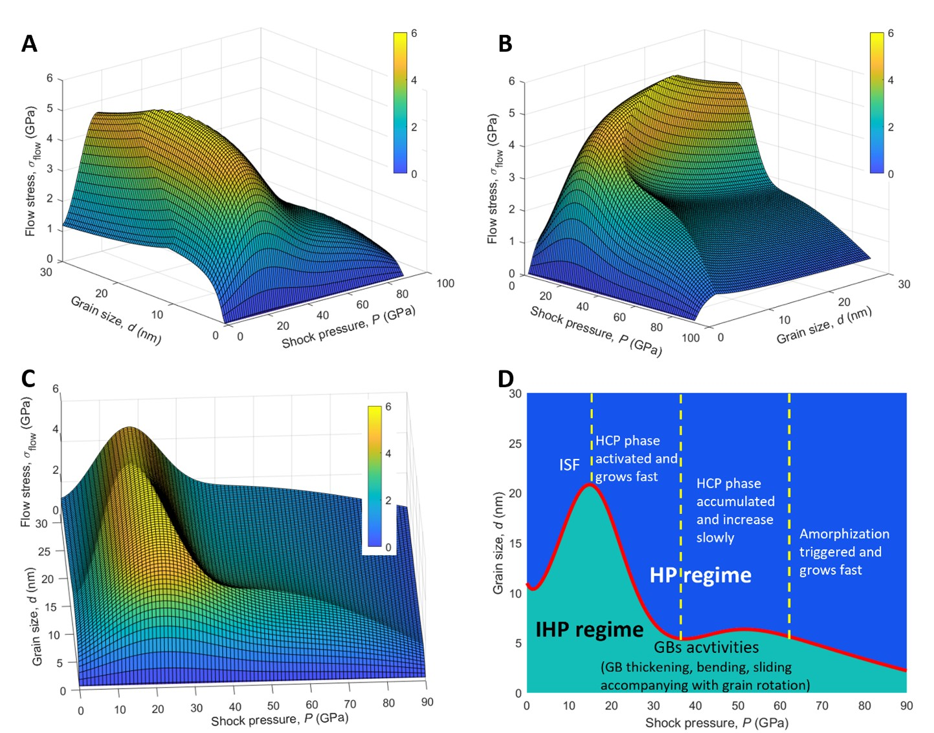

Fig. 6. The maps of predicted flow stress as a function of shock pressure and grain size and the corresponding deformation mechanisms of CoCrFeMnNi HEA under various shock loadings. A-C The three-dimensional surface showing the flow stress as a function of shock pressure and grain size. The flow stress and critical grain size are maximized at a similar range of shock pressure between 14 and 20 GPa. D The solid red line is the critical grain size boundary for the HP-IHP transition as a function of shock pressure. Domain below the red line corresponds to the IHP regime, while that above the red line to the HP regime. The dominant deformation mechanisms in GIs vary from stacking faults, HCP phase formation and its accumulation as well as amorphization with increasing shock pressure. These deformation mechanisms in GIs dominate the HP regime. In contrast, GB activities including GB sliding, rotation and thickening with increasing shock pressure dominate the IHP regime. The yellow dashed lines at 15 GPa, 38 GPa and 64 GPa are added to distinguish the four regimes.

4.3 General remark
Our present work comprehensively explores the HP and IHP relationships of the flow stress behind the shock wavefront in nanocrystalline HEAs across a wide range of shock pressures. It also provides a detailed account of the grain size-dependent deformation mechanisms. It is encouraging that the deformation mechanisms that we have identified align with findings from existing experiments. For instance, previous studies have reported the presence of a complex hierarchy of deformation mechanisms, involving stacking faults, twins, structural transformations from FCC to HCP, and amorphization, in HEAs subjected to dynamic loading (Zhao et al., 2021). The abundant plastic deformation mechanisms have been attributed to the relative low stacking fault energy of the HEA (Huang et al., 2015), and can be triggered under typical dynamic loading conditions encountered in SHPB, light-gas-gun and laser shock experiments, suggesting they are common characteristics of low stacking fault energy HEAs under dynamic loading. Our work reveals the grain size dependence of these mechanisms and establishes their link to the HP-IHP transition with a shock pressure-dependent critical grain size. Notably, within the typical strain rates in dynamic experiments typically varying from 10³- 10⁸ s⁻¹ (Albertazzi et al., 2017; Zhao et al., 2023, 2021), the strength has been reported to show positive strain-rate sensitivity, in alignment with our simulations. The excellent strain hardening ability and moderate thermal-softening effect reported in experiments are also identified in our simulations. Moreover, by taking advantage of MD simulations, our work has revealed in-situ microstructure evolution related to these deformation mechanisms, which is still challenging for dynamic experiments. Thus, our work provides not only an important supplement to the dynamic experiment, but also a guide to explore the HP-IHP transition in HEAs under shock loading. Interestingly, the breakdown of HP strength scaling in nanocrystalline Ni–W alloys at high strain rates (~10³ s⁻¹) has been reported experimentally by Jason and Christopher (Trelewicz and Schuh, 2008), using dynamic hardness testing at grain sizes ranging from 3 to 150 nm. The HP-IHP transition with a pronounced strength peak at grain size near 10-20 nm has been observed in their experiment, which was attributed to a grain size-dependent rate sensitivity. Such experimentally found HP-IHP transition in alloys at high strain rate supports our results to some extent as well although the dynamic loading condition and material system differ. In addition, our observations also hold close relevance to MEAs exposed to increasing shock intensities (Zhao et al., 2023), suggesting that our work may serve as a valuable reference for investigations into similar HEAs and MEAs under dynamic loading conditions.
Furthermore, compared to the conventional HP-IHP relations at ambient pressure and temperature under quasi-static loading conditions, where only one critical grain size exists, the shock loading conditions result in varying HP-IHP transitions and different critical grain sizes. These varying HP-IHP transitions and the critical grain sizes are a result of the complex interplay among multi-competing deformation mechanisms in both GIs and GBs in nanocrystalline HEAs. More importantly, the dominant deformation mechanisms change hierarchically from ISFs to HCP phase transformation, and to amorphization with increasing shock pressure, resulting in a highly nonlinear critical grain size as a function of shock pressure. This also indicates that the critical grain size for HP-IHP transition cannot be simply predicted without a deep understanding of the shock pressure-dependent deformation mechanisms. Thus, our work represents a significant advance in addressing this critical issue, with valuable insights for both materials and mechanics communities.

5 Conclusion
In this work, we investigate the HP to IHP transition in nanocrystalline CoCrFeMnNi HEAs under shock loading by examining their deformation mechanisms and flow stresses using large-scale molecular dynamics (MD) simulations. We leverage a series of advanced methods to dissect the dynamic mechanical properties and the corresponding deformation mechanisms in nanocrystalline HEAs under shock loading. The main conclusions in present work are as follows:
(1) Revealing the shock pressure-dependent HP-IHP transition of flow stress as a result of the complex interplay among multiple competing deformation mechanisms, including the hardening mechanisms such as dislocations interactions and grain boundary (GB) blocking, as well as the softening mechanisms like phase formation, amorphization, GB thickening, and grain rotation;
(2) Revealing hierarchical deformation mechanisms of nanocrystalline HEA from intrinsic stacking faults (ISFs) to FCC-HCP phase transformation and to amorphization under shock loading, and their roles in influencing the critical grain size for HP-IHP transition. there exist different critical shock pressures for the largest critical grain size for the HP-IHP transition and the maximum of the strength, respectively. Below the critical shock pressure, the critical grain size increases with pressure due to a stronger hardening effect in grain interior (GIs), while above the pressure, the critical grain size first decreases and then undergoes a pressure-insensitive plateau before further decrease due to softening effects in GIs.
(3) Successfully extending the HP-IHP relationships to dynamic loading conditions by proposing analytical models between flow stress and grain size as well as shock intensity to capture the varying HP-IHP transition in which different deformation mechanisms are included.
Our comprehensive and systematical study here provides deep insights into the deformation in CoCrFeMnNi HEA subjected to shock loading and provides valuable guidance for optimizing the grain size of nanocrystalline HEAs for applications involving dynamic loadings. Thus, the present simulations present a systematic exploration in dissecting the complex interplay of multiple competing deformation mechanisms in HEAs and the shock pressure-dependent HP-IHP transition in nanocrystalline HEAs under dynamic loading. Our work represents a significant advance in addressing such critical issues, with valuable insights for both materials and mechanics communities.

Acknowledgments
WL and YWZ acknowledge the financial supports from the AISG Grand Challenge in AI for Materials Discovery (AISG2-GC-2023-010), the A*STAR SERC CRF Award, and A*STAR Computational Resource Centre through the use of its high performance computing facilities. The computational work in this article was partially performed on resources of the National Supercomputing Centre (NSCC), Singapore (https://www.nscc.sg). WL acknowledges funding by the Agency for Science, Technology and Research (A*STAR) of Singapore with the Manufacturing, Trade and Connectivity (MTC) Programmatic Grant “Advanced Models for Additive Manufacturing” (M22L2b0111). MZX acknowledges the financial support by the National Natural Science Foundation of China (No.12272061).

References

Albertazzi, B., Ozaki, N., Zhakhovsky, V., Faenov, A., Habara, H., Harmand, M., Hartley, N., Ilnitsky, D., Inogamov, N., Inubushi, Y., Ishikawa, T., Katayama, T., Koyama, T., Koenig, M., Krygier, A., Matsuoka, T., Matsuyama, S., McBride, E., Migdal, K.P., Morard, G., Ohashi, H., Okuchi, T., Pikuz, T., Purevjav, N., Sakata, O., Sano, Y., Sato, T., Sekine, T., Seto, Y., Takahashi, K., Tanaka, K., Tange, Y., Togashi, T., Tono, K., Umeda, Y., Vinci, T., Yabashi, M., Yabuuchi, T., Yamauchi, K., Yumoto, H., Kodama, R., 2017. Dynamic fracture of tantalum under extreme tensile stress. Sci. Adv. 3, 1–7.
Bai, Y., Zhang, K., Chen, T., Liu, Z., Wang, Y., Wei, B., 2022. Alterable tension-compression asymmetry in work hardening of an additively manufactured dual-phase high-entropy alloy. Int. J. Plast. 158, 103432.
Branicio, P.S., Nakano, A., Kalia, R.K., Vashishta, P., 2013. Shock loading on AlN ceramics: A large scale molecular dynamics study. Int. J. Plast. 51, 122–131.
Bringa, E.M., Caro, A., Wang, Y., Victoria, M., McNaney, J.M., Remington, B.A., Smith, R.F., Torralva, B.R., Van Swygenhoven, H., 2005. Materials science: Ultrahigh strength in nanocrystalline materials under shock loading. Science (80-. ). 309, 1838–1841.
Cantor, B., Chang, I.T.H., Knight, P., Vincent, A.J.B., 2004. Microstructural development in equiatomic multicomponent alloys. Mater. Sci. Eng. A 375–377, 213–218.
Cao, Z.H., Zhai, G.Y., Ma, Y.J., Ding, L.P., Li, P.F., Liu, H.L., Lu, H.M., Cai, Y.P., Wang, G.J., Meng, X.K., 2021. Evolution of interfacial character and its influence on strain hardening in dual-phase high entropy alloys at nanoscale. Int. J. Plast. 145.
Chandan, A.K., Kishore, K., Hung, P.T., Ghosh, M., Chowdhury, S.G., Kawasaki, M., Gubicza, J., 2022. Effect of nickel addition on enhancing nano-structuring and suppressing TRIP effect in Fe40Mn40Co10Cr10 high entropy alloy during high-pressure torsion. Int. J. Plast. 150.
Chandross, M., Argibay, N., 2020. Ultimate Strength of Metals. Phys. Rev. Lett. 124.
Chen, M., Ma, E., Hemker, K.J., Sheng, H., Wang, Y., Cheng, X., 2003. Deformation twinning in nanocrystalline aluminum. Science (80-. ). 300, 1275–1277.
Choi, W.M., Jo, Y.H., Sohn, S.S., Lee, S., Lee, B.J., 2018. Understanding the physical metallurgy of the CoCrFeMnNi high-entropy alloy: An atomistic simulation study. npj Comput. Mater. 4, 1–9.
Chu, C., Chen, W., Huang, L., Wang, H., Chen, L., Fu, Z., 2024. Exceptional strength-ductility synergy at room and liquid nitrogen temperatures of Al7.5Co20.5Fe24Ni24Cr24 high-entropy alloy with hierarchical precipitate heterogeneous structure. Int. J. Plast. 175, 103939.
Coppieters, S., Jackel, M., Kraus, C., Kuwabara, T., Barlat, F., 2020. Influence of a hydrostatic pressure shift on the flow stress in sheet metal, in: Procedia Manufacturing. Elsevier B.V., pp. 1245–1249.
Dai, S.C., Xie, Z.C., Wang, Y.J., 2022. Atomistic interpretation of extra temperature and strain-rate sensitivity of heterogeneous dislocation nucleation in a multi-principal-element alloy. Int. J. Plast. 149, 103155.
Ding, Q., Li, Y., Ouyang, J., Wei, X., Zhang, Z., Gao, Y., Bei, H., 2023. The effect of stacking fault energy on the formation of nano twin/HCP during deformation in FCC concentrated solid solution (CSS) alloys. Mater. Today Nano 24, 100407.
Ding, Z.Y., He, Q.F., Wang, Q., Yang, Y., 2018. Superb strength and high plasticity in laves phase rich eutectic medium-entropy-alloy nanocomposites. Int. J. Plast. 106, 57–72.
Dong, J.L., Li, F.C., Gu, Z.P., Jiang, M.Q., Liu, Y.H., Wang, G.J., Wu, X.Q., 2023. Impact resistance and energy dissipation mechanism of nanocrystalline CoCrNi medium entropy alloy nanofilm under supersonic micro-ballistic impact. Int. J. Plast. 171, 103801.
Dupont, V., Germann, T.C., 2012. Strain rate and orientation dependencies of the strength of single crystalline copper under compression. Phys. Rev. B - Condens. Matter Mater. Phys. 86, 1–5.
Fang, Q., Chen, Y., Li, J., Jiang, C., Liu, B., Liu, Y., Liaw, P.K., 2019. Probing the phase transformation and dislocation evolution in dual-phase high-entropy alloys. Int. J. Plast. 114, 161–173.
Feng, L., Li, W., Hahn, E.N., Branicio, P.S., Zhang, X., Yao, X., 2022. Structural phase transition and amorphization in hexagonal SiC subjected to dynamic loading. Mech. Mater. 164, 104139.
Figueiredo, R.B., Kawasaki, M., Langdon, T.G., 2023. Seventy years of Hall-Petch, ninety years of superplasticity and a generalized approach to the effect of grain size on flow stress. Prog. Mater. Sci.
Foley, D.L., Huang, S.H., Anber, E., Shanahan, L., Shen, Y., Lang, A.C., Barr, C.M., Spearot, D., Lamberson, L., Taheri, M.L., 2020. Simultaneous twinning and microband formation under dynamic compression in a high entropy alloy with a complex energetic landscape. Acta Mater. 200, 1–11.
Fu, W., Huang, Y., Sun, J., Ngan, A.H.W., 2022. Strengthening CrFeCoNiMn0.75Cu0.25 high entropy alloy via laser shock peening. Int. J. Plast. 154, 103296.
George, E.P., Raabe, D., Ritchie, R.O., 2019. High-entropy alloys. Nat. Rev. Mater.
Guo, L., Wang, L., Gao, N., Chen, Y., Liu, B., Hu, W., Xiao, S., Wang, K., Gao, F., Deng, H., 2022. Orientation dependence of shock-induced change of habit plane for the 1/2<111> dislocation loop and plasticity in tungsten. Int. J. Plast. 155, 103329.
Gupta, A., Jian, W.R., Xu, S., Beyerlein, I.J., Tucker, G.J., 2022. On the deformation behavior of CoCrNi medium entropy alloys: Unraveling mechanistic competition. Int. J. Plast. 159, 103442.
Hahn, E.N., Meyers, M.A., 2015. Grain-size dependent mechanical behavior of nanocrystalline metals. Mater. Sci. Eng. A 646, 101–134.
He, F., Yang, Z., Liu, S., Chen, D., Lin, W., Yang, T., Wei, D., Wang, Z., Wang, J., Kai, J. jung, 2021. Strain partitioning enables excellent tensile ductility in precipitated heterogeneous high-entropy alloys with gigapascal yield strength. Int. J. Plast. 144, 103022.
He, J., Wang, Q., Zhang, H., Dai, L., Mukai, T., Wu, Y., Liu, X., Wang, H., Nieh, T.G., Lu, Z., 2018. Dynamic deformation behavior of a face-centered cubic FeCoNiCrMn high-entropy alloy. Sci. Bull. 63, 362–368.
Hu, J., Shi, Y.N., Sauvage, X., Sha, G., Lu, K., 2017. Grain boundary stability governs hardening and softening in extremely fine nanograined metals. Science (80-. ). 355, 1292–1296.
Hua, D., Xia, Q., Wang, W., Zhou, Q., Li, S., Qian, D., Shi, J., Wang, H., 2021. Atomistic insights into the deformation mechanism of a CoCrNi medium entropy alloy under nanoindentation. Int. J. Plast. 142, 102997.
Huang, C., Peng, X., Yang, B., Xiang, H., Sun, S., Chen, X., Li, Q., Yin, D., Fu, T., 2018. Anisotropy effects in diamond under nanoindentation. Carbon N. Y. 132, 606–615.
Huang, S., Li, W., Lu, S., Tian, F., Shen, J., Holmström, E., Vitos, L., 2015. Temperature dependent stacking fault energy of FeCrCoNiMn high entropy alloy. Scr. Mater. 108, 44–47.
Huang, Y., Xiong, Y., Li, P., Li, X., Xiao, S., Deng, H., Zhu, W., Hu, W., 2019. Atomistic studies of shock-induced plasticity and phase transition in iron-based single crystal with edge dislocation. Int. J. Plast. 114, 215–226.
JIAN, W., REN, L., 2024. Insights into orientation-dependent plasticity deformation of HfNbTaTiZr refractory high entropy alloy: An atomistic investigation. Int. J. Plast. 173, 103867.
Jiang, K., Zhang, Q., Li, J., Li, X., Zhao, F., 2022. Abnormal hardening and amorphization in an FCC high entropy alloy under extreme uniaxial tension. Int. J. Plast. 159, 103463.
Jiang, Z.J., He, J.Y., Wang, H.Y., Zhang, H.S., Lu, Z.P., Dai, L.H., 2016. Shock compression response of high entropy alloys. Mater. Res. Lett. 4, 226–232.
Jones, M.R., Nation, B.L., Wellington-Johnson, J.A., Curry, J.F., Kustas, A.B., Lu, P., Chandross, M., Argibay, N., 2020. Evidence of Inverse Hall-Petch Behavior and Low Friction and Wear in High Entropy Alloys. Sci. Rep. 10.
Kaushik, L., Kim, M.S., Singh, J., Kang, J.H., Heo, Y.U., Suh, J.Y., Choi, S.H., 2021. Deformation mechanisms and texture evolution in high entropy alloy during cold rolling. Int. J. Plast. 141, 102989.
Kawamura, M., Asakura, M., Okamoto, N.L., Kishida, K., Inui, H., George, E.P., 2021. Plastic deformation of single crystals of the equiatomic Cr−Mn−Fe−Co−Ni high-entropy alloy in tension and compression from 10 K to 1273 K. Acta Mater. 203.
Li, C., Yang, K., Gao, Y.H., Wang, L., 2022. Dislocation-dominated void nucleation in shock-spalled single crystal copper: Mechanism and anisotropy. Int. J. Plast. 155, 103331.
Li, L., Chen, Z., Kuroiwa, S., Ito, M., Kishida, K., Inui, H., George, E.P., 2022. Tensile and compressive plastic deformation behavior of medium-entropy Cr-Co-Ni single crystals from cryogenic to elevated temperatures. Int. J. Plast. 148.
Li, P., Huang, Y., Wang, K., Xiao, S., Wang, L., Yao, S., Zhu, W., Hu, W., 2022. Crystallographic-orientation-dependence plasticity of niobium under shock compressions. Int. J. Plast. 150, 103195.
Li, W., Chen, S., Aitken, Z., Zhang, Y.W., 2023. Shock-induced deformation and spallation in CoCrFeMnNi high-entropy alloys at high strain-rates. Int. J. Plast. 168.
Li, W., Hahn, E.N., Branicio, P.S., Yao, X., Zhang, X., Feng, B., Germann, T.C., 2021. Rate dependence and anisotropy of SiC response to ramp and wave-free quasi-isentropic compression. Int. J. Plast. 138, 102923.
Li, W., Hahn, E.N., Yao, X., Germann, T.C., Feng, B., Zhang, X., 2020. On the grain size dependence of shock responses in nanocrystalline sic ceramics at high strain rates. Acta Mater. 200, 632–651.
Li, W., Hahn, E.N., Yao, X., Germann, T.C., Zhang, X., 2019. Shock induced damage and fracture in SiC at elevated temperature and high strain rate. Acta Mater. 167, 51–70.
Li, W., Yao, X., Zhang, X., 2018. Planar impacts on nanocrystalline SiC: a comparison of different potentials. J. Mater. Sci. 53, 6637–6651.
Li, W.H., Yao, X.H., Branicio, P.S., Zhang, X.Q., Zhang, N.B., 2017. Shock-induced spall in single and nanocrystalline SiC. Acta Mater. 140, 274–289.
Li, X., Wei, Y., Yang, W., Gao, H., 2009. Competing grain-boundary- and dislocation-mediated mechanisms in plastic strain recovery in nanocrystalline aluminum. Proc. Natl. Acad. Sci. U. S. A. 106, 16108–16113.
Li, Y.X., Nutor, R.K., Zhao, Q.K., Zhang, X.P., Cao, Q.P., Sohn, S.S., Wang, X.D., Ding, S.Q., Zhang, D.X., Zhou, H.F., Wang, J.W., Jiang, J.Z., 2023. Unraveling the deformation behavior of the Fe45Co25Ni10V20 high entropy alloy. Int. J. Plast. 165, 103619.
Li, Z., Zhao, S., Alotaibi, S.M., Liu, Y., Wang, B., Meyers, M.A., 2018. Adiabatic shear localization in the CrMnFeCoNi high-entropy alloy. Acta Mater. 151, 424–431.
Liu, C., Wang, Y., Zhang, Y., Zhang, L.C., Wang, L., 2024. Deformation mechanisms of additively manufactured TiNbTaZrMo refractory high-entropy alloy: The role of cellular structure. Int. J. Plast. 173, 103884.
Liu, L., Zhang, Y., Zhang, Z., Li, J., Jiang, W., Sun, L., 2024. Nanoprecipitate and stacking fault-induced high strength and ductility in a multiscale heterostructured high-entropy alloy. Int. J. Plast. 172, 103853.
Liu, W.H., Wu, Y., He, J.Y., Nieh, T.G., Lu, Z.P., 2013. Grain growth and the Hall-Petch relationship in a high-entropy FeCrNiCoMn alloy. Scr. Mater. 68, 526–529.
Ming, K., Bi, X., Wang, J., 2019. Strength and ductility of CrFeCoNiMo alloy with hierarchical microstructures. Int. J. Plast. 113, 255–268.
Naeem, M., He, H., Zhang, F., Huang, H., Harjo, S., Kawasaki, T., Wang, B., Lan, S., Wu, Z., Wang, F., Wu, Y., Lu, Z., Zhang, Z., Liu, C.T., Wang, X.-L., 2020. Cooperative deformation in high-entropy alloys at ultralow temperatures, Sci. Adv.
Naik, S.N., Walley, S.M., 2020. The Hall–Petch and inverse Hall–Petch relations and the hardness of nanocrystalline metals. J. Mater. Sci. 55, 2661–2681.
Peng, J., Li, L., Li, F., Liu, B., Zherebtsov, S., Fang, Q., Li, J., Stepanov, N., Liu, Y., Liu, F., Liaw, P.K., 2021. The predicted rate-dependent deformation behaviour and multistage strain hardening in a model heterostructured body-centered cubic high entropy alloy. Int. J. Plast. 145, 1–18.
Qiao, Y., Chen, Y., Cao, F.H., Wang, H.Y., Dai, L.H., 2021. Dynamic behavior of CrMnFeCoNi high-entropy alloy in impact tension. Int. J. Impact Eng. 158, 104008.
Romero, R.A., Xu, S., Jian, W.R., Beyerlein, I.J., Ramana, C. V., 2022. Atomistic simulations of the local slip resistances in four refractory multi-principal element alloys. Int. J. Plast. 149, 103157.
Rupert, T.J., Gianola, D.S., Gan, Y., Hemker, K.J., 2009. Experimental observations of stress-driven grain boundary migration. Science (80-. ). 326, 1686–1690.
Schneider, M., George, E.P., Manescau, T.J., Záležák, T., Hunfeld, J., Dlouhý, A., Eggeler, G., Laplanche, G., 2020. Analysis of strengthening due to grain boundaries and annealing twin boundaries in the CrCoNi medium-entropy alloy. Int. J. Plast. 124, 155–169.
Shabani, M., Indeck, J., Hazeli, K., Jablonski, P.D., Pataky, G.J., 2019. Effect of Strain Rate on the Tensile Behavior of CoCrFeNi and CoCrFeMnNi High-Entropy Alloys. J. Mater. Eng. Perform. 28, 4348–4356.
Sichani, M.M., Spearot, D.E., 2015. A molecular dynamics study of the role of grain size and orientation on compression of nanocrystalline Cu during shock. Comput. Mater. Sci. 108, 226–232.
Smith, L.T.W., Su, Y., Xu, S., Hunter, A., Beyerlein, I.J., 2020. The effect of local chemical ordering on Frank-Read source activation in a refractory multi-principal element alloy. Int. J. Plast. 134, 102850.
Soares, G.C., Patnamsetty, M., Peura, P., Hokka, M., 2019. Effects of Adiabatic Heating and Strain Rate on the Dynamic Response of a CoCrFeMnNi High-Entropy Alloy. J. Dyn. Behav. Mater. 5, 320–330.
Steinberg, D.J., Cochran, S.G., Guinan, M.W., 1980. A constitutive model for metals applicable at high-strain rate. J. Appl. Phys. 51, 1498–1504.
Stukowski, A., 2012. Structure identification methods for atomistic simulations of crystalline materials. Model. Simul. Mater. Sci. Eng. 20.
Stukowski, A., 2010. Visualization and analysis of atomistic simulation data with OVITO-the Open Visualization Tool. Model. Simul. Mater. Sci. Eng. 18.
Stukowski, A., Bulatov, V. V., Arsenlis, A., 2012. Automated identification and indexing of dislocations in crystal interfaces. Model. Simul. Mater. Sci. Eng. 20.
Sun, J., Zhao, W., Yan, P., Zhai, B., Xia, X., Zhao, Y., Jiao, L., Wang, X., 2023. Dynamic shear behavior of forged CrMnFeCoNi high entropy alloy using hat-shaped specimens over a wide range of temperatures and strain rates. Int. J. Plast. 170, 103761.
Sun, S.J., Tian, Y.Z., Lin, H.R., Dong, X.G., Wang, Y.H., Wang, Z.J., Zhang, Z.F., 2019. Temperature dependence of the Hall–Petch relationship in CoCrFeMnNi high-entropy alloy. J. Alloys Compd. 806, 992–998.
Thompson, A.P., Aktulga, H.M., Berger, R., Bolintineanu, D.S., Brown, W.M., Crozier, P.S., in ’t Veld, P.J., Kohlmeyer, A., Moore, S.G., Nguyen, T.D., Shan, R., Stevens, M.J., Tranchida, J., Trott, C., Plimpton, S.J., 2022. LAMMPS - a flexible simulation tool for particle-based materials modeling at the atomic, meso, and continuum scales. Comput. Phys. Commun. 271, 108171.
Thürmer, D., Zhao, S., Deluigi, O.R., Stan, C., Alhafez, I.A., Urbassek, H.M., Meyers, M.A., Bringa, E.M., Gunkelmann, N., 2022. Exceptionally high spallation strength for a high-entropy alloy demonstrated by experiments and simulations. J. Alloys Compd. 895.
Tramontina, D., Erhart, P., Germann, T., Hawreliak, J., Higginbotham, A., Park, N., Ravelo, R., Stukowski, A., Suggit, M., Tang, Y., Wark, J., Bringa, E., 2014. Molecular dynamics simulations of shock-induced plasticity in tantalum. High Energy Density Phys. 10, 9–15.
Trelewicz, J.R., Schuh, C.A., 2008. The Hall-Petch breakdown at high strain rates: Optimizing nanocrystalline grain size for impact applications. Appl. Phys. Lett. 93, 10–13.
Wang, K., Xiao, S., Deng, H., Zhu, W., Hu, W., 2014. An atomic study on the shock-induced plasticity and phase transition for iron-based single crystals. Int. J. Plast. 59, 180–198.
Wang, K., Zhu, W., Xiao, S., Chen, K., Deng, H., Hu, W., 2015. Coupling between plasticity and phase transition of polycrystalline iron under shock compressions. Int. J. Plast. 71, 218–236.
Wang, L., Zhang, Y., Zeng, Z., Zhou, H., He, J., Liu, P., Chen, M., Han, J., Srolovitz, D.J., Teng, J., Guo, Y., Yang, G., Kong, D., Ma, E., Hu, Y., Yin, B., Huang, X., Zhang, Z., Zhu, T., Han, X., 2022. Tracking the sliding of grain boundaries at the atomic scale, Science.
Wang, R., Tang, Y., Ai, Y., Li, S., Zhu, L., Bai, S., 2024. Strengthening and ductilization of a refractory high-entropy alloy over a wide strain rate range by multiple heterostructures. Int. J. Plast. 173, 103882.
Wang, Z., Lu, W., Raabe, D., Li, Z., 2019. On the mechanism of extraordinary strain hardening in an interstitial high-entropy alloy under cryogenic conditions. J. Alloys Compd. 781, 734–743.
Wang, Z., Wang, C., Zhao, Y.L., Hsu, Y.C., Li, C.L., Kai, J.J., Liu, C.T., Hsueh, C.H., 2020. High hardness and fatigue resistance of CoCrFeMnNi high entropy alloy films with ultrahigh-density nanotwins. Int. J. Plast. 131, 102726.
Wu, B., Wang, X.X., Sui, H.N., Bao, Q., He, A.M., Sun, H.Q., Wu, Q., Wang, P., 2024. Shock compression of porous copper containing helium: Molecular dynamics simulations and theoretical model. Int. J. Plast. 174, 103899.
Wu, Y.C., Shao, J.L., 2023. FCC-BCC phase transformation induced simultaneous enhancement of tensile strength and ductility at high strain rate in high-entropy alloy. Int. J. Plast. 169, 103730.
Xiang, M., Cui, J., Yang, Y., Liao, Y., Wang, K., Chen, Y., Chen, J., 2017. Shock responses of nanoporous aluminum by molecular dynamics simulations. Int. J. Plast. 97, 24–45.
Xiang, M., Liao, Y., Wang, K., Lu, G., Chen, J., 2018. Shock-induced plasticity in semi-coherent {111} Cu-Ni multilayers. Int. J. Plast. 103, 23–38.
Xie, Z., Jian, W.R., Xu, S., Beyerlein, I.J., Zhang, X., Yao, X., Zhang, R., 2022. Phase transition in medium entropy alloy CoCrNi under quasi-isentropic compression. Int. J. Plast. 157, 103389.
Xie, Z.C., Li, C., Wang, H.Y., Lu, C., Dai, L.H., 2021. Hydrogen induced slowdown of spallation in high entropy alloy under shock loading. Int. J. Plast. 139, 102944.
Yamakov, V., Wolf, D., Phillpot, S.R., Mukherjee, A.K., Gleiter, H., 2004. Deformation-mechanism map for nanocrystalline metals by molecular-dynamics simulation. Nat. Mater. 3, 43–47.
Yang, K., Feng, Z.D., Zhao, X.J., Li, J.F., Huang, J.Y., 2022. Scripta Materialia Phase transitions in additively manufactured high-entropy alloy Cr 10 Mn 10 Fe 60 Co 10 Ni 10 induced by high strain rate compression 221, 1–6.
Yang, X., Zeng, X., Pu, C., Chen, W., Chen, H., Wang, F., 2018. Molecular dynamics modeling of the Hugoniot states of aluminum. AIP Adv. 8.
Yeh, J.W., Chen, S.K., Lin, S.J., Gan, J.Y., Chin, T.S., Shun, T.T., Tsau, C.H., Chang, S.Y., 2004. Nanostructured high-entropy alloys with multiple principal elements: Novel alloy design concepts and outcomes. Adv. Eng. Mater. 6, 299–303.
Zhang, N.B., Tang, Z.J., Lin, Z.H., Zhu, S.Y., Cai, Y., Chen, S., Lu, L., Zhao, X.J., Luo, S.N., 2022. Deformation and damage of heterogeneous-structured high-entropy alloy CrMnFeCoNi under plate impact. Mater. Sci. Eng. A 843.
Zhang, T.W., Ma, S.G., Zhao, D., Wu, Y.C., Zhang, Y., Wang, Z.H., Qiao, J.W., 2020a. Simultaneous enhancement of strength and ductility in a NiCoCrFe high-entropy alloy upon dynamic tension: Micromechanism and constitutive modeling. Int. J. Plast. 124, 226–246.
Zhang, W., Gao, Y., Feng, Z., Wang, X., Zhang, S., Huang, L., Huang, Z., Jiang, L., 2020b. Ductility limit diagrams for superplasticity and forging of high temperature polycrystalline materials. Acta Mater. 194, 378–386.
Zhang, X., Lu, X., Zhao, J., Kan, Q., Li, Z., Kang, G., 2022. Temperature effect on tensile behavior of an interstitial high entropy alloy: Crystal plasticity modeling. Int. J. Plast. 150, 103201.
Zhang, Z., Huang, Q., Zhou, H., 2023. High-entropy alloy nanocrystals with low-angle grain boundary for superb plastic deformability and recoverability. Int. J. Plast. 167, 103679.
Zhao, S., Li, Z., Zhu, C., Yang, W., Zhang, Z., Armstrong, D.E.J., Grant, P.S., Ritchie, R.O., Meyers, M.A., 2021. Amorphization in extreme deformation of the CrMnFeCoNi high-entropy alloy. Sci. Adv. 7, 1–7.
Zhao, S., Yin, S., Liang, X., Cao, F., Yu, Q., Zhang, R., Dai, L., Ruestes, C.J., Ritchie, R.O., Minor, A.M., 2023. Deformation and failure of the CrCoNi medium-entropy alloy subjected to extreme shock loading.
Zhou, X., Feng, Z., Zhu, L., Xu, J., Miyagi, L., Dong, H., Sheng, H., Wang, Y., Li, Q., Ma, Y., Zhang, H., Yan, J., Tamura, N., Kunz, M., Lutker, K., Huang, T., Hughes, D.A., Huang, X., Chen, B., 2020. High-pressure strengthening in ultrafine-grained metals. Nature 579, 67–72.
Zhu, Y.T., Liao, X.Z., Wu, X.L., 2012. Deformation twinning in nanocrystalline materials. Prog. Mater. Sci. 57, 1–62.
Zou, Y., Wheeler, J.M., Ma, H., Okle, P., Spolenak, R., 2017. Nanocrystalline High-Entropy Alloys: A New Paradigm in High-Temperature Strength and Stability. Nano Lett. 17, 1569–1574.

*Corresponding authors. Emails: gao.huajian@tsinghua.edu.cn (H.J.G); zhangyw@ihpc.a-star.edu.sg (Y.-W.Z.) †These authors contributed equally to this work

