Effect of Aluminum on the Friction and Wear Behavior of AlxCrFeNi Medium-Entropy Alloys
Ling Qiao, Raju V. Ramanujan, Jingchuan Zhu

Abstract
Several high-entropy alloys (HEAs) and medium-entropy alloys (MEAs) are promising for wear applications due to their excellent strength and fracture toughness. Herein, a series of AlxCrFeNi MEAs (x = 0.3, 0.5, 0.8, 1.0, 1.2) are prepared by a vacuum arc-melting techniques. The effects of Al content on the crystal structures and mechanical properties are evaluated in terms of hardness and wear resistance. With an increase in Al content, the microstructure changes from face-centered cubic (FCC) + body-centered cubic (BCC)/B2 phases to B2/BCC phases. A higher volume fraction of the BCC phase with increasing Al content favors spinodal decomposition. The Vickers microhardness increases from 345HV (x = 0.3) to 486HV (x = 1.2) with increasing Al content; a nanohardness size effect is revealed by nanoindentation tests. For high Al contents (x = 1.2), the coefficient of friction and wear rate reach the lowest value when the worn surface is smooth with smaller debris, indicating improved wear resistance. Furthermore, this series of MEAs exhibits wear related to abrasion, adhesion, and oxidation; the dominant wear mechanism is influenced by the Al content.
1 Introduction
High-entropy alloys (HEAs) and medium-entropy alloys (MEAs) have recently been identified as promising candidates for important applications in engineering industries, which has resulted in intense scientific interest. The concept was proposed by Yeh et al.;^{[1]} indeed, intensive research efforts have been devoted to developing HEAs containing several elements in an equimolar ratio or near-equimolar ratio.^{[2, 3]} Owing to the high configurational entropy of mixing, HEAs often form simple solid solutions, e.g., face-centered cubic (FCC) or body-centered cubic (BCC) and hexagonal closed-packed (HCP) structure during solidification rather than complex phases and intermetallic compounds.^{[4-6]} This may result in attractive performance characteristics relevant to structural applications, such as superior strength and ductility,^{[7-10]} high strength at elevated temperatures,^{[11-13]} and excellent wear resistance.^{[14-18]}
Several types of microstructures have been produced in HEAs, including single-phase, multiphase, and even amorphous alloys. Many studies have reported on low cost effective Co-free HEAs.^{[19-23]} For example, CrFeNi2Al eutectic HEAs display excellent mechanical properties with high ultimate strength and elongation.^{[19]} Chen et al.^{[20]} investigated the effects of aluminum on microstructure and compressive properties of Al–Cr–Fe–Ni eutectic multicomponent alloys at room temperature. Our previous studies^{[21]} on FeCr1.2⁢NixAl HEAs exhibit favorable combined properties of high hardness, compressive strength, and work hardening ability. Previous studies on Al–Cr–Fe–Ni HEAs focused on mechanical properties, rather than tribological properties. Hence, the friction and wear behavior need to be explored in depth.
Increasingly hostile service conditions require HEAs or MEAs to possess improved wear resistance. The alloy composition can be tuned to achieve the desired microstructure or combination of properties.^{[24]} For example, with an increase of Al content, the crystal structure of AlxCoCrFeNi HEAs varies from the single FCC phase to a FCC + B2 two-phase structure and then to a A2 + B2 two-phase structure.^{[25]} Sha et al.^{[26]} proposed that the high nitrogen content (≈26 at%) in (FeMnNiCoCr)Nx HEA coatings can achieve an excellent combination of superior hardness, wear resistance, and good scratch response. The BCC-type grains together with nitrogen-reinforced grain boundaries can mitigate the usual strength and ductility trade-offs. Our previous work^{[27]} investigated the effect of Al on the hardness of AlCrFeNi alloy system via machine learning technique and first-principles calculation; the hardness could be enhanced by the addition of Al. Chuang et al.^{[28]} reported that the Alx⁢Co1.5⁢CrFeNi1.5⁢Tiy HEAs exhibit superior wear resistance compared to conventional wear-resistant steels, SUJ2 and SKH51, due to excellent resistance to thermal softening and antioxidation. Hong et al.^{[29]} investigated the worn surface and subsurface layer structure of CoCrFeMnNi HEAs, as well as their wear mechanism in dry and ambient sliding conditions. The results show that the friction-induced oxidation and subsurface grain refinement can significantly enhance the wear resistance of these alloys. Previous literatures on HEAs^{[30-33]} show that the addition of suitable alloying elements can enhance the hardness and form a smoother wear surface and finer debris, which can further improve the wear resistance.
In this work, we investigated the friction and wear behavior of a class of Co-freeAlCrFeNi-based MEAs. Detailed characterization was performed to investigate the crystal structure, microstructure, and hardness, which is related to their wear resistance. The friction and wear behavior of AlCrFeNi-based MEAs were studied in the dry sliding condition, along with an analysis of the wear surface and wear debris precipitates. The wear mechanisms have been elucidated; they are complex due to the interaction of several processes. The aim was to evaluate the potential for the implementation of AlCrFeNi-based MEAs in demanding engineering applications.
2 Results and Discussion
2.1 Phase and Microstructure
Figure 1 shows the XRD patterns of the as-cast AlxCrFeNi MEAs; the type and content of the phases are significantly affected by the addition of Al. The minor (100) superlattice diffraction peak indicates the formation of the B2 phase. For Al concentration (x = 0.3), the FCC phase, BCC phase, and B2 phase were present. With increasing concentration of Al (x > 0.5), BCC [Fe, Cr] and B2 phase were identified. These two phases have similar lattice parameters. Taking the Al1.2CrFeNi alloy as an example, the lattice parameter of (Ni, Al) phase can be determined as 2.8892 Å, and that of the [Fe, Cr] phase was 2.8711 Å. From previous reports,^{[34, 35]} the diffraction peaks are ascribed to spinodal decomposition.
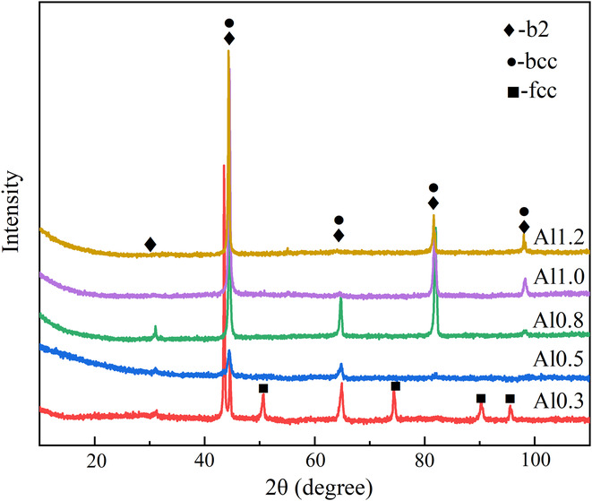
Figure 1
Open in figure viewerPowerPoint
XRD analysis of the AlxCrFeNi MEAs.
Figure 2 presents the microstructure of the as-cast AlxCrFeNi MEAs. As Figure 2a shows, the Al0.3CrFeNi alloy exhibits a typical dendritic structure where some small particles envelop the dendrites. With increasing concentration of Al, a mixed structure of dendritic and square-shaped particles can be found in the Al0.5CrFeNi alloy. When the atomic ratio of Al is above 0.8, more BCC structures appeared and exhibited spinodal microstructure. In Figure 2c–e, distinct grain boundaries were observed, and a lamellar dendritic structure was identified near the grain boundaries. Figure 2f is a magnified part of zone B in Figure 2e, which reveals a periodic and maze-shaped microstructure within the grains. The morphology composed of a BCC structure + B2 structure can be attributed to spinodal decomposition.^{[20, 36]} Spinodal decomposition was greater when the Al content was higher than x = 1.0, resulting in alternating plate structures.
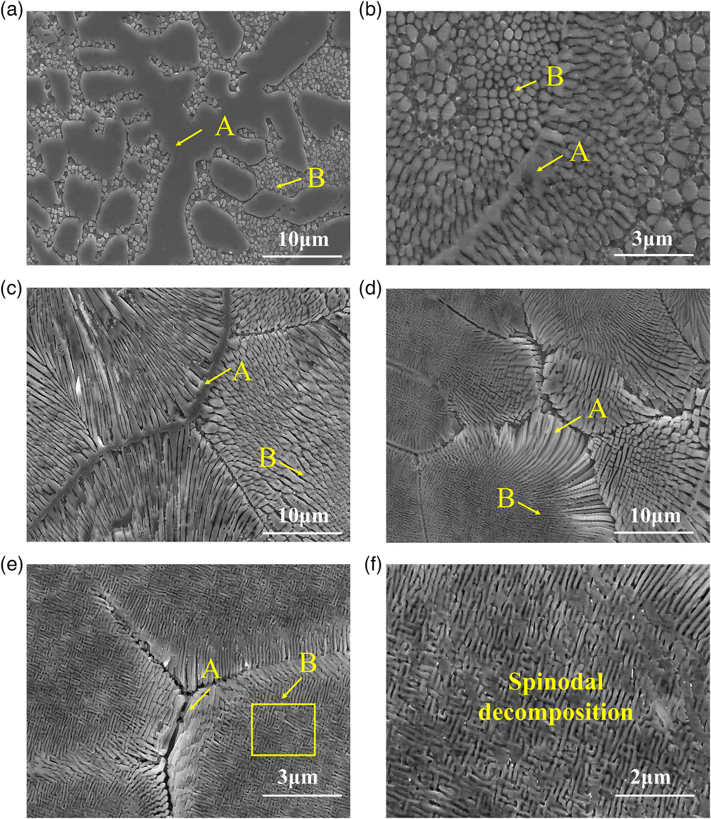
Figure 2
Open in figure viewerPowerPoint
The typical microstructure of AlxCrFeNi MEAs: a) Al_{0.3}, b) Al_{0.5}, c) Al_{0.8}, d) Al_{1.0}, e) Al_{1.2}, and f) the magnified part of zone B.
An energy-dispersive spectroscopy (EDS) analysis has been carried out on a dendrite arm and in the interdendritic region. As Table 1 illustrates, Cr and Fe are rich in zone A, while Al and Ni are rich in zone B. The concentration of Ni and Al is considerably greater in the interdentritic regions compared to the corresponding values in the dendrite arms. With lower concentration of Al, e.g., Al0.3CrFeNi and Al0.5CrFeNi, plate-shaped particles were pushed into interdendritic regions by the advancing dendritic solidification front of the [Fe,Cr] phase. Element segregation can be identified; the precipitates were Al and Ni rich, but Cr and Fe depleted. The dendrite arms are enriched with Fe and Cr elements but Al and Ni depleted in comparison to the interdendritic regions. With increasing content of Al, the elements were distributed, resulting in a low level of segregation in the interdendritic regions. The volume fraction of the BCC structure phase increases; spinodal decomposition becomes more obvious and envelops the Fe-Cr rich dendrites.
Table 1. EDS analysis for chemical composition (at%) of AlxCrFeNi MEAs
Sample | Region | Al | Cr | Fe | Ni
Al_{0.3} | Nominal | 9.1 | 30.3 | 30.3 | 30.3
 | A | 9.88 | 28.99 | 29.85 | 31.28
 | B | 16.45 | 29.83 | 25.39 | 28.32
Al_{0.5} | Nominal | 14.3 | 28.6 | 28.6 | 28.6
 | A | 8.09 | 36.98 | 33.44 | 21.49
 | B | 22.83 | 20.43 | 22.14 | 34.60
Al_{0.8} | Nominal | 21.1 | 26.3 | 26.3 | 26.3
 | A | 14.22 | 45.60 | 24.72 | 15.45
 | B | 32.89 | 15.24 | 17.89 | 33.98
Al_{1.0} | Nominal | 25 | 25 | 25 | 25
 | A | 36.04 | 11.96 | 15.30 | 36.69
 | B | 43.01 | 7.78 | 12.25 | 36.96
Al_{1.2} | Nominal | 28.6 | 23.8 | 23.8 | 23.8
 | A | 35.09 | 18.33 | 19.06 | 27.52
 | B | 36.26 | 18.22 | 18.75 | 26.77
2.2 Microhardness and Nanoindentation
Figure 3 presents the microhardness of the AlxCrFeNi MEAs. A significant increase of microhardness from 345 to 457 kgf mm⁻² was observed when the concentration of Al increases from x = 0.3 to x = 0.8. When the atomic ratio is above x = 1.0, a slight increase was observed from the further addition of Al. Al1.2CrFeNi MEAs exhibit the highest Vickers microhardness of 486 kgf mm⁻². The microhardness of the Al1.2CrFeNi MEAs was significantly better compared with Al0.3CrFeNi MEAs, due to the presence of the hard BCC phase and solid solution strengthening.

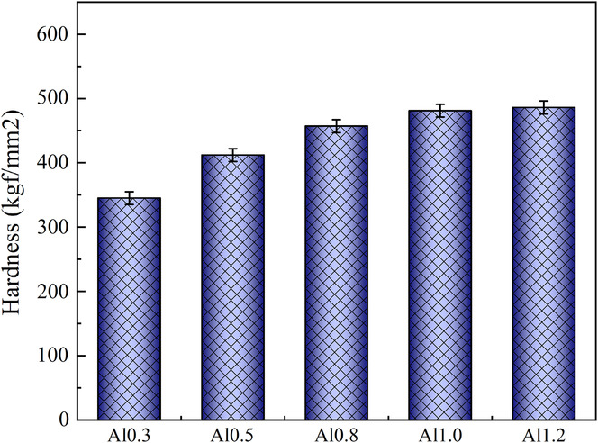
Figure 3
Open in figure viewerPowerPoint
The microhardness of the Al_{x}CrFeNi MEAs.
Figure 4 shows the nanoindentation testing results of the as-cast AlxCrFeNi MEAs. As Figure 4a shows, the load–displacement (P–h) exhibit two stages, the loading stages and the unloading stages. The loading process is accompanied by elastic and plastic deformation. After unloading, the elastic deformation is recovered. The modulus and nanohardness of the AlxCrFeNi MEAs were estimated by analyzing the load–displacement curves. Figure 4b summarizes the corresponding values of modulus and nanohardness obtained from Figure 3. The modulus and the nanohardness are both larger for higher concentration of Al. For the Al0.3CrFeNi alloy, the nanohardness was measured as 5.22 ± 0.025 GPa associated a modulus of 172.9 ± 0.025 GPa. When the atomic ratio of Al reaches x = 1.0, the modulus and nanohardness of AlCrFeNi MEAs were significantly enhanced to values of 7.32 ± 0.046 GPa and 212.7 ± 0.046 GPa, respectively. The Al1.2CrFeNi alloy displays superior performance with a nanohardness of 7.5 ± 0.025 GPa and elastic modulus of 246.4 ± 0.025 GPa, respectively, which were much greater than that of the Al0.3CrFeNi alloy. Thus, this work agrees well with the machine learning and first-principles calculation results in our previous study,^{[27]} which shows that increasing Al content brings about a significant increase in bulk modulus and hardness of Al_{x}CrFeNi MEAs. The BCC phases can evidently improve the nanohardness, in agreement with the results obtained by Vickers microhardness tests.

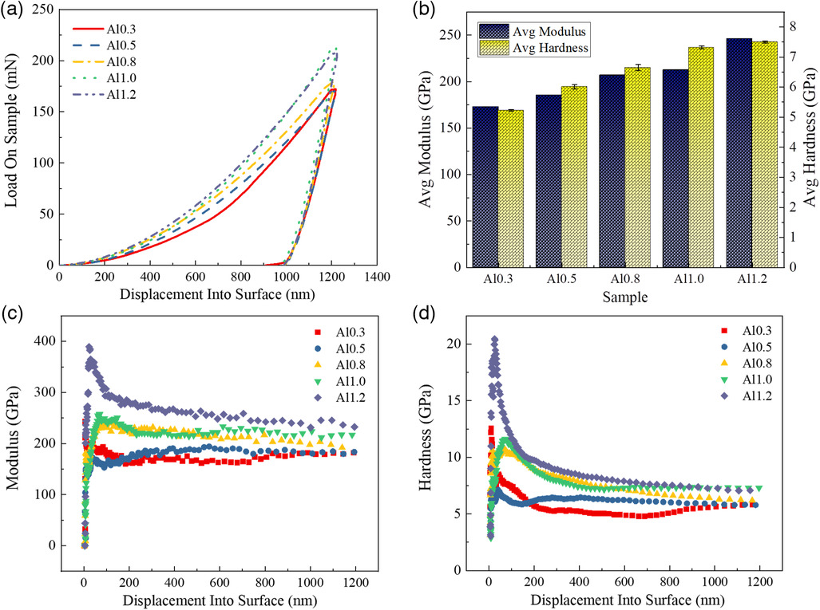
Figure 4
Open in figure viewerPowerPoint
The nanoindentation results of the Al_{x}CrFeNi MEAs: a) the load–displacement curves; b) the average hardness and modulus; c) modulus-depth curves; and d) hardness-depth curves.
Figure 4c,d presents the variation of modulus and nanohardness with indentation depth. Similar trends can be observed; the modulus and nanohardness increase rapidly for larger indentation depth for a short period at the initial stage and then decrease after reaching the peak value. This phenomenon can be attributed to the indentation size effect (ISE)^{[37]} where large strain gradients generated in the indentation can result in geometrically necessary dislocations (GNDs), which can enhance the hardening effect of AlxCrFeNi MEAs.^{[38]} The dislocation density usually decreases for larger indentation depth within GNDs, eventually resulting in the nanoindentation hardness size effect. On the other hand, the results also show that at the same indentation depth, a higher nanohardness value can be obtained for alloys with much higher Al concentration. Among the four elements (e.g., Al, Cr, Fe, Ni), Al possesses a larger atomic radius, resulting in a lattice distortion. As a result, increasing concentration of Al can bring about larger nanohardness for Al_{x}CrFeNi MEAs.
2.3 Wear Analysis and Tribological Property
2.3.1 Friction Coefficient and Wear Resistance
To assess the friction and wear properties of the as-cast alloy, Figure 5a presents the variation of the friction coefficient in AlxCrFeNi MEAs with the sliding time. With increasing time, the friction coefficients display similar characteristics. In the beginning, a running-in period was identified with significantly increasing friction coefficient. Next, a steady-state value was observed after test sliding of 200 s. The two different trends can be attributed to a change of wear mechanism. Periodic large fluctuations are observed in the friction coefficient due to the periodic accumulation and elimination of the debris on the worn surface.^{[39]} Accumulated debris on the worn surface can increase the friction coefficient; nevertheless, the friction coefficient decreases with the debris filled in the grinding cracks.
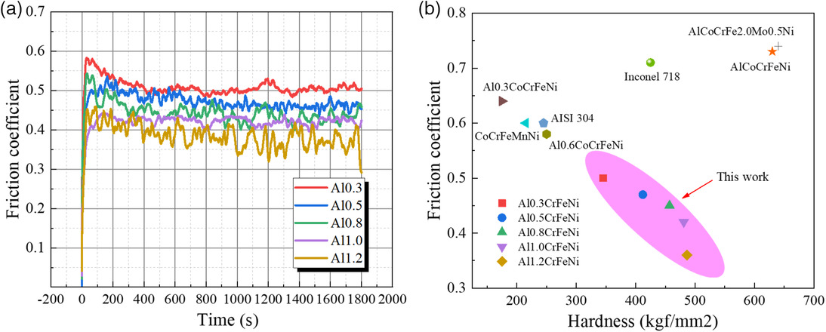
Figure 5
Open in figure viewerPowerPoint
a) Friction coefficient files of AlxCrFeNi MEAs. b) Comparison between AlxCrFeNi MEAs and some reported HEAs and conventional metallic materials.
Figure 5b summarizes the steady-state friction coefficient of the AlxCrFeNi MEAs. The lower friction coefficient indicates better resistance to wear and friction. A significant reduction in average friction coefficient occurs for AlxCrFeNi MEAs with increasing Al content, corresponding to an increase in microhardness. The Al0.3CrFeNi alloy generates a higher average friction coefficient of 0.50 among the AlxCrFeNi MEAs. The average friction coefficient can decrease to approximately 0.36 when the Al content reaches x = 1. Increasing Al content can significantly enhance the friction performance of AlxCrFeNi MEAs. A comparison with other typical HEAs and conventional metallic materials, e.g., AISI 304 and Inconel 718, is also presented in Figure 5b.^{[40-43]} Comparison with the AlxCoCrFeNi HEAs,^{[41]} shows that our AlxCrFeNi MEAs exhibit a fairly low friction coefficient, as well as superior wear resistance. Further differences arise when comparing to Inconel 718.^{[41]} Inconel 718 and Al0.5CrFeNi alloy have similar microhardness; however, the wear resistance of Al0.5CrFeNi alloy was better. AlxCrFeNi MEAs also display the superior wear resistance compared to the AISI 304 alloy^{[41]} in addition to having a superior microhardness. As a result, the Al1.2CrFeNi alloy displays the highest wear resistance compared to the other alloys in this study and is also comparable to typical HEAs and conventional alloys.
Figure 6 displays the wear track profile of the AlxCrFeNi MEAs after wear tests, obtained using 3D surface topography. Figure 6a reveals the appearance of a wear track; the corresponding wear scar profile curves are fitted in Figure 6c. To quantitatively analyze the wear properties of AlxCrFeNi MEAs, the wear grooves width and volume wear loss were measured (Figure 6b,d). The volume wear loss mainly results from plowing and microcutting by abrasive precipitates, e.g., debris from the sample surface and the tip of the Al2⁢O3 ball. The wear resistance improved with increasing Al content, with narrower wear width and lower volume wear loss. The tribological performance was evaluated by determining the values of the wear rate (K) at the end of the wear tests. The wear rate can be expressed as the ratio of the volume wear loss to the product of sliding distance and the normal load, Equation (1).
K=d⁢V/F×L(1)
where V is the volume wear loss, F is the normal load, and L is the sliding distance. The volume wear loss values show a significant reduction in wear rate with increasing Al content. Based on Equation (1), the Al0.3CrFeNi alloy generates a wear rate of 1.1×10−4⁢mm3 (Nm)−1 during the entire sliding process. The Al1.2CrFeNi alloy shows less wear rate (0.11×10−4⁢mm3 (Nm)−1), indicating good resistance against wear. The Al1.2CrFeNi alloy shows superior friction performance with lowest average friction coefficient and wear rate. Comparing with other HEAs, including the Al0.25⁢Ti0.75CoCrFeNi HEAs with the wear rate of 1.2×10−5⁢mm3 (Nm)−1^{[44]} as well as CoCrFeMnNi HEAs and Al0.1CoCrFeNi HEAs,^{[45]} the Al1.2CrFeNi alloy also exhibited superior wear resistance. With respect to the Archard's law,^{[46]} the wear resistance is proportional to the hardness of the alloys. The hardness of the AlxCrFeNi MEAs increases with larger Al content, suggesting that the lower wear rate and the friction coefficient can be related to higher hardness; the harder surface of the Al1.2CrFeNi alloy plays a key role in the reduction of the wear rate.

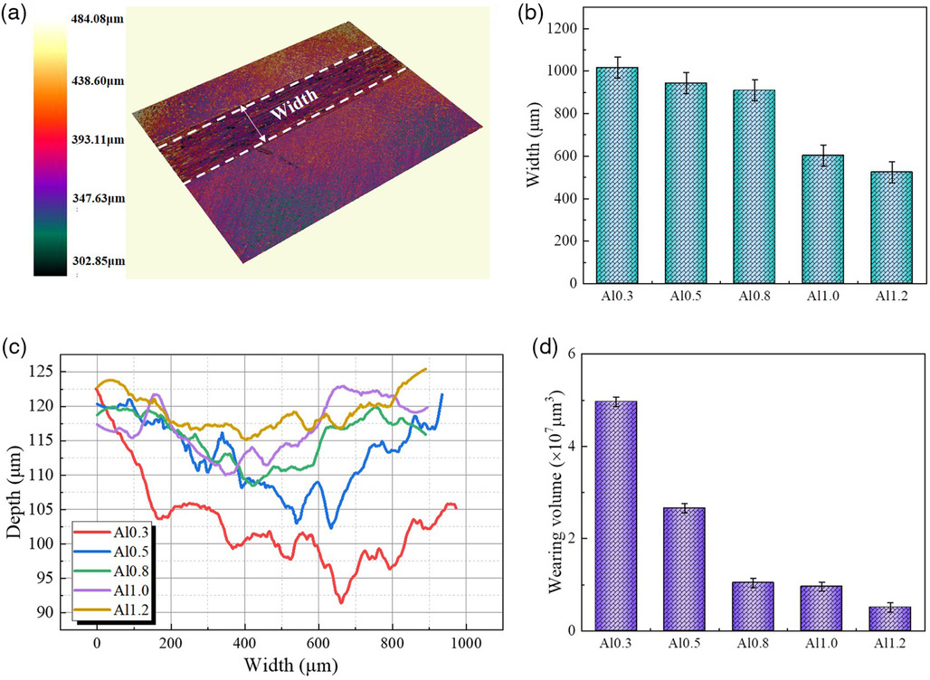
Figure 6
Open in figure viewerPowerPoint
The wear tests results: a) surface topographies with a groove; b) the width of wear track; c) the wear track profile curve; and d) the wear volume.
2.3.2 Worn Surface and Wear Mechanism
For deeper understanding, the wear tracks and debris collected from the worn surfaces were examined using EPMA, followed by EDS. Figure 7 presents the low-magnification images of wear tracks on the surface of AlxCrFeNi MEAs. No localized fracture was visible on the worn surface of the as-cast alloy. Figure 7a reveals very poor wear resistance, as suggested by the rough and wide wear tracks on the sample surface with lower concentration of Al (x = 0.3). With increasing content of Al, some shallow grooves can be observed on the worn surface, as shown in Figure 7b–d. When the concentration of Al reaches x = 1.2, the wear track was narrower and the worn surface becomes much smoother (Figure 7e), agreeing well with the above 3D microtopography analysis.
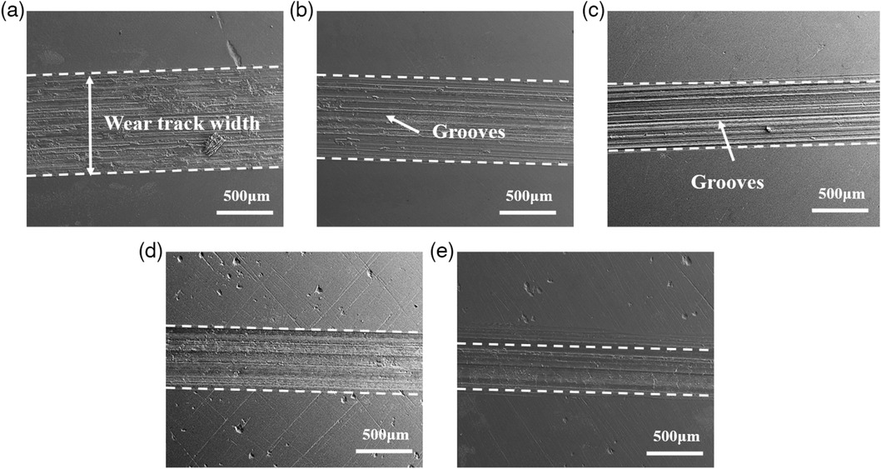
Figure 7
Open in figure viewerPowerPoint
Low-magnification images of the wear tracks on the surface: a) Al_{0.3}, b) Al_{0.5}, c) Al_{0.8}, d) Al_{1.0}, and e) Al_{1.2}.
Figure 8 shows the high-magnification morphologies of the worn surface of AlxCrFeNi MEAs after wear testing. The worn surfaces display abrasive scratches and grooves parallel to the sliding direction. For the Al0.3CrFeNi alloy, Figure 8a1 shows a rough worn surface with greater wear. The grooves are deep (Figure 8a2). From Figure 8a3, there are many wear particles as well as pock marks on the worn surface, suggesting severe adhesive wear. Under repetitive sliding action, the debris remained on the worn surface, leading to deeper grooves and scratches. During the sliding process, the work hardening on the surface was large, inducing crack growth and materials spalling on the surface. Thus, severe adhesive wear could be identified on the worn surfaces. For the Al0.5CrFeNi alloy, many large debris and deep grooves can be observed on the worn surface, as shown in Figure 8b1,b2. The hard wear particles embedded into the metal surface ploughed deep grooves during sliding. Cracks and pits were observed after the surface spalled off; adhesive junctions are formed. From Figure 8b3, considerable spallation appears on the worn surface, suggesting adhesive mechanisms. Delamination occurs when the wear debris were plastically deformed and compacted by the rubbing action between the slider and the flat. With increasing content of Al (x = 0.8), Figure 8c1 shows that the worn surface has become much softer. As revealed in Figure 8c2,c3, the formation of the adhesive layer was observed in worn areas, which resulted from the alternating loads and the high contact temperatures in dry sliding.

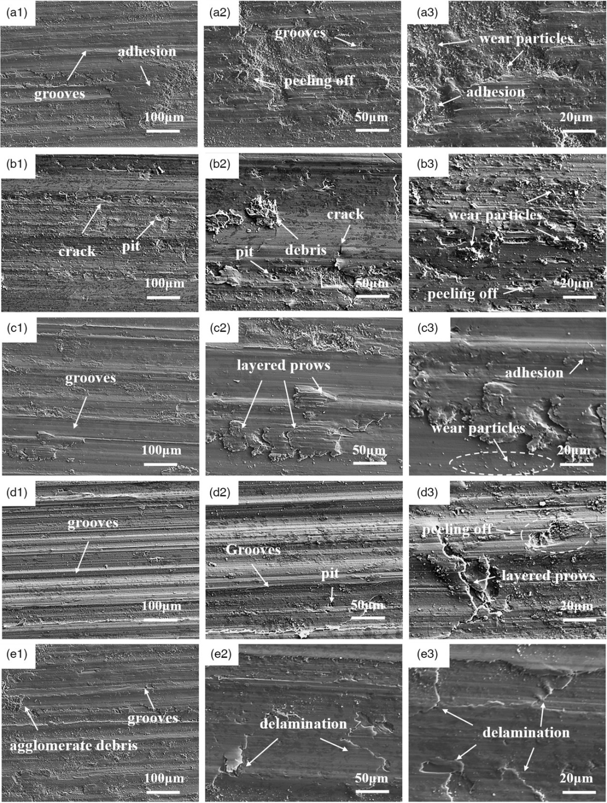
Figure 8
Open in figure viewerPowerPoint
EPMA micrographs of wear tracks on the surface: a1–a3) Al_{0.3}, b1–b3) Al_{0.5}, c1–c3) Al_{0.8}, d1–d3) Al_{1.0}, and e1–e3) Al_{1.2}.
When the concentration of Al reaches x = 1.0, Figure 8d1,d2 shows that many shallow grooves formed on the worn surface due to the debris of the AlCrFeNi alloy with higher hardness. As Figure 8d3 illustrates, layered prows and debris had peeled off the worn surface. With respect to the Al1.2CrFeNi alloy, only a few shallow scratches and a smoother worn surface can be observed on the surface, as displayed in Figure 8e1. It is noteworthy that there is hardly any obvious scratches and wear debris on the worn surface in Al1.2CrFeNi alloy, as shown in Figure 8e2,e3. It was difficult to form wear debris for the Al1.2CrFeNi alloy compared to alloys with lower Al concentration. As a result, the wear resistance of AlxCrFeNi MEAs increases with larger Al content. The dominated wear mechanism of AlxCrFeNi MEAs also changed with the variation of the content of Al. When the atomic ratio of Al is lower than x = 0.5, a relatively low hardness of alloy results in the predominant role of adhesive wear. When the concentration of Al achieves x>0.8, abrasive wear plays the critical role in the wear mechanism.
Figure 9 presents micrographs of the wear debris for AlxCrFeNi MEAs; the wear particles are characterized by big flakes. The wear debris consisted of irregular, blocky shapes. With strong adhesion, further sliding led to the formation of more fragments until a much larger wear particle eventually becomes detached. During the wear process, further plastic deformation caused the debris to be flattened and elongated in the direction of sliding, resulting in the formation of plate-like wear particles. The average chemical compositions of the debris are summarized in Table 2. The wear debris is enriched in O, suggesting that oxidation occurs during the wear tests. The oxidation resulted from heat produced by friction during the wear tests. The primary source of particle debris was broken oxide agglomerates. The content of O on the debris of AlCrFeNi and Al1.2CrFeNi alloy was higher than those of the others due to the higher heat of friction produced by the harder surface. This oxidation protection can lead to a lower wear rate and better wear resistance for the Al1.2CrFeNi alloy.^{[28]} The O content on the wear debris decreased when the atomic ratio of Al was below x = 1.0. Therefore, the abrasive wear of oxide precipitates plays a role in the wear mechanism of the AlxCrFeNi MEAs. The examination of wear debris has enabled us to understand the wear mechanisms of AlxCrFeNi MEAs. To conclude, as Figure 10 illustrates, the dominant wear mechanisms for AlxCrFeNi MEAs are abrasive wear, adhesive wear, accompanied by oxidative wear.
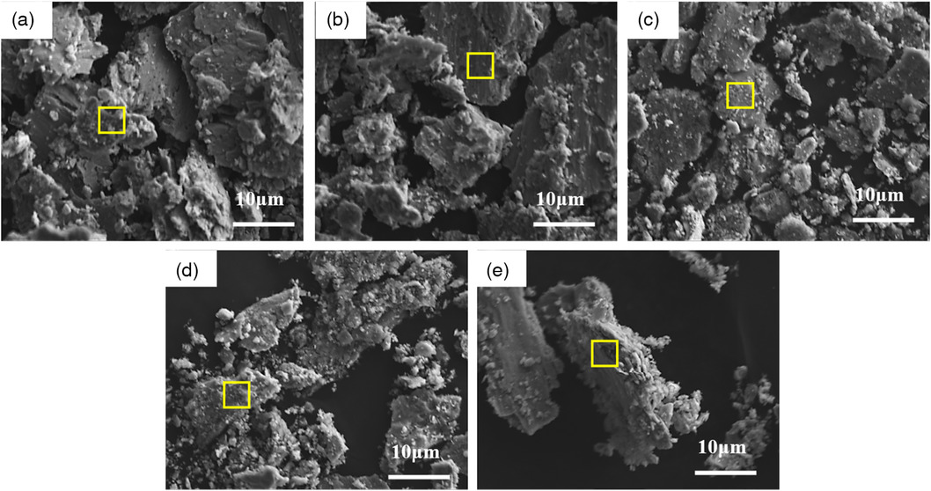
Figure 9
Open in figure viewerPowerPoint
EPMA micrographs of wear debris for AlxCrFeNi MEAs: a) Al_{0.3}, b) Al_{0.5}, c) Al_{0.8}, d) Al_{1.0}, and e) Al_{1.2}.
Table 2. EDS analysis results for chemical composition (wt%) of wear debris
Sample | O | Al | Cr | Fe | Ni
Al_{0.3} | 0.48 | 0.68 | 20.63 | 42.34 | 35.86
Al_{0.5} | 7.91 | 6.26 | 24.68 | 27.96 | 28.07
Al_{0.8} | 7.28 | 12.28 | 24.86 | 28.48 | 27.11
Al_{1.0} | 21.84 | 10.7 | 20.24 | 24.16 | 23.06
Al_{1.2} | 16.8 | 12.66 | 23.24 | 23.67 | 23.63

Figure 10
Open in figure viewerPowerPoint
Wear mechanism of AlxCrFeNi MEAs.
3 Conclusion
AlxCrFeNi MEAs were prepared by vacuum arc-melting techniques. The effect of Al on the microstructure and tribological properties was studied in detail. 1) The phase and microstructure of AlxCrFeNi HEAs are significantly affected by alloying with Al. A change from a two-phase FCC + BCC/B2 structure to only B2/BCC phase was observed with increasing Al content. The volume fraction of the B2 phase increases and spinodal decomposition becomes more distinct with higher Al content. The interdendritic regions are enriched in Ni and Al; the dendrite arms are enriched with Fe and Cr. 2) The Vickers microhardness increased from 345HV (x = 0.3) to 486HV (x = 1.2) with larger Al content due to the formation of the hard BCC phase and solid solution strengthening. The Al1.2CrFeNi alloy possessed the highest nanohardness of 7.5 ± 0.025 GPa as well as the elastic modulus of 246.4 ± 0.025 GPa. 3) Higher concentration of Al significantly improves the wear resistance of AlxCrFeNi MEAs. A smooth worn surface can be obtained with the lowest wear rate and coefficient of friction observed in Al1.2CrFeNi MEAs. The Al1.2CrFeNi MEAs displays superior wear resistance compared with typical HEAs and conventional alloys. 4) The dominant wear mechanism changes from adhesive for low Al concentration(x < 0.8) to abrasive for high Al concentration (x > 1.0), accompanied by oxidative wear.
4 Experimental Section
In this work, AlxCrFeNi MEAs (x = 0.3, 0.5, 0.8, 1.0, and 1.2) were produced by means of vacuum arc-melting techniques using high purity (>99.9%) raw elemental metals. To minimize oxidization, Ar atmosphere is filled inside the furnace. For a homogeneous compositional distribution, each arc-melted ingot was flipped and remelted at least five times. The X-Ray diffractometer (XRD, XPERT diffractometer with Cu radiation target) was utilized to analyze crystal structures with a 2θ scan from 10° to 110°, with a scanning rate of 10° per minute. A scanning electron microscopy (Zeiss Merlin Compact SEM) techniques equipped with EDS detector was employed for microstructure characterization and chemical-composition analysis. Prior to the examination, the samples were carefully mechanical ground and polished and then etched with 3% nitric acid solution.
Microhardness was measured by a Vickers hardness tester (HVS-1000 digital microhardness meter) on polished surfaces under a load of 500 g applied for 10 s. Each reported Vickers hardness value is an average of 10 indents taken on the surface. The nanoindentation tests were performed at room temperature using a Nano Indenter G200 (Agilent, US) with a Berkovich indenter in the continuous stiffness measurement (CSM) mode. To avoid the ISE, the testing depth was set as 1200 nm. A constant strain rate of 0.05 s⁻¹ was used in the loading process to reach the testing depth and then unloading at the same strain rate.
To perform the wear tests, plane samples were cut from alloy plates with dimension of 10 mm × 10 mm × 6 mm. Reciprocating ball-on-flat tests were performed on a reciprocating sliding tribometer (CETR-UMT-3) to investigate the friction and wear behavior of samples. The surfaces of AlxCrFeNi MEAs were mounted and a Al2⁢O3 ceramic ball fixed on a fixture was reciprocated at a sliding speed of 10 mm s⁻¹. The stroke length was 5 mm and the normal contact loading was 25 N for a duration of 1800 s. After the wear tests, the surface morphologies and wear volume loss were quantitatively measured via type 3D surface topography (Zeta20). To further explore the wear mechanism, the wear tracks and debris were studied by electron probe microanalysis (EPMA, JXA-8230).
Acknowledgements
This work was supported by AME Programmatic Fund by the Agency for Science, Technology and Research, Singapore under grant nos. A1898b0043 and A18B1b0061 and the China Scholarship Council.
Conflict of Interest
The authors declare no conflict of interest.
- 1J. Yeh, S. Chen, S. Lin, J. Gan, T. Chin, T. Shun, C. Tsau, S. Chang, Adv. Eng. Mater. 2004, 6, 299.
View
CASWeb of Science®Google Scholar
- 2J. Yang, Y. Zhou, Y. Zhang, G. Chen, Chinese Materials Science Technology & Equipment 2007, p. 61.
Google Scholar
- 3Y. Zhang, T. Zuo, Z. Tang, M. Gao, K. Dahmen, P. Liaw, Z. Lu, Prog. Mater. Sci. 2014, 61, 1.
View
CASPubMedWeb of Science®Google Scholar
- 4W. Liu, Y. Wu, J. He, T. Nieh, Z. Lu, Scr. Mater. 2013, 68, 526.
View
CASWeb of Science®Google Scholar
- 5J. He, W. Liu, H. Wang, Y. Wu, X. Liu, T. Nieh, Z. Lu, Acta Mater. 2014, 62, 105.
View
CASWeb of Science®Google Scholar
- 6L. Qiao, Y. Liu, J. Zhu, J. Alloy Compd. 2021, 877, 160295.
View
CASWeb of Science®Google Scholar
- 7T. Zhang, S. Ma, D. Zhao, Y. Wu, Y. Zhang, Z. Wang, J. Qiao, Int. J. Plasticity 2020, 124, 226.
View
CASWeb of Science®Google Scholar
- 8N. Nguyen, P. Asghari-Rad, P. Sathiyamoorthi, A. Zargaran, C. Lee, H. Kim. Nat. Commun. 2020, 11, 2736.
View
CASPubMedWeb of Science®Google Scholar
- 9Q. Pan, L. Zhang, R. Feng, Q. Lu, K. An, A. Chuang, J. Poplawsky, P. Liaw, L. Lu. Science 2021, 374, 984.
View
CASPubMedWeb of Science®Google Scholar
- 10Y. Han, H. Li, H. Feng, K. Li, Y. Tian, Z. Jiang, J. Mater. Sci. Technol. 2021, 65, 210.
CASGoogle Scholar
- 11N. Shah, M. Rahul, S. Bysakh, G. Phanikumar, Mater. Sci. Eng. A, 2021, 824, 141793.
View
CASWeb of Science®Google Scholar
- 12M. Wang, Y. Lu, T. Wang, C. Zhang, Z. Cao, T. Li, P. Liaw, Scr. Mater. 2021, 204, 114132.
View
CASWeb of Science®Google Scholar
- 13B. Cao, H. Kong, Z. Ding, S. Wu, J. Luan, Z. Jiao, J. Lu, C. Liu, T. Yang, Scr. Mater. 2021, 199, 113826.
View
CASWeb of Science®Google Scholar
- 14M. Poletti, G. Fiore, F. Gili, Mater. Des. 2017, 115, 247.
View
CASWeb of Science®Google Scholar
- 15B. Xin, A. Zhang, J. Han, B. Su, J. Meng, J. Alloy Compd. 2020, 836, 155273.
View
CASWeb of Science®Google Scholar
- 16S. Yang, Z. Liu, J. Pi, Mater. Lett. 2020, 261, 127004.
View
CASWeb of Science®Google Scholar
- 17N. Khan, B. Akhavan, H. Zhou, L. Chang, Y. Wang, L. Sun, Appl. Surf. Sci. 2019, 495, 143560.
View
CASWeb of Science®Google Scholar
- 18P. Sarswat, S. Sarkar, A. Murali, W. Huang, W. Tan, M. Free, Appl. Surf. Sci. 2019, 476, 242.
View
CASWeb of Science®Google Scholar
- 19X. Jin, J. Bi, L. Zhang, Y. Zhou, X. Du, Y. Liang, B. Li, J. Alloy Compd. 2019, 770, 655.
View
CASWeb of Science®Google Scholar
- 20X. Chen, J. Qi, Y. Sui, Y. He, F. Wei, Q. Meng, Z. Sun, Mater. Sci. Eng. A 2017, 68, 25.
View
Web of Science®Google Scholar
- 21L. Qiao, Aorigele, Z. Lai, J. Zhu, J. Alloy Compd. 2020, 847, 155929.
View
CASWeb of Science®Google Scholar
- 22L. Qiao, A. Bao, Y. Wang, Y. Liu, Z. Lai, J. Zhu, Intermetallics 2020, 126, 106899.
View
CASWeb of Science®Google Scholar
- 23L. Qiao, J. Zhu, Y. Teng, A. Bao, Z. Lai, Y. Wang, Vacuum 2021, 184, 109873.
View
CASWeb of Science®Google Scholar
- 24L. Qiao, Y. Liu, J. Zhu. Adv. Eng. Mater. 2021, 23, 2100505.
View
CASWeb of Science®Google Scholar
- 25T. Yang, S. Xia, S. Liu, C. Wang, S. Liu, Y. Zhang, J. Xue, S. Yan, Y. Wang, Mater. Sci. Eng. A 2015, 648, 15.
View
CASWeb of Science®Google Scholar
- 26C. Sha, Z. Zhou, Z. Xie, P. Munroe, Appl. Surf. Sci. 2020, 507, 145101.
View
CASWeb of Science®Google Scholar
- 27L. Qiao, Z. Lai, Y. Liu, A. Bao, J. Zhu, J. Alloy Compd. 2021, 853, 156959.
View
CASWeb of Science®Google Scholar
- 28M. Chuang, M. Tsai, W. Wang, S. Lin, J. Yeh, Acta Mater. 2011, 59, 6308.
View
CASWeb of Science®Google Scholar
- 29C. Nagarjuna, H. You, S. Ahn, J. Song, K. Jeong, B. Madavali, G. Song, Y. Na, J. Won, H. Kim, S. Hong, Appl. Surf. Sci. 2021, 549, 149202.
View
CASWeb of Science®Google Scholar
- 30Y. Zhao, Y. Ye, C. Liu, R. Feng, K. Yao, T. Nieh, Intermetallics, 2019, 113, 106561.
View
CASWeb of Science®Google Scholar
- 31J. Miao, H. Liang, A. Zhang, J. He, J. Meng, Y. Lu, Tribol. Int. 2021, 153, 106599.
View
CASWeb of Science®Google Scholar
- 32H. Liang, J. Miao, B. Gao, D. Deng, T. Wang, Y. Lu, Z. Cao, H. Jiang, T. Li, H. Kang, Surf. Coat. Technol. 2020, 400, 126214.
View
CASWeb of Science®Google Scholar
- 33H. Liang, H. Yao, D. Qiao, S. Nie, Y. Lu, D. Deng, Z. Cao, T. Wang, J. Therm. Spray Technol. 2019, 28, 1318.
View
CASWeb of Science®Google Scholar
- 34S. Singh, N. Wanderka, B. S. Murty, U. Glatzel, J. Banhart, Acta Mater. 2011, 59, 182.
View
CASWeb of Science®Google Scholar
- 35L. Santodonato, Y. Zhang, M. Feygenson, C. Parish, M. Gao, R. Weber, J. Neuefeind, Z. Tang, P. Liaw, Nat. Commun. 2015, 6, 5964.
View
PubMedWeb of Science®Google Scholar
- 36Y. Sui, S. Gao, X. Chen, J. Qi, F. Yang, F. Wei, Y. He, Q. Meng, Z. Sun, Vacuum 2017, 144, 80.
View
CASWeb of Science®Google Scholar
- 37Y. Milman, A. Golubenko, S. Dub, Acta Mater. 2011, 59, 7480.
View
CASWeb of Science®Google Scholar
- 38W. Nix, H. Gao, J. Mech. Phys. Solids 1998, 46, 441.
View
Web of Science®Google Scholar
- 39Y. Wang, Y. Yang, H. Yang, M. Zhang, S. Ma, J. Qiao, Mater. Chem. Phys. 2018, 210, 233.
View
CASWeb of Science®Google Scholar
- 40C. Hsu, T. Sheu, J. Yeh, S. Chen, Wear 2010, 268, 653.
View
CASWeb of Science®Google Scholar
- 41J. Joseph, N. Haghdadi, K. Shamlaye, P. Hodgson, M. Barnett, D. Fabijanic, Wear 2019, 428–429, 32.
View
CASWeb of Science®Google Scholar
- 42P. Cheng, Y. Zhao, X. Xu, S. Wang, Y. Sun, H. Hou, Mater. Sci. Eng. A 2020, 772, 138681.
View
CASWeb of Science®Google Scholar
- 43B. Jin, N. Zhang, H. Yu, D. Hao, Y. Ma, Surf. Coat. Technol. 2020, 402, 126328.
CASWeb of Science®Google Scholar
- 44B. Gwalani, A. Ayyagari, D. Choudhuri, T. Scharf, S. Mukherjee, M. Gibson, R. Banerjee, Mater. Chem. Phys. 2018, 210, 197.
CASWeb of Science®Google Scholar
- 45A. Ayyagari, C. Barthelemy, B. Gwalani, R. Banerjee, T. W. Scharf, S. Mukherjee, Mater. Chem. Phys. 2018, 210, 162.
CASWeb of Science®Google Scholar
- 46J. Archard, J. Appl. Phys. 1953, 24, 981.
Web of Science®Google Scholar

