Non-Directed C−H/C−F Coupling for the Synthesis of α-Fluoro Olefinated Arenes
Sandip Porey,¹ Yogesh Bairagi,¹ Srimanta Guin,¹ Xinglong Zhang^{2,}* & Debabrata Maiti^{1,}*
¹Department of Chemistry, Indian Institute of Technology Bombay, Powai, Mumbai 400076, India
²Institute of High Performance Computing (IHPC), Agency for Science, Technology and Research (A*STAR), 1 Fusionopolis Way, #16-16 Connexis, Singapore 138632, Republic of Singapore

ABSTRACT: The fluorinated entities are considered as privileged structure class in the field of medicinal chemistry because of the amplified bioactivity they exhibit. In this regard, developments of C−H fluorination and trifluoromethylation have been mostly targeted. The α-fluoro olefins also show potential applications as bioisosteres of amides and are also prevalent in drug candidates, but their synthetic accessibility by a C−H activation strategy remains an elusive domain. The assistance of directing group (DG) does enable the fluoroalkenylation, but also constrains the scope in terms of expansion of chemical space for drug development programs. The non-directed strategy is a ‘one-shot’ solution to the existing issues on the use of DGs. With this perspective, we herein report the non-directed protocol on Pd catalyzed C−H/ C−F coupling for accessing α-fluoro olefins in a regioselective fashion. The transformation is governed by the dual control of a pyridine and amino acid based ligands, which dictates the complementary selectivity achieved. The protocol allows for the late-stage derivatization of drugs, natural products and also enable the conjugation of drug with the natural product by means of a fluoro-olefin bridge. The incorporation of this fluorinated moieties can potentially modulate the parent bioactivity of drugs. Mechanistic investigation and DFT calculation suggest the vital role of mono-protected amino acid (MPAA) ligand in the C–H activation step through concerted metalation deprotonation, which is the overall turnover-determining state of the catalytic cycle.
KEYWORDS: C-H/C-F coupling, catalysis, non-directed strategy, drug diversification, density functional theory

1. Introduction
The endeavor of C−H activation in organic synthesis has evolved with the perspective of streamlining the process development of various target molecules.¹ Since the inception of this research area, its potential has been explored in numerous fields.² The dominance of directing group (DG) assisted C−H activation is evident in this aspect.³ Despite DG being beneficial in achieving regioselective functionalizations, its very use strains the practicality of the transformation due to added steps, the requirement of engineered DGs or of functionalities to tether a DG. The non-directed C−H activation is a ‘one-shot’ solution that could herald the present phase of C−H activation in restructuring the drug development and diversification processes without compromising the regioselectivity.⁴
The dawn of Pd catalyzed non-directed C−H activation was witnessed through the traditional Fujiwara-Moritani reaction, but was limited to electron rich arenes employed in solvent quantity.⁵ Striving towards regioselective functionalizations by Pd catalyzed non-directed strategy, ligands have had an immense role in enabling regioselective functionalizations alongside encompassing diverse arenes used as the limiting reagent.⁶ Very recently we have demonstrated the importance of ligand in a photo-induced strategy to effectuate olefination in a highly regioselective fashion.⁷ Also, dual ligands have been found effective in achieving regioselective chalcogenation under thermal conditions.^{8a} These ligands assisted protocols have made a significant contribution in effecting late-stage functionalizations of drugs or performing short-stepped synthesis of small molecule drugs.
Pertaining to the drug diversification/development process, introduction of fluorine or fluorine-containing structural motifs is an indispensable part of the program.⁹ Fluorine modulates the bioactivity and imparts unique chemical and physical properties to the molecule that has widespread application in the pharmaceutical and agrochemical sciences.¹⁰ In particular, the α-fluoro olefins constitutes a privileged structural class owing to their applicability as stable bioisosteres of amides and enols and their existence in pharmaceutically relevant molecules (Scheme 1a).¹¹ The synthetic accessibility of α-fluoro olefins by C−H activation strategy has however, remained an elusive form of chemistry compared to the developments made towards analogous fluorination and trifluoromethylation.¹² Prior precedence on the synthesis of α-fluoro olefins involves DG assisted metal catalyzed C−H/C−F coupling leading to the incorporation of fluoro olefin at the ortho-position of arenes.¹³ In both the protocols, gem-difluoro olefins served as the coupling partners. Reports have also emerged regarding the C–H/C–Br or C–H/CO₂H couplings for the synthesis of same class of α-fluoro olefins from heteroarenes.¹⁴
Gem-difluoro olefins display unique reactivities because of the chemical properties of the fluorine substituents.¹⁵ In the presence of nucleophile, one of the fluorine is substituted by addition-elimination mechanism with favorable formation of the carbanion at the β-position followed by fluoride elimination stemming from the repulsion effect of its unpaired electrons (Scheme 1b). The C−H activated complex which behaves analogous to the nucleophile is expected to follow a similar path to lead to α-fluoro olefins, making use of the putative carbocationic character which is the regio-determining factor in the 1,2-metal migration step (Scheme 1c). In this regard, a Pd chemistry for the execution of C−H/C−F coupling remains an uncharted territory.¹⁶ A fluoride elimination to oxidatively form a C−C bond is a rare occurrence with Pd catalysis because of the high dissociation energy of the C−F bond.¹⁷ Herein, we unveil the domain of Pd catalysis in C−H/C−F coupling via a non-directed strategy. The present protocol does not require any prefunctionalized arenes or added synthetic steps for tethering or removal of DG; thus a step and atom economic approach in comparison to the prior reports on the synthesis of α-fluorinated olefinated arenes. The transformation provides access to the synthesis of α-fluoro olefins in a regioselective fashion. Furthermore, the protocol can also be utilized in late-stage functionalizations of various drug molecules and conjugate a drug to natural product by a fluoro-olefin
Scheme 1. Pd Catalyzed Non-Directed C−H/C−F Coupling
bridge (Scheme 1d). Such non-directed diversification process helps expanding the chemical space and gives provision for modulating the parent bioactivity of the drug candidates, which is a limitation in case of directing group strategy.
2. Results and Discussion
We proceeded to investigate the palladium catalyzed non-directed C−H/C−F coupling strategy of naphthalene (having two distinct reaction sites, α and β) with 2,2-difluorovinyl 4-methylbenzenesulfonate (a). Unlike the traditional Fujiwara-Moritani reaction that involves a β-hydride elimination at the termination stage, the present transformation for C−H/C−F coupling is likely executed by a β-fluoride elimination. We ventured into optimizing the reaction parameters that could be crucial in forging such an elusive
Table 1. Optimization of the non-directed C-H/C-F olefination of arenesª
Entry | Alteration from standard conditions | Yield of 1 (%) | Selectivity (β :α)
1  2^{b} | None  L₁ instead of L₈ | 58  15 | 5:1  5:1
3^{b}  4^{b}  5^{b} | L₄ instead of L₈  L₆ instead of L₈  L₇ instead of L₈ | 18  trace  26 | 3:1  -  4:1
6^{b} | L₈ | 43 | 5:1
7  8 | N-Ac-L-proline  N-Ac-Phe-OH | trace  18 | -  4:1
9 | TFE instead of HFIP | 35 | 4:1
10  11 | C₆F₆ instead of HFIP  THF instead of HFIP | trace  n.d. | -  -
ªReaction conditions: arene (0.1 mmol, 1 equiv.), gem-difluoro olefin (0.2 mmol, 2 equiv.), Pd(OAc)₂ (10 mol%), N-Ac-Gly-OH (20 mol%), 6-bromo-pyridine-3-ol (30 mol%), Cu(OAc)₂ (2 equiv.), AcOH (2 equiv.), HFIP (0.6 mL), 80 ^{ο}C, 24 h. ^{b}Reaction performed without adding N-Acetyl glycine.
form of transformation. In the field of Pd catalyzed nondirected C−H functionalizations, ancillary ligand is a pre-requisite, influencing both the energy barrier and the regioselectivities under thermal or photochemical conditions.⁶⁻⁸ The pyridone class of ligand stands out in this aspect to impart assistance in the C−H cleavage path in a highly regioselective fashion.^{6a,6g,7} At the initial trials, 2-hydroxy-3-trifluoromethyl pyridine in conjunction with Pd catalyst was utilized to effectuate the synthesis of α-fluoro olefin. The details of the optimization studies are provided in the supporting information (see section 2.2 of the supporting information). However, the ligand assistance of pyridone (L₁) proved to be less effective as was observed with other substituted pyridone ligands (L₂-L₇) as well. Intriguingly, a 3-hydroxy pyridine (L₈) afforded an improved yield (43%) of the (Z)-α-fluoro-olefinated naphthalene (1) with preferential β selectivity of 5:1. Such a preference for β-site selectivity contrasts the conventional α-selectivity by electrophilic palladation pathway.^{6l,6m} It may be noted that there are precedences where the dual-ligand (combination of MPAA-pyridine) approach has had immense influence in availing good yields and selectivities for non-directed C−H functionalizations.^{6b,6e,6f,6g,6j} With 3-hydroxy pyridine (L₈) as the optimal choice of ligand we next delved to examine if the dual ligand approach in combination with a mono-protected amino acid (MPAA) would serve the purpose of yield and selectivity augmentation in the present transformation. The implementation of dual ligand approach was found beneficial in improving the yield of the desired product 1. The fluorinated solvents viz. HFIP and TFE were found to have tremendous role in the execution of the transformation, with HFIP giving superior yields. During the optimization studies we observed the use of less expensive copper salt is favorable over the commonly employed silver salts. The olefin stoichiometry also played a pivotal role, with the highest achievable yield (58%) obtained with 2 equivalents of the olefin. Stringent optimizations led to an optimal conditions that require only stoichiometric arene as substrate to access (Z)-α-fluoro olefinated arenes in good selectivity via non-directed C−H/C−F coupling strategy with gem difluoro-olefin using combination of Pd(OAc)₂ / dual ligands / copper salt.
Attaining the optimal conditions was subsequently followed by interrogating the generality of the scope that can be encompassed with the present protocol. Initially, a range of diversely substituted arenes were explored towards C−H/C−F coupling with gem-difluoro olefins having −OSO₂pC₆H₄Me (a) or −OSO₂Ph (b) substituents (Scheme 2). Naphthalene upon reaction with olefin b afforded the desired product 2 in slightly improved yield and β-selectivity in comparison to its reaction with olefin a. The product structure of 2 with β-selectivity was characterized and con- firmed by X-ray crystallography (CCDC 2162416). With benzene as the substrate, the reactions with both a and b gave the (Z)-α-fluoro-olefinated products 3 and 4 in synthetically useful yields. The C−H/C−F coupling with toluene and ethyl benzene proceeded with the preference for ortho-selectivity (5 and 6, Scheme 2). Similar observations were made with electron-rich arenes such as anisole (9), ethoxy benzene (10) and long chain alkyl ethers (11 and 12) for which the ortho-site was favored over other available distant positions. The possible reason to favor olefination next to alkyl group may be due to the electron-releasing nature of the alkyl substituents (such as in toluene substrate), which tend to be ortho- and para-directing, which resulted site selectivity for the α−position of the alkyl substitution of arenes rather β−position.^{8b,8c} However, there was a transpose of selectivity from ortho to meta in case of tert-butyl benzene (7 and 8) and diphenyl methane (13). This observ- ation indicates the intrinsic steric influence in controlling the regioselectivity of the transformation; bulkier substituent favoring palladation at the distant positions,^{8b,8c} in which the steric influences dominate over the electronic influences of the ortho- and para-directing nature of the alkyl-
Scheme 2. Scope of Arenes for Non-Directed C−H/C−F Coupling
Reaction conditions: arene (0.2 mmol, 1 equiv.), gem-difluoro olefin (0.4 mmol, 2 equiv.), Pd(OAc)₂ (10 mol%), N-Ac-Gly-OH (20 mol%), 6-bromo-pyridine-3-ol (30 mol%), Cu(OAc)₂ (2 equiv.), AcOH (2 equiv.), HFIP (1.2 mL), 80 ^{ο}C, 24 h. Isolated yields are reported.
substituents. Computational studies on the regioselectivity outcomes for toluene and tert-butylbenzene corroborated well with this observation (SI section 8.4): for toluene substrate, ortho-site is predicted to be preferentially activation (Figure S3) whereas for tert-butylbenzene, the meta-site will be preferentially activated (Figure S4). With ortho-disubstituents in arenes as in ortho-xylene (14 and 15) and ortho-methyl anisole (16 and 17), the β-selectivity predominated along with decent yields of the olefinated products. Interestingly, with benzo[d][1,3]dioxole a reversal of selectivity was observed with a predominance of α-selectivity in products (18 and 19). This may potentially be attributed to that difference in the sterics around α-position for the substrates; the fused structure of benzo[d][1,3]dioxole may not hinder the activation of the α-C–H bond whereas in ortho-methyl anisole (16 and 17), the conformationally fluxional methyl group of the methoxy may increase the steric congestion at the α-position therefore favoring β-selectivity. For ortho-bromo toluene (20) having four distinct C−H sites to be activated, the C−H/C−F coupling prevailed majorly at the α- site (ortho to Me group). Additionally, the bromo substituent remained intact. meta-Xylene as substrate gave good yields of the corresponding fluoro olefinated products (21 and 22) with high preference for β-selectivity. Alike naphthalene, 1,2,3,4-tetrahydronaphthalene under the present reaction conditions exhibited β-selectivity in products (23 and 24) upon reaction with gem-difluoro olefins a and b. The protocol was also amenable with tri-substituted arene viz. propofol methyl ether providing β-isomer 25 in a near explicit manner. Propofol, known for its anesthetic properties, could thus be diversified in the form of it’s α-fluoro olefin analogue employing the present non-directed strategy. The structure of the major isomer was also confirmed via its X-ray crystallography (CCDC 2178502). We also tried to functionalize various electron deficient arenes employing the current reaction protocol by screening different ligand entity. Unfortunately, we failed to functionalize cyano, ester, nitro, aldehyde and halogen containing arenes (see SI section 3 for details).
Scheme 3. Scope of Gem-Difluoro Olefins for Non-Directed C−H/C−F Coupling
Reaction conditions: arene (0.2 mmol, 1 equiv.), gem-difluoro olefin (0.4 mmol, 2 equiv.), Pd(OAc)₂ (10 mol%), N-Ac-Gly-OH (20 mol%), 6-bromo-pyridine-3-ol (30 mol%), Cu(OAc)₂ (2 equiv.), AcOH (2 equiv.), HFIP (1.2 mL), 80 ^{ο}C, 24 h. Isolated yields are reported.
In view of the important significance of sulfonyl compounds in drugs, agrochemicals, and materials due to the strong electron-withdrawing nature of the sulfonyl group, we next inspected the effect of the substituents present in the gem-difluoro olefin on the selectivity of the present transformation by varying the aryl groups of −OSO₂Ar (Scheme 3). The gem-difluoro olefin with 2,4,6-trimethyl (c) and 2,3,4,5,6-pentamethyl (d) substitution, the β-selective products (26 and 27, Scheme 3) were obtained almost exclusively. This distinctly illustrates that the substitution pattern at the arene ring, although placed distantly, have profound effect in governing the selectivity of the products. The 2,4-dimethoxy arene derivative in gem-difluoro olefin (e) also underwent efficient C−H/C−F coupling with o-xylene to provide useful yields of desired product 28 with high degree of β-selectivity. We further proceeded to examine the influence of different halogen substituents at the arene. All the halogen derivatives (f-k) were found compatible in this methodology, serving as effective coupling partners of o-xylene without hampering the selectivity. The yields of the products for fluoro (29 and 30, Scheme 3) and chloro (31) derivatives were moderate, however for the bromo (32) and iodo (33 and 34) derivatives, synthetically useful yields were obtained; with a high β-selectivity (>10:1) of the products being favored in all cases except for the ortho-iodo derivative (β/α 5:1 for 33). Reaction of 2,2-difluorovinyl 4-(trifluoromethyl) benzene sulfonate (l) occurred efficiently almost with the formation of an exclusive regioisomer 35 (β:α>20:1). Interestingly, the heterocycle containing difluoro olefin, such as 2,2-difluo vinyl thiophene-2-sulfonate (m), also proved to be a viable substrate leading to expected product 36 with a β-selectivity being favored (β:α 15:1). The naphthyl variant of gem-difluoro olefin (n) could also be accommodated in this transformation affording the α-fluoro olefinated product 36 in moderate yields but with high β-selectivity. A tetra substituted gem-difluoro olefin, 1,1-difluoroprop-1-en-2-yl benzenesulfonate (o) was synthesized using general procedure 2 and reacted with o-xylene (see SI section 2.1 for details). However, the standard reaction condition was not compatible enough to yield the desired product. Apart from the −OSO₂Ar substituent in gem-difluoro olefins, electron-deficient arene as substituent in olefin was also found compatible for the reaction with o-xylene (38), benzene (39) and naphthalene (40). The structure of the compound 38 was confirmed by X-ray crystallography (CCDC 2130309). On the contrary, halogen and naphthyl derived gem-difluoro olefin devoid of aryl sulfonates remained unreactive with o-xylene.
The development of the present transformation towards regioselective C−H/C−F coupling by non-directed approach gave the opportunity to expand its potential in conducting late-stage functionalization of drug molecules (Scheme 4). Three strategies were applied to enable the diversification process: (a) C−H/C−F coupling of drugs with gem difluoro olefin; (b) C−H/C−F coupling of arene with gem difluoro olefin tethered to natural product and (c) C−H/C−F coupling of drugs with gem difluoro olefin tethered to natural product to form drug-natural product conjugate. Such approaches provided the fluorinated molecules which are expected to modulate the bioactivity of the parent molecules and can be harnessed in various applications. The late-stage functionalization of nonsteroidal anti-inflammatory drugs like flurbiprofern (41) and naproxen (42) led to the corresponding α-fluoro olefinated derivatives with moderate yields and ortho-selectivity. Even complex natural product such as δ-tocoferol tethered to gem-difluorovinyl moieties could be incorporated with high regioselectivity at the β-position of o-xylene (43). Propofol methyl ether (an anesthetic drug derivative) could be conjugated to fluoro olefin tethered to δ-tocoferol (44) and vitamin E (45) at β-position in an almost completely regioselective fashion. The present C−H/C−F coupling thus allow for the expansion of chemical space that are synthetically inaccessible or complementary to the directing group strategy. Further, the C−H/C−F coupled product 14 could be converted to vicinal diaryl substituted (Z)-fluoro olefin by Pd catalyzed arylation of C−O bond (Scheme 5a).
The development of the present transformation towards regioselective C−H/C−F coupling by non-directed ap-

Scheme 4. Late-Stage Functionalization by Non-Directed C−H/C−F Coupling
Reaction conditions: arene (0.2 mmol, 1 equiv.), gem-difluoro olefin (0.4 mmol, 2 equiv.), Pd(OAc)₂ (10 mol%), N-Ac-Gly-OH (20 mol%), 6-bromo-pyridine-3-ol (30 mol%), Cu(OAc)₂ (2 equiv.), AcOH (2 equiv.), HFIP (1.2 mL), 80 ^{ο}C, 24 h. Isolated yields are reported.
proach gave the opportunity to expand its potential in conducting late-stage functionalization of drug molecules (Scheme 4). Three strategies were applied to enable the di- versification process: (a) C−H/C−F coupling of drugs with gem difluoro olefin; (b) C−H/C−F coupling of arene with gem difluoro olefin tethered to natural product and (c) C−H/C−F coupling of drugs with gem difluoro olefin tethered to natural product to form drug-natural product conjugate. Such approaches provided the fluorinated molecules which are expected to modulate the bioactivity of the parent molecules and can be harnessed in various applications. The late-stage functionalization of nonsteroidal anti-inflammatory drugs like flurbiprofern (41) and naproxen (42) led to the corresponding α-fluoro olefinated derivatives with moderate yields and ortho-selectivity. Even complex natural product such as δ-tocoferol tethered to gem-difluorovinyl moieties could be incorporated with high regioselectivity at the β-position of o-xylene (43). Propofol methyl ether (an anesthetic drug derivative) could be conjugated to fluoro olefin tethered to δ-tocoferol (44) and vitamin E (45) at β-position in an almost completely regioselective fashion. The present C−H/C−F coupling thus allow for the expansion of chemical space that are synthetically inaccessible or complementary to the directing group strategy. Further, the C−H/C−F coupled product 14 could be converted to vicinal diaryl substituted (Z)-fluoro olefin by Pd catalyzed arylation of C−O bond (Scheme 5a).
Scheme 5. Applications and Mechanistic Studies of Non-Directed C−H/C−F Coupling
3. Mechanistic Studies
In order to probe the mechanistic pathway underlying the present protocol, preliminary investigations were carried

Figure 1. DFT studies on the mechanism of palladium-catalyzed C–H/C–F coupling.
TS2 | TS2-ac | TS2-ac-L
ΔG‡ = 18.4 kcal mol⁻¹ | ΔG‡ = 25.8 kcal mol⁻¹ | ΔG‡ = 24.0 kcal mol⁻¹
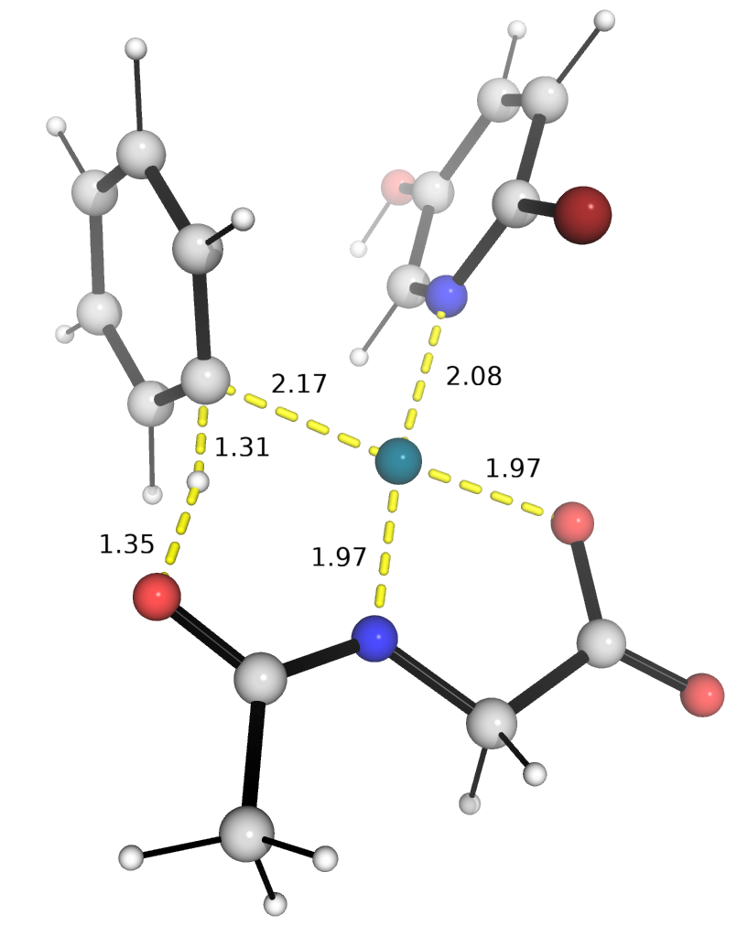 | 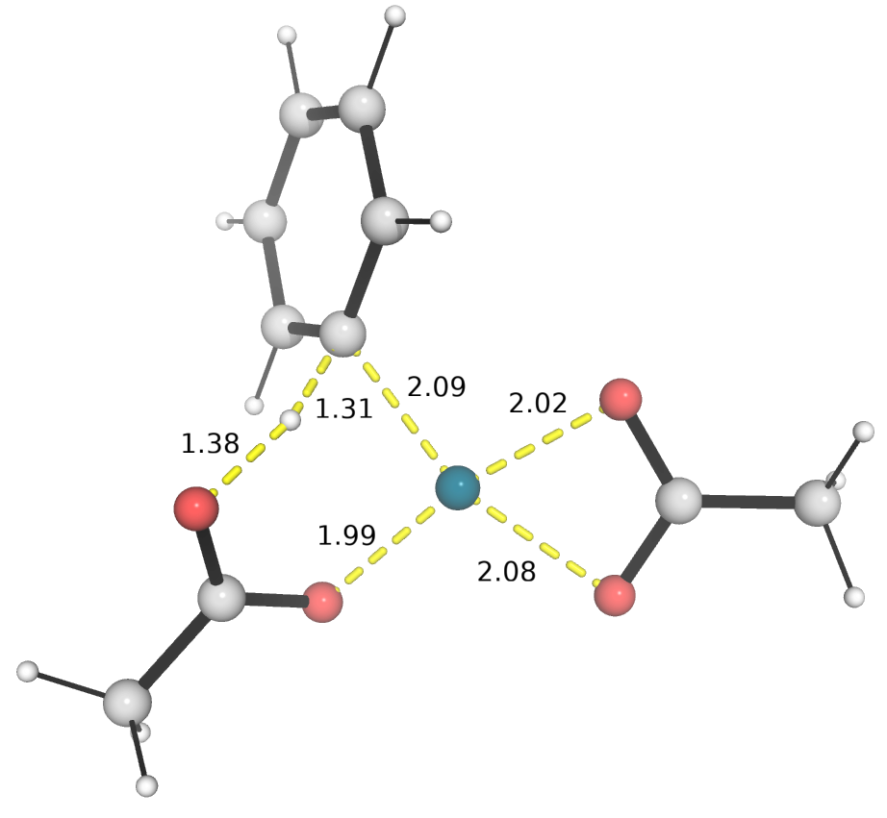 | 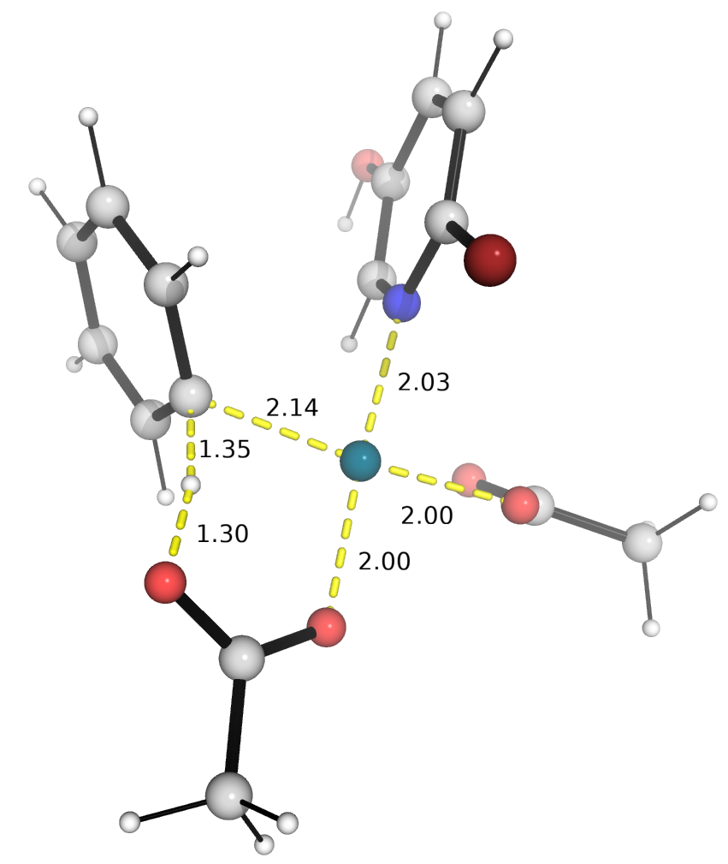
Figure 2. DFT optimized transition state structures of C–H activation step involving different ligands. All Gibbs energies were quoted with referece to the common zero reference, herein the monomeric Pd(OAc)₂.

out. The kinetic isotope effect (KIE) studies carried out with benzene and its deuterated analogue gave a k_{H}/k_{D} value of 3.12 (Scheme 5b). A high ratio obtained due to kinetics difference suggests that the C−H activation is likely the turnover-frequency determining step of the overall catalytic cycle.^{6m} For further affirmation of this observation, order determination were carried out with benzene and gem-difluoro olefin (a). The reaction kinetics followed first order for the arene while it was observed to be 0.11 with respect to the olefin. This clearly indicates that arene is the only species involved in the rate determining step while the olefin does not participate in it. However, a small but mechanistically relevant 0.11 value of olefin order suggests that although olefin does not take part in the rate determining step, but a small fraction of product may undergo conversion to the starting material while C-H activation is the key step of the observed reaction.^{6d} Kinetic experiments were also performed to understand the role of ligands in accelerating the reaction rate (see SI section 5 for details). We also get a unity order in palladium varying the loading of catalyst component keeping the ratio of ligand constant.^{6d} The combination of dual optimal ligands showed a two-fold increase in the rate compared to the mono-protected amino acid ligand system. Further the reaction was also found to be adequately hindered when performed with ligands singularly. This demonstrates the role of the dual ligand in executing the C−H/C−F coupling via non-directed strategy.
Density functional theory (DFT) calculations were performed to gain further insights into the reaction mechanism of the catalytic cycle (see SI section 8.1 for details). The solvent corrected Gibbs free energy profile is shown in Figure 1. Following the works of Liu,¹⁸ Bull,¹⁹ Musaev,²⁰ Macgregor²¹ and Maseras,²² where monomeric Pd species were considered in the catalytic cycles involving Pd(OAc)₂, we herein considered mononuclear Pd species, as we anticipate that the more stable trimeric [Pd(OAc)₂]₃ will be in equilibrium with Pd(OAc)₂ that acts as an active catalyst. In addition, Musaev and co-workers showed that in general, dinuclear complexes have higher C−H activation barriers than mononuclear complexes.²³ From DFT studies, the reaction proceeds first with the tandem N–H and O–H activation of the N-acetylglycine ligand, giving a 5-membered N,O-bound palladacycle coordinated to two molecules of bromopyridinol ligands, INT3, which is -3.4 kcal mol⁻¹ thermodynamically downhill compared to Pd(OAc)₂. We note that INT3, with MPAA activation and two ancillary ligands coordinated to the Pd-center, is similar to the proposed resting state in a related DFT study performed by van Gemmeren and co-workers.^{6d} This is followed by the displacement of one ligand by the arene substrate, which then undergoes C–H activation by the amide oxygen atom via TS2, a [5,6]-palladacyclic transition state shown to be conducive for C–H activation.²⁴ The C–H activated complex INT5 then undergoes imidic acid to amide tautomerism (energetically favored, SI section 8.3), leaving a vacant side for olefin coordination. Upon complexation of gem-difluoro olefin substrate, INT6 undergoes carbopalladation via TS3, forging the C–C bond. Intermediate INT7 then undergoes a conformational change (i.e., rotation) and allow one of the F atoms to coordinate to Pd-center before subsequent β-F elimination can occur, via TS4, to yield the final product that is coordinated to the Pd, INT9. It is worth noting that the β-F elimination of either of the two different F atoms gives rise to either E or Z stereochemistry across the C=C double bond. Our computational studies (SI section 8.5) suggest that the formation of Z-product over E-product will be favored by 1.0 kcal mol⁻¹ using benzene substrate (to yield product 4) and by 5.3 kcal mol⁻¹ using 1,3-diisopropyl-2-methoxybenzene substrate (to yield product 25). Product dissociation from INT9 then gives INT10. A possible ligand exchange of the fluoride ion by bromopyridinol ligand from INT10 and the deprotonation of the amide N–H may regenerate INT3, thereby continuing the catalytic cycle. (See the supporting information Computational Section- Part II Figures S.1 and S.2 for DFT optimized structures of other conformations of the TSs).
The carbopalldation step via TS3 has a relatively low barrier of 13.4 kcal mol⁻¹ from the C–H activated complex INT5. This process is highly exergonic and irreversible, forming carbopalladated intermediate INT7 which undergoes β-F elimination, with a barrier of 16.7 kcal mol⁻¹. Note that each catalytic cycle is favorably exergonic at -17.8 kcal mol⁻¹ (INT3 to INT3). The possible role of copper(II) acetate could be acting as scavenger of fluoride ions or providing as source of acetate ions, much like silver ion additives in Pd-catalyzed C–H functionalization.²⁶
From the calculations, the bromopyridinol ligand plays important roles in coordinating to the Pd center, giving catalytic species INT3, as well as in product release. The MPAA ligand has demonstrated importance in the C–H activation step; the participation of other ligands in C–H activation give higher activation barriers: the usage of Pd(OAc)₂ in C–H activation has a higher barrier at 25.8 kcal mol⁻¹ (TS2-ac, Figure 2), whereas the addition of the bromopyridinol ligand lowers this barrier by 1.8 kcal mol⁻¹ to 24.0 kcal mol⁻¹ (TS2-ac-L, Figure 2). Comparing TS2, at 18.4 kcal mol⁻¹, and TS2-ac-L, both with one molecule of the bromopyridinol ligand coordinated, we see that the TS using MPAA has a lower barrier than the TS using acetate ligands, by 5.6 kcal mol⁻¹ , potentially because the release of two acetate ligands by one MPAA ligand is entropically favorable.
From the overall energy profile, the turnover-frequency determining intermediate (TDI) is the activate catalyst in the form of complex INT3 while the turnover-frequency determining transition state, TDTS, is the C–H activation step (TS2). The overall energy span²⁵ is thus 21.8 kcal mol⁻¹. C–H activation of the arene substrate is irreversible and the TDTS of the overall cycle, in agreement with the experimental kinetic studies with a k_{H}/k_{D} value of 3.12 for this step as well as a measured first order dependence on the concentration of the arene. As the olefin enters the reaction after the TDTS, there is no dependence of the rate on its concentration, consistent with experimentally observed measurement.
4. Conclusions
In summary, we have devised a Pd catalyzed system to enable the first C−H/C−F coupling by a non-directed strategy. The dual ligand system plays a pivotal role in enabling the α-fluoro olefination of diverse arenes in moderate to high regioselectivities, guided by the innate steric and electronic properties. The substituents present in the olefin had a fair control on the regioselectivity of the product. The importance of the transformation can be underscored by the accessibility it provides in conjugating drug with a natural product through a fluoro-olefin bridge. The incorporation of fluorine containing olefinic moiety creates new avenues of drug diversification process with modulated bioactivity. The kinetics experiments and order determination studies provide insights about the probable mechanism operative in this transformation. Combined experimental and computational mechanistic studies with dual ligands and mono-ligand system underscore the importance of the ligand systems in accelerating the non-directed C−H/C−F couplings.
ASSOCIATED CONTENT
Supporting Information
Experimental procedures, analytical data (¹H, ¹³C NMR, ¹⁹F NMR, IR, MS). This material is available free of charge via the Internet at http://pubs.acs.org.
AUTHOR INFORMATION
Corresponding Author
*Xinglong Zhang − ²Institute of High Performance Computing (IHPC), Agency for Science, Technology and Research (A*STAR), 1 Fusionopolis Way, #16-16 Connexis, Singapore 138632, Republic of Singapore
Email: zhang_xinglong@ihpc.a-star.edu.sg
*Debabrata Maiti − Department of Chemistry, Indian Institute of Technology Bombay, Powai, Mumbai 400076, India; Email: dmaiti@iitb.ac.in.

Author Contributions
S.P., D.M. conceived the concept. S.P., Y.B. and S.G. performed the reactions and analyzed the products. S.P., Y.B., S.G., D.M. designed the control experiments and mechanistic pathway. X.Z. designed and performed the computational studies and analyzed the results. The manuscript was written through contributions of all authors. All authors have given approval to the final version of the manuscript.

Experimental Section
General Procedure for Non-Directed C-H/C-F Coupling. In an oven-dried screw cap reaction tube charged with a magnetic stir-bar was added arenes (0.2 mmol, 1 equiv.), Pd(OAc)₂ (10 mol%), N-Ac-Gly-OH (20 mol%), 6-bromo-pyrdine-3-ol (30 mol%), Cu(OAc)₂ (2 equiv.) and gem-difluoro olefin (2 equiv.). After that 1.2 mL HFIP was added followed by AcOH (2 equiv.) with a microlitre pipette under aerobic condition. The tube was tightly capped and placed in a preheated oil bath at 80 ^{ο}C and the reaction mixture was stirred for 24 h. After completion, the reaction mixture was then cooled to room temperature and filtered through a celite pad with ethyl acetate. The filtrate was concentrated and the desired compounds were purified by column chromatography using silica gel (100-200 mesh size) and ethyl acetate/petroleum ether as the eluent.
ACKNOWLEDGMENT
Financial support received from (TTR/2021/000108) is gratefully acknowledged. Financial support received from CSIR-India (Y.B.) and IIT Bombay (S.P.) is gratefully acknowledged. X.Z. acknowledges the support from the Agency for Science, Technology and Research (A*STAR) under its Career Development Fund (CDF Project Number C210812008) and Manufacturing, Trade and Connectivity (MTC) Young Individual Research Grants (YIRG Grant Number M22K3c0091) for this work. X.Z. acknowledges the Advanced Cyberinfrastructure Coordination Ecosystem: Services & Support (ACCESS allocation number: CHE220052) for computations performed in this work.
REFERENCES
1. For selected reviews, see: a) McMurray, L.; O’Hara, F.; Gaunt, M. J. Recent Developments in Natural Product Synthesis using Metal-Catalysed C−H Bond Functionalisation. Chem. Soc. Rev. 2011, 40, 1885−1898. b) Abrams, D. J.; Provencher, P. A.; Sorensen, E. J. Recent Applications of C−H Functionalization in Complex Natural Product Synthesis. Chem. Soc. Rev. 2018, 47, 8925−8967. c) Roughley, S. D.; Jordan, A. M. The Medicinal Chemist’s Toolbox: An Analysis of Reactions used in the Pursuit of Drug Candidates. J. Med. Chem. 2011, 54, 3451−3479. d) Barker, A.; Kettle, J. G.; Nowak, T.; Pease, J. E. Expanding Medicinal Chemistry Space. Drug Discovery Today. 2013, 18, 298−304. e) Boström, J.; Brown, D. G.; Young, R. J.; Keserü, G. M. Expanding the Medicinal Chemistry Synthetic Toolbox. Nat. Rev. Drug Discovery. 2018, 17, 709−727. f) Cernak, T.; Dykstra, K. D.; Tyagarajan, S.; Vachal, P.; Krska, S. W. The Medicinal Chemist’s Toolbox for Late Stage Functionalization of Drug-like Molecules. Chem. Soc. Rev. 2016, 45, 546−576.
2. Wencel-Delord, J.; Glorius, F. C−H Bond Activation Enables the Rapid Construction and Late-stage Diversification of Functional Molecules. Nat. Chem. 2013, 5, 369−375.
3. For selected reviews, see: a) Chen, Z.; Wang, B.; Zhang, J.; Yu, W.; Liu, Z.; Zhang, Y. Transition Metal-Catalyzed C–H Bond Functionalizations by the use of Diverse Directing Groups. Org. Chem. Front. 2015, 2, 1107–1295. b) Sinha, S. K.; Guin, S.; Maiti, S.; Biswas, J. P.; Porey, S.; Maiti. D. Toolbox for Distal C–H Bond Functionalizations in Organic Molecules. Chem. Rev. 2022, 122, 5682–5841. c) Dutta, U.; Maiti, S.; Bhattacharya, T.; Maiti, D. Arene Diversification via Distal C(sp²)−H Functionalization. Science 2021, 372, 701. d) Meng, G.; Lam, N. Y. S.; Lucas, E. L.; Saint-Denis, T. G.; Verma, P.; Chekshin, N.; Yu, J.-Q. Achieving Site-Selectivity for C−H Activation Processes Based on Distance and Geometry: A Carpenter’s Approach. J. Am. Chem. Soc. 2020, 142, 10571−10591. e) Das, J.; Guin, S.; Maiti, D. Diverse Strategies for Transition Metal Catalyzed Distal C(sp³)−H Functionalizations. Chem. Sci. 2020, 11, 10887−10909. f) Liu, B.; Romine, A. M.; Rubel, C. Z.; Engle, K. M.; Shi, B.-F. Transition-Metal-Catalyzed, Coordination-Assisted Functionalization of Nonactivated C(sp3)–H Bonds. Chem. Rev. 2021, 121, 14957–15074. (g) Sambiagio, C.; Schönbauer, D.; Blieck, R.; Huy, T. D.; Pototschnig, G.; Schaaf, P.; Wiesinger, T.; Zia, M. F.; Delord, J. W.; Besset, T.; Maes, B. U. W.; Schnürch, M. A comprehensive overview of directing groups applied in metal-catalysed C–H functionalisation chemistry. Chem. Soc. Rev. 2018, 47, 6603–6743.
4. a) Wedi, P.; van Gemmermen, M. The Arene-Limited Nondirected C−H Activation of Arenes. Angew. Chem. Int. Ed. 2018, 57, 13016−13027. b) Kancherla, S.; Jøgensen, K. B.; Fernández-Ibáñez, M. Recent Developments in Palladium-Catalysed Non-Directed C−H Bond Activation in Arenes. Synthesis, 2019, 51, 643-663.
5. Moritani, I.; Fujiwara, Y. Aromatic Substitution of Styrene-Palladium Chloride Complex. Tetrahedron Lett. 1967, 8, 1119–1122.
6. a) Wang, P.; Verma, P.; Xia, G.; Shi, J.; Qiao, J. X.; Tao, S.; Cheng, P. T. W.; Poss, M. A.; Farmer, M. E.; Yeung, K.-S.; Yu, J.-Q. Ligand-Accelerated Non-Directed C−H Functionalization of Arenes. Nature 2017, 551, 489−493. b) Chen, H.; Wedi, P.; Meyer, T.; Tavakoli, G.; van Gemmermen, M. Dual Ligand-Enabled Nondirected C−H Olefination of Arenes. Angew. Chem. Int. Ed. 2018, 57, 2497−2501. c) Naksomboon, K.; Poater, J.; Bickelhaupt, F. M.; Fernandez-Ibanez, M. A. para-Selective C−H Olefination of Aniline Derivatives via Pd/S,O-Ligand Catalysis. J. Am. Chem. Soc. 2019, 141, 6719−6725. d) Wedi, P.; Farizyan, M.; Bergander, K.; Muck-Lichtenfeld, C.; van Gemmermen, M. Mechanism of the Arene-Limited Nondirected C−H Activation of Arenes with Palladium. Angew. Chem. Int. Ed. 2021, 60, 15641−15649. e) Mondal, A.; Chen, H.; Flamig, L.; Wedi, P.; van Gemmermen, M. Sterically Controlled Late-Stage C−H Alkynylation of Arenes. J. Am. Chem. Soc. 2019, 141, 18662−18667. f) Zhao, D.; Xu, P.; Ritter, T. Palladium-Catalyzed Late-Stage Direct Arene Cyanation. Chem 2019, 5, 97−107. g) Chen, H.; Mondal, A.; Wedi, P.; van Gemmermen, M. Dual Ligand-Enabled Nondirected C−H Cyanation of Arenes. ACS Catal. 2019, 9, 1979−1984. h) Liu, L.-Y.; Yeung, K.-S.; Yu, J.-Q. Ligand- Promoted Non-Directed C−H Cyanation of Arenes. Chem. Eur. J. 2019, 25, 2199−2202. i) Farizyan, M.; Mondal, A.; Mal, S.; Deufel, F.; van Gemmermen, M. Palladium-Catalyzed Nondirected Late-Stage C−H Deuteration of Arenes. J. Am. Chem. Soc. 2021, 143, 16370−16376. j) Naksomboon, K.; Valderas, C.; Gomez-Martinez, M.; Alvarez-Casao, Y.; Fernandez-Ibanez, M. A. S,O-Ligand-Promoted Palladium-Catalyzed C−H Functionalization Reactions of Nondirected Arenes. ACS Catal. 2017, 7, 6342−6346. k) Grimster, N. P.; Gauntlett, C.; Godfrey, C. R. A.; Gaunt, M. J. Palladium-Catalyzed Intermolecular Alkenylation of Indoles by Solvent-Controlled Regioselective C−H Functionalization. Angew. Chem. Int. Ed. 2005, 44, 3125–3129. l) Ueda, K.; Yanagisawa, S.; Yamaguchi, J.; Itami, K. A General Catalyst for the β-Selective C–H Bond Arylation of Thiophenes with Iodoarenes. Angew. Chem. Int. Ed. 2010, 49, 8946–8949. m) Meng, G.; Wang, Z.; Chan, H. S. S.; Chekshin, N.; Li, Z.; Wang, P.; Yu. J.-Q. Dual-Ligand Catalyst for the Nondirected C−H Olefination of Heteroarenes. J. Am. Chem. Soc. 2023, 145, 8198−8208.
7. Saha, A., Guin, S., Ali, W., Bhattacharya, T., Sasmal, S., Goswami, N., Prakash, G., Sinha, S. K., Chandrashekar, H.B., Panda, S., Anjana, S. S., Maiti. D. Photoinduced Regioselective Olefination of Arenes at Proximal and Distal Sites. J. Am. Chem. Soc. 2022, 144, 1929–1940.
8. a) Sinha, S. K.; Panja, S.; Grover, J.; Hazra, P. S.; Pandit, S.; Bairagi, Y.; Zhang, X.; Maiti, D. Dual Ligand Enabled Nondirected C–H Chalcogenation of Arenes and Heteroarenes. J. Am. Chem. Soc. 2022, 144, 12032–12042. b) Dhankhar, J.; Hofer, M. D.; Linden, A.; Čorić. I. Site-Selective C−H Arylation of Diverse Arenes Ortho to Small Alkyl Groups. Angew. Chem. Int. Ed. 2022, 61, e202205470. c) Dhankhar, J.; González-Fernández, E.; Dong, C. C.; Mukhopadhyay, T. K.; Linden, A.; Čorić. I. Spatial Anion Control on Palladium for Mild C−H Arylation of Arenes. J. Am. Chem. Soc. 2020, 142, 19040–19046.
9. a) Purser, S.; Moore, P. R.; Swallow, S.; Gouverneur, V. Fluorine in medicinal chemistry. Chem. Soc. Rev., 2008, 37, 320−330. b) Gillis, E. P.; Eastman, K. J.; Hill, M. D.; Donnelly, D. J. Meanwell, N. A. Applications of Fluorine in Medicinal Chemistry. J. Med. Chem. 2015, 58, 8315–8359. c) Hagmann, W. K. The Many Roles for Fluorine in Medicinal Chemistry. J. Med. Chem. 2008, 51, 4359–4369.
10. a) Müller, K.; Faeh, C.; Diederich. F. Fluorine in pharmaceuticals: looking beyond intuition. Science 2007, 317, 1881–1886. b) Isanbor, C.; O’Hagan, D. Fluorine in Medicinal Chemistry: A Review of Anti-Cancer Agents. J. Fluorine Chem. 2006, 127, 303–319. c) O’Hagan, D. Fluorine in health care: Organofluorine containing blockbuster drugs. J. Fluorine Chem. 2010, 131, 1071–1081. d) Lee, E.; Kamlet, A. S.; Powers, D. C.; Neumann, C. N.; Boursalian, G. B.; Furuya, T.; Choi, D. C.; Hooker, J. M.; Ritter, T. A fluoride-derived electrophilic late-stage fluorination reagent for PET imaging. Science 2011, 334, 639–642. e) Tredwell, M.; Gouverneur, V. ¹⁸F Labeling of Arenes. Angew. Chem., Int. Ed. 2012, 51, 11426–11437. f) Stenhagen, I. S. R.; Kirjavainen, A. K.; Forsback, S. J.; Jørgensen, C. G.; Robins, E. G.; Luthra, S. K.; Solin, O.; Gouverneur, V. [¹⁸F]Fluorination of an arylboronic ester using [¹⁸F]selectfluor bis(triflate): application to 6-[¹⁸F]fluoro-l-DOPA. Chem. Commun. 2013, 49, 1386–1388. g) Reichenbacher, K.; Suss, H. I.; Hulliger, J. Fluorine in crystal engineering—‘‘the little atom that could.’’Chem. Soc. Rev. 2005, 34, 22−30. h) O’Hagan, D. Understanding organofluorine chemistry. An introduction to the C–F bond. Chem. Soc. Rev. 2008, 37, 308. i) Liang, T.; Neumann, C. N.; Ritter, T. Introduction of fluorine and fluorine-containing functional groups. Angew. Chem. Int. Ed. 2013, 52, 8214–8264. j) O’Hagan, D.; Deng, H. Enzymatic fluorination and biotechnological developments of the fluorinase. Chem. Rev. 2014, 115, 634–649.
11. a) Jakobsche, C. E.; Peris, G.; Miller, S. J. Functional Analysis of an Aspartate Based Epoxidation Catalyst with Amide to Alkene Peptidomimetic Catalyst Analogues. Angew. Chem. Int. Ed. 2008, 47, 6707–6711. b) Niida, A.; Fujii, N. Unequivocal Synthesis of (Z)-Alkene and (E)-Fluoroalkene Dipeptide Isosteres to Probe Structural Requirements of the Peptide Transporter PEPT1. Org. Lett. 2006, 8, 613–616. c) Vander Veken, P.; Augustyns, K. Fluoro-Olefins as Peptidomimetic Inhibitors of Dipeptidyl Peptidases. J. Med. Chem. 2005, 48, 1768–1780. d) Edmondson, S. D.; Wei, L.; Xu, J.; Shang, J.; Xu, S.; Pang, J.; Chaudhary, A.; Dean, D. C.; He, H.; Leiting, B.; Lyons, K. A. Patel, R. A.; Patel, S. B.; Scapin, G.; Wu, J. K.; Beconi, M. G.; Thornberry, N. A.; Weber, A. E. Fluoroolefins as Amide Bond Mimics in Dipeptidyl Peptidase IV Inhibitors. Bioorg. Med. Chem. Lett. 2008, 18, 2409–2413. e) Couve-Bonnaire, S.; Cahard, D.; Pannecoucke, X. Chiral Dipeptide Mimics Possessing a Fluoroolefin Moiety: a Relevant Tool for Conformational and Medicinal Studies. Org. Biomol. Chem. 2007, 5, 1151–1157. f) Osada, S.; Sano, S.; Ueyama, M.; Chuman, Y.; Kodama, H.; Sakaguchi, K. Fluoroalkene Modification of Mercaptoacetamide-Based Histone Deacetylase Inhibitors. Bioorg. Med. Chem. 2010, 18, 605–611. g) Milczek, E. M.; Bonivento, D.; Binda, C.; Mattevi, A.; McDonald, I. A.; Edmondson, D. E. Structural and Mechanistic Studies of Mofegiline Inhibition of Recombinant Human Monoamine Oxidase B^{II}. J. Med. Chem. 2008, 51, 8019–8026. h) Dutheuil, G.; Couve-Bonnaire, S.; Pannecoucke, X. Diastereomeric Fluoroolefins as Peptide Bond Mimics Prepared by Asymmetric Reductive Amination of α-Fluoroenones. Angew. Chem. Int. Ed. 2007, 46, 1290–1292. i) Ni, J.; Nishonov, B.; Pardaev, A.; Zhang, A. Palladium-Catalyzed Ring-Opening Coupling of gem−Difluorocyclopropanes for the Construction of 2‑Fluoroallylic Sulfones. J. Org. Chem. 2019, 84, 13646−13654.
j) Nenajdenko, V. G.; Goldberg, A. A.; Muzalevskiy, V. M.; Balenkova, E. S.; Shastin, A. V. Design and Synthesis of a New Family of Fluorinated Liquid Crystals. Chemistry – A European Journal. 2013, 19, 2370−2383. k) Bachi, M. D.; Korshin, E. E.; Hoos, R.; Szpilman, A. M.; Ploypradith, P.; Xie, S.; Shapiro, T. A.; Posner, G. H. A Short Synthesis and Biological Evaluation of Potent and Nontoxic Antimalarial Bridged Bicyclic β-Sulfonyl-Endoperoxides. J. Med. Chem. 2003, 46, 2516-2533.
12. a) Furuya, T.; Kamlet, A. S.; Ritter, T. Catalysis for fluorination and trifluoromethylation. Nature 2011, 473, 470–477. b) Watson, D. A.; Buchwald, S. L. Formation of ArF from LPdAr(F): catalytic conversion of aryl triflates to aryl fluorides. Science 2009, 325, 1661–1664. c) Wang, X.; Truesdale, L.; Yu, J.-Q. Pd(II)-catalyzed ortho-trifluoromethylation of arenes using TFA as a promoter. J. Am. Chem. Soc. 2010, 132, 3648–3649. d) Ye, Y.; Schimler, S. D.; Hanley, P. S.; Sanford, M. S. Cu(OTf)₂-mediated fluorination of aryltrifluoroborates with potassium fluoride. J. Am. Chem. Soc. 2013, 135, 16292–16295. e) Cho, E. J.; Buchwald, S. L. The palladium-catalyzed trifluoromethylation of aryl chlorides. Science 2010, 328, 1679–1681. f) Fier, P. S.; Hartwig, J. F. Copper-mediated fluorination of aryl iodides. J. Am. Chem. Soc. 2012, 134, 10795–10798. g) Landelle, G.; Bergeron, M.; Turcotte-Savard, M.-O.; Paquin, J.-F. Synthetic Approaches to Monofluoroalkenes. Chem. Soc. Rev. 2011, 40, 2867–2908. h) Yanai, H.; Taguchi, T. Synthetic Methods for Fluorinated Olefins. Eur. J. Org. Chem. 2011, 5939-5954.
13. a) Tian, P.; Feng, C.; Loh, T.-P. Rhodium-catalysed C(sp2)–C(sp2) bond formation via C–H/C–F activation. Nat. Commun. 2015, 6, 7472. b) Kong, L.; Zhou, X.; Li, X. Cobalt(III)-Catalyzed Regio- and Stereoselective α-Fluoroalkenylation of Arenes with gem-Difluorostyrenes. Org. Lett. 2016, 18, 6320–6323. c) Zell, D.; Dhawa, U.; Mgller, V.; Bursch, M.; Grimme, S.; Ackermann, L. C–F/C–H Functionalization by Manganese(I) Catalysis: Expedient (Per)Fluoro-Allylations and Alkenylations. ACS Catal. 2017, 7, 4209–4213. d) Cai, S.-H.; Ye, L.; Wang, D.-X.; Wang, Y.-Q.; Lai, L.-J.; Zhu, C.; Feng, C.; Loh, T.-P. Manganese-catalyzed synthesis of monofluoroalkenes via C–H activation and C–F cleavage. Chem. Commun. 2017, 53, 8731–8734. e) Kong, L.; Liu, B.; Zhou, X.; Wang, F.; Li, X. Rhodium(iii)-catalyzed regio- and stereoselective benzylic α-fluoroalkenylation with gem-difluorostyrenes. Chem. Commun. 2017, 53, 10326-10329. f) Li, N.; Chang, J.; Kongc, L.; Li, X. Ruthenium(ii)-catalyzed α-fluoroalkenylation of arenes via C–H bond activation and C–F bond cleavage. Org. Chem. Front. 2018, 5, 1978-1982. g) Zhang, L.; Deng, K.; Wu, G.; Yang, J.; Tang, S.; Fu, X.; Xia, C.; Ji, Y. Ruthenium(II)-Catalyzed α-Fluoroalkenylation of Oxime Ethers with gem-Difluorostyrenes via C–H Activation and C–F Cleavage. J. Org. Chem. 2020, 85, 12670-12681. h) Tian, M.; Yang, X.; Zhang, B.; Liu, B.; Li. X. Rh(iii)-Catalyzed α-fluoroalkenylation of N-nitrosoanilines with 2,2-difluorovinyl tosylates via C–H bond activation. Org. Chem. Front. 2018, 5, 3406-3409. i) Song, S.; Liu, H.; Wang, L.; Zhu, C.; Loh, T. P.; Feng. C. Rhodium-Catalyzed Defluorinative Vinylation of gem-Difluoroalkenes for the Synthesis of 2-Fluoro-1,3-dienes. Chin. J. Chem. 2019, 37, 1036-1040. j) Wang, N.; Yang, Q.; Deng, Z.; Mao, X.; Peng, Y. Rhodium-Catalyzed Merging of 2-Arylquinazolinone and 2,2-Difluorovinyl Tosylate: Diverse Synthesis of Monofluoroolefin Quinazolinone Derivatives. ACS Omega. 2020, 5, 14635-14644.
14. a) Schneider, C.; Hoarau, C. Palladium- and Copper-Catalyzed Stereocontrolled Direct C-H Fluoroalkenylation of Heteroarenes using Gem-Bromofluoroalkenes. Angew. Chem. Int. Ed. 2013, 52, 3246–3249. b) Rousee, K.; Schneider, C., Couve-Bonnaire, S., Pannecoucke, X. & Hoarau, C. Pd- and Cu-catalyzed Stereo- and Regiocontrolled Decarboxylative/C-H Fluoroalkenylation of Heteroarenes. Chem. Eur. J. 2014, 20, 15000–15004.
15. a) Fujita, T.; Fuchibe, K.; Ichikawa, J. Transition-Metal-Mediated and Catalyzed C-F Bond Activation by Fluorine Elimination. Angew. Chem. Int. Ed. 2019, 58, 390–402. b) Ahrens, T.; Kohlmann, J.; Ahrens, M.; Braun, T. Functionalization of Fluorinated Molecules by Transition-Metal-Mediated C−F Bond Activation to Access Fluorinated Building Blocks. Chem. Rev. 2015, 115, 931−972. c) Banks, R. E.; Smart, B. E.; Tatlow, J. C. Organofluorine Chemistry, Principles and Commercial Applications, Plenum Press, New York, 1994, 1-629. d) Uneyama, K. Organofluorine Chemistry, Blackwell Publishing, Oxford, 2006, 1-350. e) J.-P. Bégué, D. Bonnet-Delpon, Bioorganic and Medicinal Chemistry of Fluorine, Wiley, Hoboken, 2008, 1-384.
16. a) Heitz, W.; Knebelkamp, A. Synthesis of fluorostyrenes via palladium-catalyzed reactions of aromatic halides with fluoroolefins. Makromol. Chem. Rapid Commun.1991, 12, 69–75. b) Gharat, L. A.; Martin, A. R. 5-(α-fluorovinyl)-N-tosylindole. Heterocycles 1996, 43, 185–189. c) Thornbury, R. T.; Toste, F. D. Palladium-Catalyzed Defluorinative Coupling of 1-Aryl-2,2-Difluoroalkenes and Boronic Acids: Stereoselective Synthesis of Monofluorostilbenes. Angew. Chem. Int. Ed. 2016, 55, 11629–11632.
17. a) Burdeniuc, J.; Jedlicka, B.; Crabtree, R. H. Recent Advances in C–F Bond Activation. Chem. Ber. 1997, 130, 145–154. b) Amii, H.; Uneyama, K. C−F Bond Activation in Organic Synthesis. Chem. Rev. 2009, 109, 2119–2183. c) Stahl, T.; Klare, H. F. T.; Oestreich, M. Main-Group Lewis Acids for C–F Bond Activation. ACS Catal. 2013, 3, 1578–1587. d) Ahrens, T.; Kohlmann, J.; Ahrens, M.; Braun, T. Functionalization of Fluorinated Molecules by Transition-Metal-Mediated C–F Bond Activation To Access Fluorinated Building Blocks. Chem. Rev. 2015, 115, 931–972. e) Unzner, T. A.; Magauer, T. Carbon–fluorine bond activation for the synthesis of functionalized molecule. Tetrahedron Lett. 2015, 56, 877–883. f) Shen, Q.; Huang, Y.-G.; Liu, C.; Xiao, J.-C.; Chen, Q.-Y.; Guo, Y. Review of recent advances in C−F bond activation of aliphatic fluorides. J. Fluorine Chem. 2015, 179, 14–22. g) Ma, Q.; Wang, Y.; Tsui, G.-C. Stereoselective Palladium-Catalyzed C−F Bond Alkynylation of Tetrasubstituted gem-Difluoroalkenes. Angew. Chem. Int. Ed. 2020, 59, 11293–11297. h) Wang, Y.; Qi, X.; Ma, Q.; Liu, P.; Tsui, G.-C. Stereoselective Palladium-Catalyzed Base-Free Suzuki–Miyaura Cross-Coupling of Tetrasubstituted gem-Difluoroalkenes: An Experimental and Computational Study. ACS Catal. 2021, 11, 8, 4799–4809. i) Li, M.; Wang, Y.; Tsui, G.-C. Palladium-Catalyzed Stereoselective C−F Bond Vinylation and Allylation of Tetrasubstituted gem-Difluoroalkenes via Stille Coupling: Synthesis of Monofluorinated 1,3- and 1,4-Dienes. Org. Lett. 2021, 23, 8072–8076. j) Wada, S.; Jordan. R. F. Olefin Insertion into a Pd–F Bond: Catalyst Reactivation Following β-F Elimination in Ethylene/Vinyl Fluoride Copolymerization. Angew. Chem. Int. Ed. 2017, 56, 1820–1824.
18. Zhang, X.; Lu, G.; Sun, M.; Mahankali, M.; Ma, Y.; Zhang, M.; Hua, W.; Hu, Y.; Wang, Q.; Chen, J.; et al. A General Strategy for Synthesis of Cyclophane-Braced Peptide Macrocycles via Palladium-Catalysed Intramolecular sp³ C−H Arylation. Nat. Chem. 2018, 10, 540–548.
19. Antermite, D.; White, A. J. P.; Casarrubios, L.; Bull, J. A. On the Mechanism and Selectivity of Palladium-Catalyzed C(Sp3)–H Arylation of Pyrrolidines and Piperidines at Unactivated C4 Positions: Discovery of an Improved Dimethylaminoquinoline Amide Directing Group. ACS Catal. 2023, 9597–9615.
20. Xu, L. P.; Qian, S.; Zhuang, Z.; Yu, J. Q.; Musaev, D. G. Unconventional Mechanism and Selectivity of the Pd-Catalyzed C–H Bond Lactonization in Aromatic Carboxylic Acid. Nat. Commun. 2022 131 2022, 13, 1–8.
21. Davies, D. L.; Macgregor, S. A.; McMullin, C. L. Computational Studies of Carboxylate-Assisted C-H Activation and Functionalization at Group 8-10 Transition Metal Centers. Chem. Rev. 2017, 117, 8649–8709.
22. García-Cuadrado, D.; Braga, A. A. C.; Maseras, F.; Echavarren, A. M. Proton Abstraction Mechanism for the Palladium-Catalyzed Intramolecular Arylation. J. Am. Chem. Soc. 2006, 128, 1066–1067.
23. Haines, B. E.; Berry, J. F.; Yu, J.-Q. Q.; Musaev, D. G. Factors Controlling Stability and Reactivity of Dimeric Pd(II) Complexes in C-H Functionalization Catalysis. ACS Catal. 2016, 6, 829–839.
24. a) Chen, G.; Gong, W.; Zhuang, Z.; Andrä, M. S.; Chen, Y. Q.; Hong, X.; Yang, Y. F.; Liu, T.; Houk, K. N.; Yu, J. Q. Ligand-Accelerated Enantioselective Methylene C(Sp³)-H Bond Activation. Science 2016, 353, 1023–1027. b) Achar, T. K.; Zhang, X.; Mondal, R.; Shanavas, M. S.; Maiti, S.; Maity, S.; Pal, N.; Paton, R. S.; Maiti, D. Palladium‐Catalyzed Directed Meta ‐Selective C−H Allylation of Arenes: Unactivated Internal Olefins as Allyl Surrogates. Angew. Chem. Int. Ed. 2019, 58, 10353–10360. c) Cheng, G. J.; Yang, Y. F.; Liu, P.; Chen, P.; Sun, T. Y.; Li, G.; Zhang, X.; Houk, K. N.; Yu, J. Q.; Wu, Y. D. Role of N-Acyl Amino Acid Ligands in Pd(II)-Catalyzed Remote C-H Activation of Tethered Arenes. J. Am. Chem. Soc. 2014, 136, 894–897. d) Yang, Y. F.; Hong, X.; Yu, J. Q.; Houk, K. N. Experimental-Computational Synergy for Selective Pd(II)-Catalyzed C-H Activation of Aryl and Alkyl Groups. Acc. Chem. Res. 2017, 50, 2853–2860. e) Cook, A. K.; Sanford, M. S. Mechanism of the Palladium-Catalyzed Arene C−H Acetoxylation: A Comparison of Catalysts and Ligand Effects. J. Am. Chem. Soc. 2015, 137, 3109–3118. f) Gair, J. J.; Haines, B. E.; Filatov, A. S.; Musaev, D. G.; Lewis, J. C. Mono-N-protected amino acid ligands stabilize dimeric palladium(II) complexes of importance to C–H functionalization. Chem. Sci. 2017, 8, 5746–5756. g) Porey, S.; Zhang, X.; Bhowmick, S.; Kumar Singh, V.; Guin, S.; Paton, R. S. R. S.; Maiti, D. Alkyne Linchpin Strategy for Drug:Pharmacophore Conjugation: Experimental and Computational Realization of a Meta-Selective Inverse Sonogashira Coupling. J. Am. Chem. Soc. 2020, 142, 3762–3774.
25. Kozuch, S.; Shaik, S. How to Conceptualize Catalytic Cycles? The Energetic Span Model. Acc. Chem. Res. 2011, 44, 101–110.
26. Lotz, M. D.; Camasso, N. M.; Canty, A. J.; Sanford, M. S. Role of Silver Salts in Palladium-Catalyzed Arene and Heteroarene C–H Functionalization Reactions. Organometallics 2017, 36, 165-171.

Non-Directed C−H/C−F Coupling for the Synthesis of α-Fluoro Olefinated Arenes
Sandip Porey,¹ Yogesh Bairagi,¹ Srimanta Guin,¹ Xinglong Zhang^{2,}* & Debabrata Maiti^{1,}*

Graphical abstract

