Effect of heat treatment on the strength and fracture resistance of a laser powder bed fusion-processed 18Ni-300 maraging steel

Moses J. Paul¹, Yokasundery Muniandy¹, Jamie J. Kruzic¹, Upadrasta Ramamurty^{2,3}, Bernd Gludovatz^{1,}
¹School of Mechanical and Manufacturing Engineering, University of New South Wales (UNSW Sydney), Sydney NSW 2052, Australia
²School of Mechanical and Aerospace Engineering, Nanyang Technological University, Singapore 639798, Republic of Singapore
³Institute of Materials Research and Engineering, 2 Fusionopolis Way, Innovis, #08-03, Singapore 138634, Republic of Singapore
Abstract
Engineering materials processed using additive manufacturing (AM) techniques such as laser powder bed fusion (LPBF) often exhibit unique microstructures and defects that must be controlled to obtain peak performance in mechanical properties. Towards this end, we here investigate how three heat-treatments (direct aging, solution treatment + aging, and thermal cycling + aging) impact microstructure evolution and corresponding mechanical performance of LPBF-processed 18Ni-300 maraging steel. Specifically, we focus on how strength and fracture toughness measured in two orthogonal directions correlate with phase transformation kinetics as well as micro- and meso-structural features and compare findings with results from as-built and conventionally processed material. Aging results in the formation of Ni-Ti and Mo-rich nano-precipitates that enhance strength but reduce both ductility and fracture resistance when compared to as-built material. With the solution treatment, however, AM-characteristics such as cellular sub-structures and melt-pool boundaries dissolve almost entirely and as a result the damage-tolerance capacity of the material degrades and becomes comparable to cast material. Thermal cycling, on the other hand, results in the formation of reverted austenite thereby enabling the transformation-induced plasticity (TRIP) effect. This leads to extensive gains in ductility that are accompanied by only moderate reductions in strength while fracture toughness is improved significantly. While anisotropy in the obtained data from both the tensile tests and the crack resistance curve (R-curve) measurements is noticeable, it is low relative to many LPBF-processed alloys due to the strong bonding characteristics between the individual layers.
Keywords: 18Ni-300 maraging steel; laser powder bed fusion; micro- and meso-structure; strength and fracture resistance curve (R-curve) behavior; mechanical properties
- Introduction
Additive manufacturing (AM) techniques such as laser powder bed fusion (LPBF) often exhibit microstructural features that are distinctly different from counterparts that are fabricated using conventional processing routes [1]. The rapid cooling rates, for example, can result in refined microstructures which together with melt pool-induced meso-structures have the potential to impact mechanical performance and result in orientation-dependent failure characteristics. Based on the printed alloy system, however, damage-tolerance may not have fully developed after printing and subsequent heat-treatments be required to obtain peak performance in material properties such as strength and fracture toughness [2].
Maraging steels have excellent toughness and formability characteristics and are used extensively in aerospace, tool, and die industries [3–5]. Due to their low carbon content, they have excellent weldability characteristics making them suitable candidate materials for various AM methods. Previous studies have shown that fully dense AM maraging steels exhibit properties comparable to their traditionally manufactured counterparts [6–8]. Maraging steels are usually solution-treated (homogenized) and cooled from austenitic temperatures (above 800 °C) to form a heavily dislocated martensite phase. Subsequent aging results in the formation of intermetallic precipitates such as Fe₃(Ni,Mo), FeMo, Ni₃Ti, Fe₇Mo₆ [3,9] – this can increase the tensile strength, σ_{UTS} of the material by ~60-80% to around ~2000 MPa. Similarly, AM maraging steels processed using LPBF are relatively soft and ductile in the as-built condition (i.e., they exhibit failure strains, ε_{f}, of ~10-14%) and exhibit average σ_{UTS} that range between ~1000 and 1300 MPa [10–13]. The formation of intermetallic precipitates during the subsequent aging heat-treatments elevates σ_{UTS} to ~1900-2100 MPa, which, however, comes with a drastic reduction in ductility (ε_{f} ~3-4%) [10–13].
LPBF produced metals often exhibit anisotropic mechanical behavior due to their directional microstructure evolution and their associated mesostructures and interfaces of melt pool boundaries [14–17]. Yet, most studies on LPBF maraging steels do not report significant anisotropy in mechanical performance [10,11,18]. Instead, the stress-strain responses measured in various orientations are often close to isotropic which is associated with strong intra- and inter-layer bonding and a lack of crystallographic texture in the material. Mooney et al. [13,19], however, have recently investigated the effect of build-orientation (0°, 45°, and 90°) on mechanical properties in LPBF produced maraging steels after various heat-treatments and concluded that some degree of anisotropy exists in both strength and ductility that is affected by aging time and temperature. While aging their material to maximize strength (peak aging) can result in pronounced anisotropic ductility, this anisotropy can be reduced significantly by altering the aging-treatment which is, however, often associated with a significant drop in strength to levels comparable with material in the as-built condition. Additionally, the effect of solution treatment – which is conventionally used to homogenize the material and reduce residual stresses – on anisotropy in LPBF maraging steel has rarely been investigated. Bai et al. [20] suggested that conventional solution treatment temperatures (815 - 840°C) used in cast maraging steels may not be sufficient to enable effective microsegregation in LPBF-processed material. However, solution treatment temperatures at 900°C and above have been shown to result in fully homogenized materials with improved mechanical performance [20–22].
Recent studies have focused on enhancing ductility through the formation of reverted austenite during thermal cycling [22,23]. In this process, the samples are held above the austenite finish transformation temperature (A_{f} ~750°C) for a short period thereby enabling the diffusion of austenite-stabilizing elements (primarily Ni) resulting in the reverse transformation of martensite to austenite [22,24].The austenite is then stable down to room temperature which can result in ductility gains up to more than 60% [22]. However, ductility is not generally used as a mechanical engineering design property. Rather, fracture toughness is the key mechanical property that describes a material’s resistance against the propagation of a crack, i.e., its damage tolerance. For LPBF produced maraging steel, the fracture toughness of peak aged material has been reported as ~50-75 MPa√m and it does not appear to correlate linearly with strength nor with ductility [10,25]. While these fracture toughness values are comparable to their cast counterparts, they do not evaluate the impact of the unique microstructure evolution in LPBF-processed materials that has been shown to affect crack resistance during crack growth in materials such as AlSi10Mg [17]. Furthermore, the role of reverted austenite on the fracture characteristics of LPBF produced maraging steels remains unknown.
In this work, we investigate how damage tolerance in terms of strength, ductility, and fracture toughness are affected by various heat treatments of a LPBF produced maraging steel when tested both parallel and perpendicular to the build direction. We focus on understanding how fracture resistance improves and how strength and ductility develop simultaneously with the introduction of reverted austenite. Finally, we make comparisons of the microstructure and properties of our LPBF samples to a commercially available cast counterpart.
2. Experimental Section
Two 35 × 25 × 65 mm³ blocks of 18Ni-300 maraging steel were printed under high purity argon atmosphere using LPBF with gas atomized EOS MS1 powder with the particle size ranging between 15 and 53 µm. The chemical composition of the powder is shown in Table 1. Processing parameters were 305 W laser power, 1010 mm/s scan speed, 50 μm powder layer thickness, and 110 μm hatch spacing with 67° rotation scan strategy (as illustrated in Fig. 1a) to give ~99.6% relative material density measured using Archimedes’ principle with an A&D Weighing HR-250A analytical balance. The build plates were used at ambient temperature and were not heated during processing. To compare the LPBF material to a corresponding cast alloy, a commercially available W722 alloy that has similar composition (Table 1) as the LPBF material was also studied.
Table 1. Chemical composition of the 18Ni-300 maraging steel LPBF powder and the W722 cast alloy (in wt.%).
 | Ni | Co | Mo | Ti | Al | Cr | C | Fe
LPBF powder [26] | 17-19 | 8.5-9.5 | 4.5-5.2 | 0.6-0.8 | 0.05-0.15 | < 0.5 | < 0.03 | Balance
W722 [27] | 18.00 | 9.30 | 4.90 | 1.10 | - | - | < 0.03 | Balance
As-built samples were heat-treated in a Nabertherm muffle furnace using one of the three thermal processing routes shown in Fig. 1b. The first heat-treatment is based on the conventional aging process (direct aging - DA) where samples were heated to 480 °C for 6 h before slowly being air cooled to room temperature. In the second processing route (solution treated + aged - STA) samples were homogenized and solution treated at 1000 °C for 1 h prior to water quenching to room temperature; subsequently, they were aged at 480 °C for 6 h. To understand the impact of reverted austenite on damage tolerance, in the third processing route (thermally cycled + aged - TCA) samples were heated to 750 °C (A_{f}) for 5 mins and then air cooled to room temperature; this process was repeated twice before the samples were finally aged at 480°C for 6h. (The number of thermal cycles before the subsequent aging process was chosen to obtain ~10% reverted austenite after the TCA treatment.) Additionally, the cast alloy was aged using the same heat treatment conditions used for direct aging (DA).
For microstructural characterization, 5 × 5 × 5 mm³ cubes were machined from all sample conditions and mechanically ground using abrasive SiC papers (320-4000 grit size) followed by final polishing using 0.1 µm alumina to a mirror finish and etching with a 5% Nital reagent. Meso- and microstructural features such as scan tracks, melt pools, and cellular structure were characterized using an Olympus DSX510 optical microscope (OM) and a JEOL 7001F scanning electron microscope (SEM). For electron back-scatter diffraction (EBSD) characterization, the mirror-finished cubes were further polished using 0.05 µm colloidal silica. Data acquisition and analysis was performed with the EDAX OIM TSL software package of the Ametek TEAM EDAX system. For transmission electron microscope (TEM) analysis, a 1 mm thick slice from the DA material was ground to <100 μm thickness by mechanically polishing up to 4000 grit abrasive SiC papers and cutting a disc of 3 mm diameter using a TEM disc punch. Subsequently, the center of the disc was thinned to ~30 μm thickness using a Gatan 656 dimple grinder before an electron transparent region was ion milled with a Gatan 695 precision ion polishing system (PIPS).
For APT analysis of the aged samples, needle-shaped sample tips were prepared by two-stage electropolishing of blanks with approximately ~0.5 × 0.5 mm² cross section and ~20 mm length [28]. A CAMECA Imago LEAP3000Si instrument with a detector efficiency of ~57% was used to characterize the sample tips in pulsed-voltage mode. Experiments were carried out at a flight-length of 90 mm under ultra-high vacuum conditions below ~10⁻¹⁰ Torr in the analysis chamber. Data of ~20 million ions was collected at a base temperature of 50 K, a detection rate of 0.5%, a pulse rate of 200 kHz, and a pulse fraction of 20%.
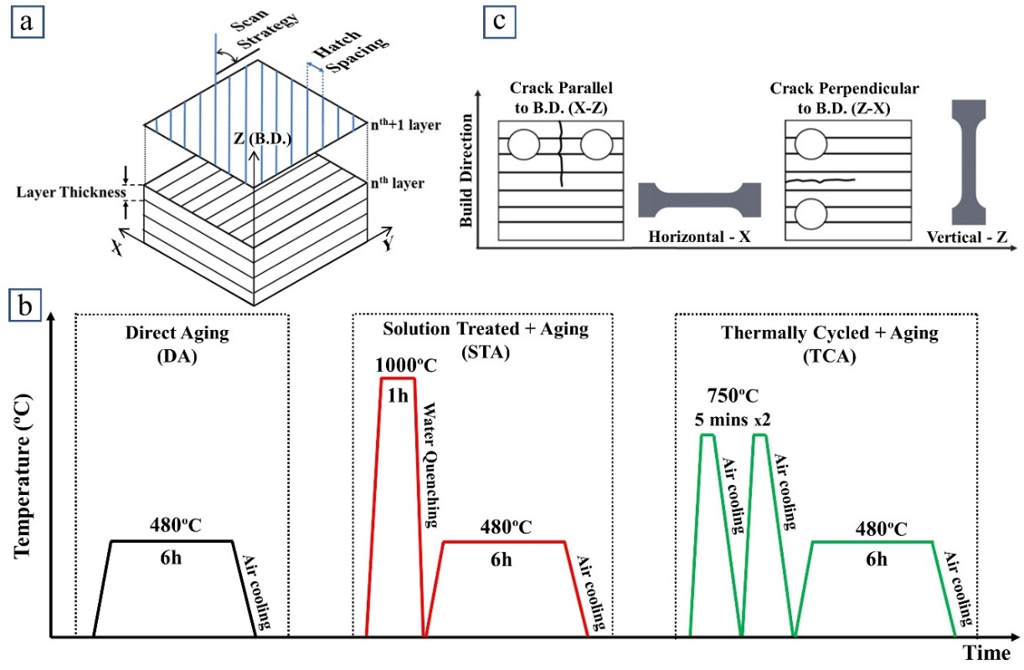
Figure 1. a) Schematic of the LPBF processing parameters; b) heat treatment processing routes; c) C(T) and tensile sample orientation reference with respect to the build direction.
Tensile stress-strain and crack propagation resistance (R-curve) properties were characterized in two orthogonal orientations for all material conditions using two samples per condition. Tensile samples were machined in accordance with the ASTM E8 standard with a cross section of 3.2 × 2 mm² and a gauge length of 13.3 mm [29]. Samples with their long axes parallel and perpendicular to the build direction (B.D.) were designated as Z (vertical) and X (horizontal), respectively, as shown in the Fig. 1c. They were tested in an Instron 3369 universal testing machine equipped with a 50 kN load cell under displacement control with a displacement rate of 1 mm/min. Strain during tensile testing was assessed using the digital image correlation (DIC) technique with the GOM correlation software package. After testing, fracture surfaces were examined in the SEM which was operated in secondary electron mode at an acceleration voltage of 25 kV.
Fracture toughness and crack resistance curves (R-curves) were determined in accordance with ASTM standard E1820 [30] using compact tension, C(T), samples of thickness (B) ≈ 4 mm and of width (W) ≈ 16 mm. The C(T) samples were prepared for testing in two orientations that were defined by a two-letter code. The first letter denotes the direction normal to the crack plane while the second letter denotes the expected crack propagation direction. Therefore, the cracks grow parallel to the B.D. in the X-Z samples whereas they grow perpendicular to B.D. in Z-X samples, as schematically illustrated in Fig. 1c. The side surfaces of all the fracture samples were mirror polished to a 0.1 µm finish before they were fatigue pre-cracked and tested in an Instron 8872 servo-hydraulic testing machine equipped with a 5 kN calibrated load cell. Crack length (a) was monitored using the unloading compliance measured with an Epsilon clip gauge (-1/+4 mm calibrated displacement range) mounted to the front face of each C(T) sample. Fatigue precracking was conducted under load control using a 30 Hz sine wave and a constant minimum to maximum load ratio (R) of 0.1 until an a/W ratio of ~0.45-0.6 was reached. The stress intensity range (ΔK) during precracking did not exceed ~ 11 MPa√m. Testing for evaluating the R-curve behavior was performed under displacement control at a loading rate of 2 mm/min. To construct the R-curves, J-integral values for the individual crack length increments were calculated and plotted against their corresponding crack extensions (Δa). They were then fitted with power law functions using data points that fell strictly within the crack extension range recommended by the ASTM E1820 standard. The intersection of the 0.2 mm-shifted blunting lines with the fitted R-curves resulted in the J_{q} values of the individually tested samples. In accordance with the ASTM standard, they were then evaluated in terms of their qualification as plane-strain, size independent fracture toughness values, i.e., J_{Ic}. Subsequently, mode I fracture toughness, K_{JIc}, values were calculated from J_{Ic} following the standard J-K equivalence, K_{JIc} = $\sqrt{E^{'}J_{Ic}} ,$where E’ = E / (1 – ν²) [30]. Mirror polished cubes with 4 mm side length were used to determine the Young's moduli (E) and Poisson's ratios (ν) using the resonant ultrasound spectroscopy (RUS) technique [31,32] with an Olympus 45MG Ultrasonic Thickness Gage equipped with M208-RM and V157-RM sensors for longitudinal and transverse wave velocity determination. The as-built samples had a Young's modulus and Poisson's ratios of ~177 GPa and ~0.33, respectively, while all heat-treated samples had a value of ~190 GPa and ~0.29, respectively.
After testing, fractography was conducted using a SEM. At least one of the tested C(T) samples for each condition was separated into two halves by cyclically loading them at ΔK ~ 7 MPa√m and a frequency of 50 Hz until the specimen fractured. A load ratio R = 0.5 was used to prevent physical contact of the crack faces during cyclic loading and preserve the fracture surface features that developed during testing. Crack path profiles and deformation during crack growth were observed using EBSD on the mid-sections of C(T) samples that were sliced in half using a diamond blade on a Buehler Isomet low speed saw and subsequently mirror polished.
3. Results
3.1 As-built microstructure
Microstructures of the as-built maraging steel samples are shown in Fig. 2. The side views (XZ and YZ planes) and the top view (XY plane) in Fig. 2a reveal semicircular melt pools with a hatch spacing of ~110 µm and the 67º off-set scan tracks, respectively, consistent with the processing parameters that were used for printing. Fig. 2b shows a high magnification SEM image of multiple melt pools and details of fine cellular sub-structures with features down to less than 1 µm in size and appears in either equiaxed or columnar shape, as shown in Figs. 2c,d; similar features were reported for other LPBF materials such as 316L SS [16,33] and AlSi alloys [17,34,35]. Figs. 2e,f show inverse pole figure (IPF) maps of the lateral planes (i.e., XZ and YZ planes) shown in Fig. 2a. The melt pool boundaries (indicated as dotted lines) are superimposed on the IPF maps from the OM images taken from the same areas. The phase map inset of Fig. 2e indicates that in the as-built condition the material consists of mainly martensite with only minor fractions of retained austenite. The IPF images additionally show randomly orientated grains without texture but epitaxial growth of individual grains across melt pool boundaries, as indicated by the arrows in Fig. 2f.
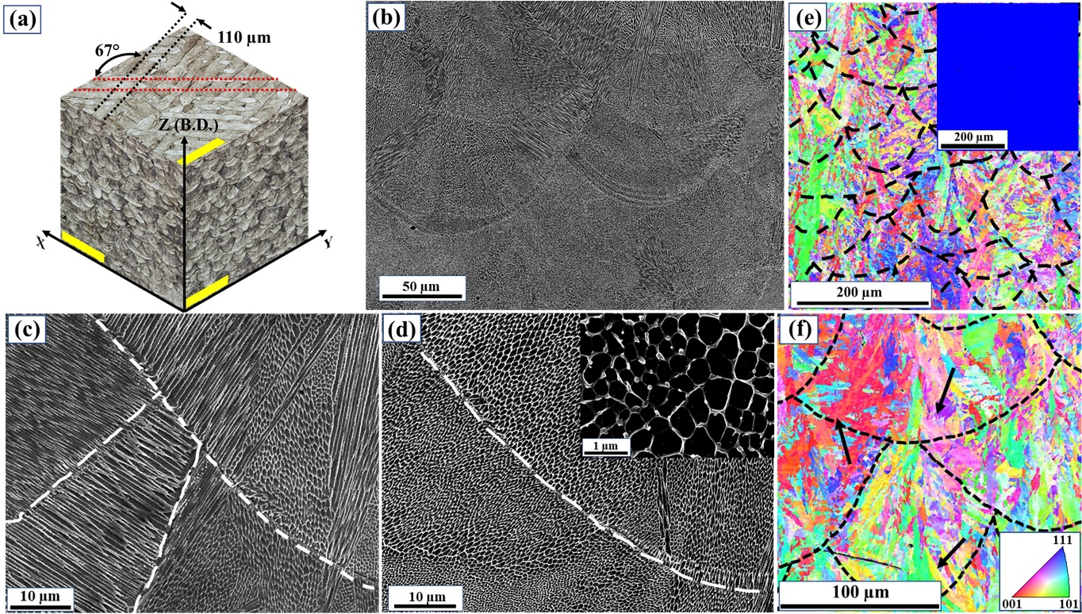
Figure 2. As-built micro and meso-structures of the LPBF-processed maraging steel. (a) 3D view of the meso-structure of an as-built sample (scale bars: 400µm); (b) SEM image of multiple melt pools; (c,d) cellular sub-structures in the vicinity of melt pool boundaries; (e,f) EBSD IPF maps across multiple melt pools showing (e) randomly oriented grains with (f) epitaxial grain growth across individual melt pool boundaries, as indicated by the arrows. The inset in (e) shows a phase map indicating primarily martensite (blue) with only minor amounts of austenite (yellow).
3.2 Effect of heat treatments on the microstructure evolution
Fig. 3 shows SEM micrographs (Figs. 3a-c) and EBSD scans (Figs. 3d-f) of the microstructures that resulted from various heat treatments characterized in this study. From Figs. 3a,c it is evident that despite a 480 °C / 6h heat treatment of the DA and TCA samples, the materials retain their cellular sub-structure with microstructural features similar to those of samples in the as-built condition (Figs. 2b-d). The EBSD scans in Figs. 3d,f confirm the retained micro- and meso-structures of these materials. However, the solution-treated + aged (STA) samples (Figs. 3b,e) neither show the LPBF-characteristic melt pool meso-structure (Fig. 3e) nor the cellular sub-structure (Fig. 3b). They have a distinct martensitic microstructure with randomly oriented, equiaxed grains (and only minor remnants of the melt-pool structure from printing). The insets in Figs. 3d-f show phase maps of martensite (blue) and austenite (yellow) in the corresponding EBSD images. While the DA- (Fig. 3d) and TCA-treated samples (Fig. 3f) exhibit ~2-4% and ~10–12% reverted austenite, respectively, the STA-treated samples (Fig. 3e) remain primarily martensitic. These observations are consistent with prior observations made for similar alloys [22,36].
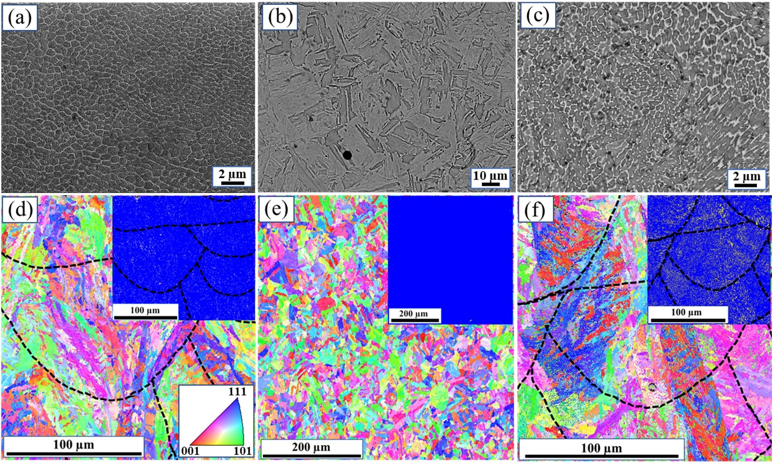
Figure 3. SEM (a-c) and EBSD maps (d-f) taken from the various heat treatment conditions. (a,d) Directly aged samples; (b,e) Solution treated + aged sample; (c,f) Thermally cycled + aged samples. The insets in (d-f) show phase maps indicating primarily martensite (blue) with only minor amounts of austenite (yellow).
3.3 Precipitate formation during direct aging
Bright field TEM images that characterize the phase evolution that occurs as a result of the aging process are displayed in Figs. 4a,b. During aging, homogeneously distributed, needle-like precipitates that are ∼50 nm long and ∼5 nm wide form in the martensitic phase, as shown in Fig. 4b. Indexing the clear, bright spots of the selected area electron diffraction (SAED) pattern, shown as inset in Fig. 4b, indicates that they correspond to the body centered cubic (BCC) martensite matrix whereas the streaking pattern results from the fine precipitates that are embedded in the BCC matrix [10,22,23].
The precipitates were additionally examined using APT. A 7% Ti and 35% Mo iso-surface visualization of the obtained APT data (Fig. 4c) reveals solute elements segregating to form nm-sized intermetallic compounds that are mostly based on Ni-Ti (yellow) while some Mo-enriched regions are also present (red). A proximity histogram (proxigram) analysis of these compounds (Fig. 4d,e) enables quantitative concentration profiles of elements across the interfaces of the precipitates and the matrix. While the positive x-axes in the concentration profiles of the proxigrams show the change in chemical composition towards the center of the precipitates, the negative axes represent the concentration profile towards the matrix. From Fig. 4d it is evident that in the Ni-Ti precipitates the concentration of both Ni and Ti gradually increase towards the center of these precipitates, with a concomitant reduction in the concentration of Fe. This is associated with the formation of intermetallic η-Ni₃Ti precipitates which are known to predominantly form in maraging steels [39–41]. In the case of the Mo-enriched regions (Fig. 4e), however, the concentration of Ni gradually decreases towards the center of these regions whereas Mo appears to have a locally saturated concentration plateau of ~40 at.% in the vicinity of the interface before further increasing towards the center. Thermocalc calculations by Jägle et al. [39] indicated the equilibrium concentration of μ-Fe₇Mo₆ precipitates to contain 45 % Mo, 35 % Fe, 15 % Ni, 5% Co with negligible amounts of Ti. These findings are in agreement with the APT results shown in Fig. 4e that confirm the formation of μ-Fe7Mo6 precipitates with similar composition during aging. Additionally, the iso-surface visualization (Fig. 4c) seems to indicate that the Mo-enriched precipitates primarily form near the η-Ni₃Ti precipitates.
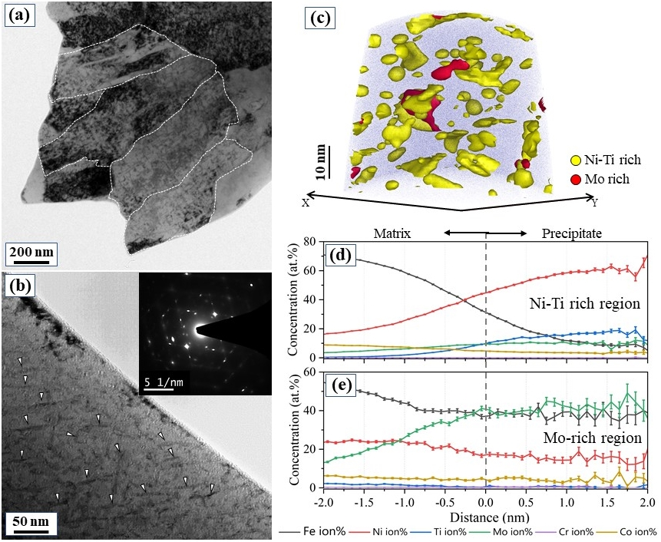
Figure 4. (a,b) TEM images (dotted lines indicate the martensite lath morphology and white arrows indicate the precipitates in the martensite matrix) and (c) APT analysis showing 7% Ti and 35% Mo iso-concentration surfaces of directly aged samples. (d) proximity histogram analysis of Ni and (e) Mo-enriched regions.
3.4 Tensile stress-strain responses
Fig. 5 shows the engineering stress - plastic strain data from the tensile tests on samples taken from the various materials conditions; average values of the 0.2%-offset yield strength, σ_{y}, ultimate tensile strength, σ_{U}, and plastic failure strain, ε_{f-pl}, of each condition are listed in Table 2 together with data for the cast + aged material. The solid and dashed lines represent samples tested in the X (horizontal) and Y (vertical) orientations with respect to B.D., respectively. Similar to the existing data in the literature [10,11], the as-built samples have a σ_{y} of ~1000 MPa, a σ_{UTS} of ~1200 MPa, and an ε_{f-pl} of ~11% while for the DA samples σ_{y} and σ_{UTS} increase to peak levels of ~1900 and ~2000 MPa, respectively, whereas ε_{f-pl} is reduced to ~4.0%. Compared to that, samples in the STA condition show strength levels comparable to those of the DA materials, however, ε_{f-pl} is significantly reduced to below 2%. TCA samples show strength levels reduced by ~10% compared to the DA material with a σ_{y} of ~1650 MPa and a σ_{UTS} of ~1750 MPa while ε_{f-pl} increases to be well above 5%. Both σ_{y} and σ_{UTS} are slightly lower in the vertical orientation compared to the horizontal orientation for all testing conditions. However, these differences are very minor and less than 5% for all cases. Failure strains in the two testing orientations of the various materials are also comparable (less than ~10% difference) and the LPBF-processed 18Ni-300 maraging steel can, irrespective of the heat treatment, be considered to have nearly isotropic tensile stress-strain properties.
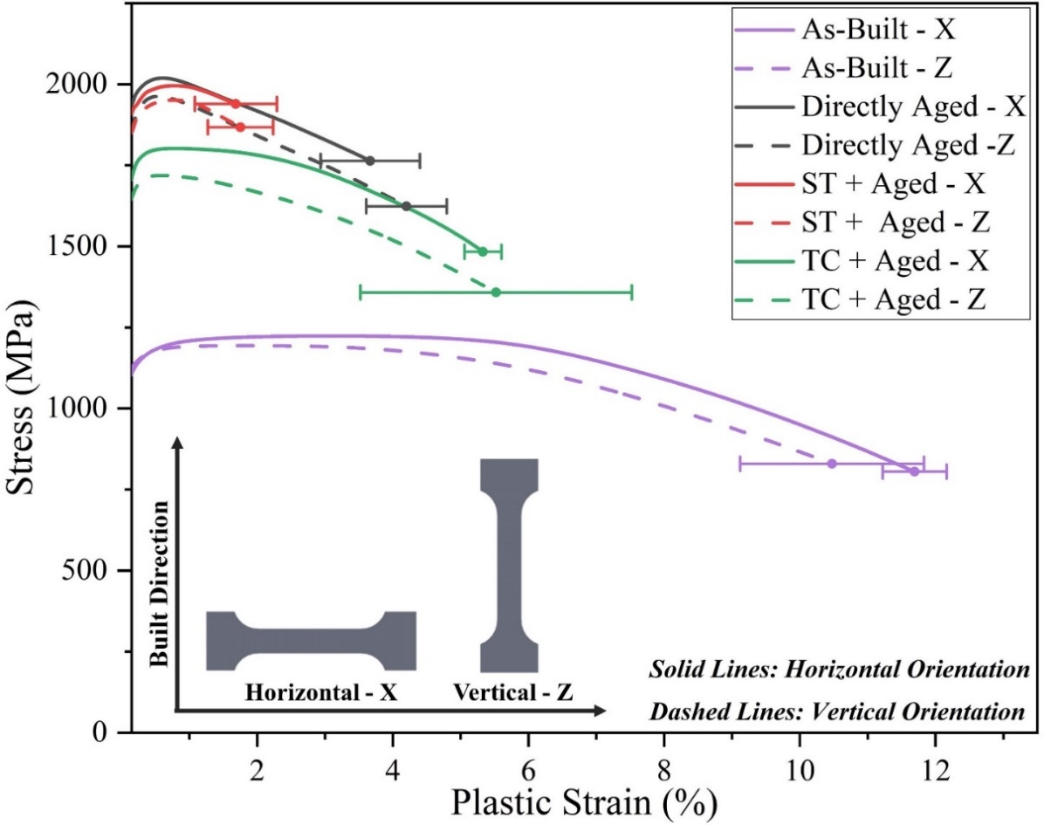
Figure 5. Tensile stress-strain curves in two different testing orientations of the various sample conditions.

Table 2: Tensile properties LPBF maraging steel in various heat-treated conditions.
Sample condition |  | σ_{Y} (MPa) | σ_{UTS} (MPa) | ε_{f-pl} (%)
As-Built | AB-X | 1044± 46 | 1224 ± 4 | 11.7 ± 0.4
As-Built | AB-Z | 1022 ± 10 | 1194 ± 15 | 10.4 ± 1.3
Directly Aged | DA-X | 1943 ± 42 | 2021 ± 8 | 3.7 ± 0.7
Directly Aged | DA-Z | 1889 ± 33 | 1967 ± 2 | 4.2 ± 0.6
Solution treated + Aged | STA-X | 1846 ± 27 | 1996 ± 8 | 1.7 ± 0.6
Solution treated + Aged | STA-Z | 1825 ± 20 | 1951 ± 7 | 1.8 ± 0.5
Thermally Cycled + Aged | TCA-X | 1666 ± 34 | 1802 ± 12 | 5.3 ± 0.3
Thermally Cycled + Aged | TCA-Z | 1614 ± 77 | 1722 ± 92 | 5.5 ± 2.1
Cast + Aged |  | 1789 ± 31 | 1990 ± 20 | 3.3 ± 0.1
3.5 Fracture toughness and R-curve behavior
Figs. 6a-d show the experimental R-curves for the as-built and heat treated LPBF maraging steel in the two testing orientations (Fig. 1c). A comparison of the average R-curves in different heat-treated conditions as well as that of the Cast + Aged material, is made in Fig. 6e. The solid and dashed lines in the plots denote the X-Z (crack propagating parallel to B.D.) and Z-X (crack propagating perpendicular to the B.D.) orientations, respectively. Table 3 lists the average values of both the measured J_{Ic} and calculated K_{JIc} for each condition. While the as-built alloy has a fracture toughness, K_{JIc} of ~150 MPa√m, the values reduce markedly to ~60-65 and ~50 MPa√m, respectively, for the DA and STA conditions. K_{JIc} of the TCA alloy, at ~95 MPa√m, is intermediate to those extrema. The K_{JIc} values of the DA material are in good agreement with existing literature [10,25], and was considerably higher those of Cast + Aged material (~50 MPa√m). In terms of anisotropy, differences between the two testing directions are limited to a maximum of ~15% in K_{JIc}. Slightly higher K_{JIc} values together with more pronounced crack growth resistance was noted for the Z-X orientation than for the X-Z orientation of the DA and TCA samples. In contrast, both K_{JIc} and crack growth resistance for the X-Z orientation of the STA samples are higher than for the Z-X orientation.
Table 3: Fracture toughness of the LPBF maraging steel obtained under different heat treatments.
Samples |  | J_{Ic}  (kJ/m²) | K_{JIc}  (MPa√m)
As-built | AB X-Z | 106.3 ± 5.3 | 148.9 ± 3.7
As-built | AB Z-X‡ | 113.9 ± 5.1 | 154.2 ± 3.4
Directly Aged | DA X-Z | 16.8 ± 1.8 | 59.3 ± 3.3
Directly Aged | DA Z-X | 21.4 ± 0.2 | 66.9 ± 0.3
Solution Treated + Aged | STA X-Z | 13.3 ± 0.1 | 52.7 ± 0.1
Solution Treated + Aged | STA Z-X | 9.8 ± 0.2 | 45.2 ± 0.5
Thermally Cycled + Aged | TCA X-Z | 39.4 ± 3.1 | 90.6 ± 3.6
Thermally Cycled + Aged | TCA Z-X | 50.8 ± 5.1 | 102.9 ± 5.1
Cast + Aged |  | 11.4 ± 1.5 | 48.8 ± 3.1

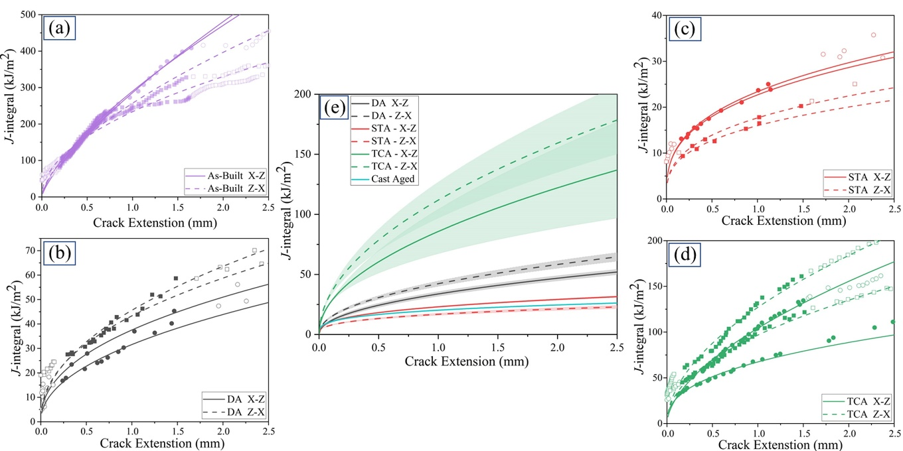 Figure 6. Crack resistance curves (R-curves) for the LPBF maraging steel samples in the (a) As-built, (b) Directly Aged (DA), (c) Solution Treated + Aged (STA), and (d) Thermally Cycled + Aged (TCA) conditions; (e) shows an overall comparison of R-curves for the different heat-treatments. (Solid lines represent C(T) X-Z samples with the crack propagating parallel to the B.D.; the dashed lines represent C(T) Z-X samples with the crack propagating perpendicular to the B.D.; the solid symbols present the data that was used for fitting the R-curves.)

Fractographs taken from the overload failure regions of the C(T) samples that were tested in the various conditions are shown in Fig. 7. Samples from the as-built condition (Figs. 7a,e) exhibit numerous large-sized dimples combined with micro-void features, whereas the failure characteristics of heat-treated samples (Figs. 7b-d,f-h) were predominantly quasi-cleavage features with only minor micro-void formation. The insets in Figs. 7a-d show the formation of shear lips in the C(T) samples during R-curve testing. While the as-built samples have shear lips forming over nearly 75% of the sample width (Fig 7a), all other samples have been aged and as a result show narrower shear lips on the fracture surface (Figs. 7b-d). Although, J_{Q} values of all tests satisfied the ASTM sample size criteria (i.e., B, b₀ > 10 J_{Q} / σ_{f} with σ_{f} being the flow stress of the material for each condition), values from as-built samples should not be considered as size-independent fracture toughness results due to the formation of pronounced shear-lips.
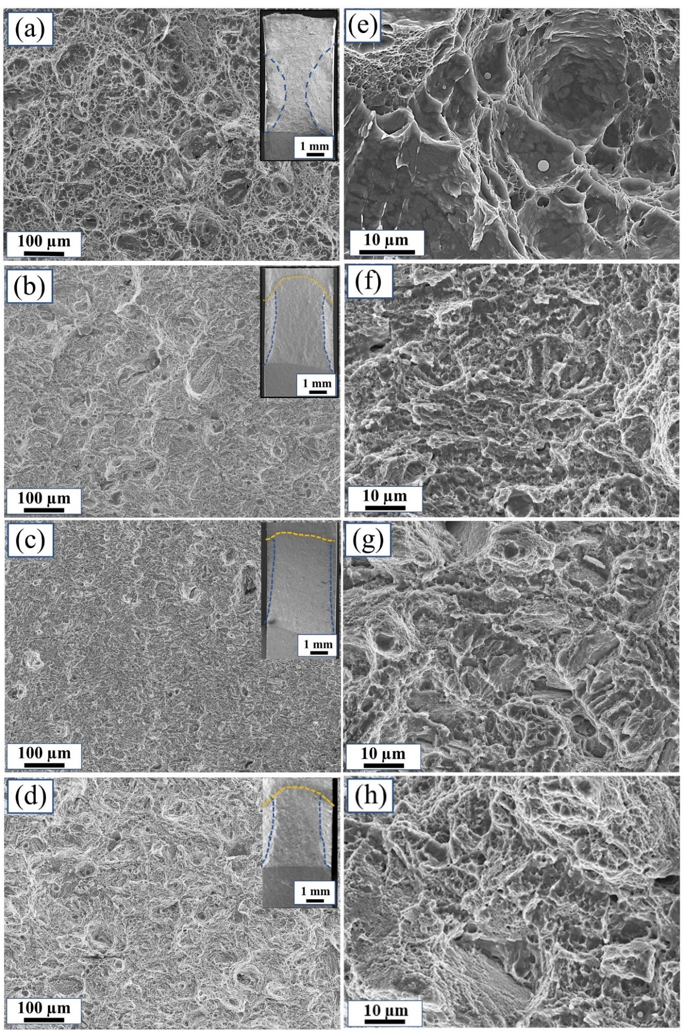
Figure 7. Fracture surfaces of C(T) samples from the various heat-treated materials. (a,e) as-built sample; (b,f) DA samples; (c,g) STA samples; (d,h) TCA samples.

4. Discussion
4.1 Micro and meso-structure evolution
The nano-sized cellular microstructure that is shown in the as-built condition in Figs. 2c and d is formed by the growth of primary dendrites of the Fe-matrix material [42]. While the high cooling rates (10³ – 10⁸ K/s) [1] that occur during the LPBF process inhibit the formation of secondary dendrite arms during solidification, solute segregation occurs within the cellular dendritic walls resulting in constitutional supercooling near the liquid-solid interface and the formation of geometrically necessary dislocations (GNDs) along the cell wall boundaries [42–44]. The obtained cellular microstructure has a three-dimensional morphology that, depending on the viewing angle, appears as either equiaxed (Fig. 2c) or as having an elongated morphology (Fig. 2d) [45]. The orientation of the cells appears to be random and cannot be related to the grain orientation that exist in materials such as AlSi-alloys [17]. Both the cells and the grains grow across the melt pool boundaries, Figs. 2c,f, respectively, with the latter growing towards the center of the melt pools, as shown in Figs. 2e,f, in the direction of the maximum temperature gradient.
During aging of the conventionally-processed maraging steel, diffusion of the solute elements into the Fe-matrix results primarily in the formation of (Fe,Ni,Co)₃(Ti,Mo) and some (Fe,Ni,Co)₇Mo₆ nano-precipitates [46–48]. Similar kinetics appear to occur in our LPBF-processed material, where the APT data in Fig. 4 reveals the formation of Ni-rich η-Ni₃Ti and Mo-rich μ-Fe₇Mo₆ precipitates. During the early stages of aging, coherent zones of Ni-Ti-Co clusters start to form in the martensite (Fe) matrix due to low interaction and elastic strain energy between these elements. With continued aging, these clusters assist in the formation of Ni₃Ti nuclei and subsequent coarsening of the precipitates with the simultaneous rejection of the Co and Fe atoms [41,49]. This is evident from the proxigram displayed in Fig. 4d, where the Ni and Ti concentrations increase towards the precipitate whereas those of Co and Fe decrease gradually. The final η-Ni₃Ti precipitates have a hexagonal crystal structure with ${\{1\overline{1}1\}}_{α}∥ {\{11\overline{2}0\}}_{p}$ and ${〈011〉}_{α}∥ {〈0001〉}_{p}$ orientation relationship with the matrix, where the subscripts α and p relate to the martensite matrix and the precipitates, respectively [50]. With increasing aging time, Mo atoms that are trapped inside the η-Ni₃Ti precipitates (Fig. 4d) start to diffuse towards the interface of the precipitate and the matrix [49,51] resulting in the formation of a Mo-rich region in the vicinity of the η-Ni₃Ti precipitates (Fig. 4c). As shown in the proxigram of the Mo-rich zone (Fig. 4e), within this region the concentration of Fe and Mo is comparable resulting in the formation of μ-Fe₇Mo₆ precipitates. As these μ-Fe₇Mo₆ precipitates form in the later stages of aging, their volume fraction is significantly lower than the volume fraction of the η-Ni₃Ti phase.
Known as an austenite stabilizer, Ni can, upon segregation that occurs during aging, also promote the reverse transformation of martensite into austenite. This is evident in the directly aged alloy that contains ~2-4% reverted austenite (phase map in Fig. 3d) despite the temperature used for the heat treatment (480 °C) being significantly lower than the austenite start (A_{s}) temperature of ~600 °C, below which martensite remains metastable. During thermal cycling of the TCA material (2 x 750 °C / 5 min), samples are heated above the A_{s} temperature, where solute diffusion occurs at an even higher rate than at the temperature that is applied during aging. Due to the stabilizing effect of Ni, the austenite that forms during this process is retained down to room temperature resulting in the presence of ~10-12% reverted austenite in the microstructure of the alloy, as shown in the phase map in Fig. 3f. In contrast to the alloy in the DA and the TCA conditions, the maraging steel in in the STA condition does not contain austenite after the aging process, as confirmed by the phase map displayed in Fig. 3e; similar results were reported in prior studies on LPBF maraging steels [22,36]. In one of these, Allam et al. [36] identified reverted austenite that forms during direct aging, to primarily form as tiny islands near the boundary regions between individual layers of the printed material. As shown in Figs. 3b,e, the STA alloy does not have the LPBF-typical melt-pools nor the cellular sub-structure. The reason for this is that the solution treatment decomposes the cellular walls leading to a homogenized material without the typical LPBF structural features. Homogenization, in turn, reduces the driving force for localized Ni segregation and the transformation to austenite during aging. Instead, quenching from 1000 °C results in prior austenitic grains to transform into martensite with hierarchical sub-structures such as packets, blocks, and laths, comparable to those found in cast maraging steels [52].
4.2 Mechanical performance
The formation of fine microstructural features such as the cellular sub-structures in 316L SS [16,33] or some Al-Si alloys [17,34], are known to improve strength in LPBF-processed materials compared to materials made using conventional processing routes. In 316L SS, for example, the cell structures contain dislocation networks because of GNDs that form due to the segregation of solute elements. They act as soft barriers that slow down dislocation motion thereby enhancing strength while simultaneously promoting plastic flow during loading [44]. A lack of such features can adversely affect both strength and ductility of the material. In maraging steels, where strength is primarily provided by dislocation interaction with homogeneously distributed precipitates, the cellular sub-structures mainly enhance ductility. This is evident in the tensile data of our DA and STA materials where both yield and tensile strength are essentially identical in the two conditions, whereas ductility in the STA samples is reduced by more than 50% compared to the DA samples (Fig. 5). While the samples made from the DA material exhibit both the AM-typical melt-pool meso-structure as well as the cellular sub-structure (Figs. 3a,d), these structural features dissolve during the solution treatment of the STA material (Figs. 3b,e). The loss of the cellular sub-structures combined with the lack of retained austenite for the STA condition results in reduced ductility compared to the DA material. Existing literature also shows that depending on the solution treatment temperature the reduction in failure strain can vary from ~20-45% compared to DA material [20,53]. While some reports claim that STA processed material can have improved ductility (at cost the of reduced strength), most of this work was carried out at lower solution treatment temperatures (840°C for 1h) thereby likely resulting in the cellular structures not having completely dissolved and as such benefiting from these remnant microstructural features [11,54].
Thermal cycling prior to aging (TCA) results in ~10-12% reduction in yield and tensile strength whereas failure strain of the material improves by more than 30% compared to the DA material. As deformation in the TCA material occurs through the transformation of austenite into martensite thereby providing transformation induced plasticity (TRIP) – this is shown in the crack path analysis in Fig. 8 and discussed in detail subsequently – the relatively large amount of austenite in the TCA material (~10-12% compared to ~2-4% in the DA material, as shown in the phase maps of Fig. 3) enables significantly more stable plastic deformation after the onset of necking resulting in the extensive gains in ductility (~5.5% failure strains compared to ~4% for the DA material) despite having only a ~10-12% drop in strength. These observations are in-line with previously reported studies [22,55–57] that show that the presence of reverted austenite stabilizes plastic deformation particularly after the initiation of necking. Wang et al. [57] emphasized that such stable deformation of maraging steels occurs in two stages; (i) in the early stages of deformation plastic strain is accommodated by soft reverted austenite, and (ii) after the austenite to martensite transformation, the material gains additional load bearing capacity due to the transformed martensite containing significantly less defects and precipitates compared to the existing martensitic phase.
The theoretical yield strength of precipitate-hardened maraging steels ($σ_{y}^{m}$) is a combination of various strengthening factors including the strength of the martensite matrix (σ_{m}), the impact of solid solution strengthening (σ_{ss}), grain size (σ_{gs}), as well as dislocation (σ_{d}) and precipitation hardening (σ_{p}), as shown in Eq. 1. Schnitzer et al. [58] suggested that except for σ_{p} the sum of these strengthening factors is representative for the yield strength of the material before aging, i.e., σ_{o} = σ_{m} + σ_{ss} + σ_{GS} + σ_{d}. In this calculation only the martensite phase is considered, and the effect of reverted austenite neglected. Pereloma et al. [41] reported that this can lead to a significant error in the calculation of the theoretical yield strength, especially in cases where the fractions of austenite cannot be ignored. To account for both phases, recent articles [58–60] suggest taking the simple rule of mixture to get a more accurate estimate of yield strength with the overall yield strength of the material (σ_{ys}) being described in terms of precipitate hardened martensite ($σ_{y}^{m}$), the yield strength of pure austenite ($σ_{y}^{γ}$), and the phase fraction of retained austenite (V_{γ}), as shown in Eq. 2.
$σ_{y}^{m} =σ_{m} + σ_{ss} + σ_{gs} + σ_{d} + σ_{p}$ | (1)
$σ_{YS}= σ_{y}^{m} \left(1-V_{γ}\right) + σ_{y}^{γ} V_{γ}$ | (2)
The η-Ni₃Ti precipitates that form during the aging process act as an obstacle to the movement of dislocations thereby increasing the strength of the material similar to strengthening in oxide-dispersed strengthening (ODS) steels [61–63]. The impact of precipitation strengthening (σ_{p}) is calculated using the Orowan criterion that assumes a dislocation to move past precipitates by bowing around them and can be estimated as:
$σ_{p}= \frac{2MGbф}{12π(L-2r)}ln\frac{L-2r}{2b}$ | (3)
where, M is the Taylor factor (3.06 for the BCC polycrystalline materials), b is the burgers vector (0.203 nm), r is the precipitate size (~5 nm), G is the shear modulus of the matrix, ф is a constant related to the Poisson’s ratio of the matrix given by ф = (1+ 1/1-υ)/2, and L is the inter-particle distance that can be estimated as:
$L= \left(1.23\sqrt{{2π}/{3f_{p}}}-2\sqrt{2/3}\right)r$ | (4)
The values of G and υ are measured using RUS and found to be 73.26 GPa and 0.293, respectively. f_{p} in Eq. 4 is the volume fraction of the precipitates, which is calculated from the APT analysis using the lever rule [64–66], as described in Eq. 5:
$f_{p}= \frac{C_{0- }C_{α }}{C_{p- }C_{α }}$ | (5)
where C_{o}, C_{α} and C_{p} are the concentrations in the bulk sample, the matrix, and the η-Ni₃Ti precipitates, respectively. The plot of $C_{0}-C_{α }$ over $C_{p} {- C}_{α }$ for each element is shown in Fig. 8a and the slope of the best-fit line for all elements results in the volume fraction of precipitates being ~10.44 %. (Only η-Ni₃Ti as the primary precipitate was considered for this analysis.)
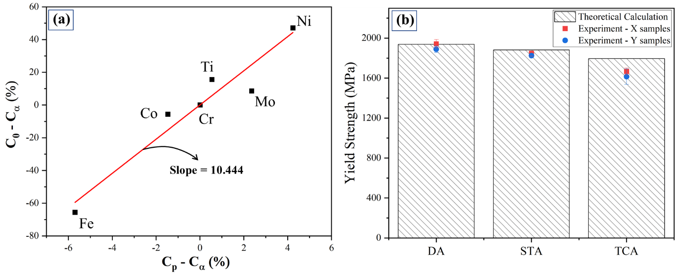
Figure 8. (a) Lever rule analysis to estimate the volume fraction of precipitates after aging; (b) comparison between the experimental and theoretical yield strength of the material. (The yield strength of pure austenite, $σ_{y}^{γ}$= 217 MPa, was obtained from literature [58].)
Fig. 8b shows a comparison of the theoretically calculated and experimentally obtained yield strengths of aged samples after the various heat treatments. The values of σ_{o} during the theoretical calculation, for samples from DA and TCA materials were taken from the yield strength of as-built samples and in the case of the STA sample, using Tabor’s relation (σ_{y} ≈ 3*HV [67]), σ_{o} was found to be 906 MPa. The results of the DA and STA materials are in good agreement, however, in case of the TCA material there is a ~9% overestimation of strength which could have resulted from the non-homogeneous distribution of austenite phase (affecting the rule of mixture assumption) and overlooking the influence of austenite on the formation of precipitates.
Aging significantly increases the strength of the maraging steel (Fig. 5), however, this comes with a pronounced reduction in fracture resistance compared to the as-built condition (Table 3 and Fig. 6). The reason for this is that the intermetallic precipitates in the aged samples not only enhance strength but also impact failure characteristics, as shown in the fractographs of the C(T) samples displayed in Fig. 7. The pronounced micro-void features in the as-built samples (Fig. 7a) are reminiscent of the extensive plasticity that develops during testing of the material in this condition. Compared to that, the heat-treated samples are significantly more brittle which is evident from quasi-cleavage failure features (Figs. 7b-d,f-h) with only minor fractions of micro-voids forming. Such brittle failure characteristics are known to consume less energy during crack extension resulting in the lower fracture toughness with reduced crack initiation and less pronounced crack growth resistance. The lack of plasticity in the aged materials is also evident from the significantly smaller shear-lips that form close to the free surface of the C(T) samples, as shown in the insets of Figs. 7b-d. The size of shear-lips correlates with the crack-tip stress triaxiality and whether crack extension occurs under predominantly plane stress or plane strain conditions. Compared to the relatively narrow shear-lips in the heat-treated alloy samples (i.e., indicative for plane strain conditions), they form under primarily plane stress conditions resulting in shear-lips as wide as 75% of the total sample thickness in the as-built samples. This leads to crack extension out of the mode I plane thereby elevating the crack resistance of the material (with K_{JIc} of ~150 MPa√m) which despite the ASTM sample size criteria being satisfied should not be considered as size-independent fracture toughness (J_{Ic}) of the material. Fractographs of the DA (Fig. 7f) and TCA (Fig. 7h) samples show similar failure characteristics, however, the TCA samples appear to have a somewhat rougher fracture surface indicating localized plastic deformation as a result of the crack interacting with small packets of reverted austenite that are scattered throughout the material. Compared to that, the lack of reverted austenite in the STA samples results in a relatively flat fracture surface (Figs. 7c,g) together with a less pronounced R-curve behavior and instabilities during crack growth (Fig. 6c).
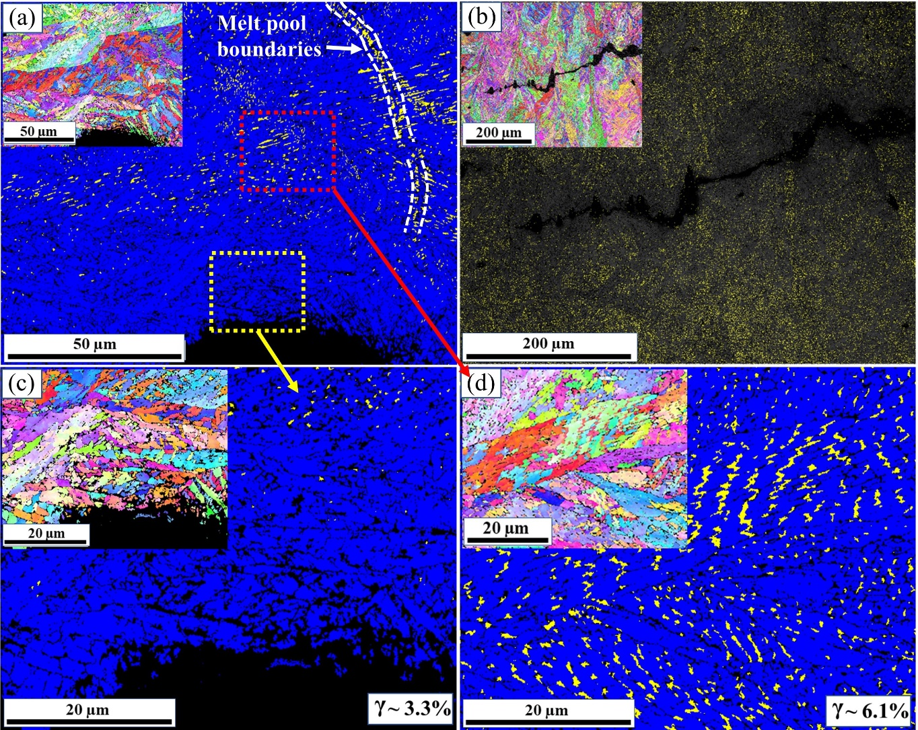
Figure 9. EBSD crack propagation path analysis of C(T) samples from the TCA material tested in the (a) X-Z orientation and (b) Z-X orientation (only austenite is shown in yellow); high resolution scans near (c) the crack tip and (d) ~35 μm away from crack tip (blue and yellow colors are for martensite and austenite, respectively).
Both tensile test results and R-curves show small amounts of anisotropy in mechanical properties between the two orthogonal orientations. However, the level of anisotropy is significantly less than in other LPBF-processed alloys such as 316L stainless steel [16,68] or Al-Si alloys [17,35]. In those materials, anisotropy is a result of the materials’ meso-structure and both the orientation of a crack and its propagation direction with respect to the melt-pool boundaries. In case of our LPBF-maraging steel, the melt-pool boundaries are significantly stronger than in AlSi10Mg and/or 316L SS and therefore crack deflection is not controlled by the melt-pool structure. However, reverted austenite along the melt-pool boundaries (as shown in Fig. 9a) can impact crack propagation. In the Z-X orientated C(T) samples, for example, the plastic zone that forms at the tip of the growing crack interacts with the austenite patches at the boundaries thereby increasing the crack growth resistance of the material. This is evident from the R-curves of the DA and TCA materials (Figs. 6b and 6d, respectively), where samples tested in the Z-X orientation have a somewhat higher fracture toughness and crack growth resistance than in the perpendicular orientation where crack propagation across the melt-pool boundaries results in significantly less interference with the reverted austenite patches. In samples from the STA material, however, the crack resistance in the Z-X orientation is slightly lower than in the X-Z orientation. (This anisotropy that exists in both crack resistance and tensile stress-strain response are presumably the result of a grain orientation dependence between austenite and the martensitic phase that forms in the vicinity of prior melt-pools.) Furthermore, the STA material lacks both reverted austenite and the AM-typical cellular and mesostructural features which reduce the material’s damage tolerance compared to other heat-treatments. This is evident from the reduced crack growth resistance with the lowest fracture toughness values of the STA samples which are comparable to cast + aged materials. The significantly improved fracture toughness of the TCA material can be attributed to the increased fraction of austenite (~10-12%) resulting from thermal cycling. As shown in the crack path analysis (Fig. 9) of samples tested in both the X-Z (Fig. 9a) and the Z-X orientations (Fig. 9b), the amount of austenite in the vicinity of the propagated crack decreases significantly as a result of the TRIP effect. This is evident from the high-resolution (0.1 µm step size) phase analyses shown in Figs. 9c,d, where the amount of austenite directly at the crack front is ~3.3% (Fig. 9c) whereas at some distance further away from the crack (~35 µm away, as shown in Fig. 9d) significantly more retained austenite (~6.1%) can be found. Additionally, the volumetric expansion associated with the transformation of austenite into martensite leads to stress relaxation near to the crack tip [69–71]. As a result, the fracture resistance of the TCA samples increases significantly more than in the other heat-treatment conditions. The formation of austenite is not uniform throughout the material and as such crack growth resistance due to the efficiency of TRIP toughening is highly localized (which may to some extent contribute to the scatter in the obtained R-curve data). Nonetheless, the improvements in damage tolerance, i.e., the combination of both strength and fracture resistance, that can be achieved through an additional thermal cycling process are significant and recommended for the use of LPBF-processed 18Ni-300 maraging steel.
5. Conclusion
Laser powder bed fusion (LPBF) additive manufacturing is used to process 18Ni-300 maraging steel and the impact of three heat-treatments (direct aging, solution treatment + aging, and thermal cycling + aging) on the structure and mechanical properties was investigated. Strength and crack resistance curve (R-curve) behavior is studied in two different orthogonal orientations and failure characteristics are analyzed and correlated with microstructural and phase evolution during the heat-treatments. Based on our findings the following conclusion can be drawn:
- A solution treatment of LPBF-processed maraging steel dissolves LPBF-characteristic cellular sub-structures and melt pool meso-structures. As a result, the ductility and fracture toughness are significantly reduced such that the R-curve behavior is comparable to cast + aged material.
- Direct aging maximizes yield and ultimate strength and results in tensile stress-strain behavior comparable to a cast + aged material. Geometrically necessary dislocations in the typical LPBF cellular sub-structure, however, hinder dislocation motion within the cellular walls while simultaneously acting as soft barrier that enables continuous plastic flow. This results in enhanced crack resistance and improved fracture properties compared to the cast + aged material.
- Thermal cycling prior to aging enables formation of 10 – 12 vol.% reverted austenite within the martensitic matrix. Despite moderate reductions (~10-12%) in the ultimate tensile strength, the formation of austenite enables a transformation-induced plasticity (TRIP) mechanism that affords significant gains in ductility (~30-35%) in combination with a >50% increase in fracture toughness.
- Strong intra- and inter-layer bonding combined with a lack of texture results in near-isotropic failure characteristics of both strength and R-curve behavior. Minor differences in the two testing orientations are associated with printing-related structure characteristics as well as the amount of reverted austenite along the melt-pool boundaries.
Acknowledgements
The authors acknowledge the facilities and the scientific and technical assistance of Microscopy Australia nodes at the Electron Microscope Unit (EMU) within the Mark Wainwright Analytical Centre (MWAC) at UNSW Sydney, and Sydney Microscopy & Microanalysis (SMM) and Sydney Analytical, which are core research facilities at the University of Sydney. SMM and the EMU are the respective institutional nodes of Microscopy Australia. The authors acknowledge Dr. Takanori Sato (the University of Sydney) and Professor Simon Ringer for help with APT sample preparation, data analysis, interpretation of the results, and helpful discussions on maraging steels. BG additionally acknowledges support from the ARC Future Fellowship (project number FT190100484) and the UNSW Scientia Fellowship schemes, and UR acknowledges funding from A*STAR, Singapore via the Structural Metals and Alloys Programme (No. A18B1b0061).
References
[1] D. Herzog, V. Seyda, E. Wycisk, C. Emmelmann, Additive manufacturing of metals, Acta Materialia. 117 (2016) 371–392. https://doi.org/10.1016/j.actamat.2016.07.019.
[2] T.H. Becker, P. Kumar, U. Ramamurty, Fracture and fatigue in additively manufactured metals, Acta Materialia. 219 (2021) 117240. https://doi.org/10.1016/j.actamat.2021.117240.
[3] M. Nageswara Rao, Progress in understanding the metallurgy of 18 % nickel maraging steels, International Journal of Materials Research. 97 (2006) 1594–1607. https://doi.org/10.3139/146.101418.
[4] A.G. dos Reis, D.A.P. Reis, A.J. Abdalla, J. Otubo, High-temperature creep resistance and effects on the austenite reversion and precipitation of 18 Ni (300) maraging steel, Materials Characterization. 107 (2015) 350–357. https://doi.org/10.1016/j.matchar.2015.08.002.
[5] C.A. Pampillo, H.W. Paxton, The effect of reverted austenite on the mechanical properties and toughness of 12 Ni and 18 Ni (200) maraging steels, Metallurgical Transactions. 3 (1972) 2895–2903. https://doi.org/10.1007/BF02652858.
[6] G. Casalino, S.L. Campanelli, N. Contuzzi, A.D. Ludovico, Experimental investigation and statistical optimisation of the selective laser melting process of a maraging steel, Optics and Laser Technology. 65 (2015) 151–158. https://doi.org/10.1016/j.optlastec.2014.07.021.
[7] D. Croccolo, M. de Agostinis, S. Fini, G. Olmi, A. Vranic, S. Ciric-Kostic, Influence of the build orientation on the fatigue strength of EOS maraging steel produced by additive metal machine, Fatigue and Fracture of Engineering Materials and Structures. 39 (2016) 637–647. https://doi.org/10.1111/ffe.12395.
[8] K. Kempen, E. Yasa, L. Thijs, J.P. Kruth, J. van Humbeeck, Microstructure and mechanical properties of selective laser melted 18Ni-300 steel, Physics Procedia. 12 (2011) 255–263. https://doi.org/10.1016/j.phpro.2011.03.033.
[9] J. Tian, W. Wang, M.B. Shahzad, W. Yan, Y. Shan, Z. Jiang, K. Yang, A new maraging stainless steel with excellent strength-toughness-corrosion synergy, Materials. 10 (2017) 1–11. https://doi.org/10.3390/ma10111293.
[10] J. Suryawanshi, K.G. Prashanth, U. Ramamurty, Tensile, fracture, and fatigue crack growth properties of a 3D printed maraging steel through selective laser melting, Journal of Alloys and Compounds. 725 (2017) 355–364. https://doi.org/10.1016/j.jallcom.2017.07.177.
[11] C. Tan, K. Zhou, M. Kuang, W. Ma, T. Kuang, Microstructural characterization and properties of selective laser melted maraging steel with different build directions, Science and Technology of Advanced Materials. 19 (2018) 746–758. https://doi.org/10.1080/14686996.2018.1527645.
[12] L. Kučerová, I. Zetková, A. Jandová, M. Bystrianský, Microstructural characterisation and in-situ straining of additive-manufactured X3NiCoMoTi 18-9-5 maraging steel, Materials Science and Engineering A. 750 (2019) 70–80. https://doi.org/10.1016/j.msea.2019.02.041.
[13] B. Mooney, K.I. Kourousis, R. Raghavendra, D. Agius, Process phenomena influencing the tensile and anisotropic characteristics of additively manufactured maraging steel, Materials Science and Engineering A. 745 (2019) 115–125. https://doi.org/10.1016/j.msea.2018.12.070.
[14] P. Kumar, O. Prakash, U. Ramamurty, Micro-and meso-structures and their influence on mechanical properties of selectively laser melted Ti-6Al-4V, Acta Materialia. 154 (2018) 246–260. https://doi.org/10.1016/j.actamat.2018.05.044.
[15] P. Kumar, U. Ramamurty, Microstructural optimization through heat treatment for enhancing the fracture toughness and fatigue crack growth resistance of selective laser melted Ti–6Al–4V alloy, Acta Materialia. 169 (2019) 45–59. https://doi.org/10.1016/j.actamat.2019.03.003.
[16] J. Suryawanshi, K.G. Prashanth, U. Ramamurty, Mechanical behavior of selective laser melted 316L stainless steel, Materials Science and Engineering A. 696 (2017) 113–121. https://doi.org/10.1016/j.msea.2017.04.058.
[17] M.J. Paul, Q. Liu, J.P. Best, X. Li, J.J. Kruzic, U. Ramamurty, B. Gludovatz, Fracture resistance of AlSi10Mg fabricated by laser powder bed fusion, Acta Materialia. 211 (2021) 116869. https://doi.org/10.1016/j.actamat.2021.116869.
[18] G. Meneghetti, D. Rigon, D. Cozzi, W. Waldhauser, M. Dabalà, Influence of build orientation on static and axial fatigue properties of maraging steel specimens produced by additive manufacturing, Procedia Structural Integrity. 7 (2017) 149–157. https://doi.org/10.1016/j.prostr.2017.11.072.
[19] B. Mooney, K.I. Kourousis, R. Raghavendra, Plastic anisotropy of additively manufactured maraging steel: Influence of the build orientation and heat treatments, Additive Manufacturing. 25 (2019) 19–31. https://doi.org/10.1016/j.addma.2018.10.032.
[20] Y. Bai, D. Wang, Y. Yang, H. Wang, Effect of heat treatment on the microstructure and mechanical properties of maraging steel by selective laser melting, Materials Science and Engineering: A. 760 (2019) 105–117. https://doi.org/10.1016/J.MSEA.2019.05.115.
[21] Y. Bai, C. Zhao, J. Yang, R. Hong, C. Weng, H. Wang, Microstructure and machinability of selective laser melted high-strength maraging steel with heat treatment, Journal of Materials Processing Technology. 288 (2021) 116906. https://doi.org/10.1016/j.jmatprotec.2020.116906.
[22] F.F. Conde, J.D. Escobar, J.P. Oliveira, M. Béreš, A.L. Jardini, W.W. Bose, J.A. Avila, Effect of thermal cycling and aging stages on the microstructure and bending strength of a selective laser melted 300-grade maraging steel, Materials Science and Engineering A. 758 (2019) 192–201. https://doi.org/10.1016/j.msea.2019.03.129.
[23] M.M. Wang, C.C. Tasan, D. Ponge, A. Kostka, D. Raabe, Smaller is less stable: Size effects on twinning vs. transformation of reverted austenite in TRIP-maraging steels, Acta Materialia. 79 (2014) 268–281. https://doi.org/10.1016/J.ACTAMAT.2014.07.020.
[24] S.D. Antolovich, A. Saxena, G.R. Chanani, Increased Fracture Toughness in a 300 Grade Maraging Steel As a Result of Thermal Cycling., Metall Trans. 5 (1974) 623–632. https://doi.org/10.1007/BF02644658.
[25] P.L.L. Santos, J.A. Avila, E.B. da Fonseca, A.H.G. Gabriel, A.L. Jardini, É.S.N. Lopes, Plane-strain fracture toughness of thin additively manufactured maraging steel samples, Additive Manufacturing. 49 (2022) 102509. https://doi.org/10.1016/J.ADDMA.2021.102509.
[26] EOS Material Datasheet MS1, (n.d.). https://www.eos.info/03_system-related-assets/material-related-contents/metal-materials-and-examples/metal-material-datasheet/werkzeugstahl_ms1_cx/ms1/ms-ms1-m280_m290_400w_material_data_sheet_05-14_en.pdf (accessed February 9, 2022).
[27] W722 VMR - BÖHLER Edelstahl GmbH & Co KG, (n.d.). https://www.bohler-edelstahl.com/en/products/w722vmr/ (accessed January 19, 2022).
[28] B. Gault, M.P. Moody, J.M. Cairney, S.P. Ringer, Atom Probe Microscopy, 160 (2012). https://doi.org/10.1007/978-1-4614-3436-8.
[29] ASTM E8, ASTM E8/E8M standard test methods for tension testing of metallic materials, Annual Book of ASTM Standards 4. ASTM Stds. (2010) 1–27. https://doi.org/10.1520/E0008.
[30] ASTM Standard E1820, Standard Test Method for Measurement of Fracture Toughness, 2013. https://doi.org/10.1520/E1820-13.Copyright.
[31] J. Krautkrämer, H. Krautkrämer, Ultrasonic Testing of Materials, Springer Berlin Heidelberg, Berlin, Heidelberg, 1990. https://doi.org/10.1007/978-3-662-10680-8.
[32] Olympus, Elastic Modulus Measurement, (2017). https://www.olympus-ims.com/en/applications/elastic-modulus-measurement/ (accessed February 4, 2021).
[33] Y.J. Yin, J.Q. Sun, J. Guo, X.F. Kan, D.C. Yang, Mechanism of high yield strength and yield ratio of 316 L stainless steel by additive manufacturing, Materials Science and Engineering: A. 744 (2019) 773–777. https://doi.org/10.1016/J.MSEA.2018.12.092.
[34] Q. Liu, H. Wu, M.J. Paul, P. He, Z. Peng, B. Gludovatz, J.J. Kruzic, C.H. Wang, X. Li, Machine-learning assisted laser powder bed fusion process optimization for AlSi10Mg: New microstructure description indices and fracture mechanisms, Acta Materialia. 201 (2020) 316–328. https://doi.org/10.1016/j.actamat.2020.10.010.
[35] J. Suryawanshi, K.G. Prashanth, S. Scudino, J. Eckert, O. Prakash, U. Ramamurty, Simultaneous enhancements of strength and toughness in an Al-12Si alloy synthesized using selective laser melting, Acta Materialia. 115 (2016) 285–294. https://doi.org/10.1016/j.actamat.2016.06.009.
[36] T. Allam, K.G. Pradeep, P. Köhnen, A. Marshal, J.H. Schleifenbaum, C. Haase, Tailoring the nanostructure of laser powder bed fusion additively manufactured maraging steel, Additive Manufacturing. 36 (2020). https://doi.org/10.1016/j.addma.2020.101561.
[37] V.K. Vasudevan, S.J. Kim, C.M. Wayman, Precipitation reactions and strengthening behavior in 18 Wt Pct nickel maraging steels, Metallurgical Transactions A. 21 (1990) 2655–2668. https://doi.org/10.1007/BF02646061.
[38] U.K. Viswanathan, G.K. Dey, M.K. Asundi, Precipitation hardening in 350 grade maraging steel, Metallurgical Transactions A 1993 24:11. 24 (1993) 2429–2442. https://doi.org/10.1007/BF02646522.
[39] E.A. Jägle, P.P. Choi, J. van Humbeeck, D. Raabe, Precipitation and austenite reversion behavior of a maraging steel produced by selective laser melting, Journal of Materials Research. 29 (2014) 2072–2079. https://doi.org/10.1557/jmr.2014.204.
[40] A. Shekhter, H.I. Aaronson, M.K. Miller, S.P. Ringer, E. v. Pereloma, Effect of aging and deformation on the microstructure and properties of Fe-Ni-Ti maraging steel, Faculty of Engineering and Information Sciences - Papers: Part A. 35 (2004) 973. https://doi.org/10.1007/s11661-004-1001-z.
[41] E. v. Pereloma, A. Shekhter, M.K. Miller, S.P. Ringer, Ageing behaviour of an Fe–20Ni–1.8Mn–1.6Ti–0.59Al (wt%) maraging alloy: clustering, precipitation and hardening, Acta Materialia. 52 (2004) 5589–5602. https://doi.org/10.1016/J.ACTAMAT.2004.08.018.
[42] D. Kong, C. Dong, S. Wei, X. Ni, L. Zhang, R. Li, L. Wang, C. Man, X. Li, About metastable cellular structure in additively manufactured austenitic stainless steels, Additive Manufacturing. 38 (2021) 101804. https://doi.org/10.1016/J.ADDMA.2020.101804.
[43] L. Cui, S. Jiang, J. Xu, R.L. Peng, R.T. Mousavian, J. Moverare, Revealing relationships between microstructure and hardening nature of additively manufactured 316L stainless steel, Materials & Design. 198 (2021) 109385. https://doi.org/10.1016/J.MATDES.2020.109385.
[44] L. Liu, Q. Ding, Y. Zhong, J. Zou, J. Wu, Y.L. Chiu, J. Li, Z. Zhang, Q. Yu, Z. Shen, Dislocation network in additive manufactured steel breaks strength–ductility trade-off, Materials Today. 21 (2018) 354–361. https://doi.org/10.1016/J.MATTOD.2017.11.004.
[45] Y. Bai, C. Zhao, J. Yang, R. Hong, C. Weng, H. Wang, Microstructure and machinability of selective laser melted high-strength maraging steel with heat treatment, Journal of Materials Processing Technology. 288 (2021) 116906. https://doi.org/10.1016/J.JMATPROTEC.2020.116906.
[46] E. v. Pereloma, R.A. Stohr, M.K. Miller, S.P. Ringer, Observation of Precipitation Evolution in Fe-Ni-Mn-Ti-Al Maraging Steel by Atom Probe Tomography, Faculty of Engineering - Papers (Archive). 40 (2009) 3069. https://doi.org/10.1007/s11661-009-9993-z.
[47] E.A. Jägle, P.P. Choi, J. van Humbeeck, D. Raabe, Precipitation and austenite reversion behavior of a maraging steel produced by selective laser melting, Journal of Materials Research. 29 (2014) 2072–2079. https://doi.org/10.1557/JMR.2014.204/FIGURES/7.
[48] E.A. Jägle, Z. Sheng, P. Kürnsteiner, S. Ocylok, A. Weisheit, D. Raabe, Comparison of Maraging Steel Micro- and Nanostructure Produced Conventionally and by Laser Additive Manufacturing, Materials 2017, Vol. 10, Page 8. 10 (2016) 8. https://doi.org/10.3390/MA10010008.
[49] M. Niu, G. Zhou, W. Wang, M.B. Shahzad, Y. Shan, K. Yang, Precipitate evolution and strengthening behavior during aging process in a 2.5 GPa grade maraging steel, Acta Materialia. 179 (2019) 296–307. https://doi.org/10.1016/J.ACTAMAT.2019.08.042.
[50] W. Sha, Z. Guo, Maraging steels : modelling of microstructure, properties and applications, 1st Edition, Woodhead Publishing Ltd, 2009.
[51] M.C. Niu, L.C. Yin, K. Yang, J.H. Luan, W. Wang, Z.B. Jiao, Synergistic alloying effects on nanoscale precipitation and mechanical properties of ultrahigh-strength steels strengthened by Ni3Ti, Mo-enriched, and Cr-rich co-precipitates, Acta Materialia. 209 (2021) 116788. https://doi.org/10.1016/J.ACTAMAT.2021.116788.
[52] H. Kitahara, R. Ueji, N. Tsuji, Y. Minamino, Crystallographic features of lath martensite in low-carbon steel, Acta Materialia. 54 (2006) 1279–1288. https://doi.org/10.1016/J.ACTAMAT.2005.11.001.
[53] P. Nandwana, R. Kannan, D.N. Leonard, Leveraging Solute Segregation in Laser Powder Bed Fusion to Achieve Superior Strength and Ductility Via Single-Step Heat Treatment in Ti-Free Grade 300 Maraging Steel, JOM 2020 72:12. 72 (2020) 4221–4231. https://doi.org/10.1007/S11837-020-04435-7.
[54] C. Tan, K. Zhou, W. Ma, P. Zhang, M. Liu, T. Kuang, Microstructural evolution, nanoprecipitation behavior and mechanical properties of selective laser melted high-performance grade 300 maraging steel, Materials and Design. 134 (2017) 23–34. https://doi.org/10.1016/j.matdes.2017.08.026.
[55] F. Zhou, R. Wu, W. Xie, L. Zhang, Effect of aging treatment on microstructure and properties of additively manufactured maraging steel, Ironmaking and Steelmaking. 47 (2020) 980–985. https://doi.org/10.1080/03019233.2019.1651022/FORMAT/EPUB.
[56] R. Casati, J.N. Lemke, A. Tuissi, M. Vedani, Aging behaviour and mechanical performance of 18-Ni 300 steel processed by selective laser melting, Metals (Basel). 6 (2016) 218. https://doi.org/10.3390/met6090218.
[57] M.M. Wang, C.C. Tasan, D. Ponge, A.C. Dippel, D. Raabe, Nanolaminate transformation-induced plasticity–twinning-induced plasticity steel with dynamic strain partitioning and enhanced damage resistance, Acta Materialia. 85 (2015) 216–228. https://doi.org/10.1016/J.ACTAMAT.2014.11.010.
[58] R. Schnitzer, S. Zinner, H. Leitner, Modeling of the yield strength of a stainless maraging steel, Scripta Materialia. 62 (2010) 286–289. https://doi.org/10.1016/J.SCRIPTAMAT.2009.11.020.
[59] J.M. Cloué, B. Viguier, E. Andrieu, Effect of the metallurgical variables on the yield stress of PH 13-08 steel, Metallurgical and Materials Transactions A 2005 36:10. 36 (2005) 2633–2639. https://doi.org/10.1007/S11661-005-0261-6.
[60] P.P. Sinha, K.T. Tharian, K. Sreekumar, K. v. Nagarajan, D.S. Sarma, Effect of aging on microstructure and mechanical properties of cobalt free 18%Ni (250 grade) maraging steel, Http://Dx.Doi.Org/10.1179/Mst.1998.14.1.1. 14 (2013) 1–9. https://doi.org/10.1179/MST.1998.14.1.1.
[61] M. Song, C. Sun, J. Jang, C.H. Han, T.K. Kim, K.T. Hartwig, X. Zhang, Microstructure refinement and strengthening mechanisms of a 12Cr ODS steel processed by equal channel angular extrusion, Journal of Alloys and Compounds. 577 (2013) 247–256. https://doi.org/10.1016/J.JALLCOM.2013.04.198.
[62] F. Siska, L. Stratil, H. Hadraba, S. Fintova, I. Kubena, V. Hornik, R. Husak, D. Bartkova, T. Zalezak, Strengthening mechanisms of different oxide particles in 9Cr ODS steel at high temperatures, Materials Science and Engineering: A. 732 (2018) 112–119. https://doi.org/10.1016/J.MSEA.2018.06.109.
[63] M.J. Paul, V.M.S. Muthaiah, S. Mula, Yttria-Reinforced Fe-Cr Ferritic Alloy-Based Nanocomposites for Fusion Reactor Structural Applications, Metallurgical and Materials Transactions A. (n.d.). https://doi.org/10.1007/s11661-020-06102-7.
[64] T.H. Simm, L. Sun, D.R. Galvin, E.P. Gilbert, D. Alba Venero, Y. Li, T.L. Martin, P.A.J. Bagot, M.P. Moody, P. Hill, H.K.D.H. Bhadeshia, S. Birosca, M.J. Rawson, K.M. Perkins, A SANS and APT study of precipitate evolution and strengthening in a maraging steel, Materials Science and Engineering: A. 702 (2017) 414–424. https://doi.org/10.1016/J.MSEA.2017.07.013.
[65] Z.K. Teng, M.K. Miller, G. Ghosh, C.T. Liu, S. Huang, K.F. Russell, M.E. Fine, P.K. Liaw, Characterization of nanoscale NiAl-type precipitates in a ferritic steel by electron microscopy and atom probe tomography, Scripta Materialia. 63 (2010) 61–64. https://doi.org/10.1016/J.SCRIPTAMAT.2010.03.013.
[66] Z.K. Teng, C.T. Liu, G. Ghosh, P.K. Liaw, M.E. Fine, Effects of Al on the microstructure and ductility of NiAl-strengthened ferritic steels at room temperature, Intermetallics (Barking). 18 (2010) 1437–1443. https://doi.org/10.1016/J.INTERMET.2010.03.026.
[67] D. Tabor, The Hardness of Metals, Oxford university press, 1951.
[68] F. Stern, J. Kleinhorst, J. Tenkamp, F. Walther, Investigation of the anisotropic cyclic damage behavior of selective laser melted AISI 316L stainless steel, Fatigue & Fracture of Engineering Materials & Structures. 42 (2019) 2422–2430. https://doi.org/10.1111/FFE.13029.
[69] A. Shibata, H. Yonezawa, K. Yabuuchi, S. Morito, T. Furuhara, T. Maki, Relation between martensite morphology and volume change accompanying fcc to bcc martensitic transformation in Fe–Ni–Co alloys, Materials Science and Engineering: A. 438–440 (2006) 241–245. https://doi.org/10.1016/J.MSEA.2005.12.044.
[70] P. Kumar, Z. Zhu, S.M.L. Nai, R.L. Narayan, U. Ramamurty, Fracture toughness of 304L austenitic stainless steel produced by laser powder bed fusion, Scripta Materialia. 202 (2021) 114002. https://doi.org/10.1016/J.SCRIPTAMAT.2021.114002.
[71] P. Kumar, R. Jayaraj, Z. Zhu, R.L. Narayan, U. Ramamurty, Role of metastable austenite in the fatigue resistance of 304L stainless steel produced by laser-based powder bed fusion, Materials Science and Engineering: A. 837 (2022) 142744. https://doi.org/10.1016/J.MSEA.2022.142744.

Corresponding author: b.gludovatz@unsw.edu.au
Heat treatments at 800 °C / 1 h, 900 °C / 1 h, and 1000 °C / 1 h were initially tested to homogenize the material and reduce residual stresses. As the 1000°C treatment resulted in the highest hardness, this heat-treatment was chosen for the subsequent work.
Samples not qualified as providing size-independent fracture toughness test results due to large shear lip formation.

