PDMS-PIM45 prevents encrustation and prevents/impedes colonization of uropathogens
Arunmozhiarasi Armugam,^{b} Siew-Ping Teong,^{a,b} Shook-Pui Chan,^{a,b} Guangshun Yi,^{a,b} and Yugen Zhang *^{a,b}

ª Institute of Sustainability for Chemicals, Energy and Environment (ISCE²), Agency for Science, Technology and Research (A*STAR), 1 Pesek Road Jurong Island, Singapore 627833, Republic of Singapore.
*Corresponding Author e-mail: zhang_yugen@isce2.a-star.edu.sg.
^{b} Institute of Bioengineering and Bioimaging (IBB), Agency for Science, Technology and Research (A*STAR), 31 Biopolis Way, The Nanos, Singapore 138669, Republic of Singapore.

Abstract
Catheters are the most widely used medical device and on the same note, catheter associated infections are also prevalent in health and medical care, globally. Among them, urinary catheters associated infections (CAUTI) pre-dominates the nosocomial infections. Antimicrobial/antifouling catheter innovations to overcome infections has escalated exponentially in recent years. Imidazolium-based polymer antimicrobial (PIM45) is a potent broad-spectrum antimicrobial and incorporation of PIM45 in PDMS matrix (PDMS-PIM45 biomaterial) proved to produce a robust, long-lasting antimicrobial biomaterial and could be recycled up to 45 days. Thus, exhibiting beneficial potential for development of medical devices that display inherent antimicrobial propensity. In this study, using a continuous flow model of artificial urine, we proved that PDMS-PIM45 could eradicate the CAUTI causative pathogens, Escherichia coli, Klebsiella pneumoniae, Vancomycin-Resistant Enterococcus sp, completely at 10⁶ CFU/ml loading. Though colonization was not inhibited, lower rate of infection and absence of biofilm development was observed for Methicillin-Resistant Staphylococcus aureus, a newly emerging CAUTI pathogen. Importantly, we have also shown that PDMS-PIM45 could prevent encrustation following Proteus mirabilis infection, and maintain the low pH of artificial urine over 7 days in continuous flow model.
Keywords: continuous flow; PDMS-PIM45; imidazolium polymer; encrustation; crystalline biofilm; antimicrobial

1. Introduction
Catheter associated infections, particularly from indwelling catheters, dominate healthcare associated infections (HAI) worldwide. Globally, treatment of HAI resulting from catheterization is further complicated by rapidly emerging antimicrobial resistance amongst the colonising pathogens. Urinary catheters have been the focal point of research and clinical interventions due to their high utilization in healthcare settings and the accompanying prevalence of catheter associated urinary tract infections (CAUTI).
Several strategies have been employed to develop urinary catheters that display antimicrobial potency or antifouling properties to circumvent the colonization of notorious microbes responsible for nosocomial infections. Surface grafting/coating, functionalization and embedding/impregnation of antimicrobial compounds into catheter materials have shown promising leads in the laboratory.[1-4] Peritoneal silicone catheters impregnated with rifampicin, triclosan and trimethoprim inhibited colonization of Methicillin-resistant Staphylococcus aureus (MRSA) for 90 days in a flow model. [5-6] However, systematic reviews and meta-analyses on randomised clinical trials involving Silver coated or Nitrofurazone impregnated catheters to prevent CAUTI in hospitals, have reported mixed outcomes [7-9]. While some studies showed promising results for the modified catheters in reducing CAUTI and risk of infection, cost remains the main barrier to their adoption in the healthcare system.
Recent data from clinical studies indicate that Escherichia coli (E.coli), Klebsiella pneumoniae (K.pneumoniae), Pseudomonas aeruginosa (P.aeruginosa), Enterococcus faecalis and Proteus mirabilis (P.mirabilis) are most widely found among CAUTI related nosocomial infections [10] with E.coli being the predominant causative pathogen in both CAUTI and non-CAUTI infections. Notably, E.coli also represents the typical strain that develop antimicrobial resistant (AMR), followed by K.pneumoniae in CAUTI cases. Though not considered an uropathogen, Methicillin-Resistant Staphylococcus aureus (MRSA), has been identified as an emerging causative pathogen in CAUTI [11]. Catheter infections often begin at the urethral meatus and travel further into the urinary tract via the urethra [12]. Nevertheless, Aumeran et al [13] observed that both the extraluminal and the intraluminal surfaces of a catheter are prone to infection and colonization by microbes, with extraluminal infections predominating within the first 6 days of catheterization. This observation indicates that it is critical for a catheter or biomaterial used for developing catheter to be able to impart antimicrobial propensity both extra and intraluminaly.
In addition to inhibiting microbial colonization or biofilm formation, the material(s) employed for urinary catheters should also prevent intraluminal encrustation. Recurrent encrustation often leads to other complications, such as stones in the urinary tract/bladder extending to kidney, in addition to blocking the catheter lumen itself, thus contributing to further complications in already unwell catheterized individuals [14]. Recent report indicates that about 60% of long-term indwelling catheterization develops encrustation [15], a 10% increase from the report from early 90s’ findings [16].
Encrustations often lead to blockage of the catheter and can be initiated either within the lumen of the catheter or extraluminally. Catheter encrustation is the result of infection by urease-producing bacterium, particularly P.mirabilis [14]. Bacterial urease converts urea in urine to ammonia, resulting in alkaline urine. At alkaline pH, calcium and magnesium phosphate crystals develop, leading to the formation of crystalline biofilms that eventually block the flow of urine from the bladder. Viable microbes that colonise the crystalline biofilm (often multispecies) further promote the resistance towards antimicrobials (development of AMR). Bacteria adhere to the catheter surface within 15 minutes of exposure, then multiply exponentially, increasing a hundred-fold after two hours of exposure[17]. As a result of rapid microbial growth, the biofilm and diffuse crystalline film forms within 24 hours. Four days after exposure, a crystalline (or mineralised) biofilm spread across the catheter surface, with P.mirabilis on the surface or embedded within the crystalline film [17, 18].
PIM45 is an imidazolium-based polymer that exhibits rapid killing and broad-spectrum antimicrobial activity [19]. Incorporation of PIM45 in a silicone (PDMS) matrix yield a composite biomaterial (PDMS-PIM45) that exhibited potent antimicrobial potential (99.999% microbial elimination). The PDMS-PIM45 composite releases the antimicrobial polymer PIM45, in aqueous solution over a prolonged period and could withstand ~ 45 days of continuous microbial challenge (contact killing). Notably, the PDMS-PIM45 material is biocompatible [19]. In this study, using a continuous flow of artificial urine, we further demonstrate that PDMS-PIM45 biomaterial is a promising candidate for development of urinary catheters. PDMS-PIM45 could eliminate the predominant CAUTI causative pathogens, E.coli and K.pneumoniae, and inhibit the formation of biofilm on the catheter surface for a period of up to 7 days under continuous flow of artificial urine. It is noteworthy, that PDMS-PIM45 could delay the colonization, maintain the pH of the artificial urine at 6.0-7.0, and further prevent crystalline biofilm formation or encrustation upon P.mirabilis infection.

2. Methods and Materials
2.1 Bacterial strains
Microbes, Klebsiella pneumonia (CI0027), Pseudomonas aeruginosa (CI0183A2), Methicillin-resistant Staphylococcus aureus (MRSA; R10309N), Vancomycin resistant Enterococcus faecium (VR Enterococcus sp; RI0252N1), Proteus mirabilis (CI0078), Escherichia coli (RI0157A), were kind gift of Dr Shawn Vasoo from National Centre for Infectious Disease, Singapore.
  - Preparation of PDMS and PDMS-PIM5 tubes
PDMS Sylgard® 184 (Dow Corning Corporation) is a heat curable PDMS supplied as a two-part kit consisting of pre-polymer (base) and cross-linker (curing agent) components. The pre-polymer and cross-linker were mixed at a 10:1 weight ratio (manufacturer’s recommendation). The PDMS polymer was degassed under vacuum to remove air bubbles and moulded to cylindrical tube-like structure with 0.4 cm internal diameter (ID) and 7 cm length. Antimicrobial PDMS was prepared with addition of PIM45 in the PDMS polymer preparation. PIM45 (1% wt% - PIM1 or 5 wt% - PIM5) prepared in 2 ml THF was mixed thoroughly with PDMS base and curing agent (10:1 ratio) in a mix-cure process. The quasi-solid substance was degassed under vacuum to remove solvent and air bubbles. The composites were moulded into tube like cylinder (0.4 cm ID x 7 cm L; volume 0.9cm³) and cured at 70 ºC overnight under vacuum. PDMS and the antimicrobial-PDMS (PDMS-PIM) composite tubes were washed with ethanol and dried at 60 ºC before use.
2.3 Surface antimicrobial assay
The antimicrobial property of the fabricated biomaterial was determined using the Japanese Industrial Standard (JIS Z 2801: 2010) Protocol. Briefly, 100 ul microbial (P.mirabilis or P.aeruginosa) suspension at 10⁶ CFU/mL in pure media (Tryptic Soy Broth; TSB), was applied onto the surface of pristine PDMS or PIM5 materials (2.5 cm x 2.5 cm) disk. A thin plastic film of 2 cm x 2 cm was then overlaid on the cell suspension. The disk was incubated at appropriate temperature for 30 seconds (revised protocol). The material was then rinsed with 9.9 ml of phosphate buffered saline (PBS) and the cell suspension was plated on LB agar plates. The plates were incubated at 36 °C for 16-18 h and viable microbe indicative of colony forming units (CFU/mL) was computed. All experiments were carried out in three replicates.
2.4 Biofilm formation and anti-biofilm assay
P.mirabilis (10⁸ CFU/ml) was inoculated in 2 ml of LB media in a 15 ml centrifuge tube. PDMS (control) and PIM5 material (2 cm x 1 cm) was added to the microbial suspension and incubated at 37 ºC/100 rpm for 72 hr. The materials were collected and processed for SEM as well as plate culture for enumeration of CFU. All experiments were carried out in three replicates.
2.5 Static model to evaluate crystalline development and changes in pH of artificial urine
P.mirabilis at 10⁸ CFU/mL, 10⁷ CFU/mL and 10⁶ CFU/mL was inoculated in 1 ml of respective growth media, pH 6.0 (computed as Day 0). Two types of media (a) neat artificial urine and (b) artificial urine supplemented with 10%LB (AU+10%LB) was used for this study. The incubation was carried out at 37 °C in a shaking incubator at 100 rpm (gentle rotation). Formation of crystalline in media and the pH of the media were recorded.

  - Microbial colonization and encrustation on in vitro continuous flow model
Continuous flow model using artificial urine to evaluate the efficacy of PIM5 in preventing microbial colonization was carried out according to Belfield et al [20] with slight modification. The equipment was set-up based on ASTM-E3321-21 protocol [21, 22]. The PDMS/PIM5 tube (0.4 cm Internal Diameter x 7 cm Length; volume 900ul) was inoculated with 500 μl of 10⁶ CFU/ml inoculum of bacteria in AU+10%LB (E.coli, K.pneumoniae, VR Entrococcus sp, MR S.aureus, P.aeruginosa and P.mirabilis) and incubated at room temperature for 1 h. The tubes were rinsed with 5 ml AU+10%LB media and connected to tubing attached to a peristaltic pump. The flow was maintained at 0.5 ml/min continuously for 7 days or until microbial colonization was observed in the PIM5 tubes. Sampling of effluent was carried out at 24 h interval. Encrustation or crystalline development upon P.mirabilis inoculation was visually assessed and recorded. When the ASTM-E3321-21 method was used for evaluation, 1 cm of the tubes was sliced/cut at every 24 h, to assess the development of intraluminal biofilm. Microbes were plated on CLED agar to enumerate viable microbes.
  - Scanning Electron Microscopy (FESEM) of material surface
The surfaces of the PDMS and PIM material was characterized by Field Emission Scanning Electron Microscopy (FESEM, JEOL JSM-7400E). Briefly, the material was rinsed with PBS and fixed in 2.5% glutaraldehyde in PBS for 2 h. The fixed materials were dehydrated sequentially in series of gradually increasing the concentration ethanol, (30%, 50%, 70%, 85%, 95% and 100%) for 20 mins each. The final 100% ethanol treatment is repeated 2x and the tubes were then dried in a fume hood. The dried material was coated with thin platinum film using high resolution sputter coater (JEOL, JFC-1600 Auto Fine Coater; coating conditions: 20 mA, 30s) and viewed under SEM [19].
3. Results and Discussion
3.1 Elimination of microbial upon PIM5 surface-contact

E.coli, K.pneumoniae, VREnterococcus sp, P.aeruginosa and P.mirabilis, representing the prevalent pathogen in CAUTI was selected for the continuous flow model assay. MRSA was included due to its emerging importance as causative pathogen in CAUTI. To note, E.coli, K.pneumoniae, MRSA, VREnterococus sp, P.aeruginosa and P.mirabilis have been flagged as the causative agent of CAUTI in hospitals. Among these, E.coli, MRSA and K.pneumoniae are associated with development of antimicrobial resistant [23], while P.mirabilis is associated with the hard-to-treat recalcitrant crystalline biofilm formation and subsequent complications related to encrustation of the urinary catheter.
Our group have demonstrated that PIM45 outperform both vancomycin and amphotericin B, to prevent development of MRSA biofilm and post-operative infections [24] as well as keratitis respectively [25]. We have also reported that PIM1 could eradicate colonization of the ESKAPE pathogens, inclusive of E.coli, K.pneumoniae, MRSA, VREnterococus sp, P.aeruginosa upon 24 h exposure [19]. In a separate study, we also proved that a mere 30sec exposure to PIM1 could eliminate 10⁵ CFU/ml of E.coli, K.pneumoniae, MRSA and VREnterococus sp, upon contact while a significant 1 log reduction in microbial viability was observed for P.aeruginosa.[26] In the current study, we further confirmed that PIM5 could eradicate P.mirabilis and P.aeruginosa within 30 sec upon surface contact (Figure 1).

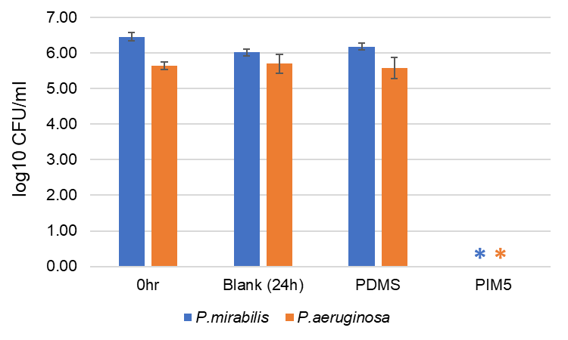
Figure 1: Surface antimicrobial assay for PDMS and PIM5. Surface antimicrobial assay was carried out using P.mirabilis and P.aeruginosa in neat/pure media following the JIS Z 2801-2010 standard protocol in 30 seconds surface contact time point. * denotes zero (0) CFU on the agar plate for undiluted samples. The results are expressed as mean and standard deviation of triplicates.

Hence, we have shown that PDMS-PIM45 composite biomaterial could eradicate microbial colonization within 30 sec of surface contact, exhibiting a rapid killing effect. The rapid killing potential of antimicrobial PIM45 is due to its dual mode of action. We have demonstrated that PIM45 induces disruption in membrane permeability and potential. Once permeabilised, the polymer binds to DNA in the cytoplasm resulting in growth arrest. SEM images of microbes treated with PIM45 also shows formation of pores and disrupted microbial membrane [27]. Several polymeric antimicrobials have also been reported to induce bactericidal activity via both membrane perturbation and DNA binding abilities [28-30]. However, their rapid killing (within seconds) bactericidal potential have not been documented.

3.2 In vitro continuous flow model and microbial colonization on “catheter mimic” tube

Robustness of PIM5-based “catheter” to prevent microbial colonization and encrustation was investigated on a continuous flow of artificial urine. Continuous flow of artificial urine was maintained at 0.5 ml/min [6] using the peristaltic pump. The urine source reservoir was refreshed daily, and sampling of the effluent was taken at 24h interval.
To note, appearance of 10³ CFU/ml microbe is considered nosocomial CAUTI and could increase to 10⁵ CFU/ml within 24h-48h, in the absence of antibiotic therapy intervention [31]. While 10⁸ CFU/ml microbes colonization mimics late stage CAUTI [5], 10⁵ CFU/mL or greater is used to define significant bacteriuria in clinical practice and many studies for the diagnosis of catheter-associated urinary tract infection [32].
Hence, we selected 10⁶ CFU/ml inoculum, 1 log higher inoculum that represent the mid-range of potential infection, to prove the robustness of our PIM5 composite biomaterial. Inoculum of E.coli, K.pneumoniae, MRSA, VREnterococus sp, P.aeruginosa and P.mirabilis, were prepared in AU+10%LB media.
Catheter mimic tubes (0.4 cm ID x 7 cm L) were prepared using the PDMS and PIM5 composite materials and inoculated with 500 μl of 10⁶ CFU/ml bacteria suspension in AU+10%LB media. The inoculum was incubated for 1 hr at room temperature to allow microbial adherence onto the luminal surface, rinsed with 5 ml of AU+10%LB and connected to the tubing attached to a peristaltic pump. The flow rate was maintained at 0.5 ml/min and AU+10%LB media was supplied as continuous flow of artificial urine. Sampling of effluent (flow through) was collected at 24h interval and continued till 168h (7 days end point). Meta-analysis on clinical data and reports on CAUTI and catheterization have shown that the first 7 days is a crucial period to prevent infections [7, 9]. Furthermore, studies on flow model have adhered to 7 days, as 1 inoculation cycle [20, 6, 33]. Microbial samples were plated following serial dilution and computed for colony forming units (CFU/ml).

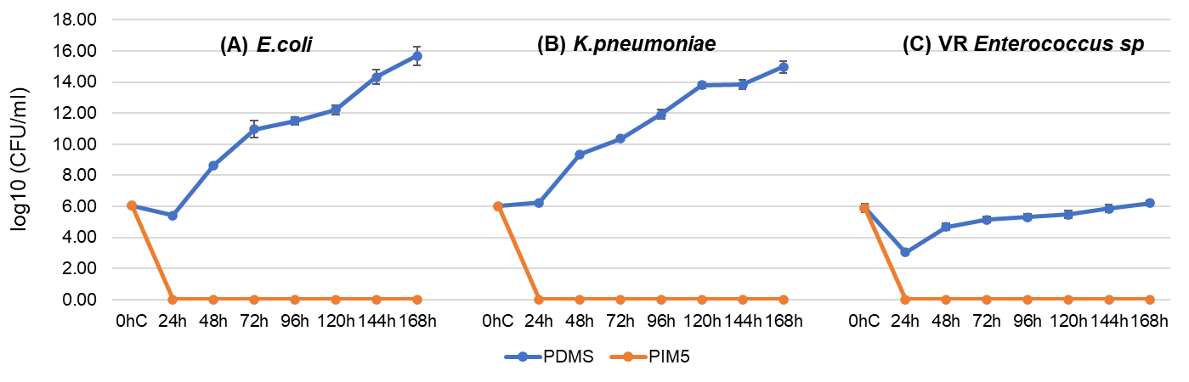
Figure 2: “Catheter tube” was inoculated with 10⁶ CFU/ml inoculum and continuous flow at 0.5ml/min of AU+10%LB media was initiated and continued for 168h (7 days) (A) E.coli (B) K.pneumoniae (C) VREnterococcus sp. 0hC (0h control) denotes log10 CFU/ml of microbes at inoculation. The results are expressed as mean and standard deviation of duplicates.

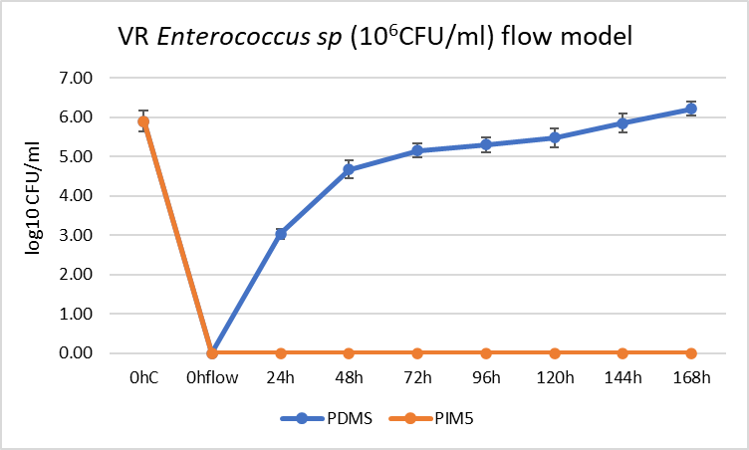
E.coli, K.pneumoniae and VREnterococcus sp were completely eliminated and did not colonise the PIM5 tube up to 168h (7 days) in continuous flow model of artificial urine (Figure 2). Bayston and team [20, 6] demonstrated that repurposed antimicrobials (triclosan/trimethoprim/rifampicin or triclosan/rifampicin/sparfloxacin) impregnated Foley catheter could prevent E.coli colonization for more than 84 days. The authors have utilised the entire Foley catheter, 30 cm-35 cm length and 2 ml of microbial load at 10⁵ CFU/ml to examine the robustness and efficacy of their antimicrobial formulation on the catheter. However, in our study, we used 500 μl of 10⁶ CFU/ml microbes to challenge a 7 cm of PIM5 tube (shorter tube and higher microbial load), to test the robustness of our composite biomaterial to withstand microbial colonization.
Both MRSA and P.aeruginosa were detected in the effluent of PIM5 catheter tube within 24h of inoculation. While P.mirabilis could be detected in the effluent at 48h (Figure 3), it remained at 2 log lower than for the PDMS control catheter tube. Notably, S.aureus, P.aeruginosa and P.mirabilis are urease producing bacterium [11, 34], where P.mirabilis colonization is associated with more serious consequences of biomineralized biofilm and encrustation of the catheter.

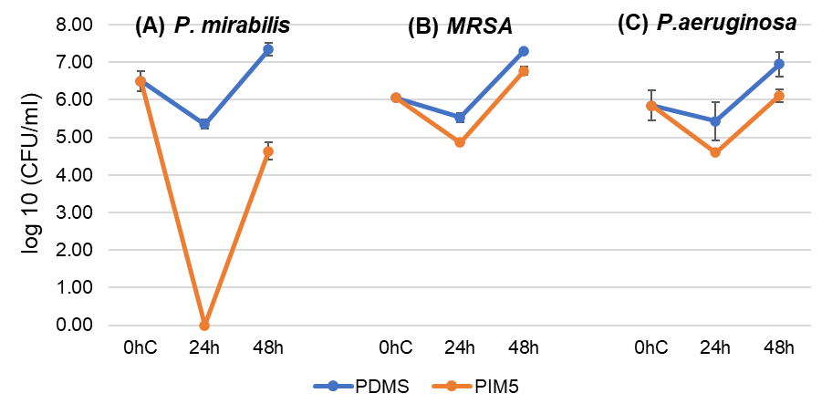
Figure 3: “Catheter tube” was inoculated with 10⁶ CFU/ml inoculum and at 0.5 ml/min of AU+10%LB media flow was initiated and continued till colonization was observed (A) P.mirabilis (B) MRSA (C) P.aeruginosa. 0hC (0h control) denotes log10 CFU/ml of microbes at inoculation. The results are expressed as mean and standard deviation of duplicates.

ASTM-E3321-21 standard describes the test protocol to evaluate antimicrobial efficacy of catheters in medical application. The protocol describes inoculation of 10³ CFU/ml microbes followed by immediately initiating the continuous flow of urine. The standard describes assessment of the effluent as well as the biofilm formed on the catheters, at 24h interval for 96h (4 days). Since, MRSA, P.aeruginosa and P.mirabilis appeared to colonize the PIM5 within 24h at 10⁶ CFU/ml inoculation, we selected these microbes to be investigated using the ASTM-E3321-21 protocol.
Planktonic MRSA was observed in the effluent within 24h for both the PDMS control and PIM5, and biofilm formed within 24h on the control PDMS material. Nevertheless, development of biofilm was prevented on PIM5 during the 96h of flow (Figure 4A). While the planktonic viable bacterium could be detected in the effluent, adhered microbes could have been destroyed or eliminated via surface contact killing, thus preventing the biofilm development. In agreement, colonization of MRSA on PIM5 appears to decline with time after peaking at 48h. Notably, PIM5 composite material eliminated pre-formed S.aureus biofilm and could prevent S.aureus colonization for at least 45 days on PIM5 [19].

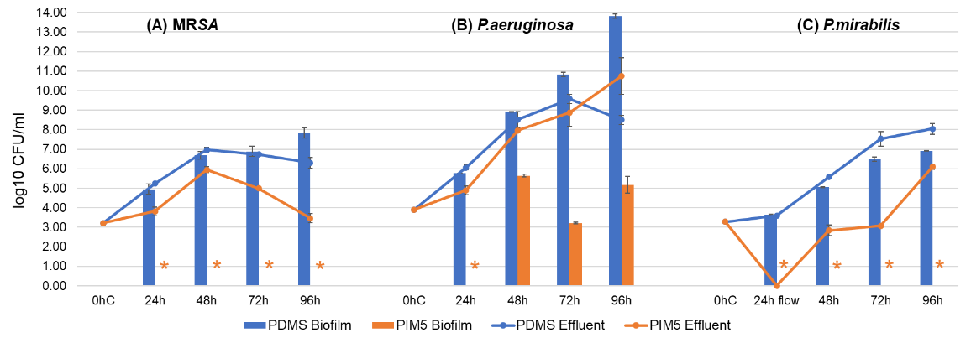
Figure 4: ASTM-E3321-21 protocol was adapted for continuous flow of AU+10%LB media for 96h (4 days) upon 10³ CFU/ml inoculation of (A) MRSA or (B) P.aeruginosa. A revised ASTM-E3321-21 protocol (1hr incubation upon microbial inoculation was included to the ASTM-E3321-21 protocol to allow adherence of bacteria on the intraluminal surface) for (C) P.mirabilis inoculation. - 0hC (0h control) denotes log10 CFU/ml of microbes at inoculation. * denotes zero (0) CFU on the agar plate for undiluted samples. The results are expressed as mean and standard deviation of duplicates.

On the other hand, P.aeruginosa appears to colonize the PDMS/PIM5 tube by 24h. While biofilm formation occurs on the PDMS control tube within 24h, a delay in biofilm development was observed in PIM5, biofilm appearing at 48h (Figure 4B). Though, PIM5 could eradicate P.aeruginosa within 30 sec exposure (static contact killing), it is unable to prevent colonization and could only delay the development of biofilm in the continuous flow model. This reduced susceptibility may be attributed to the lipopolysaccharide (LPS) core and the O-antigen that is present on the bacterial cell membrane, as observed by Navarro et al [35]. The authors found that a novel BZK-Polyacrylic acid-glutaraldehyde (BPA) formulation could not inhibit the development of biofilm by wildtype P.aeruginosa. However, an isogenic LPS-O-antigen deficient mutant P.aeruginosa was completely susceptible to the BPA. It is noteworthy that rapid killing efficiency (30 sec surface contact) analyses showed that while a 2 log reduction of microbes was observed for PIM1 (1% wt/wt of PIM45), complete elimination of microbe was demonstrated for PIM5 (5% wt/wt of PIM45; Figure 1). Perhaps, a higher load of PIM45 may be able to eradicate wildtype P.aeruginosa colonization or its biofilm development on PDMS-PIM45 in a continuous flow analyses.
Interestingly, 10³ CFU/ml P.mirabilis inoculation on ASTM-E3321-21 protocol (absence of incubation period for microbial attachment) did not result in any microbial colonization or biofilm development even for the PDMS control tube (data not shown).
Nevertheless, colonization of P.mirabilis was observed when 1h incubation period was included upon microbial inoculation, in the methodology (revised ASTM-E3321-21 protocol). In support with the documented reports [17, 18], P.mirabilis biofilm formed within 24h in the control PDMS tube. While colonization of microbes (planktonic) in the PIM5 tube was delayed to 48h albeit at lower log10 CFU/ml, we observed that biofilm did not form in the PIM5 tube for the entire 96h in continuous flow (Figure 4C). A lag phase of microbial load was noted for the PIM5 tube between 48h-72h, followed by subsequent increase at 96h. pH of the effluent for both PDMS and PIM5, remained between 6.0-6.5 without any sign of crystalline formation.

3.3 PIM5 inhibits P.mirabilis biofilm formation on material surface
Development of biofilm on surfaces, especially on catheters, is the root cause for the widespread bacterial infections. Most if not all catheter related infections are consequences of biofilm formed on the surface of the catheters, subsequently leading to the threat of antimicrobial resistance. We investigated if P.mirabilis could form biofilm on the PDMS/PIM5 composite biomaterials. P.mirabilis (10⁸ CFU/ml) was inoculated in 2 ml of LB media in a 15 ml centrifuge tube. Biomaterial (2 cm x 1 cm) was added to the microbial suspension and incubated at 37 ºC/100 rpm for 72 hr. The materials were collected and processed for SEM as well as plate culture for enumeration of CFU. Both SEM imaging and the viable colony count showed that pristine PDMS material attracts microbe adherence and biofilm are formed across the entire surface of the material (Figure 5). However, reduced clusters of microbial colonies were observed for PIM1. On the other hand, absence of colonization or viable bacterium were noted for the PIM5 composite biomaterial.
This study proves that the PIM5 exhibits potent bactericidal property, robust and could eradicate/prevent attachment of microbes on its surface. Formation of biomineralized biofilm is the main criteria for successful colonization of P.mirabilis in urinary catheters [36]. Thus, preventing or inhibiting the formation of biofilm may prove significantly crucial in preventing P.mirabilis colonization and subsequently, encrustation.
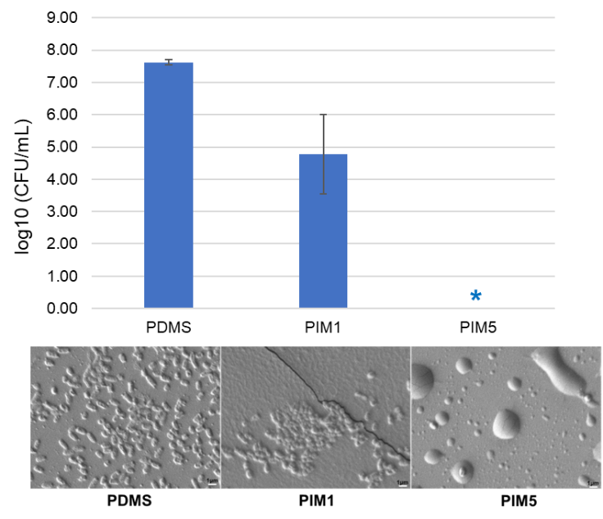
Figure 5: Evaluation of P.mirabilis biofilm development on PDMS and PDMS-PIM45. Adhered microbial colonies (biofilms) on PDMS, PIM1 and PIM5 biomaterials were evaluated. (Top) viable microbial enumeration (log₁₀CFU/ml) on LB agar plates and (Bottom) Scanning electron microscopy (SEM) images of the PDMS/PIM material surfaces. The results are expressed as mean and standard deviation of triplicates. * denotes zero (0) CFU on the agar plate for undiluted samples.

3.4 Static model to evaluate crystalline development and changes in pH in artificial urine
Microbial adhesion on the surface of biomaterial was evaluated using the static model as described by Wang et al [37]. In order to verify if the PIM material could inhibit the adhesion of microbes and formation of crystalline, 1 cm² of biomaterial was inoculated with P.mirabilis in 1 ml of either neat artificial urine [38] or artificial urine supplemented with 10%LB [36] . Inclusion of the 10%LB as supplement was intended for the worst-case scenario or conditions where presentation of compromised kidney function that may result in the release of metabolites in the urine. It should be noted that high concentration of inoculum is used to indicate the robustness of our biomaterial. In the actual clinical settings, 10⁵ CFU/mL of bacterium in urine and 10³ CFU/mL for catheter derived urine samples would be considered bacteriuria [32].
P.mirabilis at 10⁸ CFU/mL, 10⁷ CFU/mL and 10⁶ CFU/mL was inoculated in 1 ml of respective growth media pH 6.0 (computed as Day 0). We selected 2 types of media (a) neat artificial urine and (b) artificial urine supplemented with 10%LB (AU+10%LB) for this study. The incubation was carried out at 37 °C in a shaking incubator at 100 rpm (gentle rotation). Formation of crystalline in media and the pH of the media were recorded.
We observed slower growth of P.mirabilis in neat artificial urine (AU). The blank in 10⁸ CFU/mL and 10⁷ CFU/mL inoculum developed crystals at Day 3 and Day 5 respectively. At 10⁸ CFU/ml P.mirabilis (highest inoculum) crystalline was observed at Day 4 for PDMS and at Day 6 for PIM1 respectively, while PIM5 samples did not develop any crystals in artificial urine, even at Day 8 (end point; Table S1).
P.mirabilis inoculation at 10⁷ CFU/ml and 10⁶ CFU/ml in neat artificial urine did not develop neither turbidity nor crystals in the culture for PDMS materials, until 16 days. The PDMS and PIM materials were then transferred to AU+10%LB media, inoculated with 2 ml of 10⁷ CFU/ml P.mirabilis and incubated for another 24h. The PDMS biomaterials were assessed for formation of biofilm and the suspension was plated to determine the growth of planktonic bacteria in culture. Though planktonic microbial growth was slower (~4 log reduction compared to PDMS control), PIM composite material were able to prevent development of biofilm during this period. In contrary, viable microbes on the surface representing biofilm was observed for the pristine PDMS material (Figure 6).
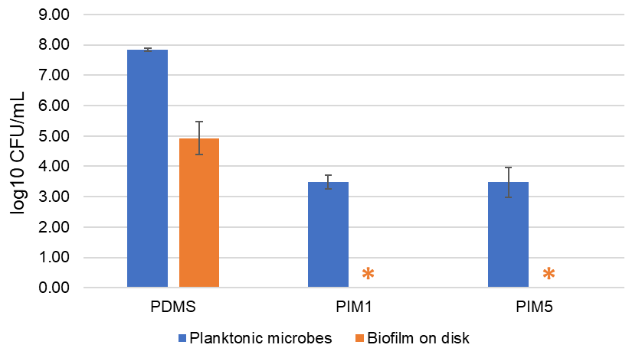
Figure 6: PDMS-PIM45 reduces growth of planktonic microbes and inhibits development of P.mirabilis biofilm following 16 days incubation in artificial urine. * denotes zero (0) CFU on the agar plate for undiluted samples. The results are expressed as mean and standard deviation of triplicates.

Hence, PIM composite material exhibits its antimicrobial property and prevented development of biofilm even after 16 days of exposure in artificial urine, though at a lower efficacy which permitted the growth of planktonic microbes. This experiment further proved the efficacy and robustness of the PIM5 composite biomaterial to reduce growth of planktonic microbes while inhibiting formation of biofilm on its surface.
Inoculation of 10⁸ CFU/mL P.mirabilis in AU+10%LB, resulted in crystalline formation (and turbid media) for all samples (Blank, PDMS Control and PIM materials) at Day 1 (24h post-inoculation; Table 1). The PIM material appears to significantly delay the pH increase. Though the crystal formation for PIM5 was observed at Day 1, we continued the incubation to study the changes in pH of the culture for the samples treated with PIM at high loading of bacteria (10⁸ CFU/mL). While turbidity/crystallization is observed for the PIM materials, it is noteworthy that the pH of the culture did not increase drastically as seen for the blank or pristine PDMS material (control) at Day 6 (Figure 7A).

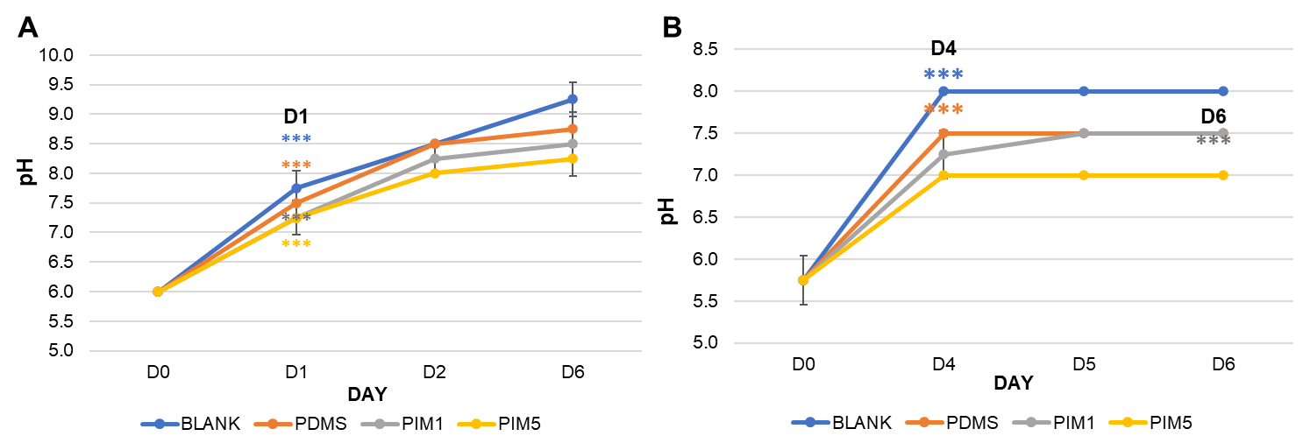
Figure 7: Development of crystalline and alteration of pH upon P.mirabilis inoculation. (A) Inoculation of 10⁸ CFU/ml bacterium in artificial urine supplemented with 10% LB media (AU+10%LB) (B) Inoculation of 10⁸ CFU/ml bacterium in neat artificial urine (AU). Crystalline formation was recorded following visual inspection and pH of the culture was measured using pH strips. ***severe crystalline formation in all 3 replicates. The results are expressed as mean and standard deviation of triplicates.

pH of media or culture plays an important role in the pathogenesis of P.mirabilis and the crystallization process [39]. Increase in pH of the urine/culture indicates the formation of ammonia from urea present in the urine sample by urease secreted by P.mirabilis. The alkalization of the urine eventually leads to the formation of crystals thereby, indicating active growth of P.mirabilis in the artificial urine media in both the blank and PDMS control cultures. At the 6th day end point, the pH of the blank and PDMS control was 9.5 and 9.0 respectively, while those with PIM material was 8.5 in cultures inoculated with 10⁸ CFU/mL. However, in neat AU media, 10⁸ CFU/mL P.mirabilis inoculum delayed the formation of crystalline/turbidity for PIM1 (to Day 6) and prevented the crystal formation for PIM5. It is noteworthy that the pH of media did not increase significantly and development of crystals was prevented for the 10⁸ CFU/mL P.mirabilis inoculum in neat artificial urine for PIM5 biomaterial (Figure 7B).
PIM materials appear to delay the crystal formation and maintain the pH at ~8.0, in the 10⁶ CFU/mL P. mirabilis inoculum. Hence, we continued the static model incubation for 21 days with inoculum refreshed at Day 10 and Day 16 (Figure 8). Interestingly, we observed that the pH of media in the presence of PIM5 material is ~9.0 with negligible crystal formation, while the pH of other PDMS material increased to 10.0, with extensive crystals being formed at the end point time of 21 days.
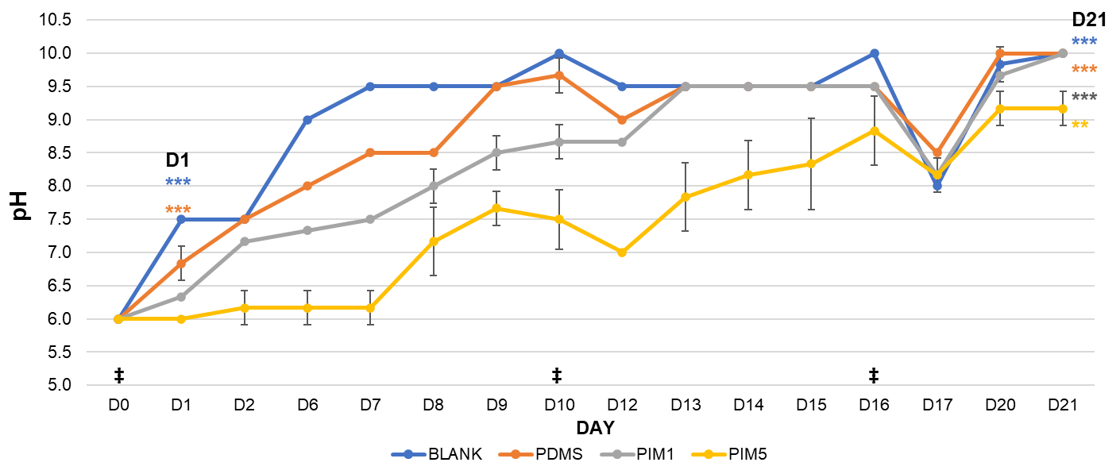
Figure 8: Development of crystalline and alteration of pH upon P.mirabilis inoculation. P.mirabilis at 10⁶ CFU/ml in artificial urine supplemented with 10% LB media (AU+10%LB) was incubated with 1 cm x 1 cm PDMS (control), PIM1 and PIM5 composite biomaterials. Blank control (media only) was included to assess the growth of P.mirabilis in respective media. Crystalline formation was recorded following visual inspection and pH of the culture was measured using pH strips. ‡ inoculation; ***severe and **traces of crystalline. The results are expressed as mean and standard deviation of triplicates.

Notably, antimicrobial polymer, PIM45 could be eluted from the PDMS-PIM material in solution. The PIM45 release profile indicates, a burst release for first 2 cycles followed by a sustain and gradual release of active compound thereafter [19]. Since crystalline formation in media is related to the presence of live microbes (that produces urease), its apparent that the PIM45 active compound is constantly being released (sustained release) to the media, to eliminate the microbes both via surface contact killing (on biomaterial) and in solution. Evidently, higher load of PIM45 could significantly delay increase in pH and impede the formation of crystal by P.mirabilis inoculum (PIM1 vs PIM5). In a similar “static model” experiment, Wang et al [40] have demonstrated that the inoculation of 10⁵ CFU/mL P.mirabilis could delay the formation of crystalline for 12 days for single Ag⁺PDA coated catheter and 45 days for the double coatings of PDA-Ag⁺-PDA. The commercial Dover Ag+ catheter, however, lasted only for 6 days before crystallization was observed in the solution. In a “bladder mimic” flow model, crystalline was observed at day 7 (at pH 6.17) on triclosan+WBPU material inoculated with 10⁵ CFU/mL P.mirabilis. The pH for test sample was at 6.17 versus 9.5 for the control [33]. In contrast, in our study, we demonstrate that PIM5 maintains the pH at 6.0 (pH of media) up to 7 days and delays/inhibits the formation of crust/crystalline up to 21 days in culture, even with 2 inoculations of fresh microbes at ~ 7 days interval. Thus, maintaining its bactericidal potency up to at least 21 days in solution.

3.5 In vitro continuous Flow Model to evaluate encrustation of PIM5 tubes
The anti-encrustation potential of PIM5 biomaterial was investigated on a continuous flow model using 10⁶ CFU/ml P.mirabilis inoculum in AU+10%LB (pH 6.0). pH of the solution/media plays a crucial role in development of crystalline, crystalline biofilm and finally encrustation. Hence, changes in pH of effluent, development of crystalline and presence of viable microbial (planktonic and biofilm) were monitored at 24h interval for 168h (7 days).
The PDMS and PIM5 tube (7 cm Length x 0.4 cm ID) lumen was inoculated with 500 μl of 10⁶ CFU/ml P.mirabilis and incubated for 1 h at room temperature to allow microbial adherence to the luminal surface. The unattached microbes were rinsed with 5 ml of flow media AU+10%LB (pH 6.0) and the continuous flow was initiated. Effluent was collected at the start of the flow (0h flow) and continued for 168h (7 days) with sampling at every 24h.
Viable microbes were observed even at 0h flow for the PDMS control tube (Figure 9). However, it was detected only at 48h for the PIM5 tube and grew gradually till 168h. Though microbes were detected in the effluent in the PIM5 tube, the magnitude is between 2-8 log lower and at much slower rate, compared to PDMS control.

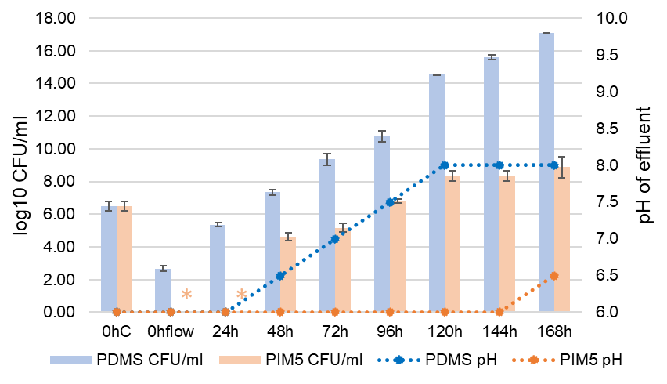
Figure 9: Development of crystalline, changes in pH and growth of P.mirabilis in AU+10% LB continuous flow. PDMS/PIM5 was inoculated with 10⁶ CFU/ml P.mirabilis, was subjected to continuous flow of AU+10% LB. Effluent was plated to determine the CFU and pH was measured using pH papers. Formation of crystalline was recorded based on visual inspection. Crystalline was observed in 96h effluent for PDMS control tube. 0hC (0h control) denotes log10 CFU/ml of microbes at inoculation; 0h flow indicate effluent collected upon initiation of 0.5ml/min of artificial urine flow. * denotes zero (0) CFU on the agar plate for undiluted samples. The results are expressed as mean and standard deviation of triplicates.

The pH of the effluent increased gradually in PDMS tube effluent from 24 h of continuous flow. The increase in pH corroborated with the development of the crystalline in PDMS control, where significantly visible crystal was observed at 96 h (pH 7.5). However, pH of PIM5 effluent remained constant at 6.0 up to 144 h and increased marginally to 6.5 at 168 h, without any sign of crystalline formation, corroborating to the results from static model.
At the end of 168 h, the tubes were investigated for the presence of intraluminal biofilm. Crystalline deposit was significant in the lumen of control PDMS tube (Figure 10, insert), while the lumen of PIM5 appeared “clean”. The tubes were sectioned into 7 pieces (1 cm each) and processed for determination of viable microbes. Crystalline biofilm was dislodged and resuspended in PBS, following the vortex (5 min) - sonication (5 min) – vortex (5 min) (2x) procedure. The suspension was diluted and plated for enumeration of CFU. Homogenous colonization of microbes (CFU/ml) forming crystalline biofilm was observed throughout the length (7 cm) of the PDMS tube (Figure 10).
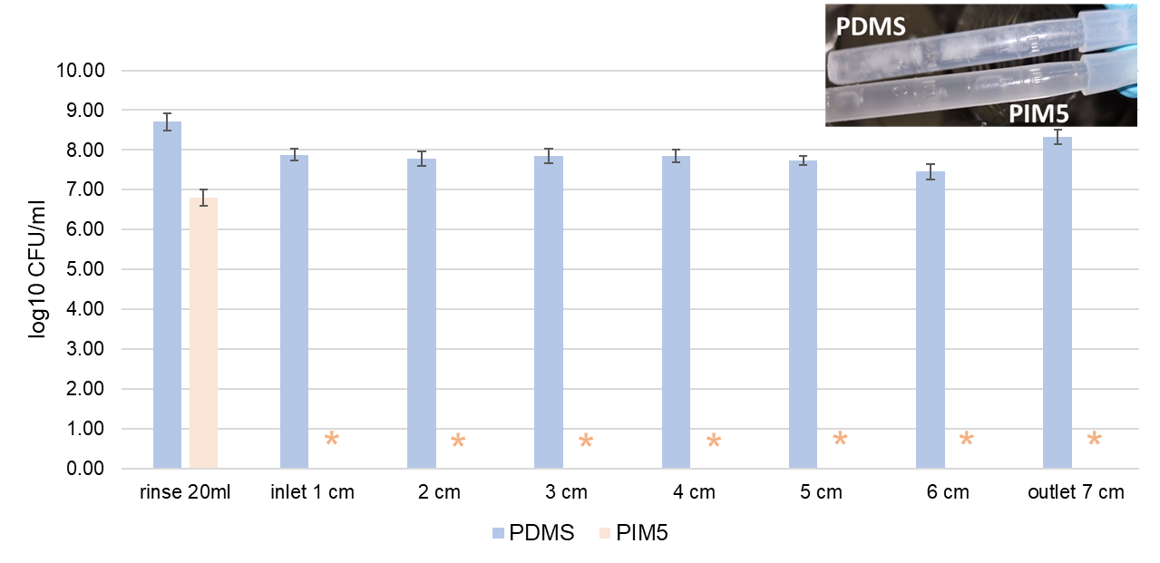
Figure 10: Quantitation of intraluminal P.mirabilis biofilm formed in the PDMS/PIM5 tubes. Viable bacterium in biofilm were enumerated from 7 sections (1 cm each) of the tube. * denotes zero (0) CFU on the agar plate for undiluted samples. The results are expressed as mean and standard deviation of duplicates.

However, though the rinse media contained viable microbes, the suspension for the PIM5 tube sections (biofilm microbes) did not indicate any sign of viable colonies. This result corroborates to the observation for the revised ASTM3221-21 data (Figure 4C), where the effluent exhibits presence of microbial colonization but absence of biofilm microbes for PIM5. The continuous flow model assay further strengthens our claim that sustain release of PIM45, the imidazolium antimicrobial polymer, from composite biomaterial (PDMS-PIM45) could inhibit or slow down the bacterial proliferation (planktonic microbes) while the PIM45 crosslinked in the PDMS matrix could inhibit microbial adherence via contact killing, thus preventing formation of hard-to-treat biofilms in the luminal surface of the tube. Hence, PDMS-PIM45 exhibits potent bactericidal property that could prove effective up to at least 7 days on continuous flow of artificial urine.
Catheter related infections or microbial contaminations occur both via extraluminal or intraluminal routes, each accounting for 34% and 66% infections respectively [41]. Commercially available antimicrobial catheters display intraluminal antimicrobial coating. However, PDMS-PIM45 biomaterial contains antimicrobial compounds as composite in the matrix with sustain release of antimicrobial polymer PIM45 in solution. Thus, the antimicrobial potential is exposed to both intraluminal and extraluminal surfaces, thereby eliminating the possibility of infection, “in and out”, proving that PDMS-PIM45 could serve as an excellent candidate for fabrication of catheter for medical application.

4. Conclusion
Catheter associated urinary tract infections represent a serious threat to individuals/patients that are subjected to indwelling catheterization either for short or long durations. Though urinary catheters with antimicrobial propensities are available, their efficacy and robustness are limited and below satisfaction/expectation. PDMS-PIM45 material has been demonstrated to be robust, exhibits long shelf live, shows high antimicrobial potency following recycling at least up to 45 days with continuous microbial challenge and could eliminate the ESKAPE pathogen within 24h of exposure. We proved that PDMS-PIM45 antimicrobial composite biomaterial is biocompatible and proposed that the antimicrobial biomaterial could be developed as urinary catheter. In this study, using a continuous flow of artificial urine, we have further supported our claims, proving that PDMS-PIM45 composite biomaterial can maintain its excellent antimicrobial efficacy on a flow model, executing combined contact killing and released-based bactericidal mechanisms. Further to preventing colonization against the prevalent CAUTI pathogens E.coli and K.pneumoniae, PIM5 could also prevent the development of encrustation following P.mirabilis colonization, a critical corollary that could impose further complications in patients undergoing indwelling urinary tract catheterizations.

Authors’ Contributions
YG-Z., acquired funding, conceived the proposal, and reviewed the manuscript. A-A., designed and carried out the experiments, collected the data, performed the analyses and wrote the manuscript. GS-Y carried out SEM and analysis. S.P-T., and S. P-C., prepared the PDMS-PIM5 matrix and synthesised PIM45 vinyl derivative respectively. All the author(s) have read and approved the final manuscript.

CRediT authorship contribution statement
YG-Z: Funding acquisition; Conceptualization; Writing - review & editing.
A-A: Conceptualization; Data curation; Formal analysis; Investigation; Methodology; Validation; Visualization; Roles/Writing - original draft; review & editing.
GS-Y: Investigation; Methodology; Validation; Writing - review & editing.
S.P-T: Investigation; Methodology; Validation; Writing - review & editing.
S. P-C: Investigation; Methodology; Validation; Writing - review & editing.

Declaration of Competing Interest
The authors declare that they have no known competing financial interests or personal relationships that could have appeared to influence the work reported in this paper.

Acknowledgements
This work was funded by the Institute of Bioengineering and Bioimaging, Biomedical Research Council, Agency for Science, Technology and Research, Singapore. The authors acknowledge the contribution of Dr Shawn Vasoo of the Infectious Diseases Research Laboratory, the National Centre for Infectious Diseases and Tan Tock Seng Hospital for the microbes. The graphical abstract figure was created in BioRender.com.

Reference
1. Z. Zhu, Z. Wang, S. Li, X. Yuan, Antimicrobial strategies for urinary catheters. J Biomed Mater Res A. 107(2019)445-467. https://doi.org/10.1002/jbm.a.36561.
2. J. Zhang, Y. Chen, M.A. Brook, Facile functionalization of PDMS elastomer surfaces using thiol-ene click chemistry. Langmuir. 29(2013)12432-42. https://doi.org/10.1021/la403425d.
3. R. Bayston, L.E. Fisher, K. Weber, An antimicrobial modified silicone peritoneal catheter with activity against both Gram-positive and Gram-negative bacteria. Biomaterials. 30(2009)3167-3173. https://doi.org/10.1016/j.biomaterials.2009.02.028
4. I.P.S. Thomé, V.S. Dagostin, R. Piletti, C.T. Pich, H.G. Riella, E. Angioletto, M.A. Fiori, Bactericidal low density polyethylene (LDPE) urinary catheters: microbiological characterization and effectiveness, Materials Science and Engineering: C, 32(2012)263-268. https://doi.org/10.1016/j.msec.2011.10.027.
5. S. Milo, N.T. Thet, D. Liu, J. Nzakizwanayo, B.V. Jones, A.T.A. Jenkins, An in-situ infection detection sensor coating for urinary catheters. Biosens Bioelectron. 81(2016)166-172. https://doi.org/10.1016/j.bios.2016.02.059.
6. L.E. Fisher, A.L. Hook, W. Ashraf, A. Yousef, D.A. Barrett, D.J. Scurr, X. Chen, E.F. Smith, M. Fay, C.D. Parmenter, R. Parkinson, R. Bayston, Biomaterial modification of urinary catheters with antimicrobials to give long-term broadspectrum antibiofilm activity. J Control Release. 202(2015)57-64.
7. R. Vopni, A. Voice, C. S. de Riese, J. Garza, W. T. de Riese, Use of Antimicrobial-Coated Catheters in Preventing Catheter-Associated Urinary Tract Infections and Bacteriuria: A Meta-Analysis for Clinicians. Urol Pract, 8(2021)705-712.
8. Y. Kai-Larsen, et al., Foley catheter with noble metal alloy coating for preventing catheter-associated urinary tract infections: a large, multi-center clinical trial. Antimicrob Resist Infect Control, 10(2021)40.
9. V. Gauhar, et al., Catheter-Associated Urinary Infections and Consequences of Using Coated versus Non-Coated Urethral Catheters-Outcomes of a Systematic Review and Meta-Analysis of Randomized Trials. J Clin Med, 11(2022)4463.
10. S. D'Incau, et al., Bacterial species and antimicrobial resistance differ between catheter and non-catheter-associated urinary tract infections: Data from a national surveillance network. Antimicrob Steward Healthc Epidemiol, 3(2023)e55.
11. J.M. Duran Ramirez, et al., Semi-Quantitative Assay to Measure Urease Activity by Urinary Catheter-Associated Uropathogens. Front Cell Infect Microbiol, 12(2022)859093.
12. D.J. Stickler, R.C. Feneley, The encrustation and blockage of long-term indwelling bladder catheters: a way forward in prevention and control. Spinal Cord, 48(2010)784-90.
13. C. Aumeran, et al., A prospective study on the pathogenesis of catheter-associated bacteriuria in critically ill patients. BMC Microbiol, 21(2021)86.
14. D.J. Stickler, Clinical complications of urinary catheters caused by crystalline biofilms: something needs to be done. J Intern Med, 276(2014)120-9.
15. S. Kalpande, P.R. Saravanan, K, Saravanan, Study of factors influencing the encrustation of indwelling catheters: prospective case series. Afr J Urol, 27(2021)1892.
16. K.A. Getliffe, The characteristics and management of patients with recurrent blockage of long-term urinary catheters. J Adv Nurs, 20(1994)140-9.
17. S.A. Wilks, M.J. Fader, C.W. Keevil, Novel Insights into the Proteus mirabilis Crystalline Biofilm Using Real-Time Imaging. PLoS One, 10(2015)e0141711.
18. D.J. Stickler, S.D. Morgan, Observations on the development of the crystalline bacterial biofilms that encrust and block Foley catheters. J Hosp Infect, 69(2008)350-60.
19. A. Armugam, et al., Broad spectrum antimicrobial PDMS-based biomaterial for catheter fabrication. Biomater Res, 25(2021)33.
20. K. Belfield, et al., An antimicrobial impregnated urinary catheter that reduces mineral encrustation and prevents colonisation by multi-drug resistant organisms for up to 12 weeks. Acta Biomater, 90(2019)157-168.
21. Standard Test Method for Intraluminal Catheter Model used to Evaluate Antimicrobial Urinary Catheters for Prevention of Escherichia coli Biofilm Growth, in ASTM-E3321-21. 2021.
22. J. Summers, D.M. Goeres, Catheter-Associated Urinary Tract Infections: Development of a Test Method for Assessing the Efficacy of Antimicrobial Technologies/Products. Targeting Biofilms in Translational Research, Device Development, and Industrial Sectors, ed. D. Williams. 2019: Springer, Cham.
23. Global burden of bacterial antimicrobial resistance in 2019: a systematic analysis. Lancet, 399(2022)629-655.
24. J. Li, Y. Wang, M. Che, X. Ji, J. Liu, Y. Sun, C. Xiao, Y. Zhang, S. Zhang, Highly efficient imidazolium-containing oligomers for preventing MRSA biofilm and postoperative spinal infection. European Polymer Journal, 137(2020)109910.
25. L. Liu, et al., Short imidazolium chains effectively clear fungal biofilm in keratitis treatment. Biomaterials, 34(2013)1018-23.
26 S.P. Teong, A. Armugam, S. P. Chan, Y. Zhang, Smart elastomer sanitizer with chemically bonded active compound and on-demand-release antimicrobial functionalities, J. Appl. Polymer, 2023, in press. doi.org/10.1002/app.54399
27. L. Liu, et al., Main-chain imidazolium oligomer material as a selective biomimetic antimicrobial agent. Biomaterials, 33(2012)8625-31.
28. S. Bai, et al., A polymeric approach toward resistance-resistant antimicrobial agent with dual-selective mechanisms of action. Sci Adv, 7(2021)eabc9917.
29. Z. Chen, et al., An alternatingly amphiphilic, resistance-resistant antimicrobial oligoguanidine with dual mechanisms of action. Biomaterials, 275(2021)120858.
30. K. Chindera, et al., The antimicrobial polymer PHMB enters cells and selectively condenses bacterial chromosomes. Sci Rep, 6(2016)23121.
31. R.P. Stark, D.G. Maki, Bacteriuria in the catheterized patient. What quantitative level of bacteriuria is relevant? N Engl J Med, 311(1984)560-4.
32. R. Platt, Quantitative definition of bacteriuria. Am J Med, 75(1983)44-52.
33. Y. Tian, et al., Antimicrobial activity Study of triclosan-loaded WBPU on Proteus mirabilis in vitro. Int Urol Nephrol, 49(2017)563-571.
34. R.J. Broomfield, et al., Crystalline bacterial biofilm formation on urinary catheters by urease-producing urinary tract pathogens: a simple method of control. J Med Microbiol, 58(2009)1367-1375.
35. S. Navarro, et al., Urinary Catheters Coated with a Novel Biofilm Preventative Agent Inhibit Biofilm Development by Diverse Bacterial Uropathogens. Antibiotics (Basel), 11(2022)1514.
36. X. Li, et al., Biomineralization strongly modulates the formation of Proteus mirabilis and Pseudomonas aeruginosa dual-species biofilms. FEMS Microbiol Ecol, 92(2016)189.
37. R. Wang, et al., Inhibition of Escherichia coli and Proteus mirabilis adhesion and biofilm formation on medical grade silicone surface. Biotechnol Bioeng, 109(2012)336-45.
38. N. Sarigul, F. Korkmaz, İ. Kurultak, A New Artificial Urine Protocol to Better Imitate Human Urine. Sci Rep, 9(2019)20159.
39. A. Torzewska, A. Rozalski, Inhibition of crystallization caused by Proteus mirabilis during the development of infectious urolithiasis by various phenolic substances. Microbiol Res, 169(2014)579-84.
40. R. Wang, et al., Antifouling coating with controllable and sustained silver release for long-term inhibition of infection and encrustation in urinary catheters. J Biomed Mater Res B Appl Biomater, 103(2015)519-28.
41. P.A. Tambyah, K.T. Halvorson, D.G. Maki, A prospective study of pathogenesis of catheter-associated urinary tract infections. Mayo Clin Proc, 74(1999)131-6.

