3D printing of ductile equiatomic Fe-Co alloy for soft magnetic applications

Shihao Li ª, Kwang Boon Lau ^{b}, Delvin Wuu ^{b}, Fengxia Wei ^{b}, Ming Lin ^{b}, Augustine Cheong ^{b}, Pei Wang ^{b,}*, Cheng Cheh Tan ^{b}, Upadrasta Ramamurty ^{a, b,}*

ª School of Mechanical and Aerospace Engineering, Nanyang Technological University, Singapore 639798, Republic of Singapore
^{b} Institute of Materials Research and Engineering, Agency for Science, Technology and Research, 2 Fusionopolis Way, Singapore 138643, Republic of Singapore

Corresponding addresses:
uram@ntu.edu.sg (U. Ramamurty), wangp@imre.a-star.edu.sg (P. Wang)

Abstract: The equiatomic Fe-Co alloy is an ideal soft magnetic material due to the combination of high saturation magnetization, permeability and low coercivity it offers. The ordered B2 phase in it, however, makes it highly brittle and hence unsuitable for industrial-scale manufacturing of bulk soft magnets. In this work, we employ the laser powder bed fusion (LPBF) technique—a widely used one for additive manufacturing of metallic parts—to fabricate bulk equiatomic Fe-Co blocks with a microstructure that almost-exclusively contains the disordered body centered cubic (BCC) phase. It plus the high dislocation density (an inherent attribute of the LPBF technique) impart considerable ductility to the as printed alloy, which will make it highly amenable for post-processing mechanical operations such as machining. Subsequent annealing heat treatment (HT) will facilitate disordered BCC to ordered B2 phase transformation and reduction in dislocation density and residual stresses, all of which will maximize the soft magnetic properties. This study demonstrates a viable method to manufacture equiatomic Fe-Co parts with desired geometry and magnetic properties.

Keywords: Fe-Co alloys, laser powder bed fusion, ductility, magnetic properties, heat treatment

- Introduction
Soft magnetic materials, which can be magnetized and demagnetized easily during cycling of an external field, are critical for the development of electromagnetic devices such as power generators, transformers, transducers, and magnetic shields [1-3]. The key performance metrics for a good soft magnetic material are high permeability, low coercivity, and high saturation magnetization [1-3]. Amongst all the available candidate magnetic materials, the Fe-Co alloys—the equiatomic alloy in the ordered state in particular—exhibit the best combination of those properties [4-9]. However, the proverbial Achilles’ heel that prevents widespread industrial application of them is their extremely poor ductility, which makes it difficult (if not impossible) to manufacture bulk components using conventional manufacturing (CM) techniques such as casting and forging [8-11]. The brittleness of Fe-Co alloys is a result of the ordered intermetallic B2 phase present in them [8-11]. It is widely known that the dislocation mobility in such intermetallic phases is rather limited, as dislocations have to move in pairs [11-14].
Several studies and Fe-Co phase diagram show that the solid-state phase transformation from the parent disordered body centered cubic (BCC) phase to ordered B2 phase occurs during the cooling of cast ingots from temperature above the critical ordering temperature (T_{c}) after solidification [15-17]. Since this transformation occurs at relatively high temperatures (T_{c} is about 730 °C for equiatomic Fe-Co alloy), the mobility of the constituent atoms is high and hence it occurs rather rapidly. The transformation can be circumvented such that the high temperature BCC phase is retained at room temperature by adopting an ultrahigh cooling rate at the level of 10³ °C/s. Since such high rates, however, are not achievable in the conventional processing routes used for materials in bulk, suppression of the transformation is generally not possible [17-19].
One strategy for improving the ductility of Fe-Co alloys is to obtain fully disordered BCC structure through a post-processing heat treatment (HT) [17,19-21]. Clegg et al reported that BCC to B2 phase transformation could be suppressed completely in the equiatomic Fe-Co alloy via quenching in iced brine after holding the alloy at 810 °C for 30 min [17]. However, the critical cooling rate required to maintain fully disordered BCC phase (established to be about 3000 °C/s) corresponds to a maximum of only about 0.7 mm for the sample thickness for obtaining a fully disordered BCC phase in the microstructure [17]. Such a low critical thickness poses a serious impediment for most industrial-scale manufacturing of Fe-Co alloy soft magnetic components. Alternatively, compositional modification through the introduction of additional alloying elements, which transforms the initial binary Fe-Co alloy into ternary Fe-Co-X alloy (X can be Cr, Nb, W, Cu, Ni, V, etc.) have been explored [15,22-30]. A typical example that follows this approach is the Fe-Co-V alloy system. Fe-Co-2V(wt.%) alloy, commercialized as Hiperco, is amendable to cold rolling after appropriate HT as its ductility is superior [26-30]. However, the ductility enhancement comes at the expense of magnetic properties such as lower saturation magnetization and higher coercivity [8,9,30].
Recent rapid advancement in additive manufacturing (AM) technologies provides new pathways for manufacturing net shaped parts of bulk Fe-Co alloy with complex geometries in one step. In addition, both the mechanical and function properties of AM alloy can be varied by changing the processing parameters [31,32]. In this study, we fabricated dense equiatomic Fe-Co blocks via laser powder bed fusion (LPBF) technique, which is a widely used and extensively researched method for metal AM [31-33]. Our results show that the bulk as-fabricated Fe-Co (AF Fe-Co) alloy blocks consist of almost fully disordered BCC phase and exhibits considerable ductility. Optimized magnetic performance comparable to that of CM Fe-Co is achieved through post-LPBF annealing. Our work demonstrates a new strategy to circumvent the ‘extreme brittleness’ roadblock that prevents the extensive deployment of equiatomic Fe-Co alloy for soft magnetic industrial applications.

- Material and methods
Pre-alloyed equiatomic Fe-Co powders were utilized as the feedstock material to manufacture the Fe-Co blocks using the LPBF system. (The alloy is simply referred as Fe-Co hereafter). These powders were spherical in shape with the nominal size ranging from 15 to 53 µm (See Fig. S1a of the supplementary information (SI)). They were processed using the nitrogen gas atomization and were procured (Sandvik, Stockholm, Sweden). The composition of the as-received powders was ascertained using X-ray fluorescence spectroscopy (XFS) as well as elemental analyzer and listed in Table S1. Before being loaded into the LPBF machine, the powders were dried at 60 °C for 12 h in an oven operated under vacuum to remove any absorbed moisture. The LPBF system used in this study is the Truprint 1000 model from Trumpf, which is equipped with a 200 W YLR-Faser-Laser with spot size of 30 µm. Powders were deposited onto a steel substrate (austenitic stainless steel 316L) with a diameter of 100 mm. The substrate was not preheated, which ensured untrahigh cooling rates and therefore the formation of full BCC phase in the AF Fe-Co blocks. Argon gas (purity: 99.9995%) was employed to prevent oxidation and the O₂ content in the chamber was reduced down to ~100 ppm. Gas pressure within the chamber was kept at 5 bar during printing. After several trails, the following optimum processing parameters, which yielded coupons with minimum porosity (with a relative density of 99.84$±$0.05%) and cracks, were identified: laser power = 120 W, scan speed = 300 mm/s, hatch spacing = 120 µm, and layer thickness = 20 µm, corresponding to a volumetric energy density of about 167 J/mm³. Chessboard scanning strategy with an island size of 4×4 mm² with 67˚ rotation of the laser scanning direction between successive layers was employed to fabricate blocks with dimension of 40 mm (Length)×10 mm (Width) ×10 mm (Height) (Bar-shaped blocks). 24 bar-shaped blocks were manufactured in this work and a representative image of these blocks is shown in Fig. S1b.
The AF Fe-Co alloy is characterized by high residual stress, a distinct feature inherent to the LPBF process, and high-density of stored dislocations (as shown later). Both these features exert detrimental effects on the permeability as well as the coercivity of the alloy, mandating a post-machining HT for improving the magnetic properties [8,9]. For enhancing the magnetic properties, two different HTs employing different annealing temperature- holding time combinations were performed on the AF Fe-Co blocks in this work. In HT1, the samples were annealed at 820 °C for 6 h and then furnace-cooled (at a rate of 5 °C/s) to room temperature (RT). HT2 consisted of pre-annealing at 700 °C for 1 h, followed by further annealing at 950 °C for 10 h and furnace-cooling (5 °C/s) to RT. The cooling rate employed is low enough to enhance disorder-to-order phase transformation in the Fe-Co alloy [17]. While HT1 was employed to transform the BCC phase present in the AF alloy into B2 phase without altering the grain structure, HT2 was designed to render the phase transformation together with recrystallization [17, 19-21].
Microstructural characterization and mechanical testing of the alloy were performed in both AF and HT conditions. Samples for the microstructural characterization were prepared using the standard metallurgical methods. Grain structures were examined using a JEOL 7800F field emission scanning electron microscope (FESEM) operated at 12 kV. Electron backscatter scanning diffraction (EBSD) measurements were conducted with a step size of 0.5 µm using the Oxford Instruments Symmetry EBSD detector available on FESEM. Inverse pole figure (IPF) images of selected sections were utilized to assess microstructural features such as the grain size, grain orientation, and potential texture. The XRD measurements were performed with 2$θ$ ranging between 30° and 80° and a step size of 0.04° using the Co source at the Singapore Synchrotron Light Source. Samples for transmission electron microscopy (TEM) analyses were prepared using either the focused ion beam (FIB, FEI Helios NanoLab 450S) lift-out method or ion milling on thin foils using precision ion polishing system (PIPS, Gatan 691). Specimens prepared using FIB were thinned to about 100 nm with a final operating voltage of 30 kV and current of 80 pA. An Ar ion plasma with an energy of 5 kV was employed for the final cleaning of the sample surfaces to remove any FIB-induced damage. In the second method, thin foils are first ground to about 70 μm, then dimpled using dimpling grinder (Gatan 656) and finally thinned to about 50 nm using PIPS operated at the final voltage of 2 kV and beam angle of 2°. TEM analyses were conducted on either a JEOL 2100F TEM or a FEI Titan 300 microscope equipped with DigiSTAR Precession electron diffraction system and Nanomegas ASTAR phase and orientation mapping system. The phase and crystallographic orientation mapping were performed by scanning the area of interest in the nano-beam diffraction (NBD) mode with a step size of 10 nm. Dislocation densities were determined using a line-intercept method proposed by Norfleet et al [36]. Five lines with random, different angular orientations are drawn cross the entire TEM images. The number N of interactions of random lines and dislocations is counted and dislocation density is determined as N divided by product of total line length and the TEM specimen thickness.
For the uniaxial tensile testing, the Fe-Co blocks are machined into cylindrical dog-bone test coupons (3.5 mm in diameter and 16.3 mm in gauge length) with the tensile axis perpendicular to the build direction according to ASTM standard E8/E8M-13a. Room temperature tensile tests were carried out at a nominal displacement rate of 1 mm min⁻¹ in a MTS Bionix Tabletop Test Systems (model 370.02) equipped with a load cell of 25 kN. The displacements during testing were measured using a non-contact laser extensometer. At least four samples were tested for each condition.
Direct current (DC) magnetic measurements were carried out on toroid ring samples with inner diameter of 32 mm, outer diameter of 40 mm and thickness of 8 mm (See Fig. S1c), according to ASTM A773 using a MATS-2010SD soft magnetic tester. Prior to the magnetic measurements, all the three ring-shaped samples (AF, HT1 and HT2 Fe-Co) were demagnetized strictly following the standard ASTM A773. The magnetic measurements were conducted with primary winding of 200 turns, secondary winding of 30 turns, maximum primary winding current of 10 A, temperature of 20 ºC and relative humidity of 55%. The magnetic flux is set to be perpendicular to the build direction during magnetic measurements for all samples.

- Results and Discussion
  - Microstructure and tensile properties of the AF alloy
Macroscopic crack-free Fe-Co blocks with high relative density (determined to be about 99.8% using the Archimedes principle) are fabricated after processing parameter optimization for subsequent microstructural characterization and property measurements. Figs. 1a and b show grain morphology and orientation distribution of side-view plane with build direction (BD) indicated by while arrow in the AF Fe-Co alloy. The backscattered electron (BSE) image in Fig. 1a shows a unique hybrid microstructure consisting of both fine equiaxed grains and columnar grains, instead of columnar-grain-dominant microstructure that is commonly reported in the LPBF alloys [37,38]. EBSD characterization covering a larger area also confirms a homogeneous microstructure with fine grains with near-random orientations. Grain size distribution determined using EBSD mapping is displayed in Fig. S2. It shows that the AF LPBF Fe-Co alloy contains mainly fine grains with an average size of 7.20$±$4.31 μm. The relatively fine grain size is a consequence of the high cooling rate inherent to the LPBF process [39]. Dispersed silica particles with diameter of 50-80 nm were identified (Fig. S3) using energy dispersive X-ray spectroscopy (EDS) mapping in TEM. The EDS mapping on region containing both grain interior and grain boundary reveals that elements distribute homogeneously without any segregation.
Representative uniaxial tensile stress-strain response obtained on specimens that were extracted from an AF Fe-Co block is displayed Fig. 1c. Following the onset of plastic deformation (with a yield strength, σ_{y}, of 625.9$±$35.9 MPa), considerable strain hardening of the alloy occurs, reaching an ultimate tensile strength (σ_{u}) of 741.9$±$28.3 MPa before breaking at a total strain (ε_{f}) of 13.4±1.8 % (with a uniform elongation of about 5.5%). Both the stress-strain responses and the morphologies of the tested samples (representative one shown in the inset of Fig. 1c), indicate to a typical ductile deformation behavior characterized by considerable plastic strain and localization of plastic flow through necking beyond σ_{u}. This is in striking contrast to the brittle deformation response without any noticeable plastic deformation reported for the Fe-Co alloys that are manufactured through the CM route of melting and casting [10]. Lüders band formation, which is characterized by the appearance of upper and lower yield points, commonly seen in CM Fe-Co alloy, is also absent in the LPBF alloy [9,10], which could be due to the appearance of high-density, uniform (macro-scale) and mobile dislocations that can be activated upon loading in the AF Fe-Co (as shown later). Postmortem EBSD analysis on the necked region of a broken tensile specimen shows elongation of the grains along the loading direction indicating extensive plastic deformation in them (Fig. S4a). Kernel average misorientation (KAM) map of the same region (Fig. S4b) shows plastic strain across the whole tensile sample, which is in accordance with the ductile response seen in Fig. 1c.
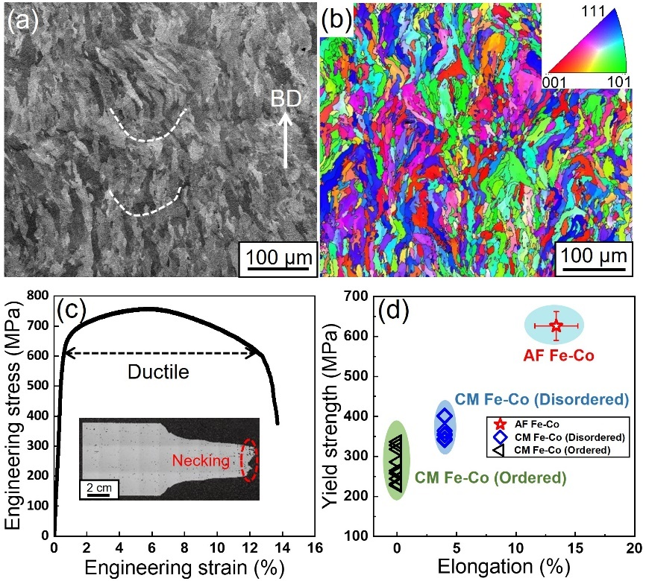
Fig. 1. Grain features and mechanical properties of AB Fe-Co. (a) Representative BSE image of AF Fe-Co along BD. Melt pool boundaries are indicated using white dashed curves. (b) EBSD mapping indicate that AB Fe-Co consists of fine equiaxed grains and elongated grains without strong texture. (c) Ductile tensile stress-strain response of AF Fe-Co with obvious necking. (d) Mechanical properties of AF Fe-Co in comparison with CM Fe-Co in both disordered and ordered states.
The tensile properties of the LPBF and CM Fe-Co alloys (taken from literature [10]) are compared in Fig. 1d in terms of a σ_{y} versus ε_{f} plot. The extreme brittleness of CM Fe-Co alloy with ordered B2 phase is reflected in near-zero ε_{f} [10]. (In fact, the alloy is so brittle that valid tests could only be conducted in compression; the data presented is from such compression tests.) Such an intrinsic brittle nature of the B2 phase renders it impractical to machine CM Fe-Co directly into magnetic parts without subsequent HT. For the disordered CM Fe-Co alloy, with a fully disordered BCC phase that is obtained through a solutionizing and quenching treatment, ε_{f} is ~4% as reported in a prior study [10]. While an improvement from that of the fully ordered alloy’s ε_{f}, this ductility is somewhat limited still. In comparison, simultaneous and significant enhancements in both ε_{f} and σ_{y} is achieved in LPBF Fe-Co alloy of the present study.
The unique advantage of the AM techniques is that they facilitate the production of complex and net shaped parts in only one processing step. Post-processing steps, if required, are often minor and involve cutting of the printed parts from the substrate, subsequent polishing to reduce surface roughness, and annealing treatments (as necessary) to relieve residual stresses. In this context, the measured ductility should be more than sufficient for any post-processing machining. In contrast, obtaining the desired part geometry through CM would often require extensive thermo-mechanical treatments (such as high temperature forging, extrusion or rolling) followed by machining. These operations cannot be performed with ease if the ductility and toughness of the alloy is low. That is the reason behind solutionizing and quenching the cast Fe-Co alloy, so as to obtain a fully disordered BCC structure and, in the process, impart some ductility to it. However, the limitation on the thickness required for achieving such as a structure through quenching, narrows the application potential of Fe-Co down to sheet/strip form [17]. In contrast, we demonstrate here that bulk Fe-Co alloy blocks with centimeter (or more) dimensions, which possess full BCC phase and enhanced ductility, can be readily fabricated through LPBF.
  - Effect of heat treatment
Microstructural characterization of HT specimens confirms that the annealing temperature of HT1 is insufficient to cause any discernable changes in the grain size and morphology (Figs. 2a, b and S5). In contrast, HT2 induces recrystallization that results in a bimodal microstructure with both fine and coarse grains (Figs. 2c and d). It appears that the bimodal microstructure is a result of the grain boundary pinning by silica particles; abnormal grain growth in some regions occurs due to non-pinning effects relative to texture, grain orientation and misorientation across adjacent grains [40,41]. Both the average grain size (10.85$±$7.69 μm) and the volume fraction of coarse grains (with the sizes larger than 20 μm) increase (Fig. S6) due to HT2. As expected, both the HTs lead to embrittlement of the LPBF Fe-Co alloy; tensile stress-strain responses (representative responses are displayed in Fig. S7) indicate completely brittle failure without any perceptible plastic deformation due to the B2 phase in them [10]. EBSD and KAM mapping on fractured region in HT1 Fe-Co shows no perceptible feature of plastic deformation (Fig. S7).
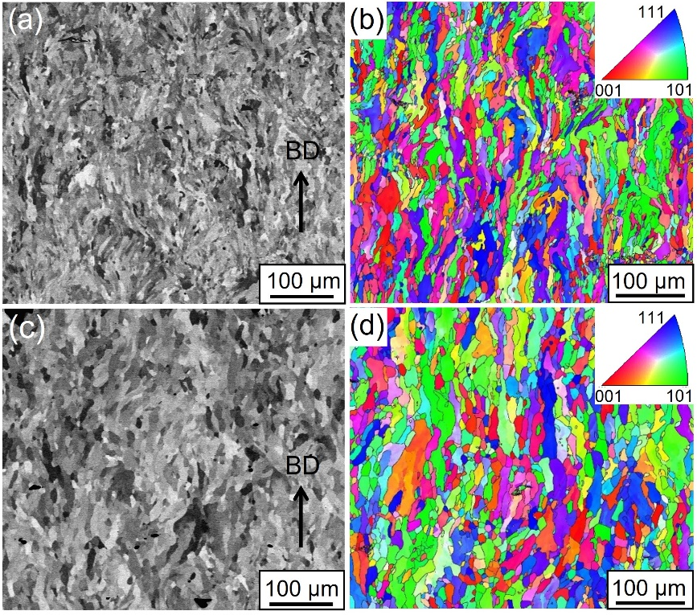
Fig. 2. Grain morphology and orientation distribution in HT1 and HT2 Fe-Co alloys. (a) BSE image and (b) EBSD mapping of HT1 Fe-Co, showing that HT1 results in no discernable grain evolution in Fe-Co alloy. (c) BSE image and (d) EBSD mapping of HT2 Fe-Co, indicating that recrystallization happens upon HT2 and results in large and bimodal grain structure in Fe-Co alloy.
Fig. 3a shows a TEM image of the AF Fe-Co which consists of several grains. Selected area diffraction patterns (SADP) collected in grains with different orientations (zone axes) all show exclusive patterns of disordered BCC phase and the inset provides a representative pattern taken along [100] zone axis. From the phase map displayed in Fig. 3b, it appears that it almost entirely consists of the BCC phase (99.8% in volume fraction) with negligible B2 phase. Such high-volume fraction of BCC phase in the AF Fe-Co is much higher than those achieved in prior studies (less than 50%) wherein laser engineered net shaping (LENS) was employed [42,43]. The higher cooling rate inherent to the LPBF process is one possible reason for this.
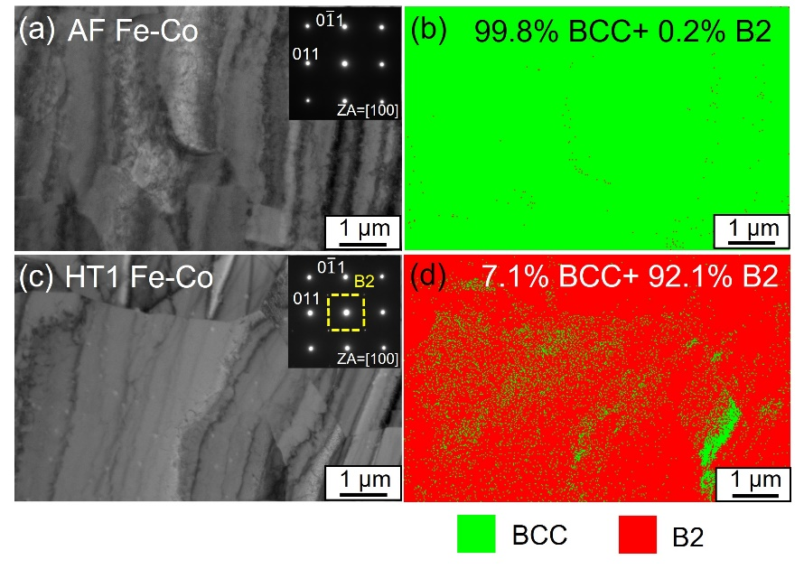
Fig. 3. Phase compositions of AF and HT1 Fe-Co alloys. (a) TEM characterization of AF Fe-Co. The inserted SADP and (b) phase mapping of the same area demonstrate that AF Fe-Co roughly consists of fully disordered BCC phase. (c) TEM characterization of HT1 Fe-Co. Corresponding SADP and (d) phase mapping reveal that HT1 Fe-Co is dominated by B2 phase with volume fraction of 92.1%.
Quantitative phase map of the alloy subjected to HT1 shows that the microstructure consists 92.1% B2 phase, in which dispersed retained BCC phase is embedded, confirming BCC to B2 transformation during HT. The typical SADP, displayed in Fig. 3c, which corresponds to B2, provides further evidence. The FIB lift-out method was employed to prepare TEM samples for phase composition measurements, which has negligible effect on volume fraction of B2 phase due to the fact that ordering can get activated only at high temperatures [44]. XRD patterns, which contain (100) peak of the B2 phase, also attest to this (Fig. S8).
The superior ductility of AF LPBF Fe-Co alloy to that of the CM alloy, even though both alloys comprise fully (or nearly-fully) disordered BCC phase, is possibly a result of distinct microstructural features in it. Such features develop as a result of the complex thermal cycles that fused alloy experiences during the LPBF process. Fig. 4 shows TEM images obtained from the AF and HT1 Fe-Co alloys both before and after tensile testing. The AF alloy contains a high density (ρ) of dislocations, which appear tangled (Fig. 4a). Dislocation cells are also observed, but only occasionally, with dislocation networks along the cell boundaries while the cell interiors also contain dislocations. The initial ρ was estimated to be ~2.33×10¹⁴ m⁻², which is comparable to that of reported in other LPBF alloys of different compositions [45,46]. Neither solidification cellular structures (Fig. 1) nor the elemental micro-segregation associated with it (Fig. S3) could be observed in the AF Fe-Co alloy. The formation of high-density dislocations could be attributed to plastic deformation induced by thermal expansion/shrinkage due to thermal gradients and thermal cycles experienced during the LB-PBF process [47]. Detailed EBSD analysis reveals the prevalence of slightly localized misorientation because of the stored dislocations in the grains (Fig. S9a). After tensile testing, ρ increases to about 5.92×10¹⁴ m⁻² (Fig. 4b). Majority of the observed dislocations are now untangled, which implies the activation of mobile dislocations during plastic deformation [48]. The higher σ_{y} in AF Fe-Co, compared to its CM counterpart, could be due to dislocation strengthening caused by a high-density of them in the microstructure.
An order of magnitude reduction in ρ (to 2.71×10¹³ m⁻²) upon HT1 is noted (Scanning transmission electron microscopy (STEM) image in Fig. 4c), which makes dislocations much sparser in the microstructure; this agrees with the EBSD results that shows less localized misorientation within the grains (Fig. S9b). Since the microstructure now consists of an ordered phase, ‘super’ dislocations, which are pairs of dislocations that are separated by an anti-phase boundary (APB), are formed (Fig. 4d) [10, 49]. It is well known that such ‘super’ dislocations mobility, in terms of both glide and cross-slip, is rather poor (as they need to move in pairs necessarily), which leads to the observed loss of ductility upon HT [49].
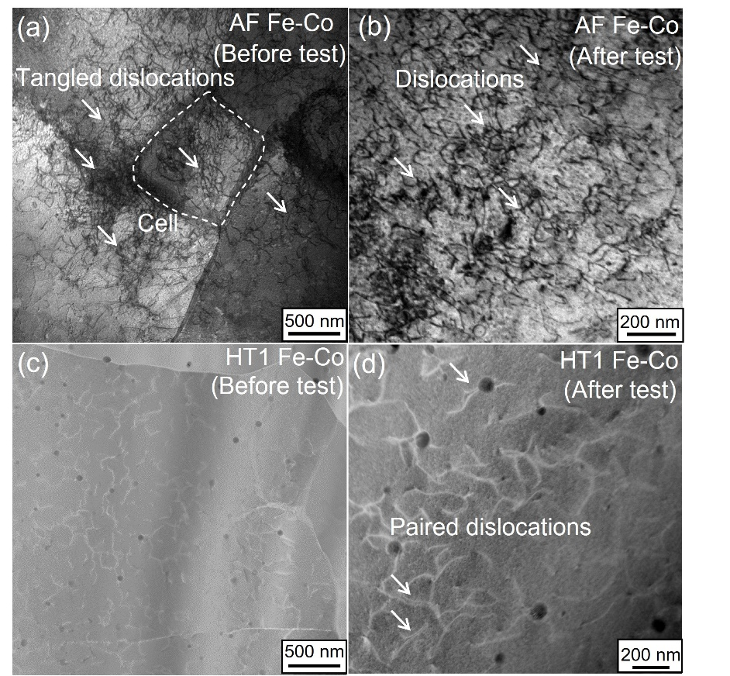
Fig. 4. Representative TEM and STEM images of AF Fe-Co and HT1 Fe-Co before and after tensile test (with loading direction perpendicular to TEM lamella). (a) Dense and tangled dislocations in AF Fe-Co before tensile test. Note the occasional appearance of dislocation cell. (b) Some dislocations stay untangled in AF Fe-Co after tensile test. (c) Relatively sparse dislocations in HT1 Fe-Co before tensile test. (d) Short paired dislocations in HT1 Fe-Co observed after tensile testing. No discernable difference between dislocation structures can be identified due to zero plastic strain.
The nature of dislocations in the AF LPBF Fe-Co alloy is distinct from those of dislocation networks and solidification cell structures (with certain elemental segregation to the cell walls) typically observed in other LPBF-processed alloys [45,46]. Importantly, such networks and cells are considerably stable both under plastic deformation and annealing treatments [50,51]. While the initial dislocation configuration in the AF LPBF Fe-Co alloy is unstable (in response to both annealing and plastic deformation), the enhancement in ρ during tensile straining does not lead to the formation of dislocation cells, which are typical features in metallic samples that have undergone extensive plastic straining. One possible reason is that the total tensile strain experienced by the alloy prior to commencement of necking (about 5.5% uniform strain as shown in Fig.1c) is not substantial, i.e., ρ is not high enough to initiate strong dislocation interactions and formation of dislocation cells.

  - Magnetic properties
Magnetic properties of the LPBF Fe-Co were measured in AB, HT1 and HT2 conditions by applying external electromagnetic field. Typical hysteresis loops and permeability curves are shown in Fig. 5a and b. Properties such as the saturation magnetization (B_{s}) and permeability (μ) with lower coercivity (Hc) estimated from such plots are listed in Table 1, along with those reported for CM Fe-Co alloy, Fe-Co-2V alloy manufactured using LPBF as well as CM routes, Fe-Co-1.5V alloy manufactured using LENS, for comparison purposes [9,42,52,53]. The values of B_{s} in LPBF Fe-Co alloy in AF, HT1 and HT2 conditions are about 2.09, 2.38 and 2.37 T, respectively. The latter two values are only ~1% smaller than B_{s} of 2.40 T reported for CM Fe-Co [9]. Marked narrowing of the central part of the hysteresis loops (displayed as inset in Fig. 5a) after HTs can be noted. This shows a significant reduction in Hc due both to the relief of residual stresses and ordering in Fe-Co alloy upon HT. μ, which is the most attractive feature of the equiatomic Fe-Co alloy for the soft-magnetic applications, instead of alloys with lower Co content, also exhibits considerable improvement after HT as shown in Fig. 5b. The maximum permeabilities (μ_{max}) in HT1 and HT2 Fe-Co are 4789 and 5008, respectively.
Table 1 Magnetic properties of Fe-Co and Fe-Co-V alloys fabricated via different methods.
Materials | Fabrication  method | Condition | Major phase | B_{s} (T) | μ_{max} | Hc (A/m) | Ref.
Fe-Co | LPBF | AF | BCC | 2.09 | 503 | 1417 | This work
 |  | HT1 | B2 | 2.38 | 4789 | 702
 |  | HT2 | B2 | 2.37 | 5008 | 450
Fe-Co | CM | Annealed | B2 | 2.40 | 5000-8000 | 150 | [9]
Fe-Co-2V | CM | As-cast | B2 | 2.18 | 1811 | 104 | [52]
 |  | Annealed | B2 | 2.23 | 12000 | 40
Fe-Co-2V | LPBF | AF | - | 1.57 | 1754 | 1287
 |  | Annealed | B2 | 2.18 | 125 | 493
 |  | Annealed ª | B2 | 2.23 | 60 | 47
 |  | Annealed ^{b} | B2 | 2.16 | 99 | 144
Fe-Co-2V | LPBF | AF | - | 1.82 | - | - | [53]
 |  | Annealed ^{c} | - | 1.41 | - | -
 |  | Annealed ^{d} | B2 | 2.17 | - | 673
 |  | Annealed ^{e} | B2 | 2.16 | - | 736
Fe-Co-1.5V | LENS | AF | BCC+B2 | 2.23 | 518 | 995 | [42]
 |  | Annealed | B2 | 2.30 | 1639 | 383
ª With pre-annealing; ^{b} With pre-normalizing; ^{c} Quenching HT; ^{d} Ordering for 2 h; ^{e} Ordering for 4 h.
The above results demonstrate that HT leads to superior B_{s}, μ, with lower Hc, as expected. This indicates that magnetic properties of LPBF-processed Fe-Co alloy can be readily tuned and improved through post-machining annealing HT procedures that are well developed for CM Fe-Co alloys [4,17,30]. Fig. 5c plots B_{s} versus μ_{max} of HT1 and HT2 Fe-Co in comparison with magnetic properties in other Fe-Co and Fe-Co-V systems manufactured through either conventional methods or AM techniques, which illustrates the favorable combination of B_{s} and μ_{max} that can be achieved in the equiatomic Fe-Co alloy through the LPBF + HT route [9,42,52,53]. Note here that the magnetic properties of AF Fe-Co are not plotted for comparison as only Fe-Co alloys after HT containing ordered B2 phase are suitable for magnetic applications [8,9]. The slight inferiority of the alloys fabricated in this work, as compared to that of the CM Fe-Co alloy, is more than compensated by the ease of fabricating net shaped parts using the proposed methodology. Compared to the binary Fe-Co alloy, the ternary Fe-Co-V is characterized by lower B_{s}, irrespective of the manufacturing method employed and annealing HT, accompanied by large scatter in μ_{max}. It is important to note here that an unbiased comparison of Hc among the above alloys is not possible, as this property is particularly sensitive to grain size [9,10,30]. An equation in Hall-Patch relation form was proposed to describe linear dependency of Hc on grain size [9,10,30].
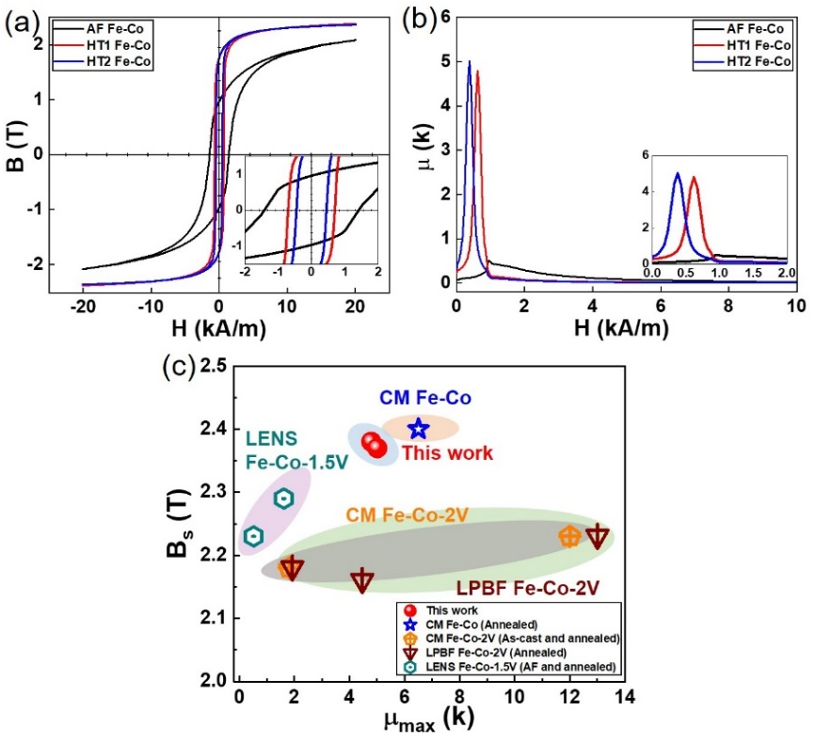
Fig. 5. Magnetic properties of Fe-Co alloy in AF, HT1 and HT2 conditions. (a-b) Typical hysteresis loops and permeability curves of AF, HT1 and HT2 Fe-Co alloys. HTs significantly improve overall magnetic properties of Fe-Co alloy. (c) B_{s} versus μ_{max} of HT1 and HT2 LPBF Fe-Co alloys in comparison with that of other Fe-Co and Fe-Co-V alloys fabricated through both CM and AM. HT1 and HT2 Fe-Co exhibit combination of B_{s} and μ_{max} comparable to that of CM Fe-Co.
Possible factors that contributed to the observed substantial improvement in magnetic properties of Fe-Co alloy upon HT should be the relief of high residual stresses, annihilation of stored dislocations built up during LPBF process, and the disordered-to-ordered phase transformation. Note that such HTs, post-machining, are always essential even in CM, for relieving machining-induced residual stress and minimization of dislocations, before application, especially for these parts fabricated using thermo-mechanical processing steps [8,9]. Although B_{s} in Fe-Co alloy is not sensitive to the grain size, both μ_{max} and Hc can be further optimized through the coarsening of the grain structure, which can be achieved by annealing at higher temperatures, as grain boundaries are known to resist movement and alignment of magnetic domains [9,52]. Better μ_{max} and Hc in the HT2 alloy, as compared to those of HT1, confirm this possibility. However, a strict control on the oxygen uptake and therefore secondary phase formation (such as silica particles observed in this study) is essential during printing and any such HTs. Here, it is worth noting that a small amount of Si is intentionally added to the bulk Fe-Co (before its atomization to produce powders) to decrease the melting point and increase the melt flowability, both of which facilitate better gas atomization for powder manufacturing subsequently. As Si addition is currently indispensable, control on oxygen content during printing and HT is vital.
Prior efforts have been made to manufacture Fe-Co blocks using AM techniques [42,43,52-55]. However, a practical strategy that incorporates AM for manufacturing bulk Fe-Co blocks suitable for magnetic applications is not developed yet. The microstructures in AF blocks manufactured via LENS are reported to be dominated by B2 phase, which results in limited workability [42,43]. Some other studies, however, focused mainly on improving the ductility at the cost of magnetic properties [54,55]. In light of this, the processing methodology utilized in the present study appear advantageous over conventional methods for the following reasons. i) Large-scale magnetic parts with fully disordered BCC phase can be manufactured directly. The current dimensional limitation of hundreds of millimeters, which is two orders of magnitude higher than that of CM ductile counterpart [17], will surely be further extended with the advances occurring in LPBF technique. ii) Due to their ductility, the AF blocks can be machined (and/or subjected to additional minor mechanical operations) without the need for additional annealing and quenching treatment that is imperative for improving the workability of CM blocks, providing a simplified and lead-time-shortened manufacturing method. iii) One issue in using Fe-Co alloys lies in its high cost due to addition of Co. From the feedstock-saving perspective, LPBF processing minimizes feedstock waste via manufacturing parts directly true to their design and recycling Fe-Co powders for printing, while conventional methods result in inevitable waste on expensive raw materials due to machining.
- Conclusions
A strategy to manufacture equiatomic Fe-Co parts with favorable ductility and magnetic properties using LPBF and post-processing annealing HT is demonstrated. The inherent attributes of LPBF, namely rapid melting and subsequent solidification of the small volumes of alloy at any given instance and thermal excursions that result in a high dislocation density, facilitate the fabrication of bulk Fe-Co alloy parts containing fully disordered BCC phase. These parts exhibit considerable ductility with ε_{f} of about 13.4% in the AF state, which enables subsequent mechanical operations that are necessary for obtaining a finished product. The magnetic properties can then be optimized through post-LPBF annealing HT, achieving magnetic properties comparable (or slightly inferior) to that of CM counterpart. The newly developed strategy paves the way for manufacturing Fe-Co parts for high performance soft magnetic application in a more convenient, efficient and low-cost manner.

Declaration of Competing Interest
The authors declare no conflict of interest.

Acknowledgements
This work was supported by the Structural Metal Alloys Program (Grant reference No.: A18b1B0061) of the Agency for Science, Technology and Research of Singapore. The authors gratefully thank the technical support on TEM sample preparation using FIB from Ms. Teo Siew Lang, sample polishing by Mr. Wei Hock Teh, EBSD data collection by Dr. Laura-Lynn Liew, magnetic results discussion with Dr. Nikolai Yakovlev of IMRE and XRD measurements by Dr. Ping Yang from Singapore Synchrotron Light Source. The authors gratefully thank the helpful comments from Dr. Baicheng Zhang from University of Science and Technology, Beijing.

Appendix A. Supporting information
Supplementary data associated with this article can be found in the online version.

References
[1] J.M. Silveyra, E. Ferrara, D.L. Huber, T.C. Monson, Soft magnetic materials for a sustainable and electrified world, Science 362 (2018) 418.
[2] H. Shokrollahi, K. Janghorban, Soft magnetic composite materials (SMCs), J. Mater. Proc. Tech. 189 (2007) 1-12.
[3] H.R. Lashgari, D. Chu, S. Xie, H. Sun, M. Ferry, S. Li, Composition dependence of the microsturcture and soft magnetic properties of Fe-based amorphous/nanocrystalline alloys: A review study, J. Non-Cryst. Sol. 391 (2014) 61-82.
[4] D.I. Bardos, Mean Magnetic Moments in bcc Fe–Co Alloys, J. Appl. Phys. 40 (1969) 1371-1372.
[5] K. Schwarz, D.R. Salahub, Band theory for the magnetic moment in the bcc Fe-Co alloy, Phys. Rev. B 25 (1982) 3427-3429.
[6] T. Sourmail, Evolution of strength and coercivity during annealing of FeCo based alloys, Scr. Mater. 51 (2004) 589-591.
[7] C. Jo, J.I. Lee, Y. Jang, Electronic and magnetic properties of ultrathin Fe−Co alloy nanowires, Chem. Mater. 17 (2005) 2667-2671.
[8] T. Sourmail, Near equiatomic FeCo alloys: Constitution, mechanical and magnetic properties Prog. Mater. Sci. 50 (2005) 816-880.
[9] R.S. Sundar, S.C. Deevi, Soft magnetic FeCo alloys: alloy development, processing, and properties, Int. Mater. Rev. 50 (2013) 157-192.
[10] L. Zhao, I. Baker, The effect of grain size and Fe: Co ratio on the room temperature yielding of FeCo, Acta Metall. Mater. 42 (1994) 1953-1958.
[11] E.P. George, A.N. Gubbi, I. Baker, L. Robertson, Mechanical properties of soft magnetic FeCo alloys, Mater. Sci. Eng. A 329 (2002) 325-333.
[12] M.C. Ha, J.-M. Koo, J.-K. Lee, S.W. Hwang, K.-T. Park, Tensile deformation of a low density Fe–27Mn–12Al–0.8C duplex steel in association with ordered phases at ambient temperature, Mater. Sci. Eng. A 586 (2013) 276-283.
[13] I. Baker, A review of the mechanical properties of B2 compounds, Mater. Sci. Eng. A 192 (1995) 1-13.
[14] S.-T. Fong, K. Sadananda, M.J. Marcinkowski, Effect of strain, temperature, and atomic order on slip deformation in FeCo, Metall. Trans. 5 (1974) 1239-1247.
[15] R.A. Buckley, Microstructure and Kinetics of the Ordering Transformation in Iron–Cobalt Alloys, FeCo, FeCo–0.4%Cr, FeCo–2.5%V, Met. Sci. 9 (1975) 243-247.
[16] H. Sato, R. Kikuchi, Kinetics of order-disorder transformations in alloys, Acta Matell. 24 (1976) 797-809.
[17] D.W. Clegg, R.A. Buckley, The disorder → order transformation in iron–cobalt-based alloys, Met. Sci. J. 7 (1973) 48-54.
[18] R.A. Buckley, Ordering and recrystallization in Fe-50Co-0.4%Cr, Met. Sci. 1979, 13, 67-72.
[19] M. Rajkovic, R.A. Buckley, Ordering transformations in Fe-50Co based alloys, Met. Sci. 15 (1981) 21-29.
[20] J. Eymery, P. Grosbras, P. Moine, Ordering kinetics of various Fe-Co alloys, Phys. Stat. Sol. 21 (1974) 517-528.
[21] Y. Ustinovshikov, B. Pushkarev, I. Shabanova, A. Ulianov, Phase transformations in the Fe-Co system, Interf. Sci. 10 (2002) 311-321.
[22] A.I.C. Persiano, R.D. Rawlings, Effects on some physical properties of soft magnetic Fe-Co alloys due to the replacement of vanadium by niobium, J. Mater. Eng. 12 (1990) 21-27.
[23] A.I.C. Persiano, R.D. Rawlings, Effect of niobium additions on the structure and magnetic properties of equiatomic iron-cobalt alloys, J. Mater. Sci. 26 (1991) 4026-4032.
[24] I.Y. Yermolenko, M.V. Ved, N.D. Sakhnenko, Y.I. Sachanova, Composition, morphology, and topography of galvanic coatings Fe-Co-W and Fe-Co-Mo, Nanoscale Res. Lett. 12 (2017) 352.
[25] P. James, O. Eriksson, B. Johansson, I.A. Abrikosov, Calculated magnetic properties of binary alloys between Fe, Co, Ni, and Cu, Phys. Rev. B 59 (1999) 419-430.
[26] M. Aykol, A.O. Mekhrabov, M.V. Akdeniz, Effect of vanadium on atomic ordering characteristics and anti-phase boundary energies of B2–FeCo alloys, Intermetallics 18 (2010) 893-899.
[27] K. Kawahara, Effect of additive elements on cold workability in FeCo alloys, J. Mater. Sci. 18 (1983) 1709-1718.
[28] A. Duckham, D.Z. Zhang, D. Liang, V. Luzin, R.C. Cammarata, R.L. Leheny, C.L. Chien, T.P. Weihs, Temperature dependent mechanical properties of ultra-fine grained FeCo–2V, Acta Mater. 51 (2003) 4083-4093.
[29] K. Kawahara, Structures and mechanical properties of an FeCo-2V alloy, J. Mater. Sci. 18 (1983) 3427-3436.
[30] B. Nabi, A.L. Helbert, F. Brisset, G. André, T. Waeckerlé, T. Baudin, Effect of recrystallization and degree of order on the magnetic and mechanical properties of soft magnetic FeCo–2V alloy, Mater. Sci. Eng. A 578 (2013) 215-221.
[31] A.R. Oliveira, V.F. Oliveira, J.C. Teixeira, E.G. Del Contel, Investigation of the build orientation effect on magnetic properties and Barkhausen Noise of additively manufactured maraging steel 300, Addit. Manuf. 38 (2021) 101827.
[32] A.R. Oliveira, J.A.A. Diaz, A.D.C. Nizes, A.L. Jardini, E.G. Del Conte, Investigation of building orientation and aging on strength-stiffness performance of additively manufactured maraging steel, J. Mater. Eng. Perf. 30 (2021) 1479-1489.
[33] P. Kumar, U. Ramamurty, High cycle fatigue in selective laser melted Ti-6Al-4V, Acta Mater. 194 (2020) 305-320.
[34] J.M. Park, Y.K. Zhao, T. Voisin, D.H. Lee, S. Komazaki, Y. Ko, D.I. Kim, J.Y. Suh, H.N. Han Y.M. Wang, U. Ramamurty, J.I. Jang, Hydrogen uptake and its influence in selective laser melted austenitic stainless steel: A nanoindentation study, Scripta Mater. 194 (2021) 113718.
[35] S.Y. Wei, K.B. Lau, J.J. Lee, F.X. Wei, W.H. The, B.C. Zhang, C.C. Tan, P. Wang, U. Ramamurty, Selective laser melting of Fe–Al alloys with simultaneous gradients in composition and microstructure, Mater. Sci. Eng. A 821 (2021) 141608.
[36] D.M. Norfleet, D.M. Dimiduk, S.J. Polasik, M.D. Uchic, M.J. Mills, Dislocation structures and their relationship to strength in deformed nickel microcrystals, Acta Mater. 56 (2008) 2988-3001.
[37] P. Kumar, O. Prakash, U. Ramamurty, Micro-and meso-structures and their influence on mechanical properties of selectively laser melted Ti-6Al-4V, Acta Mater. 154 (2018) 246-260.
[38] J. Liu, A.C. To, Quantitative texture prediction of epitaxial columnar grains in additive manufacturing using selective laser melting, Addit. Manuf. 16 (2017) 58-64.
[39] T. DebRoy, H.L. Wei, J.S. Zuback, T. Mukherjee, J.W. Elmer, J.O. Milewski, A.M. Beese, A. Wilson-Heid, A. De, W. Zhang, Additive manufacturing of metallic components – Process, structure and properties, Prog. Mater. Sci. 92 (2018) 112-224.
[40] J. Dennis, P.S. Bate, F.J. Humphreys, Abnormal grain growth in Al–3.5Cu, Acta Mater. 57 (2009) 4539-4547.
[41] J. Li, Q. Qi, C. Yuan, X. Bao, X. Gao, Selective abnormal growth behavior of goss grains in magnetostrictive Fe-Ga alloy sheets, Mater. Trans. 57 (2016) 2083-2088.
[42] A.B. Kustas, D.F. Susan, K.L. Johnson, S.R. Whetten, M.A. Rodriguez, D.J. Dagel, J.R. Michael, D.M. Keicher, N. Argibay, Characterization of the Fe-Co-1.5V soft ferromagnetic alloy processed by Laser Engineered Net Shaping (LENS), Addit. Manuf. 21 (2018) 41-52.
[43] A.B. Kustas, C.M. Fancher, S.R. Whetten, D.J. Dagel, J.R. Michael, D.F. Susan, Controlling the extent of atomic ordering in intermetallic alloys through additive manufacturing, Addit. Manuf. 28 (2019) 772-780.
[44] I. Ohnuma, H. Enokia, O. Ikeda, R. Kainuma, H. Ohtani, B. Sundman, K. Ishida, Phase equilibria in the Fe–Co binary system, Acta Mater. 50 (2002) 379-393.
[45] F. Peyrouzet, D. Hachet, R. Soulas, C. Navone, S. Godet, S. Gorsse, Selective laser melting of Al0.3CoCrFeNi high-entropy alloy: Printability, microstructure, and mechanical properties, JOM 71 (2019) 3443-3451.
[46] D. Lin, L. Xu, H. Jing, Y. Han, L. Zhao, F. Minami, Effects of annealing on the structure and mechanical properties of FeCoCrNi high-entropy alloy fabricated via selective laser melting, Addit. Manuf. 32 (2020) 101058.
[47] K.M. Bertsch, G. Meric de Bellefon, B. Kuehl, D.J. Thoma, Origin of dislocation structures in an additively manufactured austenitic stainless steel 316L, Acta Mater. 199 (2020) 19-33.
[48] B.B. He, B. Hu, H.W. Yen, G.J. Cheng, Z.K. Wang, H.W. Luo, M.X. Huang, High dislocation density–induced large ductility in deformed and partitioned steels, Science 357 (2017) 1029-1032.
[49] M.G. Mendiratta, H.-M. Kim, H.A Lipsitt, Slip directions in B2 Fe-Al alloys, Metall. Trans. A 15 (1984) 395-399.
[50] L. Liu, Q. Ding, Y. Zhong, J. Zou, J. Wu, Y.-L. Chiu, J. Li, Z. Zhang, Q. Yu, Z. Shen, Dislocation network in additive manufactured steel breaks strength–ductility trade-off, Mater. Today 21 (2018) 354-361.
[51] Y.M. Wang, T. Voisin, J.T. McKeown, J. Ye, N.P. Calta, Z. Li, Z. Zeng, Y. Zhang, W. Chen, T.T. Roehling, R.T. Ott, M.K. Santala, P.J. Depond, M.J. Matthews, A.V. Hamza, T. Zhu, Additively manufactured hierarchical stainless steels with high strength and ductility, Nat Mater. 17 (2018) 63-71.
[52] T. Riipinen, S. Metsä-Kortelainen, T. Lindroos, J.S. Keränen, A. Manninen, J. Pippuri-Mäkeläinen, Properties of soft magnetic Fe-Co-V alloy produced by laser powder bed fusion, Rapid Prototyp. J. 25 (2019) 699-707.
[53] W. Everhart, J. Newkirk, Grain size effects in selective laser melted Fe-Co-2V, Appl. Sci. 9 (2019) 3701.
[54] T.F. Babuska, M.A. Wilson, K.L. Johnson, S.R. Whetten, J.F. Curry, J.M. Rodelas, C. Atkinson, P. Lu, M. Chandross, B.A. Krick, J.R. Michael, N. Argibay, D.F. Susan, A.B. Kustas, Achieving high strength and ductility in traditionally brittle soft magnetic intermetallics via additive manufacturing, Acta Mater. 180 (2019) 149-157.
[55] T.F. Babuska, K.L. Johnson, T. Verdonik, S.R. Subia, B.A. Krick, D.F. Susan, A.B. Kustas, An additive manufacturing design approach to achieving high strength and ductility in traditionally brittle alloys via laser powder bed fusion, Addit. Manuf. 34 (2020) 101187.

