Four-dimensional (4D) printing: Applying soft adaptive materials to additive manufacturing
Zibiao Li¹ and Xian Jun Loh^{1,2,3*}

¹Institute of Materials Research and Engineering (IMRE), A*STAR, 3 Research Link, Singapore 117602, Singapore
²Department of Materials Science and Engineering, National University of Singapore, 9 Engineering Drive 1, Singapore 117576, Singapore
³Singapore Eye Research Institute, 11 Third Hospital Avenue, Singapore 168751, Singapore
* Corresponding Author E-mail: lohxj@imre.a-star.edu.sg

Abstract
Fourth dimensional (4D) printing is an up-and-coming technology for the creation of dynamic devices which have shape changing capabilities or on-demand capabilities over time. Through the printing of adaptive 3D structures, the concept of 4D printing can be realised. Modern manufacturing primarily utilises direct assembly techniques, limiting the possibility of error correction or instant modification of a structure. Self-building, programmable physical materials are interesting for the automatic and remote construction of structures. Adaptive materials are programmable physical or biological materials which possess shape changing properties or can be made to have simple logic responses. There is immense potential in having disorganized fragments form an ordered construct through physical interactions. However, these are currently limited to only self-assembly at the smallest scale, typically at the nanoscale. The answer to customisable macro-structures is in additive manufacturing, or 3D printing. 3D printing is a 30 years old technology which is beginning to be widely used by consumers. However, the main gripes about this technology are that it is too inefficient, inaccessible, and slow. Cost is also a significant factor in the adoption of this technology. 3D printing has the potential to transform and disrupt the manufacturing landscape as well as our lives. 4D printing seeks to use multi-functional materials in 3D printing so that the printed structure has multiple response capabilities and able to self-assemble on the macroscale. In this article, I will analyse the early promise of this technology as well as to highlight potential challenges that adopters could face. The primary focus will be to have a look at the application of materials to 3D printing and to show how these materials can be tailored to create responsive customised 4D structures.

- A primer on 3D Printing
Today, we can download an item’s specification from the Web and customize it to our own inclination or taste, send that data to a desktop machine which can fabricate it for us in that instance. This rising innovation is called additive manufacturing or 3D printing. 3D printing was invented in 1983 by Charles Hull. This technology has been around for about 30 years now but the interest surrounding this technology has just recently begun to take off. The slow takeup of 3D printing can be attributed to several factors, firstly, they have been excessively wasteful, secondly, the machines have not been sufficiently quick, and thirdly, the 3D printing machines themselves have been very costly. Since the heightening of the interest in 3D printing, the technique has been used to print anything from footwear to stainless steel rings to plastic mobile phone covers to titanium spinal inserts, and metallic automotive parts.
In customising a structure by 3D printing, the spatial information of the desired item has to be transferred into a machine. During the manufacturing process of the item, an extrusion process occurs layer by layer according to the design file and the item would be “printed”, in a manner which is similar to the printing of a word processing document using a desktop printer. 3D printing commonly peruses CAD information, which is requires the help of a technical professional. This information is sent to a machine that cuts the information into two-dimensional depictions of that item completely through, the machine then processes that information, layer by layer. The item gets printed, beginning at the base of the item and storing material, layer upon layer, mixing the new layer of materials to the old layer in an additive process. This material is typically in a fluid form or a material powder structure. The production procedure can happen by either firstly softening the material followed by layering or first layering and then heating the structure to mold the shape. For example, using a laser sintering machine, one can utilize a laser to intertwine the new material layer to the old layer with high precision. The main drawback is that it usually takes several hours before a physical item can be fabricated, which is not ideal for large scale production. 3D printing is not only a consumer tool, in fact, its presence in the scientific community allows for development and utilization in new fields. The use of 3D printing has also been extended to soft materials that require intricate design. They have been applied for the design of microswimmers and bio-hybrid robotics[1], development of scaffolds for tissue engineering[2, 3] and development of microfluidic devices[4]. Au et al. attempted to fabricate a valve entirely from polymer by stereolithography in order to ease the various difficulties encountered in the fabrication of PDMS valves such as requiring substantial technical know-how and the need for access to expensive fabrication amenities.[5] The efficient valving of microchannels is also demonstrated. 3D printing allows valves to be easily added to the overall design as modules to form larger operational units such as multi-way switches and pumps.
Yet, with all these excitement around 3D printing, the macro-structure that is built remains inherently non-responsive. To this end, besides the ability to customise a structure to the shape and size of one’s desires, there does not seem to be any other additional benefit of using 3D printing. Skylar Tibbits from MIT used a multi-material blend to create a water-responsive 3D printed structure, giving rise to a new development in “4D printing”. The use of the water responsive polymer is an example of using an adaptive or stimuli responsive material to elicit some type of reaction then the structure comes into contact with an external trigger. For the materials scientist, adaptive or stimuli responsive materials have been extensively studied, as we will show.

- Soft Adaptive Materials Suitable for 3D Printing
There are many types of adaptive materials which have been reported in literature. For purposes of this article, I will focus on two types which are potentially useful for 3D printing. They are stimuli responsive hydrogels and shape memory polymers (SMP) (Figure 1).[6-15] Of the types of stimuli responsive hydrogels, physically crosslinked or supramolecular hydrogels bears the most promise for 3D printing because they have the potential to be remolded and the structures are not set in a permanent form after printing.[16-22] These materials have been either extensively reviewed or reported in the past and the interested reader is directed to the references.[23-27] Soft materials such as alginate, gelatin and collagen have all been printed by 3D printing techniques.[28-30] Hydrogels are also useful for encapsulation of bioactive therapeutics and can be used for gene and drug delivery applications.[31-33] Tough hydrogels also have potential for printing. Spinks et al. showed the rapid prototyping of hydrogel based fiber composites.[34] An artificial meniscus cartilage mimicking the original 3D shape and further having fiber reinforcements was printed. This was aimed at developing 3D printed forms of soft tissues possessing spatial difference in arrangement and features leading to biological function.
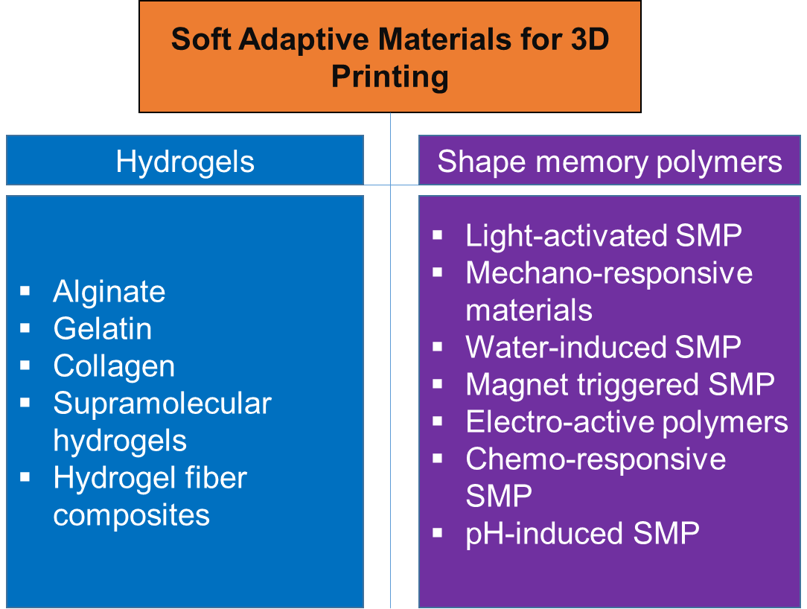
Figure 1. The two typical soft adaptive materials used for 3D printing.
In addition to the soft tissues printings, 3D printed structures can also be useful for bone regeneration scaffolds. The effect of a polyester, polycaprolactone, coating alendronate release profile, and the local drug delivery on animal model osteogenesis from polyester-coated 3D printed porous tricalcium phosphate scaffolds was investigated and the scaffolds can be custom fabricated to fit the implant site.[35] Furthermore, the experiments show that these scaffolds are useful for local drug delivery for enhanced osteogenesis for early wound healing. This fulfils the need of a scaffold that fits the site of the implant as well as aiding in the wound recovery at the implant site.
On the other hand, typical shape memory polymers possess a permanent shape which can be molded into a secondary shape through thermal or physical manipulation. Recovery of the original shape can be facilitated by exposure of the material to temperature stimulus.[36-42] Other stimulus such as water[43-45], light[46, 47] and electric current[48-50] have been used for shape recovery purposes. Recently, Boydston et al. showed successfully the printing of mechano-responsive polymers.[51] Through this work, 3D printing of mechano-responsive materials entrapped within commercially available polymer matrix is demonstrated. This process greatly simplifies the production of materials that are challenging to make with conventional engineering methods. A prototype force sensor was also developed, showing the advantages of using the additive manufacturing method of making this structure (Figure 2). White et al. recently reported using a light-activated SMP by using an amorphous liquid crystal polymer network material (Figure 3).[52] This material can be photo-fixed into a temporary state within 5 minutes using 442 nm light. Recovery of the shape can be activated through thermal or optical means. This material was thermally fixed as a catapult and later used to convert light energy into mechanical work. The authors further demonstrated the launching of an object at a rate of 0.3 m.s⁻¹. Zheng et al. showed the light-induced shape recovery of micropillar arrays fabricated with polymer/gold nanorods composites.[53] Good recovery times of about 5 seconds were achieved with a 0.3 W green laser. These structures were fabricated using a PDMS mold which is not a convenient method for scale up.
Furthermore, the variety of shapes that can be formed is limited by the mold. Thus, 3D printing could be useful in designing unique pillar structures. A sodium dodecyl sulfate/epoxy composite was designed and this material showed water-induced shape memory effect.[54] The presence of the surfactant was the key factor behind the water triggered shape memory effect. This material is useful for extrusion based methods for the fabrication of structures and can be readily adapted for 3D printing. Mechanically-adaptive materials made from nanocomposites can also react to an external stimulus which affects the composite material thereby changing its bulk mechanics.[55] Magnetic fields can be used as a remote trigger for the activation of shape recovery from a distance. Using a polymeric material possessing functionalised iron oxide nanoparticles as crosslinking points that serve to set the material in a permanent shape, the remote actuation of these materials is demonstrated.[56] The fixing of the metallic nanoparticles serves to prevent them from moving and re-aggregating in a polymer matrix and enhances the stability of the SMP networks when high temperature and external forces are applied. This leads to repeatable and durable shape memory performance obtained during the programmed deformation-recovery processes. It was observed that a homogeneous distribution of iron oxide nanoparticles achieves constant heat generation and transfer in the alternating magnetic field. Fast magnetic responsiveness was observed compared to the SMPs physically dispersed with iron oxide nanoparticles.
In another aspect, electro-active polymers or blends are useful for designing materials that are electrically stimulated to respond. Leng et al. demonstrated that the particulate additives, such as carbon fiber or carbon nanoparticles, are well dispersed within the shape memory thermoset matrix and interconnections were formed between the fibers, the long distance charge transporter was provided by the fibrous additives which form the local conductive paths.[57] Nickel powder can also be dispersed into a polyurethane shape memory polymer to create a material that can be made to respond by Joule heat induced shape recovery.[58] It was shown that ultrasound can be used as a trigger for shape recovery.[59] Using a melamine-enhanced poly(vinyl alcohol) hydrogel with 65% water content, the deformation can occur at room temperature whereas the shape fixation can be carried out by freezing the hydrogel. The freezing process fixes the PVA segments and ultrasound can be applied to induce localized heating and subsequently shape recovery under water. Water can be used as a trigger for shape recovery and this could be useful for biomedical related applications.
Recently, a report describing the chemo-responsive shape memory recovery triggered by inductive release of mechanical energy storage undergoing copper (II) chloride migration in a polyurethane was reported.[60] Copper (II) chloride was dispersed into the polymer matrix and as the particles migrate; they are released from the polymer in the water-driven shape recovery process. The release of the stored mechanical energy of a polymer was the driving force for the chemo-responsive shape memory effect. Related to water but with an added degree of control, pH responsive polymers could be incorporated into 3D printable polymers such as alginate and poly(caprolactone) to induce a pH response. Han et al. recently reported pH induced shape recovery of a polymer prepared by cross-linking β-cyclodextrin modified alginate and diethylenetriamine modified alginate.[61] The β-cyclodextrin-diethylenetriamine inclusion complexes were responsive to pH, where the protonation of the amines led to a dethreading of the system. The incorporation of this reversible system in a permanently crosslinked alginate matrix led to the formation of a pH induced shape memory polymer. Recently Li et al. also reported the development of a pH-responsive shape-memory polymer nanocomposite by mixing poly(ethylene glycol) poly(ε-caprolactone)-based polyurethane with functionalized cellulose nanocrystals.[62] The cellulose nanocrystals were functionalized with pyridine moieties and separately with carboxyl groups. At a high pH value, there are attractive interactions from the hydrogen bonding between pyridine groups and hydroxyl moieties; at a low pH value, these interactions reduced or disappeared due to the protonation of pyridine groups. The carboxyl functionalised cellulose nanocrystals showed an opposite pH response. The reversible association and disassociation led to the pH responsive shape recovery in the polymer.
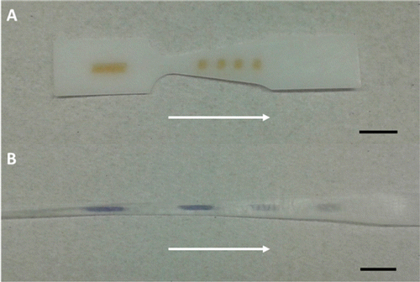
Figure 2. (A) 1 mm thick force sensor before elongation, and (B) post elongation. The white arrows indicate the direction of necking. Scale bars = 10 mm. Figure reproduced from [51] with permission.
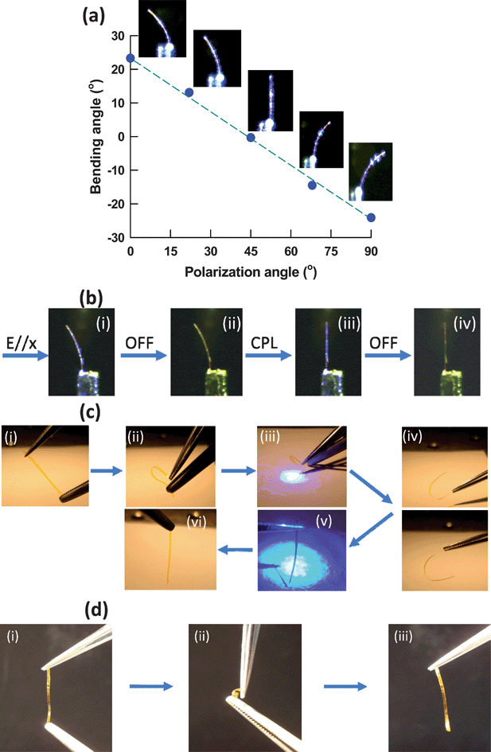
Figure. 3 (a) The magnitude of the bending angle as a function of linear polarization angle for a cantilever composed of PD-20CL exposed to 80 mW cm⁻² 442 nm light. (b) Shape-retention of the bent state (i) upon removal of the linearly polarized 442 nm light (ii). Exposure to right handed circularly polarized 442 nm light (iii) unlocks the photoreconfigured state resulting in alloptical restoration of the permanent state (iv). (c) Light-activated shape memory of a freestanding PD-20CL film (i) permanent shape, (ii) mechanical deformation, (iii) photo-fixing, and (iv) shape retention (in the absence of light). Exposure to right-handed circularly polarized light unlocks the photo-fixed state (v) allowing for recovery of the permanent shape (vi). (d) In the absence of photo-fixing, mechanical deformation of PD-20CL does not retain the deformed state: (i) permanent shape, (ii) mechanical deformation, and (iii) restoration of permanent shape after removal of mechanical deformation. Figure reproduced from [52] with permission.

- (3 + 1)D = 4D: Early Promises
When we think of 4D printing, invariably, we will question ourselves. What is the 4th dimension? The definition of the 4th dimension is as much scientific as it is philosophical. Our three dimensions of length, width and height defines the physical structure of the non-responsive material. The fourth dimension in materials had been under development long before the advent of 3D printers, and the 4D printing term was adapted from these earlier ideas. The material is able to sit through time and remain unchanged either in shape or volume. When we speak of 4D in terms of printing, we are proposing the traversing of a material through time and showing a unique change in properties. However, the change in properties usually is elicited through the use of adaptive and responsive materials as described in the earlier section. Through the printing of adaptive 3D structures, the concept of 4D printing can be realised. 4D printing is an emerging technology for the creation of dynamic devices which have shape changing capabilities or on-demand capabilities over time.[63-65] Through the innovative combination of smart adaptive materials (described in the previous section) and additive manufacturing techniques such as 3D printing, 4D printing offers a pioneering, adaptable, and useful process for designing customised sensors, robotics and self-assembled macro-structures[64]. Pei has attempted to discuss the recent developments in 4D and provide a view towards future impact. The reviews attempt to cover examples in materials fabrication, equipment use and new uses of 4D printing. This area has gained enormous momentum within the field of additive manufacturing wherein the utilization of programmable stimuli-responsive printable materials can enable pre-determined reactions when subject to external stimuli.[66, 67]

3.1 Stimuli-responsive hydrogel in 4D printing
Stimuli-responsive materials, which change its volume upon exposure to stimuli, can be incorporated into multi-material structures for 4D printing. One of the potential application is in the “printing” of an artificial muscle which can mimic the action of biological muscles. However, current materials are mechanically too weak to behave as a true muscle, leading to the development of tough hydrogels as possible synthetic alternatives.[68-70] Recent reports covering 4D printing use water or temperature to demonstrate stimuli-triggered change of shape.[64, 71] However, these materials respond very slowly, possess very limited reversibility, and the motion of the material is restricted to just bending motions that generate little force. Brinks et al. describe fast and reversible 3D printed tough hydrogel materials made from an alginate/N-isopropylacrylamide interpenetrating network and further demonstrate their integration into a smart valve that regulates water flow in a device. This key development brings the field closer to a possible soft mechanical actuator.

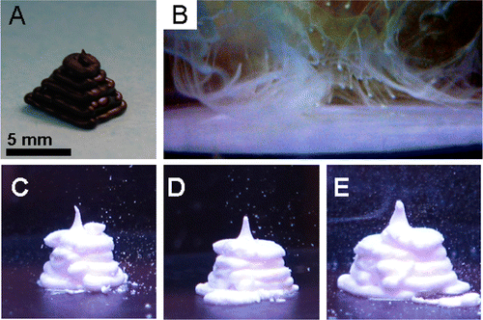
Figure 4. 3D printing of DNA-derivatized microparticles. (A) Digital photograph shows an ABS thermoplastic pyramid printed by the 3D printer to show the desired output pattern. Scale bar is 5 mm throughout. (B) Digital micrograph shows the output of the 3D printer when it attempts to extrude microparticles bearing noncomplementary DNA. (C–E) Digital micrographs show DNA cross-linked colloidal gel printed into the pyramidal shape with extrusion rates of 1.3, 1.7, and 2.1 μL/s, respectively. The 3D printer head motion pattern was identical in all three cases. Figure reproduced from [72] with permission.

In another report, DNA adhesives were used as supramolecular anchors to link up macrostructures.[72] Microparticles were assembled into a free-standing colloidal gel through extrusion with a 3D printer (Figure 4). The microscale structure can be manipulated by adjusting the reversible adhesion between particles. This technology is also biofriendly to cells, being able to encapsulate the cells within its matrix. Indeed, 4D printing has resulted in the publication of several commentaries in various websites. Binns describes the use of 4D printing for the fabrication of responsive fashion apparels and how materials science can change the current landscape of fashion design.[73] Recently, Lewis et al developed a 4D printing method relies on a combination of hydrogel materials and geometry that can be controlled in space and time (Figure 5).[74] Through the control of printing parameters, such as filament size, orientation, and interfilament spacing, the research group created mesoscale bilayer architectures with programmable anisotropy that morph into given target shapes on immersion in water.

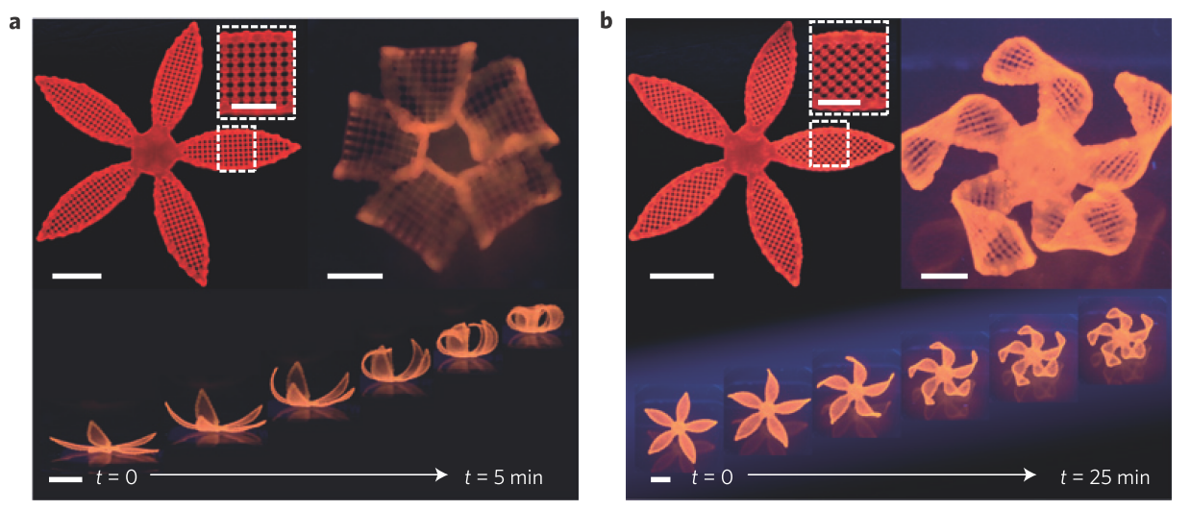
Figure 5. Complex ﬂower morphologies generated by biomimetic 4D printing. a,b, Simple ﬂowers composed of 90 ◦ /0 ◦ (a) and − 45 ◦ /45 ◦ (b) bilayers oriented with respect to the long axis of each petal, with time-lapse sequences of the ﬂowers during the swelling process (bottom panel) (scale bars, 5 mm, inset = 2.5 mm). Figure reproduced from ref [74] with permission.

3.2 Shape memory materials in 4D printing
Qi et al. have established another technique for the construction of 4D structures. Different from Tibbits’ strategy of using water-responsive 4D printing, Qi’s work is distinguished regards to the understanding of the molecular interactions in the materials. Additionally, they place greater emphasis on the fundamental mechanisms behind the observed phenomena. The group looked at using SMP composites embedded with glassy fibres to yield 4D structures. This system, which comprises of many different materials, is printed from a CAD file. The CAD file specifies the fibre architecture by controlling the material’s anisotropic and thermo-mechanical performance. The pre-determination of the reaction of these active composite materials upon external stimulation can be achieved by controlling the quantity, site and alignment of these fibres. During the fabrication process, the group used SMP fibres which were sandwiched between an elastomeric matrix. The spatial variation of the 3D material properties as well as the regulation of the lamina and the laminate architecture allows the responsive layer to self-assemble into complex 3D configurations by bending, curling and winding, as a function of time. This aspect of the material, which changes with time, leads to the 4D aspect. This idea can be further developed by using other useful material properties as well as using shape and topology variations to achieve configuration changes.[71] The same research group also showed that it is possible to print a shape memory material based on epoxy and tailor it to have a functional gradient.[75] They demonstrated both helical and self-interlocking shape memory behaviour as well as precisely shape changing sequence utilized to reach the desired material configurations. It is easy to extend this concept and implement the polymer shape memory effect the development of self-adjusting structures. In another report, Chae et al. merged the dimension of time to the production of haptic biomodels in 3D.[76] In this case, the 3D printing of the bones of the thumb at different stages of movements was used to show the potential of 4D printing. Individual thumb movements were imaged and models were fabricated using a 3D printer. In this example, the incorporation of composite spatiotemporal anatomical details was used to improve preoperative planning.

- Outlook and Perspectives
This is a period for key developments in new materials that can be 3D printed. There are many ideas bustling around with the potential for programmable carbon fiber, programmable wood (or wood-like and wood structure inspired materials[77]) and programmable textiles. Wood based materials for 3D printing possessing sawdust and wooden chips can be fabricated to bond selectively in bulk with a suitable binder such as gypsum, cellulose, sodium silicate and cement.[78] Recent development in 3D printing technology allows precise control over heterogeneous microstructures. Programmable active materials including carbon fibres and could offer exciting opportunities for the future of the 4D printing products. With continuous efforts, these active materials could be activated in a controlled manner to change the shape or configuration of the solid by a proper external stimulus, with the ability of time-dependent shape change after the printing. In addition, sensors for textile applications can also be fabricated using 3D printing to create delicate flexible sensors.[79] It was noted that 4D printing combines smart actuating and sensing materials have potential to provide a versatile and convenient method for crafting custom-designed sensors robotics and self-assembling structures. These materials serve to impact potential industries such as aerospace, automotive, clothing, construction, defense and military, healthcare and utility. The total 4D Printing Market has a projected value of $63.0 million in 2019 and is expected to reach $555.6 Million by 2025, at a CAGR of 42.98% from 2019 to 2025.[80] The excitement and interest surrounding the future of additive manufacturing is evident. For example, the US Army Research Office awarded US$855,000 worth of funds to a team comprising members from Harvard's School of Engineering and Applied Science, The University of Illinois, and The University of Pittsburgh Swanson School of Engineering, to work on the new printing technologies as well as to study the fabrication of adaptive and biomimetic composites with (re)programmable shapes, properties or functionality upon exposure to external stimuli.
In the coming years, landmark patents covering laser sintering techniques for rapid prototyping will expire and this can trigger massive development the fabrication of open-source machines. With additive manufacturing techniques, laser sintering has the capability to produce complex whole parts which is often used in 4D printed objects. One of the issues facing adopters of 3D printing is the speed of printing. It may combine more complex techniques to achieve 4D printing such as self-folding robot, self-assembly of elements, deformation mismatch and bi-stability.[81] Also, planar curing methods could lead to faster build times. Other methods could involve multiple light sources for the curing of different parts of the structure. Another factor which is important is the precise selection of material at a designated printing site. The development of materials which are suitable for printing is critical for the success of this technique. In fact, to utilise this technique for biomedical applications, there needs to be a concerted effort to develop machines that can print from aqueous medium. There is also a great demand to develop new materials that can fit such a printer. In this world of viral videos and social media, every new technology is looked upon with keen interest. In order to sustain this interest, the scientific community will have to continuously improve the system and the materials that are fabricated from these systems and also stay relevant to the practical needs of the global population.

References
[1] M.M. Stanton, C. Trichet-Paredes, S. Sanchez, Lab on a Chip, 15 (2015) 1634-1637.
[2] J.-F. Xing, M.-L. Zheng, X.-M. Duan, Chemical Society Reviews, 44 (2015) 5031-5039.
[3] S. Zhao, M. Zhu, J. Zhang, Y. Zhang, Z. Liu, Y. Zhu, C. Zhang, Journal of Materials Chemistry B, 2 (2014) 6106-6118.
[4] K.G. Lee, K.J. Park, S. Seok, S. Shin, D.H. Kim, J.Y. Park, Y.S. Heo, S.J. Lee, T.J. Lee, RSC Advances, 4 (2014) 32876-32880.
[5] A.K. Au, N. Bhattacharjee, L.F. Horowitz, T.C. Chang, A. Folch, Lab on a Chip, 15 (2015) 1934-1941.
[6] Y.J. Zheng, X.J. Loh, Polymers for Advanced Technologies, (2016) n/a-n/a.
[7] Y.-L. Wu, H. Wang, Y.-K. Qiu, X.J. Loh, RSC Advances, 6 (2016) 44506-44513.
[8] Y.-L. Wu, H. Wang, Y.-K. Qiu, S.S. Liow, Z. Li, X.J. Loh, Advanced Healthcare Materials, (2016) n/a-n/a.
[9] Y.-L. Wu, X. Chen, W. Wang, X.J. Loh, Macromolecular Chemistry and Physics, 217 (2016) 175-188.
[10] S.S. Liow, Q. Dou, D. Kai, A.A. Karim, K. Zhang, F. Xu, X.J. Loh, ACS Biomaterials Science & Engineering, 2 (2016) 295-316.
[11] B.Q.Y. Chan, Z.W.K. Low, S.J.W. Heng, S.Y. Chan, C. Owh, X.J. Loh, ACS Applied Materials & Interfaces, 8 (2016) 10070-10087.
[12] X. Fan, J.Y. Chung, Y.X. Lim, Z. Li, X.J. Loh, ACS Appl Mater Interfaces, 8 (2016) 33351–33370.
[13] X. Fan, B.H. Tan, Z. Li, X.J. Loh, ACS Sustain Chem Eng, 5 (2017) 1217–1227.
[14] Z. Li, Z. Zhang, K.L. Liu, X. Ni, J. Li, Biomacromolecules, 13 (2012) 3977-3989.
[15] Z. Li, J. Li, J. Phys. Chem. B, 117 (2013) 14763-14774.
[16] Y. Cui, M. Tan, A. Zhu, M. Guo, Journal of Materials Chemistry B, 2 (2014) 2978-2982.
[17] X. Yan, F. Wang, B. Zheng, F. Huang, Chemical Society Reviews, 41 (2012) 6042-6065.
[18] Z. Yu, J. Zhang, R.J. Coulston, R.M. Parker, F. Biedermann, X. Liu, O.A. Scherman, C. Abell, Chemical Science, 6 (2015) 4929-4933.
[19] X.J. Loh, G.R. Deen, Y.Y. Gan, L.H. Gan, J. Appl. Polym. Sci., 80 (2001) 268-273.
[20] Z. Li, H. Yin, Z. Zhang, K.L. Liu, J. Li, Biomacromolecules, 13 (2012) 3162-3172.
[21] A.A. Karim, Q. Dou, Z. Li, X.J. Loh, Chemistry – An Asian Journal, 11 (2016) 1300-1321.
[22] Z. Liu, X. Su, M.J. Tan, Z. Li, R. Lakshminarayanan, V.A. Barathi, X.J. Loh, G. Lingam, Investigative Ophthalmology & Visual Science, 57 (2016) 5819-5819.
[23] Z. Li, X.J. Loh, Chem. Soc. Rev., 44 (2015) 2865-2879.
[24] H. Ye, C. Owh, X.J. Loh, RSC Advances, 5 (2015) 48720-48728.
[25] J.Y. Zheng, M.J. Tan, P. Thoniyot, X.J. Loh, RSC Advances, 5 (2015) 62314-62318.
[26] E.A. Appel, X.J. Loh, S.T. Jones, F. Biedermann, C.A. Dreiss, O.A. Scherman, Journal of the American Chemical Society, 134 (2012) 11767-11773.
[27] X.J. Loh, Materials Horizons, 1 (2014) 185-195.
[28] S.E. Bakarich, M.i.h. Panhuis, S. Beirne, G.G. Wallace, G.M. Spinks, Journal of Materials Chemistry B, 1 (2013) 4939-4946.
[29] C. Colosi, M. Costantini, R. Latini, S. Ciccarelli, A. Stampella, A. Barbetta, M. Massimi, L. Conti Devirgiliis, M. Dentini, Journal of Materials Chemistry B, 2 (2014) 6779-6791.
[30] J.Y. Park, J.-H. Shim, S.-A. Choi, J. Jang, M. Kim, S.H. Lee, D.-W. Cho, Journal of Materials Chemistry B, 3 (2015) 5415-5425.
[31] X.J. Loh, M.-H. Tsai, J.d. Barrio, E.A. Appel, T.-C. Lee, O.A. Scherman, Polym. Chem., 3 (2012) 3180-3188.
[32] X.J. Loh, P.N.N. Vu, N.Y. Kuo, J. Li, Journal of Materials Chemistry, 21 (2011) 2246-2254.
[33] X.J. Loh, Z.X. Zhang, K.Y. Mya, Y.L. Wu, C.B. He, J. Li, Journal of Materials Chemistry, 20 (2010) 10634-10642.
[34] S.E. Bakarich, R. Gorkin, M.I.H. Panhuis, G.M. Spinks, Acs Applied Materials & Interfaces, 6 (2014) 15998-16006.
[35] S. Tarafder, S. Bose, Acs Applied Materials & Interfaces, 6 (2014) 9955-9965.
[36] Y. Bai, X. Zhang, Q. Wang, T. Wang, Journal of Materials Chemistry A, 2 (2014) 4771-4778.
[37] J. Liu, H.R. Sondjaja, K.C. Tam, 2007, pp. 5106-5109.
[38] M. Ragin Ramdas, K.S. Santhosh Kumar, C.P. Reghunadhan Nair, Journal of Materials Chemistry A, 3 (2015) 11596-11606.
[39] I.V.W. Small, P. Singhal, T.S. Wilson, D.J. Maitland, Journal of Materials Chemistry, 20 (2010) 3356-3366.
[40] Y. Wu, J. Hu, J. Han, Y. Zhu, H. Huang, J. Li, B. Tang, Journal of Materials Chemistry A, 2 (2014) 18816-18822.
[41] Z. Li, E. Ye, David, R. Lakshminarayanan, X.J. Loh, Small, 35 (2016) 4782-4806.
[42] B.H. Tan, J.K. Muiruri, Z. Li, C. He, ACS Sustain Chem Eng, 4 (2016) 5370–5391.
[43] X. Gu, P.T. Mather, RSC Advances, 3 (2013) 15783-15791.
[44] X. Qi, X. Yao, S. Deng, T. Zhou, Q. Fu, Journal of Materials Chemistry A, 2 (2014) 2240-2249.
[45] L. Wang, X. Yang, H. Chen, G. Yang, T. Gong, W. Li, S. Zhou, Polymer Chemistry, 4 (2013) 4461-4468.
[46] D. Habault, H. Zhang, Y. Zhao, Chemical Society Reviews, 42 (2013) 7244-7256.
[47] L. Yu, Q. Wang, J. Sun, C. Li, C. Zou, Z. He, Z. Wang, L. Zhou, L. Zhang, H. Yang, Journal of Materials Chemistry A, 3 (2015) 13953-13961.
[48] G. Fei, G. Li, L. Wu, H. Xia, Soft Matter, 8 (2012) 5123-5126.
[49] G. Fei, C. Tuinea-Bobe, D. Li, G. Li, B. Whiteside, P. Coates, H. Xia, RSC Advances, 3 (2013) 24132-24139.
[50] C.-L. Huang, M.-J. He, M. Huo, L. Du, C. Zhan, C.-J. Fan, K.-K. Yang, I.-J. Chin, Y.-Z. Wang, Polymer Chemistry, 4 (2013) 3987-3997.
[51] G.I. Peterson, M.B. Larsen, M.A. Ganter, D.W. Storti, A.J. Boydston, Acs Applied Materials & Interfaces, 7 (2015) 577-583.
[52] K.M. Lee, H. Koerner, R.A. Vaia, T.J. Bunning, T.J. White, Soft Matter, 7 (2011) 4318-4324.
[53] Y.W. Zheng, J. Li, E. Lee, S. Yang, Rsc Advances, 5 (2015) 30495-30499.
[54] W.X. Wang, H.B. Lu, Y.J. Liu, J.S. Leng, Journal of Materials Chemistry A, 2 (2014) 5441-5449.
[55] L. Hsu, C. Weder, S.J. Rowan, Journal of Materials Chemistry, 21 (2011) 2812-2822.
[56] S. Xia, X.J. Li, Y.R. Wang, Y. Pan, Z.H. Zheng, X.B. Ding, Y.X. Peng, Smart Materials and Structures, 23 (2014) 12.
[57] J.S. Leng, H.B. Lv, Y.J. Liu, S.Y. Du, Appl. Phys. Lett., 91 (2007).
[58] J.S. Leng, X. Lan, Y.J. Liu, S.Y. Du, W.M. Huang, N. Liu, S.J. Phee, Q. Yuan, Appl. Phys. Lett., 92 (2008).
[59] G. Li, Q. Yan, H.S. Xia, Y. Zhao, Acs Applied Materials & Interfaces, 7 (2015) 12067-12073.
[60] H.B. Lu, C.R. Lu, W.M. Huang, J.S. Leng, Smart Materials and Structures, 24 (2015) 7.
[61] X.J. Han, Z.Q. Dong, M.M. Fan, Y. Liu, J.H. Li, Y.F. Wang, Q.J. Yuan, B.J. Li, S. Zhang, Macromolecular Rapid Communications, 33 (2012) 1055-1060.
[62] Y. Li, H.M. Chen, D. Liu, W.X. Wang, Y. Liu, S.B. Zhou, Acs Applied Materials & Interfaces, 7 (2015) 12988-12999.
[63] Q. Ge, C.K. Dunn, H.J. Qi, M.L. Dunn, Smart Materials and Structures, 23 (2014).
[64] S. Tibbits, Architectural Design, 84 (2014) 116-121.
[65] S. Tibbits, C. McKnelly, C. Olguin, D. Dikovsky, S. Hirsch, Acadia 2014: Design Agency, (2014) 539-548.
[66] E. Pei, Assembly Automation, 34 (2014) 123-127.
[67] E. Pei, Assembly Automation, 34 (2014) 310-314.
[68] Y. Sun, S. Liu, G. Du, G. Gao, J. Fu, Chemical Communications, 51 (2015) 8512-8515.
[69] X. Zhao, Soft Matter, 10 (2014) 672-687.
[70] Z.W. Low, P.L. Chee, D. Kai, X.J. Loh, RSC Advances, 5 (2015) 57678-57685.
[71] Q. Ge, H.J. Qi, M.L. Dunn, Appl. Phys. Lett., 103 (2013) 5.
[72] P.B. Allen, Z. Khaing, C.E. Schmidt, A.D. Ellington, ACS Biomaterials Science & Engineering, 1 (2015) 19-26.
[73] J. Binns, Apparel, 57 (2015).
[74] A.S. Gladman, E.A. Matsumoto, R.G. Nuzzo, L. Mahadevan, J.A. Lewis, Nature materials, 15 (2016) 413-418.
[75] K. Yu, A. Ritchie, Y. Mao, M.L. Dunn, H.J. Qi, Procedia IUTAM, 12 (2015) 193-203.
[76] M.P. Chae, D.J. Hunter-Smith, I. De-Silva, S. Tham, R.T. Spychal, W.M. Rozen, Journal of Reconstructive Microsurgery, 31 (2015) 458-463.
[77] B.G. Compton, J.A. Lewis, Adv. Mater., 26 (2014) 5930-+.
[78] K. Henke, S. Treml, Eur. J. Wood Wood Prod., 71 (2013) 139-141.
[79] A. Frutiger, J.T. Muth, D.M. Vogt, Y. Menguc, A. Campo, A.D. Valentine, C.J. Walsh, J.A. Lewis, Adv. Mater., 27 (2015) 2440-2446.
[80] 4D Printing Market Worth $555.6 Million by 2025, PR Newswire, New York, 2015.
[81] Y. Zhou, W.M. Huang, S.F. Kang, X.L. Wu, H.B. Lu, J. Fu, H. Cui, Journal of Mechanical Science and Technology, 29 (2015) 4281-4288.

