Standard for High Viscosity and Multiphase Liquid Flow Measurement

Wu Jian and Luo Rongmo

Key Words / Mots Clés : Flow standard, Mass flow meter, Multiphase, High viscosity.

Summary: Mass flow meters are deployed for metering of heavy hydrocarbon such as bunker fuels. There are many challenges in measurement of mass flow influenced by high viscosity and multiphase fluids. National Metrology Centre developed a primary liquid flow standard which is capable to perform water and high viscous fluid calibration from 0.8 to 80 M³/h using gravimetric method which can calibrate mass flow meters two phase flow conditions in range of 0 to 30% gas-oil volume ratio with measurement uncertainties range of 0.05 % to 0.2 %.

1. Introduction:
Fuel oil is described as heavy oil because of high density and high viscosity. In fuel oil production and transferring pipelines, challenges of metering heavy oil are normally encountered for its ready entrainment of gas and difficulties in separating gas from the oil [1-3]. Accurate two-phase measurement of heavy oil is therefore an especially desirable technical goal. To meet requirement on more accurate measurement of the viscous heavy oil streams for allocation and custody transfer purposes, some innovative measurement methods are essential to be fully investigated. The Coriolis mass flow meters are relatively modern flow measurement technologies and continue to capture increasing market share as operators gain confidence in their performance [4].
This paper describes the liquid flow measurement standards at National Metrology Centre (NMC) of Agency for Science, Technology and Research (A*STAR). The primary standard is disseminated using gravimetric calibration directly traceable to mass unit and the reference standard of Coriolis flow standards. This facility has four parallel pipelines with diameters of 0.5, 2, 3 and 4 inch with multiple connection structure which allows bi-directional flow. Two weighing systems with capacities of 32 kg and 600 kg are able to calibrate water flow meters from 0.6 to 80 Mt/h. Another pair of similar weighing system is also set up for the viscous fluid calibration in the same flow ranges which is capable to compare the different viscous fluid measurements directly against water flow calibration, therefore the influence due to different fluid properties are able to be identified, quantified and compensated.
2. Static Gravimetric Method
Static gravimetric liquid flow calibration systems are widely used as primary liquid flow standards. Primary static weigh flow calibrations are performed by collecting a measured mass of the fluid flowing through the meter being calibrated under stable conditions of flow, pressure, and temperature. The quantities measured in connection with the calibration such as temperature, mass, time, and density are traceable to NMC’s reference or primary standards. Cumulated mass flow through the meter is calibrated against the mass collection in the weighing tanks with correction for buoyancy effects and the residue value in pipelines.

$m=M*F+K*V*dp$ (1)

where M collected mass. The inventory volume, V is the volume of piping between the meter under test and the standard used, at the end of the pipe, to measure the flow. F and K are the correction factors for buoyancy and residue volume in the pipeline. The dp are the pressure difference between steady flow process and end of the collection interval.
3. The Primary Flow Standard

NMC’s flow standard is shown in Figure 1. The system is closed loop flow system consisted two pumping systems. A screw pump with maximum 100 m3/h capability is used to generate flow for water flow calibration, a bypass way with adjustable valve arranged at downstream of the pump to help varying the flow rate at wide ranges. Another higher capacity gear pump is to generate the flow with high viscous fluid up to 1000 cSt. The both water and high viscous liquids are able to flow through meter under test with bi-directions without changing on its setting up. This allow to eliminate the influences caused by the different strains forces in each calibration setting up and benefit to precisely analysis difference only due to viscous fluid properties. Multiple valves are arranged to configure flow direction flow rates to cater full range flow measurement and satisfied to the requested flow conditions. At least 5 PTR thermal meter and pressure measurement at different locations across the meter and pipelines monitoring the flow conditions and stability as well as compensate for head pressure lost. A set of heater are available to change to temperature according to field condition for viscous fluid so that the meter can be characterised according to the filed condition, in addition the desired fluid viscosity can be obtained for calibration.

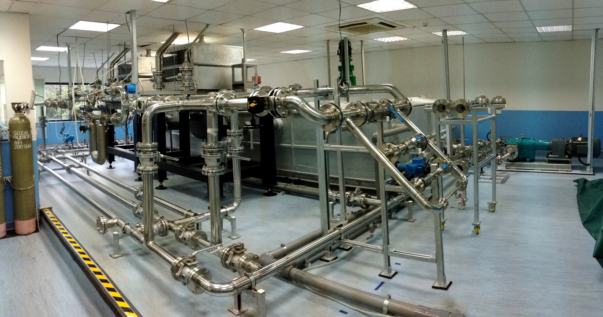
Figure 1. NMC's primary multiphase - high viscosity liquid flow standard

4. System integration

The entire calibration facility is integrated by in-house developed software on the LabView language base. The interfacing cards are able to support the 20 PRT probes and also able to collect signal from pressure sensor, Coriolis flow meters and weighing scales. The control signal to the valve allows to automatic operate the valve according to preset calibration procedures. Furthermore, the instant viscosity measurement allows to morning the fluid property during the calibration intervals. Thereafter the integration for heater, pump speed and flow rate control valves can be integrated also for fine tuning flow setting as well as the better flow conditions.

5. Function for Multiphase Flow Measurement:

The system was design to perform the calibration of mass flow with gas injection. A gas flow injection system with high pressure and measured gas flow rate were built in connection with the pipeline at upstream of the meter under test. Different gas-liquid void ratio can be generated by measurement of gas flow rate as well and the pressure in the pipeline. The two phase flow is able to be observed at windows located before and after the meter as shown in Figure 2. Since the gravimetric flow method being used, the gas void mass flow rate can still be accurately measured without affected by the present of gas and hence the deviation of meter due this reason can be known and corrected. Currently, the system is able to perform avoid ratio up to 30%. It is possible to increase to 50% and even more at lower liquid flow rate. But most mass flow meter is not able to indicate the actual rate at such high gas-liquid void ratio.

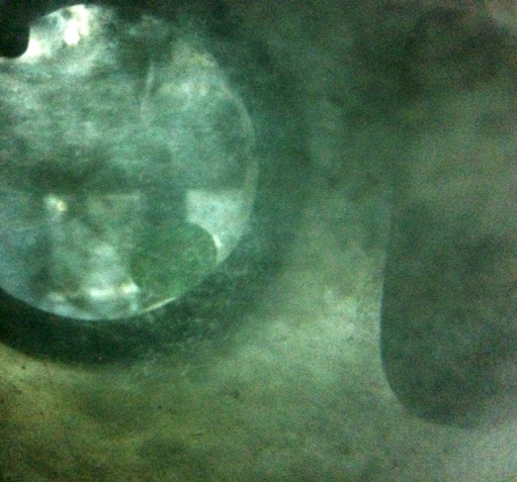
Figure 2. Gas-Liquid two phase flow measurement

6. High Viscosity Fluid Measurements

One of the main functions of the calibration facility is to perform high viscosity fluid flow calibration. The unique design allows to calibrate mass flow meter with the medium viscosity up to 1000 cSt. Due to the same reason to adopt the gravimetric method, the facility is able to perform measurement without significantly increasing measurement uncertainty and no deviation due the viscosity effects in principle. The meter can be characterised with comparison against with the water calibration results by the same flow configuration and setup via the gravimetric method also.

7. The Measurement Corrections

7.1 Buoyancy

Liquid mass values observed by the weigh scales was calibrated which has different buoyancy force to the stainless mass. To obtain the true mass of the collected liquid measurement of air and liquid fluid densities are required. The mass at standard condition can be found using the following relationship:

$M_{s}= \frac{{}_{w}^{}-{}_{s}^{}}{{}_{w}^{}-{}_{a}^{}}·M$ (2)

where: M is the apparent mass indicated by the scale, ρ_{a} the air density, and ρ_{w} is the liquid density. The buoyancy uncertainty for the liquid flow calibration was estimated less than 0.001%.

7.2 Leakage and splashes

Liquid splashing out from weigh collection system and minor leaks from the pipework are usually apparent and are trimmed off before calibrations start. Therefore, uncertainties for splashes or leaks are neglected.

7.3 Residue volume:

Storage effects due to changes in the pressure during the measurement process at start and end sessions. The pressure changes in the system lead that the density of the water and dimensions of the pipes for the volume between meter under test and the outlet of the fishtail varying accordingly. The quantity due to the storage effects must be considered and proper correct. The correction factor is based on experiment with different pipeline length and characted as:

V= K*(P₁-P_{o})*∑π L_{i} x r_{i}² (3)

Where the P₁ is the pressure at flow condition and P_{o} is atmosphere pressure; L is the total length of the pipeline between. With the proper compensation, this effect is estimated to be less than 0.007%

7.4 Water evaporation

In the case of longer collection time required, the evaporation of water became a factor to lead the measurement deviations. To minimise the error to an acceptable level, a correction factor has been applied to the gravimetric process on the basis of ambient pressure, and temperature as well as the humidity. Typically the single measurement can be done within 15 min to fill the tank completely. A set of experiment show that the evaporation is less than 0.001% under the laboratory calibration conditions.

7.5 Liquid density

In order to perform necessary conversion from mass to volumetric flow the fluid density must be known. Density of the liquid flowing through the meter being calibrated is normally required. The liquid density is able to be measured in our laboratory and a compensation factor is also applied according to fluid temperature at meter position. The measurement uncertainty for water density is about 0.003%. With including the instable temperature during a measurement which is limited within 0.2ºC, the expanded uncertainty is about 0.008%.

8. Summary of Measurement Uncertainty

8.1 The mass balance:

The calibration of mass balance was carried out on site with removed the weighing tanks; the measurement uncertainty due to the mass is less than 0.0005%. The 600 kg weighing scale was modified to allow drain pipes & control valves allocated at center positions, so that the off center effects is in significant. With including the repeatability, resolution and linearity of scale, the overall estimation on the measurement uncertainty is about 0.006%. In considering off center arrangement for 32 kg weighing tanks, the measurement uncertainty is about 0.008% of reading.

8.2 The repeatability of gravimetric method:

The repeatability of liquid collection is affected by the liquid inlet section, process flow and pressure stability, leakage and splashes etc. The tests show that entire system is able to perform a reasonable repeatability to be within 0.025%.

The summary measurement uncertainty is listed at table 1.

Items | Symbol | Value | Standard Uncertainty
- Resolution | R_{s} | 0.1g -10g | 0.001%
- Weighing scale calibration | U_{cal} | 0.006% | 0.003%
- Reproduceability of weighing scale | R_{e} | 0.005% | 0.0028%
- Buoyancy | U_{b} | 0.001% | 0.0006%
- Leakage and Splashes | U_{l} | - | -
- Residue Volume: | U_{v} | 0.007% | 0.004%
- Water Evaporation | U_{e} | 0.001% | 0.001%
- Liquid Density | ρ | 0.008% | 0.008%
- Repeatability | R_{p} | 0.025% | 0.025%
Combined uncertainty |  |  | 0.026%
Expanded uncertainty |  |  | 0.05%

9. Conclusion

NMC's established flow standard was successfully developed for calibrations of mass flow meter at low and medium liquid flow range. The facility is not only able to perform traditional water flow calibration, but also able to perform the calibration according to fluid viscosity and field conditions. It is special advance in characterizing the viscous effects of mass flow meter and two phase flow.

References

[1]. Al-lababidi, S., Addali, A., Yeung, H., Mba, D., and Khan, F., "Gas Void Fraction Measurement in Two-Phase Gas/Liquid Slug Flow Using Acoustic Emission Technology". Journal of Vibration and Acoustics, vol. 131, no. 6, pp. 064501, 2009.
[2]. Henry, M., Tombs, M., Duta, M., Zhou, F., Mercado, R., Kenyery, F., Shen, J., Morles, M., Garcia, C., and Langansan, R., "Two-phase flow metering of heavy oil using a Coriolis mass flow meter: A case study". Flow Measurement and Instrumentation, vol. 17, no. 6, pp. 399-413, 2006.
[3]. Dong, F., Zhang, F. S., Li, W., and Tan, C., "Comparison of differential pressure model based on flow regime for gas/liquid two-phase flow". Journal of Physics: Conference Series, vol. 147, no. 1, pp. 012044, 2009.
[4]. Henry, M., Tombs, M., Zamora, M., and Zhou, F., "Coriolis mass flow metering for three-phase flow: A case study". Flow Measurement and Instrumentation, vol. 30, no. 0, pp. 112-122, 2013.

Items | Symbol | Value | Standard Uncertainty
- Resolution | R_{s} | 0.1g -10g | 0.001%
- Weighing scale calibration | U_{cal} | 0.006% | 0.003%
- Reproduceability of weighing scale | R_{e} | 0.005% | 0.0028%
- Buoyancy | U_{b} | 0.001% | 0.0006%
- Leakage and Splashes | U_{l} | - | -
- Residue Volume: | U_{v} | 0.007% | 0.004%
- Water Evaporation | U_{e} | 0.001% | 0.001%
- Liquid Density | ρ | 0.008% | 0.008%
- Repeatability | R_{p} | 0.025% | 0.025%
Combined uncertainty |  |  | 0.026%
Expanded uncertainty |  |  | 0.05%

