Coupling Biogas Upgrading and Carbon Capture and Utilization for Enhanced Environmental Performance of Water Reclamation Plants

Iskandar Halim*
ª Institute of Sustainability for Chemicals, Energy and Environment (ISCE2),
Agency for Science, Technology and Research (A*STAR),
1 Pesek Road, Jurong Island, Singapore 627833, Republic of Singapore.

Abstract
One of the primary sources of greenhouse gas (GHG) emissions in water reclamation plants is the anaerobic digestion process, which releases a significant amount of biogas. Today, wastewater treatment operators face immense pressure to find solutions that reduce the GHG emissions associated with this process. This paper proposes a conceptual design for a plant that couples biogas upgrading and carbon capture and utilization to mitigate GHG emissions from biogas release at a water reclamation facility in Singapore. A comprehensive model of the plant is first developed using a process simulation tool to assess its technical feasibility. Next, the plant’s economic and environmental implications are evaluated by calculating the net carbon abated, operating cost, and carbon abated cost. The results indicate that the plant has the potential to reduce GHG emissions by 84 to 90%, depending on the type of hydrogen used (grey, blue, or green). Although the plant exhibits a negative cash flow, its operating costs are lower than Singapore’s projected carbon tax rate in 2030, except in the scenario where green hydrogen is used. Overall, the study demonstrates the technical, economic, and environmental viability of the plant for reducing GHG emissions from water reclamation facilities.

Keywords: Climate impact; Carbon emissions, Biogas enhancement; Carbon footprint; Wastewater treatment; Techno-economic and environmental analysis.
- Introduction
Climate change has emerged as one of the most pressing issues of our time. Despite COVID-19 related lockdowns, greenhouse gas (GHG) emissions have continued to increase, and they have been linked to various worldwide impacts such as extreme weather events (droughts, flooding, snowstorms, heatwaves, etc.), melting polar ice caps, and rising sea levels that pose a tremendous threat to low-lying coastal regions. To limit the Earth’s temperature rise to no more than 1.5°C by the end of this century, the UN has repeatedly called on national governments that are signatories of the Paris Agreement to take serious actions to meet their emission targets and strengthen their climate commitments in the coming years [1].
Wastewater treatment plants (WWTPs) play a critical role in protecting our health and ecosystems from harmful substances found in human wastes and industrial effluents. Today, WWTP operators are faced with the pressing need to take immediate climate action to reduce their GHG emissions. It is estimated that WWTP operations contribute to approximately 3 percent of global GHG emissions [2]. Some of the most important GHGs, such as carbon dioxide (CO₂), methane (CH₄), and nitrous oxide (N₂O), make up the main components of raw biogas and need to be mitigated to address the impacts of climate change. While most of the direct CO₂ emissions from WWTP can be considered carbon-neutral since they are naturally derived from biological sources, approximately 4-14% of the total organic carbon in the wastewater influent is of fossil origin [3]. This portion would be converted to direct CO₂ emissions during the treatment process. Meanwhile, CH₄ and N₂O gases have much higher global warming potentials (GWPs) than CO₂ at 28 and 265 times, respectively, making them more harmful to the climate [4].
Biogas is mainly produced in WWTPs by the anaerobic digestion of organic wastes. Depending on the type of the wastes and the digester’s operating conditions, the composition of the biogas can vary, typically containing up to 65 mol% of CH₄ and 35 mol% of CO₂ [5]. To mitigate the climate change impact of biogas, several measures can be taken. One option is to burn the biogas in a flare system, converting all CH₄ to CO₂ – however, this practice is not environmentally friendly. Alternatively, biogas can be combusted to produce heat and/or electricity directly. A more beneficial approach is to treat and upgrade the biogas to a high concentration of CH₄ (> 97%) for use as a transport fuel. This option is not only more economically attractive, but it also produces valuable products [6].
To upgrade biogas to a fuel standard, non-CH₄ components need to be removed. For this, various separation techniques such as water scrubbing [7, 8], amine scrubbing [9, 10], adsorption [11, 12], membrane separation [13, 14], and cryogenic distillation [15] have been reported in the literature. While all these techniques provide valuable means to address the climate change impact, their full benefits can only be realized if the separated GHGs can be prevented from escaping into the atmosphere. Two technology options can be used for this: carbon capture and storage (CCS) or carbon capture and utilization (CCU). The former involves capturing CO₂ from emission sources and transporting and storing it underground inside depleted reservoirs or deep saline aquifers. The main hurdles to widespread implementation of this technique have been widely reported, including the high costs of transporting large volumes of CO₂ over long distances and the risk of CO₂ leakage from storage sites. On the other hand, the captured CO₂ can be utilized as a raw material to produce high-value products such as fuels, chemicals, and food and beverages [16]. Compared to CCS, CCU is more economical since the value of the products created could potentially cover the overall costs of biogas upgrading and CCU, thereby improving the economic viability of the entire value chain [6].
In recent years, there has been immense interest in investigating the coupling of biogas upgrading with CCU technique. For example, Gunnarsson et al. [17] demonstrated the feasibility of converting the CO₂ component of biogas into succinic acid using a fermentation process. Ghosh et al. [18] performed a simulation study evaluating the coupling of biogas upgrading with a CCU system for methanol production via steam reforming and syngas route. They proposed three process scenarios involving two different catalysts and evaluated the feasibility of each process by comparing the maximum CH₄ obtained and methanol yield. Baena-Moreno et al. [19] developed an economic model to assess the profitability of coupled biogas upgrading with CCU for formic acid production by analyzing the effects of several key parameters on the overall process economics. In another study, Baena-Moreno et al. [20] investigated the potential for syngas production in the UK using dry reforming of the CH₄ in biogas. They performed a techno-economic feasibility analysis of the process by evaluating the required syngas price to attain process profit under different economic scenarios. Cordova et al. [21] evaluated the potential success of converting the CO₂ in biogas into CH₄ at an industrial scale in Sweden.
The problem addressed in this paper was taken from the Carbon Zero Grand Challenge [22] of the Public Utilities Board (PUB), which is Singapore’s national water agency. To achieve the target of net-zero emissions by 2050, PUB is currently seeking innovative solutions to reduce GHG emissions associated with its operations. One of the largest point sources of GHG emissions in its facilities is biogas produced from anaerobic digestion in its water reclamation plants (refer to Figure 1). This biogas consists roughly 62 mol% of CH₄, 35 mol% of CO₂, and 3 mol% of mixed H₂S and N₂O, resulting in approximately 100 kilo metric tons of CO₂ equivalent (CO₂e) emissions per year. To mitigate the climate change impacts of this biogas generation, PUB is exploring various technology options that can be readily deployed to its treatment facilities within the next decade.
This paper proposes an integrated biogas upgrading and CCU process plant to address PUB’s Grand Challenge, with a focus on producing methanol as the main product. Currently, Singapore imports substantial quantities of methanol to meet demand [23]. Our proposed technology involves a one-step methanol synthesis via direct hydrogenation of CO₂ in biogas, which has received little attention in previous studies. While one publication [18] has mentioned the viability of such a process, it involved a non-direct (two-step) conversion via the syngas route. This paper outlines a conceptual design of the direct CO₂ hydrogenation to methanol process, including process flowsheets, mass and energy balances, capital and operating costs estimates, net carbon emissions, and carbon abatement cost calculations. The objective is to evaluate the feasibility of the technology in terms of techno-economic and environmental aspects. The outcomes of this study are expected to serve as a starting point for a more detailed plant design, including process equipment specifications, as well as the design of pilot facility in the next stage.

- Methodology
We propose an integrated plant that comprises three process steps: methane purification, sour gas treating, and CO₂-to-methanol conversion (see Figure 2). The following conditions are applied in the design:
- The biogas flowrate is 24.9 kmol/h with the following composition (mol basis): 62% CH₄, 35% CO₂, 1.5% H₂S, and 1.5% N₂O. This yields a total CO₂ equivalent of 102.1 kt CO₂e/year.
- Electricity will be supplied from the nearby combined heat and power (CHP) plant. Process water and cooling water will be obtained from the neighboring water reclamation plant, which will also treat any wastewater produced by the proposed plant.
- Hydrogen (H₂) supply − in this case, grey H₂ – will be available onsite. Grey H₂ is H₂ that is derived from an energy-intensive steam reforming process of natural gas, which emits a large quantity of CO₂ emissions [24]. Other possible feedstocks are blue H₂ and green H₂. The former is essentially a grey H₂ process equipped with a CCS or CCU unit. Green H₂ is clean H₂ that is produced using clean renewable sources like solar, wind, or geothermal power.
We used Aspen HYSYS V12.1 (AspenTech) to simulate each process. For the methane purification and sour gas treating processes, we employed Aspen HYSYS proprietary thermodynamic package based on the Peng-Robinson equation of state for vapor and the eNRTL (electrolyte non-random two-liquid) activity coefficient for electrolyte solutions [25]. For the CO₂-to-methanol process, we chose the SRK (Soave-Redlich-Kwong) equation of state as the thermodynamic model.

  - Methane purification
Our proposed methane purification uses conventional amine scrubbing technology, which is a proven method for treating acid gases in the process industry. Figure 3 shows the basic flowsheet of the process. Initially, a biogas stream from an anaerobic digester unit is sent to an absorption column where it is washed with an amine solvent. While different types of amines can be used for this process, we have chosen a mixture of piperazine (PZ) and methyldiethanolamine (MDEA) solvents due to its high reaction rates and good selectivity with acid gases such as CO₂ and H₂S, as well as low heat of regeneration [26, 27]. This washing process yields a CH₄ product with a purity of 99.67% (mol). The bottom stream of the column, which is a rich amine solution carrying CO₂, H₂S, and N₂O, is sent to a regeneration (distillation) unit for reuse in the absorption column. The separated sour gas mixture (CO₂, H₂S, and N₂O) from the top of the regeneration column undergoes further treatment processes.

  - Sour gas treating
H₂S is a corrosive, toxic, and flammable gas that poses significant hazards to plant workers. Therefore, it is highly desirable to remove it early in the plant due to its significant presence in the sour gas stream. To achieve this, we propose a sour gas treating process that involves two stages. The first stage is a simple washing operation using water supplied from the neighboring reclamation plant. Since the solubility of H₂S in water is three times that of CO₂, this operation is expected to remove a significant amount of H₂S from the sour gas stream.
Figure 4 (lower portion) shows the representative flowsheet of the water washing operation based on the flowsheet proposed by Mamrosh et al. [28] for simultaneous H₂S removal and CO₂ recovery from non-condensable gas. The sour gas is initially washed with a large volume of water in an absorption column. The wash water carrying the sour gas components exits from the column bottom and is then heated using a mixture of steam and reused steam condensates. This is followed by depressurization and flash separation. The vapor stream from the flash separator is recycled back to the washing column, while the sour water carrying CO₂, H₂S, and N₂O is sent to the reclamation plant.
To further reduce the H₂S concentration in the washed sour gas stream to ppm level, a second washing process using caustic soda solution is performed. The upper portion of Figure 4 shows the basic flowsheet of the caustic washing process. The purified CO₂ stream from the water washing process, which is now free from N₂O and mainly contains CO₂ and H₂S, is sent to an absorption column. In the column, both H₂S and CO₂ absorb into the caustic soda solution. The treated CO₂ stream is sent to the methanol plant, while the caustic soda solution is recycled back to the absorption column for reuse in the washing process.

  - CO₂-to-methanol conversion
The conventional method for manufacturing methanol involves a two-step process that includes steam reforming of natural gas to produce syngas (a mixture of H₂, CO, and CO₂) followed by conversion into methanol [29]. In recent years, there has been a growing interest in producing methanol through direct CO₂ hydrogenation due to its potential to mitigate CO₂ emissions. In fact, the world’s first commercial plant has just been built in Anyang (China) with a capacity of converting 160,000 tons of CO₂ to 110,000 tons of methanol per year [30]. Another direct CO₂-to-methanol plant is expected to begin operations in Aalborg (Denmark) in 2028, with a production capacity of 130,000 tons of methanol per year [31]. Some of the benefits of the direct CO2 conversion process over the conventional one include a less exothermic reaction and fewer by-products, which then leads to a lower energy requirement for methanol purification [32].
Figure 6 depicts the flowsheet of the proposed direct CO₂-to-methanol process, which is in line with the flowsheet proposed in the literature [32-35]. Initially, the treated CO₂ stream from the sour gas treatment process is mixed with H₂ feed and a recycle gas stream containing CH₄, CO₂, CO, H₂, methanol, and water. The feed mixture is heated and then sent to a fixed-bed reactor. In the reactor, CO₂ and H₂ react in the presence of Cu/ZnO/Al₂O₃ catalyst according to the following Reverse Water Gas Shift reaction [32]:
CO₂ + 3 H₂ CH₃OH + H₂O; Δ$H_{298}^{o}$= -49.5 kJ/${mol}_{{CO}_{2}}$ (1)
CO₂ + H₂ CO + H₂O; Δ$H_{298}^{o}$= 41.2 kJ/${mol}_{{CO}_{2}}$ (2)
The reader is referred to the paper by Van-Dal and C. Bouallou [33] for more details on the reaction kinetic models. The reactor operates under isothermal conditions, and the heat removed is used to generate steam for the downstream distillation reboiler unit. The reactor effluent comprising the mixture of reactants, methanol product, CO, and water byproducts is then heat exchanged with the reactor feed stream, condensed, and then flash separated. The non-condensable gas leaving the top of the separator is recycled and mixed with the CO₂ and H₂ feed streams. The liquid from the bottom of the separator, which mainly consists of methanol and water, is sent for distillation to obtain a high purity of methanol stream at an industrial grade of 99.5% mol. The wastewater from the bottom of the distillation unit is sent to the water reclamation plant.

  - Economic and environmental measures
The feasibility of the coupled plant for meeting the PUB’s target of reducing its GHG emissions can be assessed using three indicators: net carbon abated (NCA), total operating cost (TOC), and net carbon abated cost (NCAC). NCA, which measures the amount of GHGs (expressed in CO₂e) that the plant reduces or removes annually, can be calculated by subtracting the sum of direct and indirect CO₂e outputs of the entire plant from the CO₂e of the biogas input according to the following equation [22]:
NCA = CO₂e biogas – (direct CO₂e output + indirect CO₂e output) (3)
where CO₂e biogas represents the GHG emissions per year from the biogas release of the anaerobic digestion process. Direct CO₂e output (or Scope 1 emissions) corresponds to direct GHG emissions after mitigation by the integrated biogas upgrading and CCU plant. Indirect CO₂e emissions (or Scope 2 emissions) refers to GHGs emitted due to the use of steam, electricity, and heating agents supplied by the neighboring CHP plant and water reclamation plant.
The plant has two sources of revenue: methanol product and CH₄ by-product that can be sold as transport fuel. TOC can be determined by subtracting the fixed and variable operating costs from revenues generated from the product sales. Fixed costs include annual maintenance and labor costs, while variable costs are calculated based on the input and output material and energy flows in the process, which include raw materials, energy, and waste treatment costs.
NCAC can be calculated using the equation stated in the PUB Grand Challenge as: NCAC = $\frac{Investment cost + Operating cost – Revenue}{Net carbon abated}$ (4)
Investment costs for the plant can be estimated by multiplying the installation cost of major equipment in the plant with relevant cost factors. For this, we have used the cost factors proposed by Kiani et al. [36] to consider key aspects of equipment, engineering, contractor, contingencies, and equipment spare parts in the investment calculation. The installation costs of major equipment in each process flowsheet (reactor vessels, distillation columns, heat exchangers, pumps, compressors, etc.) can be estimated using the Process Economic Analyzer module of Aspen HYSYS software.

- Results and discussions
Using the process simulator, different process operating conditions and cost variables can be simulated to allow for a quick evaluation of their impacts on the plant’s overall economic and environmental performance. The reader is referred to Table S1 in the Supporting Information for the overall material and energy balances of the methane purification process. Three variables – amine flowrate, PZ concentration, and MDEA concentration – have been set as the manipulated variables and their values varied in the ranges shown in Table 1. The physical properties data, thermodynamic model, and simulation model for these ranges of PZ and MDEA concentrations have been previously validated by AspenTech against experimental results and real plant data [25]. The absorber and regenerator columns both had 20 trays, while the reflux ratio and condenser temperature of the regenerator were fixed at 0.5 and 49°C, respectively.
The results in Table 1 reveal that the CH₄ purity in the sweet gas stream and CO₂ purity in the sour gas are not affected by the manipulated variables in those ranges. However, the manipulated variables have implications on the CO₂ flowrate in the sour gas stream and the utilities (energy) requirement. An increase in the amine flowrate would cause an increase in the energy consumption. Further, an increased PZ and a decreased MDEA in the amine solution would need to be compensated with increased energy, in order to maintain the same CO₂ flowrate of the sour gas. In this case, to yield the maximum CO₂ flowrate with minimum energy, the process needs to be operated at 5.4 m³/h amine flowrate, 7 wt. % PZ, and 38 wt. % MDEA. These are set as the base-case design values for this methane purification process.
Table 2 demonstrates the impacts of water and caustic washing on the sour gas treating process, which aims to ensure high CO₂ purity and a safe limit of H₂S exposure in the treated CO₂ gas stream. The table shows complete removal of N₂O and a significant reduction in the H₂S concentration in both the purified CO₂ and treated CO₂ streams. An increase in the wash water flowrate is found to decrease the H₂S concentration in the purified CO₂ stream. However, this needs to be complemented with caustic washing to further reduce the H₂S concentration to the safe exposure limit of 20 ppm [37]. The table also reveals that, while increasing the caustic flowrate for a fixed wash water flowrate (18.05 m³/h) improves the CO₂ purity in the treated CO₂ stream, it comes at the expense of deterioration in the H₂S concentration. To meet the ceiling limit of H₂S exposure and to maintain high CO₂ concentration, we have set the water and caustic flowrates at 18.05 and 0.369 m³/h, respectively as the base-case design values. Table S2 provides the overall material and energy balances information for this process.
The effect of varying H₂ flowrates on the CO₂-to-methanol process is highlighted in Table 3. We set the molar ratio of H₂ feed stream to CO₂ flow in the treated CO₂ stream to between three and four. Increasing the H₂ feed and recycle flow increases methanol production, but at the cost of higher energy requirements. The base case design values were set at 31 kmol/h of H₂ feed and 1439 kmol/h of recycle vapor, which yield the maximum methanol flow. For more details on the material and energy streams of this base-case process, the reader is referred to Table S3 in the Supporting Information.
Table 4 summarizes the estimated capital investment for the base case plant. The equipment installation cost, or direct cost, amounts to $8,804,200, of which about 57% is attributed to the equipment costs of CO₂-to-methanol process. The total capital investment cost, including indirect costs such as engineering and construction, contractor, contingencies, and equipment spare parts, is $14,579,391. Please note that land and site preparation costs are not included in this calculation.
Table 5 shows the breakdown of the revenue and total operating cost of the base case plant. The methanol and methane sales are $109.7 (78%) and $31.7 (22%), respectively. Of the process operating cost, utilities consumption (steam, heating oil, electricity, and cooling water) contributes the highest portion (53%), followed by hydrogen (21%), process water (15%), and wastewater treatment cost (9%), in that order. Adding the maintenance, labor, and process operating costs together, we obtain the total operating cost, which is higher than the revenue by U$467.7/h (609.3 – 141.6).
Table 6 shows the amount of GHGs emitted from each section of the plant. The plant emits a total of 16.56 kt CO₂e, with approximately 67% of emissions coming from the CO2-to-methanol process, 24% from the sour gas treatment, and the remaining 9% from the methane purification. Of these emissions, approximately 98% are considered as Scope 2 emissions, which refers to indirect emissions due to the consumption of purchased electricity, heat, and steam. The net carbon abated is 102.1 – 16.56 = 85.54 kt CO₂e/year (i.e., 83.8% removal rate), indicating the effectiveness of the proposed plant. The total operating cost per abated carbon can be calculated as (467.7 × 8760) / (85.54 × 1000) = U$47.9/t CO₂e, which is quite attractive as it is below the projected Singapore’s carbon tax rate of U$59/t in 2030 [46]. The net carbon abatement cost, which includes capital investment cost, is obtained as (14,579,391 + 467.7 × 8760) / (85.54 × 1000) = U$218.3/t CO₂e.
Table 7 highlights the implications of varying the methane, methanol, and hydrogen prices on the carbon abatement, total operating cost, and net carbon abatement cost. The results show that variations in the methanol prices have a greater impact on the total operating cost and net carbon abatement cost compared to variations in the methane prices. This is because the plant produces more methanol than methane. The table also shows that variations in the product prices have a greater impact on the operating costs compared to net abatement cost, since the latter calculation accounts for fixed capital investment costs. The results further highlight that a previous record high of methanol and methane prices reduces the operating cost and the abatement cost by 21.7% and 4.8%, respectively. Conversely, a previous record low of these prices leads to a 16.7% increase in the operating cost and 3.7% increase in the abatement cost.
The base case scenario assumes the use of grey H₂ that is sourced from conventional steam methane reforming (SMR) process of natural gas. Table 7 highlights the significant impact of switching from grey H₂ to blue and green H₂. In this case, the use of blue H₂ increases the net carbon abated by 3.8% and the operating cost by 4%, while decreasing the carbon abatement cost by 2% due to the reduced carbon footprint associated with blue H₂ utilization. For the scenario involving blue H₂ and low methanol and methane prices, the carbon abatement cost increases by 1.6% and the operating cost by 20%, though it remains below the projected carbon tax rate. On the other hand, the green H₂ scenario leads to a 52.6% increase in operating cost to U$73.1/t, which is higher than the projected carbon tax rate of U$59/t, but only a modest 6.5% increase in the net carbon abated cost. This result underscores the need for the price of green H₂ to drop to at least the level of blue H₂ to make the plant economically viable for utilizing green H₂. As water electrolysis technology continues to improve and the cost of renewable energy continues to fall, such a scenario may become plausible in the near future. Other factors that would enhance the plant’s economic attractiveness include lower H₂ price and higher prices for methanol and methane. Although the plant exhibits negative cash flow in all scenarios, its operating costs are lower than the projected carbon tax rate in 2030, except for the green H₂ scenario. To further improve the plant’s economics, exploring the reduction of energy consumption through heat integration is recommended. Development of new catalysts and implementation of process intensification to improve the yield of methanol are also worth investigating.

- Conclusions
An integrated biogas upgrading and CCU process plant has been proposed to mitigate the GHG emissions from biogas release at a water reclamation facility in Singapore. The plant consists of three main parts: methane purification, sour gas treating, and CO₂-to-methanol conversion. A 24.9 kmol/h biogas emission, with a total CO₂ equivalent of 102.1 kt CO₂e/year, was used as the basis for this plant design. A simulation study was performed using Aspen HYSYS to first evaluate the plant’s technical viability, followed by economic and environmental assessments by calculating the net carbon abated, total operating cost, and net carbon abated cost. The results showed a potential GHG emissions reduction of 84% to 90%, depending on the type of hydrogen used (grey, blue, or green). Of the GHG emissions that are not mitigated, approximately 98% are indirect emissions that come from the consumption of utilities such as electricity, heat, and steam.
While the plant was found to yield negative cash flow, its operating costs are lower than Singapore’s projected carbon tax rate in 2030 for the case of grey and blue hydrogen utilization. The sensitivity analysis results highlighted that favorable operating cost and net carbon abated cost for a green H₂ scenario are possible, provided the cost of green H₂ falls to the level of blue H₂. This indicates a need for green H₂ subsidies and improvements in green H₂ technology. Reduction of energy consumption through heat integration and process optimization can be investigated to make the plant’s economics more favorable. In conclusion, the study demonstrates the technical, economic, and environmental viability of the plant for reducing GHG emissions from water reclamation facilities. The findings provide a strong case for the next stage of process design, which includes detailed equipment design, implementation, and pilot-scale process demonstration.

References
- UN (United Nations), Countries’ Climate Promises Still Not Enough to Avoid Catastrophic Global Warming: UN Report, (2022) (Accessed 3rd March 2023), https://news.un.org/en/story/2022/10/1129892.
- B. Magill, Sewage Plants Overlooked Source of CO₂, (2016) (Accessed 3rd March 2023), https://www.climatecentral.org/news/sewage-plants-overlooked-co2-source-20840.
- Y. Law, G.E. Jacobsen, A.M. Smith, Z. Yuan, P. Lant, Fossil organic carbon in wastewater and its fate in treatment plants, Water Research 47 (2013) 5270-5281.
- IPCC (Intergovernmental Panel on Climate Change), AR5 Synthesis Report: Climate Change, (2014) (Accessed 3rd March 2023), https://www.ipcc.ch/assessment-report/ar5/.
- H. Li, Y. Tan, M. Ditaranto, J. Yan, Z. Yu, Capturing CO₂ from biogas plants, Energy Procedia 114 (2017) 6030-6035.
- A.I. Adnan, M.Y. Ong, S. Nomanbhay, K.W. Chew, P.L. Show, Technologies for biogas upgrading to biomethane: A review, Bioengineering 6(4) (2019) 92.
- W.J. Nock, M. Walker, R. Kapoor, S. Heaven, Modeling the water scrubbing process and energy requirements for CO₂ capture to upgrade biogas to biomethane, Industrial and Engineering Chemistry Research 53 (2014) 12783-12792.
- W.M. Budzianowski, C.E. Wylock, P.A. Marciniak, Power requirements of biogas upgrading by water scrubbing and biomethane compression: Comparative analysis of various plant configurations, Energy Conversion and Management 141 (2017) 2-19.
- R.S. Cavaignac, N.L. Ferreira, R. Guardani, Techno-economic and environmental process evaluation of biogas upgrading via amine scrubbing, Renewable Energy 171 (2021) 868-880.
- F. Meng, S. Han, Y. Meng, T. Ju, L. Lin, J. Jiang, Effects of alkyl groups on monoethanolamine derivatives for biomethane from biogas upgrading, ACS Sustainable Chemistry and Engineering 10 (2022) 7299-7308.
- R.L.S. Canevesi, K.A. Andreassen, E.A. da Silva, C.E. Borba, C.E. Grande, Pressure swing adsorption for biogas upgrading with carbon molecular sieve, Industrial and Engineering Chemistry Research 57 (2018) 8057-8067.
- A.A. Abd, M.R. Othman, I.K. Shamsudin, Z. Helwani, I. Idris, Biogas upgrading to natural gas pipeline quality using pressure swing adsorption for CO₂ separation over UiO-66: Experimental and dynamic modelling assessment, Chemical Engineering Journal 453 (2023) 139774.
- V. Vrbová, K. Ciahotný, Upgrading biogas to biomethane using membrane separation, Energy and Fuels 31 (2017) 9393-9401.
- P.F. Zito, A. Brunetti, G. Barbieri, Renewable biomethane production from biogas upgrading via membrane separation: Experimental analysis and multistep configuration design, Renewable Energy 200 (2022) 777-787.
- A. M. Yousef, W.M. El-Maghlany, Y.A. Eldrainy, A. Attia, Upgrading biogas to biomethane and liquid CO₂: A novel cryogenic process, Fuel 251 (2019) 611-628.
- S. Bolognesi, L. Bañeras, E. Perona-Vico, A.G. Capodaglio, M. D. Balaguer, S. Puig, Carbon dioxide to bio-oil in a bioelectrochemical system-assisted microalgae biorefinery process, Sustainable Energy and Fuels 6 (2022) 150-161.
- I.B. Gunnarsson, M. Alvarado-Morales, I. Angelidaki, Utilization of CO₂ fixating bacterium actinobacillus succinogenes 130Z for simultaneous biogas upgrading and biosuccinic acid production, Environmental Science and Technology 48 (2014) 12464-12468.
- S. Ghosh, V. Uday, A. Giri, S. Srinivas, Biogas to methanol: A comparison of conversion processes involving direct carbon dioxide hydrogenation and via reverse water gas shift reaction, Journal of Cleaner Production 217 (2019) 615-626.
- F.M. Baena-Moreno, L. Pastor-Pérez, Z. Zhang, T.R. Reina, Stepping towards a low-carbon economy. Formic acid from biogas as case of study, Applied Energy 268 (2020) 115033.
- F.M. Baena-Moreno, D. Sebastia-Saez, L. Pastor-Pérez, T.R. Reina, Analysis of the potential for biogas upgrading to syngas via catalytic reforming in the United Kingdom, Renewable and Sustainable Energy Reviews 144 (2021) 110939.
- S.S. Cordova, M. Gustafsson, M. Eklund, N. Svensson, Potential for the valorization of carbon dioxide from biogas production in Sweden, Journal of Cleaner Production 370 (2022) 133498.
- PUB (Public Utilities Board), Carbon Zero Grand Challenge, (2022) (Accessed 3rd March 2023), https://www.pub.gov.sg/innovationchallenge/Pages/CarbonZero.aspx.
- WITS (World Integrated Trade Solution), Singapore Alcohols; Saturated Monohydric, Methanol (Methyl Alcohol) Imports in 2021, (2023) (Accessed 3rd March 2023), https://wits.worldbank.org/trade/comtrade/en/country/SGP/year/2021/tradeflow/Imports/partner/WLD/product/290511.
- YCC (Yale Climate Connections) Team, The Difference Between Gray, Blue, and Green Hydrogen, (2022) (Accessed 9th May 2023), https://yaleclimateconnections.org/2022/02/the-difference-between-gray-blue-and-green-hydrogen.
- Aspen Technology, Acid Gas Cleaning Using Amine Solvents: Validation With Experimental and Plant Data, (2018) (Accessed 3rd March 2023), https://www.aspentech.com/en/resources/white-papers/acid-gas-cleaning-using-amine-solvents---validation-with-experimental-and-plant-data.
- I. Halim, R. Srinivasan, A simulation-optimization framework for efficient CO₂ capture using amine absorption, Chemical Engineering Transactions 18 (2009) 273-278.
- E.S. Hamborg, P.W.J. Derks, S.R.A. Kersten, J.P.M. Niederer, G.F. Versteeg, Diffusion coefficients of N₂O in aqueous piperazine solutions using the Taylor dispersion technique from (293 to 333) K and (0.3 to 1.4) mol·dm⁻³, Journal of Chemical and Engineering Data, 53(7) (2008) 1462-1466.
- D. L. Mamrosh, K. E. McIntush, A. Douglas, K. S. Fisher, B. M. Júlíusson, I. Gunnarsson, S. H. Markússon, K. V. Matthíasdóttir, M. P. Arnarson, Screening of H₂S abatement options for geothermal power non condensable gas at Bjarnarflag, GRC Transactions 38 (2014) 673-680.
- J.W.M.H. Geerts, J.H.B.J. Hoebink, K. van der Wiele, Methanol from natural gas. Proven and new technologies, Catalysis Today 6(4) (1990) 613-620.
- Carbon Recycling International, World’s Largest CO₂-to-Methanol Plant Starts Production, (2023) (Accessed 3rd March 2023), https://www.carbonrecycling.is/news-media/worlds-largest-co2-to-methanol-plant-starts-production.
- State of Green, Power-to-X Plant in Aalborg Will Produce Green Methanol from Local Waste-Based CO₂, (2021) (Accessed 3rd March 2023), https://stateofgreen.com/en/news/power-to-x-plant-in-aalborg-will-produce-green-methanol-from-local-waste-based-co2.
- G. Leonzio, E. Zondervan, P.U. Foscolo, Methanol production by CO₂ hydrogenation: Analysis and simulation of reactor performance, International Journal of Hydrogen Energy 44 (2019) 7915-7933.
- É.S. Van-Dal, C. Bouallou, Design and simulation of a methanol production plant from CO₂ hydrogenation, Journal of Cleaner Production 57 (2013) 38-45.
- A.A. Kiss, J.J. Pragt, H.J. Vos, G. Bargeman, M.T. de Groot, Novel efficient process for methanol synthesis by CO₂ hydrogenation, Chemical Engineering Journal 284 (2016) 260-269.
- M. Pérez-Fortes, J.C. Schöneberger, A. Boulamanti, E. Tzimas, Methanol synthesis using captured CO₂ as raw material: Techno-economic and environmental assessment, Applied Energy 161 (2016) 718-732.
- A. Kiani, K. Jiang, P. Feron, Techno-economic assessment for CO₂ capture from air using a conventional liquid-based absorption process, Frontiers in Energy Research 8 (2020) 92.
- OSHA (Occupational Safety and Health Administration), Hydrogen Sulfide, (2023) (Accessed 3rd March 2023), https://www.osha.gov/hydrogen-sulfide/hazards.
- Index Mundi, Natural Gas, (2023) (Accessed 3rd March 2023), https://www.indexmundi.com/commodities/?commodity=natural-gas.
- Methanex, Pricing, (2023) (Accessed 3rd March 2023), https://www.methanex.com/our-business/pricing.
- S. Orangi, Simulation and cost estimation of CO₂ capture processes using different solvents/blends, MSc Thesis, University of South-Eastern Norway, 2021.
- T. DiChristopher, Experts Explain Why Green Hydrogen Costs Have Fallen and Will Keep Falling, (2023) (Accessed 3rd March 2023), https://www.spglobal.com/marketintelligence/en/news-insights/latest-news-headlines/experts-explain-why-green-hydrogen-costs-have-fallen-and-will-keep-falling-63037203.
- G.D. Ulrich, P.T. Vasudevan, How to estimate utility costs, Chemical Engineering April (2006) 66-69.
- Infinity Galaxy, Caustic Soda Price Today, (2023) (Accessed 3rd March 2023), https://infinitygalaxy.org/caustic-soda-price/.
- GHG Protocol Initiative, Allocation of GHG Emissions From a Combined Heat and Power (CHP) Plant, (2006) (Accessed 3rd March 2023), https://ghgprotocol.org/sites/default/files/CHP_guidance_v1.0.pdf.
- P. Webley, ‘Green’ vs ‘Blue’ Hydrogen, and the Futility of ‘Colours’, (2022) (Accessed 3rd March 2023), https://lens.monash.edu/@technology/2022/03/22/1384527/green-versus-blue-hydrogen-and-the-futility-of-colours.
- NCCS (National Climate Change Secretariate), Carbon Tax, (2023) (Accessed 3rd March 2023), https://www.nccs.gov.sg/singapores-climate-action/mitigation-efforts/carbontax/.
- Methanol Institute, Methanol Price and Supply/Demand, (2023) (Accessed 3rd March 2023), https://www.methanol.org/methanol-price-supply-demand/.
- Trading Economics, Natural Gas, (2023) (Accessed 3rd March 2023), https://tradingeconomics.com/commodity/natural-gas.

List of Tables

Table 1. Effects of amine flowrate and concentration on sour gas flowrate.

Table 2. Effects of wash water and caustic flowrates on the energy demand and the CO₂ and H₂S concentration of treated CO₂ stream.

Table 3. Effects of hydrogen feed and recycle flowrates on energy demand and methanol product flow.

Table 4. Estimated capital investment cost.

Table 5. Process operating costs and revenues.
Table 6. Net carbon abatement calculation.
Table 7. Scenario analysis results.

Table 1. Effects of amine flowrate and concentration on sour gas flowrate.

Amine flowrate (m³/h) | PZ  (wt. %) | MDEA (wt. %) | E-Reboiler (kW) | E-Condenser (kW) | E-Pump (kW) | E-Cooler2 (kW) | CO₂ flowrate (kmol/h)
5.2  5.2  5.2  5.2  5.2  5.2 | 3  4  5  6  7  8 | 42  41  40  39  38  37 | 303.4  324.7  344.9  364.7  383.8  402.4 | 66.56  66.63  66.70  66.79  66.81  66.83 | 2.767  2.774  2.782  2.790  2.797  2.804 | 230.8  251.4  272.0  291.6  310.8  329.4 | 9.92  9.93  9.95  9.96  9.96  9.97
5.4  5.4  5.4  5.4  5.4  5.4 | 3  4  5  6  7  8 | 42  41  40  39  38  37 | 314.7  336.8  357.7  378.1  397.9  417.2 | 66.64  66.71  66.84  66.80  66.85  66.88 | 2.874  2.882  2.890  2.898  2.905  2.912 | 241.8  264.2  284.5  305.0  324.8  344.2 | 9.93  9.95  9.96  9.96  9.97  9.97
5.6  5.6  5.6  5.6 | 5  6  7  8 | 40  39  38  37 | 370.5  391.6  411.9  430.9 | 66.80  66.82  66.84  66.83 | 2.998  3.006  3.014  3.021 | 297.6  318.7  339.1  358.4 | 9.96  9.96  9.97  9.97

Table 2. Effects of wash water and caustic flowrates on the energy demand and CO₂ and H₂S concentration of treated CO₂ stream.

Wash water flowrate (m³/h) | Feed steam (kg/h) | Purified CO₂ |  | Caustic flowrate (m3/h) | Pump energy (kW) | E-Cooler (kW) | Treated CO₂
Wash water flowrate (m³/h) | Feed steam (kg/h) | Flowrate (kmol/h) | H₂S  (ppm wt) | Caustic flowrate (m3/h) | Pump energy (kW) | E-Cooler (kW) | Flowrate (kmol/h) | CO₂  (% mol) | H₂S  (ppm wt)
11.43 | 2973 | 8.640 | 20,973 | 0.372 | 0.881 | 7.596 | 8.156 | 97.54 | 40.4
15.34 | 2973 | 8.458 | 15,895 | 0.370 | 1.178 | 7.977 | 7.979 | 97.64 | 28.5
22.22 | 2973 | 8.134 | 6,097 | 0.367 | 1.700 | 7.837 | 7.727 | 97.42 | 8.3
18.05 | 2973 | 8.329 | 11,960 | 0.185 | 1.377 | 2.110 | 8.304 | 92.11 | 3.4
18.05 | 2973 | 8.329 | 11,960 | 0.218 | 1.378 | 2.987 | 8.214 | 93.14 | 7.8
18.05 | 2973 | 8.329 | 11,960 | 0.369 | 1.385 | 7.969 | 7.876 | 97.58 | 19.1
18.05 | 2973 | 8.329 | 11,960 | 0.517 | 1.391 | 9.422 | 7.848 | 98.21 | 66.1

Table 3. Effects of hydrogen feed and recycle flowrates on energy demand and methanol product flow.

H₂ Feed (kmol/h) | Recycle Vapor (kmol/h) | E-Heater (kW) | E-Cooler (kW) | Feed Steam (kg/h) | E-Condenser (kW) | E-Compressor (kW) | Methanol Product (kmol/h)
25 | 510 | 401.2 | 606.4 | 324.3 | 275.9 | 5.731 | 7.632
26 | 710 | 559.3 | 767.9 | 323.8 | 275.3 | 7.979 | 7.665
27 | 850 | 669.6 | 880.1 | 323.7 | 275.1 | 9.557 | 7.658
28 | 1022 | 805.5 | 1019.0 | 322.3 | 275.0 | 11.530 | 7.712
29 | 1231 | 970.5 | 1187.0 | 322.2 | 274.9 | 13.880 | 7.714
30 | 1345 | 1061.0 | 1279.0 | 321.7 | 274.8 | 15.160 | 7.725
31 | 1439 | 1136.0 | 1360.0 | 313.6 | 274.6 | 16.230 | 7.991

Table 4. Estimated capital investment cost

Item | Description | Amount (U$)
Methane purification  Sour gas treating  CO₂-to-methanol  Equipment installation cost  Total indirect cost (TIC)  Engineering and construction  Contractor fees  Contingencies  Total plant cost (TPC)  Spare parts cost  Total investment cost (TIC) | Total direct cost (TDC) from equipment installation  19.4% of TDC  10% of (TDC+TIC)  3% of (TDC+TIC)  25% of (TDC+TIC)  Sum of above  0.5% of TPC  TPC + spare parts | 2,269,300  1,513,800  5,021,100  8,804,200  1,708,015  1,051,221  315,366  2,628,054  14,506,856  72,534  14,579,391

Table 5. Total operating cost calculation.
Item | Amount | Unit price | Income/Expense (U$/h)
Methane sales  Methanol sales  Revenue | 247.6 kg/h  255.5 kg/h | $2.3/GJª or $128/t [38]  $430/t [39] | 31.7  109.9  141.6
MDEA make-up stream  PZ make-up stream  H₂ feed  Steam  Heating oil  Electricity  Cooling water  Wastewater treatment  Process water  Caustic  Process operating cost | 0.046 kg/h  0.009 kg/h  62.5 kg/h  3,959 kg/h  990.1 kW  125.8 kW  179 t/h  18409.9 kg/h  18169 kg/h  25.3 kg/h | $3,796/t [40]  $5,163/t [40]  $1,800/t [41]  $0.026/kg [42]  $24.1/GJ [42]  $0.11/kWh [22]  $0.47/t [42]  $2.57/t [42]  $4.5/t [42]  $625/t [43] | 0.2  0.05  112.5  102.9  85.9  13.8  84.1  47.3  81.8  15.8  544.4
Maintenance cost | Annual maintenance cost = 3% of TIC |  | 49.9
Labor cost | Annual labor cost = 30% of maintenance cost |  | 15.0
Total operating cost |  |  | 609.3

Note: ª Natural gas price is assumed

Table 6. Net carbon abatement calculation.
Stream name | Emissions  status | Quantity |  |  | GHG emissions
Stream name | Emissions  status | kmol/h | kg/h | kW | kt CO₂e/year
Biogas feed  CH₄  CO₂  N₂O  Scope 1 emissions | Input | 15.438  8.715  0.374 |  |  | 60.6  3.4  38.1  102.1 (100%)
Methane purification  CH₄  CO₂  N₂O  Electricity usage ª  Steam usage ^{b}  Scope 1 emissions  Scope 2 emissions | Output | 0.056  0.016  0.0014 | 672.9 | 56.17  512.71 | 0.22  0.01  0.14  0.20  0.90  0.37 (25%)  1.10 (75%)
Sour gas treating  Electricity usage ª  Steam usage ^{b}  Scope 2 emissions | Output |  | 2972.5 | 10.85  2264.9 | 0.04  3.97  4.01 (100%)
CO₂-to-methanol conversion  CH₄  CO₂  N₂O  Electricity usage ª  Steam usage ^{b}  Heating oil usage ^{c}  Hydrogen feed ^{d}  Scope 1 emissions  Scope 2 emissions | Output |  | 0.0001  0.007  0  55.19  181.13  62.5 | 997.4 | 0.01  0  0  0.21  0.42  4.42  6.02  0.01 (0.09%)  11.07 (99.91%)
Net carbon abated = 102.1 – (0.37+1.1+4.01+0.01+11.07) = 85.54 kt CO₂e/year (83.8%)

Note:
ª Emission factor for electricity is specified to be 0.4 kg CO₂e/kWh [22].
^{b} Emission factor for steam in CHP plant is assumed to be half of that of electricity, i.e., 0.2 kg CO₂e/kWh [44].
^{c} Efficiency of 90% is assumed for electric thermal oil heater.
^{d} Grey hydrogen with carbon footprint = 11 kg CO₂e per kg H₂ [45].

Table 7. Scenario analysis results.
Scenario | Description | Net carbon abated  (kt CO₂e/year) | Total operating cost (U$/t CO₂e) | Net carbon abatement cost (U$/t CO₂e)
Base case |  | 85.54 | 47.9 | 218.3
High methanol priceª | Methanol = $455/t (i.e., +5.8% from the base case price) in October 2021 [47] | 85.54 | 47.2 (-1.5%) | 217.7 (-0.3%)
Low methanol priceª | Methanol = $175/t (i.e., -59.3% from the base case price) in June 2020 [47] | 85.54 | 54.6 (+14%) | 225.0 (+3.1%)
High methane price^{b} | Methane = $513.4/t (i.e., +301.1% from the base case price) in August 2022 [48] | 85.54 | 38.1 (-20.5%) | 208.6 (-4.4%)
Low methane price^{b} | Methane = $75.2/t (i.e., -41.3% from the base case price) in June 2020 [48] | 85.54 | 49.2 (+2.7%) | 219.7 (+0.6%)
High methanol and methane prices | Methanol = $455/t and methane = $513.4/t | 85.54 | 37.5 (-21.7%) | 207.9 (-4.8%)
Low methanol and methane prices | Methanol = $175/t and methane = $75.2/t | 85.54 | 55.9 (+16.7%) | 226.4 (+3.7%)
Blue hydrogen | Blue hydrogen = $2,400/t [38] with carbon emissions = 5 kg CO₂e per kg H₂ [45] | 88.83 (+3.8%) | 49.8 (+4%) | 214 (-2%)
Blue hydrogen and low methanol and methane prices | Blue hydrogen = $2,400/t, methanol = $175/t, and methane = $75.2/t | 88.83 (+3.8%) | 57.5 (+20%) | 221.7 (+1.6%)
Green hydrogen | Green hydrogen = $6,550/t [41] with zero carbon footprint | 91.57 (+7%) | 73.1 (+52.6%) | 232.4 (+6.5%)

Note:

ª Methanol prices in the Southeast Asia market.

^{b} Natural gas price in the US market

List of Figures

Figure 1. Biogas generation in PUB’s water reclamation plant.
Figure 2. Simplified block diagram of a coupled biogas upgrading and CCU plant.
Figure 3. Biogas upgrading using mixed amine solution.
Figure 4. Flowsheet of integrated water scrubbing and caustic washing process.

Figure 5. Flowsheet of methanol production.

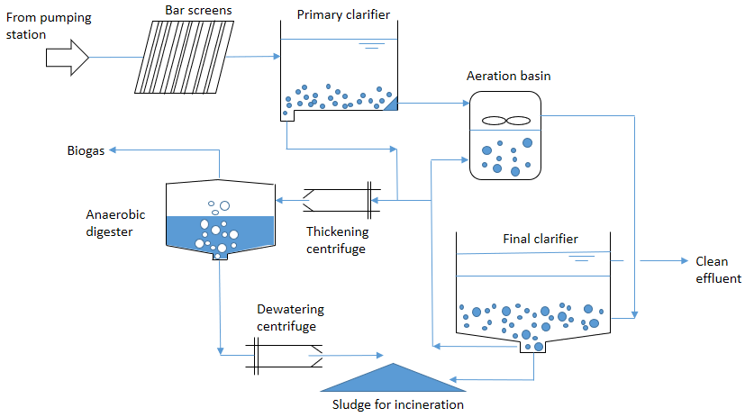

Figure 1. Biogas generation in PUB’s water reclamation plant [22].

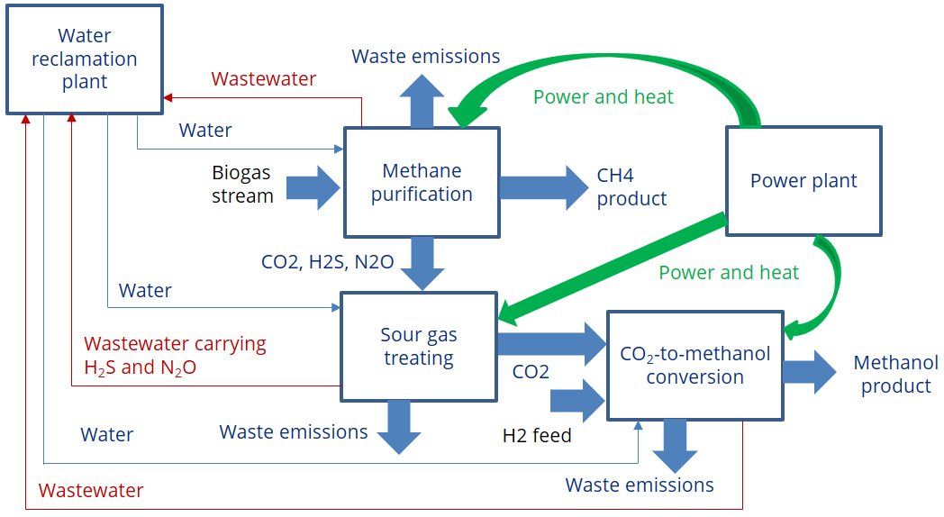

Figure 2. Simplified block diagram of a coupled biogas upgrading and CCU plant.

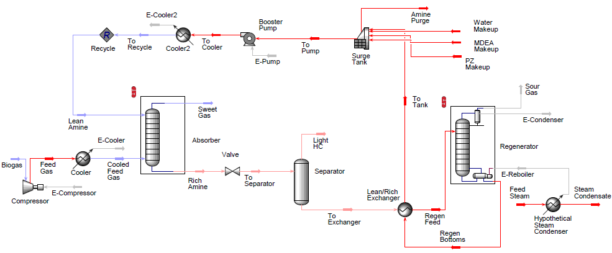
Figure 3. Biogas upgrading using mixed amine solution.

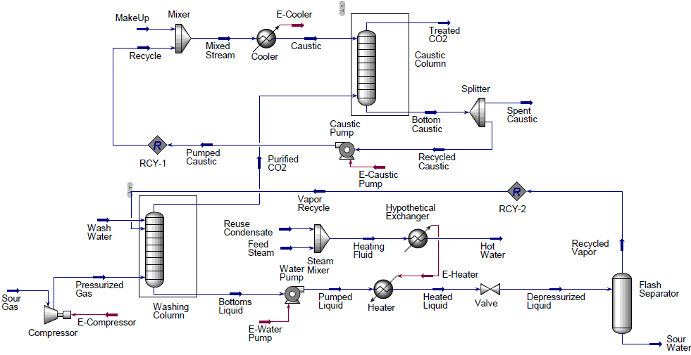
Figure 4. Flowsheet of integrated water scrubbing and caustic washing process.

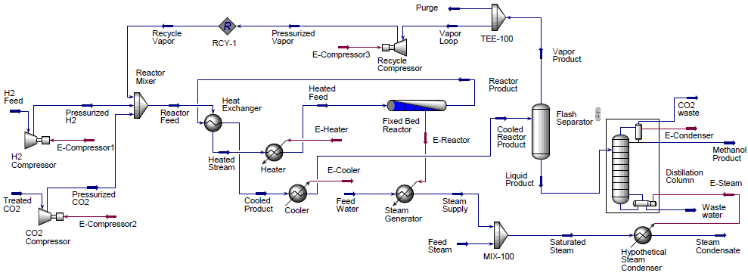

Figure 5. Flowsheet of methanol production.

* Corresponding e-mail: Iskandar_Halim@isce2.a-star.edu.sg, Phone: +65 67963962

