Role of the solidification cells on the yield strength of the Al-Si-Mg alloy manufactured using laser powder bed fusion: a micropillar compression study

Shi-Hao Li ^{a, b}, Yakai Zhao ª, Upadrasta Ramamurty ^{a, c,}*

ª School of Mechanical and Aerospace Engineering, Nanyang Technological University, Singapore 639798, Republic of Singapore.
^{b} School of Materials Science and Engineering, Zhengzhou University, Zhengzhou 450001, China.
^{c} Institute of Materials Research and Engineering, Agency for Science, Technology and Research, Singapore 138634, Republic of Singapore.

*Corresponding author; e-mail address: uram@ntu.edu.sg (U. Ramamurty)

Abstract: To ascertain the role of the solidification cell structures on the mechanical performance of Al-Si-(Mg) alloys processed using the laser powder bed fusion (LPBF) technique, micropillar compression tests were performed on LPBF Al Al-10Si-0.3Mg (AlSi10Mg). The alloy’s microstructure consists of submicron-scale cellular structures, dense dislocation networks, and dispersed nanoscale Si precipitates. The stress-strain responses of the micropillars are devoid of pronounced serrations and the yield strength and work hardening behaviors are size-independent. A comparison of the micropillar compression responses of the LPBF AlSi10Mg, 316L stainless steel and Inconel 718 alloy, and nano-and micro-crystalline alloys is made. In LPBF AlSi10Mg, the combination of dislocation networks and shear-resistant Si particles resist the dislocation motion significantly and enhance dislocation storage. This results in the cellular structure dominating the strength and plastic flow. These results show a pathway for designing high strength alloys via additive manufacturing.

Keywords: Aluminum alloys; laser powder bed fusion; mechanical properties testing; dislocation cell; precipitation.

Solidification cell structure is a distinct microstructural feature of several additively manufactured (AM) alloys, especially those processed either with laser powder bed fusion (LPBF) or directed energy deposition (DED) techniques [1-9]. The cell boundaries (CBs) are often decorated (a) with the alloying elements that segregate to them during the dendritic solidification process and (b) a high density of dislocations [1-9]. The latter feature is a direct result of the thermomechanical cycling that the deposited layers experience during the fabrication process and the dislocation pinning by the elements segregated to the CBs [10-14]. The diameters of the cells, d, and the characteristics of CBs depend on the alloy and on the specific processing method used. For example, d in the LPBF 316L austenitic stainless steel (316L) is typically smaller than 1 μm [1-3, 15] whereas it could reach 4 to 6 μm in the same steel but processed with DED [16]. Additionally, CBs in the former are enriched with Cr, Ni and Mo as well as a high density of dislocations [3, 13, 15]. In the DED 316L, in contrast, only segregated elements are observed at CBs and the dislocations are distributed uniformly through the alloy’s matrix [1, 16].
The role played by the aforementioned cellular structures on the mechanical behavior of the AM alloys is a topic of active interest. Often, alloys processed using techniques such as LPBF and DED exhibit considerably higher yield and ultimate tensile strengths (σ_{y} and σ_{U}, respectively) than their counterparts that are manufactured using conventional means (CM) [1, 17, 18]. Such a strength enhancement is attributed either to the average d being the characteristic microstructural length scale, λ, that governs σ_{y} (analogous to that of the grain size in the Hall-Petch relation) or the high density of the dislocations, ρ, present in the microstructure [17-20]. Our recent experiments on the LPBF and DED 316L show that treating d as λ may not be accurate as the shear resistance offered by the CBs in them to the dislocation glide is not as strong as that of high angle grain boundaries (GBs) [15, 16].
Aluminum based alloys, especially Al-Si and Al-Si-Mg, are also widely explored for LPBF [21, 22]. Prior studies show that these alloys exhibit unique combinations of high strength and fracture toughness [22]. While the high σ_{y} in them is attributed to the microstructural features, their enhanced fracture resistance is a result of the mesostructures amplifying the crack tortuosity [22]. While the cellular structures are common features in these alloys as well, the role played by them in determining σ_{y} and subsequent plastic flow has not been examined in detail hitherto. Since Si’s solid solubility is Al is insignificant [23], even at high temperature, its segregation to the CBs under the rapid solidification conditions that prevail during LPBF is more marked. Consequently, the resistance offered by CBs that are enriched with a high concentration of Si—and possibly Si precipitates—to plastic flow can be distinct from those observed in steels, superalloys, and high entropy alloys (HEAs). To examine this aspect, micropillar compression tests were conducted in this study on a LPBF Al-10Si-0.3Mg (composition in wt.%; referred to as AlSi10Mg hereafter) alloy.
The LPBF AlSi10Mg blocks, 32 (length)$×$26 (width)$×$64 (height) mm³, were manufactured using pre-alloyed spherical powders (diameter ~20–65 μm) under a high Ar atmosphere [22] with the following optimized process parameters: layer thickness = 60 μm, hatch spacing = 190 μm, volumetric energy density = 50 J/mm³, and 67° rotation between successive layers. Further details on the processing and microstructural features of this alloy can be found in Ref. [22]. From the printed blocks (relative density = 98.9%), small pieces were electro-discharge-machined and polished (final finish with a 0.04 μm colloidal silica suspension) such that the examined plane’s normal is parallel to the build direction (BD). The polished samples were characterized using scanning electron microscopy (SEM) and electron backscatter diffraction (EBSD; step size 0.1 μm). The samples for SEM were etched using the Weck’s reagent [22] to reveal the cellular structure. Thin, electron-transparent samples with 3 mm diameter were ion milled and characterized using a transmission electron microscope (TEM) equipped with an energy-dispersive X-ray spectroscopic (EDS) detector.
Micropillars with diameters, $D$= 1, 2, and 3.5 μm were fabricated using a dual-beam focused ion beam (FIB) system with a Ga ion source within the grains with <110> orientation (as identified by EBSD). Here, it is worth noting that most of the LPBF alloys with the face centered cubic (FCC) crystal structures (such as 316L, Inconel 718, CoCrNi HEA, and Al alloys), the cells grow during solidification along the <110> crystallographic direction. Since uniaxial compression along the long axes of such cells is geometrically the most convenient, we selected that orientation. By selecting the crystals with the grains with the <110> orientation on the plane perpendicular to BD, the compression axis also coincides with BD. Compression along <110> of the FCC crystals allows for the activation of multiple slip systems, which facilitates the investigation of interactions of dislocations and microstructures.
The fabricated micropillars have an aspect ratio of ~2–3 and a taper angle < 2°. An ion beam with a voltage of 30 kV and current of 20 pA was employed for the micropillar surface polishing to minimize the surface damage and roughness. Uniaxial micropillar compression tests were performed using a Bruker TI 980 Triboindenter equipped with a flat-punch diamond indenter. The tests were performed under displacement control mode with a nominal strain rate of 10⁻³ s⁻¹. At least five pillars were tested for each condition. Post-mortem characterization of the deformed pillars was conducted using SEM and TEM. For TEM, thin slices were FIB milled from the deformed pillars, and a weak ion beam with voltage of 5 kV and current of 20 pA was applied to minimize any surface damage.
For comparison purposes, bulk compression tests on three samples oriented along BD were conducted on cylindrical samples (2.5 mm diameter and 5 mm height) at a nominal strain rate of 10⁻³ s⁻¹.

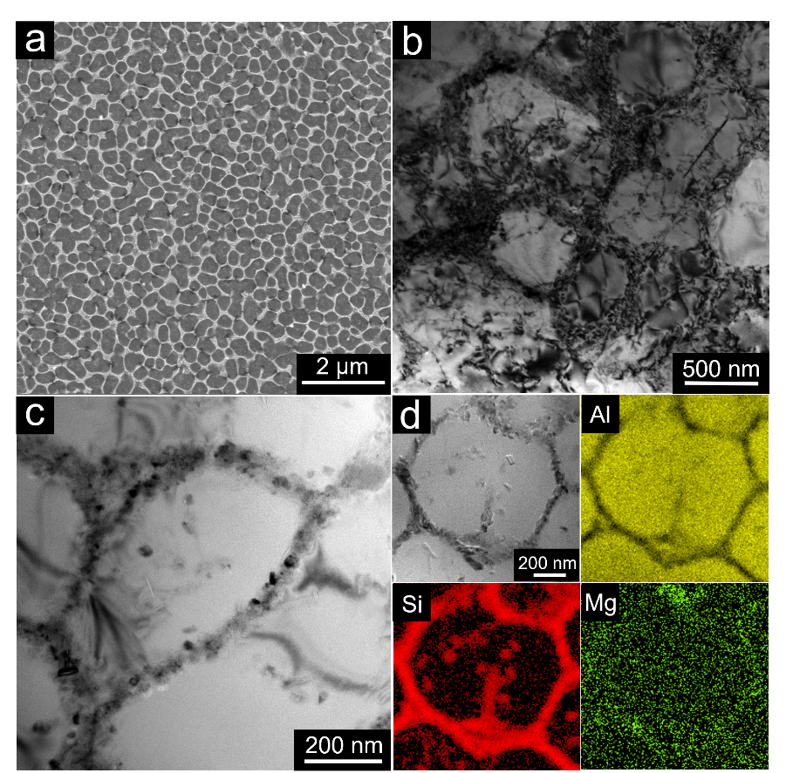
Figure 1. Microstructures of the LPBF AlSi10Mg. (a) Representative SEM image of the cellular structure. Brightfield TEM images showing (b) dislocation networks overlapping with CBs and (c) fine particles in the sample. (d) Brightfield image with complementary EDS maps showing Si segregation along CBs and Si precipitates.

Figure 1(a) shows the typical SEM image of etched LPBF AlSi10Mg. Hexagonal-shaped cellular structures could be clearly seen. The observed sharp contrast between CBs and cell interiors is a result of elemental segregation to CBs (as shown later). Using the line-intercept method, the average $d$ was determined to be 0.55$±$0.07 μm, which is comparable to those reported in other LPBF alloys [15, 24]. The TEM image shown in Figure 1(b) demonstrates that the CBs in AlSi10Mg are decorated with a high-density of tangled dislocations whereas dislocations are sparsely seen in the cell interiors. The TEM image displayed in Figure 1(c) shows small particles with ~20–60 nm diameter that are distributed along both CBs and cell interiors. These particles were identified to be Si precipitates via EDS mapping (Figure 1(d)). Their formation is expected, considering the ultralow solubility of Si in Al at room temperature [22, 23]. It appears that most Si particles tend to precipitate along CBs and form Si particle ‘networks’ with low spacing in between them, which is probably a result of the Si segregation along CBs during the solidification. The average Si particle spacing, determined based on the TEM images, is about 150 nm, which is about one-fourth of d.

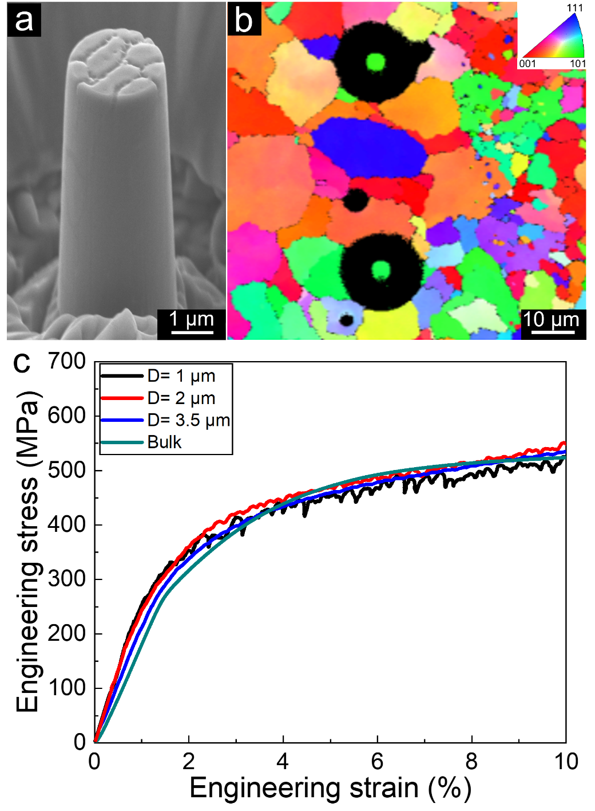
Figure 2. (a) A representative SEM image of as-fabricated pillars in the LPBF AlSi10Mg with clear cellular structures on the top surface. (b) EBSD map showing the <110> orientation of as-fabricated pillars. (c) Typical stress-strain responses of the LPBF AlSi10Mg pillars with $D$=1, 2, and 3.5 μm and the bulk compression sample.

A SEM image of a AlSi10Mg pillar with D=2 μm is shown in Figure 2(a). Due to the elemental segregation and formation of nanoscale Si particles, the resistance of CBs and cell interiors to ion beam milling is distinct, which results in a sharp contrast between them on the pillar top surface. An EBSD map obtained on the as-fabricated pillar is displayed in Figure 2(b). It shows that all the micopillars have the <110> crystallographic orientation.
Typical stress-strain responses obtained on the LPBF AlSi10Mg micropillars with $D$=1, 2, and 3.5 μm are displayed in Figure 2(c). All the pillars exhibit relatively smooth plastic stress-strain responses without any pronounced strain bursts. Although the $D$=1 μm pillar exhibits some serrations, their magnitudes (in terms of the load drops) are significantly smaller than those observed on micropillars with a similar (or smaller) $D$ in LPBF and DED 316L and LPBF IN718 [15].
For comparison, representative stress-strain response obtained during bulk compression is also displayed Figure 2(c). The observed overlap of the stress-strain curves of pillars with different $D$ suggests that it has only a marginal effect on both $σ_{Y}$ and the work hardening behavior of the LPBF AlSi10Mg. Indeed, $σ_{Y}$ obtained from 1, 2, and 3.5 μm pillars are 298±29, 295±26, and 300±17 MPa, respectively, whereas that from bulk compression is 291±13 MPa. This similarity implies the existence of a much smaller microstructural length scale (i.e., the average Si particle spacing as discussed later < 1 μm, the smallest pillar size D examined) controlling the onset of plastic flow. Similar size insensitivity in micropillars was also reported in some other Al alloys containing dispersed particles [25-28]. The work hardening exponents, n, for the micropillar and bulk compression of LPBF AlSi10Mg, are 0.22$±$0.03, 0.19$±$0.08, 0.21$±$0.06, and 0.22$±$0.05 for the micropillars with D = 1, 2, and 3 μm and bulk samples, respectively. Thus, n is also insensitive to $D$ in the AlSi10Mg pillars, which is expected from the observed overlap of the stress-strain responses seen in Figure 2(c). These observations in complete contrast to that observed in the LPBF 316L and IN718 pillars (which contain cellular structures, dislocation networks, but not nanoscale precipitates at the CBs, see Ref. [15] for details).
An SEM image showing the typical morphology of the deformed AlSi10Mg pillar ($D$=2 μm) is displayed in Figure 3(a). In similar works on other AM alloys, sharp slip bands penetrating through the entire deformed micropillar (irrespective of D) were often reported [15, 29]. The absence of such features here suggests that the propagation of the slip bands through the pillars is substantially hindered. This inference is further rationalized by recourse to TEM on the deformed micropillars. The TEM image displayed in Figure 3(b) reveals that the original morphology of the dislocation networks remains unchanged in the deformed pillar while ρ both along CBs and cell interiors increases, as compared to the pristine sample (Figure 1(b)). The slip bands, which could not be discerned well, appear to be relatively short. A higher magnification STEM image, shown in Figure 3(c), illustrates that the Si particles act as the pinning points for dislocation motion; as a result, dislocation bow-out is often observed. This, in turn, results in a reduced dislocation mean free path that leads to a much weaker dislocation avalanche activities [30, 31] and therefore relatively smooth stress-strain responses (Figure 2(c)).

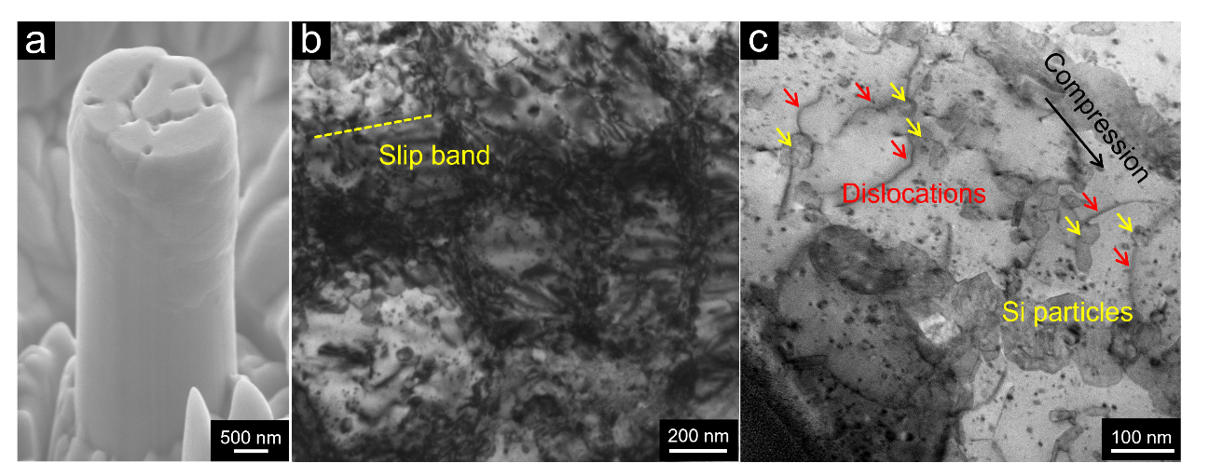
Figure 3. (a) A SEM image of the deformed AlSi10Mg micropillar. (b) A brightfield TEM image obtained from the deformed pillar shown in (a) showing short slip bands in it. (c) A STEM image showing dislocations (red arrows) that are pinned by Si particles (yellow arrows).

A size effect in micropillars is a consequence of the competition between the extrinsic length scale that depends on the specimen geometry (i.e., D) and intrinsic microstructural length scale(s) that control the plastic flow (e.g., dislocation network size and/or the precipitate spacing) [25, 30-32]. D could play a dominant role in the measured mechanical response if the pillars are micro-/nano-sized without containing internal microstructural features (i.e., GBs, twin boundaries, and particles) [30-32]. Since the diameters of the micropillars investigated here are all in the micro-scale (and not at the nano-scale), the surface effects (such as the nucleation of dislocations at the free surface) are unlikely to influence the measured responses substantially [33, 34]. For the micropillars containing relatively ‘simple’ microstructures like single-crystalline unalloyed metal pillars, the external length scale serves as the ONLY key factor dominating dislocation nucleation and multiplication. Hence, both the onset of the plastic deformation (reflected by $σ_{y}$) and the subsequent plastic flow are sensitive to D, as evidenced by the large size-sensitivity reported in the micropillar compression studies on metals and alloys with both FCC and body-centered cubic (BCC) crystal structures [30, 32]. When additional microstructural features such as nm-scale GBs, cellular structures, dislocations (networks), and precipitates are introduced, the interactions between such features and dislocations play an increasingly important role in determining mechanical performance of the micropillars.
As mentioned earlier, both a high density of dislocations that are organized into networks and dispersed Si precipitates with a spacing of ~150 nm are present in the LPBF AlSi10Mg. The size-independence of $σ_{Y}$ observed in it is a result of the combined effects of these two features. This inference is made on the following basis. In our prior micropillar compression work on LPBF 316L and IN718, which contain well-organized dislocation networks, we observed a size-dependent mechanical behavior [15]. However, the size effect exponents (0.12 and 0.14) are significantly smaller than those reported for micropillars of CM FCC metals (~0.6) [32] This indicates that the dislocation networks present in the LPBF alloys reduce substantially—but not completely eliminate—the pillar size dependence of the mechanical performance. The nanosized Si particles present in the LPBF AlSi10Mg further reduce the size-dependence to near-zero. This implies that internal length scale of the cells now controls the mechanical performance of pillars. The Si particles act as strong obstacles for dislocations due to their high strength and incoherency with the Al lattice [35, 36]. Therefore, they are more efficient in hindering dislocation motion (as compared to the dislocation networks which can get sheared) and enhancing dislocation accumulation. As a result, they dominate the observed size-independent mechanical performance.
In micron-sized pillars, the single-arm source (SAS) operation [30, 37-39], instead of dislocation starvation or surface nucleation mechanisms that generally prevail in the sub-micron or nm-scale regimes [33, 40, 41], is the key factor that leads to a size effect. With the average spacing of about 150 nm between Si precipitates, the lengths of SASs in LPBF AlSi10Mg are substantially smaller, and dislocations are likely to nucleate via bow-out due to the pinning effect of Si particles (analogous to the Frank-Read source operation). Thus, Si particles with the average spacing much smaller than the pillar sizes is the key factor dominating dislocation nucleation, motion and accumulation. As a result, the pillar size becomes inconsequential, leading to the observed size-independent and bulk-like mechanical response of the micropillars. Similar weak (or even no) size effect was reported in the pillars containing particles fabricated from Ni [42] and Al [26] alloys. Based on experimental data on various materials [42, 43], Dehm et al. proposed that, for alloys containing dispersed particles whose average spacing is smaller than 1/6 to 1/3 of $D$ [44], the strength of the micropillars would be size-independent and comparable to that of bulk counterpart. Since the average Si particle spacing in LPBF AlSi10Mg is about 1/7 of the 1 μm pillar (the smallest $D$ examined), no size effect is seen. Additionally, the Si particles resist the dislocation motion (Figure 3(c)), and in the process reduce the dislocation mean free path and enhance dislocation storage significantly. This lowers the possibility of dislocation avalanche formation resulting in a smooth plastic flow response during micropillar compression.

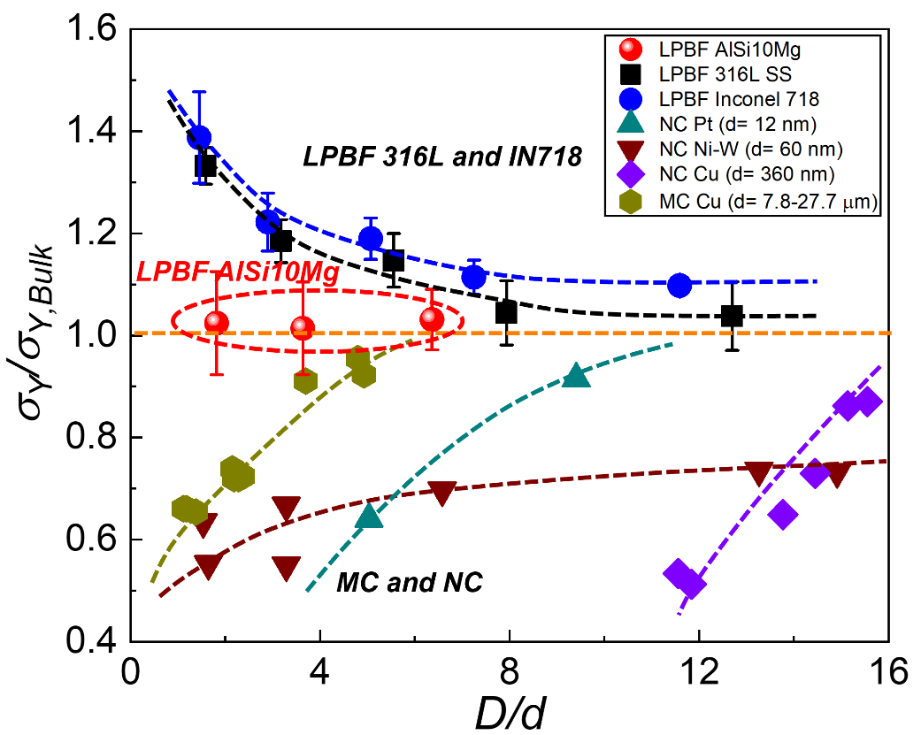
Figure 4. Variations of the yield strength $σ_{y}$ as a function of pillar size $D$ in the LPBF AlSi10Mg (this study), 316L stainless steel, Inconel 718, microcrystlalline (MC) and nanocrystalline (NC) pillars of Pt, Cu and Ni-W alloy. Data of the LPBF samples (the 316L stainless steel and Inconel 718) and MC/NC pillars are extracted from Ref. [15] and [45-48], respectively.

Finally, the equal values of $σ_{y}$ and n of micropillars and bulk samples of LPBF AlSi10Mg suggests that other microstructural features such as the grain size (ranging between 30 to 120 μm [22]) and mesostructural features such as the hatch spacing and layer thickness—all of which are significantly larger than the average cell size—does not exert significant influence on the macroscopic plastic deformation behavior (both the onset and subsequent flow) of it. Rather, the nanosized Si particles that are present at the CBs and, in turn, the cellular structures themselves, appear to control the plasticity. This is contrast to that observed in other metallic alloys. To illustrate this, variations of $σ_{y}$ as a function of $D$ of different metallic materials are compared in Figure 4. Here, $σ_{y}$ of pillars is normalized with $σ_{y}$ of the respective bulk values and $D$ is normalized by either cell or grain size. For micro-/nano-crystalline (MC/NC) pillars of Pt, Cu and Ni-W alloy that contain GBs within the micropillars, smaller is weaker, due to GB-mediated deformation, formation of geometrically necessary dislocations, and reduced resistance to dislocation activity [45-48]. In LPBF 316L and IN718, wherein CBs are decorated with dislocation networks, smaller micropillars are stronger due to a transition in the dislocation mechanisms, from SAS to the Frank-Read source operation, with increasing $D$ that results in lower $σ_{y}$ [15]. However, no size effect is observed in the strength of the AlSi10Mg pillars, as dense Si particles with low spacing, instead of the external pillar size, dominate dislocation activities. However, several additional factors contribute to the LPBF AlSi10Mg’s high strength vis-à-vis cast alloy of the same composition. One possibility is the high ρ, in the form of networks, in the LPBF alloys [15, 20]. Liu et al. [49] manufactured LPBF AlSi10Mg samples with different cell sizes and shapes examined their tensile properties. They reported that smaller and rounder cells with less concave portion in the microstructure lead to a $σ_{y}$ [49]. Since the dislocation networks overlap with CBs in LPBF AlSi10Mg, we infer that samples with smaller (which also tend to be rounder) cells may have a higher ρ and therefore superior yield strength. This is supported by the study reporting that d $∝ 1/{\sqrt{ρ}}$ [50].
In summary, micropillar compression tests were performed on the LPBF AlSi10Mg that contains submicron-scale cellular structures decorated with dense dislocation networks, segregated Si and its particles. The micropillars show smooth stress-strain responses, with $σ_{y}$ and work hardening behaviors independent on pillar size and similar to those obtained in bulk compression. Comparison of the mechanical performances of LPBF AlSi10Mg with those of other FCC alloys (316L and IN718) that are also fabricated using LPBF demonstrates that the combination of dislocation networks and shear-resistant particles in LPBF AlSi10Mg exerts a strong resistance to dislocation motion. In turn, it contributes significantly strengthening overwhelming those from other microstructural features such as GBs. The results indicate that the combination of dislocation networks and dispersed fine precipitates, when successfully incorporated, is a promising pathway for developing high strength AM materials for both room and elevated temperature applications.
Acknowledgements
This work was supported by the Structural Metal Alloys Program (Grant reference No.: A18B1b0061) of the Agency for Science, Technology and Research of Singapore. SL acknowledges the support from the National Natural Science Foundation of China (Grant No. 52101156).

References
- S.-H. Li, P. Kumar, S. Chandra, U. Ramamurty, Directed energy deposition of metals: processing, microstructures, and mechanical properties. Int. Mater. Rev. (2022) 1-43.
- T. DebRoy, H.L. Wei, J.S. Zuback, T. Mukherjee, J.W. Elmer, J.O. Milewski, A.M. Beese, A. Wilson-Heid, A. De, W. Zhang, Additive manufacturing of metallic components – Process, structure and properties. Prog. Mater. Sci. 92 (2018) 112-224.
- D. Kong, C. Dong, S. Wei, X. Ni, L. Zhang, R. Li, L. Wang, C. Man, X. Li, About metastable cellular structure in additively manufactured austenitic stainless steels. Addit. Manuf. 38 (2021) 101804.
- P. Kumar, O. Prakash, U. Ramamurty, Micro-and meso-structures and their influence on mechanical properties of selectively laser melted Ti-6Al-4V. Acta Mater. 154 (2018) 246-260.
- T.H. Becker, P. Kumar, U. Ramamurty, Fracture and fatigue in additively manufactured metals. Acta Mater. 219 (2021) 117240.
- K. Chen, R. Huang, Y. Li, S. Lin, W. Zhu, N. Tamura, J. Li, Z.W. Shan, E. Ma, Rafting-Enabled Recovery Avoids Recrystallization in 3D-Printing-Repaired Single-Crystal Superalloys. Adv. Mater. 32 (2020) e1907164.
- S.-H. Pan, G.-C. Yao, Y.-N. Cui, F.-S. Meng, C. Luo, T.-Q. Zheng, G.J.T. Singh, Additive manufacturing of tungsten, tungsten-based alloys, and tungsten matrix composites. Tungsten 5 (2022) 1-31.
- S. Wei, P. Kumar, K.B. Lau, D. Wuu, L.-L. Liew, F. Wei, S.L. Teo, A. Cheong, C.K. Ng, B. Zhang, C.C. Tan, P. Wang, U. Ramamurty, Effect of heat treatment on the microstructure and mechanical properties of 2.4 GPa grade maraging steel fabricated by laser powder bed fusion. Addit. Manuf. 59 (2022) 103190.
- S. Wei, C. Hutchinson, U. Ramamurty, Mesostructure engineering in additive manufacturing of alloys. Scr. Mater. 230 (2023) 115429.
- G. Wang, H. Ouyang, C. Fan, Q. Guo, Z. Li, W. Yan, Z. Li, The origin of high-density dislocations in additively manufactured metals. Mater. Res. Lett. 8 (2020) 283-290.
- T.R. Smith, J.D. Sugar, C. San Marchi, J.M. Schoenung, Strengthening mechanisms in directed energy deposited austenitic stainless steel. Acta Mater. 164 (2019) 728-740.
- T. Voisin, J.-B. Forien, A. Perron, S. Aubry, N. Bertin, A. Samanta, A. Baker, Y.M. Wang, New insights on cellular structures strengthening mechanisms and thermal stability of an austenitic stainless steel fabricated by laser powder-bed-fusion. Acta Mater. 203 (2021) 116476.
- K.M. Bertsch, G. Meric de Bellefon, B. Kuehl, D.J. Thoma, Origin of dislocation structures in an additively manufactured austenitic stainless steel 316L. Acta Mater. 199 (2020) 19-33.
- Z. Li, Y. Cui, W. Yan, D. Zhang, Y. Fang, Y. Chen, Q. Yu, G. Wang, H. Ouyang, C. Fan, Q. Guo, D.-B. Xiong, S. Jin, G. Sha, N. Ghoniem, Z. Zhang, Y.M. Wang, Enhanced strengthening and hardening via self-stabilized dislocation network in additively manufactured metals. Mater. Today 50 (2021) 79-88.
- S.-H. Li, Y. Zhao, J. Radhakrishnan, U. Ramamurty, A micropillar compression investigation into the plastic flow properties of additively manufactured alloys. Acta Mater. 240 (2022) 118290.
- S.-H. Li, Y. Zhao, P. Kumar, U. Ramamurty, Effect of initial dislocation density on the plastic deformation response of 316L stainless steel manufactured by directed energy deposition. Mater. Sci. Eng. A 851 (2022) 143591.
- Y.M. Wang, T. Voisin, J.T. McKeown, J. Ye, N.P. Calta, Z. Li, Z. Zeng, Y. Zhang, W. Chen, T.T. Roehling, R.T. Ott, M.K. Santala, P.J. Depond, M.J. Matthews, A.V. Hamza, T. Zhu, Additively manufactured hierarchical stainless steels with high strength and ductility. Nat. Mater. 17 (2018) 63-71.
- L. Liu, Q. Ding, Y. Zhong, J. Zou, J. Wu, Y.-L. Chiu, J. Li, Z. Zhang, Q. Yu, Z. Shen, Dislocation network in additive manufactured steel breaks strength–ductility trade-off. Mater. Today 21 (2018) 354-361.
- J.G. Kim, J.B. Seol, J.M. Park, H. Sung, S.H. Park, H.S. Kim, Effects of Cell Network Structure on the Strength of Additively Manufactured Stainless Steels. Met. Mater. Int. 27 (2021) 2614-2622.
- Z. Li, B. He, Q. Guo, Strengthening and hardening mechanisms of additively manufactured stainless steels: The role of cell sizes. Scr. Mater. 177 (2020) 17-21.
- E. Brandl, U. Heckenberger, V. Holzinger, D. Buchbinder, Additive manufactured AlSi10Mg samples using Selective Laser Melting (SLM): Microstructure, high cycle fatigue, and fracture behavior. Mater. Des. 34 (2012) 159-169.
- M.J. Paul, Q. Liu, J.P. Best, X. Li, J.J. Kruzic, U. Ramamurty, B. Gludovatz, Fracture resistance of AlSi10Mg fabricated by laser powder bed fusion. Acta Mater. 211 (2021) 116869.
- M. Fousová, D. Dvorský, A. Michalcová, D. Vojtěch, Changes in the microstructure and mechanical properties of additively manufactured AlSi10Mg alloy after exposure to elevated temperatures. Mater. Charact. 137 (2018) 119-126.
- J. Radhakrishnan, P. Kumar, S. Li, Y. Zhao, U. Ramamurty, Unnotched fatigue of Inconel 718 produced by laser beam-powder bed fusion at 25 and 600°C. Acta Materialia 225 (2022) 117565.
- S.-H. Li, W.-Z. Han, J. Li, E. Ma, Z.-W. Shan, Small-volume aluminum alloys with native oxide shell deliver unprecedented strength and toughness. Acta Mater. 126 (2017) 202-209.
- R. Gu, A.H.W. Ngan, Size effect on the deformation behavior of duralumin micropillars. Scr. Mater. 68 (2013) 861-864.
- B. Bellón, S. Haouala, J. Llorca, An analysis of the influence of the precipitate type on the mechanical behavior of Al - Cu alloys by means of micropillar compression tests. Acta Mater. 194 (2020) 207-223.
- A.K. Basak, A. Pramanik, C. Prakash, Deformation and strengthening of SiC reinforced Al-MMCs during in-situ micro-pillar compression. Mater. Sci. Eng. A 763 (2019) 138141.
- X. Wang, B. Zheng, K. Yu, S. Jiang, E.J. Lavernia, J.M. Schoenung, The role of cell boundary orientation on mechanical behavior: A site-specific micro-pillar characterization study. Addit. Manuf. 46 (2021) 102154.
- J.R. Greer, J.T.M. De Hosson, Plasticity in small-sized metallic systems: Intrinsic versus extrinsic size effect. Prog. Mater. Sci. 56 (2011) 654-724.
- T. Hu, L. Jiang, H. Yang, K. Ma, T.D. Topping, J. Yee, M. Li, A.K. Mukherjee, J.M. Schoenung, E.J. Lavernia, Stabilized plasticity in ultrahigh strength, submicron Al crystals. Acta Mater. 94 (2015) 46-58.
- M.D. Uchic, P.A. Shade, D.M. Dimiduk, Plasticity of micrometer-scale single crystals in compression. Annu. Rev. Mater. Res. 39 (2009) 361-386.
- W.D. Nix, S.-W. Lee, Micro-pillar plasticity controlled by dislocation nucleation at surfaces. Philos. Mag. 91 (2011) 1084-1096.
- A.T. Jennings, J. Li, J.R. Greer, Emergence of strain-rate sensitivity in Cu nanopillars: Transition from dislocation multiplication to dislocation nucleation. Acta Mater. 59 (2011) 5627-5637.
- A. Hadadzadeh, C. Baxter, B.S. Amirkhiz, M. Mohammadi, Strengthening mechanisms in direct metal laser sintered AlSi10Mg: Comparison between virgin and recycled powders. Addit. Manuf. 23 (2018) 108-120.
- N.T. Aboulkhair, C. Tuck, I. Ashcroft, I. Maskery, N.M. Everitt, On the precipitation hardening of selective laser melted AlSi10Mg. Metall. Mater. Trans. A 46 (2015) 3337-3341.
- S.I. Rao, D.M. Dimiduk, M. Tang, M.D. Uchic, T.A. Parthasarathy, C. Woodward, Estimating the strength of single-ended dislocation sources in micron-sized single crystals. Philos. Mag. 87 (2007) 4777-4794.
- S.-H. Li, W.-Z. Han, Z.-W. Shan, Deformation of small-volume Al-4Cu alloy under electron beam irradiation. Acta Mater. 141 (2017) 183-192.
- S.H. Oh, M. Legros, D. Kiener, G. Dehm, In situ observation of dislocation nucleation and escape in a submicrometre aluminium single crystal. Nat. Mater. 8 (2009) 95-100.
- J.R. Greer, W.C. Oliver, W.D. Nix, Size dependence of mechanical properties of gold at the micron scale in the absence of strain gradients. Acta Mater. 53 (2005) 1821-1830.
- Z.W. Shan, R.K. Mishra, S.A. Syed Asif, O.L. Warren, A.M. Minor, Mechanical annealing and source-limited deformation in submicrometre-diameter Ni crystals. Nat. Mater. 7 (2008) 115-9.
- B. Girault, A.S. Schneider, C.P. Frick, E. Arzt, Strength Effects in Micropillars of a Dispersion Strengthened Superalloy. Adv. Eng. Mater. 12 (2010) 385-388.
- D. Kiener, P. Hosemann, S.A. Maloy, A.M. Minor, In situ nanocompression testing of irradiated copper. Nat. Mater. 10 (2011) 608-13.
- G. Dehm, B.N. Jaya, R. Raghavan, C. Kirchlechner, Overview on micro- and nanomechanical testing: New insights in interface plasticity and fracture at small length scales. Acta Mater. 142 (2018) 248-282.
- X.W. Gu, C.N. Loynachan, Z. Wu, Y.W. Zhang, D.J. Srolovitz, J.R. Greer, Size-dependent deformation of nanocrystalline Pt nanopillars. Nano Lett. 12 (2012) 6385-92.
- D. Jang, J.R. Greer, Size-induced weakening and grain boundary-assisted deformation in 60 nm grained Ni nanopillars. Scr. Mater. 64 (2011) 77-80.
- N.L. Okamoto, D. Kashioka, T. Hirato, H. Inui, Specimen- and grain-size dependence of compression deformation behavior in nanocrystalline copper. Int. J. Plast. 56 (2014) 173-183.
- B. Yang, C. Motz, M. Rester, G. Dehm, Yield stress influenced by the ratio of wire diameter to grain size – a competition between the effects of specimen microstructure and dimension in micro-sized polycrystalline copper wires. Philos. Mag. 92 (2012) 3243-3256.
- Q. Liu, H. Wu, M.J. Paul, P. He, Z. Peng, B. Gludovatz, J.J. Kruzic, C.H. Wang, X. Li, Machine-learning assisted laser powder bed fusion process optimization for AlSi10Mg: New microstructure description indices and fracture mechanisms. Acta Mater. 201 (2020) 316-328.
- J. Kwon, G.M. Karthik, Y. Estrin, H.S. Kim, Constitutive modeling of cellular-structured metals produced by additive manufacturing. Acta Mater. 241 (2022) 118421.

