Construction of crystalline porous frameworks (COF/MOF) with multi-components or by multi-reactions

Siew Ping Teong, Yugen Zhang*
((Optional Dedication))

Miss S. P. Teong, Dr. Y. Zhang
Institute of Sustainability for Chemicals, Energy and Environment (ISCE²), Agency for Science, Technology and Research (A*STAR), 1 Pesek Road Jurong Island, Singapore 627833, Republic of Singapore
E-mail: zhang_yugen@isce2.a-star.edu.sg

Keywords: COF, MOF, multi-component, multitype reaction, ligands, linker

Covalent organic frameworks (COFs) and metal organic frameworks (MOFs) are crystalline porous materials with ordered framework structures. To create diverse framework structures, linkers with different geometries and sizes have been developed over the past decades. However, for more advanced applications, there is a need for continuous pore size control and property development. Researchers are exploring new synthesis methods, building blocks, and processing/fabrication protocols to meet these demands. Multi-component or multiple ligands synthesis has been widely used in the construction of MOF structures, and this synthetic strategy has recently been adopted for COF synthesis and extended to versatile linker designing strategies. This review focuses on the recent development of the multi-component or multi-reaction strategy for COF synthesis, its application in new MOF synthetic strategies, and ligand development.

1. Introduction
Covalent organic frameworks (COFs) or metal organic frameworks (MOFs) are crystalline porous materials with ordered pores and periodic structural skeletons, which are important characteristics for many applications, particularly in molecular separation and catalysis.¹⁻⁵ These frameworks are typically constructed by one or two building blocks with multiple active ends through self-condensation, hetero-coupling or coordination reactions. To pursue optimal topology diagram and diverse framework structures, various linkers ranging from 1D, 2D to 3D structures with different length and geometry have been designed during the past decades.⁶⁻⁸ Various practical applications have driven the need for more sophisticated structure designs with varying properties requirements such as precise and continuous pore size control, multiple functional knots (block), complexity, selectivity, stability, processability or printability, scalability or accessibility and so on.⁹⁻¹¹ Hence, there will be continuous efforts in exploring new synthesis methods, new building blocks and new processing/fabrication protocols. Multi-component MOFs or multiple ligands synthesis has been widely used in the construction of MOF structures.¹² Recently, this synthetic strategy has also been adopted into COF synthesis and further developed to more versatile linker design strategy.⁶ As compared to common single component approach, multi-component or multi-reaction approach provides far more opportunities in the synthesis of COF/MOFs with various structures and properties. There are many excellent review articles covering various aspects of COF and MOF materials.¹⁻¹⁴ This review will highlight the recent emerging development of multi-component or mulit-reaction strategy for covalent organic framework (COF) synthesis and its application in new MOF synthetic strategy and ligand development, which have not been covered by previous reviews.

- Construction of COFs with multi-component approach
Framework materials of COFs are designed to have periodic ordered structure and naturally they relied on specific bonding rather than multiple irregular bonding. Assembling multiple linkers has been applied in multi-component MOFs synthesis which led to versatile functionality and notable properties. It is also found that these frameworks can tolerate or accommodate certain linker variations to form a distorted or solid solution framework. The success of multi-component approaches in the construction of MOFs spiked the interest in exploring similar multi-component COF methodologies.
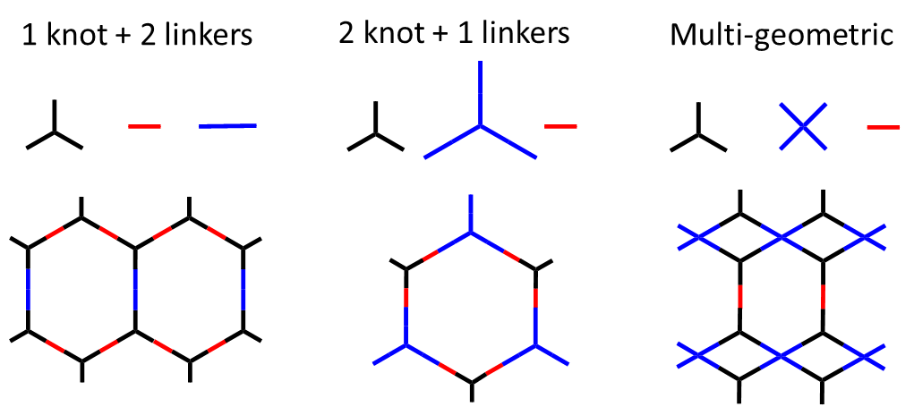
Scheme 1. Synthesis strategy of multi-component COFs.

  - Multi-components with different lengths and sizes
Linkers with the same functionality, length and size, but with different substitutions will not affect the framework structure significantly and will not be discussed here.^{13b} It is challenging for multi-components with the same reactive sites, but in different length and size to form an ordered framework structure, but it could result in specific topologies and structures.
To build up heteropore covalent organic framework,⁷ mixed linker approach has first been tried to construct heterostructure COFs. In this work, COFs were assembled from a three-component system, 4,4’,4”,4’”-(ethene-1,1,2,2-tetrayl)tetraaniline (ETTA) and two types of dialdehydes [1,1’-biphenyl]-4,4’-dicarbaldehyde (BPDA) and terephthalaldehyde (TPA) (SIOC-COF-1) or [1,1’:4’,1”-terphenyl]--biphenyl]-4,4’-dicarbaldehyde (TPDA) (SIOC-COF-2) in 1:1 ratio (Scheme 2).¹⁵ Both SIOC-COFs have triple-pore structures which were assembled from three components where two dialdehyde linkers with different length were co-existed in one framework. SIOC-COFs are crystalline framework materials with three types of pores although the porosity and crystallinity are low. Interestingly, these mixed linkers in one system can co-assemble through reversible imine condensation reaction to form an ordered framework rather than other possibilities such as co-assembling randomly to form amorphous structure, homo-coupling to form individual framework material or layered 2D material with mixed homo-coupling layers stacking together. Concurrently, Jiang’s group systematically studied the multi-component strategy in the COF structural design and synthesis by using a model system with various boronate linkages assembled using combinations of ten di-boronic acid linkers and four knots (Scheme 3).¹⁶ This work had achieved great success with 53 different multi-component COFs being synthesized. These COF materials were highly crystalline and porous under the combination of [1+2] (1 knot-two linkers (1:2 or 2:1 ratio)) and [1+3] (1 knot-three linkers) systems. It demonstrated the generality of co-assembling complex COF structures using multiple linkers with different lengths ranging from 7 to 22 Å and in different ratios. As compared to the heteropore system, the single pore structure of these COFs may support excellent crystallinity and porosity. Structural design by stretching or shrinking along one polygon direction and structural self-healing mechanism during 2D framework lattice formation were also proposed to contribute to the high crystallinity and porosity. Interestingly, COF with both electron-donating and -accepting units was assembled by [1+2] approach and the resulting materials demonstrated huge enhancement of ohmic-type conducting profiles as compared to conventional COF materials. In addition to 1 knot with multiple linkers system, McGrier’s group demonstrated a two knots-one linker combination and highly crystalline and porous boronate PDA-HH12-HH18 COF was synthesized.¹⁷

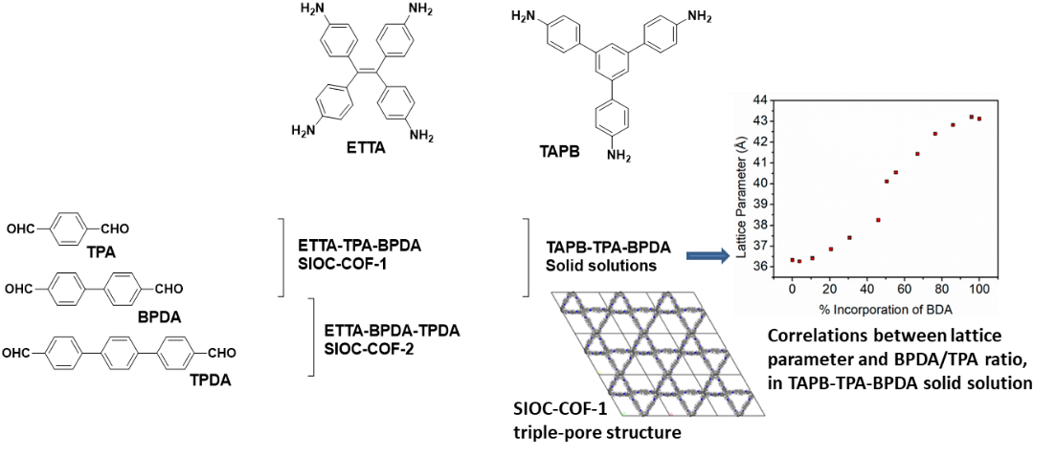
Scheme 2. Multi-component COFs with imine linkages of different sizes. Reproduced with permission from ref. [15] (Copyright 2016, ACS) and ref. [18] (Copyright 2021, ACS).
Scheme 3. Multi-component COFs with boronate linkages of different sizes.

Recently, Dichtel’s group reported a very interesting 2D imine-based COF solid solutions.¹⁸ In this system, 1,3,5-tris(4-aminophenyl)benzene (TAPB) triamine knot was mixed with two dialdehyde linkers TPA and BDA at continuously varied feed ratios from 0% to 100%. Remarkably, COF materials with different ratio of mixed linkers were obtained and all COF materials maintained relatively good crystallinity and high porosity. The lattice parameters of these COF series were also continuously varied at different feed ratios. Several important points have been proposed here: 1. Monomers with well-defined orientations of the reactive functional sites can be incorporated into a COF lattice; 2. Bond bending and more dangling bonds would help the framework to accommodate linkers with different sizes and relieve strain from the distorted framework. This example demonstrates a different perspective of the adaptivity of COF materials and new opportunity in framework designing. More recently, Nakayama’s group reported a challenging boronate-based 2D COF solid solution system using one diboronic acid linker and two knots in continuously varied feed ratios.¹⁹ This comprehensive work studied the [2 knots + 1 linker] COF formation through 12 ternary combinations using three triangular knots hexahydroxytriphenylene (HHTP), hexahydroxydehydrobenzo[12]-annulene (HH12) and hexahydroxydehydrobenzo[18]-annulene (HH18) and four diboronic acid linkers BDA, PDA, DPDA and EDPDDA. Various factors including the monomers ratio, sizes, COF growth rate and interlayer stacking were investigated to understand the principles behind the formation of mixed linker COFs and their solid solution-like characteristics. COF growth rate with HHTP knot is much slower than HH12 and HH18 knots. The unbalanced growth rate could be correlated with the lower crystallinity (HHTP-HH12 or HHTP-HH18 vis HH12-HH18). More experimental data showed that the difference between knots in the COF growth rate is not the only factor contributing to the quality of the framework. The interlayer stacking effect of the resulting structure will also affect the COF framework formation. The difference in monomer size is the major factor that directly affected the framework formation and led to structural disorder and incomplete structure (dangling or terminal linkers) which corresponded to the observation that linker/knot ratio in multi-component COF is consistently higher than conventional binary COF materials. In the trials of solid solution formation, HHTP-HH12-PDA system produced single-phase crystalline COF from all the varied feed ratios and presented as another example of COF solid solutions. In contrast, HHTP-HH18-PDA combination does not yield single phase crystalline COF at all feed ratios. In certain knots feed ratio, two COFs with independent patterns corresponding to two binary frameworks were obtained. This is due to the large difference in physical size between two knots which led to a highly strained, disordered framework, and eventually failed in forming a single-phase crystalline structure. Interestingly, this could be rectified by using a long and flexible linker, as demonstrated in the HHTP-HH18-EDPDDA system. EDPDDA is a long and flexible linker which could tolerate disordered structure and partially release structural strains. As a result, solid solution of this HHTP-HH18-EDPDDA system was observed as a single-phase crystalline COF material. Notably, binary condensation between HH18 and EDPDDA produced amorphous rather than crystalline product. It indicates that large size monomer with too much flexibility will certainly cause limited crystallinity or even amorphous structure. These results also shed light on the structural design of COF: long and flexible linker stabilized framework by self-adjusting disordered structure and released framework strains, while a small amount of easy-to-crystalline monomer could facilitate the crystalline formation of unpaired linker-knot system. The solid solution COF system is generally a kinetic controlled product and requires limited reversibility in bond formation.
  - Multi-components with different geometrics
Compared with different monomer sizes, monomers with different geometrics will be more challenging in the single-phase COF framework formation. Lotsch et al reported the first imine-based MOF structure with bi-, tri- and tetradentate linkers in one single-phase framework.²⁰ This was achieved by sub-stoichiometric design with trigonal and tetragonal linkers and it was further extended to the combination of bi-, tri- and tetragonal system. Pyrene tetraaniline (P) reacts with trialdehyde (triazine tribenzaldehyde (T) or benzene tripicolinaldehyde (Y) in 1:1 ratio and the resulting two-component framework had three different geometrical linkers. Half of tetraaniline P linker is incorporated into the framework as a bidentate linker and left two unreacted free amine groups dangling in the framework. As expected, the bidentate tetraaniline linker can be replaced with di-aniline linear linker to form a framework with the combination of bi-, tri- and tetra-dentate geometric linkers. COFs from both systems exhibited good crystallinity and high porosity. This work not only demonstrated the first COF structure with three different geometric monomers, it also presented a useful sub-stoichiometric design to form frameworks with complex topology and desirable functionality in the structure for potential applications. Similarly, another framework COF-77 with the combination of three different geometric linkers using bi-aldehyde (TPA), tri-amine (TAA) and tetra-aldehyde (TFPPy) was assembled through imine condensation reaction.²¹ This COF-77 can also be synthesized by a two-step approach.

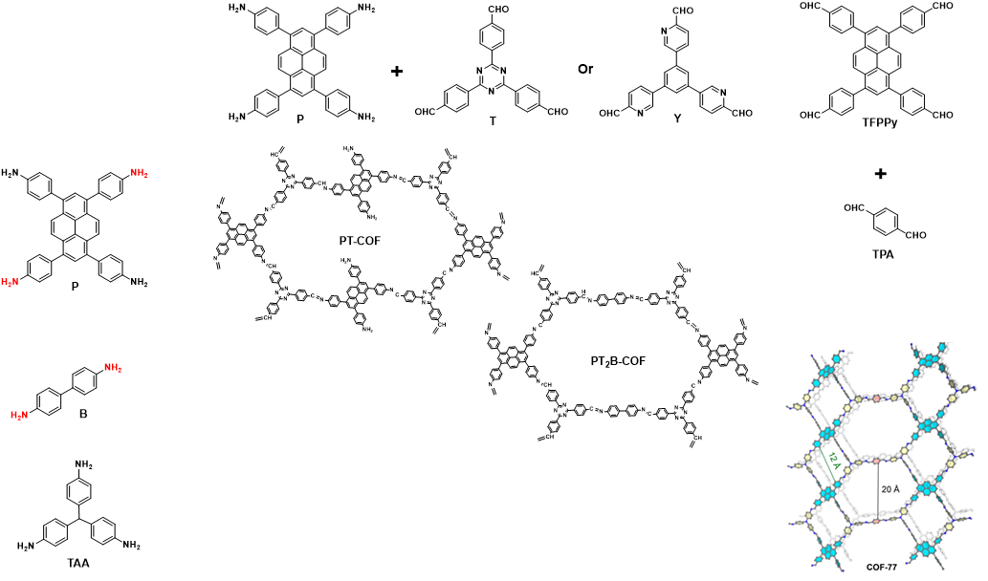
Scheme 4. Multi-component COFs with imine linkages of different geometrics. Reproduced with permission from ref. [21] (Copyright 2020, ACS).

Recently, an interesting example of multi-component COF synthesis was reported by using bifunctional linker 4-aminobenzaldehyde (PFBA) with triformylphloroglucinol (Tp) and phenylenediamine (Pa-1) or methyl-substituted one (Pa-2) to give crystalline and highly porous COFs.²² COFs assembled with continuously variable feed ratio of PFBA and Pa were also reported and a solid solution type of COF system was observed. This synthesis strategy has also been extended to other combination of amino-linkers, including 1,3,5-tris(4-aminophenyl)triazine (TATTA) and TAPB to give Tp-PFBA-TAPB and Tp-PFBA-TATTA COFs. Herein, bifunctional linker PFBA is a unique linker which could react with different functional building blocks.

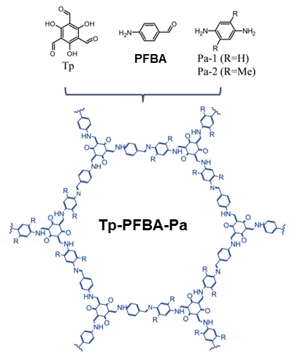
Scheme 5. Multi-component COFs with imine linkages using bi-functional linker. Reproduced with permission from ref. [22] (Copyright 2022, RSC).

  - Multi-components with different functionalities
Multi-component synthesis strategy allows the design of application driven COF by linking desired components in one framework, especially in the core skeleton. Recently, Liu’s group reported a photocatalytic COF material built with both electron-rich and electron-poor units to form a donor-π-acceptor framework.²³ Benzotrithiophene tricarbaldehyde (BTT) and triazine TFPT (1,3,5-tris-(4-formyl-phenyl)triazine) are well-known electron-rich and electron-deficient building units respectively. These two aldehyde functionalized nodes are linked by either 1,4-phenyldiacetonitrile or 1,4-phenylenediamine to form BTT-TFPT multi-component COF through either sp² carbon (COF-JLU35) or imine (COF-JLU36) linkage (Scheme 6). It was indicated that the two components were mainly incorporated into the framework in alternating arrangements which is important to form the desired properties. It was proven that the donor-π-acceptor multi-component structure led to more efficient exciton dissociation and charge separation, eventually resulted in higher photocatalytic activity for hydrogen evolution from water.
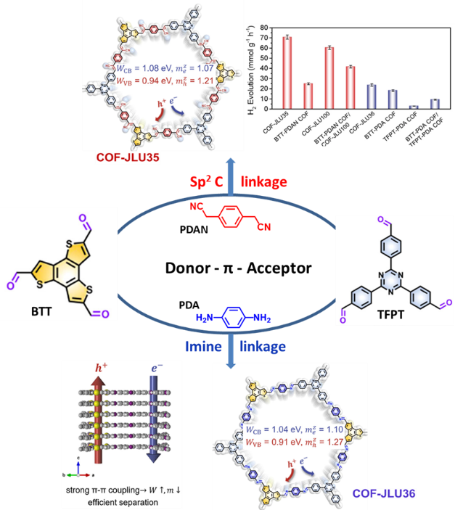
Scheme 6. Multi-component COFs with donor and acceptor functionalities. The synthesis approaches, framework structures, charge separation path with different locations of electron and hole centers, conduction/valance band width (W_{CB}/W_{VB}), out-of-plane transport with cross-plane electron/hole mass (m^{Z}_{e}/m^{Z}_{h}) and the high photocatalytic activity were presented. Reproduced with permission from ref. [23] (Copyright 2023, ACS).

- Construction of COFs with multi-reactions
Multi-component COFs could be assembled by a single condensation reaction with monomers of different sizes and geometrics. COF structures could also be fabricated under multi-condensation reactions with hetero-functional linkers (Scheme 7). This strategy opened new opportunities to extend the complexity of framework structures.

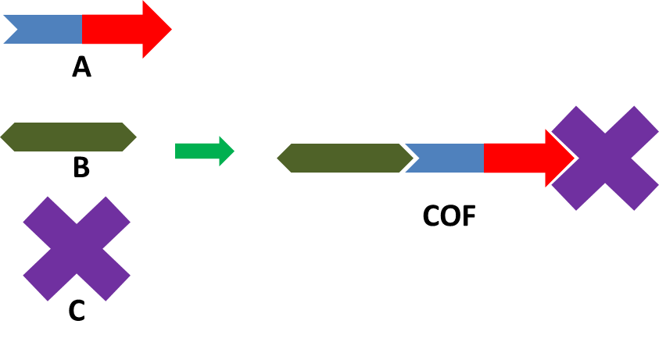
Scheme 7. Bi-functional linker A assembles with linkers B and C to form COF with two different linkages.

Currently, bifunctional linker is the key to multi-reaction COF synthesis and 4-formylphenylboronic acid (FPBA) linker is the first reported example (Scheme 8). This linker could react with two different functional groups - reaction with amine to form imine bond or with dihydroxyl group to form boronate bond. In addition, boronic acid may also undergo self-trimerization to form boroxine. Zhao’s group²⁴ reported the first example of using FPBA to construct COF via multi-reaction path (Scheme 9). In the system with FPBA and TAPB to form hexagonal COF structure, two types of reactions were involved to form boroxine ring and imine bonds. When FPBA was mixed with TAPB and HHTP in 3:1:1 ratio, another framework was established involving boronate and imine bonds reactions. Both COF materials have good crystallinity and high porosity. Two types of reversible reactions had coordinated well to form the final multi-connected framework. To one’s surprise, synthesis trials of similar COFs using a step-by-step approach were unsuccessful. Jiang’s group²⁵ had conducted a comprehensive study on this multi-reaction COF system (Scheme 9-10). A combination of FPBA and substituted FPBA with di-, tri-, tetra-amine (formation of boroxine and imine bonds) and/or tri-/tetra- dentate hydroxyl knots (formation of boronate and imine bonds) were employed. 12 new COFs were synthesized from this multi-reaction design and all of them are well-characterized as highly crystalline and porous materials. It demonstrated great versatility and the opportunity of using multi-reactions in the construction of novel COFs. Following these pioneer work, similar COFs with multi-functionalities have been synthesized and used in catalysis.²⁶ FPBA or FFPBA was employed in constructing 3D COFs by reacting with the 3D tetraaminoadamantane (TAAd). The crystalline and highly porous COFs with boroxine and imine linkages were constructed and demonstrated their application as bifunctional catalysts.

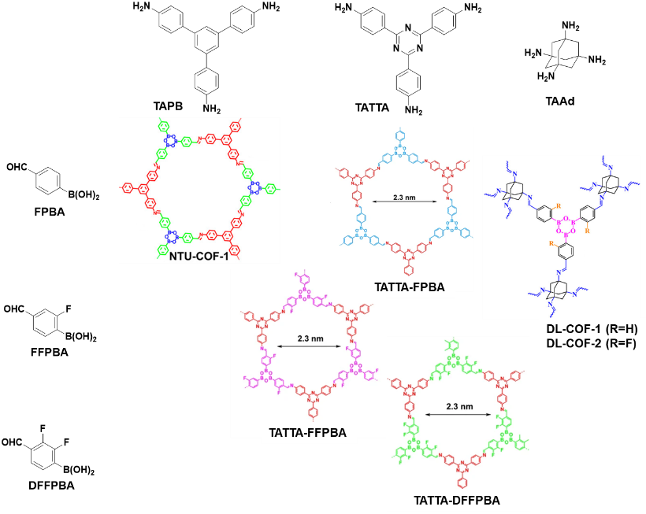
Scheme 8. Multi-reaction COFs with boroxine-imine linkages²⁴⁻²⁵. Reproduced with permission from ref. [26] (Copyright 2016, ACS).

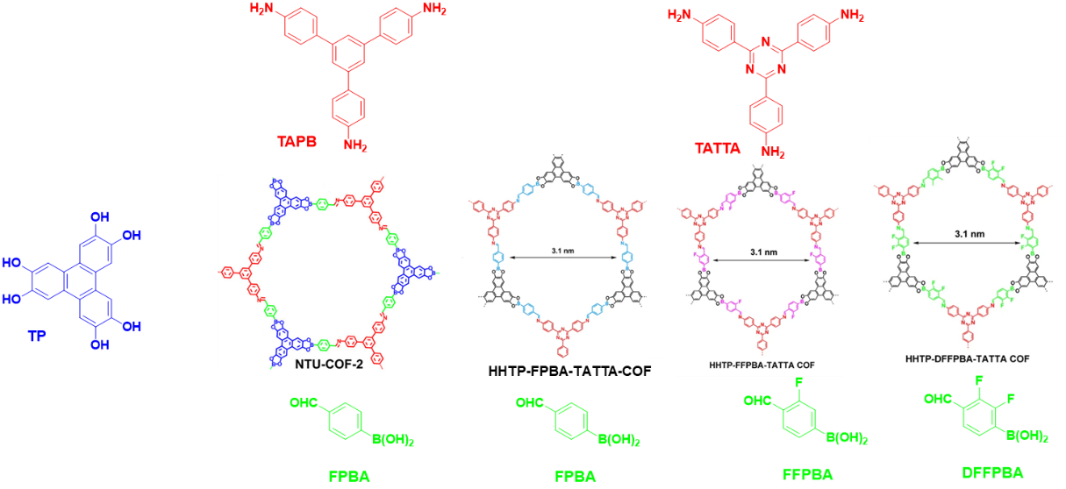
Scheme 9. Multi-reaction hexagonal COFs with boroxine-imine linkages²⁴⁻²⁵.

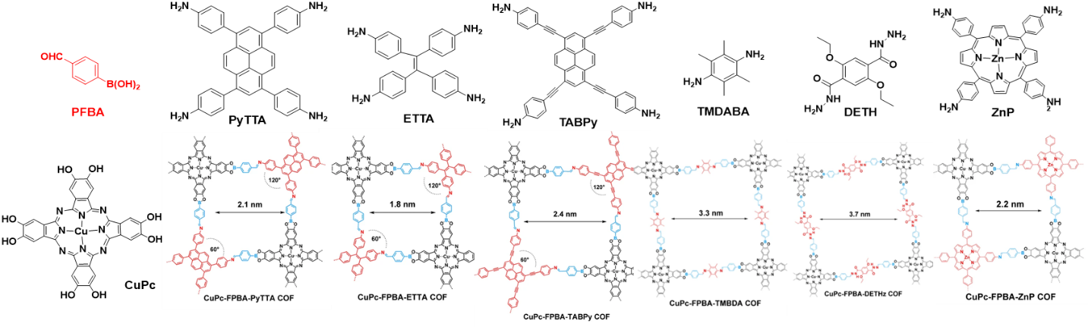
Scheme 10. Multi-reaction rhombic COFs with boronate-imine/hydrazone linkages²⁵.

The multi-reaction approach was also extended to a new multi-functional linker, 3,5-diformylphenylboronic acid (DFPBA), to construct heteropore COFs (Scheme 11). Dual-pore COF with boroxine and imine linkages was synthesized by mixing DFPBA with diaminobenzene (DAB).²⁷ Another novel dual-pore COF with boronate and imine linkages was constructed with DFPBA, tetrahydroxybenzene (THB) and DAB. These multi-pore COFs demonstrated moderate to low crystallinity and porosity. When DFPBA is assembled with diethoxyterephthalohydrazide (DETH), the boroxine-hydrazone dual-pore COF could undergo selectively hydrolysis to form an interesting nanotube structure.²⁸ The boroxine rings in the COF were completely hydrolyzed and the hydrazone linkages were well-preserved to give a single-wall COF nanotube. The multi-linkages in the COF constructed by multi-reaction will have different chemical property and stability which provide the opportunity to further manipulate or re-shape the COFs towards different applications. In contrast to this 2D to 1D process, Yaghi’s group demonstrated a 1D ribbon to 2D COF strategy multi-component and/or multi-reaction approaches.²¹ Tetrakis(p-formylphenyl)pyrene (TFPPy) reacts with tris(4-aminophenyl)amine (TAA) in 1:2 stoichiometric ratio to form a 1D ribbon COF where one of three amine groups is free in the framework. The free amine groups on the ribbon could further react with dialdehyde (TPA) or dianhydride (PMDA) to form 2D COFs with imine-imine or imine-imide linkages (Scheme 12). The 2D COFs could also be synthesized in one-pot mixture with TFPPY-TAA-TPA or TFPPY-TAA-PMDA system to give highly crystalline and porous materials. In another report, 2D COF with imine and alkene linkages synthesized by multi-reaction approach was demonstrated, Scheme 12.²⁹ COF-FD1 was synthesized with 1,3,5-triformylbenzene (TFB) and 4-aminobenzyl cyanide (ABC) by orthogonal Schiff base reaction and the Knoevenagel condensation to give a highly crystalline COF with olefin and imine dual linkages. COF-FD1 features an interesting hollow spherical morphology and exhibits remarkably high stability and excellent selectivity in fluorescence sensing of Fe³⁺ ions. All these efforts in multi-component and multi-reaction COF strategies demonstrated extremely versatile and great potential in designing COFs with new structural topology and functionality.³⁰ Although the current research only focused on few linkages such as boronate, boroxine, imine, hydrazone and imide, this strategy could be generalized and applied to all COF synthetic reactions.

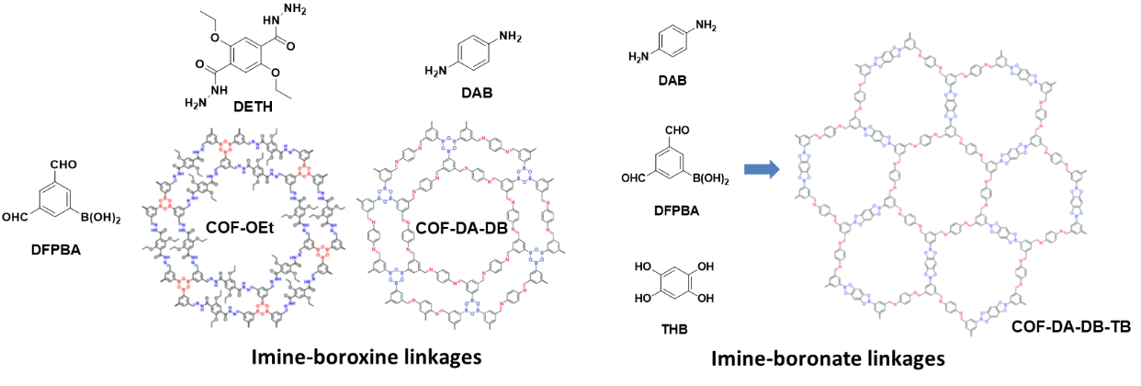
Scheme 11. Multi-reaction COFs with DFPBA as multi-functional linker. Reproduced with permission from ref. [27] (Copyright 2018, RSC) and ref. [28] (Copyright 2020, ACS).

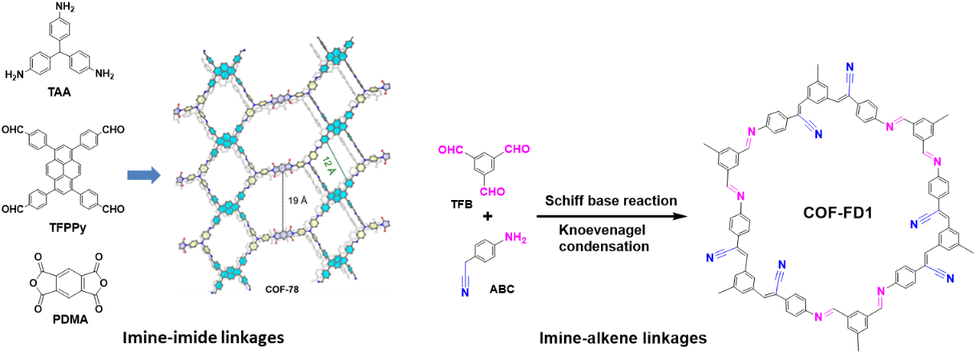
Scheme 12. Multi-reaction COFs with imine-imide linkage and imine-alkene linkage. Reproduced with permission from ref. [21] (Copyright 2020, ACS) and ref. [29] (Copyright 2022, ACS).

- Applying COF strategy in MOF synthesis

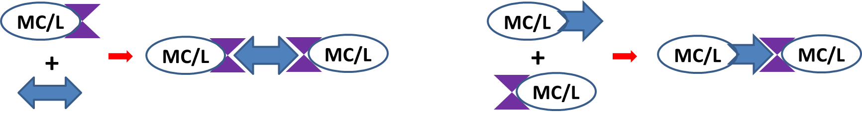
Scheme 13. Metal cluster (MC) or ligand (L) with COF bonding functionalities could be assembled into MOFs or new ligands via COF synthesis approach.

Although multi-component and hetero-functional ligand approaches have been well applied in MOF synthesis, the current development of covalent bonding strategies in COF synthesis contributed to novel MOF structural design with specific properties and applications. The COF synthesis strategy could further expand the scope of MOF ligands and change the traditional MOF synthesis strategy. MOFs typically are synthesized by ligands with metal cation through well-defined coordination reaction, while COFs are mainly synthesized by reactive sites through condensation reaction. Recently, MOF synthesis by condensation reactions of pre-synthesized metal building units has been developed (scheme 13).

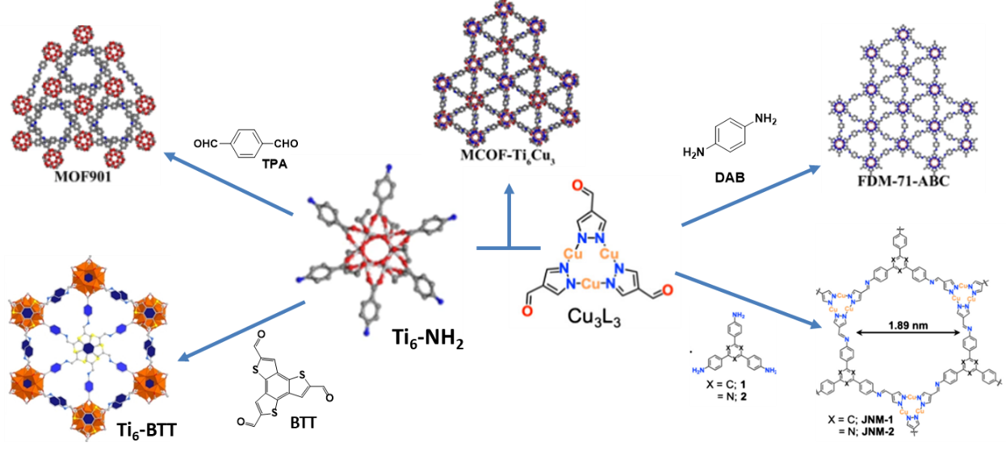
Scheme 14. MOFs synthesized through imine condensation reaction^{32, 34-35}.

Yaghi’s group synthesized a titanium(IV) cluster, [Ti₆O₆(OiPr)₆(PAB)₆] (Ti₆-NH₂), by using a bifunctional ligand p-aminobenzoate.³¹ This metal cluster has six free aniline groups which was further assembled with benzene dialdehyde (TPA) to form a novel titanium MOF (MOF-901) (scheme 14). Remarkably, MOF-901 was eventually assembled through imine condensation, a typical covalent bond approach used in COF synthesis. This demonstrates a new pathway for MOF synthesis. As the final step involved covalent bond formation, the resulting MOF may only give microcrystalline product rather than large crystals. MOF-901 is a highly crystalline and porous material and has been demonstrated as a photocatalyst in the polymerization of methyl methacrylate (MMA). More recently, Lan et al applied this titanium cluster (Ti₆-NH₂) to assemble with other functionalized organic building block or metal cluster for novel MOFs synthesis with specific functionality and applications.³² Firstly, Ti₆-NH₂ cluster was assembled with benzotrithiophene tricarbaldehyde (BTT) via imine condensation to form a highly crystalline MOF nanosheet. The well-designed structure has light-absorption group (Ti₆-NH₂) and oxidation group (BTT) which enables efficient electron-hole separation and transfer which acts as an efficient photocatalyst in 5-hydroxymethylfurfural (HMF) to 2,5-furandicarboxylic acid (FDCA) conversion. Concurrently, another metal cluster, aldehyde functionalized Cu(I) cluster [Cu₃(PyCA)₃] (PyCA, pyrazolatecarbaldehyde) (Cu₃L₃), was synthesized and co-assembled with phenylenediamine (PDA) to form a new MOF product (FDM-71).³³ FDM-71 is highly crystalline and porous with photosensitizing activity. Cu₃L₃ was also condensed with tri-aniline knots to form hexagonal MOF material with imine linage (JNMs) as efficient catalyst for the Sonogashira coupling reaction.³⁴ In another example, Ti₆-NH₂ cluster assembled with aldehyde functionalized Cu(I) cluster Cu₃L₃ to form Ti₆-Cu₃ MCOF by imine condensation reaction.³⁵ In this MCOF structure, oxidative and reductive clusters are linked by imine linkage and demonstrated good photocatalytic activity in the conversion of CO₂ and water to formic acid. Other example included using amine functionalized polyoxometalate MnMo₆ with TFPM (tetrakis(4-formylphenyl)methane) to form a 3D MOF with imine linkage and was being applied as a solid-state electrolyte.³⁶
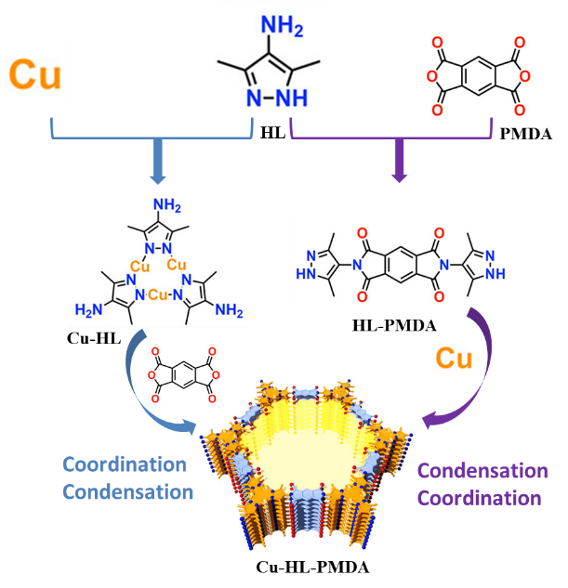
Scheme 15. MOF synthesized through condensation/coordination reactions. Reproduced with permission from ref. [37] (Copyright 2023, ACS).

In another example, the condensation approach has been well demonstrated to build functional MOF with high catalytic activity. As shown in Scheme 15, MOF (JNM-4-Ns) was synthesized among Cu(II), HL (3,5-dimethyl-1H-pyrazol-4-amine) and PMDA (pyromellitic dianhydride) through either coordination (Cu-HL) to condensation (Cu-HL-PMDA) or condensation (PMDA-HL) to coordination (PMDA-HL-Cu) paths.³⁷ Both processes gave highly crystalline and porous MOF materials with the same theoretical framework structure which demonstrated high activity in catalyzing hydroboration of alkynes. It should be noted that materials synthesized from two different approaches (condensation first or coordination first) may have differences in structural defects, terminal groups and may also reflect the difference in related properties. This example demonstrates great potential for design functional MOF materials by using COF synthesis strategy, specifically via condensation reactions.

- Perspectives
To fulfill the real application requirements, such as functional building blocks, precisely controlled pore size (large or small), highly stable, scalable and low-cost, versatile structural design for COFs and MOFs is always important. Over these years, MOFs and COFs have developed their own construction principles and methodologies. The process of learning and adopting each other’s methodologies in structural design and synthesis is an emergent hot area and will be further developed. It provides great opportunities in the development of novel functionalized porous framework materials for various specific applications. As summarized in Prof. Jiang’s review article,⁶ many covalent bond reactions have been demonstrated in COF synthesis, while only a few of them (mainly imine and boronate/boroxine formation) have been applied in multi-component or multi-reaction approach. For the multi-component approach, linkers with different physical size and geometric could be incorporated into a COF lattice. Framework strain caused by different components limited the ordered structure formation and this strain could be partially released by bond bending, dangling bonds, longer and flexible linkers or a balanced combination of linkers with the right flexibility and easy-to-crystalline property, etc. In addition, COF formation rate, packing effect and reversibility also determine the formation of crystalline multi-component COFs. Multi-component COFs with other reversible and irreversible linkages, such as azines, squaraines, imides, amides, amines, benzoxazoles, benzothiazoles, etc, are worth exploring. For multi-reaction approach, it will be very interesting to see more COFs to be developed through new hetero-functional linkers and multi-linkers with different functionality, especially those irreversible condensation reactions. Development of covalent bond strategies in COF synthetic contributes to novel MOF structural design with specific properties and applications. It provides great opportunities and numerous possibilities that are worth exploring. The COF synthetic strategy can also greatly expand the scope of MOF ligands. These new ligands could be developed by conventional COF condensation reactions with easily accessible, low cost and scalable processes. Lastly, although exciting examples have been developed through multi-component or multi-reaction framework synthesis, the detailed self-assembled mechanism and principles are still not clear. Moving forward, computational modeling, AI assisted mechanism study and structural design in this area will be a new direction.

Acknowledgement
This work was supported by the Institute of Sustainability for Chemicals, Energy and Environment (ISCE2), Agency for Science, Technology and Research (A*Star).
Keywords
COF, ligands and linker, MOF, multi-component, multitype reaction
Notes
The authors declare no competing financial interest.

Received: ((will be filled in by the editorial staff))
Revised: ((will be filled in by the editorial staff))
Published online: ((will be filled in by the editorial staff))

References
[1] A. P. Cote, A. I. Benin, N. W. Ockwig, M. O'Keeffe, A. J. Matzger, O. M. Yaghi, Science 2005, 310, 1166.
[2] K. Geng, T. He, R. Liu, S. Dalapati, K. T. Tan, Z. Li, S. Tao, Y. Gong, Q. Jiang, D. Jiang, Chem Rev 2020, 120, 8814.
[3] X. Feng, X. Ding, D. Jiang, Chem Soc Rev 2012, 41, 6010.
[4] A. H. Farmahini, S. Krishnamurthy, D. Friedrich, S. Brandani, L. Sarkisov, Chem. Rev., 2021, 121, 10666.
[5] Y. He, B. Li, M. O’Keeffe, B. Chen, Chem. Soc. Rev. 2014, 43, 5618.
[6] K. T. Tan, S. Ghosh, Z. Wang, F. Wen, D. R.-S.-Miguel, J. Feng, N. Huang, W. Wang, F. Zamora, X. Feng, A. Thomas & D. Jiang, Nat Rev Methods Primers, 2023, 3, 1
[7] R. R. Liang, X. Zhao, Org. Chem. Front, 2018, 5, 3341
[8] C. Group, T. Ma, N. Hanikel, O. M. Yaghi Science 2020, 370, 6406
[9] T. Zhang, H. Qi, Z. Liao, Y. D. Horev, L. A. Panes-Ruiz, P. St. Petkov, Z. Zhang, R. Shivhare, P. Zhang, K. Liu, V. Bezugly, S. Liu, Z. Zheng, S. Mannsfeld, T. Heine, G. Cuniberti, H. Haick, E. Zschech, U. Kaiser, R. Dong, X. Feng, Nat Commun. 2019, 10, 4225.
[10] C. Franco, D. Rodríguez-San-Miguel, A. Sorrenti, S. Sevim, R. Pons, A. E. Platero-Prats, M. Pavlovic, I. Szilágyi, M. L. R. Gonzalez, J. M. González-Calbet, D. Bochicchio, L. Pesce, G. M. Pavan, I. Imaz, M. Cano-Sarabia, D. Maspoch, S. Pané, A. J. de Mello, F. Zamora, J. Puigmartí-Luis, J Am Chem Soc. 2020, 142, 3540.
[11] Z. Wang, Z. Zhang, H. Qi, A. Ortega-Guerrero, L. Wang, K. Xu, M. Wang, S. W. Park, F. Hennersdorf, A. Dianat, A. Croy, H. Komber, G. Cuniberti, J. J. Weigand, U. Kaiser, R. Dong,
X. Feng, Nat Synth 2022, 1, 69.
[12] J. R. Li, R. J. Kuppler, H. C. Zhou, Chem. Soc. Rev., 2009, 38, 1477
[13] a) C. Qian, L. L. Feng, W. L. Teo, J. W. Liu, W. Zhou, D. D. Wang, Y. L. Zhao, Nat Rev Chem 2022, 6, 881; b) D. Zhu, J.-J. Zhang, X. Wu, Q. Yan, F. Liu, Y. Zhu, X. Gao, M. M. Rahman, B. I. Yakobson, P. M. Ajayanb, R. Verduzco, Chem. Sci., 2022, 13, 9655.
[14] K. Adil, Y. Belmabkhout, R. S. Pillai, A. Cadiau, P. M. Bhatt, A. H. Assen, G. Maurin, M. Eddaoudi, Chem. Soc. Rev., 2017, 46, 3402.
[15] Z. F. Pang, S. Q. Xu, T. Y. Zhou, R. R. Liang, T. G. Zhan, X. Zhao, J. Am. Chem. Soc. 2016, 138, 4710.
[16] N. Huang, L. Zhai, D. E. Coupry, M. A. Addicoat, K. Okushita, K. Nishimura,T. Heine, D. Jiang, Nat Commun. 2016, 7, 712325
[17] J. W. Crowe, L. A. Baldwin, P. L. McGrier, J. Am. Chem. Soc. 2016, 138, 10120.
[18] R. L. Li, A. Yang, N. C. Flanders, M. T. Yeung, D. T. Sheppard, W. R. Dichtel, J. Am. Chem. Soc. 2021, 143, 7081.
[19] M. Suzuki, M. Miura, E. Ohkubo, H. Karimata, N. Aizawa, H. Yamada, K. I. Nakayama, J. Am. Chem. Soc. 2023, 145, 3008.
[20] T. Banerjee, F. Haase, S. Trenker, B. P. Biswal, G. Savasci, V. Duppel, I. Moudrakovski, C. Ochsenfeld, B. V. Lotsch, Nature Commun., 2019, 10, 2689
[21] H. L. Nguyen, C. Gropp, O. M. Yaghi, J. Am. Chem. Soc. 2020, 142, 2771.
[22] Q. Sun, H. Niu, Y. Shi, Y. Yang, Y. Cai, Chem. Commun., 2022, 58, 12875
[23] Z. Li, T. Deng, S. Ma, Z. Zhang, G. Wu, J. Wang, Q. Li, H. Xia, S. Yang, X. Liu, J. Am. Chem. Soc., 2023, DOI:/10.1021/jacs.2c11893.
[24] Y. Zeng, R. Zou, Z. Luo, H. Zhang, X. Yao, X. Ma, R. Zou, Y. Zhao, J. Am. Chem. Soc. 2015, 137, 1020.
[25] X. Chen, M. Addicoat, E. Jin, H. Xu, T. Hayashi, F. Xu, N. Huang, S. Irle, D. Jiang, Scientific Reports, 2015, 5, 14650
[26] H. Li, Q.Pan, Y. Ma, X. Guan, M. Xue, Q. Fang, Y. Yan, V. Valtchev, S. Qiu, J. Am. Chem. Soc. 2016, 138, 14783–14788
[27] R. R. Liang, S. Q. Xu, Z. F. Pang, Q. Y. Qi, X. Zhao, Chem. Commun., 2018, 54, 880
[28] R. R. Liang, R. H. A, S. Q. Xu, Q. Y. Qi, X. Zhao, J. Am. Chem. Soc. 2020, 142, 70.
[29] J. Hu, J. Zhang, Z. Lin, L. Xie, S. Liao, X. Chen, Chem. Mater. 2022, 34, 5249.
[30] L. Li ,L. Li, C. Cui, H. Fan, R. Wang, ChemSusChem, 2017, 10, 4921.
[31] H. L. Nguyen, F. Gandara, H. Furukawa, T. L. H. Doan, K. E. Cordova, O. M. Yaghi, J. Am. Chem. Soc., 2016, 138, 4330.
[32] J. N. Chang, Q. Li, Y. Yan, J. W. Shi, J. Zhou, M. Lu, M. Zhang, H. M. Ding, Y.Chen, S. L. Li, Y. Q. Lan, Angew. Chem. Int. Ed. 2022, 61, 37
[33] X. Li, J. Wang, F. Xue, Y. Wu, H. Xu, T. Yi, Q. Li, Angew. Chem. Int. Ed. 2021, 60, 2534.
[34] R. J. Wei, H. G. Zhou, Z. Y. Zhang, G. H. Ning, D. Li, CCS Chem. 2020, 2, 2045.
[35] J. Zhou, J. Li, L. Kan, L. Zhang, Q. Huang, Y. Yan, Y. Chen, J. Liu, S. L. Li, Y. Q. Lan, Nat. Commun., 2022, 13, 4681.
[36] W. Xu, X. Pei, C. S. Diercks, H. Lyu, Z. Ji, O.M. Yaghi, J. Am. Chem. Soc., 2019, 141, 17522.
[37] R. Wei, P. You, H. Duan, M. Xie, R. Xia, X. Chen, X. Zhao, G. Ning, A. I. Cooper, D. Li, J. Am. Chem. Soc., 2023, DOI:/10.1021/jacs.2c06312.

ToC

MOFs and COFs have developed their own construction principles and methodologies. The process of learning and adopting each other’s methodologies in structural design and synthesis is an emergent hot area and will be further developed. This view highlights the recent emerging development of multi-component/reaction strategy for covalent organic framework (COF) synthesis and its application in new MOF synthetic strategy and ligand development.

Siew Ping Teong, Yugen Zhang*
Construction of crystalline porous frameworks (COF/MOF) with multi-components or by multi-reactions

