Direct ink writing of Ni structures for Electrocatalytic Water Splitting Applications
Mehmet Cagirici ^{a, b, 1}, Yanran Xun ^{a, 1}, Danwei Zhang ^{a, c, 1}, Xi Xu ^{a,d,e}, Jun Ding ^{a,*}
ª Department of Materials Science and Engineering, National University of Singapore, 9 Engineering Drive 1, EA #03-09, 117576, Singapore
^{b} Singapore Centre for 3D Printing, Nanyang Technological University, 65 Nanyang Drive, 639798, Singapore
^{c} Institute of Materials Research and Engineering, Agency for Science, Technology and Research (A*STAR), 2 Fusionopolis Way, Innovis #08-03, 138634, Singapore
^{d} Frontiers Science Center for Flexible Electronics, Institute of Flexible Electronics, Northwestern Polytechnical University, Xi’an 710072, P.R. China
^{e} Key laboratory of Flexible Electronics of Zhejiang Province, Ningbo Institute of Northwestern Polytechnical University, Ningbo 315103, China

¹ These authors contributed equally to this work.

*Corresponding author: Jun Ding: msedingj@nus.edu.sg

Abstract
Fabrication of functional metallic materials with complex shapes and fine features remains a challenge despite the advancement of various manufacturing techniques including conventional and advanced methods. Direct ink writing (DIW) is a promising 3-dimensional printing (3DP) technique that overcomes the major challenge of fabricating highly porous complex structures. Herein, we demonstrate the potential of synthesizing pure Ni structures with tailorable microstructure and geometries for functional applications, such as water-splitting and electrocatalysis, based on oxygen evolution reaction (OER) through DIW. A reduction of 3D printed NiO complex scaffolds during heat treatments yields porous or highly dense 3D Ni-meshes. The highest electrochemical surface area (ECSA) was achieved by the 3D Ni-mesh electrode with a heat treatment of 600°C-1h which leads to the best OER performance of 222 mV at a current density of 10 mA cm^{–2}. With great stability at 1.58V for 60 hours and tailorable structures, the porous 3D Ni-mesh electrode demonstrates promising water-splitting application on an industrial scale.

- Introduction
Metals are well-known materials that promise numerous advantages for a wide range of applications, such as electrical conductors, structural components, and functional catalysts. Nickel-based catalysts have received significant attention for their catalytic properties for oxygen evolution reaction (OER) and hydrogen evolution reaction (HER) in water-splitting processes. They are attractive materials due to their abundance, low cost, and high activity [1-5]. In particular, nickel meshes/foams have emerged as promising candidates due to their unique structural and electronic properties [6-9]. The nickel meshes with high surface area and porous structure allow efficient mass transport of reactants and products, while the open framework provides accessible active sites for the catalysis [5, 6]. Additionally, the electronic properties of nickel meshes can be tailored through doping and surface modification, enabling improved catalytic activity and stability [10-12].

The development of efficient and cost-effective catalysts for OER is essential for advancing renewable energy technologies. Typical metal meshes/foams are formed through various methods as such gas-reinforced foaming and melt gas injection methods [13]. These methods form stochastic pores which limit designing precise structures with optimized properties. Metal 3-dimensional printing (3DP) has been a game-changer in various manufacturing industries such as electronic, automotive and biomedical for shortened production and assembly lines. As compared to traditional metal casting and machining, metal 3DP technologies offer a cost-effective solution that results in high-precision, -resolution and -performance metal complex printed parts.

Materials extrusion, specifically Direct Ink Writing (DIW), promises relatively energy-efficient fabrication to achieve high-resolution in metal print parts. The ease of building lattice structures results in a highly active surface area for catalytic activity. As such, Jakus et.al [14] and Kenel et. al [15] developed metallic DIW paste based on a blend of metallic oxides in a nanoscale to produce metallic and high-strength high entropy alloys (HEAs) through co-reduction of green parts under Hydrogen atmosphere. In these works, polylactic acid (PLA) and polylactic-co-glycolic acid (PLGA) were used as the binder. To dissolve the polymers in the ink, a toxic volatile solvent, dichloromethane (DCM) was used. Although the rapid evaporation of DCM from the printed part allows the solidification of the green body, there is a compromise in the printing controllability and non-uniform drying and shrinkage. The resultant green body is also rigid and brittle.

Therefore, to increase the robustness and complexity of 3DP metal meshes while minimizing rapid solvent evaporation during the printing process, we utilized the method of printing flexible metallic oxide-based meshes with its reduction into metallic structures. The proposed use of reduction of NiO 3D lattices into porous or highly dense Ni 3D lattices for functional applications of water-splitting and electrocatalysis is adapted from our previously reported self-curing formulation technique [16]. Firstly, the printed flexible NiO 3D lattices are able to be configured into various complex structures without the need of support and no outgassing of volatile solvents. Secondly, the printing of metal oxide particles, instead of metal particles, minimizes reactivity; thus, it provides chemical stability and reduces costs. Thirdly, the high surface area of the eventually reduced Ni 3D lattice structures results in achieving a low overpotential of 222 mV at 10 mA cm⁻². This work opens up an exciting pathway towards functional and structural metallic devices and their integration into multi-metallic structures using an alternative 3DP technique for high-performance and high-strength complex devices.

- Materials and Methods
2.1 Materials
Diethylene glycol (DEG), poly (ethylene glycol) diglycidyl ether (PEGDE Mn 500) and nano-sized Nickel oxide powders (NiO) were obtained from Sigma Aldrich, Singapore. EpoThin 2 Hardener (ETH) was obtained from AccuMet Instruments Pte. Ltd, Singapore.

2.2 Preparation of NiO paste
6.67 g of NiO powder was homogenized with 1.25 ml DEG as a plasticizer and 0.5 ml of PEGDE Mn 500 in a mortar. Once the paste was homogenized, 0.25 ml of ETH was added to the paste and mixed for 5 minutes. Then, the homogeneous paste is loaded into a syringe for extrusion printing.

2.3 3D printing process
The specific mesh geometry considering the final thickness (after post-printing heat treatments) was designed and optimized through the initial trials. Preliminary studies showed that particular heat treatment procedures and the density of samples in as-printed stages caused a shrinkage by 40-50% depending on the debinding, annealing and heat treatment conditions. NiO paste/ink was extruded using Regenhu 3D Discovery (Fribourg, Switzerland) via compressed air. Tapered steel nozzles (purchased from Able Industrial Engineering Pte. Ltd., Singapore) of diameter 410 µm were used during the printing process. A printing pressure of 300 kPa – 400 kPa and a printing speed of 3-4 mms⁻¹ was used while maintaining the uniform flow through the nozzle.
2.4 Post-printing heat treatments
The 3D NiO lattices and mesh structures were allowed to cure at room temperature for several hours. DEG was first evaporated at 120°C for a few hours in a Carbolite Ashing Furnace AAF1100 (UK). Debinding (at 300ºC and 500ºC, for 2 – 5 hours depending on sample size) and annealing, followed by the reduction heat treatment of NiO to Ni structures, took place in Elite Thermal System (UK) tube furnace with forming gas (3% H₂ - 97% N₂). The debinding parameters are optimized based on the TGA analysis of the burn-off temperature of each organic component. Herein, reduction heat treatment was modified while combining annealing, sintering, and reduction processes together without subjecting to an open atmosphere. The tube furnace was vacuumed to minimize the oxidizing atmosphere before purging the forming gas into the system. Ramping rate of 1°C/min was used throughout the heating stages, whereas controlled cooling down to 50°C was maintained with a rate of 1°C/min. 3D Ni lattice and meshes, therefore, were obtained after the heat treatments listed in Table 1.

Table 1. Post-printing heat treatments of 3D printed Ni meshes. The meshes were subjected to different sintering temperatures and soak times. A ramping rate of 1°C/min was used throughout the heat treatment process.
Temperature (°C) | Time (h)
600 | 1, 5
700 | 1
800 | 1
900 | 1, 5, 10
1000 | 1, 5, 10

2.5 Microstructural Characterization
The microstructure of 3DP-Ni meshes was investigated by employing various characterization tools. Bruker AXS D8 Advanced X-ray diffractometer (XRD) with Cu Kα radiation source was operated at 30 kV and 30 mA while conducting phase constituent analysis. Zeiss Gemini field emission scanning electron microscope (FESEM) equipped with an EDS detector was used to explore local segregations, structural and morphological differences in the samples. All microstructural analyses were completed on heat-treated samples without additional sample preparation steps.

2.6 Electrochemical measurements
A VMP3 electrochemical workstation (Bio-logic Inc) carried out the electrochemical tests. A catalytic electrode served as the working electrode, a platinum plate served as the counter electrode, and a Hg/HgO electrode (1M KOH) served as the reference electrode for all electrochemical tests.

Chronopotentiometry was performed under the current density of 10 mA cm⁻². In order to reduce the capacitive current, LSV measurements were made in 1M KOH solution at a scan rate of 10 mV s⁻¹. A steady LSV was achieved after 20 rounds of scanning the catalytic electrode's voltage before recording. The samples were subjected to electrochemical impedance spectroscopy (EIS) experiments over three electrode systems. The applied voltage had an amplitude of 5 mV and a frequency range of 100 mHz to 700 kHz. A reversible hydrogen electrode has been used to calibrate the potentials measured for LSV (RHE).

CV scans measured the electrochemical double-layer capacitance (EDLC) of the electrode at various scan rates within the potential window where there is a non-Faradic current response. The current density at 0.14 V vs. Hg/HgO was plotted against the scan rate and the slope of the linear fit curve is the EDLC (CDL). The electrochemically active surface area (ECSA) was calculated from CDL according to
$$ECSA \left({cm}^{2}\right)=\frac{C_{DL}}{C_{S}}$$
where Cs is the capacitance of an atomically smooth planar surface of the material per unit area under identical electrolyte conditions. A value of Cs = 0.04 mF cm⁻² was used based on previously reported value. [17]

- Results & Discussion
3.1 Printability and Post-Printing Heat Treatments
Various methods can be used to formulate 3D printing inks for extrusion such as photocurable-based, water-based and self-curing-based systems. Due to the high refractive index of NiO powders, the photo crosslinking reaction will be impeded [18]. Water-based systems on the other hand will result in uneven drying at ambient temperatures leading to nonuniform lateral structures. The paste may also dry out at the nozzle tips when fine nozzle diameters are needed to print high-resolution structures, resulting in the need to change clogged nozzle tips frequently. On the other hand, self-curing-based systems (e.g., epoxy and PDMS) can solidify 3D printed parts without the influence of the filler’s physical properties such as its refractive index.

Therefore, the challenges of fabricating complex 3D metallic structures with fine geometries were eliminated through the reduction of metallic oxides and self-curable polymeric resins. Through optimization of DIW process, such as pressure and speed, functional Ni meshes were successfully fabricated (Figure 1a). The performance and microstructures of each sample were tuned delicately considering the applications, such as rotating electrodes and cellular lattices with varying patterns. The flexible body accomplished via self-curable resin allowed having complex geometries, i.e., spine-like and helix structures (Figure 1c-d). The samples shrunk by 40-50% in accordance with the post-printing heat treatment conditions (600 - 1000°C and 1 - 10 hours) and a high-resolution diameter/thickness of ~180 µm were achieved with consecutive reduction process without disintegrating the structures (Figure 1c).
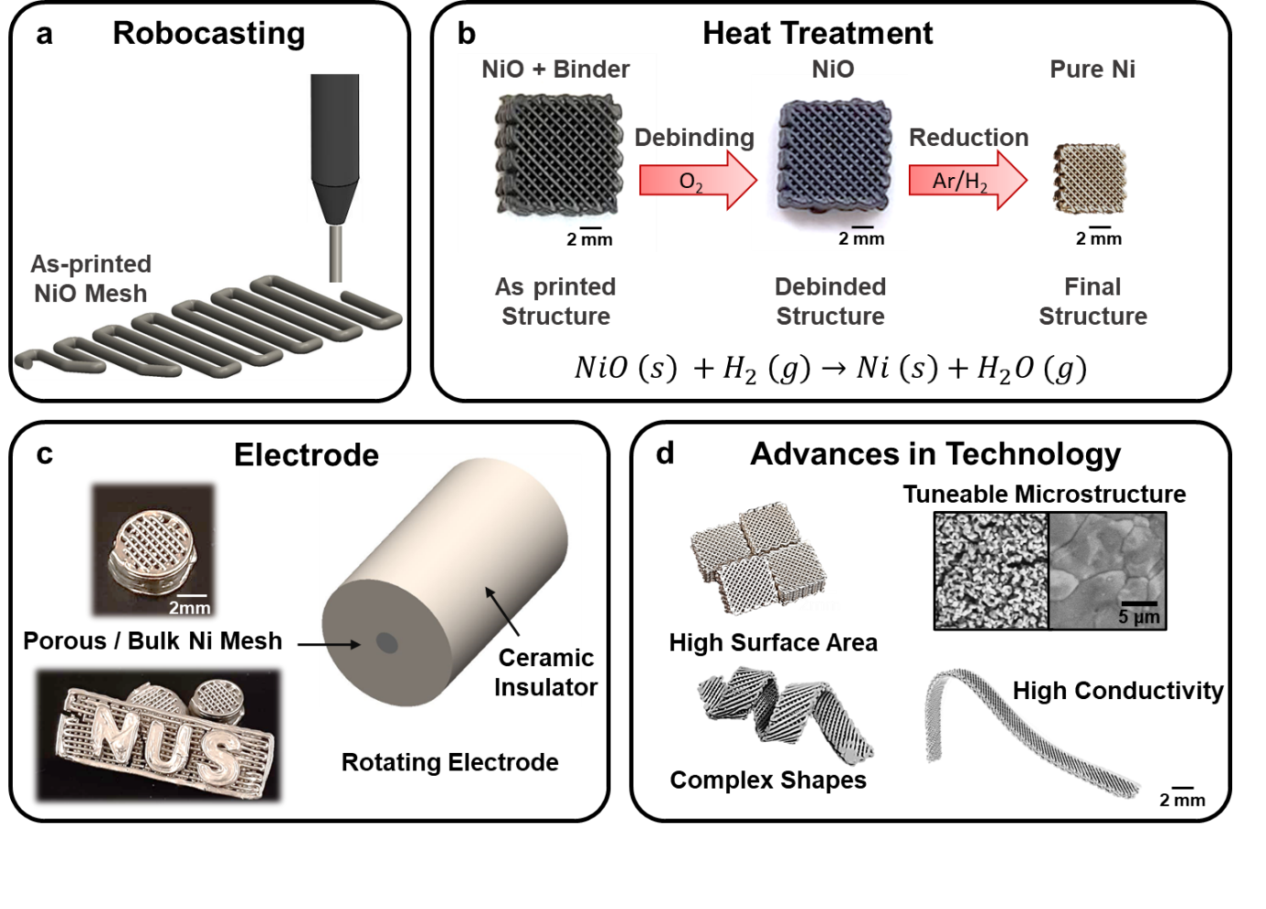
Figure 1. Schematic illustration of metallic alloy fabrication using self-curable technique and metallic oxides. (a) Robocasting (DIW), (b) modified post-printing heat treatment, (c and d) potential applications and advances in metal fabrication via DIW.

A self-curing-based epoxy system is used for the 3D printing of NiO structures. The NiO ink was formed based on our previously reported self-curing ink formulation. [16] PEGDE and ETH are utilized as the epoxide-amine self-curing polymeric backbone in this self-curing solidification reaction for the green body. DEG was added as a plasticizer which imparts flexibility to the green body due to the presence of intermolecular hydrogen bonding. The flexible green body enabled complex shaping for advanced applications. The self-curing NiO ink system was investigated for its rheological properties. The viscosity against shear rate was analyzed (Figure 2a). As the shear rate increases, viscosity decreases and vice versa. This shear-thinning flow behavior is essential for extrusion-based 3D printing. As the ink is pushed through the small nozzle orifice, there is an increase in shear rate. A low viscosity is needed for effective ink flow through the nozzle orifice. Similarly, as the ink is extruded and experiences a decrease in shear rate, high viscosity is needed to maintain the deposited 3D structure. The NiO ink displayed a linear viscoelastic region whereby the storage modulus was greater than the loss modulus until it yielded (Figure 2b). The apparent yield strength of the paste, given by the intersection of storage modulus and loss modulus, is 400 Pa. The high yield strength (more than 200 Pa) allows for the fabrication of free-standing and high aspect ratio structures. Thermogravimetric analysis (TGA) was also performed for the NiO 3D printing ink to determine its optimized post-printing heat treatment temperatures (Figure 2c). The first weight loss is due to the evaporation of DEG plasticizer (~20 wt%). Subsequently, at 300°C, PEGDE is burn-off (~5 wt%) and ETH is completely burn-off (~3 wt%) at 500°C. From TGA analysis, the NiO ink has a solid loading of 31.2 vol%. X-ray diffraction (XRD) was also performed to determine the phase of sintered structures (Figure 2d). The NiO powders used for the formulation of NiO ink were analyzed and matched to PDF #47-1049. After the NiO structures were printed and annealed under forming gas, the sintered Ni structures were analyzed for its phase under XRD. The XRD peaks in the sintered Ni structures correspond to Ni PDF 4-0850, showing a complete reduction of NiO to Ni during the heat treatment process conducted at 600ºC-1h, 600ºC-5h and 900ºC-1h.
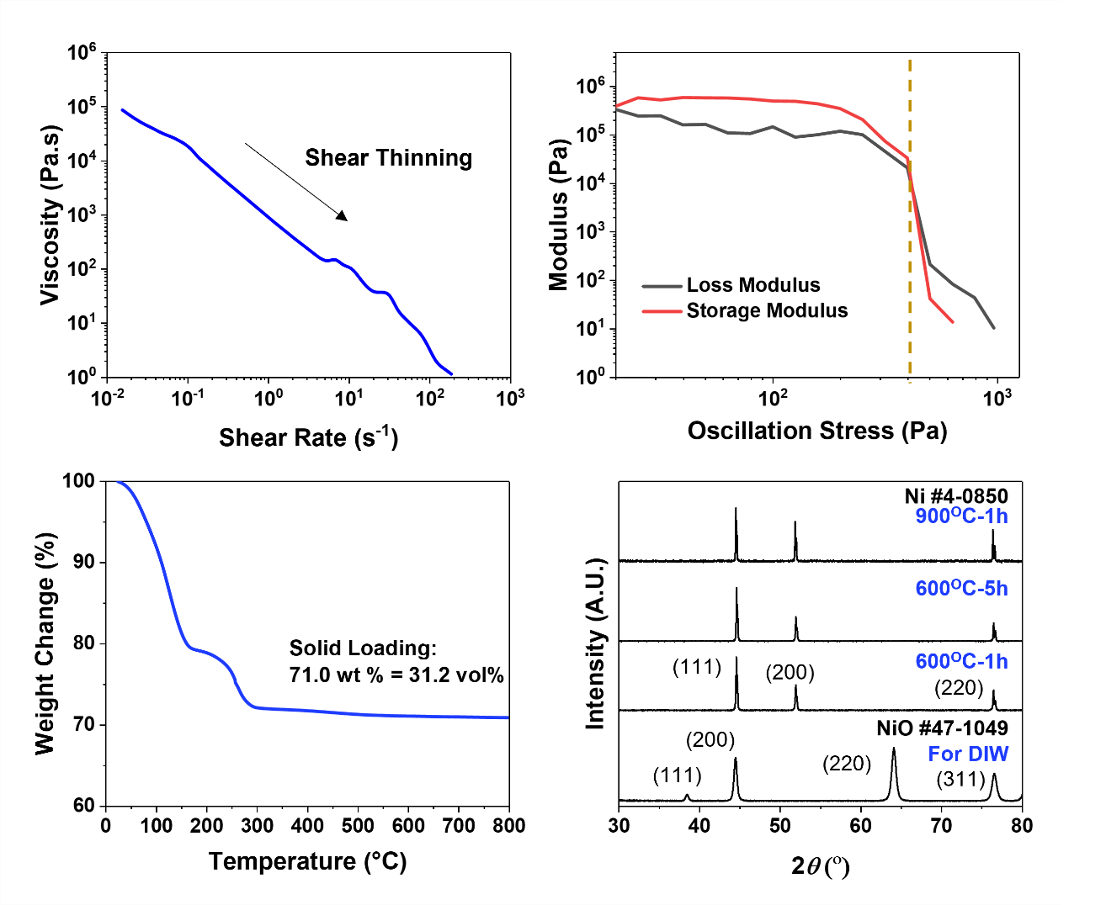
Figure 2. Optimization of manufacturing process. (a) Viscosity of NiO paste, (b) shear and loss modulus of NiO paste as a function of oscillation stress, (c) TGA curve of NiO paste, and (d) XRD spectrums obtained from NiO powder used for DIW process and 3D-printed Ni meshes after reduction heat treatment at 600^{O}C-1h, 600^{O}C-5h and 900^{O}C-1h .

  - Microstructure
The aim of having functional Ni structures focusing on different properties was achieved by tuning the microstructure of as-printed structures via post-printing heat treatments. Structural integrity without cracks and delamination was achieved in all the samples (Figure 3). The surface area of the final structures was modified while achieving porous or fully dense structures with variable grain morphologies. Increasing the reduction temperature while keeping the soaking time constant at 1 hour caused a decrease in porosity and growth in grain size. X-ray diffraction patterns proved that the applied heat treatments were sufficient to complete the reduction of NiO to Ni (Figure 2d). Although pure Ni structures were achieved by the treatments conducted at 600°C for 1 hour, the fully dense microstructure was observed in the samples treated at 900 and 1000°C for 1 hour. In addition to the effect of heat treatment temperature, the variation in soaking time was also investigated, focusing on fully dense samples obtained at 900 and 1000°C. Although both samples have fully dense microstructures, the samples attained at 900°C after 1 and 5 hours were particularly prioritized in this project in order to minimize the energy required to have Ni structures from NiO powders. Both XRD patterns and EDS images showed the completion of the reduction process of metallic oxides and the removal of any other compounds used during DIW (Figure 2d and 4). The grain size change in dense structures was revealed through statistical analysis. The average grain size of 8.2±1.3, 11.7±3.4 and 14.8±4.2 μm was measured from the samples reduced at 900°C for 1, 5, and 10 hours, respectively.
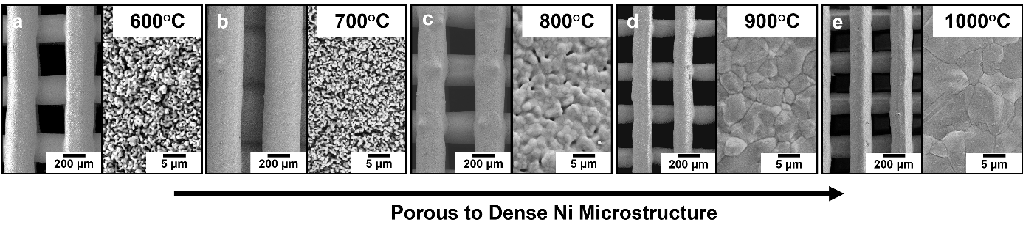
Figure 3. SEM images of robocasted Ni meshes subjected to systematic heat treatment studies. (a, b, c) Porous structures obtained by the reduction at 600, 700 and 800°C for 1 hour, and (d, e) Fully dense structures obtained by the reduction at 900 and 1000°C for 1 hour.

In addition to the grain size variations due to the change in treatment temperature and time, annealing twins and morphological changes were observed in the samples treated at 900°C (Figure 4a-b). Although some of these variations in microstructure, such as annealing twins, might create more active surfaces and boost the catalytic reactions[19], the final microstructure should be tailored considering both OER reactions and the printability of 3D structures. Oudriss et al. reported the significance of the grain size and the type of grain boundaries on the diffusion of hydrogen into pure Nickel structures [20]. The enlarged grains via prolonged heat treatments might improve the stability of 3D meshes by minimizing the hydrogen trapping sites; however, it causes a decrease in the OER performance of the structures. Therefore, the microstructure of 3D Ni meshes, considering the grain boundaries, should be tailored considering not only OER performance but also the detrimental effects of hydrogen embrittlement through the trapped atoms at grain boundaries.
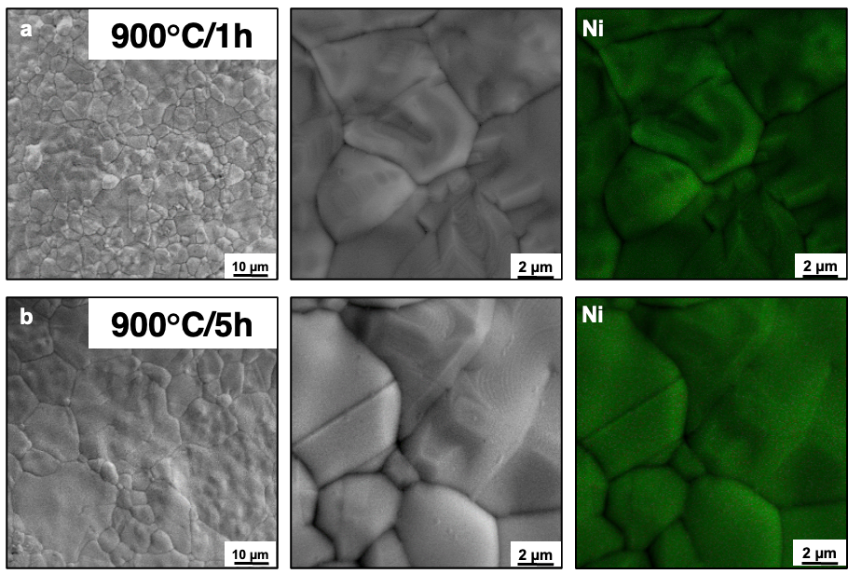
Figure 4. High magnification SEM images with corresponding EDS maps of 3D-printed Ni meshes subjected to heat treatment at 900°C for (a) 1 and (b) 5 hours.

  - Performance
3.2.1 Electrochemical Properties
As shown in the long-term chronoamperometric measurements with iR-compensation (Figure 5a), the 3D-printed porous Ni mesh electrode remains stable under the current density of 10 mA cm⁻² and shows no noticeable increase in potential over 50 h. While the 3D-printed fully dense Ni mesh electrode shows poor stability, the potential constantly increases from 1.7 V to 1.9 V (vs. RHE) with time. The electrochemical performance of the 3D-printed Ni samples that were sintered using different procedures was investigated using a typical three-electrode system. To make a comparison of OER activity of different temperature and time-sintered 3D-printed Ni samples, electrochemical performances of 600°C-1h, 600°C-5h, 900°C-1h, and 900°C-5h were tested. The 3DP-Ni mesh sintered at 600°C-1h required an overpotential of 222 mV at a current density of 10 mA cm⁻², which is lower than that of 600°C-5h sintered 3DP-Ni mesh (260 mV), 900°C-1h sintered 3DP-Ni mesh (370 mV), and 900°C-5h sintered 3DP-Ni mesh (414 mV), suggesting that 600°C-1h sintered 3DP-Ni mesh has the highest OER activity (Figure 5b).

A high electrochemically active surface area (ECSA) plays a crucial role in increasing the number of active sites and promoting OER activities. The ECSA can be estimated from the electrochemical double-layer capacitance of the catalytic electrode by measuring the non-faradaic capacitive current from cyclic voltammetry (CV) curves. Figures 5d–f show the CV curves of 600°C-5h sintered 3DP-Ni mesh, 900°C-1h sintered 3DP-Ni mesh, and 900°C-5h sintered 3DP-Ni mesh at different scan rates ranging from 10 to 80 mV s⁻¹. All three samples' CV curves had a rectangular form without any evident redox peaks (oxidation or reduction). The current densities of all three samples increased with increasing scan rates, which is indicative of a typical capacitive behavior. At all scan rates (15–50 mV s⁻¹), 600°C-5h sintered 3DP-Ni mesh exhibited the highest current density as compared to 900°C-1h sintered 3DP-Ni mesh and 900°C-5h sintered 3DP-Ni mesh, which suggested that 600°C-5h sintered 3DP-Ni mesh could achieve the highest ECSA based on its electrochemical double-layer (EDL) capacitance (more details in the Experimental section). Thus, EDL capacitances of all three samples were calculated from the gradient of the best fitted line (current density against the scan rate) (Figure 5c). Based on the calculation, the capacitances of 600°C-5h sintered 3DP-Ni mesh, 900°C-1h sintered 3DP-Ni mesh and 900°C-5h sintered 3DP-Ni mesh were 45, 0.49, and 0.62 mF cm⁻², respectively. Hence from this result, the attractiveness of 600°C-5h sintered 3DP-Ni mesh as an OER catalyst/catalyst scaffold due to its large ECSA is demonstrated, which is essential for the enhanced OER activity.

In addition, the surface wettability and bubble detachment behavior play a vital role in the catalytic performance as well. The results of wettability of 3D-printed NiO mesh sintered at 600ºC-1h, 600ºC-5h, and 900ºC-1h are shown in Supporting Video S1. All three samples demonstrated super hydrophilic properties, thus there was no water contact angle observed. Compared to planer samples, the above-mentioned three samples had excellent bubble detachment behavior, allowing for good catalytic performance efficiency [21]. There were no big bubbles observed and most small bubbles left the sample surface right after they were formed. The videos of the bubble detachment of 3D-printed NiO mesh sintered at 600ºC-1h, 600ºC-5h, and 900ºC-1h are shown in Supporting Video S2.
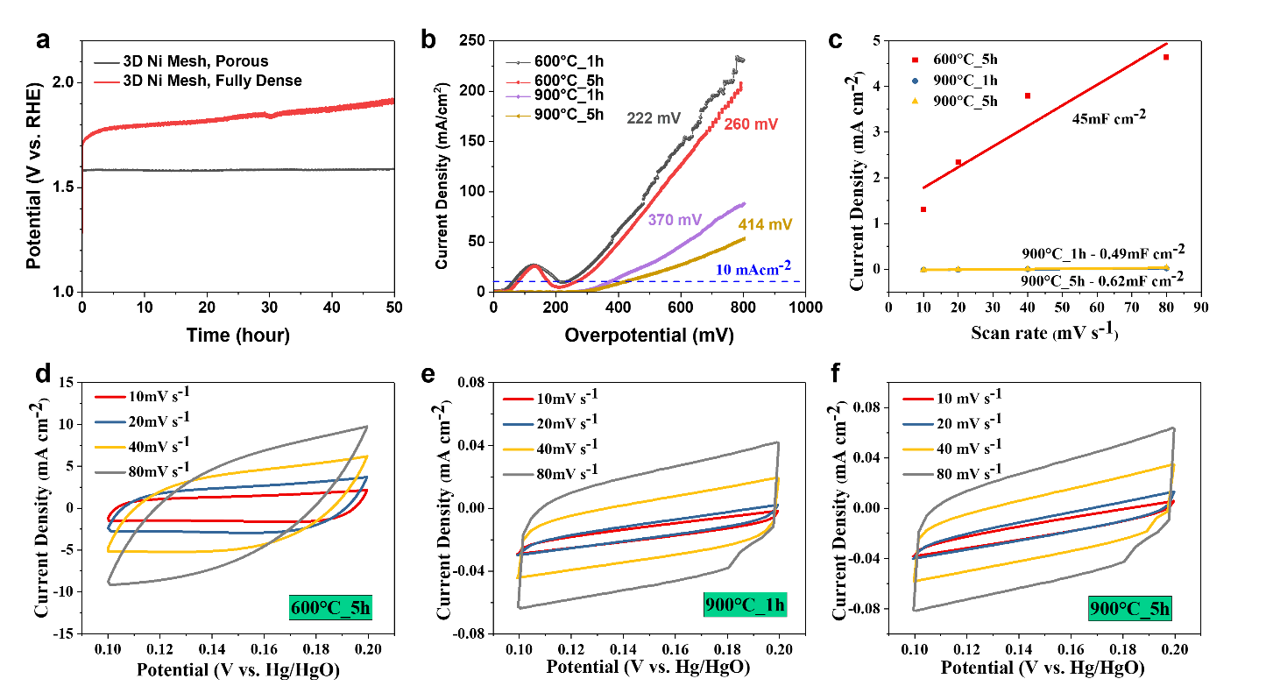
Figure 5. (a) Stability performance for porous and dense Ni meshes produced via robocasting, (b) Polarization curves of 3DP samples with iR correction at a scan rate of 10 mV s⁻¹, (c) Cathodic current measured at 0.14 V (vs. Hg/HgO) as a function of scan rate for 3DP samples, (d, e, f) Cyclic voltammograms of 3DP samples at different scan rates from 10 to 80 mV s⁻¹.

- Conclusions
In summary, a tailorable and efficient manufacturing technique has been utilized while producing functional 3DP-Ni meshes, specifically for oxygen evolution reaction (OER). 3DP-Ni meshes with modified heat treatments show tuneable porosity, leading to optimized catalytic performance for water-splitting. Highly dense and various porous Ni meshes were obtained and the respective electrochemical performances were examined in this work. With a heat treatment of 600°C-1h, the 3D Ni-mesh electrode achieved the maximum electrochemical surface area (ECSA), which results in the best OER performance of 222 mV at a current density of 10 mA cm⁻². The porous 3D Ni-mesh electrode shows promise water-splitting use on an industrial scale, with remarkable stability at 1.58V for 60 hours and adaptable 3D structure designs.

CRediT authorship contribution statement
Mehmet Cagirici: Investigation, conceptualization, writing – review & editing. Yanran Xun: Investigation, writing – review & editing. Danwei Zhang: Investigation, conceptualization, writing – review & editing. Xu Xi: Investigation, writing. Jun Ding: Supervision, fund acquisition.

Acknowledgments
The authors appreciated the financial support granted by Natural Science Foundation of Shaanxi Province (No.2023-JC-QN-0598), and High-end Foreign Expert Project.
References
[1] V. Vij, S. Sultan, A.M. Harzandi, A. Meena, J.N. Tiwari, W.-G. Lee, T. Yoon, K.S. Kim, Nickel-Based Electrocatalysts for Energy-Related Applications: Oxygen Reduction, Oxygen Evolution, and Hydrogen Evolution Reactions, ACS Catalysis 7(10) (2017) 7196-7225.
[2] F. Song, M.M. Busch, B. Lassalle-Kaiser, C.-S. Hsu, E. Petkucheva, M. Bensimon, H.M. Chen, C. Corminboeuf, X. Hu, An Unconventional Iron Nickel Catalyst for the Oxygen Evolution Reaction, ACS Central Science 5(3) (2019) 558-568.
[3] L. Yang, Z. Liu, S. Zhu, L. Feng, W. Xing, Ni-based layered double hydroxide catalysts for oxygen evolution reaction, Materials Today Physics 16 (2021) 100292.
[4] L. Li, X. Cao, J. Huo, J. Qu, W. Chen, C. Liu, Y. Zhao, H. Liu, G. Wang, High valence metals engineering strategies of Fe/Co/Ni-based catalysts for boosted OER electrocatalysis, Journal of Energy Chemistry 76 (2023) 195-213.
[5] Q. Shi, S. Fu, C. Zhu, J. Song, D. Du, Y. Lin, Metal–organic frameworks-based catalysts for electrochemical oxygen evolution, Materials Horizons 6(4) (2019) 684-702.
[6] X. Xu, C. Li, J.G. Lim, Y. Wang, A. Ong, X. Li, E. Peng, J. Ding, Hierarchical Design of NiOOH@Amorphous Ni–P Bilayer on a 3D Mesh Substrate for High-Efficiency Oxygen Evolution Reaction, ACS Applied Materials & Interfaces 10(36) (2018) 30273-30282.
[7] X. Lu, C. Zhao, Electrodeposition of hierarchically structured three-dimensional nickel–iron electrodes for efficient oxygen evolution at high current densities, Nature Communications 6(1) (2015) 6616.
[8] G. Barati Darband, N. Lotfi, A. Aliabadi, S. Hyun, S. Shanmugam, Hydrazine-assisted electrochemical hydrogen production by efficient and self-supported electrodeposited Ni-Cu-P@Ni-Cu nano-micro dendrite catalyst, Electrochimica Acta 382 (2021) 138335.
[9] M. Maleki, A. Sabour Rouhaghdam, G. Barati Darband, D. Han, S. Shanmugam, Highly Active and Durable NiCoSeP Nanostructured Electrocatalyst for Large-Current-Density Hydrogen Production, ACS Applied Energy Materials 5(3) (2022) 2937-2948.
[10] W.-Z. Li, M.-Y. Liu, L. Gong, M.-L. Zhang, C. Cao, Y. He, The electronic properties and catalytic activity of precious-metals adsorbed silicene for hydrogen evolution reaction and oxygen evolution reaction, Appl Surf Sci 560 (2021) 150041.
[11] Y. Shi, J. Li, B. Zhang, S. Lv, T. Wang, X. Liu, Tuning electronic structure of CoNi LDHs via surface Fe doping for achieving effective oxygen evolution reaction, Appl Surf Sci 565 (2021) 150506.
[12] M. Maleki, G. Barati Darband, A. Sabour Rouhaghdam, R. Andaveh, Z. Mohammad Kazemi, Mn-incorporated nickel selenide: an ultra-active bifunctional electrocatalyst for hydrogen evolution and urea oxidation reactions, Chemical Communications 58(21) (2022) 3545-3548.
[13] A. Kulshreshtha, S.K. Dhakad, Preparation of metal foam by different methods: A review, Materials Today: Proceedings 26 (2020) 1784-1790.
[14] A.E. Jakus, S.L. Taylor, N.R. Geisendorfer, D.C. Dunand, R.N. Shah, Metallic Architectures from 3D-Printed Powder-Based Liquid Inks, Advanced Functional Materials 25(45) (2015) 6985-6995.
[15] C. Kenel, N.P.M. Casati, D.C. Dunand, 3D ink-extrusion additive manufacturing of CoCrFeNi high-entropy alloy micro-lattices, Nature Communications 10(1) (2019) 904.
[16] D. Zhang, W. Jonhson, T.S. Herng, Y.Q. Ang, L. Yang, S.C. Tan, E. Peng, H. He, J. Ding, A 3D-printing method of fabrication for metals, ceramics, and multi-materials using a universal self-curable technique for robocasting, Materials Horizons 7(4) (2020) 1083-1090.
[17] C.C. McCrory, S. Jung, I.M. Ferrer, S.M. Chatman, J.C. Peters, T.F. Jaramillo, Benchmarking hydrogen evolving reaction and oxygen evolving reaction electrocatalysts for solar water splitting devices, Journal of the American Chemical Society 137(13) (2015) 4347-4357.
[18] Y. Li, C. Li, X. Zhang, Y. Wang, Y. Tan, S. Chang, Z. Chen, G. Fu, Z. Kou, A. Stefan, X. Xu, J. Ding, Incorporating Metal Precursors towards a Library of High-resolution Metal Parts by Stereolithography, Applied Materials Today 29 (2022) 101553.
[19] H.K. Park, H. Ahn, T.H. Lee, J.Y. Lee, M.G. Lee, S.A. Lee, J.W. Yang, S.J. Kim, S.H. Ahn, S.Y. Kim, C.-H. Lee, E.S. Park, H.W. Jang, Grain Boundaries Boost Oxygen Evolution Reaction in NiFe Electrocatalysts, Small Methods 5(2) (2021) 2000755.
[20] A. Oudriss, J. Creus, J. Bouhattate, E. Conforto, C. Berziou, C. Savall, X. Feaugas, Grain size and grain-boundary effects on diffusion and trapping of hydrogen in pure nickel, Acta Materialia 60(19) (2012) 6814-6828.
[21] R. Andaveh, G. Barati Darband, M. Maleki, A. Sabour Rouhaghdam, Superaerophobic/superhydrophilic surfaces as advanced electrocatalysts for the hydrogen evolution reaction: a comprehensive review, Journal of Materials Chemistry A 10(10) (2022) 5147-5173.

