Cavity-enhanced Sacrificial Layer Micromachining for Faster Release of Thin Film Encapsulated MEMS

Jae-Wung Lee*, Jaibir Sharma, Margarita Sofia Narducci, Srinivas Merugu, Zhang Xiao Lin, and Navab Singh
Institute of Microelectronics, A*STAR (Agency for Science, Technology and Research), 11 Science Park Road, Singapore 117685

E-mail: leejw@ime.a-star.edu.sg*

Abstract: This paper reports a method for fast-release and safe-sealing of Thin Film Encapsulation (TFE) for packaging of piezoelectric MEMS devices fabricated on cavity-SOI wafers. For fast releasing of the TFE, MEMS device trenches and the cavity below them were utilized and this combination acted as etch channels. Etchant can attack sacrificial layer from bottom of the MEMS device as well as side-located channels. Side-located etch channel scheme was chosen to ensure safe-sealing without mass-loading. 120 µm X 120 µm sized encapsulation on top of MEMS device with eight isolation trenches connected to the cavity was released in 25 minutes. This is twice as fast as the TFE fabricated on bulk wafer using a similar encapsulation scheme. This reduction in release time is a consequence of prefabricated cavity underneath the device which allows the etchant to attack the sacrificial layer at multiple locations as etchant can pass from one isolation trench to another.

Key words: Thin film encapsulation, packaging, MEMS, release time, cavity SOI wafer

- Introduction

Micro-electro-mechanical system (MEMS) devices received great attention in the last decade due to their cutting edge applications, including Combo-sensors, Pico-projectors and Spectrometers [1-2]. MEMS packaging with controlled ambient conditions is in high demand for providing proper operating conditions and protecting the MEMS devices from the harsh environments [3-4]. Packaging using bonding is a well-known technique and many commercial products are fabricated using this method.. However, bonding techniques are expensive in terms of die footprint due to the wide seal ring and wide dicing area requirements. This results in a reduction in the number of packaged devices per wafer [5-6].
Thin film encapsulation (TFE) is an alternative and attractive technique to wafer bonding as it helps in the reduction of the overall device thickness, seal ring area and cost due to the elimination of a cap wafer. To encapsulate MEMS devices, this technique utilizes surface micromachining processes including deposition, etching and release. However, TFE technique suffers from long release time and can introduce mass loading on MEMS devices during the sealing process. To address these issues, many different approaches have been explored by researchers and reported in the literature. These approaches are either based on the location of etch channels or the formation of pores (channels) in the cap layer to remove the sacrificial layer from TFE during release [7-12]. In one approach, the etch channels are distributed over the cap layer, as shown in Fig. 1 (a). The uniform distributions of etch holes in the cap layer result in a faster release time for TFE. However, it has a drawback of mass loading, because sealing material is deposited on the MEMS device through the etch holes as shown Fig. 1 (c) [7, 8]. The deposited material may cause damage to the MEMS device or change the response of the MEMS device. The mass loading is very critical for many devices, such as FBAR, Lamb wave resonator, since mass loading can change the operating frequency of these devices. In the second approach, etch channels are fabricated in the sidewall of the cap layer (sidewall located channel scheme) as shown in Fig. 1 (b). The sidewall located channel scheme helps in preventing the mass loading on the MEMS device during sealing process as shown in Fig. 1(d). However, this scheme’s drawback is longer release time. Long release time is due to long etching path from the sidewall to the center of the TFE, as shown in Fig 1(b) [9-11]. The problem of a long release time further aggravates on increasing the size of encapsulation. This long release time may limit choices of cap and sacrificial layer material; because long release time might increase the chance of the release etch attacking the cap layer or MEMS device materials during release process. In order to reduce the attacking of the cap layer and MEMS device materials, the release time should be decreased. The reduced release time will improve the throughput of the TFE process.
On the other hand, a porous cap layer with micro-or nano-etch holes may also be used to solve the above issues [13-15]. In these approaches, the nano- or micron-sized pores play a role of etch channels which help in fast removal of sacrificial layer and sealing of the TFE without mass loading on MEMS devices. However, the fabrication of porous structures is a very critical process and suffers from various issues, such as high temperature processing, complexity, and difficulty in controlling the etch hole size, which make this technique unsuitable as a cap layer in commercial products. At the same time, porous cap layer may also require supporting structures for enhancing its robustness for the TFE application. From the above discussion, it is evident that all of these methods suffer from either mass loading, long release time, or other issues such as complexity of process or controlling the size of pores. It can be concluded that there is a need for an innovative way or technique for fast release, safe sealing without mass loading and simple processing.
In order to solve each of the above issues in TFE simultaneously, we propose a modified approach of a side-located etch channel scheme for encapsulating the MEMS device fabricated with trenches on a cavity SOI wafer. In the proposed technique, uniformly distributed trenches in MEMS device and cavity under the MEMS device help in reducing release time of the TFE. This decrease in release time is attributed to the prefabricated cavity underneath the MEMS device which allows etchants to flow along all isolation trenches as well as along the side-located channels, and thus attack the sacrificial layer at multiple locations as shown in Fig. 2(a). Side-located etch channels help in safe sealing of TFE by avoiding sealing material falling on the MEMS device as shown in Fig. 2(b). This encapsulation technique was demonstrated by using amorphous silicon (a-Si) as a sacrificial layer and XeF₂ (SPTS Xactix XeF system) as a releasing method. The 120 µm x 120 µm cavity of 4 µm height with eight isolation trenches in the piezoelectric MEMS device was released in 25 minutes, which is twice as fast as the TFE fabricated on bulk wafer using the same encapsulation scheme. Also, the proposed technique can be used with other sacrificial materials and removal process.
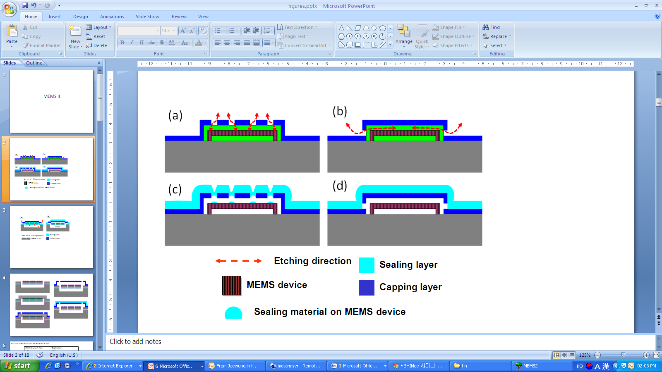
Fig. 1. Schematic diagrams of TFE with (a) uniformly distributed etch hole on the cap layer, (b) sidewall located etch channels and (c) mass loading on MEMS device during sealing (d) deposition of sealing layer for sidewall channel scheme

- Design and fabrication

Integrated Device Technology presented pMEMS resonator fabricated on cavity-SOI wafer followed by packaging using wafer bonding technology [16]. However, in this research, packaging of AlN based Lamb wave resonator on cavity-SOI wafer [17] was performed by TFE technology. Fig. 2 (a) and (b) show the schematic cross-section view of proposed TFE structure during release and after sealing process, respectively. The packaged MEMS device consists of an interdigitated top electrode arrays (checker-patterned) of Mo on piezoelectric AlN thin film which generates the acoustic wave. Eight uniformly distributed electroacoustic isolation trenches and cavity under the MEMS devices provide etch paths for rapid removal of the sacrificial layer as shown in Fig. 2 (a).
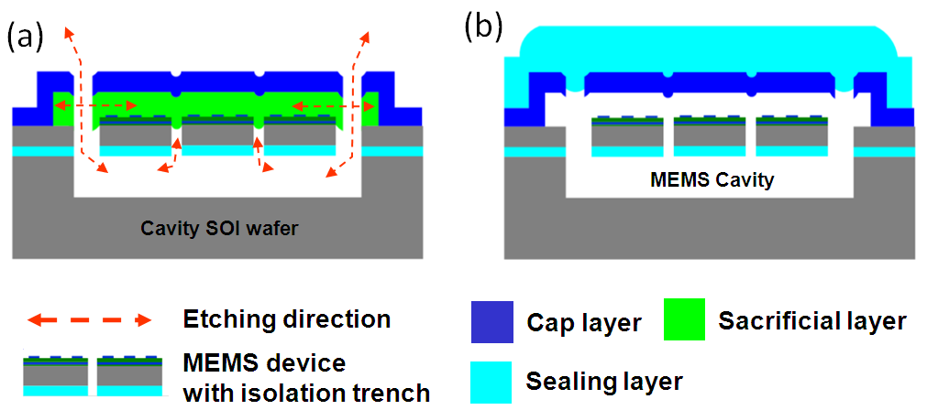
Fig. 2. (a) Cross-section view of proposed encapsulation scheme and (b) cross-section view after sealing the encapsulation
Once the side-located etch channels are connected to the cavity below the MEMS device, XeF₂ gas can reach the sacrificial layer through the isolation trenches from the bottom of the MEMS device as well as from sides of the encapsulation. This helps in faster and uniform removal of the sacrificial layer. Etch channels which are located outside the MEMS device prevent mass loading on the MEMS device during sealing process as shown in Fig. 2(b).
Table 1 shows possible choices of materials for demonstrating the proposed TFE. The selection of cap, sacrificial and sealing materials is very important for realization of the TFE as discussed above. Especially, the cap and the sacrificial layer selection needs more attention. For example, the cap layer material should not be etched during release process by the etchant. Therefore, the choice of the cap layer should be carefully determined. AlN was chosen for the cap layer because it is not etched during sacrificial layer removal. On the other hand, any material can be used as a sealing layer because the sealing layer will not be affected by the release process. However, deposition pressure of the sealing layer affects the pressure inside the cavity so deposition method should also be chosen carefully based on requirement of pressure inside the TFE for MEMS devices.

Table 1. Material selection according to releasing method
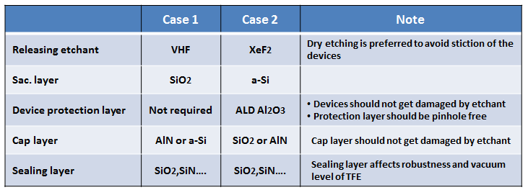

The encapsulated device comprises of five parts: 1) bottom cavity under the MEMS device (cavity SOI from Soitec), 2) MEMS devices fabricated on a cavity SOI wafer, 3) top cavity above the MEMS device, 4) cap layer and 5) sealing layer. The fabrication process flow for proposed TFE is shown in Fig. 3. First, 50 nm Al₂O₃ was deposited using Atomic Layer Deposition (ALD) to protect the MEMS device and cavity from XeF₂ attack during release process as shown in Fig. 3(a). Then, the top TFE cavity for the MEMS device was defined by depositing a 4 µm thick a-Si sacrificial layer using Plasma Enhanced Chemical Vapor Deposition (PECVD) technique and patterning it as shown in Fig. 3(b). This was followed by the deposition of a 1 µm SiO₂ cap layer using PECVD and its patterning. Fig. 3(c) shows the cross-sectional view of the device after SiO₂ cap layer patterning. This cap layer consists of etch holes near the periphery of the encapsulation to remove the a-Si sacrificial layer. After patterning the cap layer, the sacrificial layer was etched using XeF₂. This results in a released cap membrane encapsulating the MEMS device as shown in Fig. 3(d). The encapsulation was sealed by depositing a 3 µm thick SiO₂ layer using the PECVD technique as shown in Fig. 3(e). Finally, pads were opened for electrical testing of the MEMS resonator.
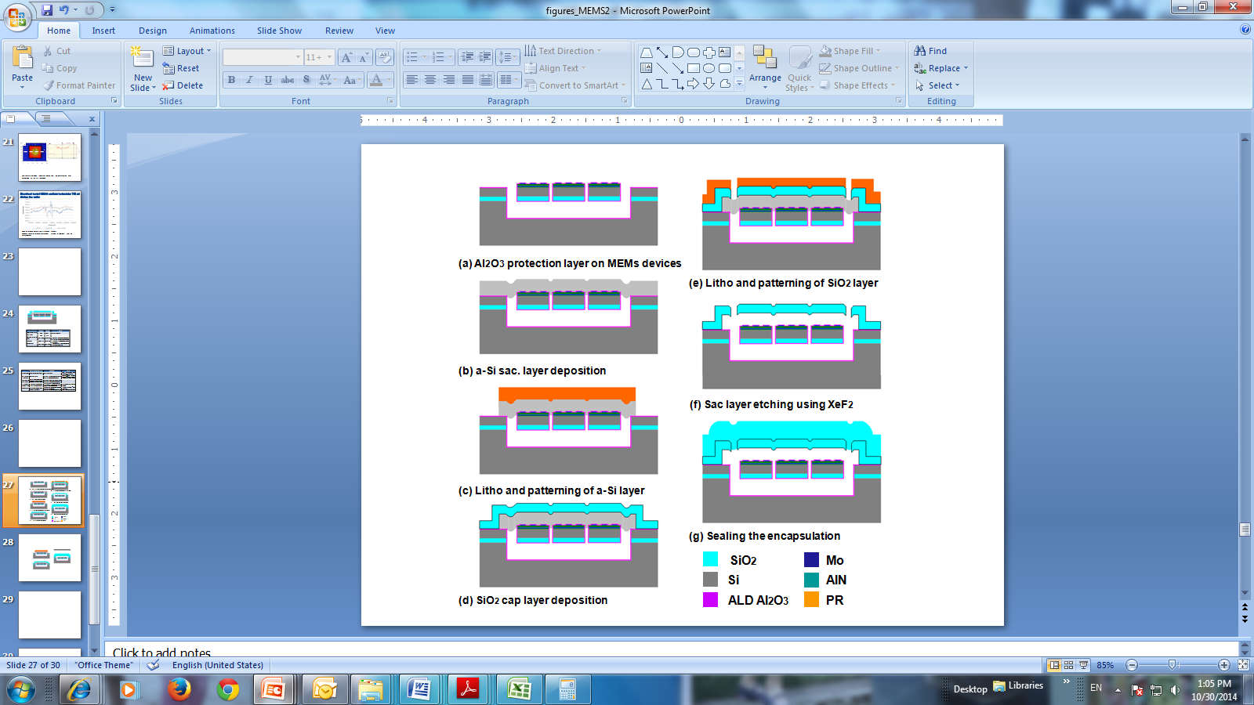
Fig. 3. Process flow diagram for the fabrication of encapsulation

Table 2 shows design guidelines for the proposed TFE scheme. The release time and thus the achievable acceleration factor depend on geometric quantities such as the ratio of the areas of the etch holes and of the trenches. In this manuscript, we propose the preliminary concept and results with a simple equation and guidelines. A model from theoretical considerations and systematic experimental validation will be communicated separately in the next technical report. Design of device trenches, etch holes in cap layer, sacrificial and sealing material is very important for realization of the TFE as discussed above. Device trenches affect process and release performance. If trench width is larger than 1 µm, covering of trenches with sacrificial layer will be difficult. Another important point on trench design is that trenches should be uniformly distributed with small pitch for fast releasing of TFE.
The sacrificial layer will define the gap between the encapsulation and the MEMS device. Thickness of the sacrificial layer should be thick enough so that bending of the encapsulation due to vacuum difference and/or bending of MEMS device due to stress after releasing should not result in touching of each other.
To decrease mass loading on MEMS devices, the etch holes should be located as far from the MEMS device as possible. Moreover, in order to seal the encapsulation easily, smaller size etch holes are preferred. Although smaller-size etch holes are preferred, small etch holes will hinder the efficient sacrificial layer etching. Overall, the etching will then also be limited by diffusion of etching species through the holes and to the etch front and of etch product from the etch front to the etch holes. As a consequence the etch time will be larger than following estimate.
$$T_{RE}≥\frac{P-T}{2X}$$
Where T_{RE} is release time, P is pitch between trenches, T is trench width and X is etching rate of sacrificial layer. However, this formula can only provide a lower estimate of the expected release time.
For robust TFE, a material with a high Young’s modulus and a thicker sealing layer is preferred. Vacuum level inside the TFE is generally decided by the sealing layer deposition method.

Table 2. Design guide line for the TFE
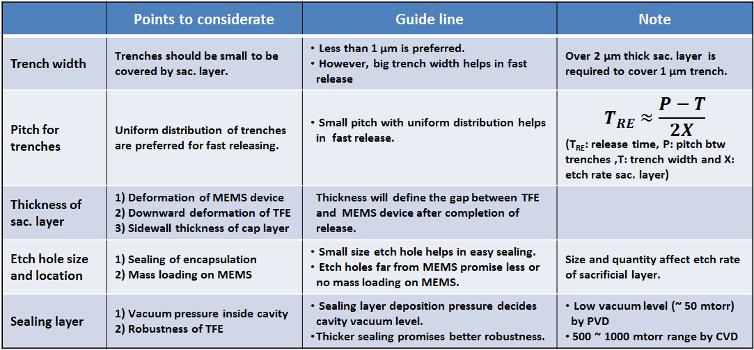

Results and discussion

Fig. 4 (a) and 4 (b) show optical images of 120 µm x 120 µm encapsulations after fifty cycles (each cycle is 30 sec) of XeF₂ release process for: a) MEMS device without cavity below it b) MEMS device fabricated on cavity SOI wafer, respectively. Fig. 4(a) clearly shows that there is a residual a-Si sacrificial layer at the center of TFE after fifty cycles of XeF₂ release process. However, Fig. 4 (b) shows that TFE fabricated for MEMS device on cavity SOI wafer is fully released after fifty cycles of XeF₂ release process. This shows that XeF₂ etched a-Si sacrificial layer through trenches in MEMS device in addition to side located channels. The remnant a-Si sacrificial layer in TFE without cavity was fully removed after an additional fifty cycles of XeF₂. This shows that cavity underneath MEMS device is very effective for reducing TFE release time. It should be noted that each MEMS device may require proper design and distribution of trenches in the MEMS device to effectively use the proposed scheme for reducing the release time. This reduction in release time may solve many complications of encapsulation during the release process such as attacking of the cap, device and isolation material by the etchant. This also allows designers to select many more materials for MEMS devices and TFE integration.
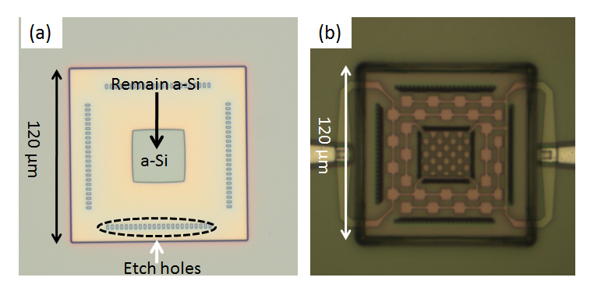
Fig. 4. Optical images of 120 µm x 120 µm encapsulation after 50 cycles of XeF₂ etch (a) Encapsulation without a cavity below it (b) Encapsulation covering MEMS device fabricated on a cavity SOI wafer.

Fig. 5(a) and 5(b) show surface profiler images of 120 µm x 120 µm encapsulations after the sealing process. Fig. 5(a) shows the top view of the encapsulation with white dotted line being the place where scan was performed. The deformation level of the TFE across the dotted line is shown in Fig. 5 (b) which shows a continuous downward deformation of the encapsulation from edge to the centre. The height of the TFE at the center was measured to be 3.1 µm which is 0.9 µm lower than the actual sacrificial layer thickness. This means 0.9 µm of downward deformation may be occurred after sealing process either due to pressure difference between inside and outside of encapsulation and/or stress between cap and sealing layers. After FIB cut, the 0.9 µm deflection disappeared due to equalisation of the pressure between cavity and outside. Therefore, downward deflection of 0.9 µm is mainly due to pressure difference. It should also be noted that the MEMS device is still safe as the encapsulation cavity height is 3.1 µm. This was further confirmed by FIB-SEM inspection.

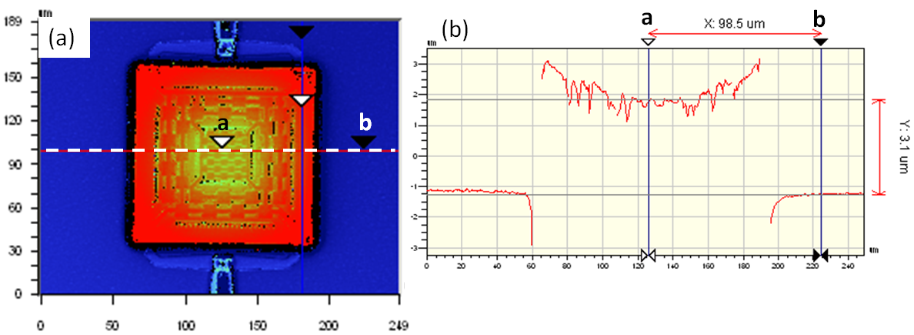
Fig. 5 Optical Surface profiler images of 120 µm x 120 µm size encapsulation after sealing (a) Top view (b) optical profiler data collected across the dotted line

Fig. 6 (a) and Fig. 6 (b) show SEM and optical microscope images of the TFE for MEMS oscillator discussed above. The SEM image shows surface topography created by the height difference of the Mo electrode, device trenches and etch holes. In these figures, etch holes can be seen outside the MEMS device. This is to prevent mass loading from the sealing process. Optical inspection was performed on the sample after release process to check release of the encapsulation and XeF₂ attack on Mo, as oxide is a transparent material. Fig. 6 (b) clearly shows that XeF₂ did not attack Mo during release since the thin Al₂O₃ layer was protecting it. Device damage from mass loading and/or XeF₂ release was further inspected by FIB-SEM and electrical testing.
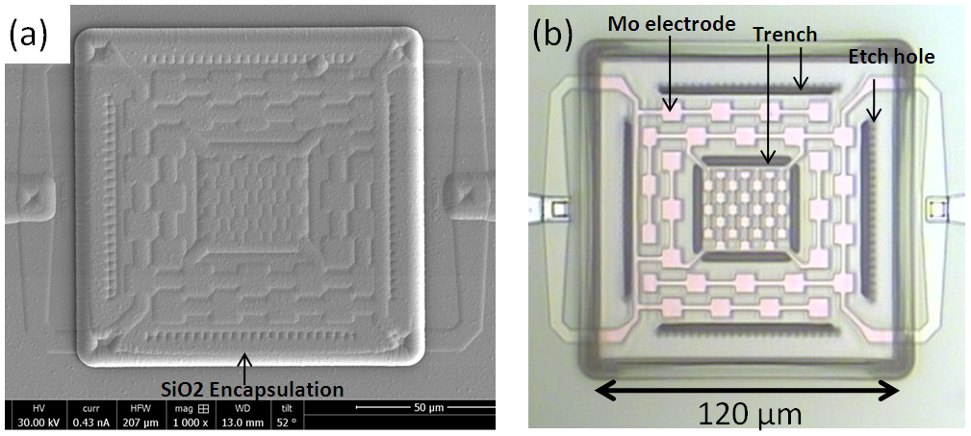
Fig. 6. Top view of encapsulated MEMS device: a) SEM image: Cannot reveal if sacrificial layer is completely etched as it only provide surface information; b) Optical microscope image: Can reveal if sacrificial layer is completely etched or not because encapsulation is optically transparent.

Fig. 7 shows the FIB-SEM cross-section image of the completed encapsulation at the edge of 120 µm x 120 µm size TFE after release and sealing process. In order to check the full release of TFE, FIB-SEM cut was selected at the edge of the cavity. This image clearly shows the TFE was released properly without any residues. Also, no damage on MEMS device was observed. This confirms 50nm ALD Al₂O₃ protects MEMS device and bottom cavity during XeF₂ release process. For this TFE demonstration, etch holes are located near exterior trenches of the MEMS device to keep the etch path shortest to the cavity under MEMS device. However, it should be noted that etch holes are not placed exactly on top of trenches to reduce mass loading during sealing process. Furthermore, safe sealing of MEMS device without mass loading can be guaranteed by placing etch holes further outside from MEMS device.
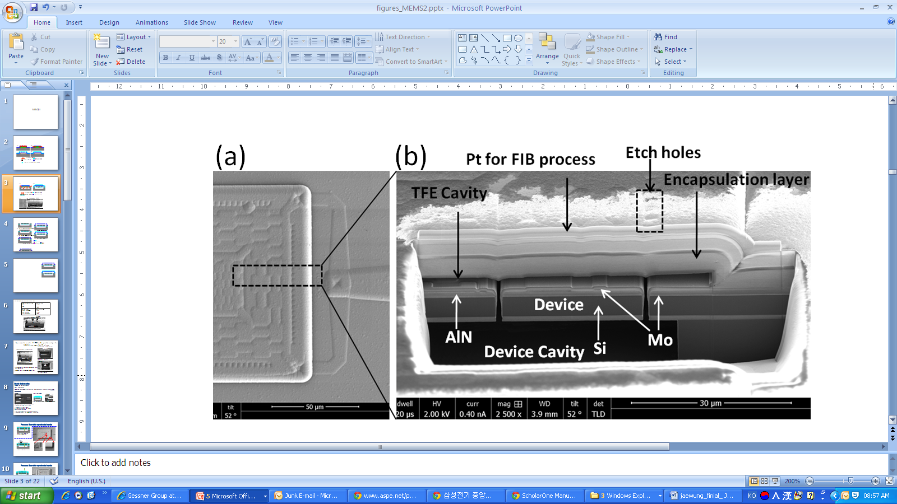
Fig. 7. a) Top view of 120x120 µm encapsulation covering MEMS device; Black dotted box shows area where FIB cut has been made; b) FIB-SEM cross-section image of the released encapsulation at the edge of 120 µm x 120 µm structures covering a MEMS device with trenches and cavity below it

In order to confirm hermeticity of the TFE, Confocal Scanning Acoustic Microscopy (C-SAM) measurement was performed after the sealing process. Fig. 8 shows the C-SAM image of the 120 µm x 120 µm TFE after release and sealing process. The white box in the C-SAM image shows that the cavity is hermetically sealed successfully. If the cavity has a leak, liquid can permeate inside cavity which results in the color changing from white to gray.
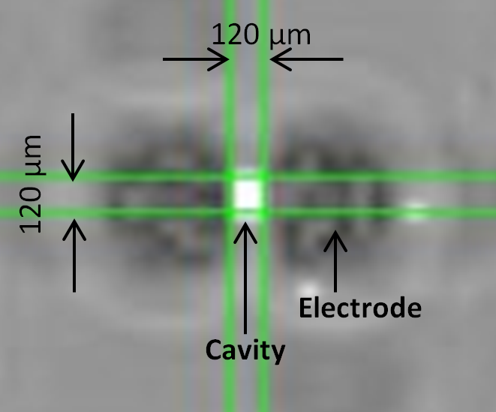
Fig. 8: C-SAM image of the 120 µm x 120 µm size TFE after release and sealing process.

Fig. 9 shows three different resonance curves of same checker-patterned resonator, which were obtained at three different stages: 1) before encapsulation, 2) after encapsulation and 3) after dicing of the encapsulated wafer. It can be observed that the series and parallel resonance peaks of the resonator have been shifted to lower frequencies after the device encapsulation. It should be noted that the signal magnitude is also reduced. These effects are due to the deposition of thin ALD Al₂O₃ protection layer which causes mass loading on the resonator device, as well as alteration of the acoustic wave velocity. However, mass loading from Al₂O₃ can be eliminated by a proper integration scheme. For example, proper selection of sacrificial material such as SiO₂, photoresist, polyimide, Ge etc. may help in eliminating the need of a protection layer since etchants for etching those materials cannot attack MEMS device materials.
There is no appreciable change in the performance of the devices after dicing. This shows that TFE is robust and can protect the encapsulated devices from dicing hazards. It should be noted here that the mass loading due to Al₂O₃ protection layer is controllable and can be included during design of the resonator device. However, the mass loading during the sealing process is un-controllable and difficult to include during the design of device. Hence, mass loading during the sealing process should be avoided which has been taken care of in this TFE scheme.
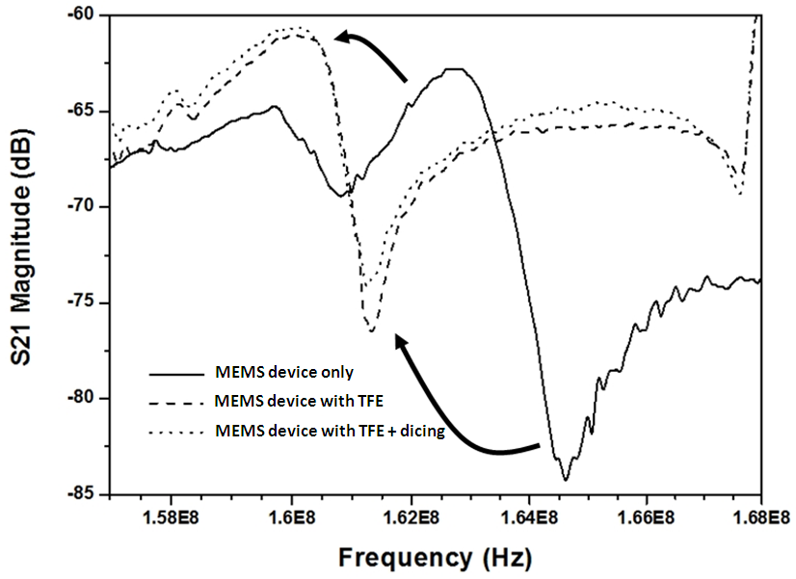
Fig. 9: Three different resonance curves of same checker-patterned resonator obtained at three different steps: 1)
MEMS device only, 2) MEMS device with TFE and 3) after dicing of encapsulated MEMS device

- Conclusion

In this work, thin film encapsulation was performed on piezoelectric MEMS devices fabricated with isolation trenches on a cavity SOI wafer. In addition to side-located etch channels in the cap layer, well-distributed trenches connected to the cavity below the MEMS device were utilized for fast releasing of the encapsulation. Side-located etch channels also help in reducing mass loading during the sealing process. The experimental results show a two-times reduction in release time for 120 µm X 120 µm sized TFE using cavity SOI wafer, in comparison to TFE fabricated on bulk wafer using the same encapsulation scheme. This decrease in release time is attributed to the prefabricated cavity underneath the device which allows etchants to flow through all isolation trenches in addition to side-located channels, and thus attack the sacrificial layer at multiple locations. This scheme can be more effective in reducing the release time for larger TFEs. This scheme is successfully demonstrated for encapsulation of the checker-patterned MEMS resonator on a smart SOI wafer. Electrical measurement results shows that device performance is not changed after dicing. Hence, it proves that the proposed encapsulation scheme protects the MEMS device from mass loading during sealing process and from dicing hazards.

References:
- Mohamed G. H., The MEMS handbook, 2nd ed., New York, USA: Taylor & Francis, 2002.
- Perlmutter M. and Robin L. 2012 High-Performance, Low cost Inertial MEMS: a Market in Motion! Position Location and Navigation Symposium (PLANS), pp.225-229
- Tummala R. R. and Rymaszewski E. J., 1989 Microelectronics Packaging Handbook, 2nd ed., Massachustts, USA: Kluwer Academic Publishers
- Najafi K. 2003 Micropackaging Technologies for Integrated Microsystems: Applications to MEMS and MOEMS, Micromaching and Microfabrication process Technology VII, Proc. Of SPIE Vol. 4979, pp.1-19.
- Partridge A., Lutz M., Kim B., Hopcroft M., Candler R.N., Kenny T.W., et al. 2005 MEMS resonators: getting the packaging right, in: SEMICON-Japan
- Stark B. H. and Najafi K. 2004 A low-temperature thin-film electroplated metal vacuum package, J. Microelectromech. Syst., vol. 13, pp. 147–157
- Lindroos V., Tilli M., Lehto A. and Motooka T., 2010 Handbook of Silicon Based MEMS Materials and Technologies, 1st ed., Elsevier, chap 38, pp. 569-574
- Colgan E. G., Furman B. K. and Jahnes C. V., Apparatus and methods for encapsulating Microelectromechanical (MEM) devices on a wafer scale, US patent,# 7,344,907 B2
- Pornin J. L., Gillot C., Parat G., Jacquet F., Lagoutte E., Sillon N., Poupon G., Dumont F. 2007 Wafer Level Thin Film Encapsulation for BAW RF MEMS, Electronic Components and Technology Conference, pp. 605-609
- Gillot C., Pornin J.L., Amaud A., Lagoutte E., Sillon N., Souriau J.C. 2005 Wafer Level Thin Film Encapsulation for MEMS,” Electronic Components and Technology Conference ,pp. 243-247
- O’Mahony C., Hill M., Olszewski Z., Blake A. 2009 Wafer-level thin-film encapsulation for MEMS, Microelectronic Engineering vol. 86, pp. 1311–1313
- Lee J.-W., Sharma J., Singh N. and Kwong D.-L. 2013 Development and evaluation of a two-level functional structure for the thin film encapsulation, J. Micro. M. vo.l 23 (7), pp. 075013
- Rico R.H., Bois B. Du, Witvrouw A., Van Hoof C., Celis J.-P. 2007 Fabrication of porous membranes for MEMS packaging by one-step anodization in sulfuric acid , J. Electrochem. Soc. 154 ( 9 ) K74 – K78
- Zekey J., Tezcan. D. S., Celis J.-P., Puers R., Van Hoof C., and Tilmans H.A.C. 2011 Wafer-Level Thin Film Vacuum Packages for MEMS using Nanoporous Anodic Alumina Membrane, Actuators and Microsystems Conference (16TH TRANSDUCERS 2011), pp. 975-977
- Lee J.-W., Wang W.-S., Sharma J., Lin Y.-C. and Singh N. 2013 Nano Porous Gold as a Capping Layer for Thin Film Encapsulation, J. Microelectromech. Syst. vol 22(5), pp.998-1000
- Bhugra H., Lee S., Pan W., Pai M. and Lei D. 2014 Commercialization of World’s First PiezoMEMS Resonators for High Performance Timing Applications, IEEE MEMS conference, pp. 204-205
- Campanella H., Khine L., Tsai J. M. 2013 Aluminum Nitride Lamb-Wave Resonators for High-Power High-Frequency Applications IEEE Electron Device Letters 34, pp. 316-318

Figures Caption:

Fig. 1 Schematic diagrams of TFE with (a) uniformly distributed etch hole on the cap layer, (b) sidewall located etch channels and (c) mass loading on MEMS device during sealing (d) deposition of sealing layer for sidewall channel scheme

Fig. 2. (a) Cross-section view of proposed encapsulation scheme and (b) cross-section view after sealing the encapsulation

Fig. 3. Process flow diagram for the fabrication of encapsulation

Fig. 4. Optical images of 120 µm x 120 µm encapsulation after 50 cycles of XeF₂ etch (a) Encapsulation without a cavity below it (b) Encapsulation covering MEMS device with a cavity below it.

Fig.5 Optical Surface profiler images of 120 µm x 120 µm size encapsulation after sealing(a) Top view (b) optical profiler data collected across the dotted line

Fig.6. Top view of encapsulated MEMS device: a) SEM image: Cannot reveal if sacrificial layer is completely etched as it only provide surface information; b) Optical microscope image: Can reveal if sacrificial layer is completely etched or not because encapsulation is optically transparent.

Fig.7. a) Top view of 120x120 µm encapsulation covering MEMS device; Black dotted box shows area where FIB cut has been made; b) FIB-SEM cross-section image of the released encapsulation at the edge of 120 µm x 120 µm structures covering a MEMS device with trenches and cavity below it

Fig. 8: C-SAM image of the 120 µm x 120 µm size TFE after release and sealing process.

Fig.9: Three different resonance curves of same checker-patterned resonator obtained at three different steps: 1) Res: before encapsulation, 2) Res TFE: after encapsulation and 3) Res TFE +dicing: after dicing of the encapsulated wafer

Figures
Fig. 1 Schematic diagrams of TFE with (a) uniformly distributed etch hole on the cap layer, (b) sidewall located etch channels and (c) mass loading on MEMS device during sealing (d) deposition of sealing layer for sidewall channel scheme

Fig. 2. (a) Cross-section view of proposed encapsulation scheme and (b) cross-section view after sealing the encapsulation

Fig. 3. Process flow diagram for the fabrication of encapsulation

Fig. 4. Optical images of 120 µm x 120 µm encapsulation after 50 cycles of XeF₂ etch (a) Encapsulation without a cavity below it (b) Encapsulation covering MEMS device with a cavity below it.

Fig.5 Optical Surface profiler images of 120 µm x 120 µm size encapsulation after sealing(a) Top view (b) optical profiler data collected across the dotted line

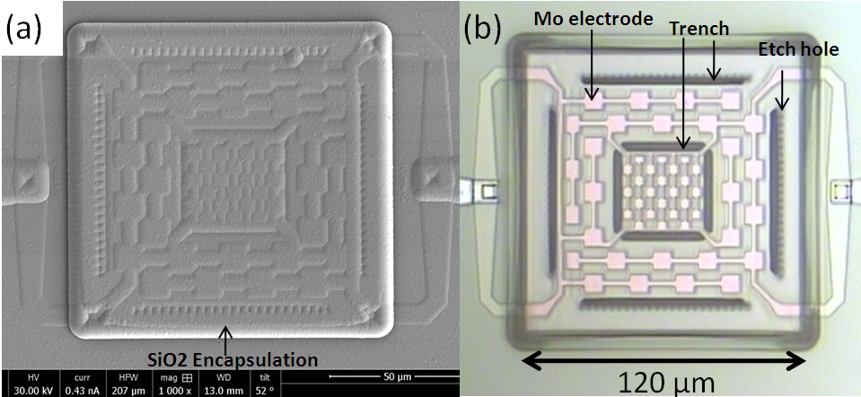
Fig.6. Top view of encapsulated MEMS device: a) SEM image: Cannot reveal if sacrificial layer is completely etched as it only provide surface information; b) Optical microscope image: Can reveal if sacrificial layer is completely etched or not because encapsulation is optically transparent

Fig.7. a) Top view of 120x120 µm encapsulation covering MEMS device; Black dotted box shows area where FIB cut has been made; b) FIB-SEM cross-section image of the released encapsulation at the edge of 120 µm x 120 µm structures covering a MEMS device with trenches and cavity below it

Fig. 8: C-SAM image of the 120 µm x 120 µm size TFE after release and sealing process.

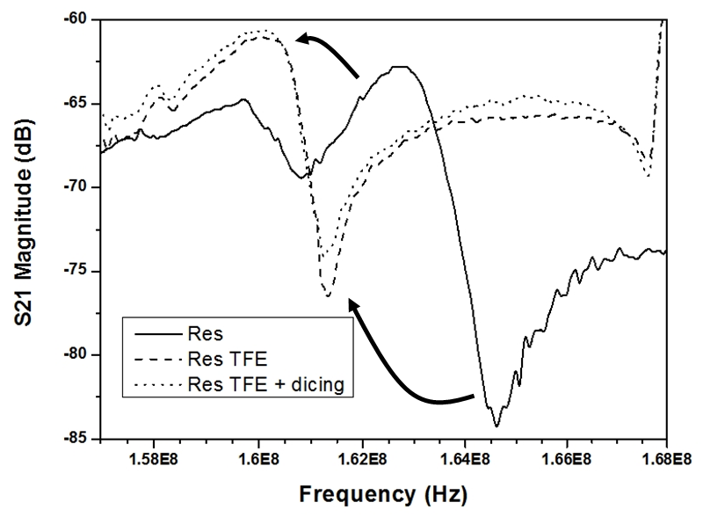

Fig.9: Three different resonance curves of same checker-patterned resonator obtained at three different steps: 1) Res: before encapsulation, 2) Res TFE: after encapsulation and 3) Res TFE +dicing: after dicing of the encapsulated wafer

