Unveiling the critical role of rheology modifiers in additive manufacturing of geopolymers and their mechanical properties
Siqi Ma a, ^{b}, Shuai Fu ^{c}, Tingting Yang ^{d}, Ke Li ^{e}, Guoliang Chen ^{a, b}, Qiuzuo Dong ^{f}, Peigang He ^{a, b,} *, Zhenlin Sun ^{g}, Xiaoming Duan ^{a, b}, Dechang Jia ^{a, b}, Paolo Colombo ^{h, i}, Yu Zhou ^{a, b}
ª Institute for Advanced Ceramics, School of Materials Science and Engineering, Harbin Institute of Technology, Harbin 150001, China
^{b} Key Laboratory of Advanced Structural–Functional Integration Materials & Green Manufacturing Technology, Harbin Institute of Technology, Harbin 150001, China
^{c} Max Planck Institute for Polymer Research, Mainz 55122, Germany
^{d} School of Electrical Engineering, Hebei University of Technology, Tianjin 300130, China
^{e} Institute of Materials Research and Engineering, A*STAR (Agency for Science, Technology and Research), Singapore, 138634, Singapore
^{f} School of materials science and engineering, Harbin Institute of Technology, Harbin, China
^{g} AECC Dongan Engine, Harbin 150066, China
^{h} Department of Industrial Engineering, University of Padova, Padova 35122, Italy
^{i} Department of Materials Science and Engineering, The Pennsylvania State University, Philadelphia 16802, USA

Abstract
Optimal selection of rheology modifiers is a crucial prerequisite for designing ideal geopolymer inks for high-precision material extrusion (ME). In this study, we shed light on this issue by exploring two-component rheology modifiers systems for ME, including Triton+Kaolin, Polyethylene Glycol (PEG)+Kaolin, and Polyvinyl Alcohol (PVA)+Kaolin. We find that the type and dosage of rheology modifiers are versatile control knobs for fine-tuning the printing open time and mechanical properties of actual printed Na-based geopolymers. By carefully adjusting the rheology modifier dosage, the printing open time of Na-based geopolymers can be extended to 180 mins. Fluid simulations reveal that the ink viscosity plays a key role in determining printing accuracy by affecting the pressure concentration stage during extrusion. Furthermore, the mechanical properties of geopolymers with the same rheology modifier composition gradually decreased with increasing printing open time. At 0 min printing open time, Na-based geopolymer containing 10% Kaolin + 1.25% Triton shows the highest compressive strengths of 68.6±2.7 MPa. The Triton-Kaolin rheology modifier combination demonstrates universality in rheological control of Na⁺, K⁺, and Cs⁺ based geopolymer inks, with the corresponding minimum slump rates of 0.7%, 0.4%, and 0.8%, respectively. Our findings provide clear guidelines for the design of high-quality metakaolin-based geopolymer inks for ME, crucial for their practical application and sustainable development.
Keywords: Material extrusion; Geopolymer; Rheology modifier; High-precision printing; Printing open time.

1. Introduction
The advent of 3D printing technology has revolutionized the design and production of matter, unleashing unprecedented potential across numerous industries [1-5]. Geopolymers, a class of materials with exceptional properties, have attracted considerable attention in the field of additive manufacturing [6-9]. Previous research has demonstrated that 3D-printed geopolymers offer a vast array of possibilities in applications such as innovative structural materials, sustainable construction components, and advanced adsorbents [10-13]. As an essential subcategory of 3D printing, material extrusion (ME) fabrication has emerged as the dominant method for geopolymer ink-based 3D printing due to its cost-effectiveness, extensive material compatibility, adaptability, and resource-saving features [14-17]. However, unlike other 3D printing techniques, ME fabrication of geopolymers also imposes stringent requirements on the shear-thinning properties, specific yield stress, and modulus of the inks used. Furthermore, geopolymer inks are reactive feedstocks whose rheology changes over time, affected by the degree of geopolymerization and several other parameters (i.e., composition, temperature, water content) [18-20]. These requirements contribute to system complexity and challenge the standardization of geopolymer inks, further emphasizing the need for continued research and development in this domain to explore control knobs for fine-tuning the printing process and product performance [21, 22].
Since Colombo and Franchin pioneered the development of intricate and structurally robust geopolymer samples through ME fabrication [23], a plethora of in-depth studies have emerged in recent years, concentrating on geopolymer composition design and structural regulation [24-26]. These investigations have systematically elucidated the interdependencies among specific geopolymer constituents - such as the Si/Al ratio, water content, alkali metal ion type, aggregate content, and printing parameters - and the open printing time, rheological properties, hardening characteristics, and mechanical properties [12, 20, 24, 25, 27-30]. Ingeniously, numerous research efforts have endowed geopolymers and their composites with unique mechanical properties and application contexts by crafting a diverse array of complex topological structures, encompassing catalytic, adsorptive, and membrane materials [31-34]. Although these studies have provided valuable insights into the advancement of 3D-printed geopolymers, gaps remain in large-scale practical implementation [35, 36].
As an essential aspect of rheological control in 3D-printed geopolymers, the importance of rheology modifiers is self-evident [37, 38]. Although they are used in small quantities, they play a critical role in the high-precision printing of geopolymers [39, 40]. At present, there are many kinds of rheology modifiers used in geopolymer inks, including Triton X-100, Tween-80, PEG, PVA, bentonite, Kaolin, fly-ash, glycerol, carboxymethyl cellulose, and nano-clay, all of which have specific effects on the rheological performance control and high-precision printing [20, 29, 31, 38, 41, 42]. Nonetheless, using the above rheology modifiers alone to control the rheology of geopolymer inks often results in poor mechanical properties of printed samples or requires high doses of rheology modifiers [24]. Moreover, the introduction of fibers or particles has been shown to be an alternative strategy to modify the rheology (especially yield stress) of geopolymer inks without affecting other important features such as the specific surface area of the printed products [35, 43, 44]. Nevertheless, clear grounds or design criteria governing the rheology of geopolymer inks remain elusive, causing 3D printing of geopolymers to stagnate at the laboratory stage [22, 36]. Moreover, there is still a lack of protocol defining the dosage and proportion of rheology modifiers, preventing 3D printing of geopolymers from obtaining clear operational guidelines and usage instructions akin to cement materials [45, 46]. Consequently, it is imperative to elucidate the impacts of rheology modifier type, dosage, and synergistic interactions on geopolymer ink open printing time, rheology, and mechanical properties of printed products to facilitate the long-term evolution and adoption of printable geopolymer inks [35, 46, 47].
In this investigation, we report a new degree of freedom to fine-tune ME fabrication of geopolymers by exploiting the synergistic effects of two-phase rheology modifier systems (with variable dosage and type). We reveal the substantial impact of rheology modifiers - Triton X-100, PEG, and PVA - with Kaolin, on the printing accuracy, open printing time, and mechanical properties of geopolymer materials, providing key insights into the rational selection of rheology modifiers and paving the way for large-scale production. This study provides comprehensive guidance for scientists and engineers seeking to optimize the performance of 3D-printed geopolymer products through the use of rheology modifiers.

2. Experiments and methods

2.1. Preparation of geopolymer inks
The raw materials used in the synthesis of geopolymer inks included NaOH (Tianjin Tianli Industrial, China), KOH (Tianjin Tianli Industrial, China), CsOH (Tianjin Tianli Industrial, China), Sol-silica (Jiangsu Xiagang Industrial, China), Kaolin (KL, Fengxian Reagent Factory, China), Triton X-100 (TRT, Tianjin Guangfu Industrial, China), Polyethylene glycol (PEG, average molecular weight: 800, Shanghai Aladdin Biochemical Technology Co., Ltd, China), and Polyvinyl alcohol (PVA, alcoholysis degree: 98.0-99.0 mol%, Shanghai Aladdin Biochemical Technology Co., Ltd, China).
As depicted in Fig. S1, the particle size distribution (PSD) of the Kaolin raw powder spans from 0.3 to 20.0 μm (with D₁₀ being 1.14 μm, D₅₀ being 3.27 μm, and D₉₀ being 8.08 μm, where D represents particle diameter). The Sol-silica used in this research is a colloidal solution formed by dispersing amorphous SiO₂ particles with sizes of 10-20 nm in water. The physical parameters of commercial Sol-silica are listed in Table 1.
Table 1 Physical parameters of Sol-silica
Particle size (nm) | SiO₂ content (%) | NaO₂ content (%) | Density  (g/cm³) | Viscosity (mPa·s) | pH level
10-20 | 40.0-41.0 | ≤0.04 | 1.15-1.17 | 2.8-6.0 | 8.5-10.5

Fig. 1 displays a schematic of the geopolymer ink synthesis process for material extrusion. First, metakaolin was obtained by calcining Kaolin at 800 °C for 2 hours in an air atmosphere. Meanwhile, different alkaline activator solutions (sodium silicate, potassium silicate, cesium silicate solutions) were prepared by mixing ROH (R = Na, K, or Cs) powder with Sol-silica solution and stirring magnetically for 3 days to ensure thorough reaction [8, 48]. Subsequently, metakaolin was incorporated into the alkaline solution by stirring for 20 minutes, forming a homogeneous geopolymer ink with pre-determined chemical composition (SiO₂/Al₂O₃=4.0, R₂O/SiO₂=0.25, and H₂O/R₂O=10). To fine-tune the rheological properties of the geopolymer inks, the indicated amounts of additives (TRT/PEG/PVA and Kaolin) were introduced and mixed for 5 minutes. Specimens were named based on the alkaline solution and additives used in their synthesis. For instance, Na-KL10TRT1.25 refers to the specimen prepared with NaOH as the alkaline solution, with 10 wt% Kaolin and 1.25 wt% Triton as additives (relative to the total content of geopolymer). In this investigation, the focus was on the printing open time of Na-based geopolymers (NaGP). To ensure the universality of the selected rheology modifiers, K-based (KGP) and Cs-based (CsGP) geopolymer inks were also synthesized for validation and control measurements.
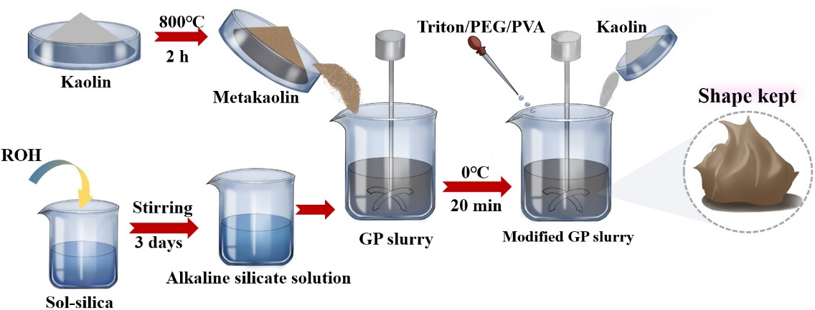
Figure 1. Schematic illustration of geopolymer ink preparation.
A commercial 3D printer (Ultimaker extend 2⁺ Connect) was adapted for material extrusion of geopolymers. The extrusion pressure was supplied by a pressure pump system and controlled by a pressure controller, as illustrated in Fig. 2a. Material extrusion was performed on glass substrates (coated with PTFE films) to prevent cracking of 3D-printed products during drying. The charging cylinder was 30 mL, the printing needle diameter was 600 μm, and the extrusion pressure was set at 15 - 80 psi (about 1×10⁵ – 5×10⁵ pa). The inks were extruded at room temperature (25 °C) immediately after mixing.
The printability of the ink was primarily assessed by fabricating a six-hole honeycomb structure and determining its slump rate [24]. The specific dimensions of the honeycomb model were as follows: the average upper surface area (contact area with the compression plate) of the honeycomb structure was 300 mm², while the width, overall height, and wall thickness of the specimens were 30 mm, 10 mm, and 1.5 mm, respectively. Utilizing the adapted 3D printer and as-synthesized Na-based geopolymer inks (modified by Triton-Kaolin rheology modifiers system), a series of high-quality geopolymer products featuring complex structures and patterns were successfully printed, as partially shown in Fig. 2b-g.
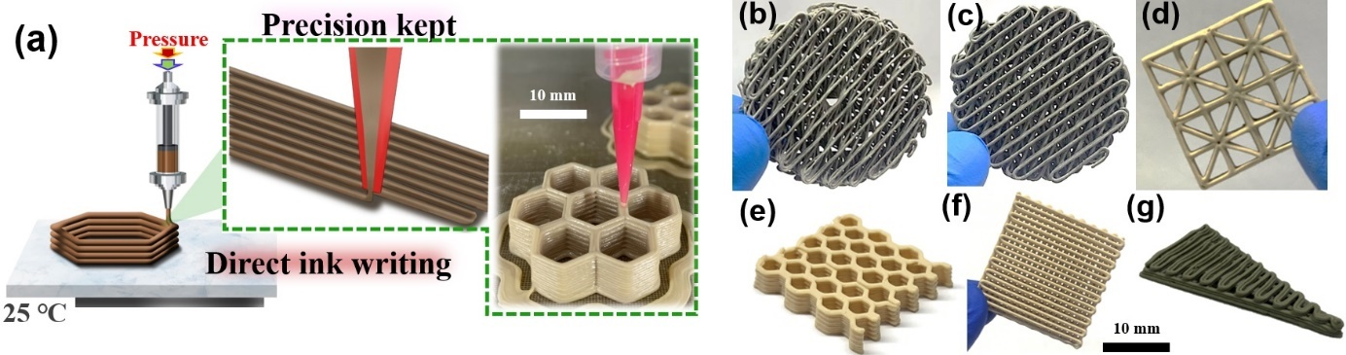
Figure 2. (a) Schematic illustration of geopolymer ink printing. (b-g) High-precision Na-based geopolymer components fabricated using rheology-controlled inks.

2.2. Rheological Testing
The rheological characteristics of geopolymer inks were investigated at ambient temperature utilizing a DHR-1 rheometer (TA Instruments, USA), with an 8 mm flat plate geometry and a 2 mm gap. The apparent viscosity of geopolymer inks was determined as a function of shear rate, which spanned from 10⁻² to 10¹ s⁻¹. Furthermore, the storage and loss moduli were examined as a function of stress from 10⁰ to 10⁴ Pa, and a frequency of 1 Hz was applied. To comprehensively evaluate the viscosity recovery of modified geopolymer inks, a three-interval thixotropy test (3ITT) was conducted. The test consists of three stages, each lasting 60 seconds: (Stage I) dynamic shear at low shear strain (1%), (Stage II) dynamic shear at high shear strain (100%), and (Stage III) dynamic shear during shear strain recovery (1%). As commonly used non-Newtonian fluid models, the Bingham and Herschel-Bulkley models were used to study the rheological properties of geopolymer inks [49]. They are represented by the following Eqs. (1)-(3):
Bingham fluid model
$τ=τ_{0}+ηγ$ (1)
Herschel-Bulkley model
$τ=τ_{0}+mγ^{n}$ (2)
$η=\frac{3m}{n+2}{\left(γ_{max}\right)}^{n-1}$ (3)
where τ is the shear stress (Pa); γ is the shear rate (s⁻¹), τ₀ is the yield stress (Pa); η is the plastic viscosity (Pa·s); m is the consistency coefficient (Pa·s); n is the flow index of the fluid.

2.3. Ink Printability Classification
To visualize the printability of geopolymer inks following rheological adjustment, Fig. 3 depicts a schematic of ink extrusion under diverse rheological conditions. Unmodified geopolymer inks typically display low viscosities and yield points, making it challenging for the inks to swiftly recover their viscosity upon exiting the nozzle. This causes discontinuities and collapses in the 3D-printed products (Fig. 3a). With the addition of appropriate rheology modifiers, geopolymer inks can be imparted with the moderate viscosity to allow for continuous and uniform extrusion while exhibiting a “stand-up” characteristic that allows them to retain their shape (Fig. 3b). Nevertheless, geopolymer inks exhibit high viscosity when incorporated with excessive amounts of rheology modifiers, requiring increased extrusion pressure for dispensing, which may lead to ink clogging, deformation, or phase separation within the ink (Fig. 3c). Moreover, inks that are too viscous may curl and deform after extrusion due to the rapid release of high extrusion pressure. As a result, the rational selection of rheology modifier dosage and combination is crucial.
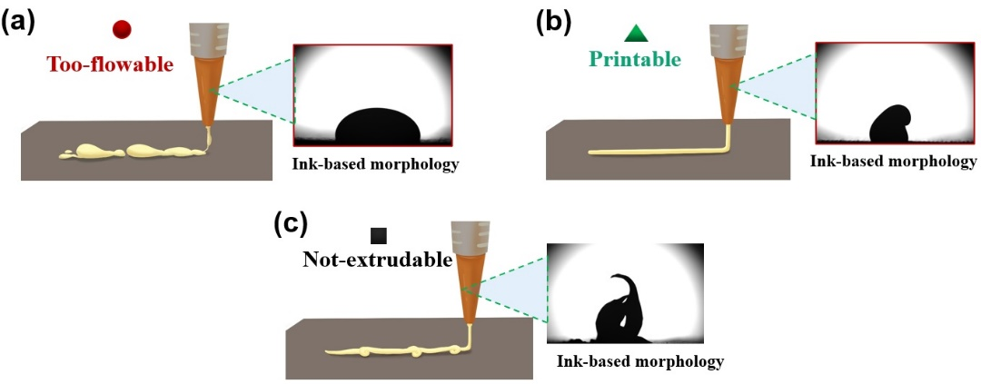
Figure 3. Schematic illustration of material extrusion using (a) low, (b) medium, and (c) high viscosity geopolymer inks.

2.4. Characterization
The compressive strength of the 3D-printed honeycomb structures was evaluated using a Universal Testing Machine (AG-X plus, Japan) at a compression rate of 1 mm/s. At least four specimens were examined for each experimental group. Scanning electron microscopy (SEM: FEI, SU5000, Japan) was employed to investigate the microstructural characteristics of the samples. The printing resolution of the 3D-printed structures was assessed by using the slump rate as an indicator, in accordance with a previous study [50]. A reduced slump rate indicates improved printing resolution of the 3D-printed structures. Geopolymer specimens with a slump rate below 2% were considered high-precision samples [24]. More specifically, the slump rate (%) is determined by the distance between the nozzle and the bottom layer (h₁, mm), as well as the distance between the top layer and the bottom layer (h₂, mm), according to Eq. (4):
$S=\left(\frac{h_{1}-h_{2}}{h_{1}}\right)$ (4)
The printing open time of the ink is determined as follows: the timing starts from the moment the ink is ready (recorded as 0 min). Then, the ink was left to stand at room temperature for 30 mins, 60 mins, 90 mins, 120 mins, 150 mins and 180 mins, and the printability and rheological properties of the ink were measured at different resting times.

2.5. Simulation methods
The Workbench 2019R2 plug-in fluent system was also applied to simulate the extrusion process of inks with different viscosities (see detailed simulation parameters in Section S2). The stress-strain curves of inks with low viscosity, optimal viscosity, and high viscosity were fitted using the Carreau-Yasuda fluid model to derive their viscosities at zero shear rate (η₀, Pa·s) and infinite shear rate (η∞, Pa·s), relaxation time (λ), and viscosity index (n) [51, 52], which are necessary for subsequent calculations. The boundary conditions were established to ensure a consistent downward extrusion velocity of 0.008 mm/s for the three inks within the syringe. This was done to ascertain their individual maximum theoretical pressures and the velocities of extrusion at the outlet. The expression of the Carreau-Yasuda model is as follows:
$τ=γ\left(η_{∞}+\frac{\left(η_{0}-η_{∞}\right)}{{\left(1+{\left(λγ\right)}^{2}\right)}^{\frac{1-n}{a}}}\right)$ (5)
where τ is the shear stress (Pa); γ is the shear rate (s⁻¹), $η_{∞}$ is the ink viscosity at infinite shear rate (Pa·s); $η_{0}$ is the ink viscosity at zero shear rate (Pa·s); n is the power-law index; λ is the relaxation time (s); a is the dimensionless parameter.
The printed honeycomb structure was modeled using SolidWorks 2018, and the deformation during the compression process was simulated using Workbench 2019 R2. The specific parameters used to set up the theoretical model are listed in Section S3.
To elucidate the intermolecular interactions between three types of high-molecular-weight organic rheology modifiers and geopolymer molecules from a microscopic perspective, Density functional theory (DFT) calculations were employed to analyze the intermolecular forces (see detailed computational parameters in Section S4) [53-55].

3. Results and discussion

3.1. Effects of combination and dosage of rheology modifiers on printing open time of geopolymer ink
As shown in Fig. 4, this study selected three typical rheological modifier combinations, namely Triton+Kaolin, PEG+Kaolin, and PVA+Kaolin, to investigate their effects on the printable open time and printing accuracy of geopolymer inks by varying the amounts of the two ingredients in each combination. The printed model was a hexagonal honeycomb structure. The ink was proven to be printable (green triangle) when the sample slump rate was less than 2%. Conversely, when the ink viscosity was either too low (red circles) or too high (black squares), the corresponding slump rates of the printed hexagonal honeycomb structures were greater than 2%, which were considered to lack printability. As depicted in Fig. 4a, geopolymer inks containing only 10% Kaolin or 0.42% Triton X-100 were not printable at the initial stage of preparation. However, Na-KL10TRT0 became suitable for printing after an open time of 180 minutes, while Na-KL0TRT0.42 became suitable for printing after an open time of 60 minutes. For inks containing both Triton and Kaolin, such as Na-KL10TRT0.42, Na-KL10TRT1.25, Na-KL10TRT2.50, Na-KL15TRT0.42, and Na-KL15TRT0.42, all geopolymer inks had a printable open time of 180 minutes, indicating that the proper dosage of Kaolin and Triton X-100 together ensured a longer printing open time range for the geopolymer inks. As the amounts of the two components increased, the printable open times decreased to 0-150 min, 0-120 min, 0-120 min, and 0-60 min for Na-KL15TRT2.50, Na-KL20TRT0.42, Na-KL20TRT1.25, and Na-KL20TRT2.50, respectively. This suggests that increasing the content of rheological modifiers results in inks that are too viscous to hold for a wider printing open time. Thus, it is evident that metakaolin-based geopolymers can be provided with flexible and tunable printing open times by rationally adjusting the amounts of Triton/Kaolin and using them synergistically. In contrast, geopolymer inks incorporating PEG+Kaolin or PVA+Kaolin mixtures only exhibited extended printing open times of up to 180 minutes when the compositions were Na-KL15PEG1.25 and Na-KL30PVA1.25, as shown in Fig. 4b and c. Other rheology modifier compositions failed to achieve a printing open time of 180 minutes due to improper ink viscosity.
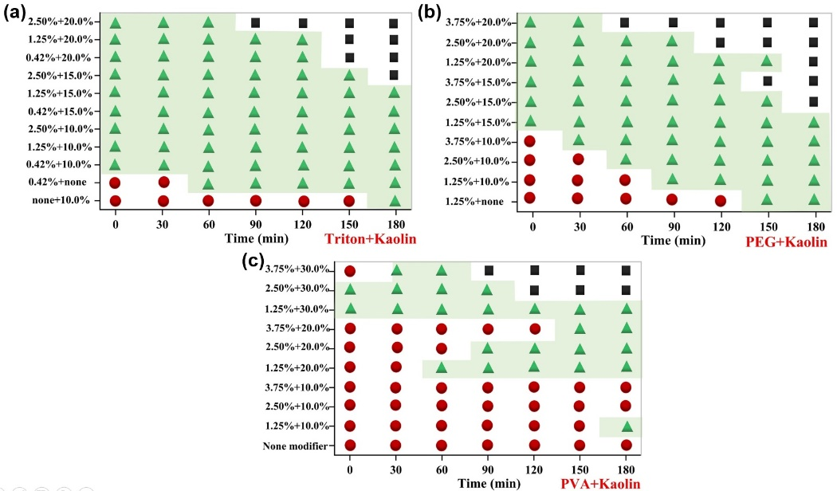
Figure 4. Influence of different rheology modifier combinations on the printing open time of geopolymer inks. (a) Effect of different Triton and Kaolin contents on the printing open time of NaGP inks. (b) Effect of different PEG and Kaolin contents on the printing open time of NaGP inks. (c) Effect of different PVA and Kaolin contents on the printing open time of NaGP inks.
To establish a direct correlation between ink printability and morphological changes in printed samples, we analyzed products printed with inks containing three typical rheology modifier compositions. The representative inks include Na-KL10TRT1.25 (suitable for high-precision printing within an open time of 180 minutes), Na-KL10PEG1.25 (exhibiting insufficient viscosity for printing within 0-60 minutes, but achieving high-precision printing capability within 90-180 minutes), and Na-KL30PVA2.50 (capable of high-precision printing within the initial 0-90 minutes interval, but facing printing hindrance due to elevated viscosity during the subsequent 120-180 minutes time frame). As illustrated in Fig. 5a, the honeycomb structures printed with Na-KL10TRT1.25 ink exhibited a complete outer profile without collapse or delamination within an open time of 0 to 180 minutes. Further microscopic characterization revealed that Na-KL10TRT1.25-30min displayed a stacked configuration with a thickness of 580 μm (Fig. 5d-1), very close to the pre-designed value of 600 μm. This indicates that negligible compression and deformation occurred during extrusion and solidification. Moreover, no obvious cracks were observed at the corner arcs, reflecting the excellent continuity of the extruded filaments. Fig. 5b reveals that Na-KL10PEG1.25 cannot achieve high-precision printing from 0 to 90 minutes post-preparation due to its low ink viscosity, as evidenced by the severe collapse and indistinct delamination of typical honeycomb structures in Na-KL10PEG1.25-0min (Fig. 5d-2). Meanwhile, by examining the morphological change of Na-KL30PVA2.50 samples within 0-180 minutes, it can be seen that the corresponding honeycomb structures gradually deformed after 90 minutes (Fig. 5c). Consequently, it can be concluded that suboptimal filament overlap and significant layer separation associated with high-viscosity inks are the primary reasons for their lower printing precision in Na-KL30PVA2.50-120min (Fig. 5(d-3)).
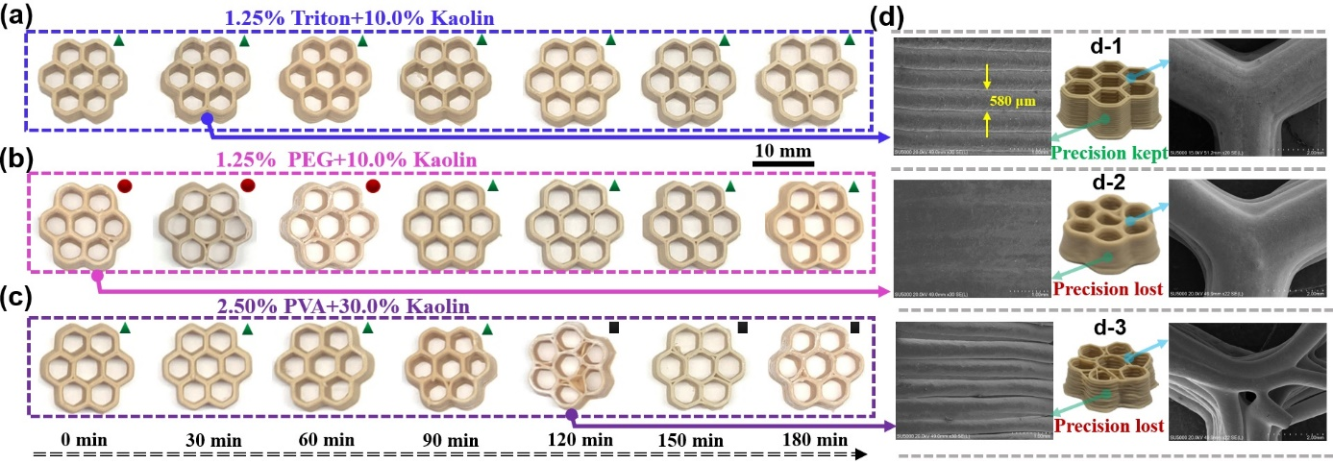
Figure 5. Comparison of honeycomb structure morphology corresponding to inks with different printable behaviors. (a) Morphological changes of Na-KL10TRT1.25 during different printing open times. (b) Morphological changes of Na-KL10PEG1.25 during different printing open times. (c) Morphological changes of Na-KL30PVA2.50 during different printing open times. (d) Microscopic morphology of honeycomb structures corresponding to Na-KL10PEG1.25-0min, Na-KL10TRT1.25-30min, and Na-KL30PVA2.50-120min.

3.2. Effects of combination and dosage of rheology modifiers on rheological properties of geopolymer ink under different printing open times
To explore the relationship between variations in the printing open time and the rheological behavior of three representative geopolymer inks, rheological measurements were conducted on three groups of inks with distinct open times. As depicted in Figs. 6a, 6b, and 6c, the apparent viscosity of Na-KL10TRT1.25, Na-KL10PEG1.25, and Na-KL30PVA2.50 geopolymer inks gradually increased as the printing open time increased from 0 to 180 minutes. This observation highlights the importance of the temporal factor in determining the printability of geopolymers, that is, optimal viscosity is critical to maintain the printability of geopolymer inks. In contrast, too low viscosity (corresponding to slow curing) or high viscosity (corresponding to rapid curing) could adversely affect the printability of geopolymer inks.
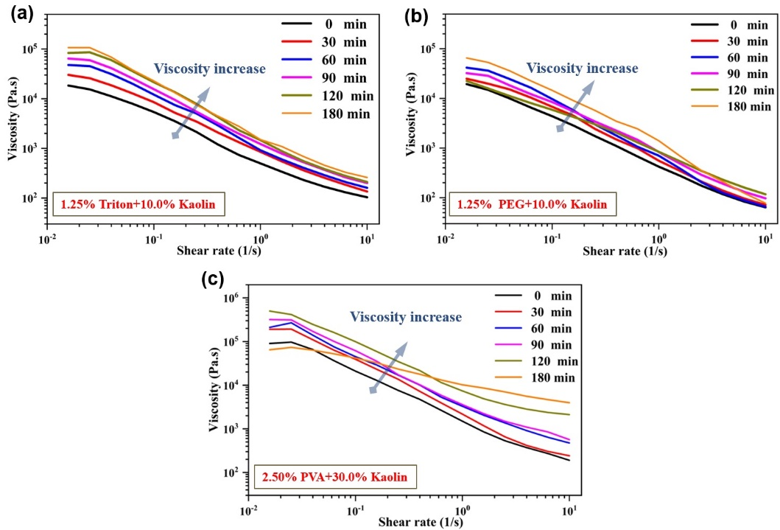
Figure 6. Apparent viscosity of three typical inks. (a) Na-KL10TRT1.25 ink. (b) Na-KL10PEG1.25 ink. (c) Na-KL30PVA2.50 ink.
As demonstrated in Fig. 7a, the pseudoplastic behavior of Na-KL10TRT1.25 ink at different open times can be observed through rheological measurements. At low stress (Stage I), the storage modulus (G') of Na-KL10TRT1.25 ink is consistently greater than the loss modulus (G'') at various open times, corresponding to a quasi-solid elastic state. After a transient increase in stress to a high level (Stage II), each Na-KL10TRT1.25 ink undergoes a rapid transition from solid to liquid, where the loss modulus becomes larger than the storage modulus (G' < G''). When stress is subsequently reduced to a low level (Stage III), both the storage and loss moduli of each Na-KL10TRT1.25 ink exhibit an increasing trend, with the storage modulus again exceeding the loss modulus (G' > G''). The shear-thinning properties of the ink under high stress and its ability to return to a quasi-solid state under low stress render it suitable for extrusion-based printing. As depicted in Fig. 8a, after completing the 3ITT test, the storage modulus (G') values of the Na-KL10TRT1.25 ink at various open times recovered more than 50% of their initial values at the end of Stage III. Figs. 7b and 7c demonstrate that Na-KL10PEG1.25 and Na-KL30PVA2.50 inks also exhibit a certain degree of modulus recovery capacity at different open times after the thixotropic test. Importantly, for the non-printable inks (too thin or viscous ink, the slump rate of the printed honeycomb structure is higher than 2%), such as Na-KL10PEG1.25-0min, Na-KL10PEG1.25-30min, and Na-KL10PEG1.25-60min, their storage moduli do not recover to 50% of their initial values after the 3ITT test, reaching only 37.1%, 45.8%, and 28.6%, respectively (see red dashed lines). With the increase of time, the storage modulus recovery rates of Na-KL10PEG1.25-90min, Na-KL10PEG1.25-120min, and Na-KL10PEG1.25-150min reach 56.3%, 67.5%, and 69.7%, respectively. Similarly, the storage modulus recovery values for the non-printable inks, i.e., Na-KL30PVA2.50-120min and Na-KL30PVA2.50-180min, are only 17.2% and 15.9%, respectively (see black dashed lines). Consequently, for metakaolin-based geopolymers employing Triton/PEG/PVA and Kaolin as rheological modifiers, the apparent viscosity of the ink gradually increases with the printing open time. Furthermore, according to the 3ITT test, we find that the crucial determinant for high-precision printing of geopolymer samples at different open times is the ability to recover more than 50% of the storage modulus.
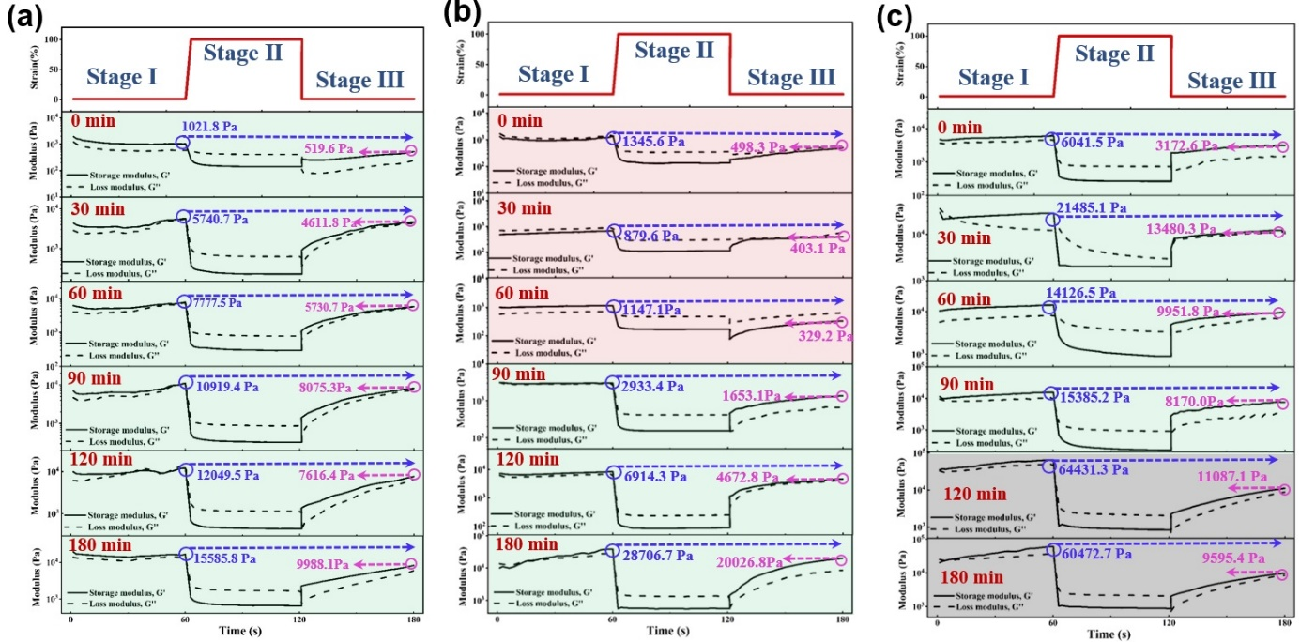
Figure 7. Thixotropic test of three typical inks. (a) Na-KL10TRT1.25 ink. (b) Na-KL10PEG1.25 ink. (c) Na-KL30PVA2.50 ink.
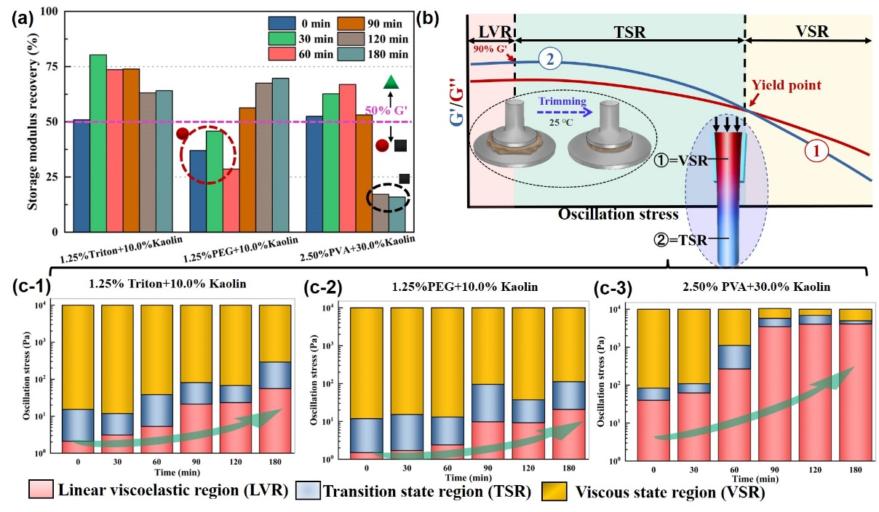
Figure 8. Storage modulus recovery and viscoelastic range distribution of various geopolymer inks during 3ITT experiments. (a) Storage modulus recovery of geopolymer inks in 3ITT tests. (b) Schematic illustrating the ideal rheological response (storage modulus (G')/loss modulus (G'') vs. shear rate (γ)) of a printable ink and the pressure-induced flow of a conventional ink with bulk non-Newtonian properties. (c) Viscoelastic range distribution of Na-KL10TRT1.25 ink at different open times. (d) Viscoelastic range distribution of Na-KL10PEG1.25 ink at different open times. (e) Viscoelastic range distribution of Na-KL30PVA2.50 ink at different open times.
To quantitatively characterize the additive-induced changes in the rheological properties of geopolymer inks, we measured their storage modulus (G') and loss modulus (G'') in the range of 10⁰-10⁴ Pa. Subsequently, we determined their yield stress (i.e., the critical values for initiating liquid-solid transitions of the geopolymer inks) by examining the crossover of G' and G''. As illustrated in Fig. 9, both the storage modulus and loss modulus of Na-KL10TRT1.25 ink gradually increased with the printing open time, accompanied by an increase in yield stress. This corresponds to an increase in the extrusion stress required to expel the ink from the nozzle. Numerically, the actual yield stress of Na-KL10TRT1.25 increased by approximately an order of magnitude from 2395.8 Pa at 0 min to 70356.2 Pa at 180 min. The faint gray curves represent the data from the previous opening time and serve as the control group. The increase in yield stress with printing open time can also be observed in samples Na-KL10PEG1.25 (Fig. 10) and Na-KL30PVA2.50 (Fig. 11).
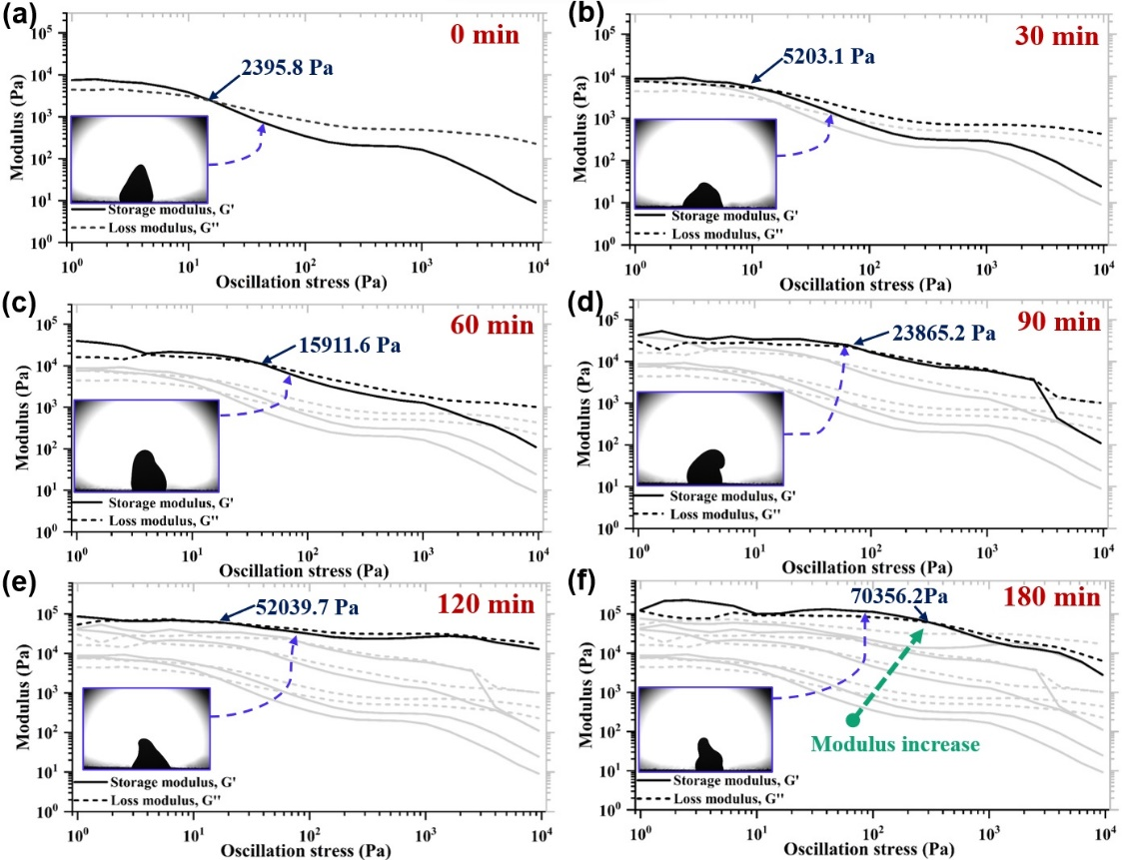
Figure 9. Log-log plot of shear modulus of Na-KL10TRT1.25 ink at various open times as a function of oscillatory stress. (a) 0 min. (b) 30 min. (c) 60 min. (d) 90 min. (e) 120 min. (f) 180 min. (The image with the blue border corresponds to the ink's state during this particular opening time)
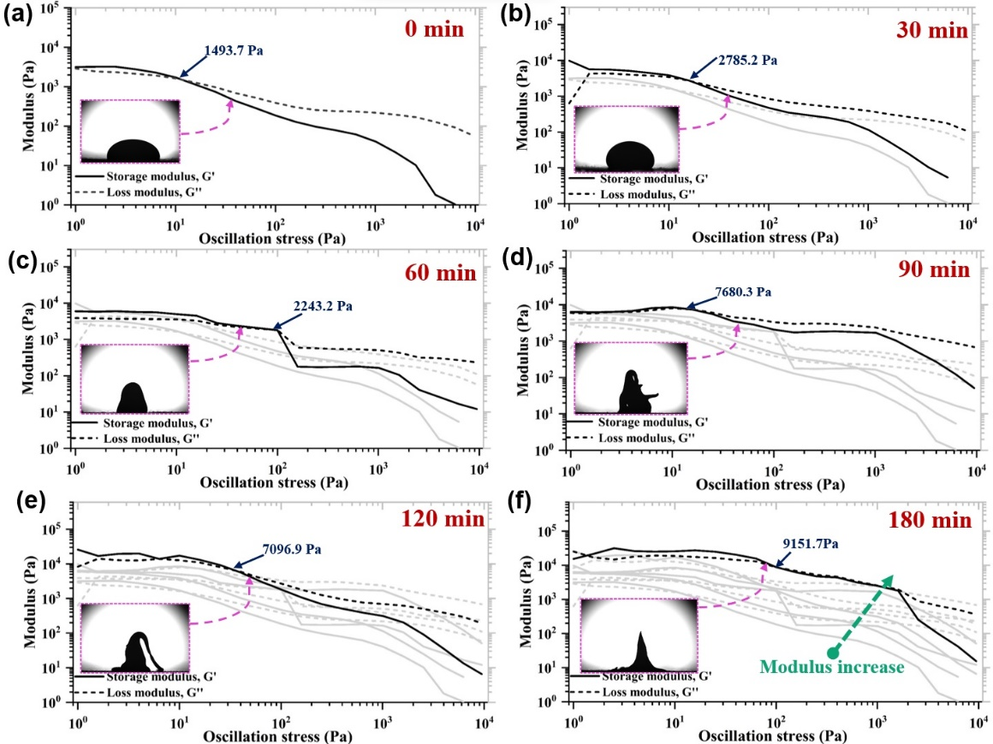
Figure 10. Log-log plot of shear modulus of Na-KL10PEG1.25 ink at various open times as a function of oscillatory stress. (a) 0 min. (b) 30 min. (c) 60 min. (d) 90 min. (e) 120 min. (f) 180 min. (the image with the pink border corresponds to the ink's state during this particular opening time)
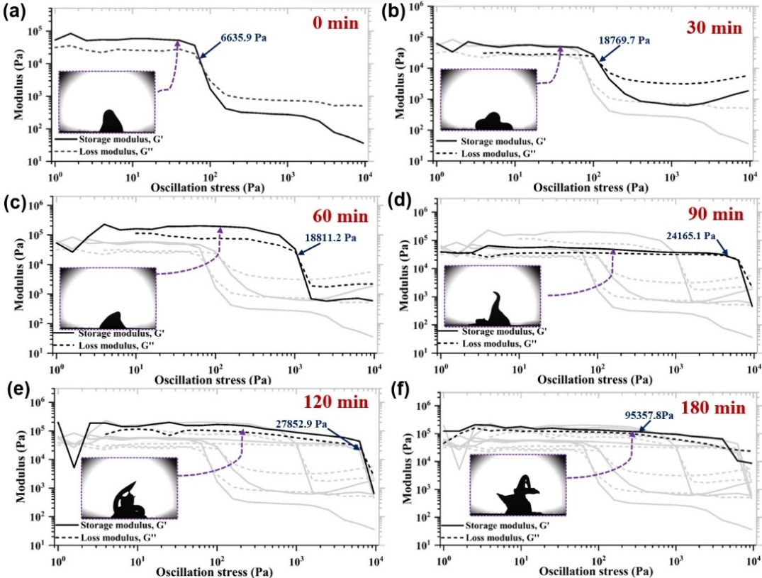
Figure 11. Log-log plot of shear modulus of Na-KL30PVA2.50 ink at various open times as a function of oscillatory stress. (a) 0 min. (b) 30 min. (c) 60 min. (d) 90 min. (e) 120 min. (f) 180 min. (the image with the purple border corresponds to the ink's state during this particular opening time)
Geopolymer inks experience a transition from a quasi-solid state to a liquid state when extruded through the nozzle under pressure and revert to a quasi-solid state upon exiting the nozzle. As illustrated in Fig. 8b, the dynamic viscosity test curves of inks for ME can be categorized into three distinct regions: Linear Viscoelastic Region (LVR), Transition State Region (TSR), and Viscous State Region (VSR) [56, 57]. The LVR refers to the state until the storage modulus retains 90% of its original value, which corresponds to the ink being initially stressed without transitioning to a liquid state. The TSR represents the transition from a solid to a liquid state with increasing extrusion stress, which continues until the ink completely yields and turns into liquid state. The VSR stands for the state where the ink is fully converted to fluid when it flows into the nozzle.
As illustrated in Fig. 8(c-1), the stress range in the LVR of Na-KL10TRT1.25 ink gradually increases with the printing open time, indicating that higher stress is required to induce the transition from solid state to transition state. For the Na-KL10PEG1.25 ink, the extension of the printing open time also significantly increased the corresponding LVR (Fig. 8(c-2)). However, for the Na-KL30PVA2.50 ink, the high viscosity of the ink itself caused the LVR to occupy almost the entire ink extrusion process when the printing open time reached 120 min, resulting in the ink to be extruded after experiencing a relatively short TSR and VSR (Fig. 8(c-3)). This prevents the effective release of stress in the ink, hindering smooth printing.
The Bingham fluid model and the Herschel-Bulkley fluid model were applied to describe the shear stress-shear rate curves of the three geopolymer inks at varying open times, and predict the theoretical yield stress and initial viscosity of non-Newtonian fluid materials, as illustrated in Fig. 12. Taking Na-KL10TRT1.25 as an illustrative case (Table 2), both the Bingham and the Herschel-Bulkley models could characterize the rheological behavior of Na-KL10TRT1.25 ink (with R² values generally higher than 0.9). Furthermore, with an increase in printing open time, the fitting outcomes revealed augmented yield stress and viscosity patterns. Similar fitting results and conclusions were also observed in the cases of Na-KL10PEG1.25 and Na-KL30PVA2.50 inks (Tables 3 and 4), suggesting that both the Bingham and Herschel-Bulkley models are equally adept at predicting the rheological parameters within the examined systems.
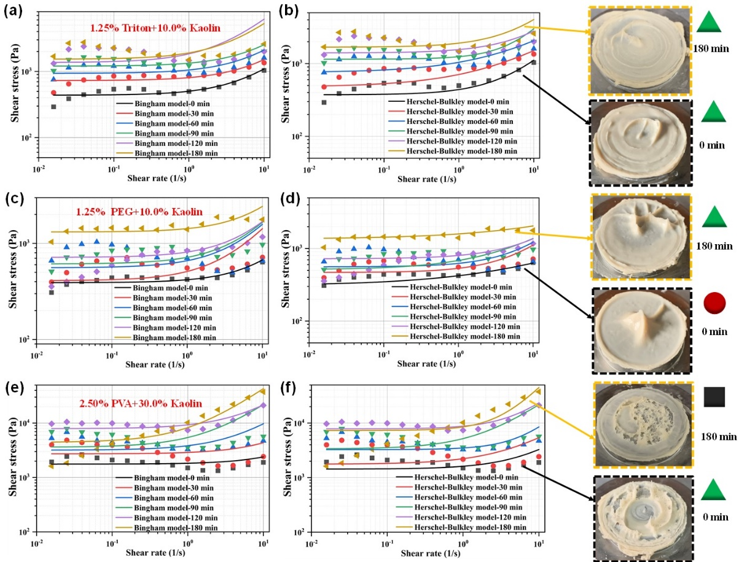
Figure 12. Bingham and Herschel-Bulkley fluid models describing the shear stress-shear rate fitting curves of three typical inks at various open times. (a-b) Na-KL10TRT1.25 ink. (c-d) Na-KL10PEG1.25 ink. (e-f) Na-KL30PVA2.50 ink.
Table 2 Comparison of rheological coefficients of Na-KL10TRT1.25 ink with different printing open times fitted by the two fluid models
 | Bingham fluid model |  |  | Herschel- Bulkley model
Specimens | τ₀ (Pa) | η (Pa⋅s) | R² | τ₀ (Pa) | η (Pa⋅s) | R²
Na-KL10TRT1.25-0min | 437.6 | 65.6 | 0.999 | 372.3 | 73.1 | 0.998
Na-KL10TRT1.25-30min | 728.8 | 78.4 | 0.998 | 478.2 | 116.6 | 0.963
Na-KL10TRT1.25-60min | 937.1 | 116.6 | 0.999 | 754.2 | 148.0 | 0.999
Na-KL10TRT1.25-90min | 1203.6 | 132.7 | 0.999 | 1150.3 | 169.4 | 0.998
Na-KL10TRT1.25-120min | 1465.4 | 479.8 | 0.999 | 1403.3 | 142.7 | 0.934
Na-KL10TRT1.25-180min | 1731.2 | 376.8 | 0.996 | 1680.3 | 234.12 | 0.999

Table 3 Comparison of rheological coefficients of Na-KL10PEG1.25 ink with different printing open times fitted by the two fluid models
 | Bingham fluid model |  |  | Herschel- Bulkley model
Specimens | τ₀ (Pa) | η (Pa⋅s) | R² | τ₀ (Pa) | η (Pa⋅s) | R²
Na- KL10PEG1.25-0min | 390.5 | 28.3 | 0.999 | 308.0 | 39.5 | 0.999
Na- KL10PEG1.25-30min | 409.3 | 101.7 | 0.999 | 467.3 | 64.9 | 0.998
Na- KL10PEG1.25-60min | 533.9 | 102.3 | 0.999 | 559.3 | 66.0 | 0.999
Na- KL10PEG1.25-90min | 612.2 | 104.6 | 0.999 | 511.1 | 96.0 | 0.999
Na- KL10PEG1.25-120min | 716.3 | 103.6 | 0.998 | 721.9 | 58.3 | 0.939
Na- KL10PEG1.25-180min | 1315.5 | 111.3 | 0.999 | 1451.8 | 83.5 | 0.989

Table 4 Comparison rheological coefficients of Na-KL30PVA2.50 ink with different printing open times fitted by the two fluid models
 | Bingham fluid model |  |  | Herschel- Bulkley model
Specimens | τ₀ (Pa) | η (Pa⋅s) | R² | τ₀ (Pa) | η (Pa⋅s) | R²
Na-KL30PVA2.50-0min | 1765.9 | 63.6 | 0.999 | 1436.7 | 180.7 | 0.997
Na-KL30PVA2.50-30min | 2728.1 | 163.2 | 0.999 | 1766.8 | 377.2 | 0.999
Na-KL30PVA2.50-60min | 3194.1 | 635.3 | 0.998 | 3268.7 | 468.1 | 0.999
Na-KL30PVA2.50-90min | 3612 .0 | 1827.0 | 0.999 | 3363.2 | 1839.7 | 0.999
Na-KL30PVA2.50-120min | 7921.1 | 1374.7 | 0.998 | 7330.6 | 1454.4 | 0.999
Na-KL30PVA2.50-180min | 4427.7 | 3851.6 | 0.998 | 7336.6 | 3212.0 | 0.985

3.3. Simulation of extrusion process for three typical inks
Previous studies have shown that under a constant extrusion pressure, as the diameter of the printing needle increases, the pressure concentration area of the ink at the needle tip reduces, and the extrusion speed gradually increases [51]. Consequently, this study will focus on the corresponding pressure distribution of inks with different viscosities (Na-KL10TRT1.25-30min (printable), Na-KL10PEG1.25-0min (low viscosity), and Na-KL30PVA2.50-120min (high viscosity)) under the same extrusion conditions. As shown in Fig. 13a, the Carreau-Yasuda model exhibits a good fitting trend for the stress-strain curves of the three geopolymer inks, with R² values of 0.975, 0.954, and 0.988, respectively. The fitting parameters obtained are shown in Table S1.
Fig. 13b simulates the extrusion process of geopolymer inks with different viscosities. To quantitatively understand the pressure-drop length at different ink viscosities, we divide the ink extrusion process into two distinct stages: i) The "pressure concentration stage", during which the pressure inside the needle is equal to the pressure inside the charging cylinder. ii) The "pressure release stage", during which the pressure inside the needle starts to decrease. As shown in Fig. 13(b-1), the maximum theoretical extrusion pressure of low-viscosity Na-KL10PEG1.25-0min ink (non-printable) in the syringe at a constant speed of 0.008 mm/s is calculated to be 5.36 × 10⁵ Pa. This indicates that the ink retains a pressure concentration stage spanning 9.3 mm within the nozzle and then undergoes a long pressure release stage of 20.7 mm before exiting the nozzle. For the moderate-viscosity Na-KL10TRT1.25-30min ink (Fig. 13(b-2)) and high-viscosity Na-KL30PVA2.50-120min ink (Fig. 13(b-3)), the gradual increase in the maximum theoretical extrusion pressure (2.442×10⁶ Pa and 3.265×10⁷ Pa) results in longer pressure concentration stages (11.2 mm and 13.1 mm) and shorter pressure release stages (18.8 mm and 16.9 mm). The positive correlation between the apparent viscosity, extrusion pressure, and pressure concentration stage summarized in Fig. 13c can be well explained by the schematic shown in Fig. 3. Specifically, low-viscosity inks flowed from the nozzle and failed to maintain their shape after prolonged pressure release. In contrast, the long pressure concentration stage of high-viscosity inks causes internal ink deformation or blockage during high-pressure extrusion. This eventually leads to curling and waving at the outlet. These results reveal the subtle interplay between pressure release speed and printing accuracy.
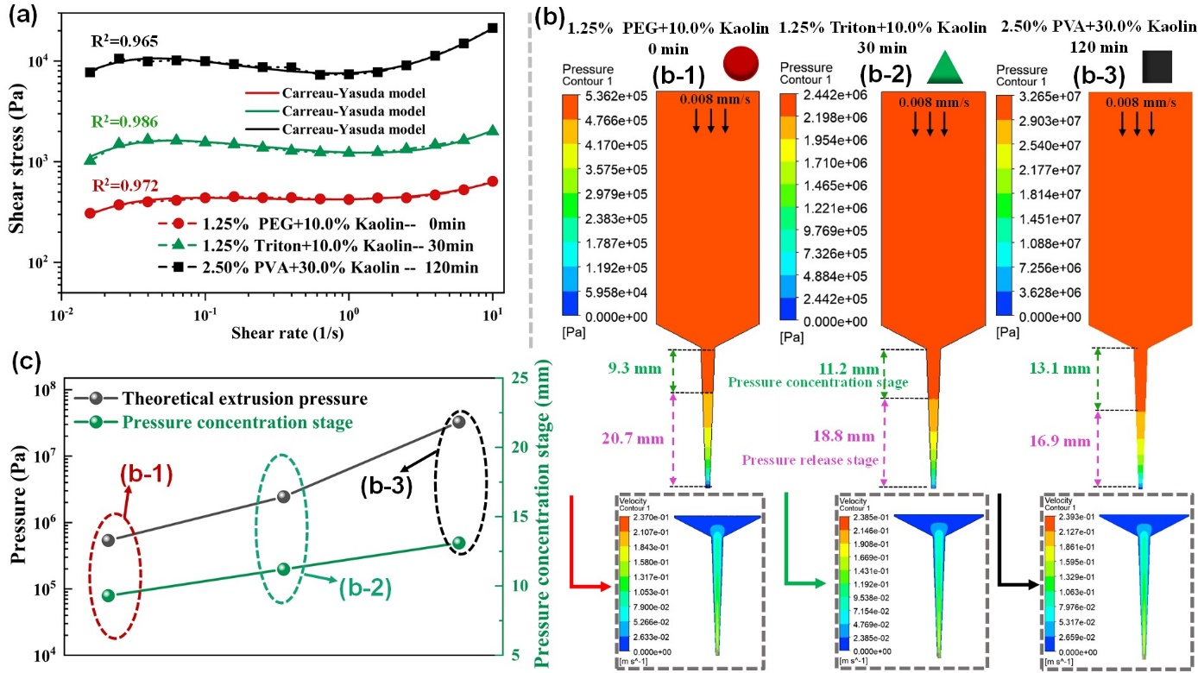
Figure 13. Finite element simulation of the extrusion process and pressure distribution for three typical inks (low, appropriate, and high viscosity). (a) The Carreau-Yasuda model describing the stress-strain curves of the three geopolymer inks. (b) Pressure distribution contour maps of the three geopolymer inks during extrusion. (c) Comparison of maximum theoretical extrusion pressure and pressure area length for the three geopolymer inks.

3.4. Variations in the compressive strength of geopolymer samples with different combinations and dosages of rheology modifiers under different printing open times
To examine the evolution of mechanical properties of geopolymer samples containing various combinations of rheology modifiers under different printing open times, three geopolymer inks (Na-KL10TRT1.25, Na-KL15PEG1.25, and Na-KL30PVA1.25) with open times ranging from 0 to 180 minutes were selected for printing high-precision honeycomb structures. As shown in Fig. 14 a, b, c, the Na-KL10TRT1.25-0min, Na-KL15PEG1.25-0min, and Na-KL30PVA1.25-0min specimens (denoted by solid black lines) exhibit the highest compressive strengths of 68.6±2.7 MPa, 41.3±2.5 MPa, and 35.5±1.8 MPa, respectively. However, the compressive strengths of all three geopolymers exhibited a decreasing trend with increasing printing open time (Fig. 14d). The decrease in the compressive strength of the printed sample resulting from the extension of the printing open time can be attributed to the following reasons: i) A decrease in the strength of overlap between extruded filaments, and ii) An increase in the viscosity of the ink, which hinders the timely discharge of internal pores, leading to an elevation in the porosity of the sample. This aspect warrants further investigation in forthcoming studies. Moreover, under the same printing open time, the compressive strength displayed a descending order of Na-KL10TRT1.25, Na-KL15PEG1.25, and Na-KL30PVA1.25.
It should be emphasized that the stress-strain curves of all specimens exhibited pseudoplastic fracture characteristics, which can be attributed to the intrinsic fracture properties of the honeycomb structures. As depicted in Fig. 14e, when a vertical load is applied to the honeycomb structure, the compressive stress is transmitted vertically through the structure. Since the hexagonal cells in the honeycomb are immobile, they can act as load-bearing units to inhibit the collapse of adjacent units. This prevents instantaneous dissipation of stress, ultimately resulting in pseudo-plastic fracture characteristics.
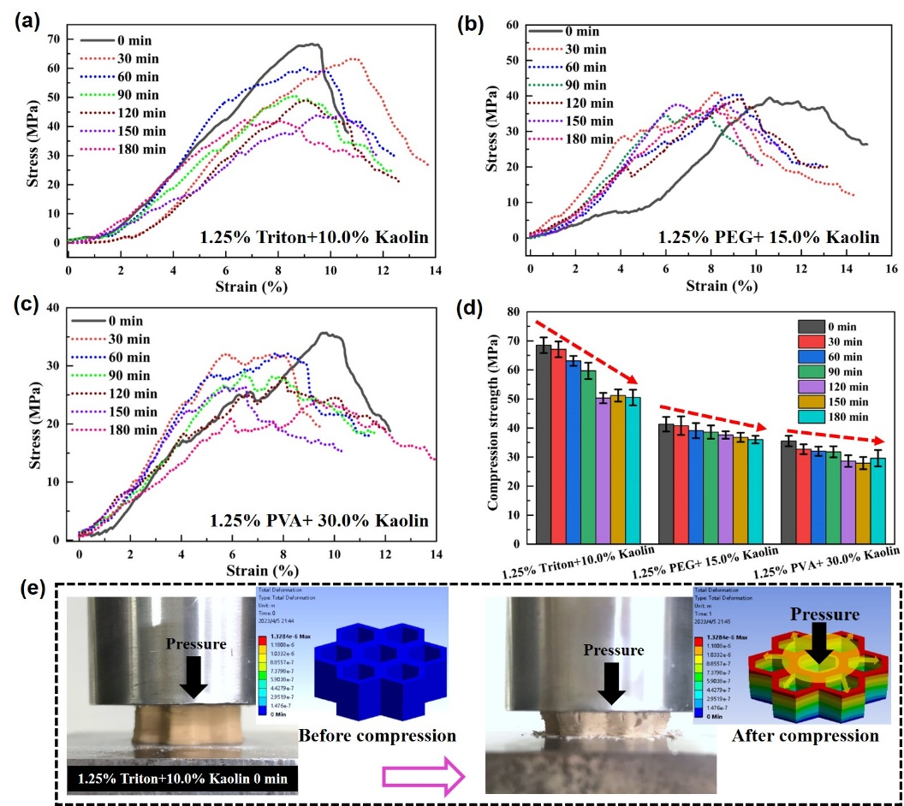
Figure 14. Mechanical properties of Na-KL10TRT1.25, Na-KL15PEG1.25, and Na-KL30PVA1.25 honeycomb structures at different printing open times. (a) Compression curves of Na-KL10TRT1.25 samples at different printing open times. (b) Compression curves of Na-KL15PEG1.25 samples at different printing open times. (c) Compression curves of Na-KL30PVA1.25 samples at different printing open times. (d) Comparison of compressive strength of the three geopolymers at different printing open times. (e) Compression process analysis of Na-KL10TRT1.25-0 min honeycomb structure.

As shown in Fig. 15a, d, and g, the cross-sectional and interlayer morphologies show that Na-KL10TRT1.25, Na-KL15PEG1.25, and Na-KL30PVA1.25 exhibit dense and well-defined external contours with no noticeable defects after a printing open time of 180 minutes. Interlayer morphology examination reveals satisfactory interlaminar bonding state of the honeycomb samples with no signs of cracking or insufficient adhesion (Fig. 15b, e, h). Furthermore, a dense and compact overlap between lines can be observed in the enlarged area (Fig. 15c, f, i), where the upper lines were effectively embedded into the surface of the lower lines under the gravitational force, thereby forming a good interfacial bonding state.
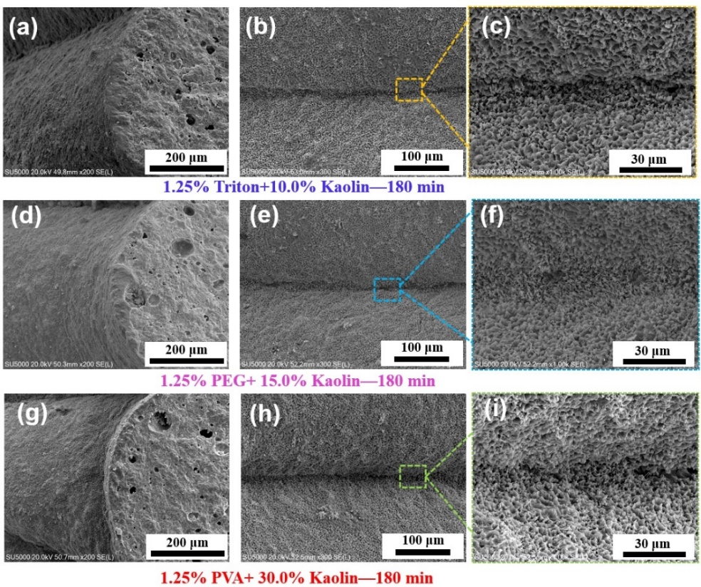
Figure 15. Cross-sectional and surface morphology of the Na-KL10TRT1.25-180min (a-c), Na-KL15PEG1.25-180min (b-f) and Na-KL30PVA1.25-180min (g-i) honeycomb structure.
To simplify the calculation process, three polymer modifiers with different structural units were chosen for simulation to validate the compatibility of each polymer modifier with the geopolymer matrix. The structural units of the three polymeric modifiers can be bound to the geopolymer surface with binding energies of 68.79 kJ/mol, 60.48 kJ/mol, and 72.26 kJ/mol, respectively. Note that the three polymer rheology modifiers can create flocculated long-chain polymers in practical applications. These polymers are interwoven with an evolving spatial network structure of geopolymers mainly composed of silica and alumina hydrates, effectively increasing the viscosity of the inks. Additionally, the introduction of two-dimensional layered Kaolin further improves the viscosity and yield stress of the geopolymer ink. This universal geopolymer ink rheological property regulation technology will thus provide theoretical and practical support for large-scale geopolymer extrusion-based 3D printing.
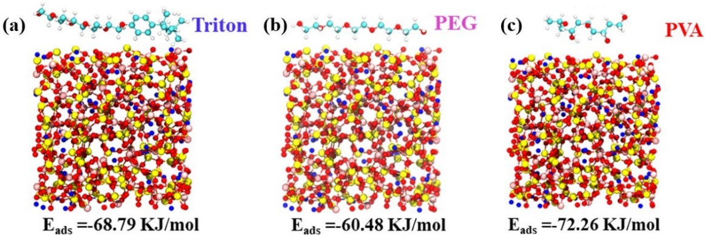
Figure 16. Binding energy calculation between Triton (a), PEG (b) and PVA (c) molecules and the geopolymer network.

After optimizing the rheological properties of NaGP inks by combining Triton and Kaolin as rheology modifiers, we investigated whether this recipe can be applied to geopolymer inks activated by different alkali metal ions (i.e., Na⁺, K⁺ and Cs⁺). Fig. 17 shows the influence of Kaolin alone and co-addition of Triton-Kaolin on the slump rate of different geopolymer inks under 0 min open time and the mechanical properties of printed honeycomb samples. As shown in Fig. 17(a, b, c), in the presence of Kaolin, the addition of Triton directly determines the printing resolution of the printed components. The slump rates of the printed components of the three geopolymer inks with the addition of Triton (red line) is significantly reduced compared to the ink without Kaolin (blue line). This indicates that the combined addition of Kaolin and Triton can promote high-precision printing of geopolymer inks. The minimum slump rates for Na-KL10TRT1.25, K-KL30TRT1.25, and Cs-KL60TRT1.25 are 0.7 %, 0.4 %, and 0.8 %, respectively. When the Triton content was fixed, the slump rate of the printed components first decreased and then increased with the increase of Kaolin content, which shows an opposite trend to the compressive strength (Fig. 17d, e, f and Table 5). This can be mainly attributed to the excessive introduction of Kaolin, which will reduce the degree of polymerization of geopolymers, thereby lowering the compressive strength. On the other hand, the excessive incorporation of kaolin may elevate the viscosity of the ink, consequently hindering the timely evacuation of the internal pores of the filament and degrading the mechanical properties. Thus, subsequent research should strive to avoid excessive addition of kaolin. In the end, Na-KL8TRT1.25, K-KL20TRT1.25, and Cs-KL40TRT1.25 possessed the highest compressive strength values of 76.5±3.6 MPa, 75.4±2.1 MPa, and 56.8±2.9 MPa, respectively (denoted by solid lines).
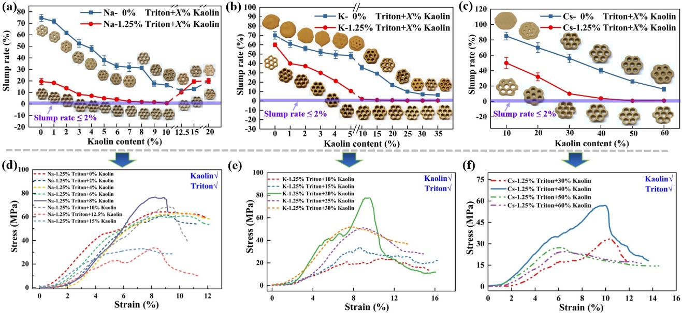
Figure 17. Effects of Triton and Kaolin as rheology modifiers on the printability and mechanical properties of geopolymers. (a, b, c) Effect of Triton and Kaolin dosage on the slump rate of geopolymers activated by different alkali metal ions, and (d, e, f) Effect of Kaolin content on the compressive strength of geopolymers activated by different alkali metal ions.

Table. 5 The effect of the specific ratio of Triton and kaolin on the compressive strength of printed samples
NaGP | Na-KL4TRT1.25 | Na-KL8TRT1.25 |  | Na-KL10TRT1.25 |  | Na-KL15TRT1.25
NaGP | 62.6±2.9 (MPa) | 76.5±3.6 (MPa) |  | 68.6±2.7 (MPa) |  | 33.2±2.1 (MPa)
KGP | K-KL10TRT1.25 |  | K-KL20TRT1.25 |  | K-KL30TRT1.25
KGP | 35.7±2.7 (MPa) |  | 75.4±2.1 (MPa) |  | 52.7±3.3 (MPa)
CsGP | Cs-KL30TRT1.25 | Cs-KL40TRT1.25 |  | Cs-KL50TRT1.25 |  | Cs-KL60TRT1.25
CsGP | 33.4±2.7 (MPa) | 56.8±2.9 (MPa) |  | 27.7±2.1 (MPa) |  | 24.5±2.2 (MPa)

4. Conclusion
Rheology modifiers play a key role in influencing the printability of geopolymer inks. Here, we show that the choice and combination of rheology modifiers constitute critical factors in geopolymer 3D printing, profoundly affecting print accuracy, printing open time, and mechanical properties of printed structures. By selecting three representative polymer rheology modifiers -Triton, PEG, and PVA - together with Kaolin, we systematically investigated the effect of rheology modifier combination and dosage on the printability of geopolymer inks. The main conclusions are as follows:
(1) By adjusting the precise proportions of Triton and kaolin, a broader range of printing open time options, up to 180 minutes, can be provided for geopolymer inks capable of producing components with slump ratios below 2%. However, the collaborative effect of PEG and PVA with kaolin leads to a relatively constrained spectrum of proportions available for achieving extended printing open times.
(2) For NaGP ink incorporating Triton/PEG/PVA and Kaolin as synergistic rheology modifiers, the ability to recover the storage modulus to over 50% of its original value after 3ITT tests has been revealed to be an essential indicator of high-precision printing, in addition to pseudoplastic rheological properties.
(3) Under the same printing open time, the compressive strength of 3D-printed geopolymer honeycomb structures was ranked as follows: Na-KL10TRT1.25 > Na-KL15PEG1.25 > Na-KL30PVA1.25. Furthermore, the mechanical properties of geopolymers with the same rheology modifier combination gradually decreased with increasing printing open time.
4) The Triton+Kaolin modifier combination showed universality in controlling the rheology of geopolymer inks, allowing rheological control of geopolymers activated by different alkali metal ions (i.e., Na⁺, K⁺, and Cs⁺) and yielding geopolymer samples with required printing accuracy. In the case of constant Triton concentration, the printing slump rates of the three alkali metal ion-activated geopolymers showed a trend of first decreasing and then increasing with the increase of Kaolin content. The minimum slump rates for Na-KL10TRT1.25, K-KL30TRT1.25, and Cs-KL60TRT1.25 are 0.7 %, 0.4 %, and 0.8 %, respectively.

Acknowledgements
The authors gratefully acknowledge the financial supports from the National Natural Science Foundation of China (NSFC, No. 52072090), the Heilongjiang Touyan Innovation Team Program, the Advanced Talents Scientific Research Foundation of Shenzhen: Yu Zhou.

Declaration of competing interest
The authors declare no competing interests.

References
[1] V. Voney, P. Odaglia, C. Brumaud, B. Dillenburger, G. Habert, From casting to 3D printing geopolymers: A proof of concept, Cement and Concrete Research 143 (2021) 106374.
[2] E. Sachyani Keneth, A. Kamyshny, M. Totaro, L. Beccai, S. Magdassi, 3D Printing Materials for Soft Robotics, Advanced materials 33 (19) (2021) e2003387.
[3] H. Yuk, X. Zhao, A New 3D Printing Strategy by Harnessing Deformation, Instability, and Fracture of Viscoelastic Inks, Advanced materials 30 (6) (2018).
[4] L. Yang, X. Zeng, A. Ditta, B. Feng, L. Su, Y. Zhang, Preliminary 3D printing of large inclined-shaped alumina ceramic parts by direct ink writing, Journal of Advanced Ceramics 9 (3) (2020) 312-319.
[5] G. Chen, H. Fu, Y. Zou, S. Wang, Y. Gao, T. Yue, J. Cao, Y. Wang, J. Qiu, J. Zhao, J. Ouyang, D. Jia, Y. Shuai, Y. Zhou, A Promising Radiation Thermal Protection Coating Based on Lamellar Porous Ca‐Cr co‐Doped Y3NbO7 Ceramic, Advanced Functional Materials (2023).
[6] S. Fu, P. He, M. Wang, M. Wang, R. Wang, J. Yuan, D. Jia, J. Cui, Monoclinic-celsian ceramics formation: Through thermal treatment of ion-exchanged 3D printing geopolymer precursor, Journal of the European Ceramic Society 39 (2-3) (2019) 563-573.
[7] S. Muthukrishnan, S. Ramakrishnan, J. Sanjayan, In-line activation of geopolymer slurry for concrete 3D printing, Cement and Concrete Research 162 (2022) 107008.
[8] S. Ma, H. Yang, S. Zhao, P. He, Z. Zhang, X. Duan, Z. Yang, D. Jia, Y. Zhou, 3D-printing of architectured short carbon fiber-geopolymer composite, Composites Part B: Engineering 226 (2021) 109348.
[9] S. Qaidi, A. Yahia, B.A. Tayeh, H. Unis, R. Faraj, A. Mohammed, 3D printed geopolymer composites: A review, Materials Today Sustainability 20 (2022) 100240.
[10] G. Franchin, J. Pesonen, T. Luukkonen, C. Bai, P. Scanferla, R. Botti, S. Carturan, M. Innocentini, P. Colombo, Removal of ammonium from wastewater with geopolymer sorbents fabricated via additive manufacturing, Materials & Design 195 (2020) 109006.
[11] J. Zhu, P. Wu, Y. Chao, J. Yu, W. Zhu, Z. Liu, C. Xu, Recent advances in 3D printing for catalytic applications, Chemical Engineering Journal 433 (2022) 134341.
[12] D.-W. Zhang, D.-m. Wang, X.-Q. Lin, T. Zhang, The study of the structure rebuilding and yield stress of 3D printing geopolymer pastes, Construction and Building Materials 184 (2018) 575-580.
[13] N.P.F. Gonçalves, S.M. Olhero, J.A. Labrincha, R.M. Novais, 3D-printed red mud/metakaolin-based geopolymers as water pollutant sorbents of methylene blue, Journal of Cleaner Production 383 (2023) 135315.
[14] J. Yan, S. Huang, Y.V. Lim, T. Xu, D. Kong, X. Li, H.Y. Yang, Y. Wang, Direct-ink writing 3D printed energy storage devices: From material selectivity, design and optimization strategies to diverse applications, Materials Today 54 (2022) 110-152.
[15] B. Panda, C. Unluer, M.J. Tan, Extrusion and rheology characterization of geopolymer nanocomposites used in 3D printing, Composites Part B: Engineering 176 (2019) 107290.
[16] J.A.H.P. Sol, L.G. Smits, A.P.H.J. Schenning, M.G. Debije, Direct Ink Writing of 4D Structural Colors, Advanced Functional Materials 32 (30) (2022) 2201766.
[17] S. Ma, Y. Jiang, S. Fu, P. He, C. Sun, X. Duan, D. Jia, P. Colombo, Y. Zhou, 3D-printed Lunar regolith simulant-based geopolymer composites with bio-inspired sandwich architectures, Journal of Advanced Ceramics 12 (3) (2023) 510-525.
[18] Y.A. Al-Noaimat, S.H. Ghaffar, M. Chougan, M.J. Al-Kheetan, A review of 3D printing low-carbon concrete with one-part geopolymer: Engineering, environmental and economic feasibility, Case Studies in Construction Materials 18 (2023) e01818.
[19] B. Panda, G.V.P.B. Singh, C. Unluer, M.J. Tan, Synthesis and characterization of one-part geopolymers for extrusion based 3D concrete printing, Journal of Cleaner Production 220 (2019) 610-619.
[20] D.-W. Zhang, D.-m. Wang, Z. Liu, F.-z. Xie, Rheology, agglomerate structure, and particle shape of fresh geopolymer pastes with different NaOH activators content, Construction and Building Materials 187 (2018) 674-680.
[21] H. Ilcan, O. Sahin, A. Kul, E. Ozcelikci, M. Sahmaran, Rheological property and extrudability performance assessment of construction and demolition waste-based geopolymer mortars with varied testing protocols, Cement and Concrete Composites 136 (2023) 104891.
[22] N. Ranjbar, M. Mehrali, C. Kuenzel, C. Gundlach, D.B. Pedersen, A. Dolatshahi-Pirouz, J. Spangenberg, Rheological characterization of 3D printable geopolymers, Cement and Concrete Research 147 (2021) 106498.
[23] G. Franchin, P. Scanferla, L. Zeffiro, H. Elsayed, A. Baliello, G. Giacomello, M. Pasetto, P. Colombo, Direct ink writing of geopolymeric inks, Journal of the European Ceramic Society 37 (6) (2017) 2481-2489.
[24] S. Ma, S. Fu, S. Zhao, P. He, G. Ma, M. Wang, D. Jia, Y. Zhou, Direct ink writing of geopolymer with high spatial resolution and tunable mechanical properties, Additive Manufacturing 46 (2021) 102202.
[25] B. Panda, C. Unluer, M.J. Tan, Investigation of the rheology and strength of geopolymer mixtures for extrusion-based 3D printing, Cement and Concrete Composites 94 (2018) 307-314.
[26] H.A. Santana, N.S. Amorim Júnior, D.V. Ribeiro, M.S. Cilla, C.M.R. Dias, 3D printed mesh reinforced geopolymer: Notched prism bending, Cement and Concrete Composites 116 (2021) 103892.
[27] H.Y. Leong, D.E.L. Ong, J.G. Sanjayan, A. Nazari, The effect of different Na 2 O and K 2 O ratios of alkali activator on compressive strength of fly ash based-geopolymer, Construction and Building Materials 106 (2016) 500-511.
[28] B. Panda, M.J. Tan, Experimental study on mix proportion and fresh properties of fly ash based geopolymer for 3D concrete printing, Ceramics International 44 (9) (2018) 10258-10265.
[29] P. Sukontasukkul, K. Panklum, B. Maho, N. Banthia, P. Jongvivatsakul, T. Imjai, V. Sata, S. Limkatanyu, P. Chindaprasirt, Effect of synthetic microfiber and viscosity modifier agent on layer deformation, viscosity, and open time of cement mortar for 3D printing application, Construction and Building Materials 319 (2022) 126111.
[30] B. Panda, S.C. Paul, N.A.N. Mohamed, Y.W.D. Tay, M.J. Tan, Measurement of tensile bond strength of 3D printed geopolymer mortar, Measurement 113 (2018) 108-116.
[31] L.K. dos Santos, R.F. Botti, M.D.d.M. Innocentini, R.F.C. Marques, P. Colombo, A.V. de Paula, D.L. Flumignan, 3D printed geopolymer: An efficient support for immobilization of Candida rugosa lipase, Chemical Engineering Journal 414 (2021) 128843.
[32] S. Ma, H. Yang, S. Fu, P. He, X. Duan, Z. Yang, D. Jia, P. Colombo, Y. Zhou, Additive manufacturing of geopolymers with hierarchical porosity for highly efficient removal of Cs(), Journal of hazardous materials 443 (Pt B) (2023) 130161.
[33] R.F. Botti, M.D.M. Innocentini, T.A. Faleiros, M.F. Mello, D.L. Flumignan, L.K. Santos, G. Franchin, P. Colombo, Additively manufactured geopolymer structured heterogeneous catalysts for biodiesel production, Applied Materials Today 23 (2021) 101022.
[34] D. Tang, H. Tang, Self-healing diamond/geopolymer composites fabricated by extrusion-based additive manufacturing, Additive Manufacturing 56 (2022) 102898.
[35] H. Zhong, M. Zhang, 3D printing geopolymers: A review, Cement and Concrete Composites 128 (2022) 104455.
[36] G. Lazorenko, A. Kasprzhitskii, Geopolymer additive manufacturing: A review, Additive Manufacturing 55 (2022) 102782.
[37] J.H. Lim, B. Panda, Q.-C. Pham, Improving flexural characteristics of 3D printed geopolymer composites with in-process steel cable reinforcement, Construction and Building Materials 178 (2018) 32-41.
[38] M. Chougan, S. Hamidreza Ghaffar, M. Jahanzat, A. Albar, N. Mujaddedi, R. Swash, The influence of nano-additives in strengthening mechanical performance of 3D printed multi-binder geopolymer composites, Construction and Building Materials 250 (2020) 118928.
[39] Z. Li, L. Wang, G. Ma, Mechanical improvement of continuous steel microcable reinforced geopolymer composites for 3D printing subjected to different loading conditions, Composites Part B: Engineering 187 (2020) 107796.
[40] H. Alghamdi, N. Neithalath, Synthesis and characterization of 3D-printable geopolymeric foams for thermally efficient building envelope materials, Cement and Concrete Composites 104 (2019) 103377.
[41] S.M. Sajadi, P.J. Boul, C. Thaemlitz, A.K. Meiyazhagan, A.B. Puthirath, C.S. Tiwary, M.M. Rahman, P.M. Ajayan, Direct Ink Writing of Cement Structures Modified with Nanoscale Additive, Advanced Engineering Materials 21 (8) (2019) 1801380.
[42] M. Chen, B. Liu, L. Li, L. Cao, Y. Huang, S. Wang, P. Zhao, L. Lu, X. Cheng, Rheological parameters, thixotropy and creep of 3D-printed calcium sulfoaluminate cement composites modified by bentonite, Composites Part B: Engineering 186 (2020) 107821.
[43] P. Scanferla, A. Conte, A. Sin, G. Franchin, P. Colombo, The effect of fillers on the fresh and hardened properties of 3D printed geopolymer lattices, Open Ceramics 6 (2021) 100134.
[44] M.B. Jaji, G.P.A.G. van Zijl, A.J. Babafemi, Slag-modified metakaolin-based geopolymer for 3D concrete printing application: Evaluating fresh and hardened properties, Cleaner Engineering and Technology 15 (2023) 100665.
[45] A. Albar, M. Chougan, M.J. Al- Kheetan, M.R. Swash, S.H. Ghaffar, Effective extrusion-based 3D printing system design for cementitious-based materials, Results in Engineering 6 (2020) 100135.
[46] M.S. Khan, F. Sanchez, H. Zhou, 3-D printing of concrete: Beyond horizons, Cement and Concrete Research 133 (2020) 106070.
[47] M. Xia, J. Sanjayan, Method of formulating geopolymer for 3D printing for construction applications, Materials & Design 110 (2016) 382-390.
[48] X. Liu, S. Ma, P. He, M. Wang, X. Duan, D. Jia, P. Colombo, Y. Zhou, 3D printing of green and environment-friendly rGO@ZnO/GP for removal of methylene blue from wastewater, Journal of Physics and Chemistry of Solids 174 (2023) 111158.
[49] X. Guo, J. Yang, G. Xiong, Influence of supplementary cementitious materials on rheological properties of 3D printed fly ash based geopolymer, Cement and Concrete Composites 114 (2020) 103820.
[50] J. Archez, N. Texier-Mandoki, X. Bourbon, J.F. Caron, S. Rossignol, Shaping of geopolymer composites by 3D printing, Journal of Building Engineering 34 (2021) 101894.
[51] G.-X. Zhou, Z. Zhao, Y.-z. Zhang, W.-j. Liu, Z.-H. Yang, D.-C. Jia, Y. Zhou, Printing and electromagnetic characteristics of 3D printing frequency selective surface using graphene, Journal of Materials Science & Technology 111 (2022) 49-56.
[52] Q. Sun, Y. Peng, X. Georgolamprou, D. Li, R. Kiebach, Synthesis and characterization of a geopolymer/hexagonal‑boron nitride composite for free forming 3D extrusion-based printing, Applied Clay Science 199 (2020) 105870.
[53] L. Shi, Q. Han, Molecular dynamics study of the influence of solvents on the structure and mechanical properties of poly(vinyl alcohol) gels, Journal of molecular modeling 24 (11) (2018) 325.
[54] M.d.A. Pacheco-Blas, L. Vicente, Molecular dynamics study of the behaviour of surfactant Triton X-100 in the extraction process of Cd2+, Chemical Physics Letters 739 (2020) 136920.
[55] S.A. Oelmeier, F. Dismer, J. Hubbuch, Molecular dynamics simulations on aqueous two-phase systems - Single PEG-molecules in solution, BMC biophysics 5 (2012) 14.
[56] M. Saadi, A. Maguire, N.T. Pottackal, M.S.H. Thakur, M.M. Ikram, A.J. Hart, P.M. Ajayan, M.M. Rahman, Direct Ink Writing: A 3D Printing Technology for Diverse Materials, Advanced materials 34 (28) (2022) e2108855.
[57] J. de Gasperi, D. Holthusen, M.F.D. Howes, N. Sattler, M.A. Longhi, E.D. Rodríguez, Temporal dynamics of rheological properties of metakaolin-based geopolymers: Effects of synthesis parameters, Construction and Building Materials 289 (2021) 123145.

* Corresponding author: E-mail addresses: peiganghe@hit.edu.cn; Tel.: +86 18846148063

