3D Printing of Polyvinyl Alcohol Hydrogels Enabled by Aqueous Two-Phase System
Rahul Karyappa^{1,3}, Nidhi Nagaraju^{1,2}, Kento Yamagishi¹, Xue Qi Koh³, Qiang Zhu^{3,4,5} and Michinao Hashimoto^{1,2}*
¹Digital Manufacturing and Design Centre, Singapore University of Technology and Design, 8, Somapah Road, Singapore 487372, Republic of Singapore
²Pillar of Engineering Product Development, Singapore University of Technology and Design, 8, Somapah Road, Singapore 487372, Republic of Singapore
³Institute of Materials Research and Engineering (IMRE), Agency for Science, Technology and Research (A*STAR), 2 Fusionopolis Way, Singapore 138634, Republic of Singapore
⁴School of Chemistry, Chemical Engineering and Biotechnology, Nanyang Technological University, 21 Nanyang Link, Singapore 637371, Republic of Singapore
⁵Institute of Sustainability for Chemicals, Energy and Environment (ISCE²), Agency for Science, Technology and Research (A*STAR), 1 Pesek Road, Jurong Island, Singapore, 627833, Republic of Singapore

*Electronic mail: hashimoto@sutd.edu.sg

Keywords: Direct ink writing, Aquesous two phase system, salting out, physical crosslinking, hydrogel

Abstract
The synthesis of PVA hydrogels (PVA-Hy) requires a high-concentration alkali solution (e.g., sodium hydroxide, NaOH, 14% w/w, 4.2 M), and the rapid physical crosslinking of PVA makes it challenging to ensure layer-to-layer adhesion for 3D printing. This work demonstrated the three-dimensional (3D) printing of PVA hydrogels in benign conditions (NaOH, 1% w/w, 0.3 M) using a two-phase system (ATPS). Salting out of PVA to form ATPS allowed temporal stabilization of 3D-printed PVA structures while it was physically crosslinked by moderate alkaline conditions. Crucially, the layer-to-layer adhesion of PVA was facilitated by delayed crosslinking of PVA at low alkaline concentrations that required additional reaction time. To verify this principle, we studied the feasibility of direct ink write (DIW) 3D printing of PVA inks (5 – 25% w/w, μ = 0.1 – 20 Pa·s, and MW = 22000 and 74800) in aqueous embedding media offering three distinct chemical environments: (1) salts for salting out (e.g., Na₂SO₄), (2) alkali hydroxides for physical crosslinking (e.g., NaOH), and (3) mixture of salt and alkali hydroxide. Our study suggested the feasibility to 3D-print PVA-Hy using the mixture of salt and alkali hydroxide, demonstrating a unique concept of embedded 3D printing enabled by ATPS for temporary stabilization of the printed structures to facilitate 3D fabrication.
- Introduction
This paper describes a unique approach to 3D-print polyvinyl alcohol hydrogels (PVA-Hy) via direct ink writing (DIW) 3D printing in embedded liquid media via slow physical crosslinking mediated by aqueous two-phase systems (ATPS). 3D printing of PVA-Hy has been demonstrated only in highly basic conditions (i.e., sodium hydroxide (NaOH), 14% w/w, 4.2 M). Rapid physical crosslinking of PVA solution in such conditions, however, makes it challenging to ensure the adhesion between filaments in 3D printing. In this research, we demonstrated an alternative approach to 3D-print physically crosslinked PVA-Hy by employing salt-induced precipitation (or salting out) of aqueous PVA in alkali conditions. The printed PVA solution was stabilized as ATPS while crosslinking in moderate alkali conditions (i.e., NaOH, 1% w/w, 0.3 M). Crucially, slow physical crosslinking of salt-induced ATPS facilitated layer-to-layer adhesion between the overlapping filaments, which ensured the fidelity of 3D printing. The developed method allowed the fabrication of 3D models of physically crosslinked PVA-Hy with varying flexibility and stretchability, which should find applications in soft robotics, tissue engineering, implantable electronics, and drug delivery.
PVA and PVA hydrogels. PVA is a semi-crystalline, biodegradable, biocompatible, and non-toxic synthetic polymer that shows characteristics of film orientation and adhesive properties^{1, 2}. PVA contains polar hydroxyl groups, and the solubility of PVA in water depends on the degree of hydrolyzation. PVA is synthesized by two-step polymerization of vinyl acetate. Different grades of PVA can be synthesized by controlling the hydrolysis that would affect its solubility, crystallinity, and chemical properties³⁻⁵. For a broad range of biomedical applications, PVA must be crosslinked into hydrogels. Physical crosslinking (e.g., freezing-thawing cycle⁶, hydrogen bonding⁷), chemical crosslinking (e.g., glutaraldehyde⁸, boric acid⁹), and radiation crosslinking (e.g., g-ray¹⁰, electron beam¹¹) have been demonstrated to prepare the PVA hydrogels. Amongst these methods, the physical crosslinking, especially the freezing-thawing cycle of PVA, is preferred to tune the mechanical properties of the hydrogels. The repeated freezing and thawing cycles induce the growth of the polymer crystallites that act as points of physical crosslinking between the chains of PVA to produce PVA hydrogels (PVA-Hy)^{6, 12, 13}. Applications in tissue engineering require the fabrication of a porous scaffold mimicking the extracellular matrix for cell attachment and proliferation^{8, 14-16}. The conventional fabrication techniques of porous scaffolds of PVA hydrogels include solvent casting¹⁷, gas foaming¹⁸, freeze drying⁴, sol-gel method/thermal annealing¹⁹, and electrospinning^{20, 21}. These conventional techniques have inherent drawbacks in the required time and steps to complete syntheses²². The energy consumption is high (e.g., freeze drying²²). Moreover, removing the residual organic solvents from the fabricated scaffolds is difficult, which may render the hydrogel cytotoxic²².
3D printing of PVA hydrogels. Recent advancements in additive manufacturing have enabled 3D printing of freeform and complex structures of different materials for industrial use (e.g., automotive, construction, sensors, actuators, and foods), medical use (e.g., tissue engineering, drug delivery, and medical devices), and sociocultural use (e.g., education, art, and jewelry)²³. 3D printing of biocompatible hydrogels has become attractive and promising for pharmaceutical and biomedical applications. 3D printing of hydrogels has enabled overcoming wastage and allowed higher accuracy and greater complexity in shape than conventional fabrication methods. Multiple methods of 3D printing, such as stereolithography (SLA), digital light processing (DLP), and direct ink writing (DIW), have been demonstrated for the 3D printing of hydrogels^{15, 16}. DIW 3D printing has attracted much attention owing to its low cost, simplicity, and ability to combine more than one material in a single processing step²⁴. DIW 3D printing prints liquid precursors through a deposition nozzle in a layer-by-layer approach to form 3D objects. DIW is one of the most popular techniques demonstrated to print PVA and PVA-based hydrogels²⁵⁻³⁰. DIW 3D printing of PVA hydrogels has been performed in three major approaches: (1) alteration of the rheological characteristics of the PVA solution by adding rheology modifiers (e.g., κ-carrageenan (κ-CA); prominent interactions between PVA and κ-CA are induced due to –OH and –SO₃⁻ groups, hydrogen bonds, and van der Waals forces)^{25, 26, 30}, (2) alteration of the rheological characteristics of the PVA solution by incorporating filler materials (e.g., hydroxyapatite, nanomaterials; PVA acts as a binder to hold the filler materials to form a paste)^{29, 31, 32}, and (3) phase change of the printed solution (e.g., in situ freezing)^{27, 28, 33}. The yield stress characteristics of the PVA inks allowed them to retain the printed shape and ensured the fidelity of printing. The main disadvantage of the existing methods is the requirement for the structural or chemical modification of pristine PVA, which does not allow retaining its original properties. Moreover, in many cases, postprocessing (such as freezing-thawing cycles) was required for the 3D-printed objects to complete the crosslinking and tune the mechanical properties of the printed hydrogels. Overall, despite these successful demonstrations, the fabrication of 3D structures of PVA hydrogels using pristine PVA ink (without altering the rheological characteristics) is not demonstrated.
3D printing in embedding media. Successful DIW 3D printing of liquid inks requires arresting the shape of the printed materials in situ by solidification or gelation. To this end, the use of liquid embedding media has been widely explored, collectively termed embedded 3D printing³⁴⁻³⁸. We previously demonstrated a novel method of embedded 3D printing (i.e., immersion precipitation 3D printing, ip3DP, and freeform polymer precipitation, FPP) based on the polymer-solvent-nonsolvent ternary system in which the dissolved polymers were dispensed directly in a nonsolvent ³⁴ ^{39, 40}. In those works, we showcased the fabrication of 3D structures of PVA polymer dissolved in water (solvent) and printed in acetone (nonsolvent). The printed structure of PVA remained a thermoplastic polymer; it did not have the characteristics of a hydrogel (e.g., elastic, flexible, water-insoluble). Microparticulate embedding media allowed freeform fabrication of thermoplastic polymers^{39, 40}, and curable resins⁴¹⁻⁴³.
PVA can be converted to a hydrogel by two simple routes potentially with embedding media: (1) with a salt solution (e.g., sodium sulfate, sodium chloride)⁴⁴⁻⁴⁶, and (2) with an alkali hydroxide solution (e.g., sodium hydroxide, potassium hydroxide)⁴⁷. When two aqueous solutions containing appropriate concentrations of specific polymers and salts are mixed, they are separated into two immiscible polymer-rich phases and a salt-rich phase with water as a solvent in both phases. Such a system is well-known as ATPS⁴⁸. The presence of salts in the embedding media affects the interactions between PVA and water molecules to form hydrogen bonding, resulting in the precipitation of PVA.^{44, 49, 50} In aqueous solutions of salts, salt ions are surrounded by hydration shells. For the ions of salts (e.g., potassium chloride, ammonium chloride, sodium carbonate), the number of water molecules bound to the ion only in the first hydration layer ranges from five to nine^{51, 52}. When the concentration of water molecules is sufficiently small, the ions of the salts borrow water molecules from the hydration shells of PVA chains to maintain their hydration shells. Therefore, hydrogen bonds between PVA and water molecules are compromised, leading to the packing of PVA chains into crystalline structures (or the formation of crystalline domains called microcrystallites) stabilized by the hydrogen bonds between the hydroxyl group of PVA^{44, 53, 54}. The timescale of the polymer precipitation (also called salting out) and the size and density of the microcrystallite are dependent on the concentration of the salt^{53, 55}. Similarly, the alkali hydroxides dissolved in water when contacted with PVA cause in situ physical crosslinking of PVA chains by rapidly inducing crystallinity (i.e., forming microcrystallite domains). The mechanical properties of PVA-Hy can be tuned by the salt and alkali concentrations ^{47, 53}. Besides, PVA hydrogels exhibit shape memory properties and are cytocompatible, hemocompatible, and biocompatible ^{47, 55}. Despite the simplicity of methods to fabricate PVA-Hy, digital fabrication of PVA-Hy via embedded 3D printing using inks prepared with pristine PVA has not been demonstrated.
To bridge this gap, we present the first demonstration of direct writing of liquid PVA inks continuously printed in liquid media to form 3D structures with controlled dimensions. Pristine PVA ink facilitates easy extrusion through the nozzles, and arresting the printed shape is the requirement for 3D printing. We took three different approaches for embedded 3D printing. The embedding media consisted of (1) salt solution, (2) alkali hydroxide solution, and (3) both salt and alkali hydroxide solution (Figure 1). These three approaches enabled arresting the printed structure of the aqueous PVA solutions by (1) salting out, (2) alkali physical crosslinking, or (3) a combination of both processes. Providing such chemical environments for the formation of hydrogels cannot be achieved without liquid embedding media. In this research, we studied the effect of critical parameters (such as concentration and molecular weight of PVA in the printing ink as well as types and concentrations of salts and alkali hydroxide in the embedding media) on the printability of PVA and the resulting properties of the PVA hydrogels. Notably, the 3D printing of PVA hydrogels by physical crosslinking was facilitated by salting out in ATPS. This is the first report to combine these two processes in embedded 3D printing. The proposed method of layer-by-layer 3D printing offered unique opportunities to print various formulations designed from a breadth of synthetic and natural hydrophilic polymers. We highlighted the capability of our approach by fabricating 3D structures of functionalized PVA hydrogels by mixing PVA with synthetic polymers such as polyvinylpyrrolidone (PVP), and natural polymers such as sodium alginate and gelatin. The concepts and methods presented here will expand the toolkit in the digital fabrication of PVA hydrogels to fabricate functional structures for tissue engineering, soft robotics, and biomedical applications such as wound dressing, vascular grafts, and artificial meniscus.

- Results and Discussions
  - Experimental Design
This work aims to develop a novel method of 3D printing of hydrogels mediated by ATPS. The initial part of this study explored salting out of ATPS to achieve this goal. Proteins in aqueous solutions can be precipitated using different salts, called ion-specific effect or Hofmeister effect⁵⁶. The ability of the salts to precipitate proteins depends on cationic and anionic effects, represented in the Hofmeister series (Fig. S1). In the Hofmeister series, the ions are divided based on their ability to order water molecules beyond their immediate solvation shells: (1) kosmotropes (structure makers) and (2) chaotropes (structure breakers). The effect of salting out is generally led by the strongly hydrated kosmotropes that remove water from the polymer effectively⁵⁶. On the other hand, weakly hydrated chaotropes do not possess this ability. The effect of interactions among the ions, the water molecule, and synthetic polymer chains on solubility and swelling of the polymers and mechanical properties of the hydrogels are well studied^{45, 57-60}. In this work, we aimed to demonstrate 3D printing facilitated with Hofmeister effect.
We selected PVA as a model polymer. PVA has a simple molecular structure with a hydrophobic (CH₂–CH₂) backbone and hydrophilic (–OH) side-groups. PVA in an aqueous solution of salts forms ATPS, and the effect of different salts on salting out of PVA has been well-studied^{44-46, 53, 55, 61}. Depending on the type of ions, three types of interactions among the ions, the PVA chains and the hydration of water molecules have been reported: (1) polarization of the hydration by anions leading to destabilization of the hydrogen bonds between PVA and the water molecules, (2) restriction of hydrophobic hydration of PVA chains by ions, and (3) binding of anions and addition of extra charges to PVA chains, which leads to increase in solubility of PVA (salting in)⁴⁵. To this end, three types of salts with different concentrations were investigated in the current study: sodium sulfate (Na₂SO₄), potassium sulfate (K₃PO₄), and ammonium sulfate ((NH₄)₂SO₄). These salts were selected to understand the ion-specific effects on in situ salting out of PVA inks.
Apart from salts, we used alkali hydroxides such as sodium hydroxide (NaOH) as a physical crosslinker in the embedding media. We chose NaOH at different concentrations in the embedding media, as it can rapidly induce crystallinity in PVA polymer chains. Successful formation of PVA-Hy using PVA of high molecular weight (molecular weight, MW = 31000 – 200000) has been reported⁴⁷. The stability and swelling of the formed PVA-Hy depend on the molecular weight (MW) of PVA⁶¹. For PVA with MW less than 31000, the physical crosslinking to form PVA-Hy was ineffective; PVA-Hy prepared with high MW PVA was more stable than the low MW. Based on these studies, we selected PVA of high MW (PVA_{h}) and low MW (PVA_{l}) to understand its effect on physical crosslinking. With the selected inks and embedding media, DIW 3D printing was performed to fabricate complex structures in a freeform manner. (Supporting Movie 1). At moderate concentrations of NaOH in the embedding media, the printed layer of PVA ink remained in a sol-gel state when the next layer was printed, which facilitated interfacial bonding between the layers to form 3D structures. However, the increased concentration of NaOH resulted in the increased rate of crosslinking of PVA in the media, thus limiting the duration of time available for interfacial bonding. Due to these constraints, practically it is preferred to perform crosslinking of PVA at a reduced concentration of NaOH. This requirement motivated us to explore the crosslinking of PVA stabilized by salts while crosslinking at low concentrations of NaOH. To this end, we examined the printability of the PVA inks to fabricate 3D structures of PVA-Hy under the different operating parameters and materials.

  - PVA Inks
First, we prepared aqueous PVA inks for 3D printing. We prepared PVA inks using a low MW PVA (PVA_{l}, MW = 22000) and a high MW PVA (PVA_{h}, MW = 74800) in concentrations of 5 w/w% to 25 w/w%. We studied the process-related viscosity (μ) of the printing inks as a function of the applied shear rate ($\dot{γ}$) for four concentrations of PVA_{h} and PVA_{l} (Figure S2). Throughout this paper, we denoted the solution of 25 w/w% of PVA_{h} as PVA_{h}(25). The same nomenclature applies to PVA_{h} and PVA_{l} with varying concentrations. Over the investigated ranges of the shear rates, the viscosity of PVA inks displayed no change over the increasing shear rate (which is a characteristic of a Newtonian fluid). The apparent viscosities of PVA inks tested in this work were calculated to be 0.1 – 20 Pa·s.

  - Preparation of Embedding Media
We used three types of embedding aqueous media to print the PVA inks: (1) salt solution, (2) alkali hydroxide solution, and (3) salt and alkali hydroxide solution. We studied three salts: sodium sulfate (Na₂SO₄), potassium phosphate (K₃PO₄), and ammonium sulfate ((NH₄)₂SO₄)) based on their distinct effects on the salting out in the Hofmeister series (Figure S1). In the presence of salts, PVA experiences salting out at a rate that depends on the concentration of salts ^{55, 61}. We varied the concentration of the salts in the embedding media from 2% w/w to 14% w/w. Throughout this paper, we denoted the solution of 2% w/w of Na₂SO₄ as Na₂SO₄(2). The same nomenclature applies to other concentrations of Na₂SO₄ and other salts. In general, aggregation of free PVA chains leads to the formation of large particles (Figure 1a). As time progresses, the dimensions of the aggregated particles increase due to the continuous addition of the free PVA chains in the solution. Finally, the coalescence of the large particles leads to precipitation or salting-out of PVA. The formation of hydrogen bonds mainly stabilizes the aggregates of PVA⁵⁵. We attempted to use this mechanism to 3D-print aqueous PVA solutions (Figure 1a).
Next, we studied the physical crosslinking of PVA in the base solution. It has been reported that PVA is readily crosslinked when the solution is rendered basic⁴⁷. We performed 3D printing of an aqueous PVA solution by directly printing it in the solution of concentrated alkali hydroxides (Figure 1b). The alkali hydroxides rapidly induce crystallinity into the dispensed dense PVA solutions, causing in situ physical crosslinking. We selected NaOH to study in situ physical crosslinking of PVA chains. We varied the concentrations of all the salts in the embedding media from 4% w/w to 20% w/w. Following the same notation, the solution of 4% w/w NaOH is denoted as NaOH(4), and similar nomenclature applies to the samples described in this paper. Lastly, we studied the combination of salting out and physical crosslinking. We hypothesized that the required concentration of NaOH can be reduced in the presence of salts facilitating the formation of ATPS (Figure 1c). To test the mixture of salts and NaOH as embedding media, we varied the concentration of salts (2 – 8% w/w) and NaOH (1 – 4% w/w), respectively.

  - 3D printing of PVA solutions by salting out (PVA-S)
First, we studied the salting out of PVA from the aqueous PVA ink with three types of salts (Na₂SO₄, K₃PO_{4,} and (NH₄)₂SO₄, 2 – 8% w/w). We filled 30 mL of salt solutions in the glass vials and mixed PVA_{h}(25) in different amounts (2 – 10 mL). The 2D plot indicates the effect of the concentration of salts and the volume of PVA_{h}(25) ink on the salting out of PVA (Figure 2a – 2c and Figure S3). Although the salting out (or aggregation of PVA) was observed at all salt concentrations we investigated, the solutions with 6 – 8% w/w of salts exhibited rapid in situ precipitation resulting from the fast aggregation of PVA.
To demonstrate 3D printing of PVA using salt solutions as liquid media, rapid, in situ phase separation of PVA solution is essential. Continuous formation of the printed filament is necessary for layer-by-layer deposition in 3D modeling³⁴. Printing PVA inks in the air formed a droplet due to the capillary effect, which was unsuitable for 3D printing (Supporting Movie S2). In contrast, all the PVA inks formed continuous filaments in the liquid embedding media with any of the three salts we studied (Supporting Movie S3). Based on these observations, we performed 3D printing of PVA inks in the embedding liquid media containing 6 – 8% w/w of salts (Figure 2d). To enhance the color contrast of PVA ink while printing and to check the diffusion of the molecules from the ink to the surrounding aqueous media, we mixed a water-soluble blue dye in PVA ink. PVA_{h}(25) printed in Na₂SO₄(6) resulted in situ salting-out of PVA with good fidelity of printing (Figure 2e). The blue dye in the printed ink diffused into the surrounding liquid media during and after printing. To understand the stability of the printed object after printing, we kept the printed model in the embedding media for 24 hr. The spreading of the printed ink was observed over time in Na₂SO₄(6) (Figure 2e). Similarly, the spreading of the object printed in Na₂SO₄(8) was observed after 24 hr of printing (Figure 2f). In the combination of the ink and embedded media we investigated, different intermolecular interactions can potentially influence the stability of the printed objects; interactions may occur between (1) ions and water molecules, (2) ions and PVA chains, (3) PVA chains and water molecules, and (4) among PVA chains. Although the in situ gelation of PVA occurred to maintain the printed shape of the 3D objects just after printing, the dissociation of hydrogen bonds among PVA chains could have caused the instability of the printed object, followed by spreading over time. A further investigation would warrant an understanding of the stability of the printed object in varying salt concentrations in the embedding media.
Despite the spreading after 24 hr, the degree of spreading was less in Na₂SO₄(8) than in Na₂SO₄(6) (Figure 2e and 2f). Crucially, a further increase in the concentration of Na₂SO₄ to 12 w/w% resulted in no spreading or sagging of printed PVA_{h}(25) after 24 hr (Figure 2g). Interestingly, the object remained the same shape for 120 hr in the embedding media without spreading or sagging. A similar effect of salt concentration on the stability of the printed object was observed when K₃PO₄ was used in the embedding media. In contrast, the use of (NH₄)₂SO₄(12) as embedding media resulted in the spreading or sagging of the printed PVA after 24 hr of printing. This observation could be attributed to the ability of NH₄⁺ and SO₄⁻ ions to form hydrogen bonds with OH groups of PVA that prevented the crystallization⁵⁴. The printed objects underwent plastic deformations when detached from the substrate (Figure S4 and Supporting Movie S4). Overall, we demonstrated a method of DIW 3D printing of PVA-salt ATPS via in situ salting out in an embedding media. The concentration of salts in the embedding media affected the rate of salting out of PVA. The relatively fast salting out of PVA in embedding media with a concentration of salts $≥$ 6 w/w% allowed the printing of PVA inks, but the spreading of the printed object was observed at extended residence times (> 24 hr). For the successful DIW of PVA solutions by salting out with long-term stability, a salt concentration of ≥ 12% w/w was necessary for Na₂SO₄ and K₃PO₄. However, the same salt concentration for (NH₄)₂SO₄ did not ensure the stability of the printed object after 24 hr.

  - 3D Printing of PVA inks by in situ physical crosslinking (PVA-A)
PVA in contact with alkali hydroxides, such as NaOH, has been shown to form in situ crystallinity ⁴⁷. In this process, OH– ions in the alkali hydroxide solutions deprotonate hydroxyl groups of PVA (Figure 3a, inset). Subsequently, a complex is formed between O– groups and free Na⁺. The formation of complex facilitates the stretching and alignment of PVA chains and leads to the formation of crystalline domains. The reaction with the OH– ions also leads to the hydrolysis of the ester group of the acetate moieties from the backbone of PVA (Figure 3a, reaction). PVA solution in contact with alkali solution is termed PVA-A; once crosslinked, the PVA construct is placed in DI water to form PVA-Hy. The density of crosslinked PVA-Hy was reported to be dependent on the concentration of the alkali hydroxides ⁴⁷. Fabrication of the 3D object of PVA-Hy has been showcased by combining 2D printing and assembly. The assembled object was then brought into contact with NaOH to form PVA-Hy by physical crosslinking ⁴⁷. Despite all these studies, embedded 3D printing of PVA solutions in a strong alkali solution to fabricate 3D objects of PVA-Hy has not been performed.
First, we tested the gelation of PVA by physical crosslinking from the aqueous PVA ink with an alkali (NaOH). We filled 2 mL of NaOH solutions in a six-well microplate and mixed PVA_{h}(25) in different amounts (0.1 – 0.7 mL). The 2D plot illustrates the effect of the concentration of NaOH and the volume of PVA_{h}(25) ink on the gelation of PVA (Figure S5). Although the gelation by physical crosslinking was observed at all NaOH concentrations we investigated, the solutions with 8 – 10% w/w of NaOH exhibited the formation of strong and thick membranes of PVA resulting from complete crosslinking of PVA. At these concentrations, swelling of PVA films was observed. It is plausible that the concentration of NaOH higher than 10% w/w would result in the formation of strong and thick membranes of crosslinked PVA as well.
When PVA_{h}(25) was printed in a low concentration of NaOH (2 – 8% w/w), the printed ink spread in the embedding media before crosslinking; presumably because the rate of physical crosslinking was not sufficiently fast to hold the printed layers together. A stable printed object was obtained with NaOH(10) and NaOH(12) as embedding media (Figure 3b and 3c). However, the swelling of the printed object was observed while printing PVA_{h}(25). Crucially, with NaOH(12) as embedding media, the motion of the nozzle was disrupted by the previously printed layers (Figure 3c and Supporting Movie S5). The vertical swelling of the previously printed layer disrupted the motion of the nozzle. With NaOH(14) as the embedded media, the swelling of the printed object was not observed, and the printability of the 3D object was demonstrated (Figure 3d). The swelling of the printed ink observed in NaOH(10) and NaOH(12) was presumably due to the lower density of crosslinking than in NaOH(14). The embedding media was then replaced with water; the printed object was left for 24 hr to remove Na⁺ ions and to stabilize the formed crystalline domains permanently in the printed object. The fabricated 3D object of PVA-Hy exhibited flexibility and elasticity (Figure 3e and Supporting Movie S6).
The increase in the concentration of NaOH in the embedding media increased the rate of crosslinking, which was necessary for the 3D printing of PVA-A. However, it, unfortunately, entailed some drawbacks: (1) detachment and (2) warping of the printed object (Figure S6a, S6b), which are inherent problems when highly-concentrated NaOH solutions were used. We overcame these problems by decreasing the distance between the nozzle and the substrate (z_{o}). Printing the first layer close to the substrate ensured the attachment of the first layer to the substrate until the printing was complete (Figure S6c). It is to be noted that the color of the aqueous dye mixed with PVA ink changed from blue to violet while printing, presumably due to its reaction of the dye with NaOH (Figure S6a, S6b). The gradual change in the color of the dye indicated the progress of the physical crosslinking of PVA. The changed color faded when the object was kept in water for the removal of Na⁺ to form a stable PVA-Hy (Figure S6c). Overall, we demonstrated 3D printing of PVA-A by in situ physical crosslinking that can be converted to PVA-Hy by the removal of Na⁺. NaOH(12) (and lower concentration of NaOH solutions) were unsuitable embedding media for PVA solutions we tested due to slow physical crosslinking that resulted in the spreading or swelling of the printed object. Adequate print fidelity was achieved with NaOH(14). However, it is worth noting that such rapid crosslinking can be a drawback to 3D printing; layer-by-layer adhesion can be achieved in DIW 3D printing only when the previous layer remains partially crosslinked. As such, we investigated the printability of a PVA solution at a low-to-moderate concentration of an alkaline bath that also contained salts for additional stabilization.

  - 3D Printing of PVA inks by combining salting out and in situ physical crosslinking (PVA-S/A)
Our experiments thus far suggested that DIW 3D printing of PVA inks was achieved with (1) Na₂SO₄ concentration ≥ 12 w/w%, and (2) NaOH concentration of ≥ 14 w/w%. Based on these observations, we hypothesized that in situ salting out and physical crosslinking of PVA may be simultaneously performed to enhance the printability of the same ink, preferably with reduced concentrations of Na₂SO₄ and NaOH (Figure 4).
We varied the Na₂SO₄, concentration (0 – 8% w/w) and NaOH concentration (0 – 4% w/w) in the embedding media to understand their effects on the printability of the PVA solutions. At the concentration of Na₂SO₄ less than 4% w/w, the ink was not printable due to spreading. With Na₂SO₄(6) as an embedding media (without NaOH), the printed object exhibited spreading after 24 hr from the printing (Figure 2e). As such, we increased the concentration of NaOH in the embedded media. The embedding media of Na₂SO₄(6)/NaOH(1) enhanced the stability of the printed object (Figure 4a); although minor sagging was observed of the printed object, the sagging of the printed object was noticeably less prominent than the object printed without NaOH. The printability was further increased when the same ink was printed in Na₂SO₄(8)/NaOH(1) (Figure 4b). We summarized the printability of PVA_{h}(25) in the embedding media containing Na₂SO₄ (0 – 8% w/w) and NaOH (0 – 4% w/w) (Figure 4c (i)). The ink did not maintain the printed structures in Na₂SO₄(4) (or less concentration of Na₂SO₄) regardless of the concentration of NaOH. Under these conditions, the spreading of the ink was observed upon printing or within 24 hr of printing. The stability of the printed object was enhanced with increasing concentrations of either Na₂SO₄ or NaOH. A good fidelity of printing of PVA_{h}(25) was observed when the concentration of Na₂SO₄ and NaOH was at ≥ 6% w/w and ≥ 2% w/w, respectively, in the embedding media. This observation suggested that both salting out and physical crosslinking can enhance the fidelity of printing. Crucially, these results are in critical contrast with the observations discussed in the previous sections: DIW of PVA_{h}(25) inks was not printable via either salting out (Na₂SO₄, < 10% w/w) or physical crosslinking (NaOH, < 10% w/w). Only when in situ salting out and physical crosslinking simultaneously occurred was the printability attained at reduced concentrations of Na₂SO₄ and NaOH. The printed PVA models (PVA-S/A) can be readily converted to PVA-Hy by immersing them in DI water to remove Na⁺. We note that the fabricated 3D object of PVA_{h}(25)-Hy was elastic, which exhibited similar mechanical properties to those crosslinked only with NaOH(14) (Figure 4d and Supporting Movie S7).
To describe the mechanism of stabilization of PVA, PVA ink was printed in Na₂SO₄(8) (Figure 2f). In this case, the structure began sagging and spreading after leaving the printed structure in the embedding media for some time (Figure S7a); the spreading was obvious when the printed object was left in the bath for 120 min. The addition of NaOH(1) to Na₂SO₄(8) prevented the sagging of the printed object and facilitated the formation of PVA-Hy. When the first layer of the PVA ink was printed in Na₂SO₄(8)/NaOH(1) (i.e., layer n₁ at time t₁), it was stabilized by in situ salting out and by the formation of crystalline domains that acted as crosslinking points (Figure 5a). As the subsequent layers (i.e., layers n₂, n_{3,} and n₄ at t₂, t_{3,} and t₄, respectively) were printed, the degree of crosslinking in the bottom layers was enhanced due to the extended contact time in the media (i.e., the first layer was left in the media for the longest time; t₁ > t₂ > t₃ > t₄) (Figure 5b, 5c and Supporting Movie S8).
When the printing was completed (post-printing contact time, T_{c} = 0), the degree of crosslinking was spatially varied within the printed structure; the bottom layer (n₁) was exposed to the embedding medium longer than the top layer (n₄). To highlight the effect of T_{c} on the degree of crosslinking within the printed object, we printed PVA_{h}(20) in Na₂SO₄(8)/NaOH(1) and Na₂SO₄(8)/NaOH(4) (Figure S7b). After printing, the printed object was left in the embedding media (T_{c} = 10 min, 30 min, and 24 hr). After each T_{c}, the printed object was placed in DI water for dialysis to remove Na⁺ for 24 hr to form PVA_{h}(20)-Hy. The 3D-printed objects with T_{c} = 10 min and 30 min appeared to be more swollen than the objects with T_{c} = 24 hr (which did not swell). This observation highlighted the effect of T_{c} on the crosslinking of PVA_{h}(20)-Hy (Figure S7b). Moreover, for a fixed T_{c}, the degree of swelling was less for the sample printed in Na₂SO₄(8)/NaOH(4) than the sample/printed in Na₂SO₄(8)/NaOH(1) (Figure S7b). This observation highlighted the effect of NaOH concentration on the crosslinking. To ensure uniform crosslinking within the printed object, we selected T_{c} = 24 hr for all subsequent experiments. Overall, the simultaneous use of salt and alkali in the embedding medius (such as Na₂SO₄(8)/NaOH(1)) allowed forming PVA-Hy at reduced concentrations of each additive. suggesting potential synergistic stabilization effects between the salt and alkali. Further study is warranted to understand the full mechanism of the formation of stable PVA-Hy.

  - Concentration of PVA on embedded 3D printing
The variation in concentration of PVA in ink can affect printability due to changes in the rate of salting out and physical crosslinking. For example, a reduced concentration of PVA can lower the rate of salting out and physical crosslinking due to an increase in water content in the ink. To understand the effect of the concentration of PVA solution (5 – 25% w/w) on their printability in embedding media (Na₂SO₄ (2 – 8% w/w) and NaOH (4% w/w)), the printability of the ink was summarized in a 2D plot (Figure 4c-ii). PVA_{h}(5) and PVA_{h}(10) were not printable in any embedding media; the threading of the ink due to the attachment of the ink to the nozzle tip was also observed. However, PVA_{h}(15), PVA_{h}(20) and PVA_{h}(25) were printable in Na₂SO₄(6)/NaOH(4) and Na₂SO₄(8)/NaOH(4). Overall, these experiments suggested the requirement for the concentration of PVA in the printed ink in embedded media with moderate concentrations of Na₂SO₄ and NaOH. PVA concentration serves as one of the major parameters to control the rate of salting out and physical crosslinking of PVA.

  - Molecular weight of PVA on embedded 3D printing
Physical crosslinking of PVA was successfully demonstrated for high MW (> 31000) polymers.⁴⁷ We studied the printability of inks containing low MW PVA (PVA_{l}, MW = 22000); the concentration of PVA_{l} (5 – 25% w/w) was printed in the embedding media containing Na₂SO₄ (2 – 8% w/w) and NaOH (4% w/w). We hypothesized that the molecular weight of PVA affected the tendency of aggregation upon contact with ions and alkali. We observed that any PVA_{l} inks (5 – 25% w/w) were unsuitable for embedded 3D printing (Figure S8). The printing was unsuccessful due to either (1) threading of the ink at the nozzle tip or (2) spreading of the ink after printing. The threading of the inks was mainly due to the low viscosity of PVA_{l} inks, and the spreading of the ink was due to the slow precipitation of PVA. We increased the concentration of PVA_{l} to 50% w/w. In this condition, the viscosity of the ink was increased and the precipitation of PVA_{l} was accelerated. As such, PVA_{l}(50) was successfully printed in Na₂SO₄(8)/NaOH(4) (Figure S9a). The printed object was elastic and flexible (Figure S9a and Supporting Movie S9). The printed object was then kept in water for 24 hr to remove Na⁺ ions. After 24 hr, the printed structure became brittle (Figure S9b and Supporting Movie S10). These experiments suggested that DIW of PVA-Hy was possible for PVA_{l} (MW = 22000) only at the high concentration of PVA_{l} (50 w/w%); the precipitation of PVA was ineffective at low concentration^{47, 62}. Despite the printability, however, the mechanical properties of PVA-Hy (after the removal of Na⁺) were dependent on the molecular weight of PVA. Further investigation will justify the effect of the molecular weight of PVA on the property of PVA-Hy, which is crucial to determining the application of 3D-printed objects.

  - Stability of 3D-printed structures of PVA
The long-term stability of the PVA constructs is often required for their applicability in cell encapsulation, tissue engineering, and drug delivery. The dissociation of hydrogels may affect their properties due to swelling, shrinkage, and changes in the hardness and elasticity of the hydrogels⁶³. As such, we investigated the stability of the 3D-printed PVA constructs by immersing them in DI water and PBS buffer at different temperatures (25, 40, 50, 60, 70, and 80 ℃).
We tested the stability of the 3D-printed PVA in various states: (1) pristine PVA, (2) PVA-S (stabilized by salting out), (3) PVA-A (stabilized by alkali solution, NaOH), (4) PVA-S/A (stabilized by salting out and NaOH), and (5) PVA-Hy (Na⁺ removed from PVA-A or PVA-S/A by immersing them in DI water at least 24 hr). We previously reported a method to 3D-print pristine PVA by immersion precipitation.³⁴ This 3D-printed pristine PVA was kept in DI water, and it was completely dissolved after 24 hr (Figure S10a). PVA-S fabricated by in situ salting out with Na₂SO₄(12) was entirely dissolved in DI water after 48 hr (Figure S10b). In critical contrast, PVA-S/A was stable in DI water (Figure S10c). Physically crosslinked PVA hydrogel was observed to be stable in DI water; the long residence time in DI water removed Na⁺, and the printed PVA became PVA-Hy. Over six months, no evidence of degradation or solubility of PVA-Hy was observed. We performed ten cycles of swelling and drying of the printed PVA-Hy; over the repeated cycles, PVA-Hy did not observe any noticeable changes (Figure S11 and Supporting Movie S11). Similar observations were made when 3D-printed PVA-Hy were maintained in a PBS buffer. In contrast, once PVA_{h}-Hy was left in the ambient condition, noticeable volume shrinkage was observed. For example, PVA_{h}(20)-Hy printed in Na₂SO₄(8)/NaOH(1–4) exhibited a volume shrinkage of ~ 75–80% after five days (Figure S12).
We observed that the printed PVA-S eventually dissolved in DI water over time, suggesting that the partially hydrolyzed PVA (88 % hydrolyzed) used in this study did not form microcrystalline domains by salting out. In critical contrast, previous studies on PVA (> 99 % hydrolyzed) suggested the formation of microcrystalline domains only by salting out, exhibiting improved stability in water. Indeed, a previous study revealed that the time scale of dissolution of the fabricated PVA-S depended on the degree of hydrolysis of PVA⁶⁴. Thin strips of PVA-S (13 μm wide, 13 μm high, and 220 μm long) were prepared by mixing two types of PVA (> 99 % and 86.7–88.7 % hydrolyzed) at different ratios (10:0, 8:2, 6:4, 4:6, 2:8, and 0:10). When those PVA samples (that are stabilized only by salting out) was exposed to DI water, they exhibited different time scales of dissolution. PVA-S prepared with PVA with > 99% degree of hydrolysis (10:0) remained stable without dissolution for more than two weeks, although a few structures underwent swelling and deformation⁶⁴. Multiple studies reported that the salting out of PVA with > 99% degree of hydrolysis introduced crystallinity in the fabricated structures.^{45, 64-66} In critical contrast, when increasing the ratio of partially hydrolyzed PVA to 2:8 or 0:10, complete dissolution of PVA-S occurred within several hours. These observations are in agreement with our experiments where PVA-S samples dissolved in DI water over time, also suggesting the absence of microcrystalline domains in the partially hydrolyzed PVA (88 %) stabilized only by the salts.
To investigate the stability of PVA-Hy against temperature changes, we immersed them in DI water at 40, 50, 60, 70, and 80 ℃ for 2 hr. After 2 hr, PVA-Hy remained stable below 60℃; no change in the morphology of the printed object was observed (Figure S13). For temperatures above 60℃, the printed object appeared to be swelled, and the degree of swelling increased as the temperature increased (Figure S13). The heating of PVA-Hy presumably led to the dissociation of microcrystallites and increased absorption of water⁴⁷. This experiment suggested that the temperature of the surrounding media altered the stability of the PVA-Hy in DI water and PBS buffer. The same study suggested that swelling of PVA-Hy can be tuned by varying the concentration of NaOH. Our study also confirmed that temperature offered another way to control the swelling of PVA-Hy. These studies can help design the applications of PVA-Hy where long-term stability is essential.

  - Effect of embedding media on the crystallinity of PVA constructs
Lastly, to understand the effect of embedding media on the crystallinity of the printed object, we characterized the fabricated 3D objects with Fourier transform infrared (FTIR) spectrometry, thermogravimetric analysis (TGA), tensile testing, and scanning electron microscopy (SEM). We characterized four states of PVA: (1) pristine PVA, (2) PVA-S, (3) PVA-Hy synthesized from PVA-A, (4) PVA-Hy synthesized from PVA-S/A.
First, FTIR spectra of four samples—(a) pristine PVA_{h}, (b) PVA_{h}(25)-S/Na₂SO₄(12), (c) PVA_{h}(25)-Hy/NaOH(16) and (d) PVA_{h}(25)-Hy/Na₂SO₄(8)/NaOH(4)—were investigated (Figure 6a). For all 3D-printed samples (i.e., samples (b), (c), and (d)), the fingerprint peak for the acetate group at 1750–1735 cm⁻¹ disappeared (Figure 6a). This peak is the signature of the stretching of C=O in the acetate group ⁴⁷. A sharp peak at 1142 cm⁻¹ appeared for PVA-Hy (i.e., samples (c) and (d)); this peak is related to the crystallinity of PVA^{47, 67} (Figure 6a, inset). The same peak also confirmed the reorganization of the PVA chains after its reaction with NaOH. In contrast, the peak at 1142 cm⁻¹ was not observed for PVA stabilized by salt (i.e., (b) PVA_{h}(25)-S), suggesting the absence of crystallinity in the ATPS of PVA. The salting out did not cause the formation of microcrystallites in PVA that supported the observation of complete dissolution of the printed object in DI water (Figure S10b). The absence of crystallinity in the printed PVA_{h}(25)-S justifies further investigation; the increase in crystallinity of PVA was highlighted after the addition of salts in PVA solutions⁵⁴ while the degree of crystallinity also depends on the degree of hydrolysis of PVA⁶⁴. Additionally, in PVA_{h}(25)-Hy, the decrease in the peak at 1018 cm⁻¹ was observed. It was attributed to the CH₂ wagging and twisting that suggested the confinement of PVA chains due to the prevention of free deformation of C-H bonds of the CH₂ groups of the backbone mainly owing to the van der Waals interactions (Figure 6a, inset).
Next, TGA was performed to understand the thermal properties of the same samples (Figure 6b). Around 100ºC, the evaporation of water trapped in PVA was observed. The evaporation of water was slower for PVA_{h}(25)-Hy than pristine PVA_{h}. The delayed evaporation (as indicative of the change of the slope) was due to the presence of the crystalline structure that decreased the diffusion of water molecules through the crystalline region of PVA chains^{47, 68}. As the temperature increased, the hydrogen bonds between the hydroxyl groups of PVA chains broke, followed by the degradation of the backbone of PVA chains. PVA_{h}(25)-S exhibited higher stability than PVA_{h}(25)-Hy presumably due to its amorphous nature. It is known that crystallites degrade faster than the amorphous chains that are entangled. The entanglement of the polymer chains in the amorphous polymers inhibited their free movement and hence required high energy for the degradation of the material^{47, 69}.
It was highlighted that the concentration of NaOH affected the degree of crosslinking and crystallinity in PVA⁴⁷. The effect can be seen on the mechanical properties of PVA-Hy created in different concentrations of NaOH: (c) PVA_{h}(25)-Hy/NaOH(16) and (d) PVA_{h}(25)-Hy/Na₂SO₄(8)/NaOH(4) (Figure 6c). PVA printed in NaOH(16) was more elastic (E = 10.0 ± 2.1 MPa) than in Na₂SO₄(8)/NaOH(4) (E = 37.3 ± 4.6 MPa), which can be attributed to a higher degree of crosslinking. The high elasticity of PVA printed in NaOH(16) than in Na₂SO₄(8)/NaOH(4) can be further supported by the presence of pores on the surface of the printed object in Na₂SO₄(8)/NaOH(4) (Figure 6f and 6g). The salting out led to the formation of pores in the printed object. The porous microstructure of PVA_{h}(25)-Hy printed in Na₂SO₄(8)/NaOH(4) was also confirmed by atomic force microscopy (AFM) topographic images (Figure 6h and 6i). The surface of PVA_{h}(25)-Hy printed in Na₂SO₄(8)/NaOH(4) was more rough than in NaOH(16). Although both the samples exhibited elastic behaviors when stretched to 100% strain, the maximum elongation was higher for PVA-Hy printed in NaOH(16) (524.1 ± 102.3 %) than in Na₂SO₄(8)/NaOH(4) (376.2 ± 91.3 %). Moreover, PVA concentration in the ink affected the mechanical properties of PVA-Hy when PVA was printed in the same embedding media. For example, PVA_{h}(25) printed in NaOH(16) was more elastic (E = 10.0 ± 2.1 MPa) and higher maximum elongation (524.1 ± 102.3 %) than PVA_{h}(15) printed in NaOH(16) (E = 37.3 ± 4.6 MPa and maximum elongation = 292 ± 10.6 %) (Figure S14). Similarly, PVA_{h}(25) printed in Na₂SO₄(8)/NaOH(4) was more elastic (E = 37.3 ± 4.6 MPa) and higher maximum elongation (376.2 ± 91.3 %) than PVA_{h}(15) printed in Na₂SO₄(8)/NaOH(4) (E = 45.2 ± 3.8 MPa and maximum elongation = 239 ± 7.2 %).
As discussed in the early section (Figure 5, Figure S7), the 3D-printed samples in the embedding medium may have anisotropic mechanical properties when the crosslinking is prematurely terminated. Typically, the fabrication of a 3D mesh cube (1 cm × 1 cm × 1 cm) in the embedding medius with printing parameters (applied pressure, P = 90 kPa; print speed, v = 1 mm/s; nozzle size, d_{i} = 420 μm; layer-to-layer distance, Δz = 2 mm) required 35 min to complete the printing. Therefore, immediately after completing the 3D printing (T_{c} = 0), the first printed layer has already been in contact with the embedding medium for ~35 min. We hypothesized that the first layer (or the bottom part of the printed object) had a higher crosslinking density than the last layer (or the top part of the printed object) immediately after printing (T_{c} = 0). Interestingly, for the sample with T_{c} = 10 min, PVA_{h}(20)-Hy underwent plastic deformation when squeezed (Figure S7b). For T_{c} = 30 min, the printed samples exhibited flexibility and elasticity (Figure S7b). In order to ensure the consistency of the degree of crosslinking within the object, we used T_{c} = 24 hr in this study unless otherwise stated. Regardless, it should be noted that T_{c} affected the spatial variation in the crosslinking density and hence the elastic modulus (E) of the printed object. Such 3D-printed objects with a considerable difference in mechanical properties from top to bottom provide an interesting platform to understand the behavior of the biological cells and tissues when are in contact.⁷⁰ The engineered mechanical properties of these structures can be helpful for the selective promotion or repulsion of biological tissues via cell integration and attachment to the surface.
Overall, these studies highlighted that embedded 3D printing of PVA solutions in salt solutions (PVA-S) did not induce crystallinity in the printed objects; as such, the structure merely stabilized by salting out did not offer a physically stable structure in water. Further postprocessing such as cycles of freezing and thawing of the printed objects is required to induce crystallinity in PVA-S⁴⁵. Crucially, we revealed that adding NaOH in the embedding media is a simple way to induce crystallinity in the printed objects to form PVA hydrogel after the removal of Na⁺ ions. To this end, the PVA stabilized by salting out (PVA-S) can be crosslinked with a moderate concentration of NaOH (4 w/w%, 1.2 M) to form PVA-Hy, which exhibited similar properties (albeit less elastic) to those crosslinked with a high concentration of NaOH (16 w/w%, 4.8 M).
  - Fabrication of 3D models of PVA-Hy
Finally, we highlighted the capability to fabricate 3D models with overhang structures of PVA-Hy (Figure 7). We fabricated various 3D structures of PVA-Hy using PVA_{h}(25) printed in Na₂SO₄(8)/NaOH(4) (Figure 7a). We also demonstrated the applicability of sodium chloride (NaCl) in the embedding medium for 3D printing of PVA inks (Figure 7b). A high concentration of NaCl (20 w/w%) allowed the stabilization of the printed object by salting out. Similarly to Na₂SO₄ discussed earlier, the fabricated structure does not confer crystallinity and long-term physical stability.
One of the advantages of using liquid inks for 3D printing is the ease of tailoring its contents by mixing additional solid and/or liquid components. PVA inks used in embedded 3D printing can be blended with other polymers such as sodium alginate (NaAlg) (Figure 7c). The mechanical properties of the fabricated PVA-Hy can be tuned by varying the concentration of sodium alginate in the ink.⁷¹ Besides, the reinforcement of PVA with different types of solid composites has been studied to enhance their mechanical, electrical, and magnetic properties^{47, 72, 73}. Magnetically active PVA by the addition of ferric oxide nanoparticles for anticancer drug delivery applications has been demonstrated⁷⁴. To this end, we demonstrated the functionalization of PVA_{h}(25) by adding ferric oxide microparticles (80 w/w% of the PVA_{h} ink) to impart magnetic properties to PVA_{h}-Hy (Figure 7d). The printed object also exhibited elasticity and flexibility (Figure 7d).
Lastly, we demonstrated that PVA_{h}-Hy can be printed overhang structures (i.e., structures without physical support underneath). Microfluidic channels require such overhang structures for covering layers for microchannels. A previously demonstrated method to fabricate a microfluidic device consisting of PVA_{h}-Hy required manual layer-by-layer assembly ⁴⁷. Our method enabled the fabrication of entirely 3D-printed microfluidic devices by direct writing of PVA inks in an aqueous medium containing salt and alkali. To this end, we first printed a 2D sheet of PVA_{h}-S/A in Na₂SO₄(8)/NaOH(4), followed by printing channel walls and the top layer on the 2D sheet (Figure 7e). The fabricated microchannel was observed as the cross-section to ensure the formation of the channel (Figure 7e). The channel size can be adjusted by tuning the design of the overhang structure or nozzle size. Overall, the developed method allows facile functionalization of PVA_{h} inks and the fabrication of complex 3D structures using biocompatible and elastic PVA_{h}-Hy, which should find diverse applications in microfluidics and soft robotics.

- Conclusions
In conclusion, we presented an unprecedented method of embedded 3D printing of PVA hydrogels by uniquely combining salting out of ATPS and alkali-based physical crosslinking. The method allowed for fabricating 3D structures of PVA hydrogels using pristine PVA without any rheological modifiers. Simultaneous salting out and physical crosslinking allowed the use of a reduced concentration of strong base (i.e., NaOH, 4 w/w%), which offered less corrosive and more suitable conditions to perform additive manufacturing by embedded 3D printing. The use of a low-concentration base permitted slow precipitation of the printed inks, which permitted layer-by-layer overlap, leading to the adhesion between printed materials necessary for extrusion-based 3D printing. To date, DIW 3D printing of PVA inks has been demonstrated only with (1) PVA inks conferred with yield stress properties or (2) embedding media with stringent conditions such as highly basic conditions (14 w/w%, NaOH). To our knowledge, this is the first study to demonstrate the reproducible 3D printing of physically crosslinked PVA hydrogels with low viscosity (μ ~ 0.1 to 20 Pa.s) and moderately basic surrounding media (4%, NaOH).
This study highlighted the unique conceptual merit of using an ATPS to enable embedded 3D printing. ATPS by salting out offers a physical reaction to stabilize the printed aqueous ink in the embedding aqueous media. Importantly, this reaction is reversible; the ion present in the system (i.e., Na⁺) can be readily removed after additional reaction (i.e., physical crosslinking by strong base) is performed. This mechanism is crucial to achieve layer-by-layer 3D printing with the adhesion of the filaments, which is crucial for the fabrication of PVA hydrogels. Due to the liquid nature of the printing material, DIW 3D printing offers potential in fabricating structures consisting of PVA hydrogels with composite additives. The degradation of the fabricated PVA hydrogels at higher temperatures (T > 60 ºC) allows recycling of the polymer making the proposed method sustainable.
Some characteristics of the developed method and PVA-Hy can be highlighted as follows: (1) the molecular weight of PVA is crucial to ensure the print fidelity of the printed PVA-Hy; (2) the concentration of PVA_{h} (15 – 25% w/w) was used in the developed method, which is higher than typical concentration reported for the formation of PVA hydrogels; (3) the post-printing time of 24 hr in the bath is required to ensure uniform mechanical properties of the printed object. These characteristics should motivate further research to improve the method and attainable properties of PVA-Hy. Nevertheless, the concept demonstrated in this study should apply to the 3D printing of elastic, flexible, and biocompatible PVA hydrogels for various applications, including microfluidics, wearable devices, and scaffolds for tissue engineering.

- Experimental Section
Preparation of PVA inks: Two commercially available PVA powders were used for this study: PVA_{h} (1788L, MW = 74800, 88% hydrolyzed, Eastchem Lab, China) and PVA_{l} (PVA500, MW 22000, 86.5% ~ 89% hydrolyzed, Kanto Chemical Co., Inc., Japan). The polymers were used without further purification. The deionized water was first heated at 90ºC, and the desired amount of PVA was then added under continuous stirring. The solution was continuously stirred until it became homogeneous and kept overnight at ambient conditions for the removal of air bubbles. The degassed solution was then used immediately for 3D printing. PVA-based inks were prepared by adding sodium alginate (Sigma-Aldrich, Singapore) into the PVA solution under continuous stirring at 90ºC. The mixtures were stirred continuously to be homogeneous and free of bubbles. The functionalized PVA inks were prepared by mixing PVA solution with ferric oxide microparticles (Sigma-Aldrich, Singapore) under continuous stirring. The mixtures were stirred continuously to be homogeneous and free of bubbles. PVA-based composite inks were then placed immediately into the dispensing syringes for 3D printing.

Preparation of Embedding Liquid Media: The salt solution was prepared by dissolving the desired concentration of sodium sulfate (Na₂SO₄, Sigma-Aldrich, Singapore), potassium phosphate (K₃PO₄, Sigma-Aldrich, Singapore), ammonium sulfate ((NH₄)₂SO₄, Sigma-Aldrich, Singapore), and sodium chloride (NaCl, Sigma-Aldrich, Singapore) in deionized water under continuous stirring until a homogeneous mixture was obtained at ambient conditions. Similarly, the alkali solution was prepared by dissolving the desired concentration of sodium hydroxide (NaOH, Sigma-Aldrich, Singapore) and potassium hydroxide (KOH, Sigma-Aldrich, Singapore) in deionized water under continuous stirring until a homogeneous mixture was obtained at ambient conditions. All the chemicals were used without further purification. The solutions were freshly prepared and used as embedding media before every 3D printing experiment.
Characterization of PVA inks: The steady-state shear viscosity of the inks was characterized using a rheometer (Discovery HR-2, TA Instruments, USA) with a 20-mm parallel plate. The shear rate was ramped stepwise from 0.001 s⁻¹ to 1000 s⁻¹. The gap between the plate and the stationary flatbed was 500 μm in all the rheological experiments. A spatula was used to deposit the ink carefully on the bottom plate. The top plate was lowered to the set gap of 500 μm. The excess sample was squeezed out between the plates, which was removed neatly to avoid the edge effects. A similar loading procedure was followed for all the measurements. All experiments were performed at room temperature and under ambient pressure.
DIW 3D Printer: MuCAD V software (Musashi Engineering Inc., Japan) was used to generate the design and print using a DIW 3D printer using a commercial 3D printing robot and a liquid dispenser (SHOTmini 200 Sx and IMAGE MASTER 350 PC Smart, Musashi Engineering Inc., Japan). For the designs of CAD, STL data was generated using a commercial CAD program and sliced using Slic3r software⁷⁵ into 100 µm to 200 µm thick layers to generate the G-code instructions. The G-code was then converted to the format readable by MuCAD V using a house-made Python script.
Protocol for 3D printing: Before each printing, the nozzle was attached to the cylindrical syringe and placed into its respective position in the liquid dispenser. For every nozzle attached, calibrations in the horizontal (x and y) and the vertical (z) direction (distance between the nozzle tip and the substrate) were performed. A petri dish was filled with the embedding liquid media, and the printing was performed. The inks were extruded through nozzles of different internal diameters (d_{i} = 160 – 680 μm) with varying applied pressure (P = 10 – 600 kPa). After completion of the printing, the printed structure was kept in the embedding media for 24 hrs to ensure complete salting out or ionic crosslinking of PVA ink in the embedding media. The physically crosslinked objects were then kept in deionized water for 24 hrs for the removal of Na⁺. All experiments were performed at room temperature.
Thermogravimetric analysis (TGA): Pyrolysis tests were performed in a differential thermogravimetric analyzer (Q50, TA Instruments, USA) with a precision of temperature measurement of ± 0.1ºC and weight measurement of ± 0.01%. The sample weight loss and the rate of weight loss were recorded continuously as a function of time and temperature from 30°C to 1000°C. The experiments were performed at atmospheric pressure, under a nitrogen atmosphere, with a flow rate of 30 mL/min at various linear heating rates of 5,10, 20, and 30 °C/min.
Fourier Transform Infrared Spectroscopy (FTIR) analysis: FTIR measurements with an attenuated total reflection (ATR) were performed to identify the functional groups present in the prepared samples. FTIR spectrophotometer (FTIR610, Jasco International Co. Ltd., Japan) with absorbance mode was used, and the interferograms were recorded in the spectral range of 4000 – 400 cm⁻¹ with 128 scans per pixel at 4 cm⁻¹ spectral resolution and aperture of 5 mm.
Tensile testing of PVA hydrogel sheets: First, PVA solution was poured onto a glass slide, and a film of 200 – 300 μm size was formed by spin coating at 500 to 1000 rpm for 10 – 20 s. The glass slide with the PVA film was immediately embedded into the liquid media for physical crosslinking for 24 hr. The crosslinked PVA hydrogel films were then kept in deionized water for the removal of Na⁺. The specimen was cut into a rectangular shape with a width of 20 mm and a length of 15 mm, of which top and bottom edges were supported by an adhesive tape to be held by the clamps of the instrument for tensile testing. Tensile tests were carried out with a universal testing machine (Instron 5943, Illinois Tool Works Inc., USA). The tensile rate was 2% strain/min.

Atomic force microscopy (AFM): Surface topography of the hydrogels was measured in water using JPK NanoWizard 3 AFM (Bruker Singapore Pte. Ltd., Singapore) quantitative imaging (QI) mode with QP-cont probes (NANOSENSORS™, Switzerland) with a spring constant of 0.08–0.51 Nm⁻¹. The probes were calibrated in water using Sader method.

Imaging: Photographs were taken using a Nikon D5600 camera (Nikon, Japan) under white-light illumination. All image processing was done using ImageJ (National Institute of Health, USA). The microscopic morphologies of the 3D printed objects were observed using a field emission scanning electron microscope (JSM-7600F, JEOL, Japan) at 5 – 15 kV. The membranous structures were sampled in liquid nitrogen and then sputtered with gold for 30 s to 60 s at 20 mA using an auto fine coater (JFC-1600, JEOL, Japan) before imaging.

Acknowledgments
M.H. thanks to Agency for Science, Technology and Research (A*STAR) (A1983c0039 and M22K2c0085) and Digital Manufacturing and Design (DManD) Centre at Singapore University of Technology and Design (RGDM1620503) for the project support.

Contributions
R.K. and M.H. planned the study; R.K. designed and performed the experiments and analyzed the data; N.N. performed FTIR measurements and analyzed the data; K.Y. performed tensile testing measurements and analyzed the data; K.X. perform AFM and analyzed the data. R.K., Z.Q. and M.H. wrote the paper.

Competing interests
The authors declare no competing interests.

Data Availability Statement
The raw data and the processed data required to reproduce these findings are available from the corresponding author on reasonable request.

References
1. J. L. Drury and D. J. Mooney, Biomaterials, 2003, 24, 4337-4351.
2. K. Y. Lee and D. J. Mooney, Chem. Rev., 2001, 101, 1869-1880.
3. J. Chana, B. Forbes and S. A. Jones, J. Nanosci. Nanotechnol., 2008, 8, 5739-5747.
4. S. Jiang, S. Liu and W. Feng, J. Mech. Behav. Biomed. Mater., 2011, 4, 1228-1233.
5. Y. Liu, L. M. Geever, J. E. Kennedy, C. L. Higginbotham, P. A. Cahill and G. B. McGuinness, J. Mech. Behav. Biomed. Mater., 2010, 3, 203-209.
6. S. R. Stauffer and N. A. Peppas, Polymer 1992, 33, 3932-3936.
7. Y.-N. Chen, L. Peng, T. Liu, Y. Wang, S. Shi and H. Wang, ACS Appl. Mater. Interfaces, 2016, 8, 27199-27206.
8. R. Rudra, V. Kumar and P. P. Kundu, RSC Adv., 2015, 5, 83436-83447.
9. T. Miyazaki, Y. Takeda, S. Akane, T. Itou, A. Hoshiko and K. En, Polymer, 2010, 51, 5539-5549.
10. A. Danno, J. Phys. Soc. Jpn., 1958, 13, 722-727.
11. N. A. Peppas and E. W. Merrill, J. Appl. Polym. Sci., 1977, 21, 1763-1770.
12. T. H. Kim, D. B. An, S. H. Oh, M. K. Kang, H. H. Song and J. H. Lee, Biomaterials, 2015, 40, 51-60.
13. S. Lin, X. Liu, J. Liu, H. Yuk, H.-C. Loh, G. A. Parada, C. Settens, J. Song, A. Masic, G. H. McKinley and X. Zhao, Sci. Adv., 2019, 5, eaau8528.
14. M. Irimia-Vladu, Chem. Soc. Rev., 2014, 43, 588-610.
15. J. Lia, C. Wu, P. K. Chu and M. Gelinsky, Mat. Sci. Eng. R Rep., 2020, 140, 100543.
16. C. Xu, G. Dai and Y. Hong, Acta Biomater., 2019, 95, 50-59.
17. J. M. Ino, P. Chevallier, D. Letourneur, D. Mantovani and L. V. C., Biomatter, 2013, 3, e25414.
18. W. Luo, S. Zhang, P. Li, R. Xu, Y. Zhang, L. Liang, C. D. Wood, Q. Lu and B. Tan, Polymer, 2015, 61, 183-191.
19. R. Bryaskova, N. Georgieva, T. Andreeva and R. Tzoneva, Surf. Coat. Tech., 2013, 235, 186-191.
20. S. A. Stone, P. iGosavi, T. J. Athauda and R. R.Ozer, Mater. Lett., 2013, 112, 32-35.
21. M. A. Teixeira, M. Teresa, P. Amorim and H. P. Felgueiras, polymers, 2020, 12, 7.
22. E. Sachlos and J. T. Czernuszka, Eur. Cell Mater., 2003, 5, 29-39.
23. C. M.Thakar, S. S.Parkhe, A. Jain, K. Phasinam, G. Murugesan and R. J. M. Ventayen, Mat. Today: Proc., 2022, 51, 842-849.
24. M. A. S. R. Saadi, A. Maguire, N. T. Pottackal, M. S. H. Thakur, M. M. Ikram, A. J. Hart, P. M. Ajayan and M. M. Rahman, Adv. Mater., 2022, 34, 2108855.
25. P. Jiang, C. Yan, Y. Guo, X. Zhang, M. Cai, X. Jia, X. Wang and F. Zhou, Biomater. Sci., 2019, 7, 1805-1814.
26. A. Li, Y. Si, X. Wang, X. Jia, X. Guo and Y. Xu, ACS Appl. Nano Mater., 2019, 2, 707-715.
27. Y. Meng, J. Cao, Y. Chen, Y. Yu and L. Ye, J. Mater. Chem. B, 2019, 8, 677-690.
28. Z. Tan, C. Parisi, D. S. L., D. Dini and A. E. Forte, Sci. Rep., 2017, 7, 16293.
29. N. M. Ergul, S. Unal, I. Kartal, C. Kalkandelen, N. Ekren, O. Kilic, L. Chi-Chang and O. Gunduz, Polym. Test., 2019, 79, 106006.
30. F. Liu, W. Li, H. Liu, T. Yuan, Y. Yang, W. Zhou, Y. Hu and Z. Yang, Macromol. Biosci., 2021, 2000398.
31. M. Angjellari, E. Tamburri, L. Montaina, M. Natali, D. Passeri, M. Rossi and M. L.Terranova, Mater. Des., 2017, 119, 12-21.
32. J. Li, X. Li, S. Long, H. Li and D. Huang, Acta Mater. Compositae Sin., 2016, 33, 2412-2418.
33. H. Kim, G. H. Yang, C. H. Choi, Y. S. Cho and G. H. Kim, Int. J. Biol. Macromol., 2018, 120, 119-127.
34. R. Karyappa, A. Ohno and M. Hashimoto, Mater. Horizons, 2019, 6, 1834-1844.
35. R. Karyappa, T. Ching and M. Hashimoto, ACS Appl. Mater. Interfaces, 2020, 12, 23565-23575.
36. F. Zhu, L. Cheng, J. Yin, Z. L. Wu, J. Qian, J. Fu and Q. Zheng, ACS Appl. Mater. Interfaces, 2016, 8, 31304-31310.
37. G. M. Gratson, M. Xu and J. Lewis, Nature, 2004, 428, 386.
38. A. McCormack, C. B. Highley, N. R. Leslie and F. P. W. Melchels, Trends Biotechnol., 2020, 38, 584-593.
39. R. Karyappa and M. Hashimoto, ACS Appl. Polym. Mater., 2021, 3, 908-919.
40. R. Karyappa, H. Liu, Q. Zhu and M. Hashimoto, ACS Appl. Mater. Interfaces, 2023, 15, 21575-21584.
41. T. Bhattacharjee, S. M. Zehnder, K. G. Rowe, S. Jain, R. M. Nixon, W. G. Sawyer and T. E. Angelini, Sci. Adv., 2015, 1.
42. T. J. Hinton, A. Hudson, K. Pusch, A. Lee and A. W. Feinberg, ACS Biomater. Sci. Eng., 2016, 2, 1781-1786.
43. M. Stang, J. Tashman, D. Shiwarski, H. Yang, L. Yao and A. Feinberg, Adv. Mater. Technol., 2022, 8.
44. B. Filova, L. Musilova, A. Mracek, M. L. Ramos, V. L. M. P., V. A. J. M. and R. A. C. F., J. Mol. Liq., 2020, 304, 112728.
45. S. Wu, M. Hua, Y. Alsaid, Y. Du, Y. Ma, Y. Zhao, C.-Y. Lo, C. Wang, D. Wu, B. Yao, J. Strzalka, H. Zhou, X. Zhu and X. He, Adv. Mater., 2021, 33, 2007829.
46. W. Cui, Y. Zheng, R. Zhu, Q. Mu, X. Wang, Z. Wang, S. Liu, M. Li and R. Ran, Adv. Funct. Mater., 2022, 2204823.
47. M. A. Darabi, A. Khosrozadeh, Y. Wang, N. Ashammakhi, H. Alem, A. Erdem, Q. Chang, K. Xu, Y. Liu, G. Luo, A. Khademhosseini and M. Xing, Adv. Mater., 2020, 7, 1902740.
48. A. L. Grilo, M. R. Aires-Barros and A. M. Azevedo, Sep. Purif. Rev., 2016, 45, 68-80.
49. A. Bhattacharya and P. Ray, Journal of Applied Polymer Science, 2004, 93, 122-130.
50. B. Briscoe, P. Luckham and S. Zhu, Polymer, 2000, 41, 3851-3860.
51. A. Bankura, V. Carnevale and M. L. Klein, J. Chem. Phys., 2013, 138.
52. B. Hribar, N. T. Southall, V. Vlachy and K. A. Dill, J. Am. Chem. Soc., 2002, 124, 12302-12311.
53. S. Komiya, E. Otsuka, Y. Horashima and A. Suzuki, Prog. Nat. Sci.: Mater. Int., 2011, 21, 375-379.
54. O. N. Tretinnikov and S. A. Zagorskaya, J. Appl. Spectrosc., 2012, 78, 904-908.
55. M. Perfetti, N. Gallucci, I. R. Krauss, A. Radulescu, S. Pasini, O. Holderer, G. D’Errico, G. Vitiello, G. O. Bianchetti and L. Paduano, Macromolecules, 2020, 53, 852-861.
56. P. Jungwirth and P. S. Cremer, Nat. Chem., 2014, 6, 261-263.
57. Y. Zhang and P. S. Cremer, Curr. Opin. Chem. Biol. , 2006, 10, 658-663.
58. Y. Zhang, S. Furyk, D. E. Bergbreiter and P. S. Cremer, J. Am. Chem. Soc., 2005, 127, 14505-14510.
59. R. S. Carnegie, C. L. D. Gibb and B. C. Gibb, Angew. Chem., Int. Ed. , 2014, 53, 11498-11500.
60. Q. He, Y. Huang and S. Wang, Adv. Funct. Mater., 2018, 28, 1705069.
61. B. E. B. Jensen, A. A. A. Smith, B. Fejerskov, A. Postma, P. Senn, E. Reimhult, M. Pla-Roca, L. Isa, D. S. Sutherland, B. Stadler and A. N. Zelikin, Langmuir, 2011, 27, 10216-10223.
62. F. Auriemma, D. R. C. and R. Triolo, Macromolecules, 2006, 39, 9429-9434.
63. B. Semmling, S. Nagel, K. Sternberg, W. Weitschies and A. Seidlitz, J. Pharm. Technol. Drug Res., 2013, 2, 19.
64. R. Sanchis‐Gual, H. Ye, T. Ueno, F. C. Landers, L. Hertle, S. Deng, A. Veciana, Y. Xia, C. Franco, H. Choi, J. Puigmartí‐Luis, B. J. Nelson, X. Z. Chen and S. Pané, Adv. Funct. Mater., 2023, 33, 2212952.
65. S. Wu, T.-W. Wang, Y. Du, B. Yao, S. Duan, Y. Yan, M. Hua, Y. Alsaid, X. Zhu and X. He, NPG Asia Materials, 2022, 14, 65.
66. X. Fu, H. Tong, X. Zhang, K. Zhang, L. Douadji, S. Kang, J. Luo, Z. Pan and W. Lu, ACS Appl. Polym. Mater., 2023, 5, 9876-9887.
67. O. N. Tretinnikov and S. A. Zagorskaya, J. Appl. Spectrosc., 2012, 79, 521-526.
68. M. Hedenqvist and U. W. Gedde, Prog. Polym. Sci., 1996, 21, 299-333.
69. Y. K. Godovsky, Thermophysical Properties of Polymers, Springer, Berlin, 2012.
70. M. Hakim Khalili, V. Panchal, A. Dulebo, S. Hawi, R. Zhang, S. Wilson, E. Dossi, S. Goel, S. A. Impey and A. I. Aria, ACS Appl. Polym. Mater., 2023, 5, 3034-3042.
71. M. Bahadoran, A. Shamloo and Y. D. Nokoorani, Sci. Rep., 2020, 10.
72. A. A. Novakova, V. Y. Lanchinskaya, A. V. Volkov, T. S. Gendler, T. Y. Kiseleva, M. A. Moskvina and S. B. Zezin, J. Magn. Magn. Mater., 2003, 258-259, 354-357.
73. Y. Pan, L. Fu, Q. Zhou, Z. Wen, C.-T. Lin, J. Yu, W. Wang and H. Zhao, Polym. Compos., 2020, 41, 210-218.
74. A. K. Bajpai and R. Gupta, J. Mater. Sci. Mater. Med., 2011, 22, 357-369.
75. A. Ranellucci, Slic3r, https://slic3r.org/).

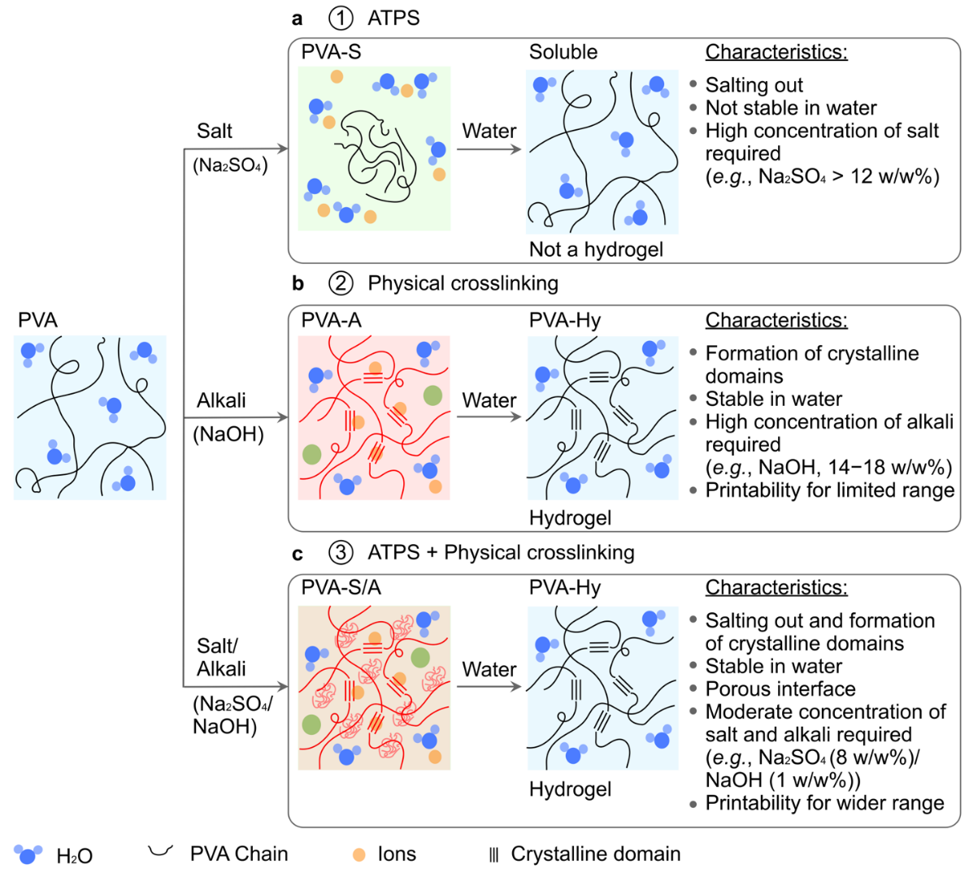
Figure 1. Overview of embedded 3D printing of polyvinyl alcohol (PVA) inks. (a) PVA/salt aqueous two-phase system (ATPS), in situ salt-induced precipitation (salting out), (b) physical crosslinking by alkali, and (c) combination of ATPS and physical crosslinking. PVA can be grouped into five different categories: (1) pristine PVA, (2) PVA-S (stabilized by salting out), (3) PVA-A (stabilized by alkali solution, NaOH), (4) PVA-S/A (stabilized by salting out and NaOH), and (5) PVA-Hy (Na+ removed from PVA-A or PVA-S/A by immersing them in DI water at least 24 hr), as described in schematics.
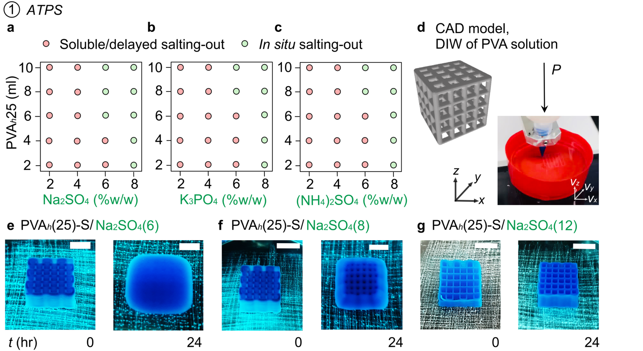Figure 2. Embedded 3D printing of PVA_{h} inks by ATPS (PVA-S). Effect of concentration of (a) Na₂SO₄, (b) K₃PO₄ and (c) (NH₄)₂SO₄ on in situ salting out of PVA solutions. (d) The CAD model of the 3D object and a DIW 3D printer showing direct writing of PVA solutions in a salt solution. Optical images showing fidelity of printing of PVA_{h}(25) in (e) Na₂SO₄(6), (f) Na₂SO₄(8) and (g) Na₂SO₄(12) just after printing and 24 hr after printing (PVA-S: PVA printed in salt solution). Scale bars = 1 cm.

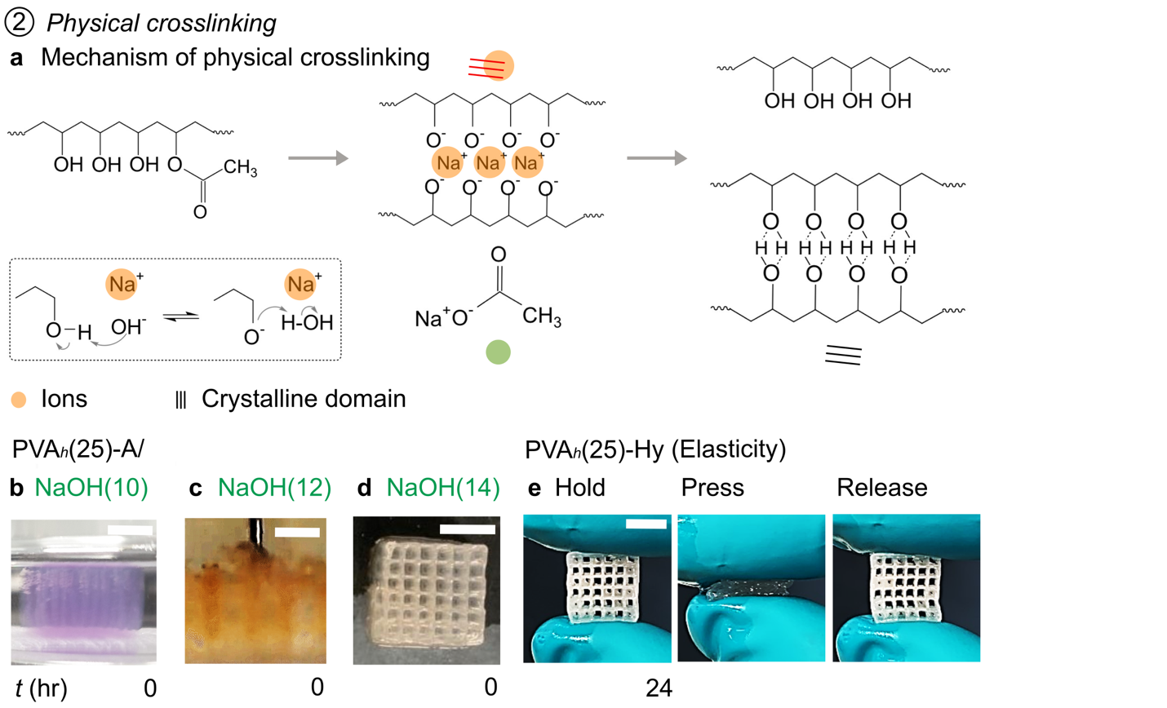

Figure 3. Embedded 3D printing of PVA_{h} inks by physical crosslinking (PVA-A). (a) Schematic illustration of the mechanism of physical crosslinking by NaOH (PVA_{h}-A: PVA printed in NaOH solution, PVA_{h}-Hy: Na⁺ removed from PVA-A). Optical images showing the effect of concentration of NaOH (b) NaOH(10), (c) NaOH(12), and (d) NaOH(14). Swelling of the printed objects was observed when the concentration of NaOH was ≤ 14 w/w%. Disruption of the previously printed filaments by the moving nozzle due to swelling of the previously printed filaments was observed in NaOH(12). (e) Optical images showing the elastic and flexible nature of the 3D-printed object. Scale bars = (b) 1 cm, (c) 5 mm, and (d-e) 1 cm.

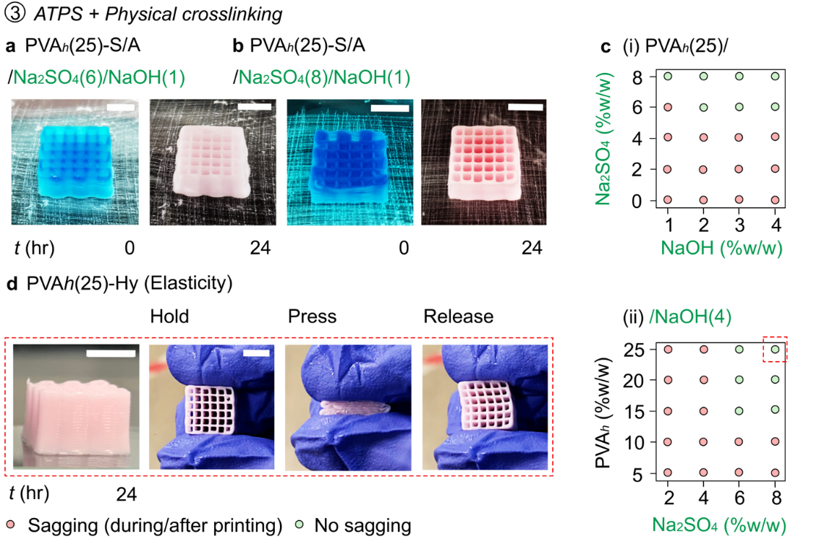

Figure 4. Embedded 3D printing of PVA_{h} inks by the combination of in situ salting out and physical crosslinking (PVA-S/A). (a-b) Optical images showing good fidelity of printing when NaOH was added to the salt solutions. (c-i) A plot showing the stability of the printed object during or 24 hr after printing when PVA_{h}(25) was printed in an embedding media with varying concentrations of Na₂SO₄ and NaOH. (c-ii) A plot showing the stability of the printed object fabricated by dispensing inks with different concentrations of PVA_{h} in NaOH(4) and varying concentrations of Na₂SO₄. (d) Optical images showing the elastic and flexible nature of the 3D printed object.

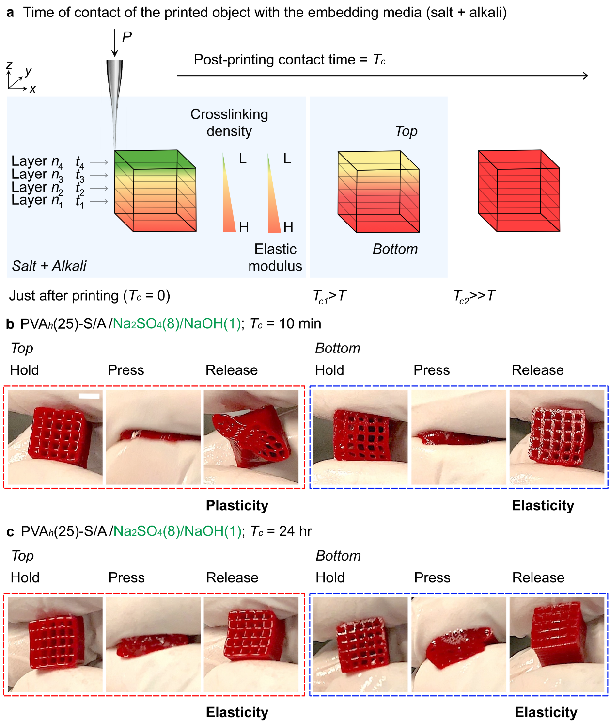
Figure 5. Anisotropy of mechanical property of the 3D-printed PVA-S/A. (a) Schematic illustration showing the effect of contact time after printing (T_{c}) on the degree of crosslinking of the printed PVA inks. Crosslinking occurs in the order of the layers printed; a short T_{c} can induce a gradient in the mechanical properties of the printed structure. For T_{c} = 0 (immediately after printing), the crosslinking density would be higher for the initially printed layers (e.g., layer n₁ printed at t₁) than for the layers printed at the end of the printing process (e.g., layer n₄ printed at t₄). (b) At T_{c} = 10 min, the degree of crosslinking of PVA varies within the printed object. The bottom of the object exhibited the elastic recovery of the shape, while the top part of the object exhibited the plastic deformation upon compression. (c) ) At T_{c} = 24 hr, homogeous crosslinking was achieved. The compression of the printed object resulted in elastic recovery regardless of the location of the 3D-printed object. Scale bars = 1 cm.
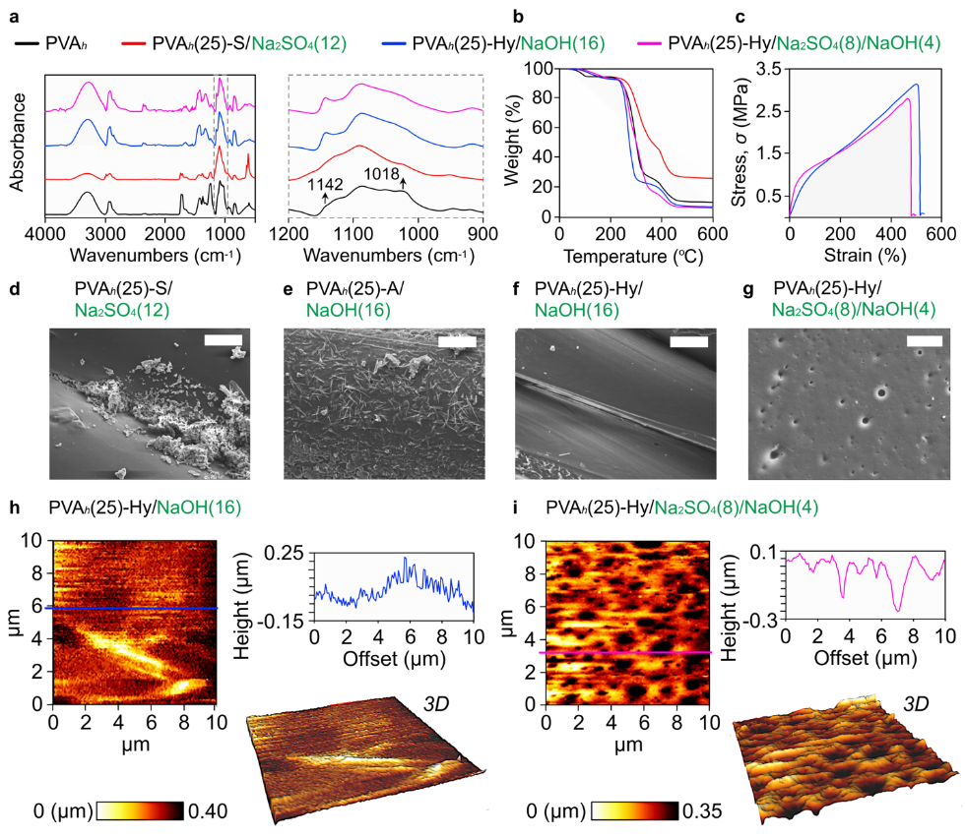
Figure 6. Physical characterization of PVA-S and PVA-Hy. Four samples—PVA_{h} (powder), PVA_{h}-S (printed in Na₂SO₄(12)), PVA_{h}-Hy (printed in NaOH(16) followed by Na⁺ removal), and PVA_{h}-Hy (printed in Na₂SO₄(8)/NaOH(4) followed by Na⁺ removal)—were analyzed for (a) Fourier transform infrared spectroscopy (FTIR) and (b) Thermogravimetric analysis (TGA). (c) Stress-strain curves of PVA_{h}-Hy printed in NaOH(16) and Na₂SO₄(8)/NaOH(4). SEM images of the surface of the 3D structure of PVA_{h} are shown for (d) PVA_{h}-S (printed in Na₂SO₄(12)), (e) PVA_{h}-A (printed in NaOH(16)), (f) PVA_{h}-Hy (printed in NaOH(16) followed by Na⁺ removal), and (g) PVA-Hy (printed in Na₂SO₄(8)/NaOH(4) followed by Na⁺ removal). Atomic force microscopy (AFM) topographic images, the surface profile of a random horizontal line and 3D representation are shown for PVA_{h}-Hy printed in (h) NaOH(16), and (i) Na₂SO₄(8)/NaOH(4). Scale bars = (d-g) 10 μm.
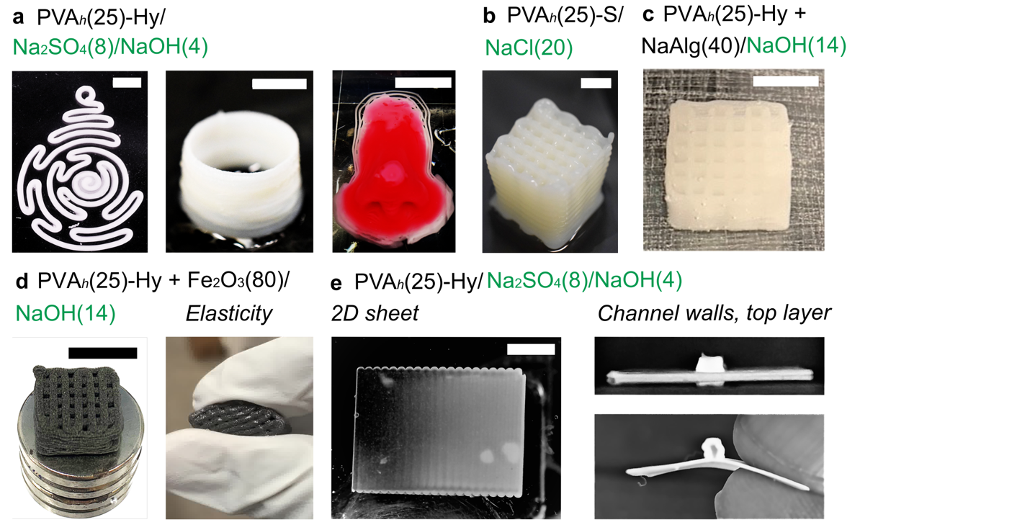

Figure 7. Optical images of 3D printed models of PVA_{h} printed in different combinations of salt and alkali systems. (a) 2D and 3D models of PVA_{h}-Hy prepared by salting out and physical crosslinking. (b) PVA-S printed in NaCl (20) as an embedding medium. (c) PVA_{h}-Hy composite with sodium alginate. (d) PVA_{h}-Hy composite with magnetic microparticles of Fe₂O_{3.} (e) Microchannels consisting of PVA_{h}-Hy printed on the flat sheet of PVA_{h}-Hy. Scale bars = (a-b) 1 cm, (c) 5 mm, (d) 1 cm, (e) 5 mm.

