An enhanced transit accessibility evaluation framework by integrating Public Transport Accessibility Levels (PTAL) and Transit gap
DOI: https://doi.org/10.1016/j.jtrangeo.2024.104013

Manish Yadav
Department of Civil Engineering,
Indian Institute of Technology Bombay,
Mumbai, Maharashtra, India 400076

Institute of High Performance Computing (IHPC),
Agency for Science Technology and Research (A*STAR)
1 Fusionopolis Way, #16-16 Connexis
Singapore 138632, Republic of Singapore

Email: 214040001@iitb.ac.in, stuyadavm@ihpc.a-star.edu.sg, manishyadav1701@gmail.com

Rakhi Manohar Mepparambath
Institute of High Performance Computing (IHPC),
Agency for Science Technology and Research (A*STAR)
1 Fusionopolis Way, #16-16 Connexis
Singapore 138632, Republic of Singapore
Email: rakhimm@ihpc.a-star.edu.sg

Gopal R. Patil
Department of Civil Engineering,
Indian Institute of Technology Bombay,
Mumbai, Maharashtra, India 400076
Email: gpatil@iitb.ac.in

ABSTRACT
Rapid urbanization has presented many challenges, notably spatial imbalances between the transit supply and demand within cities. The inequitable distribution of transit supply, which include the transit infrastructure and services, may lead to formation of areas where transit is under provisioned. This work aims to develop an enhanced framework for measuring spatial disparities in accessing transit systems by combining established concepts of Public Transport Accessibility Levels (PTAL) and transit gap. The proposed framework incorporates PTAL as a supply indicator and transit dependent population as the demand indicator while estimating the transit gap. PTAL takes into account the intricate relationship between transit infrastructure and transit services, an aspect that was overlooked by the previous studies on transit gap. Inclusion of PTAL enhances the transit gap evaluation method by offering a deeper understanding and a holistic perspective on the transit system. We demonstrate the proposed approach with an application in Singapore. Additionally, we propose a new classification system based on PTAL and transit gap to distinguish areas where high transit gap is a result of very high demand rather than poor supply. Results show that 44.82% of the transit dependent population in Singapore lives in high transit gap area out of which 4.69% population stays in transit desert zones, where supply is poor, and 40.13% lives in transit stressed zone, where demand is very high. The study also developed a simple decision framework based on PTAL and transit gap scores to suggest effective policy measures for reducing the spatial disparity in transit system accessibility. The findings from the work can aid policymakers and transport planners in land-use and transport planning of cities.

Keywords: Transit supply, Transit demand, Transit desert, Equivalent Doorstep Frequency, Singapore

1. INTRODUCTION
Improving access to public transit networks can enhance the sustainability and livability of urban areas. An accessible and reliable public transit system can motivate individuals to shift the mode from private vehicle to public transport (Owen & Levinson, 2015). This mode shift can significantly reduce the negative impacts of private vehicles on the environment (Thomas & Serrenho, 2024) and improve urban mobility in densely populated areas (Batty et al., 2015). Additionally, a well-connected public transportation network simplifies commutes for employment (Nassir et al., 2016), education (Moreno-Monroy et al., 2018), and healthcare (Sharma & Patil, 2021), while promoting social inclusion for marginalized groups such as the elderly and individuals with disabilities (Currie & Stanley, 2008). Ensuring an equitable distribution of public transit is essential for fostering equity in cities, as it improves accessibility to essential services and enhances overall societal well-being (Aman & Smith-Colin, 2020). Individuals unable to access public transit due to financial constraints or physical limitations can often sidelined from engaging in economic and social activities (Adhvaryu et al., 2019; Cai et al., 2020; Nassir et al., 2016). Proportionate distribution of public transit system has emerged as a popular solution to solve city spatial equality challenges by providing more opportunities to reach different services for a broader section of society (Liu et al., 2023).

Iacono et al (2010) defined accessibility as a “tool for monitoring land use and the transportation system, and for assessing the effect of proposed policies and decision making on land use or the transport network”. In the realm of spatial transit accessibility studies, previous research predominantly centered on either the supply or demand side of the transit system, often failing to present a comprehensive view. However, over the last decade, researchers have endeavored to address this limitation by employing “transit gap” and “transit desert” analysis (Chen & Jiao, 2022; Jiao, 2017; Jiao & Dillivan, 2013). Drawing parallels with the well-established notion of a food desert, Jiao & Dillivan 2013) introduced the concept of transit desert. A transit gap examine the disparity between the transit service level (supply) and the residents’ transit demand (demand) and if the value of transit gap exceeds a negative cutoff i.e. transit demand far outweighs the transit supply value the area classified as transit desert (Cai et al., 2020; Jiao & Dillivan, 2013; Lee et al., 2021).

With increase in city population, demand for public transport system also increases and it is necessary to study whether the current public transit system can meet this increased demand, and how a city or region can achieve a balance between transportation demand and supply. A comprehensive framework for assessing disparities is essential in determining whether transportation policies contribute to a fairly distributed transit system (Nazari Adli et al., 2019) or conversely, give rise to areas with inadequate transit accessibility (Aman & Smith-Colin, 2020). The primary distinction of this research from previous studies lies in addressing the limitations of the existing method for analyzing transit gap, which fails to differentiate whether a high transit gap arises due to genuine shortages in transit supplies or because of the excessive demand that overwhelms adequate supply levels. In this study, we have developed a comprehensive framework for understanding the transit gap, incorporating the Public Transport Accessibility Level (PTAL) (introduced in Section 2.1) as a measure of transit supply. Moreover, through the cross-classification of the transit gap and PTAL, we propose a revised classification system. This new classification system aims to distinguish areas where high transit gaps result from poor supply levels from those where a satisfactory level of supply is overwhelmed by demand. By analyzing PTAL and the transit gap, this study aims to illuminate spatial disparities in accessibility to public transit across different city areas and identify potential pathways for improvement and policy interventions to foster a more inclusive and equitable urban transportation system.

The next section provides the literature review that establishes the foundational theories in accessibility and transit gaps. Subsequent section offers an overview of the study area, and the data utilized. The methodology section describes our approach, integrating Public Transport Accessibility Levels (PTAL) with transit gap analysis to address existing challenges. We apply this methodology to a case study of Singapore, analyzing spatial transit disparities and developing a decision framework to guide policy interventions. The paper concludes by highlighting the implications of our findings for improving transit planning strategies, emphasizing the need for a balanced approach that considers both transit supply and demand.

2. LITERATURE REVIEW
The literature review section is structured into two parts: the first section discusses the definition of Accessibility and its implications across various studies. The second part of the review focuses on defining and exploring the transit gap and transit desert, providing insights into how this concept is understood and measured within the context of urban and transportation planning.

2.1 Accessibility
Accessibility is a term applied across various academic disciplines like urban studies, social studies, geography, transport planning, land use planning (Geurs & Van Wee, 2004) and, information and technology (Yesilada & Harper, 2019). However, the definition and measurement of accessibility vary depending on the field of application, making it crucial to establish a clear definition. Notably, Hansen (1959) defined accessibility as "the potential for opportunities for interaction." Similarly, Dalvi & Martin (1976) described accessibility as “the ease with which any land-use activity can be reached from a location using a particular transport system.” Ben-Akiva & Lerman (2021) interpreted accessibility as "the benefits provided by a transportation/land-use system.” In the context of transportation planning, accessibility can broadly be defined as the ease of reaching facilities/destination.

There are two parts of transit accessibility, the first is system accessibility or access to the transit system, and the second one is system-facilitated accessibility or accessibility by the transit system (Malekzadeh & Chung, 2020). System accessibility measures time or effort to reach a transit network. System accessibility includes two components, spatial component (i.e., transit stops and stations) and temporal component, i.e., service frequency (Bree et al., 2020). The one of the popular approaches of estimating system accessibility is by counting the number of transit stops and number of routes available in a fixed buffer distance. System accessibilities are affected by several attributes like distance to the stops, service frequency (headway), reliability of public transit service and route coverage. All these factors directly impact transit system users’ satisfaction, overall loyalty, and travel behavior. Higher network coverage, better service reliability, and frequent service availability helps in increasing transit ridership (Diab et al., 2015; Van Lierop et al., 2018).

System-facilitated accessibility measures the traveller’s opportunity to reach an opportunity by considering travel cost spent in the transit network (Mavoa et al., 2012). System-facilitated accessibility measurement have two primary components: the attractiveness and location of urban opportunities and the cost of travel (impedance factor) to reach these locations (Ben-Akiva & Lerman, 2021; Ermagun & Tilahun, 2020; Hansen, 1959; Sharma & Patil, 2021).

Foda & Osman (2010) used simple distance-based measures like Ideal and Actual Stop Accessibility Indicators (ISAI and ASAI) and Stop Coverage Ratio Index (SCRI); all these methods are based on pedestrian density based fixed coverage area (400 m radius buffer) and actual coverage area (400 m access threshold based on an actual pedestrian network). However, ISAI and ASAI methods may be confusing because the decrease in index value does not mean the bus stop is less accessible. In fact, it may be due to a greater access coverage area instead of decreased pedestrian road network length. Cheng & Agrawal (2010) used Time-Based Transit Service Area Tool (TTSAT) that utilizes geographic information systems and transit network data to calculate and visualize service areas based on travel time thresholds. It incorporates transit schedules, service frequencies, and transfer times to assess transit accessibility accurately. TTSAT generates polygons representing areas reachable within specified time thresholds, allowing for spatial analysis and visualization. However, TTSAT's accuracy relies on the quality and availability of transit data, and it makes simplified assumptions about travel behaviour. Pitot et al (2006) introduced the Land Use & Public Transport Accessibility Index (LUPTAI) which assess the accessibility of different locations to public transport based on their land use characteristics. LUPTAI combines land use data with information about public transport networks to measure accessibility. The index considers factors such as the proximity of land use types (residential, commercial, recreational) to public transport stops or stations, the density of land use in the vicinity of these transit nodes, and the availability of different modes of public transport (buses, trains, trams). Public Transport Accessibility Level (PTAL) is an origin-based measure that considers factors such as the proximity of public transport stops, wait time, frequency of service, service reliability, and the availability of different modes of public transportation (Adhvaryu et al., 2019; Adhvaryu & Kumar, 2021; Currie, 2010; Saghapour et al., 2016). The PTAL required less data and computational power than TTSAT and LUPTAI (Adhvaryu et al., 2019; Adhvaryu & Kumar, 2021). As in developing countries, getting primary data is very difficult, PTAL provides an opportunity to study system access accessibility in simple and limited data sets. As in developing countries, getting primary data is very difficult, PTAL provides an opportunity to study system access accessibility in simple and limited data sets.

Access to transit systems is primarily achieved by walking, and understanding the appropriate walking distance for accessing transit stops is crucial for designing transit-oriented urban planning and encouraging higher public transit usage. Since the 1970s, the research community has been exploring the most suitable walking distance to access transit stations. Commonly found that a walking distance of 400 meters to bus stands and 800 meters to railway stations is optimal for accessing transit stops (Daniels & Mulley, 2013; El-Geneidy et al., 2014; Zhao et al., 2003). However, it's important to consider that walking ability may vary based on socio-economic behaviour, age, and trip characteristics. Walking distances beyond 800 meters from transit stops significantly reduce public transit ridership (Zhao et al., 2003).

Many studies have documented the positive impacts of higher accessibility on social equity, health quality, employment rates, and environment. Ermagun & Tilahun (2020) shown that higher public transit accessibility is associated with increased employment rates, while Cervero & Kang (2011) found it is also linked to increased land values. Sharma & Patil (2021) highlight that improved public transit accessibility enhances access to healthcare facilities and hospitals, leading to better individual health outcomes. Malekzadeh & Chung, (2020) assert that enhancing public transit accessibility can reduce car use and greenhouse gas emissions. The accessibility maps derived from public transit accessibility studies can be invaluable to urban planners, facilitating investment decisions for future public transit infrastructure and enhancing urban planning by aligning land-use and transportation considerations. Furthermore, accessibility measurement can assist in evaluating transportation investments and assessing their performance (Adhvaryu et al., 2019).

2.2 Transit Gap and Transit Desert
System accessibility measure supply side of a transit system, offering insights into the availability and reach of public transportation. Also, calculation of the transit-dependent population helps us to understand the demand for transit services within a given area. Bridging the gap between these aspects is the concept of a transit desert, a term introduced by Jiao and Dillivan (2013), drawing parallels with the well-established notion of a “food desert”. Food desert refers to an area with limited access to affordable and nutritious food, particularly fresh fruits and vegetables. These areas are often characterized by a scarcity of grocery stores or markets, making it difficult for residents to obtain healthy food options within a reasonable distance (Páez et al., 2010).

Transit deserts refer to areas where the provision of transit services significantly lags behind the demand for such services (Aman & Smith-Colin, 2020; Cai et al., 2020; Chen & Jiao, 2022; Jiao, 2017; Jiao & Cai, 2020; Jiao & Dillivan, 2013; Lee et al., 2021). Research on transit deserts has involved three major concepts: (i) transit demand, (ii) transit supply and, (iii) transit gap. In essence, transit demand calculations encompass a fraction of the population that relies on transit services, including individuals who are too young to possess a driving license, the elderly, those with physical disabilities, and economically disadvantaged individuals who cannot afford personal vehicles (Aman & Smith-Colin, 2020; Jiao, 2017). On the other hand, the transit supply involves critical components such as the number of transits stops, service frequency, availability of pedestrian walkways, presence of bicycle stands, network connectivity (Cai et al., 2020; Jiao & Cai, 2020) and accessibility to various destinations (Aman & Smith-Colin, 2020). Transit gap represent the difference between transit supply and transit demand (Cai et al., 2020). An inadequacy in any of these aspects can create transit deserts, where the demand for reliable public transit outstrips the available supply i.e. the value of transit gap exceeds a negative cutoff, leaving a portion of the population underserved in terms of system access options. Consequently, individuals residing in transit desert face challenges accessing essential services, employment opportunities, healthcare facilities, and social engagements due to the limited and often inefficient public transportation options (Aman & Smith-Colin, 2020). The applicability of this analytical method has been rigorously tested and confirmed in various cities worldwide, including Texas (Jiao, 2017), Dallas (Aman & Smith-Colin, 2020), Wuhan (Cai et al., 2020), Seoul (Lee et al., 2021), Cape Town (Vanderschuren et al., 2021) and several European cities (Chen & Jiao, 2022).

In assessing transit supplies, prior research has mainly concentrated on the quantitative details of transit infrastructure, like the number of bus or railway stops and the length of roads, as well as aspects of transit services such as frequency and available routes, often evaluating them separately without acknowledging the interconnection between these two facets of the transit network. In our study, we focus solely on transit system accessibility and introduce the PTAL as an indicator of supply to estimate the transit gap. The introduction of PTAL into the calculation of transit supply within this study tries to address transit infrastructure and transit service interconnection challenges. To the best of our knowledge, none of the transit gap studies has used the PTAL method to estimate transit supplies. Further, we tried to categorize transit desert and transit stressed zones based on the cross-classification of transit gap and PTAL.

3. STUDY AREA AND DATASETS
Singapore is a city-state with an area of 710 sq.km and 4.04 million residents (Census Singapore, 2021) The Urban Redevelopment Authority (URA) of Singapore has divided Singapore into five regions named as Central Region (CR), East Region (ER), Northeast Region (NER), North Region (NR) and West Region (WR). The regions are divided into 55 planning areas (PA), which are further subdivided into 323 subzones. Figure 1 shows the location of public transport stations (bus stops and train stations), urban planning regions boundary, planning areas boundary and subzones boundary of Singapore.
Figure 1: Distribution of public transport stops/stations in Singapore
There are two modes of public transport in Singapore including bus and train (LRT and MRT). The database of the road network, transit routes, bus stops and train stations has been obtained from the Land Transport Authority (LTA) DataMall website (datamall.lta.gov.sg). This dataset includes an extensive range of road types, encompassing all minor and major roads, such as expressways, arterial, sub-arterial, collector and local streets. As per the database till August 2022, Singapore has 5150 bus stops, 127 Mass Rapid Transit (MRT) and 37 Light Rapid Transit (LRT) stations. There are 518 bus routes with a daily ridership of 3.7 million and train system consisting of six MRT line and two LRT lines. The 200 km of MRT system and 28 km of LRT system has three million and 0.2 million daily ridership respectively (LTA, 2024). From Figure 1 we can observe that bus stops are distributed throughout the city, whereas MRT stations have major concentration in central and east regions of Singapore, which may be due to the higher density of commercial spaces and tourist destinations located in these areas. The LRT system acts as feeder services for MRT thereby helping in increasing the connectivity. As per the Census 2020 of Singapore, share of mode of transportation for work trips, consisted of 57.7% of public transportation (bus and train), 21.1% of car, 9.8% of walk, 3.4% of motorbike/scooter, 3% of private taxi, 2.1% of private charted bus/van and 1.6% of cycle and 1.3% of lorry/pickup (Census Singapore, 2021).

In this study, the assumed maximum walking distance to reach a bus stop or LRT station entrance was set at 400 m, while the maximum walking distance to an MRT station entrance was 800 m, these values were selected based on the guidelines provided by Land Transport Authority of Singapore (LTA, 2019). Adhvaryu et al. (2019), compared PTAL mapping using 1000 m, 500 m, 100 m, and 30 m square grids, suggesting that for city-level strategic transport planning, a 1000 m grid can be a good starting point. Considering these factors, we chose a 400 m square grid to align with our assumed walking distance to bus stops and LRT stations, and two grid sizes equal to the MRT stop distance. The grid was then intersected with the land use layer extracting water body, agricultural space, reservoir, and special use areas from the consideration (SMP-19, 2019) keeping only areas suitable for urban development and transportation planning.

Singapore primarily offers two types of dwelling options: flats provided by the Housing and Development Board (HDB) and those developed by private companies. HDB flats come in a range of sizes, from one-room studio flat to five-room apartments. These flats are categorized by the number of rooms: 1-HDB, 2-HDB, 3-HDB, 4-HDB, and 5-HDB, as well as executive flats. For example, a 3-HDB refers to a three-room flat (1 hall and 2 bedrooms). On the other hand, private housing mainly consists of condominiums and landed properties. The population data used in this study is taken from the database of the 2020 census of Singapore, which is accessible on the Singapore Department of Statistics (DOS) website (singstat.gov.sg). This database contains age wise total residential population and different size wise total number of dwellings at the subzone level and employed population working in various planning areas. All the data in this study was aggregated at the subzone level. Data readily available from reliable sources was adopted in its original form. When the data was available at a coarser level, such as the planning area level, it was transformed into a finer level, specifically the subzone, through appropriate approximations.

The aggregate vehicle ownership data from Singapore is also used in the study. In Singapore, there are 1.37 million households, out of which 34.63% households have their own cars and 10.50% have their own motorbikes (MOT 2022, 2022). However, this information is not available at the subzone level. To estimate the number of cars and motorbikes in each subzone, we did approximation based on the fact that in Singapore, the use of cars for work trips is predominant in 4-HDB, 5-HDB, condominiums, and landed properties, accounting for 94.14% of work trips. Similarly, the use of motorbikes for commuting to work is prevalent in 3-HDB, 4-HDB, and 5-HDB, constituting 90.81% (Census Singapore, 2021). Therefore, we assumed that 4-HDB, 5-HDB, condominiums, and landed properties possess all the cars. We multiplied a factor of 0.3463 by the sum of the number of 4-HDB, 5-HDB, executive flats, condominiums, and landed properties in each subzone to estimate the number of cars for subzone. Similarly, for motorbike we assumed that in 3-HDB, 4-HDB, and 5-HDB possess all the motorbikes and multiplied a factor of 0.1050 to the sum of the number of 3-HDB, 4-HDB, and 5-HDB in each subzone to estimate the number of motorbikes for subzone.

4. METHODOLOGY
Figure 2 presents an overview of the methodology used in this study. The initial step is to estimate system accessibility using the Public Transport Accessibility Level (PTAL) method, followed by the estimation of the transit gap. Subsequently, a decision framework is developed based on the PTAL and transit gap results, from which policy measures are suggested. The details of each step are discussed in the subsequent sections.

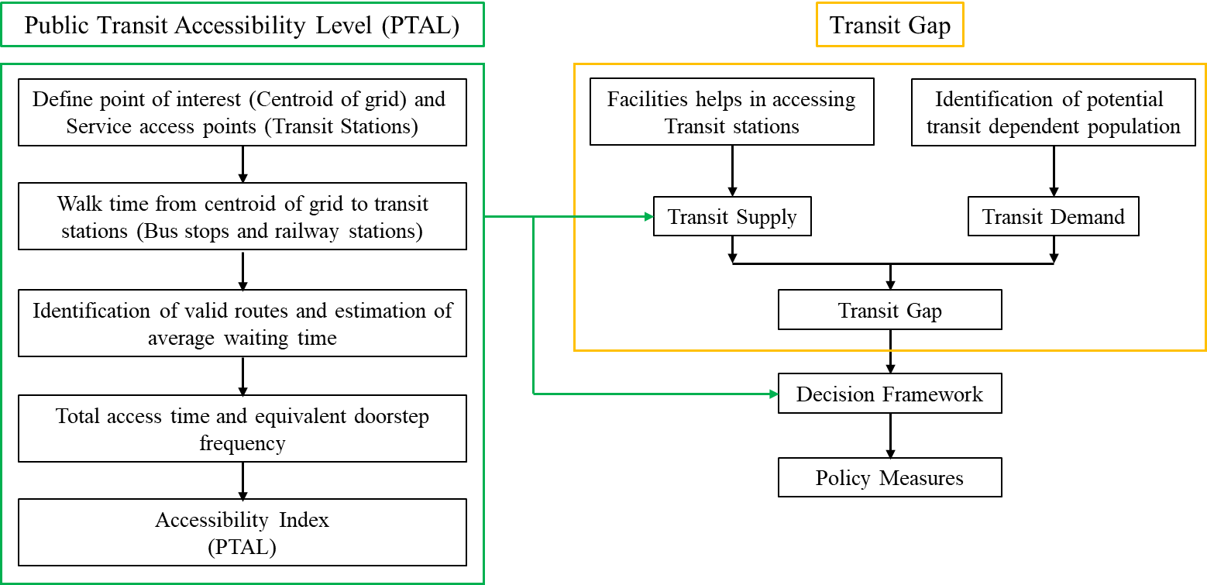
Figure 2: Overview of the study methodology
4.1 Public Transport Accessibility Level
Public Transport Accessibility Level (PTAL) is a highly detailed origin-based transit accessibility estimate, that consider factors such as service access points, walking time, service availability, and average waiting time. The method was originally developed and tested by London Borough of Hammersmith and Fulham in 1992 (London, 2010). Its applicability has been tested in several well-known cities of developed and developing countries like Melbourne (Currie, 2010; Saghapour et al., 2016), Auckland (Wu & Hine, 2003), Lucknow (Adhvaryu & Kumar, 2021), Surat (Adhvaryu et al., 2019), and Ahmedabad (Shah & Adhvaryu, 2016). PTAL allows for the identification of areas with high and low public transit system accessibility and can assess the impact of potential changes in public transit on social inclusion objectives. The PTAL calculation adopted for Singapore is summarized below:

Step 1: Define point of interest (centroid of grid) and service access points (transit stations): Singapore is divided into 400 $×$ 400 m grids and the centroid of these grids are taken as Point of Interests (POI) whose accessibility is being measured. The transit stops that include train stations and bus stops are the Service Access Points (SAP).

Step 2: Estimating walk access time between POI and SAP: The distance between POIs and SAPs were measured using the road network data that was available. As mentioned earlier, the maximum walking distance to a bus stop or LRT station was set at 400 meters, and to an MRT station at 800 meters.

In London's study, the walking speed was considered 80 m/min. (Tanaboriboon et al., 1986), found that mean walking speed in Singapore was 74 m/min, but for the elderly population (age over 60 years) had mean walking speed was much lower that was only 54 m/min. The median age of Singapore in 1980 was 23.5 years while the median age in 2023 is 42.4 years i.e., median age has increased by 1.80 times in last four decades. In 2022, Singapore had 24.1 individuals aged 65 years and above per hundred people aged 15 to 64 years, representing the old-age dependency ratio. Over the past decade, this ratio has seen a notable rise of 1.68 times, starting at 13.5 in 2012 (MTI, 2023). Walking with elderly person reduces the walking speed (Finnis & Walton, 2008) and additionally usage of mobile phones and carrying baggage (Rastogi et al., 2011) also reduce the walking speed of individuals. Singapore is facing the challenge of an increasingly aging population hence, considering these factors in view, a walking speed of 60 m/min was assumed for this study.

Step 3: Calculating scheduled waiting time (SWT) and average waiting time (AWT) for each route at each SAP: In the PTAL calculation, route information is considered only once. If a bus or train route served multiple SAPs within a POI catchment area, the SAP closest to the nearest POI is considered. For Singapore's public transit system (bus and rail), travel card tap-in data from 6:00 AM to 11:00 AM shows that 73.12% of tap-ins occur between 6:00 AM and 9:00 AM. Our investigations on the supply change from peak (peak hour average frequency is 11.55 minutes) to off-peak (off-peak hour average frequency is 12.62 minutes) showed that compared to the demand drop, the supply drop from peak to off-peak is minimal, indicating that morning period is critical for transit gap analysis. Hence, the study used routes and service frequencies during the peak hours of 7:00 AM to 9:00 AM (LTA, 2019) to determine the average waiting time (AWT).

The waiting time for passengers arriving at SAPs is assumed to be random, without adjusting their arrival time according to bus or train schedules. The Scheduled Waiting Time (SWT) is estimated to be half the interval between service arrivals at SAPs. For example, if a bus service had a frequency of four buses per hour at intervals of 15 minutes, the average SWT for passengers was 7.5 minutes. The AWT (in minutes) is estimated by summing the SWT and the reliability factor. The reliability factor (K) accounted for the possibility of actual wait times being longer than scheduled due to unpredictable traffic conditions and deviations from traffic rules. In this study, reliability factors of 0.83 minute for trains (MRT and LRT), and 1.5 minutes for buses were consider which was same as provided by the Land Transport Authority of Singapore (LTA, 2019).

 | $${SWT}_{ij}=0.5*\left(\frac{60}{F_{ij}}\right)$$ | (1)
 | $${AWT}_{ij}={SWT}_{ij}+K_{j}$$ | (2)
Where ${SWT}_{ij}$ is the schedule waiting time (min) at the nearest stop to the POI $i$ for public transit mode $j$, $F_{ij}$ is the frequency of mode j at the nearest stop to the POI $i$, ${AWT}_{ij}$ is the average waiting time (min) at the nearest stop to the POI $i$ for public transit mode $j$ and $K_{j}$ is the reliability factor.

Step 4: Calculate total access time (TAT) and equivalent doorstep frequency (EDF) for each route at each SAP: TAT (in minutes) included walk time from POI to the SAP and average waiting time at SAP. The EDF converted the TAT back into the units of frequency. EDF explained what service would have been available at the center of POI without any walking. For finding AWT, frequency was converted into SWT, and in this step, TAT was converted back into frequency.

 | $${TAT}_{ij}={WT}_{ij}+{AWT}_{ij}$$ | (3)

 | $${EDF}_{ij}=0.5×\left(\frac{60}{{TAT}_{ij}}\right)$$ | (4)
Where ${TAT}_{ij}$ is the total access time (min) of public transit mode $j$ at the nearest stop to the POI $i$, ${WT}_{ij}$ is the walk time (min) from the POI $i$ to the nearest stop of public transport mode $j$ and ${EDF}_{ij}$ is the equivalent frequency for public transport mode $j$ at the nearest stop to the POI $i$.
Step 5: Calculate Access Index (AI): The PTAL method gave more weightage to the service with the highest EDF and less weight to other services within the same mode. This assumes that a specific route from the nearest stop is the most suitable and most preferred by the individual. AI is estimated by adding the EDFs of all routes at all SAPs within the catchment of walking distance.
 | $${AI}_{ij}{=ϑEDF}_{ij_{max}}+\left(μ\sum_{j≠j_{max}}{{EDF}_{ij}}\right)$$ | (5)
 | $${AI}_{i}= \sum_{j}{{AI}_{ij}}$$ | (6)

Where ${AI}_{ij}$ is the access index of public transit mode $j$ at the nearest stop to the POI $i$, $ϑ$ and $μ$ are the coefficients considered for the highest EDF per mode and all other modes respectively. Land Transport Authority has defined a weightage of one to the highest EDF per mode ($ϑ$ ) and a weight of half to all other modes ($μ$) (LTA, 2019), and we have used same for the calculation.

ArcGIS 10.6 was used to perform all the analysis and mapping purposes. The estimated accessibility levels are further classified into six groups for mapping same as studies of Wu & Hine (2003) and Saghapour et al. (2016) (i) Very poor (0-5) (ii) Poor (5-10) (iii) Moderate (10-15) (iv) Good (15-20) (v) Very Good (20-25) and Excellent (>25).

4.2 Transit Gap
The primary step in deciding the transit gap is estimating transit demand. Based on need, mobility, and ability, this study used three different demographic factors to measure transit dependency. Once transit demand is estimated, the next challenge is estimating transit supply. Transit supply includes infrastructure and service availability factors (Aman & Smith-Colin, 2020; Cai et al., 2020; Chen & Jiao, 2022; Jiao & Cai, 2020; Jiao & Dillivan, 2013; Lee et al., 2021; Vanderschuren et al., 2021), which will be addressed in the following section.

4.2.1 Transit Demand
Public transit demand is mainly driven by transit-dependent populations who do not have their own personal vehicle and a fraction of the population that relies on transit services, including individuals who are too young to possess a driving license, the elderly and those with physical disabilities. Past studies concerning transit deserts employed the methodology introduced by the US Department of Transportation, to gauge the transit-reliant demographic who do not possess personal vehicles and depend on public transportation services (Jiao, 2017; Jiao & Dillivan, 2013; Lee et al., 2021)). In this study, we adopted a similar approach tailored to Singapore's data availability. Notably, previous studies did not consider motorbikes in their calculations. However, for our analysis in the context of Singapore, we incorporated motorbike data. Singapore has approximately 142.45 thousand motorbikes (LTA, 2024), out of which 51.60% motorbike users reported to use motorbikes for their daily work commutes (Census Singapore, 2021).

In Singapore, individuals can get a driving license at age of eighteen, and individuals aged sixty-five or older are required pass a renewal test to maintain their license status. Given the availability of census data in five-year age ranges, we considered the population between the ages of 20 and 65 as potential drivers. Fwa & Chua (2007) reported that the average passenger occupancy (APO) per car for work trips in Singapore remained stable from 1990 to 2005, marginally increasing from 1.33 to 1.37. For our study, we adopted the same car occupancy rate of 1.37 for our calculations. In the absence of literature or reports explaining the average passenger occupancy for two-wheelers, we assumed an average passenger occupancy of one for two-wheelers in this study.

School going students in Singapore also prefer using the bus and metro systems for their daily commutes. Therefore, to identify the potential transit dependent residence population by subzone, we combined the population of minors (aged 5 to 20 years), the transit dependent potential driver population (aged 21 to 64 years), elderly population (those aged 65 and over) and subtracted the number of motorbikes and car numbers multiplied by the car occupancy ratio. Equation 7 is used for estimating potential transit dependent residence population by subzone. For the rest of the study, we use term “Transit Dependent Residence Population (TDRP)” for defining potential transit dependent residence population by subzone.

 | $${TDRP}_{sz }=P_{sz}-(C_{sz}×O_{c})-({TW}_{sz}×O_{tw})$$ | (7)

Where, $P_{sz}$ is population over five years and above, $C_{SZ}$ and ${TW}_{SZ}$ represent the number of cars and two-wheelers in a subzone, respectively, and $O_{c}$ and $O_{tw}$ are the average passenger occupancy per car and per two-wheeler, assumed to be 1.37 and 1, respectively, for this study.

To validate the estimation of TDRP at the Singapore level, we used publicly available census data (Census Singapore, 2021). We made efforts to avoid double counting any population group to ensure accuracy. This validation included the sum of population using public transit to reach work locations, minors, the elderly, the disabled population, the unemployed population (those who are not working but actively seeking employment), and the population outside the labour force (including students over 20 years old and individuals involved in childcare or caregiving). The difference observed between the estimated numbers obtained from the TDRP equation (Eq. 7) and the validation steps is less than 1%.

Within Singapore, 43.3% of the working population is employed in planning areas where only 1.2% of the working population resides. Therefore, estimating demand solely by residence location provides only a partial picture of the demand generated across all types of subzones, especially those dedicated to employment. Singapore's land use data includes 31 classes (SMP-19, 2019), of which 16 cover areas such as residential blocks, water bodies, beaches, roads, and open spaces. The remaining 15 classes represent areas where the majority of the population works. We grouped these 15 classes into three major categories: (i) commercial, (ii) industrial, and (iii) service sector land use.

Commercial land use includes areas covered by business parks, and commercial institutions (such as banks, hotels, offices, recreation clubs, cinemas, and entertainment venues). Industrial land use encompasses areas covered by minor and major industries. The service sector includes areas occupied by utility offices, civic and community institutions, healthcare and educational institutions, and locations where shops and food courts are shared with residential areas. Commercial and industrial spaces occupy approximately 78% of the land use, while the service sector accounts for 22%.

Employment data was available at the planning area level; to estimate it on the subzone level, we made an approximation assuming that jobs were uniformly distributed across the commercial, industrial and services sector land uses of the planning area. Firstly, we determined the employed population density within each planning zone by dividing the total employed population in that planning zone by the area designated for commercial, industrial and services sector land use within that same planning zone. Subsequently, we estimated the number of employed individuals within each specific subzone by multiplying the employed density calculated at the planning zone level by the area of commercial, industrial and services land use space situated within the boundaries of that subzone. For the rest of this study, we use term “Transit Dependent Employed Population (TDEP)” for mentioning transit dependent employed population by subzone of workplace”.

After estimating TDRP and TDEP, it was divided by subzone area to estimate density and nullified size effect. After estimating population density, Z score for each subzone was estimated. Z score, also known as a standard score, is a statistical measurement that describes a value's relation to the mean of a group of values (Jiao, 2017; Jiao & Dillivan, 2013; Lee et al., 2021). It is expressed in terms of standard deviations from the mean. A positive Z score suggests that the data point is above the mean, negative Z score indicates that it is below the mean and zero implies that the data point's score is identical to the mean.

4.2.2 Transit Supply
Previous studies on transit desert defined transit supply using factors including the count of bus stops, number of routes, frequency of bus arrivals on weekdays, length of sidewalks, availability of bike paths, existence of roads with low-speed limits, and the density of intersections (Cai et al., 2020; Chen & Jiao, 2022; Jiao, 2017; Jiao & Cai, 2020; Jiao & Dillivan, 2013; Lee et al., 2021). The presumption that proximity to bus stops represents real access to transport services overlooks situations where transit service is restricted (Aman & Smith-Colin, 2020) selection of valid routes and waiting time.

In this work, we utilized PTAL as a key supply indicator, encompassing transit frequency, the proximity of transit stations within a 400-meter walking distance to bus stops and LRT stations and an 800-meter walk to the MRT stations. The introduction of PTAL into the calculation of transit supply within this study tries to address transit infrastructure and transit service interconnection challenges. PTAL encompasses more than just network access; it encompasses service frequency, walkability to transit stops, and the selection of viable routes, offering a more comprehensive evaluation of transit supply. PTAL provides a better logical connection between all these factors than considering all factors individually and provides equal weightage to all variables for estimating transit supply.

Factors like intersection density, density of sidewalks, and density of cycle routes can facilitate access to public transportation, yet they don't directly reflect the level of transit supply in the region (Aman & Smith-Colin, 2020). Contrary to previous studies, which assigned equal weight to all supply variables, our approach determined the final Z score by attributing weighted factors to each variable. These factors were based on the utilization of public transit, cycling, and walking as modes for work trips by the residents of Singapore.
 | $$Z_{{Supply}_{sz}}=αZ_{PTAL}+βZ_{cycle racks density}+γZ_{footpath density}$$ | (8)

Where, $Z_{{Supply}_{sz}}$ is Z score of a subzone, $Z_{PTAL}$ is Z score of PTAL value for a subzone, $Z_{cycle racks density}$ is Z score of cycle racks density for a subzone, $Z_{footpath density}$ is Z score of footpath density for a subzone, $α$ (0.693-0.984) represents the fraction of people using public transit as their mode for work trips in the subzone, $β$ (0.003-0.138) represents the fraction of people using cycling as their mode for work trips in the subzone, and $γ$ (0.002-0.275) represents the fraction of people using walking as their mode for work trips in the subzone. The value of alpha, beta and gamma for each subzone was derived from the Census data (Census Singapore, 2021).

4.2.3 Transit Gap
After calculating Z scores for transit supply and transit demand, subtracting demand from supply gives the transit gap value. A negative value indicates demand exceeding supply, while a positive signified greater supply than demand. The calculation of the transit gap within each subzone is based on the following equation:

 | $${Transit gap}_{sz}=Z_{{Supply}_{sz}}-Z_{{Demand}_{sz}}$$ | (9)
We categorize transit gaps into four levels using the quartile method (Aman & Smith-Colin, 2020; Jacques et al., 2013). Each quartile encompassed twenty five percent of subzones, and this method helped us to identify the worst quartile or subzones with the highest level of transit gap. Table 1 provides a detailed breakdown of the descriptive statistics for demand and supply variables.
Table 1: Descriptive statistics of transit demand and transit supply variables.
Variables (Units) |  | Sum | Max | Mean | Standard Deviation
Transit Demand | Potential transit dependent residence population by subzone (Counts) | 3138127 | 101921 | 10530.63 | 14009.51
Transit Demand | Transit dependent employed population by subzone of workplace (Counts) | 1183303 | 42349 | 3970.82 | 5622.76
Transit Supply | Bus stops (Counts) | 5150 | 92 | 17.28 | 13.60
Transit Supply | Metro station (Counts) | 164 | 4 | 0.51 | 0.79
Transit Supply | Cycle racks (Counts) | 19129 | 1033 | 64.19 | 155.52
Transit Supply | Length of footpath (m) | 3767935 | 76127 | 12644.07 | 10680.68

5. RESULTS
5.1 Singapore PTAL Mapping
The accessibility index is calculated for each 400 × 400 m grid. After excluding reserved areas, the PTAL values were aggregated to the subzone using the area-weighted average. Figure 3 shows the PTAL map for Singapore.
Figure 3: PTAL for Singapore
In Singapore, among 298 subzones, 32 subzones lie in the very poor accessibility level, having 0.67% of TDRP and 12.55% of TDEP. 34 and 33 zones lie in poor (4.01% of TDRP and 11.59% of TDEP) and moderate (8.82% of TDRP and 5.91% of TDEP) accessibility levels, respectively. Meanwhile, 195 subzones show accessibility level good and above. Figure 4 illustrates the percentage distribution of TDRP and TDEP across PTAL ranges, showing better transit access in residential areas than in commercial and industrial estates subzones.

Figure 4: Percentage of population lying in different PTAL range

Figure 5: Percentage of subzones lying in different PTAL ranges in different regions of Singapore.
Figure 5 shows the percentage of subzones of different regions in different PTAL ranges. The central region of Singapore has the highest number of subzones, followed by the western, northeast, north, and east regions. Central region especially has commercial areas, and 34.3% of all employed population work in five planning areas of central region (Census Singapore, 2021). Subzones of the central region show exceptionally well as compared to other planning regions. 85.16% of subzones of central region show a Good to Excellent level of PTAL values.

In terms of area, the west region is the largest region of Singapore; the region mainly has residential towns and industrial houses. Jurong Island and Tuas planning areas of west region mainly have heavy industries and the subzones of these planning areas are showing poor and very poor accessibility levels. 52.31% of subzones of the western region show very poor to moderate accessibility levels. Singapore's bus density (Number of bus stops per sq.km.) is 8.62 bus stops per sq. km. However, for the western region, bus density is 5.88 bus stops per sq. km. Bus stop density for Tuas and Pioneer planning areas are 4.42 and 10.88, respectively; lack of bus stops and low frequency of buses might be the reason for the high use of private buses/vans and lorries/pickups for reaching the job locations. Use of private buses and vans for reaching job locations is highest in the subzones of Tuas (16.61% of total private bus and van users for accessing their job location) and Pioneer (11.40% of total private bus and van users for accessing their job location) planning area of west region (Census Singapore, 2021). Because of heavy industry, a significant number of migrant labourers also worked in the west region, who access their job locations by travelling through lorry/pickup services (Lei, 2023), which is also an indication of a lack of public transit services in industrial areas of the western region. 25.57% of total lorry/pickup user for accessing their job location has been done in six planning areas of the western region in Singapore.

60.71% Area of the east region shows only up to the moderate level of accessibility, and 87.26% of TDRP staying in the eastern region have an accessibility level of good and above. The North region mainly has residential estates, and it is Singapore's youngest urban developed area. 83.45% of transit dependent residents in northern regions have good and above access levels to transit stops.

5.2 Spatial Distribution of Transit Demand and Transit Supply
Table 2 details TDRP and TDEP across population density ranges, and Figure 6 shows the spatial distribution of Z score for TDRP and TDEP. 141 Subzones have population density within a range of 0 to 5000 individuals per sq. km., 7.03% of the TDRP reside in these areas. Conversely, twenty-five subzones having a density of over 25,000 individuals per sq. km. contain 24% of Singapore’s TDRP. Notably, these sub-zones are distributed across all regions of Singapore.

Table 2: Breakdown of transit dependent residence population and transit dependent employed population
Population Density (Individuals per sq. km.) | Number of Subzones |  | Population Percentage
Population Density (Individuals per sq. km.) | Transit dependent residence population | Transit dependent employed population | Transit dependent residence population | Transit dependent employed population
0-5000 | 141 | 235 | 07.03 | 50.92
5000-15000 | 73 | 36 | 26.21 | 21.91
15000-25000 | 59 | 11 | 42.76 | 05.96
>25000 | 25 | 16 | 24.00 | 21.22

For TDEP, in the range of 0 to 5000 individuals per sq. km. there are 235 subzones, constituting 50.92% of the total population of employed person. The highest density bracket, with sixteen subzones accounts for 21.22% TDEP, 11 of these subzones are in the Downtown Core planning area. The 2020 census of Singapore shows 12.90% of employed persons work in the Downtown Core planning area (Census Singapore, 2021). Figure 6(b) highlights the central region's high concentration of transit-dependent workers.

(a) | (b)
Figure 6: Spatial distribution of transit demand (Z score) (a) transit dependent residence population and (b) transit dependent employed population
Figure 7: Spatial distribution of transit supply (Z score)

Figure 7 depicts the spatial distribution of transit supply in Singapore. The PTAL score includes motorized transport factors, whereas the non-motorized transport system is characterized by two criteria walking and cycling, encompassing footpath length and the number of cycle racks within each subzone. The Z score calculation for transit supply, detailed in the methodology section, indicates that the central region has higher supply levels than other regions. Over half (51.60%) of the TDRP lives in areas with above-average supply Z scores, indicating better transport access than the mean value.
5.3 Spatial Distribution of Transit Gap
The transit gap is calculated by deducting the standardized Z score of demand from that of supply. A negative transit gap value signifies that the area's transit demand surpasses its supply, whereas a positive value indicates the opposite.
5.3.1 Transit gap based on transit dependent residence population
Figure 8 shows the spatial distribution of the transit gap for Singapore based on TDRP. The transit gap scores are grouped by quartiles, each quartile includes 25% of the subzones in the dataset. This approach helps us to understand what number of population is lying in below 50% of subzone. 61.52% of the population stays in areas of high transit gap zones, this means that even though the supply shown by PTAL is high in various zones but simultaneously, demand in these zones is also very high, which compensates for the high supply. These high transit gap zones are mainly in the western, northern and northeastern regions of Singapore. Figure 9 shows the percentage of different age groups within the TDRP staying in various transit gap classes. The percentage of individuals experiencing a high transit gap is relatively similar between minors (aged 5 to 20 years) and adults (aged 21 to 64 years), at 63.01% and 62.75%, respectively. However, a lower percentage of the elderly (56.20%) falls into the high transit gap category compared to minors and adults.

Figure 8: Spatial distribution of transit gap considering transit dependent residence population as transit demand

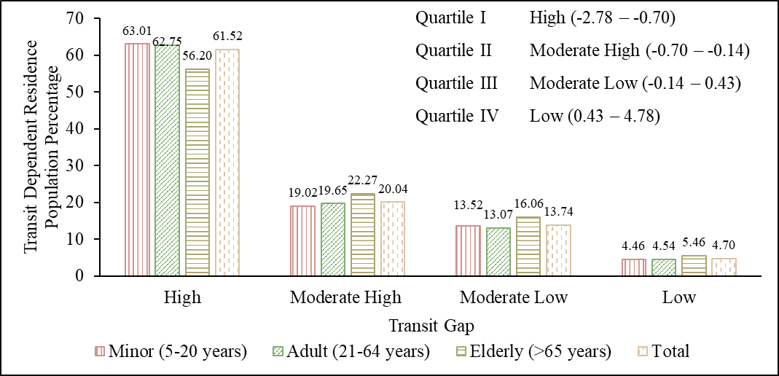
Figure 9: Transit dependent residence population staying in different transit gaps
5.3.2 Transit gap based on transit dependent employed population
In a manner akin to understanding transit dependence among the residential population, we also endeavoured to comprehend transit dependence among the employed population based on their workplace subzones. Figure 10 illustrates the transit gap for transit dependent employed individuals categorized by subzones of their workplace. Similar to the previous section, the transit gap scores in this case are grouped into quartiles, each comprising 25% of the subzones in the dataset. Figure 11 presents the TDEP residing in different transit gap classes.
Figure 10: Spatial distribution of transit gap considering transit dependent employed population as transit demand

Interestingly, 45.65% of the employed population work in subzones with high transit gap. These subzones are notably distributed along Singapore's coastline and within the central region. In the central region, the subzones with high transit gap are primarily covered by commercial land use. Conversely, the subzones with high transit gap along Singapore's coastline are predominantly occupied by industrial land use. Service land use is relatively uniformly distributed throughout the city. However, compared to residential locations, workplace locations have a lower proportion of the population working in high transit gap areas. Only 12.54% of the employed population work in low transit gap areas.
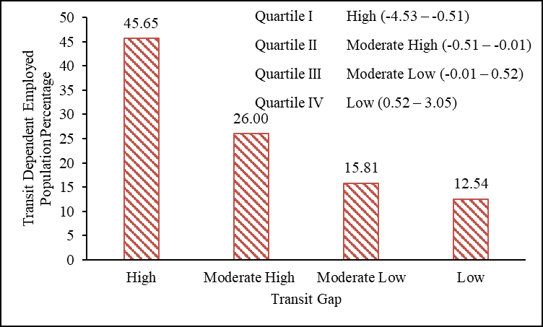
Figure 11: Transit dependent employed population by subzone of workplace falling under different transit gaps
Understanding the transit dependence of residence locations and workplace locations separately is important. For example, a zone showing low transit gap considering TDRP might fall under high transit gap if the analysis is based on TDEP. Moreover, there is temporal differences in the transit demand of resident population and workplace population. Hence, this dual perspective helps to comprehensively assess transit demand and plan transit systems that cater to the dynamic needs during different times of the day.
5.4 Comparison of transit gap results with other European cities
In this section, we compare findings from Chen & Jiao (2022) transit gap study on four European cities with Singapore. Chen & Jiao (2022) aggregated all data at the census block group level for Grand Paris, Greater London, Madrid, and Milan. Transit demand was calculated based on the transit-dependent population, estimated using the non-vehicle rate and the number of residents living in each spatial unit. Transit supply is estimated based on seven criteria: public transit facilities, frequency, transit routes, sidewalks, bike routes, low-speed limit roads, and intersections. The density of transit demand and all transit supply variables were calculated, and all supply variables were integrated based on an equal share of the seven supply variables. Table 3 delineates the proportions of areas and people residing in areas where the transit gap values are less than negative one across the five cities.

Table 3: Portion of areas/people in transit gap value less than negative one within five cities
City | Population (millions) | Area (Sq. km) | Percentage of Area in transit gap value less than -1.0 | Percentage of transit dependent population in transit gap value less than -1.0
Grand Paris | 7.0 | 814.9 | 40.6 | 48.1
Greater London | 8.9 | 2049.2 | 58.8 | 54.5
Madrid | 3.2 | 601.9 | 48.3 | 45.1
Milan | 1.3 | 181.8 | 33.0 | 61.9
Singapore | 4.0 | 701.5 | 07.3 | 44.8

Milan and Greater London have over 50% of their transit-dependent population in areas where the transit gap value is less than negative one, indicating considerable service gaps. Singapore performs better, with only 44.8% in such conditions. Greater London faces the largest area-based transit service distribution issue (58.8%), followed by Madrid (48.3%). Grand Paris and Milan also have significant gaps, but Singapore excels with only 7.3% of its area in transit gap value less than negative one. It's important to note that direct comparisons between cities may be inappropriate due to variations in urban structures, policies, and socioeconomic factors (Chen & Jiao, 2022). However, on a broader scale, considering the provided metrics, Singapore emerges as a leader in transit services among the five cities.

6. DECISION FRAMEWORK AND POLICY MEASURES
Previous studies have defined transit deserts as areas where the supply of public transportation significantly lags the demand generated from those areas (Aman & Smith-Colin, 2020; Cai et al., 2020; Jiao & Dillivan, 2013; Lee et al., 2021). These studies mainly use a cutoff value to define transit desert areas from negative transit gap value areas. Defining a universal cutoff for transit deserts is challenging due to the diverse geographical structures, socioeconomic conditions, and sociodemographic factors inherent to each city. Studies in the USA (Jiao, 2017; Jiao & Dillivan, 2013) and South Africa (Vanderschuren et al., 2021) used a cutoff of negative five, while European (Chen & Jiao, 2022) and South Korean (Lee et al., 2021) studies used negative one to define the transit desert. Lower cutoff values in the USA and South Africa likely reflect their lower public transit usage compared to European and Asian cities.

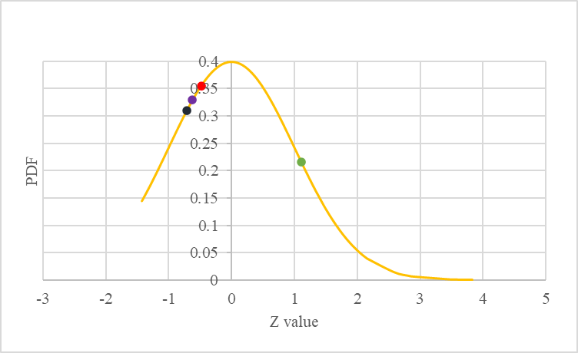  (a) Transit supply | 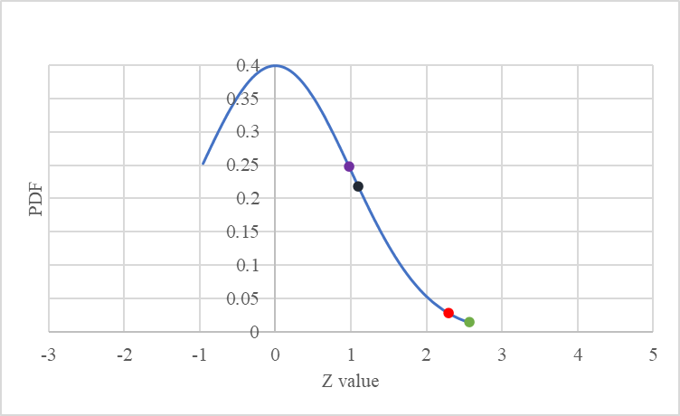  (b) Transit demand
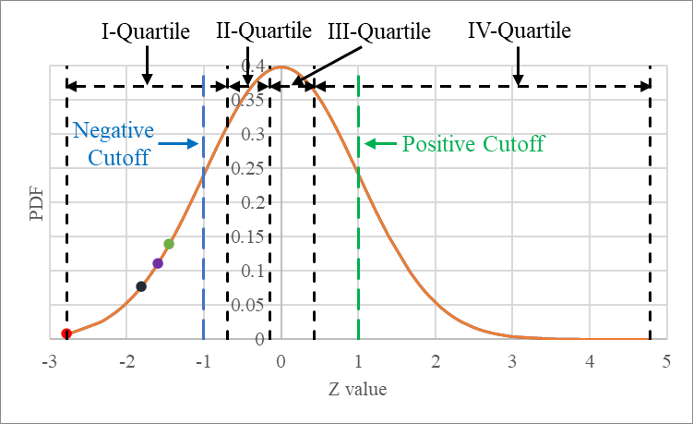
(c) Transit gap

Figure 12: Z score curves for (a) transit supply (b) transit demand and (c) transit gap

Table 4: Transit demand, transit supply, transit gap and PTAL results for selected subzones
Subzone | TDP Density  (Person /Km²) | Demand  (Z Score) | Supply  (Z Score) | Transit gap  (Z Score) | PTAL | PTAL Level | Transit gap (TG) | Color
Jurong West Central | 33784 | 2.56 | 1.11 | -1.45 | 39.25 | Excellent | High TG
Fajar | 31206 | 2.29 | -0.48 | -2.77 | 16.23 | Good | High TG
Fernvale | 18556 | 0.98 | -0.62 | -1.60 | 11.25 | Moderate | High TG
Sembawang East | 19748 | 1.10 | -0.71 | -1.81 | 08.83 | Poor | High TG

Analysing transit supply, transit demand and transit gap results, we found that several subzones with high transit supplies have high transit gap due to high transit dependency; even their transit gap values fall into the lowest quartile range. Figures 12 (a), 12 (b), and 12 (c) illustrate the Z score curves for transit supply, transit demand, and transit gap, respectively. We can gain deeper insight into such scenarios by examining transit gap values alongside PTAL scores. Table 4 lists the Z scores for transit supply, transit demand, transit gap, and PTAL scores for selected subzones. We found that there are several subzone’s where PTAL values are lying in good to excellent level, but because of very high transit demand these subzones show high transit gap. For example, Jurong West Central (indicated by a green dot in Figure 12) have an Excellent Level PTAL score and a supply Z score above average, but its high transit-dependent population ranks it among subzones with High transit gaps. Conversely, subzones like Fernvale (purple dot) and Sembawang East (black dot), where the transit-dependent population exceeds the average but have PTAL levels below good (Fernvale at a moderate level and Sembawang East at a poor level), demonstrate developing high transit gaps due to inadequate transit supplies. These examples suggest that a high transit gap (below the cutoff value) conditions arise either from lack of transit supply or from excessive demand, despite high supply, in a zone. Thus, classifying an area as a transit desert based solely on its transit gap value below a cutoff may be misleading, because existing definition of transit desert is not enough to provide all view whether this high transit gap is developing because of lack of supply or excessive demand overpowering better supply level. Current definition of transit desert may hamper in making proper plans to provide optimum solution and prioritizing the zones for developing transportation infrastructure. Hence, we suggest reclassifying the term transit desert to comprehend such areas better, thereby contributing more effectively to the land use and transportation planning of these areas.

We propose a framework to classify transit desert and transit oasis based on the transit gap and PTAL, as shown in Figure 13. Based on the transit gap the zones were first grouped into the four quartiles. It is required to choose a cutoff value from first and fourth quartile. Zones with a transit gap value less than the negative cutoff can be called as transit deficient zones, while those with a transit gap value exceeding the positive cutoff can be called as transit surplus zones. This study adopted negative one and positive one as the cutoff values due to the similarity of Singapore with other Asian and European cities in transit usage. Here, the cutoff values of 1 and -1.0 lie in the first and fourth quartile, respectively (see Figure 12). Similarly, the zones can also be classified based on the well-established PTAL categories as presented in Figure 4. The transit desert and transit oasis are defined within the transit deficient, and transit surplus zones respectively based on the PTAL levels.

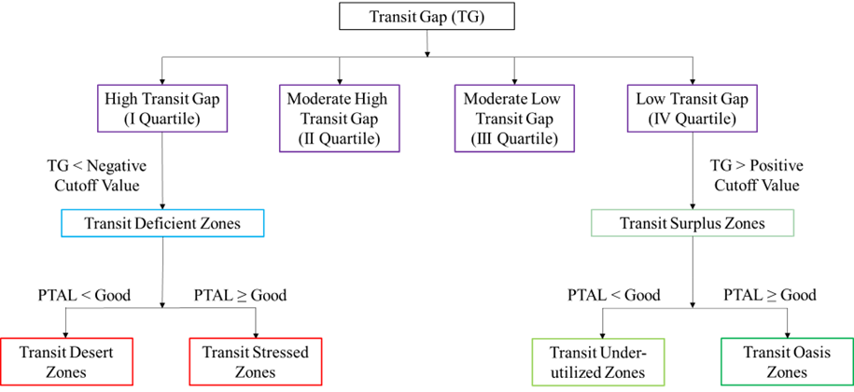
Figure 13: Proposed framework for defining transit desert and transit oasis

By employing a cross-classification between transit gap and PTAL, an area is considered a ‘transit desert’ if its transit gap value is less than the negative cutoff value and its PTAL is below Good Level. This new method of identifying transit deserts based on transit gap and PTAL facilitates a more precise differentiation between areas experiencing high transit gaps due to insufficient service provision and those where service provision is relatively better but still resembles a transit desert due to a significant transit-dependent population. We label areas with a transit gap less than a negative cutoff value but with a PTAL at a Good Level or above as ‘transit stressed zones’. Similar to the transit desert, we have refined the classification schema for transit oasis. An area is considered a ‘transit oasis’ if its transit gap value is more than the positive cutoff value and its PTAL is at a Good Level or above. Areas where the transit gap value exceeds the positive cutoff value and the PTAL is below a Good Level are named as ‘transit underutilized zones’ since these areas lack a sufficient transit-dependent population to exert pressure on the existing, albeit underperforming, transit supply system. The proposed classification emphasizes the significance of transit supply, acknowledging the fact that transport and urban planners have greater control over the supply aspect of the transit system than over transit demand factors.

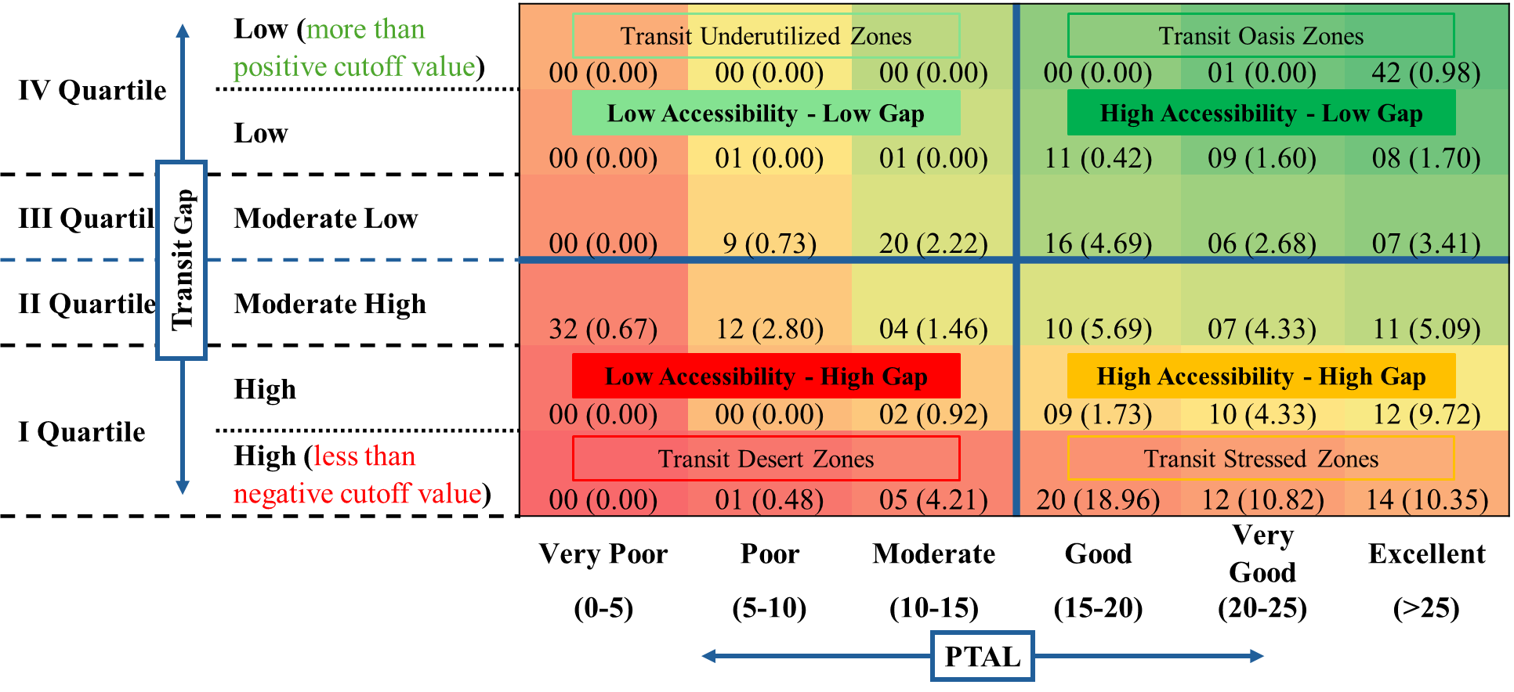
Figure 14: Cross-classification between PTAL levels and transit gaps (Numbers in the table show number of subzones and numbers in bracket indicating percentage of transit dependent population staying in each category)

Figure 15: Spatial cross-classification between PTAL and transit gap levels

Figures 14 and 15 present the results of the cross-classification between PTAL levels and transit gaps for Singapore. These results, illustrated in Figures 14 and 15, are based on the TDRP. Areas with high transit gaps are spread throughout the country, forming clusters in various sub-regions. Specifically, 52 subzones show transit gap values more negative than -1.0. These zones, account for 44.82% of Singapore's transit-dependent population, cover only 7.33% of its total area. Of these 52 zones, 3 are in the eastern region, 11 in the central region, 7 in the northern region, 12 in the northeastern region, and 19 in the western region of Singapore. Additionally, when applying the PTAL scale to assess the transit desert condition, 6 subzones fall under the transit desert criterion, encompassing 4.69% of the transit-dependent population. Meanwhile, 46 subzones meet the definition of transit over-utilized zone, accounting for 40.13% of the transit-dependent population. These findings indicate that although the supply aspect in Singapore is generally good, a significant portion of the transit-dependent population resides in very small areas, resulting in excessive demand on the existing transit supply system. Conversely, 43 subzones display transit gap values exceeding 1.0, all adhering to the definition of transit oasis areas. However, the transit-dependent population residing in these subzones is significantly lower, constituting nearly one percent of the total transit-dependent population. Most of these transit oasis zones primarily comprise commercial spaces with limited residential blocks.

This systematic approach of classification of zones can aid in decision-making and facilitate targeted interventions to improve areas with poor transit services. We now propose a simple decision framework based on this classification system that can be used by policymakers and urban planning authorities. Broadly the cross-classification table can be divided into four quadrants (see Figure 12), (i) Low Accessibility and High Gap (LA-HG) (ii) Low Accessibility and Low Gap (LA-LG) (iii) High Accessibility and Low Gap (HA-LG) and (iv) High Accessibility and High Gap (HA-HG).

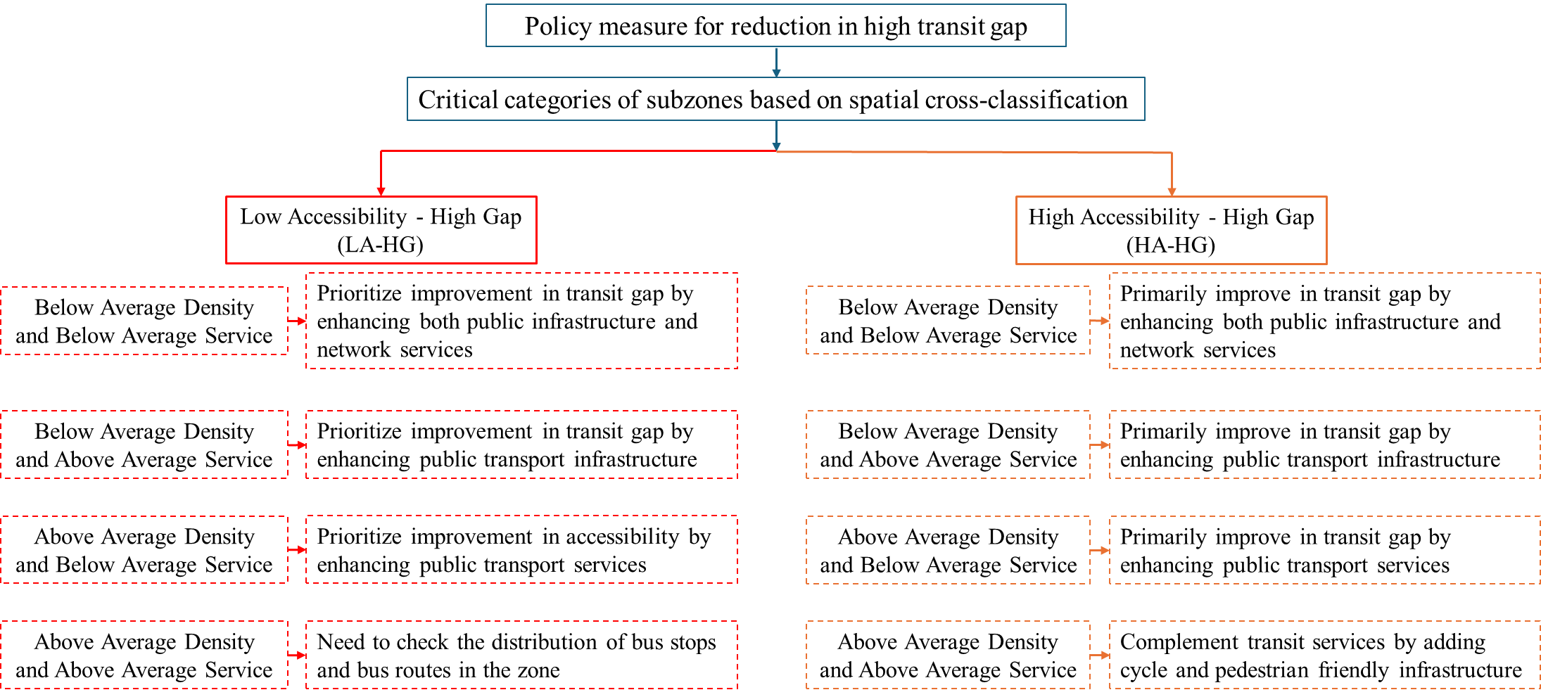
Figure 16: Decision framework of policy measures to improve transit system accessibility and minimise the transit gap

We tried to develop a decision framework for enhancing transit system accessibility and reducing transit deserts and transit stressed zones (see Figure 16). Initially, the subzones undergo evaluation through a spatial cross-classification method (illustrated in Figure 12). As LA-HG is the most critical category, but from the transportation and urban planning prospects HA-HG can be more challenging. In the proposed framework, the assessment of public transit availability is based on both average bus stop density and average bus services within each subzone.

Four distinct categories of policy measures emerge from combination of bus stop density and bus service, these combinations (“Bus Stop Density-Bus Service”) are (i) Below Average Density-Below Average Service, (ii) Below Average Density-Above Average Service, (iii) Above Average Density-Below Average Service, and (iv) Above Average Density-Above Average Service. The initial term in each pair indicates the level of bus stop density, while the latter signifies the level of bus service. For instance, in the Below Average Density-Above Average Service class, where “Below Average Density” represents the bus density in subzone is less than the average bus density of subzones and “Above Average Accessibility” indicates the bus service in subzone exceed the average bus service of subzones.

The average bus stop density in a subzone is around 15 bus stops per km. sq. and average public bus service in a subzone is around 32 buses per hour per bus stop. For the subzones lying in LA-HG category, two policy measures can be possible: (i) enhance the bus stops number and (ii) improve the bus frequency. If a subzone's bus stop density is below average, increasing the number of bus stops is recommended to enhance transit access and improve user accessibility. Conversely, if the density is above average, improving the number of routes and bus frequency can boost PTAL values and lessen the transit gap. Figure 17 shows the policy measure required to reduced transit gaps by improving accessibility to transit system.

Figure 17: Policy measures required to reduce transit gaps in subzones
For subzones in the HA-HG category, the first strategy is to elevate subzones with Good and Very Good PTAL to Excellent PTAL by increasing bus density and frequency. Although we did not consider the individual capacity of public transit vehicles in this study, it is important to note that transit-stressed zones with Excellent PTAL could be prone to overcrowding. In case where zones already have Excellent PTAL but still facing transit desert issues, enhancing frequency or density might not be feasible due to practical limitations. In this condition, we need to focus on the options like cycle and walk. Adding cycling lanes and pedestrian-friendly infrastructure can complement public transit services.

For subzones in the HA-LG category, regularly monitoring of supply and demand is crucial to maintain quality transit services, these areas can be focused more for the future development projects. Similarly, areas lying in LA-LG might not require immediate intervention, but these locations could be potential targets for transportation improvements to cater the future growth.

As previously mentioned, the framework developed above is based on the TDRP. The same analysis has also been performed with the transit depenedent employed population. Our analysis reveals that some subzones could be transit oasis when examining residential data, while the same zones may behave as transit deserts when considering employment dataset. This situation arises because of temporal variation in the transit demand of resident population and workplace population. Analysing transit demand shifts, especially in industrial and commercial areas, is crucial. This dual view is essential for assessing transit needs comprehensively and planning systems that meet varying daily demands.

7. CONCLUSION
This paper trying to contribute advancement in existing literature of transit gap and transit desert concept in several ways. Transit gap is essentially a measure that illuminates the difference between the level of transit service available (transit supply) and the transit need of the population (transit demand) in a specific area. To estimate transit supplies, previous studies predominantly focus on the quantitative aspects of transit infrastructure (such as the number of bus/railways stops and road length) and transit services (including frequency and routes) independently, without considering any relationship between these two aspects of transit network. In this study we developed a framework for evaluating transit gap by using Public Transport Accessibility Level (PTAL) as a supply indicator. PTAL plays a pivotal role in establishing a relationship between transit infrastructure and transit services, shedding light on their interplay and their combined impact on the accessibility to transit system i.e. system accessibility. On the demand side, we primarily focused on the potential transit-dependent population, encompassing individuals who rely on public transit due to age, physical limitations, or not availability of car. Furthermore, recognizing the importance of employed populations working in different areas, we emphasized the need to consider their impact on transit demand patterns. These patterns can significantly alter the demand landscape, influencing transit accessibility requirements.

We have found that many subzones exhibit high transit gaps, not solely due to insufficient transit supply but also because of the high demand from transit dependent populations. This observation underlines the complexity of addressing urban transit challenges and emphasizes that areas with sufficient transit supply can still experience large transit gaps if the demand significantly exceeds supply. Our study introduces a nuanced framework to classify transit desert and transit stressed zone, considering the interplay between transit gap and PTAL. We propose that a transit desert should be identified not only by its high negative transit gap values but also by considering the PTAL. Our results illustrate that 52 subzones show transit gap values more negative than -1.0, affecting nearly half of Singapore's transit dependent population yet occupying a minor fraction of its area. While a majority fall under the category of transit stressed due to better PTAL scores, a smaller portion fits within the characterization of transit desert.

To prioritize the transportation infrastructure and better urban planning in urban areas, based on transit gap and PTAL results a decision framework has also proposed. The proposed framework is applied to the city of Singapore, which is a major global financial hub with a dense population (Asian Development Bank, 2011). Utilizing the decision framework outlined in this study, subzones are classified into four main categories to determine where and what types of enhancements that are practical and impactful. This framework, focusing a balance between bus stop density and bus service levels, allows for a nuanced understanding of transit system accessibility challenges. It points out the importance of enhancing infrastructure and services in critical areas, particularly those with high transit gaps. This framework can assist in the development of specialized and focused strategies for enhancing urban and transportation infrastructure for critical areas needing immediate attention and infrastructure improvements to accommodate the future growth.

The findings of this study hold significant value for policymakers and urban planners, these results can serve as a resource for shaping policy recommendations aimed at addressing the spatial disparities between transit demand and supply. Furthermore, they offer a blueprint for the implementation of sustainable and well-balanced transit service strategies in urban areas.

Nonetheless, it is important to acknowledge several limitations in this study. This study has used data aggregation (explained in methodology section), which may lead to the Modified Area Unit Problem in the results (T. Cheng & Adepeju, 2014). Additionally, shifting the grid may result in a different grid pattern and could slightly alter the results at the grid level. However, aggregating at the subzone level may minimize this impact. Once an accessibility issue is identified within a subzone, further analysis at a finer grid or building level can be conducted to mitigate this problem before determining optimal locations for new infrastructure or services. Future enhancements in results could be achieved by considering data availability at the subzone level. In this study the work locations are considered as a separate identity. However, future research could advance the analysis by encompassing total accessibility levels, which would encompass system accessibility as well as system-facilitated accessibility to various services, offering a more comprehensive understanding of spatial mismatches with destinations. One can also withdraw the spatial equity results from this study, but addition of socioeconomic factors in future research could significantly enrich the equity analysis, providing valuable insights into the impact of socioeconomic variables.

AUTHOR CONTRIBUTION STATEMENT
Manish Yadav: Conceptualization, Methodology, Data curation, Formal analysis, Visualization, Writing - original draft. Rakhi Manohar Mepparambath: Conceptualization, Methodology, Visualization, Writing - review and editing, Supervision. Gopal R. Patil: Conceptualization, Methodology, Writing - review and editing, Supervision.

ACKNOWLEDGMENTS
This research is supported by Prime Minister’s Research Fellowship (PMRF) at IIT Bombay (PMRF ID: 1302025) and A*STAR Research Attachment Programme (ARAP) at A*STAR’s IHPC (ARAP Reference No: HQ/R25-ARAP210210). The authors declare that they have no known competing financial interests or personal relationships that could have appeared to influence the work reported in this paper.

REFERENCES
Adhvaryu, B., Chopde, A., & Dashora, L. (2019). Mapping public transport accessibility levels (PTAL) in India and its applications: A case study of Surat. Case Studies on Transport Policy, 7(2), 293–300. https://doi.org/10.1016/j.cstp.2019.03.004
Adhvaryu, B., & Kumar, S. (2021). Public transport accessibility mapping and its policy applications: A case study of Lucknow, India. Case Studies on Transport Policy, 9(4), 1503–1517. https://doi.org/10.1016/j.cstp.2021.08.001
Aman, J. J. C., & Smith-Colin, J. (2020). Transit Deserts: Equity analysis of public transit accessibility. Journal of Transport Geography, 89, 102869.
Asian Development Bank. (2011). Annual report 2011. Volume 1.
Batty, P., Palacin, R., & González-Gil, A. (2015). Challenges and opportunities in developing urban modal shift. Travel Behaviour and Society, 2(2), 109–123.
Ben-Akiva, M., & Lerman, S. R. (2021). Disaggregate travel and mobility-choice models and measures of accessibility. In Behavioural travel modelling (pp. 654–679). Routledge.
Bree, S., Fuller, D., & Diab, E. (2020). Access to transit? Validating local transit accessibility measures using transit ridership. Transportation Research Part A: Policy and Practice, 141, 430–442. https://doi.org/10.1016/j.tra.2020.09.019
Cai, M., Jiao, J., Luo, M., & Liu, Y. (2020). Identifying transit deserts for low-income commuters in Wuhan Metropolitan Area, China. Transportation Research Part D: Transport and Environment, 82. https://doi.org/10.1016/j.trd.2020.102292
Census Singapore. (2021). Census of population 2020. Statistical release 2, Households, geographic distribution, transport and difficulty in basic activities. Dept. of Statistics, Ministry of Trade and Industry.
Cervero, R., & Kang, C. D. (2011). Bus rapid transit impacts on land uses and land values in Seoul, Korea. Transport Policy, 18(1), 102–116. https://doi.org/10.1016/j.tranpol.2010.06.005
Chen, Y., & Jiao, J. (2022). Are There Transit Deserts in Europe? A Study Focusing on Four European Cases through Publicly Available Data. Sustainability (Switzerland), 14(20). https://doi.org/10.3390/su142013182
Cheng, C.-L., & Agrawal, A. W. (2010). TTSAT: A new approach to mapping transit accessibility. Journal of Public Transportation, 13(1), 55–72.
Cheng, T., & Adepeju, M. (2014). Modifiable temporal unit problem (MTUP) and its effect on space-time cluster detection. PloS One, 9(6), e100465.
Currie, G. (2010). Quantifying spatial gaps in public transport supply based on social needs. Journal of Transport Geography, 18(1), 31–41. https://doi.org/10.1016/j.jtrangeo.2008.12.002
Currie, G., & Stanley, J. (2008). Investigating links between social capital and public transport. Transport Reviews, 28(4), 529–547.
Dalvi, M. Q., & Martin, K. M. (1976). The measurement of accessibility: some preliminary results. Transportation, 5(1), 17–42.
Daniels, R., & Mulley, C. (2013). Explaining walking distance to public transport: The dominance of public transport supply. Journal of Transport and Land Use, 6(2), 5–20. https://doi.org/10.5198/jtlu.v6i2.308
Diab, E. I., Badami, M. G., & El-Geneidy, A. M. (2015). Bus transit service reliability and improvement strategies: Integrating the perspectives of passengers and transit agencies in North America. Transport Reviews, 35(3), 292–328.
El-Geneidy, A., Grimsrud, M., Wasfi, R., Tétreault, P., & Surprenant-Legault, J. (2014). New evidence on walking distances to transit stops: Identifying redundancies and gaps using variable service areas. Transportation, 41(1), 193–210. https://doi.org/10.1007/s11116-013-9508-z
Ermagun, A., & Tilahun, N. (2020). Equity of transit accessibility across Chicago. Transportation Research Part D: Transport and Environment, 86. https://doi.org/10.1016/j.trd.2020.102461
Finnis, K. K., & Walton, D. (2008). Field observations to determine the influence of population size, location and individual factors on pedestrian walking speeds. Ergonomics, 51(6), 827–842.
Foda, M. A., & Osman, A. O. (2010). Using GIS for measuring transit stop accessibility considering actual pedestrian road network. Journal of Public Transportation, 13(4), 23–40.
Fwa, T. F., & Chua, G. K. (2007). PASSENGER CAR TRAVEL CHARACTERISTICS IN SINGAPORE-Analysis of Changes from 1990 to 2005. In 48 IATSS RESEARCH (Vol. 31, Issue 2).
Geurs, K. T., & Van Wee, B. (2004). Accessibility evaluation of land-use and transport strategies: review and research directions. Journal of Transport Geography, 12(2), 127–140.
Hansen, W. G. (1959). How Accessibility Shapes Land Use. Journal of the American Institute of Planners, 25(2), 73–76. https://doi.org/10.1080/01944365908978307
Iacono, M., Krizek, K. J., & El-Geneidy, A. (2010). Measuring non-motorized accessibility: issues, alternatives, and execution. Journal of Transport Geography, 18(1), 133–140.
Jacques, C., Manaugh, K., & El-Geneidy, A. M. (2013). Rescuing the captive [mode] user: an alternative approach to transport market segmentation. Transportation, 40, 625–645.
Jiao, J. (2017). Identifying transit deserts in major Texas cities where the supplies missed the demands. Journal of Transport and Land Use, 10(1), 529–540. https://doi.org/10.5198/jtlu.2017.899
Jiao, J., & Cai, M. (2020). Using open source data to identify transit deserts in four major Chinese cities. ISPRS International Journal of Geo-Information, 9(2). https://doi.org/10.3390/ijgi9020100
Jiao, J., & Dillivan, M. (2013). Transit deserts: The gap between demand and supply. Journal of Public Transportation, 16(3), 23–39. https://doi.org/10.5038/2375-0901.16.3.2
Lee, H. K., Jiao, J., & Choi, S. J. (2021). Identifying spatiotemporal transit deserts in Seoul, South Korea. Journal of Transport Geography, 95. https://doi.org/10.1016/j.jtrangeo.2021.103145
Lei, L. (2023, August 3). Singapore not banning lorries for migrant worker transport despite accidents injuring dozens. eco-business.com
Liu, L., Porr, A., & Miller, H. J. (2023). Realizable accessibility: evaluating the reliability of public transit accessibility using high-resolution real-time data. Journal of Geographical Systems, 25(3), 429–451.
London, T. F. (2010). Measuring Public Transport Accessibility Levels. Academic Press.
LTA. (2019). Transport Impact Assessment Guidelines for Developments 2019 Edition. https://www.lta.gov.sg/content/dam/ltagov/industry_innovations/industry_matters/development_construction_resources/Street_Work_Proposals/Guidelines/TIA_Guidelines_WCP_Final_07Dec2018.pdf
LTA. (2024, August). Land Transport Authority. www.lta.gov.sg
Malekzadeh, A., & Chung, E. (2020). A review of transit accessibility models: Challenges in developing transit accessibility models. In International Journal of Sustainable Transportation (Vol. 14, Issue 10, pp. 733–748). Taylor and Francis Ltd. https://doi.org/10.1080/15568318.2019.1625087
Mavoa, S., Witten, K., McCreanor, T., & O’Sullivan, D. (2012). GIS based destination accessibility via public transit and walking in Auckland, New Zealand. Journal of Transport Geography, 20(1), 15–22. https://doi.org/10.1016/j.jtrangeo.2011.10.001
Moreno-Monroy, A. I., Lovelace, R., & Ramos, F. R. (2018). Public transport and school location impacts on educational inequalities: Insights from São Paulo. Journal of Transport Geography, 67, 110–118. https://doi.org/10.1016/j.jtrangeo.2017.08.012
MOT 2022. (2022, October 31). Number of cars in singapore. Ministry of Transport Singapore.
MTI. (2023, October). Department of Statistics Singapore, Ministry of Trade and Industry.
Nassir, N., Hickman, M., Malekzadeh, A., & Irannezhad, E. (2016). A utility-based travel impedance measure for public transit network accessibility. Transportation Research Part A: Policy and Practice, 88, 26–39. https://doi.org/10.1016/j.tra.2016.03.007
Owen, A., & Levinson, D. M. (2015). Modeling the commute mode share of transit using continuous accessibility to jobs. Transportation Research Part A: Policy and Practice, 74, 110–122.
Pitot, M., Yigitcanlar, T., Sipe, N., & Evans, R. (2006). Land Use and Public Transport Accessibility Index (LUPTAI) tool: the development and pilot application of LUPTAI for the Gold Coast. Proceedings of the 29th Australian Transport Research Forum, 1–18.
Rastogi, R., Thaniarasu, I., & Chandra, S. (2011). Design Implications of Walking Speed for Pedestrian Facilities. Journal of Transportation Engineering, 137(10), 687–696. https://doi.org/10.1061/(ASCE)TE.1943-5436.0000251
Saghapour, T., Moridpour, S., & Thompson, R. G. (2016). Public transport accessibility in metropolitan areas: A new approach incorporating population density. Journal of Transport Geography, 54, 273–285. https://doi.org/10.1016/j.jtrangeo.2016.06.019
Shah, J., & Adhvaryu, B. (2016). Public transport accessibility levels for Ahmedabad, India. Journal of Public Transportation, 19(3), 19–35.
Sharma, G., & Patil, G. R. (2021). Public transit accessibility approach to understand the equity for public healthcare services: A case study of Greater Mumbai. Journal of Transport Geography, 94. https://doi.org/10.1016/j.jtrangeo.2021.103123
SMP-19. (2019). Master Plan Written Statement 2019. www.ura.gov.sg
Tanaboriboon, Y., Siang Hwa, S., & Chor, C. H. (1986). PEDESTRIAN CHARACTERISTICS STUDY IN SINGAPORE.
Thomas, H., & Serrenho, A. C. (2024). Using different transport modes: An opportunity to reduce UK passenger transport emissions? Transportation Research Part D: Transport and Environment, 126. https://doi.org/10.1016/j.trd.2023.103989
Van Lierop, D., Badami, M. G., & El-Geneidy, A. M. (2018). What influences satisfaction and loyalty in public transport? A review of the literature. Transport Reviews, 38(1), 52–72.
Vanderschuren, M., Cameron, R., Newlands, A., & Schalekamp, H. (2021). Geographical modelling of transit deserts in cape town. Sustainability (Switzerland), 13(2), 1–16. https://doi.org/10.3390/su13020997
Wu, B. M., & Hine, J. P. (2003). A PTAL approach to measuring changes in bus service accessibility. Transport Policy, 10(4), 307–320. https://doi.org/10.1016/S0967-070X(03)00053-2
Yesilada, Y., & Harper, S. (2019). Web Accessibility. Springer.
Zhao, F., Chow, L.-F., Li, M.-T., Ubaka, I., & Gan, A. (2003). Forecasting transit walk accessibility: Regression model alternative to buffer method. Transportation Research Record, 1835(1), 34–41.

