Layer-by-Layer Assembled Multilayer Shells for Encapsulation and Release of Fragrance
Anton V. Sadovoy¹, Maria V. Lomova ^{2,3}, Maria N. Antipina¹, Norbert A. Braun⁴, Gleb B. Sukhorukov², and Maxim V. Kiryukhin^{1*}
¹Institute of Materials Research and Engineering, Agency for Science, Technology and Research (A*STAR), 3 Research link, 117602, Singapore
²School of Engineering and Material Science, Queen Mary University of London, Mile End Road, London, E1 4NS, UK
³Saratov State University, 83 Astrakhanskaya Street, Saratov, 410012, Russia.
⁴Symrise Asia Pacific Pte. Ltd., Scent & Care, Innovation, 226 Pandan Loop, Singapore 128412, Singapore.
*Corresponding author: Fax: (+65) 6872 7528; Tel: (+65) 6874 8252; E-mail: kiryukhin-m@imre.a-star.edu.sg
Abstract: Layer-by-Layer assembled shells are prospective candidates for encapsulation, stabilization, storage and release of fragrances. A shell comprising four alternative layers of a protein and a polyphenol is employed to encapsulate the dispersed phase of a fragrance-containing oil-in-water emulsion. The model fragrance used in this work consists of ten ingredients, covering a range of typically employed aroma molecules, all premixed in equal mass and with sunflower oil acting as the base. The encapsulated emulsion is stable after two months of storage at 4 °C as revealed by Static Light Scattering and Confocal Laser Scanning Microscopy. Gas chromatography – mass spectrometry data show that the encapsulation efficiency of eight out of ten fragrance ingredients depends on the water solubility: the less water-soluble an ingredient, the more of it is encapsulated. The amount of these fragrance ingredients remaining encapsulated decreases linearly upon emulsion incubation at 40°C and the multilayer shell doesn’t hinder their release. The other two fragrance ingredients having the lowest saturation vapor pressure demonstrate sustained release over 5 days of incubation at 40ºC. The composition of released fragrance remains almost constant over 3 days of incubation, upon further incubation it becomes enriched with these two ingredients when others start to be depleted.
Keywords: Layer-by-Layer assembly, multilayer capsules, o/w emulsions, fragrance, encapsulation, release
Introduction
Fragrance- and flavor-containing oil-in-water (o/w) emulsions are used in numerous applications, including personal care products (e.g. hair sprays, shampoos, toothpastes), home care products (e.g. fabric conditioners, liquid laundry detergents, floor cleaners), and food products.^{1,2} Emulsion stability and fragrance/flavor release profiles are always of great importance when developing formulations. Typically, these formulations for emulsion require fabrication of a shell around oil droplets, e.g. by coacervation of gelatin with gum Arabic, alginates with calcium ions or by polymerization of melamine formaldehyde and urethanes. Recently, so-called Layer-by-Layer (LbL) shells have been sought to explore the feasibility of stabilizing liquid microdroplets in o/w emulsions.³⁻⁷ Assembly of even a single bi-layer shell significantly improves the stability of o/w emulsions with regards to coalescence and flocculation.⁸ In general, as extensively seen over the last decade, LbL assembly of polymers containing complementary groups leads to multilayer thin film formation.⁹ This method allows precise control over thickness and composition of the shells on a nanometer length scale thus providing a means for tailoring their functionality towards a particular application.
An oil can be loaded into pre-formed hollow multilayer shells (capsules) by solvent-exchange method.^{10,11} Alternatively, direct LbL coating of emulsion droplets can be used for encapsulation. However, this process is not that straightforward when compared to the coating of solid colloidal particles. The main challenge is to wash out unadsorbed species after each deposition step. This washing can be avoided if one utilizes a saturation concentration of polymers, but estimation of the saturation concentration is not trivial for polydisperse o/w emulsions.¹² Another approach is to wash out non-adsorbed polyelectrolytes in a microfluidic device with an array of micropillars that guides oil microdroplets through parallel laminar streams of two polyelectrolytes and a washing solution.¹³ Alternatively, washing can be performed by either filtration,^{12,14-15} or collecting the creamed upper layer of the emulsion upon phase separation.¹⁶
The aim of this work was to examine the stability of an LbL-assembled multilayer bovine serum albumin (BSA) - tannic acid (TA) shell encapsulating the dispersed phase of fragrance-containing o/w emulsion, and study release properties of a model fragrance. LbL-assembled shells exhibit semipermeable properties with a cut-off molecular weight of a few kDa: small molecules can diffuse through the shell, whereas high molecular weight macromolecules are excluded.⁹ Fragrances are complex mixtures of aroma molecules with molecular weights less than 300 Da that do not contain strongly ionizing functional groups (e.g. alkenes, alcohols, phenols, aldehydes, ketones, esters, nitriles etc.).^{17,18} Therefore they are expected to permeate the multilayer shell and be released into the outside environment. The model fragrance used in this work consists of ten ingredients listed in Figure 1 covering a range of typically employed aroma molecules.
We propose a protein (BSA) and a polyphenol of natural origin (TA) to be used as the capsule constituents since the cost of materials and biocompatibility are among the key issues for a wide range of practical applications. TA is known to precipitate proteins by hydrogen bonding and hydrophobic interactions with proline, arginine and phenylalanine.¹⁹⁻²¹ Moreover, strong antioxidant activity of TA has been proven to protect polyunsaturated fatty acids of the oil phase against the oxidative degradation.¹⁴
The fragrance is mixed with sunflower oil as a base and dispersed in a water solution of bovine serum albumin (BSA) as an emulsifier followed by LbL assembly of TA and BSA. Confocal Laser Scanning Microscopy and Static Light Scattering have been used to characterize the resulted o/w emulsion. Release profiles for each individual ingredient has been measured by gas chromatography – mass spectrometry (GC-MS) and analyzed in terms of water solubility and vapor pressure.
Experimental
Materials. Bovine serum albumin, tetramethylrhodamine isothiocyanate labeled BSA (TRITC-BSA), tannic acid and sunflower seed oil from Helianthus annuus were purchased from Sigma-Aldrich and used as received. Following aroma molecules were tested (see Fig. 1): (R)-4-isopropenyl-1-methylcyclohexene = D-limonene (1); 2,4,4,7-tetramethyloct-6-en-3-one = Claritone® (2);²² 6,6-dimethoxy-2,5,5-trimethylhex-2-ene = Amarocit® (3); 4-methyl-2-(2-methylprop-1-en-1-yl)tetrahydro-2H-pyrane = Rose oxide high cis (4); methyl salicylate (5); 1-octanal (6); 1-octanol (7); 3-methyl-5-phenylpentanenitrile = hydrocitronitrile (8); 2,2-dimethyl-3-(3-methylphenyl)propan-1-ol = Majantol® (9), and ethyl 2-methylbutanoate (10); all provided by Symrise Asia Pacific Pte Ltd. These ingredients were premixed in equal mass to make the model fragrance. Oil-soluble fluorescent dye (3,4,9,10-tetra-(hectoxy-carbonyl)-perylene, THCP) synthesized as reported²³ was used for dispersed phase staining and visualization by confocal microscope. Deionized (DI) water with specific resistivity higher than 18.2 MΩ m⁻¹ from a three-stage Milli-Q Plus 185 purification system was used to make all solutions.
Emulsion Preparation and LbL Coating of Oil Microdroplets. The model fragrance was mixed with sunflower oil acting as a base at 50:50 vol.%. The base is necessary as it provides greater retention of a fragrance and hampers decrease of the volume of disperse phase upon fragrance evaporation.²⁴⁻²⁶ Primary emulsion (referred as A) was obtained by dispersing 10 % v/v of model fragrance/sunflower oil mix in 90 % v/v of emulsifier (BSA, 4 mg/mL) water solution with Ultra Turrax homogenizer (T18, IKA, Germany) operating at 24000 rpm over 2 min. Uncoupled BSA was thoroughly removed from the emulsion via 3 washing cycles with DI water in a modified 50 mL filtration cell (Millipore Corp., USA) as described earlier.^{12, 14} In each cycle, 10 mL of emulsion was topped-up with 40 mL of DI water, and then 40 mL of aqueous phase were filtered through 0.22 μm hydrophilic surfactant free MF-Millipore membrane under pressure of compressed argon (20 psi). The resulting emulsion is referred in the text as B.
LbL coating of oil microdroplets was done using the same filtration cell. 20 mL of filtered emulsion was topped-up with 20 mL of TA (3 mg/mL) water solutions and stirred for 15 min followed by 3 washing cycles to remove uncoupled polymers. Then 20 mL of BSA (4 mg/mL) were introduced to form the next layer. Further alternating layers of TA and BSA were introduced to coat oil microdroplets with the desired number of layers to produce LbL-coated emulsion C. The schematic diagram of this process is shown in the Figure 2. It is important to note that the filtration cell used in this work allows us to avoid dilution of the emulsion and maintain approximately constant the concentration of dispersed phase (10% v/v) over the whole process of LbL shell assembly. The emulsion C was stored in closed vials at 2-4°C.
Confocal Laser Scanning Microscopy (CLSM). CLSM was used to visualize both oil cores and LbL-assembled shells of the encapsulated emulsion. For this purpose model fragrance/sunflower oil mix with dissolved THCP (~0.2 mg/ml) was emulsified in BSA/BSA-TRITC (4:1) solution followed by LbL coating of oil microdroplets as described above. Optical images were obtained on a Carl Zeiss Lsm510 META CLSM system (Carl Zeiss AG, Germany) equipped with a C-Apochromat 63X/1.2 Water Lens (Carl Zeiss AG, Germany) objective. The excitation (λ_{exc}) and emission (λ_{em}) wavelengths λ_{exc} = 529 nm, λ_{em} = 596 nm, and λ_{exc} = 488 nm, λ_{em} = 525 nm were used for TRITC-BSA and THCP imaging, respectively.
Emulsion Core-Shell Size Analysis. Size distribution of water dispersed emulsion droplets was determined by static light scattering using Mastersizer 2000 (Malvern Instruments Ltd, UK) and averaged from five measurements. Prior to measurements, 10 % v/v emulsion was 500 times diluted with DI water. Refractive index of model fragrance/sunflower oil mix was 1.467 as determined by Abbe Refractometer (Atago Co. Ltd, USA).
To estimate the thickness of (BSA-TA)₂ shell, the corresponding multilayer was assembled on a silicon wafer by dip-coating using the same stock solutions as for emulsion preparation described above. The thickness of thus formed multilayer was determined by variable angle spectroscopic ellipsometer (J.A. Woollam Co, USA).
Fragrance Release from Emulsions. Release of aroma molecules from emulsions was studied as following: an emulsion was stirred in an open vial placed in a fume hood at 40°C. Agitation was necessary to prevent creaming of the emulsion. Temperature of 40ºC was applied as stability tests in fragrances are oftentimes done at this elevated temperature level to simulate prolonged shelf life in shorter time.²⁷ Fume hood environment (face velocity 0.54 m/s) ensures evaporation of aroma molecules into a flowing stream of air, i.e. infinite volume where the saturation vapour pressure can never be achieved. Evaporative losses of water from the emulsion samples were compensated by adding DI water at certain intervals to keep volume of the emulsion samples constant. 1 mL of the emulsion was taken each day, placed into a 20 mL headspace vial and the aroma molecules content in the headspace was measured by GC-MS using Varian 4000 (USA) equipped with column VF-5ms with 30m x 0.25mm x 0.5μm size parameters. Before analysis, every sample was incubated at 60 °C and shaken for 10 min. Injection of 0.3 mL of vapor phase was performed with a 1 mL gas-tight syringe. Both syringe and injector temperatures were 60 °C. The following temperature program was used: column was kept at 60 °C for 1 min then heated with 10 °C/min till 180 °C and further heated till 220 °C at 20 °C/min. Helium was used as carrying gas with 1 mL/min flow. Peak area of each fragrance ingredient was averaged from seven measurements.
Pure individual fragrance ingredients were analyzed by GC-MS to determine retention time as well as the mass spectrum of each ingredient.
Results
Fig. 3a (lines 1-3) shows size distributions of oil droplets in LbL-coated emulsion C just after preparation and after 1 week and 2 months of storage at 4ºC. The mean sizes of droplets are listed in table 1. These data give a clear evidence of good stability of (BSA-TA)₂ encapsulated fragrance emulsion towards flocculation and coalescence. It is important to mention, that one layer of BSA at oil/water interface was not enough to produce a stable emulsion and extensive coalescence was observed in emulsion B samples after 1 week of storage.
A typical 3D CLSM image of emulsion C after two months of storage at 4°C is shown in Fig. 2b-c. Green ovoids in Fig. 3b represent the fragrance cores with dissolved THCP, varying from ~ 1 to ~ 4 µm in size. By comparison the Fig. 3b and Fig. 3c it can be seen that each of the relatively large cores (> 2 µm in diameter) is surrounded by the red coating shell made of (BSA/TRITC-TA)₂. Brownian motion of the microdroplets upon scanning results in blur imaging that doesn’t allow to resolve core-shell structure for smaller droplets.
Thickness of the (BSA-TA)₂ shell surrounding oil core can’t be measured directly. We can just estimate it if extrapolate from thickness of the same (BSA-TA)₂ multilayer film deposited on a silicon wafer (~10-15 nm according to ellipsometry data). The data correspond to double thickness of the BSA molecule adsorbed in end-on conformation (native form of BSA has a heart shape with around 8.0 nm side and 3.0 nm depth, which is also the main form of BSA in solutions at pH values between 4 and 8)²⁸ as contribution of TA to the overall thickness of multilayer is negligible. On the other hand, native BSA conformation could alter on the interface between hydrophobic oil and water,²⁹ alternatively BSA layer could swell in the direction normal to surface.³⁰
Figure 4 shows the changes in fragrance composition released from emulsion C upon its incubation in an open vial at 40°C. The relative content of each individual ingredient was calculated as a ratio of the corresponding peak area in the chromatogram to the total area of all peaks. It can be seen that the fragrance is enriched with D-limonene (1) (~ 47%), but contains just traces (~0.3%) of ethyl 2-methylbutanoate (10). The relative content of other aroma molecules varies from ~ 2 till ~ 20%. Fragrance composition is nearly stable within the first three days of incubation. However, further incubation leads to the dramatic change in fragrance: the relative content of 5 aroma molecules [Amarocit® (3), rose oxide (4), methyl salicylate (5), 1-octanal (6), and 1-octanol (7)] starts to decrease. On the other hand, the relative content of hydrocitronitrile (8) and Majantol® (9) in released fragrance increases over time, reaching nearly 12% after 5 days of incubation for both compounds. The size distribution and mean size of droplets in emulsion C at this point are shown in Fig. 3a (line 4) and Table 1. Some shift of the size distribution towards larger sizes and increase in the mean size from 3.8 to 4.6 µm has been observed.
Figure 5 shows release profiles for the two individual aroma molecules [rose oxide (4) and hydrocitronitrile (8)] upon incubation of emulsions B and C in an open vial at 40°C. The relative peak area of each individual ingredient was calculated as a ratio of the corresponding peak area in the chromatogram to the peak area of this ingredient released at the first day of incubation. Amount of rose oxide in vapor phase linearly drops with time having the same slope for both emulsions. Only traces of rose oxide could be detected in the released fragrance after 5 days of incubation. Six other aroma molecules [D-limonene (1), Claritone® (2), Amarocit® (3), methyl salicylate (5), 1-octanal (6), and 1-octanol (7)] have similar release profiles which are available in the Supporting information (see S.I. Figures 1-5). However, this is not the case for hydrocitronitrile (8). Its pressure in the vapor phase is nearly constant and does not depend on agitation time. Majantol® (9) has the same release profile as hydrocitronitril (8) (see S.I. Figure 6). Amount of ethyl 2-methylbutanoate (10) drops below the detection limit within 2 days of incubation for emulsion B (see S.I. Figure 7) and 1 day of incubation of emulsion C (data not shown).
Fragrance compositions released from emulsions A and B are shown in the Figure 6. The fragrance released from emulsion A (see black bars in Fig. 5) is enriched with D-limonene (1) (~29%) and ethyl 2-methylbutanoate (10) (~26%). The content of hydrocitronitrile (8) and Majantol® (9) is less than 0.5%. The content of other 6 aroma molecules [Claritone® (2), Amarocit® (3), rose oxide (4), methyl salicylate(5), 1-octanal (6), and 1-octanol (7)] varies in the range of 5-10%. The fragrance released from emulsion B contains three times less amount of ethyl 2-methylbutanoate (~8%), but the content of all other aroma molecules is increased by 30-100% if compared to primary emulsion A (see dashed bars in fig. 5).
Discussion
The composition of fragrance released from the LbL-coated emulsion C is proportional to the water solubility of aroma molecules: the less water-soluble the molecules, the higher their equilibrium pressure in the headspace and, correspondingly, the relative content in released fragrance (see Table 2). D-Limonene (1) has the lowest water solubility among the tested compounds (13.8 mg/L at 25ºC) followed by Claritone® (2) (28.12 mg/L). These two compounds give 66% of the fragrance released from emulsion C. Ethyl 2-methylbutanoate (10) is on the other side of water solubility scale (1070 mg/L) and has the lowest relative content of 0.3% in fragrance. All other aroma molecules, in general, follow the same trend. It is just important to note that there are no experimental data available on water solubility for all aroma molecules tested here. So some data listed in the table were calculated from corresponding octanol-water partition coefficients (estimated using the Estimation Programs Interface Suite™).³¹ They can be used with a certain caution for the sunflower oil-water system because of the hydrogen bond forming potential of a hydroxyl group in octanol. It was shown that for the non-polar solutes, the oil-water and octanol-water partition are nearly identical (octanol-water partition is about 25% less than oil-water over a very wide range of structures and partition coefficients).³² However for aliphatic molecules containing one hydroxyl group, the oil-water partition could be smaller than octanol-water partition by factor of 10.5. Thus the actual water solubility of molecules able to form strong hydrogen bonds should be higher than indicated in table 2.
In general, the lower water solubility of aroma molecules, the higher their retardation in a dispersed phase of o/w emulsion.³³ As a result, transfer of such molecules as D-limonene (1) and Claritone® (2) into continuous phase and their subsequent losses (due to evaporation and with waste water upon LbL coating of emulsion in the filtration cell) will be smaller, their concentration in the dispersed phase will be higher, so they give the highest equilibrium vapor pressure in a sample headspace. Oppositely, ethyl 2-methylbutanoate (10) easily transfers from the oil to aqueous phase and is nearly completely depleted from the emulsion during the multilayer assembly process: it is the second largest ingredient released from primary emulsion A (24%), it’s content decreases more than three times upon washing out uncoupled BSA molecules in emulsion B (8%) (see Figure 6), and further decreases to 0.3% upon LbL coating in emulsion C (see Figure 4, Table 1). It is worth to note that overall amount of all other aroma molecules released from emulsion B appeared to be higher than in primary emulsion A. The reason can be the high concentration of uncoupled BSA in primary emulsion that is known to bind nonpolar molecules to nonpolar patches on the surfaces of proteins through hydrophobic attraction.² As a result there is an increase in the overall concentration of aroma molecules in the aqueous phase and a corresponding decrease in the equilibrium vapor phase of a headspace. Thus it is difficult to quantify the losses of aroma molecules during the layer-by-layer build up in the filtration cell without thorough study of the effect of BSA concentration on water solubility of these molecules and qualitative comparison is available only.
Hydrocitronitril (8) and Majantol® (9) make an exception to this rule. Both have relatively low water solubility (36.25 and 195.13 mg/L, correspondingly), but their relative content in the fragrance released from LbL-coated emulsion initially is very low (~ 2%) (see Figure 4, Table 1). One explanation could be the very low saturation vapor pressure of these compounds (0.001 and 0.002 mm Hg, correspondingly). The equilibrium pressures of both hydrocitronitril and Majantol® are stable over the five days of incubation (see lines 3, 4 in Figure 5 and Supporting information). This could be an indication that the saturation vapor pressure was reached in a headspace of all tested samples. Hence vapor pressure of molecules 8 and 9 in a headspace doesn’t reflect the absolute amount of these molecules in a dispersed phase. Their relative content in released fragrance starts to increase after four days of incubation, when all other fragrance ingredients are depleted.
Equilibrium pressures in sample headspace of eight out of ten aroma molecules studied here (1-7, and 10) decay linearly with incubation time (see lines 1, 2 in Figure 5 and Supporting Information) meaning that they are always below saturation. Then the slope of this decay reflects the rate of evaporation of corresponding molecules upon incubation:
C_{molecule} = [Molecule]_{g} + [Molecule]_{w} + [Molecule]_{o} = [Molecule]_{g} (1 + 1/P_{g/w} + P_{o/w}/P_{g/w}),
d([Molecule]_{g})/d(t) = (1 + 1/P_{g/w} + P_{o/w}/P_{g/w})⁻¹ d(C_{molecule})/d(t)
where C_{molecule} is an overall amount of particular aroma molecule, [Molecule]_{g}, [Molecule]_{w}, and [Molecule]_{o} are equilibrium concentrations of this molecule in a headspace, continuous phase and dispersed phase, correspondingly, and P_{g/w} is gas-water molecule partitioning coefficient. Evaporation of aroma molecules from o/w emulsions consists of the following steps: aroma molecules dissolve in the aqueous continuous phase, diffuse across it towards emulsion surface, and evaporate. For stirred emulsions with no creaming and aroma molecules with low water solubility, evaporation rate is determined by a combination of aroma molecules mass transfer through a stabilizing shell, water and a stagnant vapor layer.³³ If (BSA-TA)₂ shell would hinder the diffusion of aroma molecules, the P_{o/w} should be smaller for emulsion B with single BSA layer than for coated emulsion C. Consequently, the rate of evaporation d([Molecule]_{g})/d(t) should be higher for emulsion B than for emulsion C. However evaporation rates of molecules 1-7 and 10 appeared to be nearly the same for both emulsions B and C (see lines 1, 2 in Figure 5 and Supporting Information).
Evaporation of a half of oil volume (model fragrance was mixed with sunflower oil base at 50:50 vol.%) reduces the diameter of oil droplets by nearly 20 %. We have checked the size distribution of emulsion after five days of incubation at 40ºC and found that the mean size has even increased from ~ 3.8 to 4.6 µm (see Figure 3a and Table 1) probably due to aggregation of droplets. Nevertheless the shrinkage of oil cores is unavoidable. In emulsion B, BSA acts as a surfactant and its adsorption to an oil-water interface is reversible.² Hence oil cores shrinkage leads to desorption of BSA maintaining constant its surface concentration. In contrast, formation of BSA-TA multilayer shell is virtually irreversible. Molecules of tannic acid bind cooperatively at several sites on the protein and cross-link neighboring protein molecules into a network.²⁰ As Kawamoto et al. have shown for BSA-TA precipitates, the content of both TA and BSA in such a network nearly do not change after a few washings and start gradually do so only after 5-7 washing cycles.²¹ For irreversibly adsorbed multilayer shells, oil evaporation should lead to their thickening (probably by some folding) and one could expect retardation of aroma molecules release with incubation time. However it was not the case and content of eight out of ten aroma molecules decays linearly with incubation time.
Hence diffusion of aroma molecules through the (BSA-TA)₂ shell into continuous phase is not the rate-limiting step and doesn’t hinder the fragrance evaporation. And this result was expected as LbL-assembled shells become less permeable for macromolecules with molecular weight higher than few kDa,⁹ but aroma molecules have molecular weights less than 300 Da.^{17,18}
Conclusion
The LbL approach was used to encapsulate the dispersed phase of fragrance-containing emulsions. The two bi-layers of bovine serum albumin and tannic acid provide the emulsion stability towards coalescence and flocculation: the emulsion was found stable over at least 2 months of storage at 4°C.
The encapsulation efficiency of eight fragrance ingredients out of ten tested (D-limonene (1), Claritone® (2), Amarocit® (3); rose oxide (4), methyl salicylate (5), 1-octanal (6), 1-octanol (7), and ethyl 2-methylbutanoate (10)) was observed to be dependent on the water solubility: the less water-soluble an ingredient, the smaller its losses upon LbL coating of emulsion in the filtration cell, and the higher its relative content in released fragrance. The (BSA-TA)₂ multilayer doesn’t hinder release of aroma molecules, their content decay linearly with incubation time and the slope of decay was nearly the same as from emulsion stabilized with single BSA layer. The composition of released fragrance was found to be nearly constant upon incubation over 3 days at 40 ºC. Hydrocitronitrile (8) and Majantol® (9), the compounds having the lowest saturation vapor pressure, demonstrate sustained release over 5 days of incubation at 40 ºC. The released fragrance became enriched with these substances upon longer than 3 days incubation, when other ingredients started to be depleted.
Two major concerns usually hampering industrial applications of LbL encapsulation method are the time required to produce a stable capsule and price of its constituents. The shell proposed in this manuscript enables to address both issues. Good stability upon long term storage achieved by encapsulation in just two bi-layers considerably decreases the fabrication time. Both TA and BSA are relatively cheap and available compounds. Moreover, BSA can be replaced with other proteins or polysaccharides depending on application needs. Being an antioxidant compound, TA additionally protects the oil base against peroxidation enabling the use of natural oils in formulations. The BSA-TA shell properties and fragrance release data indicate that LbL method has perspectives to be further explored for encapsulation, stabilization, storage and followed controlling release of fragrances.
Supporting Information Available
Release profiles of D-limonene (1), Claritone® (2), Amarocit® (3), methyl salicylate (5); 1-octanol (7), Majantol® (9), and ethyl 2-methylbutanoate (10) both from LbL-coated emulsion C and corresponding emulsion stabilized with single BSA layer B are presented in the supporting information. This information is available free of charge via the Internet at http://pubs.acs.org.
References
(1) Delivery system handbook for personal care and cosmetic products: technology, applications, and formulations. Meyer, R. R., Ed.; William Andrew Inc.: New York, 2005, pp. 409-497.
(2) McClements, D. J. Food emulsions: principles, practices, and techniques, 2nd ed.; CRC press, 2005, pp. 389-431.
(3) Guzey, D.; McClements, D. J. Adv. Colloid Interface Sci. 2006, 128–130, 227–248.
(4) Grigoriev, D. O.; Miller, R. Curr. Opin. Colloid Interface Sci. 2009, 14, 48-59.
(5) Shchukina, E. M.; Shchukin, D. G. Adv. Drug Delivery Rev. 2011, 63, 837-846.
(6) Shchukina, E. M.; Shchukin, D. G. Curr. Opin. Colloid Interface Sci. 2012, 17, 281-289.
(7) McClements, D. J. Curr. Opin. Colloid Interface Sci. 2012, 17, 235-245.
(8) Yang, X.; Tian, H.; Ho, C. T.; Huang Q. J. Agric. Food Chem. 2012, 60, 402-409.
(9) Multilayer Thin Films: Sequential Assembly of Nanocomposite Materials, 2nd ed. Decher, G., Schlenoff J., Eds.; Wiley-VCH, 2012, pp. 1-41.
(10) Moya, S.; Sukhorukov, G. B.; Auch, M.; Donath, E.; Mohwald, H. J. Colloid Interface Sci. 1999, 216, 297-302.
(11) Sivakumar, S.; Gupta, J. K.; Abbott, N. L.; Caruso, F. Chem. Mater. 2008, 20, 2063-2065.
(12) Sadovoy, A. V.; Kiryukhin, M. V.; Sukhorukov, G. B.; Antipina, M. N. Phys. Chem. Chem. Phys. 2011, 13, 4005-4012.
(13) Kantak, C.; Beyer, S.; Yobas, L.; Bansala, T.; Trau, D. Lab Chip 2011, 11, 1030-10305.
(14) Lomova, M. V.; Sukhorukov, G. B.; Antipina, M. N. ACS Appl. Mater. Interfaces 2010, 2, 3669-3676.
(15) Teng, X.; Shchukin, D. G.; Mohwald, H. Adv. Funct. Mater. 2007, 17, 1273–1278.
(16) Grigoriev, D. O.; Bukreeva, T.; Mohwald, H.; Shchukin, D. G. Langmuir 2008, 24, 999-1004.
(17) Surburg, H.; Panten. J. Common fragrance and flavor materials, 5th ed.; Wiley-VCH: Weinheim, 2006, pp. 7-175.
(18) Braun, N. A. Personal Care Mag. Asia Pacific 2009, 10, 39-43.
(19) Meek, K. M.; Weiss, J. B. Biochim. Biophys. Acta, Gen. Subj. 1979, 587, 112–120.
(20) Charlton, A. J.; Baxter, N. J.; Khan, M. L.; Moir, A. J. G.; Haslam, E.; Davies, A. P.; Williamson, M. P. J. Agric. Food Chem. 2002, 50, 1593-1601.
(21) Kawamoto, H.; Mizutani, K.; Nakatsubo, F. Phytochemistry 1997, 46, 473-478.
(22) Trade names, brands, registered trademarks etc. used in this article, even when not marked as such, are not to be considered unprotected by law. Neither the presence nor the absence of such designation should be regarded as affecting the legal status of any trademark.
(23) Mo, X.; Shi, M. M.; Huang, J. C.; Wang M.; Chen, H. Z. Dyes Pigm. 2008, 76, 236-242.
(24) McNulty, P. B. In Food Structure and Behaviour; Blanshard, J. M., Lillford P., Eds.; Academic Press: London, 1987; pp 245-258.
(25) Harrison, M.; Hills, B. P.; Bakker, J.; Clothier, T. J. Food Sci. 1997, 62, 653-660.
(26) Carey, M. E.; Asquith, T.; Linforth, R. S. T.; Taylor, A. J. J. Agric. Food Chem. 2002, 50, 1985-1990.
(27) The Fundamentals of Stability Testing, 1st ed. IFSSC, Ed.; Micelle Press: Weymouth, 1992; Vol. 2, pp. 6-8.
(28) Carter, D. C.; Ho, J. X. Adv. Protein Chem. 1994, 45, 153-203.
(29) Castelain, C.; Genot, C. Biochim. Biophys. Acta, Gen. Subj. 1994, 1199, 59-64.
(30) Giacomelli, C. E.; Esplandiu, M. J.; Ortiz, P. I.; Avena, M. J.; De Pauli, C. P. J. Colloid Interface Sci. 1999, 218, 404-411.
(31) ChemSpider, a free chemical structure database, Royal Society of Chemistry. http://www.chemspider.com (accessed Jun 25, 2013).
(32) Scott, D. C.; Clymer, J. W. Pharm. Technol. North Am. 2002, 26, 30-40.
(33) Binks, B. P.; Fletcher, P. D. I.; Holt, B. L.; Beaussoubre, P.; Wong, K. Langmuir 2010, 26, 18024-18030.

Table 1. Mean droplet size for coated emulsion C.
 | Mean size, µm
Emulsion after preparation | 3.8 ± 0.8
After 1 week of storage at 4ºC | 3.9 ± 0.8
After 2 months of storage at 4ºC | 3.9 ± 0.8
After 5 days of fragrance evaporation in an open vial at 40⁰C | 4.6 ± 1.0

Table 2. Physicochemical properties of aroma molecules used in the work.
Aroma molecule | Content [%] in the released fragrance upon three days of incubation. | Water solubility at 25ºC, mg/L³¹ | Vapor pressure, mm Hg (25 ºC)^{31***}
D-Limonene (1) | 50 ± 2.5 | 13.8 | 1.541
Claritone (2) | 19 ± 1.5 | 28.12* | 0.040
Amarocit (3) | 12 ± 1.5 | 65.23* | 0.214
Rose oxide (4) | 5.8 ± 0.6 | 63.97* | 0.551
Methyl salicylate (5) | 4.6 ± 0.6 | 700** | 0.070
1-Octanal (6) | 3.8 ± 0.4 | 560 | 2.068
1-Octanol (7) | 1.8 ± 0.2 | 540 | 0.114
Hydrocitronitrile (8) | 1.9 ± 0.5 | 36.25* | 0.001
Majantol (9) | 1.9 ± 0.6 | 195.3* | 0.002
Ethyl 2-methylbutyrate (10) | 0.26 ± 0.07 | 1070* | 7.853
* - Water solubility calculated from corresponding octanol-water partition coefficients and applicable correction factors using the Estimation Programs Interface Suite™ for Microsoft® Windows, v 4.11 (United States Environmental Protection Agency, Washington, DC, USA).
** - Water solubility measured at 30ºC.
*** - Vapor Pressure predicted as a function of temperature and boiling point temperature using the ACD/PhysChem Suite (Advanced Chemistry Development, Inc., Toronto, ON, Canada), all data round to the thousandths place.

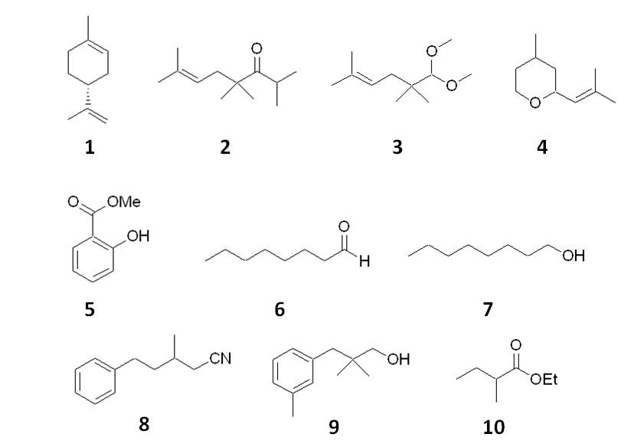
Figure 1. Aroma molecules used in model fragrance

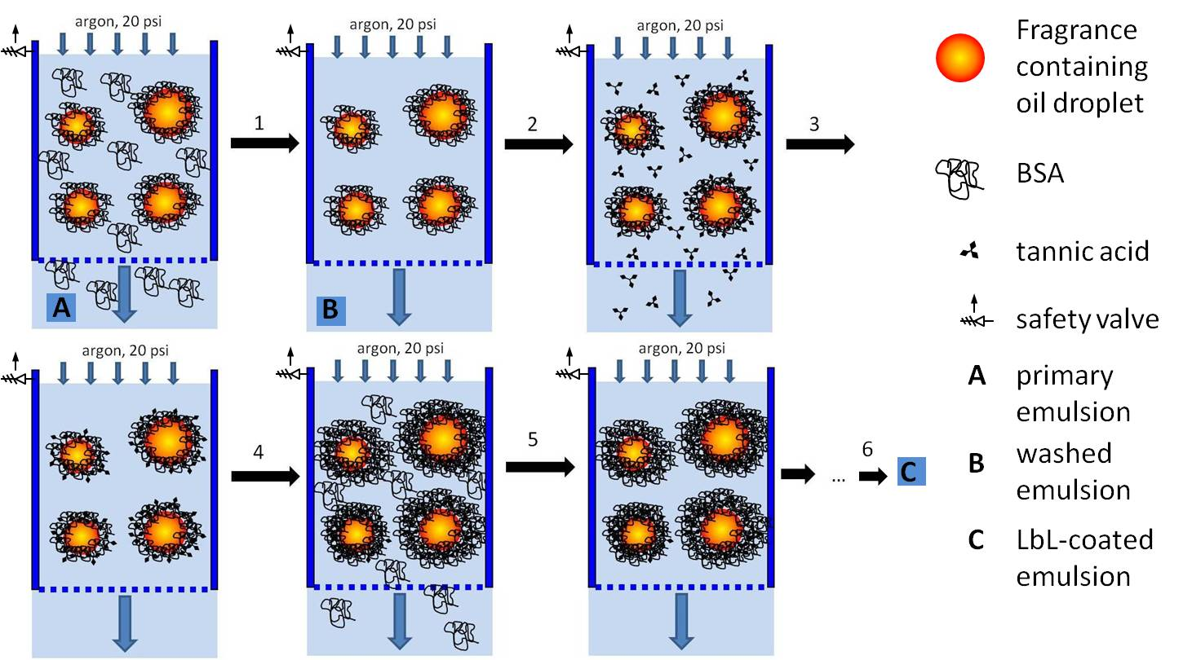
Figure 2. Schematic diagram of the process. 1 – washing out uncoupled BSA; 2 – coating with TA; 3 – washing out uncoupled TA; 4 – coating with the second BSA layer; 5 – washing out uncoupled BSA; 6 – coating with the second TA layer and washing out uncoupled TA.

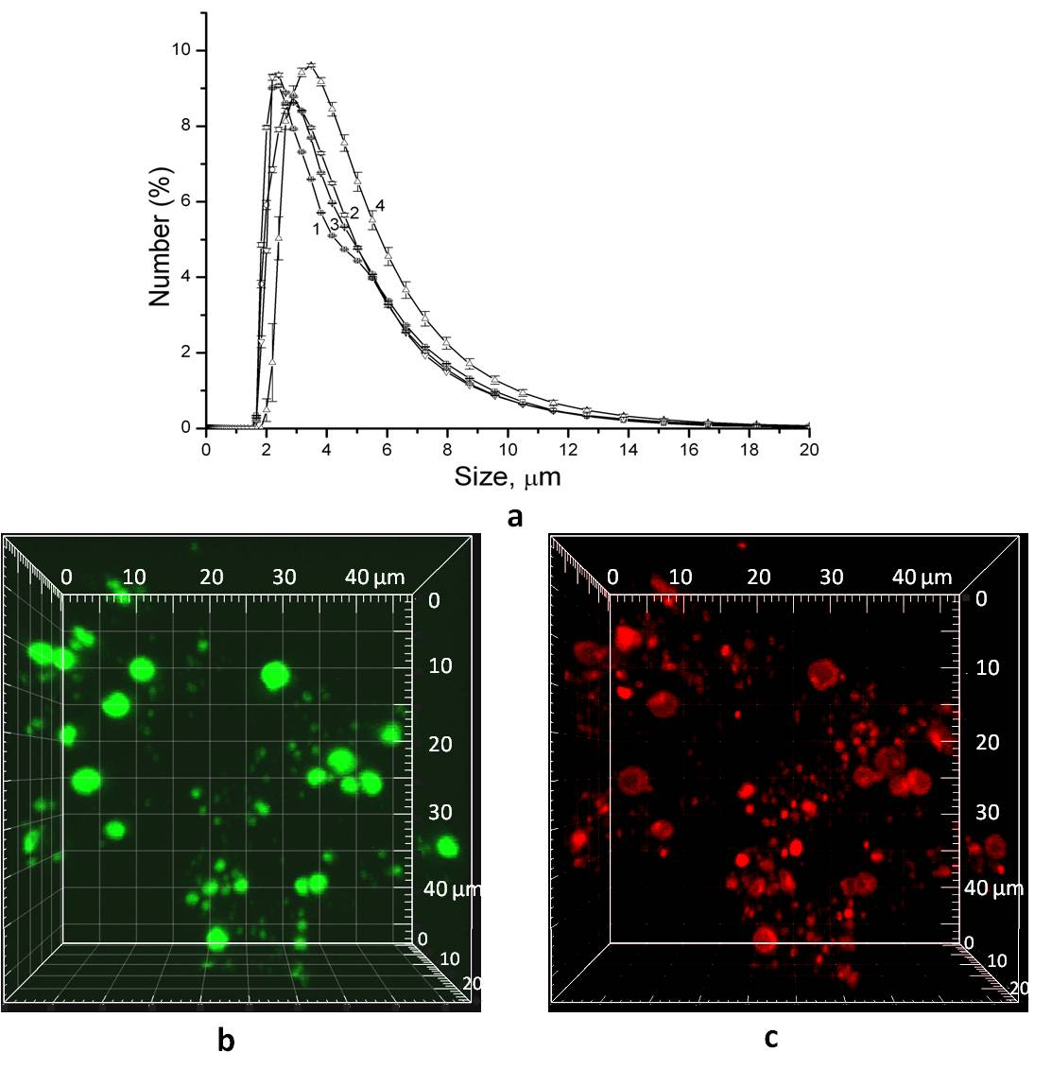
Figure 3. (a) Droplet size distributions in just prepared coated emulsion C (1), after 1 week (2), 2 months (3) of storage at 4ºC and after 5 days of fragrance evaporation in an open vial at 40ºC (4); (b, c) - CLSM images of emulsion C after the two months of storage at 4°C. (b) λ_{exc} = 488 nm, λ_{em} = 525 nm; (c) λ_{exc} = 529 nm, λ_{em} = 596 nm.
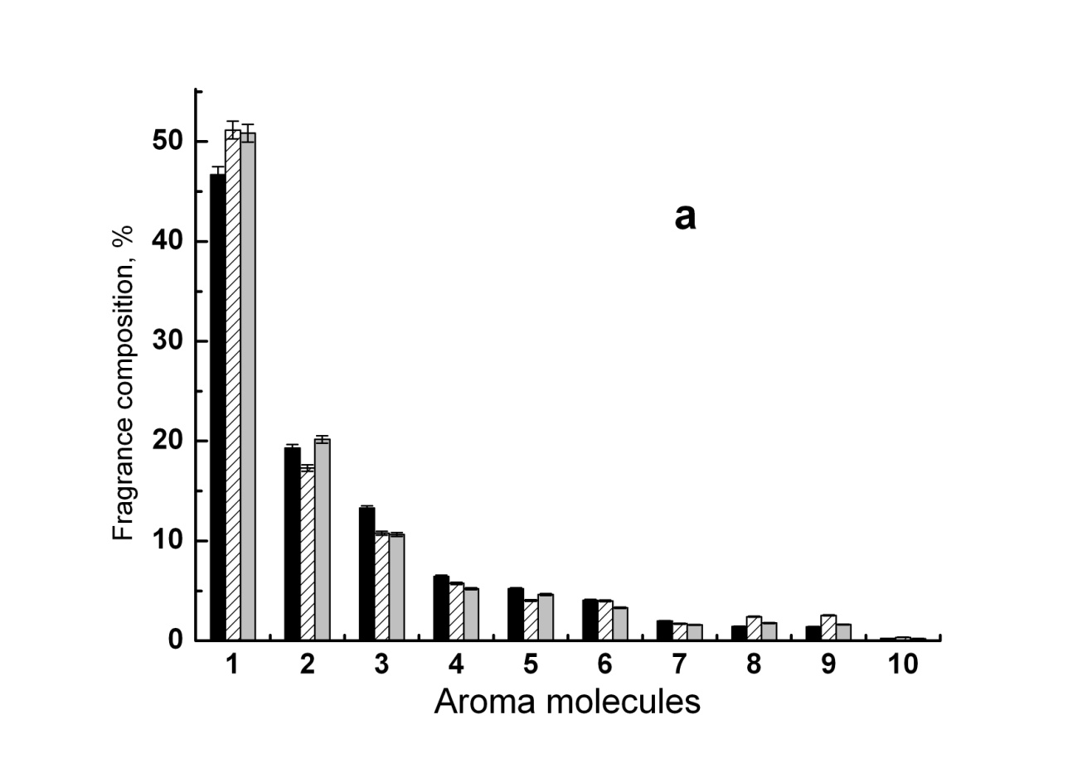
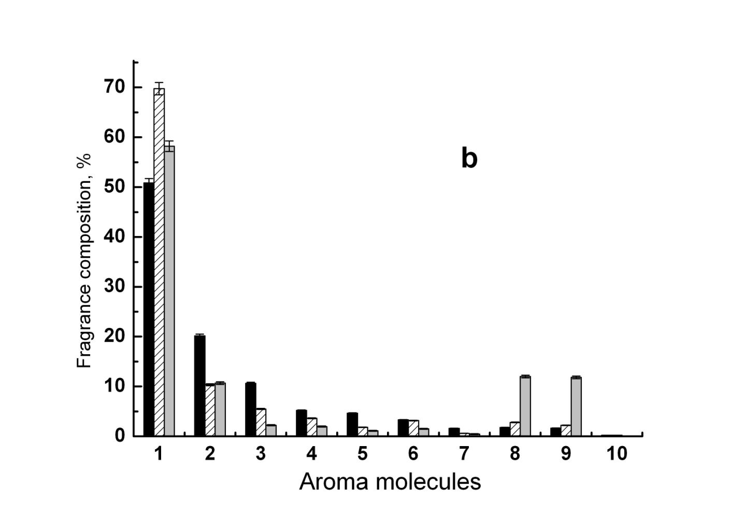
Figure 4. Composition of fragrance released from emulsion C at 40°C upon its agitation in an open vial. Time of agitation was: a) 1 ( ), 2 ( ) and 3 ( ) days; b) 3 ( ), 4 ( ), and 5 ( ) days.
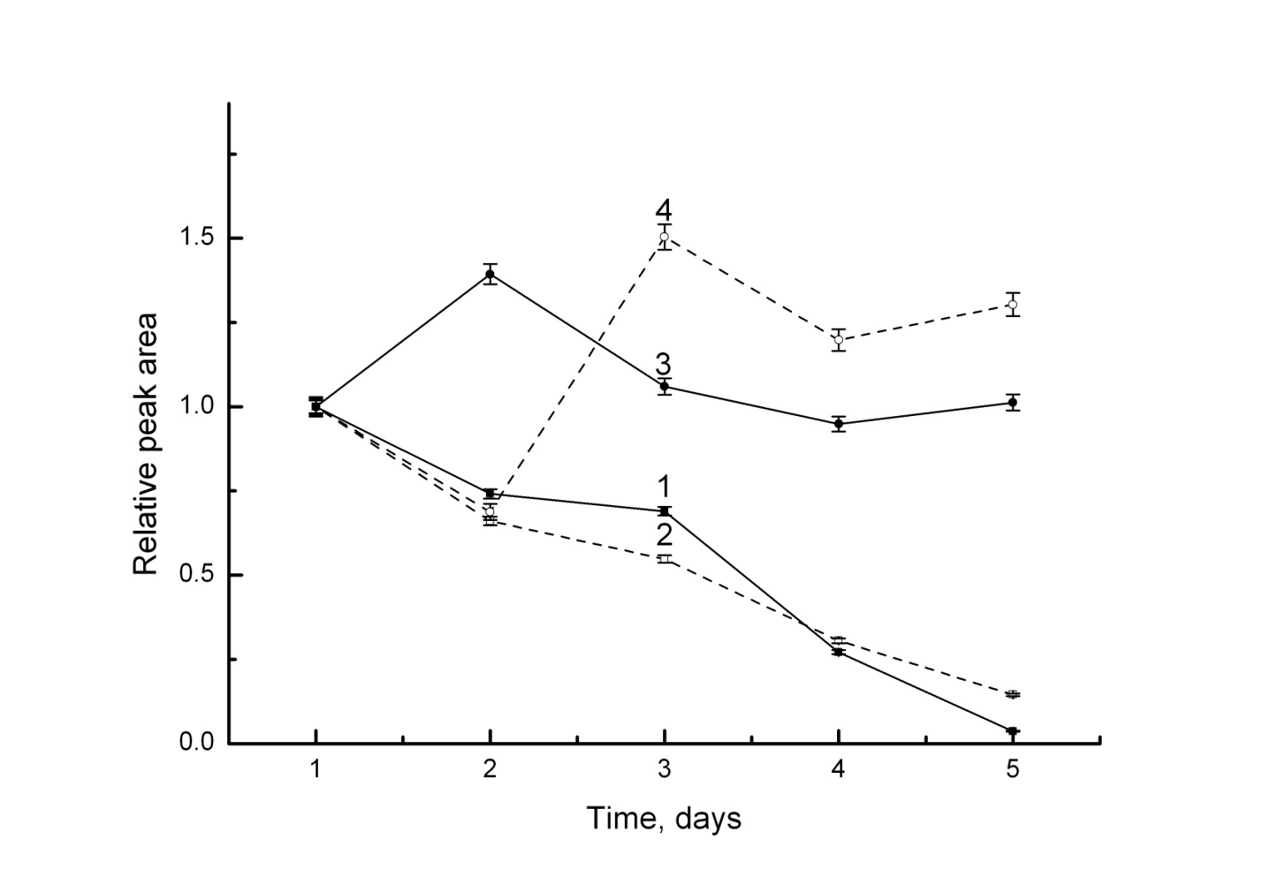
Figure 5. Release profiles of Rose oxide (1, 2) and hydrocitronitrile (3, 4) from LbL-coated emulsion C (1, 3) and corresponding emulsion stabilized with single BSA layer B (2, 4) upon incubation in an open vial at 40°C.

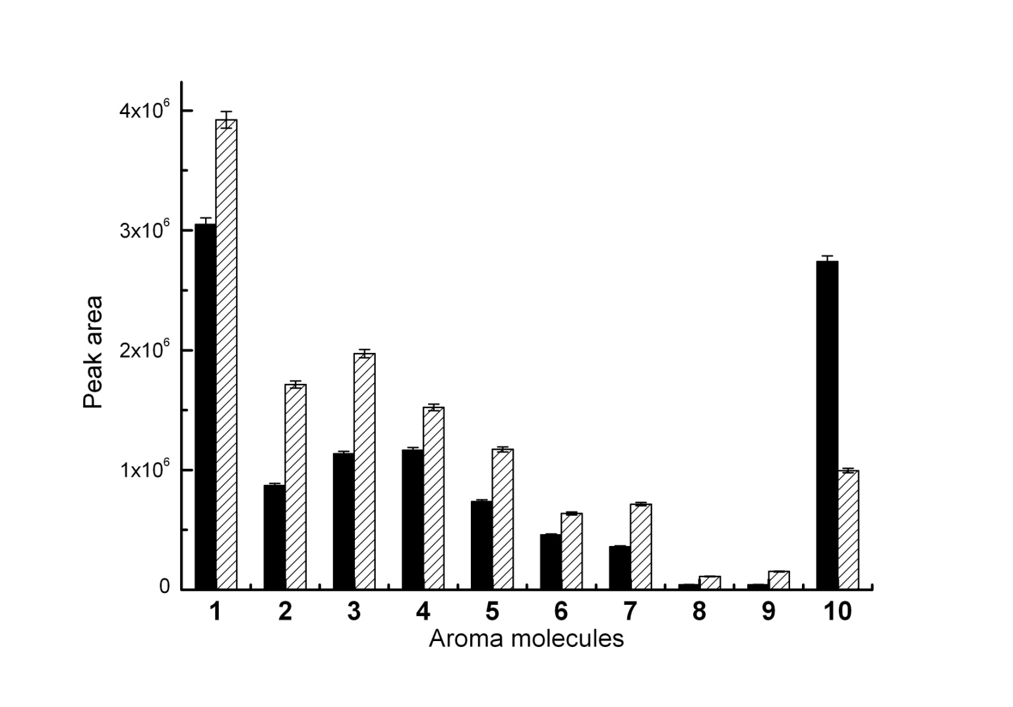
Figure 6. Composition of fragrance released from emulsion A ( ) and B ( ) just after their preparation.

Table of contents graphic

