C-Plasma Derived Precise Volumetric Buffering for High-Rate and Stable Alloying-Type Energy Storage

Bo Ouyang,^{a,d,†} Dongliang Chao,^{b,}* Guichong Jia,^{b} Zheng Zhang,^{c} Erjun Kan,ª Hong Jin Fan,^{b,}* and Rajdeep Singh Rawat^{d,}*

ª Department of Applied Physics and Institution of Energy and Microstructure, Nanjing University of Science and Technology, Nanjing 210094, China;
^{b} School of Physical and Mathematical Sciences, Nanyang Technological University, Singapore 637371, Singapore;
^{c} Institute of Materials Research and Engineering, A*STAR (Agency for Science, Technology and Research), #08-03, 2 Fusionopolis Way, Innovis, 138634, Singapore;
^{d} Natural Sciences and Science Education, National Institute of Education, Nanyang Technological University, 637616, Singapore

[*] Email: S120055@e.ntu.edu.sg; fanhj@ntu.edu.sg; rajdeep.rawat@nie.edu.sg

Abstract
The void introduction for high-energy alloying-type electrode has suffered a dilemma between insufficient void leading to structural collapse and excessive void causing low volumetrical utilization ratio. Herein, a novel tunable void structure of SnO₂-void-hierarchically vertical graphene (SnO₂□hVG) nanoarray has been designed via facile C-plasma technique, which facilitates simultaneous encapsulation of protective vertical graphene and moderate void formation. Benefiting from the tunable void and interconnected highly conductive graphene shells and backbones, our all-in-one framework delivers excellent structural integrity and superior Li⁺ storage capabilities due to the precise volume buffering without collapse of structure and extravagant void. As a result, an imposing capacity of 650 mA h g⁻¹ at 2 A g⁻¹ and negligible capability degradation after 1000 cycles can be achieved. This result opens a new opportunity in tunable void design to enhance the electrochemical performance of alloying-type electrode materials.
Introduction
Transition metal oxides (TMOs) have been recognized as appropriate anode materials for Li⁺ batteries owing to their abundance, great chemical stability and enhanced theoretical capacities as compared to graphite [1-3]. The large volumetric change during the Li⁺ insertion/extraction inevitably results in pulverization of the electrode materials and rapid deterioration of the anodic performance, which severely hinders their practical applications. To address this issue, yolk-shell nanostructures have been designed [4-6]. The improved electrochemical performance of such architectures lies in their well-defined void space, allowing the active materials to expand freely without breaking the outward protective shell and ensuring the structural integrity [7-9]. However, excess void space can significantly accommodate the volume expansion at the cost of a further decreased energy density, whilst insufficient void is unable to maintain the structural integrity after the repeated cycles and volume expansion. Hence, it is highly desirable to precisely control the void space to simultaneously achieve stable cycling performance and maintain a reasonable volumetric energy density.
Typically, silica served as a favorable sacrificial layer to create appropriate void space for high-capacity anode materials. Zhang et al. reported the yolk-shell FeO_{x}-C nano-particles with controlled void space based on adjusting the thickness of SiO₂ [10]. Recently, Wang et al. synthesized FeP@C yolk-shell nanobox by carbonizing Fe₂O₃@poly-dopamine composite followed by partial removal of Fe₂O₃ core with HCl and phosphorization, which exhibited a high reversible capacity and excellent cycling stability (400 mA h g⁻¹ at 1 A g⁻¹ for 600 cycles) [11]. Inspired by that, Wang et al. achieved Si@void@C, where the internal void space was tactfully created by partially removing the polymeric shell with acetone [12]. Despite this progress, it remains challenging to prepare void structures with precisely controlled void volume to accommodate expansion/contraction during cycling [13-16]. More advanced technologies without the introduction of other sacrificial agents are necessary. Moreover, current researches on yolk-shell frameworks are restricted in powder-based materials, which inevitably lead to the introduction of binder, conductive additives and metal Cu current collectors in cell assembly, and thus worsen the energy/power densities [17-19]. Hence, it is still very desirable to explore new strategies to construct tunable void structures for high-performance energy storage.
In this work, a facile C-plasma strategy is applied on SnO₂ nanowires to simultaneously produce tunable void structures and a protective encapsulation framework. C-plasma is capable of achieving hierarchically vertical graphene (hVG) on the surface of SnO₂ nanoarray and in-situ generation of the void by removal of the reductive Sn. The void space can be precisely controlled via modulating plasma duration. Moreover, the low temperature (≤400 ºC) C-plasma strategy is favourable for ensuring structural integrity as binder-free electrodes. As a result, the SnO₂□hVG electrode exhibits excellent charge storage behaviors with high specific capacity of 650 mA h g⁻¹ and imposing cycling performance for 1000 cycles at 2 A g⁻¹. Overall, the C-plasma strategy paves a novel pathway to simply fabricate and precisely modulate void architectures for high-performance electrodes.
Results and Discussion
The SnO₂□hVG void structures were synthesized via a simple C-plasma process without any additional sacrificial species (Figure 1). First, SnO₂ nanowires were synthesized by a typical chemical vapor deposition (CVD) route on graphene foam (GF) surface (see Experimental Section for details in Supporting Information). Subsequently, SnO₂ was uniformly coated with hVG after the C-plasma and simultaneously in-situ reduced to metallic Sn on its surface. After immersing the obtained composites into HCl solution, Sn can be completed removed, forming a tunable void between hVG and the remaining SnO₂ nanowire. The void space can be controlled by simply modulating the processing duaration. With too short duration, skimpy void is produced, leading to the pulverization of hVG during lithiation, while elongated duration should cause the formation of luxurious void, resulting in the surplus void space during cycling (refer to the schematic in Figure 1). The precise void between SnO₂ nanowire and hVG nanotubes provide adequate volume and give rise to a typical yolk-shell structure. It is believed that during the cycling process, a stable SEI layer could be blocked by the outer graphene shell. Thus the continual rupturing and reforming can be ingeniously avoided. The outward hVG layer is electronically conductive, allowing for superior transport kinetics. More importantly, the gaps between SnO₂ and graphene shell allow electroactive SnO₂ to swell accurately while preserving the electrode integrity.
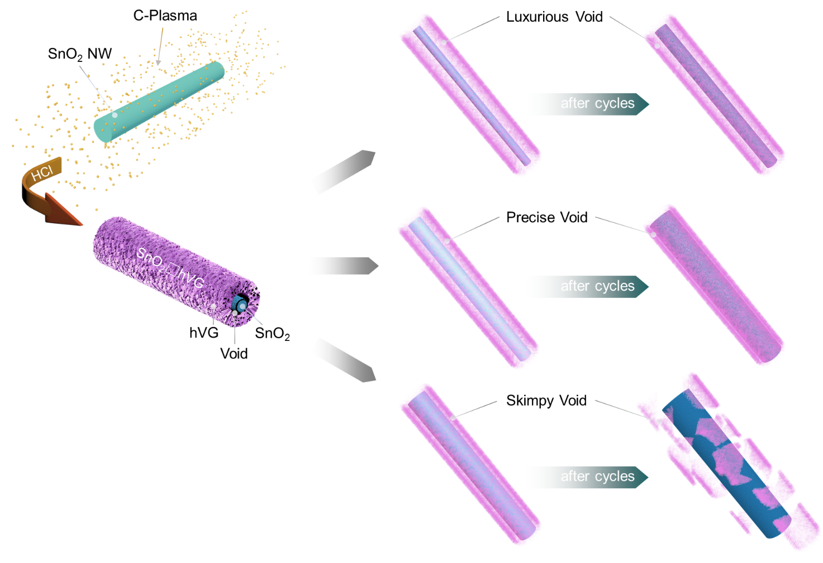
Figure 1. The fabrication procedure of SnO₂□hVG and schematic illustration of SnO₂□hVG with different voids.
To investigate the simultaneous graphene encapsulation and achieve tunable void nano-framework via facile plasma approach, we modulate plasma treatment duration to control the void volume of SnO₂□hVG for confirming the optimized nano-structures in Li⁺ storage application. As indicated, the large volume expansion up to 300% for SnO₂ anode materials has been observed during cycling [20]. Herein, the radius of as-achieved void should be at least 1.73 times bigger than the inner SnO₂ nanowire to preserve the structural integrity. With increasing C-plasma treatment duration from 30, 90, 180, 300, to 420 s on GF-SnO₂ surfaces, the void volume of resultant structures is increased (Figure 2a). In Figure 2b, a negligible void can be observed between SnO₂ and encapsulated graphene with a shell thickness of ~10 nm after treatment of 30 s. In terms of treated sample for 90 s, the void can be apparently observed with increased graphene thickness of ~13 nm (Figure 2c). The achieved void is not quite uniform due to rapid plasma reduction, and the space is not sufficient to accommodate the expansion of active materials. The sample treated with C-plasma for 180 s exhibits the well-defined void framework. However, it is not sufficient enough for such a void to accommodate the expansion-contraction of SnO₂ during cycling (Figure 2d). The optimized SnO₂□hVG with appropriate void volume is fabricated with plasma treatment of 300 s (Figure 2e). The increase in C-plasma processing duration to 420 s resulted in the reduction of all SnO₂ to metallic Sn, and only the vertical graphene nanotubes were achieved after acid removal of metal, which has been reported in our previous work [21]. The corresponding SEM observations also exhibit the morphological changes with elongating plasma duration (Figure S1). The amounts of outer vertical graphene increase as processing goes on, which verifies above TEM results.
Therefore, we select the 300 s plasma-treated SnO₂ (SnO₂□hVG) as the anode materials along with the initial GF-SnO₂ as the reference. GF-SnO₂ clearly shows a smooth surface of SnO₂ nanowire array with its uniform diameters of ~50 nm (Figure 3a). With hVG encapsulation (Figure 3b), the nanowire surfaces become relatively rough with numerous vertical graphene nanosheets, and the diameters are increased to ~130 nm. In order to observe the interior structure of SnO₂□hVG more clearly, TEM measurements were also implemented. Figure 3c confirms that the as-synthesized SnO₂ nanowires are highly-ordered consisting of a well-crystallized phase with sharp periodic lattice fringe of 0.26 nm, corresponding to (101) facet [22, 23]. After hVG coating, the SnO₂ nanowire with a radius of ~33 nm and the complete graphene shell with a thickness of ~13 nm can be clearly observed (Figure 3e and S2). Moreover, it can be seen that the average distance from the internal surface of the SnO₂ to the outer surface of the hVG is ~33 nm, allowing for the accommodation of ~173% radius changes of SnO₂ nanowires during cycling without any volume waste.
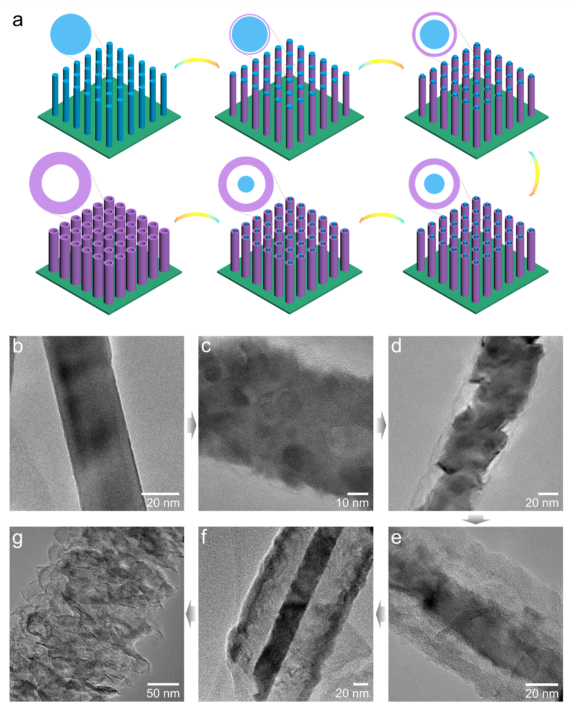
Figure 2. Mechanism investigation of SnO₂□hVG void nano-structures with different plasma durations. (a) the schematic diagram of achieved SnO₂□hVG with different void volume at different treatment durations, (b) 0 s, (c) 30 s, (d) 90 s, (e) 180 s, (f) 300 s, (g) 420 s.
The characterizations of GF, GF-SnO₂ and SnO₂□hVG are further carried out. In terms of XRD patterns in Figure 3e, the diffraction peak at 27° is attributed to the graphene nano-sheets of GF and hVG (JCPDS 75-1621) [24, 25]. For GF-SnO₂ and SnO₂□hVG, beside graphene-related peak, other typical peaks of tetragonal rutile SnO₂ (JCPDS No. 51-0614) are clearly observed without impurities, confirming the formation of SnO₂ with excellent crystallinity [26, 27]. Notably, with hVG coverage, little change of the diffraction peaks was observed, indicating the great preservation of SnO₂ after C-plasma treatment. Figure 3f shows the Raman spectra of SnO₂□hVG, GF-SnO₂ and GF. For GF, strong G and 2D peak with little D band at 1350 cm⁻¹ were observed, indicating that the graphene sheets are of high quality with little defects. The I_{2D}/I_{G} is 0.79, indicative of few-layer graphene. After the growth of SnO₂ nanowires, three bands centred at 478, 625 and 765 cm⁻¹ are observed, corresponding to E_{g}, A_{1g} and B_{2g} vibration modes of SnO₂, respectively [28, 29]. These results show the typical feature of rutile phase of SnO₂ in accordance with the XRD measurements. Notably, weak G band can still be observed after SnO₂ deposition, confirming the uniform growth of nanowires on GF. Further encapsulation of hVG resulted in the well-defined D and G bands with a tremendous decrease of SnO₂-related band at 625 cm⁻¹, which indicates the successful growth of vertical graphene [30, 31]. Strong D-band confirmed the presence of exposed edges and defects on the composite surface, facilitating Li⁺ migration.
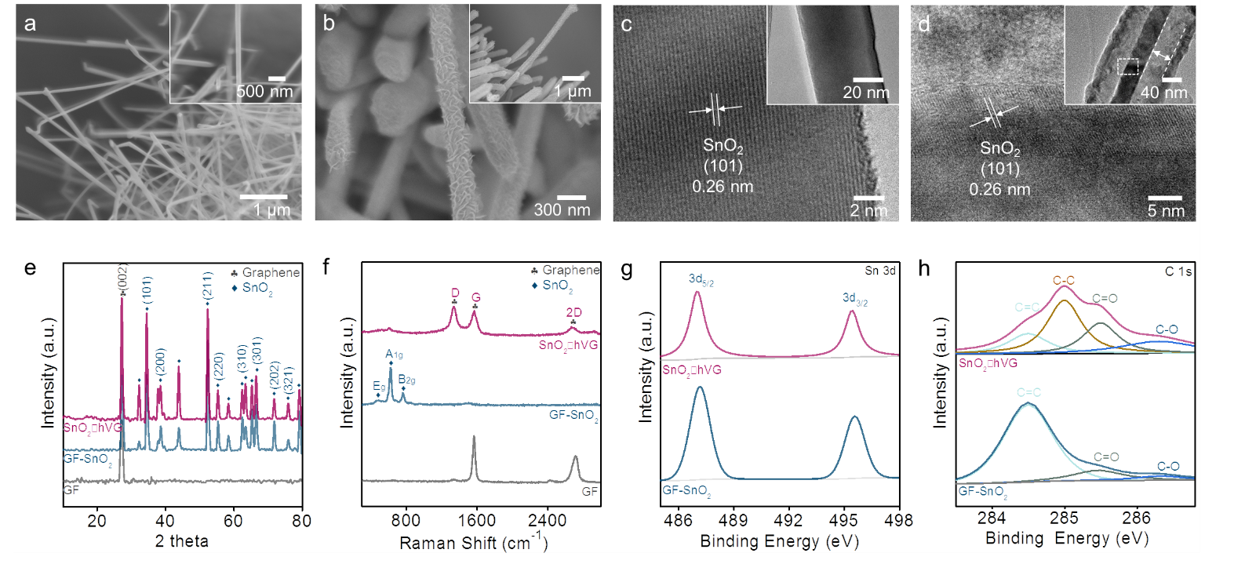
Figure 3. The characterizations of GF, GF-SnO₂ and SnO₂□hVG composites. (a) and (c) SEM and TEM images of GF-SnO₂, (b) and (d) SEM and TEM images of SnO₂□hVG, (e) XRD patterns, (f) Raman spectra, XPS high resolution spectra of (g) Sn 3d and (h) C 1s.
To further investigate the state of Sn and C in SnO₂□hVG and GF-SnO₂, the XPS measurement of Sn 3d and C 1s region is conducted. As shown in Figure 2g, the main peaks sitting at 486.5 and 495.9 eV in GF-SnO₂ are attributed to Sn 3d_{5/2} and Sn 3d_{3/2} in SnO₂, respectively [32, 33]. After hVG coverage, no apparent changes of peak location were observed in Sn 3d, indicating the total removal of metallic Sn along with the presence of SnO₂. In C 1s spectrum (Figure 3h), the main peak centered at 284.5 eV in GF-SnO₂ was ascribed to C=C bond, indicating the graphitic structure of GF [34]. For SnO₂□hVG, three peaks at 284.5 eV, 285 eV and 285.5 eV belong to C=C, C-C and C=O bonds, respectively, which serves as the specific features of vertical graphene [25, 31]. In view of the above analysis, it is safe to conclude that the SnO₂-hVG is successfully fabricated in a controlled way to achieve a void structure.
Afterwards, the electrochemical performances of both composites were thoroughly characterized via cyclic voltammetry (CV), galvonostatic charge-discharge (GCD) and electrochemical impedance spectroscopy (EIS) tests, as shown in Figure 4. The specific capacity is calculated based on the mass of active materials (GF-SnO₂and SnO₂□hVG), the mass loading of the electrode is ~1.4 mg cm⁻². Figure 4a and S3 exhibit the CV curves of both samples between 0.005 and 3.00 V (vs. Li/Li⁺) at a scan rate of 0.1 mV s⁻¹. As observed in Figure 4a, the broad peak from 0.5 to 0.9 V during the 1st discharging process could be assigned to the formation of solid electrolyte interface (SEI) layer. During the 1st charging process, both composites delivered two anodic peaks at 0.61 and 1.35 V, corresponding to the reversible Li_{x}Sn dealloying reaction (Equation 1) and conversion from Sn to SnO₂ (Equation 2) [35, 36]. For subsequent cycles, the broad cathodic peak at ~0.70 V shifts to 1.11 and 0.58 V, which can be assigned to the conversion of SnO₂ → SnO → Sn. The same results were also observed in CV curves of bare GF-SnO₂ electrode (Figure S3). Noticeably, the 2nd and 3rd cycles of SnO₂□hVG are largely overlapped, are compared to the apparent changes of peak position in GF-SnO₂, especially at ~1.13 V, indicating better reversibility of SnO₂-hVG electrode.
SnO₂ + 4Li⁺ + 4e⁻ ↔ Sn + 2Li₂O Equation 1
Sn + xLi⁺ + xe⁻ ↔ Li_{x}Sn (0≤x≤4.4) Equation 2
Noticeably, it has been proven that the anodic peak at 1.35 V is ascribed to the oxidation of Sn to SnO₂. In terms of GF-SnO₂, the obvious decay of such peak indicates that relatively low amounts of Sn are reoxidized, implying the considerable irreversibility of active materials and thus the rapid capacity fading. In comparison, the SnO₂□hVG has more stable anodic peaks at 1.35 V, suggesting that the vertical graphene shell can enhance and stabilize the reversibility of Equation (1), which delivers more effective utilization of active materials and improved capabilities. Figure 4b and S4 show the voltage-specific capacity plots of the first three cycles for both electrodes. For GF-SnO₂nanocomposite (Figure S4), the initial discharge capacity is 1267 mA h g⁻¹, while the initial charge capacity is 995 mA h g⁻¹, with the Coulombic efficiency of 78% for the 1st cycle. In the second cycle, it delivers discharge and charge capacities of 901 and 828 mA h g⁻¹, respectively, with the Coulombic efficiency of 92%. Such results show that the GF-SnO₂ provides a high capacity loss during the initial cycle, which is in accordance with the CV results. The substantial irreversible capacity during the 1st cycle is attributed to the irreversibility of the reaction described by Equation (1) and the SEI formation [27, 37]. When encapsulated by vertical graphene, the SnO₂□hVG sample exhibits initial discharge and charge capacities of 1405 and 1004 mA h g⁻¹, respectively, with the Coulombic efficiency of 71%. Combining the CV results, it can be concluded that the tunable void structure exhibits the increased reversibility and hence higher capacity than initial SnO₂ nanowires. Moreover, the decomposition of electrolyte in the low-potential region and the simple adsorption of Li⁺ on the surface of the encapsulated graphene matrix is also considered as the causes of the excess capacity.
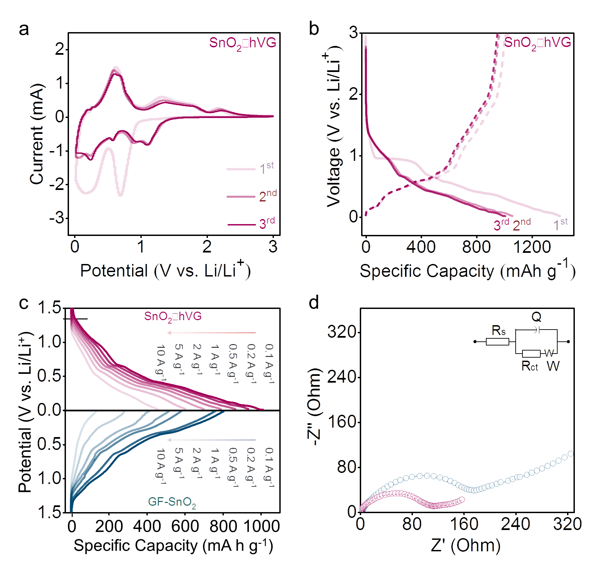
Figure 4. Electrochemical performance and kinetics of the SnO₂□hVG and GF-SnO₂. (a) CV curves of the SnO₂□hVG, (b) GCD profiles of SnO₂□hVG at 0.1 A g⁻¹, (c) the comparison of discharge curves for both electrodes at different rates, (d) the comparison of EIS spectra for both electrodes.
In order to investigate the rate performance of both samples, they were cycled between 0.005 and 3.00 V at different rates from 0.2 to 10 A g⁻¹. The results are shown in Figure 4c. SnO₂□hVG void nanowires deliver discharge capacities of 1010, 937, 867, 786, 701, 605, and 456 mA h g⁻¹ at current densities of 0.1, 0.2, 0.5, 1.0, 2.0, 5.0, and 10.0 A g⁻¹, respectively, with capacity retention of 45%. GF-SnO₂ nano-composites provide capacities of 803, 763, 585, 520, 416, 282, and 137 mA h g⁻¹, with 17% retention, considerably lower than that of SnO₂□hVG composites at the same current densities. To further study the charge transport kinetics facilitated by the unique void structure, EIS spectra were conducted on both samples. As shown in Figure 4d, both GF-SnO₂ and SnO₂□hVG electrodes demonstrate one semicircle in the high-frequency range (corresponding to charge-transfer impedance, R_{ct}, in electrode-electrolyte interface) and an inclined line in the low-frequency range (corresponding to Li⁺ diffusion process). As fitted, SnO₂□hVG has much smaller R_{ct} of 96 Ω than that of GF-SnO₂ (202 Ω), indicating better electronic transport of vertical graphene than bare SnO₂.
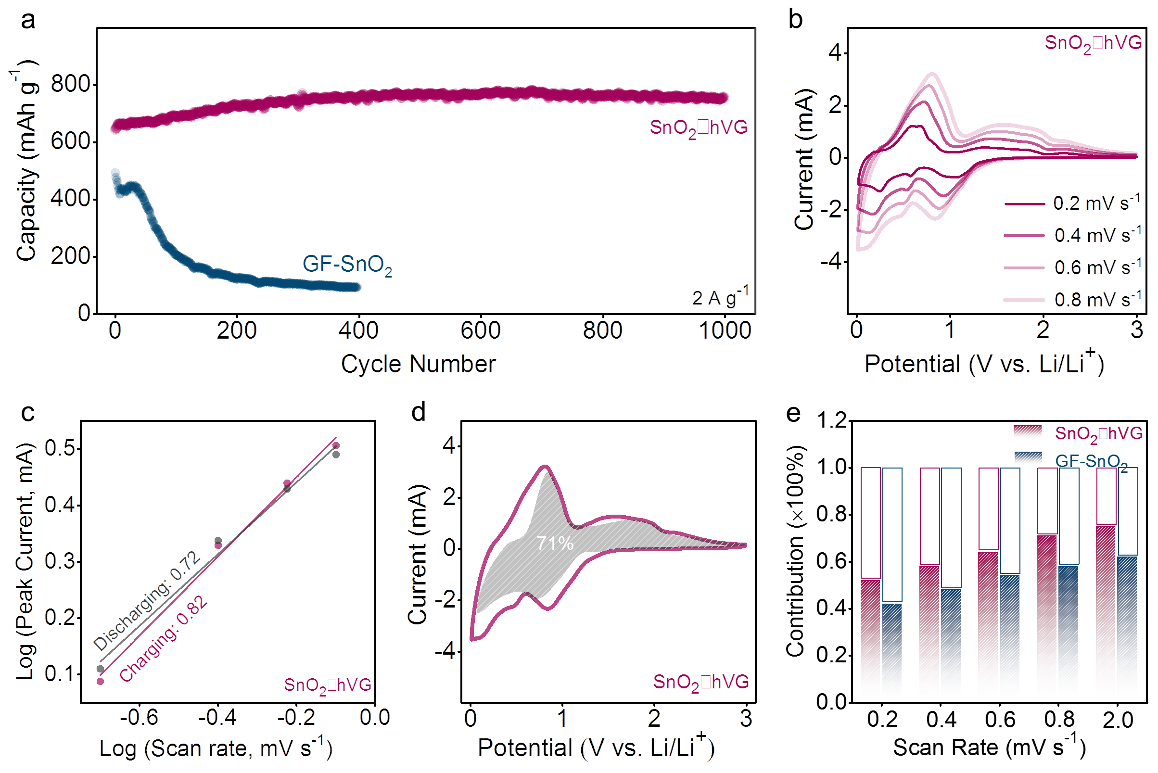
Figure 5. Cycling stability and charge storage mechanism of SnO₂□hVG. (a) the comparison of long-term cycling behaviors for GF-SnO₂ and SnO₂□hVG electrodes at 2 A g⁻¹, (b) the CV curves of SnO₂□hVG at different scan rate, (c) plot of log scan rate versus log peak current, (d) pseudocapacitive contribution of SnO₂□hVG at 0.8 mV s⁻¹, (e) the pseudocapacitive contribution comparison of both electrodes at different scan rates.
Long-term cycling performance serves as an essential role in evaluating electrode materials. As shown in Figure 5a, GF-SnO₂ undergoes short capacity preservation followed by a rapid decay in the first 100 cycles. Their capabilities remain stable less than 100 mA h g⁻¹, like the results reported previously [27, 38, 39]. By contrast, SnO₂□hVG exhibits remarkably enhanced stability during discharge-charge cycles. The capacities in the 1st and the 1000th cycles are 654 and 753 mA h g⁻¹, respectively, with a capacity retention of 115%. The complete hVG enclosure and the void space between the core and shell can physically restrict the SnO₂ core and buffer its volume expansion, preventing it from pulverization and detaching from the current collector. That is beneficial to maintain a high capacity during discharge-charge cycles. Such excellent specific capacity, rate performance and cycling behavior of our nano-composites are comparable or even superior to those of state-of-the-art SnO₂-based anodes in previous studies [40-42].
To further figure out the high-rate and long-term performance of SnO₂□hVG nano-composites, the pseudocapacitive contribution was analyzed by investigating the kinetics of both electrodes. CV analysis displays similar shapes with increased scan rates from 0.2 to 0.8 mV s⁻¹ (Figure 5b and S5), indicating the same electrochemical reactions. The pseudocapacitive effects brought by both electrodes were revealed by analyzing the b value using the i = av^{b} formula. The b value can be obtained from the slope of the logi – logv plots. Typically, 0.5 and 1.0 of b value represent diffusion-controlled and capacitive-controlled processes, respectively [42]. As exhibited in Figure 5c, SnO₂□hVG delivers the b value of 0.72 and 0.82 for anodic and cathodic processes, higher than that of GF-SnO₂ (0.54 and 0.52, Figure S6), which suggests a higher ratio of the capacitive contribution in such void electrode.
The increased level of pseudocapacitive charge storage at different scan rates for GF-SnO₂ and SnO₂□hVG was further quantified based on the formula i = k₁v + k₂v^{1/2}. By determining both k₁ and k₂, it is possible to distinguish the fraction of the current contributed by capacitor-controlled processes and those arising from diffusion-controlled processes [43]. The results shown in Figure 5d and S7 indicate that pseudocapacitive charge storage in SnO₂□hVG electrode is of much greater extent compared to that in GF-SnO₂ (71% versus 58% at 0.8 mV s⁻¹). As the scan rate increases, the proportion of capacitive contribution of SnO₂□hVG increases further with a maximum value of 79% at 2 mV s⁻¹, in comparison to that of GF-SnO₂ electrode (62%) (Figure 5e). The increased capacitive current originated from encapsulated hVG and conductive GF matrix, and was considered beneficial for charge transfer and high-rate performance of SnO₂□hVG.
To further verify the tunable void nanostructure of SnO₂□hVG, the morphological changes upon full lithiation and delithiation were investigated after cycles via TEM results (Figure S8). In full delethiation (Figure S8a), SnO₂ core exhibits a twisted nanowire structure without breaking the outward hVG. After full lithiation (Figure S8b), SnO₂ occupies almost the whole void space, which maximizes the usage of the volumetrical space. Additionally, the intact hVG shell provides a fixed surface for the formation of stable solid electrolyte interface (SEI) layer, preventing the continual repture-reoformation of SEI and hence preserving the excellent cycling stability.

Conclusion
In summary, we provide a facile plasma strategy for engineering SnO₂□hVG void nano-structures. The generated void space can be easily modulated to precisely accommodate the volume changes of SnO₂ during cycling. Hierarchically vertical graphene is simultaneously achieved on the surfaces to deliver tunable void nano-architectures, which serves as both protector and sensitizer for Li⁺ transport. With an optimized void volume of such nano-framework, the SnO₂□hVG exhibits high reversible capacity (654 mA h g⁻¹ at 2 A g⁻¹) and excellent cycling stability (115% retention after 1000 cycles). Moreover, C-plasma technique is capable of tailoring void structure on interconnected nano-substrates without any sacrificial agent, broadening its further utilization in other areas. Our strategy may open a novel avenue to modulate other void nano-composites with enhanced electrochemical performance for next-generation LIBs.
Acknowledge
This study at Nanjing University of Science and Technology is supported by the NSFC (51522206, 11774173, 11574151, 51790492), by the Fundamental Research Funds for the Central Universities (No.30915011203, No.30918011334), China, and was supported by NIE AcRF research grant No. RI 6/14 RSR and RS 6/18 RSR provided by National Institute of Education, Nanyang Technological University, Singapore.
References
1. Li, H., et al., Lithium-Ion Batteries: Bimetal–Organic Framework: One-Step Homogenous Formation and its Derived Mesoporous Ternary Metal Oxide Nanorod for High-Capacity, High-Rate, and Long-Cycle-Life Lithium Storage (Adv. Funct. Mater. 7/2016). Advanced Functional Materials, 2016. 26(7): p. 982-982.
2. Liu, W., et al., Nickel-Rich Layered Lithium Transition-Metal Oxide for High-Energy Lithium-Ion Batteries. Angewandte Chemie International Edition, 2015. 54(15): p. 4440-4457.
3. Wang, Z., L. Zhou, and X.W. Lou, Metal Oxide Hollow Nanostructures for Lithium-ion Batteries. Advanced Materials, 2012. 24(14): p. 1903-1911.
4. Li, X., et al., Three-Dimensional Porous Core-Shell Sn@Carbon Composite Anodes for High-Performance Lithium-Ion Battery Applications. Advanced Energy Materials, 2012. 2(2): p. 238-244.
5. Wang, J., et al., Smart construction of three-dimensional hierarchical tubular transition metal oxide core/shell heterostructures with high-capacity and long-cycle-life lithium storage. Nano Energy, 2015. 12: p. 437-446.
6. Hwang, T.H., et al., Electrospun Core–Shell Fibers for Robust Silicon Nanoparticle-Based Lithium Ion Battery Anodes. Nano Letters, 2012. 12(2): p. 802-807.
7. Liu, N., et al., A Yolk-Shell Design for Stabilized and Scalable Li-Ion Battery Alloy Anodes. Nano Letters, 2012. 12(6): p. 3315-3321.
8. Yang, J., et al., Yolk-shell silicon-mesoporous carbon anode with compact solid electrolyte interphase film for superior lithium-ion batteries. Nano Energy, 2015. 18: p. 133-142.
9. Wu, C., et al., A Review: Enhanced Anodes of Li/Na-Ion Batteries Based on Yolk–Shell Structured Nanomaterials. Nano-Micro Letters, 2018. 10(3): p. 40.
10. Zhang, H., et al., Tailoring the Void Size of Iron Oxide@Carbon Yolk–Shell Structure for Optimized Lithium Storage. Advanced Functional Materials, 2014. 24(27): p. 4337-4342.
11. Wang, Q., et al., Tailoring yolk–shell FeP@carbon nanoboxes with engineered void space for pseudocapacitance-boosted lithium storage. Inorganic Chemistry Frontiers, 2018. 5(10): p. 2605-2614.
12. Wang, F., et al., Construction of Structure-Tunable Si@Void@C Anode Materials for Lithium-Ion Batteries through Controlling the Growth Kinetics of Resin. ACS Nano, 2019. 13(10): p. 12219-12229.
13. Fang, X., et al., Precisely controlled resorcinol–formaldehyde resin coating for fabricating core–shell, hollow, and yolk–shell carbon nanostructures. Nanoscale, 2013. 5(15): p. 6908-6916.
14. Liu, N., et al., A pomegranate-inspired nanoscale design for large-volume-change lithium battery anodes. Nature Nanotechnology, 2014. 9(3): p. 187-192.
15. Guan, B., et al., A versatile cooperative template-directed coating method to synthesize hollow and yolk-shell mesoporous zirconium titanium oxide nanospheres as catalytic reactors. Nano Research, 2014. 7(2): p. 246-262.
16. Zhang, W., et al., A self-crosslinking procedure to construct yolk–shell Au@microporous carbon nanospheres for lithium–sulfur batteries. Chemical Communications, 2020. 56(8): p. 1215-1218.
17. Liu, H., et al., Multi-dimensional construction of a novel active yolk@conductive shell nanofiber web as a self-standing anode for high-performance lithium-ion batteries. Nanoscale, 2015. 7(47): p. 19930-19934.
18. Xiao, Z., et al., Synthesis of Yolk–Shell-Structured Si@C Nanocomposite Anode Material for Lithium-Ion Battery. Journal of Electronic Materials, 2018. 47(10): p. 6311-6318.
19. Liu, J., et al., Hierarchical Fe3O4@TiO2 Yolk–Shell Microspheres with Enhanced Microwave-Absorption Properties. Chemistry – A European Journal, 2013. 19(21): p. 6746-6752.
20. Li, H.Z., et al., Improved electrochemical performance of yolk-shell structured SnO2@void@C porous nanowires as anode for lithium and sodium batteries. Journal of Power Sources, 2016. 324: p. 780-787.
21. Ouyang, B., et al., Hierarchical vertical graphene nanotube arrays via universal carbon plasma processing strategy: A platform for high-rate performance battery electrodes. Energy Storage Materials, 2019. 18: p. 462-469.
22. Lee, S.-Y., et al., Unveiling origin of additional capacity of SnO2 anode in lithium-ion batteries by realistic ex situ TEM analysis. Nano Energy, 2016. 19: p. 234-245.
23. Yang, L., et al., Chestnut-like SnO2/C nanocomposites with enhanced lithium ion storage properties. Nano Energy, 2016. 30: p. 885-891.
24. Zhang, Z., et al., Hierarchical composite structure of few-layers MoS2 nanosheets supported by vertical graphene on carbon cloth for high-performance hydrogen evolution reaction. Nano Energy, 2015. 18: p. 196-204.
25. Xia, X., et al., Boosting sodium ion storage by anchoring MoO2 on vertical graphene arrays. Journal of Materials Chemistry A, 2018. 6(32): p. 15546-15552.
26. Wang, X., et al., N-Doped Graphene-SnO2 Sandwich Paper for High-Performance Lithium-Ion Batteries. Advanced Functional Materials, 2012. 22(13): p. 2682-2690.
27. Liang, J., et al., Bowl-like SnO2@Carbon Hollow Particles as an Advanced Anode Material for Lithium-Ion Batteries. Angewandte Chemie International Edition, 2014. 53(47): p. 12803-12807.
28. Liu, L.Z., et al., Identification of oxygen vacancy types from Raman spectra of SnO2 nanocrystals. Journal of Raman Spectroscopy, 2012. 43(10): p. 1423-1426.
29. Bonu, V., et al., Invoking forbidden modes in SnO2 nanoparticles using tip enhanced Raman spectroscopy. Journal of Raman Spectroscopy, 2015. 46(11): p. 1037-1040.
30. Ghosh, S., et al., Supercapacitive vertical graphene nanosheets in aqueous electrolytes. Nano-Structures & Nano-Objects, 2017. 10: p. 42-50.
31. Zhang, L.X., et al., Understanding the growth mechanism of vertically aligned graphene and control of its wettability. Carbon, 2016. 103: p. 339-345.
32. Costa, I.M., et al., Sb doping of VLS synthesized SnO2 nanowires probed by Raman and XPS spectroscopy. Chemical Physics Letters, 2018. 695: p. 125-130.
33. Akgul, F.A., et al., Structural and electronic properties of SnO2. Journal of Alloys and Compounds, 2013. 579: p. 50-56.
34. Gao, H., et al., A simple method to synthesize continuous large area nitrogen-doped graphene. Carbon, 2012. 50(12): p. 4476-4482.
35. Wang, C., et al., Ultrathin SnO2 Nanosheets: Oriented Attachment Mechanism, Nonstoichiometric Defects, and Enhanced Lithium-Ion Battery Performances. The Journal of Physical Chemistry C, 2012. 116(6): p. 4000-4011.
36. Wang, L., et al., Interface Chemistry Engineering for Stable Cycling of Reduced GO/SnO2 Nanocomposites for Lithium Ion Battery. Nano Letters, 2013. 13(4): p. 1711-1716.
37. Kim, W.-S., et al., Synthesis of SnO2 nano hollow spheres and their size effects in lithium ion battery anode application. Journal of Power Sources, 2013. 225: p. 108-112.
38. Zuo, S., et al., SnO2/graphene oxide composite material with high rate performance applied in lithium storage capacity. Electrochimica Acta, 2018. 264: p. 61-68.
39. Lin, J., et al., Graphene Nanoribbon and Nanostructured SnO2 Composite Anodes for Lithium Ion Batteries. ACS Nano, 2013. 7(7): p. 6001-6006.
40. Nam, S., et al., Wrapping SnO2 with porosity-tuned graphene as a strategy for high-rate performance in lithium battery anodes. Carbon, 2015. 85: p. 289-298.
41. Li, Z., et al., High rate SnO2–Graphene Dual Aerogel anodes and their kinetics of lithiation and sodiation. Nano Energy, 2015. 15: p. 369-378.
42. Yang, Y., et al., Phosphorized SnO2/graphene heterostructures for highly reversible lithium-ion storage with enhanced pseudocapacitance. Journal of Materials Chemistry A, 2018. 6(8): p. 3479-3487.
43. Chao, D., et al., Array of nanosheets render ultrafast and high-capacity Na-ion storage by tunable pseudocapacitance. Nature Communications, 2016. 7(1): p. 12122.

