Machine learning accelerated design of a family of AlxCrFeNi medium entropy alloys with superior high temperature mechanical and oxidation properties
Ling Qiao ª ^{b}, R.V. Ramanujan ^{b}, Jingchuan Zhu ª
ª
School of Material Science and Engineering, Harbin Institute of Technology, Harbin 150001, Heilongjiang, China
^{b}
School of Material Science and Engineering, Nanyang Technological University, 50 Nanyang Avenue, 639798, Singapore

Abstract
This work implemented machine learning (ML) approach to map the relationship between temperature, alloying elements and yield strength in multi-component alloys. Then AlxCrFeNi medium-entropy alloys (MEAs) were developed and a two-phase structure, formed by the spinodal decomposition mechanism, was observed. With increasing Al content, the high temperature mechanical properties dramatically improved. Our developed AlxCrFeNi MEAs (x > 0.8) offer low density and excellent mechanical properties, superior to conventional alloys. The oxidation behavior of AlxCrFeNi MEAs (x > 0.8) at 1000 °C was explored and the oxidation mechanism was identified. This work has identified a promising family of MEAs for high temperature structural applications.
1. Introduction
In recent years, the concept of high entropy alloys (HEAs) or medium entropy alloys (MEAs) was introduced to broaden the alloy field [1]. To break the limitation of conventional design strategy which is always composed of one or two principal metal elements, the HEAs and MEAs generally contain 4∼6 principal metallic elements with equimolar ratio or near equimolar ratio [2], [3]. The high mixing entropy effect contributes to the formation of simple solid solution structures (FCC, BCC or mixed), overcoming the conventional metallurgical problem that the multiple alloying elements tend to create the intermetallic compounds in alloys [4], [5]. In the past decade, many literature have been reported on the HEAs, including the excellent corrosion [6], [7] and oxidation resistance [8], [9], [10], exceptional mechanical properties [11], [12], [13], [14], [15], as well as at elevated temperature [16], [17], [18].
Towards the high temperature application, the conventional superalloys have provided practical contributions over the past few years. Although the intermetallic compounds, including the Ti–Al, Ni–Al, and Fe–Al binary systems, always possess high specific strengths and excellent thermal resistance, the brittleness cannot be neglected. With the increasing service temperature, especially in gas-turbine engines and aero engines, the traditional Ni-based superalloys could not meet the urgent demand. As known, the commercial Ni-based superalloys usually possess inherently high densities and the service temperature has arrived at 80% of the melting points [19], [20]. Thus, to explore a new generation of lightweight and low-cost structural materials that exhibit excellent properties at elevated temperatures has been a hot spot of researches for high-temperature applications.
With the further development of HEAs system, several series have been considered as promising candidate for high-temperature applications, such as AlxCrFeNi [21], AlxCoCrFeNi [22], AlxCrFeNiTi [23], CoCrFeNiTiAlx [24], etc. To cope with the high costs brought by Co addition, the Co-free alloy system without dramatically compromising the mechanical properties has attracted extensive attention in HEAs research area which can make HEAs competitive and accelerate the potential in engineering applications. Taking the Al–Cr–Fe–Ni alloy system as an example, our previous studies [25] on FeCr1.2NixAl HEAs exhibit favorable combination properties of high compressive strength and work hardening ability at elevated temperature. Besides, K. B Kim et al. [26] proposed that the addition of the minor element Mo and Ti in AlCrFeNi HEAs can effectively enhance the high-temperature hardness. Despite many studies have been reported on Al–Cr–Fe–Ni HEAs so far, available reports are mainly focused on mechanical properties at room temperature while rarely focus on the high temperature mechanical properties.
For researches in exploring the HEAs performance, machine learning (ML) method [27], [28], [29], [30], [31], [32], [33], [34], [35] has gained immense popularity. By constructing composition-target property model, this methodology has greatly accelerates the excavation and development of materials. Up to now, many neural networks have been proposed, e.g., back-propagation neural network (BPNN) [36], [37], [38], radial basis function neural network (RBFNN) [39], [40], support vector machine (SVM) [41], [42], [43]. In which, BPNN has been widely and frequently used due to its high predictive ability as statistical regression models. While, the presence of so many training factors increases the complexity of model construction. Compared with BPNN, generalized regression neural network (GRNN) possesses high learning ability and generalization ability [44], [45], [46], [47], [48], [49] by adjusting only one training factor, which is called spread value in the pattern layer. Even in dealing with small sample data, GRNN exhibits excellent predictive ability [50], which has broad research prospects in the materials field.
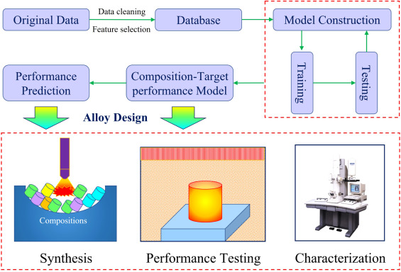
- Download: Download high-res image (804KB)
- Download: Download full-size image
Fig. 1. Machine learning guided construction of composition-target performance model.
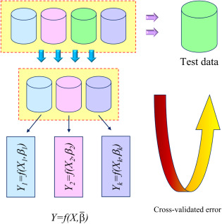
- Download: Download high-res image (249KB)
- Download: Download full-size image
Fig. 2. K-fold cross-validation (CV) estimator.
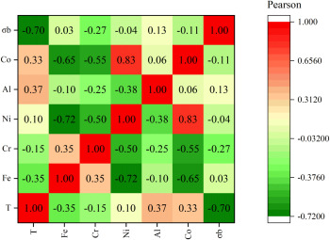
- Download: Download high-res image (340KB)
- Download: Download full-size image
Fig. 3. Pearson coefficient between temperature, alloying elements and yield strength.
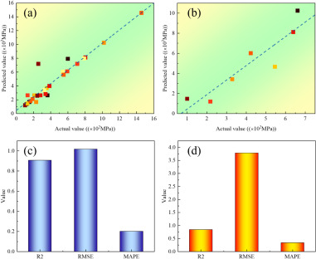
- Download: Download high-res image (238KB)
- Download: Download full-size image
Fig. 4. Training and testing results (a) regression analysis on training data (b) regression analysis on testing data (c) evaluating indicator for training data (d) evaluating indicator for testing data.
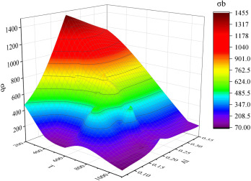
- Download: Download high-res image (429KB)
- Download: Download full-size image
Fig. 5. Effect of temperature and elemental Al on the yield strength at elevated temperature.
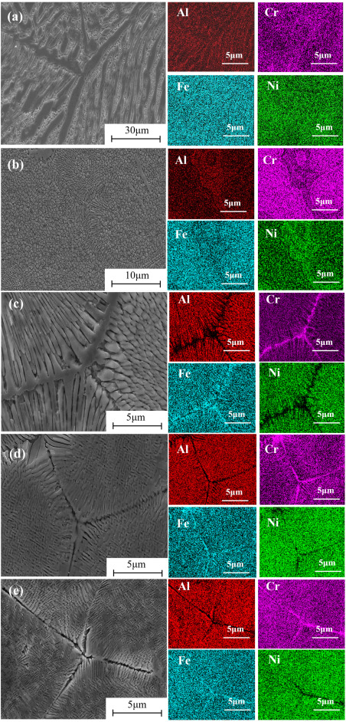
- Download: Download high-res image (5MB)
- Download: Download full-size image
Fig. 6. The initial microstructure and EDS mapping analysis of AlxCrFeNi alloy. (a) x = 0.3 (b) x = 0.5 (c) x = 0.8 (d) x = 1.0 (e) x = 1.2.
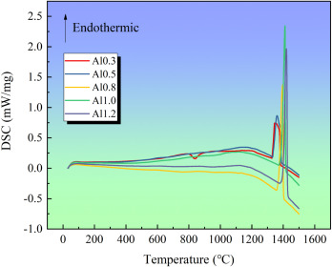
- Download: Download high-res image (266KB)
- Download: Download full-size image
Fig. 7. DSC curves of AlxCrFeNi MEAs.
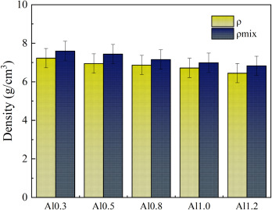
- Download: Download high-res image (825KB)
- Download: Download full-size image
Fig. 8. Density of the AlxCrFeNi MEAs.
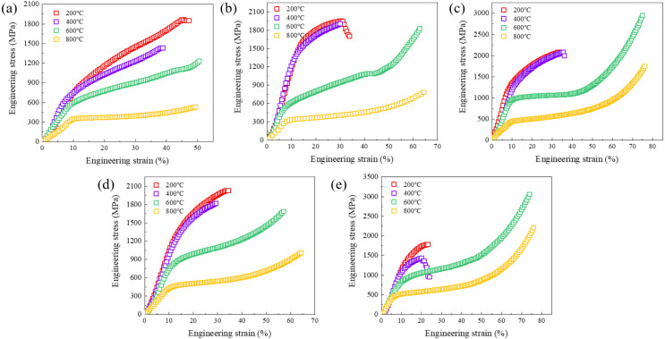
- Download: Download high-res image (679KB)
- Download: Download full-size image
Fig. 9. The engineering stress–strain curves of the AlxCrFeNi alloy samples at elevated temperature (a) x = 0.3 (b) x = 0.5 (c) x = 0.8 (d) x = 1.0 (e) x = 1.2.
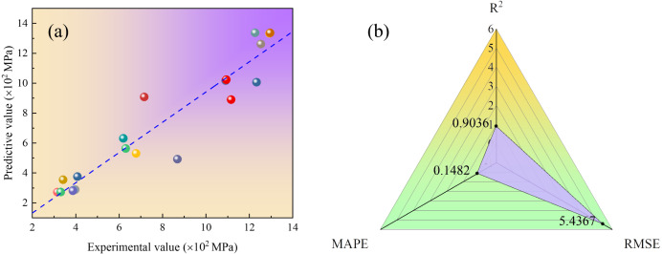
- Download: Download high-res image (311KB)
- Download: Download full-size image
Fig. 10. (a) Regression analysis on the experimental and predictive results (b) Evaluating indicator (R2, RMSE, MAPE).
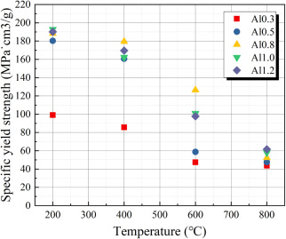
- Download: Download high-res image (245KB)
- Download: Download full-size image
Fig. 11. The specific yield strength of the AlxCrFeNi alloy.
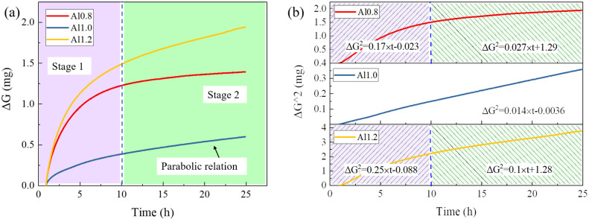
- Download: Download high-res image (677KB)
- Download: Download full-size image
Fig. 12. Oxidation weight gain curves of the Al0.8, Al1.0 and Al1.2 alloy (a) ΔG−t (b) ΔG2−t.
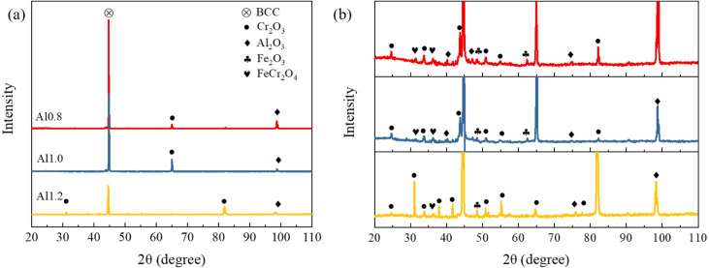
- Download: Download high-res image (339KB)
- Download: Download full-size image
Fig. 13. XRD patterns of the alloys after 24 h oxidation (a) The overall XRD patterns (b) The magnified view of small peaks.
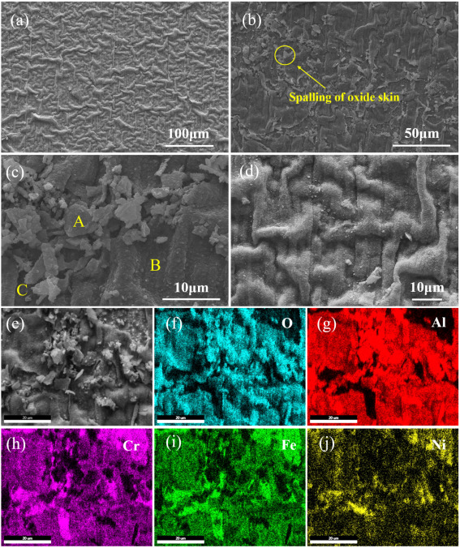
- Download: Download high-res image (3MB)
- Download: Download full-size image
Fig. 14. The morphology and chemical element distribution of Al0.8CrFeNi alloy after oxidation (a)–(d) The typical morphology of oxidized surface (e)–(j) EDS mapping analysis of the oxidized surface.
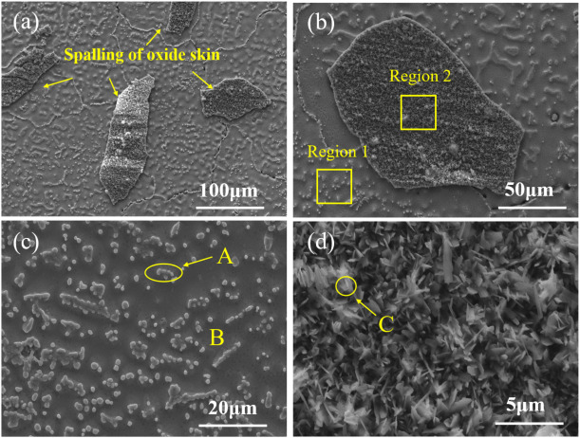
- Download: Download high-res image (1MB)
- Download: Download full-size image
Fig. 15. The typical microstructure of AlCrFeNi alloy after oxidation (a) (b) at low magnification (c) (d) at high magnification.
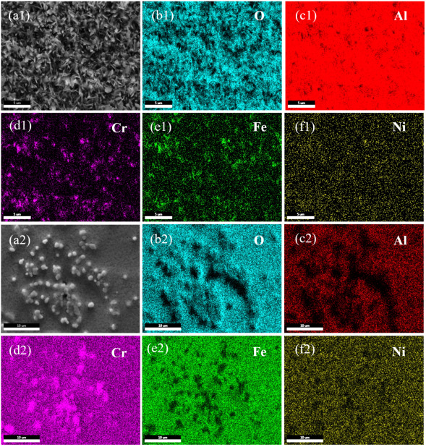
- Download: Download high-res image (4MB)
- Download: Download full-size image
Fig. 16. The EDS mapping analysis of (a1)–(f1) spalling structure and (a2)–(f2) alloy substrate for the AlCrFeNi alloy after oxidation.
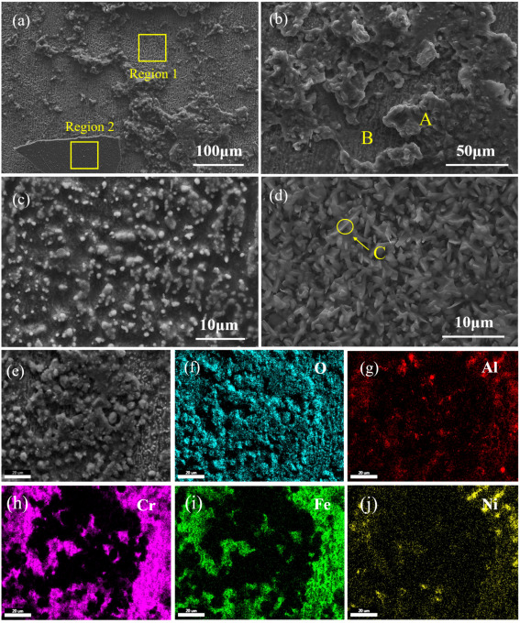
- Download: Download high-res image (2MB)
- Download: Download full-size image
Fig. 17. The microstructure and chemical element distribution of Al1.2CrFeNi alloy after oxidation. (a)–(d) Typical microstructure of Al1.2CrFeNi alloy (e)–(g) EDS mapping analysis of Al1.2CrFeNi alloy.
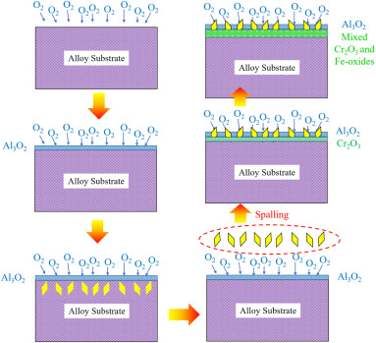
- Download: Download high-res image (1MB)
- Download: Download full-size image
Fig. 18. The oxidation mechanism of AlxCrFeNi alloy (x = 0.8,1.0 and 1.2).
With the aim of developing alloys for high temperature application, this study endeavors to utilize ML method to construct the relationship between composition and mechanical properties at elevated temperature. The alloying effect on the yield strength at elevated temperature can be derived from the constructed GRNN model. Then a series of AlxCrFeNi (x = 0.3, 0.5, 0.8, 1.0 and 1.2) MEAs were developed, and the mechanical properties at elevated temperature were investigated. The initial microstructure, density and melting point due to the variation of Al content are also discussed, which provides essentials of this MEA system for further research and applications. In order to achieve a higher elevated-temperature strength, the effect of Al concentration on the mechanical properties was explored in detail. To further assess its high temperature performance, the following experiments are performed on the AlxCrFeNi MEAs (x > 0.8) to investigate their oxidation behavior at 1000 °C and attempts have been made to provide in depth understanding on the oxidation mechanisms. This design strategy suggests that learning from composition together with performance of multi-component alloys tends to exploit knowledge in terms of accelerating the search for better alloys instead of a large amount of experimental work.
Table 1. The MSE corresponding to different spread value during the cross validation.
The first cross validation |  | The first cross validation |  | The first cross validation |  | The first cross validation
Spread | MSE | Spread | MSE | Spread | MSE | Spread | MSE
0.1 | 4.9245 | 0.1 | 0.262 | 0.1 | 8.5108 | 0.1 | 2.5332
0.2 | 4.9603 | 0.2 | 0.53349 | 0.2 | 8.2784 | 0.2 | 2.2411
0.3 | 5.1747 | 0.3 | 0.89372 | 0.3 | 6.8749 | 0.3 | 1.5009
0.4 | 5.8444 | 0.4 | 1.19 | 0.4 | 5.1693 | 0.4 | 0.90892
0.5 | 7.0143 | 0.5 | 1.4116 | 0.5 | 4.0208 | 0.5 | 0.66942
0.6 | 8.3173 | 0.6 | 1.5925 | 0.6 | 4.1364 | 0.6 | 0.71207
0.7 | 9.5215 | 0.7 | 1.8014 | 0.7 | 4.9419 | 0.7 | 0.87957
0.8 | 10.651 | 0.8 | 2.0588 | 0.8 | 5.8937 | 0.8 | 1.0962
0.9 | 11.7671 | 0.9 | 2.3472 | 0.9 | 6.7662 | 0.9 | 1.3404
1 | 12.8719 | 1 | 2.6387 | 1 | 7.503 | 1 | 1.6092
1.1 | 13.9273 | 1.1 | 2.9111 | 1.1 | 8.1103 | 1.1 | 1.899
1.2 | 14.8933 | 1.2 | 3.1513 | 1.2 | 8.6099 | 1.2 | 2.1944
2. Methodology
2.1. Machine learning details
To explore the high temperature performance, Fig. 1 presents the schematic of using ML method to construct the relationship between composition, temperature and target properties. In this case, a ML model is constructed using GRNN algorithm, which consists of four layers, including the input layer, pattern layer, summation layer, and output layer. To avoid the intervention resulted from subjective assumption, the GRNN learning algorithm has only one parameter to adjust the transfer function of each unit in the pattern layer to obtain the best regression estimation. In the input layer, each unit corresponds to individual process parameter, which is closely connected to the pattern layer. Then the unit in pattern layer corresponds to the neurons in summation layer. The output layer can yield the predicted value based on an unknown input variable. To develop the prediction model, a dataset was constructed by collecting from the reported literatures. Additional experimental data by our group were added to enrich the database. The alloying elements and temperature were denoted as the input variables, while the output variable was the yield strength (σb) at various temperature. Then another 7 group data were assigned for the test set to validate the appropriateness of trained models. Prior to the training, the inputs and outputs variables were normalized to eliminate dimensional differences between the parameter ranges, as expressed in Eq. (1).(1)X′=X−0.95Xmin1.05Xmax−0.95Xminwhere X is the actual experimental data, Xmin and Xmax are the minimum and maximum value of X, respectively, and X′ is the normalized value of the X.
To overcome the overfitting problem, K-fold cross-validation (CV) estimator was utilized in the training process, which can be employed to compare two or more proposed models in describing a promising property in the field of applied machine learning. As an exemplification, the procedure has been briefly schematized in Fig. 2. At first, the datasets were randomly divided into k folders, where k-1 folders were used for model training and the remaining one was used to test the performance of the model. As an estimate of the model accuracy, the mean square error (MSE) of each model was determined subsequently, as illustrated in Table 1. Thus then, the developed model with lower MSE value was selected to be calibrated with the whole dataset. Due to a limited dataset in present work, the K-fold cross-validation is an effective method to generalize and exactly predict the independent data.
2.2. Experimental procedure
To prove the accuracy of the developed ML model, experimental characterization was carried out in the following section. In present work, the alloy with nominal composition of Al, Cr, Fe, Ni was produced by arc melting of the high-purity (>99.9 (at)%) elements in a argon atmosphere inside a water-cooled copper cavity. Produced ingot was re-melted 5 times to achieve a homogeneous distribution. The initial microstructure of the alloy was studied using scanning electron microscopy (SEM) equipped with energy-dispersive (EDS) detector for chemical composition measurements. Prior to the examination, the samples were carefully mechanical ground and polished to remove the oxides on the surface. To explore the nano structure, nanoscale morphologies and the phase formation, Transmission Electron Microscopy with Energy Dispersive (EDS) detector was used.
Density of the alloy was measured via Archimedes method. To measure the melting point, a QMS403D-Is 50 calorimeter was used to perform differential scanning calorimetry. Each sample was heated up to 1500 °C at a rate of 10 °C/min under an Ar flow and then was cooled down to room temperature. The compressive tests were performed on the AG-X Plus 250kN/50kN Electronic Universal Testing Machine to investigated the compressive properties of alloys. The cylindrical specimens with 4 mm in diameter and 6 mm in height were prepared to perform compressive tests at room temperature with initial strain rate of 0.5 mm/min. To evaluate the mechanical properties under high temperature, the initial strain rate was 2 mm/min and the temperature was of 200 °C, 400 °C, 600 °C, and 800 °C. Before testing, the samples were placed in preheated furnace and held for 10 min.
The oxidation behavior of the alloy was investigated by using high-temperature oxidation and corrosion analyzer. The rectangular specimens with dimensions of 10 mm × 10 mm × 2 mm were cut from the as-cast ingots. Each sample were ground with 1200 grit SiC abrasive paper, ultrasonically cleaned and dried before the oxidation tests. Samples were heated up at a rate of 10 °C/min, held at the temperature of 1000 °C for 24 h, and subsequently cooled to room temperature. The oxidation kinetic curves can be automatically measured during the oxidation tests. After that, the phase, microstructural and chemical analysis on the oxidized samples were performed with XRD and SEM equipped with EDS.
3. Results and discussion
3.1. Machine learning results
Prior to the training process, the original data was analyzed in detail. The average value, standard deviation, minimum value and maximum value were summarized in Table 2. It can be observed that the temperature investigated in this case ranges from 200 °C to 1100 °C. The output variable (yield strength) tested for the input variables ranges from 430.48 MPa to 1456 MPa. To estimate the correlation between variables, the Pearson coefficient was calculated and the results were illustrated in Fig. 3. As known, the greater Pearson regression coefficient (close to 1) indicates the greater correlation. From the plot, it exhibits a strong negative correlation between temperature and yield strength, indicating that the higher temperature significantly reduces the yield strength of materials. Among the proposed alloying elements, Al has the strongest positive association with the yield strength at elevated temperature. Fe also has a certain positive effect on the enhancement of yield strength. However, Cr, Co and Ni exhibit negative correlation with the yield strength.
Regression analysis of the training procedure was shown in Fig. 4(a), and after the training procedure, the developed model was tested as shown in Fig. 4(b). The training results, comparing the predicted value with the corresponding literature reported value, suggest a satisfying coincidence degree. The data points are evenly distributed on both sides of the asymptote. To quantitatively evaluate the predictive performance of the model, the correlation coefficient (R2), root mean square error (RMSE) and mean absolute percentage error (MAPE) on the training and testing results were calculated according to Eq. (2)–(4)(2)R=∑i=1N(Ei−E¯)(Pi−P¯)∑i=1N(Ei−E¯)2∑i=1N(Pi−P¯)2(3)RMSE=1N∑i=1N(Ei−Pi)2(4)MAPE(%)=1N∑i=1N|Ei−PiEi|×100%where, E is the experimental value, P is the predicted value, E¯ and P¯ are the average value of E and P, respectively, and N is the number of samples. Fig. 4(c) and (d) present the calculated results for training and testing, respectively. It is derived that the R2 can achieve 0.9068 for the training results, and even exhibit a high value of 0.8421 for the testing results. The GRNN demonstrated a very good predictive performance with R2 value very close to 1. Furthermore, the RMSE and MAPE calculated for training results were 1.01 and 0.20, respectively. Regarding the testing results, the RMSE and MAPE value were 3.78 and 0.34, respectively, indicating that the predictive yield strength are consistent with the experimental values. Given the success of GRNN model to describe the implicit relationships between temperature, alloying elemental variables and yield strength at elevated temperature, attempts can be made to identify the further interactions by using the developed model.
Table 2. Statistical analysis of original data.
Input | Average value | Standard deviation | Minimum value | Maximum value
T | 733.7 | 219.23 | 200 | 1100
Fe | 0.16 | 0.14 | 0 | 0.36
Cr | 0.21 | 0.058 | 0.14 | 0.34
Ni | 0.38 | 0.095 | 0.26 | 0.58
Al | 0.17 | 0.048 | 0.06 | 0.35
Co | 0.035 | 0.064 | 0 | 0.15
σb | 430.48 | 295.78 | 100 | 1456
To provide further characteristics, Fig. 5 presents the detailed information on the role of temperature and elemental Al on the yield strength of alloys. Despite some disorder features in the existing research conditions, the addition of Al brought some increase to the yield strength of alloy at first, then led to a slight decrease with further increase of Al content. In the following section, taking the Al–Cr–Fe–Ni alloy system, a series of AlxCrFeNi medium-entropy alloys were developed for high-temperature structural applications. The proposed scheme is evaluated with experiments, characterized by microstructure observation, mechanical property test and oxidation resistance test.
3.2. Phase and microstructure
Fig. 6 presents the initial microstructure of AlxCrFeNi MEAs (x = 0.3,0.5,0.8,1.0 and 1.2). To explore the distribution of chemical composition of the alloy, the EDS mapping analysis were also presented. For all the developed alloys, no porosity or other micro-defects were observed. With the lower Al concentration (x = 0.3), Fig. 6(a) show that the dendritic structure distributed in disorder within the grains. Regarding the distribution of alloying elements, it can be clearly seen that the interdendritic regions are depleted of Al elements. For Al0.5CrFeNi alloy, Fig. 6(b), typical grain boundary can be observed and the spherical particles were distributed in grains. The morphology of lamellar structure can also be identified near the grain boundary. From the plot, the lamellar structure are enriched in Al and Ni and depleted of Fe and Cr elements. According to Fig. 6(c)(d)(e), the identical lamellar structure can be clearly seen in the AlxCrFeNi MEAs when the x value exceeds 0.8. The dense lamellar can be identified near the grain boundaries and the mazeshaped morphologies can be observed within the grains, which was the typical spinodal structure consisting of alternating interconnected dual-phase microstructure. Otherwise, the alloying elements distribution indicate that an obvious element segregation can be evidently identified inside a grain and the boundary between dendrites. In general, Fe–Cr enrichment is in favor of the formation of disordered solid solution A2 phase, whereas Ni–Al enrichment tends to form ordered B2 phase. EDS results confirm that it is enriched in Fe and Cr element at the lamellar regions near the grain boundary and the Al–Ni rich phases were distributed within the grains.
3.3. DSC analysis and density
Melting point: Towards high temperature applications, it is of great significance to investigate the melting point of alloys. In this case, a thermal analysis of the AlxCrFeNi MEAs was performed by DSC. Fig. 7 presents the DSC curves with the temperature ranging from 30 °C to 1500 °C. From the plot, a slight exothermic peak can be found in the Al0.3CrFeNi alloy. DSC analysis indicate that there is no any phase transition below 1300 °C when the x value is more than 0.5. It can be seen that a single endothermic peak can be observed which is primarily due to the melting of the alloy. The onset for Al0.3CrFeNi alloy, maximum and area of this peak correspond to the solidus (1328 °C) and liquidus (1385 °C), respectively, accompanied with the melting range of 57 °C. In particular, the liquidus value can be regarded as an upper limit.
The experimental data seems to present a slight increase of melting point which can be derived from the addition of Al, especially when the x value exceeds 0.8. When the atomic ratio of Al increases to 0.8, the alloy possesses a larger melting range of 44 °C since it began to melt at 1360 °C and completed at 1404 °C. While, for the Al1.2CrFeNi alloy, it began to melt at 1385 °C and completed at 1430 °C, with the melting range of 42 °C.
Among the studied alloy system, Al and Ni have a melting point of 660 °C and 1453 °C respectively, while Cr and Fe have a melting point of 1857 °C and 1538 °C respectively. Combined with the EDS results, the grains are enriched with the elements (Ni and Al) which have the lowest melting point and the elements (Fe and Cr) with a higher melting point are segregating within the dendrites.
Density: Fig. 8 presents the density of the AlxCrFeNi alloys measured by the Archimedes method. Each sample was measured 5 times to obtain the averaging values. To further improve the accuracy, the rule of mixed density was calculated according to the densities of pure elements and the corresponding alloy compositions. Taking the Al0.3CrFeNi alloy as an example, the measured density is 7.45 g/cm3 and the mixed value is 7.6 g/cm3. For comparison, a good agreement can be derived between the measured and mixed value and the relative errors are all within 5%. Among the studied alloy system (Al, Cr, Fe, Ni), the element Al possesses the lowest density of 2.7 g/cm3 so that a decrease in density (from 7.45 g/cm3 to 6.45 g/cm3) is observed for higher Al content. The prepared Al1.2CrFeNi alloy possesses the lowest density among the developed MEAs compositions. The low density resulting from higher Al concentration is favorable for aerospace and other transport applications.
3.4. Mechanical properties at elevated temperature
To evaluate the mechanical properties of the prepared alloy at elevated temperature, the compression stress–strain curves at various temperature (200 °C, 400 °C, 600 °C, 800 °C) were presented in Fig. 9(a)–(e). Only a small decrease in fracture strength was observed when the temperature increased from 200 °C to 400 °C. In particular, a pronounced work hardening stage can be observed on the stress–strain curves. When the temperature increases above 600 °C, the AlxCrFeNi alloy behaves similarly during compressive testing, a significant decrease in yield strength can be detected.
Table 3. The specific fracture strength and plastic strain of the AlxCrFeNi alloy.
Alloy | Temperature (°C) | Fracture strength (MPa) | Plastic strain (%)
Al0.3 | 200 | 1609.3 | 40.0
Al0.3 | 400 | 1438.0 | 48.9
Al0.3 | 600 | No fracture | No fracture
Al0.3 | 800 | No fracture | No fracture
Al0.5 | 200 | 1952.5 | 30.7
Al0.5 | 400 | 1905.1 | 30.0
Al0.5 | 600 | No fracture | No fracture
Al0.5 | 800 | No fracture | No fracture
Al0.8 | 200 | 2083.7 | 33.56
Al0.8 | 400 | 2076.7 | 35.42
Al0.8 | 600 | No fracture | No fracture
Al0.8 | 800 | No fracture | No fracture
Al1.0 | 200 | 2028.2 | 34.1
Al1.0 | 400 | 1822.6 | 30.2
Al1.0 | 600 | No fracture | No fracture
Al1.0 | 800 | No fracture | No fracture
Al1.2 | 200 | 1783.9 | 22.85
Al1.2 | 400 | 1435.0 | 34.8
Al1.2 | 600 | No fracture | No fracture
Al1.2 | 800 | No fracture | No fracture
The alloy shows exceptional plasticity among the prepared alloys since no fracture occurred in the samples. The high temperature mechanical properties, yield strength (σ0.2), fracture strength (σu) and plastic strain (ɛɛ), are summarized in Table 3. For the Al0.3CrFeNi alloy, the fracture strength and plastic strain denote 1609.3 MPa and 40.0% at 200 °C, respectively. Testing at 400 °C reveals a decrease of strength to 1438.0 MPa but enhanced plastic strain of 48.9%. With further increased of temperature (>600°C), higher plasticity was accompanied by decreasing strength.
When the concentration of Al increases to 0.5, the strength of alloy increases to 1952.5 MPa and 1905.1 MPa at 200 °C and 400 °C, respectively. The Al0.5CrFeNi alloy also possesses high plasticity at 400 °C. The Al0.8CrFeNi alloy has demonstrated high yield stress of 2083.7 MPa with relatively high plastic strain of 33.56% at 200 °C. Further increase of testing temperature to 600 °C and 800 °C results in a continuous decrease of yield strength and increase of plasticity, no fracture occurred even with a height reduction of 75%.
When the atomic ratio of Al increases to 1.0, the strength shows a slight decrease in terms of AlCrFeNi alloy. With further increasing of Al content (Al1.2), the strength decreases to 1783.9 MPa and 1435.0 MPa, the fracture strain decreases to 22.9% and 34.8%, at 200 °C and 400 °C, respectively. The excellent mechanical properties at elevated temperatures can be primarily ascribed to the two phase structure of ordered (Ni, Al) phase and [Fe, Cr] phase.
To further verify the prediction ability of the ML model, the composition (Al, Cr, Fe, Ni) and the testing temperature (200, 400, 600, 800 °C) used in mechanical examinations were applied as input variables. Then the prediction can be made by using the developed ML model, outputting the yield strength at elevated temperature. Fig. 10(a) plotted the regression analysis on the experimental and predictive results. Although very few data points deviate from the asymptote, most of the data points evenly distributed near the asymptote, indicating that the predicted yield are consistent with the experimental values with a very small difference. The evaluating indicators (R2, RMSE, MAPE) derived from the prediction were plotted in Fig. 10(b). A high R2 value of 0.9036 (close to 1), and low RMSE and MAPE value of 5.4367 and 0.1482 assume a significant agreement. Given the high accuracy, the implicit interactions between temperature, alloying elemental variables and yield strength can be identified, and provide further prediction.
The temperature dependence of specific yield strength are also listed in Fig. 11. The specific yield strength of our developed AlxCrFeNi MEAs decreases with rising temperature. It exhibited an obvious decline when the temperature is above 600 °C. By comparison with the Al0.3CrFeNi alloy, the AlxCrFeNi MEAs display an enhanced specific yield strength when the atomic ratio of Al exceeds 0.8. The Al0.5CrFeNi alloy possesses relatively high specific yield strength at 200 °C and 400 °C, however, it shows a rapid decrease for a test temperature above 600 °C. The Al0.8CrFeNi alloy exhibited the highest specific yield strength among the investigated alloys at temperatures between 400 °C and 600 °C. When the temperature increases to 800 °C, the Al1.2CrFeNi alloy displays the highest specific yield strength, indicating excellent softening resistance at elevated temperatures.
Our developed AlxCrFeNi MEAs (x≥0.8) exhibit the superior specific yield strength comparing with some of reported RHEAs, such as MoNbTaW and TaNbHfZrTi refractory high entropy alloy (RHEA) [51], as well as the conventional superalloys Haynes 230 [52] and is also comparable to the typical Ni-based superalloys, Inconel 718 [52]. This high specific yield strength can be derived from the low density and high yield strength at elevated temperatures. As Fig. 3 shows, the developed alloy possesses a low density owing to the high concentration of low-density element Al. On the other hand, strengthening by the Ni–Al rich B2 phase and Fe–Cr rich A2 phase leads to high yield strength at elevated temperature. In view of that, the present AlxCrFeNi MEAs (x≥0.8) are promising candidates for high-temperature applications.
3.5. Oxidation behavior at high temperatures
3.5.1. Oxidation dynamic curves
To fully utilize potential of HEAs as high-temperature material, the oxidation behaviors of Al0.8CrFeNi, Al1.0CrFeNi, Al1.2CrFeNi alloy were specifically investigated. Thermogravimetric analyses (TGA) were conducted at temperatures of 1000 °C for 24 h in dry air. The mass gain versus the exposure time curves of the three alloys, measured by TGA, are shown in Fig. 12(a). The oxidation kinetics of the three alloys followed the two-stage parabolic rate law, including a rapid initial stage followed by a steady-state stage. This can be ascribed to solid-state diffusion which is the rate-limiting step for the reactions. The diffusion of oxygen and other elements during the oxidation process were drastically reduced by the oxide layer formed on the metallic substrate, a slower oxidation rate was observed in the steady stage. After 24 h, the weight gain of Al0.8, Al1.0 and Al1.2 alloy is about 1.4mg/cm2, 0.6mg/cm2 and 1.9mg/cm2, respectively. Among the three alloys, the AlCrFeNi alloy displayed the highest resistance to oxidation, followed by Al0.8CrFeNi and Al1.2CrFeNi alloy exhibiting slightly less resistance to oxidation. By comparing with some reported steels and alloys, e.g., the work of Kim et al. it was observed that the weight gain of commercial SUS 405 stainless steel at 1000 °C is 6.45 mg/cm2 and that of the Cr–Mn–Fe–Co–Ni HEA is 4.45mg/cm2 after a 24 h oxidation test. This reveals the superior oxidation resistance of our three alloys at elevated temperatures.
In general, the parabolic rate law can be utilized to describe the oxidation kinetics of the alloy, as expressed in Eq. (1).(5)ΔG2=KT⋅t+Cwhere ΔG is the mass gain, k is the oxidation rate constant, and t is the oxidation time. Accordingly, the oxidation rate constants can be acquired from the slope of a linear regression line fitted on the mass gain per surface area versus time plot. Herein, Fig. 12(b) presents the kinetic curves of ΔG2−t after the oxidation. A linear correlation can be detected in the AlCrFeNi alloy. However, for the Al0.8CrFeNi and Al1.2CrFeNi alloy, the kinetic curve consists of two stages. The oxidation kinetic equations of the prepared alloys are summarized in Table 4. The Al0.8CrFeNi alloy exhibits a oxidation rate of 0.16 at the rapid initial stage and a lower oxidation rate of 0.026 in the steady stage. The AlCrFeNi alloy displays the lowest oxidation rate of 0.014, indicating best oxidation resistance. Interestingly, the Al1.2CrFeNi alloy shows a poor oxidation resistance compared with Al0.8CrFeNi and Al1.2CrFeNi, exhibiting an oxidation rate of 0.24 and 0.1 in the initial stage and the later steady stage.
3.5.2. Oxidation products and oxidation mechanisms
To explore the oxidation products of the alloy, the XRD patterns of the studied alloys after 24 h oxidation are shown in Fig. 13(a). From the plot, the peaks of the substrate (BCC) were detected by XRD for all the alloys. The oxidation products, e.g., Al2O3 and Cr2O3 are the major XRD peaks for the oxidation of Al0.8CrFeNi, AlCrFeNi and Al1.2CrFeNi alloys. The Cr2O3 peaks intensity is more for a lower concentration of Al, especially in AlCrFeNi alloy. To understand the oxidation products more clearly, Fig. 13(b) presents the enlarged view of the small peaks. Besides the Al2O3 and Cr2O3 peaks, some iron-oxides, e.g., Fe2O3 and FeCr2O4, can also be detected and the intensity of the Fe2O3 and FeCr2O4 peaks increases with lower Al concentration. In Al0.8CrFeNi and AlCrFeNi alloy, the peak of Fe2O3 can be identified near 49° and 64°. For Al1.2CrFeNi alloy, the Fe2O3 peaks near 64° disappear. A very small peak can be observed near 30° and 36°, which matches the peak of FeCr2O4. Nevertheless, the volume fraction of FeCr2O4 seems to be very low. Based on the above analysis, the oxide scales mainly composed of Al2O3, Cr2O3, Fe2O3 and FeCr2O4. The excellent oxidation resistance of Al0.8CrFeNi, AlCrFeNi can be explained by the increasing Cr2O3 content, which is considered as an effective passivation layer against further oxidation. The Fe2O3 and FeCr2O4 also play a significant role in the antioxidation capacity of the alloy.
The microstructure and chemical element distribution in different regions of the studied alloys after 24 h oxidation were also analyzed. Metallurgical examination of oxidation involved the use of SEM and EDS. Fig. 14 presents the microstructure and EDS elemental maps of Al0.8CrFeNi alloy. As a result of observing the oxidation surfaces, the long strips are intertwined as network structures, as Fig. 14(a) illustrated. At the junction of reticular structure, in Fig. 14(b), the spalling of oxide scale can be observed. For a better understanding, Fig. 14(b) and (c) present the enlarged view of Fig. 14(a) and (b). Table 5 shows the chemical compositions of the points identified in Fig. 14(c), as measured by EDS. It can be inferred that both of the different regions (Region A, B and C) consist of Al2O3 and Cr2O3 oxides, which is consistent with the XRD results. In region B and C, a small number of iron oxides were detected, with Ni barely detected. In region C, very small amount of Cr, Fe and Ni can be detected since the major oxidation products are Al2O3.
Table 4. Oxidation kinetic equations.
Alloy | Oxidation kinetic equations
Empty Cell | Stage1 | Stage2
Al0.8 | ΔG2=0.16t+0.16 | ΔG2=0.026t+1.34
Al1.0 | ΔG2=0.014t+0.0097 | ΔG2=0.014t+0.0097
Al1.2 | ΔG2=0.24t+0.17 | ΔG2=0.1t+1.4
Fig. 15 presents the typical microstructure of AlCrFeNi alloy after oxidation. One thing unique here is that serious spallation of oxide skin can be observed after 24 h of oxidation, as illustrated in Fig. 15(a). Fig. 15(b) provides the enlarged view of the alloy substrate as well as regular blocklike spalling structure. As known, the spallation of oxide layer is primarily ascribed to the compressive stress resulted from the mismatch between the thermal expansion coefficients of the substrate and the oxides. To capture more in-depth description, two typical regions (region 1 on the alloy substrate, and region 2 on the spalling structure) were identified and the enlarged views were presented in Fig. 15(c) and (d). From Fig. 15(c), some white round particles can be detected on the substrate. In terms of the spalling structure, Fig. 15(d), the morphology was characterized as needle and flower-like structure. Based on the characterization of microstructure at surface flaking, Fig. 15 gives the EDS mapping analysis of the blocklike spalling structure (Fig. 16 (a1)) and alloy substrate (Fig. 16 (a2)). Recognizing this, the spallation on the surface confirms to be Al2O3 oxide according to the scanning results of elements distribution, Fig. 16 (b1–f1). From Fig. 16 (b1–f1), the white particles on the alloy substrate were identified as Cr2O3 oxides. Furthermore, EDS point analysis on the different locations (A, B and C) were summarized in Table 5. In location A, the oxide scales mainly consisted of Cr2O3, as well as a small amount Fe-oxides (Fe2O3 and FeCr2O4) combined with the XRD analysis. This result confirms the white round particles to be Cr2O3. Regarding the location B, the volume fraction of Fe-oxides increases thus the oxide scales mainly consisted of Cr2O3, Fe2O3 and FeCr2O4. However, for the oxide spalling structure, the oxide scales were primarily composed of Al-oxides (Al2O3), accompanied with very mild amount of (Cr, Fe and Ni) oxides which are negligible. Based on the above analyses, it can be inferred that the adhesion of Al2O3 to alloy substrate was considerably low. In the present case, the oxide layers can produce the degree of compressive stress required for spallation.
Table 5. The alloy element distribution (at.%) in different regions.
Alloy | Region | Alloy composition
Empty Cell | Empty Cell | Al | Cr | Fe | Ni | O
Al0.8 | A | 46.35 | 13.95 | 12.12 | 5.40 | 22.17
Al0.8 | B | 34.82 | 13.09 | 10.24 | 2.85 | 39.00
Al0.8 | C | 43.45 | 5.94 | 3.97 | 0.67 | 45.97
Al1.0 | A | 2.27 | 67.41 | 10.68 | 2.43 | 17.21
Al1.0 | B | 2.42 | 37.25 | 25.37 | 5.30 | 29.67
Al1.0 | C | 41.85 | 0.33 | 0.25 | 0.07 | 57.50
Al1.2 | A | 59.9 | 0.75 | 0.60 | 0.35 | 38.41
Al1.2 | B | 2.295 | 56.03 | 31.5 | 4.71 | 5.42
Al1.2 | C | 43.81 | 0.29 | 0.19 | 0.17 | 55.54
For the Al1.2CrFeNi alloy, surface observation and analysis of the chemical element distribution were plotted in Fig. 17. From Fig. 17(a), the spallation of oxides can also be detected on the surface of alloy, such as some regular square-shaped structures. In addition, a large number of irregular cluster oxides can be detected, which can be clearly observed in Fig. 17(b). For a better view, Fig. 17(c) and (d) plot the enlarged images of the region 1 and region 2, respectively. Similar with the AlCrFeNi alloy, white particles with various sizes can be observed on the alloy substrate. From the perspective of spalling oxides, Fig. 17(d), a large number of strips in different direction are intertwined. To capture the alloying element distribution of the alloy substrate and spalling oxides, EDS point analysis of location A, B and C were listed in Table 5. In location A and C, the oxide scales were composed of Al oxides, with Cr, Fe and Ni barely detected. In view of the location B, it shows an obvious increase in the Cr and Fe content. It can be inferred that a large amount of Cr oxides and Fe oxides were formed on the alloy surface. Furthermore, these oxidizing products were further confirmed by the EDS mapping analysis in Fig. 17 (e–j), in which the irregular cluster oxides conformed to be Al oxides and the Cr-oxides and Fe-oxides were identified on the surface of the alloy matrix. It shows a poor adhesion between the alloy substrate and Al oxides.
According to the above results, the oxidation mechanism of the alloy was discussed in the present case. It seems no obvious Al–Ni rich dendrite and Cr–Fe rich interdendrite structures in alloy after the oxidation tests, which was identified in the initial microstructure of the AlxCrFeNi alloy. This phenomenon is presumed to be resulted from the homogenization effect by high temperature (1000 °C) atmosphere. The oxidation mechanism is also determined by the concentration of Al and/or Cr within the alloy and the diffusion of Cr2O3 or Al2O3. At the initial stage of oxidation tests, Al reacts with O to generate Al2O3 oxidation layer on the surface. With the further oxidation, the poor adhesion between Al2O3 and alloy substrate causes Al2O3 spallation. Compared with Ni, the fast diffusion of Cr onto the surface results in the formation of Cr2O3 as the oxidation process proceed which can slow down further oxidation. Besides, the Fe elements react with O to generate the Fe-oxides which can also be identified in the oxide layer. Given the above, Fig. 18 presents the dynamic evolution of surface oxidation at high temperature. Accordingly, the Al2O3 and Cr2O3 oxides provides protective effect to prevent further oxidation so that the developed alloy possesses excellent anti-oxidation property. In particular, the strong stability of Cr2O3 at high temperature (above 1000 °C) can provide a long-term protection against the oxidation. The formation of more Cr2O3 were responsible for the reduction in the oxidation rates of AlCrFeNi alloy.
4. Conclusion
In this study, the essentials of AlxCrFeNi MEAs system for high temperature applications were estimated. The mechanical properties and oxidation behavior at elevated temperature due to the variation of Al concentration are discussed in detail. The conclusions are drawn as follows:
(1) The present work utilized the GRNN model embedded with K-fold cross-validation to predict the yield strength of alloys at elevated temperature. The developed model can capture the correlations between material features and make predictions with high accuracy. The strong association between alloying elements can be well identified, as the most critical elements, the addition of Al leads to a trend of increasing first and then decreasing. Then a series of AlxCrFeNi medium-entropy alloys were developed for high-temperature structural applications.
(2) The initial microstructure of AlxCrFeNi MEAs were observed and all the prepared alloys composed of Al–Ni rich dendrite and Cr–Fe rich interdendrite structures. The DSC analysis show that all the developed alloys display a high melting point above 1300 °C. A slight increase of melting point can be derived from the addition of Al and the Al1.2CrFeNi can achieve approximately 1400 °C. Except for Al0.3CrFeNi alloy, no any phase transition can be identified below 1300 °C. Towards high temperature service condition, this alloy system exhibits a low density and the increasing concentration of Al (from x = 0.3 to 1.2) generated a further decrease in density (from 7.45 g/cm3 to 6.45 g/cm3).
(3) The AlxCrFeNi samples exhibited a relatively high strength with a fairly high strain-to-failure when x is above 0.5. The developed alloy shows exceptional plasticity since no fracture occurred in the compressive tests at higher temperature (>600°C). The mechanical examination further demonstrates the high predictive ability of ML model. The specific yield strength of the alloy was found to be comparable with some reported RHEAs and conventional superalloys. This series of alloys are excellent structural materials which have important applications in high temperature fields owing to the properties of high mechanical properties, high melting point and low density.
(4) The oxidation behavior of AlxCrFeNi (x = 0.8, 1.0 and 1.2) alloys were investigated, and in particular, to examine the roles of Al addition on the oxidation kinetics. For all three alloys, the oxidation kinetics followed the parabolic rate law, with AlxCrFeNi alloy exhibiting the highest resistance to oxidation. The developed alloys also show superior oxidation resistance than some reported alloys known to possess great high-temperature oxidation resistance.
(5) The major oxidation products were Al2O3, Cr2O3, Fe2O3 and FeCr2O4. The spallation of Al2O3 oxides can be detected on the surface for all the alloys due to the poor adhesion between Al2O3 and alloy substrate. The formation of more Cr2O3 were responsible for the reduction in the oxidation rates of AlCrFeNi alloy. This work provides guidelines for understanding the oxidation mechanisms and improving oxidation resistance of Co-free MEAs at elevated temperature.
Declaration of Competing Interest
The authors declare that they have no known competing financial interests or personal relationships that could have appeared to influence the work reported in this paper.
Acknowledgments
This work is supported by AME Programmatic Fund by the Agency for Science, Technology and Research, Singapore under Grants No. A1898b0043 and A18B1b0061 and the China Scholarship Council .
Data availability
The authors do not have permission to share data.
References
- [1]
Yeh J.W., Chen S.K., Lin S.J., Gan J.Y., Chin T.S., Shun T.T., Tsau C.H., Chang S.Y.
Nanostructured high-entropy alloys with multi-principal elements-novel alloy design concepts and outcomes
Adv. Eng. Mater., 6 (2004), pp. 299-303
Google Scholar
- [2]
Zhang Yong, Zuo Ting Ting, Tang Zhi, Gao Michael C., Dahmen Karin A., Liaw Peter K., Lu Zhao Ping
Microstructures and properties of high-entropy alloys
Prog. Mater. Sci., 61 (2014), pp. 1-93
View PDFView articleGoogle Scholar
- [3]
Juanyu Yang, Yunjun Zhou, Yong Zhang, et al.
Solid solution formation criteria in the multi- component alloys with high entropy of mixing
Chin. Mater. Sci. Technol. Equip. (5) (2007), pp. 61-63
Google Scholar
- [4]
Zhang W., Liaw P.K., Zhang Y.
Science and technology in high-entropy alloys
Sci. China Mater., 61 (1) (2018), pp. 2-22
View in ScopusGoogle Scholar
- [5]
Zhang Y., Yang X., Liaw P.K.
Alloy design and properties optimization of high-entropy alloys
JOM, 64 (2012), pp. 830-838
CrossrefView in ScopusGoogle Scholar
- [6]
Wang Ying, Jin Junsong, Zhang Mao, Liu Famei, Wang Xinyun, Gong Pan, Tang Xuefeng
Influence of plastic deformation on the corrosion behavior of CrCoFeMnNi high entropy alloy
J. Alloys Compd., 891 (2022), Article 161822
View PDFView articleView in ScopusGoogle Scholar
- [7]
Shuang S., Yu Q., Gao X., He Q.F., Zhang J.Y., Shi S.Q., Yang Y.
Tuning the microstructure for superb corrosion resistance in eutectic high entropy alloy
J. Mater. Sci. Technol., 109 (2022), pp. 197-208
View PDFView articleView in ScopusGoogle Scholar
- [8]
Kim Young-Kyun, Joo Yeun-Ah, Kim Hyoung Seop, Lee Kee-Ahn
High temperature oxidation behavior of Cr-Mn-Fe-Co-Ni high entropy alloy
Intermetallics, 98 (2018), pp. 45-53
View PDFView articleCrossrefView in ScopusGoogle Scholar
- [9]
Qiao Ling, Bao Aorigele, Wang Yuan, Liu Yong, Lai Zhonghong, Zhu Jingchuan
Thermophysical properties and high temperature oxidation behavior of FeCrNiAl0.5 multi-component alloys
Intermetallics, 126 (2020), Article 106899
View PDFView articleView in ScopusGoogle Scholar
- [10]
Lo Kai-Chi, Murakami Hideyuki, Yeh Jien-Wei, Yeh An-Chou
Oxidation behaviour of a novel refractory high entropy alloy at elevated temperatures
Intermetallics, 119 (2020), Article 106711
View PDFView articleView in ScopusGoogle Scholar
- [11]
Tripathy B., Malladi S.R.K., Bhattacharjee P.P.
Development of ultrafine grained cobalt-free AlCrFe2Ni2 high entropy alloy with superior mechanical properties by thermo-mechanical processing
Mater. Sci. Eng. A, 831 (2022), Article 142190
View PDFView articleView in ScopusGoogle Scholar
- [12]
Qiao Ling, Bao Aorigele, Lai Zhonghong, Liu Yong, Zhu Jingchuan, Wang Yuan
Alloy design and properties optimization of multi-component alloy based on solidification characteristics
Mater. Sci. Eng. A (2021), Article 140576
View PDFView articleView in ScopusGoogle Scholar
- [13]
Fan Rui, Wang Liping, Zhao Lili, Wang Lei, Zhao Sicong, Zhang Yanjia, Cui Bo
Synergistic effect of Nb and Mo alloying on the microstructure and mechanical properties of CoCrFeNi high entropy alloy
Mater. Sci. Eng. A, 829 (2022), Article 142153
View PDFView articleView in ScopusGoogle Scholar
- [14]
Bhowmik Shubhrodev, Zhang Jianzhong, Vogel Sven C., Nene Saurabh S., Mishra Rajiv S., McWilliams Brandon A., Knezevic Marko
Effects of plasticity-induced martensitic transformation and grain refinement on the evolution of microstructure and mechanical properties of a metastable high entropy alloy
J. Alloys Compd., 891 (2022), Article 161871
View PDFView articleView in ScopusGoogle Scholar
- [15]
Shi J., Zhao Y.W., Jiang C.L., Wang X., Zhang Y.Z., Zou D.L., Xu H.Y., Huang H., Luo C.
Development of single-phase bcc UHfNbTi high-entropy alloy with excellent mechanical properties
Mater. Lett., 307 (2022), Article 130822
View PDFView articleView in ScopusGoogle Scholar
- [16]
Nabizada A., Zarei-Hanzaki A., Abedi H.R., Barati M.H., Asghari-Rad P., Kim H.S.
The high temperature mechanical properties and the correlated microstructure/texture evolutions of a TWIP high entropy alloy
Mater. Sci. Eng. A, 802 (2021), Article 140600
View PDFView articleView in ScopusGoogle Scholar
- [17]
Zhou Yang, Jin Xi, Zhang Lu, Du Xingyu, Li Bangsheng
A hierarchical nanostructured Fe34Cr34Ni14Al14Co4 high-entropy alloy with good compressive mechanical properties
Mater. Sci. Eng. A, 716 (2018), pp. 235-239
View PDFView articleView in ScopusGoogle Scholar
- [18]
Stepanov N.D., Shaysultanov D.G., Salishchev G.A., Tikhonovsky M.A.
Structure and mechanical properties of a light-weight AlNbTiV high entropy alloy
Mater. Lett., 142 (2015), pp. 153-155
View PDFView articleView in ScopusGoogle Scholar
- [19]
Reed R.C.
The Superalloys: Fundamentals and Applications
Cambridge University Press (2008)
Google Scholar
- [20]
Wang Mingliang, Lu Yiping, Wang Tongmin, Zhang Chuan, Cao Zhiqiang, Li Tingju, Liaw Peter K.
A novel bulk eutectic high-entropy alloy with outstanding as-cast specific yield strengths at elevated temperatures
Scr. Mater., 204 (2021), Article 114132
View PDFView articleView in ScopusGoogle Scholar
- [21]
Chen X., Qi J.Q., Sui Y.W., et al.
Effects of aluminum on microstructure and compressive properties of Al-Cr-Fe-Ni eutectic multi-component alloys
Mater. Sci. Eng. A, 681 (2017), pp. 25-31
View PDFView articleGoogle Scholar
- [22]
Wang Woei-Ren, Wang Wei-Lin, Wang Shang-Chih, Tsai Yi-Chia, Lai Chun-Hui, Yeh Jien-Wei
Effects of Al addition on the microstructure and mechanical property of AlxCoCrFeNi high-entropy alloys
Intermetallics, 26 (2012), pp. 44-51
View PDFView articleView in ScopusGoogle Scholar
- [23]
Nong Zhi-Sheng, Zhu Jing-Chuan, Zhao Rong-Da
Prediction of structure and elastic properties of AlCrFeNiTi system high entropy alloys
Intermetallics, 86 (2017), pp. 134-146
View PDFView articleView in ScopusGoogle Scholar
- [24]
Jiang Shuying, Lin Zhifeng, Xu Hongming, Sun Yongxing
Studies on the microstructure and properties of AlxCoCrFeNiTi1-x high entropy alloys
J. Alloys Compd., 741 (2018), pp. 826-833
View PDFView articleView in ScopusGoogle Scholar
- [25]
Qiao Ling, Aorigele, Lai Zhonghong, Zhu Jingchuan
A promising new class of multi-component alloys with exceptional mechanical properties
J. Alloys Compd., 847 (2020), Article 155929
View PDFView articleView in ScopusGoogle Scholar
- [26]
Jumaev Elyorjon, Abbas Muhammad Aoun, Mun Sang Chul, Song Gian, Hong Soon-Jik, Kim Ki Buem
Nano-scale structural evolution of quaternary AlCrFeNi based high entropy alloys by the addition of specific minor elements and its effect on mechanical characteristics
J. Alloys Compd., 868 (2021), Article 159217
View PDFView articleView in ScopusGoogle Scholar
- [27]
Qiao Ling, Ramanujan R.V., Zhu Jingchuan
Machine learning discovery of a new cobalt free multi-principal-element alloy with excellent mechanical properties
Mater. Sci. Eng. A, 845 (2022), Article 143198
View PDFView articleView in ScopusGoogle Scholar
- [28]
Wen Cheng, Zhang Yan, Wang Changxin, Xue Dezhen, Bai Yang, Antonov Stoichko, Dai Lanhong, Lookman Turab, Su Yanjing
Machine learning assisted design of high entropy alloys with desired property
Acta Mater., 170 (2019), pp. 109-117
View PDFView articleView in ScopusGoogle Scholar
- [29]
Qiao Ling, Liu Yong, Zhu Jingchuan
A focused review on machine learning aided high-throughput methods in high entropy alloy
J. Alloys Compd., 877 (2021), Article 160295
View PDFView articleView in ScopusGoogle Scholar
- [30]
Krishna Yegi Vamsi, Jaiswal Ujjawal Kumar, Rahul M.R.
Machine learning approach to predict new multiphase high entropy alloys
Scr. Mater., 197 (2021), Article 113804
View PDFView articleView in ScopusGoogle Scholar
- [31]
Wen Cheng, Wang Changxin, Zhang Yan, Antonov Stoichko, Xue Dezhen, Lookman Turab, Su Yanjing
Modeling solid solution strengthening in high entropy alloys using machine learning
Acta Mater., 212 (2021), Article 116917
View PDFView articleView in ScopusGoogle Scholar
- [32]
Bhandari Uttam, Rafi Md. Rumman, Zhang Congyan, Yang Shizhong
Yield strength prediction of high-entropy alloys using machine learning
Mater. Today Commun., 26 (2021), Article 101871
View PDFView articleView in ScopusGoogle Scholar
- [33]
Qiao Ling, Zhu Jingchuan, Wang Yuan
Coupling physics in machine learning to predict interlamellar spacing and mechanical properties of high carbon pearlitic steel
Mater. Lett., 293 (2021), Article 129645
View PDFView articleView in ScopusGoogle Scholar
- [34]
Yang Chen, Ren Chang, Jia Yuefei, Wang Gang, Li Minjie, Lu Wencong
A machine learning-based alloy design system to facilitate the rational design of high entropy alloys with enhanced hardness
Acta Mater., 222 (2022), Article 117431
View PDFView articleView in ScopusGoogle Scholar
- [35]
Ozdemir H.C., Bedir E., Yilmaz R., et al.
Machine learning-assisted design of biomedical high entropy alloys with low elastic modulus for orthopedic implants
J. Mater. Sci., 57 (2022), pp. 11151-11169
CrossrefView in ScopusGoogle Scholar
- [36]
Qiao Ling, Deng Yong, Wang Yuan, Zhu Jingchuan
A comparative study on arrhenius equations and BP neural network models to predict hot deformation behaviors of a hypereutectoid steel
IEEE Access (99) (2020), p. 1
Google Scholar
- [37]
Liu Xiujuan, Xu Pengcheng, Zhao Juanjuan, Lu Wencong, Li Minjie, Wang Gang
Material machine learning for alloys: Applications, challenges and perspectives
J. Alloys Compd., 921 (2022), Article 165984
View PDFView articleView in ScopusGoogle Scholar
- [38]
Qiao L., Liu Y., Zhu J., Wang Y.
Phase prediction of high carbon pearlitic steel: An improved model combining mind evolutionary algorithm and neural networks
Adv. Eng. Mater. (2021)
2100204
Google Scholar
- [39]
Guo Wenhui, Li Jingyuan, Qi Mingfan, Xu Yuzhao, Ezatpour Hamid Reza
Mechanical performances and processing-property modeling for Al0.3CoCrFeNiMn high-entropy alloy
J. Alloys Compd., 905 (2022), Article 163791
View PDFView articleView in ScopusGoogle Scholar
- [40]
Qiao L., Zhu J., Wang Y.
Machine learning-aided process design: Modeling and prediction of transformation temperature for pearlitic steel
Steel Res. Int., 93 (2022), Article 2100267
View in ScopusGoogle Scholar
- [41]
Wang Chuangye, Zhong Wei, Zhao Ji-Cheng
Insights on phase formation from thermodynamic calculations and machine learning of 2436 experimentally measured high entropy alloys
J. Alloys Compd., 915 (2022), Article 165173
View PDFView articleView in ScopusGoogle Scholar
- [42]
Hou S., Li Y., Bai M., Sun M., Liu W., Wang C., Tetik H., Lin D.
Phase prediction of high-entropy alloys by integrating criterion and machine learning recommendation method
Materials, 15 (2022), p. 3321
CrossrefView in ScopusGoogle Scholar
- [43]
Liu Feng, Xiao Xiangyou, Huang Lan, Tan Liming, Liu Yong
Design of NiCoCrAl eutectic high entropy alloys by combining machine learning with CALPHAD method
Mater. Today Commun., 30 (2022), Article 103172
View PDFView articleView in ScopusGoogle Scholar
- [44]
Qiao Ling, Wang Zibo, Zhu Jingchuan
Application of improved GRNN model to predict interlamellar spacing and mechanical properties of hypereutectoid steel
Mater. Sci. Eng. A, 792 (2020), Article 139845
View PDFView articleView in ScopusGoogle Scholar
- [45]
Gu Hang-Hang, Wang Run-Zi, Zhu Shun-Peng, Wang Xiao-Wei, Wang Dong-Ming, Zhang Guo-Dong, Fan Zhi-Chao, Zhang Xian-Cheng, Tu Shan-Tung
Machine learning assisted probabilistic creep-fatigue damage assessment
Int. J. Fatigue, 156 (2022), Article 106677
View PDFView articleView in ScopusGoogle Scholar
- [46]
Chang Huinan, Tao Yiwen, Liaw Peter K., Ren Jingli
Phase prediction and effect of intrinsic residual strain on phase stability in high-entropy alloys with machine learning
J. Alloys Compd., 921 (2022), Article 166149
View PDFView articleView in ScopusGoogle Scholar
- [47]
Qiao Ling, Liu Yong, Zhu Jingchuan, Wang Zibo
Machine-learning approach to predict work hardening behavior of pearlitic steel
Mater. Lett., 289 (2021), Article 129384
View PDFView articleView in ScopusGoogle Scholar
- [48]
Zhang C., Wei J., Jing H., Fei C., Tang W.
Reliability-based low fatigue life analysis of turbine blisk with generalized regression extreme neural network method
Materials, 12 (2019), p. 1545
CrossrefView in ScopusGoogle Scholar
- [49]
Yilmaz Muharrem, Metin Ertunc H.
The prediction of mechanical behavior for steel wires and cord materials using neural networks
Mater. Des., 28 (2) (2007), pp. 599-608
View PDFView articleView in ScopusGoogle Scholar
- [50]
Qiao Ling, Liu Yong, Zhu Jingchuan
Application of generalized regression neural network optimized by fruit fly optimization algorithm for fracture toughness in a pearlitic steel
Eng. Fract. Mech., 235 (2020), Article 107105
View PDFView articleView in ScopusGoogle Scholar
- [51]
Senkov O.N., Scott J.M., Senkova S.V., et al.
Microstructure and elevated temperature properties of a refractory TaNbHfZrTi alloy
J. Mater. Sci., 47 (2012), pp. 4062-4074
CrossrefView in ScopusGoogle Scholar
- [52]
Senkov O.N., Wilks G.B., Scott J.M., Miracle D.B.
Mechanical properties of Nb25Mo25Ta25W25 and V20Nb20Mo20Ta20W20 refractory high entropy alloys
Intermetallics, 19 (5) (2011), pp. 698-706
View PDFView articleView in ScopusGoogle Scholar

