Fracture resistance of AlSi10Mg fabricated by laser powder bed fusion

Moses J. Paul¹, Qian Liu¹, James P. Best^{1,2}, Xiaopeng Li¹, Jamie J. Kruzic¹, Upadrasta Ramamurty^{3,4}, Bernd Gludovatz^{1,}
¹School of Mechanical and Manufacturing Engineering, University of New South Wales (UNSW Sydney), Sydney NSW 2052, Australia
²Max-Planck-Institut für Eisenforschung GmbH, Max-Planck-Straβe 1, 40237 Düsseldorf, Germany
³School of Mechanical and Aerospace Engineering, Nanyang Technological University, Singapore 639798, Republic of Singapore
⁴Institute of Materials Research and Engineering, 2 Fusionopolis Way, Innovis, #08-03, Singapore 138634, Republic of Singapore

Abstract
The combination of refined microstructures (induced by rapid cooling) and melt pool-induced mesostructures in AlSi10Mg fabricated using laser powder bed fusion (LPBF) – a widely used additive manufacturing technique – impart high strength and fracture toughness. Further exploitation of such property combinations requires a detailed understanding of how the processing conditions control the micro- and mesostructures and, in turn, the mechanical performance, especially regarding fracture resistance. Towards this end, the crack resistance curve (R-curve) behavior in different orientations of LPBF-fabricated AlSi10Mg alloys processed with different layer thickness, hatch spacing, and scan strategies was evaluated and correlated with micro- and mesostructural features such as grain size and grain orientation, texture, cell morphology, and melt pool arrangement. Results show a strong anisotropy in both tensile stress-strain behavior and fracture toughness with layer thickness and hatch spacing controlling strength and scan strategy dictating fracture resistance. In terms of tensile stress-strain behavior, the arrangement of melt pool boundaries with respect to loading direction results in anisotropy in ductility whereas strength is controlled by grain size and cellular structure. In case of fracture toughness, measurements show that failure is dominated primarily by melt pool morphology and hence the mesostructure that is controlled by scan strategy. They furthermore reveal, that, despite the pronounced anisotropy in the R-curve behavior the presence of such mesostructure enables a level of damage-tolerance in AlSi10Mg that cannot be achieved in a cast alloy.
Keywords: AlSi10Mg; laser powder bed fusion; microstructure and mesostructure; crack resistance curve (R-curve) behavior; mechanical properties
1. Introduction
Additive manufacturing (AM) of metallic components offers several advantages over conventional processing and provides unique opportunities for materials design to enhance mechanical performance. In the context of the latter, technologies such as laser powder bed fusion (LPBF) has the following two key advantages. (1) Due to the prevalence of rapid solidification conditions, highly refined microstructures, which can be also metastable in some alloys, are intrinsic to the fabricated parts. As a result, substantial enhancements in strength (as compared to products that are manufactured in conventional processing routes) often accrue [1,2]. (2) At a more macroscopic scale, the strategy of bottom-up building of the component leaves a signature mesostructure reflecting the line-by-line and layer-by-layer fabrication. It has been thoroughly demonstrated that such a structure can substantially enhance the fracture behavior of certain alloys [2–4].
Al-Si alloys are widely used in automotive and aerospace industries and constitute approximately 80-90% of the worldwide produced cast Al products [5]. Magnesium is commonly added to enhance strength, and conventionally cast Al-Si-Mg alloys obtain their increased strength from semi-coherent Mg₂Si precipitates which form during aging and act as barriers to dislocation movement under stress [6]. LPBF-processed AlSi10Mg has been extensively studied with significant research focusing on process parameter optimization to obtain a fully dense material [7–11]. Mechanical characterization of the as-built alloy reveals remarkable strength equivalent to conventionally processed material that has been aged. The strength enhancement is attributed to a cellular sub-structure that forms during the LPBF process [12–14]. Also heat treatment of LPBF-produced AlSi10Mg has shown an adverse effect on mechanical performance resulting in lower strength relative to conventionally processed material [8,15,16].
Anisotropic microstructures and crystallographic texture often arise in LPBF-produced AlSi10Mg from thermal gradients that lead to directional solidification with columnar grain growth along the build direction [17]. This can lead to anisotropic mechanical behavior. For example, tensile tests on Al-Si samples machined parallel (vertical) to the build direction have shown only ~50% of the ductility compared to the orthogonal, horizontal, orientation even though differences in strength are essentially negligible [3,9,12,18–21]. Such anisotropy, although not apparent in some studies [4,22,23], can be reduced by subsequent heat treatment. However, this generally comes with a loss in strength [3,18].
Fracture toughness that defines their damage tolerance and reliability is an essential property of structural alloys. Yet, studies of LPBF-produced Al-Si alloys are scarce. The reported fracture toughness values in literatures [3,24–26] are in the range of 40-60 MPa$\sqrt{m}$. These numbers, although significantly higher than values of cast Al-Si alloys, e.g., AlSi7Mg has been reported with a fracture toughness of 20-28 MPa$\sqrt{m}$ [27], may be somewhat elevated as a result of sample size effects [3] and/or a lack of fatigue precracking [24–26] prior to testing. Furthermore, the size independent fracture toughness values calculated from the recent work by Liu et al. [28] on the LPBF AlSi10Mg are comparable (27-31 MPa$\sqrt{m}$) with cast material. However, they represent fracture toughness numbers of only one testing direction (the build direction) and hence do not represent other orientations.
Despite significant progress in our understanding of structure-property relationships of LPBF processed Al-Si materials has been made, how processing parameters and the associated structures control fracture remains unclear. In this study, we hence focus on the effect of anisotropy, micro and mesostructures induced by the LPBF process on both strength and fracture toughness of AlSi10Mg. Using elastic-plastic fracture mechanics (EPFM), we systematically examine the mechanisms that control crack initiation and crack growth toughness in two orthogonal orientations (parallel and perpendicular to the build direction) while additionally evaluating the tensile stress-strain behavior of the materials. Layer thickness, hatch spacing, and scan strategy are varied to identify their impact on the failure characteristics and results compared to cast material. Our findings reveal a pronounced influence of processing parameters on not only strength and ductility but also on both fracture toughness and crack growth resistance of the material.
2. Materials and experiments
Four batches of the Al alloys with 10 wt.% Si and 0.3 wt.% Mg commonly known as AlSi10Mg (two blocks of 32 × 26 × 64 mm³ per batch) were processed under high purity Argon atmosphere using the LPBF technique with varying layer thickness (LT), hatch spacing (HS), and scan strategy (SS) detailed in Table 1. LT, HS, and SS are schematically illustrated in Figs. 1a and 1b. Energy density, E (E = P / (v × LS × HS), where P is laser power in W, v is scan speed in mm/s, and LS and HS are in mm, respectively, for all build conditions was kept at ~50 J/mm³, while P and v were varied such that ~99% relative material density was achieved; see Table 1. The build plates of the individual batches were not heated prior to or during the fabrication. Material density of each batch was determined using Archimedes’ principle with three cubes of 5 × 5 × 5 mm³ each in an A&D Weighing HR-250A balance against a theoretical density of 2.67 g/cm³. Density measurement were done using distilled water. This may result in bubbles adhering to the surface of the samples which can lead – in case of water – to an error of ± 0.002 g/cm³ [29]. To evaluate the influence of the 90° scan strategy (90SS) on property changes within the XY plane perpendicular to the build direction (Fig. 1c), two additional blocks of the 90SS batch were fabricated. To compare the LPBF materials to cast material, AlSi10Mg powder was placed in a boron-nitride coated graphite crucible and melted inside an induction furnace under Argon atmosphere. An ingot of 40 mm diameter and 60 mm length was cast and subsequently T6 heat-treated (520 °C/1 h solution treatment + 160 °C/8 h aging).
Table 1: Processing parameters used for the four batches of LPBF produced AlSi10Mg alloy. Gas atomized AlSi10Mg powders with particle size range between ~20-65 µm were used; energy density was kept constant at ~50 J/mm³.
Parameters | 60LT/190HS  /67SS | 30LT/190HS  /67SS | 30LT/100HS  /67SS | 30LT/100HS  /90SS
Layer Thickness  (µm) | 60 | 30 | 30 | 30
Hatch Spacing  (µm) | 190 | 190 | 100 | 100
Scan Strategy  (°) | 67 | 67 | 67 | 90
Relative Density  (%) | 98.9 | 98.7 | 99.5 | 99.6

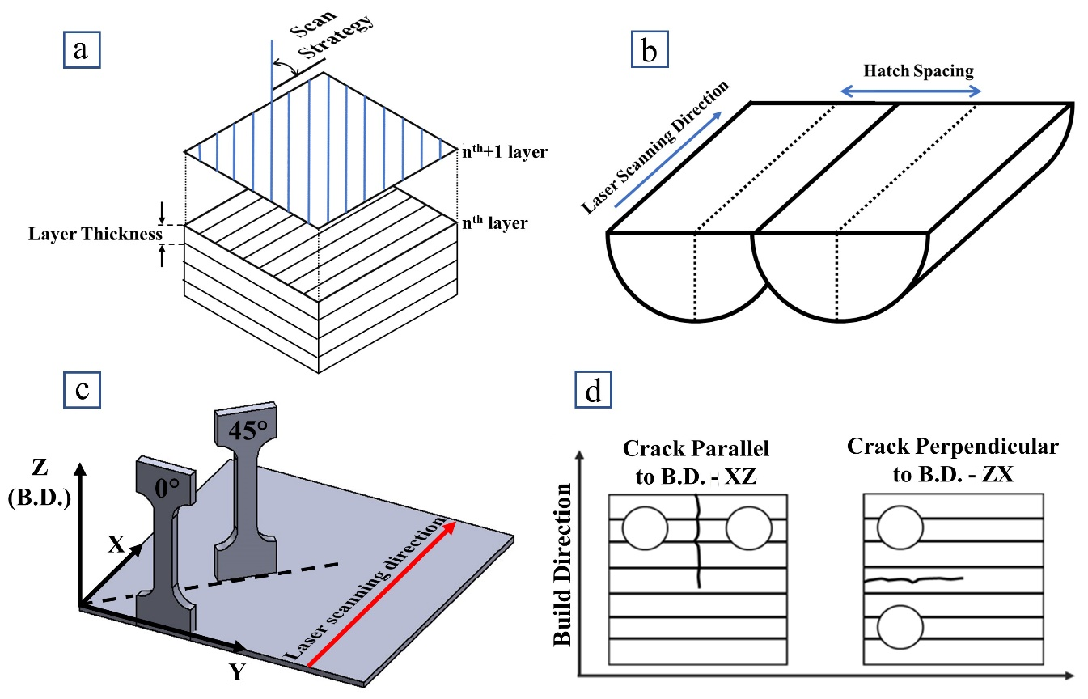
Figure 1: Schematics of LPBF processing parameters and sample orientation. (a) Layer-by-layer build pattern, layer thickness, and scan strategy; (b) hatch spacing; (c) orientation reference for the in-plane (XY) property characterization of the material that was built with the 90° scan strategy. (d) C(T)-sample orientation reference with respect to the build direction.
Microstructural characterization was conducted on samples from each batch that were mechanically ground using SiC paper (320-4000 grit size) followed by the final surface polishing using a 0.1 µm alumina suspension. Subsequently, the samples were etched with Weck’s reagent (4 g of KMnO₄, 1g of NaOH and 100 mL of distilled water). The grain/cell structures, scan tracks, and melt pools were characterized for each batch using an Olympus DSX510 optical microscope (OM) and a JEOL 7001F scanning electron microscope (SEM). To relate the cellular structure with the strength of the material, the morphology indices (i.e., shape and dimensional-scale index) introduced in [28] were estimated from scan track images of all LPBF batches. Samples for electron back-scatter diffraction (EBSD) analysis were additionally polished using 0.05 µm colloidal silica to minimize surface damage and data acquisition was performed on an Ametek TEAM EDAX system and analyzed using the EDAX OIM TSL software package.
Nanoindentation tests across the melt pool boundaries were carried out using a Hysitron TI 950 TriboIndenter equipped with diamond Berkovich probe (half angle of 65.27°) and a 10 mN load cell. Tests were conducted at a loading rate of 1000 μN/s to a maximum load of 5000 μN and with a holding time of 5 seconds at the peak load. As the melt boundary dimensions change based on the utilized processing parameters, five indents were manually placed in the center of the various zones under study.
Tensile and crack propagation resistance (R-curve) properties were characterized for two orthogonal orientations for each batch; two samples were tested per condition. Tensile samples with a cross section of 3.2 × 2 mm² and a gauge length of 13.3 mm were machined from the individual batches in accordance with ASTM E8 standard [30]. Samples were machined in two different orientations, with their long axes either parallel (vertical, V) or perpendicular (horizontal, H) to the build direction (B.D.). Tensile tests were conducted in displacement control at 1 mm/min using an Instron 3369 universal testing machine equipped with a calibrated 50 kN load cell. Strain was measured on the surface of the samples using digital image correlation (DIC) with the GOM correlation software package. After testing, fracture surfaces were examined in the SEM. A mirror polished 5 mm cube from each batch was used to determine the Young’s moduli (E) and Poisson’s ratios (ν) in both B.D. and perpendicular to B.D. using resonant ultrasound spectroscopy (RUS) technique [31,32] with an Olympus 45MG Ultrasonic Thickness Gage equipped with M208-RM and V157-RM sensors for longitudinal and transverse wave velocity determination, respectively.
R-curves and fracture toughness were determined in accordance with ASTM standard E1820 [33] using compact tension (C(T)) samples of 5-6 mm thickness and a width (W) to thickness (B) ratio of 4 for all samples. The C(T) sample orientations were defined by a two-letter code where the first letter denoted the direction normal to the crack plane and the second letter denoted the expected crack propagating direction. Prior to precracking, all samples where mirror polished to a 0.1 μm surface finish to enable (pre)-crack length (a) measurements using OM. Both fatigue precracking and R-curve testing was performed using an Instron 8872 servo-hydraulic testing machine equipped with a calibrated 5 kN load cell. Crack extension was monitored using unloading compliance with an Epsilon clip gauge (-1/+4 mm calibrated displacement range) mounted to knife edges attached to the front face of the C(T) samples. Precracking was performed to a/W-ratios of ~0.45-0.6 under load control with a maximum stress intensity range of ΔK ~ 6.5 MPa$\sqrt{m}$, a constant minimum to maximum load ratio (R) of 0.1, and a frequency (f) of 30 Hz (sine wave). R-curve testing was conducted at a loading rate of 2 mm/min. J-integral values for each increment of crack growth were calculated and plotted with respect to crack extension to construct the R-curves. They were then fitted with power law functions using data points that fell strictly within the crack extension region recommended by the ASTM E1820 standard. J_{q} values were obtained from the intersection of R-curves with their corresponding 0.2 mm-shifted blunting lines and each sample satisfied the ASTM-specific size criteria such that qualified values of J_{Ic} were obtained, i.e., J_{q} = J_{Ic}. Mode I fracture toughness, K_{JIc} values were also calculated from J_{Ic} following the standard J-K equivalence, K_{JIc} = $\sqrt{E^{'}J_{Ic}} ,$where E’ = E / (1 – ν²) [33].
To examine the fracture surfaces in the SEM after testing, half of the samples were cyclically loaded to failure to gently split the samples without distorting the fracture surfaces associated with the R- curves. Fatigue conditions were ΔK ~ 5 MPa$\sqrt{m}$, R = 0.5 and f = 50 Hz (sine wave). For a stereophotogrammetric analysis of the failure characteristics, 3-dimensional height profiles of the fracture surfaces were obtained from the difference between images of the BSE detector quadrants of a Hitachi TM4000 SEM. Crack-tip open displacement (CTOD_{m}) values for individual samples were measured and compared to theoretical values (CTOD_{th}) that were calculated based on ASTM standard E1820. For crack path studies, the second half of the fracture samples were sliced into halves at the mid-point of the thickness and EBSD analysis was performed along the propagated cracks after mirror polishing the surfaces.
3. Results
3.1 Microstructural analysis
Fig. 2 shows microstructure and morphology of the as-built materials. All four batches exhibit typical LPBF features with semi-circular melt pool layers that can be seen in both the front (YZ) and side (XZ) views and scan tracks that are evident on the top plane (XY) that is perpendicular to the build direction. The cutoffs in the individual scan tracks result from variations in depth and shape of the melt pools that occurred by re-melting fractions of the previously solidified, underlying layer. Scan track profile measurements reveal hatch spacings of ~190 µm (190HS, Figs. 2a and 2b) and ~100 µm (100HS, Figs. 2c and 2d), in good agreement with the processing parameters that were used for producing the respective blocks. Similarly, the two scan strategies can be identified from the overlapping scan tracks in the top plane, 67º (67SS) for build conditions shown in Figs. 2a to 2c and 90º (90SS) for the condition displayed in Fig. 2d. For a constant cross section of the materials, the number of MPs reduced with increasing layer thickness and hatch spacing; e.g., the MP density of the 30LT/100HS builds (Fig. 2c,d) was significantly higher than for the 60LT/190HS material (Fig. 2b). Changing the scan strategy from 67º (Fig. 2c) to 90º (Fig. 2d) resulted in a significant change in melt pool morphology. While the 67° rotation shows similar morphology for any side view that is perhaps transversely isotropic, the 90° rotation gives a more anisotropic morphology in the XY plane. In the front view (YZ plane) of the 90SS material (0º to the scan track), layers of semi-circular MPs are separated by horizontal boundaries that correspond to the 90º change in laser scanning direction (Fig. 2d). (This can also be clearly seen in the micrograph shown in Fig. 9b.) However, in the XZ plane, i.e., the plane viewing at 45º to the scan track, the MPs were uniformly distributed layer by layer (Fig. 2d).
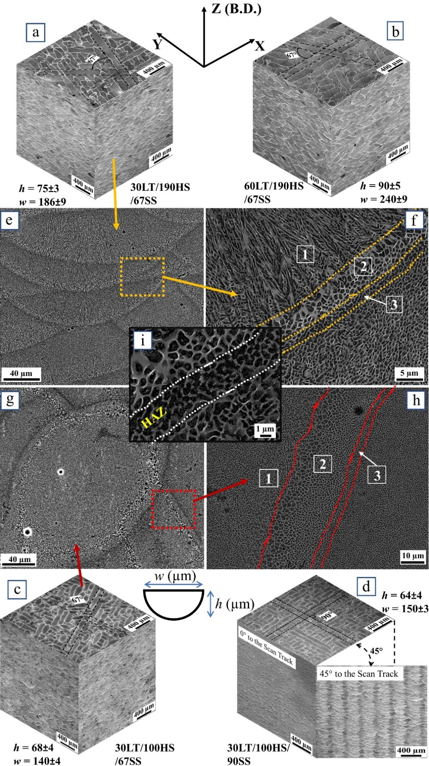
Figure 2: Micrographs of the LPBF-produced AlSi10Mg alloys. Scan track orientation and melt pool morphology details of (a) the 30LT/190HS/67SS build; (b) the 60LT/190HS/67SS build; (c) the 30LT/100HS/67SS build; and (d) the 30LT/100HS/90SS build. (Note: the YZ plane shows the melt pool morphology along 0° to the laser scanning orientation, the other plane shows a view 45° to that orientation.) (e-f) SEM images of the melt pool; (g-h) SEM images from the scan track; (i) magnified view of the HAZ. (The dotted lines in (f) and (h) represent the boundaries between the individual zones.)
Figs. 2e to 2h show detailed micrographs of both the scan tracks in the XY plane (Figs. 2e and 2f, respectively) and the melt pools in the YZ and XZ planes (Figs. 2g and h, respectively). Compared to cast Al-Si alloys, where long needle-like Si particles precipitate within the soft Al matrix [34], the microstructures of AM Al-Si materials exhibit novel cellular characteristics. Due to the rapid cooling rates (>10⁵ K/s [35]) that prevail during the fabrication, Al solidifies through the segregation of Si followed by the formation of a Si-rich composition around the primary Al phase thereby forming a cellular structures that is unique to these LPBF materials [13]. The shape of the cells varies when viewed from different perspectives. Along the MP they appear columnar (Fig. 2g) whereas equiaxed cells are evident along the scan tracks (Fig. 2e). At the MP boundaries (Fig. 2f,h) three different zones can be distinguished; zone ‘1’ with fine cells, zone ‘2’ with coarse cells, and a heat-affected zone (HAZ) indicated as ‘3’. Compared to zone 1 (that is representative for the interior of the MP), the coarse cells (zone 2) have thick cellular walls indicating enhanced Si segregation might have occurred in the coarse region during the short cooling duration [36]. The HAZ (Fig. 2i) is formed by the heat input of the new layer decomposing of Si from the fine cellular structure of the underlying layer. The HAZ can experience a temperature rise in the rage of 280 and 560 °C for 3-4 s, which can lead to a breakdown of the cellular structure in zone 1 [36]. The widths of the region of the coarse zone (zone 2) and the HAZ strongly depend on the processing parameters used for LPBF [36,37]. Their combined width was measured at the bottom of the melt pool for all batches. At 12.3 ± 0.3 µm the width of the two zones for the 60LT samples was roughly twice the width of the 30LT samples with 6.2 ± 0.2 µm. Compared to layer thickness, the hatch spacing and scan strategy had only negligible impact on the size of these zones.
To study both grain size and morphology, EBSD was performed on the planes parallel (YZ and XZ planes) and perpendicular (XY plane) to the build direction. Figs. 3a-j shows the inverse pole figure (IPF) maps and the corresponding (001) pole figures (PF) of the various material batches; Figs. 3e,j shows the grain evolution of the 90SS build viewed at 45° to the laser scanning direction. The boundaries of the melt pool and the scan track can be visualized by superimposing OM images taken from the same area as the IPF maps. It can clearly be seen that the grain evolution is distinctly different in the various batches and the two views. Most grains in the melt pools (left column of IPF maps) grow with columnar shape and arrangement towards the center of the melt pool whereas some equiaxed grains can be seen near the intersection of the individual melt pool boundaries. The amount of equiaxed grains reduces with increasing LT and HS. In the 90SS build condition, the growth of columnar grains (Fig. 3d,e) was significantly affected by the laser scanning direction. In the plane 45° to the laser scanning direction (Fig. 3e), the formation of columnar grains follows a pattern of columns of larger elongated grains that are separated by equiaxial grains. However, when looking in the 0° plane (90SS-0D) (Fig. 3d) such a pattern was not observed; instead, a considerable reduction in the length of columnar grains was evident. In comparison, the top view (XY plane, right column of IPF maps) indicates equiaxed grains representing the cross-sections of the columnar grains that formed in the melt pool regions. As shown in Figs. 3f to 3h, the grain size reduces with decreasing LT and HS.
The IPF maps of the melt pools (Figs. 3a-e) also show that grain growth is not affected by the melt pool boundaries, especially in the center of the melt pool, where the grains maintain both the crystallographic and geometric orientation across two (or more) MPs. This epitaxial grain growth occurs when the growing direction of a new grain aligns along the seed crystal in the underlying layer, that is closest to the thermal gradient in the melt pool. This type of epitaxial growth introduces texture in LPBF materials [17]. Indeed, the pole figures in the inserts of Figs. 3a-j show 〈100〉 fiber texture in all build conditions [38]. Columnar grains prefer to grow along 〈100〉 in the build direction, as growth along this particular crystallographic direction has a higher accommodation coefficient compared to other directions in the FCC structure [22,39]. These texture patterns are in good agreement with previous studies on LPBF AlSi10Mg materials [22,40–42].
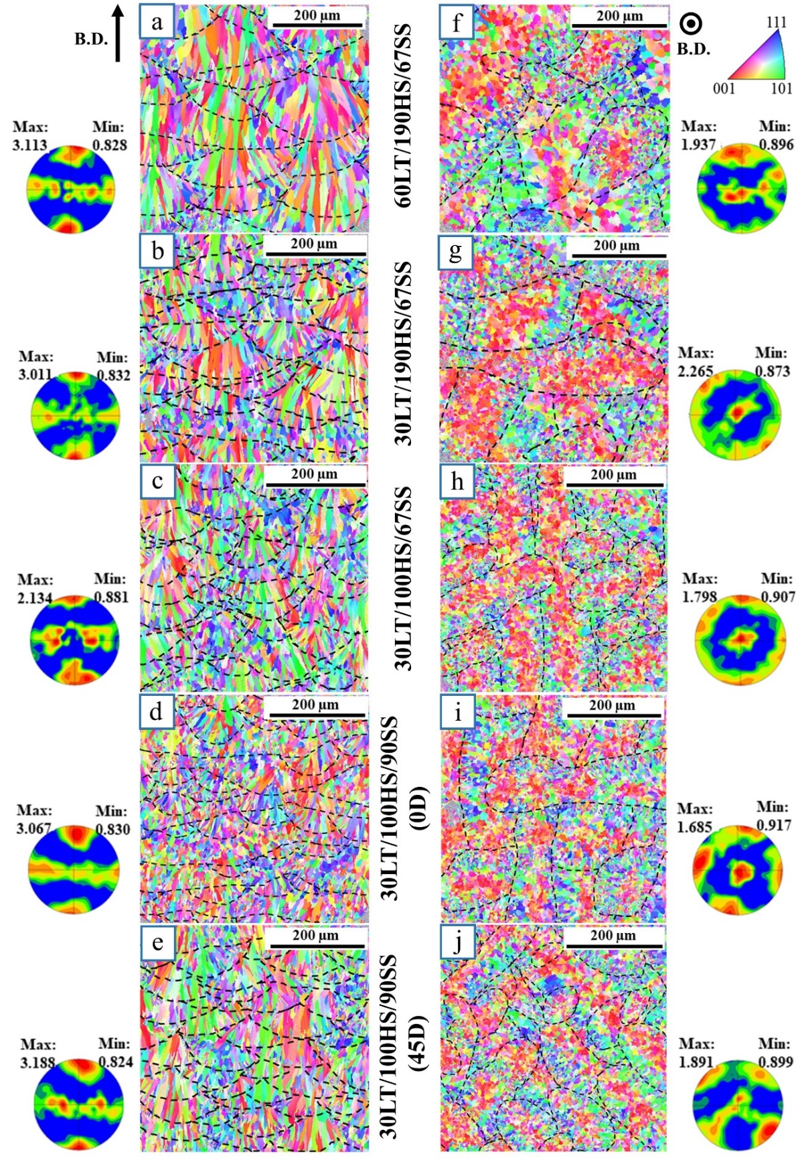
Figure 3: EBSD IPF maps with respect to (a-e) the melt pool and (f-j) the scan track for all build conditions; corresponding (001) pole figures are placed adjacent to the images. (Melt pool boundaries are drawn as dashed lines from superimposing optical microscopy images taken from the same area.)
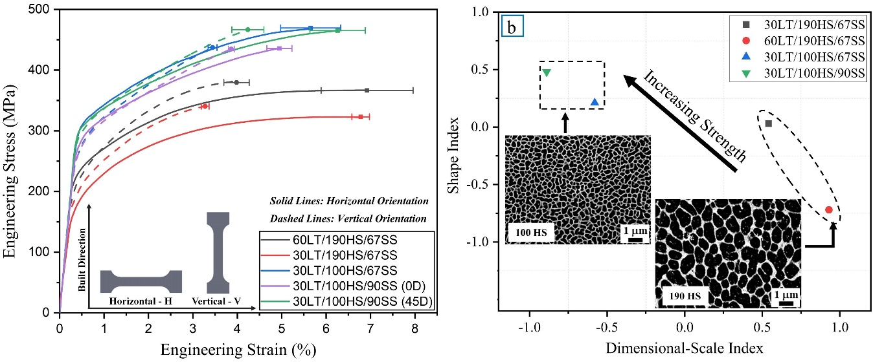
Figure 4: (a) Tensile stress-strain curves obtained in two different orientations of the various LPBF materials; (b) Cell morphology indices (i.e., shape and dimensional-scale index) from the fine zones of scan track micrographs of the cellular sub-structure.
3.2 Tensile responses
Representative tensile stress-strain responses are displayed in Fig. 4a. It is seen that the strength of the LPBF materials is strongly influenced by the processing parameter combinations employed whereas the ductility is relatively insensitive (Fig. 4a). Values of yield and ultimate tensile strengths, fracture strain, strain hardening exponent and Young’s modulus (from RUS measurements) of the various material batches are shown in Table 2. It is noted that an increase in LT from 30 to 60 µm resulted in a strength reduction of ~10-12%. Similarly, an increase in HS from 100 to 190 µm resulted in a reduction of tensile strength by approximately 13-21% (this trend is also indicated by the cell morphology parameter analysis in Fig. 4b). In both instances, ductility was not affected significantly. However, in the case of the 90SS material, the observed reductions in strength (~7%) and ductility (~21%) between the 45D and 0D test conditions implies that sample orientation within the individual planes considerably effects the tensile strength. Additionally, scan strategy did not seem to show a pronounced effect on the tensile properties of the as-built alloys. Overall, hatch spacing had significantly more impact on tensile properties compared to layer thickness and scan strategy.
Strain-hardening exponents were calculated by fitting the true plastic strain data points to the Hollomon equation according to ASTM standard E646 [43] and the results are given in Table 2. Samples tested horizontal (H) to the build plate showed less strain hardening and more ductility before failure compared to their vertical (V) counterparts with strain hardening exponents of 0.168 ± 0.004 and 0.202 ± 0.007 for H and V samples, respectively. Using the Considere's criterion to verify the onset of necking [44], only the 60LT/190HS/67SS – H samples satisfied the criterion at ε = 6%; failure occurred at 6.7% strain. All other samples failed before necking.
Table 2: Summary of the average tensile properties of the various AlSi10Mg batches fabricated with different processing parameters. Elastic moduli are reported from the RUS measurements and yield strength, ultimate tensile strength (UTS), and fracture strain of T6 heat-treated cast material added for comparison from [45].
Samples | Elastic modulus  (GPa) | Yield strength (MPa) | UTS  (MPa) | Fracture strain  (%) | Strain hardening exponent (-)
60LT/190HS/67SS - H | 76.01 | 189.6  ± 1.8 | 323.0  ± 2.1 | 6.7  ± 0.2 | 0.18
60LT/190HS/67SS - V | 78.49 | 213.9  ± 5.6 | 340.3  ± 0.3 | 3.2  ± 0.1 | 0.23
30LT/190HS/67SS - H | 75.03 | 243.8  ± 1.1 | 366.6  ± 3.9 | 6.9  ± 1 | 0.16
30LT/190HS/67SS - V | 77.50 | 232.5  ± 1.5 | 379.6  ± 2.1 | 3.9  ± 0.2 | 0.20
30LT/100HS/67SS - H | 76.40 | 313.8  ± 1.3 | 469.4  ± 3.5 | 5.6  ± 0.6 | 0.16
30LT/100HS/67SS - V | 79.40 | 278.0  ± 1.4 | 437.1  ± 3.5 | 3.4  ± 0.1 | 0.19
30LT/100HS/90SS (0D) - H | 72.01 | 297.4  ± 4.5 | 435.8  ± 0.7 | 4.9  ± 0.2 | 0.17
30LT/100HS/90SS (0D) - V | 74.22 | 284.1  ± 11.8 | 434.6  ± 4.4 | 3.8  ± 0.1 | 0.19
30LT/100HS/90SS (45D) - H | 74.53 | 309.7  ± 3.2 | 465.2  ± 2.8 | 6.2  ± 0.6 | 0.17
30LT/100HS/90SS (45D) - V | 78.58 | 301.3  ± 14.3 | 466.6  ± 5.5 | 4.2  ± 0.3 | 0.20
Cast - T6 | - | 242 | 309 | 6.9 | -

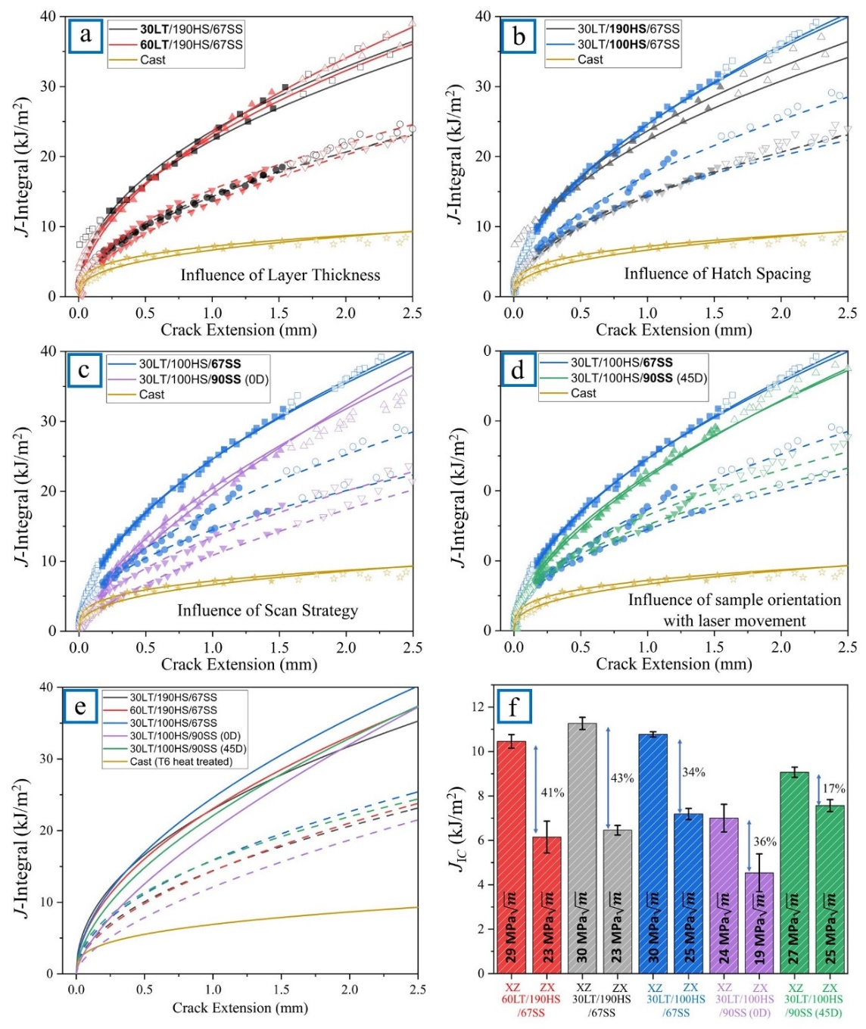
Figure 5: Crack resistance curve behavior and fracture toughness with respect to testing direction. R-curve dependence on (a) layer thickness, (b) hatch spacing, (c) scan strategy, and (d) the 0° and 45° orientation in the 90SS samples. (e) Direct comparison of R-curves from various testing conditions. (Solid lines represent C(T)-XZ samples with the crack propagating parallel to the B.D.; the dashed lines represent C(T)-ZX samples with the crack propagating perpendicular to the B.D.; the solid symbols present the data that was used for fitting the R-curves.) (f) J_{Ic} values of all build conditions. (The differences in J_{Ic} between orientation is indicated as percentage; K_{JIc} values are denoted inside the individual bars.)
3.3 Fracture toughness
Figs. 5a to 5d show the influence of processing parameters on the crack resistance (R-curve) behavior together with the results of the cast material for comparison. Table 3 summarizes the measured J_{Ic} and calculated K_{JIc} values for the individual material batches and lists both the measured and theoretical values of the corresponding CTODs. (The data for the cast material mentioned in Table 3 and Fig. 5 was obtained from the T6 heat treated cast samples, as mentioned in section 2.) In all the batches, the XZ samples (with crack propagation direction parallel to B.D.) showed more pronounced R-curve behavior compared to samples that were tested with the crack propagating perpendicular to B.D. (ZX samples). The obtained K_{JIc} values of ~30 MPa$\sqrt{m}$ for the XZ samples were insensitive to LT and HS. Changing scan strategy from 67° to 90° (0D), however, markedly reduced the K_{JIc} values (by ~22%). Compared to all other build conditions, samples of the 90SS-0D batch were found to have the lowest fracture toughness in both testing orientations. Samples from the 90SS-45D batch showed the least anisotropy in fracture toughness, which is associated with a reduced fracture toughness of the XZ samples rather than improvements of the ZX samples. While larger grains together with lower strength of the 60LT samples would suggest an enhanced fracture resistance, the lack of such fracture toughness improvements compared to the other batches indicates that crack initiation toughness and crack propagation resistance are less influenced by grain size and microstructure than by melt pool arrangement and hence the mesostructure of the material. A direct comparison of the crack resistance curves from all batches (Fig. 5f) shows a pronounced anisotropy of fracture toughness in the two testing directions and significant improvements in fracture behavior of LPBF AlSi10Mg materials compared to cast and T6 heat-treated samples. While the cast samples had a K_{JIc} of ~19 MPa$\sqrt{m}$, values of the LPBF materials ranged between ~20-30 MPa$\sqrt{m}$ with pronounced R-curve behavior that is strongly dependent on testing direction but less dependent on processing parameters.
Table 3: Fracture toughness and crack tip open displacements (CTOD) of the LPBF AlSi10Mg alloys.
Samples | J_{Ic}  (kJ/m²) | K_{JIc}  (MPa$\sqrt{m}$) | CTOD_{th}  (µm) | CTOD_{m}  (µm)
60LT/190HS/67SS – XZ | 10.4  ±0.3 | 29.9  ± 0.4 | 18.2  ±0.4 | 13.4  ±1
60LT/190HS/67SS – ZX | 6.1  ±0.7 | 23.4  ±1.3 | 10.1  ±1.16 | 6.6  ±1.44
30LT/190HS/67SS – XZ | 11.2  ±0.2 | 30.9  ±0.3 | 17.2  ±0.2 | 10.6  ±1
30LT/190HS/67SS – ZX | 6.4  ±0.2 | 23.7  ±0.4 | 9.6  ±0.3 | 5.8  ±0.6
30LT/100HS/67SS – XZ | 10.7  ±0.1 | 30.4  ±0.1 | 12.8  ±0.1 | 8.9  ±1.5
30LT/100HS/67SS – ZX | 7.1  ±0.2 | 24.9  ±0.4 | 9.2  ±0.4 | 5.6  ±1
30LT/100HS/90SS (0D) – XZ | 7  ±0.6 | 23.8  ±1.1 | 8.9  ±0.8 | 6.1  ±1.1
30LT/100HS/90SS (0D) – ZX | 4.5  ±0.8 | 19.5  ±1.8 | 5.8  ±1.1 | 3.4  ±1.9
30LT/100HS/90SS (45D) – XZ | 9.0  ±0.2 | 27.1  ±0.3 | 10.9  ±0.3 | 9.7  ±0.3
30LT/100HS/90SS (45D) – ZX | 7.5  ±0.2 | 25.5  ±0.4 | 9.1  ±0.4 | 6.6  ±1.1
Cast (T6 heat-treated) | 3.7  ±0.4 | 18.6  ±1.1 | - | -

4. Discussion
4.1 Microstructure and grain anisotropy
The EBSD analysis in Figs. 3a-e shows columnar grains with a preference for growth towards the center of the melt pools. Additionally, the SEM image of the melt pool region in Fig. 6c with the superimposed grain boundary data from the EBSD analysis in Fig. 6a shows that the cells within these grains also have a preferred growth direction. This indicates that there is a correlation between the orientation of cells and the grain growth direction which primarily depends on the solidification of the Al phase. Such orientation dependence of the cell structure cannot be observed along the scan tracks where equiaxial grains are evident (Figs. 3f-j). Cross-sections of the columnar grains that grow towards the center of the melt pool can be seen the middle of each scan track. At the scan track boundaries, smaller-sized grains, which have an equiaxed structure and form in regions where melt pools intersect, are noted. Such fine-grained regions can also be found in the planes parallel to the build direction (Fig. 3a-e). In the 67SS sample (Fig. 3a-c), for example, they are distributed randomly because of the 67° scan track rotation between subsequent layers. In the 90SS samples (Fig. 3d,e), however, they are more uniformly distributed resulting from the perpendicular scanning sequence of the alternating layers. The (0D) scans (Fig. 3d) show significantly more fine-grained regions compared to the (45D) scans (Fig. 3e) as a result the viewing angle of an otherwise identical material. The 45° view of the 90SS build material shows cross-sections of melt pools with columnar grain growth and only small fractions of regularly distributed equiaxed grains. Compared to that, the 0° view shows cross-sections of continuous scan tracks that have been cut at a certain depth and hence display a larger fraction of equiaxed grains.
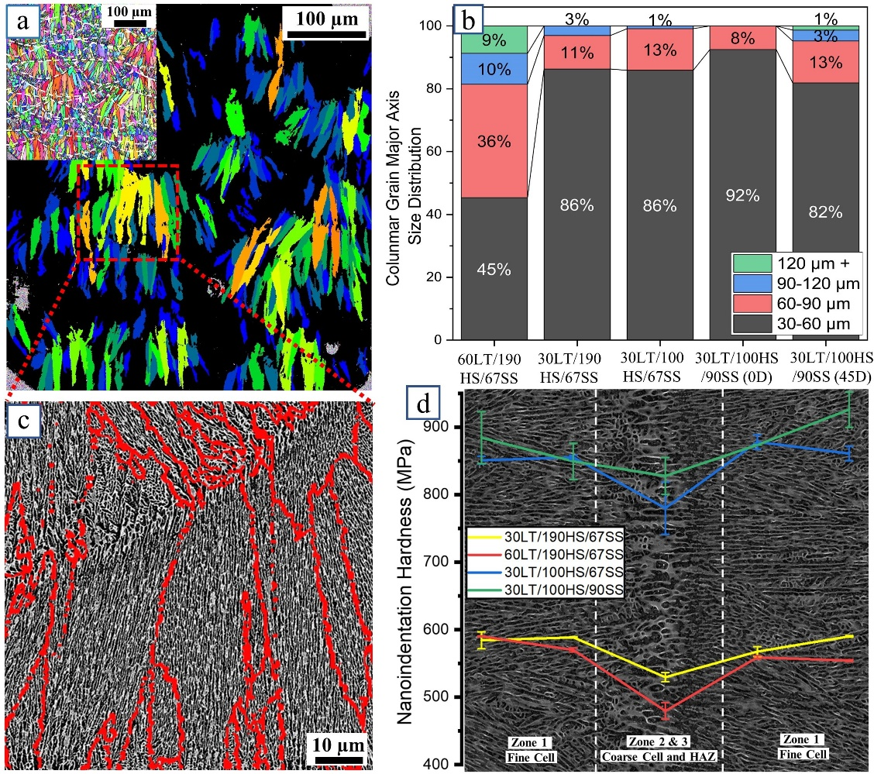
Figure 6: Microstructure characterization. (a) Grains with aspect ratio less than 0.3 from EBSD analysis; (b) Size distribution of columnar grains (major axis size); (c) Cellular and grain orientation analysis; (d) Nano-indentation hardness variation near the melt pool boundaries taken from the XZ-plane (the image is a representation of the melt pool boundary and the individual zones for general interpretation of the location of the indents).

Fig. 6a shows columnar grains with an aspect ratio of minor to major axis <0.3 with grains for the various material batches grouped into distinct size-ranges in Fig. 6b. The 60LT material has significantly more grains in the size range of 60-150 µm compared to the 30LT batches. This is caused by the larger spacing between the individual layers together with the overall larger melt pool size (h = 90 µm, w = 240 µm vs. h ~ 65-75 µm, w ~ 140-190 µm for the 30LT materials, Fig. 2b) which enables grain growth because of fewer melt pool interactions during fabrication compared to the other materials. Changing layer thickness to 30 µm reduces the number of longer grains significantly while the fraction of 30-60 µm grains increases. Similarly, changing hatch spacing from 190 µm to 100 µm results in fewer grains longer than 90 µm, as shown in Fig. 6b for the 30LT/100HS/67SS material compared to the 30LT/190HS/67SS batch. The viewing angles of the 90SS material also result in different grain size distributions. While the two angles represent extremes of the fractions of grains that are 60 µm or more – the (45D) EBSD scans (Fig. 3e) intersect significantly more evenly distributed MPs with a larger number of columnar grains – their average is comparable to the other 30LT batches.
Columnar grains with major axis lengths larger than the layer thickness are formed through epitaxial grain growth across melt pool boundaries [1,2]. However, the interference of neighboring melt pools has regions of coarse cell structure and HAZ (zones 2 and 3 in Figs. 2e-i, respectively) that are apparent even within the same grain (Fig. 6c) which has the essentially same crystal orientation (Fig. 6a). These structurally different regions affect the properties of the interface between neighboring melt pools which is evident from nanoindentation tests that show significantly reduced hardness across the interface of the melt pool boundaries (Fig. 6d). Similar trends have previously been reported in [36,46]. The nanoindentation tests additionally show the importance of the cellular structure not only on the local properties at the melt pool boundaries but point to a significant impact on the macroscopic mechanical behavior of the material. Kim et al. [47] have shown that, upon loading, dislocations in the Al matrix pile up near the Si-rich interface leading to the formation of stacking faults resulting in twinning in the Si nanoparticles located at the Si-rich cell boundaries. This indicates that strengthening caused by the cellular interface is influenced by the shape and size of the cellular structures which is controlled by the processing parameters. Indeed, the morphology indices analysis of the individual structures (Fig. 4b), reveal that increasing the layer thickness to 60 µm results in larger cell sizes (indicated by the highest I_{d} value, 0.93) and boundaries with more eccentric and wider shapes (indicated by the lowest I_{s} value, -0.72) compared to the 30LT samples. Reducing the hatch spacing to 100 µm, results in finer cells (indicated by higher I_{s} value and lower I_{d} values), as shown in Fig. 4b. Changing the scan strategy, however, does not play a significant role on the cell morphology compared to hatch spacing and layer thickness.
4.2 Tensile properties
The strength enhancements of LPBF AlSi10Mg alloys compared to cast and aged material are known to result from the combination of the fine grain structure and Si-rich cellular substructure that form during the rapid solidification process. As such, the shape and size of both the grains and the cells, that are controlled by the various processing parameters, affect not only the mean free path of dislocations but the strength within the various regions of each material batch. Indeed, samples with 60 µm layer thickness (60LT) show lower strength compared to samples from the 30LT materials (Fig. 4a). This correlates with the amount of larger-sized columnar grains as well as wider cells in the two materials. The 60LT material contains ~55% grains that have a columnar structure with >60 µm length whereas the 30LT material has only 10-20% of such grains (Fig. 6b). Additionally, the fine zones of 60LT samples contain larger and wider-shaped Si-network cells (as discussed in 4.1), when compared to the samples built with 30 µm layer thickness. This further increases the mean free path of dislocations and results in less pronounced strengthening. However, compared to layer thickness the influence of hatch spacing on material strength appears to be much more pronounced. This is evident for the 30LT materials where 100HS samples exhibit significantly higher strength values compared to samples from the 190HS material while having a similar grain size distribution. Such differences can be attributed to cell morphology where an analysis of shape index and dimensional-scale index of materials batches with both 190 μm and 100 μm hatch spacing show significant differences between the two groups (Fig. 4b). This is in agreement with previous work on LPBF AlSi10Mg alloy [28]. In addition to strength, the influence of cell morphology is also evident from nanoindentation where hardness across melt pool boundaries (Fig. 6d) show not only significant drops at the heat-affected zones at the interface but more than 300 MPa (~25%) difference in the hardness of the 100HS and 190HS materials.
The tensile stress-strain properties of the various batches were not only affected by hatch spacing and layer thickness but also by the properties of the melt pool boundaries. The melt pool interface that consists of both coarse cells and HAZ are softer than the fine cellular zone, which is evident from the nanoindentation results in Fig. 6d. Delahaye et al. [36] reported that the Si content in the cellular walls of both the fine and coarse zones was much higher (~22%) compared to the HAZ (~17%) resulting from Si decomposing from the cellular walls into the Al matrix. This is associated with the thermal history during fabrication which results in decomposed cells in the HAZ (Fig. 2i), which increases the mean free path of dislocations thereby lowering the strength of this zone. Although the coarse cell zone (zone 2 in Figs. 2f,h) has higher Si content compared to the HAZ, the wider cell structure also reduces strength compared to the interior of the melt pool with finer cell structure. Upon loading, localized plastic deformation of the weak interfaces is constrained by the higher strength of the melt pools resulting in failure without significant strain softening [4,48].
Materials that have highly textured microstructures often show an anisotropy in their mechanical properties, particularly in yield strength. This is the result of an orientation dependent activation of individual slip and twin systems [49,50]. However, in our current study, the differences in both yield and tensile strength in the two testing directions are small compared to the anisotropy in strain to failure (Fig. 4a). Fractography of tensile samples that were tested parallel (V) and perpendicular (H) to the build direction reveal distinct failure characteristics for the two orientations (Fig. 7). While H-samples show failure by shear resulting in a fracture surface that is inclined to the tensile direction (Fig. 7a), the V-samples resemble cup-and-cone-type failure characteristics (Fig. 7b); this occurred for all samples from the various batches. The inclined fracture surface of the H-samples can be associated with a sample size effect resulting from the small cross sections used for tensile testing. This promotes plane stress in the gauge section of the samples that results in shear-failure due to a lack of stress-triaxiality [51] and sample size-dependent failure strains. However, in case of the V-samples, the scan track pattern that is evident on the fracture surface (Fig. 7e) reveals that failure occurred along the melt pool boundaries that are dominated by the weak interface from the coarse and heat-affected zones (Fig. 7g). Upon loading, the plastic deformation within the interface is constrained by the higher strength of the fine zones on either side of the melt pool boundaries, thereby enabling stress-triaxiality and resulting in the formation of microvoid coalescence at these boundaries. Indeed, detailed fractography reveals the presence of microvoids on the fracture surface of the V-samples (Fig. 7e,f), whereas in the H-samples (Fig. 7c,d) they do not exist. (It should be noted that some of the features that are found on the fracture surface may be pre-existing porosity. LPBF induced gas porosity, however, can be distinguished from voids due to their significantly smoother surface.) The dimple features that are evident in both orientations (inserts of Fig. 7d,f) have dimensions comparable to the cells in the fine and heat-affected zones; e.g., the dimples size of the 60LT/190HS/67SS samples was ~0.83 µm as compared to ~0.74 µm cells size in the fine zone (in case of the elongated dimples in Fig. 7d, only the width of the dimples was considered). Similar correlations have previously been observed [36]. This indicates that the Si-rich boundaries impede dislocation motion in the Al-matrix thereby increasing the strength of the material. With increasing load, plastic deformation occurs in the Al-matrix leading to debonding at the Si-rich cell interface causing the nucleation of cavities that can subsequently be seen as dimple-like features on the fracture surface.
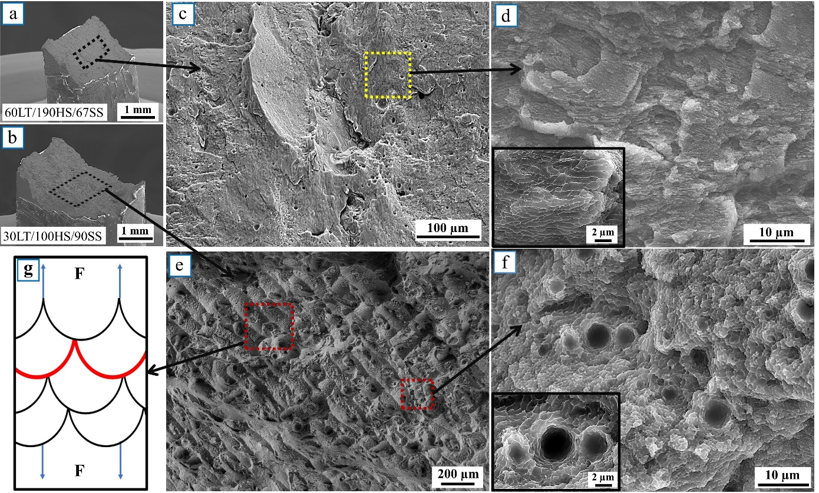
Figure 7: Failure characteristics of tensile samples. Fracture surface of samples tested (a) horizontally, and (b) vertically; (c-f) magnified SEM images of the fracture surfaces; (g) schematic representation of the failure in vertical samples.
4.3 Fracture toughness and crack propagation resistance
Fig. 8a shows the fracture surface of a C(T)-sample that was tested in the XZ orientation clearly indicating a change in fracture characteristics from the fatigue precrack to the overload region. The triaxial stress state ahead of the crack tip at the onset of overload fracture results in microvoids coalescence leading to the formation of larger-sized voids (Fig. 8b). Their height profiles can be assessed from 3-dimensional surface reconstructions of identical locations of the two corresponding fracture surfaces (Fig. 8c). Assessing such height profiles from the overload region in the vicinity of the precrack (Fig. 8d) allows for the correlation of the theoretical CTOD values (CTOD_{th}) from fracture toughness measurements with the CTOD_{m} values measured at the first physical crack extensions [52–54]. The CTOD values in Table 3 are in good agreement and support the J_{Ic} values that were measured in accordance with the ASTM standard.
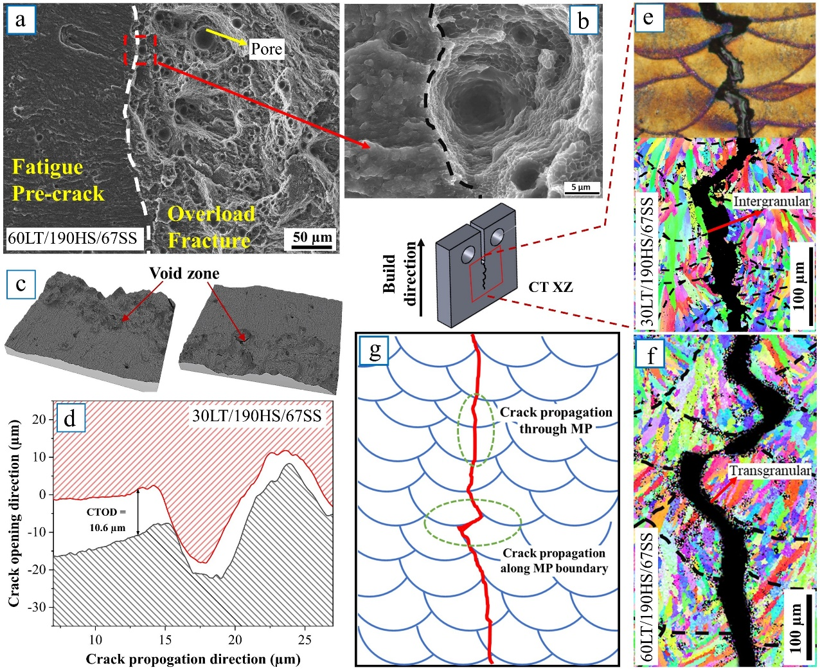
Figure 8: Fracture analysis of the sample tested in the C(T) XZ orientation. (a) Fractographic image showing the facture mode changing from fatigue precrack region to overload fracture; (b) an image of the a microvoid near the fatigue precrack front; (c) 3D-profiles from both halves of corresponding fracture surfaces; (d) a representative image illustrating the experimental CTOD analysis; (e,f) crack propagation path analysis using EBSD; (g) schematic representation of the crack propagation path.
The observed anisotropy in the R-curve behavior of samples tested in the two orientations can be rationalized by analyzing the alignment of the crack plane and the crack propagation direction (this corresponds to the two-letter code used for the C(T)-samples) with respect to the scan strategy and the associated arrangement of the melt pools. For the 67° scan strategy, sample orientation has only minor impact on the fracture toughness as long as tests are conducted with both crack plane normal and crack propagation direction perpendicular to B.D. (ZX-samples). This is also true for configurations where the crack growth direction is parallel to B.D. (XZ-samples). In the 90SS batch, however, the sample orientation in both configurations plays a crucial role. This can be seen in the significantly different fracture toughness values of (0D) and (45D) samples where the ZX and XZ-configurations had a fracture toughness, K_{JIc} ranging from 19-25 MPa$\sqrt{m}$ and from 24-27 MPa$\sqrt{m}$, respectively (Fig. 5g).
To characterize the crack paths for the various testing directions, EBSD analyses were conducted at the mid-section of the samples. Figs. 8e and 8f show the crack propagation profiles for samples in the XZ orientation. The higher fracture toughness for this orientation compared to the other testing direction results from a combination of crack propagation across the melt pool and crack deflection along the melt pool boundaries (Figs. 8e to 8g). Crack propagation across the melt pool boundaries occurs through both inter and transgranular failure; intergranular failure along the elongated grain boundaries dominates in regions where the crack passes the melt pool perpendicularly, whereas transgranular failure is more likely to occur if the crack crosses the melt pool boundary at an angle. Crack deflection at the interface of the individual melt pools can be observed in regions where crack deflection is energetically more favorable than crossing a melt pool. This indicates that there is a difference in crack propagation resistance across the melt pool compared to the melt pool boundary. The difference between the two paths, however, must be limited as crack propagation would otherwise occur solely by one or the other. While crack deflection alone would result in an even higher crack propagation resistance, fracture toughness in the build direction of all tested materials is significantly higher than in the other orientation where the crack plane normal is parallel to the B.D. and crack propagation occurs essentially between individual layers. This enables less tortuous crack propagation along the melt pool boundaries thereby reducing crack propagation resistance (Fig. 9c-e). The difference in the crack propagation resistance in the two orientations is evident from the R-curves whereby differences in the fracture toughness values (Table 3) become more pronounced with crack extension. Moreover, both the fracture toughness and crack resistance curve behavior of LPBF AlSi10Mg in all orientations is significantly better than the properties of the cast material. The reason for this is that in the cast material needle-like Si-precipitates act as stress concentrators leading to the formation of microcracks (Fig. 9f). During R-curve testing these microcracks enable crack bridging resulting in a fracture toughness of ~19 MPa$\sqrt{m}$ – values that are comparable with data in the literature [27] – together with crack resistance curve behavior. Their toughening effect, however, is significantly less efficient than the crack path variations caused by the melt pool mesostructure of the various build conditions and as such results in a less damage-tolerant material.
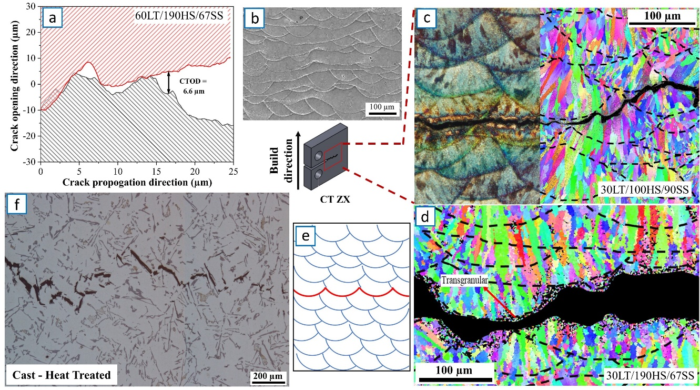
Figure 9: Fracture analysis of C(T) ZX orientated samples and cast material. (a) CTOD analysis of C(T) ZX orientated sample; (b) continuous melt pool in the 90SS-0D material; (c,d) crack propagation path analysis of C(T) ZX samples; (e) schematic representation of the crack path in ZX orientation; (f) crack propagation in cast material.
For the 67SS samples, hatch spacing and layer thickness were essentially doubled between the individual batches resulting in significantly different microstructures (Fig 3a-c,f-h). This had a pronounced impact on tensile strength but not on fracture toughness with K_{JIc} ~30 MPa$\sqrt{m}$ and ~23-25 MPa$\sqrt{m}$ in the XZ and ZX orientations, respectively. The reason for this is that the 67° scan strategy leads to randomly distributed melt pools that cause more tortuous crack propagation through crack deflection and twisting (in addition to changes in melt pool boundary strength). Changing the scan strategy to 90° (0D), K_{JIc} in both orientations drops significantly to the lowest values recorded. This is associated with crack propagation along the continuous melt pool boundaries (Fig. 9b) that enable crack extension without significant crack deflections. Compared to the (0D) samples, the (45D) samples have better fracture toughness in both orientations; in fact, the recorded values in the ZX-orientation are comparable to K_{JIc} of the 67SS samples. The reason for this is that crack propagation occurs across numerous melt pool boundaries (Fig. 2d) resulting from a locally reduced crack propagation resistance, i.e., a lower intrinsic fracture toughness, along the melt pool boundary thereby enabling a globally more tortuous crack path and increased fracture toughness results. This indicates that melt pool morphology has a strong influence on both fracture toughness and R-curve behavior of LPBF AlSi10Mg.
5. Conclusions
Strength and crack resistance curve (R-curve) behavior of laser powder bed fusion (LPBF) fabricated AlSi10Mg have been investigated to understand the effect of build parameters such as layer thickness, hatch spacing and scan strategy on the structure and mechanical properties. Tensile stress-strain behavior and fracture toughness in different orientations were tested and failure characteristics were analyzed and correlated with microstructure morphology and anisotropy. The following conclusion can be drawn:
- The processing parameters used for LPBF strongly influence the microstructure and melt pool morphology of the materials. Increasing hatch spacing and layer thickness result in larger columnar grains with a wider cellular sub-structure whereas scan strategy controls the melt pool arrangement and the formation of a melt pool dominated mesostructure.
- Hatch spacing and layer thickness have a bigger impact on tensile stress-strain properties than scan strategy. In contrast, for fracture toughness the scan strategy has significantly more impact than the other two factors.
- Differences in grain size, grain orientation, cellular morphology and melt pool arrangement result in strong anisotropy of both strength and ductility. Tensile samples tested with loading along the build direction show more pronounced strain hardening resulting in premature failure along the melt pool boundaries at ~3.5% ductility compared to ~5-7% failure strains for the orientation loaded perpendicular to the build direction.
- A size-independent fracture toughness, K_{JIc}, ranging between ~20-30 MPa$\sqrt{m}$ has been determined for LPBF AlSi10Mg. Crack plane orientation and crack propagation direction with respect to the build direction and melt pool morphology, however, strongly affect fracture toughness values and crack resistance curve behavior. Both crack initiation toughness and crack propagation resistance are higher when the melt pool mesostructure promotes more crack deflection and a more tortuous crack path.
- Material built with a 90° scan strategy has reduced fracture toughness (ranging from ~19-27 MPa$\sqrt{m}$) compared to material built with a 67° scan strategy (which is in the range of ~25-31 MPa$\sqrt{m}$). This difference is associated with a less tortuous crack propagation path in the material with the 90° scan strategy resulting from the formation of two distinct melt pool orientations as compared to a random melt pool arrangement in the 67° material.
Acknowledgements
The authors acknowledge the facilities and the scientific and technical assistance of Microscopy Australia at the Electron Microscope Unit (EMU) within the Mark Wainwright Analytical Centre (MWAC) at UNSW Sydney. They would also like to thank Mr. Halsey Ostergaard for help with sample preparation and material characterization and Dr. David Miskovic for his help fabricating the cast samples. BG additionally acknowledges support from the UNSW Scientia Fellowship scheme, XL would like to acknowledge the support from the Australian Research Council (ARC) Discovery Early Career Researcher Award (DECRA) DE190101495, and UR acknowledges funding from A*STAR, Singapore via the Structural Metals and Alloys Programme (No. A18B1b0061).
References
[1] P. Kumar, O. Prakash, U. Ramamurty, Micro-and meso-structures and their influence on mechanical properties of selectively laser melted Ti-6Al-4V, Acta Mater. 154 (2018) 246–260. https://doi.org/10.1016/j.actamat.2018.05.044.
[2] P. Kumar, U. Ramamurty, Microstructural optimization through heat treatment for enhancing the fracture toughness and fatigue crack growth resistance of selective laser melted Ti–6Al–4V alloy, Acta Mater. 169 (2019) 45–59. https://doi.org/10.1016/j.actamat.2019.03.003.
[3] J. Suryawanshi, K.G. Prashanth, S. Scudino, J. Eckert, O. Prakash, U. Ramamurty, Simultaneous enhancements of strength and toughness in an Al-12Si alloy synthesized using selective laser melting, Acta Mater. 115 (2016) 285–294. https://doi.org/10.1016/j.actamat.2016.06.009.
[4] L. Zhao, J.G. Santos Macías, T. Douillard, Z. Li, A. Simar, Unveiling damage sites and fracture path in laser powder bed fusion AlSi10Mg: Comparison between horizontal and vertical loading directions, Mater. Sci. Eng. A. 807 (2021) 140845. https://doi.org/10.1016/j.msea.2021.140845.
[5] F.C. Robles Hernandez, J.M. Herrera Ramírez, R. Mackay, F.C. Robles Hernandez, J.M. Herrera Ramírez, R. Mackay, Al-Si Alloys, Minor, Major, and Impurity Elements, in: Al-Si Alloy., Springer International Publishing, 2017: pp. 1–15. https://doi.org/10.1007/978-3-319-58380-8_1.
[6] S. Shivkumar, C. Keller, M. Trazzera, D. Apelian, Precipitation hardening in A356 alloys, in: Prod. Refining, Fabr. Recycl. Light Met., Elsevier, 1990: pp. 264–278. https://doi.org/10.1016/b978-0-08-040416-5.50028-x.
[7] D. Buchbinder, H. Schleifenbaum, S. Heidrich, W. Meiners, J. Bültmann, High power Selective Laser Melting (HP SLM) of aluminum parts, Phys. Procedia. 12 (2011) 271–278. https://doi.org/10.1016/j.phpro.2011.03.035.
[8] K. Kempen, L. Thijs, J. Van Humbeeck, J.P. Kruth, Processing AlSi10Mg by selective laser melting: Parameter optimisation and material characterisation, Mater. Sci. Technol. (United Kingdom). 31 (2015) 917–923. https://doi.org/10.1179/1743284714Y.0000000702.
[9] N. Read, W. Wang, K. Essa, M.M. Attallah, Selective laser melting of AlSi10Mg alloy: Process optimisation and mechanical properties development, Mater. Des. 65 (2015) 417–424. https://doi.org/10.1016/j.matdes.2014.09.044.
[10] E.O. Olakanmi, Selective laser sintering/melting (SLS/SLM) of pure Al, Al-Mg, and Al-Si powders: Effect of processing conditions and powder properties, J. Mater. Process. Technol. 213 (2013) 1387–1405. https://doi.org/10.1016/j.jmatprotec.2013.03.009.
[11] E. Louvis, P. Fox, C.J. Sutcliffe, Selective laser melting of aluminium components, J. Mater. Process. Technol. 211 (2011) 275–284. https://doi.org/10.1016/j.jmatprotec.2010.09.019.
[12] K. Kempen, L. Thijs, J. Van Humbeeck, J.P. Kruth, Mechanical Properties of AlSi10Mg Produced by Selective Laser Melting, in: Phys. Procedia, Elsevier B.V., 2012: pp. 439–446. https://doi.org/10.1016/j.phpro.2012.10.059.
[13] J. Wu, X.Q. Wang, W. Wang, M.M. Attallah, M.H. Loretto, Microstructure and strength of selectively laser melted AlSi10Mg, Acta Mater. 117 (2016) 311–320. https://doi.org/10.1016/j.actamat.2016.07.012.
[14] X.P. Li, X.J. Wang, M. Saunders, A. Suvorova, L.C. Zhang, Y.J. Liu, M.H. Fang, Z.H. Huang, T.B. Sercombe, A selective laser melting and solution heat treatment refined Al-12Si alloy with a controllable ultrafine eutectic microstructure and 25% tensile ductility, Acta Mater. 95 (2015) 74–82. https://doi.org/10.1016/j.actamat.2015.05.017.
[15] W. Li, S. Li, J. Liu, A. Zhang, Y. Zhou, Q. Wei, C. Yan, Y. Shi, Effect of heat treatment on AlSi10Mg alloy fabricated by selective laser melting: Microstructure evolution, mechanical properties and fracture mechanism, Mater. Sci. Eng. A. 663 (2016) 116–125. https://doi.org/10.1016/j.msea.2016.03.088.
[16] N.T. Aboulkhair, I. Maskery, C. Tuck, I. Ashcroft, N.M. Everitt, The microstructure and mechanical properties of selectively laser melted AlSi10Mg: The effect of a conventional T6-like heat treatment, Mater. Sci. Eng. A. 667 (2016) 139–146. https://doi.org/10.1016/j.msea.2016.04.092.
[17] J. Liu, A.C. To, Quantitative texture prediction of epitaxial columnar grains in additive manufacturing using selective laser melting, Addit. Manuf. 16 (2017) 58–64. https://doi.org/10.1016/j.addma.2017.05.005.
[18] U. Tradowsky, J. White, R.M. Ward, N. Read, W. Reimers, M.M. Attallah, Selective laser melting of AlSi10Mg: Influence of post-processing on the microstructural and tensile properties development, Mater. Des. 105 (2016) 212–222. https://doi.org/10.1016/j.matdes.2016.05.066.
[19] E. Sert, L. Hitzler, S. Hafenstein, M. Merkel, E. Werner, A. Öchsner, Tensile and compressive behaviour of additively manufactured AlSi10Mg samples, Prog. Addit. Manuf. 5 (2020) 305–313. https://doi.org/10.1007/s40964-020-00131-9.
[20] L. Hitzler, C. Janousch, J. Schanz, M. Merkel, B. Heine, F. Mack, W. Hall, A. Öchsner, Direction and location dependency of selective laser melted AlSi10Mg specimens, J. Mater. Process. Technol. 243 (2017) 48–61. https://doi.org/10.1016/j.jmatprotec.2016.11.029.
[21] T. Maconachie, M. Leary, J. Zhang, A. Medvedev, A. Sarker, D. Ruan, G. Lu, O. Faruque, M. Brandt, Effect of build orientation on the quasi-static and dynamic response of SLM AlSi10Mg, Mater. Sci. Eng. A. 788 (2020) 139445. https://doi.org/10.1016/j.msea.2020.139445.
[22] S.R. Ch, A. Raja, P. Nadig, R. Jayaganthan, N.J. Vasa, Influence of working environment and built orientation on the tensile properties of selective laser melted AlSi10Mg alloy, Mater. Sci. Eng. A. 750 (2019) 141–151. https://doi.org/10.1016/j.msea.2019.01.103.
[23] Q. Yan, B. Song, Y. Shi, Comparative study of performance comparison of AlSi10Mg alloy prepared by selective laser melting and casting, J. Mater. Sci. Technol. 41 (2020) 199–208. https://doi.org/10.1016/j.jmst.2019.08.049.
[24] L. Hitzler, J. Hirsch, J. Schanz, B. Heine, M. Merkel, W. Hall, A. Öchsner, Fracture toughness of selective laser melted AlSi10Mg, Proc. Inst. Mech. Eng. Part L J. Mater. Des. Appl. 233 (2019) 615–621. https://doi.org/10.1177/1464420716687337.
[25] S. AlRedha, A. Shterenlikht, M. Mostafavi, D. Van Gelderen, O.E. Lopez-Botello, L.A. Reyes, P. Zambrano, C. Garza, Effect of build orientation on fracture behaviour of AlSi10Mg produced by selective laser melting, Rapid Prototyp. J. 27 (2020) 112–119. https://doi.org/10.1108/RPJ-02-2020-0041.
[26] L. Hitzler, · E Sert, · E Schuch, · A Öchsner, · M Merkel, · B Heine, · E Werner, Fracture toughness of L-PBF fabricated aluminium-silicon: a quantitative study on the role of crack growth direction with respect to layering, Prog. Addit. Manuf. 5 (2020) 259–266. https://doi.org/10.1007/s40964-020-00113-x.
[27] M. Tiryakioǧlu, Fracture toughness potential of cast Al-7%Si-Mg alloys, Mater. Sci. Eng. A. 497 (2008) 512–514. https://doi.org/10.1016/j.msea.2008.06.037.
[28] Q. Liu, H. Wu, M.J. Paul, P. He, Z. Peng, B. Gludovatz, J.J. Kruzic, C.H. Wang, X. Li, Machine-learning assisted laser powder bed fusion process optimization for AlSi10Mg: New microstructure description indices and fracture mechanisms, Acta Mater. 201 (2020) 316–328. https://doi.org/10.1016/j.actamat.2020.10.010.
[29] J. Gheysen, M. Marteleur, C. van der Rest, A. Simar, Efficient optimization methodology for laser powder bed fusion parameters to manufacture dense and mechanically sound parts validated on AlSi12 alloy, Mater. Des. 199 (2021) 109433. https://doi.org/10.1016/j.matdes.2020.109433.
[30] ASTM E8, ASTM E8/E8M standard test methods for tension testing of metallic materials, Annu. B. ASTM Stand. 4. ASTM Stds. (2010) 1–27. https://doi.org/10.1520/E0008.
[31] J. Krautkrämer, H. Krautkrämer, Ultrasonic Testing of Materials, Springer Berlin Heidelberg, Berlin, Heidelberg, 1990. https://doi.org/10.1007/978-3-662-10680-8.
[32] Olympus, Elastic Modulus Measurement, (2017). https://www.olympus-ims.com/en/applications/elastic-modulus-measurement/ (accessed February 4, 2021).
[33] H.T. Intema, S. Van Der Tol, W.D. Cotton, A.S. Cohen, I.M. Van Bemmel, H.J.A. Röttgering, Ionospheric calibration of low frequency radio interferometric observations using the peeling scheme: I. Method description and first results, 2009. https://doi.org/10.1051/0004-6361/200811094.
[34] W.S. Miller, L. Zhuang, J. Bottema, A.J. Wittebrood, P. De Smet, A. Haszler, A. Vieregge, Recent development in aluminium alloys for the automotive industry, Mater. Sci. Eng. A. 280 (2000) 37–49. https://doi.org/10.1016/S0921-5093(99)00653-X.
[35] Y. Li, D. Gu, Parametric analysis of thermal behavior during selective laser melting additive manufacturing of aluminum alloy powder, Mater. Des. 63 (2014) 856–867. https://doi.org/10.1016/j.matdes.2014.07.006.
[36] J. Delahaye, J.T. Tchuindjang, J. Lecomte-Beckers, O. Rigo, A.M. Habraken, A. Mertens, Influence of Si precipitates on fracture mechanisms of AlSi10Mg parts processed by Selective Laser Melting, Acta Mater. 175 (2019) 160–170. https://doi.org/10.1016/j.actamat.2019.06.013.
[37] A. Pfaff, M. Jäcklein, K. Hoschke, M. Wickert, Designed Materials by Additive Manufacturing—Impact of Exposure Strategies and Parameters on Material Characteristics of AlSi10Mg Processed by Laser Beam Melting, Metals (Basel). 8 (2018) 491. https://doi.org/10.3390/met8070491.
[38] L. Thijs, K. Kempen, J.P. Kruth, J. Van Humbeeck, Fine-structured aluminium products with controllable texture by selective laser melting of pre-alloyed AlSi10Mg powder, Acta Mater. 61 (2013) 1809–1819. https://doi.org/10.1016/j.actamat.2012.11.052.
[39] B.L. Jones, G.M. Weston, Orientation relations between dendrites grown in a highly undercooled melt, J. Cryst. Growth. 7 (1970) 143–146. https://doi.org/10.1016/0022-0248(70)90003-5.
[40] L. Thijs, K. Kempen, J.P. Kruth, J. Van Humbeeck, Fine-structured aluminium products with controllable texture by selective laser melting of pre-alloyed AlSi10Mg powder, Acta Mater. 61 (2013) 1809–1819. https://doi.org/10.1016/j.actamat.2012.11.052.
[41] N. Takata, H. Kodaira, K. Sekizawa, A. Suzuki, M. Kobashi, Change in microstructure of selectively laser melted AlSi10Mg alloy with heat treatments, Mater. Sci. Eng. A. 704 (2017) 218–228. https://doi.org/10.1016/j.msea.2017.08.029.
[42] X. Liu, C. Zhao, X. Zhou, Z. Shen, W. Liu, Microstructure of selective laser melted AlSi10Mg alloy, Mater. Des. 168 (2019) 107677. https://doi.org/10.1016/j.matdes.2019.107677.
[43] ASTM Standard E646, Standard Test Method for Tensile Strain-Hardening Exponents (n-Values) of Metallic Sheet Materials, ASTM B. Stand. 03 (2000) 1–8. https://doi.org/10.1520/E0646-16.
[44] G.E. Dieter, D. Bacon, Mechanical Metallurgy: SI Metric Edition, McGRAW-HILL BOOK COMPANY, 1989.
[45] K. Zyguła, B. Nosek, H. Pasiowiec, N. Szysiak, Mechanical properties and microstructure of AlSi10Mg alloy obtained by casting and SLM technique, World Sci. News. 104 (2018) 462–472.
[46] M. Tang, P.C. Pistorius, Anisotropic Mechanical Behavior of AlSi10Mg Parts Produced by Selective Laser Melting, Jom. 69 (2017) 516–522. https://doi.org/10.1007/s11837-016-2230-5.
[47] D.K. Kim, J.H. Hwang, E.Y. Kim, Y.U. Heo, W. Woo, S.H. Choi, Evaluation of the stress-strain relationship of constituent phases in AlSi10Mg alloy produced by selective laser melting using crystal plasticity FEM, J. Alloys Compd. 714 (2017) 687–697. https://doi.org/10.1016/j.jallcom.2017.04.264.
[48] D.D. Ben, Y.R. Ma, H.J. Yang, L.X. Meng, X.H. Shao, H.Q. Liu, S.G. Wang, Q.Q. Duan, Z.F. Zhang, Heterogeneous microstructure and voids dependence of tensile deformation in a selective laser melted AlSi10Mg alloy, Mater. Sci. Eng. A. 798 (2020) 140109. https://doi.org/10.1016/j.msea.2020.140109.
[49] A.F. Liu, Mechanics and mechanisms of fracture: an introduction, Choice Rev. Online. 43 (2006) 43-5914-43–5914. https://doi.org/10.5860/choice.43-5914.
[50] L. Thijs, M.L. Montero Sistiaga, R. Wauthle, Q. Xie, J.P. Kruth, J. Van Humbeeck, Strong morphological and crystallographic texture and resulting yield strength anisotropy in selective laser melted tantalum, Acta Mater. 61 (2013) 4657–4668. https://doi.org/10.1016/j.actamat.2013.04.036.
[51] T.L. Anderson, Fracture Mechanics: Fundamentals and Applications, Third Edit, Taylor & Francis, 2005.
[52] B. Gludovatz, A. Hohenwarter, D. Catoor, E.H. Chang, E.P. George, R.O. Ritchie, A fracture-resistant high-entropy alloy for cryogenic applications, Science (80-. ). 345 (2014) 1153–1158. https://doi.org/10.1126/science.1254581.
[53] J. Stampfl, S. Scherer, M. Berchthaler, M. Gruber, O. Kolednik, Determination of the fracture toughness by automatic image processing, Int. J. Fract. 78 (1996) 35–44. https://doi.org/10.1007/BF00018499.
[54] J. Stampfl, S. Scherer, M. Gruber, O. Kolednik, Reconstruction of surface topographies by scanning electron microscopy for application in fracture research, Appl. Phys. A Mater. Sci. Process. 63 (1996) 341–346. https://doi.org/10.1007/BF01567324.

Corresponding author: b.gludovatz@unsw.edu.au
In accordance with the structural analysis in [28], micrographs of the cell structure were used to compute weighted morphology indices, Y_{i} from ten morphology features, X₁-X₁₀ of each cell; $Y_{i}=b_{i1}⋅X_{1}+b_{i2}⋅X_{2}+b_{i3}⋅X_{3}+...+b_{i10}⋅X_{10}$, where the coefficients b_{i} reflect the impact of each microstructural feature to the related morphology index. After a principal component analysis, based on the contribution of the coefficients of features, the dimensional-scale index, I_{d} and the shape index, I_{s} were found to relate to the mechanical properties of the LPBF material. While I_{d} captures the effect of the structural size (i.e., area, major axis length and perimeter) and factors such as spherical shape and convexity, the shape index, I_{s} is used to describe shape (e.g., aspect ratio and eccentricity) and boundary details (e.g., tortuosity).
The Considere's criterion defines the point where at the onset of necking the work hardening rate is equal to the true stress of the material; i.e., mathematically $\frac{dσ}{dε}=σ,$ where σ, ε are true stress and true strain.
Tensile tests on the cast samples resulted in premature failure as samples were machined from the regions containing pores. Thus, for the comparison of tensile properties and to evaluate J_{Ic} of the cast material, tensile data from the literature was used.
The regular distribution of columnar and equiaxed grains is causing an etching effect that results in the dark, vertical regions in the micrographs shown in Fig. 2d.
It should be noted that the estimated CTOD_{m} values are lower than the CTOD_{th} values from the fracture toughness measurements for all tests. The ASTM E1820 standard defines fracture toughness, J_{IC} at a sub-critical crack growth of 200 µm. CTOD_{m}, however, is determined at the point of first crack extension when the precrack coalesces with the first void that forms ahead of the crack tip. This results in lower CTOD_{m} values thereby providing a more conservative assessment of the fracture toughness of the material.

