Oxygenic Enrichment in Hybrid Ruthenium Sulfide Nanoclusters for Optimized Photothermal Effect
Houjuan Zhu,*,†,‡ Zibiao Li‡ Enyi Ye,‡ David Tai Leong,*,†
†Department of Chemical and Biomolecular Engineering, Faculty of Engineering, National University of Singapore, Singapore 117585, Singapore.
‡Institute of Materials Research and Engineering, A*STAR (Agency for Science, Technology and Research), Singapore 138634, Singapore.
*Corresponding author. Email: cheltwd@nus.edu.sg; zhu_houjuan@imre.a-star.edu.sg
KEYWORDS: ruthenium sulfide nanoclusters, oxygen enrichment, sulfur defect, photothermal effect, photothermal therapy
ABSTRACT: Transition metal dichalcogenide (TMD) based nanomaterials have been extensively explored for photonic therapy. To the best of our knowledge, near infrared light is the requirement for photothermal therapy to achieve the feature of deep-tissue penetration, whereas no obvious absorption peaks in the near-infrared (NIR) region for existing TMD nanomaterials limited their therapeutic efficacy. As one category of TMD nanomaterials, ruthenium sulfide based nanomaterials were less exploited in biomedical application including tumor therapy so far. Here we develop a facile biomineralization assisted bottom-up strategy to synthesize oxygenic hybrid ruthenium sulfide nanoclusters (RuS_{x} NCs) with regulating oxygen amount and sulfur defects for optimized photothermal therapy (PTT). With regulating the increasing initial molar ratios of Ru to S, RuS_{x} NCs with small sizes were endowed with ascending oxygen content and sulfur defect, leading to the photothermal conversion efficacy (PCE) from 32.8 % to 41.9 %, which were higher that of most small sized inorganic photothermal nanoagents. In contrast to the commercial ICG, such RuS_{x} NCs exhibited higher photostability under NIR laser irradiation. The high PCE and superior photostability allowed RuS_{x} NCs to effectively and completely ablate cancer cells. Thus, such defect engineering strategy facilitates RuS_{x} NCs with excellent photothermal effect for PTT of tumor of living mice, also proved the potential to explore more property of RuS_{x} NCs for future biomedical application.
INTRODUCTION
Phototherapy holds exciting promise for cancer therapy due to its low toxicity, non-invasive activation and high therapeutic efficacy.¹⁻⁵ In comparison with traditional therapy strategies including chemotherapy and radiotherapy, light-activated therapy provided the potential to minimize drug side effects and optimize tissue selectivity.⁶⁻⁸ In particular, photothermal therapy (PTT) utilized a photoabsorptive agent to generate heat to eradicate cancer cells.^{3, 9, 10} By virtue of high near-infrared (NIR) extinction coefficients, conventional NIR dyes including indocyanine green (ICG), Cypate, IR825, IR780 and IR820 shows potential as photothermal molecules for tumor treatment,^{11, 12} however their poor photostability and low hydrophilicity greatly limited the clinical use.¹³ An increasing number of inorganic nanomaterials with high NIR absorption coefficients have been reported for photothermal tumor ablation, such as gold nanoparticles and quantum dots.¹⁴⁻¹⁶ These inorganic photothermal nanoagents suffered from long retention time in the body and non-biodegradability that may induce long-term toxicity¹⁷. Thereby, there is still an urgent need to develop alternative and novel photothermal therapeutic systems.
Transition metal dichalcogenides (TMDs) based nanomaterials consisting of transition metal and chalcogen in stoichiometric ratio, have gained some attention in the past few years.¹⁸⁻²⁰ TMDs nanomaterials are found in a wide application scope ranging from photodetectors,²¹ sensors,²² catalysts,²³ transistors, energy storage devices²⁴ and biomedicine^{25, 26}. Most synthesis and processing approaches to obtain TMD nanomaterials are based on lithium intercalation and exfoliation which requires tedious post synthesis processes to render them, biocompatible.²⁷⁻²⁹ These top down synthesis methods can only be deployed on bulk crystals minerals that exists naturally, thus it is impossible to create the entire TMDs nanomaterials library from these methods. However, bottom up synthesis approaches that coincidentally are relatively mild were recently reported for 0D TMDs QDs.^{19, 30} As stable noble metal, Ru have been extensively used as catalysts and electrochemical application, and has been reported to have the ability to efficiently kill bacterial and cancer.³¹⁻³⁴ At present, ruthenium sulfide (RuS_{x}) based nanomaterials are applied as an efficient catalyst with excellent hydrogen evolution reaction (HER) activities arising from their rich redox chemistry and multiple valence states.^{35, 36} However, ultra-small RuS_{x} nanoparticles have been never reported for bioapplication. Herein, using the bottom up method, we report rare RuS_{x} nanomaterials designed for biomedical application.^{37, 38}
In this study, we demonstrated a facile biomineralization assisted bottom-up route to prepare oxygenic hybrid ruthenium sulfide nanoclusters (RuS_{x} NCs) with a range of oxygen and sulfur defects degrees though controlling initial molar feed ratio of Ru and S during synthesis (Figure 1). All the as-synthesized RuS_{x} NCs under mild condition are colloidally stable and monodispersed with a size range of approximately 4 to 7 nm. These RuS_{x} NCs were endowed with different oxygen and sulfur defect degrees, allowing for different NIR extinction coefficient. This differential defect states phenomenon increased photothermal conversion efficiency (PCE) from 32.9 % to 41.9 % in an ascending oxygen trend. In light of such high PCE and photostability, RuS_{x} NCs could ablate cancer cells with high therapeutic efficacy under NIR laser irradiation. Therefore, defect engineering not only endowed as-synthesized RuS_{x} NCs with superior photothermal effect and may spark future explorations of RuS_{x} NCs for biomedical applications.
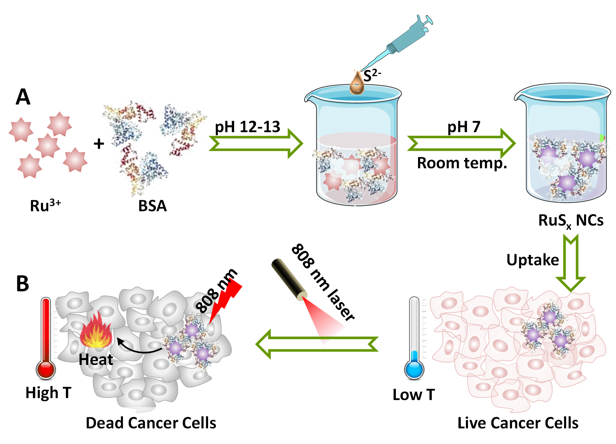
Figure 1. (A) Schematic illustration of synthesizing RuS_{x} NCs under a mild condition. (B) Illustrated description of RuS_{x} NCs for photothermal ablation of cancer cells.
RESULTS AND DISCUSSION
Synthesis and Characterization. The oxygenic hybrid ruthenium sulfide nanoclusters (RuS_{x} NCs) with a high yield were obtained via a biomineralization assisted bottom-up method.³⁹⁻⁴² This strategy was driven by a chemical reaction of Ru³⁺ and Na₂S•9H₂O (Figure 1). Bovine serum albumin (BSA) was employed as surfactant and stabilizer for controlling size growth.^{43, 44} The pH value of Ru³⁺-BSA complex solution formed from BSA with RuCl₃ •xH₂O was adjusted to be around 12-13. This high pH facilitated the decomposition of RuCl₃ •xH₂O to generate stable RuO₄²⁻. The chemical reaction mechanism can be explained as: ${4RuCl}_{3}+O_{2}+{8OH}^{-}+{2H}_{2}O→{4RuO}_{4}^{2-}+12HCl$. S²⁻ solution was subsequently introduced to the above mixture. Adjusting of pH value to 7 triggered the reaction of RuO₄²⁻ with sulfur, accompanying with the gradual change of solution color to brownish black as small sized RuS_{x} NCs. The transmission electron microscopy (TEM) images showed that RuS_{x} NCs were monodispersed with a size in the range from 4 to 7 nm (Figure 2A, Figure S1), which was further confirmed by atomic force microscopy (AFM) (Figure S2A). Such ultra-small and uniform NCs is mainly attributed to the strong multichelating effects from BSA that stemmed the growth of NCs.
To optimize the photothermal effect of NCs, the RuS_{x} NCs hybridised with different content of oxygen were prepared through varying the initial feed molar ratios of Ru²⁺ and S²⁻ (2:1, 1:1, 0.5:1, 0.25:1 and 0.17:1 and termed as RuS_{x} NCs-2, RuS_{x} NCs-1, RuS_{x} NCs-0.5, RuS_{x} NCs-0.25 and RuS_{x} NCs-0.17). To investigate the effect of initial molar ratios on stability, the sizes of RuS_{x} NCs were respectively surveyed by dynamic light scattering (DLS) in DI water and PBS. The average hydrodynamic diameters of RuS_{x} NCs gradually elevated from 7.2 to 20.4 nm and their corresponding primary size measured by TEM showed no change when the molar ratio of Ru and S decreased from 2 to 0.17, where the sizes were slightly larger as compared with that from TEM (Figure 2B and Figure S1). Such phenomena may be ascribed to more BSA chelating on the surface of RuS_{x} NCs. In addition, due to the stabilizing effect of BSA, all RuS_{x} NCs showed no size changes in DI water even after storage for at least three months. While RuS_{x} NCs-2 rapidly aggregated from ~7.2 to 2000 nm when added into PBS in 60 min. However, RuS_{x} NCs with molar ratios of Ru to S of 0.5, 0.25 and 0.17 exhibited excellent stability in PBS probably due to more BSA coating, implying its suitability for biological applications. It should be noted that the RuS_{x} NCs-1 also led to an aggregation with a slight rise in the diameters from 10.3 to 20 nm (Figure 2C).
As the initial feed molar ratio increased, the absorbance of RuS_{x} NCs was observed to slightly decrease along with observable red shifts except for the absorption peak at 274 nm (Figure 2D). Decreasing Ru amounts account for the red shifts with the unchanging peak at 274 nm due to BSA. Correspondingly, according to Tauc’s equation based on the correlation of (αћν)² and ћν, where α is absorbance, ћ represents the Planck’s constant and ν is frequency), the bandgap energy of NCs were calculated and showed a slight increase from 3.00 to 3.10 eV (Figure 2E and Figure S2B). The minor increase was caused by that sulfur defects and the incorporation of oxygen atom as n-type dopants. More oxygen incorporation resulted in more charge carriers, accompanied by bandgap narrowing. Note that the localized defect states and surface states can collectively lower the calculated optical bandgap energy. To explore the crystalline structure of RuS_{x} NCs, the X-ray diffraction (XRD) spectrum for five samples was respectively determined. As shown in Figure 2F, XRD diffraction peaks for RuS_{x} NCs were all widening, suggesting the an increasingly less crystalline structure. The exception is the slight shift of major diffraction peaks located at around 30.8° and 41.5° with index to (111) and (211) toward lower angles could be seen for all RuS_{x} NCs samples on a JCPDS card (no. 19-1107), no other diffraction patterns were observed. This implied the lattice constants were gradually enlarged with a decreasing amount of sulfur and the homogeneously defective structures of all RuS_{x} NCs.
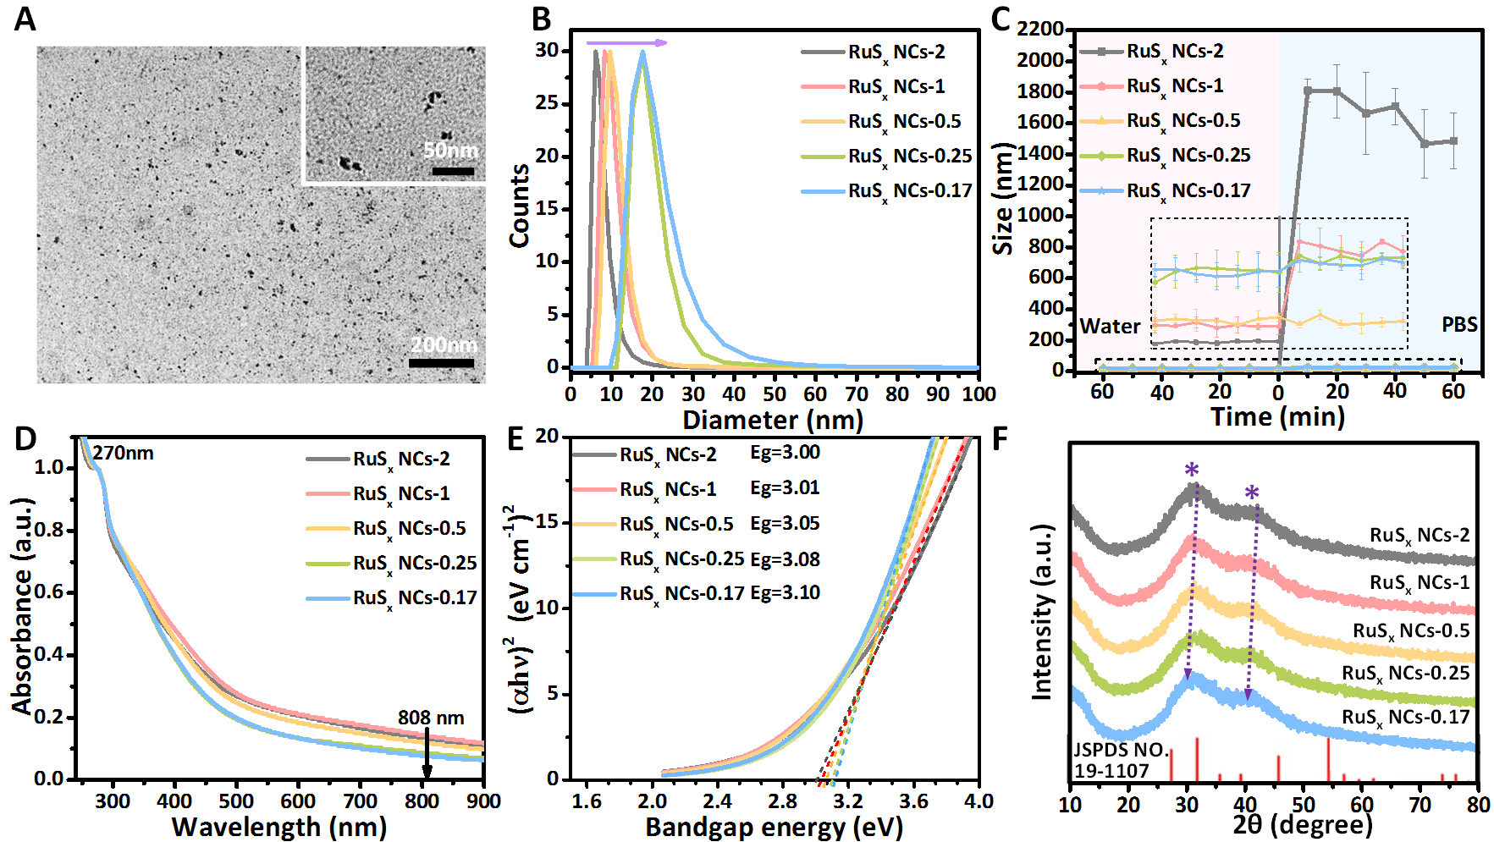
Figure 2. Synthesis and characterization of RuS_{x} NCs. (A) Representative TEM images of RuS_{x} NCs. Inset: high magnification image of RuS_{x} NCs. (B) DLS of RuS_{x} NCs with different molar ratios of Ru and S. (C) Size stability of all RuS_{x} NCs incubated in DI water and 1 × PBS (pH = 7.4) for 60 min. (D) UV–vis spectra of all RuS_{x} NCs in DI water. (E) The corresponding bandgap energy of all RuS_{x} NCs. (F) XRD spectrum of the as-synthesized RuS_{x} NCs powders on a JCPDS card (no. 19-1107).
To elucidate the chemical composition and the corresponding valence bond of elements, the X-ray photoelectron spectroscopy (XPS) for Ru, S, C and O elements in five RuS_{x} NCs samples were scanned. To understand the valence bond of Ru in the various compositions NCs, we firstly analyzed Ru 3p and Ru 3d by fitting the relative peaks. It was observed in Figure 3A (a) that the binding energy (B.E.) peaks at around 463.0 eV and 484.8 eV in Ru 3p XPS were respectively assigned to Ru 3p3/2 and Ru 2p1/2, while peak of Ru 3p3/2 in pure RuS₂ that was assigned to Ru⁴⁺ was reported to be located at 461.4 eV. Such enormous shift of Ru 3p3/2 to the higher energy binding was attributed to the attraction of Ru’s electrons by the incorporation of oxygen atoms as n-type dopants with strong electronegativity, where more electronegative oxygen atoms could produce more charge carriers and shift the B.E. peak (Table S1). Accordingly, the small two peaks at around 466.1 eV and 486.9 eV were ascribed to RuO₂, indicating the valence state of Ru from RuS_{x} NCs is 4+. The percentages of R-O in Ru 3p XPS calculated by ratio of peak area (A_{R-O}/A_{total}) were quantified to gradually decrease from 20.81 % to 18.27 % when molar ratio of Ru to S (RuS_{x}-2 to RuS_{x}-0.17) decreased from 2 to 0.17, suggesting that sulfur amount decreases led to more substitution of oxygen and created more sulfur vacancies as generalized RuO_{y}S_{3−y} (Figure 3B), offering the direct evidence of positive correlation between sulfur/oxygen atom amount and defect in RuS_{x} NCs
Simultaneously, in the high-resolution Ru 3d spectrum (Figure 3A (b)), the two representative peaks centred at 281.7eV and 285.0 eV in RuS_{x} NCs respectively corresponded to Ru 3d3/2 and Ru 3d1/2, which represented the characteristics of Ru²⁺ from RuS₂. Also, peaks at around 286.3 eV suggested the existence of RuO₃, and other two peaks located at 284.5 eV and 287.9 eV could possibly be ascribed to C-C and C=C from BSA on the surface of RuS_{x} NCs. Notably, a negative shift of Ru 3d5/2 from RuS_{x} NCs-2 was observed in comparison with that of RuS_{x} NCs-0.17, indicating the generation of sulfur vacancies through the gradual substitution of sulfur atoms with oxygen in the increasing initial feed molar ratios trend of Ru:S.
The high-resolution S 2p spectrum exhibited two representative peaks at 161.5eV and 163.7 eV, which were ascribed to S 2p3/2 and S 2p1/2 bands, respectively (Figure 3A (c)). Additionally, the peaks at 164.6 eV were observed to belong to C-S-C bond signal from RuS_{x} NCs-0.5, RuS_{x} NCs-0.25 and RuS_{x} NCs-0.17 by virtue of high amount of sulfur. The larger one or two B.E. peaks (around 166.6 and 169.3 eV) in five samples verified the existence of high valence sulfide state, implying that S could be easily oxidized during the chemical reaction process of preparing RuS_{x} NCs. Note that the peak position of S-O bond greatly shifted to the higher binding energy with decreasing molar ratios of Ru to S. A possible reason is that substitution of oxygen atom increased along with an increasing amount of sulfur vacancies during in situ RuS_{x} NCs formation. To further explore the chemical valence state and the corresponding content of oxygen element, deconvolution of these O 1s peaks was conducted in XPS of five RuS_{x} NCs samples via Gaussian fitting (Figure 3A (d)). The representative peaks at the lower binding energy ~531.4 eV (O_{I}) were ascribed to the presence of O²⁻ in a stoichiometric RuO_{y}S_{3-y} structure, whereas another representative peaks at the higher binding energy ~532.9 eV (O_{II}) were assigned to O²⁻ originated from “oxygen deficient” in RuS_{x} NCs. The percentages of O_{II} calculated by ratios of peak area (O_{II}/O_{total}) were rising with decreasing molar ratios of Ru to S in NCs: 14.43 % to 20.57 % from RuS_{x} NCs-2 to RuS_{x} NC-0.17 (Figure 3C), indicating an increase in the relative quantity of oxygen defects in RuS_{x} NCs.
In light of these combined XPS data above, the reaction pathway could be hypothesized to be $RuO_{4}^{2-}+(3-y)S^{2-}+ {(8-2y)H}^{+}→{RuO}_{y}S_{(3-y)}+ {(4-y)H}_{2}O$ (Figure 3D). The relatively lower sulfur level could contribute to the S defect in RuS_{x} NCs. With increasing molar ratio of Ru to S during RuS_{x} NCs synthesis process, this reaction was intentional limited by insufficient sulfur; residual Ru-O bonds originated from RuO₄²⁻ were subsequently employed within the RuS_{x} NCs structure, which thus created more oxygen substitutions and sulfur defects.
Figure 3. XPS analysis for all RuS_{x} NCs. (A) Ru 3p (a), Ru 3d (b), S 2p (c) and O 1s (d) XPS spectrum. (B) Relative fraction of Ru-O in Ru 3p XPS spectra, (C) O_{II} in O 1s XPS spectra. (D) Schematic illustration of the reaction pathway of RuS_{x} NCs and oxygen enriched engineering in RuS_{x} NCs as a function of precursor stoichiometry.
Investigation of Photothermal Activities. The photothermal performance of RuS_{x} NCs with various sulfur vacancies were evaluated and compared by examining the temperature increase of the sample dispersions at different concentrations under an 808 nm irradiation at the power density of 1.0 W/cm². Temperatures of all RuS_{x} NCs were elevated in a time- and concentration-dependent manner; similar to other photothermal nanomaterials. As revealed in Figure 4A, due to the high NIR absorption, all RuS_{x} NCs dispersions exhibited an fast temperature rise from room temperature of 21 °C to maxima of 65 °C; confirming the NIR-induced photothermal performance for all samples. Correspondingly, infrared thermal (IRT) imaging of all RuS_{x} NCs at concentration of 1mM was directly visualized to show time -dependent temperature increases (Figure 4B). Especially, using RuS_{x} NCs-1 as an example, the temperature quickly went up. At the concentration as low as 0.4 mM, the solution temperature of RuS_{x} NCs-1 could be arrived to 50.3 °C under continuous irradiation of an 808 nm laser for 5 min (Figure 4C), which was higher than the critical temperature (42 °C) for induction of cancer cell apoptosis. As the concentration was reached to 1mM, the temperatures can increase as high as 63.3 °C, while PBS as control only induced a little increase of temperature (1.6 °C) at the same irradiation condition. Additionally, RT imaging was further monitored to directly demonstrate the excellent photothermal conversion capability of RuS_{x} NCs-1, where high imaging intensity contrast corresponding to solution temperature was observed to increase with the RuS_{x} NCs-1 concentration and the irradiation duration increasing (Figure 4D). In the following, the satisfactory photothermal stability is the essential for an excellent photothermal nanoagent. The temperature changes of all RuS_{x} NCs (1 mM) dispersions were monitored upon irradiation circles. It was found the maximum temperature remained perfectly unchanged even after five repeated irradiation cycles (Figure 4E). In contrast, the maximum temperatures of commercial NIR photothermal agent indocyanine green (ICG) were gradually declined with an increasing irradiation circle number. This clearly suggested the excellent thermal stability of RuS_{x} NCs than that of ICG. Additionally, optical absorption of RuS_{x} NCs maintained constant while that for ICG greatly degraded upon 5 repeating irradiation circles (Figure S2C). These data further indicated the high photostability of NCs upon repeated heating, which is a key factor for practical photothermal application.
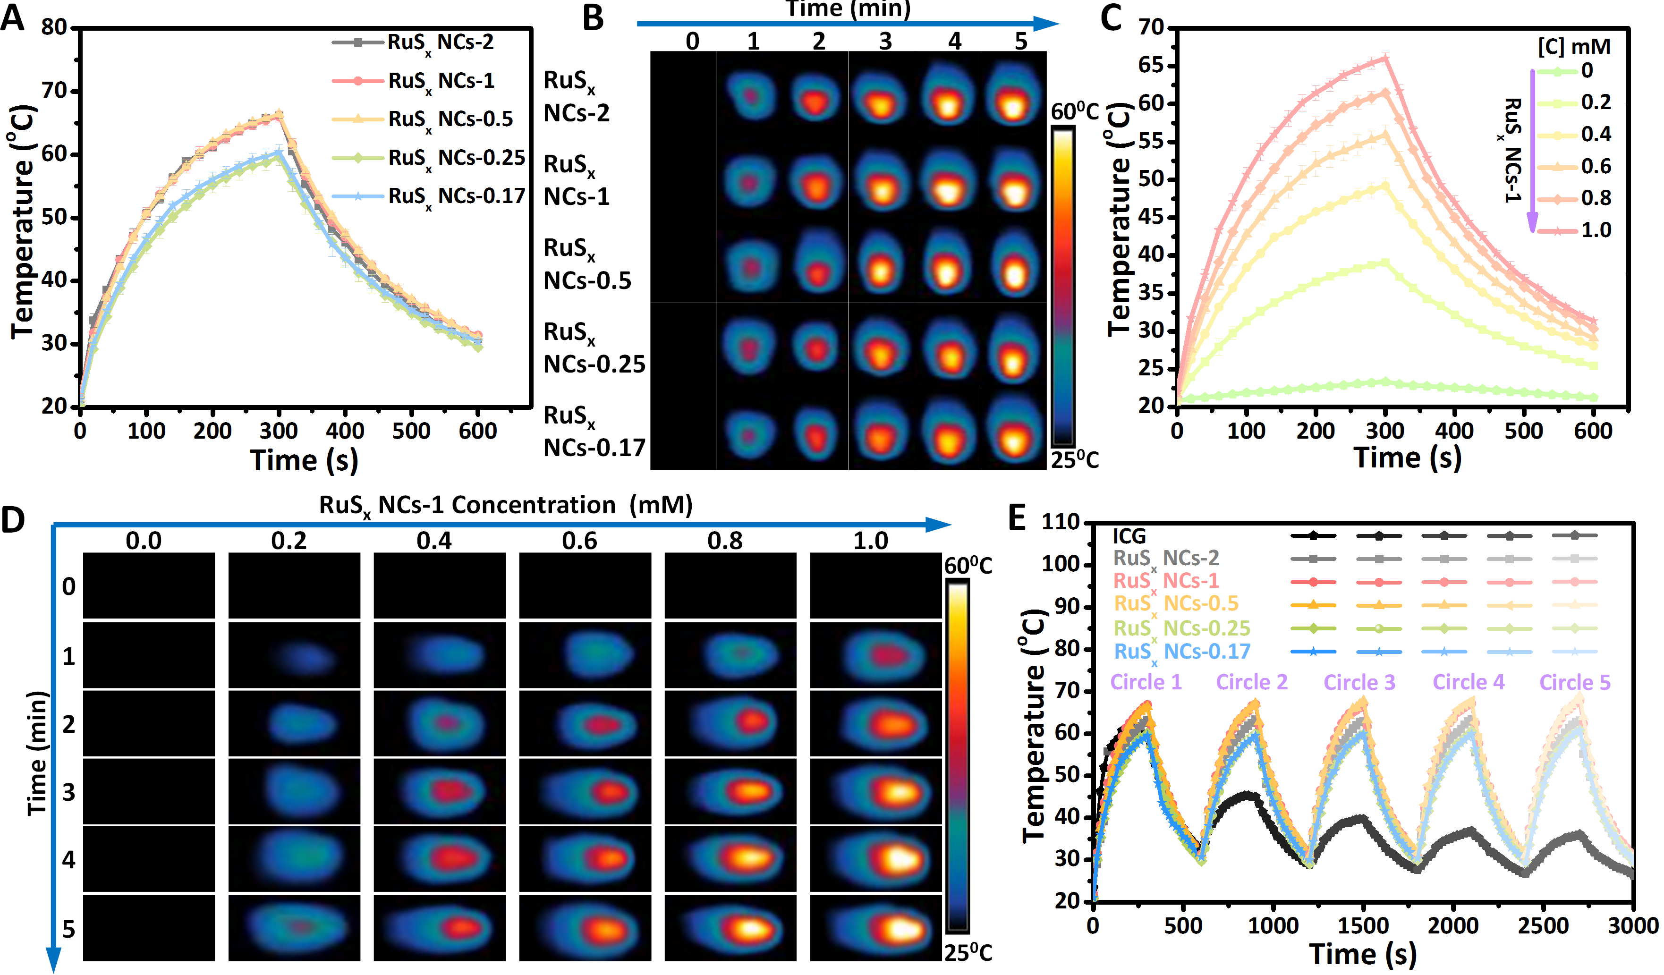
Figure 4. Photothermal effect of RuS_{x} NCs dispersions with various initial molar ratios of Ru and S. (A) Temperature elevation of RuS_{x} NCs dispersion with different molar ratios of Ru and S at the same concentration of 1mM under irradiation with an 808 nm laser (1 W/cm²) for 5 min. (B) IR thermal images of RuS_{x} NCs dispersions (1 mM) irradiated for 5 min. (C) Temperature elevation of RuS_{x} NCs-1 dispersions with varous concentrations of Ru³⁺ (0, 0.2, 0.4, o.6, 0.8 and 1.0 mM) as a functional of irradiation time (0-5 min) under the irradiation of an 808 nm laser (1.0 W/cm²). (D) IR thermal images of RuS_{x} NCs-1 at indicated concentrations and irradiated for different durations. (E) Photothermal stability study of RuS_{x} NCs solution (1 mM) and ICG solution (0.1 mM) upon photothermal heating and nature cooling cycles under 808 nm laser irradiation (1.0 W/cm²).
Besides the profound photothermal stability, high photothermal conversion efficiency (PCE) is the prerequisite for photothermal agents. The correlation between PCE and oxygen amount in RuS_{x} NCs were hypothesized and studied under physiological condition. Due to the positive correlation between PCE and absorbance at the wavelength of 808 nm, molar absorbance coefficients were firstly calculated for RuS_{x} NCs dispersions with different molar ratios. These Liner plots were found between absorbance at 808 nm and concentrations of RuS_{x} NCs, as well as the slopes enhanced with a rising molar ratio of Ru to S in NCs, implying the positive effect of oxygen content on correlation coefficients (Figure 5A). To quantitatively and accurately evaluate the photothermal conversion capability, the photothermal conversion efficiency of all RuS_{x} NCs were measured and calculated by following Roper’s method with some modifications. Typically, temperature elevation/decrease curve of all RuS_{x} NCs with the absorbance of 0.05 at 808 nm corresponding to the NIR laser on/off process were recorded in Figure 5B, where the temperature changes of RuS_{x} NCs dispersions and PBS at the equilibrium maximum temperature were represented as ΔT_{max,dis} and ΔT_{max,PBS}, respectively. Correspondingly, these system time constant τ_{s} were respectively obtained according to the correlation of the negative natural logarithm of the driving force temperature versus the linear time from the cooling period (Figure 5C). PCE of RuS_{x} NCs dispersions were calculated to decline with a decreasing oxygen amount in NCs: 41.9 % to 32.8 % from RuS_{x} NCs-2 to RuS_{x} NCs-0.17, confirming their excellent photothermal conversion performance (Figure 5D). This phenomenon appeared to be in accordance with the above calculated correlation coefficients. Inspired by these results, the underlying mechanism that governed such phenomenon is hypothesized to be associated with oxygen amounts and sulfur defects in NCs (Figure 5E). It means that the decreasing molar ratios of Ru to S in RuS_{x} NCs could lead to an ascending amount of oxygen accompanying with an increasing sulfur defect, the higher oxygen amount in RuS_{x} NCs could account for the higher PCE.
It has been widely acknowledged that photothermal agents with higher PCE could result in the inhibition of cancer cells at even a lower concentration of NCs using a NIR laser with a lower power density in a shorter irradiation time. Among all the reported inorganic nanomaterials that have been gained wide attraction and extensively applied for photothermal applications,^{34, 45-47} the high PCE of RuS_{x} NCs was close to that of typical TMD QDs such as tungsten disulfide QDs (WS₂ QDs),⁴⁸ and higher than that of most small sized nanoparticles,⁴⁹⁻⁵¹ including BSA coated silver disulfide QDs (AgS₂ QDs),⁵² black phosphorous QDs (BP QDs),⁵³ copper sulfide nanoparticles (CuS NPs),⁵⁴ carbon dots (CD),⁵⁵ suggesting the potential to be photothermal nanoagents. Additionally, such photothermal conversion efficiency was even higher than common gold nanorods (Au NRs)⁵⁶ and 2D nanosheets including molybdenum disulfide nanosheets (MoS₂ NSs)^{9, 57} and ternary chalcogenide nanosheets (Ta₂NiS₅ NSs) ⁵ (Figure 5F). This could mainly be attributed to high absorption coefficient at 808 nm and the distinct NIR absorption bands from RuS_{x} NCs. it should be noted that other Ru based nanomaterials have been also applied for photothermal therapy of tumor (Figure S3),^{31-34, 58, 59} in comparison with them, our RuS_{x} NCs exhibited ultra-small size, which could induce more passive accumulation in tumor site and metabolism through kidney, thus realizing the enhanced therapy efficiency of tumor. Also, the BSA coating endowed RuS_{x} NCs with good biocompobility and stability, improving their bioavailability in vivo. In brief, because of having this very high PCE and ultra-small size for our RuS_{x} NCs, we can achieve the same photothermal effect at lower concentrations and shorter excitation of the laser. This can greatly decrease the off target effects.
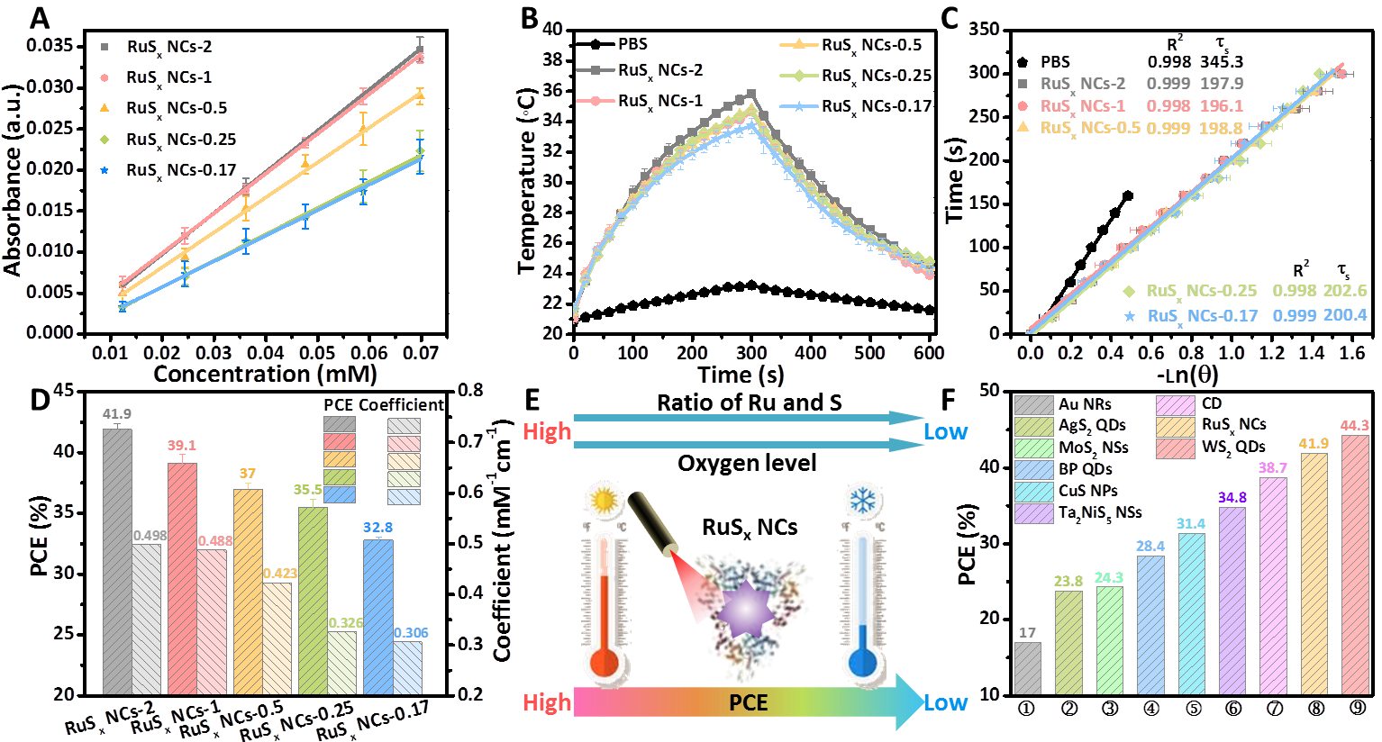
Figure 5. Oxygen enrichment enhanced PCE of RuS_{x} NCs. (A) A calibration plot for all RuS_{x} NCs concentration versus absorbance at 808 nm by applying Beer-Lambert law. (B) Temperature evaluation of PBS and all RuS_{x} NCs with the same absorbance of 0.05 at 808 nm during the irradiation for 5 min (808 nm laser, 1 W/cm²). (C) Time constant τ_{s} of (B) PBS and all RuS_{x} NCs for heat transfer by applying the linear time data from the cooling period versus negative natural logarithm of driving force temperature. (D) The comparison of PCE and molar absorbance coefficients for all RuS_{x} NCs. (E) Proposed oxygen deficiency related PCE mechanism of RuS_{x} NCs. (F) PCE of RuS_{x} NCs-2 solution in comparison with other photothermal nanoagents reported by the references, including gold nanorods (Au NRs), silver disulfide quantum dots (AgS₂ QDs), molybdenum disulfide nanosheets (MoS₂ NSs), black phosphorous quantum dots (BP QDs), copper sulfide nanoparticles (CuS NPs), ternary chalcogenide nanosheets (Ta₂NiS₅ NSs), carbon dots (CD), and tungsten disulfide quantum dots (WS₂ QDs).
In Vitro Cytotoxicity and PTT. To evaluate the suitable of RuS_{x} NCs as photothermal nanoagents in biomedical applications, we investigated the intrinsic cytotoxicity of RuS_{x} NCs against human epidermoid carcinoma cell lines (A431 cells) and epithelial human breast cancer cell lines (MDA-MB-231 cells) (Figure 6A and B). After incubating with RuS_{x} NCs dispersions at various concentrations for 24 h (but without irradiation), it was observed that the cell viability of all RuS_{x} NCs groups remained at least 90 % or higher even at high concentrations of 1.0 mM, suggesting low intrinsic toxicity of RuS_{x} NCs. This may be caused by BSA modification on the surface of NCs which could greatly improve the cytocompatibility of nanomaterials. This result verified the fact that biological activity of nanomaterials was closely linked to the chemical property on their surface. Note that NCs could traverse the cell membrane and be taken up via endocytosis like other nanoparticles, while pinocytosis dominated the uptake process due to the ultra-small size of NCs. Additionally, by virtue of the high PCE and superior photothermal stability of RuS_{x} NCs, the PTT efficacy on ablating cancer cells was then validated using RuS_{x} NCs-1 as an example. A431 cells were incubated with RuS_{x} NCs-1 at different concentrations for 24 h, and then exposed to 808nm-laser for 5 min. Subsequently; the cell viabilities were quantitatively measured. Notably, under NIR laser irradiation, the cell viabilities were decreased with an increasing concentration of NCs (Figure 6C). In particular, when incubating with RuS_{x} NCs-1 at concentration of 1 mM, around 70 % of cancer cells were ablated. Note that no significant cytotoxicity to A431 cells without NCs treatment was observed even at the same irradiated condition. To further identify photothermal therapeutic efficacy of NCs in vitro, the fluorescence imaging of cancer cells was conducted after different treatments (Figure 6D and Figure S4). The cell status was qualitatively investigated by staining calcein AM green fluorescence) and propidium iodide (PI, red fluorescence), which was respectively applied to differentiate live and dead cells. After irradiating for 5 min by an 808 nm laser at power density of 1 W/cm², red fluorescent spots in the cells became more pronounced and more so at higher concentrations of NCs. In contrast, cells with NCs treatment alone and without laser irradiation showed only green fluorescence, indicating either NCs incubation or NIR laser irradiation caused no effect on cells. Correspondingly, the average red fluorescence intensity and green fluorescence intensity in fluorescence images were quantified, and their ratios were observed to substantially elevate with an increasing amount of NCs. Especially, such ratio reached to about 105-fold higher than the control when the concentration was 1 mM. These results verified that the RuS_{x} NCs possessed higher photothermal effect, presenting powerful novel photothermal nanoagent against cancer cells. Additionally, it should be noted that RuS_{x} NCs exhibited good degradation observed in Figure S5, which could be decomposed to Ru ions that was easily excreted after therapy, thus reducing biogenic accumulation in the body with lowered the systemic side effects.
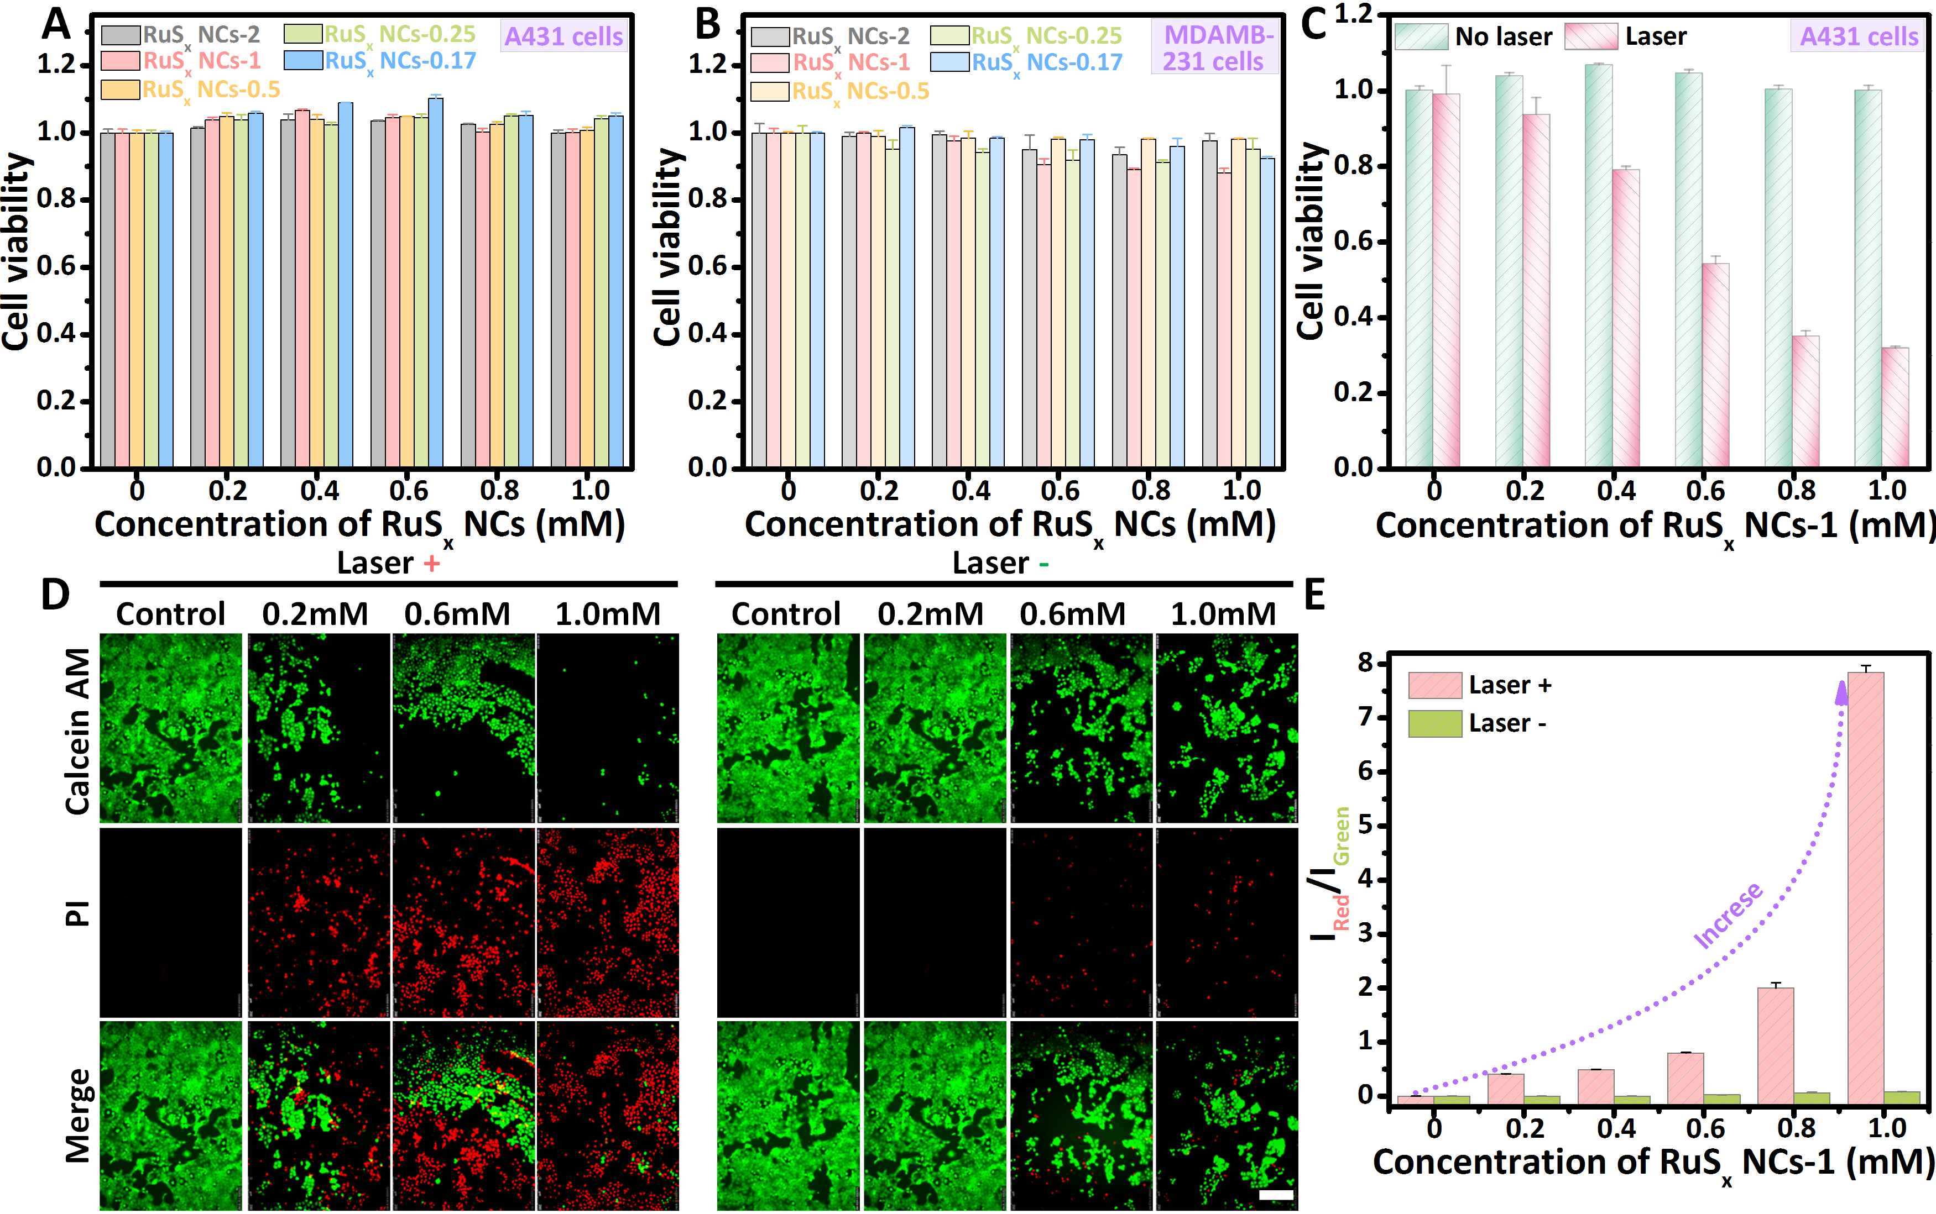
Figure 6. In vitro cell cytotoxicity and photothermal cytotoxicity. Cell viability of (A) A431 cells and (B) MDA-MB-231 cells incubated with various RuS_{x} NCs at different concentration (0-1.0 mM) for 24 h. (C) Photothermal ablation of A431 cells incubated with different concentrations of RuS_{x} NCs-1 solution under 808 nm laser irradiation for 5min. Error bars were based on the standard deviations (SD) of three parallel samples. (D) Fluorescence images of Calcein AM/PI co-stained A431 cells incubated with RuS_{x} NCs-1 (0, 0.2, 0.6, 1.0 mM) under the same irradiation conditions used in (C). Calcein AM and PI were applied to stain live and dead cells and respectively expressed in green and red colors in the images, scar bar: 250 μm. (E) Comparison of red to green fluorescent intensity ratios of A431 cells stained by PI and Calcein AM in (D).
Conclusions
All in all, we demonstrated the biomineralization assisted bottom-up approach to develop a series of RuS_{x} NCs with controllable oxygen amount and sulfur defect for optimized photothermal cancer therapy. This method employed in situ chemical reaction of Ru cations and S anions under assistance of BSA with a high yield and within short times. Though this chemical reaction, oxygen enriched RuS_{x} NCs were synthesized via controlling the reaction molar ratio of Ru to S. Such as-prepared RuS_{x} NCs exhibited the photothermal conversion efficacy (PCE) as high as 41.9 % by virtue of their high and featured absorbance in the NIR region. RuS_{x} NCs was able to convert NIR light into heat more efficiently, reaching higher photothermal temperature as compared with most other inorganic nanoagents. Photothermal stability of RuS_{x} NCs was observed relative to commercial ICG, paving their way for a possible cancer therapy. Strongly positive correlation between oxygen amount/sulfur defects and photothermal effect could be observed in the as-synthesized RuS_{x} NCs. With increasing oxygen amount/sulfur defects, PCE of RuS_{x} NCs decreased from 41.9 % to 32.8 %. Such oxygen enriched photothermal properties of RuS_{x} NCs resulted in significantly amplified photothermal inhibition of cancer cells. Thereby, our study not only introduced in situ synthetic method to develop a class of RuS_{x} NCs based nanoagents but also created alternative design guidelines to tune PTT performance according the specific clinical needs.
METHOD
Materials. All chemicals and reagents were used as received without any further purification. RuCl₃•xH₂O, Na₂S•9H₂O and bovine serum album (BSA) were purchased from Sigma-Aldrich Co. (USA). Deionized water was used throughout the synthesis.
Characterization. The morphologies of RuS_{x} NCs samples were characterized by TEM (FE-TEM; JEOL JEM-2100F, Japan). Nanoparticle sizes were determined by measuring no < 200 randomly selected nanoparticles from TEM micrographs with ImageJ. Atomic force microscope (AFM) image was recorded on an atomic force microscopy (MFP-3D, Asylum Research) in tapping mode under ambient conditions. The elemental composition and binding energy of the samples were characterized by X-ray photoelectron spectroscopy (XPS; AXIS HIS, Kratos Analytical). The powder XRD measurements were performed using a Bruker D8 advanced diffractometer with a Cu Ka irradiation in the 2θ range of 200-600. Dynamic light scattering (DLS) measurements were performed at room temperature with a Zetasizer Nano ZS (Malvern Instruments). The recorded intensity autocorrelation function was transformed into number functions to investigate particle size distribution. The concentrations of metal ions were measured using inductively coupled plasmaoptical emission spectrometry (ICP, JY 200-2 HORIBA Scientific). UV−vis spectra were recorded on a Shimadzu UV-2450 spectrophotometer. An 808 nm high power NIR Laser (operating mode, CW; output power after fiber, 2.5 W; LED display, diode current, multimode fiber; fiber core diameter, 400 µm; fiber connector, SMA905, with tunable laser driver module of 0%–100%) purchased from CNI Co., Ltd. was used for PTT experiments. The laser spot size was 1 cm². The laser power was measured by laser power meter. The temperature was recorded by an IR thermal (IRT) camera (DT-8891E Shenzhen Everbest Machinery Industry Co., Ltd., China) every 20 s. Fluorescence imaging was conducted with inverted fluorescence microscope (Leica DMI6000, Germany) and the phase contrast images were captured by inverted microscope (Olympus-CX41, Japan).
Synthesis of RuS_{x} NCs. In a typical procedure, RuCl₃•xH₂O solution (0.1 M) and 40 mg BSA was firstly dispersed into 40 mL DI water to prepare the Ru-precursor solution, following by adjusting pH value of the mixture to above 12 using 1 M HCl. Then, 0.5 M Na₂S•9H₂O was dropped slowly under vigorous stirring at room temperature. Subsequently, a brownish black solution containing RuS_{x} NCs was quickly generated after adjusting pH value to neutral. To purify the as-prepared RuS_{x} NCs, ultrafiltration centrifuge tube (MWCO 5000) was used and centrifuged in 4 °C for several times. The concentration of RuS_{x} NCs was measured by ICP. Also, RuS_{x} NCs with different sulfur vacancies was prepared by adjusting the molar ratios of RuCl₃•xH₂O and Na₂S•9H₂O solution.
Photothermal Effect of RuS_{x} NCs. To measure the photothermal performance of RuS_{x} NCs with various oxygen amounts, the temperature of aqueous dispersion were monitored at different concentrations (0, 0.2, 0.4, 0.6, 1 mM). In brief, 0.2 mL of sample dispersion in small tubes was irradiated with an 808 nm laser (1.0 W/cm²), and their temperature was recorded every 20 s for 5 min by using an IR thermal camera, then turned off the laser and recorded the temperature declining process of the samples.
To investigate the photothermal conversion efficiency (PCE) of all RuS_{x} NCs, the dispersion (absorbance at 808 nm: 0.05) was exposed to NIR laser for 5min. After switching off the laser, the temperature was further monitored for another 5 min. The photothermal conversion efficiency (η) was then calculated according to the following equations.
$$η=\frac{hS\left(T_{max}-T_{sur}\right)-Q_{dis}}{I(1-{10}^{-A_{808}})}$$
η is the photothermal conversion efficiency, T_{sur} is the surrounding temperature. T_{max} is the equilibrium temperature for solution, Q_{dis} is the heat loss. I is the incident laser power, and A is the absorbance of RuS_{x} NCs solution at 808 nm.
$$τ_{s}=\frac{m_{D}C_{D}}{hs}$$
m_{D} is the mass of solvent (0.2 g) and C_{D} is the heat capacity [4.2 × 10³ J/ (kg ºC)]. τ_{s} is the sample system time constant.
To evaluate the photothermal stability of all RuS_{x} NCs samples, different sample dispersions (1 mM) were irradiated with the NIR laser for 5 min, and then the laser was off to cool these samples for another 5 min. Such on-off irradiation cycle was repeated five times. 0.1 mM of ICG solution was chosen and tested as control.
In Vitro Cytotoxicity Assay of RuS_{x} NCs. The in vitro cytotoxicity was monitored using Alamar Blue viability assay in epithelial Human breast cancer cell lines (MDA-MB-231 cells) and Human epidermoid carcinoma cell lines (A431 cells). The MDA-MB-231 cells and A431 cells were cultured in Dulbecco’s Modified Eagle Medium (DMEM) containing 10 % fetal bovine serum in a humidified environment containing 5 % CO₂ and 95 % air at 37 °C. MDA-MB-231 cells and A431 cells were respectively seeded in 96-well plates (Costar, IL, USA) at an intensity of 3 × 10⁴ cells/mL. After overnight incubation, the medium was replaced by fresh medium containing different RuS_{x} NCs suspensions at various concentrations, and the cells were then incubated for 24 h. After the designated time intervals, the Alamar Blue reagent was added into cell culture medium in 1 to 10 volume ratio for cell incubation. Cell metabolism reaction of the Alamar Blue reagent after 3 h in an 37ºC incubator through fluorescent measurement (Ex.: 560 nm, Em.: 590 nm). The cell survival efficiency was obtained through normalizing against untreated samples to the cell viability.
In Vitro Photothermal Ablation of Cancer Cells with RuS_{x} NCs. To evaluate photothermal effect of RuS_{x} NCs on cancer cells, RuS_{x} NCs-1 was chosen as test modal. The A431 cells were seeded and cultured on a 24-well plate at a density of 2.5 × 10⁵ cells per well at 37.0 °C with the growth DMEM medium under a humid atmosphere containing 5 % CO₂. After incubating for 24 h, A431 cells were firstly exposed to various concentrations of RuS_{x} NCs-1 for 24 h under a NIR laser irradiation (1.0, W/cm²) for 5 min. Relative cell viabilities were determined by the standard Alamar Blue assay mentioned above. In order to further explore in vitro PTT effect, A431 cells seeded into 8-well plates were incubated with different concentrations of RuS_{x} NCs-1 for 24 h and subsequently irradiated by an 808 nm laser at the power density of 1.0 W/cm² for 5 min. The cells were stained with Calcein AM and PI for 30 min, washed with PBS, and then imaged.
ASSOCIATED CONTENT
Supporting Information. Figure S1-5 consisted of in vitro characterization of nanoparticles including TEM, AFM, XPS analysis, Tyndall effect and bandgap energy measurements of RuS_{x} NCs solution, solution color change of ICG against laser irradiation and fluorescence imaging of Calcein AM/PI co-stained A431 cells incubated with RuS_{x} NCs with and without NIR laser irradiation. These supplementary information are available online.
AUTHOR INFORMATION
Corresponding Author
David Tai Leong- Department of Chemical and Biomolecular Engineering, Faculty of Engineering, National University of Singapore, Singapore 117585, Singapore. Email: cheltwd@nus.edu.sg
Houjuan Zhu-Department of Chemical and Biomolecular Engineering, Faculty of Engineering, National University of Singapore, Singapore 117585, Singapore. Institute of Materials Research and Engineering, A*STAR (Agency for Science, Technology and Research), Singapore 138634, Singapore. Email: zhu_houjuan@imre.a-star.edu.sg
Author
Zibao Li- Institute of Materials Research and Engineering, A*STAR (Agency for Science, Technology and Research), Singapore 138634, Singapore.
Enyi Ye- Institute of Materials Research and Engineering, A*STAR (Agency for Science, Technology and Research), Singapore 138634, Singapore.
Author Contributions
The manuscript was written through contributions of all authors. All authors have given approval to the final version of the manuscript.
Notes
The authors declare no competing financial interest
ACKNOWLEDGMENT
This work was supported by the National Environment Agency, Singapore and the Agency of Science, Technology, and Research (A∗STAR). We acknowledge the funding provided by the National Research Foundation, Prime Minister’s Oﬃce, Singapore, under Competitive Research Program (Award No. NRFCRP13-2014-03).
REFERENCES
[1] Mitsunaga M., Ogawa M., Kosaka N., Rosenblum L. T., Choyke P. L., Kobayashi H.; Cancer cell-selective in vivo near infrared photoimmunotherapy targeting specific membrane molecules. Nat Med 2011, 17, 1685-1691.
[2] Ng K. K., Zheng G.; Molecular Interactions in Organic Nanoparticles for Phototheranostic Applications. Chem Rev 2015, 115, 11012-11042.
[3] Tao W., Ji X., Xu X., Islam M. A., Li Z., Chen S., Saw P. E., Zhang H., Bharwani Z., Guo Z., Shi J., Farokhzad O. C.; Antimonene Quantum Dots: Synthesis and Application as Near-Infrared Photothermal Agents for Effective Cancer Therapy. Angew Chem Int Ed Engl 2017, 56, 11896-11900.
[4] Zhu H., Li J., Qi X., Chen P., Pu K.; Oxygenic Hybrid Semiconducting Nanoparticles for Enhanced Photodynamic Therapy. Nano Lett 2018, 18, 586-594.
[5] Zhu H., Fang Y., Miao Q., Qi X., Ding D., Chen P., Pu K.; Regulating Near-Infrared Photodynamic Properties of Semiconducting Polymer Nanotheranostics for Optimized Cancer Therapy. ACS Nano 2017, 11, 8998-9009.
[6] Huang P., Lin J., Wang X., Wang Z., Zhang C., He M., Wang K., Chen F., Li Z., Shen G., Cui D., Chen X.; Light-triggered theranostics based on photosensitizer-conjugated carbon dots for simultaneous enhanced-fluorescence imaging and photodynamic therapy. Adv Mater 2012, 24, 5104-5110.
[7] Zhu H., Xie C., Chen P., Pu K.; Organic Nanotheranostics for Photoacoustic Imaging-Guided Phototherapy. Curr Med Chem 2019, 26, 1389-1405.
[8] Sun X., Ni N., Ma Y., Wang Y., Leong D. T.; Retooling Cancer Nanotherapeutics' Entry into Tumors to Alleviate Tumoral Hypoxia. Small 2020, 16, e2003000.
[9] Zhu H., Lai Z., Fang Y., Zhen X., Tan C., Qi X., Ding D., Chen P., Zhang H., Pu K.; Ternary Chalcogenide Nanosheets with Ultrahigh Photothermal Conversion Efficiency for Photoacoustic Theranostics. Small 2017, 13,
[10] Zhu H., Cheng P., Chen P., Pu K.; Recent progress in the development of near-infrared organic photothermal and photodynamic nanotherapeutics. Biomater Sci 2018, 6, 746-765.
[11] Hu D., Zhang J., Gao G., Sheng Z., Cui H., Cai L.; Indocyanine Green-Loaded Polydopamine-Reduced Graphene Oxide Nanocomposites with Amplifying Photoacoustic and Photothermal Effects for Cancer Theranostics. Theranostics 2016, 6, 1043-1052.
[12] Huang P., Rong P., Jin A., Yan X., Zhang M. G., Lin J., Hu H., Wang Z., Yue X., Li W., Niu G., Zeng W., Wang W., Zhou K., Chen X.; Dye-loaded ferritin nanocages for multimodal imaging and photothermal therapy. Adv Mater 2014, 26, 6401-6408.
[13] Chatterjee D. K., Fong L. S., Zhang Y.; Nanoparticles in photodynamic therapy: an emerging paradigm. Adv Drug Deliv Rev 2008, 60, 1627-1637.
[14] Ning L., Zhu B., Gao T.; Gold Nanoparticles: Promising Agent to Improve the Diagnosis and Therapy of Cancer. Curr Drug Metab 2017, 18, 1055-1067.
[15] Zhu H., Ni N., Govindarajan S., Ding X., Leong D. T.; Phototherapy with layered materials derived quantum dots. Nanoscale 2020, 12, 43-57.
[16] Zhu J., Sevencan C., Zhang M., McCoy R. S. A., Ding X., Ye J., Xie J., Ariga K., Feng J., Bay B. H., Leong D. T.; Increasing the Potential Interacting Area of Nanomedicine Enhances Its Homotypic Cancer Targeting Efficacy. ACS Nano 2020, 14, 3259-3271.
[17] Shao X., Ding Z., Zhou W., Li Y., Li Z., Cui H., Lin X., Cao G., Cheng B., Sun H., Li M., Liu K., Lu D., Geng S., Shi W., Zhang G., Song Q., Chen L., Wang G., Su W., Cai L., Fang L., Leong D. T., Yu X. F., Li H.; Intrinsic bioactivity of black phosphorus nanomaterials on mitotic centrosome destabilization through suppression of PLK1 kinase. Nat Nanotechnol 2021, 16, 1150-1160.
[18] Chhowalla M., Shin H. S., Eda G., Li L. J., Loh K. P., Zhang H.; The chemistry of two-dimensional layered transition metal dichalcogenide nanosheets. Nat Chem 2013, 5, 263-275.
[19] Ding X., Peng F., Zhou J., Gong W., Slaven G., Loh K. P., Lim C. T., Leong D. T.; Defect engineered bioactive transition metals dichalcogenides quantum dots. Nat Commun 2019, 10, 41.
[20] Li B. L., Setyawati M. I., Zou H. L., Dong J. X., Luo H. Q., Li N. B., Leong D. T.; Emerging 0D Transition-Metal Dichalcogenides for Sensors, Biomedicine, and Clean Energy. Small 2017, 13, 1700527.
[21] Lopez-Sanchez O., Lembke D., Kayci M., Radenovic A., Kis A.; Ultrasensitive photodetectors based on monolayer MoS2. Nat Nanotechnol 2013, 8, 497-501.
[22] Yu F., Liu Q., Gan X., Hu M., Zhang T., Li C., Kang F., Terrones M., Lv R.; Ultrasensitive Pressure Detection of Few-Layer MoS2. Adv Mater 2017, 29, 1603266.
[23] Liu C., Kong D., Hsu P. C., Yuan H., Lee H. W., Liu Y., Wang H., Wang S., Yan K., Lin D., Maraccini P. A., Parker K. M., Boehm A. B., Cui Y.; Rapid water disinfection using vertically aligned MoS2 nanofilms and visible light. Nat Nanotechnol 2016, 11, 1098-1104.
[24] Bonaccorso F., Colombo L., Yu G., Stoller M., Tozzini V., Ferrari A. C., Ruoff R. S., Pellegrini V.; 2D materials. Graphene, related two-dimensional crystals, and hybrid systems for energy conversion and storage. Science 2015, 347, 1246501.
[25] Zhu X., Ji X., Kong N., Chen Y., Mahmoudi M., Xu X., Ding L., Tao W., Cai T., Li Y., Gan T., Barrett A., Bharwani Z., Chen H., Farokhzad O. C.; Intracellular Mechanistic Understanding of 2D MoS2 Nanosheets for Anti-Exocytosis-Enhanced Synergistic Cancer Therapy. ACS Nano 2018, 12, 2922-2938.
[26] Liu B., Li C., Chen G., Deng X., Wei Y., Xia J., Xing B., Ma P., Lin J.; Synthesis and Optimization of MoS₂@Fe₃O₄-ICG/Pt(IV) Nanoflowers for MR/IR/PA Bioimaging and Combined PTT/PDT/Chemotherapy Triggered by 808 nm Laser. Adv Sci (Weinh) 2017, 4, 1600540.
[27] Coleman J. N., Lotya M., O'Neill A., Bergin S. D., King P. J., Khan U., Young K., Gaucher A., De S., Smith R. J., Shvets I. V., Arora S. K., Stanton G., Kim H. Y., Lee K., Kim G. T., Duesberg G. S., Hallam T., Boland J. J., Wang J. J., Donegan J. F., Grunlan J. C., Moriarty G., Shmeliov A., Nicholls R. J., Perkins J. M., Grieveson E. M., Theuwissen K., McComb D. W., Nellist P. D., Nicolosi V.; Two-dimensional nanosheets produced by liquid exfoliation of layered materials. Science 2011, 331, 568-571.
[28] Zhou J., Lin J., Huang X., Zhou Y., Chen Y., Xia J., Wang H., Xie Y., Yu H., Lei J., Wu D., Liu F., Fu Q., Zeng Q., Hsu C. H., Yang C., Lu L., Yu T., Shen Z., Lin H., Yakobson B. I., Liu Q., Suenaga K., Liu G., Liu Z.; A library of atomically thin metal chalcogenides. Nature 2018, 556, 355-359.
[29] Eda G., Yamaguchi H., Voiry D., Fujita T., Chen M., Chhowalla M.; Photoluminescence from chemically exfoliated MoS2. Nano Lett 2011, 11, 5111-5116.
[30] Li Y., Tang H., Zhu H., Kakinen A., Wang D., Andrikopoulos N., Sun Y., Nandakumar A., Kwak E., Davis T. P., Leong D. T., Ding F., Ke P. C.; Ultrasmall Molybdenum Disulfide Quantum Dots Cage Alzheimer's Amyloid Beta to Restore Membrane Fluidity. ACS Appl Mater Interfaces 2021, 13, 29936-29948.
[31] Liu Y., Lin A., Liu J., Chen X., Zhu X., Gong Y., Yuan G., Chen L.; Enzyme-Responsive Mesoporous Ruthenium for Combined Chemo-Photothermal Therapy of Drug-Resistant Bacteria. ACS Appl Mater Interfaces 2019, 11, 26590-26606.
[32] Huang X., Chen G., Pan J., Chen X., Huang N., Wang X., Liu J.; Effective PDT/PTT dual-modal phototherapeutic killing of pathogenic bacteria by using ruthenium nanoparticles. J Mater Chem B 2016, 4, 6258-6270.
[33] Zhao S., Zhu X., Cao C., Sun J., Liu J.; Transferrin modified ruthenium nanoparticles with good biocompatibility for photothermal tumor therapy. J Colloid Interface Sci 2018, 511, 325-334.
[34] Zhu X., Gong Y., Liu Y., Yang C., Wu S., Yuan G., Guo X., Liu J., Qin X.; Ru@CeO₂ yolk shell nanozymes: Oxygen supply in situ enhanced dual chemotherapy combined with photothermal therapy for orthotopic/subcutaneous colorectal cancer. Biomaterials 2020, 242, 119923.
[35] Pu Z., Amiinu I. S., Kou Z., Li W., Mu S.; RuP2 -Based Catalysts with Platinum-like Activity and Higher Durability for the Hydrogen Evolution Reaction at All pH Values. Angew Chem Int Ed Engl 2017, 56, 11559-11564.
[36] Yu J., Guo Y., Miao S., Ni M., Zhou W., Shao Z.; Spherical Ruthenium Disulfide-Sulfur-Doped Graphene Composite as an Efficient Hydrogen Evolution Electrocatalyst. ACS Appl Mater Interfaces 2018, 10, 34098-34107.
[37] Su J., Yang Y., Xia G., Chen J., Jiang P., Chen Q.; Ruthenium-cobalt nanoalloys encapsulated in nitrogen-doped graphene as active electrocatalysts for producing hydrogen in alkaline media. Nat Commun 2017, 8, 14969.
[38] Deng J., Deng D., Bao X.; Robust Catalysis on 2D Materials Encapsulating Metals: Concept, Application, and Perspective. Adv Mater 2017, 29, 1606967.
[39] Zou Q., Abbas M., Zhao L., Li S., Shen G., Yan X.; Biological Photothermal Nanodots Based on Self-Assembly of Peptide-Porphyrin Conjugates for Antitumor Therapy. J Am Chem Soc 2017, 139, 1921-1927.
[40] Sun H., Chang R., Zou Q., Xing R., Qi W., Yan X.; Supramolecular Protein Nanodrugs with Coordination- and Heating-Enhanced Photothermal Effects for Antitumor Therapy. Small 2019, 15, e1905326.
[41] Xing R., Zou Q., Yuan C., Zhao L., Chang R., Yan X.; Self-Assembling Endogenous Biliverdin as a Versatile Near-Infrared Photothermal Nanoagent for Cancer Theranostics. Adv Mater 2019, 31, e1900822.
[42] Zhao L., Liu Y., Xing R., Yan X.; Supramolecular Photothermal Effects: A Promising Mechanism for Efficient Thermal Conversion. Angew Chem Int Ed Engl 2020, 59, 3793-3801.
[43] Dong Z., Feng L., Hao Y., Chen M., Gao M., Chao Y., Zhao H., Zhu W., Liu J., Liang C., Zhang Q., Liu Z.; Synthesis of Hollow Biomineralized CaCO₃-Polydopamine Nanoparticles for Multimodal Imaging-Guided Cancer Photodynamic Therapy with Reduced Skin Photosensitivity. J Am Chem Soc 2018, 140, 2165-2178.
[44] Wang Z., Huang P., Jacobson O., Liu Y., Lin L., Lin J., Lu N., Zhang H., Tian R., Niu G., Liu G., Chen X.; Biomineralization-Inspired Synthesis of Copper Sulfide-Ferritin Nanocages as Cancer Theranostics. ACS Nano 2016, 10, 3453-3460.
[45] Liu J., Zheng X., Yan L., Zhou L., Tian G., Yin W., Wang L., Liu Y., Hu Z., Gu Z., Chen C., Zhao Y.; Bismuth sulfide nanorods as a precision nanomedicine for in vivo multimodal imaging-guided photothermal therapy of tumor. ACS Nano 2015, 9, 696-707.
[46] Wang F., Sun Q., Feng B., Xu Z., Zhang J., Xu J., Lu L., Yu H., Wang M., Li Y., Zhang W.; Polydopamine-Functionalized Graphene Oxide Loaded with Gold Nanostars and Doxorubicin for Combined Photothermal and Chemotherapy of Metastatic Breast Cancer. Adv Healthc Mater 2016, 5, 2227-2236.
[47] Zan M., Li J., Huang M., Lin S., Luo D., Luo S., Ge Z.; Near-infrared light-triggered drug release nanogels for combined photothermal-chemotherapy of cancer. Biomater Sci 2015, 3, 1147-1156.
[48] Yong Y., Cheng X., Bao T., Zu M., Yan L., Yin W., Ge C., Wang D., Gu Z., Zhao Y.; Tungsten Sulfide Quantum Dots as Multifunctional Nanotheranostics for In Vivo Dual-Modal Image-Guided Photothermal/Radiotherapy Synergistic Therapy. ACS Nano 2015, 9, 12451-12463.
[49] Ouyang J., Feng C., Ji X., Li L., Gutti H. K., Kim N. Y., Artzi D., Xie A., Kong N., Liu Y. N., Tearney G. J., Sui X., Tao W., Farokhzad O. C.; 2D Monoelemental Germanene Quantum Dots: Synthesis as Robust Photothermal Agents for Photonic Cancer Nanomedicine. Angew Chem Int Ed Engl 2019, 58, 13405-13410.
[50] Yu X., Cai X., Cui H., Lee S. W., Yu X. F., Liu B.; Fluorine-free preparation of titanium carbide MXene quantum dots with high near-infrared photothermal performances for cancer therapy. Nanoscale 2017, 9, 17859-17864.
[51] Li X., Liu Z., Luo K., Yin X., Lin X., Zhu C.; Biomimetic Synthesis of Ag₂Se Quantum Dots with Enhanced Photothermal Properties and as "Gatekeepers" to Cap Mesoporous Silica Nanoparticles for Chemo-Photothermal Therapy. Chem Asian J 2019, 14, 155-161.
[52] Zhao D. H., Yang J., Xia R. X., Yao M. H., Jin R. M., Zhao Y. D., Liu B.; High quantum yield Ag₂S quantum dot@polypeptide-engineered hybrid nanogels for targeted second near-infrared fluorescence/photoacoustic imaging and photothermal therapy. Chem Commun (Camb) 2018, 54, 527-530.
[53] Sun Z., Xie H., Tang S., Yu X. F., Guo Z., Shao J., Zhang H., Huang H., Wang H., Chu P. K.; Ultrasmall Black Phosphorus Quantum Dots: Synthesis and Use as Photothermal Agents. Angew Chem Int Ed Engl 2015, 54, 11526-11530.
[54] Huang Y., Lai Y., Shi S., Hao S., Wei J., Chen X.; Copper sulfide nanoparticles with phospholipid-PEG coating for in vivo near-infrared photothermal cancer therapy. Chem Asian J 2015, 10, 370-376.
[55] Zheng M., Li Y., Liu S., Wang W., Xie Z., Jing X.; One-Pot To Synthesize Multifunctional Carbon Dots for Near Infrared Fluorescence Imaging and Photothermal Cancer Therapy. ACS Appl Mater Interfaces 2016, 8, 23533-23541.
[56] Wang B., Wang J. H., Liu Q., Huang H., Chen M., Li K., Li C., Yu X. F., Chu P. K.; Rose-bengal-conjugated gold nanorods for in vivo photodynamic and photothermal oral cancer therapies. Biomaterials 2014, 35, 1954-1966.
[57] Yin W., Yan L., Yu J., Tian G., Zhou L., Zheng X., Zhang X., Yong Y., Li J., Gu Z., Zhao Y.; High-throughput synthesis of single-layer MoS2 nanosheets as a near-infrared photothermal-triggered drug delivery for effective cancer therapy. ACS Nano 2014, 8, 6922-6933.
[58] Zhu X., Chen X., Huo D., Cen J., Jia Z., Liu Y., Liu J.; A hybrid nanozymes in situ oxygen supply synergistic photothermal/chemotherapy of cancer management. Biomater Sci 2021, 9, 5330-5343.
[59] Zhang P., Wang J., Huang H., Qiu K., Huang J., Ji L., Chao H.; Enhancing the photothermal stability and photothermal efficacy of AuNRs and AuNTs by grafting with Ru(ii) complexes. J Mater Chem B 2017, 5, 671-678.

BRIEFS : Table of Contents.
Oxygenic hybrid ruthenium sulfide nanoclusters were synthesized by a facile biomineralization assisted bottom-up strategy for photothermal therapy. Their photothenrmal effect could be enhanced by regulating sulfur defect based on this method.
