Hydrochromic Xanthylium Cations with Tuneable Colour and High Moisture-Sensitivity for Potential Smart Packaging
Ming Hui Chua ^{a, b},* Xiang Yun Debbie Soo ^{b}, Kang Le Osmund Chin ^{a, b}, Zhuang Mao Png ^{a, b}, Qiang Zhu ^{a,b, *}, Jianwei Xu ^{a, b, c} *
ª Institute of Sustainability for Chemicals, Energy and Environment (ISCE²), Agency for Science, Technology and Research (A*STAR), 1 Pesek Road, Jurong Island, Singapore 627833
^{b} Institute of Materials Research and Engineering, Agency for Science, Technology and Research (A*STAR), 2 Fusionopolis Way, Innovis, #08-03, Singapore 138634.
^{c} Department of Chemistry, National University of Singapore, 3 Science Drive 3, Singapore 117543.

Correspondence: Xu_Jianwei@isce2.a-star.edu.sg (J. Xu); chua_ming_hui@isce2.a-star.edu.sg (M.H. Chua); zhuq@imre.a-star.edu.sg (Q. Zhu)

Abstract
Hydrochromic materials exhibit a colour change in response to water and moisture. Intensely coloured xanthylium cations, generated by acidifying xanthene-9-ol precursors with trifluoroacetic acid (TFA), are found to exhibit dramatic decolourization with high moisture-sensitivity. Mechanistic study confirms that the hydrochromic mechanism of xanthylium cations involves the nucleophilic addition of water molecules at the carbocation centre at 9-position of xanthylium, thus regenerating xanthene-9-ol. This accounts for the high reversibility with up to 50 acid-activation/moisture-deactivation cycles. Furthermore, functionalizing the cations with different aliphatic and aromatic groups (electron rich, electron poor and extended pi-conjugated moieties) at the 9- and 2,7-positions, enables the tuning of colour and moisture sensitivity of this hydrochromic system, by controlling the cations’ frontier molecular orbital energies and optical bandgap, as well as their chemical stability and nucleophilicity. To demonstrate the potential of the hydrochromic system for humidity sensing in smart packaging, optical paper probes and polymer films pre-doped with xanthene-9-ol precursors were prepared. Upon activation with TFA fume, they reveal different colour and decolourization rate in response to atmospheric moisture, ranging from minutes to hours, demonstrating feasibility for smart packaging and other potential applications.

Keywords
Hydrochromic; Moisture Sensing; Humidity Monitoring; Optical Sensor; Smart Packaging

Introduction
Chromism is the phenomenon in which a material exhibits colour and fluorescence changes in response to an external stimulus, such as electrical voltage (electrochromism),¹⁻⁶ light (photochromism),⁷⁻¹¹ mechanical forces (mechanochromism)¹²⁻¹⁵ and temperature change (thermochromism).¹⁶⁻²⁰ The visual obviousness of these phenomena makes chromic materials useful for many applications, especially in sensing and optoelectronics. Hydrochromism refers to the phenomenon where a material reveals an optical response such as a change in colour and/or fluorescence when it is in contact with water or moisture. Hydrochromic materials are useful for a range of applications such as anti-counterfeiting encryption,^{21, 22} sweat-pore mapping, finger-printing, rewritable paper,²³ humidity monitoring and moisture sensing,²⁴ etc. In particular, moisture sensing is especially essential for packaging of moisture-sensitive products such as food, drugs, electronics, batteries and chemicals. Commercially, this is best associated with humidity indicator cards and self-indicating desiccants containing hydrochromic CoCl₂, CuCl₂ or methyl violet, which change colour from blue-to-pink, yellow-to-blue and orange-to-green, respectively. Despite its extensive use in packaging, hydrochromic materials are still limited. Furthermore, CoCl₂ and CuCl₂ are toxic, thus raising safety concerns in applications. In this aspect, the discovery of new hydrochromic materials compatible and incorporable into smart packaging solutions is therefore welcomed.
Compared to inorganic hydrochromic materials, organic counterparts may offer several advantages including low toxicity, expanded colour range, and solution processability. Notably, there were several reports of organic hydrochromic materials based on different working mechanisms. Zhang’s group studied colourless oxazolidine, oxazine, fluoran and spiropyran -based molecular derivatives that undergo a reversible ring opening mechanism upon exposure to water, thus leading to intense colouration and NIR fluorescence turn on.²⁵⁻²⁷ Likewise, Kim’s group reported the moisture-sensitivity of fluorescein which exhibits fluorescence turn-on response upon undergoing water-triggered ring-opening.²⁸ Kim’s group also demonstrated hydrochromism in polydiacetylenes (PDAs) containing hygroscopic carboxylic acid and imidazolium head groups, which undergo moisture-mediated and temperature-dependent colour and fluorescent changes, due to conformational changes of PDAs when the head groups were hydrated.²⁹⁻³¹ Other hydrochromic systems based on water-mediated deprotonation reaction, rearrangement of dye packing, polarity-induced zwitterions formation, and interference of coordinating sphere were also reported by Maeda and Wurthner,³² Tan et al.,³³ Harima et al.³⁴ and Zhang et al.,³⁵ respectively.
We previously reported the reversible hydrochromism of thioxanthylium cations (Tx⁺) generated by acidifying thioxanen-9-ol (TxOH) precursors with TFA.³⁶ The colour and moisture-sensitivity of Tx⁺ can be tuned by structural functionalization of TxOH. As a chalcogen analogue of Tx⁺, xanthylium cations may therefore have similar hydrochromic properties. Xanthylium cations constitute the chemical structures of natural pigments that are found in some plants, fruits and wine.³⁷⁻⁴⁴ Chemically, xanthylium cations can be generated from xanthen-9-ols in an acidic medium, or via flash photolysis.⁴⁵⁻⁴⁷ Boyd et al. had earlier reported the fluorescence quenching of 9-aryl-substituted xanthylium cations generated in strongly acidic aqueous solutions with increasing concentration of “free” water, suggesting the possible hydrochromic properties of xanthylium cations.⁴⁸ Some earlier reports on the chemical reactions of xanthylium cations with nucleophiles such as indoles, amines, sodium phenolate, sodium thiophenolate, imidazole and benzimidazole, revealed that 9-substituted aryl groups at xanthen-9-ols appear to influence their corresponding cation’s reactivity,^{47, 49-51} suggesting the possibility of tuning hydrochromic properties via structural functionalization, similar to what we have previously observed with Tx⁺ cations.
Herein, we report the hydrochromism of a series of simple xanthylium cations (Xn⁺) generated by exposing their xanthen-9-ol precursors (XnOH) to TFA. The intensely-coloured Xn⁺ cations can be decolourised when in contact with water and moisture, and mechanism study confirms that the regeneration of XnOH can be achieved by neutralization of acid. To study the structure-property relationship of the hydrochromic system, we synthesized a series of structural derivatives of XnOH and found that the colour and moisture sensitivity of Xn⁺ can also be tuned via structural functionalization, where the optical bandgaps and chemical reactivity of Xn⁺ towards water are respectively influenced. We subsequently studied the optical responses of Xn⁺ derivatives in solution, spin-casted thin films, and coated paper probes towards moisture. In particular, paper probes activated with TFA fume exhibit a decolourization rate that was influenced by relative humidity (RH) and can be regenerated up to 50 colourization/decolourization cycles. Finally, to demonstrate the applicability of the solution-processable XnOH/Xn⁺ hydrochromic system for moisture-sensing in smart packaging, porous transparent polymer films doped with XnOH derivatives were prepared, and their hydrochromic properties were examined.
Results and Discussions
A series of 9-functionalized (XnOH-a – XnOH-n) and 2,7-bifunctionalized (XnOH-o – XnOH-w) derivatives of XnOH precursors were synthesized and the hydrochromic properties of the corresponding Xn⁺, including the effects of structural functionalization on the colour and sensitivity, were studied. Derivatives XnOH-a – XnOH-n bear different groups at the 9-position, ranging from aliphatic cyclohexyl to various electron-rich, electron-deficient, heteroaromatic, polyfused, π-extended aromatic groups. They were facilely synthesized via the Grignard reaction between xanthen-9-one and the Grignard reagents that were either commercially-available or prepared in situ (Scheme 1a). Derivatives XnOH-o – XnOH-w, which were functionalized with different aromatic groups at the 2,7-positions, were obtained by first preparing the 2,7-bifunctionalized xanthen-9-one intermediates (XnO-o – XnO-w) from the cross-coupling reactions with 2,7-dibromoxanthen-9-one, followed by the Grignard reaction with phenyl magnesium bromide (Scheme 1a). The XnOH precursors are generally stable under ambient conditions. They can simply be exposed to TFA to generate intensely-coloured Xn⁺ cations (Scheme 1b).
Reagents and Conditions: (a) Mg, I₂ (cat), THF, Reflux for 3 hr; (b) THF, Reflux for 24 hr, then H₂O; (c) Br₂, Acetic acid, Reflux for 24 hr; (d) KOAc, Pd(dppf)Cl₂ (cat), 1,4-dioxane, 80 °C for 24 hr; (e) K₂CO₃, Pd(PPh₃)₄ (cat), Toluene, Ethanol, Water, 100 °C for 18 hr.
Scheme 1. (a) Synthesis and chemical structures of XnOH precursors XnOH-a – XnOH-w. (b) Generation of Xn⁺ cations Xn⁺-a – Xn⁺-w from XnOH precursors by adding acid, and the proposed change back to XnOH on adding water.

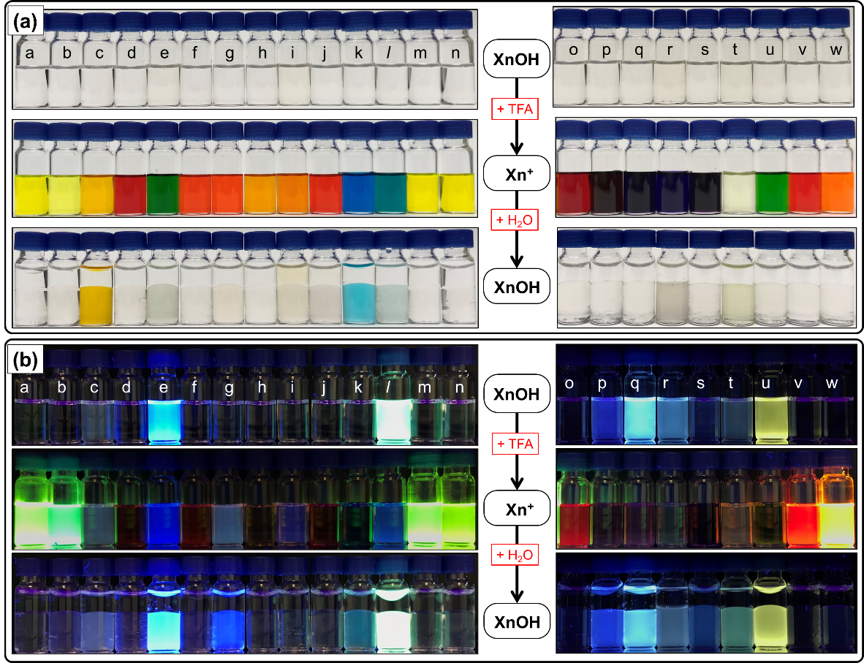
Figure 1. (a) Solution colour changes of XnOH derivatives (1 mM in CHCl₃) upon adding a few drops of TFA, followed by water. The corresponding fluorescence changes (0.1 mM in CHCl₃) observed under UV irradiation (λ_{ex} = 365 nm) are shown in (b).
Figure 1 shows the changes in colour and fluorescence of the 23 XnOH derivatives solutions when TFA was added, followed by addition of a large amount of water. All the derivatives of XnOH are soluble in chloroform to give colourless solutions. The 9-functionalized XnOH derivatives are mostly non-fluorescent with the exception of XnOH-e and XnOH-l which exhibit bright blue fluorescence originating from the pyrene and triphenylamine (TPA) groups, respectively. For the 2,7-bifunctionalized derivatives, XnOH-p – XnOH-r displayed deep to bright blue fluorescence while XnOH-u revealed bright yellow fluorescence attributed to naphthyl, thienyl, furanyl, and TPA -functionalized xanthene cores, respectively. In contrast, functionalizing the xanthene core at 9- and 2,7- positions with different single phenyl aromatic groups did not cause XnOH derivatives to be fluorescent.
Upon addition of a few drops of TFA, intense colouration was observed in all derivative solutions except for XnOH-t. As shown in Figure 1, a wide range of colour across the entire visible region could be achieved for this series of functionalized derivatives. The intense colouration signals the generation of Xn⁺ cations, where the 9-position carbon becomes sp²-hybridised and establishes π-conjugation between the xanthene core and the 9-functionalized aryl groups, thus reconfiguring the frontier molecular orbitals energy levels to absorb intensely in the visible region. Likewise, bright green to yellow fluorescence were turned on for derivatives Xn⁺-a, Xn⁺-b, Xn⁺-m, Xn⁺-n and Xn⁺-w, whereas red and orange fluorescence was turned on for Xn⁺-o and Xn⁺-v, respectively. The bright blue fluorescence of XnOH-e and XnOH-l becomes dimmer and turns deep blue in colour, whereas the blue and yellow fluorescence of XnOH-p – XnOH-r and XnOH-u is effectively quenched. The remaining solutions appear either dimly or non-fluorescent. Nonetheless, the range of colour achieved for this series of Xn⁺ cations appear to be wider compared to those of Tx⁺ analogues that we have previously reported, which generally reveal orange, red, brown and dark green colour.³⁶
Subsequently, a large excess of water was added to the solutions to demonstrate hydrochromism of the generated Xn⁺ cations. Dramatic decolouration was observed for all solutions except for mesityl-functionalized Xn⁺-c which remains orange in colour, and dimethylaniline-functionalized XnOH-k/Xn⁺-k which appears pale blue in colour with partial decolourization. Likewise, most of the solutions regained their fluorescence with the exception of XnOH-g and XnOH-k which now reveals deep blue and pale-turquoise fluorescence, respectively. Similar to the TxOH/Tx⁺ system, it is believed that the XnOH was regenerated upon Xn⁺ cations chemically react with water.
To confirm the mechanism of hydrochromism of the XnOH/Xn⁺ system, NMR studies were conducted on XnOH-a. ¹H NMR titration studies were performed in deuterated THF solution and changes in the signal in the aromatic region of 7.0 – 8.7 ppm were monitored. The colourless solution of XnOH-a gave a compact set of peaks in the up-field region of 7.0 – 7.4 ppm. As TFA was added incrementally, intensities of these peaks gradually decreased while concurrently, a new set of signals gradually emerged in the more down-field region of 7.6 – 8.6 ppm, corresponding to the formation of Xn⁺-a (Figure 2a). When the ¹H NMR signals of XnOH-a were completely disappeared, a bright yellow solution was obtained. Water was then added incrementally and a reversible trend of changes to the ¹H NMR signals was observed: the signals corresponding to Xn⁺-a gradually decreased in intensity while the peaks corresponding to XnOH-a re-emerged (Figure 2b), resulting in a colourless emulsion solution. This study therefore confirms the hydrochromism mechanism of XnOH/Xn⁺ system: (1) Xn⁺ cations are generated from XnOH when acid protonates the OH group causing a dehydration reaction; (2) water added undergoes a nucleophilic addition to the Xn⁺ carbocation centre, resulting in the regeneration of XnOH (Scheme S2, ESI). The mechanism is similar to that of the TxOH/Tx⁺ hydrochromic system that we reported previously.³⁶
The changes in colour and fluorescence of XnOH derivatives observed in Figure 1 are also in good agreement with the results obtained from spectrophotometric titration studies performed in dilute chloroform solutions (Figure S1 – S25, ESI). The colourless nature of all XnOH derivative solutions are evident in the absence of absorption beyond 400 nm. Taking XnOH-a/Xn⁺-a as an example, the addition of an incremental amount of TFA to XnOH-a resulted in the disappearance of absorption peaks at 246 and 291 nm and the emergence of highly intense absorption bands at 258, 375 and 452 nm, corresponding to the formation of Xn⁺-a cation (Figure 2c).
Functionalization at the 9-position with 2-naphthyl, 1-pyrenyl, biphenyl, and 4-methoxylphenyl groups for Xn⁺-d, Xn⁺-e, Xn⁺-f, and Xn⁺-j, respectively, led to bathochromic shifts in their absorption spectra in comparison with Xn⁺-a with phenyl substituent at the 9-position (Figures S4 – S6, S10, ESI), as evidenced by red-shifting of colours from yellow to red, green, orange, and red, respectively. Styryl-functionalized Xn⁺-g exhibited intense absorption band at 695 nm but minimal absorption in the yellow to orange region (Figure S7, ESI), whereas absorption bands from 300 – 550 nm emerged for thienyl and furanyl -functionalized Xn⁺-h and Xn⁺-i (Figure S8 – S9, ESI). The solutions of these two cations appeared orange in colour. In contrast, intense absorptions in the red to far-red region were also observed for dimethylaminophenyl and TPA -functionalized Xn⁺-k and Xn⁺-l (Figure S11 – S12, ESI), translating to distinct blue and green colors, respectively. In the case of Xn⁺-m and Xn⁺-n functionalized with 4-fluorophenyl and 4-(trifluoromethyl)phenyl at the 9-position, respectively, only modest bathochromic shift in absorptions relative to Xn⁺-a were observed (Figure S13 – S14, ESI). Turning to the realm of bifunctionalized derivatives, two distinct absorption bands with similar relative intensities were observed for 4-ethylphenyl and 4-fluorophenyl-functionalized Xn⁺-o and Xn⁺-v, at 372 and 478, and 369 and 458 nm, respectively (Figure S15, S22, ESI). On the other hand, Xn⁺-p, Xn⁺-q, Xn⁺-r and Xn⁺-s, exhibited absorptions covering most or entire of the visible region hence more intense solution colors compared to other derivatives (Figure S16 – S19, ESI). TPA-bifunctionalized Xn⁺-u displayed a broad and intense absorption spanning from 550 – 1100 nm (Figure S21, ESI) underscoring the large extent of π-conjugation.
Similarly, the emergence of two strong photoluminescence (PL) bands at 421 and 509 nm reflects the turn-on of bright greenish-yellow fluorescence observed in Figure 1 due to the generation of Xn⁺-a (Figure 2d). TFA solutions were added until no further changes in the intensities of the absorption bands were observed. Following this, water (diluted in THF, owing to the high water sensitivity of the system) was incrementally added. This led to the gradual collapse of Xn⁺-a absorption bands and the re-emergence of XnOH-a absorption bands of similar relative intensities (Figure 2e), as well as the complete quenching of Xn⁺-a’s PL bands (Figure 2f), when approximately 221 μM of water was added.
Likewise, upon acidification of the precursors of Xn⁺-b, Xn⁺-m and Xn⁺-n, bright green fluorescence bands with maxima at 497, 511, and 561 nm, respectively, were observed (Figure S24b, ESI). Conversion of XnOH-e to Xn+-e led to the quenching of its PL at 417 nm. In general, PL intensities of other 9-functionalized Xn⁺ derivatives were relatively weak. For the 2,7-bifunctionalized derivatives, the turn-on of red fluorescence on generating Xn⁺-o and Xn⁺-v from XnOH-o and XnOH-v, respectively, was associated with the collapse of 342 nm PL bands and the emergence of broad PL bands stretching across the visible region with maxima at 538 and 521 nm, respectively (Figure S25, ESI). Similar trend in PL spectra change was observed for yellow-fluorescent Xn⁺-w which has a PL maxima at 583 nm. Additionally, most of the remaining XnOH and Xn⁺ derivatives, however, exhibited low intensity in PL.
The findings obtained from spectrophotometric titration study confirmed the high water and moisture sensitivity of most Xn⁺ derivatives, which means that direct solution processing of Xn⁺ cations under open-air ambient conditions would be difficult, probably requiring strict inert atmosphere. Fortunately, XnOH precursors are highly ambient-stable and soluble in common organic solvents, and thus solution processing of XnOH, followed with the “activation” by acid to form Xn⁺ at the point of use, can be straightforwardly performed in open-air for various intended applications. To study the potential of the XnOH/Xn⁺ hydrochromic system for atmospheric moisture sensing and relative humidity (RH) monitoring, XnOH precursors were spin-coated onto glass substrates and the rate of change in thin film absorption upon activation by TFA fume and then subsequent exposure to “open-air” in a controlled lab environment (24 °C, RH 70 %) were monitored. Taking XnOH-a/Xn⁺-a as an example, the absorption peaks of Xn⁺-a at 373.5 and 450.5 nm gradually collapsed within a short period of 20 minutes due to the regeneration of XnOH-a by reaction with atmospheric moisture (Figure 2g).
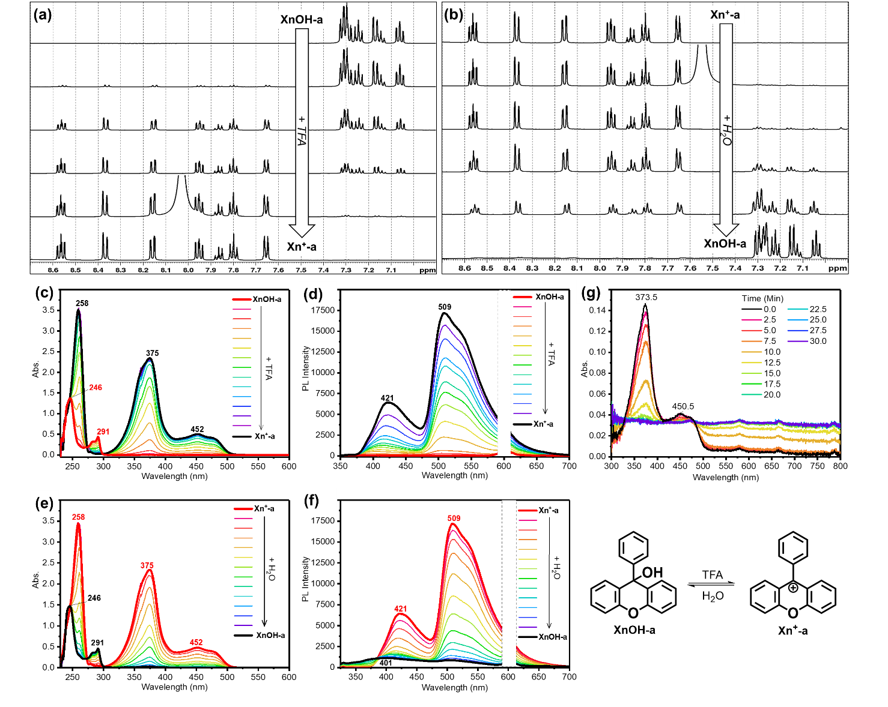
Figure 2. Changes in ¹H NMR spectra of XnOH-a with incremental addition of TFA (a) and subsequently, incremental addition of water (b). Changes in UV-Vis absorption spectra (c) and photoluminescence (PL) spectra (d) of XnOH-a with incremental addition of TFA was added until no further changes, and the subsequent changes in UV-Vis absorption (e) and photoluminescence (f) spectra when water (dissolved in THF) were incrementally added. (g) Changes in UV-Vis absorption spectra of XnOH-a thin film spin-coated on glass substrate and exposed to TFA fume, over a duration of 30 minutes.
Likewise, the activated thin films of XnOH-b – XnOH-w also generally reveal a similar trend in absorption changes associated with the conversion of Xn⁺ to XnOH upon reacting with atmospheric moisture in a controlled laboratory environment (24 °C, RH 70 %) (Figure S26 – S27, ESI). In addition, the rate and extent of changes in absorption spectra over the period of 30 minutes can reflect the moisture sensitivity of each Xn⁺ derivative, which correlates with the nature and positions of the different groups functionalized on the xanthene core. Amongst the 9-functionalized derivatives, cyclohexyl functionalized Xn⁺-b showed a rapid collapse of absorption band within 5 minutes while mesityl functionalized Xn⁺-c showed no change in the absorption spectra after 30 minutes. Meanwhile, only partial collapses of absorption bands of pyrene, biphenyl and TPA -functionalized Xn⁺-e, Xn⁺-f, and Xn⁺-l were observed, indicating their lower moisture sensitivities relative to that of Xn⁺-a (Figure S26, ESI). On the other hand, for 2,7-bifunctionalized derivatives, the collapses of 4-ethylphenyl, 2-naphthyl and 4-methoxyphenyl -functionalized Xn⁺-o, Xn⁺-p, and Xn⁺-s, proceeded much more slowly and incompletely compared to Xn⁺-a, as well as 9-functionalized derivatives Xn⁺-d and Xn⁺-j, whereas absorption spectral changes of Xn⁺-v and Xn⁺-w functionalized with 4-fluorophenyl and 4-(trifluromethyl)phenyl groups, respectively, proceeded much more rapidly than these of 9-functionalized Xn⁺-m and Xn⁺-n (Figure S27, ESI).
Some trends can be observed from these findings. Firstly, Xn⁺ derivatives functionalized with electron-donating (e.g., 4-methoxy) and pi-extended (e.g., naphthyl and pyrene) aromatic groups are generally more stabilised, less electrophilic and thus less moisture sensitive. In contrast, Xn⁺ derivatives functionalized with aliphatic group (cyclohexyl at the 9-position) and electron-deficient (e.g., 4-trifluoromethylphenyl and 4-fluoro phenyl) aromatic groups are generally less stabilised, more electrophilic, and thus more moisture sensitive. Secondly, when comparing functionalization of Xn⁺ with the same aromatic groups at the 2,7-positions vs. the 9-position, it appears that the former has a greater influence on the cation stability, and hence electrophilicity and moisture sensitivity than the latter. For instance, naphthyl and 4-methoxy 2,7-bifunctionalized Xn⁺-p and Xn⁺-s appear to be less moisture sensitive than their 9-functionalized counterparts, Xn⁺-d and Xn⁺-j, respectively, while 4-fluorophenyl 2,7-bifunctionalized Xn⁺-v appears to be more moisture sensitive than 9-bifunctionalized Xn⁺-m. The high stability of Xn⁺-c is believed to be due to the steric hinderance imposed by mesityl group, which impedes nucleophilic attack of water molecules at the carbocation centre. Compared with the hydrochromic Tx⁺ analogues, the results herein seem to suggest that Xn⁺ cations are generally more moisture-sensitive. For example, Xn⁺-a thin film took approximately 20 minutes to completely decolourize (Figure S26a, ESI) whereas analogue Tx⁺-a took approximately 27.5 minutes.³⁶
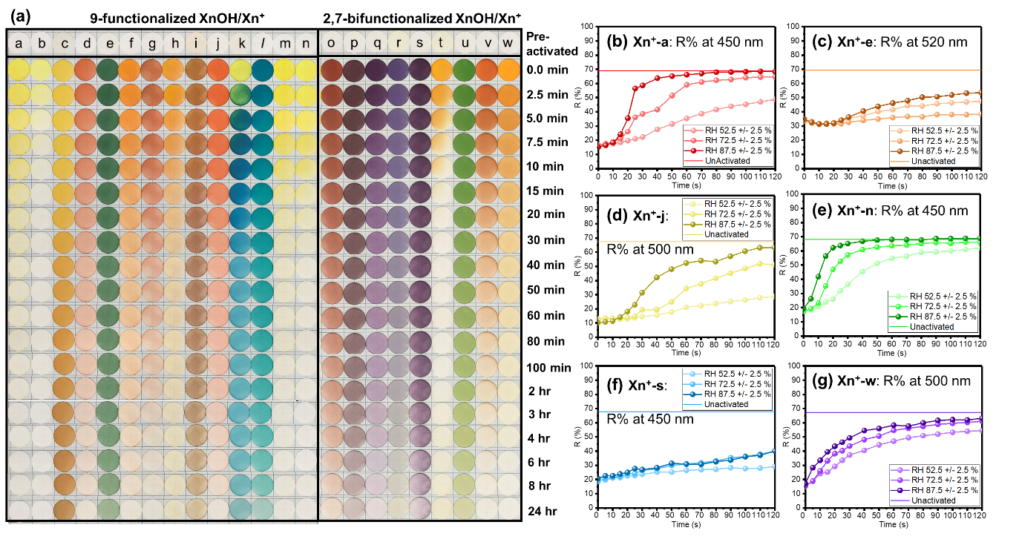
Figure 3. (a) Decolourization of activated paper probes containing derivatives Xn⁺-a to Xn⁺-w over time (24 hr), standing under controlled laboratory environment. Changes in reflectance (R%) of activated paper probes containing (b) Xn⁺-a, (c) Xn⁺-e, (d) Xn⁺-j, (e) Xn⁺-n, (f) Xn⁺-s and (g) Xn⁺-w at 450, 520, 500, 450, 450 and 500 nm, respectively, obtained through colorimetric analysis, over time (2 hr), standing under different RHs at 25 °C.
Paper probes were therefore fabricated by simply immersing cellulose-based Whatman® filter paper into XnOH derivatives solutions, and then air-dried. The fibrous nature of filter paper offers greater porosity, making the probes more suitable for activation by TFA fume and subsequent sensing of atmospheric moisture. All pre-activated paper probes appear white in colour but brief exposure to TFA fume led activated probes to display a range of colour due to the generation of Xn⁺ (Figure 3a). The activated probes were then placed in a controlled laboratory environment (24 °C, RH 70 %) and their colour changes of probes were visibly monitored over a period of 24 hours.
The activated probes were observed to decolourize at different rates, reflecting the differences in moisture sensitivity of Xn⁺ derivatives, which are influenced by structural functionalization. Taking Xn⁺-a probe as a reference for comparison (which decolourises within 30 minutes), Xn⁺-b probe decolourized within 5 minutes showing the destabilisation of Xn⁺ with aliphatic cyclohexyl group at the 9-position. Xn⁺-m and Xn⁺-n probes decolourised within 20 minutes due to the destabilisation effect of electron-withdrawing aromatic groups at the 9-position. The cation stabilisation effect of electron-donating and π-extended aryl groups at the 9-position was evident in paper probes containing Xn⁺-d, Xn⁺-e, Xn⁺-i, Xn⁺-j, Xn⁺-k and Xn⁺-l as Xn⁺-d probe took 2 hours to decolourise while the rest remained partially coloured even after 24 hours. In contrast, 2,7-bifunctionalization of Xn⁺ with electron-rich and π-extended aryl groups led to greater Xn⁺ cation stability as Xn⁺-o, Xn⁺-q and Xn⁺-r took up to 8 hours while decolourization of Xn⁺-p, Xn⁺-s and Xn⁺-u remained incomplete after 24 hours. It was also worth noted that decolourization of electron-deficient aryl groups bifunctionalized Xn⁺-v and Xn⁺-w probes was slower compared to Xn⁺-a, as well as Xn⁺-m and Xn⁺-n. Interestingly, Xn⁺-t decolourised shortly within 10 minutes which could be due to electron-donating dimethylaniline groups undergoing additional protonation by TFA thus destabilising and increasing the electrophilicity of the Xn⁺-t carbocation centre. The trends observed in Figure 3a generally agree with changes in activated thin film absorptions.
Further colorimetric analysis was performed on probes coated with XnOH-a, XnOH-e, XnOH-j, XnOH-n, XnOH-s and XnOH-w. The reflectance (R%) of each probe in the visible region, and the L* a* b* colour coordinates defined in the CIE1976 colour chart were monitored over time upon activation by TFA fume and placed in a humidity chamber at a fixed temperature of 25 °C. As RH increased from 52.5 ± 2.5 % to 72.5 ± 2.5 % and 87.5 ± 2.5 %, both the rate and extent of changes in R% spectra of pre-activated probes increased for all six derivatives (Figure S28 – S33, ESI). Further analysis of the R% for each derivative at the wavelength that showed the greatest difference between pre and post activation, (450, 520, 500, 450, 450 and 500 nm, respectively) displayed the same trend over the duration of 120 minutes (Figure 3b – g). Similar trends can also be observed for the respective plots of L* values against time, which reflects the changes in brightness of probes colour, with white being the brightest (Figure S34, ESI).
Monitoring the different rate and extent of changes in R% spectra (Figure S28 – S33, ESI), R% at specific wavelengths of study (Figure 3b – g) and L* values (Figure S34, ESI) of the probes, over the period of 2 hours, the moisture sensitivity of each Xn⁺ derivative was also proven to be influenced by structural functionalization. Replacing phenyl group at 9-position with π-extended pyrene and electron-rich 4-anisole moieties reduces moisture sensitivities of Xn⁺-e and Xn⁺-j, respectively, while replacement with electron-poor 4-(trifluorophenyl)phenyl group increases moisture sensitivity of Xn⁺-n. Bi-functionalization of anisole group at the 2,7-positions significantly reduces moisture sensitivities of Xn⁺-s owing to the extra cation stabilisation effect from both inductive electron-donating methoxy groups, as well as extension of Xn⁺ π-network with two additional aryl groups. On the other hand, 4-(trifluorophenyl)phenyl group functionalization at the 2,7-positions reduces moisture sensitivity of Xn⁺-w to a lesser extent than Xn⁺-n (at the 9-position), probably due to the cation stabilisation effect via extension of Xn⁺ π-network in the former offsetting destabilisation effect attributed to the induction of electron-deficient trifluoromethyl groups. In addition, the results herein confirms the trend of Xn⁺ cations being slightly more moisture-sensitive than Tx⁺ analogues. For example, paper probes containing the Xn⁺-a took approximately 90 minutes to decolourize under RH of 87.5 ± 2.5 % (Figure 3b) compared to approximately 100 minutes for the Tx⁺-a.³⁶
The XnOH/Xn⁺ hydrochromic system was also found to be highly reversible, as evident in most derivatives’ probes being able to undergo 10 cycles of reactivation by TFA fume and decolourization by atmospheric moisture (Figure 36, ESI). For example, the selected probes containing the six derivatives studied above still reveal intense colouration even after the 10th time (Figure 4a). Nonetheless, the reversibility of derivatives functionalized with mesityl, styryl, furanyl, and dimethylaminophenyl groups exhibited poorer reversibility, which is highly likely attributed to the occurrence of side reactions in these reactive groups. Colorimetric analysis performed on XnOH-a -coated probe showed only small changes in R% at 450 nm throughout 50 decolourization/reactivation cycles (Figure 4b), thus demonstrating the high reversibility of this hydrochromic system.
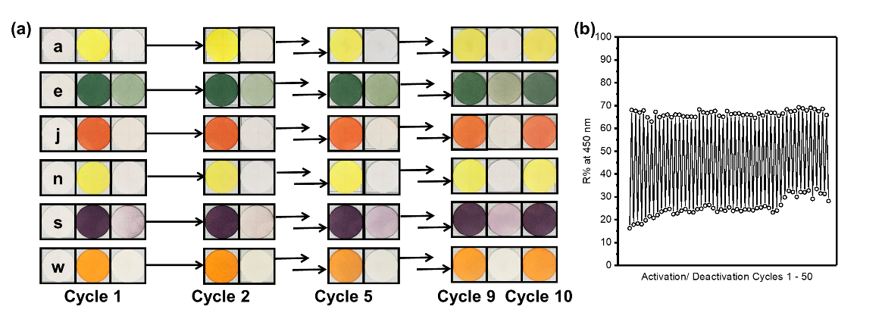
Figure 4. (a) Photos of paper probes coated with XnOH-a, XnOH-e, XnOH-j, XnOH-n, XnOH-s and XnOH-w undergoing up to 10 cycles of (re)activation by TFA fume and decolourization after standing in open air for 24 hours. (b) R% of XnOH-a probe at 450 nm undergoing 50 cycles of (re)activation and decolourization.
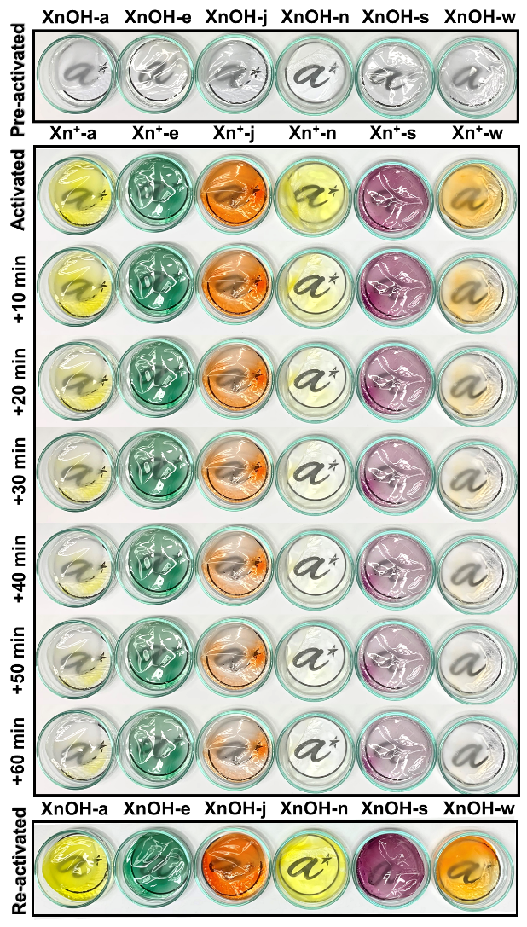
Figure 5. TFA fume -activation, atmospheric moisture-induced decolourization, and reactivation of transparent cellulose triacetate films doped with 5 wt.% of XnOH-a, XnOH-e, XnOH-j, XnOH-n, XnOH-s and XnOH-w.
Moisture-sensitive products must be packed in inert gas atmosphere or vacuum-packed conditions to minimise exposure to external humidity in order to effectively avoid deterioration of quality and spoilage. In addition to the use of desiccants, monitoring the internal humidity will be useful to gauge any compromise of packaging mechanism, thus contributing to shelf-life improvement, quality assurance, and wastage reduction. To explore the possibilities of incorporating the XnOH/Xn⁺ hydrochromic system into polymers or plastics for smart packaging materials with humidity monitoring and moisture-sensing function, different XnOH derivatives were homogenously mixed at 5 wt.% loading into cellulose triacetate solutions pre-dissolved in chloroform. The doped solutions were casted into thin films using petri-dishes as a mould, which can be easily peeled off after drying. Cellulose triacetate was chosen due to its high porosity, which allows for gaseous interactions. The doped films appeared colourless and optically transparent. Upon short exposure to TFA fume, intense colouration occurred due to the formation of Xn⁺ cations (Figure 5). The activated films decolourized at different rates over a period of 1 hour on standing in open air in a controlled laboratory environment. Both the colour and decolourization rate of the activated films were, similarly, influenced by structural functionalization as discussed earlier. Films doped with Xn⁺-e, Xn⁺-j and Xn⁺-s retained some colouration due to the cations stabilising effect of pyrene and anisole groups, while films doped with Xn⁺-n and Xn⁺-w decolourised within half an hour as 4-(trifluoromethyl)phenyl groups enhances Xn⁺ electrophilicity and hence films’ moisture sensitivities. Thereafter, upon re-exposure to TFA fume, all the films could be reactivated with intense colouration occurring almost instantaneously.
Conclusion
In summary, we reported a new hydrochromic system based on the reversible switching between XnOH and Xn⁺ brought about by acidification and hydration, respectively, where intensely coloured Xn⁺ revealed drastic decolourization and fluorescence change upon exposure to water or moisture. It was also demonstrated that both colour and sensitivity of hydrochromic Xn⁺ cations can be tuned via structural functionalization. In general, electron rich and π-extended aromatic groups contribute to cation stabilisation, reducing electrophilicity and hence exhibiting lower moisture sensitivity. In contrast, aliphatic groups and electron-deficient aromatic groups destabilise Xn⁺, hence increasing electrophilicity and showing less moisture sensitivity. Structural functionalization also affects the optical bandgaps of cations, thus influencing their colour and fluorescence. This hydrochromic system was also found to be highly reversible, with XnOH-a coated paper probes able to undergo up to 50 cycles of activation and decolourization. To explore the possibility of incorporating this system into polymers or plastics to develop smart packaging with moisture sensing function, cellulose triacetate films doped with different derivatives of XnOH were prepared. The optically transparent films can be easily activated and reactivated with TFA fume, exhibiting different colour and rate of decolourization.
This XnOH/Xn⁺ hydrochromic system is analogous to that of TxOH/Tx⁺ system that we have previously reported. Comparing the two systems, the XnOH/Xn⁺ system appears to offer a wider colour range and higher moisture sensitivity, as evident by comparing the rate of decolourization of activated paper probes, and R% changes at different RHs with similar experimental conditions. The latter is likely due to the larger and more polarizable S atom in Tx⁺ that enables better cation stabilization than the O atom in Xn⁺. Similar differences in reactivity were also observed by Hori et al. when comparing 9-phenylchalcogenoxanthylium salts.⁵⁰ More importantly, apart from the facile synthesis and versatile functionalization, the XnOH/Xn⁺ hydrochromic system has many advantages including fast and easy of activation by acid, extreme moisture sensitivity and RH-dependence decolourization. They also have tuneable colour and moisture sensitivity, reversibility and solution-processability. As a potentially low-cost and robust alternatives to existing inorganic and organic systems, the XnOH/Xn⁺ system is highly promising for a wide range of applications such as anti-counterfeiting and re-writable paper, and especially in moisture-sensing for smart packaging solutions.
Declaration of Conflict of Interests:
The authors declare no personal or financial conflicts of interests that may influence this work’s results or conclusion.
Acknowledgement:
This research is supported by A*STAR 2020 Career Development Fund (Grant Number: C210112042)
References
1. W. T. Neo, Q. Ye, S.-J. Chua and J. Xu, Conjugated polymer-based electrochromics: materials, device fabrication and application prospects, J. Mater. Chem. C, 2016, 4, 7364-7376.
2. M. H. Chua, Q. Zhu, T. Tang, K. W. Shah and J. Xu, Diversity of electron acceptor groups in donor–acceptor type electrochromic conjugated polymers, Sol. Energy Mater Sol. Cells., 2019, 197, 32-75.
3. X. Lv, W. Li, M. Ouyang, Y. Zhang, D. S. Wright and C. Zhang, Polymeric electrochromic materials with donor–acceptor structures, J. Mater. Chem. C, 2017, 5, 12-28.
4. Y. Huang, B. Wang, F. Chen, Y. Han, W. Zhang, X. Wu, R. Li, Q. Jiang, X. Jia and R. Zhang, Electrochromic Materials Based on Ions Insertion and Extraction, Adv. Opt. Mater., 2022, 10, 2101783.
5. R. J. Mortimer, Electrochromic materials, Chem. Soc. Rev., 1997, 26, 147-156.
6. M. H. Chua, Q. Zhu, K. W. Shah and J. Xu, Electroluminochromic Materials: From Molecules to Polymers, Polymers, 2019, 11, 98.
7. S. Wang, W. Fan, Z. Liu, A. Yu and X. Jiang, Advances on tungsten oxide based photochromic materials: strategies to improve their photochromic properties, J. Mater. Chem. C, 2018, 6, 191-212.
8. M. Irie, T. Fukaminato, K. Matsuda and S. Kobatake, Photochromism of Diarylethene Molecules and Crystals: Memories, Switches, and Actuators, Chem. Rev., 2014, 114, 12174-12277.
9. J. Zhang, Q. Zou and H. Tian, Photochromic Materials: More Than Meets The Eye, Adv. Mater., 2013, 25, 378-399.
10. S.-D. Han, J.-X. Hu and G.-M. Wang, Recent advances in crystalline hybrid photochromic materials driven by electron transfer, Coord. Chem. Rev., 2022, 452, 214304.
11. A. Abdollahi, H. Roghani-Mamaqani and B. Razavi, Stimuli-chromism of photoswitches in smart polymers: Recent advances and applications as chemosensors, Prog. Polym. Sci., 2019, 98, 101149.
12. X. Huang, L. Qian, Y. Zhou, M. Liu, Y. Cheng and H. Wu, Effective structural modification of traditional fluorophores to obtain organic mechanofluorochromic molecules, J. Mater. Chem. C, 2018, 6, 5075-5096.
13. R. Zhang, Q. Wang and X. Zheng, Flexible mechanochromic photonic crystals: routes to visual sensors and their mechanical properties, J. Mater. Chem. C, 2018, 6, 3182-3199.
14. H. Traeger, D. J. Kiebala, C. Weder and S. Schrettl, From Molecules to Polymers—Harnessing Inter- and Intramolecular Interactions to Create Mechanochromic Materials, Macromol. Rapid Commun., 2021, 42, 2000573.
15. Y. Q. Dong, J. W. Y. Lam and B. Z. Tang, Mechanochromic Luminescence of Aggregation-Induced Emission Luminogens, J. Phys. Chem. Lett., 2015, 6, 3429-3436.
16. A. Seeboth, D. Lötzsch, R. Ruhmann and O. Muehling, Thermochromic Polymers—Function by Design, Chem. Rev., 2014, 114, 3037-3068.
17. A. Hakami, S. S. Srinivasan, P. K. Biswas, A. Krishnegowda, S. L. Wallen and E. K. Stefanakos, Review on thermochromic materials: development, characterization, and applications, J. Coat. Technol. Res., 2022, 19, 377-402.
18. F. Xu, X. Cao, H. Luo and P. Jin, Recent advances in VO2-based thermochromic composites for smart windows, J. Mater. Chem. C, 2018, 6, 1903-1919.
19. W. Zhang, A. P. H. J. Schenning, A. J. J. Kragt, G. Zhou and L. T. de Haan, Thermochromic Multicolored Photonic Coatings with Light Polarization- and Structural Color-Dependent Changes, ACS Appl. Polym. Mater., 2022, 4, 537-545.
20. B. Li, H.-T. Fan, S.-Q. Zang, H.-Y. Li and L.-Y. Wang, Metal-containing crystalline luminescent thermochromic materials, Coord. Chem. Rev., 2018, 377, 307-329.
21. Z. Wan, Y. Li, Y. Zhou, D. Peng, X. Zhang, J. Zhuang, B. Lei, Y. Liu and C. Hu, High-Efficiency Solid-State Luminescence from Hydrophilic Carbon Dots with Aggregation-Induced Emission Characteristics, Adv. Funct. Mater., 2023, 33, 2207296.
22. L. Ju, W. Gao, J. Zhang, T. Qin, Z. Du, L. Sheng and S. X.-A. Zhang, A new absorption/fluorescence dual-mode hydrochromic dye for water-jet printing and anti-counterfeiting applications, J. Mater. Chem. C, 2020, 8, 2806-2811.
23. C. Sun, H. Lu, C.-Y. Yue, H. Fei, S. Wu, S. Wang and X.-W. Lei, Multiple Light Source-Excited Organic Manganese Halides for Water-Jet Rewritable Luminescent Paper and Anti-Counterfeiting, ACS Appl. Mater. Interfaces, 2022, 14, 56176-56184.
24. X. Wei, S. X.-A. Zhang and L. Sheng, “Enzyme-Like” Spatially Fixed Polyhydroxyl Microenvironment-Activated Hydrochromic Molecular Switching for Naked Eye Detection of ppm Level Humidity, Adv. Mater., 2023, 35, 2208261.
25. L. Sheng, M. Li, S. Zhu, H. Li, G. Xi, Y.-G. Li, Y. Wang, Q. Li, S. Liang, K. Zhong and S. X.-A. Zhang, Hydrochromic molecular switches for water-jet rewritable paper, Nat. Commun., 2014, 5, 3044.
26. P. Chen, H.-M. Wang, G.-J. Liu and S. X.-A. Zhang, Design, synthesis and properties of near-infrared molecular switches containing a fluorene ring, Org. Biomol. Chem., 2016, 14, 4456-4463.
27. G. Xi, L. Sheng, I. Zhang, J. Du, T. Zhang, Q. Chen, G. Li, Y. Zhang, Y. Song, J. Li, Y.-M. Zhang and S. X.-A. Zhang, Endowing Hydrochromism to Fluorans via Bioinspired Alteration of Molecular Structures and Microenvironments and Expanding Their Potential for Rewritable Paper, ACS Appl. Mater. Interfaces, 2017, 9, 38032-38041.
28. M. Pyo, J. Lee, W. Baek, C. W. Lee, B. J. Park and J.-M. Kim, Sweat pore mapping using a fluorescein–polymer composite film for fingerprint analysis, Chem. Commun., 2015, 51, 3177-3180.
29. J. Lee, M. Pyo, S.-h. Lee, J. Kim, M. Ra, W.-Y. Kim, B. J. Park, C. W. Lee and J.-M. Kim, Hydrochromic conjugated polymers for human sweat pore mapping, Nat. Commun., 2014, 5, 3736.
30. D.-H. Park, W. Jeong, M. Seo, B. J. Park and J.-M. Kim, Inkjet-Printable Amphiphilic Polydiacetylene Precursor for Hydrochromic Imaging on Paper, Adv. Funct. Mater., 2016, 26, 498-506.
31. M. Seo, D.-H. Park, B. J. Park and J.-M. Kim, Flexible patch-type hydrochromic polydiacetylene sensor for human sweat pore mapping, J. Appl. Polym. Sci., 2017, 134.
32. T. Maeda and F. Würthner, Halochromic and hydrochromic squaric acid functionalized perylene bisimide, Chem. Commun., 2015, 51, 7661-7664.
33. V. K. Singh, R. K. Chitumalla, S. K. Ravi, Y. Zhang, Y. Xi, V. Sanjairaj, C. Zhang, J. Jang and S. C. Tan, Inkjet-Printable Hydrochromic Paper for Encrypting Information and Anticounterfeiting, ACS Appl. Mater. Interfaces, 2017, 9, 33071-33079.
34. Y. Ooyama, M. Sumomogi, T. Nagano, K. Kushimoto, K. Komaguchi, I. Imae and Y. Harima, Detection of water in organic solvents by photo-induced electron transfer method, Org. Biomol. Chem., 2011, 9, 1314-1316.
35. X. Zhang and G. Zhang, Hydrochromic fluorescence of organo-boronium-avobenzone complexes, Anal. Methods, 2012, 4, 2641-2643.
36. M. H. Chua, X. Y. D. Soo, W. P. Goh, Z. M. Png, Q. Zhu and J. Xu, Thioxanthylium Cations: Highly Reversible Hydrochromic Mate-rials with Tunable Color and Moisture Sensitivity, Chem. Eur. J., 2022, 28, e202201975.
37. N.-E. Es-Safi, C. Le Guernevé, H. Fulcrand, V. Cheynier and M. Moutounet, Xanthylium salts formation involved in wine colour changes, Int. J. Food Sci. Technol., 2000, 35, 63-74.
38. F. Bührle, A. Gohl and F. Weber, Impact of Xanthylium Derivatives on the Color of White Wine, Molecules, 2017, 22, 1376.
39. E. Yanase, K. Nishimoto, Y. O. Kamatari and S.-i. Nakatsuka, Isolation of a New Xanthylium-Related Pigment from Adzuki Beans Vigna angularis, Biosci. Biotechnol. Biochem., 2012, 76, 1571-1572.
40. N.-E. Es-Safı, C. Le Guernevé, H. Fulcrand, V. Cheynier and M. Moutounet, New Polyphenolic Compounds with Xanthylium Skeletons Formed through Reaction between (+)-Catechin and Glyoxylic Acid, J. Agric. Food. Chem., 1999, 47, 5211-5217.
41. N.-E. Es-Safi, Colour of a xanthylium pigment in aqueous solutions at different pH values, Food Chemistry, 2004, 88, 367-372.
42. Y. Ito, N. Sugimoto, T. Akiyama, T. Yamazaki and K. Tanamoto, Cepaic acid, a novel yellow xanthylium pigment from the dried outer scales of the yellow onion Allium cepa, Tetrahedron Lett., 2009, 50, 4084-4086.
43. A. Guo, N. Kontoudakis, G. R. Scollary and A. C. Clark, Production and Isomeric Distribution of Xanthylium Cation Pigments and Their Precursors in Wine-like Conditions: Impact of Cu(II), Fe(II), Fe(III), Mn(II), Zn(II), and Al(III), J. Agric. Food. Chem., 2017, 65, 2414-2425.
44. G. Hrazdina and A. J. Borzell, Xanthylium derivatives in grape extracts, Phytochemistry, 1971, 10, 2211-2213.
45. P. Wan, K. Yates and M. K. Boyd, Adiabatic photodehydroxylation of 9-phenylxanthen-9-ol. Observation of carbocation fluorescence in neutral aqueous solution, J. Org. Chem., 1985, 50, 2881-2886.
46. A.-M. N. Fouad, A. S. Bassili and S. A. Badie, Studies on Xanthylium Salts. Behaviour of 9-Vinylidenexanthenes in Acid Media, Bull. Chem. Soc. Jpn., 1979, 52, 3431-3433.
47. R. A. McClelland, N. Banait and S. Steenken, Electrophilic reactions of xanthylium carbocations produced by flash photolysis of 9-xanthenols, J. Am. Chem. Soc., 1989, 111, 2929-2935.
48. M. K. Boyd, H. Y. Lai and K. Yates, Water quenching behavior of excited 9-xanthylium cations in aqueous sulfuric acid solutions, J. Am. Chem. Soc., 1991, 113, 7294-7300.
49. R. Deschner and U. Pindur, Zur elektrophilen Substitution des Xanthylium-Ions an Indolen. Untersuchungen zur Positionsselektivität, J. Heterocycl. Chem., 1984, 21, 1485-1488.
50. M. Hori, T. Kataoka, H. Shimizu, C. F. Hsu, Y. Hasegawa and N. Eyama, Reactivities of heteroaromatic cations containing a Group VIB element in nucleophilic reactions. Reactions of 9-phenyl-xanthylium, -thioxanthylium, and -selenoxanthylium salts with amines, sodium phenolate, and sodium benzenethiolate, J. Chem. Soc., Perkin Trans. 1, 1988, DOI: 10.1039/P19880002271, 2271-2276.
51. L. P. Yunnikova, Y. E. Likhareva, M. K. Islyaykin and E. A. Danilova, Xanthylium, Thioxanthylium, and Tropylium Salts in Reactions with Imidazole and Benzimidazole, Russ. J. Org. Chem., 2020, 56, 828-832.

