Dynamic Covalent Bonds Enabled Carbon Fiber Reinforced Polymers Recyclability and Material Circularity

Xiaotong Fan,^{[a]} Jie Zheng,^{[a]} Jayven Chee Chuan Yeo,^{[b]} Sheng Wang,^{[a]} Ke Li,^{[b]} Joseph Kinyanjui Muiruri,^{[a]}* Nikos Hadjichristidis,^{[c]}* Zibiao Li^{[a][b][d]}*

[a] Institute of Sustainability for Chemicals, Energy and Environment (ISCE2), Agency for Science, Technology and Research (A*STAR), 1 Pesek Road, Jurong Island, Singapore 627833, Republic of Singapore. Email: lizb@imre.a-star.edu.sg; joseph_muiruri@isce2.a-star.edu.sg

[b] Institute of Materials Research and Engineering (IMRE), Agency for Science, Technology and Research (A*STAR) , 2 Fusionopolis Way, Innovis #08-03, Singapore 138634, Republic of Singapore. Email: lizb@imre.a-star.edu.sg

[c] Polymer Synthesis Laboratory, Chemistry Program, Physical Sciences and Engineering Division, KAUST Catalysis Center, King Abdullah University of Science and Technology (KAUST), Thuwal 23955, Saudi Arabia.
Email: nikolaos.hadjichristidis@kaust.edu.sa

[d] Department of Materials Science & Engineering, National University of Singapore, 9 Engineering Drive 1, Singapore 117575, Singapore.

Abstract
Due to their remarkable features of lightweight, high strength, stiffness, high-temperature resistance, and corrosion resistance, carbon fiber reinforced polymers (CFRPs) are extensively used in sports equipment, vehicles, aircraft, windmill blades, and other sectors. The urging need to develop a resource-saving and environmentally responsible society requires the recycling of CFRPs. Traditional CFRPs, on the other hand, are difficult to recycle due to the permanent covalent crosslinking of polymer matrices. The combination of covalent adaptable networks (CANs) with carbon fibers (CFs) marks a new development path for closed-loop recyclable CFRPs and polymer resins. In this review, we summarize the most recent developments of closed-loop recyclable CFRPs from the unique paradigm of dynamic crosslinking polymers, CANs. These sophisticated materials with diverse functions, oriented towards CFs recycling and resin sustainability, are further categorized into several active domains of dynamic covalent bonds, including ester bonds, imine bonds, disulfide bonds, boronic ester bonds, and acetal linkages etc. Finally, the possible strategies for the future design of recyclable CFPRs by combining dynamic covalent chemistry innovation with materials interface science are proposed.

Keywords: dynamic covalent bonds, carbon fiber reinforced polymers, recyclability, materials circularity

1. Introduction
Carbon fiber reinforced polymers (CFRPs) are widely used in industries like high-end sports, entertainment, automotive, and aerospace due to their exceptional properties, including lightweight, high strength, remarkable rigidity, resistance to elevated temperatures, and corrosion resilience.^{[1-3]} Over the last decade, there has been a substantial increase in demand for carbon fibers (CFs), with an annual growth rate of 12%. It is expected that this demand was on track to reach 500,000 tons by 2050. In 2020, the CFs composites market was estimated to be approximately USD 24.3 billion, and projections indicate it is poised to reach USD 31.5 billion by 2025.^{[4]} This surge in demand is accompanied by a significant rise in the volume of discarded CFRPs materials, primarily due to the limited service life of 20 to 25 years and the non-recyclable characteristics inherent in traditional CFRPs. Therefore, there is an urgent need to develop efficient and cost-effective CFRPs recycling methods, offering both environmental mitigation and material value extraction.
CFRPs typically exhibit a multiphase solid structure where CFs are dispersed within a continuous polymer resin matrix.^{[5-7]} Typically, thermoset resins, known for their robust chemical crosslinking, are used as matrix material. This crosslinked network provides CFRPs with exceptional mechanical strength, thermal stability, chemical resistance, and dimensional stability.^{[2, 8]} However, this crosslinked network that imparts strength and durability to CFRPs also poses challenges for recycling, particularly in recovering CFs through matrix degradation, making recycling inherently challenging.
Conventional CFRPs recycling methods, such as mechanical grinding, pyrolysis, and solvolysis, come with inherent limitations.^{[2, 9]} For example, mechanical recycling yields low-value resin-rich powder. Pyrolysis risks compromising CFs performance, despite the production of oil, gas, and solids. Solvolysis demands high energy and safety measures, especially in high-temperature, high-pressure settings. Low-temperature solvolysis with corrosive agents, such as boiling nitric acid, poses industrial-scale safety concerns. These methods struggle to recover valuable CFs, thus requiring more efficient and safer recycling alternatives.
The incorporation of covalent adaptable networks (CANs) into CFRPs offers a promising remedy for recycling challenges associated with these materials.^{[9-12]} CANs are polymeric materials characterized by reversible covalent crosslinks,^{[13-15]} demonstrating dynamics when exposed to particular stimuli, such as heat, catalysts, light, or pH fluctuations.^{[16-17]} In the absence of these stimuli, they exhibit properties similar to thermosets, including heightened strength and durability. In contrast to conventional thermosets, which are typically non-recyclable, CANs hold the potential for recycling, thanks to their dynamic nature. Thus, the adoption of CFRPs with CANs introduces an advanced solution, enabling the effortless separation of CFs from the polymer matrix with specific stimuli. This forward-thinking approach promotes a closed-loop recycling system, streamlining the efficient recovery of valuable CFs and polymers, promoting resource conservation and reducing the environmental footprint.
This review explores recent developments in CAN-based recyclable CFRPs possessing a variety of dynamic crosslinks such as ester bonds, imine bonds, disulfide bonds, boronic ester bonds, and acetal linkages etc. (Figure 1). After an introduction to CANs, special emphasis is given on their application to CFRPs with easy recyclability under different conditions, thus contributing to the development of the next-generation closed-loop recyclable CFRPs under mild conditions. This review concludes with a brief perspective on the future research direction of recyclable CFRPs.
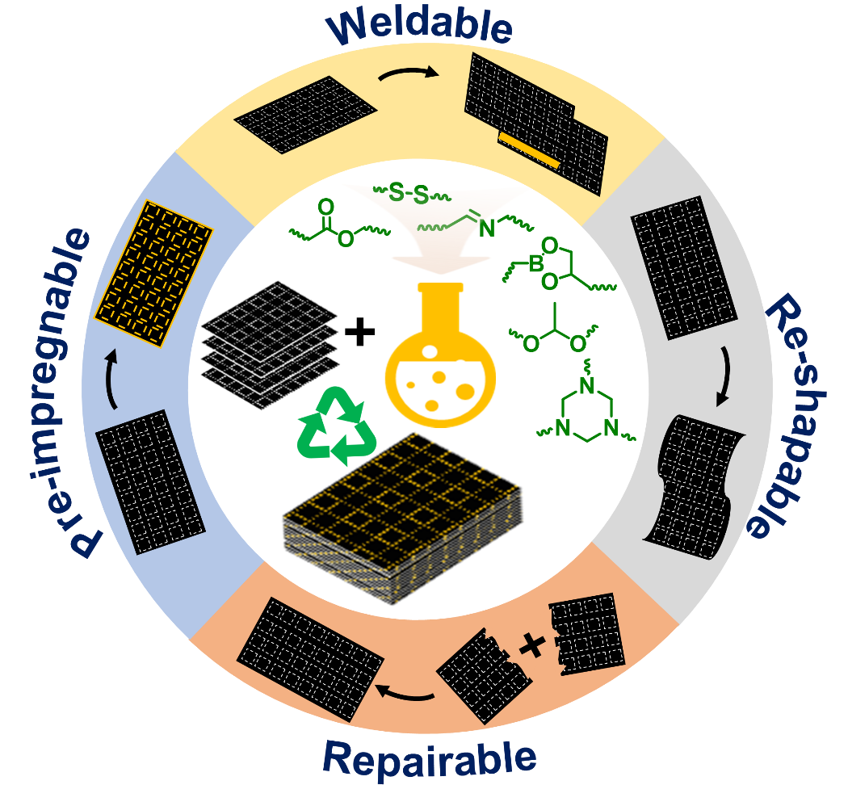
Figure 1. Schematic illustration of dynamic covalent bonds used in the fabrication of recyclable CFRPs and the corresponding characteristics.

2. Covalent adaptable networks (CANs)
CANs are living polymer networks created through exchangeable covalent bonds that facilitate reprocessing while maintaining the benefits of thermoset materials.^{[13, 18-21]} Additionally, CANs can exhibit characteristics such as malleability, shape memory, and self-healing. Over the past two decades, significant progress has been made in the field of CANs, with a wide range of crosslinkers, polymeric matrices, and applications.^{[22-25]} CANs can be categorized into two main types based on the nature of the reversible covalent bonds employed: dissociative CANs and associative CANs, often referred to as vitrimers (Figure 2).^{[26-28]} In dissociative CANs, reversible bonds break into their constituent reactive partners before reformation occurs (Figure 2A). On the other hand, dynamic bonds within vitrimers (associative CANs) undergo cleavage and regeneration simultaneously, maintaining a consistent crosslinking density throughout the exchange process (Figure 2B). This property contributes to enhanced dimensional integrity.
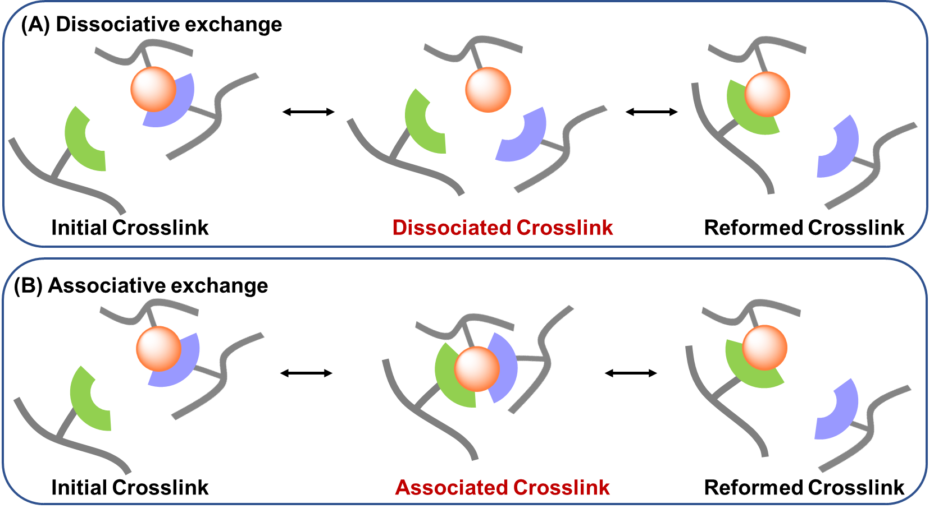
Figure 2. An illustrative representation of the bond exchange routes for (A) dissociative and (B) associative CANs.

2.1. Dissociative CANs
Dissociative CANs, as shown in Figure 2A, are well-known for their ability to undergo reversible bond cleavage in response to external stimuli such as heat, light, or changes in pH. This property allows for the selective disruption and subsequent reformation of covalent bonds within the polymer. During this process, polymer bonds dissociate, leading to the breakdown of material crosslinks and the release of reactive groups. These reactive groups are then repaired by chemically complementary segments from other network regions, restoring the crosslinks. This repetitive cycle of crosslink cleavage and regeneration gives materials the ability to structurally reconstruction. Despite this, the sensitivity of dissociative CANs to stimuli, particularly in real-life applications, remains a major concern. For example, dissociative CANs-based coatings or adhesives, their high reactivity to common environmental factors such as temperature or light could lead to premature degradation or failure of the material. This sensitivity arises from the dependence of the material's instantaneous crosslink density on the equilibrium constant between associated and dissociated crosslinks. In addition, achieving full recovery of the original network crosslink and mechanical properties after stimulus removal is challenging due to the presence of factors such as chain rearrangement, vitrification, or crosslink degradation, which can lead to changes in crosslink density during processing.
Dissociative CANs include various types of reversible bonds, each with their unique properties and applications. Examples include furan-maleimide Diels−Alder (DA) adducts, alkyl anilinium salts, aminal transamination, hindered ureas, and Michael adduct exchange (Scheme 1).^{[10-12, 26-27, 29]} These diverse chemical interactions provide a broad toolbox for tailoring the behavior and functionality of dissociative CANs in response to specific environmental elements, making them a promising choice for a wide range of fields, including materials science, chemistry, and engineering.

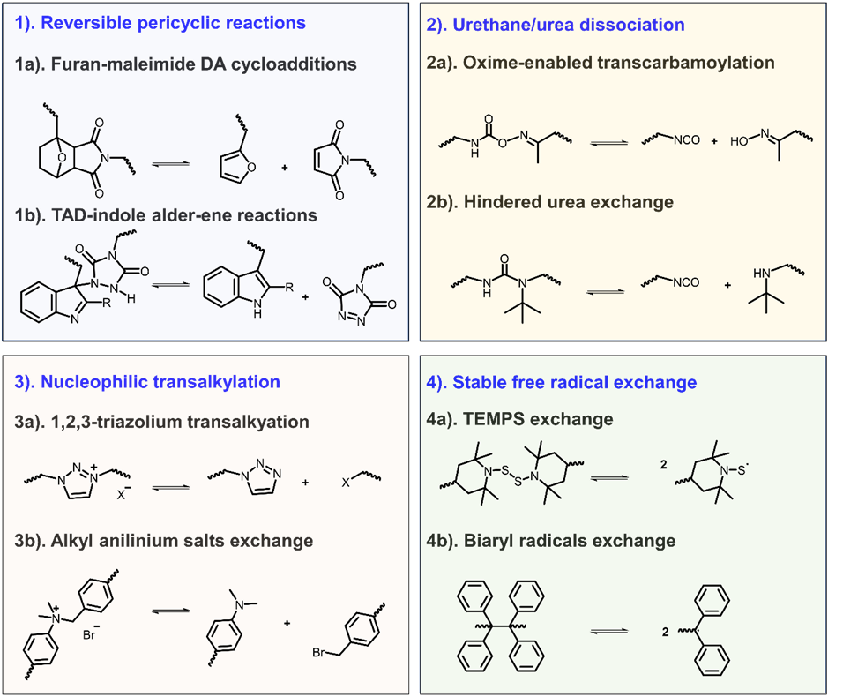
Scheme 1. Overview of various dynamic covalent reactions used for dissociative CANs.

2.2. Associative CANs (Vitrimers)
Associative CANs, as shown in Figure 2B, are a class of crosslinked polymer materials featuring dynamic covalent linkages that allow the exchange of crosslinks, similar to their dissociative counterparts. However, in associative CANs, the bond cleavage and regeneration occur simultaneously in a single reaction, as opposed to being separated into distinct dissociation and association steps. This unique characteristic grants associative CANs a viscosity-temperature relationship similar to vitreous silica. In 2011, Leibler et al.^{[30]} introduced the term 'vitrimers' to describe these associative CANs. What distinguishes vitrimers from their dissociative counterparts is their ability to achieve a dynamic equilibrium in crosslink exchange, maintaining a constant crosslinking density throughout the process. This remarkable property offers several advantages, including enhanced dimensional stability and prolonged material performance, making them an attractive choice for applications where durability and adaptability are crucial. To date, various associative exchange reactions, such as transesterification,^{[30-31]} imine exchange,^{[32-33]} disulfide exchange,^{[34-35]} dioxaborolane metathesis,^{[36-38]} and silyl ether exchange,^{[39]} have been extensively studied for the formation of vitrimers (Scheme 2).
In thermally activated vitrimers, distinct physical properties are observable in different temperature ranges, characterized by two significant transition temperatures. The first is the glass transition temperature (T_{g}), representing the point at which polymer chain segments begin to move, leading to a transition from a rigid to a malleable state. Typically, this transition is assessed using dynamic mechanical analysis (DMA) or differential scanning calorimetry (DSC). The second key transition is the topology freezing transition temperature (T_{v}), indicating the temperature at which rapid bond exchange occurs, causing the polymer to flow and transforming the material from a viscoelastic solid to a viscoelastic liquid. This transition is often identified when the viscosity reaches a value of 10¹² Pa s. Methods such as dilatometry tests, stress-relaxation tests, and dynamic mechanical tests can be used to monitor the T_{v}. Furthermore, Ji’s group^{[40]} introduced a sensitive and versatile method for detecting T_{v} by incorporating aggregation-induced emission (AIE) luminogens as fluorescent probes within polymers. This approach enables precise T_{v} determination, as fluorescence density undergoes significant changes both below and above T_{v}, offering an accurate determination method without external force interference.
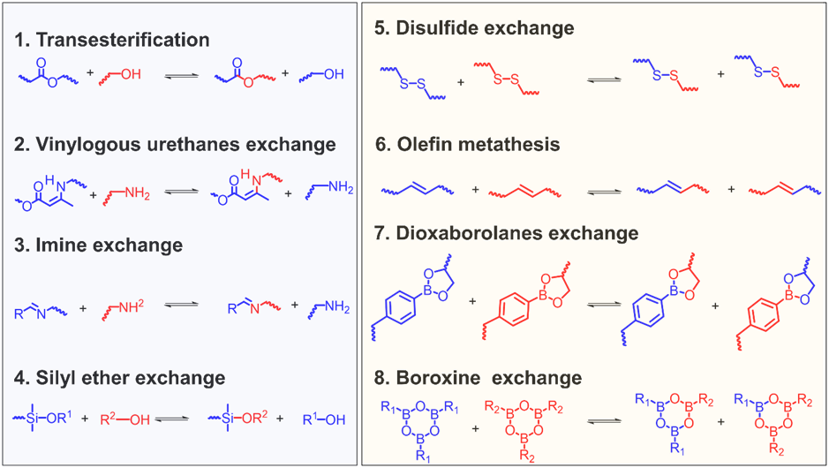
Scheme 2. Various dynamic covalent reactions used for associative CANs.

Theoretically, T_{g} and T_{v} are two temperatures that are inherently independent of each other, due to the different interactions they derive from. In most cases, T_{g} is lower than T_{v} (Figure 3A). In this scenario, the vitrimer undergoes a transition from a rigid solid state below T_{g} to an elastic solid state between T_{g} and T_{v}, and eventually becomes a viscoelastic liquid above T_{v}. At temperatures above T_{v}, the decrease in viscosity can be accurately described by the Arrhenius equation, as the flow rate is primarily governed by the rate of chemical exchanges. Conversely, in some cases, T_{v} may be lower than T_{g} (Figure 3B). In such situations, extensive segmental motion is absent below T_{g}, and thus, no exchange reactions occur. Consequently, the network can be regarded as fixed. As the temperature crosses T_{g} and rises, the viscosity experiences a sharp drop over a narrow temperature range, as predicted by the Williams−Landel−Ferry equation. Further heating leads to chemical kinetics that again governs the exchange rate, and the viscosity variation obeys the Arrhenius equation. This less common behavior was first reported by Guan's group in 2017.^{[41]}
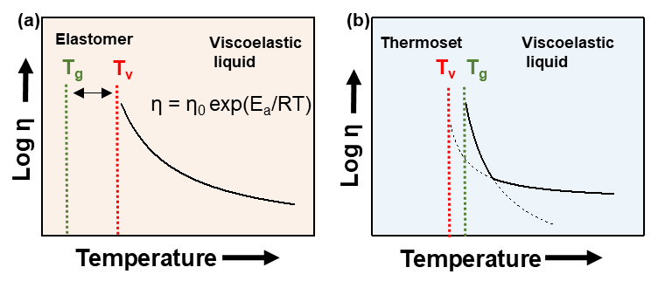
Figure 3. Idealised viscosity-temperature relationship of associative CANs with (a) T_{g} lower than T_{v}, and (b) T_{v} lower than T_{g}. Reproduced with permission^{[11]}. Copyright 2021, Elsevier.

In real polymer networks, the exchange mechanism of these dynamic bonds is closely associated with the reaction conditions. The theoretically associative bonds may undergo dissociative exchange and vice versa. For example, imine bonds, formed through the reaction of an amine and an aldehyde or ketone, typically undergo associative exchange. However, under certain conditions, such as high temperatures or acidic conditions, imine bonds can undergo dissociative exchange, where the bond breaks directly without forming a complex. Another example is disulfide bonds, which can undergo both associative and dissociative exchange mechanisms. Under mild conditions, disulfide bond exchange is often associative, involving the formation of a transition state complex. However, under harsher conditions, such as high temperatures or in the presence of reducing agents, the exchange mechanism can switch to a dissociative pathway, where the disulfide bond breaks directly without forming a complex. Understanding and controlling these exchange mechanisms are crucial for designing dynamic polymer networks with desired properties.

3. Closed-loop recyclable CFRPs from CANs
Conventional CFRPs recycling methods (such as mechanical grinding, pyrolysis, and solvolysis) face limitations, including low-value outputs, compromised fiber performance, and safety concerns.^{[42]} The incorporation of CANs into CFRPs offers a promising remedy for recycling challenges, which enables easy separation of CFs from the polymer matrix, achieving closed-loop recyclability upon specific stimuli.
In the pursuit of closed-loop recycling for CFRPs, the strategic selection of dynamic bonds is pivotal. These bonds must preserve the structural integrity of CFRPs during their operational life while enabling efficient, selective deconstruction and recycling post-use. Notable dynamic bonds that facilitate these properties include imine, ester, disulfide, boronic ester, acetal linkages, and hexahydrotriazine structures. For instance, imine bonds offer reversibility under acidic conditions, simplifying the breakdown and recovery of the composite materials. Ester bonds are known for their transesterification potential in the presence of catalysts, providing avenues for material reshaping and recycling. Disulfide bonds can be selectively cleaved under mild conditions by reduction agents, allowing for the neat separation of the polymer matrix from the CFs. Boronic ester bonds, responsive to changes in pH and diol concentration, and hexahydrotriazine and acetal linkages, which respond to acidic environments, further exemplify the versatility and adaptability of dynamic bonds in recycling processes. By integrating such dynamically bonded materials, CFRPs designs can achieve not only high performance during their use phase but also promote end-of-life recyclability, aligning with sustainable manufacturing goals and closed-loop ecosystems.
In this section, we will introduce recyclable CFRPs based on these dynamic covalent bonds, exploring how each type contributes uniquely to efficient, sustainable recycling processes and enhanced lifecycle management.

3.1. CFRPs recycling based on dynamic imine bonds in CANs
Imine bond, discovered by Hugo Schiff in 1864, is produced via weak acid-catalyzed or uncatalyzed condensation reaction of amines and aldehydes (or ketones).^{[14, 43]} It can be readily identified by the presence of an imine bond in a general formula R₃R₂C=NR₁, where R₁ = alkyl or aryl, but not hydrogen, whereas R₃ and R₂ can be hydrogens.^{[44-45]} Interestingly, the imine linkage is hydrolyzable to an aldehyde (or ketone) and an amine in an acidic environment and can undergo transamination and imine metathesis reversible exchange reactions^{[46]} (Scheme 3).

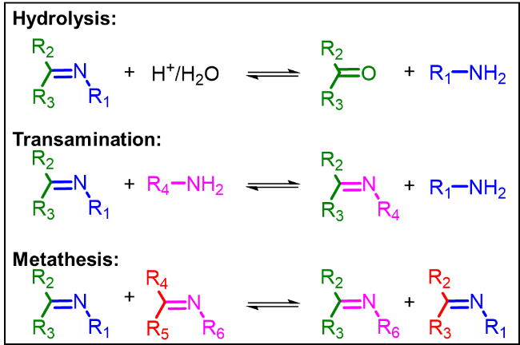
Scheme 3. Hydrolysis, transamination, and metathesis of imine bonds.

Because of the reversible reactions of imine bonds, they have been applied to the fabrication of CANs for recyclable CFRPs.^{[9, 47-49]} For example, the Zhang’s group^{[47]} developed a malleable polyimine network as the binder component for woven carbon fiber composites. This innovation enables an efficient closed-loop recycling process, where all fiber and binder materials are recovered and can be directly reused. The resulting CFRP sheet exhibits excellent mechanical strength, such as a tensile strength of 399 ± 85 MPa, a Young’s modulus of 14 ± 1 GPa, and an elongation at break of 3.3% ± 0.6%. Furthermore, by simply immersing the CFRP sheet in an excess diamine monomer solution, CFs can be easily separated from the polymer matrix due to transimination reactions. The recycled CFs and polymer solution can be reused to form a new CFRP with greater than 100% recovery of mechanical performance. Recently, Zha et al.^{[48]} designed a new crosslinked polyimide (PI) film utilizing a PI oligomer, a chain extender, and a crosslinker (Figure 4A-a₁). Leveraging the synergistic effects of the chain extender and the crosslinker, the resulting PI film demonstrated superior recyclability. Furthermore, this film enables the closed-loop recycling of monomers through depolymerization in an acidic solution at ambient temperature (Figure 4A-a₂). These attributes significantly enhance the mechanical performance of subsequent CFRPs with PI matrices, displaying exceptional bending strength of approximately 530 MPa, surpassing many CFRPs described in the literature. More importantly, the scanning electron microscopy (SEM) image indicated that recycled CFs still maintained intact structures (Figure 4A-a₃), and it supports recycling multiple times with a non-destructive rate of up to 100% (Figure 4A-a₄). Additionally, Liang and colleagues^{[49]} developed a closed-loop recyclable CFRP based on epoxy resins with dynamic imine bonds. Their approach utilizes inexpensive raw materials and a straightforward process suitable for mass production. The dynamic nature of imine linkages in the epoxy vitrimeric material enabled it to exhibit reprocessability, and thermadapt shape memory properties. These characteristics were imparted to the resulting CFRPs, resulting in impressive tensile strength (349 MPa) and, importantly, recyclability under weak acid conditions. The recycled CF monofilaments with similar surface morphology and mechanical strength with the original CF monofilaments.
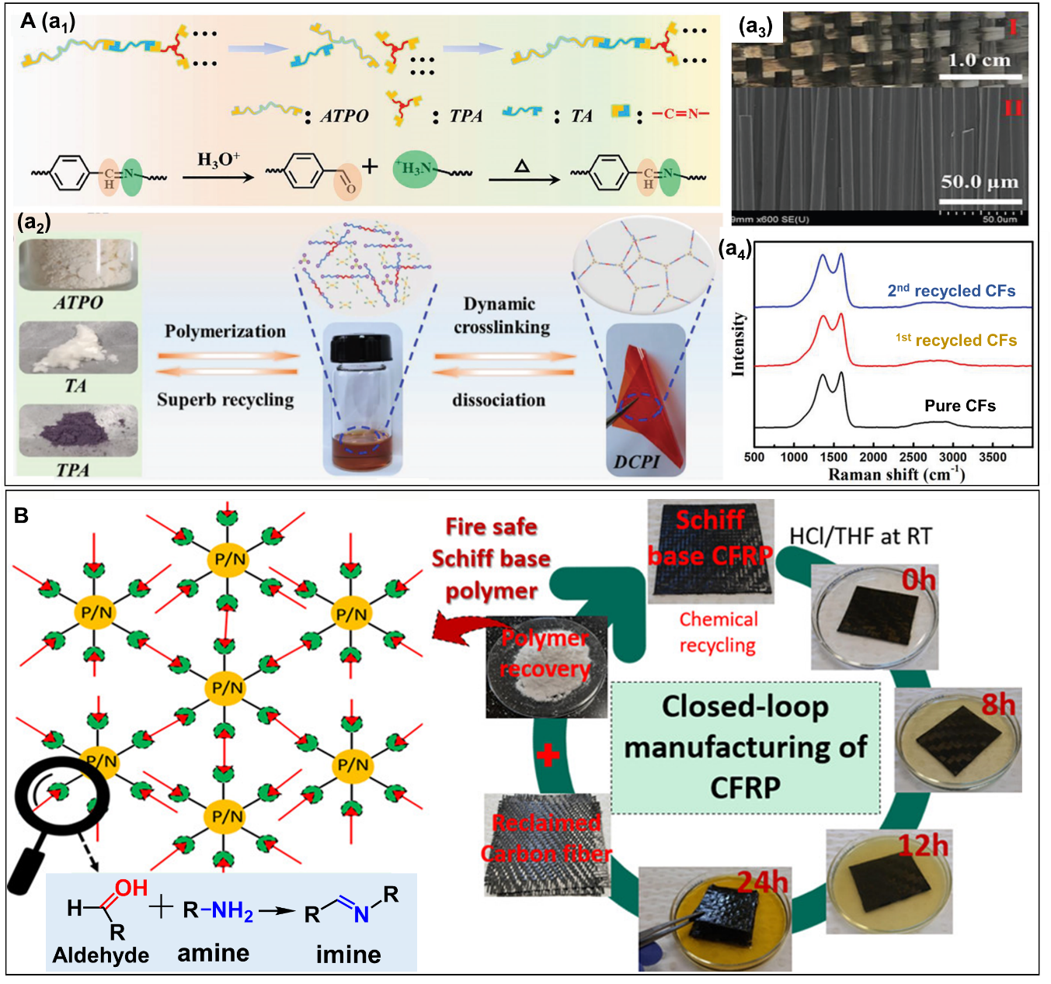
Figure 4. (A) (a₁) Synthesis of polyimine film. (a₂) Photos of the starting materials, the generated of polyimine film and its degradation. (a₃) SEM image of the recycled CFs. (a₄) Raman spectra of pure and recycled CFs. Reproduced with permission from ref.^{[48]} Copyright 2023, Wiley. (B) Closed-loop process for chemical recycling of dynamic imine bond CFRPs using an acid solution at room temperature. Reproduced with permission from ref.^{[50]} Copyright 2021, American Chemical Society.

Epoxy resins have been recognized as the most extensively utilized thermosetting resins globally.^{[51]} Moreover, epoxy resin has exceptional adhesion properties, which allow it to bond strongly with CFs, leading to improved mechanical properties of the composite material. These characteristics facilitate their widespread use in polymer matrices for CFRPs. The presence of dynamic linkages, such as imine bonds, allows for reversible crosslinking, enabling properties such as self-healing or reprocessability. This results in matrices that offer excellent adhesion to CFs, strong interfacial bonding within the composite, and high mechanical strength and stiffness, contributing to the overall performance of CFRPs components. The chemical structure of the epoxy resins can be tailored to achieve specific properties, making them versatile for various applications. Many Schiff base epoxy vitrimer resin systems reported have high viscosity or are in a solid state, often necessitating the use of solvents during product fabrication to reduce viscosity and slow down reactions. To address this issue, Zhang et al.^{[52]} developed a novel dynamic imine-based epoxy system with low viscosity, enabling the preparation of recyclable CFRPs through a solvent-free, one-pot synthesis method. The resulting CFRPs demonstrated excellent tensile strength (443.6 MPa) and elastic modulus (16.8 GPa), along with notable welding properties (lap shear strength, 8.3 MPa). Additionally, the material exhibited efficient chemical recycling properties in HCl aqueous solution at 200°C. The recovered carbon fiber showed minimal damage in terms of surface morphology, thermal stability, and monofilament tensile properties. Moreover, CFRP manufactured using the recycled CFs maintained a commendable mechanical performance, with a tensile strength of 389.5 MPa.
Beyond that, to advance the circular economy, renewable and biosourced materials, particularly lignin derivative vanillin, have been extensively utilized in the preparation of CANs and their subsequent CFRPs.^{[53-54]} Up to date, various vanillin-based crosslinker, such as vanillin-terminated phosphazene monomer (HVP),^{[55]} methacrylated vanillin (MVL),^{[56]} and vanillin-terminated bisaminomethyl cyclohexane (VAN-BAC),^{[57]} were developed for fabricating dynamic polyimine thermosets and the corresponding CFRPs. As an example, Naebe and colleagues^{[50]} utilized vanillin as a starting material to produce highly crosslinked imine bond based polymers and CFRPs (Figure 4B). The fabricated CFRPs exhibit mechanical features comparable to traditional non-recyclable epoxy-based CFRPs. For instance, the tensile strength, Young's modulus, and flexural strength of the imine bond based CFRPs compared to conventional CFRPs are 455/ 606 MPa, 47.3/ 42.3 GPa, and 461/ 622 MPa, respectively. Considering the closed-loop recyclability in and acid condition, the CFRPs based imine bonds demonstrates much greater appeal than conventional epoxy-based CFRP. In another study, the Zhu group^{[58]} employed a synthesized formyl group-containing vanillin-based monoepoxide to react with a diamine, forming the Schiff base structure and epoxy network in situ. Compared to a non-recyclable bisphenol A epoxy resin, this vitrimer system demonstrated similar characteristics, including a T_{g} of 172°C, a tensile strength of 81 MPa, and a modulus of 2112 MPa, along with excellent thermal stability (5% weight loss at 323°C). When applied in a CFRPs system, this vitrimer epoxy material offers both the appealing mechanical properties (e.g., tensile strength = 763 MPa; and tensile modulus = 35.3 GPa) and recyclability under mild condition. Other renewable biosource materials, such as soybean oil,^{[59]} glycerol triglycidyl ether,^{[60]} and cellulose,^{[61]} have also been investigated for the fabrication of CANs, showing great potential for the construction of recyclable CFRPs with excellent mechanical properties, both before and after recycling.

3.2. CFRPs recycling based on dynamic ester bonds in CANs
Ester bonds are formed between carboxyl groups and hydroxyl groups through a condensation reaction, where water is eliminated during the process.^{[62]} Ester bonds can be hydrolyzed under alkaline conditions.^{[63-64]} Additionally, it can undergo transesterification in the presence of a catalyst, such as zinc (II) acetate (Scheme 4).⁶⁴ By leveraging these characteristics, ester bonds have been utilized to fabricate degradable thermoplastics, such as polyhydroxyalkanoates, polybutylene succinate, polylactic acid, etc., and thermosetting resins. Due to the dynamic transesterification nature, early in 2011, Leibler’s group,^{[30]} for the first time, fabricated recyclable epoxy polymer resins which contained ester bonds. After that, CANs from ester bonds^{[11, 65-66]} and CFRPs based on them^{[67-68]} have attracted more and more attention.
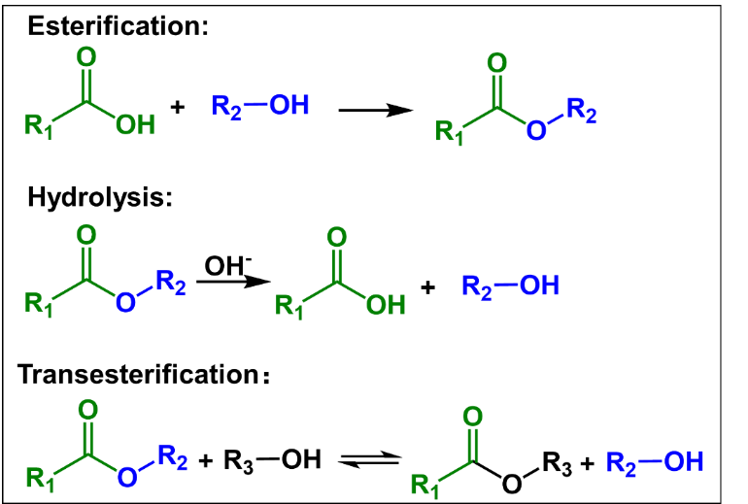
Scheme 4. Esterification, hydrolysis, and transesterification of ester bonds.

Epoxy-based polymer systems with ester linkages within the network are widely used for the fabrication of recyclable CFRP. As an example, Zhang’s group^{[69]} developed recyclable CFRPs using epoxy/anhydride thermosetting systems with extremely high T_{g} (>200 °C) (Figure 5A). The thermosets are fabricated from tetraglycidyl methylenedianiline (TGDDM) as the epoxy matrix and triethanolamine (TEOA) as the co-curing agent. The fabricated thermosets could be recycled without any catalysts in a mild condition. The polymer matrix could be easily hydrolyzed in aqueous solution owing to the catalytic tertiary amines on TGDDM and TEOA (Figure 5A-a₁). Free hydroxyl groups on TEOA could also react with ester bonds by transesterification, facilitating the degradability and recyclability. The mild reaction conditions result in almost no damage to the structure of recycled CFs, which could be used for reproducing CFRPs, thus enabling the closed-loop recyclability of CFRPs (Figure 5A-a₂). CFRPs (TN-0.1TEOA-CF) fabricated from the recycled CFs and polymer matrices exhibited a tensile strength of 437 MPa, which retained 87% of that of original CFRPs (502 MPa). Recently, Zhang and co-workers^{[70]} fabricated CANs by curing phthalic anhydride (PA) with diglycidyl 4,5-epoxycyclohexane-1,2-dicarboxylate (DGEDC) and glycerol. The abundant free hydroxyl groups in the polymer networks enabled rapid transesterification reactions at 180 °C within 205 s, facilitating the convenient degradability, reprocessability and recyclability. CFRPs based on CANs presented strong mechanical properties with modulus of 8.5 GPa and tensile strength of 559 MPa, superior to that of pure CANs (modulus: 3.2-3.9 GPa, tensile strength: 65-78 MPa). Most importantly, CFRPs could be degraded at 190 °C in ethylene glycol through transesterification, realizing the recyclability of CFs. The elongation at break and tensile strength of recycled CFs was 1.24 % and 3.55 GPa, respectively, like those of original CFs (1.35 %, 3.78 GPa), indicating the recycled CFs retained the mechanical properties during the recycling process. In another recent work, Chen et al.^{[71]} prepared closed-loop recyclable CFRPs based on the vitrimers from glycerol triglycidyl ether (GTE), fumaropimaric acid (FPA), and hydroxyterminated hyperbranched polyesters (HBPs) (Figure 5B). The introduction of HBPs significantly improves the mechanical properties of CFRPs with tensile strength of around 585 ± 35 MPa, and interlayer shear strength of 43 ± 4 MPa. The abundant hydroxyl groups of HBPs endows the CFRPs with reprocessing properties. The CFRPs could be degraded by ethylene glycol, therefore, recycling CFs and polymer matrices (Figure 5B-b₁). The properties of CFs examined by SEM and mechanical testing indicated that they are not affected by the degradation reaction. The reformed CFRPs made by the recycled CFs and polymer matrices showed the similar structures with the original ones (Figure 5B-b₂) and exhibited mechanical properties with a tensile strength of 467 ± 45 MPa, and interlayer shear strength of 35 ± 3 MPa, like that of the original CFRPs. This work introduces an eco-friendly approach to fabricate closed-loop recyclable CFRPs. Similarly, Qi et al.^{[72]} demonstrated the recyclability of CFs by immersing CFRPs composites in hot ethylene glycol. The heated EG molecules contributed to transesterification reactions to dissolve the epoxy matrix and broke the long polymer chains into small segments. By dissolving the epoxy matrix, CFs with unchanged properties were easily recovered for recycling. The strength (4.4 ± 0.53 GPa) and modulus (223 ± 16.3 GPa) of recycle CFs are very similar to those of original ones (4.2 ± 0.19 GPa, 239 ± 11.7 GPa, respectively). Furthermore, the mechanical properties of recycled CFRPs retained nearly 100 % to that of the original CFRPs.

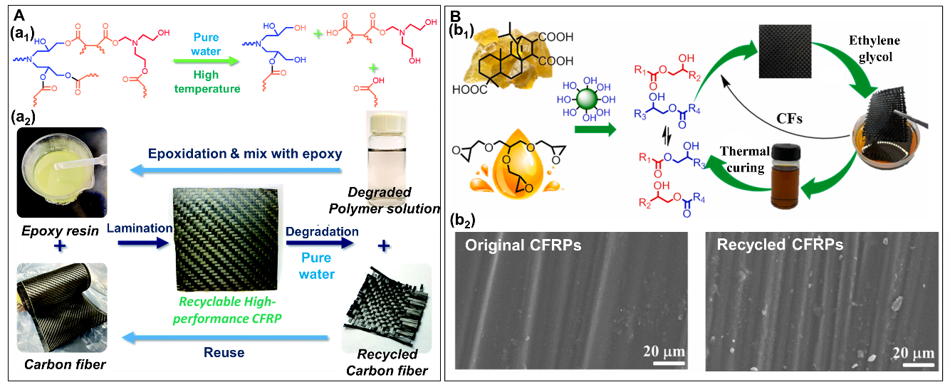
Figure 5. (A) Schematic representation of the recycling mechanism and process of CFRPs based on TGDDM/TEOA polymer resins. (a₁) Hydrolysis of ester bonds in the epoxy polymer matrix in aqueous solution. (a₂) Preparation and recycling process of CFRPs. Reproduced with permission from ref.^{[69]} Copyright 2022, Royal Society of Chemistry. (B) Scheme of the preparation and recycling process of CFRPs based on FPA/GTE/HBP vitrimers. (b₁) Fabrication and recycling process of resultant CFRPs composites by transesterification reactions. (b₂) SEM images of the original and recycled CFRPs. Reproduced with permission from ref.^{[71]} Copyright 2022, Elsevier.

Epoxies suffer from an over-reliance on petroleum-based products. Bio-based epoxy products have aroused considerable attention and are widely used in preparing CANs for CFRPs. As an example, bio-based epoxy CANs was prepared by Chen and colleagues^{[73]} combining tung oil (TO)-based poly-functional acid/anhydride curing agents and diglycidyl ether of bisphenol-A. First, the authors synthesized TO-based acid-anhydride curing agent (TOSMA) from tung oil, maleic anhydride. Then tung oil-based epoxy CANs were prepared by mixing TOSMA, DGEBA, zinc (II) acetylacetonate (transesterification catalyst) and DMP-30 (accelerator) and cured at 100 °C/2 h, 120 °C/2 h, 140 °C/2 h, and 160 °C/4 h. TOSMA-based CANs could be degraded by NaOH/ethanol (1:1) at 100 °C/8 h through transesterification reactions. The structure of immersed CFs, recycled CFs were almost the same as that of virgin CFs. The authors further prepared CFRPs composites using the CANs and CFs of different layers, and the 1-layer CFRPs produced with TOSMA- CANs displayed exceptional mechanical properties (tensile strength:120.8 MPa, elongation at break: 0.49%). Like the unfilled epoxy CANs, the CFRPs can be degraded by transesterification reaction using alkaline ethanol to recover the CFs for reuse and recycling to produce sustainable materials. Recently, Hu and co-workers^{[74]} for the first time fabricated recyclable CFRPs utilizing biobased epoxy matrices from epoxidized soybean oil (ESO) and natural camphoric acid (CPA). The composites exhibited self-adherence, and was easily reprocessed because of the transesterification reactions. The modulus and tensile stress of prepared CFRPs were 16 GPa and 1.6 GPa, respectively, indicating the excellent mechanical properties of CFRPs. Furthermore, CFs can be recycled by degrading CFRPs in the ethylene glycol at 190 °C. The recovered CFs exhibited a similar mechanical property to the original CFs. In another recent example, Xu et al.^{[75]} fabricated CFRPs based on epoxidized menthane diamine-adipic acid (EMDA-AA) vitrimers from adipic acid (AA) and bio-based menthane diamine (MDA). Due to the multiple reactive groups of EMDA, CFRPs based on the vitrimers exhibited high mechanical properties with tensile strength of 465 MPa, higher than that of EMDA-AA vitrimers (tensile strength: 57 MPa), suggesting that the introduction of CFs could greatly enhance the mechanical properties of the vitrimers. The presence of tertiary amines with catalysis functions in the polymer networks resulted in the vitrimers self-rearranged through transesterification without catalysts. Furthermore, the polymer matrix within CFRPs could be degraded with ethanolamine under mild conditions, leading to CFs recycling. Raman spectroscopy and SEM tests indicated the recycled CFs retained the same chemical structure as the original CFs. The tensile strength and elongation at break of recycled CFs was 2795 MPa and 4.3%, respectively, like that of original CFs.

3.3. CFRPs recycling based on dynamic disulfide bonds in CANs
Disulfide crosslinks can undergo cleavage through reduction using agents like dithiothreitol (Scheme 5).^{[35, 76]} Additionally, the thiol-disulfide exchange reaction and disulfide metathesis can be triggered by heat, UV light, or catalysts.^{[14, 77-78]} CANs, especially disulfide networks, are promising polymer matrices to develop CFRPs composites.
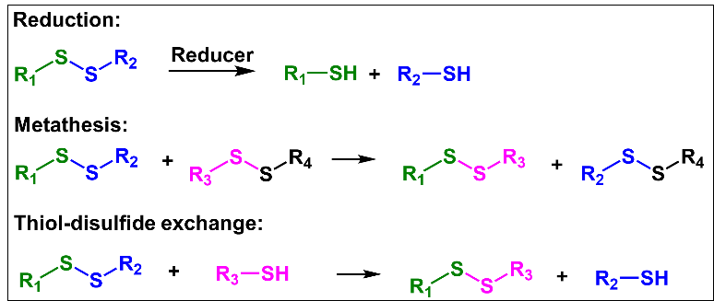
Scheme 5. Reduction, metathesis and thiol-disulfide exchange of disulfide bonds.

Epoxy resins attract considerable attention in preparing CANs containing disulfide bonds for recyclable CFRPs. As an example, Chen’s team^{[79]} recently synthesized an epoxy vitrimer with high contents of exchangeable disulfide bonds, which could facilitate the metathesis reaction between disulfide bonds within the polymer networks and improve the recycling efficiency of the vitrimer based CFRPs (Figure 6). The vitrimers could be completely decomposed by dithiothreitol (DTT), and the degradation efficiency of dual disulfide vitrimers was higher than that of single disulfide vitrimers (Figure 6a). CFRPs based on the vitrimers displayed excellent mechanical properties with a tensile strength of 334.5 MPa and a storage modulus of 10.5 GPa. CFs and polymer matrices could be recycled after treating the CFRPs by DTT for reproducing CFRPs (Figure 6b). The structures of recycled CFs were not affected by the recycling process (Figure 6c). The reformed CFRPs still exhibited excellent mechanical properties with a tensile strength of 320.9 MP and a storage modulus of 8.2 GPa, which indicated that the mechanical properties of recycled CFRPs were like that of the original ones (Figure 6d), suggesting the closed-loop recyclability. In another recent study, Saito et al.^{[80]} designed CFRPs based on dynamic polyurea/epoxy (DPE) vitrimers with disulfide bonds. To synthesize DPE, diglycidyl ether of bisphenol A (DGEBA), and hexamethylene diisocyanate (HDI) were combined with 4-aminophenyl disulfide (AFD) as the dynamic crosslinkers. Due to the rapid metathesis reactions between disulfide bonds, the DEP resins demonstrated multi-cycle reprocessability at low temperature. The resulting CFRPs based on DEP resins exhibited high flexural strength of 903 MPa, interlaminar shear strength of about 50 MPa, tensile strength of around 400 MPa and tensile strain of 3.5 %. The CFRPs also demonstrated chemical recyclability, allowing for the recycling of CFs while maintaining resistance to various solvents. The easily designed CFRPs with multi-cycle recyclability advanced the development of next-generation CFRPs with highly sustainable manufacturing methods.
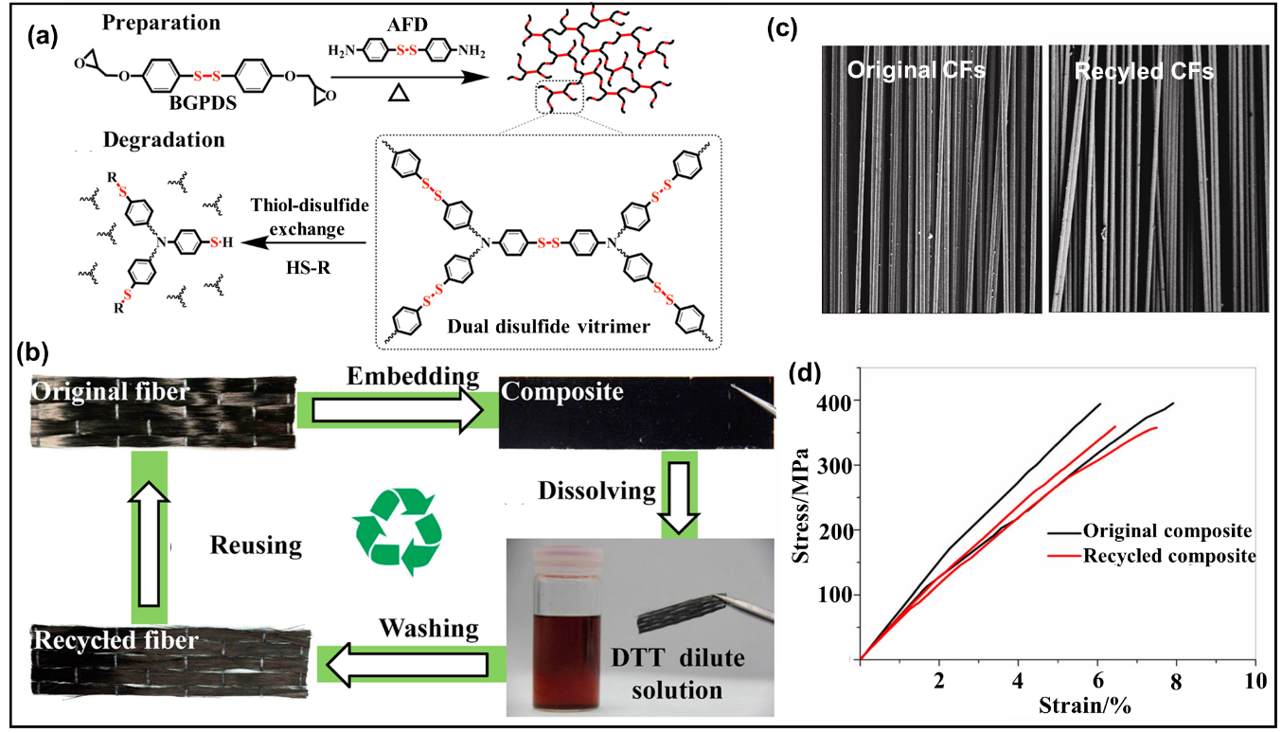
Figure 6. (a) Preparation and degradation of polymer networks containing disulfide bonds. (b) Recycling process of CFRPs based on disulfide vitrimers. (c) SEM images of the original (left) and recycled (right) CFs. (d) Tensile tests of the original (black) and recycled (red) CFRPs composites. Reproduced with permission from ref.^{[79]} Copyright 2020, Elsevier.

3.4. CFRPs recycling based on dynamic boronic ester bonds in CANs
Boronic esters can be easily synthesized by condensing boronic acids with compounds containing hydroxyl groups.^{[81]} Due to their hydrolysis capability, as well as their potential for metathesis and transesterification (Scheme 6), boronic esters have found application in the development of recyclable CANs.^{[37, 82-83]} In 2015, Guan et al.^{[84]} pioneered the successful use of the dynamic boronic ester linkage for crafting CANs with self-healing and recyclable attributes. The inherent self-healing and recyclable characteristics were attributed to the transesterification of boronic esters. Afterward, boronic ester-based CANs have garnered increasing attention for preparing CFRPs.
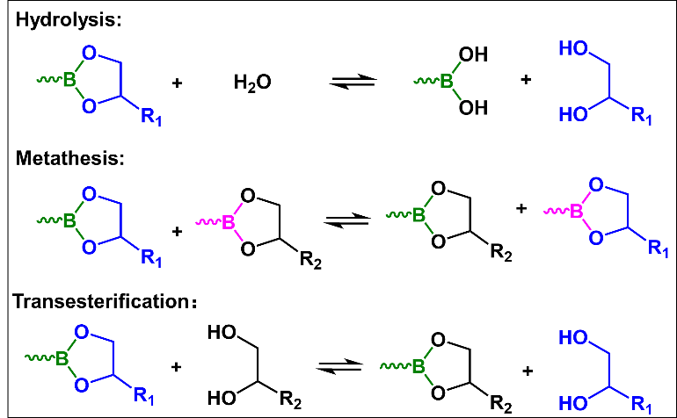
Scheme 6. Hydrolysis, metathesis and transesterification of boronic ester bonds.

Incorporating boronic ester linkages into CFRPs is a new and viable way to improve its functionality and performance. To synthesize CFRPs with boronic ester bonds, researchers usually introduce boronic ester-functionalized monomers into the polymer matrix. Typically, the fabrication process involves the selection of boronic ester-functionalized monomers, preparation of the CFRPs by impregnating the CFs with the monomer mixture, and finally, curing the composite at elevated temperatures to facilitate the formation of boronic ester bonds. As an example, Jing et al.^{[85]} fabricated closed-loop recyclable CFRPs made from CFs and boronate networks, leveraging the dynamic nature of boronic ester bonds (Figure 7A). They utilized phenylboric acid (PBA) to crosslink novolak resin (NR), named as PBNRs, and obtained prepregs by brushing PBNRs solution onto CFs. After drying in a vacuum oven to remove the solvent and facilitate the formation of boronic ester bonds, CFRPs with exceptional mechanical properties were obtained, whose modulus and flexural strength reached up to 24.2 ± 0.3 GPa and 411.6 ± 5.3 MPa, respectively. The reversibility of boronic ester bonds allowed the CFRPs to be completely recycled in ethanol (Figure 7A-a₁), and the recycling process is illustrated in Figure 7A-a₂. The architecture of recycled CFs was similar to that of original CFs (Figure 7A-a₃), which could be reprocessed with recovered polymer matrices to create new CFRPs. After third recycling, the flexural modulus and flexural strength of CFRPs were respectively 20.1 ± 0.6 GPa, 380.8 ± 5.7 MPa, exhibiting similar mechanical properties to the original. This indicated the closed-loop recycling of CFRPs. In another recent study, Goh’s group^{[86]} prepared robust vitrimer films by combining tannic acid (TA), boric acid (BA), and polyvinyl alcohol (PVA) through dynamic boronic ester bonds, which can be used for fabricating closed-loop recyclable CFRPs, as shown in Figure 7B. The tensile strength and Young’s modulus of vitrimers were examined to be 77 MPa and 3.1 GPs, respectively. CFs could significantly enhance the vitrimers’ mechanical properties, resulting in remarkable mechanical properties of CFRPs with tensile strength of 570 MPa and Young’s modulus of 21 GPa. Both polymer networks and CFs can be recovered by decomposing CFRPs in ethanol/water at 95 °C for reproducing CFRPs (Figure 7B-b₁). The structures of original and recycled CFs were presented in Figure 7B-b₂, indicating the recycling process exhibited no damage on CFs. The tensile strength of the reproduced CFRPs recovered to nearly 100% of the original CFRPs, however, the Young’s modulus showed a recovery efficiency of 67%.
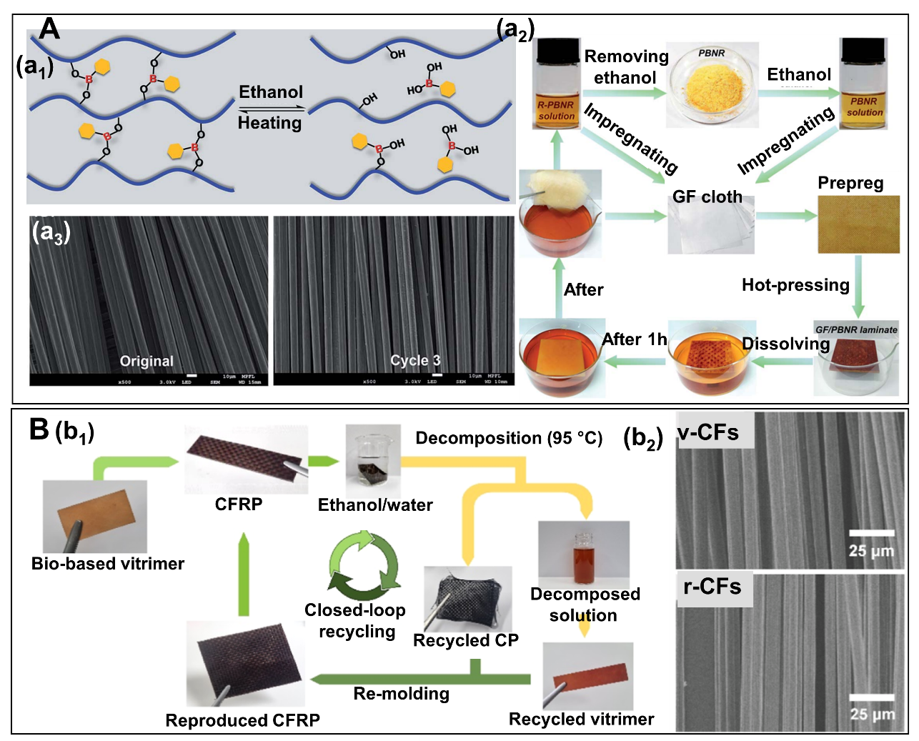
Figure 7. (A) (a₁) Reversibility of the cured PBNRs. (a₂) The recycling process of the CFs/PBNR composites in ethanol at room temperature. (a₃) Images of the original and multi-recycled CFs. Reproduced with permission from ref.^{[85]} Copyright 2018, Royal Society of Chemistry. (B) (b₁) Scheme of the chemical recycling process of the CFRPs, (b₂) SEM images of virgin and recycled CFs. Reproduced with permission from ref.^{[86]} Copyright 2023, American Chemical Society.

The use of bio-based CANs to fabricate CFRPs represents a resource-saving way for producing recycled CFRPs. Following this thought, Zych’s group^{[87]} first reported bio-based CANs derived from boronic ester bonds for CFRPs. The polymer networks were fabricated through the reaction between a diboronic ester-containing crosslinker and epoxidized linseed oil (ELO) without the use of catalysts or solvents. The resulting CFRPs exhibited a flexural strength of 220 MPa and an elastic modulus of 20 GPa. The mechanical properties of these CFRPs could compete with those fabricated from commercial epoxy resins. Furthermore, both CFs and polymer matrices can be conveniently recovered in ethanol under mild conditions due to the engagement of dynamic boronic ester bonds. Incorporating boronic ester bonds into epoxy resins was recently reported to construct recyclable CFRPs. As an example, Xie et al.^{[88]} used commercially available materials to create boronic ester crosslinkers in one-pot preparation, ingeniously formed by amines and glycidol without any solvent. The excellent miscibility of the monomers facilitates large-scale production and the practical application of dynamic polymer networks, which can be used for fabricating CFRPs. CFRPs with a tensile strength of around 800 MPa and elongation at break of approximately 3.8% can be produced using a straightforward process, offering a sustainable alternative to traditional composites.

3.5. CFRPs recycling based on dynamic acetal bonds in CANs
Acetal bonds are formed when the carbonyl group of an aldehyde or ketone reacts with an alcohol,^{[89-90]} leading to the creation of an acetal and typically resulting in the release of a water molecule (Scheme 7). These acetal linkages can be cleaved by acid yet remain stable in the absence of acid.^{[91]} Thanks to the reversible feature, acetal linkages were integrated into polymer networks to realize the recyclability and degradability.^{[92]}

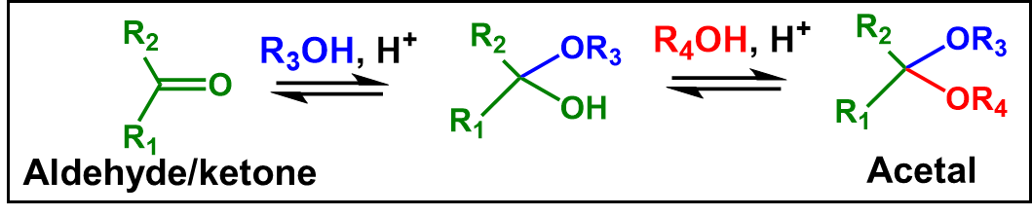
Scheme 7. The reversible synthesis of acetal linkages.

In recent years, polymer resins containing acetal linkages have been widely utilized in fabricating recyclable CFRPs. As an example, Zhu’s group^{[93]} firstly fabricated a high-performance, degradable polyurethane thermoset for the fabrication of CFRPs, which was incorporated with acetal linkages (Figure 8A). The PU thermoset (PU-HMDO) was prepared by acetal diol reacting with hexamethylene diisocyanate trimer (Figure 8A-a₁). The tensile strength and elongation at break of the PU thermoset was 68 MPa and 7.9%, respectively, which could be completely decomposed under certain mild conditions, while resistant to water, acid, and alkali. CFRPs based on the PU vitrimer could be completely degraded at 60 °C in 0.1 M HCl (H₂O/ solvent = 1/9, v/v) solution for 3 h (Figure 8A-a₂). Recycled CFs exhibited the similar architectures with the original ones (Figure 8A-a₃), which could be reused with polymer resins to prepare CFRPs again, exhibiting high mechanical properties with tensile strength of 377 ± 95 MPa, tensile modulus of 15.8 ± 1.5 GPa, elongation at break of 4.6 ± 0.8 %, similar to that of original CFRPs (tensile strength: 381 ± 66 MPa, tensile modulus: 16.3 ± 1.9 GPa, elongation at break: 4.2 ± 0.6 %). Ma et al.^{[94]} prepared spiro diacetal structures containing acetal linkages to synthesize recyclable polymer resins, which could be used for fabricating recyclable CFRPs. The dynamic acetal linkages endowed the polymer resins with stability under basic or neutral conditions while maintaining degradability under mild acidic conditions and presenting excellent thermal stability. The developed CFRPs based on the spiro diacetal structures exhibited high mechanical properties with an elongation at break of 2.9 %, a tensile modulus of 40.0 GPa, and a tensile strength of 731 MPa, even higher than those fabricated from the traditional bisphenol A epoxy resins. Furthermore, the dynamic acetal bonds enabled the CFRPs to be degraded within 30 min in 1M HCl solution (acetone/H₂O, 9/1, v/v), facilitating the recyclability of CFs from the prepared CFRPs. The mechanical properties, chemical details and morphology of recycled CFs were respectively like the virgin ones.
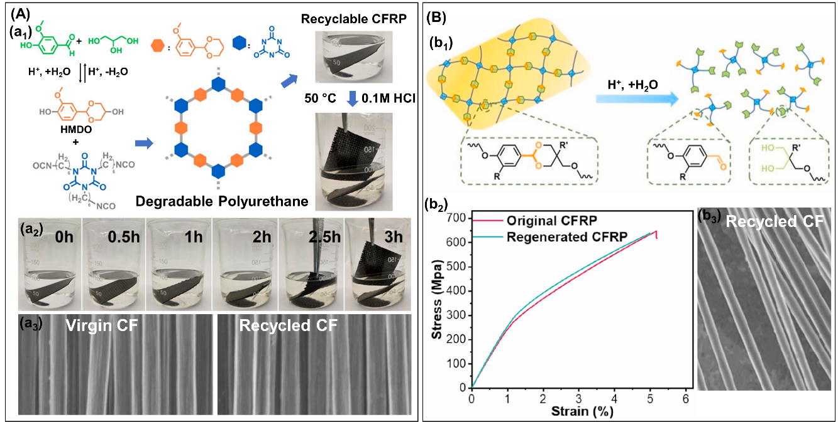
Figure 8. (A) (a₁) Design of the recyclable CFRPs based on degradable polyurethane containing acetal linkages. (a₂) Degradation process of the CFRPs composite at 60 °C in 0.1 M HCl H₂O/acetone (1/9, v/v) solution. (a₃) Comparison of structures of virgin and recycled carbon fibers. Reproduced with permission from ref.^{[93]} Copyright 2020, American Chemical Society. (B) (b₁) Schematic representation of degradable epoxy networks containing benzyl cyclic acetal linkages. (b₂) Tensile stress-strain curves of the original and reproduced CFRPs. (b₃) Comparison of the structures of virgin and recycled carbon fibers. Reproduced with permission from ref.^{[95]} Copyright 2022, Elsevier.

To increase the processability of thermoset, Li and co-workers^{[95]} for the first time developed liquid epoxy monomers for easy processability with degradability, which were synthesized through acetalization between triols and p-hydroxybenzaldehyde analogues (Figure 8B). They reduced the crystallization ability of epoxy monomers by introducing methyl or ethyl groups on the acetal ring structure to destroy the regularity. Due to the presence of cleavable acetal architectures, CFRPs based on the developed polymer resins could undergo degradation in mild acidic environments (Figure 8B-b₁). This process enabled the recovery of CFs from the CFRPs without causing damage, allowing them to be reused to reproduce CFRPs while preserving their original structures and mechanical properties (Figure 8B-b₂ and b₃). Young’s modulus, elongation at break, and tensile strength of reproduced CFRPs were respectively 25.4 ± 1.2 GPa, 5.0 ± 0.7% and 644.0 ± 35.6 MPa, comparable to those of original CFRPs (Young’s modulus: 25.5 ± 0.7 GPa, elongation at break: 5.9 ± 0.8%, and tensile strength: 635.9 ± 24.1 MPa). These results indicated that the recycled CFs could be reused to fabricate CFRPs which maintained the mechanical properties. Lv et al.^{[96]} prepared CFRPs from a degradable epoxy resin containing acetal linkages. The employed epoxy resin was diglycidyl ether pentaerythritol vanillin diacetal (DEPVD), which could be degraded in acid conditions. The CFRPs were fabricated by using bisphenol as a diluent and 4,4’-diaminodiphenylsulfone (DDS) as a curing agent through the resin transfer molding (RTM) process. The content of DEPVD played an important role in the tensile and flexural strength of the CFRPs. The 70 % content of DEPVD could endowed the composites with a tensile strength as high as 1649.4 MPa. Furthermore, the recycled CFRPs showed similar mechanical properties to the original samples. Kuroyanagi et al.^{[97]} prepared recycled CFRPs using acetal-linkage-containing epoxy resins. These epoxy polymer resins had a high thermal decomposition temperature (T_{d}) of 319 °C, suggesting the good thermal stability. The toughness of CFRPs based on the degradable polymer resins was higher than that of CFRPs from bisphenol A-based epoxy resins. The fabricated CFRPs exhibited mechanical properties with a tensile stress of 132.5 MPa, elongation at break of 1.8 %, and Young’s modulus of 11.9 GPa. Furthermore, CFRPs can be completely decomposed by hydrolysis under acidic conditions and the polymer matrices were soluble in a tetrahydrofuran (THF)/H₂O mixture. Therefore, CFs can be easily recycled to make other products.

3.6. CFRPs recycling based on other dynamic covalent bonds in CANs
Besides the commonly used dynamic bonds introduced above, some other dynamic bonds, such as hexahydrotriazine (Scheme 8A), Knoevenagel condensation (Scheme 8B), maleic acid tertiary amide bonds (Scheme 8C), benzyl ether bonds (Scheme 8D), and acylsemicarbazide bonds (Scheme 8E) are recently utilized to fabricate degradable polymer matrices for recyclable CFRPs.
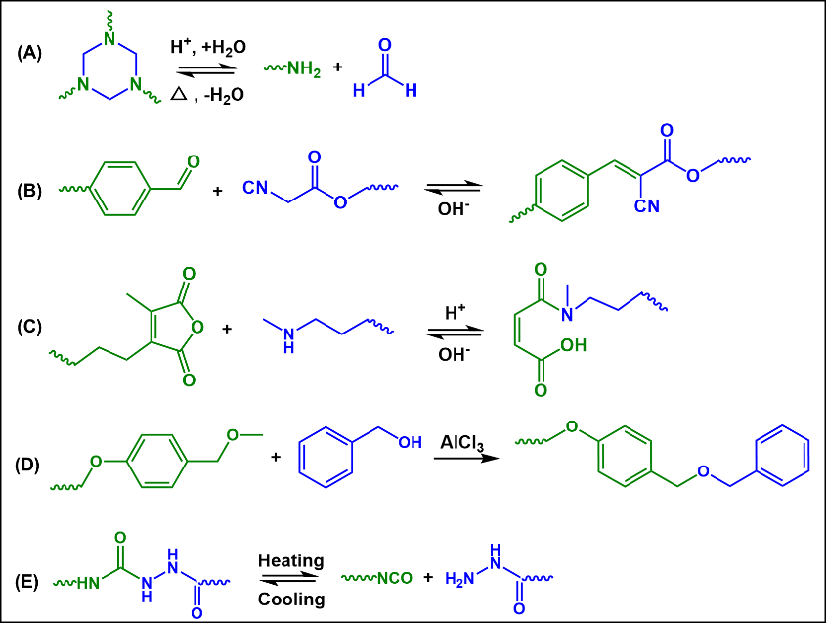
Scheme 8. (A) Degradation mechanism of hexahydrotriazine structures. (B) The reversibility of Knoevenagel condensation. (C) Degradation mechanism of maleic acid tertiary amide bonds. (D) Degradation mechanism of benzyl ether bonds. (E) The reversibility of dynamic acylsemicarbazide bonds.

Hexahydrotriazine structure, a cyclic triaminal arrangement, can be created through the condensation of formaldehyde and amines, and it can be hydrolysed under acidic conditions. This characteristics of hexahydrotriazine structures make them promising candidates for fabricating CFRPs. In 2014, Hedrick’s group^{[98]} firstly reported poly(hexahydrotriazine)s thermosets by polycondensation between paraformaldehyde and 4,4ʹ-oxydianiline (ODA), which was recyclable owing to the presence of hexahydrotriazine structures. Inspired by this, closed-loop recyclable CFRPs were fabricated based on hexahydrotriazine structures. As an example, Zhang and co-workers^{[99]} fabricated closed-loop recyclable high-performance CFRPs composites by thiol-functionalized carbon fiber (TCF) and a hyperbranched polymer (HT₃) with considerable mechanical performance (Figure 9A). The mechanical properties of HT₃/TCF composites were higher than those of CFRPs based on pristine carbon fiber (PCF) composites, which was ascribed to the increased interaction between TCF and the polymer matrix. The HT₃/TCF composites could be completely degraded at 25 °C by using 2.6 M H₃PO₄/THF solution for approximately 24 h owing to the degradability of hexahydrotriazine structures, realizing polymer resins and CFs recyclability for being reused. The polymer resins after two recyclability were used to prepared CFRPs, exhibiting a tensile strength of 312.81 MPa, around 8% lower than that of the original HT₃/TCF composites. The authors also employed the second recycled CFs to prepare recycled CFRPs, which showed similar mechanical performance to the original. This indicated that the recycled CFs were almost not damaged during degradation. In another recent work, Hu’s group^{[100]} prepared degradable and recyclable poly(imide-hexahydrotriazine) (PHT) thermosets, which can be used to serve as the matrix for recyclable CFRPs. The thermoset materials also demonstrate remarkable thermal stability, with a T_{g} of approximately 211 °C and UV stability. The CFRPs with high performance could be recycled within 6 h in a mildly acidic solution because of the degradable dynamic nature of the chemical bonds. The CFRPs composite exhibited a flexural strength of 649 MPa and an interlaminar shear strength of 53 MPa, indicating the interfacial performances were not inferior to other analogous CFRPs. Furthermore, recycled CFs and polymer resins were used to re-produce CFRPs composites with a flexural strength of 578 MPa and an interlaminar shear strength of 46 MPa. These results indicated the closed-loop recyclability of high-performance CFRPs.
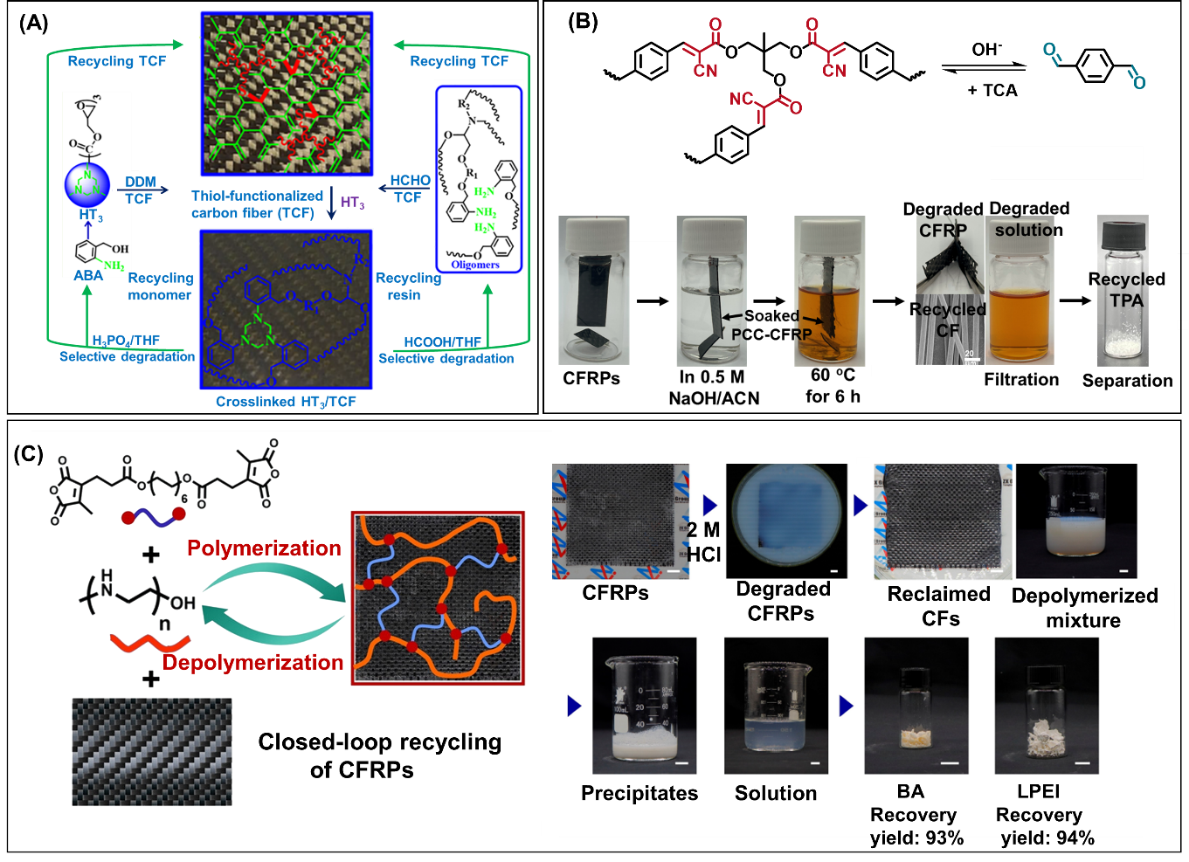
Figure 9. (A) Closed-loop recycling process of HT₃/TCF composites for recycling both CFs and resin. Adapted with permission from ref.^{[99]} Copyright 2021, American Chemical Society. (B) Schematic representation of recycling mechanism and process of CFRPs involving Knoevenagel condensation. Adapted with permission from ref.^{[101]} Copyright 2024, American Chemical Society. (C) Schematic representation of closed-loop recycling of CFRPs to pure CFs and monomers based on reversible amidation chemistry. Adapted with permission from ref.^{[102]} Copyright 2023, John Wiley & Sons, Inc.

Knoevenagel condensation is a nucleophilic addition of an active hydrogen compound to a carbonyl group followed by a dehydration reaction in which a molecule of water is eliminated.^{[103]} Knoevenagel adducts can be cleaved under alkaline conditions. By leveraging the dynamic nature, Wang et al.^{[101]} fabricated tough thermoset materials, poly(α-cyanocinnamate) (PCC), by Knoevenagel condensation between a triarm cyanoacetate star and terephthalaldehyde (TPA) (Figure 9B). The resulted thermosets presented high mechanical properties with a tensile strength of 102 MPa, and a Young’s modulus of 3.8 GPa, accompanied with a Tg of ∼178 °C. Meanwhile, thermoset materials exhibited considerable flexibility and stability, rendering them resistant to various chemical conditions. Furthermore, the developed thermosets could be degraded, allowing them to be partially recycled into the initial monomer terephthalaldehyde for use in a new production cycle. CFRPs based on thermosets can be degraded in a 0.5 M NaOH/acetonitrile solution, achieving the recyclability of CFs and terephthalaldehyde. In a very recent work, by leveraging decomposability of aromatic pinacols, Sun’s group^{[104]} fabricated high-performance CFRPs based on polyurethane thermosets crosslinked by aromatic pinacols (PU-AP). The thermoset matrices presented a Young’s modulus of 248.7 MPa, and a breaking strength of 95.5 MPa. The polymer matrices could strongly adhere to CFs due to abundant hydrogen bonding interactions. This resulted in the high mechanical properties of CFRPs (CF/PU/AP composites), with a tensile strength of 870 MPa and a Young’s modulus of 22.31 GPa, indicating the introduction of CFs could significantly enhance the mechanical properties of polymer resins. This composite demonstrated high stability against water and various organic solvents because of no pinacol rearrangement reaction occurred in this condition. By heating at 100 °C in DMF solvent, aromatic pinacols could be cleaved, recovering CFs and the liner polymers. This process realized the upcycling of CFRPs composites.
Maleic acid tertiary amide bond was recently reported to prepare closed-loop recycling polymeric materials because of its dynamic nature.^{[105]} In an acid condition, this bond can be completely cleaved, making the polymeric networks closed-loop recyclable. Following this work, Xu’s groups^{[102]} fabricated a closed-loop recyclable CFRPs, utilizing reversible amidation chemistry (Figure 9C). The maleic acid tertiary amide bond, resulting from the amidation of maleic anhydride and secondary amine, was fully cleavable in acidic conditions. Networks derived from a multifunctional macromonomer (LPEI) and a bifunctional cross-linker (BA) could serve as polymer matrices for preparation of CFRPs. The CFRPs exhibited high mechanical properties with a tensile strength of 466 ± 12 MPa, a breaking elongation of 4.0 ± 0.13 %, a Young’s modulus of 13.1 ± 0.25 GPa. In acidic environments, the polymer matrices depolymerized, facilitating the efficient recovery of intact CFs and pure monomers (LPEI and BA). Reclaimed CFs maintained original mechanical properties, and the recovered monomers boasted high purity, enabling multiple reuse cycles in CFRPs preparation with over 95% mechanical property recovery.
Benzyl ethers are dynamic bonds that can be decomposed through metal reduction, oxidative treatments, hydrogenation, or Lewis acid. By leveraging the dynamic property, Xia et al.^{[106]} synthesized an epoxy monomer with a dynamic benzyl ether bond and used it with commercial amine-curing agent to create epoxy thermosets with a Young's modulus of 2.2 GPa, and a tensile strength of 91.8 MPa. In the presence of aluminum chloride catalyst, these thermosets showed degradation at 190°C in benzyl alcohol owing to the bond exchange between benzyl alcohol and benzyl ether. CFRPs made from the polymer matrix exhibited significantly enhanced mechanical properties with a Young's modulus of 27 GPa, and a tensile strength of 725 MPa. The epoxy matrix's degradability allowed for the complete recovery of CFs from CFRPs composites.
Dynamic acylsemicarbazide bonds, formed by reacting a hydrazine derivative with an isocyanate, can undergo controlled cleavage at elevated temperatures.^{[107]} By selectively breaking these bonds, it becomes feasible to recover CFs and reuse them in fabricating new CFRPs. As an example, Xia’ group^{[108]} produced polyacylsemicarbazide by reacting hexamethylene diisocyanate trimer and sebacic dihydrazide with isophorone diisocyanate. The polymer resins exhibited mechanical properties with a Young's modulus of 2.73 GPa, a tensile strength of 101 MPa, and an elongation at break of 8.67%, which surpassed those of the original dynamic polymers, demonstrating their recycling performance. CFRPs based on the polymer resins could be decomposed in DMF at 120°C, enabling the recycling of CFs and polymer matrix. The tensile strength and elongation at break of recycled CFRPs are 711 MPa and 3.3 %, respectively, similar to those of original CFRPs, indicating excellent recyclability. This upcycling mitigates environmental impact, potentially contributing to the circular economy.

3.7. CFRPs recycling based on dual/multiple dynamic linkages in CANs
To further improve the recyclability and reprocessability of CANs, more complex vitrimer systems, such as those containing dual dynamic bonds or even multiple dynamic bonds, have been developed. As an example, Chen and colleagues^{[109]} designed interlocked epoxy networks comprising disulfide and imine bonds in one-pot synthesis. This approach aims to improve the stability of CANs without sacrificing the dynamic properties or redissolving the networks. In their work, they utilized epoxy monomers (diglycidyl ether of bisphenol-A) and two curing agents (aminophenyl disulfide, aminophenyl diimine) to construct interlocked CANs, which exhibited enhanced mechanical performance and stability. In addition, the authors reported the unlocking of the CANs by sequential degrading disulfide bonds in DTT solutions and imine bonds in HCl solutions. The CANs could serve as the matrix for preparing CFRPs, which exhibited a tensile strength as high as approximately 321.1 MPa. When the disulfide and imine bonds in the polymer matrix were cleaved by DTT and HCl, respectively, the CFs were recycled. The reformed CFRPs retained strong mechanical properties, with a tensile strength of around 330 MPa, representing 94.4% of the original value. In a similar work, Serra’s group^{[110]} prepared epoxy-based vitrimers by using monomers with disulfide and imine groups, derived from renewable sources. The prepared vitrimers exhibited rapid relaxation times, easy degradability via two different methods, and excellent thermomechanical properties. The polymer matrix in CFRPs could be completely degraded in a 0.3 M DTT Dimethylformamide (DMF) solution at 50 °C or 0.2 M HCl solution at room temperature for recovering CFs, which did not suffer from any change. Furthermore, the recycled CFs can be utilized for fabricating new CFRPs. Besides combining with imine bonds, disulfide bonds also worked together with ester bonds to fabricate recyclable CFRPs. To illustrate with an example, Cheng et al.^{[111]} employed 4-aminophenyl disulfide and tung oil-based triglycidyl ester (TOTGE) to produce a dual dynamic vitrimer composed of disulfide and ester bonds networks. Disulfide bonds resulted in a low activation energy (66.51 kJ/mol) of bond exchange in the vitrimer, facilitating the reprocessability and recyclability of the vitrimer. Because of the presence of disulfide and ester bonds, CFRPs based on the vitrimer could be recycled for multiple times by adding ethanolamine, ethylene glycol and mercaptoehtanol through thiol-transesterification or disulfide exchange reaction. Ni’s group^{[112]} fabricated degradable polymers containing both dynamic disulfide bonds and carbon-nitrogen bonds with good mechanical properties and heat resistance. CFs can be recovered from CFRPs by being performed in 2-Mercaptoethanol/DMF for 24 h, and then in H⁺/THF mixed solution for 4 h. SEM examination indicated that the structure of CFs was not affected by the recycling process. Song and colleagues^{[113]} developed recyclable CFRPs by utilizing a bio-based polybenzoxazine reinforced with pine oleoresin-based vitrimer containing both imine bonds and β-hydroxy ester linkages. The generated vitrimer demonstrates rapid topological rearrangement, and degradability. Additionally, the incorporation of the polybenzoxazine (PBz) structure into the epoxy system has significantly enhanced the mechanical properties, thermal decomposition temperature, carbon yield, and hydrophobicity, making it a suitable matrix for recyclable CFRPs with high hardness and stiffness, along with excellent reprocessability. Interestingly, two pieces of the vitrimer were hot-pressed together and could lift the weight of 25 kg (>20,000 times its own weight), demonstrating its excellent self-adhesion. Furthermore, the CFs can be easily recycled via ammonolysis with n-butylamine under mild conditions (60°C) with 98% properties recovery. In addition to the dual dynamic bonds systems mentioned above, combination of other dynamic bonds^{[114-115]} (eg., Diels-Alder bonds, boronic ester bonds), and/or non-covalent interactions^{[116], [117-118]} (e.g., hydrogen bonds, π-π interactions, and metal coordination), have also been explored for the fabrication of interlocked CANs, showing promising potential to form recyclable CFRPs with enhanced stability.
Additionally, multiple dynamic bonds have been integrated into a single polymer network to achieve orthogonal control for CFRPs. As an example, Zhu et al.^{[119]} fabricated polyurethane thermosets by combining ester bonds with other two dynamic covalent bonds (urethane and thiourethane bonds). The thermosets exhibited excellent mechanical properties, recyclability, reprocessability, and high transparency. In the prepared CFRPs composites, CFs can be easily recycled under a mild condition and reused in preparing other polymer composites. Konkolewicz’s group^{[120]} reported a polymer nanocomposite featuring three dynamic bonds: hydrogen bonds, thiol-Michael linkages, and Diels−Alder bonds. These bonds contribute to the material's flexibility, recyclability, thermos-responsive properties, and covalent bonding between the nanocomposite and the polymer matrix. Such a system of multiple dynamic bonds offers a solution to the trade-off between material elongation and enhanced mechanical performance in dynamic polymer nanocomposites, demonstrating great potential for use in the fabrication of advanced recyclable CFRPs.
In the above text, we have introduced closed-loop recyclable CFRPs based on various dynamic covalent bonds or a combination of multiple dynamic bonds, with the recycling methods and properties outlined in Table 1. CFRPs based on dynamic covalent bonds have the advantages of recycling in a mild condition, low request for equipment and high mechanical properties. As more covalent adaptable networks appear in future, we believe CFRPs with high mechanical properties and closed-loop recyclability will continue to emerge.

Table 1. Recycling methods and properties of closed-loop recyclable CFRPs derived from various dynamic covalent bonds.
Dynamic Bonds | Polymer Matrix | Recycling Mechanism  and Conditions | Original CFRP  Properties | Recycled CFRP Properties | Ref
Imine bonds | Polyimine network | (Transamination/ associative) diethylenetriamine | σ_{f}: 399 MPa, E_{t}': 14.2 GPa; ε_{t}: 3.3 % | Greater than 100% recovery of mechanical performance | ^{[47]}
Imine bonds | Polyimine network | (Acid hydrolysis/ dissociative)  HCl solution, RT | σ_{b}: 530 MPa | - | ^{[48]}
Imine bonds | Epoxy vitrimer | (Acid hydrolysis/ dissociative)  1 M HCl (H₂O/THF, 2/8, v/v) solution, RT, 24 h | σ_{f}: 349 MPa, E: 6.7 GPa, ε_{t}: 12.19 % | - | ^{[49]}
Imine bonds | Epoxy vitrimer | (Acid hydrolysis/ dissociative)  0.2 M HCl solution, 200 °C, 4 h | σ_{f}: 443.6 MPa, E_{t}': 16.8 GPa | σ_{f}: 389.5 MPa, E_{t}': 14 GPa | ^{[52]}
Imine bonds | Bio-based epoxy vitrimer | (Acid hydrolysis)/ dissociative  0.1 M HCl solution (methanol/H₂O = 8/2, v/v), RT, 15h | σ_{f}: 763 MPa, E: 35.3 GPa, ε_{t} :3.02 % | σ_{f}: 778 MPa, E: 37.0 GPa, ε_{t}: 2.92 (%) | ^{[58]}
Imine bonds | Bio-based  polyimine network | (Acid hydrolysis/ dissociative)  1 M HCl/THF solution (2/8, v/v), RT, 12h | σ_{f}: 271 MPa, E_{f}': 46.3 GPa | More than 100% recovery of flexural properties | ^{[55]}
Ester bonds | Epoxy polymer matrix | (Hydrolysis/ dissociative)  pure water, 200 °C | σ_{t}: 437 MPa | σ_{t}: 502 MPa | ^{[69]}
Ester bonds | Epoxy polymer matrix | (Transesterification/ associative)  ethylene glycol, 190 °C | σ_{t}: 559 MPa,  E: 8.5 GPa,  σ_{b}: 420 MPa | - | ^{[70]}
Ester bonds | Hyperbranched polyester | (Transesterification/ associative)  ethylene glycol  180 °C, 12 h | σ_{t}: 585 ± 35 MPa  ILSS: 43 ± 4 MPa | σ_{t}: 467 ± 45 MPa  ILSS: 35 ± 3 MPa | ^{[71]}
Ester bonds | Epoxy matrix | (Transesterification/ associative)  ethylene glycol | σ_{t}: 90 MPa  E: 1.7 GPa | σ_{t}: 85 MPa  E: 1.6 GPa  (For the 4th recycling generation) | ^{[72]}
Ester bonds | Epoxy matrix | (Transesterification/ associative)  NaOH/ethanol (1:1), 100 °C | σ_{t}: 1.6 GPa  E: 16 GPa  ε_{t}: 0.49 ± 0.5 % | - | ^{[73]}
Ester bonds | Bio-based  epoxy vitrimer | (Transesterification/ associative)  ethylene glycol, 190 °C | σ_{t}: 120 ± 8.5 MPa  E: 5.5 ± 0.8 GPa  σ_{f} : 65MPa  E_{f}': 20.6 GPa  G': 24.3 GPa  Tg: 56 °C | - | ^{[74]}
Ester bonds | Bio-based  epoxy vitrimer | (Transesterification/ associative)  Ethanolamine, 60 °C | σ_{t}: 465 MPa  ε_{t}: 7.7 % | - | ^{[75]}
Disulfide bonds | Epoxy matrix | (Thiol-disulfide exchange/ associative)  DTT solution | σ_{t}: 334.5 MPa  G': 10.5 GPa | σ_{t}: 320.9 MPa  G': 8.2 GPa | ^{[79]}
Disulfide bonds | Polyurea/epoxy vitrimer | (Thiol-disulfide exchange/ associative)  1-dodecanethiol solution | σ_{f}: 903 MPa  ILSS: 50 MPa  σ_{t}: 400 MPa  ε_{t}: 3.5 % | σ_{t}: 400 MPa  ε_{t}: 3.75 % | ^{[80]}
Boronic esters | Bio-based  vitrimer | (Hydrolysis/ associative)  Ethanol, 150 min | E_{f}': 24.2 ± 0.3 GPa,  σ_{f}: 411.6 ± 5.3 MPa | T_{g}: 202 ◦C, σ_{f}: 380.8 ± 5.7 MPa, E_{f}': 20.1 ± 0.6 GPa, ILSS: 41.5 ± 2.5 MPa | ^{[85]}
Boronic esters | Bio-based Vitrimer | (Hydrolysis/ associative)  ethanol, 95 °C, 4 h | σ_{t}: 569 MPa  E: 21 GPa | σ_{t}: 568 MPa  E: 14 GPa | ^{[86]}
Boronic esters | Bio-based vitrimer | (Hydrolysis/ associative)  ethanol 90% v/v solution, 75 °C, 3 h | E_{t}': 20 GPa  σ_{f}: 220 MPa | - | ^{[87]}
Boronic esters | Bio-based vitrimer | (Hydrolysis/ associative)  75 wt% ethanol, 70 °C, 4 h | σ_{t}: 800 MPa,  ε_{t}: 3.8 % | - | ^{[88]}
Acetal bonds | Polyurethane vitrimer | (Hydrolysis/ dissociative)  0.1 M HCl (H₂O/ solvent = 1/9, v/v) solution, 60 °C, 3 h | σ_{t}: 377 ± 95 MPa,  E:15.8 ± 1.5 GPa, ε_{t}: 4.6 ± 0.8 % | σ_{t}: 381 ± 66 MPa, E: 16.3 ± 1.9 GPa, ε_{t}: 4.2 ± 0.6 % | ^{[93]}
Acetal bonds | Bio-based epoxy vitrimer | (Hydrolysis/ dissociative)  1 M HCl solution (acetone/H₂O= 9/1, v/v), 30 min | σ_{t}: 731 ± 58 MPa  E: 40 ± 1.8 GPa  ε_{t}: 2.9 ± 0.5 % | - | ^{[94]}
Acetal bonds | Epoxy vitrimer | (Hydrolysis/ dissociative)  0.1 M HCl acetone/water (9:1, v/v), RT, 24 h | σ_{t}: 635.9 ± 24.1 MPa  E: 25.5 ± 0.7 GPa  ε_{t}: 5.9 ± 0.8 %  ILSS: 62.4 ± 0.9 MPa  T_{g}: 143 ◦C  G': 14.7 GPa | σ_{t}: 644.0 ± 35.6 MPa  E: 25.4 ± 1.2 GPa  ε_{t}: 5.0 ± 0.7 %  ILSS: 64.8 ± 2.7 MPa  T_{g}: 147 ◦C  G': 13.6 GPa | ^{[95]}
Acetal bonds | Bio-based epoxy vitrimer | (Hydrolysis/ dissociative)  1 M HCl solution (THF/H₂O = 9/1, v/v) | σ_{t}: 1649.4 MPa.  σ_{f}: 1207.4 MPa | - | ^{[96]}
Acetal bonds | Epoxy vitrimer | (Hydrolysis/ dissociative)  0.1 M HCl solution, THF/H2O (9/1, v/v), 24 h | σ_{t}: 132.5 MPa, ε_{t}: 1.8 %,  E: 11.9 GPa | - | ^{[97]}
Hexahydrotriazine bonds | Epoxy vitrimer | (dissociative)  2.6 M H₃PO₄/THF solution, 25 °C, 24 h. | σ_{t}: 365 MPa, E: 36 GPa,  ε_{t}: 3.31 %, σ_{f}: 145 MPa,  E_{f}': 18 GPa, ILSS: 65 MPa | σ_{t}: 335 MPa, E: 35 GPa  σ_{f}: 130 MPa, E_{f}': 18 GPa  ILSS: 60 MPa (from second-generation recycled CFRPs) | ^{[99]}
Hexahydrotriazine bonds | Poly(imide-hexahydrotriazine) | (dissociative)  1 M HCl/THF solution (2/8, v/v), 25 °C | σ_{f}: 649 MPa, ILSS: 53 MPa | σ_{f}: 578 MPa, ILSS: 46 MPa | ^{[100]}
Maleic acid tertiary amide bonds | Network from polyethyleneimine and maleic anhydride | (Associative)  2.0 M HCl, RT | σ_{t}: 466 ± 12 MPa  ε_{t}: 4.0 ± 0.13 %  E: 13.1 ± 0.25 GPa | σ_{t}: 457 ± 27 MPa  ε_{t}: 4.3 ± 0.54 %  E: 13.1 ± 0.61 GPa (from the second recyclability) | ^{[102]}
Aromatic pinacols bonds | Polyurethane thermosets | (associative)  N, N-dimethylacetamide (DMAc), 100°C | σ_{t}: 870 MPa  E: 22.31 GPa | - | ^{[104]}
Benzyl Ether Bonds | Epoxy vitrimer | (associative)  Benzyl alcohol/aluminum chloride, 190°C, 3h | σ_{t}: 725.27 MPa, E: 27.5 GPa, ε_{t}: 5.45 %, ILSS: 62.07 MPa | - | ^{[106]}
Acylsemicar-bazide bonds | Epoxy vitrimer | (dissociative)  DMF solution,  120°C, 2h | σt: 491 MPa, ε_{t}: ~2.7 %,  ILSS: 43.85 MPa | σ_{t}: 711 MPa, ε_{t}: 3.3 %,  ILSS: 36.94 MPa | ^{[108]}
Dual-dynamic cross-linked network | Epoxy vitrimer | (Reduction of disulfide bond/ dissociative, acid hydrolysis of imine bond/ dissociative)  DTT solution, 80 ºC, 8h or HCl solution, 50 ºC, 5 h | σ_{t}: 321.1MPa; | σ_{t}: 303.0 MPa | ^{[109]}
Dual-dynamic cross-linked network | Bio-based epoxy vitrimer | (Aminolysis/ associative)  n-butylamine, 60 °C, 30 min | σ_{f}: 495 MPa, ε_{t}: 7.6 % | - | ^{[113]}
Dual-dynamic cross-linked network | Epoxy vitrimer | (Acid hydrolysis/ dissociative)  1 M HCl/THF at 50 °C | ILSS: 48.1 MPa, σ_{f}: 605.1 MPa, σ_{i}: 106.9 kJ/m² | ILSS: 49.3 MPa, σ_{f}: 600.8 MPa, σ_{i}: 99.7 kJ/m² | ^{[116]}
σ_{t}: Tensile strength, σ_{f} : Flexural strength, σ_{i}: Impact strength, ε_{t}: Elongation at break, E_{t}': Elastic modulus, E: Young’s modulus, E_{f}': Flexural modulus, G': storage modulus, T_{g}: glass transition temperature, ILSS: interlaminar shear strength, σ_{b}: bending strength, RT: room temperature

4. Emerging characteristics of recyclable CFRPs enabled by CANs
In addition to recyclability, CANs-based CFRPs possess various other characteristics,^{[9]} such as prepregs, repairability, welding, and reshaping capabilities (Figure 1). During the prepreg manufacturing process, CFs are pre-impregnated or precoated with resins. This operation is usually carried out in a controlled environment to guarantee uniform resin coating on the fibers. The resin functions as a binding agent, holding the CFs together and shielding them from external factors. Prepregs offer several advantages in CFRPs manufacturing: (i) Prepregs ensure uniform resin content and fiber alignment, leading to dependable and consistent mechanical properties in the resulting CFRP composite. (ii) Prepregs simplify the manufacturing process by eliminating the need for resin mixing and ensuring uniform distribution of resins. (iii) Employing prepregs reduces waste in comparison to wet layup processes, where excess resins might be utilized.
In CAN-based CFRPs, repairability, weldability and reshape ability often appear together, as they, like recyclability, result from the rearrangement nature of the dynamic polymer networks. So, we will introduce these characteristics together. For example, Feng et al.^{[121]} fabricated multifunctional CFRPs composites that can be closed-loop recycled. The dynamic covalent crosslinked polymers based on hemiacetal esters were the matrix for creating high-performance CFRPs composites. The fabricated CFRPs can be reshaped to form a stable “W"-shaped composite sheet without damaging the interlayer. Due to the dynamic nature of polymer networks, the CFRPs showed characteristics of reshaping, rapid welding, and self-healing. During the formation of a stable “W"-shaped composite sheet, the interlayers were not damaged. Ibon Aranberri and co-workers^{[122]} synthesized vitrimers by using epoxy resins with medium-range viscosity and a bis(a-aminophenyl disulfide) as a dynamic crosslinkers. Based on the vitrimers with excellent mechanical properties, a recyclable CFRP was fabricated. The CFRPs here can be reshaped by being heated at 190 °C first to cleave the dynamic bonds, then being cooled to 100 °C to rearrange the networks to obtain a wavy 3D composite. Odriozola’s group^{[123]} developed recyclable CFRPs from dynamic epoxy resin, which exhibited strong mechanical characteristics along with reshaping and repairability. After being placed into a pre-heated mould and pressed, the CFRPs could be reshaped to a zig-zag structure after cooling down to room temperature. Furthermore, the damaged samples could be completely repaired after compression for 5 minutes at 100 bar and 200 °C.
Besides repairability, weldability and reshape ability, some CFRPs based on CANs also exhibit characteristics of anti-flammability,^{[50, 124-125]} making them highly desirable for a range of applications where these properties are crucial. As an example, Hu et al.^{[124]} fabricated CFRPs composites from epoxy resins containing Schiff base with intrinsic anti-flammability ability. The epoxy thermosets demonstrated high mechanical properties with a tensile modulus of 60 MPa and a storage modulus of 2695 MPa, superior to that of conventional bisphenol A epoxy resins. CFRPs based on the polymer resins exhibited recyclability due to the presence of dynamic Schiff base bonds. Furthermore, the composites exhibited excellent flame resistance, making them promising for applications where such properties are critical.

5. Conclusion and future perspective
With the growing global demand for CFRPs and the imperative for environmental protection, there is an urgent requirement to establish closed-loop recycling systems for CFRPs. This review begins by introducing various types of CANs and subsequently delves into the role of dynamic bonds in closed-loop recycled CFs and polymer matrices. In addition to recyclability, other characteristics, such as enduring prepregs, repairability, and reshaping of closed-loop recycled CFRPs based on CANs are also discussed. Depending on the dynamic bonds used, CFRPs could be cleaved under the stimulation of pH changes, reducing or oxidizing agents, or other catalysts, thereby achieving the recyclability of CFs and polymer resins.
The main challenges currently faced by closed-loop recyclable CFRPs are mainly how to enhance their mechanical properties while maintaining degradability and how to realize the full recyclability of the monomers that form the CANs in a mild condition. Furthermore, the recyclable CFRPs made of CANs usually require a catalyst to realize the decomposition, such as acids for imine bonds, and reducing agents for disulfide bonds. The introduction of catalysts can increase the cost and may cause secondary pollution in the recycling process. Dynamic bonds may also suffer from long-term instability because of oxidation or hydrolysis, which may affect the mechanical properties of CFRPs made from CANs.
Some of the key factors that determine the performance of CFRPs are the interaction between CFs and matrix, as well as the structures of the interface and interphase. These elements enable the transfer of stress from the relatively weak polymer resins to the strong reinforcing CFs. To get high performance CFRPs, some researchers have dedicated to using controlled radical polymerization techniques to grow polymers on CFs surface.^{[126]} Controlled radical polymerization is a polymer synthesis technique^{[127-128]} that allows for facile preparation of polymers with precise control over molecular weight (MW), molecular weight distribution (MWD), and chain topology. The main controlled radical polymerization methods include atom transfer radical polymerization (ATRP), reversible addition-fragmentation chain transfer (RAFT) polymerization, and nitroxide-mediated polymerization (NMP).^{[129-131]} This technique provides the possibility of precisely tailoring polymer precursors for CFs. A possible strategy to fabricate recyclable CFRPs based on controlled radical polymerization method is to introduce ATRP/RAFT agents, for example, an α-bromocarbonyl unit for ATRP polymerization, on CFs surface through dynamic covalent bonds. In this way, the polymers on the surface can be separated from CFs by cleaving the dynamic bonds, facilitating the recycling of CFRPs.
The possible exploration of closed-loop recyclable CFRPs based on CANs in the future is mainly (i) to enhance the mechanical properties of CFRPs by inducing interactions between the polymer matrices and CFs, therefore broadening the application scenarios of CFRPs. The interaction between the polymer matrix and CFs significantly impacts the mechanical strength, thermal stability, and delamination of the resultant CFRP. Thermoset polymers, including epoxy resins, polyimides, or vinyl esters exhibit strong interaction with CF, enhancing the composite's properties. This interaction involves mechanical interlocking, van der Waals forces, and chemical bonding. The rough CF surface enables mechanical interlocking with the polymer matrix, improving load transfer. Weak attractive forces between carbon atoms in the fiber and polymer molecules will also contribute to adhesion. These interactions lead to enhanced mechanical properties, including strength, stiffness, and fatigue resistance, as well as improved thermal stability and reduced delamination, making CFRPs suitable for diverse applications. (ii) To explore other controllable dynamic bonds under mild conditions to produce recyclable CFRPs. Dynamic bonds in closed-loop recycling CFRPs must possess crucial features such as reversibility, controlled reactivity, and durability to ensure the material maintains its integrity during use but can be disassembled and reprocessed post-use. These bonds should also support multiple reprocessing cycles without significant degradation of mechanical properties, offer self-healing capabilities, and remain stable under various environmental conditions. (iii) To incorporate multiple dynamic covalent bonds into a single polymer matrix for CFRPs. By combining different types of dynamic covalent bonds, such as imine bonds, ester bonds, and disulfide bonds, within the polymer network, a more robust and adaptable material can be achieved. This multi-dynamic approach not only improves the recyclability of CFRP but also enhances its mechanical properties. Additionally, the ability to tailor the dynamic interactions in the polymer system allows for the design of materials with specific properties tailored to different applications. Meanwhile, the bonding technology must be compatible with existing manufacturing processes and CFs, ensuring scalability and practical application in industrial production while minimizing environmental impact and resource consumption. (iv) To introduce both dynamic covalent bonds and non-covalent bonds (e.g., hydrogen bonds, π-π interactions, and metal coordination) into a single system for recycling CFRPs. The synergistic effects of these bonds endow the materials with enhanced mechanical properties as well as good shape memory ability. More importantly, non-covalent bonds could enable the materials to quickly self-heal at room temperature. However, challenges such as design complexity, balancing interactions between bonds, increased synthesis complexity, and sensitivity to environmental conditions of non-covalent bonds must be addressed to fully realize the benefits of these systems in advanced material design. Therefore, meticulous selection of the type and number of dynamic bonds, along with understanding their interactions and their impact on the materials matrix, is a major research direction for designing next-generation circular materials. (v) Moreover, the utilization of renewable materials such as biomass-derived components are a promising avenue. CANs based on biomass-derived materials that can achieve the recyclability of both monomers and CFs should be considered, which can fulfill the closed-loop recyclability of CFRPs in a greener attribute.
In summary, this review provides a thorough perspective on the recent advancements for preparing closed-loop recyclable CFRPs together with the characteristics ranging from enduring prepregs to reshaping. We hope that closed-loop recycled CFRPs made from CANs will prevail in the future, advancing the development of circular economy.

Acknowledgements
X. Fan and J. Zheng contributed equally to this work. This projet is supported by the Agency for Science, Technology and Research (A*STAR) under its RIE2025 Manufacturing, Trade and Connectivity (MTC) Programmatic Funding (Grant No. M22K9b0049). N.H. gratefully acknowledges the support of the King Abdullah University of Science and Technology (KAUST).

Conflict of Interest
The authors declare no conflict of interest.

References
[1] J. Anguita, C. Smith, T. Stute, M. Funke, M. Delkowski, S. Silva, Nature materials 2020, 19, 317-322.
[2] J. Zhang, V. S. Chevali, H. Wang, C.-H. Wang, Compos. B. Eng. 2020, 193, 108053.
[3] N. Di Trani, A. Masini, T. Bo, M. M. Paci, J. S. Batra, M. Reggiani, A. Grattoni, Adv. Funct. Mater. 2023, 2310243.
[4] L. Ciacci, G. Zattini, C. Tosi, B. Berti, F. Passarini, L. Giorgini, Sustainability 2022, 14, 3744.
[5] K. Yang, J. Guan, K. Numata, C. Wu, S. Wu, Z. Shao, R. O. Ritchie, Nat. Commun. 2019, 10, 3786.
[6] T. Liu, L. Shao, B. Zhao, Y. C. Chang, J. Zhang, Macromolecular Rapid Communications 2022, 43, 2200538.
[7] W. J. Wright, E. Celik, Adv. Funct. Mater. 2023, 33, 2303282.
[8] J. Wan, J. Zhao, X. Zhang, H. Fan, J. Zhang, D. Hu, P. Jin, D.-Y. Wang, Progress in Polymer Science 2020, 108, 101287.
[9] B. Wang, S. Ma, S. Yan, J. Zhu, Green Chem. 2019, 21, 5781-5796.
[10] N. Zheng, Y. Xu, Q. Zhao, T. Xie, Chem. Rev. 2021, 121, 1716-1745.
[11] J. Zheng, Z. M. Png, S. H. Ng, G. X. Tham, E. Ye, S. S. Goh, X. J. Loh, Z. Li, Mater. Today 2021, 51, 586-625.
[12] Y. Yang, Y. Xu, Y. Ji, Y. Wei, Progress in Materials Science 2021, 120, 100710.
[13] C. J. Kloxin, C. N. Bowman, Chem. Soc. Rev. 2013, 42, 7161-7173.
[14] S. V. Wanasinghe, O. J. Dodo, D. Konkolewicz, Angew Chem Int Ed Engl 2022, 61, e202206938.
[15] F. Van Lijsebetten, T. Debsharma, J. M. Winne, F. E. Du Prez, Angew. Chem. Int. Ed. 2022, 61, e202210405.
[16] S. Samanta, S. Kim, T. Saito, A. P. Sokolov, J. Phys. Chem. B 2021, 125, 9389-9401.
[17] N. D. A. Watuthanthrige, P. Chakma, D. Konkolewicz, Trends Chem. 2021, 3, 231-247.
[18] F. Van Lijsebetten, J. O. Holloway, J. M. Winne, F. E. Du Prez, Chem. Soc. Rev. 2020, 49, 8425-8438.
[19] K. Li, N. V. Tran, Y. Pan, S. Wang, Z. Jin, G. Chen, S. Li, J. Zheng, X. J. Loh, Z. Li, Adv. Sci. 2023, 2302816.
[20] Y. Ma, X. Jiang, Z. Shi, J. A. Berrocal, C. Weder, Angew. Chem. Int. Ed. 2023, 62, e202306188.
[21] V. Schenk, K. Labastie, M. Destarac, P. Olivier, M. Guerre, Mater. Adv. 2022, 3, 8012-8029.
[22] K. Yokoyama, Z. Guan, Angew Chem Int Ed Engl 2024, 63, e202317264.
[23] S. Kamarulzaman, Z. M. Png, E. Q. Lim, I. Z. Lim, Z. Li, S. S. Goh, Chem 2023, 9, 2771-2816.
[24] P. R. Christensen, A. M. Scheuermann, K. E. Loeffler, B. A. Helms, Nat. Chem. 2019, 11, 442-448.
[25] B. Zhang, N. De Alwis Watuthanthrige, S. V. Wanasinghe, S. Averick, D. Konkolewicz, Adv. Funct. Mater. 2022, 32, 2108431.
[26] G. M. Scheutz, J. J. Lessard, M. B. Sims, B. S. Sumerlin, J. Am. Chem. Soc. 2019, 141, 16181-16196.
[27] N. J. Van Zee, R. Nicolaÿ, Progress in Polymer Science 2020, 104, 101233.
[28] S. Wang, B. Li, J. Zheng, N. E. B. Surat’man, J. Wu, N. Wang, X. Xu, J. Zhu, X. J. Loh, Z. Li, ACS Mater. Lett. 2023, 5, 608-628.
[29] S. Wang, N. Wang, D. Kai, B. Li, J. Wu, J. C. C. Yeo, X. Xu, J. Zhu, X. J. Loh, N. Hadjichristidis, Nat. Commun. 2023, 14, 1182.
[30] D. Montarnal, M. Capelot, F. Tournilhac, L. Leibler, Science 2011, 334, 965-968.
[31] M. Delahaye, J. M. Winne, F. E. Du Prez, J. Am. Chem. Soc. 2019, 141, 15277-15287.
[32] K. Saito, F. Eisenreich, T. Türel, Ž. Tomović, Angew. Chem. Int. Ed. 2022, 61, e202211806.
[33] J. A. Chiong, Y. Zheng, S. Zhang, G. Ma, Y. Wu, G. Ngaruka, Y. Lin, X. Gu, Z. Bao, J. Am. Chem. Soc. 2022, 144, 3717-3726.
[34] P. Sang, Q. Chen, D.-Y. Wang, W. Guo, Y. Fu, Chem. Rev. 2023, 123, 1262-1326.
[35] S. Begum, K. Kutonova, A. Mauri, M. Koenig, K. C. Chan, C. Sprau, C. Dolle, V. Trouillet, Z. Hassan, T. Leonhard, Adv. Funct. Mater. 2023, 2303929.
[36] A. P. Bapat, B. S. Sumerlin, A. Sutti, Mater. Horiz. 2020, 7, 694-714.
[37] J. Wang, W. You, L. Chen, D. Xiao, X. Xiao, T. Shan, Y. Liu, M. Liu, G. Li, W. Yu, F. Huang, Angew Chem Int Ed Engl 2024, e202405761.
[38] L. Cheng, J. Zhao, Z. Xiong, S. Liu, X. Yan, W. Yu, Angew.Chem. 2024, e202406937.
[39] C. A. Tretbar, J. A. Neal, Z. Guan, J. Am. Chem. Soc. 2019, 141, 16595-16599.
[40] Y. Yang, S. Zhang, X. Zhang, L. Gao, Y. Wei, Y. Ji, Nature communications 2019, 10, 3165.
[41] Y. Nishimura, J. Chung, H. Muradyan, Z. Guan, J. Am. Chem. Soc. 2017, 139, 14881-14884.
[42] Y. Wang, A. Li, S. Zhang, B. Guo, D. Niu, Constr. Build. Mater. 2023, 367, 130301.
[43] C. Wang, F. Eisenreich, Z. Tomovic, Adv. Mater. 2023, 35, e2209003.
[44] M. E. Belowich, J. F. Stoddart, Chem. Soc. Rev. 2012, 41, 2003-2024.
[45] P. Taynton, K. Yu, R. K. Shoemaker, Y. Jin, H. J. Qi, W. Zhang, Adv. Mater. 2014, 26, 3938-3942.
[46] Y. Jin, C. Yu, R. J. Denman, W. Zhang, Chem. Soc. Rev. 2013, 42, 6634-6654.
[47] P. Taynton, H. Ni, C. Zhu, K. Yu, S. Loob, Y. Jin, H. J. Qi, W. Zhang, Adv. Mater. 2016, 28, 2904-2909.
[48] B. Wan, M. Xiao, X. Dong, X. Yang, M. S. Zheng, Z. M. Dang, G. Chen, J. W. Zha, Adv. Mater. 2023, 2304175.
[49] X. Liu, E. Zhang, J. Liu, J. Qin, M. Wu, C. Yang, L. Liang, Chem. Eng. J. 2023, 454, 139992.
[50] P. Zamani, O. Zabihi, M. Ahmadi, R. Mahmoodi, T. Kannangara, P. Joseph, M. Naebe, ACS Sustain. Chem. Eng. 2021, 10, 1059-1069.
[51] Y. Jiang, J. Li, D. Li, Y. Ma, S. Zhou, Y. Wang, D. Zhang, Chem. Soc. Rev. 2024, 53, 624-655.
[52] M. Fei, Y.-C. Chang, C. Hao, L. Shao, W. Liu, B. Zhao, J. Zhang, Compos. B. Eng. 2023, 248, 110366.
[53] H. Memon, Y. Wei, L. Zhang, Q. Jiang, W. Liu, Compos. Sci. Technol. 2020, 199, 108314.
[54] H. Memon, H. Liu, M. A. Rashid, L. Chen, Q. Jiang, L. Zhang, Y. Wei, W. Liu, Y. Qiu, Macromolecules 2020, 53, 621-630.
[55] T. Liu, J. Peng, J. Liu, X. Hao, C. Guo, R. Ou, Z. Liu, Q. Wang, Compos. B. Eng. 2021, 224, 109188.
[56] Y. Xu, K. Odelius, M. Hakkarainen, ACS Sustain. Chem. Eng. 2020, 8, 17272-17279.
[57] M. A. Rashid, S. Zhu, L. Zhang, K. Jin, W. Liu, Eur. Polym. J. 2023, 187, 111878.
[58] S. Wang, S. Ma, Q. Li, X. Xu, B. Wang, W. Yuan, S. Zhou, S. You, J. Zhu, Green Chem. 2019, 21, 1484-1497.
[59] Y.-Y. Liu, J. He, Y.-D. Li, X.-L. Zhao, J.-B. Zeng, Composites Communications 2020, 22, 100445.
[60] Y.-Y. Liu, G.-L. Liu, Y.-D. Li, Y. Weng, J.-B. Zeng, ACS Sustain. Chem. Eng. 2021, 9, 4638-4647.
[61] Z. Su, L. Yu, L. Cui, G. Zhou, X. Zhang, X. Qiu, C. Chen, X. Wang, ACS Nano 2023, 17, 21420-21431.
[62] D. Zhang, X. Wang, Z. Zhang, N. Hadjichristidis, Angew. Chem. Int. Ed. 2024, e202402233.
[63] H. Lei, Q. Ma, Z. Wang, D. Zhang, X. Huang, M. Qin, H. Ma, W. Wang, Y. Cao, ACS Nano 2023, 17, 16870-16878.
[64] P. Chakma, D. Konkolewicz, Angew Chem Int Ed Engl 2019, 58, 9682-9695.
[65] H. Li, B. Zhang, R. Wang, X. Yang, X. He, H. Ye, J. Cheng, C. Yuan, Y. F. Zhang, Q. Ge, Adv. Funct. Mater. 2022, 32, 2111030.
[66] C. He, S. Shi, D. Wang, B. A. Helms, T. P. Russell, J. Am. Chem. Soc. 2019, 141, 13753-13757.
[67] Y. Xu, S. Dai, H. Zhang, L. Bi, J. Jiang, Y. Chen, ACS Sustain. Chem. Eng. 2021, 9, 16281-16290.
[68] Z. Chen, Q. Shi, X. Kuang, H. J. Qi, T. Wang, Compos. B. Eng. 2020, 194, 108054.
[69] C. Hao, T. Liu, W. Liu, M.-e. Fei, L. Shao, W. Kuang, K. L. Simmons, J. Zhang, J. Mater. Chem. A 2022, 10, 15623-15633.
[70] B. Zhang, T. Cui, X. Jiao, Y. Ma, L. Gao, J. Hu, Chem. Eng. J. 2023, 476, 146625.
[71] Y. Xu, H. Zhang, S. Dai, S. Xu, J. Wang, L. Bi, J. Jiang, Y. Chen, Compos. Sci. Technol. 2022, 228, 109676.
[72] K. Yu, Q. Shi, M. L. Dunn, T. Wang, H. J. Qi, Adv. Funct. Mater. 2016, 26, 6098-6106.
[73] W. Li, L. Xiao, J. Huang, Y. Wang, X. Nie, J. Chen, Composites Science and Technology 2022, 227, 109575.
[74] W. Zhang, J. Wu, L. Gao, B. Zhang, J. Jiang, J. Hu, Green Chem. 2021, 23, 2763-2772.
[75] Y. Xu, S. Dai, L. Bi, J. Jiang, H. Zhang, Y. Chen, Chem. Eng. J. 2022, 429, 132518.
[76] C. Cui, F. Wang, X. Chen, T. Xu, Z. Li, K. Chen, Y. Guo, Y. Cheng, Z. Ge, Y. Zhang, Adv. Funct. Mater. 2024, 2315469.
[77] P. Yan, W. Zhao, B. Zhang, L. Jiang, S. Petcher, J. A. Smith, D. J. Parker, A. I. Cooper, J. Lei, T. Hasell, Angew Chem Int Ed Engl 2020, 59, 13371-13378.
[78] J. Z. Zhao, T. J. Yue, B. H. Ren, X. B. Lu, W. M. Ren, Nat. Commun. 2024, 15, 3002.
[79] H. Si, L. Zhou, Y. Wu, L. Song, M. Kang, X. Zhao, M. Chen, Compos. B. Eng. 2020, 199, 108278.
[80] Z. Zhou, S. Kim, C. C. Bowland, B. Li, N. Ghezawi, E. Lara-Curzio, A. Hassen, A. K. Naskar, M. A. Rahman, T. Saito, Cell Rep. Phys. Sci. 2022, 3, 101036.
[81] W. A. Ogden, Z. Guan, J Am Chem Soc 2018, 140, 6217-6220.
[82] X. Zhang, S. Wang, Z. Jiang, Y. Li, X. Jing, J. Am. Chem. Soc. 2020, 142, 21852-21860.
[83] B. Jin, S. Yang, Adv. Funct. Mater. 2023, 33, 2304769.
[84] O. R. Cromwell, J. Chung, Z. Guan, J. Am. Chem. Soc. 2015, 137, 6492-6495.
[85] S. Wang, X. Xing, X. Zhang, X. Wang, X. Jing, J. Mater. Chem. A 2018, 6, 10868-10878.
[86] J. Hong, Y. Hong, J. Jeong, D. Oh, M. Goh, ACS Sustain. Chem. Eng. 2023, 11, 14112-14123.
[87] D. Sangaletti, L. Ceseracciu, L. Marini, A. Athanassiou, A. Zych, Resources, Conservation and Recycling 2023, 198, 137571.
[88] L. Xie, Y. Wang, G. Chen, H. Feng, N. Zheng, H. Ren, Q. Zhao, T. Xie, Composites Communications 2021, 28, 100979.
[89] S. Yu, S. Wu, C. Zhang, Z. Tang, Y. Luo, B. Guo, L. Zhang, ACS Macro Letters 2020, 9, 1143-1148.
[90] S. C. Leguizamon, T. F. Scott, Nature Communications 2020, 11, 784.
[91] L. Odenwald, F. P. Wimmer, N. K. Mast, M. G. Schußmann, M. Wilhelm, S. Mecking, J. Am. Chem. Soc. 2022, 144, 13226-13233.
[92] W. Zhang, F. Gao, X. Chen, L. Shen, Y. Chen, Y. Lin, ACS Sustain. Chem. Eng. 2023, 11, 3065-3073.
[93] B. Wang, S. Ma, X. Xu, Q. Li, T. Yu, S. Wang, S. Yan, Y. Liu, J. Zhu, ACS Sustain. Chem. Eng. 2020, 8, 11162-11170.
[94] S. Ma, J. Wei, Z. Jia, T. Yu, W. Yuan, Q. Li, S. Wang, S. You, R. Liu, J. Zhu, J. Mater. Chem. A 2019, 7, 1233-1243.
[95] P. Li, S. Ma, B. Wang, X. Xu, H. Feng, Z. Yu, T. Yu, Y. Liu, J. Zhu, Composites Science and Technology 2022, 219, 109243.
[96] C. Yan, J. Wei, Y. Zhu, H. Xu, D. Liu, G. Chen, X. Liu, J. Dai, D. Lv, Polymer Composites 2023, 44, 4081-4094.
[97] M. Kuroyanagi, A. Yamaguchi, T. Hashimoto, M. Urushisaki, T. Sakaguchi, K. Kawabe, Polymer Journal 2022, 54, 313-322.
[98] J. M. García, G. O. Jones, K. Virwani, B. D. McCloskey, D. J. Boday, G. M. ter Huurne, H. W. Horn, D. J. Coady, A. M. Bintaleb, A. M. Alabdulrahman, Science 2014, 344, 732-735.
[99] X. Ma, H. Xu, Z. Xu, Y. Jiang, S. Chen, J. Cheng, J. Zhang, M. Miao, D. Zhang, ACS Macro Lett 2021, 10, 1113-1118.
[100] Y. Liu, F. Lu, J. Wan, L. Yang, Y. Huang, Z. Hu, Polym. Chem. 2022, 13, 3063-3075.
[101] S. Wang, H. Feng, J. Y. C. Lim, K. Li, B. Li, J. J. Q. Mah, Z. Xing, J. Zhu, X. J. Loh, Z. Li, J Am Chem Soc 2024, 146, 9920-9927.
[102] B. Qin, S. Liu, J. F. Xu, Angew Chem Int Ed Engl 2023, 62, e202311856.
[103] H. Feng, S. Wang, J. Y. Lim, B. Li, W. Rusli, F. Liu, N. Hadjichristidis, Z. Li, J. Zhu, Angew. Chem. Int. Ed. 2024, e202400955.
[104] T. Yang, X. Lu, X. Wang, X. Wei, N. An, Y. Li, W. Wang, X. Li, X. Fang, J. Sun, Angew Chem Int Ed Engl 2024, e202403972.
[105] B. Qin, S. Liu, Z. Huang, L. Zeng, J.-F. Xu, X. Zhang, Nature Communications 2022, 13, 7595.
[106] X. Zhang, S. Cai, Z. Jian, X. Yang, Y. Wang, Z. Wang, X. Lu, H. Xia, Ind. Eng. Chem. Res. 2023, 62, 18473-18483.
[107] D. Fu, W. Pu, J. Escorihuela, X. Wang, Z. Wang, S. Chen, S. Sun, S. Wang, H. Zuilhof, H. Xia, Macromolecules 2020, 53, 7914-7924.
[108] Y. Wang, W. Ma, Z. Jian, X. Zhang, X. Yang, X. Lu, Z. Wang, H. Xia, ACS Sustain. Chem. Eng. 2023, 11, 12562-12570.
[109] S. Xiang, L. Zhou, R. Chen, K. Zhang, M. Chen, Macromolecules 2022, 55, 10276-10284.
[110] P. Verdugo, D. Santiago, S. De la Flor, A. Serra, ACS Sustain Chem Eng 2024, 12, 5965-5978.
[111] Y. Xu, H. Ma, H. Zhang, S. Xu, X. Cheng, L. Bi, J. Jiang, Y. Chen, Ind. Crops Prod. 2023, 116755.
[112] Q. Zhou, X. Zhu, W. Zhang, N. Song, L. Ni, ACS Appl. Polym. Mater. 2020, 2, 1865-1873.
[113] X. Zhou, M. Shen, F. Fu, Q. Li, H. Liu, Z. Song, Chem. Eng. J. 2024, 484, 149585.
[114] Y. You, Z. Y. Wang, M. Z. Rong, M. Q. Zhang, Macromolecules 2023, 56, 8507-8517.
[115] M. Zhang, W. Choi, M. Kim, J. Choi, X. Zang, Y. Ren, H. Chen, V. Tsukruk, J. Peng, Y. Liu, Angew. Chem. Int. Ed. 2024, e202318035.
[116] Y. Liu, F. Lu, L. Yang, B. Wang, Y. Huang, Z. Hu, ACS Sustain. Chem. Eng. 2023, 11, 1527-1539.
[117] R. Zhang, C. Zhang, Z. Yang, Q. Wu, P. Sun, X. Wang, Macromolecules 2020, 53, 5937-5949.
[118] Y. Chen, Z. Tang, Y. Liu, S. Wu, B. Guo, Macromolecules 2019, 52, 3805-3812.
[119] H. Yue, J. Zhou, M. Huang, C. Hao, R. Hao, C. Dong, S. He, H. Liu, W. Liu, C. Zhu, Polymer 2021, 237, 124358.
[120] O. J. Dodo, L. Petit, D. Dunn, C. P. Myers, D. Konkolewicz, ACS Appl. Polym. Mater. 2022, 4, 6850-6862.
[121] H. Feng, X. Xu, B. Wang, Y. Su, Y. Liu, C. Zhang, J. Zhu, S. Ma, Compos. B. Eng. 2023, 257, 110677.
[122] I. Aranberri, M. Landa, E. Elorza, A. M. Salaberria, A. Rekondo, Polym. Test. 2021, 93, 106931.
[123] A. Ruiz de Luzuriaga, R. Martin, N. Markaide, A. Rekondo, G. Cabañero, J. Rodríguez, I. Odriozola, Mater. Horiz. 2016, 3, 241-247.
[124] H. Nabipour, X. Wang, Y. Hu, Eur. Polym. J. 2023, 194, 112166.
[125] H. Nabipour, X. Wang, L. Song, Y. Hu, Mater. Today Chem. 2023, 27, 101315.
[126] D. J. Eyckens, F. Stojcevski, A. Hendlmeier, J. D. Randall, D. J. Hayne, M. K. Stanfield, B. Newman, F. Vukovic, T. R. Walsh, L. C. Henderson, J. Mater. Chem. A 2021, 9, 26528-26572.
[127] K. Matyjaszewski, N. V. Tsarevsky, J. Am. Chem. Soc. 2014, 136, 6513-6533.
[128] K. Matyjaszewski, N. V. Tsarevsky, Nat Chem 2009, 1, 276-288.
[129] M. Kopeć, M. Lamson, R. Yuan, C. Tang, M. Kruk, M. Zhong, K. Matyjaszewski, T. Kowalewski, Prog. Polym. Sci. 2019, 92, 89-134.
[130] S. V. Wanasinghe, M. Sun, K. Yehl, J. Cuthbert, K. Matyjaszewski, D. Konkolewicz, ACS Macro Lett. 2022, 11, 1156-1161.
[131] X. Pan, M. Fantin, F. Yuan, K. Matyjaszewski, Chem. Soc. Rev. 2018, 47, 5457-5490.

