Role of metastable austenite in the fatigue resistance of 304L stainless steel produced by laser-based powder bed fusion

Punit Kumar^{1∗#}, Jayaraj R.¹, Zhiguang Zhu², R. L. Narayan³, U. Ramamurty^{1,4}

¹School of Mechanical and Aerospace Engineering, Nanyang Technological University, Singapore, 639798, Republic of Singapore
² Singapore Institute of Manufacturing Technology, 73 Nanyang Drive, 637662, Republic of Singapore
³ Department of Materials Science and Engineering, Indian Institute of Technology, Hauz Khas, New Delhi, India 110016
⁴Institute of Materials Research and Engineering, Agency for Science, Technology and Research (A∗STAR), Singapore 138634.

Abstract:
The fatigue crack growth (FCG) behavior and fatigue strength of 304L stainless steel (SS) manufactured by the laser powder bed fusion (LB-PBF) process were investigated. Effect of build orientation, microstructure, and temperature--considering that the alloy undergoes temperature-dependent stress-induced martensitic transformation (SIMT)--were determined. FCG rates were found to be broadly independent of the build orientation and microstructure, although it is reduced in shorter builds due to the presence of higher compressive residual stress in them. Microstructural investigations of the fatigue crack reveal that SIMT occurs at the crack tip of alloys tested at room temperature, whereas the same was negligible at 150 °C. SIMT induces dilatation and shear, which enhances crack closure and retards FCG rates at RT compared to that at 150 °C. Using the microstructural observations of the transformed zone, an estimate of the crack closure due to SIMT is provided. Finally, failure envelopes or the Kitagawa-Takahashi diagram was prepared for different temperatures to facilitate a damage tolerant design approach.

Keywords: Powder bed fusion, stainless steel, fatigue, stress-induced martensitic transformation

1. Introduction
Austenitic stainless steels (SS) processed by laser beam powder bed fusion (LB-PBF), one of the popular additive manufacturing (AM) methods, possess better strength, ductility, and resistance to low cycle fatigue than their conventionally manufactured (CM) counterparts [1–4]. The improved mechanical performance is an outcome of the unique processing attributes associated with the LB-PBF method that includes iterative melting and development of thermal gradients, which in turn facilitates the formation of a hierarchical and fine microstructure in the build [3,5–8]. However, some process-induced defects, such as lack of fusion (LOF) and keyhole pores, which form during LB-PBF manufacturing, deteriorate the high cycle fatigue resistance of the material. This is because these pores act as stress raisers and reduce the time required to initiate cracks in the material [9,10]. In fact, prior studies indicate that LB-PBF processed SS has relatively lower HCF strength (σ_{f}) than CM SS [1,10–14]. Despite extensive efforts directed towards improving the mechanical properties of LB-PBF processed SS, its poor HCF resistance remains a matter of concern [1,6,10,15], primarily because it is nearly impossible to eliminate porosity in this method. Although post-fabrication treatments such as shot peening and hot isostatic pressing (HIP) can improve the σ_{f} of the LB-PBF processed components, they add to the cost and time investment in the process [16,17]. Moreover, HIPing an LB-PBF processed SS component at high temperatures dissolves the cellular structure and triggers grain growth, which in turn, reduces the yield strength (σ_{YS}) with only marginal improvement in σ_{f} [1,11]. Therefore, alternative approaches to impart HCF resistance in LB-PBF processed SS need to be explored.
One attractive method to enhance fatigue resistance in the presence of pores is to tailor the microstructure by varying the scanning strategy and processing parameters of the LB-PBF process [10,18–20]. Another approach is to introduce metastable austenite (γ) in the microstructure, which promotes crack closure due to deformation-induced martensitic transformation near the crack tip [21]. Some studies have already reported that stress-induced martensitic transformation (SIMT) in LB-PBF processed 304L SS significantly improves its strength, ductility, and fracture toughness, in addition to improving its low cycle fatigue resistance [22,23]. However, very few studies have investigated the HCF performance and fatigue crack growth (FCG) rates in these alloys. Moreover, the stress-induced transformation of γ in SS is sensitive to the composition and the temperature at which it is deformed. A composition-specific critical temperature, m_{d30}, is defined below which less than 50% of γ transforms to martensite (α’) at a true strain of 30 % [22]. Since 304L SS is extensively used in high-temperature structural applications, it is important to understand how the HCF behavior and FCG rates are affected at temperatures above and below m_{d30} of LB-PBF processed SS.
With these objectives in mind, we investigate the HCF and FCG behavior of LB-PBF 304L SS, whose γ phase has md30 ~52 °C, at RT and 75 °C. Note that TRIP may still be triggered in the material near the crack tip at 75 °C during fatigue loading, owing to the higher frequency of testing compared to quasi-static testing. Considering that TRIP will most likely be suppressed at temperatures significantly higher than md30, fatigue tests are also performed at 150 °C. The effect of build orientation and microstructure on fatigue behavior is also determined. Finally, based on microstructural observations and analysis of the fatigue data, a framework for damage tolerant design of AM materials susceptible to SIMT is developed.

2. Materials and experiments
Builds of LB-PBF 304L SS were produced using a metal 3D printer ProX 300 equipped with a fiber laser. The builds were fabricated in an inert atmosphere to avoid oxidation; concomitantly an optimized set of parameters were used to fabricate the specimens with density >99.7% -laser power (w) = 182 W, scanning speed (v) = 1000 mm/s, layer thickness (t) = 30 μm, hatch spacing (h) = 55 μm, and scan rotation between each layer (ϕ) = 90°. The details of the processing parameters and composition of the powders/printed parts can be found elsewhere [22,23]. The relative density was measured by Archimedes’ principle using a weighing balance that has a resolution of 0.0001 g. The microstructure of the printed specimens was investigated using a scanning electron microscope (SEM) equipped with electron backscatter diffraction (EBSD). A step size of 0.2 µm was used for the EBSD inverse pole figure (IPF) and phase mapping.
As illustrated in Fig. 1a, specimens of length, width, and thickness of 32×32×14 mm³ were printed for fatigue crack growth (FCG) tests. The specimens were machined by electron discharge machining (EDM) in compact tension C(T) shape with thickness, b ⁓12 mm and width, W ⁓24 mm with a chevron notch. The notch in the specimens was designed to evaluate the fatigue crack growth (FCG) rate in directions perpendicular to build direction (PBD), perpendicular to transverse direction (PTD), and horizontally built specimens (HS), as shown by the schematics in Fig 1a. The FCG tests were conducted at a stress ratio, R ⁓0.1, using a load of sinusoidal waveform following ASTM E647-15 [24]. In addition to RT tests, FCG tests were also conducted at 75 °C but only on PBD and HS specimens due to the lack of material. At least two specimens were tested in ambient conditions to ensure repeatability. The average values obtained from these tests are reported.
Paucity of material also prevented us from performing independent FCG tests for any specimen orientation at 150 °C. However, in one specimen each from the lot of PBD and HS specimens, the temperature was sequentially changed from 75 °C to 150 °C and finally to 25 °C after every 200 µm increment in the fatigue crack length near the threshold. The two elevated testing temperatures, 75 °C, and 150 °C were chosen to understand the FCG behaviour above m_{d30}.
FCG was monitored using a long-distance traveling optical microscope (OM) of magnification 60X and equipped with a high-resolution CCD camera. The FCG tests at 75 °C and 150 °C were conducted inside a furnace with a glass window, which allows visualization of the fatigue crack. The step-down method described in ASTM E647-15 was used to evaluate the threshold stress intensity factor range, ΔK_{o} corresponding to crack growth rate, da/dN of ⁓2×10⁻⁹ m/cycle. The Paris equation: da/dN = C(ΔK)^{m}, where ΔK is the stress intensity factor range, C is the Paris constant, and m is the Paris exponent, was used to evaluate the da/dN vs ΔK relationship.

For high cycle fatigue (HCF) tests, specimens of length, width, and height of 65, 10, and 10 mm, respectively, were printed in the horizontal direction (See Fig. 1a). For unnotched HCF tests in rotating bending fatigue (RBF) configuration, the specimens were machined into an hourglass shape with gauge length, minimum diameter, and continuous fillet radius of 22, 5, and 61 mm, respectively. The machined specimens were subsequently polished by sandpapers to reduce the average surface roughness, R_{a} below 1 µm. The RBF tests were conducted following ISO 1143 [25] at RT and 150 °C to determine σ_{f}. Initially, the specimen was tested at a stress amplitude, σ_{a} ⁓450 MPa, which is nearly equal to the yield strength of 304L SS LPBF specimens in the horizontal direction (HS) [22]. Subsequently, σ_{a} was reduced by 50 MPa until at least three specimens survived 10⁷ cycles, referred to as σ_{f}. To further improve the accuracy of measured σ_{f} for the RT-tested specimen, some more tests were performed with σ_{a} in the range of 350-400 MPa. The fracture surfaces of all the failed HCF specimens were investigated using SEM.
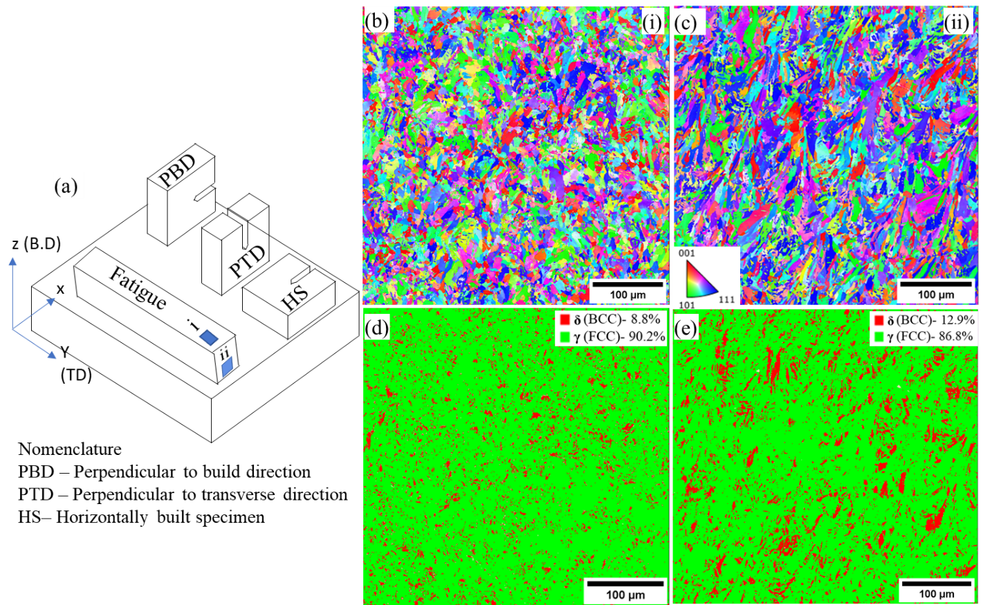
Fig. 1. (a) Schematic illustration of the specimens printed for high cycle fatigue and fatigue crack growth tests in perpendicular to build direction (PBD), perpendicular to transverse direction (PTD) and horizontally build specimens (HS). Representative IPF maps of the build on (b) XY plane ((i) in (a)) and (c) XZ plane ((ii) in (a)). (d) and (e) contains the phase maps of the microstructures in (b) and (c), respectively.

3. Results

3.1 Microstructure and fatigue crack growth studies
The IPF maps of the XY and XZ planes of the HS specimens are shown in Figs. 1b and 1c, respectively. On the XY plane, the grains are smaller and equiaxed whereas, on the XZ plane, they are slightly elongated along the build direction, with a grain aspect ratio of ~1.2. The equivalent diameters (d) of the grains are ~ 7 ± 3 and 8 ± 4 µm, respectively. Closer examination of the microstructure revealed hierarchical features such as cells and melt-pool boundary networks, the details of which are reported elsewhere [23]. The EBSD phase maps of the XY and XZ plane, shown in Figs. 1c and 1d, reveal the presence of 8.8 and 12.9% (volume fraction, V_{f}) of δ-ferrite, respectively. The relative presence of δ-ferrite in LB-PBF SS 304L is consistent with those reported in previous studies [22,23,26].
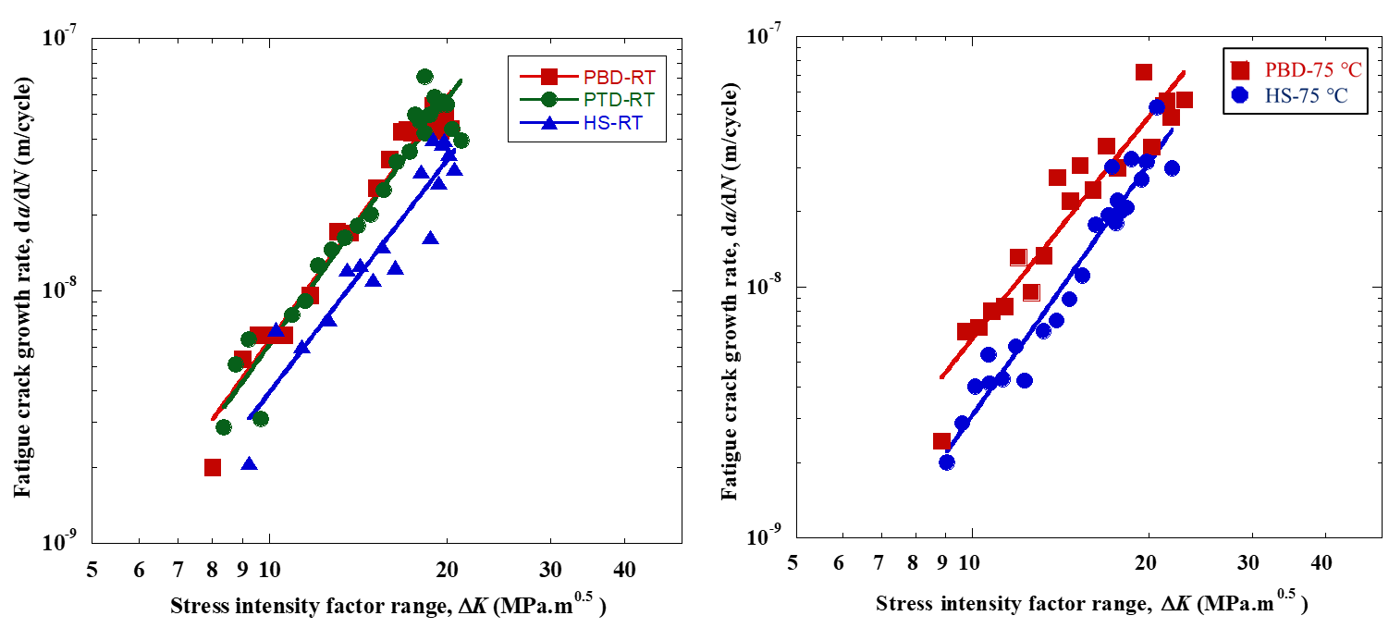
Fig. 2. Fatigue crack growth rate, da/dN vs. stress intensity factor range, ΔK for (a) PBD, PTD, and HS specimens at room temperature (RT) and (b) PBD and HS specimens at 75 °C.

The variations of da/dN as a function of ΔK for PBD, PTD, and HS specimens at RT and 75 °C are shown in Fig. 2a and 2b, respectively. The values of m, C, and ΔK_{o} of all the specimens are listed in Table 1. At RT, the values of m for PBD, PTD, and HS specimens are 3.01, 2.96, and 2.75, respectively. Note that the ΔK_{o} of all specimen types are also similar and in the range of ~8.4-9 MPa√m, irrespective of the testing temperature. This indicates that the fatigue threshold is insensitive to the orientation and testing temperature. However, for a particular ΔK, the da/dN in HS specimens is relatively lower than that of PBD and PTD specimens. In contrast, the FCG rate of PBD and PTD specimens are nearly identical for a specific ΔK. At 75 °C, while m of the HS specimen is ~3.34, which is 15% higher than that of the PBD specimen, the da/dN in the former is still lower than that in the latter. As mentioned earlier, owing to the unavailability of powder, PTD specimens could not be fabricated to perform FCG tests at 75 °C. However, given that m and ΔK_{o} of PBD and HS specimens are relatively insensitive to the testing temperatures, these parameters for the PTD specimen are also expected to be the same as that at RT.

Specimens |  | Paris constant, C (Exp-12) | Paris exponent, m | ΔK_{o} (MPa.m^{0.5})
RT | PBD | 6.9 | 3.01 ± 0.02 | 8.5
RT | PTD | 7.8 | 2.96 | 8.4
RT | HS | 8.3 | 2.75 | 8.9
75 °C | PBD | 7.2 | 2.9 | 8.8
75 °C | HS | 1.4 | 3.34 | 9

Table 1. The Paris constant, C, exponent, m, and threshold stress intensity factor range, ΔK_{o} obtained by fatigue crack growth tests at room temperature and 75 °C of PBD, PTD, and HS specimens.

To understand the fatigue crack-microstructure interactions at RT in detail, microstructural investigations in the vicinity of the crack in the LB-PBF processed SS 304L are performed. Fig. 3a displays the EBSD phase map of the regions close to the crack in the RT-tested PBD specimen. A continuous red envelope with width, T_{z}, is observed on either side of the crack line. This red envelope is identified as the fully transformed region containing the α’-phase. T_{z} is measured along the length of the crack and plotted as a function of ΔK in Fig. 3b. From this plot, it is observed that at the highest ΔK, which corresponds to ⁓30 MPa√m, T_{z} is also the highest (80 µm). Thereafter, there is a monotonic decrease in T_{z} with decreasing ΔK. Additionally, the cyclic plastic zone size (r_{pc}) for each ΔK is calculated from the Dugdale model [27–29] using,
r_{pc} = $\frac{πα}{8}{\left(\frac{∆K}{{2σ}_{YS}}\right)}^{2}$ (1)
where, α = $\left[\frac{1}{2}\frac{σ_{app}}{σ_{YS}}+ \sqrt{1-\frac{3}{4}{\left(\frac{σ_{app}}{σ_{YS}}\right)}^{2}}\right],$which depends on a. Assuming $σ_{app}$ as far-field applied stress corresponding to maximum stress intensity factor (K_{max}), α ≈ 1. Next, the variations in the cyclic plastic zone size with ΔK, are included in Fig. 3b for reference. It is observed that although the trend in variations of r_{pc} and T_{z} as a function of ΔK are similar, the latter is an order of magnitude smaller than the former. This implies that transformation-induced plasticity, where γ transforms to the martensitic α’ phase is one of the important deformation mechanisms in the cyclic plastic zone of the fatigue crack at RT.

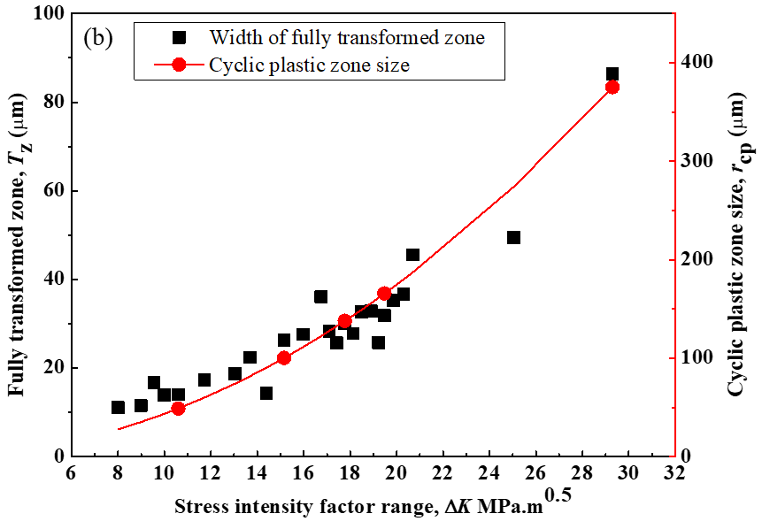
Fig. 3. (a) EBSD phase map of the microstructure near the fatigue crack in the PBD specimen. The fully transformed zone, T_{z}, enveloping the crack is colored in red. (b) T_{z} and cyclic plastic zone size, r_{cp} versus stress intensity factor range, ΔK, for the fatigue crack in the PBD specimen at RT.

From the PBD and HS specimens that were sequentially subjected to 75 °C, 150 °C and RT, the crack opening displacement (COD) was measured. Figs. 4a and 4b show the minimum and maximum COD, COD_{min} and COD_{max}, (measured along the load line, i.e., by crosshead movement) as a function of ΔK for the PBD and HS specimens, respectively at the three different testing temperatures. As expected, both COD_{min} and COD_{max}, at a specific temperature increase with increasing ΔK. Interestingly, in both HS and PBD specimens, COD_{max} at RT and 75 °C for ΔK ~9 MPa√m is ~0.1 mm, whereas that at 150 °C is twice as high. In fact, while COD_{min} ~ COD_{max} at 150 °C for the same ΔK, the COD_{min} at RT and 75 °C are 4 times lower. Using the relationship COD ~ $\frac{{(K)}^{2}}{Eσ_{y}}$, where E is the Young’s modulus, it can be ascertained that both maximum and minimum stress intensity factor, K_{max} and K_{min}, at 150 °C is significantly higher than that at RT and 75 °C. Note that a higher average value of stress intensity factor, K_{avg} (~$\frac{K_{max}+K_{min}}{2}$), is associated with higher FCG. It is also important to note that any estimates of K_{max} and K_{min} from the COD_{max} and COD_{min} data are qualitative as our measurements of the latter lacked accuracy in the absence of a clip gauge.
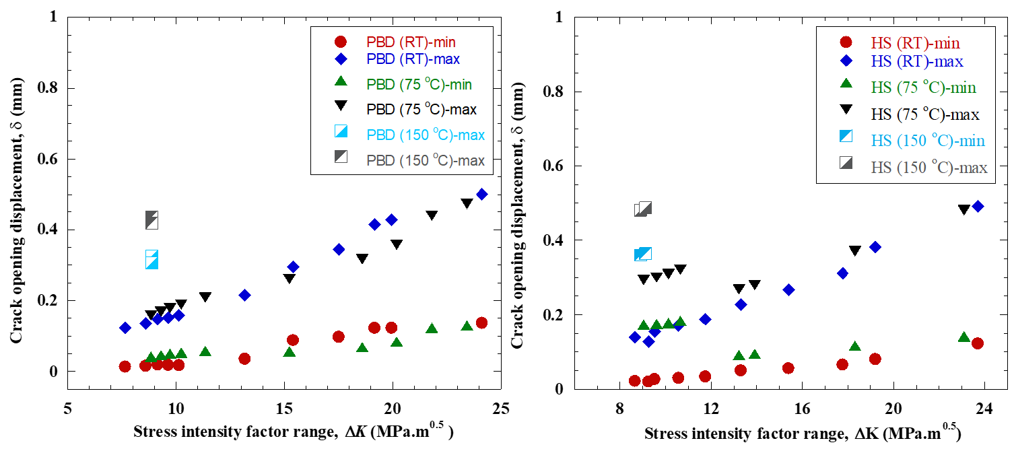
Fig. 4. Crack opening displacement (COD) versus ΔK for fatigue crack growth at RT, 75 °C, and 150 °C in (a) PBD and (b) HS specimens.

To understand the microstructural change associated with the variations in COD and K_{avg}, further EBSD phase mapping is performed in the vicinity of the fatigue cracks in PBD and HS specimens, which are displayed in Fig. 5a and 5b, respectively. The portions of the crack that grew at a specific temperature are separated by black dashed lines. While all the portions of the crack are enveloped by the transformed α’ phase (colored in red), the T_{z} varies. Considering that ΔK for all three portions was maintained in the range of ± 0.1 MPa√m, T_{z} at different portions of the fatigue crack can be directly compared. While T_{z} ~ 10 ± 2.5 µm and ~7.9 ± 1.2 µm at the portions of the crack that grew at RT and 75 °C, respectively, that at 150 °C, is only ~ 5.1 ± 1.7 µm for the HS specimen. Similarly, in the PBD specimen, T_{z} is 13.6 ± 3.4, 10.4 ± 1.9, and 5.7 ± 1.7 µm at RT, 75 °C, and 150 °C, respectively.
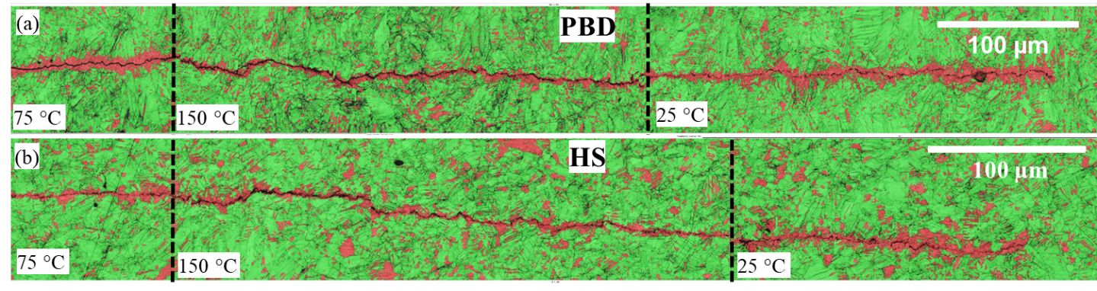
Fig. 5. EBSD phase maps of the microstructure near the fatigue crack grown RT, 75 °C, and 150 °C in (a) PBD and (b) HS specimens. Stress-induced martensite enveloping the crack is colored in red.

Overall, it was observed that the FCG rates in LB-PBF SS 304 at RT and 75 °C are lower in the HS specimen compared to PBD and PTD specimens whereas the ΔK and m are similar for all specimens irrespective of the build orientation and temperature. While FCG rates were not directly measured at 150 °C, it is expected to be higher than that at RT and 75 °C, owing to a significantly larger K_{avg}. Microstructural examination showed that the γ phase transforms to α’ in the cyclic plastic zone ahead of the crack tip at all temperatures in both PBD and HS specimens, although the spatial extent of this transformation is significantly lower at 150 °C than at RT and 75 °C.

3.2 High cycle fatigue
The fatigue behavior of LB-PBF processed SS 304L is further examined at RT and 150 °C by performing RBF tests. The S-N curves obtained from RBF tests at RT and 150 °C are displayed in Fig. 6. The σ_{f} ~385 MPa for specimens tested at RT, which is significantly higher than σ_{f} of ~200 - 300 MPa, was previously reported for other AM processed SS. However, at 150 °C the σ_{f} of LB-PBF SS 304L is only 250 MPa [1,10,30]. This significant drop in σ_{f} for tests conducted at 150 °C is surprising as the yield strength drop from RT to 150 °C is only 9% [22].
3
3
Fig. 6. Stress amplitude, σ_{a} versus the number of cycles to failure, N_{f}, data obtained RT and 150 °C. Arrows indicate run-out specimens (did not fail even after 10⁷ cycles) and the numbers next to the arrows indicate the number of specimens that survived at that σ_{a}.

Fig. 7a and 7b display the fractographs of the failed specimens tested at RT and 150°C. Regions on the fracture surfaces are marked with dashed lines to indicate the crack initiation sites and propagation regions in both specimens. The insets of Fig. 7a and 7b, which contain the magnified images of the crack initiation sites, suggest that in both specimens, the fatigue crack initiated from LOF pores present near the surface. The pore diameter, d, is approximated as the square root of the pore area bounded by white dashed lines in the magnified images. For σ_{a} ⁓300 MPa at 150 °C, the specimen failed after ⁓2×10⁵ cycles from a pore with d ⁓96 µm. However, for the specimen tested at RT, the specimen survived ⁓2×10⁵ cycles at σ_{a} ⁓ 450 MPa, even though the fatigue crack initiated from a larger pore of d ⁓167 µm. This suggests that specimens tested at RT exhibit inherently higher resistance to fatigue than those tested at 150 °C.
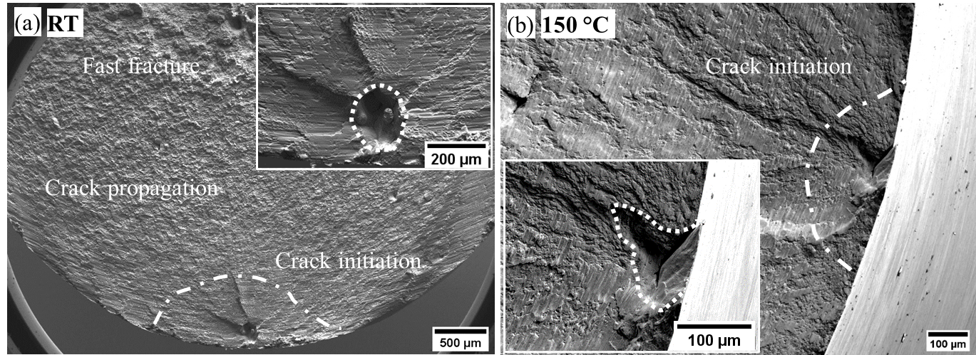
Fig. 7. Fracture surfaces of rotating bending fatigue-tested specimens at (a) stress amplitude (σ_{a}) ~ 450 MPa at RT and (b) σ_{a} ~ 300 MPa at 150 °C. Insets of (a) and (b) are high magnification images of crack initiation sites.

4. Discussion

4.1. Mechanism of FCG and build orientation effects
The occurrence of martensitic transformation in the plastic zone of the fatigue crack in SS 304L is relatively well known [31,32]. Typically, any SS with an unstable γ phase undergoes SIMT at temperatures < m_{d30}. In the present case, m_{d30} is 52 °C [22], which implies that the γ phase in the cyclic plastic zone in these specimens undergo SIMT at RT during fatigue loading. This is further validated by the equivalence of r_{pc} and T_{z} for all values of ΔK (see Fig. 3b) in the HS specimen. Note that the γ → α’ martensitic transformation in 304L SS is associated with ⁓2% volume expansion and ⁓10% shear strain [21]. The dissipation of energy and accommodation of strains around the crack tip and inhibits fatigue crack growth [31]. Moreover, the transformation itself requires additional energy, which would otherwise be spent for propagating the fatigue crack.

Nevertheless, the similarities in the FCG rate in the Paris regime for PBD and PTD specimens are unique for LB-PBF processed SS 304L as the same alloy processed via wire arc additive manufacturing (WAAM) exhibits starkly different FCG rates along these orientations [1–3]. Even other SS alloys processed by LB-PBF, such as SS 316, exhibits anisotropy in FCG rates along different directions [1,6]. In these studies, the variations in FCG rates along the PBD and PTD type specimens in the WAAM processed SS 304L and LB-PBF processed SS 316 were attributed to the anisotropy in the micro and mesostructural features of the builds [1,6]. Note that AM processing of SS (304L and 316) leads to the formation of elongated columnar grains and cellular microstructures, whose growth directions are governed by the local thermal gradient during solidification. Additionally, the builds have a network of melt-pool boundaries, also referred to as the ‘mesostructure’, whose interconnectivity and alignment are governed by the scan strategy employed. If the aspect ratio of grains and melt-pool boundaries are high, the fatigue crack will undergo greater deflection in some directions compared to the other, which in turn leads to anisotropy in FCG rates. For instance, in LB-PBF processed SS 316 and WAAM processed SS 304L that have columnar grains with aspect ratios >> 1, the FCG rate is lower in the direction perpendicular to their major axis compared to that in the direction parallel to it [1,33]. Alternately, if the grain and melt-pool aspect ratios are ~1, such as the LB-PBF processed SS 304L examined in this study (see Fig. 1), the FCG rates in both directions will be similar.

However, in the HS specimens, the FCG rates at RT and 75 °C are lesser than those of PBD and PTD specimens, which suggests some effect of the build orientation on the fatigue behavior. The origin of this effect is less likely to involve differences in microstructural features or deformation mechanisms along different orientations as ΔK and m are broadly similar for all orientations. Instead, we believe that it is likely due to the difference in the compressive residual stresses in the builds. Prior studies suggest that SS parts that are built along their smallest dimensions, like the HS specimen, will have relatively higher compressive residual stresses than those that are printed along their larger dimensions (PBD and PTD specimens) [34]. These compressive residual stresses limit the opening of fatigue cracks and retards their growth [35,36]. While this anisotropy in FCG rates can be eliminated by performing residual stress-relieving treatments, it would accelerate the FCG rates in all orientations and is, therefore, undesirable [37].

4.2. Influence of temperature on FCG
The γ → α’ martensitic transformation is suppressed at temperatures > m_{d30}, which in turn deteriorates the fatigue resistance of LB-PBF processed SS 304 L. This is deduced from the observation that, fatigue cracks at 150 °C, which grow at a faster rate (owing to a larger K_{avg}) than that at RT (see section 3.1), are associated with a significantly smaller T_{z} (see Fig. 5a and 5b). The 35% reduction of σ_{f} at 150 °C compared to that at RT (see Fig. 6) further validates this argument.
However, it is surprising to observe that at 75 °C, which is also > m_{d30}, the FCG rate (see Fig. 2a and 2b), T_{z,} and COD (see section 3.1) is approximately the same as that at RT. This could be attributed to the fact that the inhibition of SIMT is not significant when the testing temperature is close to m_{d30}.

The inverse correlation between K_{avg} and T_{z} suggests that the occurrence of SIMT in the cyclic plastic zone ahead of the fatigue crack tip in LB-PBF SS 304L reduces net K, near the crack tip, and promotes crack closure, which in turn, reduces FCG rates. The stress intensity factor correction (K_{T}) due to relaxation caused by volume expansion during SIMT can be quantified by assuming a dilatant cylindrical martensite particle inside an infinite large elastic body [21] where the martensitic transformation is controlled by shear strain and expressed as,
K_{T} = $-0.5Bε^{T}\sqrt{w}\left(V_{o}+\frac{2}{3}\left(V_{i}-V_{o}\right)\right)$ (2)
where, B = bulk modulus, $ε^{T}$= volumetric strain, which is 0.02, w = total width of the transformation zone, which spreads further than T_{z}, V_{o} = volume fraction of α’ at the end of transformation zone w, V_{i} = volume fraction of α’ at the crack front. In the present case, assuming V_{i} = 0.9, i.e., 90% of γ is transformed to α’ at the crack front or in T_{z} as observed from the EBSD phase maps in Figs. 5a and 5b. Moreover, α’ is not distributed homogeneously in the transformed zone w, which implies that V_{o} ≈ 0.1, i.e., 10% α’ is present at the edge of the r_{pc}. Note that the undeformed specimens have ≈ 10% BCC phase in the matrix (see Figs. 1d and e). Therefore, the assumption that V_{o} ≈ 0.1 is reasonable. Fig. 8 shows the variation in |K_{T}| as a function of ΔK at RT in the PBD specimen. For comparison, the variations of K_{max} and K_{min} are also included in the same plot. For all ΔK, |K_{T}| is always higher than K_{min}, which suggests that the majority of the SIMT occurs at peak load, or when the COD is highest. Therefore, the effective maximum stress intensity factor, K’_{max}, at the crack tip for FCG at RT is ≈ (K_{max}- |K_{T}|).
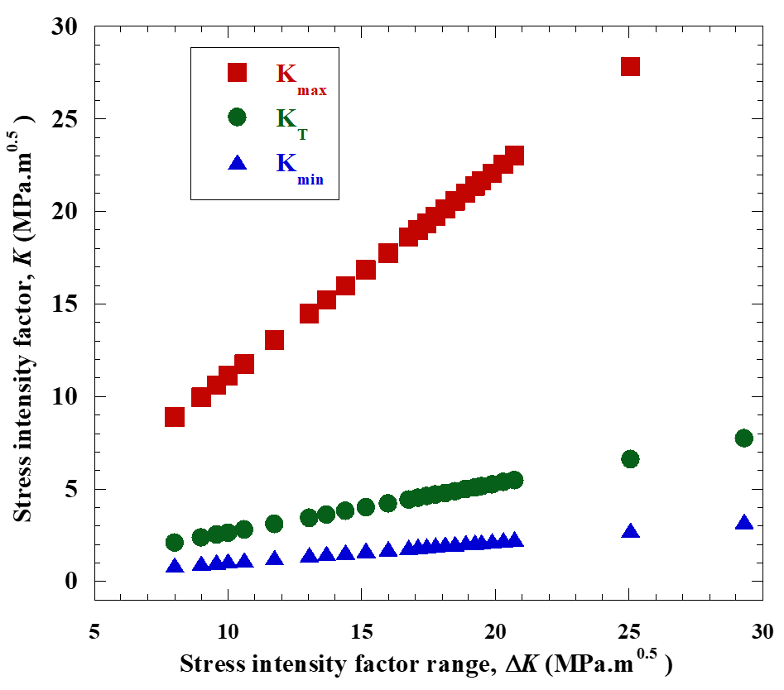
Fig. 8. Maximum stress intensity factor, K_{max}, minimum stress intensity factor K_{min}, and relaxed stress intensity factor, K_{T}, versus stress intensity factor range, ΔK for fatigue crack growth in PBD specimens at RT.

Substituting the estimated values of w (~r_{pc}) of fatigue cracks in PBD specimen from Fig. 5 (assuming T_{z} $∝r_{pc}$) in eq. 2, the calculated |K_{T}| at ΔK ~ 9 MPa√m for RT, 75 °C and 150 °C conditions are 2.37, 2.1 and 1.54 MPa√m, respectively. The 35% lower value of |K_{T}| for specimens tested at 150 °C indicates that the crack closure effect is minimal and corroborates with the observed COD at this temperature. The calculation of |K_{T}| solely from eq. 2 should be only taken as a semi-quantitative estimate of the crack closure due to SIMT as it does not take the evolution of shear strains into account. The shear strain accompanying SIMT will further enhance the K_{T} and reduce K’_{max}. Unfortunately, this analysis is out of the scope of our work as we were unable to estimate the relaxation caused by shear strain in the cyclic plastic zone experimentally or analytically [38].

4.3 Influence of porosity and other considerations
Fatigue crack initiation in SS 304L occurs from sub-surface pores irrespective of the occurrence of SIMT, as was seen for HCF specimens tested at RT and 150 °C (see Fig. 7). K_{max} for a surface pore is estimated using the Murakami equation [39,40],
K_{max} = 0.65 × σ_{a} ×$\sqrt{πd}$ (3)
where σ_{a} is the stress amplitude. However, for a valid comparison of K obtained from this relation and that for FCG specimens, conditions of similitude must be met in the HCF specimens. The primary condition of similitude for short cracks, in this case, is that the crack length must exceed the microstructural dimensions significantly [20]. This condition is easily met in the HCF specimens tested at RT and 150 °C, as fatigue cracks initiating from pores of sizes d ⁓ 167 and 96 µm respectively, are at least 10 times higher than the grain size of ~8±4 µm in SS 304L [22]. On the basis that similitude conditions are satisfied, r_{pc} for a fatigue crack initiating from this pore is calculated using eq.1 and this can be further used to estimate K_{T} for an applied σ_{a} using eq. 2 [20]. Moreover, the effective stress amplitude, σ_{a}^{eff}, which excludes the crack closure effect of SIMT, is obtained by substituting K’_{max} in equation (3).

Fig. 9a shows the plot of σ_{a}^{eff} vs. N_{f} for specimens tested at RT and 150 °C. Data obtained from the experimental results of HCF tests are included for comparison. From this plot it is evident that σ_{a}^{eff} for specimens tested at RT is similar to σ_{a} is estimated as 278 MPa. Moreover, for samples tested at RT, σ_{f}^{eff}, ~278 MPa, which is just slightly higher than σ_{f} ⁓250 MPa estimated at 150 °C, where SIMT was considerably inhibited (see Fig. 6). The slightly higher value of σ_{f}^{eff} at RT is attributed to the shear strains that contribute to crack closure during SIMT. Moreover, it is also likely that the calculation of K_{T}, considering w ≈ r_{pc} might overpredict the effect of dilatation on K’_{max}. Nevertheless, this analysis is still reasonably accurate in predicting fatigue life for AM alloys that are used in fatigue-intensive applications.

For instance, using the HCF and FCG results reported in this article a failure envelope, or the Kitagawa-Takahashi (KT) diagram is plotted in Fig. 9b based on the El-Haddad formulation [17,41],
σ_{a} = $\frac{{∆K}_{o}}{Y\sqrt{π(a+a_{o})}}$ (4)
here, a_{o} is intrinsic crack length defined as ≈ $\frac{1}{π}{\left(\frac{{∆K}_{o}}{Yσ_{f}}\right)}^{2}$. From the viewpoint of damage tolerant design approach, these curves provide a guideline for choosing the appropriate σ_{a} at different temperatures. In addition, a predicted failure envelope that excludes the crack tip relaxation effect by SIMT at RT is included in Fig. 9b. This modified envelope can be used as a conservative limit for RT fatigue applications in environments where SIMT could be inhibited due to other factors.
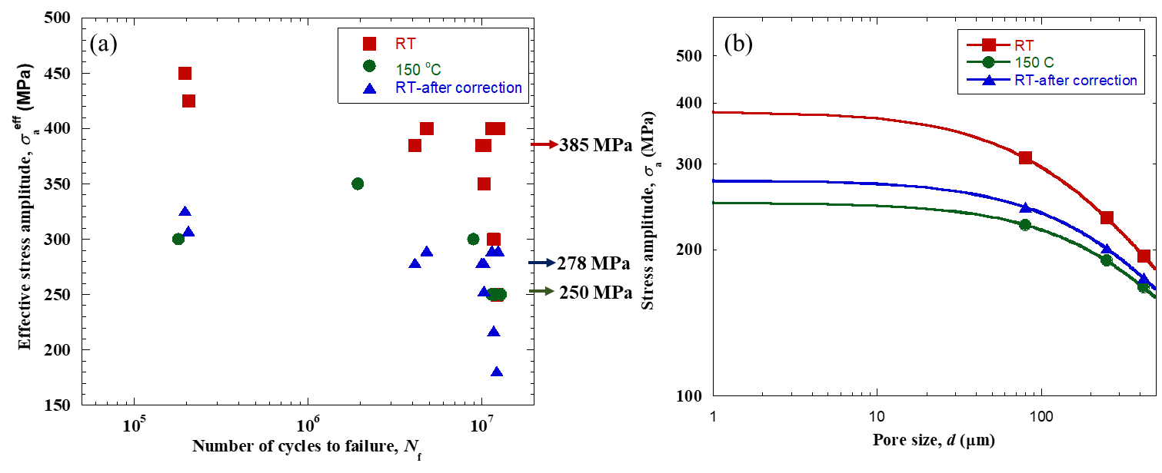
Fig. 9. (a) Effective stress amplitude, σ_{a}^{eff} versus the number of cycles to failure, N_{f} at room temperature. σ_{a}^{eff} is calculated by subtracting the effect of K_{T}. Data from Fig. 6 is included for comparison. Arrows indicate the fatigue strength, σ_{f}, for the HCF tests at RT with and without corrections and at 150 °C. (b) Fatigue failure envelopes (Kitagawa-Takahashi diagram) for LB-PBF processed SS 304 at RT and 150 °C calculated from σ_{f}. The plot also shows the predicted failure envelope for the corrected value of σ_{f} for RT tests.

5. Summary and conclusions
The effect of build orientation, microstructure, and temperature on fatigue crack growth (FCG) behavior and fatigue strength of LB-PBF processed SS 304L is evaluated. The FCG parameters are broadly insensitive to build orientation as the microstructure is relatively equiaxed. It was observed that stress-induced martensitic transformation (SIMT) of the γ phase occurs at room temperature and 75 °C in the cyclic plastic zone of the fatigue crack. At higher temperatures, i.e., 150 °C, SIMT is inhibited, which leads to greater crack opening displacement and higher average stress intensity factor of fatigue cracks. This leads to lower fatigue strength of the alloy at 150 °C compared to that at room temperature. From microstructural observations, the crack closure specific stress intensity factor associated with SIMT is quantitatively estimated by considering only volumetric strain relaxation. These results are further validated by noting that the stress amplitude, fatigue strength, and failure envelope of the alloy at room temperature, in the absence of SIMT, is similar to that of the alloy tested at 150 °C.

Declaration of competing interest
The authors declare that they have no known competing financial interests or personal relationships that could have appeared to influence the work reported in this paper.

Acknowledgments
PK and UR acknowledge funding from the ‘Structural Metals and Alloys Programme’ under RIE-2020 from A∗STAR, Singapore (No. A18B1b0061). RLN acknowledges funding and support from the Start-up research grant (SRG/2020/000095) of the Science and Engineering Research Board, DST, GoI. The authors thank Dr. Nai Mui Ling Sharon of Singapore Institute of Manufacturing Technology (SIMTech) for her support in providing the materials for the experiments.

6. References
[1] T.H. Becker, P. Kumar, U. Ramamurty, Fracture and Fatigue in Additively Manufactured Metals, Acta Materialia. 219 (2021) 117240. https://doi.org/10.1016/j.actamat.2021.117240.
[2] P. Kumar, U. Ramamurty, Microstructural optimization through heat treatment for enhancing the fracture toughness and fatigue crack growth resistance of selective laser melted Ti 6Al 4V alloy, Acta Materialia. 169 (2019) 45–59. https://doi.org/10.1016/j.actamat.2019.03.003.
[3] S. Huang, P. Kumar, W.Y. Yeong, R.L. Narayan, U. Ramamurty, Fracture Behavior of Laser Powder Bed Fusion Fabricated Ti41Nb via In-situ Alloying, Acta Materialia. (2021) 117593. https://doi.org/10.1016/j.actamat.2021.117593.
[4] P. Agrawal, S. Thapliyal, S.S. Nene, R.S. Mishra, B.A. McWilliams, K.C. Cho, Excellent strength-ductility synergy in metastable high entropy alloy by laser powder bed additive manufacturing, Additive Manufacturing. 32 (2020) 1–7. https://doi.org/10.1016/j.addma.2020.101098.
[5] L. Liu, Q. Ding, Y. Zhong, J. Zou, J. Wu, Y.L. Chiu, J. Li, Z. Zhang, Q. Yu, Z. Shen, Dislocation network in additive manufactured steel breaks strength–ductility trade-off, Materials Today. 21 (2018) 354–361. https://doi.org/10.1016/j.mattod.2017.11.004.
[6] J. Suryawanshi, K.G. Prashanth, U. Ramamurty, Mechanical behavior of selective laser melted 316L stainless steel, Materials Science and Engineering: A. 696 (2017) 113–121. https://doi.org/10.1016/j.msea.2017.04.058.
[7] H. Zhang, M. Xu, P. Kumar, C. Li, Z. Liu, Y. Zhang, Fatigue life prediction model and entropy generation of 304L stainless steel fabricated by selective laser melting, Journal of Materials Processing Tech. (2021) 117279. https://doi.org/10.1016/j.jmatprotec.2021.117279.
[8] R. Jayaraj Radhakrishnan, P. Kumar, H.L. Seet, S.M.L. Nai, P. Wang, U. Ramamurty, Cascading of the as-built microstructure through heat treatment and its role on the tensile properties of laser powder bed fused Inconel 718, Materialia. 21 (2022). https://doi.org/10.1016/j.mtla.2021.101272.
[9] R. Shrestha, J. Simsiriwong, N. Shamsaei, Fatigue behavior of additive manufactured 316L stainless steel parts: Effects of layer orientation and surface roughness, Additive Manufacturing. 28 (2019) 23–38. https://doi.org/10.1016/j.addma.2019.04.011.
[10] P. Kumar, R. Jayaraj, J. Suryawanshi, U.R. Satwik, J. McKinnell, U. Ramamurty, Fatigue strength of additively manufactured 316L austenitic stainless steel, Acta Materialia. 199 (2020) 225–239. https://doi.org/10.1016/j.actamat.2020.08.033.
[11] A. Yadollahi, N. Shamsaei, Additive manufacturing of fatigue resistant materials: Challenges and opportunities, International Journal of Fatigue. 98 (2017) 14–31. https://doi.org/10.1016/j.ijfatigue.2017.01.001.
[12] Y. Uematsu, T. Kakiuchi, K. Hattori, N. Uesugi, F. Nakao, Non-destructive evaluation of fatigue damage and fatigue crack initiation in type 316 stainless steel by positron annihilation line-shape and lifetime analyses, Fatigue and Fracture of Engineering Materials and Structures. 40 (2017) 1143–1153. https://doi.org/10.1111/ffe.12572.
[13] B. Voloskov, S. Evlashin, S. Dagesyan, S. Abaimov, I. Akhatov, I. Sergeichev, Very high cycle fatigue behavior of additively manufactured 316L stainless steel, Materials. 13 (2020) 1–11. https://doi.org/10.3390/ma13153293.
[14] A. Damiens, H. Bonnefoy, I. Titeux, Influence of processing parameters on mechanical and fatigue properties of 316 L steel manufactured by selective laser melting, Welding in the World. 64 (2020) 1321–1328. https://doi.org/10.1007/s40194-020-00885-4.
[15] B. Blinn, M. Ley, N. Buschhorn, R. Teutsch, T. Beck, Investigation of the anisotropic fatigue behavior of additively manufactured structures made of AISI 316L with short-time procedures PhyBaL LIT and PhyBaL CHT, International Journal of Fatigue. 124 (2019) 389–399. https://doi.org/10.1016/j.ijfatigue.2019.03.022.
[16] H. Masuo, Y. Tanaka, S. Morokoshi, H. Yagura, T. Uchida, Y. Yamamoto, Y. Murakami, Influence of defects, surface roughness and HIP on the fatigue strength of Ti-6Al-4V manufactured by additive manufacturing, International Journal of Fatigue. 117 (2018) 163–179. https://doi.org/10.1016/j.ijfatigue.2018.07.020.
[17] P. Kumar, U. Ramamurty, High cycle fatigue in selective laser melted Ti-6Al-4V, Acta Materialia. 194 (2020) 305–320. https://doi.org/10.1016/j.actamat.2020.05.041.
[18] U. Krupp, A. Giertler, M. Söker, H. Fu, B. Dönges, H.J. Christ, A. Hüsecken, U. Pietsch, C.P. Fritzen, W. Ludwig, The behavior of short fatigue cracks during Very High Cycle (VHCF) Fatigue of duplex stainless steel, Engineering Fracture Mechanics. 145 (2015) 197–209. https://doi.org/10.1016/j.engfracmech.2015.03.024.
[19] P. Agrawal, R.S. Haridas, S. Thapliyal, S. Yadav, R.S. Mishra, B.A. Mcwilliams, K.C. Cho, Metastable high entropy alloys: An excellent defect tolerant material for additive manufacturing, (2021). https://doi.org/10.1016/j.msea.2021.142005.
[20] S. Suresh, R.O. Ritchie, Propagation of short fatigue cracks, International Metals Reviews. 29 (1984) 445–475. https://doi.org/10.1179/imtr.1984.29.1.445.
[21] Z. Mei, J.W. Morris, Influence of deformation-induced martensite on fatigue crack propagation in 304-type steels, Metallurgical Transactions. A, Physical Metallurgy and Materials Science. 21 A (1990) 3137–3152. https://doi.org/10.1007/BF02647310.
[22] P. Kumar, Z. Zhu, S.M.L. Nai, R.L. Narayan, U. Ramamurty, Fracture toughness of 304L austenitic stainless steel produced by laser powder bed fusion, Scripta Materialia. 202 (2021) 114002. https://doi.org/10.1016/j.scriptamat.2021.114002.
[23] Z. Zhu, W. Li, Q.B. Nguyen, X. An, W. Lu, Z. Li, F.L. Ng, S.M. Ling Nai, J. Wei, Enhanced strength–ductility synergy and transformation-induced plasticity of the selective laser melting fabricated 304L stainless steel, Additive Manufacturing. 35 (2020) 101300. https://doi.org/10.1016/j.addma.2020.101300.
[24] ASTM E647-15, Standard test method for measurement of fatigue crack growth rates, ASTM International. 3.01 (2016). https://doi.org/10.1520/E0647.
[25] International Standard, ISO-1143 Metallic materials-Rotating bar bending fatigue testing, ISO 1143:2010(E). 2010 (2010) 1–6.
[26] C. Zitelli, P. Folgarait, A. di Schino, Laser powder bed fusion of stainless steel grades: A review, Metals. 9 (2019). https://doi.org/10.3390/met9070731.
[27] H.-B. Park, K.-M. Kim, B.-W. Lee, Plastic zone size in fatigue cracking, 1996.
[28] B. Ould Chikh, A. Imad, M. Benguediab, Influence of the cyclic plastic zone size on the propagation of the fatigue crack in case of 12NC6 steel, Computational Materials Science. 43 (2008) 1010–1017. https://doi.org/10.1016/j.commatsci.2008.02.019.
[29] T.J. Lu, C.L. Chow, A modified Dugdale model for crack tip plasticity and its related problems, Engineering Fracture Mechanics. 37 (1990) 551–568. https://doi.org/10.1016/0013-7944(90)90380-Y.
[30] S. Lee, J.W. Pegues, N. Shamsaei, Fatigue behavior and modeling for additive manufactured 304L stainless steel: The effect of surface roughness, International Journal of Fatigue. 141 (2020). https://doi.org/10.1016/j.ijfatigue.2020.105856.
[31] S. Suresh, Fatigue of Materials, Second, Cambridge University Press, New York, 2002. https://doi.org/10.1201/9780203910399.ch14.
[32] H.R. Mayer, S.E. Stanzl‐Tschegg, Y. Sawaki, M. Hühner, E. Hornbogen, Influence of Transformation‐Induced Crack Closure on Slow Fatigue Crack Growth Under Variable Amplitude Loading, Fatigue & Fracture of Engineering Materials & Structures. 18 (1995) 935–948. https://doi.org/10.1111/j.1460-2695.1995.tb00918.x.
[33] A. Riemer, S. Leuders, M. Thöne, H.A. Richard, T. Tröster, T. Niendorf, On the fatigue crack growth behavior in 316L stainless steel manufactured by selective laser melting, Engineering Fracture Mechanics. 120 (2014) 15–25. https://doi.org/10.1016/j.engfracmech.2014.03.008.
[34] G. Sander, A.P. Babu, X. Gao, D. Jiang, N. Birbilis, On the effect of build orientation and residual stress on the corrosion of 316L stainless steel prepared by selective laser melting, Corrosion Science. 179 (2021). https://doi.org/10.1016/j.corsci.2020.109149.
[35] C. Li, Z.Y. Liu, X.Y. Fang, Y.B. Guo, Residual Stress in Metal Additive Manufacturing, in: Procedia CIRP, Elsevier B.V., 2018: pp. 348–353. https://doi.org/10.1016/j.procir.2018.05.039.
[36] A.S. Wu, D.W. Brown, M. Kumar, G.F. Gallegos, W.E. King, An Experimental Investigation into Additive Manufacturing-Induced Residual Stresses in 316L Stainless Steel, Metallurgical and Materials Transactions A 2014 45:13. 45 (2014) 6260–6270. https://doi.org/10.1007/S11661-014-2549-X.
[37] J. v Gordon, C. v Haden, H.F. Nied, R.P. Vinci, D.G. Harlow, Fatigue crack growth anisotropy, texture and residual stress in austenitic steel made by wire and arc additive manufacturing, (2018). https://doi.org/10.1016/j.msea.2018.03.075.
[38] J.C. Lambropoulost, Shear, shape and orientation effects in transformation toughnening, 1986.
[39] Y. Yamashita, T. Murakami, R. Mihara, M. Okada, Y. Murakami, Defect analysis and fatigue design basis for Ni-based superalloy 718 manufactured by selective laser melting, International Journal of Fatigue. 117 (2018) 485–495. https://doi.org/10.1016/j.ijfatigue.2018.08.002.
[40] Y. Murakami, Material defects as the basis of fatigue design, International Journal of Fatigue. 41 (2012) 2–10. https://doi.org/10.1016/j.ijfatigue.2011.12.001.
[41] J.J. Kruzic, R.O. Ritchie, Kitagawa-Takahashi diagrams define the limiting conditions for cyclic fatigue failure in human dentin, Journal of Biomedical Materials Research - Part A. 79 (2006) 747–751. https://doi.org/10.1002/jbm.a.30939.

∗Corresponding author; punit.nitrkl@gmail.com, #Current affiliation: Lawrence Berkeley National Lab, California, USA

