Operando Facet Control of Hydrophobic Iron Nitride Nano-Coral for Surface Protection via Field-Modulated Plasma Strategy

Bo Ouyang^{a,e,#}, Chao Sun^{a,b,#,}***, Yuechuan Duª, Avinash Chaurasiya^{e}, Zheng Zhang^{c}, Jipeng Zhu^{b}, Erjun Kan^{a,}*, Fengkun Li^{d,e,}**, Rajdeep Singh Rawat^{e,}*
ª MIIT Key Laboratory of Semiconductor Microstructure and Quantum Sensing, School of Science, Nanjing University of Science and Technology, Nanjing 210094, China
^{b} The Laboratory of Road and bridge, Civil Engineering, School of Science, Nanjing University of Science and Technology, Nanjing 210094, China
^{c} Institute of Materials Research and Engineering, A*STAR (Agency for Science, Technology and Research), #08-03, Fusionopolis Way, Innovis, 138634, Singapore
^{d} School of Energy and Mechanical Engineering, Dezhou University, Dezhou, 253023, China
^{e} Natural Sciences and Science Education, National Institute of Education, Nanyang Technological University, 637616, Singapore

# These authors contribute equally to this work.
* corresponding authors:
ekan@njust.edu.cn (Erjun Kan)
lifengkun@nuaa.edu.cn (Fengkun Li)
rajdeep.rawat@nie.edu.sg (Rajdeep Singh Rawat)

Abstract
A facile facet reconfiguration has been considered as an essential issue for nitride coating in promoting surface protection behaviour. Compared to physical-chemical methods to achieve heterogeneous coating, plasma nitridation strategy is regarded as a favourable technique to in-situ deliver nitride protecting layer, but it is difficult to precisely control surface framework through plasma technique due to complicated interaction environment. To simply achieve nitride coating with favourable surface protection behaviour, we design a novel auxiliary insulator-confined plasma system to directly achieve hydrophobic iron nitride nano-coral (hFeNC) with desirable corrosion- and wear-resistant properties by controlling surface heating process during plasma nitridation. The resultant hFeNC nano-framework delivers corrosion rate of 1.2 mpy, 4- and 9-times lower than that of solid iron nitride film (sFeN) via normal plasma and initial Fe in NaCl condition, respectively. Operando plasma diagnostics along with numerical simulation further confirm the effect of surface heating on typical plasma parameters as well as the iron nitride nano-frameworks, indicating surface heating as the key factor responsible for the favourable surface protection coating.
Keywords: Facet control, hydrophobic nitride nano-coral, insulator-confined plasma, surface heating modulation, surface protection
1. Introduction
Surface protection for iron-based frameworks has served as a long-standing issue in diversified industrial fields for hundreds of years [1-3]. With vibrant development of nano-composites, different functionalized nano-frameworks have been introduced with excellent surface-protecting behaviours based on diversified strategies [4, 5]. Typically, heterogeneous coatings such as 2D structures, polymers and metals along with their composites have been commonly applied via physical-chemical approaches [6-8]. Although these coatings have satisfied industrial applications, their fabrication inevitably involves introduction of environmental-hazardous species along with multi-step fabrication process [9, 10]. Additionally, an essential issue is to achieve good adhesion between coating and substrates for stable coating for durability to reduce expenses. In this regard, operando growth of surface coating is considered as an essential candidate for surface protection, within which plasma nitridation has attracted considerable attentions in such field.
To date, numerous efforts have been devoted to achieving in-situ uniform nitride coating for effective surface protection of iron-based substrate using various types of plasma synthesis/processing system. Specifically, Yang et al achieved nitride coating with Fe₂₋₃N phase via direct-current (DC) plasma technique [11]. Naeem et al delivered Fe₄N and Fe₂₋₃N phases on plain carbon steel via cathodic cage plasma [12] and Cleber et al further achieved the similar results on low-carbon steel via DC pulsed plasma [13]. Both of them have delivered nitride layer with little nano-structurization on substrate surface. Comparatively, Yan et al found the formation of Fe₄N and FeN_{0.076} nanocrystals on M50 carbon steel after pulsed plasma processing [14]. Indeed, the influences of different discharge parameters on the nitride structures along with protection performance have been learned via systematic investigations using different plasma techniques. The same reaction conditions within different nitriding system exhibit certain statistical regularities in their effects on nitride structures [15, 16]. However, even within the same type of plasma system, apparent disparities usually persist in the regulation of nitride structure, which makes it difficult to precisely control the achieved frameworks and hence limits the protection capability. It has been elucidated that continual variation of surface reaction temperature, influenced by the interaction of reactive species and substrate surface, constitutes a pivotal factor in impacting nitride structure and the corresponding performance [17-19]. Hence, the exploration of a highly effective strategy to control surface reaction temperature is deemed imperative for the precise regulation of coating structure with favourable surface protection behaviour.
Herein, we present a facile insulator-confined plasma strategy for in-situ modulation of exposed facets of hydrophobic iron nitride nano-coral frameworks (hFeNC) through a controlled surface heating process during plasma nitridation. In comparison, the solid iron nitride film (sFeN) with apparent hydrophilicity is formed during normal N₂ plasma treatment in conventional processing without the introduction of insulator-confinement. The resultant nano-framework yields the exposed (101) and (2-10) facets of Fe₃N on coralline surface of hFeNC, leading to desirable corrosion- and wear-resistant behaviours compared to sFeN with exposed Fe₃N (002) facet. Numerical simulation was used to validate the advantages of achieving the desired surface facet of iron nitride. The operando plasma diagnostics shows that the preservation of substrate surface heating via insulator-confined plasma processing results in an increased density of reactive species and a tailored surface temperature, facilitating the rapid kinetics of iron species and hence the formation of iron nitride nano-coral. In summary, our work introduces a facile strategy for the precise control of exposed facets and morphology in hFeNC, thereby enhancing its surface protection behaviour.

2. Experimental Section
2.1. Materials.
Fe plate (thickness: 0.5 mm) was purchased from Changsha Lyrun Material Co. Ltd. All the chemical regents were used as received without any further purification.
2.2. Material fabrication
Hydrophobic Iron Nitride Nano-Coral Fabricated by Plasma Strategy (hFeNC): The hFeNC was prepared by our indigenously designed radio frequency (RF) plasma system with the introduction of our self-made insulator-confined plasma system (detailed schematic of procedure is shown in Fig. S1). Briefly, Fe plate with the size of 2 cm × 2 cm was cleaned ultrasonically with acetone and 3 M HCl solution for 15 min in each and washed subsequently with water and ethanol for several times. Then the cleaned Fe was located on the electrode surface within the chamber. The distance of two capacitively coupled RF electrode was kept at 40 cm. After evacuating the chamber by the combination of rotary and turbo pump, N₂ gas was made to flow into the system at a flow rate of 40 sccm and the pumping rates was adjusted using mechanical valves to keep the chamber pressure as ~30 Pa. Nitrogen plasma was produced by RF waves launched from Caeser136 RF generator (800 W, 13.56 MHz), coupled through Navio Matching network to RF electrodes. After nitridation for 300 s, the RF glow-discharge plasma was switched off. The reaction chamber was subsequently vent to atmospheric pressure and the resultant hFeNC was obtained.
Solid Iron Nitride Film Fabricated by Plasma Strategy (sFeN): The sFeN was fabricated through the same RF plasma system except the introduction of insulator-confined component during N₂ plasma processing. All the procedure is same with that in the preparation of hFeNC.
2.3. Characterization, performance evaluation and computational analysis
Characterization: Scanning electron microscopy (SEM) analysis was carried on JEOL JSM-7600F scanning electron microscope with an accelerating voltage of 15 kV. Transmission electron microscopy (TEM) measurements were performed by JEOL-2100F high resolution transmission electron microscope with an accelerating voltage of 200 kV. X-ray diffraction (XRD) patterns were collected using a D8 advanced diffractometer equipped with Cu Kα radiation (λ = 0.15406 nm). X-ray photoelectron spectroscopy (XPS) analysis was conducted using VG ESCALAB 220i-XL XPS with a monochromatic Al Kα (1486.7 eV) X-ray source. Binding energy of C1s peak from sp²-bonded carbon at 284.5 eV was used as a reference for correction. The XPS probing depth is 4~6 nm.
Corrosion-Resistant Behavior Evaluation: The electrochemical measurements were carried out by an electrochemical workstation (SHI660E, CH Instruments Ins) with three-electrode system. Saturated calomel electrode (SCE) was selected as the reference electrode and platinum electrode was applied as the counter electrode. All prepared samples were tested directly as the working electrodes without addition of binder and conductor. Tafel slopes and electrochemical impedance spectroscopy (EIS) were performed in 3.5 wt% NaCl.
Mechanical Property Evaluation: The tribological studies were carried out on a computer integrated pin-on-disc tribometer (DUCOM Wear and Friction Monitor TR-20LE-PHM400) with an inbuilt load cell to measure the frictional force. The tribo-testing was continuously conducted with three different Si₃N₄ loads (2.2 N, 4.2 N and 6.2 N) for 15 min. The sliding was carried up to a distance of 45 m at a constant sliding speed of 3 m min⁻¹.
Computational Analysis: The density functional theory (DFT+D3) calculation was performed to investigate based on Vienna Ab-initio Software Package (VASP) program with Perdew-Burke-Emzerhof (PBE) exchange-correlation functional. Based on our experimental results, we applied Fe, Fe₃N and FeN model with typical surfaces. A 1×1×1 Monkhorst-Pack grids was applied to carry the surface calculations. Intermediate absorbents were further located on substrate surfaces for obtaining absorbing energy. The slab is controlled to 20 Å along the c-direction to prevent the interaction of neighboring atoms. The energy cutoff was set to 520 eV with energy and force consistency of 10⁻⁵ eV and 10⁻² eV Å⁻¹.
The binding energy of adsorbates on substrates can be defined as:
E_{ads} = E_{substrate+adsorbate} – (E _{substrate} + E_{adsorbate})
In which E_{ads} was the absorbing energy between the catalyst and adsorbate; E_{substrate+adsorbate} referred to the total energy of catalyst surface with the adsorbate, while E_{substrate} and E_{adsorbate} stand for the total energy of the catalyst surface and adsorbates.
In present work, the Gibbs free energy change (ΔG) of each elementary step was obtained by:
ΔG = ΔE + ΔEZPE – TΔS
Where the ΔE denotes the adsorption energy, ΔZPE and ΔS are the changes of zero-point energy and entropy, and the temperature T is set to 300 K.

3. Results and Discussion
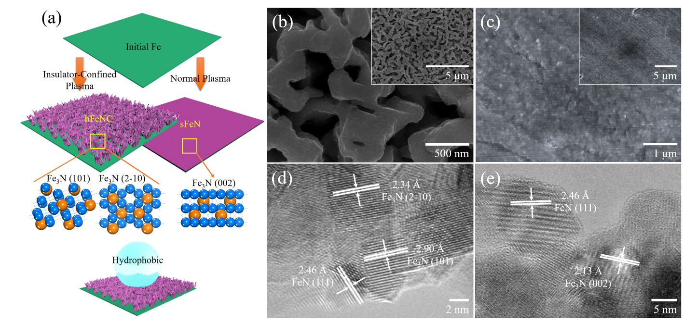
Fig. 1. Schematic procedure and characterization of iron nitride-based nano-coral frameworks or films obtained through diverse plasma strategies. (a) Schematic diagram, (b-c) SEM images of hFeNC and sFeN, and (d) and (e) TEM images of hFeNC and sFeN.
As shown in schematic diagram (Fig. 1a), the iron nitride nano-coralline frameworks, hFeNC, are directly achieved on the Fe foil surface without any additives using N₂ plasma processing with notable surface-heating effect for insulator-confined nitrogen plasma processing. Comparatively, there is uniform nitride film formation, sFeN, on substrate surface via conventional plasma nitridation without insulator introduction. Detailed fabrication procedures of hFeNC and sFeN are provided in Supporting Information. The self-designed plasma systems are applied in our prior and current work depicting configurations with and without insulator-confinement component [17]. In this context, the insulating component is anticipated to facilitate the enhanced accumulation of thermal energy onto the substrate surface during the nitrogen plasma processing. This is achieved through heat confinement, leading to a rapid increase in substrate surface temperature during plasma treatment, in stark contrast to the apparent thermal dissipation observed in conventional plasma processing without any insulator-confinement.
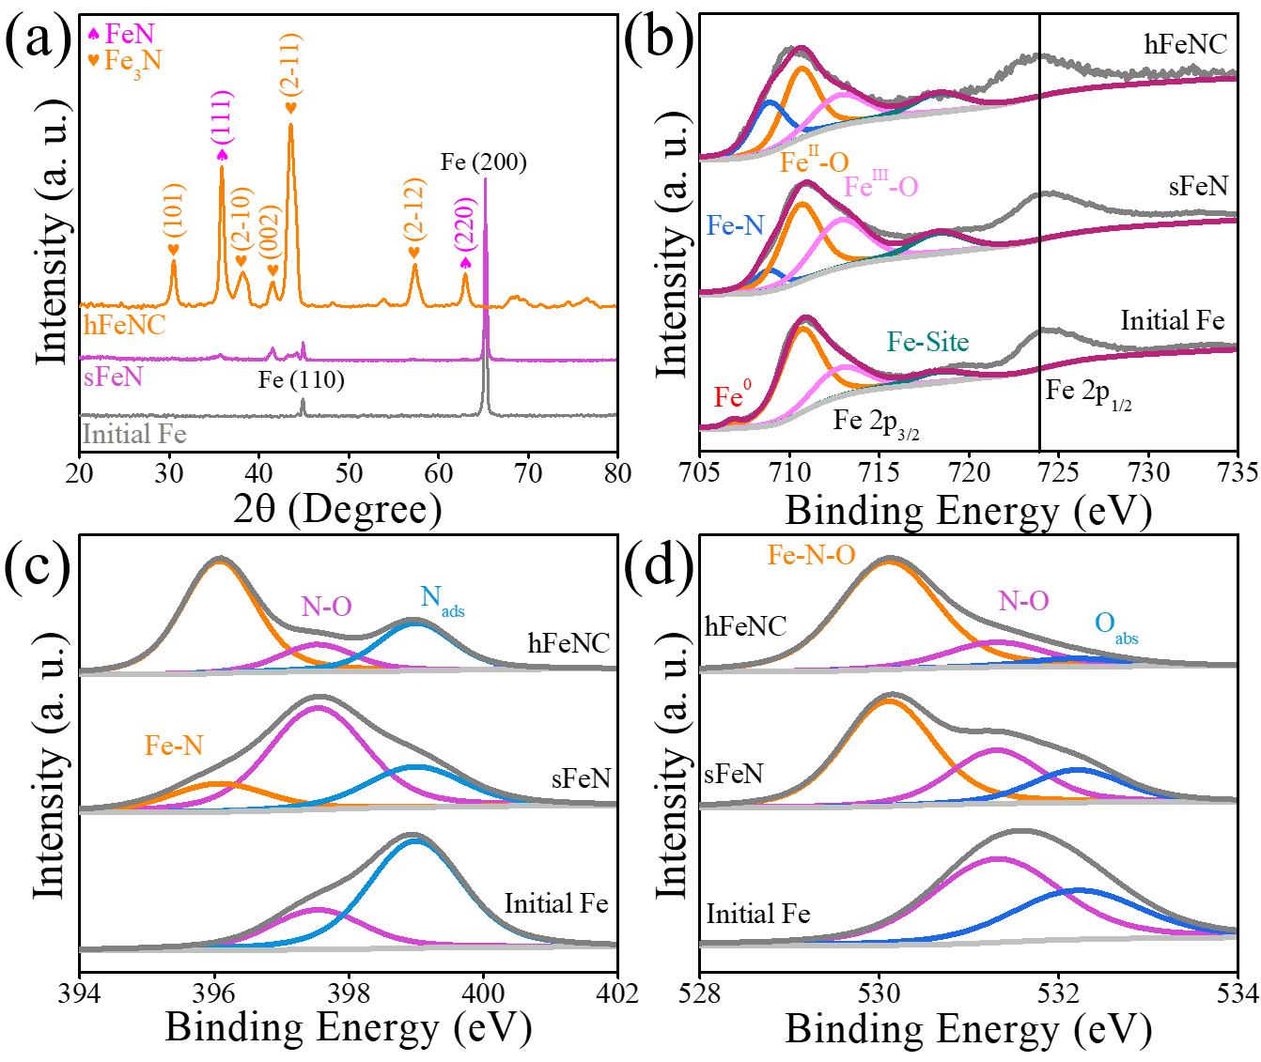
Fig. 2. Structural characterizations of prepared iron nitride nano-frameworks via different plasma strategies. (a) XRD patterns, (b) XPS Fe 2p spectra, (c) XPS N 1s spectra, and (d) XPS O 1s spectra.
In terms of scanning electron microscopy (SEM) images presented in Fig. 1b, there is the successful growth of iron nitride nano-corals on Fe foil with an average diameter of 110 nm via insulator-confinement-controlled plasma processing. In comparison, with conventional plasma nitridation without insulator introduction, a uniformly covered nitride film is achieved on Fe substrate with little nano-structure formation (Fig. 1c). The enhanced nano-structurization observed in hFeNC is attributed to the effect of the preserved thermal field on the kinetics of iron species during insulator-confined N₂ plasma processing. Based on cross-section SEM (Fig. S2), it is found that the thickness of hFeNC is about 2.4 μm, higher than 1.67 μm of sFeN. According to energy dispersive X-ray spectroscopy (EDX), the nitrogen content of hFeNC is 5.61 wt.%, higher than 5.16 wt.% of sFeN (Fig. S3). This indicates that reactive N-based species could penetrate into substrate with increased depth with raised thermal field. According to the transmission electron microscopy (TEM) results, hFeNC delivers the typical facet exposure of Fe₃N (2-10), Fe₃N (101) and FeN (111) with lattice spacings of 2.34, 2.90 and 2.46 Å respectively (Fig. 1d) [20, 21]. Conversely, there are exposure of only FeN (111) and Fe₃N (002) facets (Fig. 1e) on sFeN surface, which indicates the different exposed facets for iron nitride nano-coral framework and iron nitride film.
Detailed characterizations were conducted to comprehensively analyse all samples. X-ray diffraction (XRD) patterns (Fig. 2a) reveal that initial Fe exhibits prominent peaks at 44.8⁰ and 65.2⁰, corresponding to (110) and (200) facets of cubic Fe with space group of Im3m. For hFeNC, the diffraction peaks are observed at 30.5⁰, 35.8⁰, 38.1⁰, 41.4⁰, 43.5⁰, 57.4⁰ and 63.0⁰, which are attributed to Fe₃N (101), FeN (111), Fe₃N (2-10), Fe₃N (002), Fe₃N (2-11), Fe₃N (2-12) and FeN (220) respectively (JCPDS #83-0879, #75-2128) [22, 23]. This indicates that nitride nano-coral is composed of hexagonal Fe₃N with the space group of P6322 and cubic FeN with the space group of F43m. The same peaks are also found in sFeN, confirming the formation of iron nitride film. It is found that the nitride-based peaks in hFeNC are much increased along with the existence of iron-based peaks, in stark comparison with that of sFeN, which indicates increased proportion of iron nitride growth during insulator-confined N₂ plasma processing. X-ray photoelectron spectroscopy (XPS) results provide further insights. As shown in XPS survey spectra (Fig. S4), there are the presence of Fe, O, N, in all samples. Significantly, the intensity of the N-based band in hFeNC is higher than that of sFeN along with suppression of Fe binding energy peak in hFeNC, confirming the increased nitride formation in nano-coralline framework. In terms of Fe 2p in hFeNC and sFeN (Fig. 2b), well-defined bands at 708.9, 710.7 and 713.0 eV are observed, corresponding Fe-N, Fe^{II}-O, and Fe^{III}-O respectively [24]. The initial Fe displays a distinct band of pure Fe at 706.8 eV along with the oxide-based bands, which is attributed to partial oxidation of Fe with air, a common phenomenon in prior work [25]. Noticeably, hFeNC exhibits increased intensity of the Fe-N band compared to sFeN (Fig. 2b), indicating reduced oxide formation on nitride nano-coral surface. According to N 1s spectra (Fig. 2c), there are apparent bands at 396.1 eV in both iron nitride frameworks, ascribed to Fe-N bond. Two typical bands are found at 397.5 and 399.0 eV, indicating the N-O bond and N₂ adsorption (N_{ads}) respectively. The intensity of Fe-N bonding in hFeNC is increased while N-O bonding intensity is decreased compared to sFeN, suggesting improved protection behaviour of iron nitride nano-coral. It is noticeable that initial Fe N-O and N_{ads} bands, indicating the adsorption of N-species from the air, a typical phenomenon according to prior work [26, 27]. The comparison of O 1s spectra further confirm that the typical band at 530.1 eV is attributed to Fe-O binding formation in hFeNC and sFeN, reflecting the partial surface oxidation of nitrides. Two apparent bands appear at 531.3 and 532.2 eV in all samples, associated with O-N bond and oxygen adsorption, consistent with the results of N 1s spectra.
Electrochemical analysis was conducted using a three-electrode configuration with 3.5% NaCl as the electrolyte. In terms of open circuit potential curves (OCP, Fig. 3a), it is observed that the stabilized OCP value of hFeNC is more positive than that of sFeN and initial Fe. The OCP value of initial Fe is continuously shifted to more active potential, indicating its reactive behaviour in NaCl media. In comparison, hFeNC and sFeN exhibit stable OCP during 300 s, indicating their greater chemical inertness in such conditions. According to Nyquist plots (Fig. 3b), the hFeNC displays Nyquist loop with increased diameter compared to sFeN and initial Fe. Based on equivalent circuit fitting (Fig. 3c and S5), the charge transfer resistance (R_{ct}) of hFeNC is 4921 Ω, much higher than 1383 and 646 Ω of sFeN and initial Fe. Additionally, in term of corrosion protection efficiency (η_{CPE}) calculated via equation S1. The η_{hFeNC} is 88%, higher than 53% of η_{sFeN}. The potentio-dynamic polarization curves (Fig. 3d) exhibit that the corrosion potential (E_{p}) of hFeNC is -0.29 V, more positive than -0.49 and -0.78 V of sFeN and initial Fe. Accordingly, the corrosion rate of hFeNC (1.2 mpy) is about 4- and 9-fold lower compared to sFeN (4.9 mpy) and initial Fe (11.0 mpy) (detailed calculation is shown in Table S1). As shown in Bode plots (Fig. 3e), hFeNC delivers the corrosion resistance (R_{corr}) of 4880 Ω cm², higher than that of sFeN (1712 Ω cm²) and 4 times higher than that of initial Fe (1262 Ω cm²). The phase angles in Bode plots (Fig. 3f) display that surface-coated nitrides deliver reduced degree of -13⁰ compared to -1⁰ of initial Fe at 0.01 Hz, indicating increased layer capacitance of nitrides. Additionally, the intensity of maximized degree in hFeNC is higher than that of sFeN and initial Fe, which indicates the reduced structural pulverization of iron nitride coating during surface corrosion. The SEM characterizations are further conducted to observe the surface modification after polarization test in NaCl. It is clearly observed in Fig. 3g that hFeNC preserve its nano-coralline structure with little structural degradation. Comparatively, partial coating sFeN is etched along with the presence of squamous frameworks (Fig. S6), which is indicative of iron oxide growth during corrosion process.
Water contact angle (WCA) measurement is conducted to verify the hydrophobicity of nitride coating. It is shown in Fig. 3h that hFeNC provide apparent hydrophobic behaviour with WCA of 133.5⁰ compared to hydrophilic feature of sFeN (27.0⁰), while initial Fe provides the WCA of 72.6⁰ (Fig. S7). The increased hydrophilicity of sFeN compared to pure metal is attributed to polar Fe-N bond on nitride surface, so the much increased WCA of hFeNC should be ascribed to its perpendicularly oriented nano-coralline architecture [28, 29]. This increased hydrophobicity of hFeNC leads to the excellent protection capability of iron nitride nano-coral framework. Based on the above evaluations and characterizations, it is confirmed that the hFeNC coating exhibits superior corrosion-resistant behaviour, attributed to the surface hydrophobicity of nano-coral growth. These activities are comparable and, in some cases, superior to those reported state-of-the-art works (Fig. 3i) [30-39].
A detailed computational analysis is conducted to confirm the results of electrochemical evaluation on the basis of density functional theory (DFT). In our work, typical facets in Fe₃N, FeN and Fe electrode models are constructed and their performances in the adsorption of O₂ and H₂O are systematically compared. The optimized lattice parameters of Fe crystal are obtained as a=b=c=2.86 Å, α=β=γ=90⁰, Fe₃N crystal as a=b=4.68 Å, c=4.30 Å, α=β=90⁰, γ=90⁰, and FeN crystal as a=b=c=4.20 Å, α=β=γ=90⁰ (Fig. S8). According to these optimized structures, the crucial facets of Fe, Fe₃N and FeN are constructed based on XRD patterns, including Fe (110), Fe (200) and Fe (211); Fe₃N (002), Fe₃N (101), Fe₃N (2-10), Fe₃N (2-11) and Fe₃N (2-12); FeN (111). In terms of above models, the reaction sites are denoted by Fe on slab surfaces. Noticeably, different exposed facets of Fe₃N are observed in sFeN and hFeNC according to TEM results, which are capable of delivering diversified behaviours. The theoretical surface energies of exposed (101), (2-10) and (002) facets in Fe₃N are compared to confirm their thermal stabilities (detailed calculation procedure shown in Table S2 in Supplementary Information). As can be seen from Table S2, the (101) and (2-10) facets of Fe₃N deliver surface energies of 1.43 and 3.11 eV Å⁻², lower than 5.79 eV Å⁻² of (002) facet, indicating that (101) and (2-10) facets exhibit enhanced stability at raised temperature and metastable (002) facet is usually exposed at mild condition.
Since O₂ and H₂O are two inevitable factors to achieve surface corrosion [40]. all slabs of Fe, Fe₃N and FeN with different surface facets/models are adsorbed by O₂ and H₂O molecules with further adsorptions of O and OH species, respectively (refer Fig. S9-S17 in Supplementary Information). For typical facets of Fe (Fig. S9-S10), it is observed that surface active sites in all typical facets of Fe achieve O-Fe-O bond after O₂ adsorption along with further Fe-O bond with O adsorption. For adsorbed H₂O and OH, O serves as the adsorbing site with surface Fe in all facets. According to critical facets of Fe₃N, O₂ are mostly adsorbed on active sites with bridge bonds like Fe-O-O-Fe and O-Fe-O (Fig. S11-S16), which is also observed on FeN (111) surface (Fig. S17). Based on comparison of Gibbs free energy for O₂-adsorption (ΔG_{O2*}), Fe (110), Fe (200) and Fe (211) facets deliver ΔG_{O2*} of 0.37, -2.09 and 0.16 eV, refer Fig. 4a, with a decrease in Gibbs free energy for O-adsorption (ΔG_{O*}) for corresponding facets of Fe. Since Fe (200) facet serves as an essential facet in initial iron owing to the highest peak intensity of XRD pattern, O₂ should be easily absorbed on iron surface (Fig. 4a) due to lowest value ΔG_{O2*} of -2.09 eV for this facet. In comparison, typical facets of (002), (101), (2-10), (2-11) and (2-12) in Fe₃N provide the much-increased ΔG_{O2*} of 2.03, 8.79, 3.15, 7.39 and 3.84 eV respectively, followed by reduced free energy during O-adsorption (Fig. 4b). Similarly, FeN (111) provides ΔG_{O2*} of 0.40 eV along with -0.17 eV for O-absorption (Fig. S18a). Hence, it is demonstrated that iron nitrides, particularly Fe₃N facets, deliver much enhanced O₂-adsorbing barrier compared to initial Fe. Moreover, exposed Fe₃N (002) facet in sFeN displays reduced ΔG_{O2*} compared to Fe₃N (101) and Fe₃N (2-10) in hFeNC, elucidating improved corrosion-resistant behaviour of iron nitride nano-coral framework of hFeNC.
Fig. 3. Electrochemical corrosion behaviour of initial Fe and iron nitride frameworks fabricated by different plasma strategies in NaCl condition. (a) OCP profiles, (b) Nyquist plots, inset of magnified Nyquist plots, (c) comparison among different electrodes in R_{ct} and η_{CPE}, (d) potentio-dynamic polarization curves, (e) bode magnitudes, (f) bode phase angles, (g) SEM images of hFeNC after polarization test, (h) WCA comparison of hFeNC and sFeN, and (h) comparison among hFeNC and other corrosion-resistant coatings reported in literature in terms of corrosion potential.
For H₂O absorption, free energies of (002), (101), (2-10), (2-11) and (2-12) facets in Fe₃N are -0.74, -1.11, -1.09, -0.24 and -1.27 eV respectively, while it -1.97 eV for FeN (111) (Fig. 4c and Fig. S18b). In comparison, (110). (200) and (211) facets of initial iron deliver ΔG_{H2O*} of -7.95, -0.81 and -4.03 eV, mostly lower than that of iron nitrides (Fig. S18c). This indicates that initial iron provides enhanced tendency in adsorbing H₂O. The ΔG_{OH*} (free energy of OH-adsorption) of different facets in iron and iron nitrides indicate various trends, but free energy in iron nitrides is usually higher than that in initial iron, which indicates apparent hydration thermodynamics of iron with H₂O. Based on above free energy diagrams, it can be confirmed that initial Fe delivers much enhanced absorption tendency towards O₂ and H₂O, leading to improved corrosion resistance behavior of iron nitrides.
In terms of surface absorption of above models, electrons are regarded to fill into d-band of surface Fe. Hence, the location of the d-band center, an essential indicator for O₂ and H₂O absorption, is further analyzed by comparing partial density of states of typical facets in initial iron and iron nitrides [41]. In accordance with TEM results, the exposed facets of iron nitride film are Fe₃N (101), Fe₃N (2-10) and FeN (111). It is observed in Fig. 4d that the d-band center of typical facets in iron and iron nitrides are down-shifted from -0.99 eV for Fe (200) to -1.70 eV for Fe₃N (101). Since antibonding orbital in d-band is close to Fermi level compared to bonding orbital, the downshift of d-band center indicates an increase in the proportion of antibonding orbital, leading to reduced adsorption behavior of active sites in Fe₃N and FeN. The d-band centers of all facets in iron and iron nitrides are further compared and are shown in Fig. 4e and Fig. S19. It is found that most facets of Fe₃N and FeN provide reduced d-band center compared to that of initial iron. Specifically, Fe₃N (101), the major exposed facets in hFeNC, delivers the lowest d-band center. Comparatively, Fe₃N (002) in sFeN exhibits increased d-band center compared to other facets in iron nitrides, justifying relatively lower corrosion-resistant behavior observed experimentally for sFeN. Furthermore, since there is the polarization between Fe 3d and O 2p orbitals during O₂-adsorption, the difference between d- and p-band centers (O_{d-p}) is also considered as an essential parameter to evaluate the adsorption performance of varied facets. As shown in Fig. 4f, the d-band center of Fe is closer to p-band of O in Fe (200) compared to exposed facets in iron nitride, indicating enhanced polarization of active sites in initial iron. Based on quantitative analysis (Fig. 4g), the O_{d-p} of Fe₃N (101) is 3.8 eV, higher than 0.85 eV of Fe₃N (2-10), 0.94 eV of FeN (111) and 0.82 eV of Fe (200). This indicates reduced polarization property and thus improved O₂ desorption behavior of iron nitrides compared to initial iron.
Further insight into the enhanced corrosion resistance feature of iron nitrides is provided through crystal orbit Hamiltonian population (COHP) analysis (Fig. 4h). It is known that the positive and negative COHP values indicate the antibonding and bonding states respectively [42]. Accordingly, compared to nitride-based surfaces, there is an apparent upshift of antibonding orbital beyond Fermi level in Fe (200), leading to decreased proportion of antibonding and hence increased hybridization between d-band of surface Fe and the p-band of O₂. Quantitative analysis of integrated COHP (ICOHP), the difference between bonding and antibonding orbitals below Fermi level, further confirms the reduced O₂ adsorption behaviour of different facets in Fe₃N and FeN (Fig. 4i). It is found that the ICOHP of Fe (200) is -0.5481 eV, higher than -0.85, -0.74 and -1.14 eV of FeN (111), Fe₃N (2-10) and Fe₃N (101) respectively. This demonstrates the increased antibonding proportion during O₂ adsorption on iron nitride surface compared to initial iron.
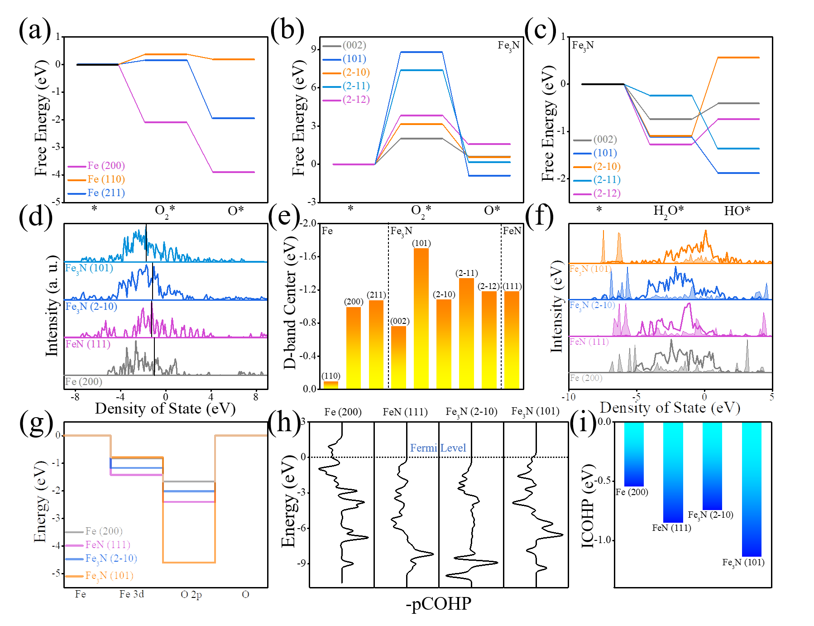
Fig. 4. DFT-Simulated corrosion-resistant behaviour of Fe and iron nitride-based facet models. (a) and (b) free energy diagrams for O₂-adsorption on typical facets of initial Fe and Fe₃N, (c) free energy diagrams for H₂O-adsorption on typical facets of Fe₃N, (d) partial DOS comparison of Fe 3d, (e) d-band center comparison, (f) partial DOS of Fe 3d and O 2p, (g) d-p band polarization between O₂ and surface Fe, (h) COHP comparison between Fe and adsorbed O₂, and (i) ICOHP comparison.
Based on the above performance evaluations along with computational analysis, it is confidently demonstrated that hFeNC delivers improved protection behaviour benefiting from its exposed facets with strong O₂-desorption and hydrophobic surface. Furthermore, wear resistance measurement is regarded as the essential evaluation for practical applications of surface coating in diversified environments [43]. By comparing wear behaviours among three samples (Fig. 5a), it is found that the coefficient of friction (COF) of both coatings along with initial Fe are comparatively stable. The COF of hFeNC is stabilized to 1.77 with the load of 2.2 N, higher than 1.07 and 0.86 of sFeN and initial Fe respectively. Accordingly, initial Fe without any surface treatment provides insufficient tribological performance and hence is exposed to severe wear during sliding. Based on high air sensitivity of iron, it is oxidized rapidly in such environment, leading to the oxide formation with increased hardness and reduced shear stress and hence reduced COF [44, 45]. Comparatively, the stable coefficient of hFeNC and sFeN during friction process (15 min) is ascribed to the preservation of iron nitride coating on substrate surface with reduced oxide formation. The ex-situ SEM morphology of wear track on hFeNC is further exhibited in Fig. 5b. It is observed that there are only a few wear debris with little groove after friction. According to the corresponding electron dispersive X-ray spectroscopy (EDX) mapping, it is found that there is little O-signals and the O-proportion is 0.9% compared to 2.1% of N-signal. This indicates the structural preservation of nano-coralline coating. Comparatively, there are apparent grooves along with large amounts of wear debris on sFeN surface indicating its reduced wear resistance. The apparent O-signal could be observed within wear track with O-proportion of 3.2%, indicating the partial pulverization of nitride coating along with oxide formation. In terms of initial Fe (Fig. S20), deep grooves along and numerous wear debris are observed, even with the existence of smooth surface of the substrate, which confirms significantly poor wear-resistant behaviour of initial Fe as compared to that of hFeNC.
Based on friction evaluation with loads of 4.2 N (Fig. S21a), hFeNC delivers higher initial COF than that of sFeN and initial Fe. Noticeably, apparent COF decrease of hFeCN is observed from friction test of 11 min, which is originated from the degradation of iron nitride nano-framework along with rapid formation of iron oxides during wear test. The corresponding EDX mappings further confirm such hypothesis. According to Fig. S21b, clear surface pulverization is observed on hFeNC as well as increased O-signal along the wear track. Comparatively, numerous wear debris on sFeN is found along with much raised O-signal, even not to say total surface deterioration of initial Fe (Fig. S21c and S21d). Similar phenomena are also be found with increased load of 6.2 N (Fig. S22). As shown in Fig. S22b, partial well-defined coating is also observed on hFeNC surface after friction even with such high load, while little nitride coating is found on sFeN (Fig. S22c), indicating better wear resistant behaviour of hFeNC. By comparing average COF among three samples (Fig. 5d), hFeNC exhibits much increased friction coefficient along with the optimized coating preservation during varied load friction, confirming its great potential for practical application.
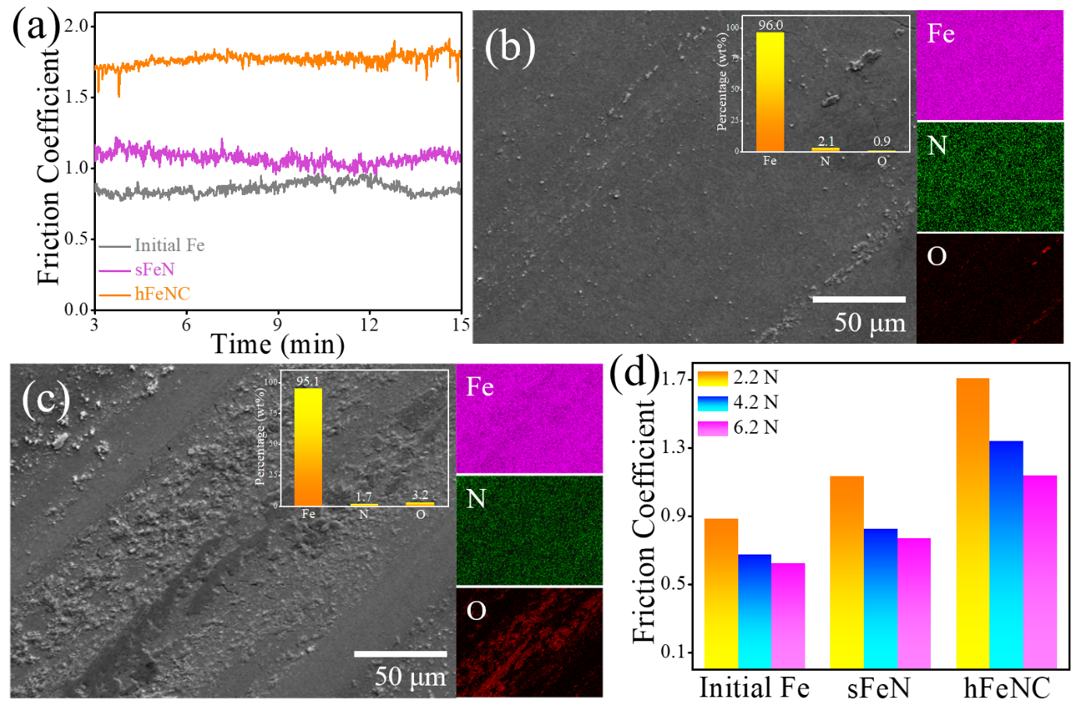
Fig. 5. Wear behaviour measurements along with surface characterizations of iron nitride frameworks. (a) COF curves with Si₃N₄ load of 2.2 N, (b) and (c) SEM images and EDX mapping of wear track on hFeNC and sFeN, and (d) comparison of friction coefficients at different weight loads of Si₃N₄ balls.
Furthermore, the specific wear rates of hFeNC, sFeN and initial Fe under the same wear conditions are compared with the load of 2.2 N. We apply the profilometer to obtain the two-dimensional profile of the wear track (Fig. S23a), and then calculate the specific wear rate of three samples based on the following equations.
$$V=\frac{Lh}{6b}(3h^{2}+4b^{2})$$
where, V is the wear volume (mm³), L is the length of wear track (mm), h is the depth of wear track (mm) and the b is width of wear track (mm).
The specific wear rate K (mm3N-1m-1) is given by
K =V/PS
where V is the wear volume (mm³), P is a load (N) and S is the total sliding distance (m).
As shown in Fig. S23b, the specific wear rate of initial Fe is 4.93×10⁻⁵ mm³N⁻¹m⁻¹. The specific wear rates of sFeN and hFeNC are 2.99×10⁻⁵ and 8.46×10⁻⁶ mm³N⁻¹m⁻¹, respectively, which are lower by 40% and 83% compared with the substrate. It indicates that auxiliary insulator-confined plasma system could achieve hydrophobic iron nitride nano-coral (hFeNC) with desirable wear-resistant properties.
The hardness of both coatings is further compared based on nano-indenter with the load of 1 mN in Fig. S24 in Supporting Information. It is observed that the hardness of hFeNC coating is higher than that of sFeN. Additionally, the hardness of hFeNC is continuously decreased with the depth below 100 nm, which is attributed to the presence of nanostructure [46, 47]. The hardness stabilizes at the depth higher than 100 nm. Comparatively, sFeN delivers the stable hardness throughout the different depths, though lower than hFeNC, indicating significantly reduced surface nano-structurization. Hence, it is confirmed that the increased hardness of nitride nano-corals provides positive effect on wear behaviour.
To elucidate the mechanisms underlying the formation of hFeNC and sFeN, operando plasma diagnostics were employed, encompassing infrared thermal imaging and optical emission spectroscopy (OES) measurements. In-situ infrared thermal imaging (Fig. 6a) reveals that the surface temperature for hFeNC fabrication rapidly reached 224 ºC during nitrogen plasma processing for 300 s, while the temperature for sFeN preparation remained at 100 ºC. This temperature disparity is attributed to the effect of auxiliary insulator-confined plasma nitridation for hFeNC, where thermal energy accumulates on the substrate surface with reduced heat dissipation due to confinement provided by the insulator. The elevated surface temperature contributes to modulation of plasma parameters, including ion density, electron temperature, and further influencing the surface morphology and microstructure of prepared iron nitride. In terms of in-situ OES spectra from 5 to 300 s, with intervals of 20 s (Fig. 6b and Fig. S25), prominent emission peaks at 315.63, 336.78, and 357.35 nm were observed during the N₂ plasma processing of both iron nitride frameworks, indicative of the presence of radiative state N₂* essential for surface modulation [48].
Such peak intensities, proportionally related to the density of species, continuously increased during hFeNC fabrication, in contrast to a modest rise during sFeN synthesis (Fig. 6c). This implies that a higher density of N₂* during hFeNC formation was facilitated by the insulator-based physical confinement of nitrogen plasma. Similar tendencies were observed for other emission peaks at 336.78 and 357.35 nm (Fig. 6d and S26). The evolution processes of N₂* are quantitatively compared based on non-linear fitting for above curves between duration and peak intensity (Fig. 6e). By comparing the coefficient A of equivalent fitting curves, the A value of hFeNC at varied wavelengths are found to be higher than that of sFeN (fitting formula exhibited in Fig. 6e), affirming that the accumulated thermal field on the substrate surface enhances the density of reactive N-species, influencing the structural features of resultant nano-frameworks of hFeNC.
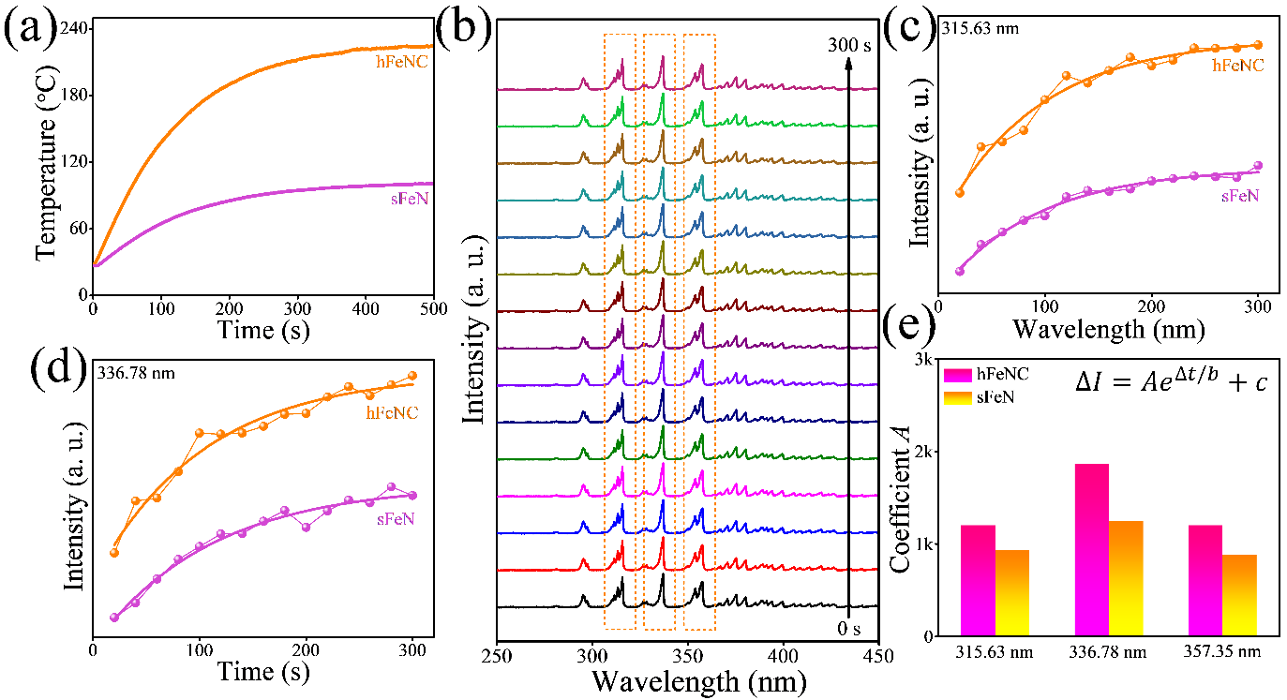
Fig. 6. Operando plasma diagnostics of both N₂ plasma processing, with and without insulator confinement. (a) In-situ infrared temperature measurement, (b) time-dependent OES spectra of hFeNC, (c) and (d) the variation of peak intensity of N₂⁺ with processing duration, and (e) the comparison of equivalent coefficient A with OES peaks in both spectra.
The raised surface reaction temperature for hFeNC evidently promotes the kinetics of surface iron, leading to the preferential formation of iron nitride with improved nano-structurization and controlled exposed facets for insulator-confined plasma processing, thereby enhancing corrosion-resistant behaviour. Building upon the aforementioned characterizations, performance evaluations, numerical simulation and plasma diagnostics, it is affirmed that the surface reaction temperature plays a pivotal role in influencing the structure of iron nitride nano-frameworks.
To further confirm the benefit of our plasma strategy in practical application, we have applied carbon steel (CS), one favourable steel in practical application, as the substrate. Based on plasma treatment with insulator-confinement introduction, there is the formation of nano-coralline structure in Fig. S27a, similar to that on intrinsic Fe surface. According to XRD results (Fig. S27b), it is found that that the achieved nano-corals are mainly composed of Fe₃N and FeN. For electrochemical behavior (Fig. S27c), plasma-treated CS delivers improved corrosion-resistant behavior compared to initial CS. In terms of hydrophobic performance, plasma-treated CS deliver higher water-contact angle than that of initial CS (Fig. S27d). This indicates that our plasma strategy is capable of achieving hydrophobic corrosion-resistant nitride on iron-based substrates for practical applications.
All in all, it is confidently confirmed that our insulator-confined plasma is capable of modulating surface structure of iron-based substrate with improved tribological properties for practical applications. Different from prior work to establish the relationship between easily-modulated discharge condition with surface structure, factors during plasma processing should also be essential in tailoring nitride structure, such as plasma parameters and the thermal field between substrate and plasma. The typical mechanism of how such factors can be used to achieve the precise control of surface structure is a matter of greater interest and forms the scope for future studies.

4. Conclusion
Overall, we have developed a novel auxiliary insulator-confined nitrogen plasma processing technique for formation of hydrophobic iron nitride nano-coral framework (hFeNC) on processed iron foils. We demonstrated that the exposed facets of achieved nano-framework can be precisely modulated in hFeNC via simply tailoring substrate reaction temperature through insulator-confined plasma processing, in stark comparison with sFeN film formation via convention non-insulator-confined plasma processing. With favourable surface protection behaviour, hFeNC delivers the corrosion inhibition 4- and 9-times higher than sFeN and initial Fe. Numerical simulation along with operando diagnostics elucidates the effect of surface heating on plasma parameters as well as the iron nitride nanostructure with exposed facets, indicating the controlled surface temperature as the key factor responsible for the desirable surface-protecting coating. Our strategy provides a novel scheme to control iron nitride nano-frameworks with enhanced surface protection.

Declaration of competing interest
The authors declare that they have not known competing financial interests or personal relationships that could have appeared to influence the work reported in this paper.

Acknowledgement
This study is supported by National Natural Science Foundation of China (12304020), National Science Fund for Distinguished Young Scholars (T2125004), Natural Science Foundation of Jiangsu Province (BK20230909), Fundamental Research Funds for the Central Universities (30923011013), Funding of NJUST (TSXK2022D002), China, and was also supported by NIE AcRF grant RI 7/22 RSR.

Supplementary Material
Supplementary material associated with this article can be found.

References
[1] B. Fotovvati, N. Namdari, A. Dehghanghadikolaei, On coating techniques for surface protection: A review, J. Manuf. Mater. Process. 3 (2019) 28.
[2] R. Asri, W. Harun, M. Samykano, N. Lah, S. Ghani, F. Tarlochan, M. Raza, Corrosion and surface modification on biocompatible metals: A review, Mater. Sci. Eng. 77 (2017) 1261-1274.
[3] W. Yao, W. Liang, G. Huang, B. Jiang, A. Atrens, F. Pan, Superhydrophobic coatings for corrosion protection of magnesium alloys, J. Mater. Sci. Technol. 52 (2020) 100-118.
[4] W.Y. Chen, S.-N. Lai, C.-C. Yen, X. Jiang, D. Peroulis, L.A. Stanciu, Surface functionalization of Ti3C2T x MXene with highly reliable superhydrophobic protection for volatile organic compounds sensing, ACS Nano 14 (2020) 11490-11501.
[5] A. Thakur, A. Kumar, S. Kaya, R. Marzouki, F. Zhang, L. Guo, Recent advancements in surface modification, characterization and functionalization for enhancing the biocompatibility and corrosion resistance of biomedical implants, Coatings 12 (2022) 1459.
[6] D.S. Chauhan, M. Quraishi, K. Ansari, T.A. Saleh, Graphene and graphene oxide as new class of materials for corrosion control and protection: Present status and future scenario, Prog. Org. Coat. 147 (2020) 105741.
[7] M. Ates, A review on conducting polymer coatings for corrosion protection, J. Adhes. Sci. Technol. 30 (2016) 1510-1536.
[8] A.A. Nazeer, M. Madkour, Potential use of smart coatings for corrosion protection of metals and alloys: A review, J. Mol. Liq. 253 (2018) 11-22.
[9] V. Sharma, V. Sharma, M.S. Goyat, A. Hooda, J.K. Pandey, A. Kumar, R. Gupta, A.K. Upadhyay, R. Prakash, J.B. Kirabira, P. Mandal, P.K. Bhargav, Recent progress in nano-oxides and CNTs based corrosion resistant superhydrophobic coatings: A critical review, Prog. Org. Coat. 140 (2020) 105512.
[10] A. Khan, M. Puttegowda, P. Jagadeesh, H.M. Marwani, A.M. Asiri, A. Manikandan, A.A. Parwaz Khan, G.M. Ashraf, S.M. Rangappa, S. Siengchin, Review on nitride compounds and its polymer composites: a multifunctional material, J. Mater. Res. Technol. 18 (2022) 2175-2193.
[11] Y. Yang, X. Zhou, X.Z. Dai, J. Li, S.H. Zhang, C.S. Zhang, J.C. Ding, J. Zheng, Comparative study of plasma nitriding and plasma oxynitriding for optimal wear and corrosion resistance: Influences of gas composition, J. Mater. Res. Technol. 15 (2021) 448-459.
[12] M. Naeem, M. Shafiq, M. Zaka-ul-Islam, A. Ashiq, J.C. Díaz-Guillén, M. Shahzad, M. Zakaullah, Enhanced surface properties of plain carbon steel using plasma nitriding with austenitic steel cathodic cage, Mater. Design 108 (2016) 745-753.
[13] C.P. Fenili, F.S. de Souza, G. Marin, S.M.H. Probst, C. Binder, A.N. Klein, Corrosion resistance of low-carbon steel modified by plasma nitriding and diamond-like carbon, Diam. Relat. Mater. 80 (2017) 153-161.
[14] M.F. Yan, B.F. Chen, B. Li, Microstructure and mechanical properties from an attractive combination of plasma nitriding and secondary hardening of M50 steel, Appl. Surf. Sci. 455 (2018) 1-7.
[15] B. Ouyang, Y. Zhang, X. Xia, R.S. Rawat, H.J. Fan, A brief review on plasma for synthesis and processing of electrode materials, Mater. Today Nano 3 (2018) 28-47.
[16] L.D. Tadepalli, A.M. Gosala, L. Kondamuru, S.C. Bairi, R. Subbiah, S.K. Singh, A review on effects of nitriding of AISI409 ferritic stainless steel, Mater. Today Proceed. 26 (2020) 1014-1020.
[17] B. Ouyang, Y. Zhang, X. Wang, Y. Deng, F. Liu, Z. Fang, R.S. Rawat, E. Kan, Facet Control of Nickel Nitride Nano‐Framework for Efficient Hydrogen Evolution Electrocatalysis via Auxiliary Cooling Assisted Plasma Engineering, Small 18 (2022) 2204634.
[18] B. Ouyang, C. Sun, X. Wang, J. Xu, Y. Cao, F. Wu, R.S. Rawat, J. Zhu, E. Kan, Structural control of heterostructured Co₃N-Co nano-corals for boosting electrocatalytic hydrogen evolution based on insulator-confined plasma engineering, Chem. Eng. J. 466 (2023) 143211.
[19] B. Ouyang, E. Kan, R.S. Rawat, Plasma nanotechnology: novel tool for high-performance electrode materials for energy storage and conversion, Rev. Mod. Plasma Phys. 7 (2023) 29.
[20] D. Laniel, A. Dewaele, S. Anzellini, N. Guignot, Study of the iron nitride FeN into the megabar regime, J. Alloys Compds. 733 (2018) 53-58.
[21] N. Zhao, W. Wang, X. Lei, Z. Ye, X. Chen, H. Ding, H. Yang, Synthesis, structure and magnetic properties of Fe₃N nanoparticles, Journal of Materials Science: Mater. Electron. 28 (2017) 15701-15707.
[22] A.-M. Zieschang, J.D. Bocarsly, M. Dürrschnabel, L. Molina-Luna, H.-J. Kleebe, R. Seshadri, B. Albert, Nanoscale iron nitride, ε-Fe₃N: preparation from liquid ammonia and magnetic properties, Chem. Mater. 29 (2017) 621-628.
[23] X. Ma, X. Xiong, J. Zeng, P. Zou, Z. Lin, M. Liu, Melamine-assisted synthesis of Fe₃N featuring highly reversible crystalline-phase transformation for ultrastable sodium ion storage, J. Mater. Chem. A 8 (2020) 6768-6775.
[24] F. Yu, H. Zhou, Z. Zhu, J. Sun, R. He, J. Bao, S. Chen, Z. Ren, Three-Dimensional Nanoporous Iron Nitride Film as an Efficient Electrocatalyst for Water Oxidation, ACS Catalysis, 7 (2017) 2052-2057.
[25] K. Idczak, R. Idczak, R. Konieczny, An investigation of the corrosion of polycrystalline iron by XPS, TMS and CEMS, Physica B 491 (2016) 37-45.
[26] T. Wang, X. Tian, Y. Yang, Y.-W. Li, J. Wang, M. Beller, H. Jiao, Coverage-dependent N2 adsorption and its modification of iron surfaces structures, J. Phys. Chem. C 120 (2016) 2846-2854.
[27] I. Goikoetxea, M. Alducin, R.D. Muiño, J. Juaristi, The dynamics of adsorption and dissociation of N₂ in a monolayer of iron on W (110), Phys. Chem. Chem. Phys. 17 (2015) 19432-19445.
[28] X. Sun, S. Yang, B. Xue, K. Huo, X. Li, Y. Tian, X. Liao, L. Xie, S. Qin, K. Xu, Super-hydrophobic poly (lactic acid) by controlling the hierarchical structure and polymorphic transformation, Chem. Eng. J. 397 (2020) 125297.
[29] H. Teisala, H.-J.r. Butt, Hierarchical structures for superhydrophobic and superoleophobic surfaces, Langmuir 35 (2018) 10689-10703.
[30] A.Y. Adesina, Z.M. Gasem, A. Madhan Kumar, Corrosion resistance behavior of single-layer cathodic arc PVD nitride-base coatings in 1M HCl and 3.5 pct NaCl solutions, Metall. Mater. Trans. B 48 (2017) 1321-1332.
[31] E. De Las Heras, G. Ybarra, D. Lamas, A. Cabo, E.L. Dalibon, S.P. Brühl, Plasma nitriding of 316L stainless steel in two different N₂-H₂ atmospheres-Influence on microstructure and corrosion resistance, Surf. Coat. Technol. 313 (2017) 47-54.
[32] W. Yang, M. Zhang, Y. Zhao, M. Shen, H. Lei, L. Xu, J. Xiao, J. Gong, B. Yu, C. Sun, Enhancement of mechanical property and corrosion resistance of 316L stainless steels by low temperature arc plasma nitriding, Surf. Coat. Technol. 298 (2016) 64-72.
[33] X. Zhang, J. Wang, H. Fan, D. Pan, Erosion-corrosion resistance properties of 316L austenitic stainless steels after low-temperature liquid nitriding, Appl. Surf. Sci. 440 (2018) 755-762.
[34] M. Yuan, X. Gao, X. Gu, C. Dong, S. Wang, M. Wen, K. Zhang, Simultaneous enhancement of hardness and wear and corrosion resistance of high‐entropy transition‐metal nitride, J. Am. Ceram. Soc. 106 (2023) 1356-1368.
[35] S. Ren, M. Cui, J. Pu, Q. Xue, L. Wang, Multilayer regulation of atomic boron nitride films to improve oxidation and corrosion resistance of Cu, ACS Appl. Mater. Interfaces 9 (2017) 27152-27165.
[36] J. Alphonsa, V. Raja, S. Mukherjee, Study of plasma nitriding and nitrocarburizing for higher corrosion resistance and hardness of 2205 duplex stainless steel, Corros. Sci. 100 (2015) 121-132.
[37] H. Qian, S. Chen, T. Wang, G. Cheng, X. Chen, Z. Xu, Q. Zeng, Y. Liu, D. Yan, Silicon nitride modified enamel coatings enable high thermal shock and corrosion resistances for steel protection, Surf. Coat. Technol. 421 (2021) 127474.
[38] A. Kameneva, V. Kichigin, Corrosion, wear, and friction behavior of a number of multilayer two-, three-and multicomponent nitride coatings on different substrates, depending on the phase and elemental composition gradient, Appl. Surf. Sci. 489 (2019) 165-174.
[39] F. Fernandes, S. Heck, C. Picone, L.C. Casteletti, On the wear and corrosion of plasma nitrided AISI H13, Surf. Coat. Technol. 381 (2020) 125216.
[40] Y. Zhang, G. Zhao, Y.F. Cheng, Effect of O₂ on down-hole corrosion during air-assisted steam injection for heavy oil recovery, Corros. Eng. Sci. Technol. 54 (2019) 310-316.
[41] Z. Chen, Y. Song, J. Cai, X. Zheng, D. Han, Y. Wu, Y. Zang, S. Niu, Y. Liu, J. Zhu, Tailoring the d‐band centers enables Co₄N nanosheets to be highly active for hydrogen evolution catalysis, Angew. Chem. Int. Ed. 57 (2018) 5076-5080.
[42] S. Steinberg, R. Dronskowski, The crystal orbital Hamilton population (COHP) method as a tool to visualize and analyze chemical bonding in intermetallic compounds, Crystals 8 (2018) 225.
[43] S.V. Bhaskar, H.N. Kudal, Tribology of nitrided-coated steel-a review, Arch. Mech. Technol. Mater. 37 (2017) 50.
[44] H. Tekdir, A.F. Yetim, Additive manufacturing of multiple layered materials (Ti6Al4V/316L) and improving their tribological properties with glow discharge surface modification, Vacuum 184 (2021) 109893.
[45] A.F. Yetim, H. Tekdir, K. Turalioglu, M. Taftali, T. Yetim, Tribological behavior of plasma-sprayed Yttria-stabilized zirconia thermal barrier coatings on 316L stainless steel under high-temperature conditions, Mater. Lett. 336 (2023) 133873.
[46] Y. Liu, A.H.W. Ngan, Depth dependence of hardness in copper single crystals measured by nanoindentation, Scripta Mater. 44 (2001) 237-241.
[47] Q. Tao, J. Wang, L. Fu, Z. Chen, C. Shen, D. Zhang, Z. Sun, Ultrahigh hardness of carbon steel surface realized by novel solid carburizing with rapid diffusion of carbon nanostructures, J. Mater. Sci. Technol. 33 (2017) 1210-1218.
[48] J. Kaupe, P. Riedl, D. Coenen, S. Mitic, Temporal evolution of electron density and temperature in low pressure transient Ar/N₂ plasmas estimated by optical emission spectroscopy, Plasma Sources Sci. Technol. 28 (2019) 065012.

