Hierarchical spontaneous self-assembly of polyethylenimine-poly(propylene glycol) copolymer into cationic polyelectrolyte pH-responsive thermogel
Qianyu Lin,ª Chen Chuan Lim,^{b} Cally Owh,^{a,c} Liangfeng Guo,^{b} Jason Y. C. Lim^{a,d*} and Xian Jun Loh^{a,e*}
ªInstitute of Materials Research and Engineering (IMRE), Agency for Science, Technology and Research (A*STAR), 2 Fusionopolis Way, 138634, Singapore
^{b}Institute of Sustainability for Chemical, Energy and Environment (ISCE²), Agency for Science, Technology and Research (A*STAR), 1 Pesek Road, Jurong Island, 627833, Singapore
^{c}Department of Biomedical Engineering, National University of Singapore (NUS), 4 Engineering Drive 3, 117583, Singapore
^{d}Department of Materials Science and Engineering, National University of Singapore (NUS), 9 Engineering Drive, 117576, Singapore
^{e}School of Materials Science and Engineering, Nanyang Technological University (NTU), 50 Nanyang Avenue, Block N4.1, 639798, Singapore

Abstract
Temperature-responsive hydrogels, otherwise known as thermogels, are promising biomaterials which undergo phase change from liquid to a solid-like gel state when warmed. Although poly(ethylene glycol) (PEG) is employed extensively as the hydrophilic segment in thermogelling polymer design, recent years has witnessed development of new families of PEG-free thermogelling copolymers which offer new opportunities in expanding material property profiles for new biomedical applications. Herein, we study the supramolecular self-assembly process of PEG-free amphiphilic branched graft copolymer containing polyethylenimine (PEI) and poly(propylene glycol) (PPG), which shows both thermogelling ability and pH-responsive gelation behaviour. Additionally, we demonstrate the ease of post-synthetic modulation of thermogel properties by amine functionalisation on the PEI copolymer segments through convenient nucleophilic substitution and amide formation reactions. The synthetic platform offered by PEI-PPG thermogels allow facile customisation of these versatile materials for targeted biomedical applications.
Keywords
Polyethylenimine; cationic; PEG-free; thermogel; pH-responsive; post-synthetic functionalisation

Thermogels are a class of supramolecular hydrogels formulated from amphiphilic copolymers that exhibit sol-gel phase transitions when warmed that are highly sought-after for different biomedical applications.^{1,2} While a myriad of polymers, both natural³ and synthetic,⁴ have been employed as the hydrophobic temperature responsive segments of amphiphilic thermogelling block copolymers, poly(ethylene glycol) (PEG)⁵ is almost invariably the archetypical hydrophilic segment. The heavy reliance on PEG not only limits the post-synthetic customizability of PEG-thermogels due to their unreactive predominantly polyether backbones⁵ but also led to growing concerns of PEG-conjugates eliciting immunogenicity in some applications.⁶ These have thus driven efforts to develop non-PEG-based thermogel platforms, such as DL-polyalanine thermogel⁷ and a cell crosslinked thermogel.⁸ Despite this, these PEG-free thermogels only show single stimuli-responsiveness in response to temperature.⁹
In recent years, development of smart multi-responsive hydrogels has gained traction, particularly in response to pH and temperature^{10,11} - the two most common environmental triggers in chemical and biological systems. Although a handful of hydrogels comprising of thermosensitive (e.g. poly(2-oxazoline), N-isopropylacrylamide) and pH-responsive components (e.g. acrylates, alginates) have been reported,^{12,13} pH-responsive thermogels have thus far been largely overlooked. Polyethylenimine (PEI) is a highly hydrophilic polymer with abundant nucleophilic hydrogen bonding forming nitrogen atoms. PEI-based amphiphilic copolymers are well-known to form micelles with pH-responsiveness¹⁴ for a number of important biomedical uses such as in-vivo imaging,¹⁵ targeted drug delivery,¹⁶ gene transfection,¹⁷ and antimicrobial¹⁸ applications. However, these PEI-based micelles are rarely shown to be able to self-assemble in response to temperature to form a supramolecular hydrogel.
Herein, we demonstrate the hierarchical self-assembly process of PEG-free thermogelling copolymers containing PEI and poly(propylene glycol) (PPG) as the sole hydrophilic and temperature responsive segments. We showed that the PPG-PEI copolymer undergoes temperature-controlled self-assembly from unimer to a supramolecular hydrogel matrix upon warming. The abundant amines on the PEI-based thermogel imbues it with pH-responsiveness as protonation increases the hydrophilicity of the copolymer and thus influences the gelation process. Lastly, we demonstrate the ease of copolymer modification and tuning of its subsequent rheological properties by facile post-synthetic functionalisations by leveraging on well-established amine chemistry.
The PEI-based thermogel in this study was formulated from an amphiphilic copolymer that was synthesised by conjugating poly(propylene glycol) monobutyl ether (PPG-mbe, 2.5 kDa) onto branched PEI (M_{n} = 10 kDa, M_{w} = 25 kDa) via urethane linkages by employing carbonyldiimidazole (CDI) as the coupling agent and 4-dimethylaminopyridine (DMAP) as catalyst (Scheme 1). After purification by dialysis, the copolymer, named PCP, is obtained as a yellow solid with ~ 70 % yield after lyophilisation (see Section S1, SI for full synthesis details).
¹H NMR analysis of the purified product in deuterated methanol showed characteristics peaks of PEI at δ = 2.36 - 2.97 ppm while the characteristics peaks of PPG were observed at δ = 1.04 - 1.15 ppm and δ = 3.38 - 3.62 ppm (Figure 1A). Comparing the molar ratio of PPG-mbe to PEI in the purified copolymer with the feed molar ratios of the macromonomers showed that 90.8 % grafting efficiency was achieved (Table S1). ¹³C NMR analysis of the purified copolymer showed a distinct peak at δ = 164 ppm which corresponded to the urethane group (Figure S1A). Further evidence of the urethane linkages was obtained using FTIR, which showed the characteristic C=O stretch of urethanes at 1653 cm⁻¹ (Figure S1B). In addition, diffusion ordered spectroscopy (DOSY) of the PCP copolymer yielded the same diffusion coefficient of 7.93 x 10⁻¹² m²s⁻¹ for both the PPG and PEI segments (Figure S1C). Taken together, these results confirmed that PPG-mbe was successfully conjugated onto PEI via the formation of urethane bonds. The final composition of the copolymer and its molecular weight were determined from the ¹H NMR integration ratios of the respective PPG and PEI peaks (Table S1), which showed an average 6.54 units of PPG-mbe conjugated onto each PEI unit (estimated average M_{n} = 26.3 kDa) with grafting efficiency being 90.8 % (Table S1).
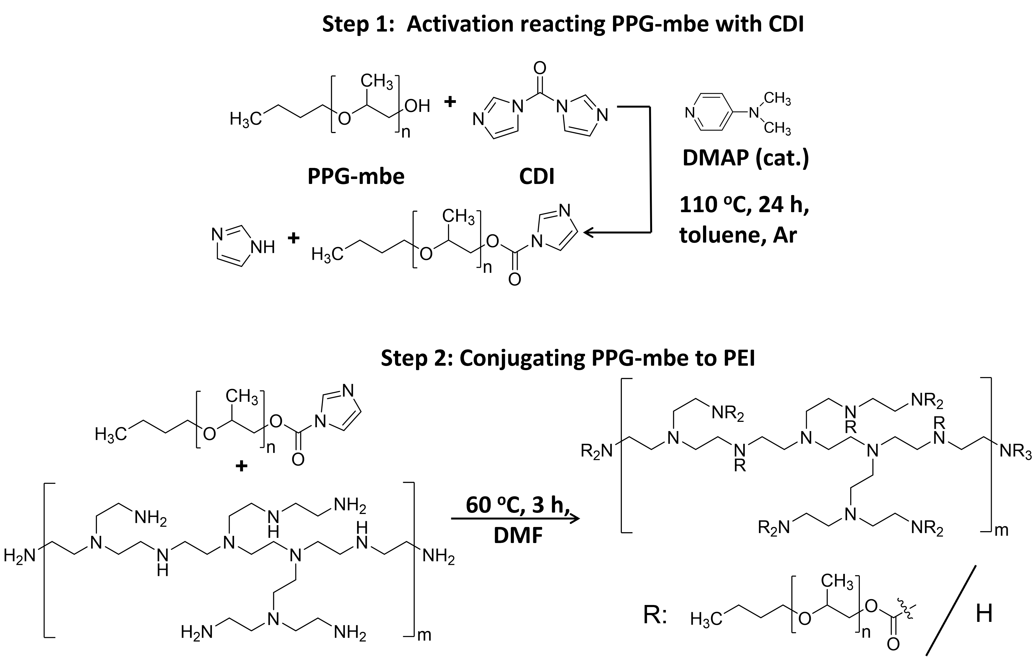
Scheme 1. Synthesis of the PCP copolymer using branched PEI and PPG-mbe macromonomers.
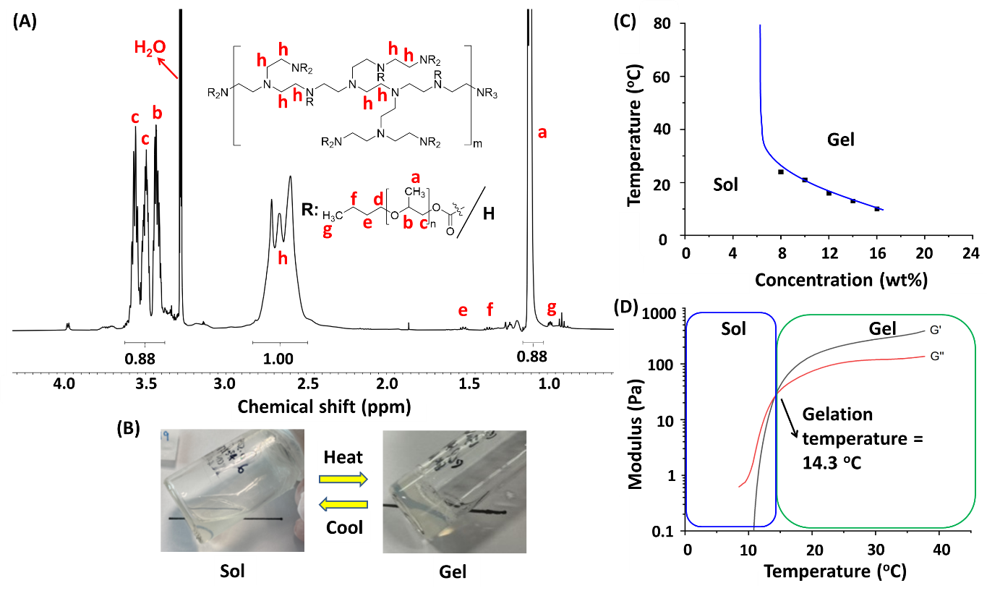
Figure 1. (A) ¹H NMR spectrum of PCP copolymer. (B) Photos of PCP sol and gel phase at 4 ºC and 37 ºC respectively. (C) Temperature-concentration phase diagram of PCP thermogel at pH 7. (D) Rheology temperature sweep measurement of PCP thermogel at 15 wt% and pH 7.
The PCP copolymer dissolved in water to form homogeneous sols at low temperatures (< 10 ºC) and they are observed to undergo spontaneous and reversible sol-gel phase transition that is characteristic of thermogels upon warming (Figure 1B). The tube-inversion method with gradual temperature increase was employed to obtain the temperature-concentration phase diagram. The lowest temperature whereby a non-flowing gel forms is the gelation temperature and it demarcates the sol-gel phase boundary. We found that the critical gelation concentration (CGC) of the PCP copolymer was 8 wt% with a corresponding gelation temperature of 24 ºC at pH 7 (Figure 1C). Higher polymer concentrations result in lower gelation temperatures. This is congruent with traditional PEG-based thermogels where higher polymer concentrations promotes the formation of hydrogel matrix and consequently lowers gelation temperature.¹⁹ In addition, the PEI thermogels in this study are observed to be optically transparent or slightly translucent (at higher concentrations).
PEG-based thermogels commonly possess gel-turbid sol phase boundaries at the higher temperatures (> 60 ºC) in addition to their sol-gel phase boundary.²⁰ The upper phase boundary is due to the excessive dehydration of the copolymers such that the copolymers aggregate into a bulk causing the collapse of the hydrogel matrix.²¹ In contrast, the PEI-based thermogels displayed no gel-turbid gel phase boundary as they do not collapse even at temperatures close to 100 ºC (Figure 1C). This suggests that the PEI-based thermogel plausibly has enhanced water affinity as compared to the PEG-based counterparts and this may be contributed by the protonation of the PEI segments at physiological pH,²² which is supported by the PCP copolymer’s positive zeta potential of +22.5 mV.
Rheological temperature sweep measurements were performed on the PCP thermogels to further characterise their sol-gel phase transitions. At low temperatures, the loss modulus, G”, was greater than the storage modulus, G’, confirming that the thermogels were in the sol phase. With gradual heating of 3 ºC min⁻¹, both G’ and G” increased, with G’ increasing more rapidly than G” such that G’ eventually exceeded G”. The temperature at which G’ first exceeded G” is the gelation temperature. At 15 wt% and pH 7, the PCP thermogel showed a gelation temperature of 14.3 ºC (Figure 1D), which is notably lower than the T_{gel} of Pluronic F127 (22.5 ºC) at a higher concentration of 20 wt% (Figure S2). Notably, our PCP thermogel’s G’ value of 381 Pa at 37 ºC allows it to be potentially used as wound dressing patches²³ or implantable drug delivery platforms.²⁴
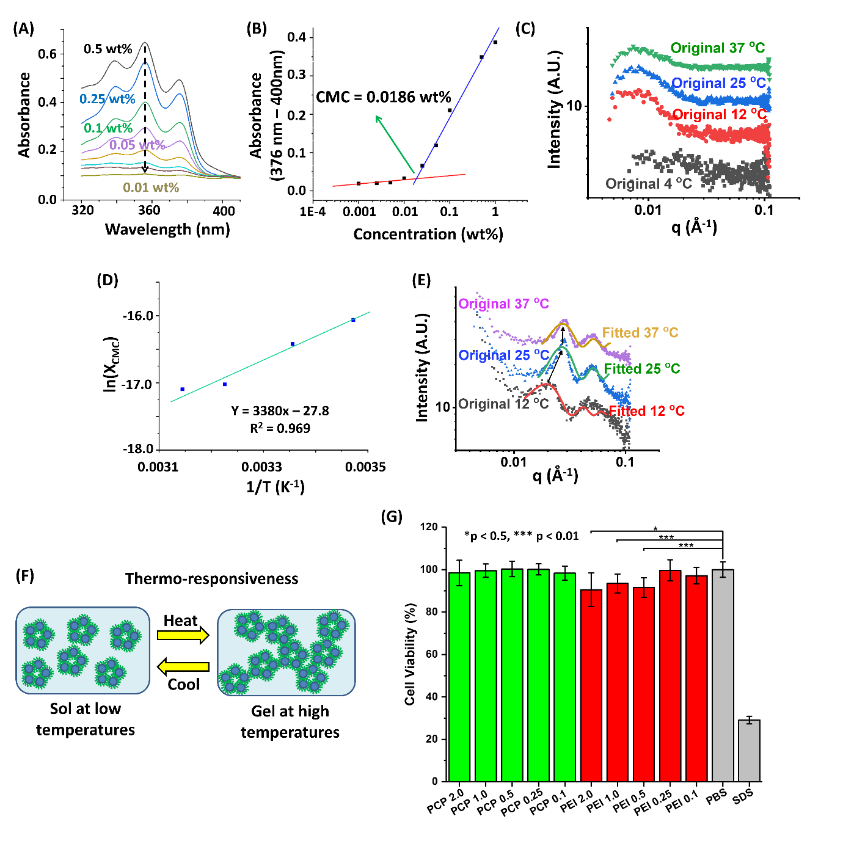
Figure 2. (A) Absorbance of DPH in PCP micellar solutions. (B) Plot of DPH absorbance against lg(concentration) for PCP copolymer at 25 ºC to determine critical micelle concentration (CMC). (C) SAXS scattering (original and fitted) spectra of PCP sol at 1 wt% at 12, 25, and 37 ºC. (D) Arrhenius plot of PCP sol. (E) SAXS scattering (original and fitted) spectra of PCP thermogel at 10 wt% and pH 7 at 12, 25, and 37 ºC. (F) Schematic representation of micellar self-assembly of PCP during sol-gel phase transition. (G) In-vitro biocompatibility evaluation of PCP micelles against NIH3T3 mouse fibroblasts.
To show that the PCP copolymers undergo hierarchical self-assembly from unimers to micelles and finally into an aggregated micellar supramolecular hydrogel network in response to temperature, a number of techniques are employed. First, we employed the hydrophobic dye (diphenylhexatriene, DPH) absorbance method to ascertain the presence of micelles and determine the critical micelle concentration (CMC) of the PCP copolymer. A significant increase in DPH absorbance was observed with increasing PCP concentration (Figure 2A); this suggests that micelles have formed that encapsulated DPH in their hydrophobic cores and led to the sharp increase in absorbance.²⁵ The CMC of the PCP copolymer is determined by plotting the absorbance against concentration of copolymer where the point of sharp increase in absorbance indicates the CMC.²⁵ CMC of the PCP copolymer is found to be 0.0186 wt% at 25 ºC (Figure 2B).
Small angle X-ray scattering (SAXS) measurements were also performed on 1 wt% PCP sol at increasing temperatures of 4, 12, 25, and 37 ºC (Figure 2C), which revealed distinct microstructural changes in the solution that accompanied micellar self-assembly upon warming. At 4 ºC, no scattering peaks are observed, suggesting that no structures are present within the sol and that the PCP polymers likely remain as unassociated unimers. Upon warming to 12 ºC and above, prominent scattering peaks at the low q < 0.01 region were observed which could be well-fitted as spheres.²⁶ The z-average size of micelles at 1 wt% was found to be 65.7 nm in diameter via dynamic light scattering (DLS) at 25 ºC.
To elucidate the thermodynamic driving force for micellisation, we determined the changes in enthalpy (ΔH) and entropy (ΔS) of PCP micellisation by the Arrhenius method (Figure 2D, Table S2). At 25 ºC, the negative Gibbs free energy (ΔG = ̶ 41.7 kJ mol⁻¹) is indicative of spontaneous micelle formation, while the increase in entropy (ΔS = + 0.234 kJ mol⁻¹ K⁻¹) and its endothermicity (ΔH = + 28.0 kJ mol⁻¹) is consistent with hydrophobic effect being the main driving force of micellisation.²⁷ As PCP unimeric solution is warmed, heat is absorbed for the desolvation of the PPG-mbe segments.²⁸ To reduce the amount of exposed hydrophobic PPG-mbe segments in solution, the PPG-mbe segments spontaneously coalesce and result in the aggregation of unimers into micelles.²⁹ During the desolvation process, large amounts of structured water initially bound to PPG-mbe in the solvated state is released which accounts for the positive gain in entropy.³⁰
At gel forming concentrations of PCP copolymer, warming the unimeric solution not only caused the formation of micelles by hydrophobic effect but also leads to the aggregation of micelles due to the same effect. To investigate the microstructural changes happening during the sol-gel phase transition, SAXS measurements at four temperatures were performed on the gel-forming PCP 10 wt% formulation to further probe the process of micellar self-assembly during gelation. At 12 ºC and higher, we observed two prominent scattering peaks 0.02 Å⁻¹ < q < 0.03 Å⁻¹ and 0.04 Å⁻¹ < q < 0.06 Å⁻¹ which can be fitted satisfactory by a model describing spheres with core-shell structure (Figure 2E), that can pack together to form physically cross-linked supramolecular micellar matrix (Figure 2F). Notably, this core-shell microstructure for PCP is different from the microstructures of PEG-based thermogels. In particular, we have previously reported that linear PEG-based thermogelling copolymers are able to pack tightly together and form cylindrical microstructures²⁰ while branched copolymers having globular polymer architectures are found to form spherical microstructures due to their increased steric hindrance.¹⁹
As a supramolecular micellar hydrogel, the PCP thermogel is likely to undergo erosion via micelle shedding like their PEG-based counterparts when implanted into the body for applications such as drug delivery platforms. As cells are known to ingest these micelles³¹ and PEI-based micelles are commonly shown to disrupt cell membranes due to their positive charges,³² it is essential to evaluate the biocompatibility of the PCP micelles. An initial in-vitro biocompatibility test was performed on various concentrations of PEI-PPG micelles using NIH3T3 mouse fibroblasts. As shed micelles are likely circulated through the whole body with only transient contact with specific tissues,²¹ the PCP micellar solutions were incubated with the mouse fibroblasts for 1 h before the cell viability of the cells were evaluated. Our results showed that good cell viability was maintained for all tested PCP concentrations (0.1 wt% - 2.0 wt%) as compared to the positive control (1x sterile phosphate buffer solution) while incubation with 1 % sodium dodecyl sulfate (SDS) for 1 h led to significant apoptosis (Figure 2G). For additional comparison, similar concentrations of branched PEI (25 kDa) were also incubated with the mouse fibroblasts and the results showed that the higher concentrations of PEI (> 0.5 wt%) led to significant reductions in cell viability (Figure 2G). This improved cell viability of PCP micelles may be attributed to reduced charge density on PEI due to reduced hydration of the amines after conjugation of hydrophobic PPG-mbe side chains to PEI.³² Taken together, the in-vitro results provide some confidence that the PCP thermogel would be suitable for potential biomedical applications.
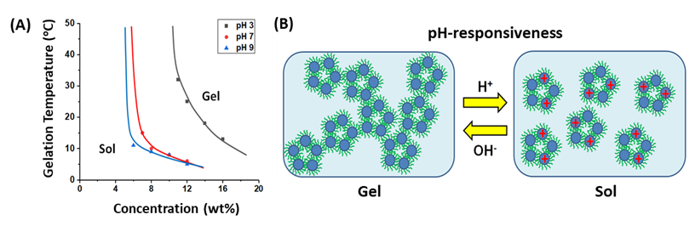
Figure 3. (A) Temperature-concentration phase diagrams of PCP thermogel in 0.1M pH 3, 7, and 9 buffers. (B) Schematic representation of the pH-responsiveness of the PCP thermogel.
The reversible self-assembly process of the PEI-based thermogel was also demonstrated to be pH sensitive. With decreasing pH, the phase diagram was observed to shift rightwards towards increasing CGC (Figure 3A), from 5 wt% at pH 9 to 11 wt% at pH 3. This is expected due to protonation of amines in PCP; protonation greatly increases the hydrophilicity of the PCP copolymer and also simultaneously increase the electrostatic repulsion between copolymers. Both of these factors contribute to increased difficulty to achieve gelation via hydrophobic association of micelles, and as such higher polymer concentration is required to form the stable supramolecular matrix for gelation (Figure 3B). For gel stiffness, it was found that higher pH is generally associated with higher ultimate storage modulus (Figure S3). This can plausibly be attributed to reduced electrostatic repulsion between copolymers due to less protonation in basic environments which may contribute to improved self-assembly and hence increased stiffness.
The pKa values of PEI is highly dependent upon molecular weight,²² degree of branching,³³ and presence of salts.²² Due to the high sensitively, a whole range of pKa values had been reported for linear PEIs via potentiometric titrations²² and measurements on branched PEIs remains challenging as their complex dendritic architectures with varied intramolecular interactions complicates the protonation process.³³ While in general tertiary amines are protonated first followed by secondary and primary amines,³⁴ computer simulations suggest that the protonation of branched PEI would begin on alternating dendrimer shells in an onionlike pattern until all available amines are protonated at very low pH (~ 0);³³ this pattern minimised the amount of free energy by avoiding interactions between all nearest neighbour pairs.³³ In the case of our PCP copolymer, we postulate that its protonation would resemble that of branched PEI with differences likely arising due to changes in the polymer electronics after the formation of urethanes and reduced number of secondary and primary amines present.
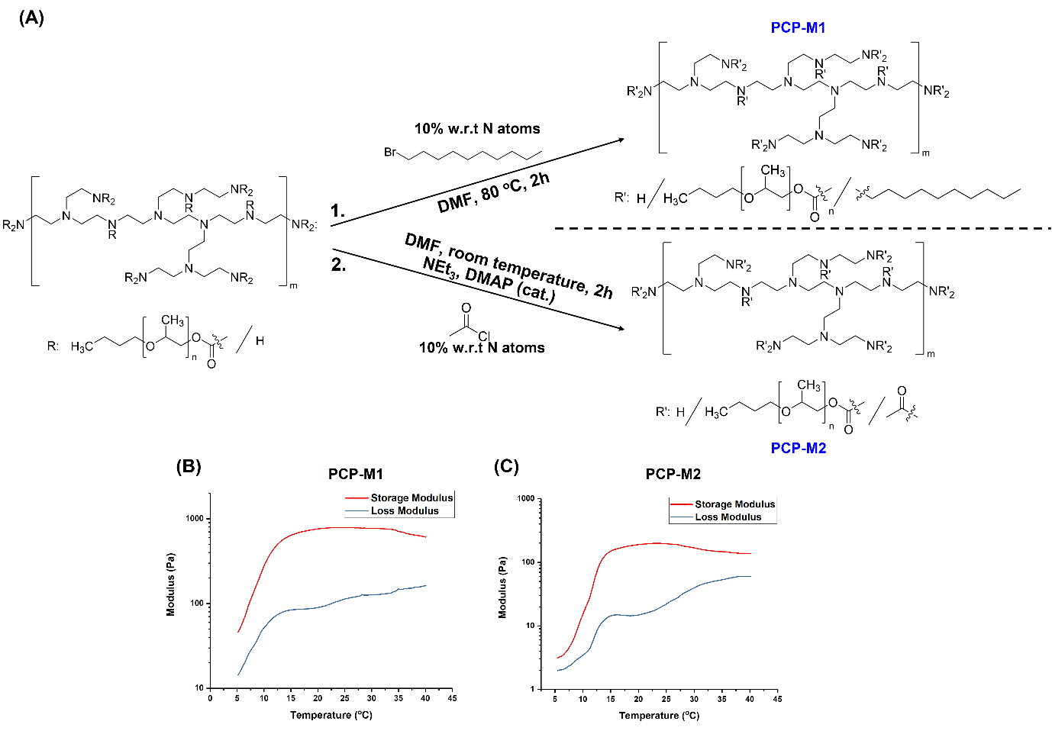
Figure 4. (A) Post-synthetic functionalization of PCP copolymer with bromododecane and acetyl chloride. Oscillatory temperature sweep from 5 – 40 ºC of 10 wt% (B) PCP-M1 (modified with bromododecane) and (C) PCP-M2 (modified with acetyl chloride).
Finally, to demonstrate the versatility of PCP thermogel towards post-synthetic functionalisation, the purified PCP copolymer was redissolved in DMF and reacted with a representative alkyl halide (1-bromododecane) and acetyl chloride separately; the modified copolymers were purified via dialysis and are named as PCP-M1 and PCP-M2 respectively (Figure 4A). The appearance of the characteristic bromododecane peak at δ = 0.88 ppm in PCP-M1 in MeOD accompanied by the disappearance of characteristic bromododecane peaks at δ = 3.4 ppm, δ = 1.8 ppm, and δ = 1.4 ppm (Figure S4A and S4B) suggest successful nucleophilic substitution between amines on PCP and bromododecane; integration of the respective characteristic peaks indicates that there is complete reaction between bromododecane and PCP amines such that 10 % of all amines in the copolymer became functionalized (Table S3). On the other hand, the appearance of two peaks at δ = 1.95 ppm and δ = 1.76 ppm in PCP-M2 spectrum in deuterated methanol (Figure S4C) suggests successful tertiary³⁵ and secondary amide³⁶ formation between acetyl chloride and the secondary and primary amines of PCP respectively. Integration of the respective characteristic peaks also indicates complete reaction such that 10 % of all amines became amides (Table S4).
The resultant modified PCP-M1 and PCP-M2 copolymers were purified by dialysis and subsequently lyophilised to remove all unreacted functionalising reagents, before being dissolved in deionised water to investigate their thermogelling ability. From subsequent temperature sweep rheology measurements, it was found that both PCP-M1 and PCP-M2 copolymers still formed thermogels possessing the characteristic temperature responsiveness (Figure 4B and 4C). Despite the relatively small degree of functionalisation on both PCP-M1 and PCP-M2, it appears that there is an appreciable increase in the overall hydrophobicity of the modified copolymers such that there is a large increase in gel stiffness to the extent that no crossover temperature was observed in both samples (Figure 4B and 4C). This initial demonstration indicates that the PEI-thermogel system has the potential of undergoing a myriad of facile post-synthetic functionalisation by leveraging upon well-established amine chemistry for easy customisation and tuning of bulk gel properties.
In conclusion, we demonstrated that the temperature-controlled hierarchical supramolecular self-assembly of PEI-PPG polymers in aqueous solution is responsible for the macroscopic thermogelling behaviour observed. Upon warming, dissolved PEI-PPG polymers first self-assemble into micelles, which undergo further supramolecular aggregation to form a hydrogel matrix, thereby achieving reversible sol-gel phase transition. Moreover, due to the abundance of nitrogen atoms in PEI, this PEI-thermogel has high propensity towards protonation and is thus also pH-responsive. Lastly, we demonstrated that the PEI-thermogel can be easily customised and tuned via facile post-synthetic functionalisations by exploiting the abundant amines present. We expect this PEI-thermogel system to be useful for a number of advanced biomedical applications such as sustained and localised gene and drug delivery, anti-microbial, and anti-fouling applications.
The authors acknowledge the IAF-PP grant (OrBiTAl: Ocular Biomaterials for Vitreoretinal Therapeutic Applications; Grant number H20c6a0033), National Research Foundation Investigatorship (THETA: Thermogels for Therapeutic Applications; NRF-NRFI07-2021-0003), and the A*STAR Central Research Fund for generous funding support for this work.
The authors declare no conflicts of interests.

References
1. Lin, Q., et al., Acc. Mater. Res. (2021) 2 (10), 881
2. Moon, H. J., et al., Chem. Soc. Rev. (2012) 41 (14), 4860
3. Patel, M., et al., Biomaterials (2018) 159, 91
4. Owh, C., et al., Thermogelling Polymers and Their History. 2018
5. Lin, Q., et al., Macromolecules (2023) 56 (23), 9368
6. Shiraishi, K., and Yokoyama, M., Sci. Technol. Adv. Mater. (2019) 20 (1), 324
7. Lee, H. J., and Jeong, B., ACS Macro Lett. (2022) 11, 825
8. Piao, Z., et al., ACS Appl. Mater. Interfaces (2023) 15 (14), 17688
9. Liow, S. S., et al., ACS Biomater. (2016) 2 (3), 295
10. Jin, C., et al., ACS Sustain. Chem. Eng. (2018) 6 (2), 1763
11. Bolla, P. K., et al., J. Drug Deliv. Sci. Technol. (2018) 46, 416
12. Zhang, J., et al., Polymer (2007) 48 (6), 1718
13. Hoogenboom, R., and Schlaad, H., Polym. Chem. (2017) 8 (1), 24
14. Guo, R., et al., Nanoscale (2020) 12 (20), 11251
15. Wang, Y., et al., Acta biomater (2021) 122, 278
16. Sarkar, P., et al., Colloids Surf. B (2021) 197, 111382
17. Afrouz, M., et al., J Drug Deliv Sci Technol (2023) 79, 104016
18. Lei, X.-L., et al., Chem. Eng. J. (2023) 462, 142222
19. Lin, Q., et al., Biomaterials (2021), 121262
20. Lim, Y. C. J., et al., Mater. Adv. (2020) 1 (9), 3221
21. Lin, Q., et al., Front. Bioeng. Biotechnol. (2022) 10, 864372
22. Ziebarth, J. D., and Wang, Y., Biomacromolecules (2010) 11 (1), 29
23. Zubik, K., et al., Polymers (2017) 9 (4), 119
24. Yu, Y., et al., Carbohydr. Polym. (2022) 278, 118969
25. El-Badry, M., and Schubert, R., Bull. Pharm. Sci. (2002) 25 (2), 201
26. Okamoto, S., et al., Macromolecules (1994) 27 (20), 5547
27. Chan, B. Q. Y., et al., Polymers (2018) 10 (1), 89
28. Loh, W. W., et al., Mater. Today Chem. (2022) 23, 100674
29. Loh, X. J., et al., Biomaterials (2008) 29 (14), 2164
30. Loh, X. J., et al., J. Appl. Polym. (2014) 131 (5)
31. Wu, W., et al., AAPS PharmSciTech (2023) 24 (2), 69
32. Xue, L., et al., Drug Deliv. Transl. Res. (2021) 11, 255
33. Koper, G. J., et al., Macromolecules (2003) 36 (7), 2500
34. Sun, C., et al., Biophys. J. (2011) 100 (11), 2754
35. Moglie, Y., et al., ChemCatChem (2019) 11 (5), 1487
36. Barneto, J. L., et al., Org. Biomol. Chem. (2010) 8 (4), 857

