Crystallinity control on Bi₂MoO₆ microspheres for improved photocatalytic oxygen evolution
Xuelian Wu^{a*}, Hui Ling Tan^{b}, Yingge Zhangª, Yanyan Huangª, Xiaojiao Yang^{c*}
ª School of Mechanical Engineering, Chengdu University, Chengdu, 610106, P. R. China.
^{b} Institute of Sustainability for Chemicals, Energy and Environment (ISCE2), Agency for Science, Technology and Research (A*STAR), 1 Pesek Road, Jurong Island, Singapore 627833, Republic of Singapore.
^{c} College of Materials Science and Engineering, Sichuan University, Chengdu, 610065, P. R. China.
E-mail: wuxuelian@cdu.edu.cn, yangxiaojiao@scu.edu.cn
Abstract
Crystallinity of the photocatalyst has a profound impact on its reactivity. Here, flower-like Bi₂MoO₆ microspheres were synthesized via a solvothermal method and subsequently calcined at varying temperatures to regulate the crystallinity and particle size. The thermally treated samples exhibited enhanced photocatalytic oxygen evolution compared to the pristine Bi₂MoO₆. Higher calcination temperatures led to the formation of larger crystallites, significantly boosting the activity. We demonstrate that crystallinity, rather than surface area, plays a more vital role in governing the photocatalytic performance of Bi₂MoO₆. Improved crystallinity can thicken the space charge layer (SCL), resulting in a greater band bending that facilitates the separation of electron-hole pairs. Conversely, poor crystallinity leads to an abundance of surface and bulk defects, promoting electron-hole recombination. Overall, efficient charge separation and suppressed recombination endow the calcined Bi₂MoO₆ with enhanced water oxidation efficiency.
Keywords: Crystallinity, calcination, photocatalytic oxygen evolution, band bending, charge separation

Introduction
Bismuth molybdate (γ-Bi₂MoO₆) has been extensively studied as a photocatalyst for water oxidation due to its deep valence band (VB) position.[1-3] However, their activity under light illumination remains unsatisfactory. To address this, many modification strategies, such as morphology control,[4] crystal facet manipulation,[5] doping,[6] and heterojunction,[7-9] have been developed to improve light absorption, promote charge transport and separation, or accelerate surface reaction kinetics. Morphology plays a significant role in determining photocatalytic performance, and morphology engineering is therefore a common strategy used to modulate the photoreactivity. For instance, our previous study demonstrated the effectiveness of plate-like Bi₂MoO₆ for oxygen production from water oxidation.[10] The flower-like Bi₂MoO₆ appears as easily self-assembled hierarchical spheres with numerous thin flakes. This morphology offers a micron-size diameter and large specific surface area, which favors the adsorption and activation of rhodamine B (RhB) for high degradation capability under visible light irradiation.[11]
Crystallinity, alongside surface area, is a critical parameter in photocatalysis. Better crystallinity reduces crystal defects – the recombination centers for charge carriers – leading to enhanced photocatalytic activity.[12-15] Calcination is an effective way to remove impurities and improve crystallinity. For instance, Wu et al. tuned the crystallinity of anatase TiO₂ by varying hydrothermal temperature. The sample with the best crystallinity (i.e., largest crystallite size) achieved the highest photodegradation efficiency.[16] Similar observations were made for Bi₂WO₆,[17, 18] and C₃N₄,[19, 20], where high crystallinity consistently led to better photoactivity. Interestingly, Wang and coworkers have studied the effectiveness of surface area and crystallinity in enhancing photocatalytic hydrogen production of C₃N₄. They elucidated that crystallinity is the dominant factor for light absorption and charge dynamics, which played a more significant role in improving the photocatalytic activity of hydrogen generation, whereas surface area primarily affected mass transfer.[21]
While highly crystalline materials are crucial in photocatalysis, the importance of crystallinity for Bi₂MoO₆ remains unclear. The correlation between photocatalytic oxygen evolution and the surface area and crystallinity of flower-like Bi₂MoO₆ is also scarcely explored. In this work, flower-like Bi₂MoO₆ with large surface area was synthesized by a one-pot template-free solvothermal method. To adjust its crystallinity, calcination treatments were conducted at different temperatures. The oxygen evolution results revealed that crystallinity plays the dominant role in governing the photoactivity of Bi₂MoO₆. Higher crystallinity led to greater oxygen yield despite lower surface area. To understand this improved activity, detailed investigations into the crystal structure, morphology, optical properties, and charge separation characteristics were conducted.
Experimental details
Solvothermal synthesis of Bi₂MoO₆
Flower-like Bi₂MoO₆ was prepared through a facile and simple solvothermal routine, 3.5 mM of Bi(NO₃)₃5H₂O and 1.75 mM of Na₂MoO₄2H₂O were dissolved in 5 mL of ethylene glycol, respectively. The Mo precursor was dropwise added to the Bi(NO₃)₃ solution with a white precipitate forming. Another 20 mL of ethanol was slowly added to the mixture under continuous magnetic stirring for 30 min. The obtained solution was transferred to a 50 mL Teflon-line stainless steel autoclave, which was then heated to 160 ℃ and kept for 20 h. After cooling down to room temperature, the yellow particles were collected by centrifugation and washed with distilled water and ethanol to remove the residuals. The dried samples were then calcined at various temperatures (400, 450, 500, 550, and 600 ℃, respectively) with a ramping rate of 5 ℃min⁻¹.
Material Characterization
X-ray diffraction (XRD) analysis was performed on an MPD Xpert Multipurpose X-ray Diffraction System operating at 45 kV and 40 mA using Cu Kα radiation (λ = 1.54 Å). The material morphology was verified by scanning electron microscope (SEM, FEI Nova NanoSEM 450 FE-SEM microscope). The specific surface areas of all samples were assessed by Brunauer-Emmet-Teller method, which was conducted on a Micromeritic Tristar 3030 nitrogen adsorption apparatus. UV-Vis diffuse reflectance spectra (DRS) were obtained via a Shimadzu UV-3600 UV-Vis-NIR spectrophotometer. A Renishaw inVia 2 Raman Microscope with 532 nm diode laser was used to record the Raman spectra. Photoluminescence (PL) spectra were collected by a Horiba Fluoromax-4 spectrofluorometer with an excitation wavelength of 420 nm.
Photocatalytic oxygen evolution activity
The photocatalytic performance of the Bi₂MoO₆ samples was evaluated by measuring the oxygen evolution rate. Firstly, 50 mg of photocatalyst was well-dispersed in an aqueous solution (150 mL) containing 0.05 M of AgNO₃ as a sacrificial reagent. The mixture suspension was transferred to a customized reactor with a top-irradiated quartz window. The reactor was sealed and purged with Ar gas for 30 min to remove air. A Xenon lamp (Oriel) was used as the light source and irradiated from the top with a cutoff filter (λ ≥ 420 nm) for 3 h. The gaseous product was collected every 30 min and injected into a gas chromatography (Shimazu GC-A8) to estimate the amount of generated O₂.
Results and discussion
The XRD diffraction peaks of all samples in Figure 1 can be readily assigned to the orthorhombic phase of γ-Bi₂MoO₆ (JCPD: 21-0102), indicating the successful formation of Bi₂MoO₆. For the solvothermally as-synthesized particles, only a few characteristic Bi₂MoO₆ peaks are observed at 2θ = 11.6°, 28.3° and 32.7°, corresponding to (020), (131), and (200) planes, respectively. It is worth noting that these peaks have relatively weaker intensities and wider full width at half maximum (FWHM) compared to the calcined samples. This suggests the improved crystallinity of our calcined samples, as evidenced by the sharpening of the dominant peaks and the emergence of additional Bi₂MoO₆ peaks.
Raman spectra (Figure S1) further corroborates the successful synthesis of Bi₂MoO₆, and provides insights into the local structure variations arising from the post-synthesis calcination treatment. The post-calcination treatment imposes a subtle influence on its local structure. Notably, the zoomed-in spectra (700-900 cm⁻¹, Figure S1b) reveal distinct features amongst the as-prepared and post-calcined samples. The Raman modes observed at 841 cm⁻¹, 800 cm⁻¹ and 715 cm⁻¹ for the uncalcined Bi₂MoO₆ can be assigned to the asymmetric and symmetric stretching modes of the A_{g} terminal O-Mo-O groups within the MoO₆ octahedra. Interestingly, upon increasing the calcination temperature from 0 to 600°C, the peak at 800 cm⁻¹ shifts to 792 cm⁻¹, while the peak at 841 cm⁻¹ exhibits a slightly shift towards 851 cm⁻¹. Additionally, the shoulders observed around 778 cm⁻¹ and 809 cm⁻¹ become more pronounced with higher temperatures. The ratio between these two shoulder peaks also increases with increasing calcination temperature, suggesting a greater degree of anti-symmetry in the Mo-O bond. This distorted structure is known to be more favorable for enhancing photocatalytic activity, as demonstrated by several studies.[5, 22, 23]
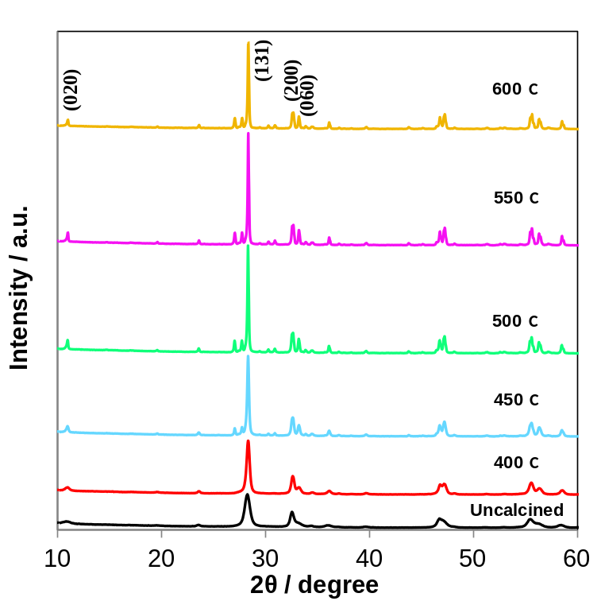
Figure 1. XRD patterns of as-prepared and post-calcined Bi₂MoO₆ at different temperatures.

As Bi₂MoO₆ possesses a deep VB position, it can drive various photo-oxidation reactions. One example is oxygen evolution from water oxidation that is the half-reaction of water splitting. To disclose the correlation between the calcination temperature and photocatalytic performance, we conducted oxygen evolution reactions (OER). The amount of oxygen (O₂) produced is shown in Figure 2. Under visible light irradiation, no O₂ was detected for the as-synthesized, uncalcined Bi₂MoO₆. In contrast, all calcined samples generated O₂ after half hour for light exposure and the amount of O₂ increased with longer illumination times. After 3 h, the samples calcined at 400 ℃ produced ~10.3 μmol of O₂, while the sample calcined at 550 ℃ showed the best performance, generating ~23.5 μmol of O₂. To confirm the reproducibility of the experiment, the OER reaction was repeated three times for each sample (Figure S2). Similar to Figure 2, the uncalcined Bi₂MoO₆ again generated trace amount of O₂, while the calcined samples exhibited significant O₂ evolution. The stability of the calcined Bi₂MoO₆ samples was examined using XRD technique. As shown in Figure S3, the crystal structures of Bi₂MoO₆ particles remained intact after the photocatalytic OER experiment. A new peak at 38.5° can be assigned to the (111) facet of metallic Ag, which is originated from the photoreduction of the AgNO₃ electron acceptor used in the reaction.
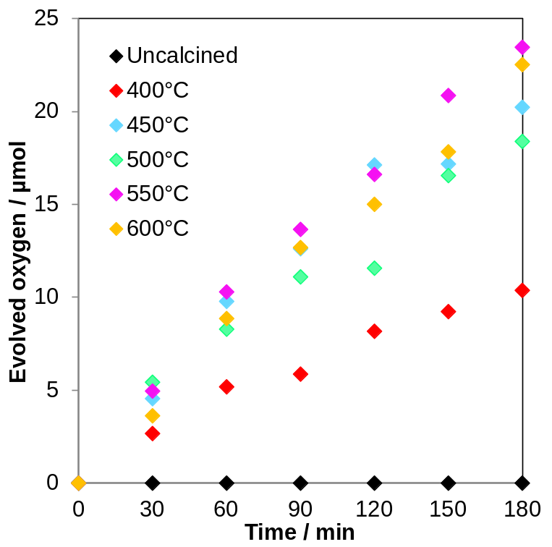
Figure 2. Photocatalytic oxygen evolution of as-prepared Bi₂MoO₆ calcined at different temperatures under visible light irradiation (λ ≥ 420 nm).

To gain insights into how calcination temperature affects the variation in photocatalytic activity enhancement of Bi₂MnO₆, diverse characterization techniques were employed to compare the physicochemical, optical, and electronic properties of the Bi₂MoO₆ samples. Scanning electron microscopy (SEM) was employed to scrutinize the morphological properties. Figure 3a shows that the as-synthesized Bi₂MoO₆ particles obtained via solvothermal method are composed of flower-like spheres with a diameter of ~1.5 μm. These spheres are composed of uniform-thickness nanoplates. At 400 ℃ calcination (Figure 3b), the flower-like shape remains, but the nanoplates become thicker. Increasing the temperature to 450 ℃ (Figure 3c) transforms the nanoplates into nanoparticles, whereby the flower-like morphology disappears and a hollow structure forms. Higher calcination temperatures could significantly increase the particle size (Figure 3d-e) and eventually the polyhedrons aggregate into a hollow structure with well-defined and smooth facets (Figure 3f).
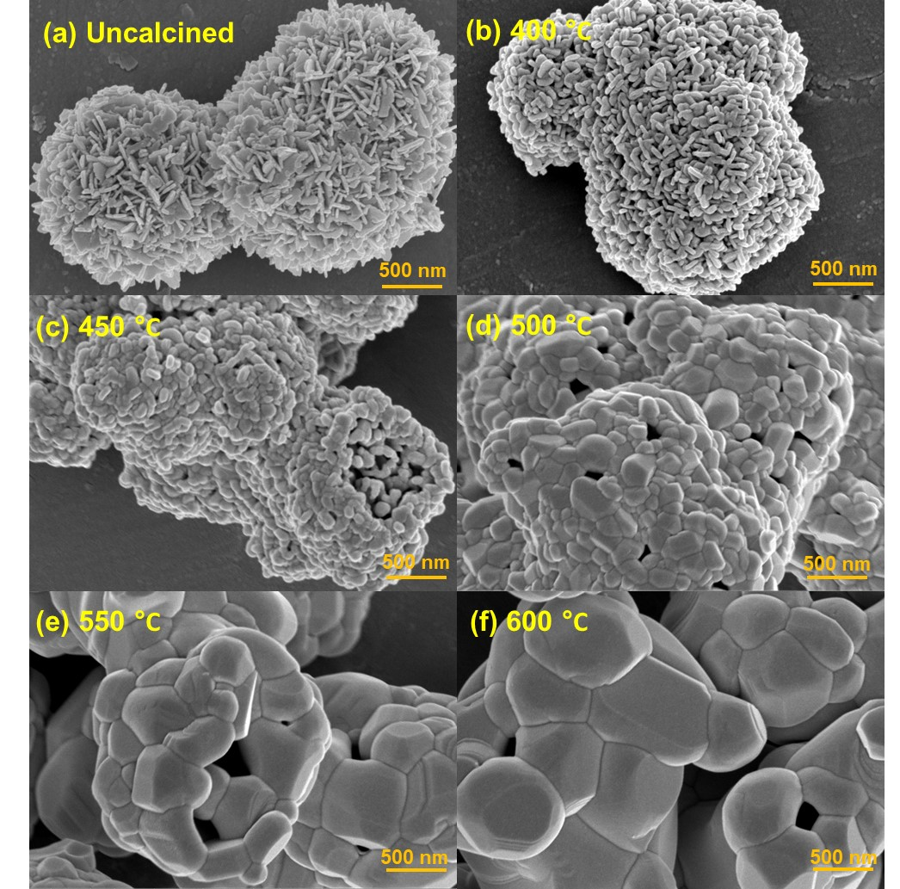
Figure 3. SEM images of as-prepared Bi₂MoO₆ calcined at different temperatures, (a) uncalcined, (b) 400 ℃, (c) 450 ℃, (d) 500 ℃, (e) 550 ℃, and (f) 600 ℃.
UV-Vis DRS was carried out to investigate the optical properties of the samples. As depicted in Figure 4a, all the samples show an absorption edge at ~470 nm. Compared to the uncalcined sample, those calcined at 400 ℃ and 450 ℃ show a blue shift. Conversely, the absorption edge for the higher calcination temperature samples shifts red towards longer wavelengths. Figure 4b shows the corresponding optical band gaps, which are all around 2.7 eV, consistent with the values reported in the literature. Interestingly, the uncalcined Bi₂MoO₆ absorbs more visible light than the 400 ℃ and 450 ℃ samples, despite having negligible photocatalytic activity. This can be explained by the flower-like structure of the uncalcined material. The cross-linked nanoplates hinders light from reaching the active sites within the flower, while the structure itself promotes light refraction. As a result, the absorbed light is not efficiently used to generate the electrons and holes needed for photocatalysis.
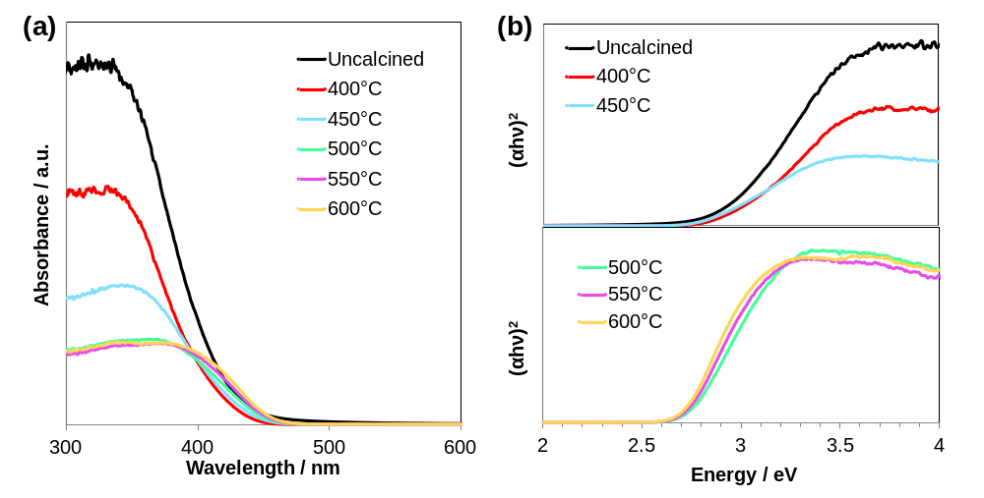
Figure 4. (a) UV-Vis DRS, and (b) derived bandgap energies of as-prepared Bi₂MoO₆ calcined at different temperatures.
Our results so far suggest that calcination temperature affects the crystallinity and morphology of Bi₂MoO₆, which in turn influences the material’s photocatalytic OER performance. We calculated the average crystallite size of the samples using Scherrer equation:
D=Kλ/(βcosθ)
where K is a constant taken as 0.89, λ is the wavelength of X-ray radiation used (1.54 Å), β is FWHM, θ is the diffraction angle. The calculation is based on the most intense diffraction peak at 28.3°, which corresponds to (131) plane of Bi₂MoO₆.
As shown in Table 1, the crystallite size increases gradually with increasing calcination temperature, reaching a maximum size of 81.34 nm at 550 ℃. This sample also exhibits the highest oxygen evolution activity. As larger crystallite size indicates higher crystallinity, the result suggests that higher crystallinity benefits the photocatalytic oxygen evolution of flower-like Bi₂MoO₆. Furthermore, the surface area decreases from 35.23 to 1.11 m²g⁻¹ for the uncalcined and 600 ℃ calcined samples, respectively. This contradicts the general trend where a larger surface area leads to better photocatalytic performance owing to more active sites for reactant adsorption and desorption.
This study suggests that crystallinity is a more critical factor in governing the OER for Bi₂MoO₆. In suspension photocatalytic system, charge separation heavily relies on the thickness of the space charge layer (SCL) – the driving force at the particle/liquid interface to separate photogenerated electron and hole pairs.[24, 25] Large particle with high crystallinity typically possesses a thicker SCL with greater band bending, facilitating more efficient charge separation. Consequently, calcined Bi₂MoO₆ with larger crystallite size outperforms samples with smaller crystallite size. In contrast, the low-crystallized uncalcined Bi₂MoO₆ exhibits negligible SCL and band bending, leading to its poor O₂ evolution activity despite its largest surface area. Additionally, abundant defects within or on the surface of these low crystallized particles serve as electron-hole recombination centers (evidenced by EPR analysis in Figure S4), significantly hindering surface redox reactions. Additionally, previous studies have shown that exposing active facets promotes spatial separation of electron-hole pairs, directing the reduction and oxidation reactions to specific surfaces.[26, 27] In this work, the larger and well-crystalline Bi₂MoO₆ particle possesses well-defined crystal facet, which is conducive to spatially separating electron-hole pairs. Therefore, tour post-calcined Bi₂MoO₆ samples demonstrate enhanced charge separation, ultimately improving photocatalytic O₂ production.
Table 1. The crystallite size and surface area of as-prepared Bi₂MoO₆ calcined at different temperatures.
Calcination temperature  / ℃ | Crystallite size  / nm | Specific surface area  / m²g⁻¹
Uncalcined | 17.60 | 35.23
400 | 34.41 | 15.72
450 | 47.78 | 4.25
500 | 66.91 | 1.38
550 | 81.34 | 1.25
600 | 66.91 | 1.11

Photoluminescence (PL) spectra, shown in Figure 5, further characterize charge separation efficiency. The peak located at 470 nm originates from the band gap emission of Bi₂MoO₆, consistent with the UV-Vis DRS result. Notably, the calcination treatment reduces the peak intensity to some extent, signifying less photogenerated electron-hole recombination. Therefore, the enhanced photocatalytic O₂ evolution performance in this study is primarily ascribed to the improved crystallinity of Bi₂MoO₆ achieved through a simple calcination process.
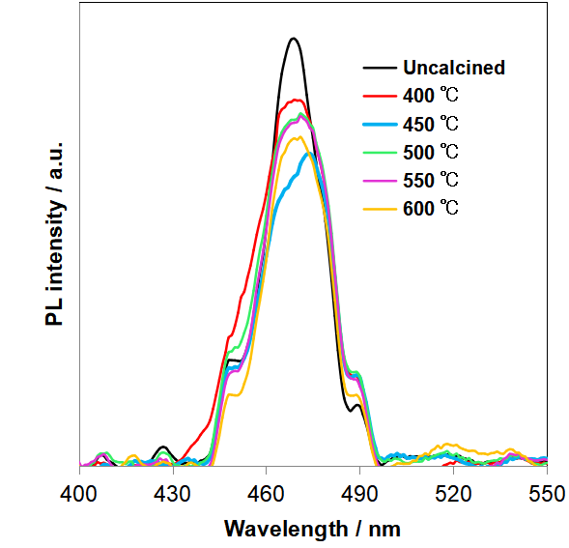
Figure 5. PL spectra of as-prepared Bi₂MoO₆ calcined at different temperatures.

Conclusions
Thermal treatment significantly impacts the photocatalytic oxygen evolution capability of flower-like Bi₂MoO₆. Crystallinity, rather than surface area, emerges as the critical factor governing its performance. Higher calcination temperatures lead to improved crystallinity with larger crystallites, resulting in enhanced oxygen evolution activity. This is attributed to thicker SCL and fewer defects in the well-crystallized particles, promoting efficient charge separation. This work highlights the importance of crystallinity over surface area in tailoring the water oxidation efficiency of Bi₂MoO₆ photocatalyst.

CRediT authorship contribution statement
Xuelian Wu: Conceptualization, Data curation, Writing - original draft. Hui Ling Tan: Formal analysis, Writing - review& editing. Yingge Zhang: Data curation, Formal analysis. Yanyan Huang: Resources, Writing - review& editing. Xiaojiao Yang: Resources, Funding acquisition, Writing - review& editing.

Declaration of competing interest
The authors declare that they have no known competing financial interests or personal relationships that could have appeared to influence the work reported in this paper.

Data availability
Data will be made available on request.

Acknowledgment
This work was financially supported by the Guangdong Basic and Applied Basic Research Foundation (2022A1515011820) and Program of Sichuan Province Science and Technology Project (2020ZDZX0008, 2020YFG0465). The authors also acknowledge the support from Chengdu University (2081924008).

Appendix A. Supporting information
Supplementary data associated with this article can be found in the online version at XXX.

References
[1] H. Yu, L. Jiang, H. Wang, B. Huang, X. Yuan, J. Huang, J. Zhang, G. Zeng, Modulation of Bi₂MoO₆-based materials for photocatalytic water splitting and environmental application: a critical review, Small, 15 (2019) 1901008.
[2] G. Yin, Y. Jia, Y. Lin, C. Zhang, Z. Zhu, Y. Ma, A review on hierarchical Bi₂MoO₆ nanostructures for photocatalysis applications, New J. Chem., 46 (2022) 906-918.
[3] J. Wang, C. Zhao, S. Yuan, X. Li, J. Zhang, X. Hu, H. Lin, Y. Wu, Y. He, One-step fabrication of Cu-doped Bi₂MoO₆ microflower for enhancing performance in photocatalytic nitrogen fixation, J. Colloid Interface Sci., 638 (2023) 427-438.
[4] J. Bi, L. Wu, J. Li, Z. Li, X. Wang, X. Fu, Simple solvothermal routes to synthesize nanocrystalline Bi₂MoO₆ photocatalysts with different morphologies, Acta Mater., 55 (2007) 4699-4705.
[5] X. Wu, Y.H. Ng, W.H. Saputera, X. Wen, Y. Du, S.X. Dou, R. Amal, J. Scott, The dependence of Bi₂MoO₆ photocatalytic water oxidation capability on crystal facet engineering, ChemPhotoChem, 3 (2019) 1246-1253.
[6] Z. Dai, F. Qin, H. Zhao, J. Ding, Y. Liu, R. Chen, Crystal defect engineering of Aurivillius Bi₂MoO₆ by Ce doping for increased reactive species production in photocatalysis, ACS Catal., 6 (2016) 3180-3192.
[7] H. Li, J. Liu, W. Hou, N. Du, R. Zhang, X. Tao, Synthesis and characterization of g-C₃N₄/Bi₂MoO₆ heterojunctions with enhanced visible light photocatalytic activity, Appl. Catal., B, 160-161 (2014) 89-97.
[8] Z. Wang, B. Cheng, L. Zhang, J. Yu, Y. Li, S. Wageh, A.A. Al-Ghamdi, S-Scheme 2D/2D Bi₂MoO₆/BiOI van der Waals heterojunction for CO₂ photoreduction, Chin. J. Catal., 43 (2022) 1657-1666.
[9] S. Wu, B. Yi, D. Lan, Fabrication of Bi₂MoO₆/g-C₃N₄ visible-light driven photocatalyst for enhanced tetracycline degradation, J. Photochem. Photobiol., A, 444 (2023) 115013.
[10] X. Wu, J.N. Hart, X. Wen, L. Wang, Y. Du, S.X. Dou, Y.H. Ng, R. Amal, J. Scott, Improving the photo-oxidative performance of Bi₂MoO₆ by harnessing the synergy between spatial charge separation and rational co-catalyst deposition, ACS Appl. Mater. Interfaces, 10 (2018) 9342-9352.
[11] Z.-Q. Li, X.-T. Chen, Z.-L. Xue, Bi₂MoO₆ Microstructures: controllable synthesis, growth mechanism, and visible-light-driven photocatalytic activities, CrystEngComm, 15 (2013) 498-508.
[12] M. Bellardita, A. Di Paola, B. Megna, L. Palmisano, Determination of the crystallinity of TiO₂ photocatalysts, J. Photochem. Photobiol., A, 367 (2018) 312-320.
[13] M. Inagaki, R. Nonaka, B. Tryba, A.W. Morawski, Dependence of photocatalytic activity of anatase powders on their crystallinity, Chemosphere, 64 (2006) 437-445.
[14] J. Liu, W. Fu, Y. Liao, J. Fan, Q. Xiang, Recent advances in crystalline carbon nitride for photocatalysis, J. Mater. Sci. Technol., 91 (2021) 224-240.
[15] B. Zhao, W. Zhong, F. Chen, P. Wang, C. Bie, H. Yu, High-crystalline g-C₃N₄ photocatalysts: synthesis, structure modulation, and H₂-evolution application, Chin. J. Catal., 52 (2023) 127-143.
[16] H. Liu, J.B. Joo, M. Dahl, L. Fu, Z. Zeng, Y. Yin, Crystallinity control of TiO₂ hollow shells through resin-protected calcination for enhanced photocatalytic activity, Energy Environ. Sci., 8 (2015) 286-296.
[17] H.Y. Chung, X. Wu, R. Amal, Y.H. Ng, Balancing the crystallinity and specific surface area of bismuth tungstate for photocatalytic water oxidation, Mol. Catal., 487 (2020) 110887.
[18] F. Amano, K. Nogami, B. Ohtani, Visible light-responsive bismuth tungstate photocatalysts: effects of hierarchical architecture on photocatalytic activity, J. Phys. Chem. C, 113 (2009) 1536-1542.
[19] L.-L. Liu, F. Chen, J.-H. Wu, J.-J. Chen, H.-Q. Yu, Synergy of crystallinity modulation and intercalation engineering in carbon nitride for boosted H₂O₂ photosynthesis, PNAS, 120 (2023) e2215305120.
[20] T. Jiang, Z. Wang, G. Wei, S. Wu, L. Huang, D. Li, X. Ruan, Y. Liu, C. Jiang, F. Ren, Defective high-crystallinity g-C₃N₄ heterostructures by double-end modulation for photocatalysis, ACS Energy Lett., 9 (2024) 1915-1922.
[21] S. Wang, F. He, Y. Lu, Y. Wu, Y. Zhang, P. Dong, X. Liu, C. Zhao, S. Wang, D. Wang, J. Zhang, S. Wang, Enhancing photocatalytic hydrogen production of carbon nitride: dominant advantage of crystallinity over mass transfer, J. Colloid Interface Sci., 654 (2024) 317-326.
[22] L. Zhang, T. Xu, X. Zhao, Y. Zhu, Controllable synthesis of Bi₂MoO₆ and effect of morphology and variation in local structure on photocatalytic activities, Appl. Catal., B, 98 (2010) 138-146.
[23] H.L. Tan, A. Suyanto, A.T.D. Denko, W.H. Saputera, R. Amal, F.E. Osterloh, Y.H. Ng, Enhancing the photoactivity of faceted BiVO₄ via annealing in oxygen-deficient condition, Part. Part. Syst. Charact., 34 (2017) 1600290.
[24] H.L. Tan, R. Amal, Y.H. Ng, Exploring the different roles of particle size in photoelectrochemical and photocatalytic water oxidation on BiVO₄, ACS Appl. Mater. Interfaces, 8 (2016) 28607-28614.
[25] Z. Zhang, J.T. Yates, Jr., Band bending in semiconductors: chemical and physical consequences at surfaces and interfaces, Chem. Rev., 112 (2012) 5520-5551.
[26] R. Li, H. Han, F. Zhang, D. Wang, C. Li, Highly efficient photocatalysts constructed by rational assembly of dual-cocatalysts separately on different facets of BiVO₄, Energy Environ. Sci., 7 (2014) 1369-1376.
[27] R. Li, F. Zhang, D. Wang, J. Yang, M. Li, J. Zhu, X. Zhou, H. Han, C. Li, Spatial separation of photogenerated electrons and holes among {010} and {110} crystal facets of BiVO₄, Nat. Commun., 4 (2013) 1432.

