Pectin as a Rheology Modifier: Origin, Structure, Commercial Production and Rheology

Siew Yin Chan^{ab}, Wee Sim Choo^{a*}, David James Young^{abc*}, and Xian Jun Loh^{bde*}

ªSchool of Science, Monash University Malaysia, 47500 Bandar Sunway, Selangor Darul Ehsan, Malaysia.
^{b}Institute of Materials Research and Engineering (IMRE), A*STAR, 2 Fusionopolis Way, Innovis, #08-03, Singapore 138634, Singapore.
^{c}Faculty of Science, Health, Education and Engineering, University of the Sunshine Coast, Maroochydore DC, Queensland 4558, Australia.
^{d}Department of Materials Science and Engineering, National University of Singapore, 9 Engineering Drive 1, Singapore 117576, Singapore.
^{e}Singapore Eye Research Institute, 11 Third Hospital Avenue, Singapore 168751, Singapore.

Emails: choo.wee.sim@monash.edu, dyoung1@usc.edu.au, lohxj@imre.a-star.edu.sg

Abstract
Pectins are a diverse family of biopolymers with an anionic polysaccharide backbone of α-1,4-linked ᴅ-galacturonic acids in common. They have been widely used as emulsifiers, gelling agents, glazing agents, stabilizers, and/or thickeners in food, pharmaceutical, personal care and polymer products. Commercial pectin is classified as high methoxy pectin (HMP) with a degree of methylation (DM) >50% and low methoxy pectin (LMP) with a DM <50%. Amidated low methoxy pectins (ALMP) can be obtained through aminolysis of HMP. HMP gels by cross-linking through hydrogen bonds and hydrophobic forces between the methyl groups, assisted by a high co-solute concentration and low pH. In contrast, LMP gels by forming ionic linkages via calcium bridges between two carboxyl groups from two different chains in close proximity, known as the ‘egg-box’ model. Pectin gels exhibit Newtonian behaviour at low shear rates and shear-thinning behaviour when the shear rate is increased. An overview of pectin from its origin to its physicochemical properties is presented in this review.

1.0 Introduction
Production of pectin originated in the 1900s in Germany when an apple juice manufacturer tried to cook dried apple pomace, the by-product from apple juice processing (Ciriminna, Chavarría-Hernández, Inés Rodríguez Hernández, & Pagliaro, 2015). Pectin was thereafter marketed as a gelling agent. It is a hydrocolloid capable of forming networks to trap water and forming gels at low concentrations (<1%) (Abid et al., 2017; S. Chan, Choo, Young, & Loh, 2016; Liang et al., 2012; Ptitchkina, Danilova, Doxastakis, Kasapis, & Morris, 1994; Lúcia C. Vriesmann & Petkowicz, 2013). The prolonged commercial success of pectin has shown the importance of using fruit by-products as raw materials to produce value-added products. New application opportunities continue to emerge and pectin is no longer just a gelling agent but also used as a stabiliser and thickener (Brejnholt, 2009). Pectin is seen as an attractive investment and has been industrialized by companies such as CP Kelco, Cargill, Calleva, DSM Yantai Andre Pectin, Dupont, FMC Biopolymers, Herbstreith & Fox, etc and contributes significantly to the global market of hydrocolloids with an estimated $850 million worth of pectin sold in 2013 (Bomgardner, 2013). This market is expected to continue growing at a rate of 5-6% per year (Bomgardner, 2013). Today, the food applications of pectin are diverse from beverage (Nakamura, Yoshida, Maeda, & Corredig, 2006; Zulueta, Esteve, Frasquet, & Frígola, 2007), confectionery (Basu & Shivhare, 2010), dairy (Joudaki et al., 2013) to meat processing (Pereira, Marques, Hatano, & Castro, 2010). Pectin has also attracted substantial attention from the pharmaceutical (Günter & Popeyko, 2016), cosmetic (Lupi et al., 2014), and polymer (da Costa, de Mello Ferreira, & de Macedo Cruz, 2016) industries.
Rheology is the study of the deformation and flow of matter. It defines the relationship between strain, stress and time. Strain is the change in shape or length of the sample while stress is the force per unit area producing the change in shape. When subjected to external forces, solids (or truly elastic materials) will deform, whereas liquids (or truly viscous materials) will flow. Contemporary rheology also involves investigating the behaviour of real materials with properties intermediate between those of ideal solids and ideal liquids. A rheology modifier is a material that alters the rheology of a fluid composition to which it is added; and thus, it plays an essential role in achieving desirable flow characteristics (Braun & Rosen, 2000). Most products in food, pharmaceutical, personal care or household applications contain rheology modifiers to achieve appropriate application characteristics. In this review, we highlight pectin as a rheology modifier.
Pectin is characterized as an emulsifier, gelling agent, glazing agent, stabilizer, and/or thickener in commercial applications (Codex Alimentarius, 2015). All of these functional terms are in fact subsets of the term “rheology modifier”. Pectin is a rheology modifier that thickens many food matrices; conversely, it can also decrease the viscosity of a system (Rojas, Rosell, & Benedito de Barber, 1999; Shi & BeMiller, 2002). Herein we provide an overview of pectin in terms of origin, structures, commercial production and most importantly, rheological properties.

2.0 Occurrence of Pectin
Pectin was first discovered in apple juice by Vauquelin (1790) and named by Henri Braconnot (1825), borrowing from the Greek word pektikos which means to congeal or solidify. Since then, pectin has been studied extensively by scientists from different branches of science. Chemically, pectin is defined as an anionic polysaccharide made up largely by covalently linked α-1,4-linked ᴅ-galacturonic acid (also known galactosyluronic acid) (GalA) units (Figure 1A). It derives naturally from plants, in which pectin makes up approximately one third of the cell walls in dicotyledonous and some monocotyledonous plants (H Braconnot, 1825). Pectin can also be found in small proportions of cell walls in grasses (2-10%) and wood tissue (5%) (A. J. Voragen, Coenen, Verhoef, & Schols, 2009).

A

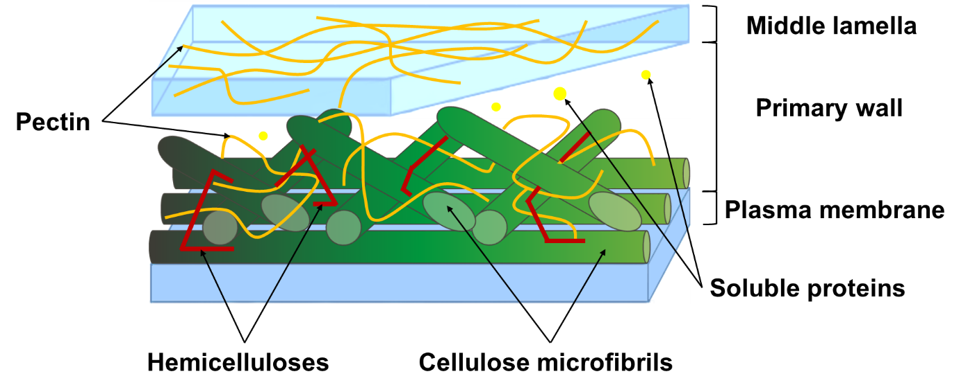
B

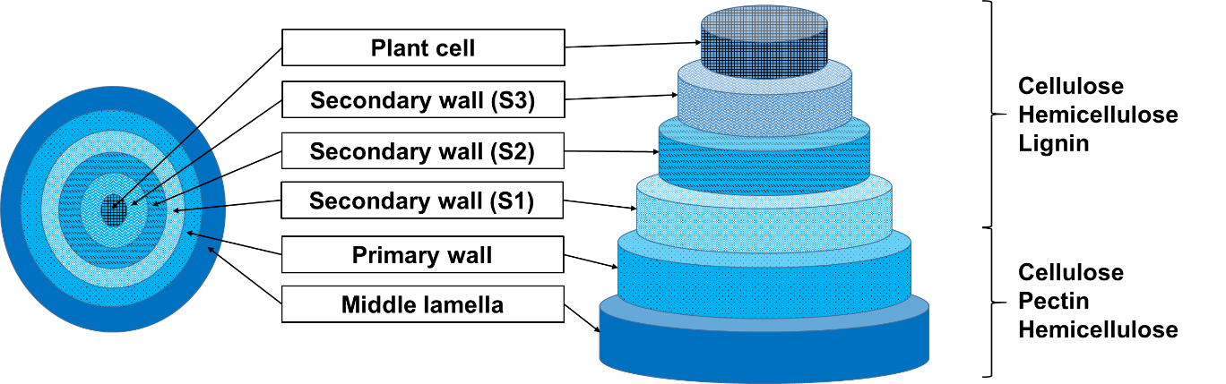
C
Figure 1. [A] Pectin with covalently α-1,4-linked ᴅ-galacturonic acid (GalA) units, [B] The structure of cell wall. Pectins are often associated with other cell wall components such as cellulose or hemicellulose in plant tissues; and [C] Pectins are most abundant in middle lamella and primary cell walls, and greatly decreased or are absent in secondary cell walls towards the plasma membrane (Sticklen, 2008).

Pectin in plant tissues is associated with other cell wall components, such as celluloses or hemicelluloses; playing important roles in plant growth and development (Ferrari et al., 2013; Rao & Silva, 2006) (Figure 1B). Pectin is a common component of young tissues, fruits and vegetables (de Assis, Lima, & de Faria Oliveira, 2001). In general, it is most abundant in the middle lamella layers between adjoining plant cells (Mellerowicz & Sundberg, 2008). This is followed by the primary cell walls of plants which also contain fairly high amount of pectin (Cosgrove & Jarvis, 2012). The amount of pectin is greatly decreased or even absent beginning from the secondary cell walls of plants towards the plasma membranes of plant cells (W. T. Willats, McCartney, Mackie, & Knox, 2001) (Figure 1C).
Biologically, pectin has specific functions depending on its location and molecular structure. Pectin can function as a gel and thereby assisting with cell adhesion and softening cell walls for cell elongation (Parre & Geitmann, 2005; Suárez et al., 2013; W. T. Willats et al., 2001). This polysaccharide lends strength and support to plants by maintaining cell consistency and mechanical resistance (A. J. Voragen et al., 2009). Additionally, pectin influences various cell wall properties such as porosity, surface charge, pH, and ion balance by forming networks and trapping solute molecules that enable ion transportation (Harholt, Suttangkakul, & Vibe Scheller, 2010; A. J. Voragen et al., 2009). Pectin also activates plant defenses by stimulating the accumulation of phytoalexins which have a wide spectrum of anti-microbial activity (Benedetti et al., 2015; Hahn, Darvill, & Albersheim, 1981). In addition, pectin oligosaccharides induce accumulation of protease inhibitors in plant tissues as wound response (Bishop, Makus, Pearce, & Ryan, 1981; Ferrari et al., 2013) and also lignification (Matsunaga et al., 2004; Robertsen, 1986; Xiao & Anderson, 2013).

3.0 Chemical Structure of Pectin
Although it has been more than 210 years since the discovery of pectins, their chemical and structural properties are still the subject of investigation due to the inhomogeneity of this polymer family. To begin with basic structure, pectin is assembled by at least 17 different monosaccharides, of which GalA (Figure 2Ai) is the most plentiful, followed by L-arabinose, ᴅ-galactose, L-rhamnose and others (Kaya, Sousa, Crépeau, Sørensen, & Ralet, 2014). These monosaccharides can be interconnected through 20 different linkages (Kaya et al., 2014). Within GalA monomers, the carboxylic groups or hydroxyls may be methyl-esterified (Figure 2Aii) and/or O-acetyl-esterified (Figure 2Aiii), respectively. O-acetyl-esterification occurs predominantly at the O-3 position and occasionally at the O-2 position.

A

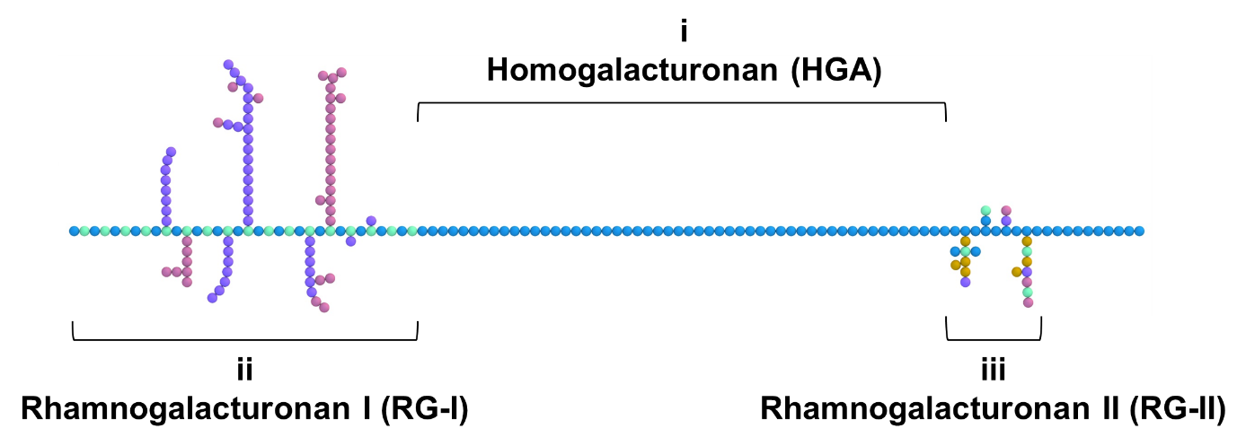
B

Figure 2. [A] Forms of galacturonic acids (GalA) found in pectin: (i) GalA, (ii) Methylated GalA and (iii) O-Acetylated GalA; and [B] Pectin chain comprising of covalently linked (i) homogalacturonan (HGA), (ii) rhamnogalacturonan I (RG-I) and (iii) rhamnogalacturonan II (RG-II). The diagram shown here is intended only to illustrate some of the major domains found in most pectins rather than indicate definitive structures.

Native pectins in plants are composed of polysaccharide domains: homogalacturonan (HGA), rhamnogalacturonan I (RG-I), rhamnogalacturonan II (RG-II), xylogalacturonan, and apiogalacturonan. The latter three have been classified as substituted HGA (Caffall & Mohnen, 2009; Harholt et al., 2010; Beda M. Yapo, 2011a). The deposition and the way in which these domains are joined to one another is still a matter of debate. Currently, it is thought that the polysaccharide domains are covalently linked, and to a greater or lesser extent, ionically cross-linked with other pectin strands to form pectic networks that branch throughout the primary cell walls (Figure 2B) (Harholt et al., 2010; W. T. Willats, McCartney, & Knox, 2003). There are three models proposed: (a) the pectin backbone consists of alternating HGA and RGI domains (Schols & Voragen, 1996); (b) the pectin backbone comprises RGI domain with HG being linked as its side chain (Vincken et al., 2003); and (c) the pectin backbone is composed of alternating, perpendicularly linked-HGA strands and a RGI domain (Beda M. Yapo, 2011a).

3.1 Homogalacturonan (HGA)
HGA is a linear homopolymer of α-1,4-linked GalA and is known as the “smooth region” (Figure 2Bi). It is an abundant and widespread domain of pectin, accounting for approximately 60-65% of total pectin amount (A. J. Voragen et al., 2009). HGA appears to be synthesized in the Golgi apparatus and then transferred to the middle lamella and primary cell walls (W. T. Willats et al., 2001). It is then deposited in a form that has 70-80% of GalA units methyl-esterified and could be O-acetyl-esterified at O-2 or O-3 (Mohnen, 2008; O'Neill, Albersheim, & Darvill, 1990). The amount of GalA units present in a HGA chain is estimated to be around 100-200 units, however, this range could be an underestimate (Bonnin, Dolo, Le Goff, & Thibault, 2002). The smooth region can sometimes be joined by one or two α-1,2-linked l-rhamnopyranose units and most of the pectins have this structure. In addition, GalA units may be substituted at the C-2 or C-3 positions with residues of xylose or apiose, producing domains known as xylogalacturonan or apiogalacturonan, respectively (Ovodov, 2009). These biosynthetic modifications alter the functional properties of the HGA domain.

3.2 Rhamnogalacturonan I (RG-I)
RG-I consists of up to 100 or more repeating units of the disaccharide α-1,2-linked-l-rhamnose-α-1,4-d-GalA (Figure 2Bii). The rhamnose residues account for > 30% of a pectin (Catherine M. G. C. Renard, Crépeau, & Thibault, 1995). Within these rhamnose residues, 50-78% is estimated to be RGI (Catherine M. G. C. Renard et al., 1995). The GalA residues of RG-I are not methyl-esterified; however, the GalA residues of RG-I could be O-acetyl-esterified (Caffall & Mohnen, 2009). In most cases, 20-80% of rhamnose residues in this domain are substituted at the C-4 position with neutral sugar side chains (Mohnen, 2008). Attachment of neutral sugar side chains to the C-2, C-3 and/or C-4 positions of rhamnose residues is also possible. The neutral sugars side chains are predominantly galactose and arabinose, forming galactan, arabinan and arabinogalactans. Other sugars such as glucose, mannose, fucose, xylose, and glucuronic acid are found covalently linked to the backbones as side chains. The composition and size of neutral sugar side chains can be a single glycosyl residue up to 50 or more, resulting in a large and highly variable family of polysaccharides with a range of glycosidic linkages (A. J. Voragen et al., 2009). The highly branched nature of RG-I has led to the name “hairy region”.

3.3 Rhamnogalacturonan II (RG-II)
RG-II is not structurally related to RG-I, despite their names running in sequence and the fact that it is also included in the hairy region (Figure 2Biii). It is a branched pectic domain containing a HGA backbone. RG-II is highly compact and composed of a homopolymer of around nine α-1,4-linked GalA units (of which some are methyl-esterified) and to which four structurally different polymeric side chains of are substituted. These side chains contain eleven rare sugars including apiose, 2-O-methyl-l-fucose, 2-O-methyl-d-xylose, 3-C-carboxy-5-deoxy-l-xylose (aceric acid), 3-deoxy-d-manno-octulosonic acid and 3-deoxy-d-lyxoheptulosaric acid (Beda M. Yapo, 2011b). A fascinating feature of RG-II is that it appears to be the only major pectic domain that does not have significant structural diversity or modulation of its fine structure. It is thought that the ends of RG-II are linked glycosidically to the HGA domains (Beda M. Yapo, 2011a). It is a highly conserved and widespread domain isolated from cell walls by endopolygalacturonase cleavage, indicating its covalent attachment to HGA. Interestingly, RG-II crosslinks two pectin molecules (apiosyl residues) within the cell wall by borate ester links.

3.4 Analytical Tools for Pectin Macromolecules
There are multiple analytical tools capable of exploring the fine structures and functionalities of the pectin macromolecule such as Fourier transform infrared spectroscopy (FT-IR) (Coimbra, Barros, Barros, Rutledge, & Delgadillo, 1998), FT-Raman spectroscopy (Bichara et al., 2016), gas chromatography (GC) (Huisman, Oosterveld, & Schols, 2004; Walter & Sherman, 1983), high performance liquid chromatography (HPLC) (Levigne, Ralet, & Thibault, 2002; A. G. J. Voragen, Schols, & Pilnik, 1986), gas chromatography mass spectroscopy (GC-MS) (Brett J. Savary & Nuñez, 2003), electrospray-ionization mass spectroscopy (ESIMS) (Ishii, Ichita, Matsue, Ono, & Maeda, 2002), ion-exchange chromatography (IEC) (Bonnin et al., 2002; Kravtchenko, Voragen, & Pilnik, 1992b; Ralet, Bonnin, & Thibault, 2001), polysaccharide analysis using carbohydrate gel electrophoresis (PACE) (Goubet, Ström, Dupree, & Williams, 2005), capillary electrophoresis (CE) (Ström, Ralet, Thibault, & Williams, 2005; Zhong, Williams, Goodall, & Hansen, 1998) and nuclear magnetic resonance (NMR) spectroscopy (Cardoso, Silva, & Coimbra, 2002). Combinations of these methods with enzymatic fingerprinting is a powerful suite to elucidate the complex structure of pectin (Daas, Arisz, Schols, De Ruiter, & Voragen, 1998; Daas, Meyer-Hansen, Schols, De Ruiter, & Voragen, 1999; Daas, Voragen, & Schols, 2000; Limberg et al., 2000). Pectin is an extremely complex and structurally diverse group of polymers. The chemical structure of pectin varies between plants, tissues and even within a cell wall (W. G. T. Willats, Knox, & Mikkelsen, 2006). Although considerable research has been devoted to its chemical structure, there is much to be done to correlate the functionalities and interactions of each division of pectin to its unique biomechanical properties. This requires thoughtful planning and the application of new analytical tools.

4.0 Sources of Pectin
In spite of its availability in a large number of plant species, commercial sources of pectin are limited. Historically, apple pomace has been the major source, but there has been an increasing use of citrus peel in recent years (Brejnholt, 2009). Today, commercially available pectin are mostly extracted from citrus peel (85.5%), followed by apple pomace (14.0%) and to a smaller extent, sugar beet pulp (0.5%) (Ciriminna et al., 2015; Staunstrup, 2009). Citrus peel and apple pomace are available in copious amounts as remainders from juice and essential oil production (Masmoudi et al., 2008; Nussinovitch & Hirashima, 2013; Shalini & Gupta, 2010), while sugar beet pulp is obtained from the sugar industry (B. M. Yapo, Robert, Etienne, Wathelet, & Paquot, 2007). Other feasible sources are shown in Table 1. Different plant species have different pectin content and the pectins extracted from each plant species have different physicochemical properties.

Table 1. Pectin content (%) of commercial and other feasible raw materials used for pectin production.
Raw Materials Producing Pectins |  | Pectin Content (%) | References
Commercial Sources
Apple pomace |  | 4.60-20.92 | Canteri-Schemin, Fertonani, Waszczynskyj, and Wosiacki (2005); Bockki Min et al. (2011)
Citrus peel | Orange peel | 10.90-24.80 | Kaya et al. (2014); B. B. Koubala et al. (2008); Venzon et al. (2015)
Citrus peel | Grapefruit peel | 21.60-28.00
Citrus peel | Lemon peel | 20.90-30.60
Citrus peel | Lime peel | 9.00-33.60
Sugar beet pulp |  | 4.10-24.96 | Lv, Wang, Wang, Li, and Adhikari (2013); B. M. Yapo et al. (2007)
Other Feasible Sources
Banana peels |  | 2.40-21.70 | Happi Emaga, Ronkart, Robert, Wathelet, and Paquot (2008); Oliveira et al. (2015)
Carrots (rejected) |  | 8.70-9.10 | Christiaens et al. (2015)
Carrot peels (steamed) |  | 8.90-9.10 | Christiaens et al. (2015)
Celeriac peels (steamed) |  | 15.40-16.40 | Christiaens et al. (2015)
Cocoa husks |  | 3.38-12.60 | S.-Y. Chan and Choo (2013); Lúcia Cristina Vriesmann, de Mello Castanho Amboni, and de Oliveira Petkowicz (2011)
Creeping fig seeds |  | 5.25-6.07 | Liang et al. (2012)
Dragon fruit peel |  | 5.60-26.38 | Muhammad, Mohd. Zahari, Gannasin, Mohd. Adzahan, and Bakar (2014)
Durian rind |  | 2.10-10.30 | Wai, Alkarkhi, and Easa (2010)
Faba bean hulls |  | 9.57-15.75 | Korish (2015)
Green beans cutting waste |  | 8.10-8.30 | Christiaens et al. (2015)
Jackfruit peel |  | 8.94-15.19 | Begum, Aziz, Uddin, and Yusof (2014)
Leek cutting waste |  | 10.60-11.00 | Christiaens et al. (2015)
Mangosteen rind |  | 12.00-12.40 | Gan and Latiff (2011)
Mango peel |  | 9.20-31.80 | B. B. Koubala et al. (2008)
Passion fruit rind |  | 2.25-30.30 | Liew, Chin, and Yusof (2014); Seixas et al. (2014)
Papaya peel |  | 11.11-49.83 | Benoît B. Koubala, Christiaens, Kansci, Van Loey, and Hendrickx (2014)
Pomelo peel |  | 8.32-27.63 | Methacanon, Krongsin, and Gamonpilas (2014)
Plum pomace |  | 3.80-21.30 | Kosmala et al. (2013)
Rapeseed cake |  | 1.80-6.20 | Jeong et al. (2013)
Sisal waste |  | 4.61-19.20 | Santos, Espeleta, Branco, and de Assis (2013)
Sunflower head |  | 7.40-11.60 | Iglesias and Lozano (2004)
Tomato peel |  | 14.90-83.50 | Grassino, Halambek, et al. (2016); Namir, Siliha, and Ramadan (2015)
Watermelon rind |  | 13.01-25.79 | Prakash Maran, Sivakumar, Thirugnanasambandham, and Sridhar (2014)

5.0 Safety status and classification of pectins
The Joint FAO/WHO Expert Committee on Food Additives (JECFA) has recommended pectin (Codex Alimentarius No. 440) as a safe additive with no limit on acceptable daily intake. Pectin is not digested by humans as there are no enzymes in vivo that are able to degrade the molecule (HansUlrich & Frank, 2012). However, certain bacteria of the gut flora such as Bacteroides, Bifidobacterium, Clostridium, Erwinia, Escherichia, and Eubacterium strains are able to use pectin as substrates for fermentation (Dongowski, Lorenz, & Anger, 2000; HansUlrich & Frank, 2012). Pectin is quite stable under the acidic condition of the stomach, although a slight de-esterification can occur. Without the fermentation process, pectin would pass almost unchanged through the digestive system. Increasing consumer awareness of a healthy lifestyle and the emerging trend to produce functional food have made pectin popular. It has been reported that pectin has numerous positive influences on health (Endress, 1991) including improving colonic health (Byungjick Min et al., 2015), lowering of cholesterol and serum glucose levels (Jones et al., 2015; Zhu et al., 2015), reducing cancer propensity (Concha, Weinstein, & Zúñiga, 2013; Xin Wang, Chen, & Lü, 2014), and stimulating the immune response (Bernard et al., 2015).
Commercial pectin is very heterogeneous. The degree of methyl-esterification (also known as degree of methylation) (DM) of GalA units is used to classify pectin (Deuel, 1943). DM is a percentage which expresses the molar ratio of methyl-esters present to GalA units (includes both free GalA and substituted GalA). It is the major parameter affecting gelling, influencing surface tension and emulsion formation (Müller-Maatsch, Caligiani, Tedeschi, Elst, & Sforza, 2014). There are two types of pectin classified according to DM: low methoxy pectin (LMP) and high methoxy pectin (HMP). HMP forms gels in high co-solute concentration (55-75%) and acidic (pH 2.50-3.50) systems (D. Oakenfull & Scott, 1984) while LMP forms gels in the presence of cations over a broad pH range(M. J. Gidley, Morris, Murray, Powell, & Rees, 1980; Hoefler, 1991). Aside from the typical LMP and HMP, there is another type of commercial pectin, viz amidated low methoxy pectin (ALMP). ALMP is obtained from ammonia de-esterification of HMP (Figure 3A). The difference between LMP and ALMP is that there are primary amide groups in the chemical structure, replacing methyl-ester groups on carboxyl groups in HMP. Degree of amidation (DAm) is a percentage which expresses the molar ratio of primary amide group present to GalA units (including both free GalA and substituted GalA). Most commercial ALMP contains a DAm of 15-25.

A

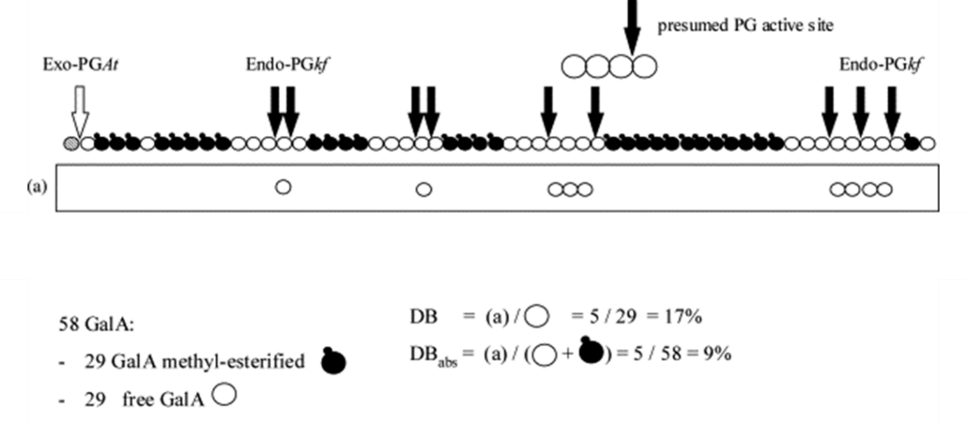
B

C

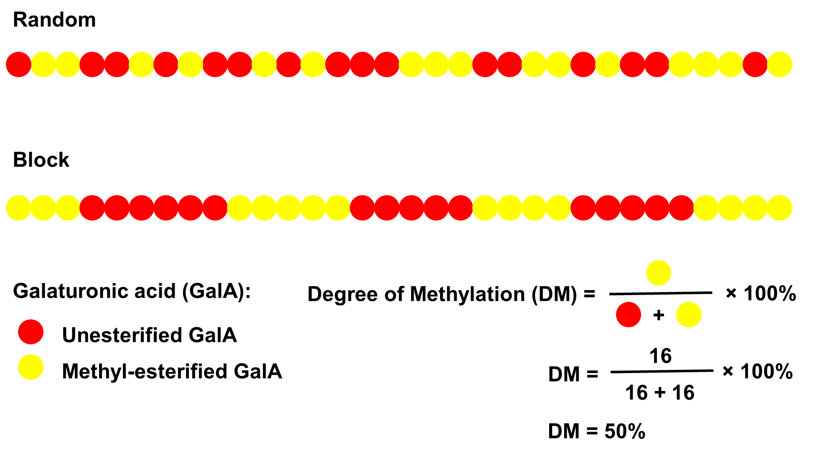
D
Figure 3. [A] Ammonia de-esterification of pectin, yielding amidated low methoxy pectin (ALMP); [B] Schematic diagram of enzymatic digestion on a 50% degree of methylation (DM) pectin with endopolygalacturonase from Kluyveromyces fragilis (endo-PGkf) and exopolygalacturonase from Aspergillus tubingensis (exo-PGAt). The black and white arrows symbolize the action of endo-PGkf and exo-PGAt, respectively. Oligomers released by endo-PGkf are indicated as (a). The degree of blockiness (DB) and absolute degree of blockiness (DB_{abs}) are calculated as illustrated. Figure adapted from Guillotin et al. (2005); [C] β-elimination cleavage of glycosidic bond near the presence of a methyl group at C6, leading to formation of a double bond between C4 and C5 in the galacturonic acid (GalA) unit; and [D] Random and block distribution of GalA units (either unesterified or methyl-esterified) in pectin with 50% DM.

Deuel (1943) also proposed calculating the degree of acetyl-esterification (DA). DA is a percentage which expresses the molar ratio of acetyl-esters present to GalA units (includes both free GalA and substituted GalA). DA is also an important determinant of gelling capacity of pectin; however, it is not as significant as DM in commercial pectin classification. Recently, another popular way to classify pectin has been developed, the degree of blockiness (DB). Daas et al. (1999) introduced DB as a percentage expressing the total amount of non-esterified mono-, di- and tri- GalA liberated from degradation of pectin by endopolygalacturonase relative to the total amount of non-esterified GalA present in the pectin. Through DB, the pattern of methyl-esterification can be known. Moreover, the pattern of methyl-esterification can radically alter gel formation and the properties of the gels formed. Guillotin et al. (2005) have further introduced the expression “absolute degree of blockiness” (DB_{abs}), which takes the original total GalA units (includes both free GalA and substituted GalA) into account. DB_{abs} is defined as the amount of non-esterified mono-, di- and tri- GalA liberated from degradation of pectin by endopolygalacturonase relative to the total amount of GalA present in the pectin (Figure 3B).

6.0 Extraction and Purification of pectin
Pectin can be extracted via water, buffers, chelating agents, acids, and/or bases. When used successively in the above-mentioned order (from water to bases), these different chemical agents may selectively extract pectin with different solubility from the same starting material (Beda M. Yapo, 2009). This selectivity, however, is less evident when the extraction does not occur in the above sequence, especially when acid is used first or when these agents are used individually to extract pectin from the same starting materials (Beda M. Yapo, 2009). Acids are generally the highest yielding extracting agents (Beda M. Yapo, 2009). Another advantage of using acid extraction is that the pectin obtained are usually enriched with GalA units (Rao & Silva, 2006).
On a commercial scale, mineral acids are used to extract pectin. Mineral acids are cheaper and more efficient in terms of production yield. Commonly used minerals acids include hydrochloric acid, nitric acid and sulphuric acid (Fishman, Chau, Hoagland, & Hotchkiss, 2006; Iglesias & Lozano, 2004; Mesbahi, Jamalian, & Farahnaky, 2005; Pagán, Ibarz, Llorca, Pagán, & Barbosa-Cánovas, 2001; Rao & Silva, 2006). Pretreatment such as washing, blanching, or drying increase the stability of raw materials during transportation and storage. These processes inactivate enzymes such as pectin methyl-esterase (PME) and bacteria that would otherwise rapidly degrade pectin. To prevent fermentation, peels are dried to 10-12% moisture level. The fresh or dried raw materials are then extracted in demineralized water that has been acidified to pH 1.5-3.0 at 50-100 °C for approximately three hours (Nussinovitch & Hirashima, 2013). The extract containing pectin is separated from the raw materials by filtration or centrifugation. Polyvalent cations such as aluminum or copper salts are also used to precipitate pectin. These metal ions are then removed by acidified alcohol washes, followed by a wash in alkaline alcohol to neutralize the product. The precipitates obtained are washed with alcohol again and pressed dry. Pectin can be further de-esterified in an alcohol suspension. The final steps involve drying and milling to yield powdered pectin, followed by blending with different production batches to standardize structure and functionality. Dilution with sucrose or dextrose may be used to standardize performance (May, 1990).

6.1 De-esterification of Pectin
Pectin obtained from industrial production is mostly HMP. LMP does occur naturally in plants but is usually obtained from HMP by acid, alkaline and/or enzymatic de-esterification. One of the most common industrial methods to de-esterify HMP to produce LMP is alkaline de-esterification by ammonia in alcohol at relatively low temperatures (Figure 3B). Others reagents used for aminolysis include hydroxylamine and other ammonia derivatives (Racape, Thibault, Reitsma, & Pilnik, 1989). The benefits of using ALMP include the production of relatively high pectin molecular weights. In this heterogeneous system, the methyl-esterified GalA residues undergo saponification at a slower rate than with sodium hydroxide in water at the same pH. As the time of reaction increases, the DM decreases, DAm increases and the GalA content remains constant (C. M. G. C. Renard & Thibault, 1996). The neutral sugar composition and number of side chains remain constant (Reitsma, Thibault, & Pilnik, 1986). The molecular weight of ALMPs do not change drastically relative to the initial HMP used, suggesting that the reaction does not lead to drastic de-polymerization under these conditions (Anger & Dongowski, 1988).
Acid de-esterification is achieved by using strong inorganic acids such as hydrochloric acid. Alkaline de-esterification is usually performed using sodium hydroxide. However, there are two disadvantages of these methods that could lead to pectin degradation, viz hydrolysis and β-elimination. Hydrolysis is a pH-dependent reaction and it occurs mainly under acidic conditions; (Krall & McFeeters, 1998; Smidsrød, Haug, & Larsen, 1966). Acid hydrolysis involves the removal of “ballast” which includes neutral polysaccharides and to a lesser extent, proteins and phenolic compounds (Constenla & Lozano, 2003; Kravtchenko, Berth, Voragen, & Pilnik, 1992; Kravtchenko, Voragen, & Pilnik, 1992a; Kravtchenko, Voragen, et al., 1992b). By comparison, β-elimination involves cleavage of glycosidic bonds, leading to formation of a double bond between C4 and C5 in the GalA units (BeMiller, 1986; Keijbets & Pilnik, 1974) (Figure 3C).
The rate of reaction of acid hydrolysis increases as pH decreases. The pH of plant cell walls generally ranges between 4-6 (Brett & Waldron, 1990). Fraeye et al. (2007) found that acid hydrolysis at this pH range is negligible. The lower the DM, the faster pectin is hydrolyzed, probably due to a lower amount of methyl-esterified target groups. This in turn influences gel strength, leading to the formation of a weaker gel. However, at controlled or reduced temperatures, there is a higher possibility that LMP will be obtained without extensive main-chain breakdown (Rao & Silva, 2006).
Unlike acid hydrolysis, β-elimination is more temperature dependent than it is pH dependent. A kinetic study by Kravtchenko, Arnould, Voragen, and Pilnik (1992) revealed that any increase in temperature increases the rate of β-elimination reaction. It was reported that the activation energies of β-elimination are similar at pH values ranging from 4.5 to 11.0. However, this mechanism occurs extensively and rapidly under alkaline conditions, or even at near neutral pH (Rao & Silva, 2006; Taylor, 1982). It can occur at weak acidic pH but the reaction rate is very low. There is a prerequisite for β-elimination to occur, which is the presence of a methyl group at C6 (Keijbets & Pilnik, 1974). As DM decreases, the reaction rate of β-elimination decreases.
Enzyme de-esterification has becoming increasingly popular for obtaining LMP in an efficient and environmentally sustainable manner. Most importantly, enzyme de-esterification is capable of producing random or block distribution of unesterified GalA units (Denès, Baron, Renard, Péan, & Drilleau, 2000; B. J. Savary, Hotchkiss, Fishman, Cameron, & Shatters, 2003) (Figure 3D). One of the most commonly used enzymes for enzyme de-esterification is pectin methyl-esterase (PME). There are two mechanisms proposed for enzyme de-esterification of pectin using PME: single-chain reaction of the enzyme acts to produce a block pattern of carboxylates by moving along linearly on a single pectin chain while multiple-attack involves multiple attachments of the enzyme, producing shorter blocks of de-esterified pectin (Hotchkiss et al., 2002; Limberg et al., 2000).
Rapid-setting HMP is usually obtained after a short extraction time at temperatures close to boiling. This is due to short extraction times with high temperature reduces de-esterification. Conversely, long extraction times with low temperature favors de-esterification to produce slow-setting HMP or even LMP (Nussinovitch & Hirashima, 2013). Therefore, it is important to select suitable extraction conditions to obtain pectin with the desired properties (S.-Y. Chan & Choo, 2013).

6.2 Other Feasible Extraction Additives and Methods
Recent reports suggest that there is a potential for organic acids such as acetic, citric, lactic, malic and tartaric acid to be employed in pectin extraction (S.-Y. Chan & Choo, 2013; Jamsazzadeh Kermani et al., 2014; B. M. Yapo, 2009). S.-Y. Chan and Choo (2013), Kumar and Chauhan (2010) found that organic acids can achieve higher yields of pectin compared to conventional inorganic acids. Enzymes can also be used in isolation or employed as an additive to give higher production yield or better quality. Wikiera, Mika, Starzyńska-Janiszewska, and Stodolak (2015) have demonstrated that multicatalytic enzymatic preparation Celluclast 1.5L is efficient for pectin extraction from apple pomace, comparable to acidic treatment and three-fold higher than water extraction. Recent reports also describe ultrasound (Grassino, Brnčić, et al., 2016), ultra-high pressure (Guo et al., 2012), microwave (Hosseini, Khodaiyan, & Yarmand, 2016b), electric field and electromagnetic (Zouambia, Youcef Ettoumi, Krea, & Moulai-Mostefa, 2016). Polysaccharide extracted by ultrasound possessed lower viscosity, molecular weight and degree of esterification (DE), but with a greater degree of branching and purity than conventional heat-extracted pectin (W. Wang et al., 2015). Ultra-high pressure may be an eco-friendlier alternative to produce pectin with higher viscosity and stability (Guo et al., 2012). Microwave can assist acid extractions of pectin at relatively low temperatures, in contrast to the rather high temperatures of conventional hot acid extraction and that the extraction process can be shortened from hours to minutes (Fishman, Chau, Cooke, & Hotchkiss Jr, 2008). Seixas et al. (2014) have suggested that milder, weak organic acids could potentially replace strong acids if microwave is incorporated to assist the pectin extraction. Electric fields have been used to shorten the extraction time and reduce degradation brought about by the extended exposure to heat during the conventional method (de Oliveira, Giordani, Gurak, Cladera-Olivera, & Marczak, 2015). Combination of the above methods can produce pectin with better quality in more efficient ways.
In summary, by understanding the effect by each extraction methods, food scientists will be able to design a more energy efficient and greener way to deliver a better end-product with enhanced properties. In that way, we can eventually reduce the waste and pollution from the conventional extraction processes and also save costs on both the processing and post-treatment of the waste generated.

7.0 Rheological Properties of Pectin
7.1 Pectin Solution
Dilute solutions of pectin contain homogeneously dispersed pectin molecules that are too far apart to interact with one another, and thus there is only a slight increase in viscosity due to distortion in the velocity pattern of the liquid by an increased proportion of hydrated molecules (Guimarães, Coelho Júnior, & Garcia Rojas, 2009). The viscosities of pectin solutions increase with increasing pectin concentration (Figure 4Ai). This behaviour has been observed for pectin from apple pomace (Bockki Min et al., 2011), cacao pod husks (Lúcia C. Vriesmann & Petkowicz, 2013), citrus peel (Sousa, Nielsen, Armagan, Larsen, & Sørensen, 2015), dragon fruit peel (Muhammad et al., 2014), mango pulp (Iagher, Reicher, & Ganter, 2002), pomelo peel (Methacanon et al., 2014), sour orange peel (Hosseini, Khodaiyan, & Yarmand, 2016a) and tamarillo fruit pulp (Nascimento, Simas-Tosin, Iacomini, Gorin, & Cordeiro, 2016). When the concentration is increased continuously, the intermolecular distances between the pectin molecules decreases, facilitating intermolecular interactions such as hydrogen bonding (Guimarães et al., 2009). A linear relationship is observed between shear stress and shear rate of pectin solutions, indicating Newtonian behaviour (Figure 4Aii), but only up to a certain concentration. Pectin dispersions at concentrations up to 3% behave like a Newtonian liquid and subsequent increases in concentration results in shear thinning behaviour (i.e. a decrease in viscosity with increase in shear rate) (Figure 4B). It should be noted that the actual pectin concentration at which the solution transforms from Newtonian to shear thinning behaviour is dependent on the molecular weight of the pectin used. There are many studies reporting the observation of an increase in pseudoplasticity with an increase in pectin concentration (Muhammad et al., 2014; Nascimento et al., 2016; Sato, Oliveira, & Cunha, 2008; Sousa et al., 2015). This pseudoplastic behaviour is magnified with increasing concentration (characterized by increasing slope at higher shear rate) (Figure 10). While at near-zero shear rate, the viscosity of pectin increases with increasing concentration (Figure 4B). This phenomenon is common for polysaccharides in which the zero shear viscosity value becomes higher with an increase in polymer concentration (Muhammad et al., 2014). It is also noteworthy that the Newtonian plateau limit is shifted to a low shear rate region with increasing pectin concentration.

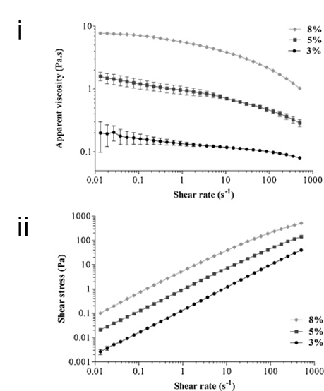
A

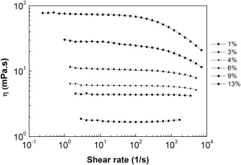
B
Figure 4. [A] The effect of shear rate on the [i] apparent viscosity and [ii] shear stress of aqueous dispersion of high methyl-esterified pectin from tamarillo pulp in water at 3%, 5% and 8%. Figure adapted from Nascimento et al. (2016); and [B] The effect of shear rate on the viscosity of citrus pectin solution at different pectin concentrations. Figure reprinted from Sousa et al. (2015).

7.2 Pectin Gelation
Gelling is the formation of a three-dimensional (3D) network of polymer chains with solvent and solutes trapped within.(Loh et al., 2014; Loh, Nam Nguyen, Kuo, & Li, 2011; Nam Nguyen, Kuo, & Loh, 2011; Wu, Loh, Wu, Lay, & Liu, 2010) The conditions required for gelation and the properties of the gel ultimately depend on the molecular structure, the intermolecular forces which hold the network together and the nature of the junction zones at which the polymer molecules are cross-linked (Axelos & Thibault, 1991a). The junction zones in polysaccharide gels are complex and the molecular structures are held together by a large number of individually weak interactions such as electrostatic interactions and hydrogen bonds. HMP and LMP have different gelation mechanisms, although the gel characteristics are governed by the same macromolecular properties such as the composition, size and conformation of the polymers (Axelos & Thibault, 1991a).

7.21 High Methoxy Pectin (HMP)
HMP gels are obtained at low pH in the presence of a high sucrose concentration or similar co-solute. A high sucrose concentration reduces water activity which is necessary to promote chain-chain interactions rather than chain-solvent interactions; while low pH protonates carboxylate residues, minimizing electrostatic repulsion (Thibault & Ralet, 2003). Walkinshaw and Arnott (1981) inferred from X-ray diffraction (XRD) studies that HMP gels are stabilized by intermolecular hydrogen bonds and hydrophobic bonding between methyl esters. This finding was subsequently confirmed by D. Oakenfull and Scott (1984). Figure 5A schematically illustrates the gelation of HMP.

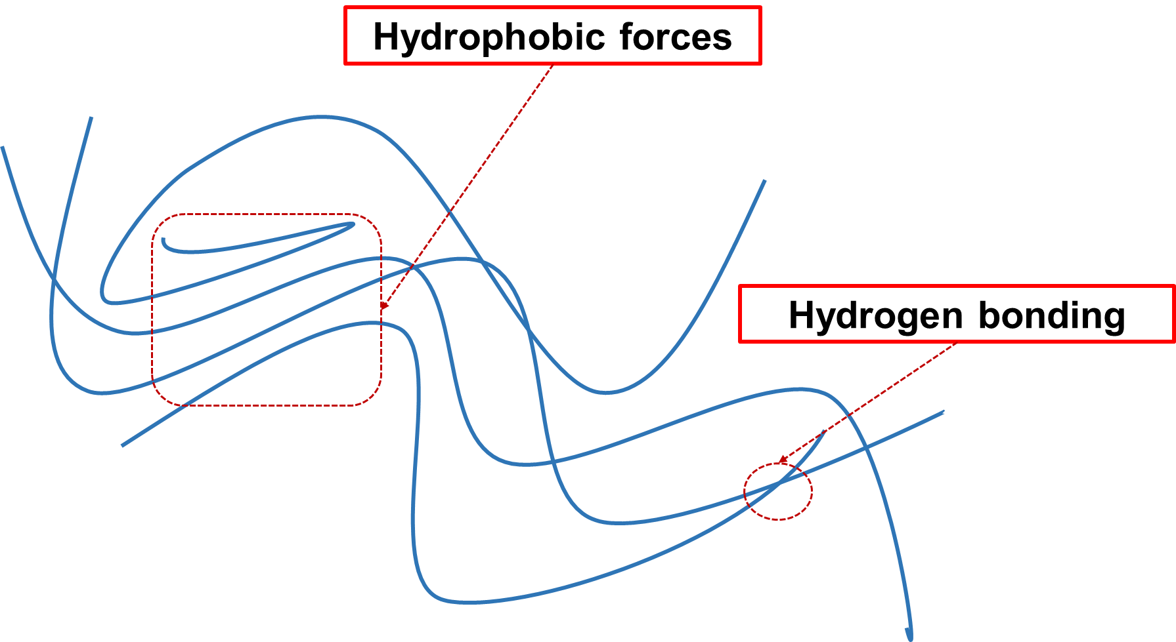
A

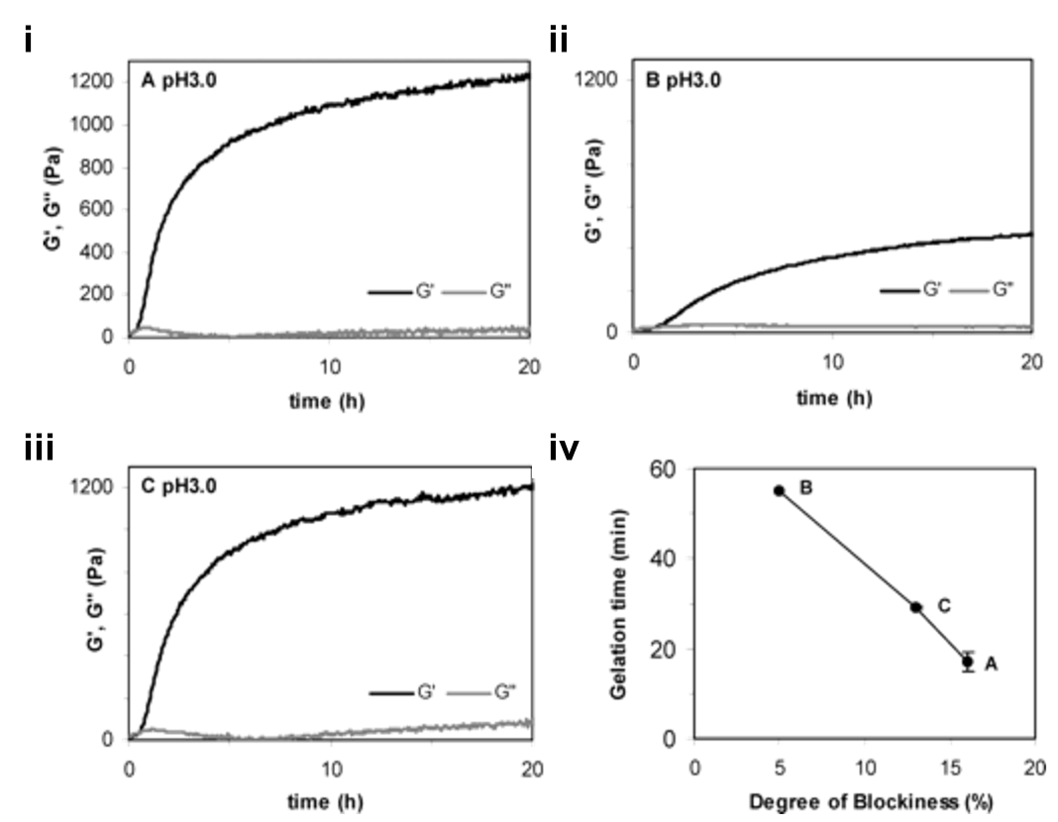
B
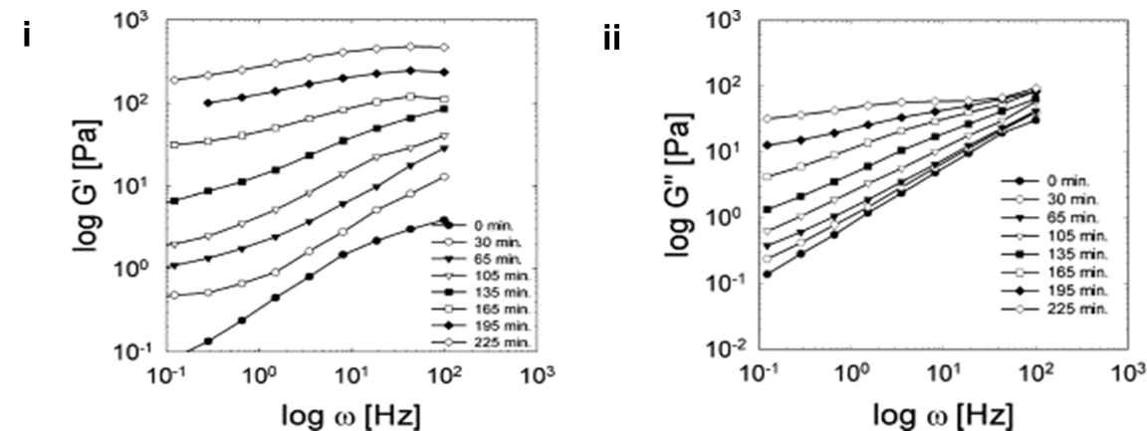
C
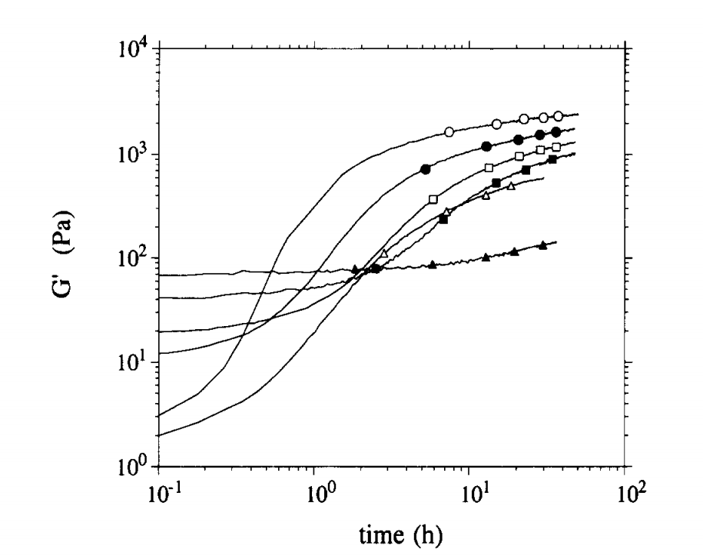
D
Figure 5. [A] HMP gelation is governed by intermolecular hydrogen bonds and hydrophobic interactions between methyl esters; [B] Gelation time for 0.75% of citrus pectin (i) A, (ii) B and (iii) C with DM 74%, 72% and 82%, respectively, in the presence of 60% sucrose at pH 3. The gelation time was plotted as a function of (iv) degree of blockiness (DB). Figure adapted from Löfgren, Guillotin, Evenbratt, Schols, and Hermansson (2005); [C] Frequency sweeps on apple pectin dispersion at pH 1.5, 22 °C: (i) storage moduli and (ii) loss moduli. Figures adapted from Seshadri, Weiss, Hulbert, and Mount (2003); and [D] Storage moduli (G’) as a function of ageing time for 1% HMP from citrus in the presence of 60% sucrose at pH 3 at several ageing temperatures: 5 °C (shaded-triangle), 10 °C (shaded- square), 15 °C (open square), 20 °C (shaded-circle), 30 °C (open circle), 50 (open triangle). Figure adapted from da Silva, Gonçalves, and Rao (1995).

Hydrogen bonds between pectin molecules are favored by the conformation of adjacent GalA units. Individual hydrogen bonds are relatively weak, but a large number of them confer significant thermodynamic stability to the gel. Hydrogen bonding is the main interaction that sustains the HMP gel structure, but it is insufficient to overcome the entropic barrier to gelation. Hydrophobic interactions are essential for HMP gelation. The contribution of hydrophobic interactions to the free energy of junction zones in HMP (with DM = 70%) is half that arising from hydrogen bonding (D. Oakenfull & Scott, 1984). The unfavourable interaction between the non-polar methyl esters of pectin and water molecules result in this hydrophobic effect (Thakur, Singh, Handa, & Rao, 1997). These methyl esters coalesce, thereby reducing the surface area exposed to water and therefore overall entropy is decreased. Guimarães et al. (2009) have reported that HMP is more viscous and deduced that this was due to an increase in these hydrophobic interactions.
Recent studies have demonstrated the importance of the pattern of methylation on gelation of HMP (Löfgren et al., 2005; Slavov et al., 2009). Pectins gel at a faster rate when they possess a block distribution of methyl esterified-GalA units, relative to pectin with the same DM, but with a random distribution of methyl esters (Löfgren et al., 2005) (Figure 5B). Randomly distributed pectins have a considerably lower storage modulus (G’) relative to pectin with a higher DB and therefore the latter form stronger gels.
Sucrose is often used as an additive for HMP gel preparation but it can be replaced by other co-solutes such as glucose, fructose or polyols such as glycerol (Evageliou, Richardson, & Morris, 2000; Tsoga, Richardson, & Morris, 2004a). Hydrophobic interactions depend largely on the molecular geometry of the co-solutes and the interaction with neighboring water molecules (Matubayasi, 1994; Tsoga, Richardson, & Morris, 2004b). D. Oakenfull and Scott (1984) deduced that the function of sugar in the formation of gels by HMP is to stabilize junction zones by promoting hydrophobic interaction between methyl-ester groups. The effect of sucrose can be explained by the concept of “preferential hydration” introduced by Lee and Timasheff (1981). “Preferential hydration” describes the heterogeneous distribution of solvent around the macromolecules. Sucrose at a concentration of 50% by weight increases hydrophobic interaction between two methyl esters by 67% compared with water alone (D. Oakenfull & Scott, 1984).
pH is also an important gelation factor. Pectin is an anion polysaccharide and lowering the pH protonates carboxylic groups, reducing electrostatic repulsions along and between pectin chains (Thakur et al., 1997). Moreover, at low pH, non-dissociated carboxylic groups form inter- and intramolecular hydrogen bonds with secondary alcohol groups.
The formation of HMP gels is time dependent (Seshadri et al., 2003) (Figure 5C). In this study, a native pectin mixture (1.15% apple pectin, 41.40% sucrose, pH 1.50) at time zero was highly viscous in nature. This solution was then subjected to stress at different gelation times and the magnitude of the stress response to the oscillatory sweeps increased as gelation time increased, indicating that the solution became more elastic in nature. The frequency dependence of the storage modulus (G’) became simultaneously less pronounced, corresponding to a change from viscous to a rubbery behavior. At t = 225 min, G’ was higher than G”, indicating that an elastic gel was formed. This rheological data can be explained in terms of network formation. Initially, there is no network formed and each pectin molecule behaves very much like a single, dispersed molecule. As the pectin dispersion is sheared, the molecules relax quickly due to their high molecular mobility. As a consequence, there is no extensive stress buildup, particularly at low oscillation frequencies. As time progresses, the pectin molecules begin to associate by the formation of hydrogen bond and with the help of hydrophobic interactions. The resulting 3D network restricts the freedom of molecules to react to the superimposed flow. As a result, the relaxation time increases, which is indicated by a shift of the storage modulus from the viscous region to the rubber plateau.
The gelation of HMP is also highly dependent on temperature, as demonstrated in a study by da Silva et al. (1995) (Figure 5D). The authors performed gelation of HMP at a temperature of 5 °C and found that gelation was slow and resulted in a weak gel. They attributed this to the lack of hydrophobic interaction at low temperature. The pseudo-equilibrium G’ increased for temperatures up to 30 °C and then decreased. It was inferred that hydrogen bonds and hydrophobic interactions are best facilitated at an intermediate temperature range and contribute to a network with higher elasticity. The structure of HMP-sugar gels is reported to be irreversible on heating (Rao & Silva, 2006). Evageliou et al. (2000) reported an unusual “thermal annealing” behavior of HMP when a gel was heated and cooled. This behavior, however, was pH-dependent. At pH 4.7, a HMP (of DM = 70%, 0.5 wt%) gel in the presence of 65 wt% sucrose was fully reversible on heating with no detectable thermal hysteresis. At pH 3.0 and 3.5, there was a slight reduction in G’ and G” on heating. However, stability at 30°C was observed to be virtually constant despite the pH difference.

7.22 Low Methoxy Pectin (LMP)
LMP gels are stabilized by ionic cross-linkages via calcium bridges between two carboxylates from two different chains, instead of by hydrogen bonds and hydrophobic interactions (Axelos & Thibault, 1991b) (Figure 6A). This is known as the “egg-box” model (Michael J. Gidley, Morris, Murray, Powell, & Rees, 1979; Grant, Morris, Rees, Smith, & Thom, 1973; Morris, Powell, Gidley, & Rees, 1982) and is characterized as junction zones formed by the ordered, side-by-side associations of GalA, whereby specific sequences of GalA monomers in adjacent chains are linked intermolecularly through electrostatic and ionic bonding of carboxyl groups, forming structures like an egg-box (Braccini & Pérez, 2001). The “egg-box” model was first introduced to explain the gelation mechanism of alginate.(Low, Chee, Kai, & Loh, 2015) Although the “egg-box” model can explain the gelation of alginate, it is only an approximation for the mechanism of gelation of LMP. The latter is better described as a “shifted” egg-box, since one of the chains is slightly shifted with respect to the other. The “egg-box” models for the gelation of alginate and pectin have been revisited by Braccini and Pérez (2001); Fang et al. (2008); and Ventura, Jammal, and Bianco-Peled (2013).

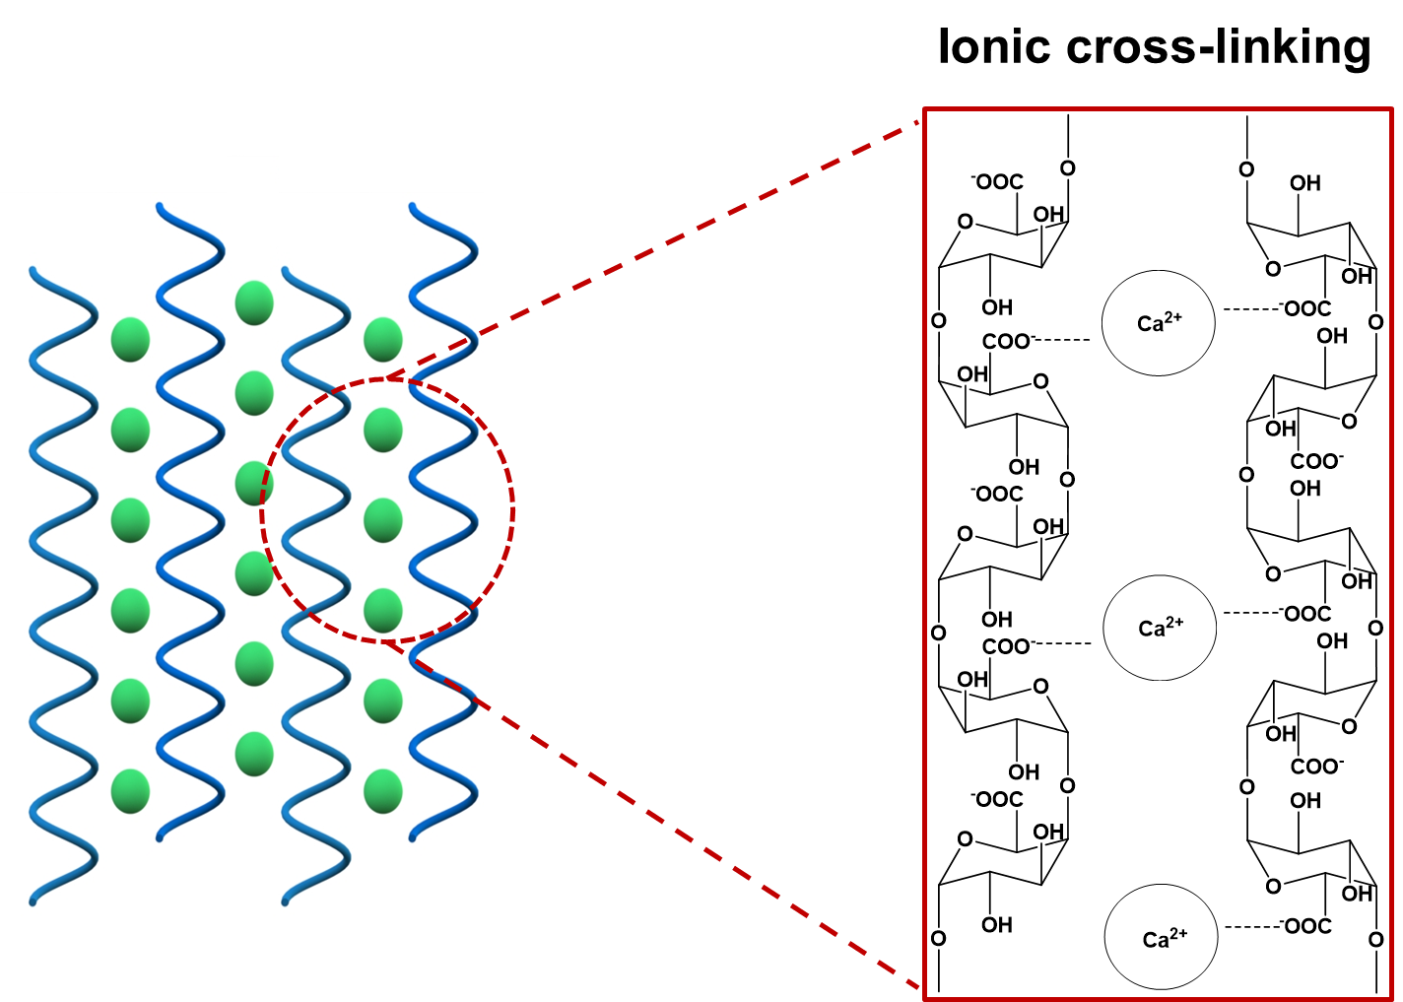
A
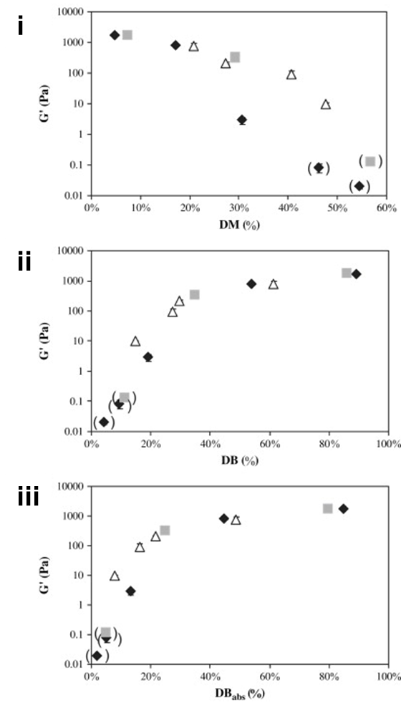
B
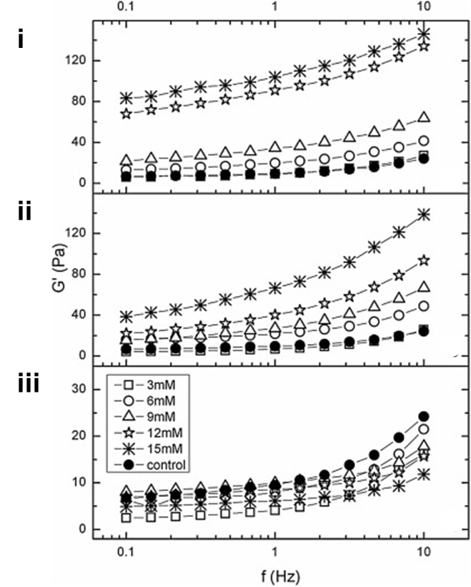
C
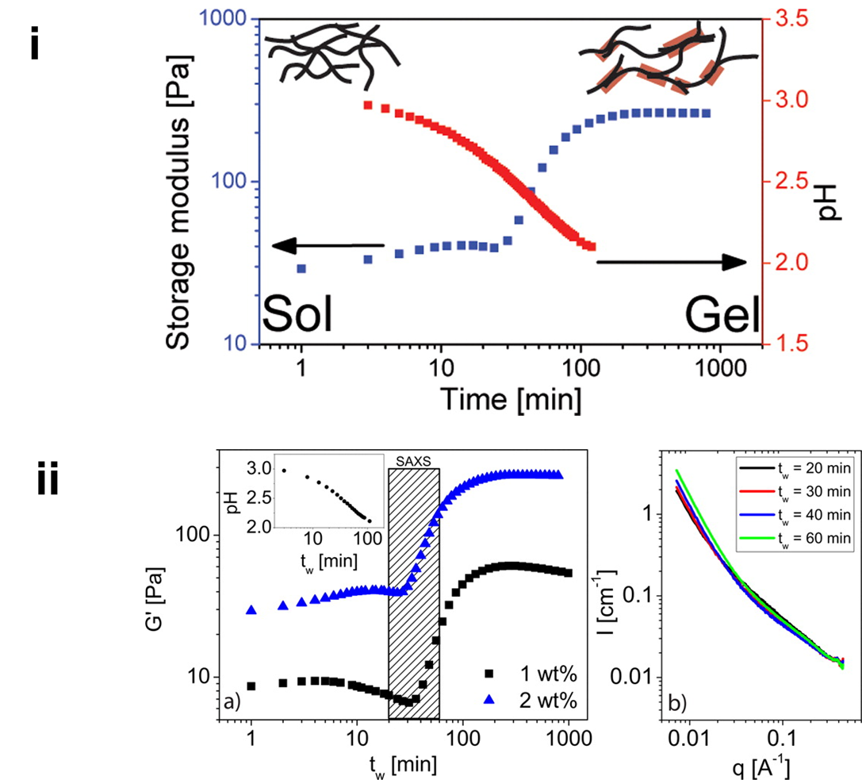
D
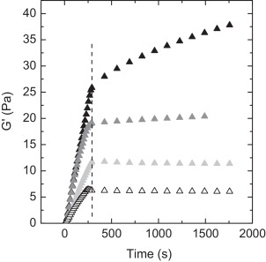
E
Figure 6. [A] LMP gelation mechanism is governed by ionic cross-linking via calcium (divalent) ions between two carboxyl groups from two different chains in close proximity; [B] Effect of (i) degree of methylation (DM), (ii) degree of blockiness (DB) and (iii) absolute degree of blockiness on storage moduli of pectin de-esterified by sodium hydroxide (symbol: rhombus), pectin de-esterified by Aspergillus aculeatus pectin methyl-esterase (PME) (symbol: square) and pectin de-esterified by tomato PME (symbol: triangle). Data points placed between brackets represent pectin-calcium mixtures that did not exhibit gel character. The final GalA concentration was fixed at 43mM. The calcium concentration of the added calcium chloride solution depended on the DM of each pectin and was adjusted so that in the final gel the stoichiometric ratio R = 2[Ca²⁺]/[COO⁻] was equal to 0.2. Figure adapted from Fraeye et al. (2009); [C] Storage moduli of apple pectin with the addition of (i) calcium hydroxide [Ca(OH)₂], (ii) iron lactate [C₆H₁₀FeO₆] and (iii) magnesium hydroxide [Mg(OH)₂]. Figure adapted from Mierczyńska, Cybulska, Sołowiej, and Zdunek (2015); [D] (i) Gelation of LMP via hydrogen bonds in the presence of acid, (ii) Evolution of storage moduli for 1 and 2 % acid LMP gels and time resolved small-angle X-ray scattering (SAXS) for the corresponding gels recorded at four different times after mixing (t_{w}). Figures adapted from Mansel et al. (2015); and [E] Storage moduli (G’) as a function of time for 1% pectin samples at pH 3 with the absence of salt (open symbol), and the addition of 0.05 M LiCl (light gray), 0.05 M NaCl (dark gray) and 0.05 M KCl (black). The temperature from the left to the vertical dotted line was decreased from 40 °C to 5 °C over time, and kept constant at T = 5 °C throughout the time frame investigated. Figure adapted from Ström, Schuster, and Goh (2014).

A two-stage process has been suggested with an initial dimerization of two macromolecules and subsequent aggregation of these dimers (Axelos & Thibault, 1991b; Rao & Silva, 2006). The junctions are formed between unbranched, non-esterified galacturonan blocks bound together by coordinating calcium ions. The intra- and intermolecular interactions of the polymer are modified by the charge density and distribution of the non-methyl-esterified carboxyl groups. The new conformation changes the placement of carboxyl groups to be outward facing from the polymer backbone, facilitating inter-chain hydrogen bonding (Gilsenan, Richardson, & Morris, 2000; Mansel et al., 2015). In general, egg-boxes formed between two neighbouring chains are stabilized predominantly by electrostatic interactions, followed by hydrogen bonds and then by van der Waals interactions.
Formation of cooperative egg-boxes is only possible when stretches of non-methylated GalA units of a minimum length are present. The “egg-boxes” are stable only when there are at least six consecutive carboxyl groups on the interior of each participating chain (Braccini & Pérez, 2001; Powell, Morris, Gidley, & Rees, 1982). The occurrence of methyl ester groups in the primary backbone limits the extent of such junction zones leading to formation of the gel. As DM decreases, LMP-calcium mixtures transform from liquid-like to gel-like with G’ increasing, hence increasing gel strength with decreasing DM (Fraeye et al., 2009) (Figure 6Bi) . With decreasing DM, there is a higher probability of the number of sequences of non-methylated GalA residues being long enough for formation of “egg-boxes”. Formation of a higher amount of “egg-boxes” results in a stronger gel. Fraeye et al. (2009) further observed that the gel strength of LMP-calcium gels was better explained by the pattern of methylation than by the degree of methylation. G’ increased as DB increased from 0 to 40%, indicating that stronger gels were formed when the NMG residues were distributed blockwise (Figure 6Bii). The same correlation is true for the DB_{abs} (Figure 6Biii).
Fraeye et al. (2009) reported that the gel strength of LMP-calcium gels increases with increasing GalA concentration. However, it was suggested that this is also affected by the distribution of non-methylated GalA available for egg-box formation. Dobies, Kozak, and Jurga (2004) reported that the strength of LMP-calcium gel is stronger with a higher concentration of calcium ions, as evidenced by the increase in G’ values with calcium concentration. An increase in concentration of calcium ions allows additional cross-linking of non-methylated GalA, generating a denser and more elastic gel network (Basak & Bandyopadhyay, 2014; Ngouémazong et al., 2012). The storage moduli of pectin solutions also increases with increasing concentration of divalent iron ions (Mierczyńska et al., 2015) (Figure 6C). Addition of calcium or iron ions increases pseudoplasticity, providing an alternative to higher concentrations of thickening agents in fluids (Figure 6Ci and ii). Conversely, addition of magnesium ions causes a decrease in G’, suggesting a weakening of the pectin gel by magnesium (Mierczyńska et al., 2015) (Figure 6Ciii). It could be assumed that divalent iron ions could probably bind to pectin in an egg-box like model; however there is sparse information on the interaction of pectin with metal ions other than calcium.
Commercially, LMP is usually dispersed in aqueous calcium solutions at about 70ºC and then cooled slowly. At high temperature, gelation of LMP is dominated by the formation of egg-box junction zones via calcium bridges, supported by hydrophobic interactions. On cooling, hydrogen bonding increases, supported by inter-dimer associations facilitating the gelation process. Random electrostatic interactions of calcium with single dissociated carboxyl groups of pectin chains (calcium cross-linking) also promotes the structuring process. When the temperature is increased, gelation is accelerated. Durand, Bertrand, Clark, and Lips (1990) reported that the gelation time of LMP in the presence of calcium is increased considerably by a small increase in the gel formation temperature. The sol-gel transition temperature is influenced mostly by the amount of pectin and calcium. The binding of calcium ions to pectin is less stable at high temperature and thus more calcium ions are required to form an elastically active junction zone (Garnier, Axelos, & Thibault, 1993). An increase of metal ion concentration increases the temperature gel point to a concentration limit and then decreases.
The number of methoxy groups is relatively low in LMP (< 50%) but it should not be ignored and also contributes to gelling through hydrophobic interactions (Kastner, Einhorn-Stoll, & Senge, 2012). The free carboxyl groups are assumed to be randomly distributed. The presence of small amounts of sugar (10-30%) in LMP gel tends to impart desirable textural properties (Fu & Rao, 2001). The presence of sugar can also promote inter-chain interactions, as in HMP gelation. However, high concentrations of sugar will affect the gelling of LMP adversely as the dehydrating effect of sugar favours hydrogen bonding and decreases cross-linking by calcium ions (Fu & Rao, 2001).
Recent studies have reported new ways to make LMP gels via acid-induced (Gilsenan et al., 2000; Ström et al., 2007) and monovalent ion-induced gelation (Ström et al., 2014; Wehr, Menzies, & Blamey, 2004). Pectin has a conformational transition below a certain pH that depends on both the temperature and pH and induces aggregation and eventually gelation. At low pH and/or low temperature, the conformation of pectin is predominantly 3₁ helices (Gilsenan et al., 2000). At high pH and/or high temperature, the solution conformation is predominantly 2₁ helices, with only limited conversion to the 3₁ form on cooling (Gilsenan et al., 2000). The 2₁ helices are highly extended and reduction in temperature and/or pH can promote a conformational transition to the more compact 3₁ helices. This transition is reversible. Gelation occurs by dimerization of (antiparallel) three-fold helices, with more extensive aggregation at very low pH where the chains become essentially uncharged (Gilsenan et al., 2000). Protonation of carboxyl groups appears to promote conformational ordering and association by two different mechanisms: (a) suppression of electrostatic repulsion, and (b) allowing the carboxyl groups to act as hydrogen-bond donors (Gilsenan et al., 2000).
Calcium-pectin interactions are essentially cooperative at low ionic strength; however, if the DM is too low, pectin can be precipitated out of solution instead of forming a stable gel. The number of dissociated free carboxyl groups is relatively low at a pH of about 3 (i.e. below the pK_{a} value of 3.5). Therefore, the formation of typical egg-box-junction zones is limited with more interactions between undissociated carboxyl groups via hydrogen bonds instead. The hydrogen bonds formed between protonated and unprotonated carboxyl groups are weakened by protonation and so acid-induced pectin gels are not stable at very low pH (Gilsenan et al., 2000; Mansel et al., 2015) (Figure 6Di). As gelation proceeds, small-angle X-ray scattering (SAXS) data indicates that the entangled pectin solution starts to aggregate and form cross-links with time (Schuster, Cucheval, Lundin, & Williams, 2011), but not at low pH (Mansel et al., 2015) (Figure 6Dii). In the early stages of network build-up, pectin molecules in solution are far apart. The polymers then cluster, thereby lowering the effective concentration of the solution. As more clusters nucleate, grow and connect, a stronger network is slowly formed, as reflected by the increase in G’. Acid-induced gels have less junction zones than pectin-calcium gels, highlighting the importance of hydrogen bond formation (Mansel et al., 2015).
Ström et al. (2014) have reported that gelling of LMP at low pH may be assisted by monovalent ions up to a critical limit (Xiaoyong Wang, Lee, Wang, & Huang, 2007). Interestingly, ionic cross-linking by divalent ions is inhibited by monovalent ions such as sodium, which tie up the free carboxyl groups. However, monovalent ions can also be beneficial, improving the solubility of LMP in the presence of calcium. Monovalent ions such as sodium, potassium and lithium induce a stronger acid gel for LMP by permitting both hydrogen and ionic bonding (Ström et al., 2014) (Figure 6E).

7.23 Amidated Low Methoxy Pectin (ALMP)
Löfgren, Guillotin, and Hermansson (2006) have demonstrated that ALMP and LMP appear very similar in gel microstructure and kinetic behaviour at pH 3 and pH 7. ALMP shows rapid gel formation with G’ > G” throughout, with and without 30% sucrose (Figure 7A). The presence of sucrose influences neither the kinetic behaviour nor the microstructure of the gels, but strongly increases the storage modulus. ALMP generally has reduced sensitivity towards calcium (Löfgren et al., 2006). However, some studies have suggested that amidation might have little influence on sensitivity towards calcium (Capel, Nicolai, Durand, Boulenguer, & Langendorff, 2006). By comparison, ALMP strongly favours acid-induced gelation (Capel et al., 2006; Lootens et al., 2003). The hydrogen bonds between amide groups help to promote gel formation at low pH. Gels from ALMP are pH sensitive and thermally reversible. They can be heated and solidify again on cooling, while conventional pectin-gels remain liquid under the same conditions (J. Chen et al., 2014).
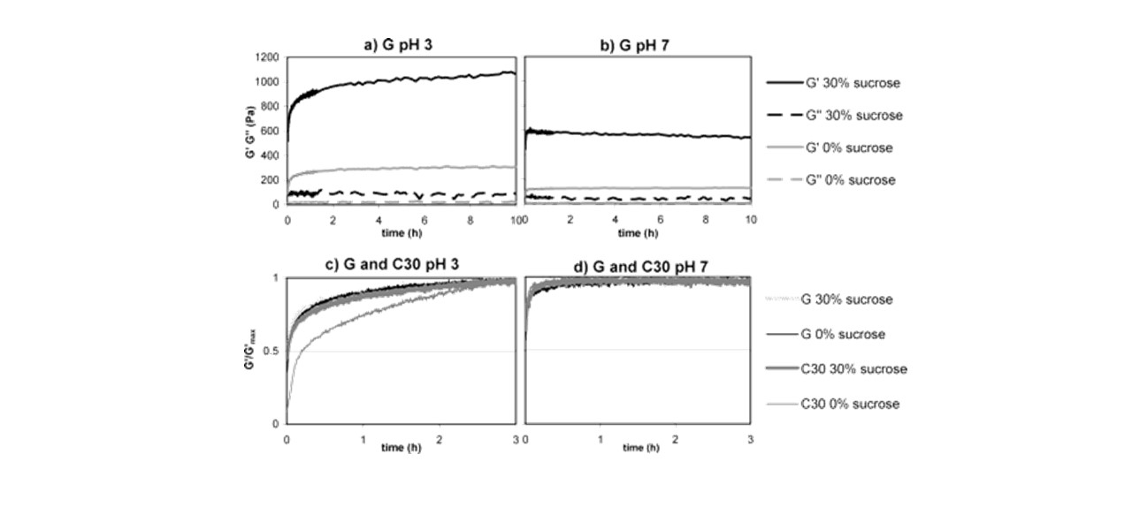
A

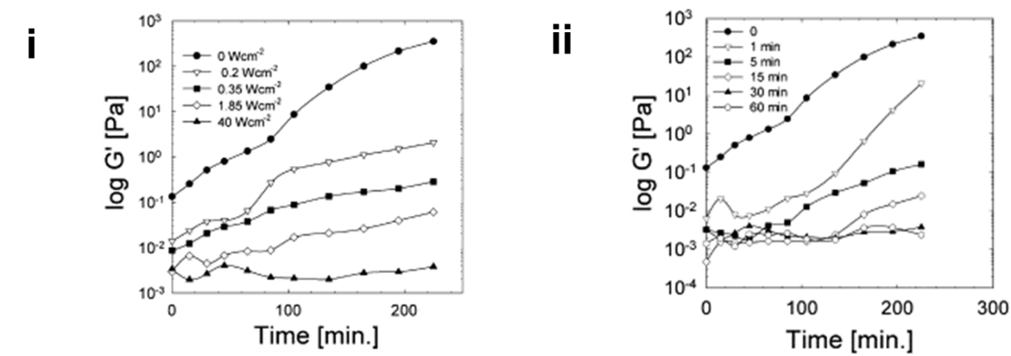
B
Figure 7. [A] G’ and G” during gel formation of 8% pectin G (non-amidated pectin) at (a) pH 3; (b) pH 7. Normalized G’ values during gel formation of 0.8% pectin G and pectin C30 (amidated pectin) at (c) pH 3; (d) pH 7. The initial 9 min involves a temperature decrease from 80 to 25°C. Figure reprinted from Löfgren et al. (2006); and [B] Effect of (i) sonication intensity and (ii) sonication time on the development of storage moduli of apple pectin gels. Figures adapted from Seshadri et al. (2003).

7.3 Intrinsic and Extrinsic Factors
The gelation process is affected by both intrinsic and extrinsic parameters. Intrinsic factors include the number and distribution pattern of free carboxyl groups, the molecular weight and types of pectin while extrinsic factors include pectin concentration, calcium concentration, pH, ionic strength and temperature (Gigli, Garnier, & Piazza, 2009).
Comparing commercial pectin from different sources; apple pectin produces a more elastic-viscous gel and citrus pectin produces a more elastic-brittle gel. By contrast, sugar beet pectin is less effective as a gelling agent. However, it possesses emulsifying properties (H.-m. Chen, Fu, & Luo, 2016) and is capable of forming covalently cross-linked hydrogels and so is of commercial value (May, 1990). Gelation of pectin is influenced by molecular weight because the rigidity of the gel is determined by the number of effective junctions formed per chain (Axelos & Thibault, 1991a). The lower the molecular weight, the less junction zones per molecule can be formed, decreasing the extent of cross-linking and thereby weakening the gel. Although molecular weight is mainly affected by the origin of the pectin, handling methods such as extraction also affect the molecular weight of the polymer significantly. For example, ultrasound may be used to increase the yield of pectin extraction. However, Seshadri et al. (2003) found that the rheological properties of pectin that had been treated with ultrasound were inferior. As sonication intensity and time was increased, gel strength was reduced. As shown in Figure 7Bi and ii, G’ decreased as sonication intensity and time increased. This result was attributed to the reduction in the molecular weight of pectin by cavitational promoted chain degradation.
The presence of sugar monomers such as rhamnose, whose dimensions are not compatible with the geometry of the junction zones formed by GalA monomers, obstructs the molecular orientation necessary for junction-zone formation (Axelos & Thibault, 1991a). Rhamnose influences the conformation of the polymer in solution and ultimately its gelling properties (D. G. Oakenfull, 1991). This sugar is most abundant in rhamnogalacturonan, disturbing the regularity of the galacturonan backbone and forming the “hairy region” which limits inter-chain association. This could further explain the reason sugar beet pectin exhibited the poorest gelling properties of the three commercial pectins, as it possesses a relatively high rhamnose content (Table 2). However, it should be noted that the regularity and frequency of the rhamnose interruptions to the pectin chain are different in pectins from different plant species or even within the same species. The presence of neutral sugars also limit inter-chain association (Kravtchenko, Voragen, et al., 1992a) (Table 2). However, these branches are often removed during extraction or purification and are therefore not usually present in significant amounts in commercial pectins.

Table 2. Molecular weight and rhamnose content (%) of commercial pectin.
Pectins | Molecular weight (Da) | Rhamnose content (%) | Neutral sugar (%) | References
Apple | 63,000-81,000 | 2.30 | 12.60 | Schmidt, Schmidt, Kurz, Endreß, and Schuchmann (2015); B. M. Yapo et al. (2007); (Kravtchenko, Voragen, et al., 1992a); Leroux, Langendorff, Schick, Vaishnav, and Mazoyer (2003)
Citrus | 38,000-162,000 | 1.40 | 5.10
Sugar beet | 20,200-90,100 | 5.40 | 6.80-32.90

7.4 Comparison in Rheology of HMP, LMP and ALMP
Comparing the three commercially available pectins, HMP shows the highest apparent viscosity, followed by LMP and ALMP (Vithanage, Grimson, Wills, Harrison, & Smith, 2010). The Young’s modulus is used to define the force displacement of matter. It is determined by calculating the slope from the plot of stress versus strain. Vithanage et al. (2010) found that the Young’s modulus for HMP gel was the highest, followed by LMP and ALMP (Table 3). In other words, HMP gel requires a higher force to break its structure compared to LMP and ALMP gels, indicating that hydrogen bonding in HMP pectin is stronger than the ionic bonding (with calcium ions) in LMP and ALMP. The Young’s modulus is temperature dependent (Table 3).

Table 3. Young’s modulus of high methoxyl pectin (HMP), low methoxyl pectin (LMP) and amidated low methoxyl pectin (ALMP) gels (Vithanage et al., 2010).
Pectins | Young’s modulus (Nm⁻²)
Pectins | At 5 °C | At 20 °C
HMP | (6.40 ± 0.20) × 10³ | (4.91 ± 0.20) × 10³
LMP | (1.80 ± 0.05) × 10³ | (9.50 ± 0.05) × 10²
ALMP | (7.90 ± 0.08) × 10² | (5.60 ± 0.01) × 10²

HMP gels demonstrate the broadest range of elastic behaviour in puncture and strain sweep tests, followed by LMP and ALMP gels (Vithanage et al., 2010). Comparing LMP and ALMP gels, the strength of the former is reported to be greater than that of the latter; however, ALMP gels exhibit a higher storage modulus than LMP gels (Vithanage et al., 2010). The G’ and G” values for ALMP gel increases with increasing temperature, forming a more rubbery elastic medium; whereas HMP and LMP gels show a decrease of G’ and G” with increasing temperature, forming a more liquidly medium (Vithanage et al., 2010). This is postulated to be due to the formation of stable junctions by hydrogen bonding through amide groups in ALMP. At lower temperature, hydrogen bonds are favoured, reinforcing the junction zones; while at higher temperatures, the loss of hydrogen bonding is compensated for with reinforced hydrophobic interactions (Alonso-Mougán, Meijide, Jover, Rodrı́guez-Núñez, & Vázquez-Tato, 2002). The sol/gel transition of LMP is sensitive to the ionic strength of the medium, while the viscoelastic properties of the gel structure is time-dependant and resistant to moderate temperature (retained up to 60°C) (Fu & Rao, 2001; Gigli et al., 2009).

7.5 Rheology of Mixed Pectin Systems
Synergistic mixed gels are also of interest to industry. Synergism can lead to different microstructures to that of pure gels with improved texture and enhanced rheological properties that result in cost savings during manufacturing. Synergistic effects can be achieved by mixing HMP, LMP and/or ALMP to produce a strengthened mixed gel. The G’ of mixed HMP/LMP gel is higher than that of HMP or LMP (Löfgren & Hermansson, 2007). Figure 8A demonstrates that G’ values for mixed HMP/LMP are considerably higher than for HMP gels. The mixed gel exhibits similar rheological behaviour to HMP gels of higher sugar concentration. The strong aggregation of LM pectin in the presence of sucrose and calcium contributes to a large influence on the storage modulus of the mixed gels, increasing the storage modulus by about thirty times (based on 60% sucrose) (Löfgren & Hermansson, 2007). By comparison, the addition of HMP in a mixed gel based on 30% sucrose increased the storage modulus five times (Löfgren & Hermansson, 2007). When ALMP is mixed with HMP, it is possible to obtain high viscosity and reduced pseudoplasticity (Sato et al., 2008).
A
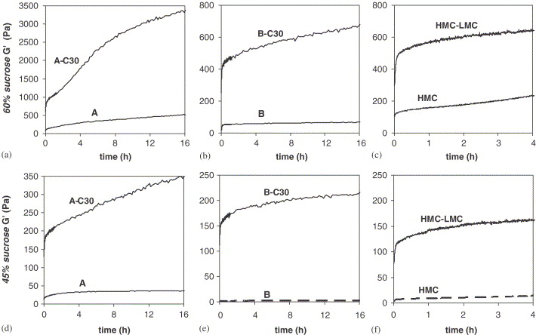
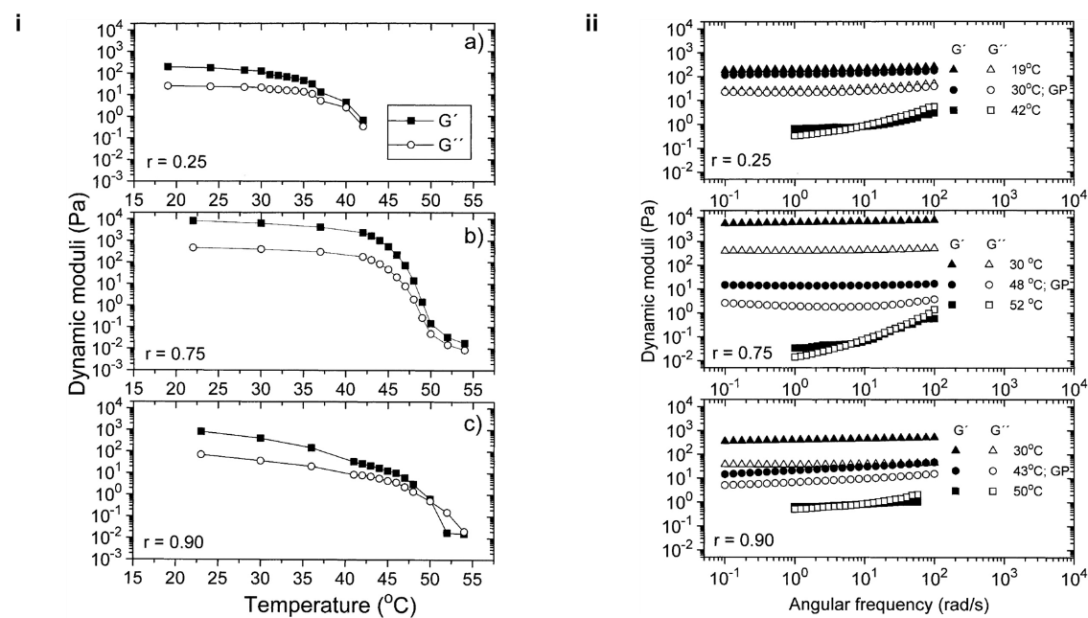
B
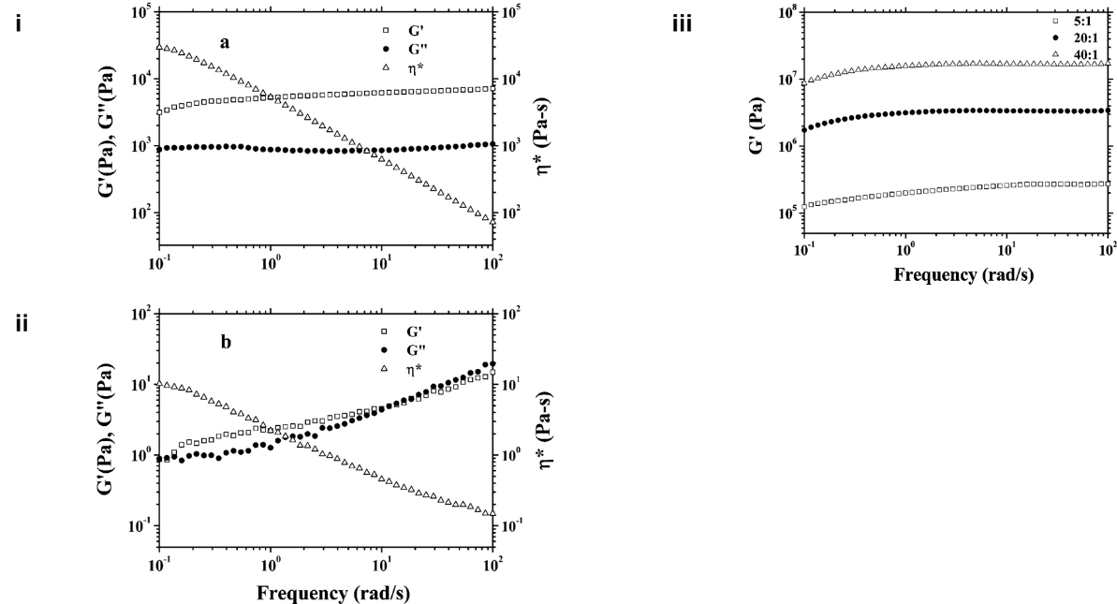
C
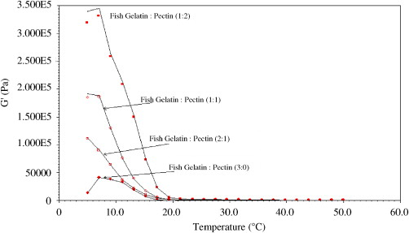
D
Figure 8. [A] Storage moduli during gel formation in mixed 0.8% HMP/0.4% LMP compared to 1.2% HMP gels. A, B, and HMC are HMP while C30 and LMC are LMP. (a), (b) and (c) were gels formed in the presence of 60% sucrose while (d), (e) and (f) were gels formed in the presence of 45% sucrose. Figure reprinted from Löfgren and Hermansson (2007); [B] (i) Temperature dependences of a fixed dynamic moduli (frequency of 1.2 rad/s) for acid aqueous mixtures of pectin-chitosan at the compositions indicated. (ii) Frequency dependences of storage modulus and loss modulus at different temperatures (stages) of the gel-forming process for pectin-chitosan mixtures at compositions indicated. Figures adapted from Nordby, Kjøniksen, Nyström, and Roots (2003); [C] (i) The complex viscosity, η*, storage modulus G’, and loss modulus G” versus angular frequency for β-lacglobulin-pectin coaservates at composition 5:1 prepared at a concentration of sodium chloride = 0.02M. (ii) The complex viscosity, η*, storage modulus G’, and loss modulus G” versus angular frequency for 2% pectin solution prepared at a concentration of sodium chloride = 0.02M. (iii) The storage modulus G’ versus frequency curves for β-lacglobulin-pectin coaservates at different compositions prepared at a concentration of sodium chloride = 0.11M. Figures adapted from Xiaoyong Wang et al. (2007); and [D] Temperature sweep of low-fat spread with varying ratios of fish gelatin and pectin. Figure reprinted from Cheng, Lim, Chow, Chong, and Chang (2008).

Polysaccharides and proteins are two major components of food products. They are often used to control structure, texture, and stability. Textural and structural properties depend largely on these biopolymers forming organized structures. The mixture of these different components or even of the same class of biopolymer (carbohydrate-carbohydrate or protein-protein) can lead to phase separation. There are two types of phase separation: segregative which results in an unmixingof the two phases; and associative which leads to complex formation of the two biopolymers. Associative phase separation has been widely applied to stabilize products in the food, cosmetic, pharmaceutical, medical and biotechnological industries. In the pectin-casein system, for example, pectin can prevent aggregation of casein micelles or be the cause of it (Maroziene & de Kruif, 2000), changing the microstructure stability and rheology of dairy products. Pectin and milk protein are generally not considered compatible at neutral pH; however, the interaction can be mediated by calcium bridging between pectin and casein micelles.
Agoda-Tandjawa, Durand, Gaillard, Garnier, and Doublier (2012) demonstrated that the presence of LMP does not modify the viscoelasticity and microstructural properties of microfibrillated cellulose suspensions but it does increase the shear-thinning behaviour and thixotropic characteristic of the suspensions. They suggested that this outcome was due to the viscosifier effect of LMP. Nordby et al. (2003) demonstrated that a pectin-chitosan mixture at different ratios at very low pH (≈ 1.7) behaves more elastic at lower temperatures (Figure 8Bi). At temperatures below the gel temperature, G’ is always larger than G”, indicating that the pectin-chitosan mixture is in a solid-like state. At temperatures above the gel temperature (42-50°C), G” is always larger than G’, indicating that the mixture is in a more viscous-like state (Figure 8Bii). Khondkar, Tester, Hudson, Karkalas, and Morrow (2007) used phosphate cross-linking between starch and pectin to prepare gels with greater elasticity and better microstructure.
Xiaoyong Wang et al. (2007) have demonstrated that increasing the amount of pectin in a protein-polysaccharide mixture favours the formation of stronger gels (Figure 9C). The significantly higher G’ than G” indicates that β-lacglobulin-pectin coaservates form a highly interconnected gel-like network structure. The typical viscoelastic behaviour of pectin solution (Figure 8C) has been observed in coacervates with similar pectin content, indicating that the elastic behaviour of β-lacglobulin-pectin coaservates is primarily due to the interactions between β-lacglobulin molecules and pectin chains. Sadahira, Rodrigues, Akhtar, Murray, and Netto (2016) deduced that egg white and pectin complexes increased continuous phase viscosity and enhanced foam stability by slowing liquid drainage. When incorporated with fish gelatin in a low-fat spread, an increase in pectin content could also increase the consistency and melt ability of the low-fat spread (Cheng et al., 2008) (Figure 8D). It was also predicted that the low-fat spread sample with more pectin content would perform better with ‘melt in the mouth’ characteristics and a better instant in-mouth flavour release effect.

8.0 Modification of Pectin Structure
Pectin formulations can be manipulated to achieve gels, 3-D matrices, films and micro-/ nano-particles. However, there can be a lack of reproducible performance due to the large diversity of molecular structures, leading to problems in quality control and quality assurance (Günter et al., 2014). Solutions to this complication fall into two categories: the development of new technologies for pectin isolation, purification, and characterization and the modification of pectin macromolecules (Liu, Fishman, & Hicks, 2007). J. Chen et al. (2014) recently published a thorough review on chemical modifications of pectins detailing substitutions, chain elongation and depolymerization. Alkylation and thiolation are among these many modifications related to modifying gelling behavior. Through modification, the limitations of pectin such as poor solubility in organic solvents could possibly be resolved and a greater range of functionalities and applications be achieved.

9.0 Conclusion
Pectins are a family of versatile biopolymers abundant in plants and used commercially as emulsifiers, gelling agents, glazing agents, stabilizers, and/or thickeners. The carboxylic groups of pectins are usually methyl-esterified to some degree and this biosynthetic modification alters their functional properties. HMP requires high co-solute content and acid to form gels whereas LMP can form gels in the absence of a co-solute and at a wider range of pH values. Pectin produced industrially is typically HMP. LMP does occur naturally in plants but is usually obtained commercially from HMP by acid, alkaline and/or enzymatic de-esterification. One of the most common de-esterification methods is aminolysis, yielding ALMP. The presence of a primary amide group in the chemical structure alters the gelation properties of pectin.
Pectin exhibits Newtonian behaviour at low shear rates and pseudoelastic behaviour when shear rates are increased. The precise role of each structural feature on rheology and the gelling mechanism is of considerable commercial interest. The gelation process is affected by both intrinsic and extrinsic factors including the number and distribution pattern of free carboxyl groups, the molecular weight and types of pectin, pectin concentration, calcium ion concentration, pH, ionic strength and temperature. Understanding these influences enables us to predict the rheological behaviour of pectin during industrial processing.
It is also important to understand the rheology and network structures of mixed pectin-protein and pectin-polysaccharide systems that are used commercially for cosmetic, pharmaceutical, medical and biotechnological applications. Pectin can be incorporated in to mixed structures and stabilize other system (polysaccharides and/or proteins), or vice versa. Synergism can lead to a different microstructure from that of pure gels and can improve gel quality. Although extensive studies have been conducted on the rheology of mixed systems involving pectin, there are many other potential combinations that have yet to be investigated.
Pectin is a natural, biocompatible, biodegradable and renewable polysaccharide but suffers from the irreproducibility and inhomogeneity of its structure. This complicates quality assurance and control. Structural modification can greatly alter the solubility and gelling properties of pectins, but collaboration between different disciplines of science can provide a better understanding of this biopolymer’s properties so that its true commercial potential can be realized. While it is common to focus on applications of pectin in the food and pharmaceutical industries, pectin may potentially be used in a number of other industries as a renewable and biocompatible material.

Acknowledgements
The authors thank B. Q. Y. Chan and C. E. Wong for proofreading the manuscript. The authors acknowledge B. Q. Y. Chan and C. Owh for their assistance with illustrating the schematic diagrams in this manuscript. S. Y. Chan acknowledges the funding and support from Monash University Malaysia and the A*STAR Institute for Materials Research and Engineering.

References
Abid, M., Cheikhrouhou, S., Renard, C. M. G. C., Bureau, S., Cuvelier, G., Attia, H., & Ayadi, M. A. (2017). Characterization of pectins extracted from pomegranate peel and their gelling properties. Food Chemistry, 215, 318-325.
Agoda-Tandjawa, G., Durand, S., Gaillard, C., Garnier, C., & Doublier, J. L. (2012). Rheological behaviour and microstructure of microfibrillated cellulose suspensions/low-methoxyl pectin mixed systems. Effect of calcium ions. Carbohydrate Polymers, 87(2), 1045-1057.
Alonso-Mougán, M., Meijide, F., Jover, A., Rodrı́guez-Núñez, E., & Vázquez-Tato, J. (2002). Rheological behaviour of an amide pectin. Journal of Food Engineering, 55(2), 123-129.
Anger, H., & Dongowski, G. (1988). Amidated pectins—characterization and enzymatic degradation. Food Hydrocolloids, 2(5), 371-379.
Axelos, M. A. V., & Thibault, J. F. (1991a). The Chemistry of Low-Methoxyl Pectin Gelation. In R. H. Walter (Ed.), The Chemistry and Technology of Pectin (pp. 109-118). San Diego: Academic Press
Axelos, M. A. V., & Thibault, J. F. (1991b). Influence of the substituents of the carboxyl groups and of the rhamnose content on the solution properties and flexibility of pectins. International Journal of Biological Macromolecules, 13(2), 77-82.
Basak, R., & Bandyopadhyay, R. (2014). Formation and rupture of Ca2+ induced pectin biopolymer gels. Soft Matter, 10(37), 7225-7233.
Basu, S., & Shivhare, U. S. (2010). Rheological, textural, micro-structural and sensory properties of mango jam. Journal of Food Engineering, 100(2), 357-365.
Begum, R., Aziz, M. G., Uddin, M. B., & Yusof, Y. A. (2014). Characterization of Jackfruit (Artocarpus Heterophyllus) Waste Pectin as Influenced by Various Extraction Conditions. Agriculture and Agricultural Science Procedia, 2, 244-251.
BeMiller, J. N. (1986). An Introduction to Pectins: Structure and Properties. In Chemistry and Function of Pectins (pp. 2-12). Washington DC: American Chemical Society
Benedetti, M., Pontiggia, D., Raggi, S., Cheng, Z., Scaloni, F., Ferrari, S., . . . De Lorenzo, G. (2015). Plant immunity triggered by engineered in vivo release of oligogalacturonides, damage-associated molecular patterns. Proceedings of the National Academy of Sciences, 112(17), 5533-5538.
Bernard, H., Desseyn, J.-L., Gottrand, F., Stahl, B., Bartke, N., & Husson, M.-O. (2015). Pectin- Derived Acidic Oligosaccharides Improve the Outcome of Pseudomonas aeruginosa Lung Infection in C57BL/6 Mice. PLoS ONE, 10(11), e0139686.
Bichara, L. C., Alvarez, P. E., Fiori Bimbi, M. V., Vaca, H., Gervasi, C., & Brandán, S. A. (2016). Structural and spectroscopic study of a pectin isolated from citrus peel by using FTIR and FT-Raman spectra and DFT calculations. Infrared Physics & Technology, 76, 315-327.
Bishop, P. D., Makus, D. J., Pearce, G., & Ryan, C. A. (1981). Proteinase inhibitor-inducing factor activity in tomato leaves resides in oligosaccharides enzymically released from cell walls. Proceedings of the National Academy of Sciences, 78(6), 3536-3540.
Bomgardner, M. M. (2013). Pushing Pectin Chemical & Engineering News (Vol. 91). Washington DC American Chemical Society
Bonnin, E., Dolo, E., Le Goff, A., & Thibault, J.-F. (2002). Characterisation of pectin subunits released by an optimised combination of enzymes. Carbohydrate Research, 337(18), 1687-1696.
Braccini, I., & Pérez, S. (2001). Molecular Basis of Ca²⁺-Induced Gelation in Alginates and Pectins: The Egg-Box Model Revisited. Biomacromolecules, 2(4), 1089-1096.
Braconnot, H. (1825). Nouvelles observations sur l’acide pectique. Annales de Chimie et de Physique, 30, 96-102.
Braconnot, H. (1825). Recherches sur un nouvel acide universellement répandu dans tous les végétaux. Annales de Chimie et de Physique, 28(2), 173-178.
Braun, D. B., & Rosen, M. R. (2000). Preface. In Rheology Modifiers Handbook - Practical Use and Application. New York, United States of America: William Andrew Publishing
Brejnholt, S. M. (2009). Pectin. In Food Stabilisers, Thickeners and Gelling Agents (pp. 237-265): Wiley-Blackwell
Brett, C., & Waldron, K. (1990). Cell wall structure and the skeletal functions of the wall. In Physiology and Biochemistry of Plant Cell Walls (pp. 4-57). Dordrecht: Springer Netherlands
Caffall, K. H., & Mohnen, D. (2009). The structure, function, and biosynthesis of plant cell wall pectic polysaccharides. Carbohydrate Research, 344(14), 1879-1900.
Canteri-Schemin, M. H., Fertonani, H. C. R., Waszczynskyj, N., & Wosiacki, G. (2005). Extraction of pectin from apple pomace. Brazilian Archives of Biology and Technology, 48, 259-266.
Capel, F., Nicolai, T., Durand, D., Boulenguer, P., & Langendorff, V. (2006). Calcium and acid induced gelation of (amidated) low methoxyl pectin. Food Hydrocolloids, 20(6), 901-907.
Cardoso, S. M., Silva, A. M. S., & Coimbra, M. A. (2002). Structural characterisation of the olive pomace pectic polysaccharide arabinan side chains. Carbohydrate Research, 337(10), 917-924.
Chan, S.-Y., & Choo, W.-S. (2013). Effect of extraction conditions on the yield and chemical properties of pectin from cocoa husks. Food Chemistry, 141(4), 3752-3758.
Chan, S., Choo, W., Young, D., & Loh, X. (2016). Thixotropic Supramolecular Pectin-Poly(Ethylene Glycol) Methacrylate (PEGMA) Hydrogels. Polymers, 8(11), 404.
Chen, H.-m., Fu, X., & Luo, Z.-g. (2016). Effect of molecular structure on emulsifying properties of sugar beet pulp pectin. Food Hydrocolloids, 54, Part A, 99-106.
Chen, J., Liu, W., Liu, C.-M., Li, T., Liang, R.-H., & Luo, S.-J. (2014). Pectin Modifications: A Review. Critical Reviews in Food Science and Nutrition, 55(12), 1684-1698.
Cheng, L. H., Lim, B. L., Chow, K. H., Chong, S. M., & Chang, Y. C. (2008). Using fish gelatin and pectin to make a low-fat spread. Food Hydrocolloids, 22(8), 1637-1640.
Christiaens, S., Uwibambe, D., Uyttebroek, M., Van Droogenbroeck, B., Van Loey, A. M., & Hendrickx, M. E. (2015). Pectin characterisation in vegetable waste streams: A starting point for waste valorisation in the food industry. LWT - Food Science and Technology, 61(2), 275-282.
Ciriminna, R., Chavarría-Hernández, N., Inés Rodríguez Hernández, A., & Pagliaro, M. (2015). Pectin: A new perspective from the biorefinery standpoint. Biofuels, Bioproducts and Biorefining, 9(4), 368-377.
Codex Alimentarius. (2015). General Standards for Food Additives, Codex Stan 192-1995. Pectin (p. 169). Rome, Italy: Food and Agriculture Organization of the United Nations.
Coimbra, M. A., Barros, A., Barros, M., Rutledge, D. N., & Delgadillo, I. (1998). Multivariate analysis of uronic acid and neutral sugars in whole pectic samples by FT-IR spectroscopy. Carbohydrate Polymers, 37(3), 241-248.
Concha, J., Weinstein, C., & Zúñiga, M. (2013). Production of pectic extracts from sugar beet pulp with antiproliferative activity on a breast cancer cell line. Frontiers of Chemical Science and Engineering, 7(4), 482-489.
Constenla, D., & Lozano, J. E. (2003). Kinetic model of pectin demethylation. Latin American applied research, 33, 91-95.
Cosgrove, D., & Jarvis, m. (2012). Comparative structure and biomechanics of plant primary and secondary cell walls. Frontiers in Plant Science, 3(204).
da Costa, M. P. M., de Mello Ferreira, I. L., & de Macedo Cruz, M. T. (2016). New polyelectrolyte complex from pectin/chitosan and montmorillonite clay. Carbohydrate Polymers, 146, 123-130.
da Silva, J. A. L., Gonçalves, M. P., & Rao, M. A. (1995). Kinetics and thermal behaviour of the structure formation process in HMP/sucrose gelation. International Journal of Biological Macromolecules, 17(1), 25-32.
Daas, P. J. H., Arisz, P. W., Schols, H. A., De Ruiter, G. A., & Voragen, A. G. J. (1998). Analysis of Partially Methyl-Esterified Galacturonic Acid Oligomers by High-Performance Anion-Exchange Chromatography and Matrix-Assisted Laser Desorption/Ionization Time-of-Flight Mass Spectrometry. Analytical Biochemistry, 257(2), 195-202.
Daas, P. J. H., Meyer-Hansen, K., Schols, H. A., De Ruiter, G. A., & Voragen, A. G. J. (1999). Investigation of the non-esterified galacturonic acid distribution in pectin with endopolygalacturonase. Carbohydrate Research, 318(1–4), 135-145.
Daas, P. J. H., Voragen, A. G. J., & Schols, H. A. (2000). Characterization of non-esterified galacturonic acid sequences in pectin with endopolygalacturonase. Carbohydrate Research, 326(2), 120-129.
de Assis, S. A., Lima, D. C., & de Faria Oliveira, O. M. M. (2001). Activity of pectinmethylesterase, pectin content and vitamin C in acerola fruit at various stages of fruit development. Food Chemistry, 74(2), 133-137.
de Oliveira, C. F., Giordani, D., Gurak, P. D., Cladera-Olivera, F., & Marczak, L. D. F. (2015). Extraction of pectin from passion fruit peel using moderate electric field and conventional heating extraction methods. Innovative Food Science & Emerging Technologies, 29, 201-208.
Denès, J.-M., Baron, A., Renard, C. M. G. C., Péan, C., & Drilleau, J.-F. (2000). Different action patterns for apple pectin methylesterase at pH 7.0 and 4.5. Carbohydrate Research, 327(4), 385-393.
Deuel, H. (1943). Pektin als hochmolekularer Elektrolyt. Mitt. Geb. Lebensmittelunters. Hyg., 34, 41-51.
Dobies, M., Kozak, M., & Jurga, S. (2004). Studies of gelation process investigated by fast field cycling relaxometry and dynamical rheology: the case of aqueous low methoxyl pectin solution. Solid State Nuclear Magnetic Resonance, 25(1–3), 188-193.
Dongowski, G., Lorenz, A., & Anger, H. (2000). Degradation of pectins with different degrees of esterification by Bacteroides thetaiotaomicron isolated from human gut flora. Applied and environmental microbiology, 66(4), 1321-1327.
Durand, D., Bertrand, C., Clark, A. H., & Lips, A. (1990). Calcium-induced gelation of low methoxy pectin solutions — thermodynamic and rheological considerations. International Journal of Biological Macromolecules, 12(1), 14-18.
Endress, H. U. (1991). Nonfood Uses of Pectin. In R. H. Walter & S. Taylor (Eds.), The Chemistry and Technology of Pectin (pp. 251-268). San Diego: Academic Press
Evageliou, V., Richardson, R. K., & Morris, E. R. (2000). Effect of pH, sugar type and thermal annealing on high-methoxy pectin gels. Carbohydrate Polymers, 42(3), 245-259.
Fang, Y., Al-Assaf, S., Phillips, G. O., Nishinari, K., Funami, T., & Williams, P. A. (2008). Binding behavior of calcium to polyuronates: Comparison of pectin with alginate. Carbohydrate Polymers, 72(2), 334-341.
Ferrari, S., Savatin, D., Sicilia, F., Gramegna, G., Cervone, F., & De Lorenzo, G. (2013). Oligogalacturonides: plant damage-associated molecular patterns and regulators of growth and development. Frontiers in Plant Science, 4(49).
Fishman, M. L., Chau, H. K., Cooke, P. H., & Hotchkiss Jr, A. T. (2008). Global Structure of Microwave-Assisted Flash-Extracted Sugar Beet Pectin. Journal of Agricultural and Food Chemistry, 56(4), 1471-1478.
Fishman, M. L., Chau, H. K., Hoagland, P. D., & Hotchkiss, A. T. (2006). Microwave-assisted extraction of lime pectin. Food Hydrocolloids, 20(8), 1170-1177.
Fraeye, I., De Roeck, A., Duvetter, T., Verlent, I., Hendrickx, M., & Van Loey, A. (2007). Influence of pectin properties and processing conditions on thermal pectin degradation. Food Chemistry, 105(2), 555-563.
Fraeye, I., Doungla, E., Duvetter, T., Moldenaers, P., Van Loey, A., & Hendrickx, M. (2009). Influence of intrinsic and extrinsic factors on rheology of pectin–calcium gels. Food Hydrocolloids, 23(8), 2069-2077.
Fu, J. T., & Rao, M. A. (2001). Rheology and structure development during gelation of low-methoxyl pectin gels: the effect of sucrose. Food Hydrocolloids, 15(1), 93-100.
Gan, C.-Y., & Latiff, A. A. (2011). Extraction of antioxidant pectic-polysaccharide from mangosteen (Garcinia mangostana) rind: Optimization using response surface methodology. Carbohydrate Polymers, 83(2), 600-607.
Garnier, C., Axelos, M. A. V., & Thibault, J.-F. (1993). Phase diagrams of pectin-calcium systems: Influence of pH, ionic strength, and temperature on the gelation of pectins with different degrees of methylation. Carbohydrate Research, 240(0), 219-232.
Gidley, M. J., Morris, E. R., Murray, E. J., Powell, D. A., & Rees, D. A. (1979). Spectroscopic and stoicheiometric characterisation of the calcium-mediated association of pectate chains in gels and in the solid state. Journal of the Chemical Society, Chemical Communications(22), 990-992.
Gidley, M. J., Morris, E. R., Murray, E. J., Powell, D. A., & Rees, D. A. (1980). Evidence for two mechanisms of interchain association in calcium pectate gels. International Journal of Biological Macromolecules, 2(5), 332-334.
Gigli, J., Garnier, C., & Piazza, L. (2009). Rheological behaviour of low-methoxyl pectin gels over an extended frequency window. Food Hydrocolloids, 23(5), 1406-1412.
Gilsenan, P. M., Richardson, R. K., & Morris, E. R. (2000). Thermally reversible acid-induced gelation of low-methoxy pectin. Carbohydrate Polymers, 41(4), 339-349.
Goubet, F., Ström, A., Dupree, P., & Williams, M. A. K. (2005). An investigation of pectin methylesterification patterns by two independent methods: capillary electrophoresis and polysaccharide analysis using carbohydrate gel electrophoresis. Carbohydrate Research, 340(6), 1193-1199.
Grant, G. T., Morris, E. R., Rees, D. A., Smith, P. J. C., & Thom, D. (1973). Biological interactions between polysaccharides and divalent cations: The egg-box model. FEBS Letters, 32(1), 195-198.
Grassino, A. N., Brnčić, M., Vikić-Topić, D., Roca, S., Dent, M., & Brnčić, S. R. (2016). Ultrasound assisted extraction and characterization of pectin from tomato waste. Food Chemistry, 198, 93-100.
Grassino, A. N., Halambek, J., Djaković, S., Rimac Brnčić, S., Dent, M., & Grabarić, Z. (2016). Utilization of tomato peel waste from canning factory as a potential source for pectin production and application as tin corrosion inhibitor. Food Hydrocolloids, 52, 265-274.
Guillotin, S. E., Bakx, E. J., Boulenguer, P., Mazoyer, J., Schols, H. A., & Voragen, A. G. J. (2005). Populations having different GalA blocks characteristics are present in commercial pectins which are chemically similar but have different functionalities. Carbohydrate Polymers, 60(3), 391-398.
Guimarães, G. C., Coelho Júnior, M. C., & Garcia Rojas, E. E. (2009). Density and Kinematic Viscosity of Pectin Aqueous Solution†. Journal of Chemical & Engineering Data, 54(2), 662-667.
Günter, E. A., & Popeyko, O. V. (2016). Calcium pectinate gel beads obtained from callus cultures pectins as promising systems for colon-targeted drug delivery. Carbohydrate Polymers, 147, 490-499.
Günter, E. A., Popeyko, O. V., Markov, P. A., Martinson, E. A., Litvinets, S. G., Durnev, E. A., . . . Ovodov, Y. S. (2014). Swelling and morphology of calcium pectinate gel beads obtained from Silene vulgaris callus modified pectins. Carbohydrate Polymers, 103(0), 550-557.
Guo, X., Han, D., Xi, H., Rao, L., Liao, X., Hu, X., & Wu, J. (2012). Extraction of pectin from navel orange peel assisted by ultra-high pressure, microwave or traditional heating: A comparison. Carbohydrate Polymers, 88(2), 441-448.
Hahn, M. G., Darvill, A. G., & Albersheim, P. (1981). Host-Pathogen Interactions: XIX. THE ENDOGENOUS ELICITOR, A FRAGMENT OF A PLANT CELL WALL POLYSACCHARIDE THAT ELICITS PHYTOALEXIN ACCUMULATION IN SOYBEANS. Plant Physiology, 68(5), 1161-1169.
HansUlrich, E., & Frank, M. (2012). Pectin. In Dietary Fiber and Health (pp. 385-408): CRC Press
Happi Emaga, T., Ronkart, S. N., Robert, C., Wathelet, B., & Paquot, M. (2008). Characterisation of pectins extracted from banana peels (Musa AAA) under different conditions using an experimental design. Food Chemistry, 108(2), 463-471.
Harholt, J., Suttangkakul, A., & Vibe Scheller, H. (2010). Biosynthesis of Pectin. Plant Physiology, 153(2), 384-395.
Hoefler, A. C. (1991). Other Pectin Food Products. In R. H. Walter & S. Taylor (Eds.), The Chemistry and Technology of Pectin (pp. 51-66). San Diego: Academic Press
Hosseini, S. S., Khodaiyan, F., & Yarmand, M. S. (2016a). Aqueous extraction of pectin from sour orange peel and its preliminary physicochemical properties. International Journal of Biological Macromolecules, 82, 920-926.
Hosseini, S. S., Khodaiyan, F., & Yarmand, M. S. (2016b). Optimization of microwave assisted extraction of pectin from sour orange peel and its physicochemical properties. Carbohydrate Polymers, 140, 59-65.
Hotchkiss, A. T., Savary, B. J., Cameron, R. G., Chau, H. K., Brouillette, J., Luzio, G. A., & Fishman, M. L. (2002). Enzymatic Modification of Pectin To Increase Its Calcium Sensitivity while Preserving Its Molecular Weight. Journal of Agricultural and Food Chemistry, 50(10), 2931-2937.
Huisman, M. M. H., Oosterveld, A., & Schols, H. A. (2004). Fast determination of the degree of methyl esterification of pectins by head-space GC. Food Hydrocolloids, 18(4), 665-668.
Iagher, F., Reicher, F., & Ganter, J. L. M. S. (2002). Structural and rheological properties of polysaccharides from mango (Mangifera indica L.) pulp. International Journal of Biological Macromolecules, 31(1–3), 9-17.
Iglesias, M. T., & Lozano, J. E. (2004). Extraction and characterization of sunflower pectin. Journal of Food Engineering, 62(3), 215-223.
Ishii, T., Ichita, J., Matsue, H., Ono, H., & Maeda, I. (2002). Fluorescent labeling of pectic oligosaccharides with 2-aminobenzamide and enzyme assay for pectin. Carbohydrate Research, 337(11), 1023-1032.
Jamsazzadeh Kermani, Z., Shpigelman, A., Kyomugasho, C., Van Buggenhout, S., Ramezani, M., Van Loey, A. M., & Hendrickx, M. E. (2014). The impact of extraction with a chelating agent under acidic conditions on the cell wall polymers of mango peel. Food Chemistry, 161, 199-207.
Jeong, H.-S., Kim, H.-Y., Ahn, S. H., Oh, S. C., Yang, I., & Choi, I.-G. (2013). Effects of combination processes on the extraction of pectins from rapeseed cake (Brassica napus L.). Food Chemistry, 139(1–4), 9-15.
Jones, M., Gu, X., Stebbins, N., Crandall, P., Ricke, S., & Lee, S.-O. (2015). Effects of soybean pectin on blood glucose and insulin responses in healthy men. The FASEB Journal, 29(1 Supplement).
Joudaki, H., Mousavi, M., Safari, M., Razavi, S. H., Emam-Djomeh, Z., & Gharibzahedi, S. M. T. (2013). A practical optimization on salt/high-methoxyl pectin interaction to design a stable formulation for Doogh. Carbohydrate Polymers, 97(2), 376-383.
Kastner, H., Einhorn-Stoll, U., & Senge, B. (2012). Structure formation in sugar containing pectin gels – Influence of Ca²⁺ on the gelation of low-methoxylated pectin at acidic pH. Food Hydrocolloids, 27(1), 42-49.
Kaya, M., Sousa, A. G., Crépeau, M.-J., Sørensen, S. O., & Ralet, M.-C. (2014). Characterization of citrus pectin samples extracted under different conditions: influence of acid type and pH of extraction. Annals of Botany, 114(6), 1319-1326.
Keijbets, M. J. H., & Pilnik, W. (1974). β-Elimination of pectin in the presence of anions and cations. Carbohydrate Research, 33(2), 359-362.
Khondkar, D., Tester, R. F., Hudson, N., Karkalas, J., & Morrow, J. (2007). Rheological behaviour of uncross-linked and cross-linked gelatinised waxy maize starch with pectin gels. Food Hydrocolloids, 21(8), 1296-1301.
Korish, M. (2015). Faba bean hulls as a potential source of pectin. Journal of Food Science and Technology-Mysore, 52(9), 6061-6066.
Kosmala, M., Milala, J., Kołodziejczyk, K., Markowski, J., Zbrzeźniak, M., & Renard, C. M. G. C. (2013). Dietary fiber and cell wall polysaccharides from plum (Prunus domestica L.) fruit, juice and pomace: Comparison of composition and functional properties for three plum varieties. Food Research International, 54(2), 1787-1794.
Koubala, B. B., Christiaens, S., Kansci, G., Van Loey, A. M., & Hendrickx, M. E. (2014). Isolation and structural characterisation of papaya peel pectin. Food Research International, 55, 215-221.
Koubala, B. B., Kansci, G., Mbome, L. I., Crépeau, M. J., Thibault, J. F., & Ralet, M. C. (2008). Effect of extraction conditions on some physicochemical characteristics of pectins from “Améliorée” and “Mango” mango peels. Food Hydrocolloids, 22(7), 1345-1351.
Krall, S. M., & McFeeters, R. F. (1998). Pectin Hydrolysis: Effect of Temperature, Degree of Methylation, pH, and Calcium on Hydrolysis Rates. Journal of Agricultural and Food Chemistry, 46(4), 1311-1315.
Kravtchenko, T. P., Arnould, I., Voragen, A. G. J., & Pilnik, W. (1992). Improvement of the selective depolymerization of pectic substances by chemical β-elimination in aqueous solution. Carbohydrate Polymers, 19(4), 237-242.
Kravtchenko, T. P., Berth, G., Voragen, A. G. J., & Pilnik, W. (1992). Studies on the intermolecular distribution of industrial pectins by means of preparative size exclusion chromatography. Carbohydrate Polymers, 18(4), 253-263.
Kravtchenko, T. P., Voragen, A. G. J., & Pilnik, W. (1992a). Analytical comparison of three industrial pectin preparations. Carbohydrate Polymers, 18(1), 17-25.
Kravtchenko, T. P., Voragen, A. G. J., & Pilnik, W. (1992b). Studies on the intermolecular distribution of industrial pectins by means of preparative ion-exchange chromatography. Carbohydrate Polymers, 19(2), 115-124.
Kumar, A., & Chauhan, G. S. (2010). Extraction and characterization of pectin from apple pomace and its evaluation as lipase (steapsin) inhibitor. Carbohydrate Polymers, 82(2), 454-459.
Lee, J. C., & Timasheff, S. N. (1981). The stabilization of proteins by sucrose. Journal of Biological Chemistry, 256(14), 7193-7201.
Leroux, J., Langendorff, V., Schick, G., Vaishnav, V., & Mazoyer, J. (2003). Emulsion stabilizing properties of pectin. Food Hydrocolloids, 17(4), 455-462.
Levigne, S., Ralet, M.-C., & Thibault, J.-F. (2002). Characterisation of pectins extracted from fresh sugar beet under different conditions using an experimental design. Carbohydrate Polymers, 49(2), 145-153.
Liang, R.-h., Chen, J., Liu, W., Liu, C.-m., Yu, W., Yuan, M., & Zhou, X.-q. (2012). Extraction, characterization and spontaneous gel-forming property of pectin from creeping fig (Ficus pumila Linn.) seeds. Carbohydrate Polymers, 87(1), 76-83.
Liew, S. Q., Chin, N. L., & Yusof, Y. A. (2014). Extraction and Characterization of Pectin from Passion Fruit Peels. Agriculture and Agricultural Science Procedia, 2, 231-236.
Limberg, G., Körner, R., Buchholt, H. C., Christensen, T. M. I. E., Roepstorff, P., & Mikkelsen, J. D. (2000). Analysis of different de-esterification mechanisms for pectin by enzymatic fingerprinting using endopectin lyase and endopolygalacturonase II from A. Niger. Carbohydrate Research, 327(3), 293-307.
Liu, L., Fishman, M., & Hicks, K. (2007). Pectin in controlled drug delivery – a review. Cellulose, 14(1), 15-24.
Löfgren, C., Guillotin, S., Evenbratt, H., Schols, H., & Hermansson, A.-M. (2005). Effects of Calcium, pH, and Blockiness on Kinetic Rheological Behavior and Microstructure of HM Pectin Gels. Biomacromolecules, 6(2), 646-652.
Löfgren, C., Guillotin, S., & Hermansson, A.-M. (2006). Microstructure and Kinetic Rheological Behavior of Amidated and Nonamidated LM Pectin Gels. Biomacromolecules, 7(1), 114-121.
Löfgren, C., & Hermansson, A.-M. (2007). Synergistic rheological behaviour of mixed HM/LM pectin gels. Food Hydrocolloids, 21(3), 480-486.
Loh, X. J., Gan, H. X., Wang, H., Tan, S. J. E., Neoh, K. Y., Jean Tan, S. S., . . . Chan, K. H. (2014). New thermogelling poly(ether carbonate urethane)s based on pluronics F127 and poly(polytetrahydrofuran carbonate). Journal of Applied Polymer Science, 131(5), n/a-n/a.
Loh, X. J., Nam Nguyen, V. P., Kuo, N., & Li, J. (2011). Encapsulation of basic fibroblast growth factor in thermogelling copolymers preserves its bioactivity. Journal of Materials Chemistry, 21(7), 2246-2254.
Lootens, D., Capel, F., Durand, D., Nicolai, T., Boulenguer, P., & Langendorff, V. (2003). Influence of pH, Ca concentration, temperature and amidation on the gelation of low methoxyl pectin. Food Hydrocolloids, 17(3), 237-244.
Low, Z. W., Chee, P. L., Kai, D., & Loh, X. J. (2015). The role of hydrogen bonding in alginate/poly(acrylamide-co-dimethylacrylamide) and alginate/poly(ethylene glycol) methyl ether methacrylate-based tough hybrid hydrogels. RSC Advances, 5(71), 57678-57685.
Lupi, F. R., Gabriele, D., Seta, L., Baldino, N., de Cindio, B., & Marino, R. (2014). Rheological investigation of pectin-based emulsion gels for pharmaceutical and cosmetic uses. Rheologica Acta, 54(1), 41-52.
Lv, C., Wang, Y., Wang, L.-j., Li, D., & Adhikari, B. (2013). Optimization of production yield and functional properties of pectin extracted from sugar beet pulp. Carbohydrate Polymers, 95(1), 233-240.
Mansel, B. W., Chu, C.-Y., Leis, A., Hemar, Y., Chen, H.-L., Lundin, L., & Williams, M. A. K. (2015). Zooming in: Structural Investigations of Rheologically Characterized Hydrogen-Bonded Low-Methoxyl Pectin Networks. Biomacromolecules, 16(10), 3209-3216.
Maroziene, A., & de Kruif, C. G. (2000). Interaction of pectin and casein micelles. Food Hydrocolloids, 14(4), 391-394.
Masmoudi, M., Besbes, S., Chaabouni, M., Robert, C., Paquot, M., Blecker, C., & Attia, H. (2008). Optimization of pectin extraction from lemon by-product with acidified date juice using response surface methodology. Carbohydrate Polymers, 74(2), 185-192.
Matsunaga, T., Ishii, T., Matsumoto, S., Higuchi, M., Darvill, A., Albersheim, P., & O'Neill, M. A. (2004). Occurrence of the Primary Cell Wall Polysaccharide Rhamnogalacturonan II in Pteridophytes, Lycophytes, and Bryophytes. Implications for the Evolution of Vascular Plants. Plant Physiology, 134(1), 339-351.
Matubayasi, N. (1994). Matching-Mismatching of Water Geometry and Hydrophobic Hydration. Journal of the American Chemical Society, 116(4), 1450-1456.
May, C. D. (1990). Industrial pectins: Sources, production and applications. Carbohydrate Polymers, 12(1), 79-99.
Mellerowicz, E. J., & Sundberg, B. (2008). Wood cell walls: biosynthesis, developmental dynamics and their implications for wood properties. Current Opinion in Plant Biology, 11(3), 293-300.
Mesbahi, G., Jamalian, J., & Farahnaky, A. (2005). A comparative study on functional properties of beet and citrus pectins in food systems. Food Hydrocolloids, 19(4), 731-738.
Methacanon, P., Krongsin, J., & Gamonpilas, C. (2014). Pomelo (Citrus maxima) pectin: Effects of extraction parameters and its properties. Food Hydrocolloids, 35, 383-391.
Mierczyńska, J., Cybulska, J., Sołowiej, B., & Zdunek, A. (2015). Effect of Ca²⁺, Fe²⁺ and Mg²⁺ on rheological properties of new food matrix made of modified cell wall polysaccharides from apple. Carbohydrate Polymers, 133, 547-555.
Min, B., Koo, O. K., Park, S. H., Jarvis, N., Ricke, S. C., Crandall, P. G., & Lee, S.-O. (2015). Fermentation Patterns of Various Pectin Sources by Human Fecal Microbiota. Food and Nutrition Sciences, 6(12), 1103.
Min, B., Lim, J., Ko, S., Lee, K.-G., Lee, S. H., & Lee, S. (2011). Environmentally friendly preparation of pectins from agricultural byproducts and their structural/rheological characterization. Bioresource Technology, 102(4), 3855-3860.
Mohnen, D. (2008). Pectin structure and biosynthesis. Current Opinion in Plant Biology, 11(3), 266-277.
Morris, E. R., Powell, D. A., Gidley, M. J., & Rees, D. A. (1982). Conformations and interactions of pectins. Journal of Molecular Biology, 155(4), 507-516.
Muhammad, K., Mohd. Zahari, N. I., Gannasin, S. P., Mohd. Adzahan, N., & Bakar, J. (2014). High methoxyl pectin from dragon fruit (Hylocereus polyrhizus) peel. Food Hydrocolloids, 42, Part 2, 289-297.
Müller-Maatsch, J., Caligiani, A., Tedeschi, T., Elst, K., & Sforza, S. (2014). Simple and Validated Quantitative ¹H NMR Method for the Determination of Methylation, Acetylation, and Feruloylation Degree of Pectin. Journal of Agricultural and Food Chemistry, 62(37), 9081-9087.
Nakamura, A., Yoshida, R., Maeda, H., & Corredig, M. (2006). The stabilizing behaviour of soybean soluble polysaccharide and pectin in acidified milk beverages. International Dairy Journal, 16(4), 361-369.
Nam Nguyen, V. P., Kuo, N., & Loh, X. J. (2011). New biocompatible thermogelling copolymers containing ethylene-butylene segments exhibiting very low gelation concentrations. Soft Matter, 7(5), 2150-2159.
Namir, M., Siliha, H., & Ramadan, M. F. (2015). Fiber pectin from tomato pomace: characteristics, functional properties and application in low-fat beef burger. Journal of Food Measurement and Characterization, 9(3), 305-312.
Nascimento, G. E. d., Simas-Tosin, F. F., Iacomini, M., Gorin, P. A. J., & Cordeiro, L. M. C. (2016). Rheological behavior of high methoxyl pectin from the pulp of tamarillo fruit (Solanum betaceum). Carbohydrate Polymers, 139, 125-130.
Ngouémazong, D. E., Jolie, R. P., Cardinaels, R., Fraeye, I., Van Loey, A., Moldenaers, P., & Hendrickx, M. (2012). Stiffness of Ca2+-pectin gels: combined effects of degree and pattern of methylesterification for various Ca2+ concentrations. Carbohydrate Research, 348, 69-76.
Nordby, M. H., Kjøniksen, A.-L., Nyström, B., & Roots, J. (2003). Thermoreversible Gelation of Aqueous Mixtures of Pectin and Chitosan. Rheology. Biomacromolecules, 4(2), 337-343.
Nussinovitch, A., & Hirashima, M. (2013). Cooking Innovations : Using Hydrocolloids for Thickening, Gelling, and Emulsification. London: CRC Press.
O'Neill, M., Albersheim, P., & Darvill, A. (1990). 12 - The Pectic Polysaccharides of Primary Cell Walls. In D. E. Y. P.M (Ed.), Methods in Plant Biochemistry (pp. 415-441): Academic Press
Oakenfull, D., & Scott, A. (1984). Hydrophobic Interaction in the Gelation of High Methoxyl Pectins. Journal of Food Science, 49(4), 1093-1098.
Oakenfull, D. G. (1991). The Chemistry of High-Methoxyl Pectins. In R. H. Walter & S. Taylor (Eds.), The Chemistry and Technology of Pectin (pp. 87-108). San Diego: Academic Press
Oliveira, T. Í. S., Rosa, M. F., Cavalcante, F. L., Pereira, P. H. F., Moates, G. K., Wellner, N., . . . Azeredo, H. M. C. (2015). Optimization of pectin extraction from banana peels with citric acid by using response surface methodology. Food Chemistry.
Ovodov, Y. S. (2009). Current views on pectin substances. Russian Journal of Bioorganic Chemistry, 35(3), 269-284.
Pagán, J., Ibarz, A., Llorca, M., Pagán, A., & Barbosa-Cánovas, G. V. (2001). Extraction and characterization of pectin from stored peach pomace. Food Research International, 34(7), 605-612.
Parre, E., & Geitmann, A. (2005). Pectin and the role of the physical properties of the cell wall in pollen tube growth of Solanum chacoense. Planta, 220(4), 582-592.
Pereira, C. M., Marques, M. F., Hatano, M. K., & Castro, I. A. (2010). Effect of the Partial Substitution of Soy Proteins by Highly Methyl-Esterified Pectin on Chemical and Sensory Characteristics of Sausages. Food Science and Technology International.
Powell, D. A., Morris, E. R., Gidley, M. J., & Rees, D. A. (1982). Conformations and interactions of pectins: II. Influence of residue sequence on chain association in calcium pectate gels. Journal of Molecular Biology, 155(4), 517-531.
Prakash Maran, J., Sivakumar, V., Thirugnanasambandham, K., & Sridhar, R. (2014). Microwave assisted extraction of pectin from waste Citrullus lanatus fruit rinds. Carbohydrate Polymers, 101, 786-791.
Ptitchkina, N. M., Danilova, I. A., Doxastakis, G., Kasapis, S., & Morris, E. R. (1994). Pumpkin pectin: gel formation at unusually low concentration. Carbohydrate Polymers, 23(4), 265-273.
Racape, E., Thibault, J. F., Reitsma, J. C. E., & Pilnik, W. (1989). Properties of amidated pectins. II. Polyelectrolyte behavior and calcium binding of amidated pectins and amidated pectic acids. Biopolymers, 28(8), 1435-1448.
Ralet, M.-C., Bonnin, E., & Thibault, J.-F. (2001). Chromatographic study of highly methoxylated lime pectins deesterified by different pectin methyl-esterases. Journal of Chromatography B: Biomedical Sciences and Applications, 753(1), 157-166.
Rao, M. A., & Silva, J. A. L. d. (2006). Pectins. In Food Polysaccharides and Their Applications (pp. 353-411): CRC Press
Reitsma, J. C. E., Thibault, J. F., & Pilnik, W. (1986). Properties of amidated pectins. I. Preparation and characterization of amidated pectins and amidated pectic acids. Food Hydrocolloids, 1(2), 121-127.
Renard, C. M. G. C., Crépeau, M.-J., & Thibault, J.-F. (1995). Structure of the repeating units in the rhamnogalacturonic backbone of apple, beet and citrus pectins. Carbohydrate Research, 275(1), 155-165.
Renard, C. M. G. C., & Thibault, J.-F. (1996). Degradation of pectins in alkaline conditions: kinetics of demethylation. Carbohydrate Research, 286(0), 139-150.
Robertsen, B. (1986). Elicitors of the production of lignin-like compounds in cucumber hypocotyls. Physiological and Molecular Plant Pathology, 28(1), 137-148.
Rojas, J. A., Rosell, C. M., & Benedito de Barber, C. (1999). Pasting properties of different wheat flour-hydrocolloid systems. Food Hydrocolloids, 13(1), 27-33.
Sadahira, M. S., Rodrigues, M. I., Akhtar, M., Murray, B. S., & Netto, F. M. (2016). Effect of egg white protein-pectin electrostatic interactions in a high sugar content system on foaming and foam rheological properties. Food Hydrocolloids, 58, 1-10.
Santos, J. D. G., Espeleta, A. F., Branco, A., & de Assis, S. A. (2013). Aqueous extraction of pectin from sisal waste. Carbohydrate Polymers, 92(2), 1997-2001.
Sato, A. K., Oliveira, P., & Cunha, R. (2008). Rheology of Mixed Pectin Solutions. Food Biophysics, 3(1), 100-109.
Savary, B. J., Hotchkiss, A. T., Fishman, M. L., Cameron, R. G., & Shatters, R. G. (2003). Development of a Valencia Orange Pectin Methylesterase for Generating Novel Pectin Products. In F. Voragen, H. Schols & R. Visser (Eds.), Advances in Pectin and Pectinase Research (pp. 345-361). Dordrecht: Springer Netherlands
Savary, B. J., & Nuñez, A. (2003). Gas chromatography–mass spectrometry method for determining the methanol and acetic acid contents of pectin using headspace solid-phase microextraction and stable isotope dilution. Journal of Chromatography A, 1017(1–2), 151-159.
Schmidt, U. S., Schmidt, K., Kurz, T., Endreß, H. U., & Schuchmann, H. P. (2015). Pectins of different origin and their performance in forming and stabilizing oil-in-water-emulsions. Food Hydrocolloids, 46, 59-66.
Schols, H. A., & Voragen, A. G. J. (1996). Complex Pectins: Structure elucidation using enzymes. In J. Visser & A. G. J. Voragen (Eds.), Progress in Biotechnology (pp. 3-19): Elsevier
Schuster, E., Cucheval, A., Lundin, L., & Williams, M. A. K. (2011). Using SAXS to Reveal the Degree of Bundling in the Polysaccharide Junction Zones of Microrheologically Distinct Pectin Gels. Biomacromolecules, 12(7), 2583-2590.
Seixas, F. L., Fukuda, D. L., Turbiani, F. R. B., Garcia, P. S., Petkowicz, C. L. d. O., Jagadevan, S., & Gimenes, M. L. (2014). Extraction of pectin from passion fruit peel (Passiflora edulis f. flavicarpa) by microwave-induced heating. Food Hydrocolloids, 38, 186-192.
Seshadri, R., Weiss, J., Hulbert, G. J., & Mount, J. (2003). Ultrasonic processing influences rheological and optical properties of high-methoxyl pectin dispersions. Food Hydrocolloids, 17(2), 191-197.
Shalini, R., & Gupta, D. K. (2010). Utilization of pomace from apple processing industries: a review. Journal of food science and technology, 47(4), 365-371.
Shi, X., & BeMiller, J. N. (2002). Effects of food gums on viscosities of starch suspensions during pasting. Carbohydrate Polymers, 50(1), 7-18.
Slavov, A., Garnier, C., Crépeau, M.-J., Durand, S., Thibault, J.-F., & Bonnin, E. (2009). Gelation of high methoxy pectin in the presence of pectin methylesterases and calcium. Carbohydrate Polymers, 77(4), 876-884.
Smidsrød, O., Haug, A., & Larsen, B. (1966). The influence of pH on the rate of hydrolysis of acidic polysaccharides. . Acta Chemica Scandinavica, 20, 1026-1034.
Sousa, A. G., Nielsen, H. L., Armagan, I., Larsen, J., & Sørensen, S. O. (2015). The impact of rhamnogalacturonan-I side chain monosaccharides on the rheological properties of citrus pectin. Food Hydrocolloids, 47, 130-139.
Staunstrup, J. (2009). Citrus Pectin Production and World Market The International Citrus & Beverage Conference
Sticklen, M. B. (2008). Plant genetic engineering for biofuel production: towards affordable cellulosic ethanol. Nat Rev Genet, 9(6), 433-443.
Ström, A., Ralet, M.-C., Thibault, J.-F., & Williams, M. A. K. (2005). Capillary electrophoresis of homogeneous pectin fractions. Carbohydrate Polymers, 60(4), 467-473.
Ström, A., Ribelles, P., Lundin, L., Norton, I., Morris, E. R., & Williams, M. A. K. (2007). Influence of Pectin Fine Structure on the Mechanical Properties of Calcium−Pectin and Acid−Pectin Gels. Biomacromolecules, 8(9), 2668-2674.
Ström, A., Schuster, E., & Goh, S. M. (2014). Rheological characterization of acid pectin samples in the absence and presence of monovalent ions. Carbohydrate Polymers, 113, 336-343.
Suárez, C., Zienkiewicz, A., Castro, A. J., Zienkiewicz, K., Majewska-Sawka, A., & Rodríguez-García, M. I. (2013). Cellular localization and levels of pectins and arabinogalactan proteins in olive (Olea europaea L.) pistil tissues during development: implications for pollen–pistil interaction. Planta, 237(1), 305-319.
Taylor, A. J. (1982). Intramolecular distribution of carboxyl groups in low methoxyl pectins — A review. Carbohydrate Polymers, 2(1), 9-17.
Thakur, B. R., Singh, R. K., Handa, A. K., & Rao, M. A. (1997). Chemistry and uses of pectin — A review. Critical Reviews in Food Science and Nutrition, 37(1), 47-73.
Thibault, J.-F., & Ralet, M.-C. (2003). Physico-Chemical Properties of Pectins in the Cell Walls and After Extraction. In F. Voragen, H. Schols & R. Visser (Eds.), Advances in Pectin and Pectinase Research (pp. 91-105). Dordrecht: Springer Netherlands
Tsoga, A., Richardson, R. K., & Morris, E. R. (2004a). Role of cosolutes in gelation of high-methoxy pectin. Part 1. Comparison of sugars and polyols. Food Hydrocolloids, 18(6), 907-919.
Tsoga, A., Richardson, R. K., & Morris, E. R. (2004b). Role of cosolutes in gelation of high-methoxy pectin. Part 2. Anomalous behaviour of fructose: calorimetric evidence of site-binding. Food Hydrocolloids, 18(6), 921-932.
Vauquelin, M. (1790). Analyse du tamarin. Ann. chim, 5, 92-106.
Ventura, I., Jammal, J., & Bianco-Peled, H. (2013). Insights into the nanostructure of low-methoxyl pectin–calcium gels. Carbohydrate Polymers, 97(2), 650-658.
Venzon, S. S., Canteri, M. H. G., Granato, D., Junior, B. D., Maciel, G. M., Stafussa, A. P., & Haminiuk, C. W. I. (2015). Physicochemical properties of modified citrus pectins extracted from orange pomace. Journal of food science and technology, 52(7), 4102-4112.
Vincken, J.-P., Schols, H. A., Oomen, R. J. F. J., McCann, M. C., Ulvskov, P., Voragen, A. G. J., & Visser, R. G. F. (2003). If Homogalacturonan Were a Side Chain of Rhamnogalacturonan I. Implications for Cell Wall Architecture. Plant Physiology, 132(4), 1781-1789.
Vithanage, C. R., Grimson, M. J., Wills, P. R., Harrison, P., & Smith, B. G. (2010). Rheological and Structural Properties of High-Methoxyl Esterified, Low-Methoxyl Esterified and Low-Methoxyl Amidatated Pectin Gels. Journal of Texture Studies, 41(6), 899-927.
Voragen, A. G. J., Schols, H. A., & Pilnik, W. (1986). Determination of the degree of methylation and acetylation of pectins by h.p.l.c. Food Hydrocolloids, 1(1), 65-70.
Voragen, A. J., Coenen, G.-J., Verhoef, R., & Schols, H. (2009). Pectin, a versatile polysaccharide present in plant cell walls. Structural Chemistry, 20(2), 263-275.
Vriesmann, L. C., de Mello Castanho Amboni, R. D., & de Oliveira Petkowicz, C. L. (2011). Cacao pod husks (Theobroma cacao L.): Composition and hot-water-soluble pectins. Industrial Crops and Products, 34(1), 1173-1181.
Vriesmann, L. C., & Petkowicz, C. L. O. (2013). Highly acetylated pectin from cacao pod husks (Theobroma cacao L.) forms gel. Food Hydrocolloids, 33(1), 58-65.
Wai, W. W., Alkarkhi, A. F. M., & Easa, A. M. (2010). Effect of extraction conditions on yield and degree of esterification of durian rind pectin: An experimental design. Food and Bioproducts Processing, 88(2–3), 209-214.
Walkinshaw, M. D., & Arnott, S. (1981). Conformations and interactions of pectins: II. Models for junction zones in pectinic acid and calcium pectate gels. Journal of Molecular Biology, 153(4), 1075-1085.
Walter, R. H., & Sherman, R. M. (1983). The Induced Stabilization of Aqueous Pectin Dispersions by Ethanol. Journal of Food Science, 48(4), 1235-1237.
Wang, W., Ma, X., Xu, Y., Cao, Y., Jiang, Z., Ding, T., . . . Liu, D. (2015). Ultrasound-assisted heating extraction of pectin from grapefruit peel: Optimization and comparison with the conventional method. Food Chemistry, 178, 106-114.
Wang, X., Chen, Q., & Lü, X. (2014). Pectin extracted from apple pomace and citrus peel by subcritical water. Food Hydrocolloids, 38, 129-137.
Wang, X., Lee, J., Wang, Y.-W., & Huang, Q. (2007). Composition and Rheological Properties of β-Lactoglobulin/Pectin Coacervates: Effects of Salt Concentration and Initial Protein/Polysaccharide Ratio. Biomacromolecules, 8(3), 992-997.
Wehr, J. B., Menzies, N. W., & Blamey, F. P. C. (2004). Alkali hydroxide-induced gelation of pectin. Food Hydrocolloids, 18(3), 375-378.
Wikiera, A., Mika, M., Starzyńska-Janiszewska, A., & Stodolak, B. (2015). Application of Celluclast 1.5L in apple pectin extraction. Carbohydrate Polymers, 134, 251-257.
Willats, W. G. T., Knox, J. P., & Mikkelsen, J. D. (2006). Pectin: new insights into an old polymer are starting to gel. Trends in Food Science & Technology, 17(3), 97-104.
Willats, W. T., McCartney, L., & Knox, J. P. (2003). Pectin Cell Biology: Complexity in Context. In F. Voragen, H. Schols & R. Visser (Eds.), Advances in Pectin and Pectinase Research (pp. 147-157): Springer Netherlands
Willats, W. T., McCartney, L., Mackie, W., & Knox, J. P. (2001). Pectin: cell biology and prospects for functional analysis. In N. C. Carpita, M. Campbell & M. Tierney (Eds.), Plant Cell Walls (pp. 9-27): Springer Netherlands
Wu, D.-C., Loh, X. J., Wu, Y.-L., Lay, C. L., & Liu, Y. (2010). ‘Living’ Controlled in Situ Gelling Systems: Thiol−Disulfide Exchange Method toward Tailor-Made Biodegradable Hydrogels. Journal of the American Chemical Society, 132(43), 15140-15143.
Xiao, C., & Anderson, C. (2013). Roles of pectin in biomass yield and processing for biofuels. Frontiers in Plant Science, 4(67).
Yapo, B. M. (2009). Biochemical Characteristics and Gelling Capacity of Pectin from Yellow Passion Fruit Rind as Affected by Acid Extractant Nature. Journal of Agricultural and Food Chemistry, 57(4), 1572-1578.
Yapo, B. M. (2009). Pectin quantity, composition and physicochemical behaviour as influenced by the purification process. Food Research International, 42(8), 1197-1202.
Yapo, B. M. (2011a). Pectic substances: From simple pectic polysaccharides to complex pectins—A new hypothetical model. Carbohydrate Polymers, 86(2), 373-385.
Yapo, B. M. (2011b). Pectin Rhamnogalacturonan II: On the Small Stem with Four Branches; in the Primary Cell Walls of Plants. International Journal of Carbohydrate Chemistry, 2011.
Yapo, B. M., Robert, C., Etienne, I., Wathelet, B., & Paquot, M. (2007). Effect of extraction conditions on the yield, purity and surface properties of sugar beet pulp pectin extracts. Food Chemistry, 100(4), 1356-1364.
Zhong, H.-J., Williams, M. A. K., Goodall, D. M., & Hansen, M. E. (1998). Capillary electrophoresis studies of pectins. Carbohydrate Research, 308(1–2), 1-8.
Zhu, R.-G., Sun, Y.-D., Li, T.-P., Chen, G., Peng, X., Duan, W.-B., . . . Jin, X.-Y. (2015). Comparative effects of hawthorn (Crataegus pinnatifida Bunge) pectin and pectin hydrolyzates on the cholesterol homeostasis of hamsters fed high-cholesterol diets. Chemico-Biological Interactions, 238, 42-47.
Zouambia, Y., Youcef Ettoumi, K., Krea, M., & Moulai-Mostefa, N. (2016). A new approach for pectin extraction: Electromagnetic induction heating. Arabian Journal of Chemistry, http://dx.doi.org/10.1016/j.arabjc.2014.1011.1011.
Zulueta, A., Esteve, M. J., Frasquet, I., & Frígola, A. (2007). Vitamin C, vitamin A, phenolic compounds and total antioxidant capacity of new fruit juice and skim milk mixture beverages marketed in Spain. Food Chemistry, 103(4), 1365-1374.

