Mechanical behavior and dynamic strain ageing in Haynes®282 superalloy subjected to accelerated ageing

A. H. V. Pavan^{1*}, R.L. Narayan^{2*}, Shi-Hao Li³, Kulvir Singh¹, U. Ramamurty³

¹Metallurgy Department, Corporate R&D Division, Bharat Heavy Electricals Limited, Vikasnagar, Hyderabad, India, 500 042
²Department of Materials Science and Engineering, Indian Institute of Technology, Delhi, Hauz Khas, New Delhi, India, 110016
³School of Mechanical and Aerospace Engineering, Nanyang Technological University, 50 Nanyang Ave, Singapore, Republic of Singapore, 639798

*Corresponding address: pavanahv@bhel.in, rlnarayan@iitd.ac.in

ABSTRACT: The microstructure, hardness, impact toughness, and tensile properties of Haynes®282 alloy subjected to accelerated ageing at three temperature and time combinations were studied. Microstructural examination revealed that ageing promotes grain growth, the precipitation and coarsening of various phases and carbides in the matrix and at grain boundaries. While the ageing temperature and time has a minimal effect on the hardness and strength, it significantly deteriorates the ductility and impact strength of the alloy. Elevated temperature tensile behavior reveals that this alloy shows serrated flow due to dynamic strain ageing, and the type of serrations depends on the ageing treatment. In the as-received condition, serrations change from type A to a mixture of type A and type B, and further to type C with increase in strain. Alternately, only type C serrations are present on the flow curves of all the aged alloys. Dislocation interactions with interstitial solutes and substitutional solutes are responsible for the type A and mixture of type A and type B serrations, and type C serrations, respectively. Prolonged ageing also changes the deformation mode from planar slip to wavy slip on the account of γ’ coarsening. Fractographic examination of tensile tested and impact tested specimens indicated that the fracture mechanism transitions from ductile fracture with dimple features to brittle inter-granular features with an increase in the ageing duration. It was inferred that continuous inter-connected carbide network formed during ageing was responsible for reduction in ductility and impact strength.

KEYWORDS: Nickel-based superalloys, Ageing, Dynamic strain ageing, Intergranular failure, Mechanical properties.

1. Introduction
Advanced Ultra Super Critical (AUSC) power plants are replacing regular power plants as they operate at higher temperatures and are therefore more efficient. However, the higher operating temperatures of them necessitates that their components are built with materials that retain their structural integrity and strength at those temperatures and several Ni-base superalloys and steels are being considered as potential candidates [1, 2]. Amongst these, Haynes®282 (referred as ‘alloy 282’ hereafter) is the most promising as it has good creep resistance and high temperature strength [3-8] at 710 - 720 ºC, which is the operating temperature of AUSC power plants [9, 10]. These properties are due to the presence of the γ' phase, which offers a strong resistance to the dislocation motion at elevated temperatures [11-13]. Moreover, alloy 282 can resist strain-age cracking and is highly formable in the solution annealed condition as the kinetics of γ' phase precipitation can be closely controlled by choosing appropriate thermal treatments [8, 14].
The components of AUSC are expected to serve reliably for extended periods of time, even decades in some instances. Recent studies have shown that long term ageing of alloy 282 results in the formation of secondary phases such as MC, Ti(C,N), M₆C, M₂₃C₆, µ, M₅B₃, M₃B₂, but the alloy, in general, exhibits good creep resistance [3, 5, 11, 12, 15-22].
Components used in service for extended periods of time will get damaged from exposure to elevated temperatures and stresses. However, the effect of long-term thermal exposure on other mechanical properties such as strength, fatigue and impact toughness has not yet been studied. However, conducting long term ageing of an alloy to evaluate its properties is a challenge, since the exposure time scales are relatively large (> 100,000 hours [1, 2]) and cannot be adapted for laboratory-scale experimental investigations. Hence, the alloy is subjected to an accelerated ageing (AA) treatment in which the expected long-term service damage is simulated by subjecting the alloy to higher temperatures (than the service temperature) but for shorter time spans [23]. Whether the AA technique is valid for predicting the operational damage in alloy 282 is yet to be investigated. With this as motivation, we conducted AA on 282 with three different combinations of temperature and ageing time and investigated the microstructural changes with the unaged condition as a reference. Then, the effect of microstructural changes that occur due to ageing on the mechanical properties, such as strength, ductility, serrated flow behavior, impact toughness, and hardness at different temperatures were examined. Results show that hardness and tensile strength increase with ageing treatments, while impact strength and tensile ductility markedly reduce with the ageing duration. Tensile deformation studies at elevated temperatures reveal dynamic strain ageing occurring in these alloys and deformation mode transitions from planar slip to wavy slip with increase in ageing duration. These results are rationalized by considering the evolution of the microstructure and phases with ageing and its interactions with dislocations.

2. Materials and experiments
Haynes®282, a Ni-based superalloy procured in the form of a hot-rolled and solution annealed plate from M/s Haynes International, USA, is utilized for this work. Solution annealing was carried out at the temperatures of 1150 ºC (± 30 ºC). The nominal and actual chemical compositions of the alloy in the as-received condition are provided in Table 1 [24]. Henceforth, we will refer to the alloy in the as-received condition as “AR” alloy, whose average grain size is ~90 μm.

Table 1. Chemical composition of the AR alloy (in wt.%).
 | Cr | Co | Mo | Ti | Al | Fe | Mn | Si | C | B | Ni
Nominal [24] | 20 | 10 | 8.5 | 2.1 | 1.5 | 1.5 max. | 0.3 max. | 0.15 max. | 0.06 | 0.005 | Bal.
Actual | 19.44 | 10.21 | 8.49 | 2.20 | 1.55 | 0.85 | 0.03 | <0.05 | 0.071 | 0.004 | Bal.

Considering the typical operating conditions in the AUSC power plants, the AA methodology, which will be described next, simulates the damage accumulated at 700 ºC and 100,000 hours at a fixed stress level. The first step in implementing this methodology is to determine the Larson Miller Parameter (LMP), which is defined as [25, 26]:

LMP = T ($\log_{10}{t_{r}}$ + C) (1)

where, ‘T’ is the test temperature, in K; ‘t_{r}’ is time to rupture, in hours; ‘C’ is parametric, material-specific constant referred to as the Larson Miller constant. For the material under consideration ‘C’ ~ 20 [3, 14]. Since LMP encompasses the combined effects of time and temperature, it will be utilized as the primary descriptor of the aged state.
Next, three ageing temperatures, T_{o} = 750, 800, and 850 ºC, are chosen to simulate the desired service conditions of 700 ºC and 100,000 hours. These temperatures are chosen such that they neither cause abnormal grain growth nor dissolve most of the precipitates present in the alloy that, in turn, weakens it. Moreover, they are within 150 ºC from the desired service temperature, 700 ºC. At each T_{o}, the optimum ageing duration can be estimated by equating the LMPs of the alloy subjected to 700 ºC (973 K) for 100,000 hours to that at T_{o}, for t_{o} hours, where t_{o} is the ageing duration (in hours) at T_{o} (in K). In an equation form this can be written as:

LMP_{973 K/ 100000 h} (i.e., 973 (log 10⁵ + 20)) = LMP_{To/ to} (i.e., T_{o} (log t_{o} + 20)). (2)

Using the above equation, t_{o} for the above-mentioned T_{o} are determined and listed in Table 2.
The superalloy plate material is sectioned by water-jet cutting and separated into 4 batches. The first batch consists of material obtained in the AR condition whereas the other 3 batches are subjected to ageing treatments according to the conditions listed in Table 2. Additionally, three more batches of the AR alloy are extracted and aged at (a) 750 ºC for 46 hours (b) 750 ºC for 470 hours and (c) 800 ºC for 46 hours, so as to investigate the effect of isothermal ageing on the evolution of microstructure and mechanical properties of the alloy 282. Ageing was performed in three-zone furnaces, each fitted with a thyristor based Proportional-Integral-Derivative (PID) controller. The temperature inside the furnace is measured with an accuracy of ± 2 ºC. Following ageing, the material was air cooled.

Table 2. Accelerated aging conditions considered for simulating 700 ºC / 100,000 hours exposure.

Aging temperature, T_{o} (ºC) | Aging duration, t_{o} (hours)
750 | 6000
800 | 470
850 | 46

An illustration of a sectioned plate is shown in Fig. S1 (a) of the supplementary information (SI). From each plate, small rectangular pieces were extracted for microstructural examination along the plane perpendicular to the normal direction (see Fig. S1(a)) using a low-speed saw (Struers Minitom). These pieces were first ground using emery papers complying with American National Standards Institute (ANSI) grit sizes in the sequence:180, 220, 400, 600 and 1200. They were subsequently polished sequentially to a mirror finish on a micro-fibre cloth with a 3 and 1 µm polycrystalline diamond suspension solution. Finally, they were polished with a 0.05 µm non-crystallizing colloidal silica solution. Etching was performed using a freshly prepared solution of H₂O₂ and concentrated HCl, mixed in the proportion of 1:25.
Microstructural examination was carried out using Leica DMI 5000M inverted metallurgical microscope in the bright field mode. Grain size measurements were carried out using Abrams three-circle procedure in accordance with the ASTM E112-13 standard [27]. High magnification images were captured by a Carl Zeiss Supra 55 VP Field Emission Scanning Electron Microscope (FESEM). The compositions of phases and precipitates were determined from Energy Dispersive X-ray Spectroscopy (EDS) inside the FESEM at an accelerating voltage of 20 kV.
Vickers diamond indentations were carried out on AR and aged alloys at room temperature using the Shimadzu HSV-30 hardness tester. Pieces extracted for microstructural examination were further polished such that its two opposing surfaces were aligned perfectly parallel to the horizontal so that the indenter tip makes perfectly normal contact with it. A load of 5 Kg and a dwell time of 15 seconds were maintained in all the tests. Each indent measured ~200 µm in case of AR alloy and ~160 µm in case of aged alloys. It was also observed that each indent covered a minimum of 3 to 4 grains. At least 15 indents were made on each specimen and the average of these hardness measurements is reported.
Charpy impact tests were conducted on 2 mm V-notched rectangular specimens (55 mm in length and 10 mm in width and thickness) that were fabricated from both AR and aged alloy blocks along the rolling direction (see Fig. S1(a)). A low magnification image of the impact test specimen is shown in Fig. S1(b). Tests were conducted as per the ASTM E23-16b standard [28] on a Walter+Bai robotized instrumented impact testing machine with 150 J hammer at ambient temperature (25 ºC). At least 5 specimens were tested for each condition.
Cylindrical dog-bone tensile specimens, having a gauge diameter of 7 mm and gauge length of 35 mm, were extracted from the plate along the hot rolling direction (see Fig. S1(a)). A representative image of the tensile specimens is shown in Fig. S1(c). The design and dimensions of the specimen meet the ASTM E8-M standard [29]. Tensile tests were carried out on a servo-hydraulic Universal Testing Machine equipped with 500 kN load cell and a high temperature furnace. Tests were conducted at a fixed strain rate of 5 x 10⁻⁴ s⁻¹ and at temperatures, T_{tensile} = 25 ºC, 700 ºC and 750 ºC. Two specimens from each batch were tested at each temperature. Fractured surfaces of impact and tensile tested specimens were sectioned using a low-speed saw (Struers Minitom). Fracture surfaces of impact and tensile tested specimens were observed in the FESEM for understanding mechanism of fracture.
Thin foils were extracted from AR and aged specimens by sectioning and grinding tensile specimens prior to and post tensile tests. From these foils, disks of 3 mm diameter were punched out and ground to a thickness of ~ 50 µm. These disks were dimpled using Gatan 656 dimple grinder after which the foils were further thinned down to ~ 50 nm thickness to produce electron transparent regions using Gatan precision ion polishing system (PIPS) 691 operated at a final voltage of 2 kV and beam angle of 2º. Some of the specimens where extraction of foils was difficult, focused ion beam (FIB) technique was utilized. Lamellae of thickness ~120 to 150 nm were extracted using Zeiss Crossbeam 540 FIB operating at a voltage of 30 kV and current of 50 pA. Since, FIB is known to cause surface damage, a final polishing operation at a voltage of 5 kV and current of 20 pA was done prior to lift-out of the electron transparent lamellae. Transmission Electron Microscopy (TEM) was conducted on all these specimens using JEOL 2100F Field Emission TEM operated at 200kV. Imaging was conducted in the quasi-two beam condition, which enhances the contrast of the dislocation structures in the specimens.

3. Results
3.1 Microstructural characterization
Figs. 1 (a)–(d) shows the representative microstructures of the AR alloy and alloys aged at 750 ºC for 46, 470, and 6000 hours. The AR alloy has equiaxed grains of the γ phase and primary MC carbides distributed at grains and grain boundaries. Within these grains, several twins, which formed during solution annealing, were also observed (see Fig. 1(a)). This agrees with the microstructure of AR alloy described in literature [11, 30]. Upon ageing the alloy, the following microstructural changes were observed. In alloys that were aged at 750 ºC for 46, 470, and 6000 hours (see Figs. 1 (b), (c) and (d), respectively) the grains are larger than that of the AR alloy and their grain boundaries contain precipitates with dark contrast. A similar increase in the grain size and presence of precipitates were observed for alloys that were aged at 800 ºC for 46 hours and 850 ºC for 46 hours (see Fig. S2 in SI). Moreover, with an increase in ageing time, there is a progressive increase in (a) the grain size and (b) the volume fraction and size of grain boundary precipitates (see Figs. S2 (a) and (b) and Figs. 1 (a) and (b)). In fact, while the grain boundary precipitates are spherical in the alloy aged at 750 ºC for 46 hours, they grow to large needle shaped precipitates when the ageing duration is increased to 6000 hours (see Figs. 1 (a)-(d)).

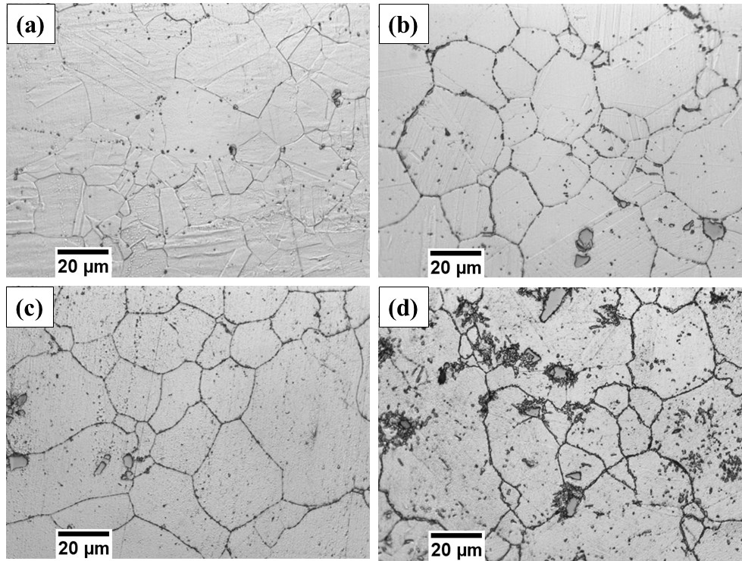
Fig. 1. Optical micrographs in (a) the as-received condition, and aged at 750 ºC for (b) 46, (c) 470, and (d) 6000 hours. An increase in the grain boundary precipitate fraction with the increase in aging duration can be observed.

The measured ASTM grain size numbers of the alloy in the AR and aged conditions are listed in Table 3. As per convention, a larger ASTM grain size number corresponds to a smaller average grain size. Since the grain boundary and the boundaries of the annealing twins in AR alloy have similar contrast, automated grain size measurements on it could not be performed. Nevertheless, its ASTM grain number is determined to be 4 by visual examination. From this table, it appears that the average grain size of the AR alloy is much larger compared to that of the aged alloys. However, this is an incomplete representation of the size of grains in the aged alloys as they are bimodally distributed. For this reason, the two modes of the grain size, m₁ and m₂, in each aged alloy are also measured and listed in Table 3. It is evident that alloys aged for a longer duration have a larger m₂ but a smaller m₁. For instance, for the sample aged at 750 ºC for 46 hours, m₂ ~ 107 ± 21 μm and m₁ ~ 19 ± 3 μm. However, those aged for 470 and 6000 hours at the same temperature have m₂ ~ 110 ± 21 and 163 ± 48 μm, and m₁ ~ 17 ± 4 and 14 ± 3 μm, respectively. A similar pattern of changes in the grain size distribution is observed for alloys aged at 800 ºC when the ageing time increases from 46 to 470 hours. A comparison of the grain numbers for alloys aged at 750 and 800 ºC, for the same duration of time (say 46 hours), reveals that higher ageing temperature also promotes higher m₂ but lower m₁. This is consistent with the mechanism of competitive grain growth which suggests that smaller grains shrink at the expense of larger grains [31].

Table 3. Grain sizes in aged specimens estimated using ASTM E112 Abrams three-circle procedure and explicit mean size of measurements of large grains and small grains by manual methods [27].

Aging condition |  | ASTM grain size number | Average size of small grains, m₁ (µm) | Average size of large grains, m₂ (µm)
Temperature (ºC) | Duration (hours) | ASTM grain size number | Average size of small grains, m₁ (µm) | Average size of large grains, m₂ (µm)
750 | 46 | 7.03 | 19.1 ± 2.9 | 106.9 ± 20.6
750 | 470 | 6.53 | 17.0 ± 3.7 | 110.4 ± 20.9
750 | 6000 | 6.06 | 14.2 ± 3.4 | 163.1 ± 48.3
800 | 46 | 6.36 | 16.2 ± 2.5 | 110.3 ± 21.8
800 | 470 | 6.26 | 16 ± 4.1 | 126.2 ± 30.1
850 | 46 | 6.86 | 17.9 ± 3.9 | 99.3 ± 22.1

Next, an analysis of the phases and precipitates present in the AR and aged alloys is conducted. SEM images taken from them in the backscatter electron (BSE) mode, which allows us to discern different phases by their relative contrast, are shown in Fig. 2. Based on the EDS analysis (see Fig. S3), several different precipitates were identified in the γ matrix and grain boundaries of the aged alloys. These precipitates have been labeled in the images for reference. For instance, the MC type precipitates, Ti, Mo-rich carbides, have a dark grey contrast while Ti(C,N) is much darker in comparison. The M₆C type precipitates (Mo-rich phase), are the brightest, whereas the M₂₃C₆ type precipitates (Cr-rich carbides) have a contrast similar to that of the matrix. Overwhelmingly, the grain boundary precipitates were either M₂₃C₆ type or the M₆C type [5]. The corresponding EDS spectra of these precipitates, shown in Fig. S3, confirm their identity and compositions.
These images also reveal some important details regarding the growth characteristics of the precipitates as a function of ageing time. When the alloy is aged for 46 and 470 hours at 750 ºC, the volume fractions of MC and M₆C within the grains and at grain boundaries and M₂₃C₆ carbides at grain boundaries increase. On ageing the alloy for 6000 hours, several white, needle-shaped precipitates form within the matrix and around the MC carbides. EDS analysis of these new precipitates indicate that they are rich in Molybdenum (see Fig. S4). A TEM image of such a precipitate is shown in Fig. S4(c), along with the selected area electron diffraction pattern (SAED) obtained from it. On its basis, the precipitate is identified that it is the topologically closed packed (TCP) µ phase [11] with a hexagonal crystal structure and (Ni,Co,Fe)₇Mo₆ stoichiometry [32,33]. Higher magnification images of the grain boundaries are shown in Fig. S5. These images capture the evolution of the other carbides at grain boundaries with ageing. In specimens that were aged for short durations (46 hours), carbides appear to be distributed in a discrete fashion along the grain boundaries. However, with increasing ageing duration, a highly interconnected carbide network forms along the grain boundary (see Fig. S5(d)). Simultaneously, tiny dark precipitates, identified as γ’ precipitates, were also found embedded within the matrix. Note that these precipitates become resolvable in the SEM only because they coarsen significantly during long term ageing of the alloy. Otherwise, in alloys that were aged for smaller durations, they could be observed only via TEM.

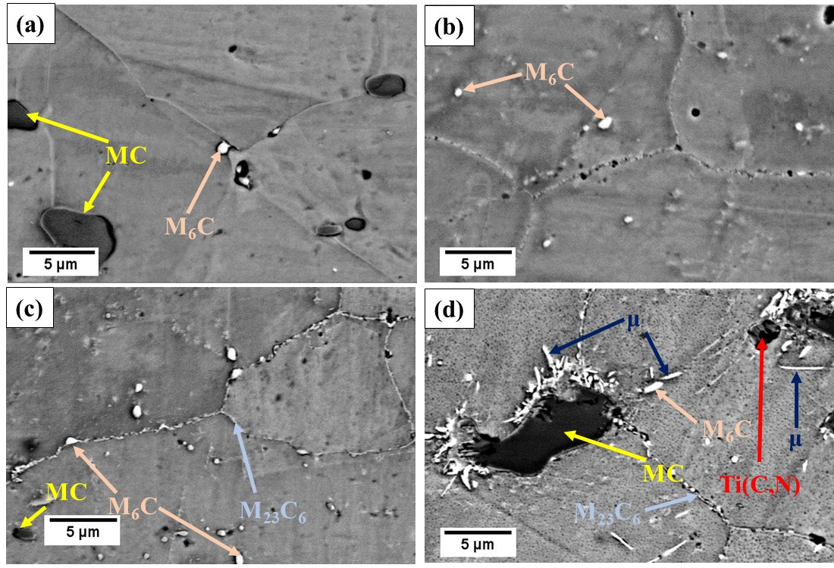
Fig. 2. Back scattered electron micrographs of the alloy (a) in the as-received condition and aged at 750 ºC for (b) 46, (c) 470, and (d) 6000 hours.

Figs. 3(a) and 3(b) display the bright field TEM images of alloys aged at 750 ºC for 46 hours. Inset shows the SAED pattern of the region in Fig. 3(a). From these images, it is evident that the grain boundaries contain discrete M₂₃C₆ precipitates and the γ matrix contains several spherical γ’ precipitates, which have an average diameter of ~20.4 ± 4.2 nm with the interparticle spacing of 10.7 ± 2.4 nm. Figs. 3(c) and 3(d) are TEM images of alloys aged at 750 ºC for 6000 hours and at 850 ºC for 46 hours, respectively. While γ’ precipitates are still spherical, they coarsen considerably (119.6 ± 27.1 nm and 74.6 ± 14.8 nm, respectively), with a concomitant increase in the interparticle spacing (45.8 ± 21.2 nm and 37.0 ± 10.4 nm, respectively). Additionally, while several M₂₃C₆ precipitates embellish the grain boundary in the alloy aged at 750 ºC for 6000 hours, they form within the grains in the alloy aged at 850 ºC for 46 hours. Fig. 4 shows the HRTEM image of the γ/γ’ interface in the alloy aged at 750 ºC for 6000 hours. From the fast Fourier transforms (FFTs) of the locations enclosed with dotted rectangles, γ and γ’ phases are identified. While the γ/γ’ interface has a slight misorientation (marked by red and yellow lines), it is largely coherent. A similar interface coherence is expected in the other two alloys as well, as they have smaller γ’ precipitates. Also, due to the coherence, the misfit strain at the interface is low, which preserves the sphericity of the γ’ phase [34,35]. Elemental mapping conducted in the Scanning Transmission Electron Microscopy (STEM) mode (see Fig. S6)) reveals that γ is rich in Cr, Mo, Mn and Co whereas Al, Ti and Ni partition into γ’. In Table S1, a complete list of all phases and precipitates present in the alloy is provided. However, studying the sequence of precipitation and growth of these precipitates is beyond the scope of the present study.

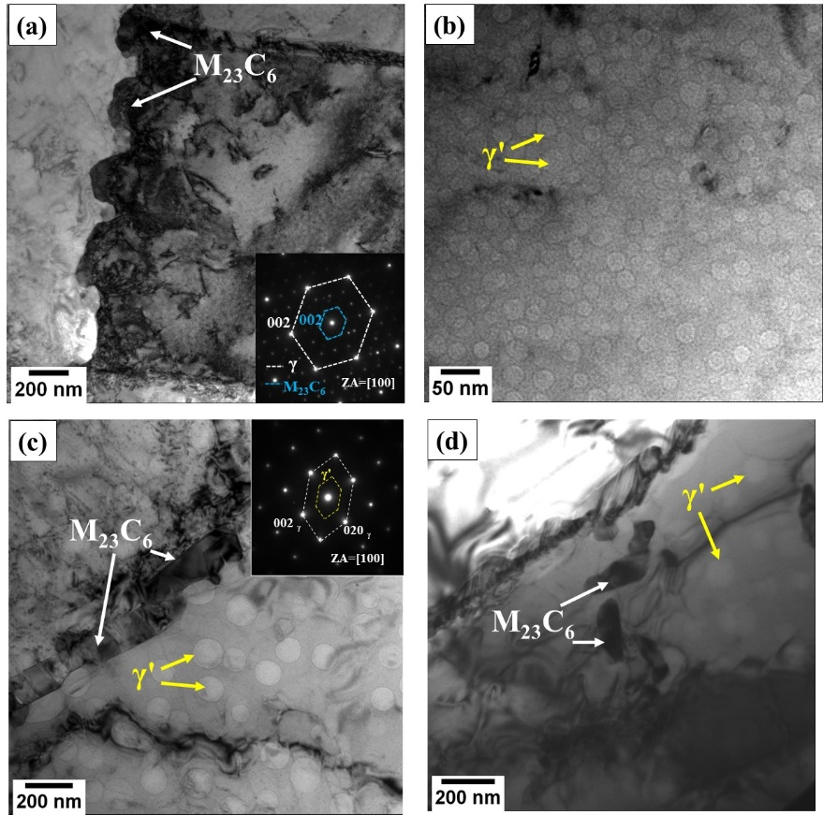

Fig. 3. Bright field TEM micrographs indicating (a) a few M₂₃C₆ precipitates at the grain boundary of alloy aged at 750 ºC for 46 hours with inset indicating SAED pattern obtained from matrix and M₂₃C₆ precipitates, (b) γ’ precipitates within the grain of alloy aged at 750 ºC for 46 hours, (c) M₂₃C₆ precipitates at grain boundary and γ’ precipitates within the grain of alloy aged 750 ºC for 6000 hours with inset indicating SAED pattern obtained from matrix and superlattice reflections from γ’, (d) M₂₃C₆ and γ’ precipitates within the grain of alloy aged 850 ºC for 46 hours. Note that the γ’ phase has a slight brighter contrast in comparison with that of the matrix (γ).

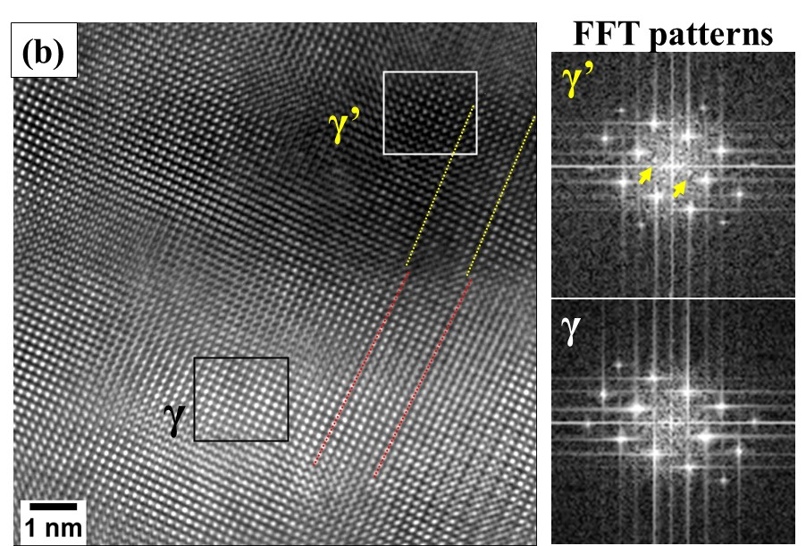
Fig. 4. High resolution TEM micrograph of alloy aged at 750 ºC for 6000 hours showing γ and γ’ phases along with their respective FFT patterns. Additional spots due to γ’ are indicated in its FFT pattern by yellow arrows.

The microstructural analyses conducted hitherto reveal that several significant changes occur during the ageing of alloy 282. An increase in the ageing duration and/or ageing temperature changes the bimodal grain size distribution to a unimodal one and also promotes the precipitation of different types of carbides at the grain boundaries. The increase and decrease in the value of m₂ and m₁, respectively, indicate that larger grains coarsen at the expense of smaller grains. However, this process is sluggish as grain boundary mobility is limited by the presence of multiple phases present at the grain boundaries. Additionally, ageing at 750 ºC promotes: (i) progressive coarsening of γ’, (ii) the precipitation of the acicular μ phase, and (iii) the formation of a thick interconnected network of grain boundary carbides. Ageing at 850 ºC accelerates processes (i) and (ii) in addition to facilitating the formation of carbides within the grains.

3.2. Mechanical properties in the AR and aged conditions
3.2.1. Tensile properties
Representative tensile stress (σ) - strain (ε) responses of AR and aged alloys at T_{tensile} = 25, 700, and 750 ºC are presented in Figs. 5 (a), (b) and (c), respectively. From these curves, mechanical properties such as yield strength (YS), ultimate tensile strength (UTS) and % elongation, η, are extracted and summarized in Table 4. An examination of this data leads to the following observations. Overall, for any particular T_{tensile}, YS and UTS of all the aged alloys are significantly higher than that of the AR alloy. YS of the alloy aged at 850 ºC for 46 hours is comparatively lower than those aged at 700 and 750 ºC. Moreover, when the AR alloy is tested at T_{tensile} ~700 ºC, YS and UTS drop by ~27% and ~15%, respectively, compared to that measured at T_{tensile} of ~25 ºC. Further increase in T_{tensile} to 750 ºC has negligible effect on these properties.
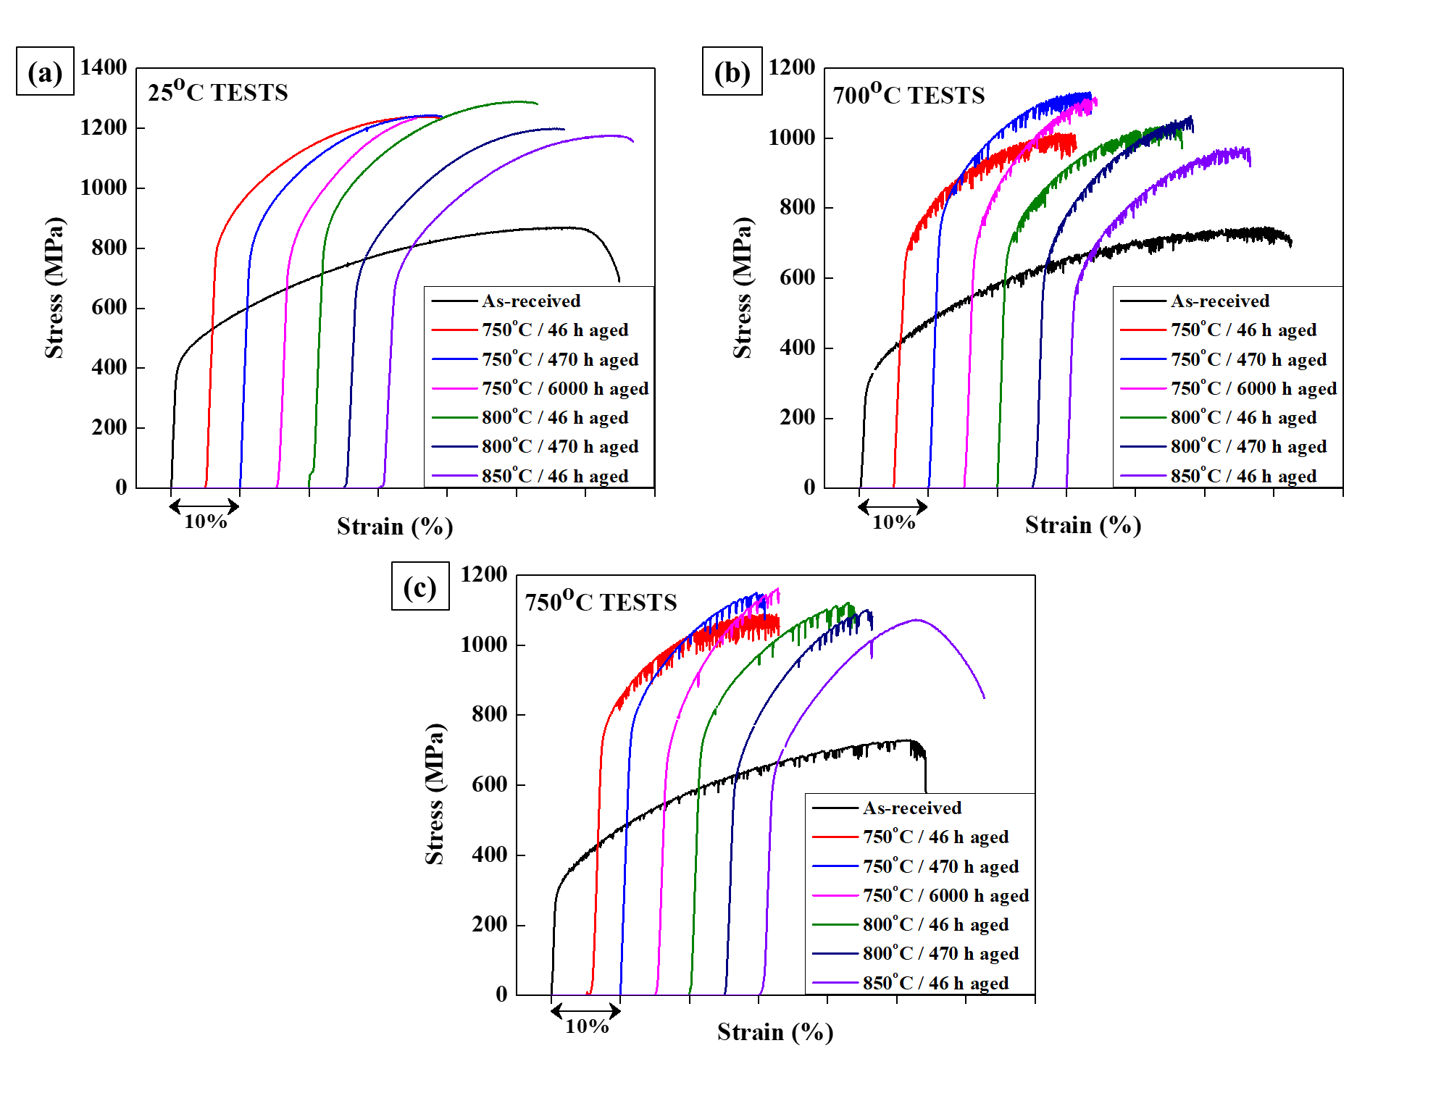
Fig. 5. Tensile stress-strain responses of as-received and aged alloys at (a) 25 ºC, (b) 700 ºC and (c) 750 ºC.

In contrast, the YS of the aged alloys is the same at all T_{tensile} (within a reasonable margin of error) irrespective of the T_{o} they were aged at. The two exceptions were the alloys aged at 750 and 850 ºC for 46 hours and tested at T_{tensile} ~700 ºC. In both the cases, some softening could be noted, as compared to their respective counterparts that were tested at T_{tensile} ~25 ºC. The rationale for this is provided later. UTS of the all the aged alloys are less by 10-20% when they are tested at higher temperatures (T_{tensile} ~700 and 750 ºC), compared to their corresponding counterparts tested at T_{tensile} ~25 ºC. This decrease in the extent of strain hardening when aged alloys are deformed at elevated temperatures is expected as higher temperatures promote accelerated recovery processes. Interestingly, YS and UTS of aged alloys at any given T_{tensile} are largely insensitive to t_{o} and T_{o}, i.e., increasing the ageing time or ageing temperature appears to have a minimal effect on these two properties.
In the context of ductility, of all the alloys considered, the AR alloy has the highest η of ~50-65% at all T_{tensile}. While η is affected dramatically by t_{o}, it is insensitive to T_{tensile} and T_{o}. In fact, η of alloys aged for 46, 470, and 6000 hours, are 2, 3 and 4 times lower than that of the alloy in the AR conditions, respectively. In all, the above results indicate that subjecting the alloy 282 to elevated temperatures, even for short durations (~46 hours), significantly increases its strength but deteriorates ductility by a greater measure. Moreover, while further exposure to elevated temperatures does not affect the former, the latter continues deteriorating.

Table 4. Mechanical properties in AR and aged conditions.

Condition | T (ºC) | YS (MPa) | UTS (MPa) | η (%) | IE (J) | Hardness (HV₅)
AR | 25 | 404 ± 11 | 868 ± 9 | 60 ± 3 | 224 ± 6 | 205 ± 11
AR | 700 | 291 ± 16 | 741 ± 11 | 64 ± 7 | - | -
AR | 750 | 321 ± 28 | 734 ± 12 | 53 ± 2 | - | -
Aged at 750 ºC for 46 hours | 25 | 789 ± 25 | 1228 ± 21 | 29 ± 1 | 42 ± 1 | 354 ± 13
Aged at 750 ºC for 46 hours | 700 | 633 ± 2 | 990 ± 33 | 26 ± 2 | - | -
Aged at 750 ºC for 46 hours | 750 | 775 ± 33 | 1090 ± 3 | 24 ± 1 | - | -
Aged at 750 ºC for 470 hours | 25 | 753 ± 34 | 1255 ± 37 | 26 ± 1 | 29 ± 2 | 359 ± 10
Aged at 750 ºC for 470 hours | 700 | 797 ± 9 | 1121 ± 15 | 22 ± 1 | - | -
Aged at 750 ºC for 470 hours | 750 | 748 ± 46 | 1135 ± 12 | 18 ± 2 | - | -
Aged at 750 ºC for 6000 hours | 25 | 751 ± 4 | 1232 ± 10 | 17 ± 1 | 16 ± 2 | 355 ± 12
Aged at 750 ºC for 6000 hours | 700 | 698 ± 14 | 1122 ± 9 | 18 ± 1 | - | -
Aged at 750 ºC for 6000 hours | 750 | 694 ± 15 | 1149 ± 14 | 16 ± 0.5 | - | -
Aged at 800 ºC for 46 hours | 25 | 818 ± 8 | 1263 ± 44 | 29 ± 1 | 41 ± 2 | 348 ± 10
Aged at 800 ºC for 46 hours | 700 | 663 ± 31 | 1044 ± 45 | 24 ± 1 | - | -
Aged at 800 ºC for 46 hours | 750 | 739 ± 37 | 1112 ± 9 | 21 ± 1 | - | -
Aged at 800 ºC for 470 hours | 25 | 693 ± 22 | 1201 ± 8 | 28 ± 2 | 36 ± 2 | 323 ± 9
Aged at 800 ºC for 470 hours | 700 | 667 ± 7 | 1056 ± 9 | 20 ± 0.5 | - | -
Aged at 800 ºC for 470 hours | 750 | 698 ± 4 | 1098 ± 9 | 18 ± 1 | - | -
Aged at 850 ºC for 46 hours | 25 | 685 ± 14 | 1173 ± 13 | 34 ± 3 | 55 ± 3 | 310 ± 9
Aged at 850 ºC for 46 hours | 700 | 562 ± 18 | 985 ± 14 | 24 ± 1 | - | -
Aged at 850 ºC for 46 hours | 750 | 640 ± 24 | 1054 ± 30 | 30 ± 1 | - | -

3.2.2. Serrations in the flow curves
It was noted that the flow curves of AR and aged alloys at T_{tensile} ~ 25 ºC are smooth, whereas those tested at T_{tensile} ~ 700 and 750 ºC, exhibit serrations reminiscent of dynamic strain ageing (DSA). The number of serrations, N_{s}, strain at which they appear, ε_{c}, average stress drop, Δσ_{avg}, and average strain between two consecutive serrations, Δε_{BS-avg}, in each stress-strain response were quantified and are listed in Table 5. The flow curves of AR and alloy aged at 750 ºC for 470 hours at T_{tensile} ~ 700 and 750 ºC are magnified and the representative serrations and their types are shown in Figs. 6 and 7. Type C serrations were observed in the flow curves of all the aged alloys irrespective of T_{o} and t_{o}. The AR alloys initially exhibit type A serrations in the ε range of ~ 1.7 to 5.89 % and ~ 3.06 to 5.01 % at T_{tensile} ~ 700 and 750 ºC, respectively. Thereafter, the serrations transition to a mixture of types A and B up to a ε of ~ 33.5 % and ~ 22 % at T_{tensile} ~ 700 and 750 ºC, respectively, and finally to type C until failure. A more detailed analysis of the types of serrations and their implications will be addressed later.

Table 5. Serrated flow properties and behavior in AR and aged conditions.

Test Temperature |  | 700 ºC |  |  |  | 750 ºC
Ageing condition |  | N_{s} | ε_{c} (%) | Δσ_{avg} (MPa) | Δε_{BS-avg} (%) |  | N_{s} | ε_{c} (%) | Δσ_{avg} (MPa) | Δε_{BS-avg} (%)
T_{o} (ºC) | t_{o} (h)
AR |  | 323 | 1.70 | 13.74 ± 9.68 | 0.19 ± 0.12 |  | 136 | 3.06 | 11.82 ± 9.82 | 0.38 ± 0.37
750 | 46 | 150 | 2.20 | 29.02 ± 14.5 | 0.16 ± 0.09 |  | 111 | 4.40 | 36.61 ± 16.49 | 0.21 ± 0.15
750 | 470 | 66 | 3.92 | 28.07 ± 12.3 | 0.30 ± 0.28 |  | 21 | 8.47 | 32.68 ± 9.74 | 0.62 ± 0.55
750 | 6000 | 70 | 2.25 | 17.77 ± 10.31 | 0.25 ± 0.15 |  | 13 | 6.266 | 28.61 ± 7.69 | 0.96 ± 0.87
800 | 46 | 116 | 2.35 | 24.95 ± 9.95 | 0.21 ± 0.17 |  | 23 | 10.06 | 38.83 ± 12.15 | 0.62 ± 0.71
800 | 470 | 107 | 2.20 | 15.66 ± 8.86 | 0.20 ± 0.13 |  | 16 | 10.76 | 30.48 ± 10.76 | 0.70 ± 0.51
850 | 46 | 110 | 1.55 | 18.07 ± 10.5 | 0.23 ± 0.16 |  | 1 | 16.32 | 46.97 | -

At T_{tensile} ~700 ºC, variations in N_{s} match the variations of η for AR and aged alloys. For instance, N_{s} of AR alloys ~323, whereas that of alloy aged at T_{o} ~750 ºC for t_{o} ~46, 470 and 6000 hours are 2-4 times lower. This correlation between η and N_{s} suggests that serrated flow accompanies plastic deformation until failure. While a weak correlation between N_{s} and η is also observed at T_{tensile} ~750 ºC, it is not as explicit and direct as that seen at T_{tensile} ~700 ºC. This is probably because the flow curves of all alloys at T_{tensile} ~750 ºC are smooth between intermittent occurrence of serrations. In fact, N_{s} is only ~136 for the AR alloy tested at T_{tensile} ~750 ºC, despite having only a slightly lower η than when tested at T_{tensile} ~700 ºC. A similar reduction in N_{s} at T_{tensile} ~750 ºC compared to that at T_{tensile} ~700 ºC is also observed for all the aged alloys. In fact, in the case of the alloy aged at 850 ºC for 46 hours, only 1 serration in the flow curve is observed.

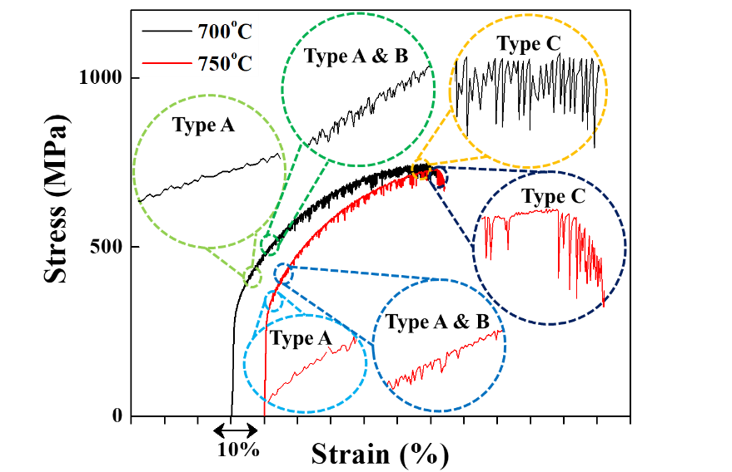
Fig. 6. Tensile stress-strain response of as-received alloy showing change in the type of serrations from “A” to “A & B” to “C” with increase in strain at 700 ºC and 750 ºC.

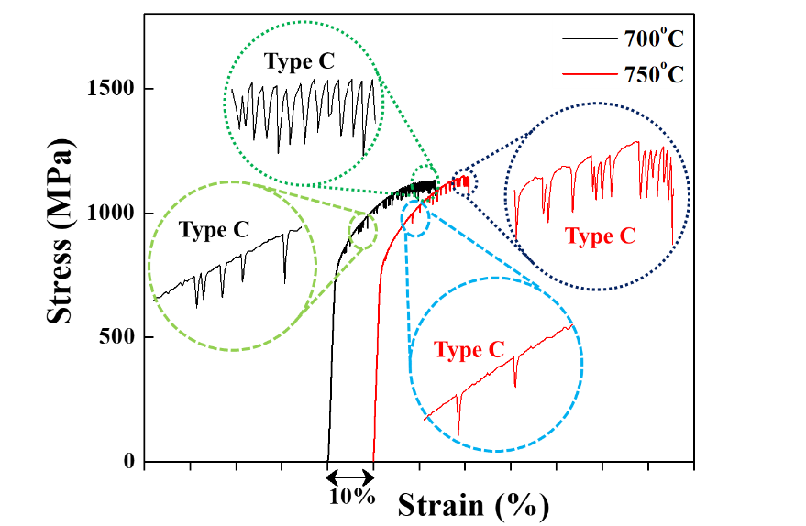
Fig. 7. Tensile stress-strain response of alloy aged at 750 ºC for 470 hours showing typical “C” type of serrations at 700 ºC and 750 ºC.

The aged alloys have serrations whose Δσ_{avg} ranges from 15-29 MPa, whereas that of AR alloy is 13.74 MPa at T_{tensile} ~700 ºC. Similarly, Δσ_{avg} of AR alloy is lower than aged alloys even at T_{tensile} ~700 ºC. Moreover, Δσ_{avg} of serrations in aged alloys are 30-40% MPa higher in magnitude when tested at T_{tensile} ~750 ºC compared to that at ~700 ºC. Similarly, Δε_{BS-avg} of alloys tested at T_{tensile} ~750 ºC is generally at least twice as high as those tested at ~700 ºC, with the only exception of alloy aged at T_{o} ~750 ºC for t_{o} ~46 hours. Also, ε_{c} for alloys tested at T_{tensile} ~700 ºC are in the range of 1.55-3.92, whereas those tested at 750 ºC have significantly larger range of 3.06–16.32. This indicates that the appearance of serrations occurs at higher strains when T_{tensile} is higher.
The variations in the magnitude of individual stress drops, Δσ, of all alloys tested at T_{tensile} ~ 700 and 750 ºC as a function of ε are shown in Figs. 8 (a) and (b), respectively. Individual scatter of Δσ for different alloys is enclosed in translucent trapezium-shaped envelopes to capture the overall trends in their variations. In general, Δσ increases with increasing ε for all alloys at both T_{tensile}. However, the rate of increase in Δσ is more gradual for AR alloys than that of aged alloys. At T_{tensile} ~ 700 ºC, the peak Δσ is similar for both AR and aged alloys, whereas the peak Δσ at T_{tensile} ~750 ºC for AR alloy is ~35-40% lower than that of aged alloys. Also, the lower ductility of the aged alloys implies that the ε range over which the serrations occur in the aged alloys is smaller compared to that of the AR alloy. Irrespective of the aged condition, the alloy deformed at 750 ºC has lower frequency of serrations, which initiate at a higher ε compared to that deformed at 700 ºC. However, the average scale of serrations, in terms of both drops in σ and increase in ε, is much larger for alloys tested at the higher T_{tensile}.

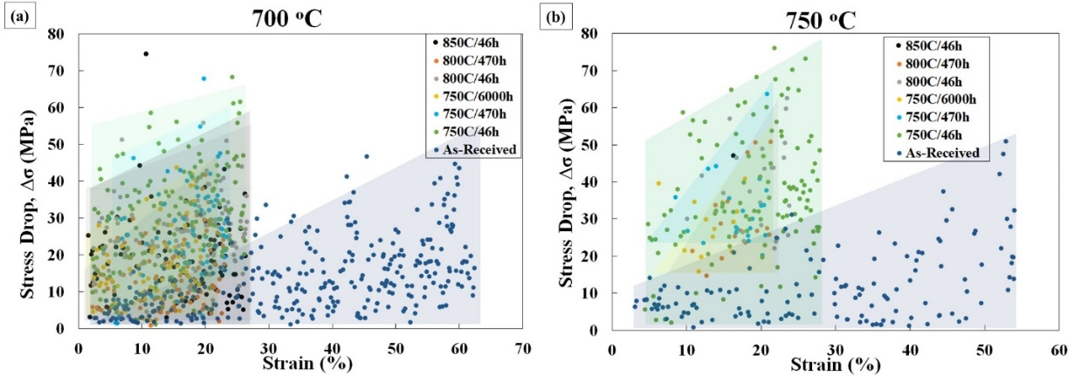
Fig. 8. Data plots showing stress drop (Δσ) due to serrations as a function of strain at (a) 700 ºC and (b) 750 ºC.

3.2.3. Post facto TEM imaging on tensile tested alloy 282
The interactions between dislocations and different microstructural features at the two T_{tensile} is studied in AR and aged alloys by performing TEM investigations on their tensile-tested specimens. TEM images of AR alloy and that aged at T_{o} ~750 ºC for t_{o} ~46 and ~6000 hours, which were tensile-tested at T_{tensile} ~ 700 ºC, are shown in Figs. 9(a)-(c). The alloy aged at T_{o} ~850 ºC for t_{o} ~46 hours and tensile-tested at T_{tensile} ~ 750 ºC is shown in Fig. 9(d). Comparison of these with the images of the alloys prior to tensile testing (see Fig. 3) indicates that the dense black features in the γ matrix are a dense network of dislocations. From the nature of the dislocation traces, it was determined that planar slip occurred on the {111} planes in both AR and alloy aged at T_{o} ~750 ºC for t_{o} ~46 hours. Also, several dislocation tangles, which form due to the interactions of dislocations on adjacent slip planes were observed (marked with white dotted circles in Figs. 9(a) and 9(b)). In contrast, wave slip is observed in the alloy aged at T_{o} ~750 ºC for t_{o} ~6000 hours, Fig. 9(c). Although the alloy aged at T_{o} ~850 ºC for t_{o} ~46 hours and tensile-tested at T_{tensile} ~ 750 ºC also exhibits characteristics of planar slip, its γ matrix has a considerably lower density of dislocations, Fig. 9(d).
With respect to the size of γ’ precipitates in these tensile-tested specimens, it was observed that only those in the alloy aged at T_{o} ~750 ºC for t_{o} ~6000 hours (T_{tensile} ~ 700 ºC) coarsen to 134.3 ± 17.8 nm while their interparticle spacing increases to 72.4 ± 14.4 nm. γ’ in other aged conditions retain their original dimensions. The occurrence of wavy slip in alloy aged at T_{o} ~750 ºC for t_{o} ~6000 hours is attributed to the coarsening of γ’ precipitates. It was suggested that when dislocations encounter relatively larger γ’ precipitates (diameter > 80 nm), their glide is hindered. This forces them to climb with further increase in plastic strain [36]. Distinct slip traces and surface offsets were observed in the γ’ precipitates (marked by dotted white circles) present in all the alloys, which indicates that they were also sheared during deformation. Similar slip traces were also reported by Zhang et al. [13] in alloy 282 post deformation. From the above results, it appears that alloy 282 undergoes planar slip when deformed at higher temperatures, in the AR and aged conditions, with the exception of alloys with much coarser precipitates.

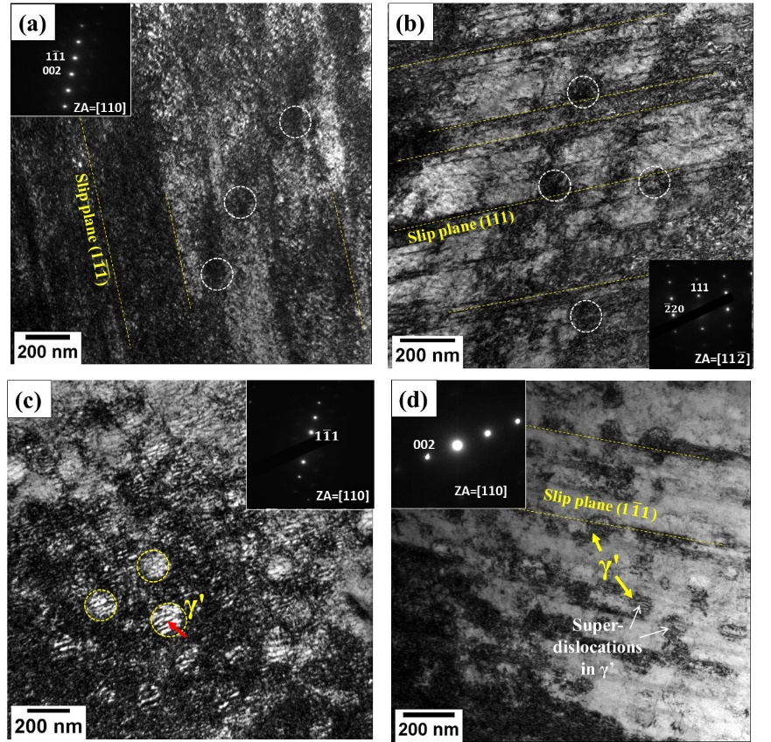
Fig. 9. TEM micrographs of post tensile test samples (a) in as-received condition and (b) aged at 750 ºC for 46 hours, both tested at 700ºC, showing planar slip and dislocation cells (enveloped by white lines) formation after tensile deformation; (c) aged at 750 ºC for 6000 hours tested at 700ºC showing wavy slip with high dislocation density in the matrix and superdislocations (indicated by red arrow) in γ’ (enveloped by yellow lines); (d) Alloy aged at 850 ºC for 46 hours tested at 750ºC showing planar slip along with superdislocations in γ’. (a, c, d) were imaged using quasi two beam mode whereas (b) is imaged using conventional mode.

3.2.4. Fractography
Fig. 10 shows the fractographs obtained from the tensile tested (at 25 ºC) AR alloy and the alloys that were aged at 750 ºC for different t_{o}. The AR alloy has a relatively flat fracture surface and contains typical ductile fracture features, such as dimples, which are characteristic of microvoid coalescence (Fig. 10(a)). In contrast, the fracture surfaces of all the three aged alloys (see Figs. 10 (b), (c) and (d)) is corrugated and faceted, indicating the occurrence of brittle intergranular fracture. This transition from transgranular failure in the AR state to intergranular failure in the aged state is also seen for specimens aged at all T_{o} (750, 800, and 850 ºC) and tested at all T_{tensile} (~ 25, 700, and 750 ºC) (See Figs. S7 to S11). It is worth noting that the reduction in the ductility of the aged specimens coincides with the transition in the fracture morphology of the tensile tested specimens of alloy 282.

3.2.5. Hardness and impact tests
Next, we examine the hardness variations for determining the influence of different phases and precipitates. The values of Vickers hardness for AR and aged alloys are listed in Table 4. While the AR alloy has a hardness of 205 ± 11 HV, ageing it at T_{o} ~750 ºC for 46 hours can increase it to 354 ± 13 HV. For the same t_{o}, the hardness of the alloy aged at T_{o} ~800 ºC is similar, but drops to 310 ± 9 HV at T_{o} ~850 ºC. These trends are similar to that of YS measured from tensile tests conducted at T_{tensile} = 25 ºC for the same set of ageing parameters. However, the hardness, like YS and UTS, appears to be insensitive to the ageing duration as the alloys aged at T_{o} ~750 ºC for different t_{o} are similar. However, the dramatic reduction in hardness of the alloy aged at T_{o} ~800 ºC for 470 hours compared to that aged at 46 hours, suggests otherwise. Note that it is speculative to predict a trend in hardness for alloys aged at T_{o} ~800 ºC as data from higher t_{o} is unavailable.

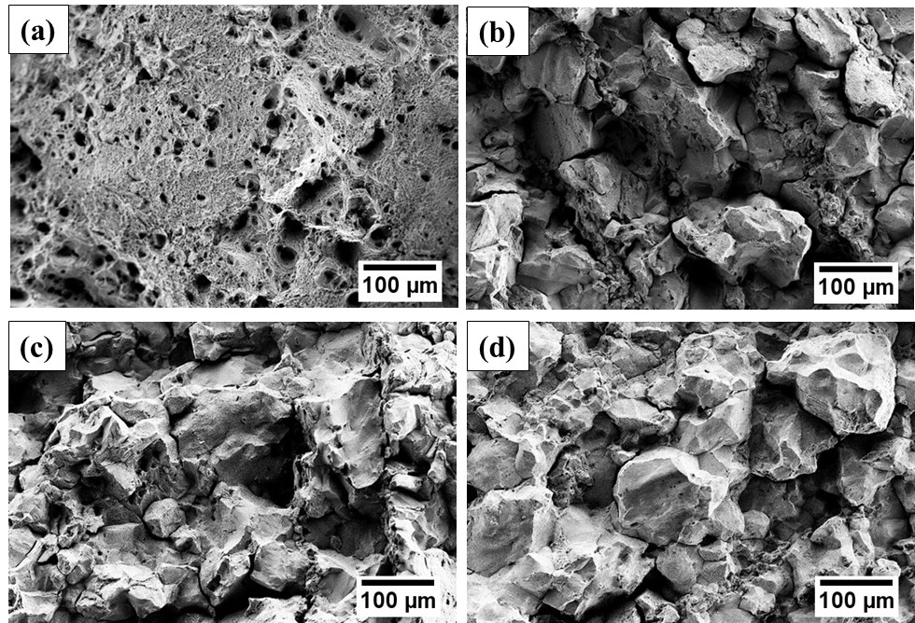
Fig. 10. Scanning electron micrographs showing representative fractured surface features on tensile tested samples at 25 ºC for the alloy (a) in AR condition, and aged at 750 ºC for (b) 46, (c) 470, and (d) 6000 hours.

The Impact Energies (IE) of AR and all aged alloys are listed in Table 4. Prior to ageing, the alloy’s IE is ~ 224 J. In comparison, for alloys aged at T_{o} ~800 and 750 ºC for 46 hours, IE drops dramatically to 40 J. The alloy aged at T_{o} ~850 ºC is also brittle compared to the alloy in the AR state, but is marginally tougher than the above mentioned cases with IE ~ 55 J. A concomitant improvement in impact toughness and decrease in hardness for the alloy aged at T_{o} ~850 ºC is related to the relatively lower volume fraction of M₂₃C₆ carbides at the grain boundaries as they dissolve in the matrix above ~805 ºC and form within the grain (see Fig. 3 (d)) [11]. Although the presence of M₂₃C₆ carbides improve the strength of grain boundaries, it also embrittles them. Ageing for longer durations further embrittles the alloys as IE are ~30 and 15 J for alloys aged at T_{o} ~750 ºC for 470 and 6000 hours, respectively. The fractographs of impact tested AR alloy and the alloy aged at T_{o} ~750 ºC at t_{o} ~ 46, 470 and 6000 hours are shown in Fig. S12, indicating transition from ductile dimple features to brittle intergranular fracture features. Fig. S13 displays fractographs of impact tested alloy aged at T_{o} ~800 ºC at t_{o} ~ 46 and 470 hours and T_{o} ~850 ºC at t_{o} ~ 46 hours, which shows similar transition in fracture surface morphology. A good match between the fractographic features of the impact tested specimens and those of the tensile tested specimens, discussed in section 3.2.1, further confirms that alloy 282 embrittles with long term ageing.

4. Discussion
4.1. Strength, hardness, ductility and impact toughness
The increase in YS and hardness of 282 with ageing is primarily attributed to the precipitation of the γ’ phase [11-13]. This phase introduces a precipitation hardening effect during plastic deformation that becomes even more prominent at elevated temperatures. Since γ’ is an ordered phase, it obstructs dislocations during plastic deformation despite being a coherent precipitate. A brief explanation of dislocation interaction with γ’ is as follows. When a dislocation, with a Burgers vector, $\vec{b}$, in the γ (matrix) enters γ’, the perfect ordering of γ’ gets disrupted. Given that the ordered γ’ phase has an L1₂ structure, $\vec{b}$ in it is twice that of γ phase. For energy minimization, the order in γ’ is restored by a trailing dislocation. Therefore, shearing of γ’ occurs by a pair of dislocations, referred to as super-dislocations. The region between these super-dislocations is known as anti-phase boundary (APB). Note that slip of dislocations occurs in γ, γ’ on {111}<110> (see Figs. 9(a), (b) and (d)). During slip of dislocations, there is also a tendency of super-dislocations to cross-slip onto {100} planes where APB energy is lower. This leads to locking of these dislocations, also referred to as Kear-Wilsdorf lock, and is responsible for the increase in strength of superalloys. As the temperature increases, the cross-slip of dislocations on {100} increases, which increases the extent of dislocation locking. Enhanced locking at higher temperatures is the reason why aged alloys retain their strength at high testing temperatures (i.e. T_{tensile} ~ 700 ºC and 750 ºC) [13,37]. It then follows that alloys that do not contain γ’ precipitates, such as AR alloys, and alloys aged at 750 and 850 ºC for 46 hours, will be relatively softer at elevated temperatures than at ambient temperatures (see Table 4). These observations agree with the tensile deformation studies conducted on alloy 282 below 760 ºC [13].
The precipitation of grain boundary carbides during ageing are also expected to contribute to strengthening, whose extent of contribution is not expected to be significant given that an increase in volume fraction of carbides with increasing t_{o} at T_{o} ~750 ºC appears to have no effect on the alloy YS and hardness. However, the marginal drop in YS and hardness of alloys aged at T_{o} ≥ 800 ºC suggests otherwise. Note that ageing promotes the precipitation of M₂₃C₆ precipitate along grain boundaries in alloy 282. While these precipitates should be present in all aged alloys, they are stable only up to a temperature of ~805 ºC [11]. Therefore, alloys aged at T_{o} ≥ 800 ºC are expected to have lower volume fraction of these carbides, resulting in its comparatively lower strength. Absence of the M₂₃C₆ precipitate in the AR alloy is because it was solution annealed in the temperature range of 1150 ± 30 ºC.
It is also noteworthy that the fracture features in the tensile tested and impact tested specimens of the aged alloys exhibit inter-granular fracture features. The degree of faceting in the fracture features is higher for alloys that were aged for longer durations. This implies that in aged alloys the grain boundaries are less resistant to cracking than the grains and are preferred paths for crack propagation prior to failure. Given that carbides preferentially precipitate at the grain boundaries (see Fig. 3(c)) [11,38] unlike γ’, which precipitates uniformly during ageing [11, 12], it can be asserted that their formation is solely responsible for the embrittlement of the alloy. Furthermore, a higher degree of faceting with an increase in ageing duration suggests that the formation of grain boundary carbide networks further embrittles the alloy.
Based on the results obtained in the study, the following assessment of the AA approach is made. The values of YS and UTS of the alloys aged at the three ageing conditions listed in Table 2 for simulating the damage accumulated in an alloy at 700 ºC for 100,000 hours are broadly similar. However, the similarities end there as the ductility and toughness of the alloys subjected to the ageing conditions are significantly different. This implies that the accelerated ageing methodology may not necessarily mimic the actual damage accumulated in the alloy at the prescribed service conditions.
The AA approach does not provide a good extrapolation of the target aged state due to the following reasons. In the formulation of LMP, indicated in equation (1), C is considered as ‘20’. This value of C is extracted from some previous studies on the same material [3,14,30]. However, Furillo et al. [39] suggested that C is a complex parameter, which depends on the alloy system, test environment, creep activation energy, structure constant and the Garofalo exponent.
The AA approach that employs LMP would function seamlessly when the test environment, microstructural features, alloy system and localized composition in the alloy remain the same within the range of anticipated operating temperature and duration. For example, in 1-2% CrMoV steels, this methodology works well for long-term damage simulation in the 560 to 600 ºC temperature range [23], by employing higher temperatures and shorter durations (described in Section 2.2).
However, in case of Ni-base superalloys, a variety of microstructural changes occur in the 750 to 850 ºC temperature range, as mentioned in Section 3.1. The AA methodology does not consider such changes that occur at different T_{o}. Moreover, the effect of ageing variables, T_{o} and t_{o}, on alloy system, test environment, creep activation energy, structure constant and Garofalo exponent, is unknown. Therefore, the value of C cannot be estimated accurately. Thus, employing the AA methodology for simulating damage via the use of LMP is not suitable for Ni-base superalloys such as alloy 282.

4.2. Dynamic strain ageing
The occurrence of plastic instabilities that manifest as periodic abrupt changes in σ, or serrations in a σ-ε curve, are broadly referred to as the Portevin-Le Châtelier (PLC) effect or dynamic strain ageing (DSA) [40-42]. A detailed description of serration characteristics and physical processes that cause them can be found in the reference [42]. A summary is provided here. The primary mechanism that leads to σ fluctuations during tensile testing of crystalline alloys is the repeated trapping and release of dislocations by solute atoms or some microstructural feature [40,42-44]. Based on their characteristics, five unique types of serrations were identified [42,45]. Type A serrations are characterized by a significant increase in σ followed by its decrease and are widely spaced. They typically occur at low testing temperatures and high strain rates, $\dot{ε}$, and are associated with interactions of dislocations with diffusing solutes. Type B serrations are of low amplitude and high frequency, which occur at slightly higher T and lower $\dot{ε}$. However, types A and B serrations are also reported to occur together in the same flow curve for some alloys [36,42,46-48]. Type C serrations are characterized by a sharp drop in σ followed by a steady increase to its initial magnitude and occur at high T and low $\dot{ε}$. Their formation is attributed to the interactions of dislocations with substitutional solutes. Type D serrations manifest as plateauing σ followed by its increment. The formation of these serrations is an outcome of stress localization in the absence of strain hardening. Serrations that exhibit no pattern in terms of σ fluctuations are categorized as type E serrations.
The PLC effect has been reported in superalloys in both solid-solution and precipitate-strengthened conditions [45-54]. In the former, types A and B serrations are usually observed [42,55,56] and are attributed to the solute atoms such as carbon diffusing to the dislocations and pinning them. Since a higher stress is required to break the dislocation free from the solute atom, σ initially increases slightly before dropping. The free dislocation is again trapped by the diffusing solutes after some time and needs the application of higher σ to escape. The repetitive unpinning and free glide of the dislocations, which requires a σ excursion followed by its drop manifests as type A serrations. This explains why the AR alloy, which is in the solutionized condition, exhibits type A serrations at lower ε in the σ-ε curves at T_{tensile} ~700 and 750 ºC. At higher ε, while several more dislocations form, they are less strongly pinned by carbon atoms. This is because the carbon content in the alloy, which is fixed by the composition, is distributed over a larger number of dislocations. Consequently, the critical σ required to free a dislocation from the solutes diminishes significantly [44-46]. Moreover, at the critical unlocking σ, more dislocations get unlocked, which leads to a larger Δσ. The combination of low unlocking σ and larger Δσ manifests as the transition of serration from type A to C in the flow curves of AR alloys (see Fig. 5). The gradual increase in Δσ with increasing ε, observed in Fig. 8(a) and 8(b), is also the outcome of this phenomenon.
At higher temperatures, a larger concentration of solutes can diffuse to more dislocations at a faster rate due to enhanced diffusion rates. This should not only hasten the onset of DSA but also increase the number of interactions between dislocations and solutes. One would then expect a decrease in ε_{c} and increase in N_{s}, respectively, at higher T_{tensile}. However, the converse was found to be true in our study possibly because higher T_{tensile} also hastens climb of dislocations, which allows them to evade the diffusing solutes. Alternately, serrations are not observed for the flow curves of AR alloy at T_{tensile} ~25 ºC as the thermal input at this temperature is not sufficient to facilitate the diffusion of solutes.
In precipitation strengthened superalloys, only type C serrations are observed in the flow curves [42,55]. The reason behind this is that during the precipitation of γ’, Cr, which has low solubility in it, partitions to the γ matrix (Fig. S6). During deformation at higher temperatures, this excess Cr can diffuse to dislocations and pin them [45,46]. Note that carbon exists in the form of metal carbides in these alloys and hence does not play a role in pinning dislocations [48]. However, the dislocation pinning effect of Cr is much weaker than that of carbon and other interstitial solutes. This is because, the Cr atom, owing to its larger size than C atoms, is less effective in relaxing the strain within dislocation cores. Given that a relatively lower stress is required for freeing the pinned dislocations, such alloys ubiquitously exhibit type C serrations in their flow curves. Since all aged alloys in the current study contain γ’ precipitates and metal carbides, they exhibit type C serrations in their flow curves at T_{tensile} ~700 and 750 ºC. Moreover, the diffusion rate of Cr, being a substitutional solute, is relatively lower in the γ matrix. This manifests as higher ε_{c} for all aged alloys compared to that of the AR alloy at both T_{tensile} examined in this work. It was also noted that higher ageing duration facilitates the formation of secondary M₂₃C₆ precipitates (where M is predominantly Cr) in alloy 282. Since this would deplete Cr in γ, it needs to diffuse longer distances to pin dislocations, leading to smoother slip, which in turn means that N_{s} should decrease. Also, Δε_{BS-avg}, which is the measure of the deformation interval within which a dislocation can unlock itself from a solute, should also increase. This is consistent with the observed increase in Δε_{BS-avg} and diminishing N_{s} with increasing t_{o} (at a specific T_{o}) in aged alloys, at both T_{tensile} of ~700 and 750 ºC (see Table 5).
The following additional observations on the variations in the serration characteristics can be rationalized in a similar manner by recourse to the ‘dislocation interactions with Cr’ mechanism. For instance, much like that seen in the AR alloys, the number of dislocations in aged alloys will also increase with increasing ε, leading to their effective pinning by Cr, which in turn results in progressively increasing Δσ. Moreover, the greater magnitude of Δσ in aged alloys, compared to that in AR alloys, at any ε, is the outcome of the comparatively lower dislocation pinning ability of Cr, compared to that of interstitial C. Note that DSA may still occur despite considerable depletion of Cr (to form M₂₃C₆) as Mo is also capable of locking dislocations [45]. Finally, as mentioned earlier, dislocations escape the diffusing solute at higher testing temperatures. This would lead to the delayed onset of serrations and a smaller number with greater interval between them, i.e., lower N_{s} but higher ε_{c} and Δε_{BS-avg}, respectively for all aged alloys at T_{tensile}~750 ºC compared to those aged at ~700 ºC.
Interestingly, the alloy aged at T_{o} ~850 ºC and t_{o} ~46 hours and tested at T_{tensile} ~750 ºC, exhibits only one serration. We believe that this is possibly due to dissolution of carbides at the grain boundaries at 850 ºC and their subsequent precipitation inside the grains. The absence of carbides at the grain boundaries provides an additional avenue to the dislocations so that they can cross slip to the adjacent grain and avoid getting trapped by Cr. This conclusion is supported by the TEM image shown in Fig. 9(d), where the alloy appears to have comparatively lower dislocation density, possibly because of their escape to adjacent grains.
The observed DSA in alloy 282 is particularly important in the context of thermomechanical processing of it. Jerky plastic flow is undesirable as it introduces dimensional inaccuracies in the component during shaping operations. While it appears that DSA is observed at when alloy 282 is deformed at elevated temperatures, irrespective of the aged condition, the effect of varying the strain rate also needs to be considered. This is because, enhanced strain rate can diminish DSA if dislocations travel fast enough to evade diffusing solutes. To determine the combined effects of strain rate and temperature of testing, a follow-up study is underway.

5. Conclusions
With the objective of studying the effect of thermal ageing on the mechanical behavior of alloy 282, detailed microstructural and mechanical characterizations were performed on the alloy in its AR and 3 different AA states. The following are the key conclusions that can be drawn from this study. While abnormal grain growth was observed during ageing, grain growth is limited as the simultaneous precipitation of carbides at grain boundaries, which coarsen and eventually form a network along the grain boundaries that restrict the motion of grain boundaries. Formation of the network grain boundary precipitates elevates the hardness, YS and UTS of the alloy but is detrimental to its ductility and impact toughness. These mechanical properties vary significantly in each combination of ageing time and temperature, which implies that the LMP-based AA technique cannot be used to simulate a reference aged state for alloy 282. Serrated flow due to DSA was observed in AR and the aged alloys at high temperatures. In the AR alloy, intermittently pinning of the dislocations by the interstitial solute atoms leads to type A serrations at lower strains and type C serrations at larger strains. On the other hand, all the aged alloys contain γ’ precipitates, which leads to increase in the Cr content in the γ matrix. Their weaker dislocation pinning ability compared to carbon leads to type C serrations in the flow curves of aged alloys. The deformation mechanism also is mostly planar slip but alloys containing coarsened γ’ exhibit wavy slip. Thus, ageing also influences the mechanism of deformation in addition to changing flow characteristics.

Acknowledgements
AHVP and KS thank BHEL management for funding this study. AHVP is grateful to BHEL management for sponsoring his doctoral program. Special thanks are extended by AHVP to Mr. D. Kumar, BHEL Corp. R&D for his help in tensile specimen testing. RLN's research at IITD was supported through the Start-up research grant (SRG/2020/000095) of Science and Engineering Research Board, DST, GoI. UR’s research at NTU is supported by Agency for Science, Technology and Research (A*STAR) of Singapore via the Structural Metals and Alloys Programme (No. A18B1b0061).

References
[1] A. Di Gianfrancesco, Materials for Ultra-Supercritical and Advanced Ultra-Supercritical Power Plants, Woodhead Publishing Series in Energy – 104, Elsevier, 2017. https://doi.org/10.1016/C2014-0-04826-5.
[2] P.J. Ennis, Nickel-based alloys for advanced power plant components, in: Ahmed Shilbi (Ed.), Coal Power Plant Materials and Life Assessment, Woodhead Publishing Series in Energy – 62, Elsevier, 2014, pp. 147-167. https://doi.org/10.1533/9780857097323.1.147.
[3] P.F. Tortorelli, H. Wang, K.A. Unocic, M.L. Santella, J.P. Shingledecker, V. Cedro, Long-Term Creep-Rupture Behavior of Inconel® 740 and Haynes® 282, Proceedings of the ASME 2014 Symposium on Elevated Temperature Application of Materials for Fossil, Nuclear, and Petrochemical Industries, ETAM, ASME, 2014, pp. 29–36. https://doi.org/10.1115/ETAM2014-1003.
[4] D.L. Klarstrom, L.M. Pike, V.R. Ishwar, Nickel-Base Alloy Solutions for Ultrasupercritical Steam Power Plants, Procedia Eng. 55 (2013) 221–225. https://doi.org/https://doi.org/10.1016/j.proeng.2013.03.246.
[5] J.R. Robertson, Continued Developments in the Characteristics of HAYNES® 282® Alloy for Use in A-USC Applications, Proceedings of the ASME 2014 Symposium on Elevated Temperature Application of Materials for Fossil, Nuclear, and Petrochemical Industries, ETAM, ASME, 2018, pp. 1-8. https://doi.org/10.1115/ETAM2018-6745.
[6] Y. Yang, R.C. Thomson, R.M. Leese, S. Roberts, Microstructural evolution in cast Haynes 282 for application in advanced power plants, Adv. Mater. Technol. Foss. Power Plants - Proc. from 7th Int. Conf., EPRI (2014) 143–154.
[7] F. Abe, Research and Development of Heat-Resistant Materials for Advanced USC Power Plants with Steam Temperatures of 700 °C and Above, Engineering. 1 (2015) 211–224. https://doi.org/10.15302/J-ENG-2015031.
[8] K.L. Kruger, 15 - HAYNES 282 alloy, in: Materials for Ultra-Supercritical and Advanced Ultra-Supercritical Power Plants, A. Di Gianfrancesco (Ed.), Woodhead Publishing, 2017: pp. 511–545. https://doi.org/https://doi.org/10.1016/B978-0-08-100552-1.00015-4.
[9] A. Mathur, O. P. Bhutani, T. Jayakumar, D. K. Dubey, S. C. Chetal. India’s national A-USC mission—Plan and progress, Adv. Mater. Technol. Foss. Power Plants - Proc. from 7th Int. Conf., EPRI (2014) 53–59.
[10] S.C. Chetal, T. Jayakumar, A.K. Bhaduri, Materials research and opportunities in thermal (coal-based) power sector including advanced ultra super critical power plants, Proc. Indian Natl. Sci. Acad. 81 (2015) 739–754. https://doi.org/10.16943/ptinsa/2015/v81i4/48294.
[11] R. Fu, S. Zhao, Y. Wang, Q. Li, Y. Ma, F. Lin, C. Chi, The microstructural Evolution of Haynes 282 alloy during long-term exposure tests, Proceedings of Energy Materials 2014, Springer, Cham, 2014, pp. 193-202. https://doi.org/10.1007/978-3-319-48765-6_21.
[12] C. Joseph, C. Persson, M. Hörnqvist Colliander, Influence of heat treatment on the microstructure and tensile properties of Ni-base superalloy Haynes 282, Mater. Sci. Eng. A. 679 (2017) 520–530. https://doi.org/10.1016/j.msea.2016.10.048.
[13] P. Zhang, Y. Yuan, H. Yin, Y. Gu, J. Wang, M. Yang, G., Yang, X. Song, Tensile Properties and Deformation Mechanisms of Haynes 282 at Various Temperatures, Metall. Mater. Trans. A. 49 (2018) 1571–1578. https://doi.org/10.1007/s11661-018-4515-5.
[14] L.M. Pike, Haynes®282TM Alloy – A New Wrought Superalloy Designed for Improved Creep Strength and Fabricability, Proceedings of GT2006, ASME Turbo Expo 2006: Power of Land, Sea and Air, ASTM, 2006, pp. 1031-1039, https://doi.org/10.1115/GT2006-91204.
[15] J.A. Hawk, T. Le Cheng, J.S. Sears, P.D. Jablonski, Y.H. Wen, Gamma Prime Stability in Haynes 282: Theoretical and Experimental Considerations, J. Mater. Eng. Perform. 24 (2015) 4171–4181. https://doi.org/10.1007/s11665-015-1711-y.
[16] L.O. Osoba, A.K. Khan, O.A. Ojo, Identification of Mo-based Precipitates in Haynes 282 Superalloy, Metall. Mater. Trans. A. 48 (2017) 1540–1543. https://doi.org/10.1007/s11661-017-3999-8.
[17] H. Yin, Y. Gao, Y. Gu, Effects of post-welding heat treatment on microstructure and mechanical properties of welding joint of new Ni-Fe based superalloy with Haynes 282 filler metal, Mater. Sci. Eng. A. 708 (2017) 118–128. https://doi.org/10.1016/j.msea.2017.09.121.
[18] L.O. Osoba, R.G. Ding, O.A. Ojo, Improved resistance to laser weld heat-affected zone microfissuring in a newly developed superalloy haynes 282, Metall. Mater. Trans. A. 43 (2012) 4281–4295. https://doi.org/10.1007/s11661-012-1212-7.
[19] C.J. Boehlert, S.C. Longanbach, A comparison of the microstructure and creep behavior of cold rolled HAYNES® 230 alloyTM and HAYNES® 282 alloyTM, Mater. Sci. Eng. A. 528 (2011) 4888–4898. https://doi.org/10.1016/j.msea.2011.03.019.
[20] M. Santella, J. Shingledecker, B. Swindeman, Materials for Advanced Ultra-Supercritical Steam Boilers, Session-3, Proceedings of 24th Annual Conference on Fossil Energy Materials. https://www.netl.doe.gov/events/conference-proceedings/2010/fem, 2010 (accessed 06 January 2018).
[21] D.H. Bechetti, J.N. DuPont, J.A. Siefert, J.P. Shingledecker, Microstructural Evolution and Creep-Rupture Behavior of A-USC Alloy Fusion Welds, Metall. Mater. Trans. A. 47 (2016) 4502–4518. https://doi.org/10.1007/s11661-016-3603-7.
[22] X. Song, L. Tang, Z. Chen, R. Zhou, Micro-mechanism during long-term creep of a precipitation-strengthened Ni-based superalloy, J. Mater. Sci. 52 (2017) 4587–4598. https://doi.org/10.1007/s10853-016-0703-0.
[23] S.C. Bose, K.S. Reddy, G.J. Reddy, K. Singh, D.S. Sarma, Effect of service-simulated aging on the microstructure and properties of casing casting steel (1CrMoV) vis-à-vis remnant life assessment, Metall. Mater. Trans. A Phys. Metall. Mater. Sci. 34 A (2003) 1265–1274. https://doi.org/10.1007/s11661-003-0237-3.
[24] Technical datasheet and brochure number H-3173D, Haynes® International High Temperature Alloys - Haynes® 282® Alloy. http://haynesintl.com/docs/default-source/pdfs/new-alloy-brochures/high-temperature-alloys/brochures/282-brochure.pdf, 2019 (accessed 09 June 2019).
[25] G.E. Dieter, Mechanical Metallurgy, Third Ed., McGraw Hill Book Company (UK) Limited, 1988.
[26] R. Viswanathan, Damage Mechanisms and Life Assessment of High Temperature Components, ASM International, Metals Park, Ohio, 1989.
[27] ASTM E112-13, Standard Test Methods for Determining Average Grain Size, ASTM International, West Conshohocken, PA, 2013. https://doi.org/10.1520/E0112-13.
[28] ASTM E23-16b, Standard Test Methods for Notched Bar Impact Testing of Metallic Materials, ASTM International, West Conshohocken, PA, 2016. https://doi.org/10.1520/E0023-16B.
[29] ASTM E8 / E8M-13a, Standard Test Methods for Tension Testing of Metallic Materials, ASTM International, West Conshohocken, PA, 2013. https://doi.org/10.1520/E0008_E0008M-13A.
[30] L.M. Pike, Development of a fabricable gamma-prime (γ′) strengthened superalloy, Proc. Int. Symp. Superalloys (2008) 191–200. https://doi.org/10.7449/2008/Superalloys_2008_191_200.
[31] D.A. Porter, K.E. Easterling, M.Y. Sherif, Phase transformations in metals and alloys, third ed., CRC Press, Taylor and Francis Group, Boca Raton, Florida, 2009.
[32] P.J. Ennis, A. Strang, S.P. Gill, G.M. McColvin, H. V Atkinson, Microstructural stability of nickel based alloys for advanced power plant applications, Energy Mater. 4 (2012) 184–188. https://doi.org/10.1179/174892312x13269692038978.
[33] S. Schröders, S. Sandlöbes, C. Birke, M. Loeck, L. Peters, C. Tromas, S. Korte-Kerzel, Room temperature deformation in the Fe₇Mo₆ μ-Phase, Int. J. Plast. 108 (2018) 125–143. https://doi.org/10.1016/j.ijplas.2018.05.002.
[34] K.A. Unocic, J.P. Shingledecker, P.F. Tortorelli, Microstructural Changes in Inconel® 740 After Long-Term Aging in the Presence and Absence of Stress, Jom. 66 (2014) 2535–2542. https://doi.org/10.1007/s11837-014-1208-4.
[35] S. Mukherjee, S.K. Sarkar, S. Ahlawat, A. Biswas, G.K. Mandal, K. Barat, S. Tarafder, S.K. Kar, Temporal Evolution of γ Precipitate in Haynes 282 During Ageing – Growth and Coarsening Kinetics, Solute Partitioning and Lattice Misfit, SSRN Electron. J. (2020) 1–43. https://doi.org/10.2139/ssrn.3692929.
[36] Y. Cai, C. Tian, G. Zhang, G. Han, S. Yang, S. Fu, C. Cui, Q. Zhang, Influence of γ′ precipitates on the critical strain and localized deformation of serrated flow in Ni-based superalloys, J. Alloys Compd. 690 (2017) 707–715. https://doi.org/10.1016/j.jallcom.2016.08.194.
[37] R.C. Reed, The Superalloys Fundamentals and Applications, First ed., Cambridge University Press, 2006. https://doi.org/10.1017/CBO9780511541285.
[38] L.M. Pike, Long term thermal exposure of haynes 282 alloy, 7th Int. Symp. Superalloy 718 Deriv. 2010. 2 (2010) 645–660. https://doi.org/10.7449/2010/Superalloys_2010_645_660
[39] F.T. Furillo, S. Purushothaman, J.K. Tien, Understanding the Larson-Miller parameter, Scr. Metall. 11 (1977) 493–496. https://doi.org/10.1016/0036-9748(77)90164-8.
[40] A.H. Cottrell, A note on the Portevin-Le Chatelier effect, Philos. Mag. J. Sci. 44 (1953) 829–832. https://doi.org/10.1080/14786440808520347.
[41] C. Cui, R. Zhang, Y. Zhou, X. Sun, Portevin-Le Châtelier effect in wrought Ni-based superalloys: Experiments and mechanisms, J. Mater. Sci. Technol. 51 (2020) 16–31. https://doi.org/10.1016/j.jmst.2020.03.023.
[42] P. Rodriguez, Serrated plastic flow, Bull. Mater. Sci. 6 (1984) 653–663. https://doi.org/10.1007/BF02743993.
[43] P.G. McCormick, A model for the Portevin-Le Chatelier effect in substitutional alloys, Acta Metall. 20 (1972) 351–354. https://doi.org/10.1016/0001-6160(72)90028-4.
[44] W. Charnock, The initiation of serrated yielding at elevated temperatures, Philos. Mag. 20 (1969) 427–432. https://doi.org/10.1080/14786436908228714.
[45] B.M.B. Grant, E.M. Francis, J.Q. da Fonseca, M. Preuss, M.R. Daymond, The effect of γ’ size and alloy chemistry on dynamic strain ageing in advanced polycrystalline nickel base superalloys, Mater. Sci. Eng. A. 573 (2013) 54–61. https://doi.org/10.1016/j.msea.2013.02.027.
[46] G.M. Han, C.G. Tian, C.Y. Cui, Z.Q. Hu, X.F. Sun, Portevin-Le Chatelier effect in Nimonic 263 superalloy, Acta Metall. Sin. English Lett. 28 (2015) 542–549. https://doi.org/10.1007/s40195-015-0230-z.
[47] S.A. Nalawade, M. Sundararaman, R. Kishore, J.G. Shah, The influence of aging on the serrated yielding phenomena in a nickel-base superalloy, Scr. Mater. 59 (2008) 991–994. https://doi.org/10.1016/j.scriptamat.2008.07.004.
[48] T. Peng, Y. Wang, B. Yang, G. Yang, Tensile properties and deformation mechanisms of nimonic 105 superalloy at different temperatures, Mater. Sci. Eng. A. (2021) 142028. https://doi.org/10.1016/j.msea.2021.142028.
[49] K. Gopinath, A.K. Gogia, S. V. Kamat, U. Ramamurty, Dynamic strain ageing in Ni-base superalloy 720Li, Acta Mater. 57 (2009) 1243–1253. https://doi.org/10.1016/j.actamat.2008.11.005.
[50] C.Y. Cui, T. Jin, X.F. Sun, Effects of heat treatments on the serrated flow in a Ni-Co-Cr-base superalloy, J. Mater. Sci. 46 (2011) 5546–5552. https://doi.org/10.1007/s10853-011-5501-0.
[51] K. Mo, G. Lovicu, X. Chen, H.M. Tung, J.B. Hansen, J.F. Stubbins, Mechanism of plastic deformation of a Ni-based superalloy for VHTR applications, J. Nucl. Mater. 441 (2013) 695–703. https://doi.org/10.1016/j.jnucmat.2013.03.083.
[52] M. Hörnqvist, C. Joseph, C. Persson, J. Weidow, H. Lai, Dynamic strain aging in Haynes 282 superalloy, MATEC Web Conf. 14 (2014) 0–5. https://doi.org/10.1051/matecconf/20141416002.
[53] C. Tian, C. Cui, L. Xu, Y. Gu, X. Sun, Dynamic strain aging in a newly developed Ni-Co-Base superalloy with low stacking fault energy, J. Mater. Sci. Technol. 29 (2013) 873–878. https://doi.org/10.1016/j.jmst.2013.04.012.
[54] R. Zhang, C. Tian, C. Cui, Y. Zhou, X. Sun, Portevin-Le Châtelier effect in a wrought Ni–Co based superalloy, J. Alloys Compd. 818 (2020) 152863. https://doi.org/10.1016/j.jallcom.2019.152863.
[55] X. Wang, G. Han, C. Cui, S. Guan, J. Li, G. Hou, Y. Zhou, X. Sun, On the γ′ precipitates of the normal and inverse Portevin-Le Châtelier effect in a wrought Ni-base superalloy, J. Mater. Sci. Technol. 35 (2019) 84–87. https://doi.org/10.1016/j.jmst.2018.09.014.
[56] Y. Brechet, Y. Estrin, On the influence of precipitation on the Portevin-Le Chatelier effect, Acta Metall. Mater. 43 (1995) 955–963. https://doi.org/10.1016/0956-7151(94)00334-E.

While the stress is also important when accounting for damage during ageing, it is assumed that the extent of damage is fixed, irrespective of the ageing duration and temperature. Moreover, it is assumed to have a fixed effect on microstructure and properties compared to temperature, which is strictly not true

