Synchronizing Motor Imagery Cue in fNIRS Brain-Computer Interface to reduce confounding effects of respiration
Brian Premchand¹, Zhuo Zhang¹, Juanhong Yu¹, Tao Yang^{1,3}
and Kai Keng Ang^{1,2}
Abstract— Functional near-infrared spectroscopy (fNIRS) is a neuroimaging method that measures oxygenated hemoglobin (HbO) levels in the brain to infer neural activity using near-infrared light. Measured HbO levels are directly affected by a person’s respiration. Hence, respiration cycles tend to confound fNIRS readings in motor imagery-based fNIRS Brain-Computer Interfaces (BCI). To reduce this confounding effect, we propose a method of synchronizing the motor imagery cue timing with the subject’s respiration cycle using a breathing sensor. We conducted an experiment to collect 160 single trials from 10 subjects performing motor imagery using an fNIRS-based BCI and the breathing sensor. We then compared the HbO levels in trials with and without respiration synchronization. The results showed that respiration synchronization yielded HbO levels that were less dispersed across trials, and a negative correlation between the dispersion index of HbO levels with MI decoding accuracies was found across the 10 subjects. This showed that synchronizing motor imagery cues to respiration can yield increased HbO level consistency leading to better MI performance. Hence, the proposed method holds promise to improve the decoding performance of fNIRS-BCI by reducing the confounding effects of respiration.

INTRODUCTION
Functional near-infrared spectroscopy (fNIRS) is a relatively non-invasive method of functional neuroimaging, which can be used to quantify brain activity in real-time by measuring blood oxygenation in the brain [1], [2]. Living tissue, including skin and bone, is relatively translucent to near-infrared light in the 700-1300 nm window as hemoglobin absorbs photons in that range [3]. Since oxygenated and deoxygenated hemoglobin have different absorption spectra in the near-infrared range, fNIRS systems can measure changes in the absorption of near-infrared light using the modified Beer–Lambert law to estimate changes in the concentrations of oxygenated hemoglobin (HbO) and deoxygenated hemoglobin (HbR). Since neural activity in the brain leads to changes in HbO and HbR via the hemodynamic response, fNIRS can measure neural activity indirectly, albeit with a delay and lower temporal resolution than neural electrical activity measurements such as electroencephalogram (EEG) or microelectrode recordings [4].
Although fNIRS does not measure neural electrical signals directly, it is more robust in the presence of the electrical noise sources that frequently plague EEG recordings, such as power lines and muscle movements [5]. Thus fNIRS can be used as a medium for a variety of functions, such as Brain-Computer Interfaces (BCIs), psychological studies on cognition, as well as neurophysiological studies [2], [6]–[9]. Furthermore, fNIRS can also complement EEG to produce multimodal recordings, allowing researchers to record neurophysiological phenomena which occur on different time scales [10]–[12].
However, relying on spectroscopic readings of blood oxygenation leads to other issues. Hemoglobin oxygenation (HbO) in the blood changes periodically over the course of the respiratory cycle, and such changes are reflected in fNIRS readings [13]–[15]. Since many applications of fNIRS measure changes in HbO/HbR from a baseline calculated by the experimenter rather than their absolute quantities, respiration-induced changes in HbO/HbR can result in inconsistent baselines, and potentially spurious results such as false positives and false negatives [16]. To complicate matters further, respiration-related oscillations in HbO/HbR occur at a similar frequency range as hemodynamic response functions, meaning that they cannot simply be removed using a band-pass filter [17]. One potential approach to circumvent this problem is to instruct subjects to breath in a specific manner while performing the task [18]. Hence we propose an approach: by using a breathing sensor to the trigger the initiation of each trial to ensure that each trial is synchronized with the same phase of the subject’s respiratory cycle.
In this paper, we investigated the effects of synchronizing respiration trial onset timings using the proposed approach on the HbO changes in the context of a left-versus-right motor imagery (MI) task. We also explored how the stability or dispersion of HbO signals could potentially affect decoding accuracy across subjects, and discussed the implications in situations where fNIRS-based BCIs are used.

Methods

Experiment procedure
The study was approved by the Institutional Review Board at the A*STAR (Agency for Science, Technology and Research), Singapore. Ten healthy adult subjects (4 females, 6 males) gave informed consent and participated in the experiment.We used a multichannel NIRS instrument NIRSport2 (NIRx Medizintechnik GmbH) for fNIRS data collection. The device includes 8 illuminator and 8 detector optodes. We used a customized cap to collect multimodal EEG and fNIRS data simultaneously. Each optode pair was placed at a fixed distance of 3 cm. The optodes were arranged on the left and right hemisphere above the motor cortex, around C3 on the left hemisphere and C4 on the right hemisphere following the International 10-20 system. As each detector-illuminator pair formed one channel, four pairs of illuminator and detector optodes constituted 10 channels on each hemisphere. Near-infrared light emitted from illuminators passed through the cranium and cortical tissue before reaching the detector optodes. The fNIRS data were acquired at a sampling rate of 8.72 Hz. This paper focused on the fNIRS data and the EEG data collected were not included in this investigation 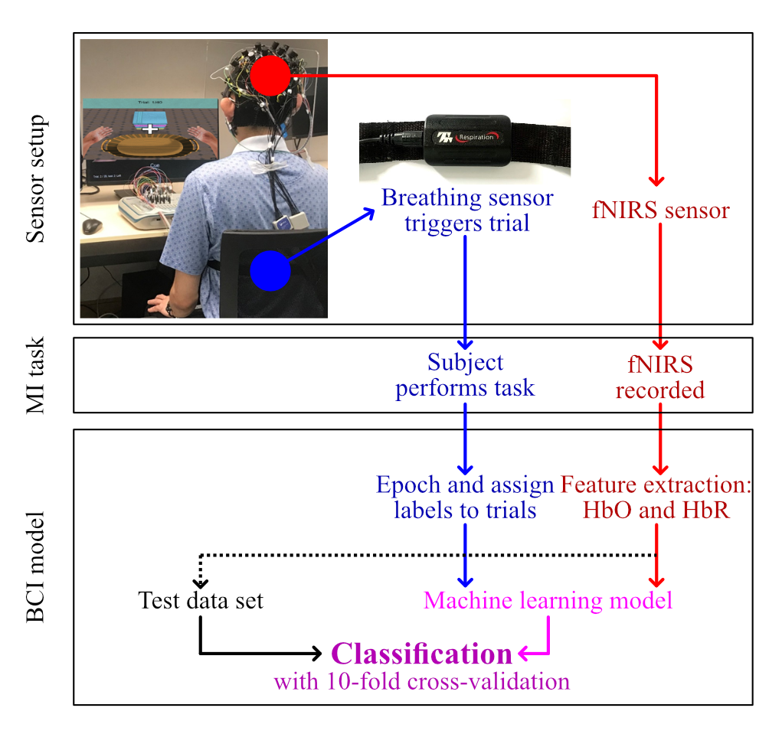
Figure 1. Overview of the experimental set-up.

During the experiment data collection, the subjects sat on a chair in a quiet room, in front of a computer screen that displayed the stimuli. A respiration strain sensor (SA9311M, ThoughtTech) was mounted on the subject’s abdomen. A single trial contained a preparation period, an MI period, and an inter-trial interval (ITI). Each trial started with a 2 s preparation period, where an audio cue alerted the subject to get ready for the MI task. Following this, when the breathing sensor detected an inhalation, a cue was displayed on the screen to instruct the subject to perform left- or right-hand MI for 10 s. Finally, there was an ITI period, during which the subject fixated on a cross displayed on the screen for 10 s. Each subject performed trials in four experimental blocks containing 40 trials each with equal numbers of left and right trials. A total of 160 trials were collected from each subject.

Breathing detection
Figure 2 illustrates the protocol of using the breathing sensor in the experiment setup. In our protocol, the cue to perform MI were triggered by the inhalation phase of the respiration cycle, whereas MI cues are not triggered by the respiratory patterns in commonly used BCI experimental protocols. The respiration sensor is used to detect abdominal expansion or contraction, and the output of this respiration cycle is sent to the computer via a USB port. We developed a real-time peak detection algorithm to detect inhalation and exhalation during the respiratory cycle. The cue for MI was displayed on the screen when inhalation is detected by the algorithm after the preparatory period.
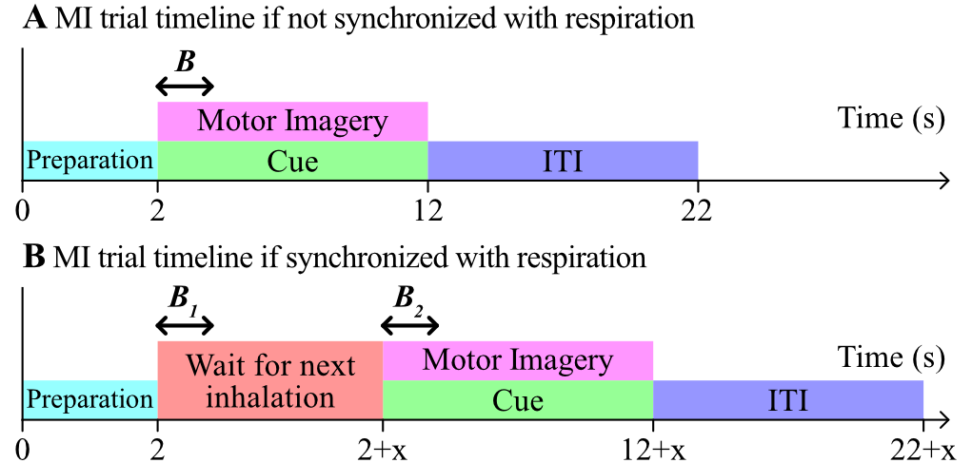

Figure 2. Timelines of motor imagery (MI) trials, not to scale. After a 2 s preparation period, a cue was delivered for 10 s, and subjects were instructed to perform MI while the cue was visible. Afterwards, there was a 10 s inter-trial interval (ITI) before the next trial began. A) In most other fNIRS MI experiments, trial timings are not synchronized with the subject’s respiration. B indicates the 2 s baseline period for fNIRS measurements. B) For our fNIRS MI experiment, the cue to begin performing MI was only delivered when inhalation was detected after the preparation period. In this example, there was a wait of x seconds. B₂ indicates the 2 s baseline period for fNIRS measurements. To determine if synchronizing trials with respiration resulted in more consistent baselines, we compared B₂ with B₁, the latter being the fNIRS baseline period if there were no respiration synchronization.

By performing the experiment using respiration-synchronized MI cues, we expected to see more consistent HbO levels at the start of the MI period (i.e. less HbO dispersion) across the 160 single trials, which we hypothesize that will improve the MI decoding performance. To quantify this objectively, we compared the distribution of HbO values for the 2 s periods B₁ and B₂ shown in Figure 2(B). B₁ yields the HbO values for respiration-unsynchronized case commonly used in BCI protocol whereby the MI cues were not triggered by the respiration cycle. B₂ yields the HbO values for respiration-synchronized case that were obtained in our experiment whereby the MI cues were triggered by the respiration cycle. We then quantified the difference between these two cases by comparing the HbO variance in B₁ versus B₂ across 160 trials, defining it as the dispersion index D in equation (1) given by

$D=\frac{\sum_{i=1}^{n_{t}}{{\left(x_{i}^{B_{2}}-{\overline{x}}^{B_{2}}\right)}^{2}}}{\sum_{i=1}^{n_{t}}{{\left(x_{i}^{B_{1}}-{\overline{x}}^{B_{1}}\right)}^{2}}}$ ( 1 )

where $n_{t}$ is the number of trials, $x_{i}^{B_{1}}$ is the HbO values of the i^{th} trial from segment B₁, $x_{i}^{B_{2}}$ is the HbO values of the i^{th} trial from segment B₁, ${\overline{x}}^{B_{1}}$ is the mean of the HbO values from segment B₁, and ${\overline{x}}^{B_{2}}$ is the mean of the HbO values from segment B₂

Data analysis
Changes in HbO and HbR concentrations can be computed from changes in optical density (denoted by ΔOD) by applying the modified Beer–Lambert law. In this work, we only used HbO values for our analyses because of their superior predictive performance compared to HbR values [19]. The fNIRS data were band-pass filtered with a Butterworth filter of order 3 between 0.05 and 0.60 Hz to remove systemic artifacts associated with pulses and very slow oscillations. The HbO data were then separately analyzed for left and right MI.

Motor imagery classification
HbO values from multiple channels along the time axis of an epoch can be used to form a spatial-temporal feature space representing blood saturation changes in the brain. We thus constructed a simple MI detection algorithm using this feature. The algorithm employed a feature scaling and normalization part, a vectorization part, and employed Linear Discriminant Analysis (LDA) model as a classifier. We then performed 10-fold cross validation with a random seed to evaluate the performance of each subject data. We evaluated the MI performance for the respiration-synchronized protocol and not the commonly used respiration-unsynchronized protocol since the experiment were performed in the former.

Results
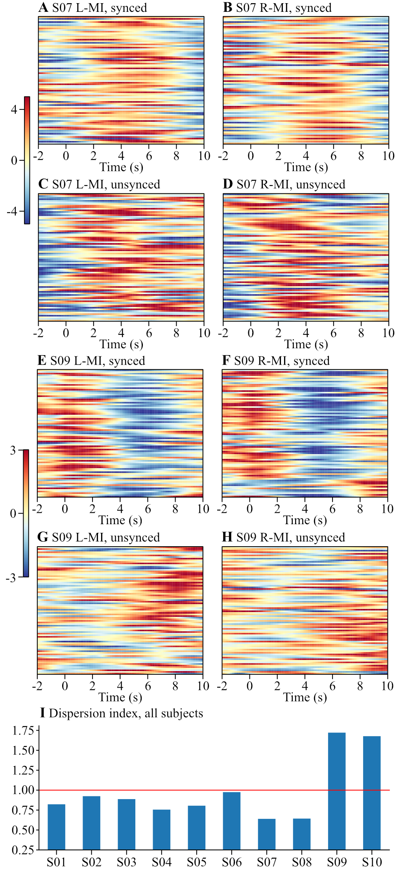
Figure 3. A) Plot of HbO values from subject S07 across 80 trials of left-MI in respiration-synchronized case. Each horizontal line represents 1 trial with HbO levels quantified by color (units are 10⁻⁷ mol/L). B) Same as A, but for right-MI. C-D) Same as A-B respectively, but for respiration-unsynchronized case. E-H) Same as A-D, but from subject S09. I) Dispersion index across subjects. Synchronizing trials with respiration resulted in dispersion indices below 1.00 (i.e. more consistent HbO values) in 8 out of 10 subjects.

Figure 3 shows the multi-trial HbO values along the timeline for subjects S07 and S09. From Figure 3A-D, we can observe effect of respiration synchronization, where the pattern of HbO changes is more consistent across MI trials in the synchronized case. To quantify the respiration-synchronization effect, we introduced dispersion index, as shown in the bottom plot of Figure 3.
The results showed that in the respiration-unsynchronized case, the variance in HbO decreased in 8 out of 10 subjects whereby the dispersion index is less than 1.00, and the variance in HbO increased in 2 subjects. Since the HbO variance was significantly increased in 2 subjects, this was not statistically significant (mean dispersion index was 0.985, t-test difference from 1.00 p = 0.91).

B. MI decoding accuracy and dispersion index
We found that in most subjects, respiration synchronization resulted in more consistent HbO values as quantified by dispersion index. Hence, we also investigated the correlation between dispersion index and BCI decoding accuracy.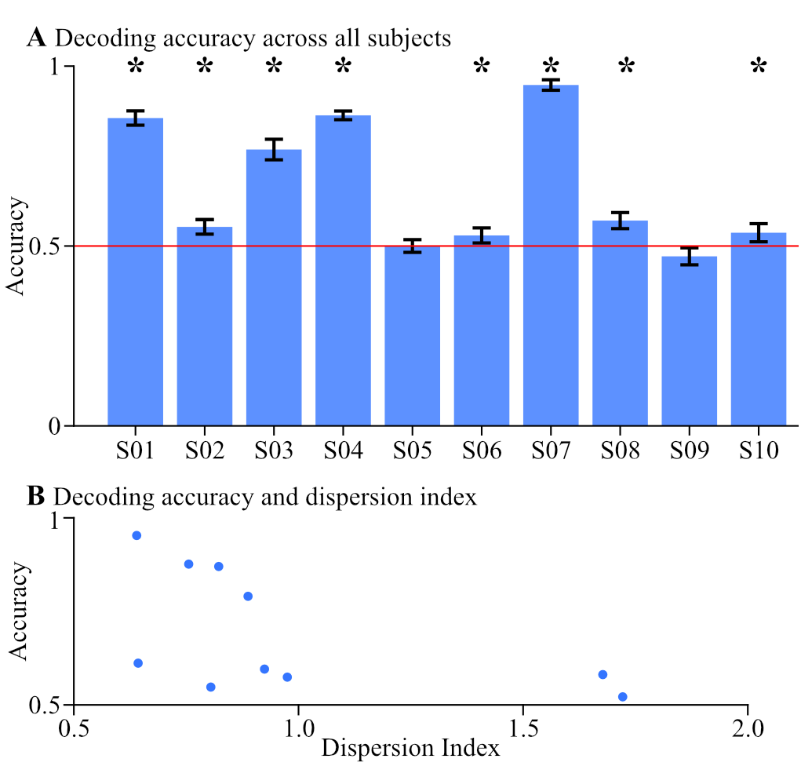
Figure 4. A) Blue bars plot mean accuracy for each subject, with standard deviations as error bars. The red line represents the chance accuracy of 0.5. An asterisk indicates that MI accuracy is better than chance level for that subject (one-tailed t-test, α = 0.005 after Bonferroni correction). 8 out of 10 subjects performed better than chance level. B) Plot of MI accuracy of subjects vs dispersion index. MI accuracy was negatively correlated with dispersion index (Pearson’s correlation coefficient = -0.548).

Figure 4 shows the results of correlating the MI accuracy of the subjects with the dispersion index. The results showed that 8 out of 10 subjects performed better than chance level. We also found a negative correlation between decoder accuracy and dispersion index. Thus the results showed that subjects with higher dispersion in their HbO readings tend to have lower MI accuracy.

Discussion
In the respiration-synchronization case, HbO values were visibly more consistent in the most of the subjects, and the dispersion index and thus variance in HbO was lower across the trials in 8 out of 10 subjects. This was consistent with our hypothesis and showed promise that synchronizing motor imagery cues to respiration can yield increased HbO level consistency.
Nonetheless, while we expected to observe lower in HbO variance in the respiration-synchronized case, we observed increased in the dispersion index in 2 of the 10 subjects. Currently, we are still investigating this in more detail. Potential reasons include the possibility that these two subjects had inherently irregular breathing, or that the breathing sensor was reading erroneous data due to artifacts such as physical movements. We will have to analyze the breathing sensor data in more detail and instruct subjects to breathe deeply and regularly, improve our inhalation detection algorithm, use different a different sensor to monitor breathing (such as an acoustic respiration sensor) and/or implement experimental exclusion criteria to exclude subjects with excessively irregular breathing patterns.
Nevertheless, we found that higher dispersion index was somewhat correlated with poorer MI performance. This suggests that consistent HbO readings without confounding effects of respiration are indeed important for fNIRS-based BCI. Hence the proposed method of synchronizing the motor imagery cue timing with the subject’s respiration cycle holds promise to improve the decoding performance of fNIRS-BCI by reducing the confounding effects of respiration. We hope that the preliminary evidence provided in this paper can help fNIRS-BCI researchers to deploy similar experimental protocols to reduce confounding effects of respiration.

Acknowledgment
Research was supported by the Institute for Infocomm Research (I2R), Agency for Science, Technology and Research (A*STAR) Singapore, and the Rehabilitation Research Institute of Singapore Research Grant RRG4/2008.

References
[1] Y. Hoshi and M. Tamura, “Detection of dynamic changes in cerebral oxygenation coupled to neuronal function during mental work in man,” Neurosci Lett, vol. 150, no. 1, pp. 5–8, Feb. 1993, doi: 10.1016/0304-3940(93)90094-2.
[2] M. Ferrari and V. Quaresima, “A brief review on the history of human functional near-infrared spectroscopy (fNIRS) development and fields of application,” NeuroImage, vol. 63, no. 2, pp. 921–935, Nov. 2012, doi: 10.1016/j.neuroimage.2012.03.049.
[3] F. F. Jo Bsis-Vandervliet, “Discovery of the near-infrared window into the body and the early development of near-infrared spectroscopy,” J Biomed Opt, vol. 4, no. 4, pp. 392–396, Oct. 1999, doi: 10.1117/1.429952.
[4] J. Steinbrink, A. Villringer, F. Kempf, D. Haux, S. Boden, and H. Obrig, “Illuminating the BOLD signal: combined fMRI–fNIRS studies,” Magnetic Resonance Imaging, vol. 24, no. 4, pp. 495–505, May 2006, doi: 10.1016/j.mri.2005.12.034.
[5] A. B. Usakli, “Improvement of EEG Signal Acquisition: An Electrical Aspect for State of the Art of Front End,” Comput Intell Neurosci, vol. 2010, p. 630649, 2010, doi: 10.1155/2010/630649.
[6] L.-A. Tuscan, J. D. Herbert, E. M. Forman, A. S. Juarascio, M. Izzetoglu, and M. Schultheis, “Exploring frontal asymmetry using functional near-infrared spectroscopy: a preliminary study of the effects of social anxiety during interaction and performance tasks,” Brain Imaging Behav, vol. 7, no. 2, pp. 140–153, Jun. 2013, doi: 10.1007/s11682-012-9206-z.
[7] S. Fazli et al., “Enhanced performance by a hybrid NIRS–EEG brain computer interface,” NeuroImage, vol. 59, no. 1, pp. 519–529, Jan. 2012, doi: 10.1016/j.neuroimage.2011.07.084.
[8] J. Yu, Y. Pan, K. K. Ang, C. Guan, and D. J. Leamy, “Prefrontal cortical activation during arithmetic processing differentiated by cultures: a preliminary fNIRS study,” Annu Int Conf IEEE Eng Med Biol Soc, vol. 2012, pp. 4716–4719, 2012, doi: 10.1109/EMBC.2012.6347020.
[9] J. Yu, K. K. Ang, H. Yang, and C. Guan, “Cortical activation of passive hand movement using Haptic Knob: a preliminary multi-channel fNIRS study,” Annu Int Conf IEEE Eng Med Biol Soc, vol. 2014, pp. 2097–2100, 2014, doi: 10.1109/EMBC.2014.6944030.
[10] P. A. Cicalese et al., “An EEG-fNIRS hybridization technique in the four-class classification of alzheimer’s disease,” J Neurosci Methods, vol. 336, p. 108618, Apr. 2020, doi: 10.1016/j.jneumeth.2020.108618.
[11] M. J. Khan, K.-S. Hong, N. Naseer, and M. R. Bhutta, “A hybrid EEG-fNIRS BCI: Motor imagery for EEG and mental arithmetic for fNIRS,” in 2014 14th International Conference on Control, Automation and Systems (ICCAS 2014), Oct. 2014, pp. 275–278. doi: 10.1109/ICCAS.2014.6988001.
[12] J. Yu, K. K. Ang, C. Guan, and C. Wang, “A multimodal fNIRS and EEG-based BCI study on motor imagery and passive movement,” in 2013 6th International IEEE/EMBS Conference on Neural Engineering (NER), Nov. 2013, pp. 5–8. doi: 10.1109/NER.2013.6695857.
[13] P. Reddy, M. Izzetoglu, P. A. Shewokis, M. Sangobowale, R. Diaz-Arrastia, and K. Izzetoglu, “Evaluation of fNIRS signal components elicited by cognitive and hypercapnic stimuli,” Sci Rep, vol. 11, no. 1, p. 23457, Dec. 2021, doi: 10.1038/s41598-021-02076-7.
[14] N. Hakimi et al., “Estimation of Respiratory Rate from Functional Near-Infrared Spectroscopy (fNIRS): A New Perspective on Respiratory Interference,” Biosensors, vol. 12, no. 12, p. 1170, Dec. 2022, doi: 10.3390/bios12121170.
[15] D. Candia-Rivera, M. S. Sappia, J. M. Horschig, W. N. J. M. Colier, and G. Valenza, “Confounding effects of heart rate, breathing rate, and frontal fNIRS on interoception,” Sci Rep, vol. 12, no. 1, p. 20701, Nov. 2022, doi: 10.1038/s41598-022-25119-z.
[16] I. Tachtsidis and F. Scholkmann, “False positives and false negatives in functional near-infrared spectroscopy: issues, challenges, and the way forward,” Neurophotonics, vol. 3, no. 3, p. 031405, Jul. 2016, doi: 10.1117/1.NPh.3.3.031405.
[17] M. A. Yücel et al., “Mayer waves reduce the accuracy of estimated hemodynamic response functions in functional near-infrared spectroscopy,” Biomed Opt Express, vol. 7, no. 8, pp. 3078–3088, Jul. 2016, doi: 10.1364/BOE.7.003078.
[18] Y.-L. Zheng, D.-X. Wang, Y.-R. Zhang, and Y.-Y. Tang, “Enhancing Attention by Synchronizing Respiration and Fingertip Pressure: A Pilot Study Using Functional Near-Infrared Spectroscopy,” Front. Neurosci., vol. 13, p. 1209, Nov. 2019, doi: 10.3389/fnins.2019.01209.
[19] R. Luke, M. J. Shader, A. Gramfort, E. Larson, A. K. Lee, and D. McAlpine, “Oxygenated hemoglobin signal provides greater predictive performance of experimental condition than de-oxygenated.” bioRxiv, p. 2021.11.19.469225, Nov. 20, 2021. doi: 10.1101/2021.11.19.469225.

1 are with the Institute for Infocomm Research (I2R), Agency for Science, Technology and Research (A*STAR), 1 Fusionopolis Way, #21-01 Connexis (South Tower), Singapore 138632. (Corresponding author e-mail: brianp@i2r.a-star.edu.sg). 2 is also with the School of Computer Science and Engineering, Nanyang Technological University, 50 Nanyang Ave, #32 Block N4 #02a, Singapore 639798. 3 is also with the Singapore Research Centre Shanghai MicroPort MedBot (Group) Co., Ltd.

