Supplementary Information
Single-component Cationic Polyethylenimine Thermogel for Sustained and Localized Gene Delivery to Combat Multi-drug Resistant Cancer
Qianyu Lin,^{a#} Minting Liu,^{b#} Lingjie Ke,^{b} Nicholas Ong,^{c,d} Joey H. M. Wong,ª Cally Owh,^{a,e} Valerie Ow,^{a,e} Belynn Sim,^{a,d} Yi Jian Boo,ª Jason Y. C. Lim,^{a,f}* Yunlong Wu,^{b}* Xian Jun Loh^{a,c,d,f}*

# These authors contributed equally to the manuscript

Corresponding authors:
*Email: lohxj@imre.a-star.edu.sg; wuyl@xmu.edu.cn; jason_lim@imre.a-star.edu.sg

- Supplementary tables

Table S1. Feed amounts of reactants for the synthesis of gloPEI-mulPPG thermogelling cationic copolymer.
Feed PPG-mbe : PEI molar ratio (normalised  to PEI) | CDI (g)ª | PPG-mbe (g) | PEI (g) | DMAP (mg)^{b}
18 | 0.585 | 9 | 5 | 22.1
ªCDI was added at 1:1 molar ratio with respect to PPG-mbe (2.5 kDa).
^{b}DMAP was added at 5 mol% with respect to PPG-mbe (2.5 kDa).

Table S2. GloPEI-mulPPG copolymer composition and absolute molecular weight calculation.
 | PPG-mbe | PEI
Chemical shift of characteristic peak (ppm) | 0.81 | 2.32
Mass of (macro)monomer  (g mol⁻¹) | 2500 | 10000
Mass of repeating unit  (g mol⁻¹) | 58 | 43
No. of repeating units | 41.8 | 233
No. of protons in repeating unit for the NMR peak of interest | 3 | 4
No. of protons per (macro)monomer for that NMR peak | 125 | 930
Relative NMR integrals | 0.86 | 1.00
Mole ratio of (macro)monomers | 6.88*10⁻³ | 1.08*10⁻³
Normalised mole ratio  (PEI set to 1) | 6.37 | 1
Average molecular weight of gloPEI-mulPPG copolymer (kDa) | 25.9

- Supplementary figures

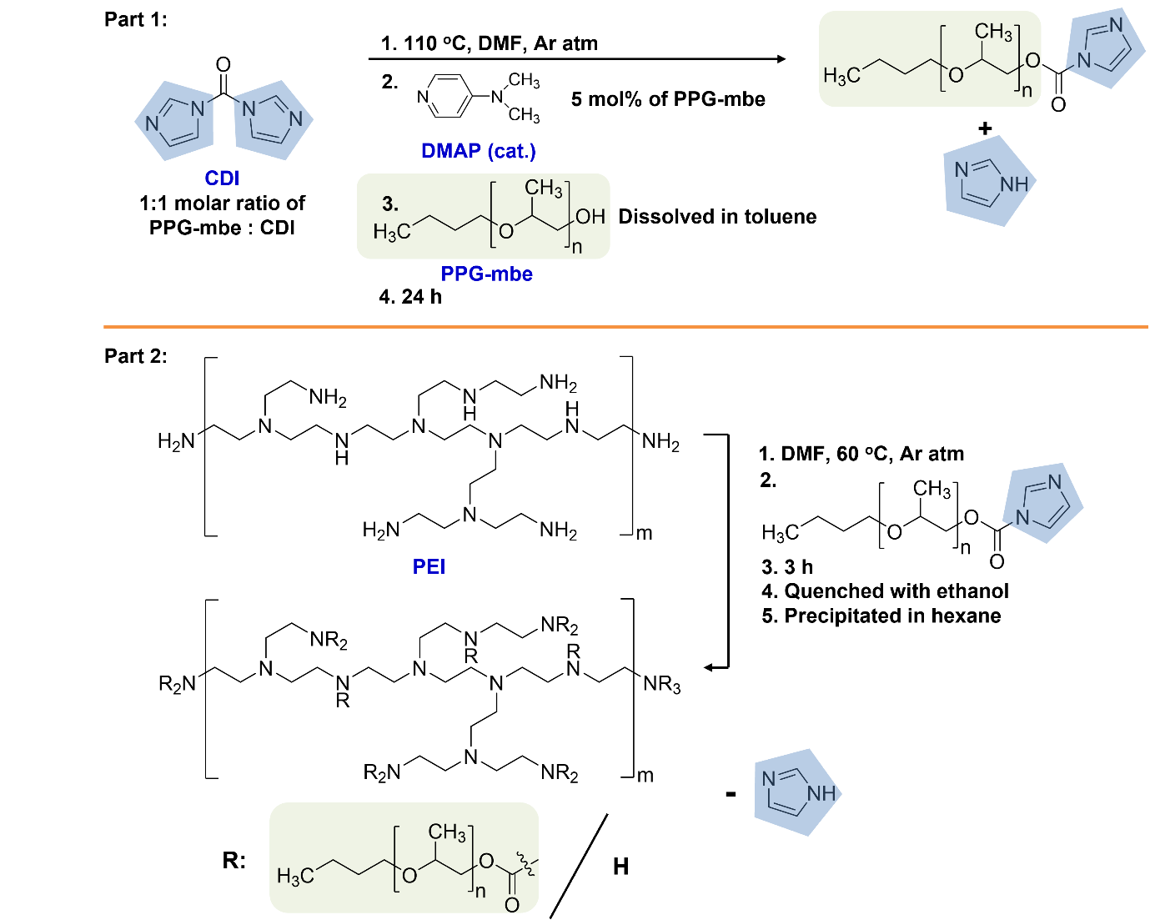
Figure S1. Synthetic route of gloPEI-mulPPG copolymer.
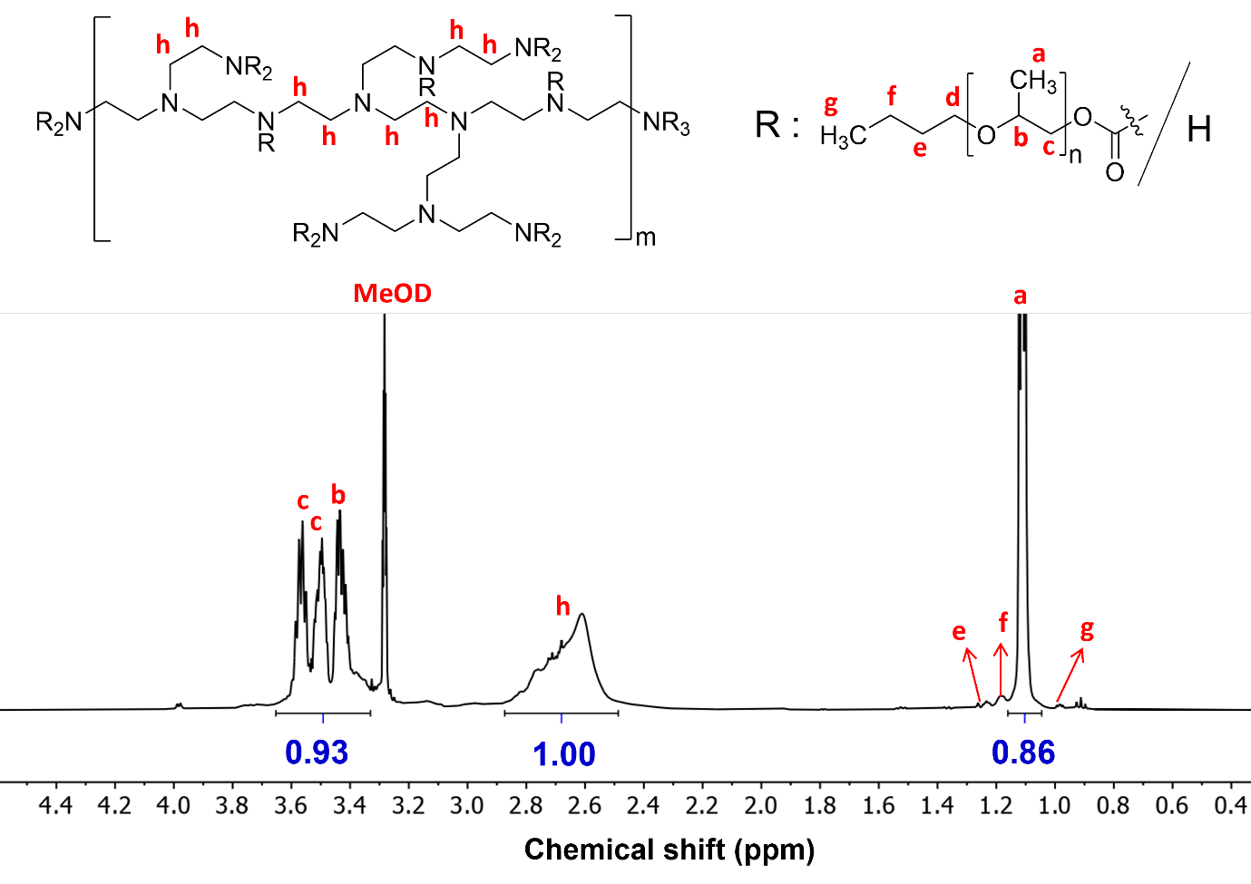
Figure S2. ¹H NMR spectrum of gloPEI-mulPPG copolymer in deuterated methanol with corresponding protons labelled and integration of characteristic peaks shown.
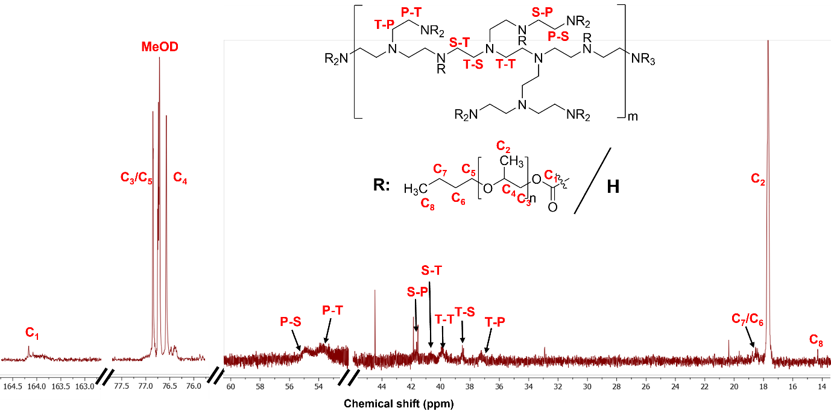
Figure S3. ¹³C NMR spectrum of gloPEI-mulPPG copolymer in deuterated methanol.

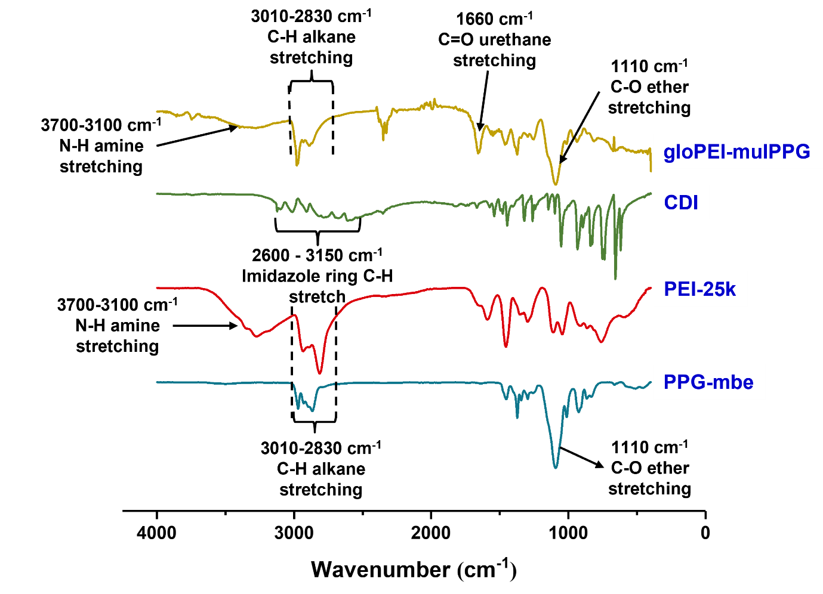
Figure S4. FTIR spectra of macromonomers and gloPEI-mulPPG copolymer.

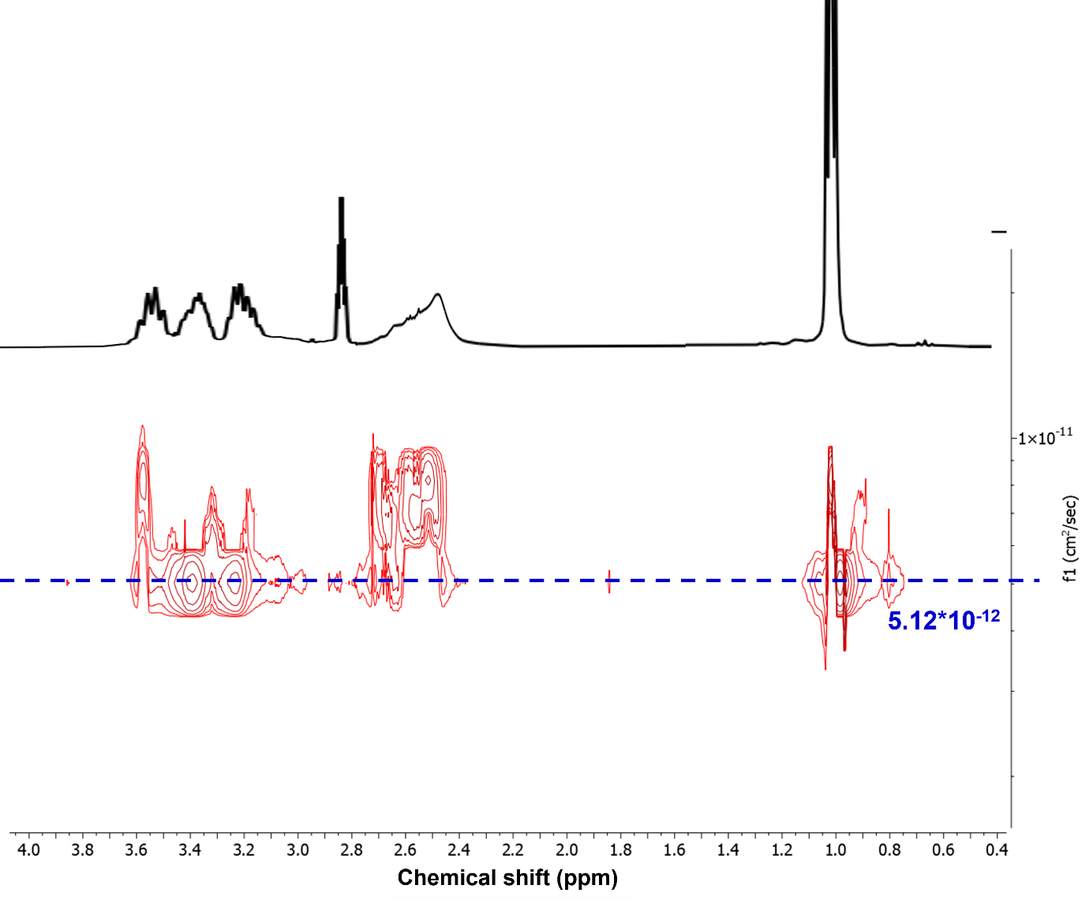
Figure S5. DOSY spectrum of gloPEI-mulPPG micelles in D₂O.

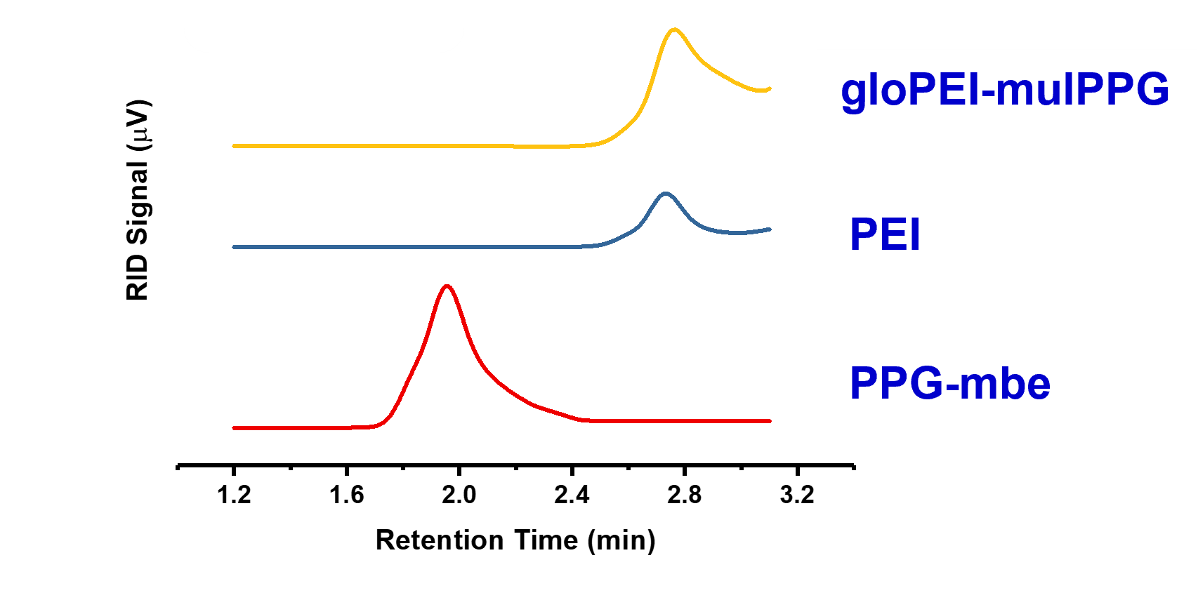
Figure S6. Stacked GPC spectra of macromonomers and gloPEI-mulPPG copolymer. The presence of only one peak for the gloPEI-mulPPG copolymer with different retention times as both PEI and PPG-mbe macromonomers is evident that these components are covalently conjugated together.

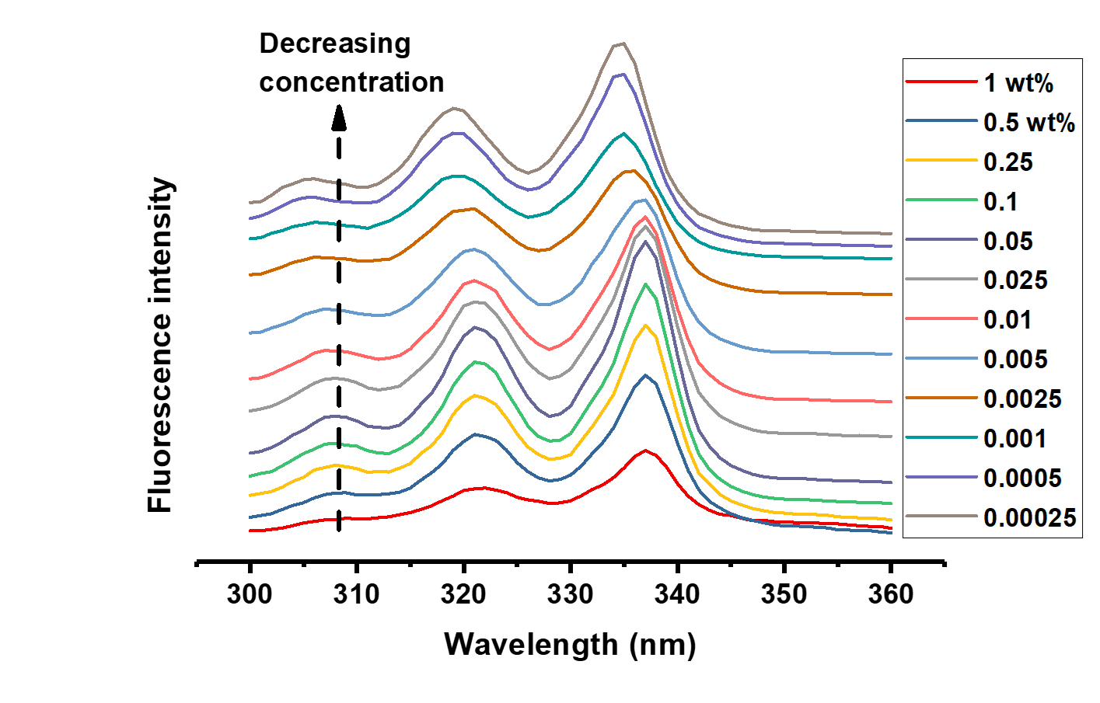
Figure S7. Fluorescence emission spectrum of pyrene (excitation wavelength = 317 nm) in aqueous gloPEI-mulPPG solutions ranging from 0.00025 wt% - 1 wt% at room temperature.

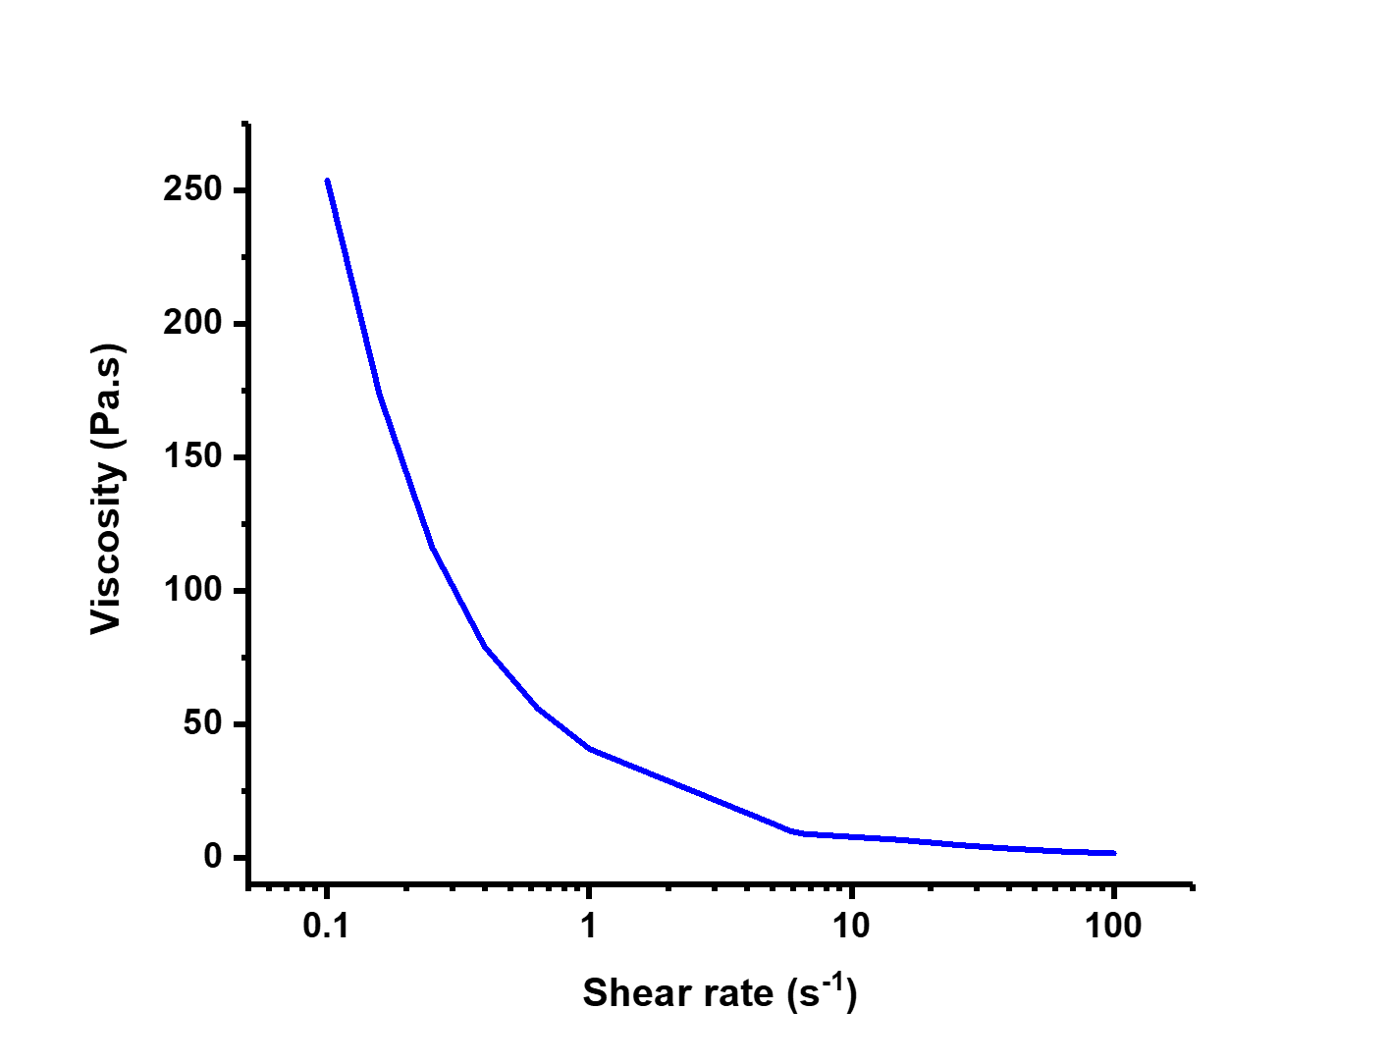
Figure S8. Flow sweep rheological measurement of gloPEI-mulPPG 10 wt% thermogel at 37 ºC.
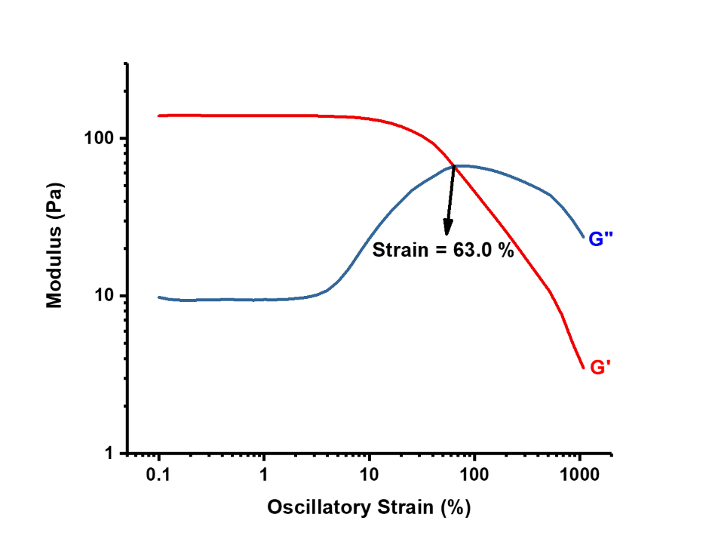
Figure S9. Oscillatory amplitude sweep of gloPEI-mulPPG thermogel at 37 ºC and 1 Hz.
Figure S10. Time sweep oscillatory rheological measurement at fixed 1 % strain and 1 Hz to quantify the duration required for 10 wt% gloPEI-mulPPG sol at 5 ºC to form a stable gel when exposed to 37 ºC as simulation of the use case where cold sol (5 ºC) is injected into tumour (37 ºC).

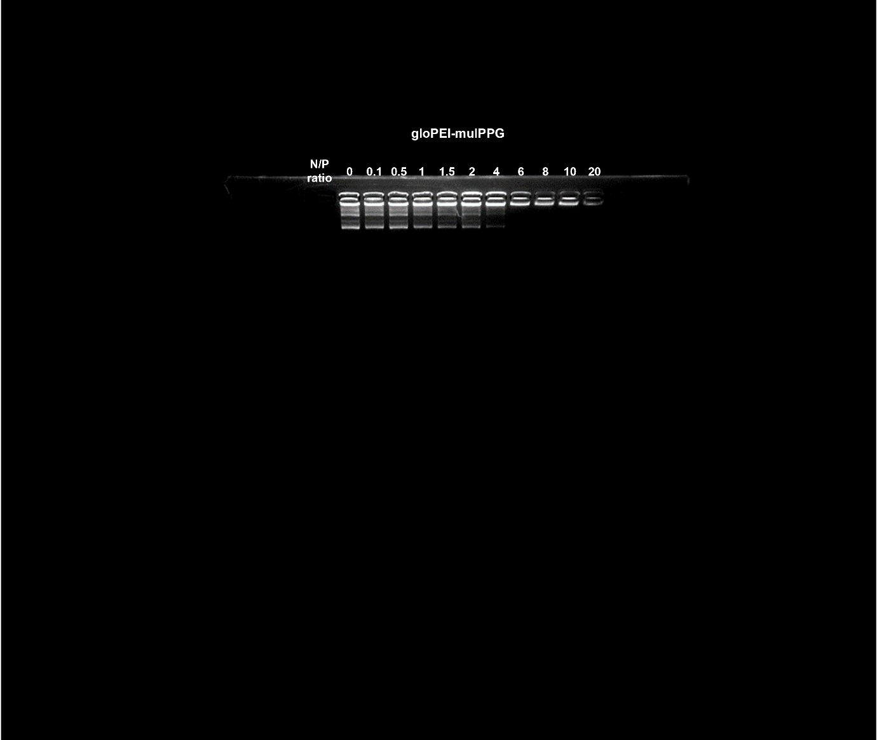
Figure S11. Uncropped and unprocessed gel retardation result for gloPEI-mulPPG complexed pNur77 at varying N/P ratios.

Figure S12. Uncropped and unprocessed gel retardation result for PEI-25kDa complexed pNur77 at varying N/P ratios.

Figure S13. Modelling of in-vitro pNur77 release from gloPEI-mulPPG using Korsmeyer-Peppas power law given by $log\frac{M_{t}}{M_{0}}=\log{k}+nlog\left(t\right)$, where $\frac{M_{t}}{M_{0}}$ is the fraction of released plasmid at time $t$, $k$ is the rate constant, and $n$ is the release exponent. From the linearlised fit, $k$ is found to be 0.385 day^{-0.461} and $n$ is 0.461.

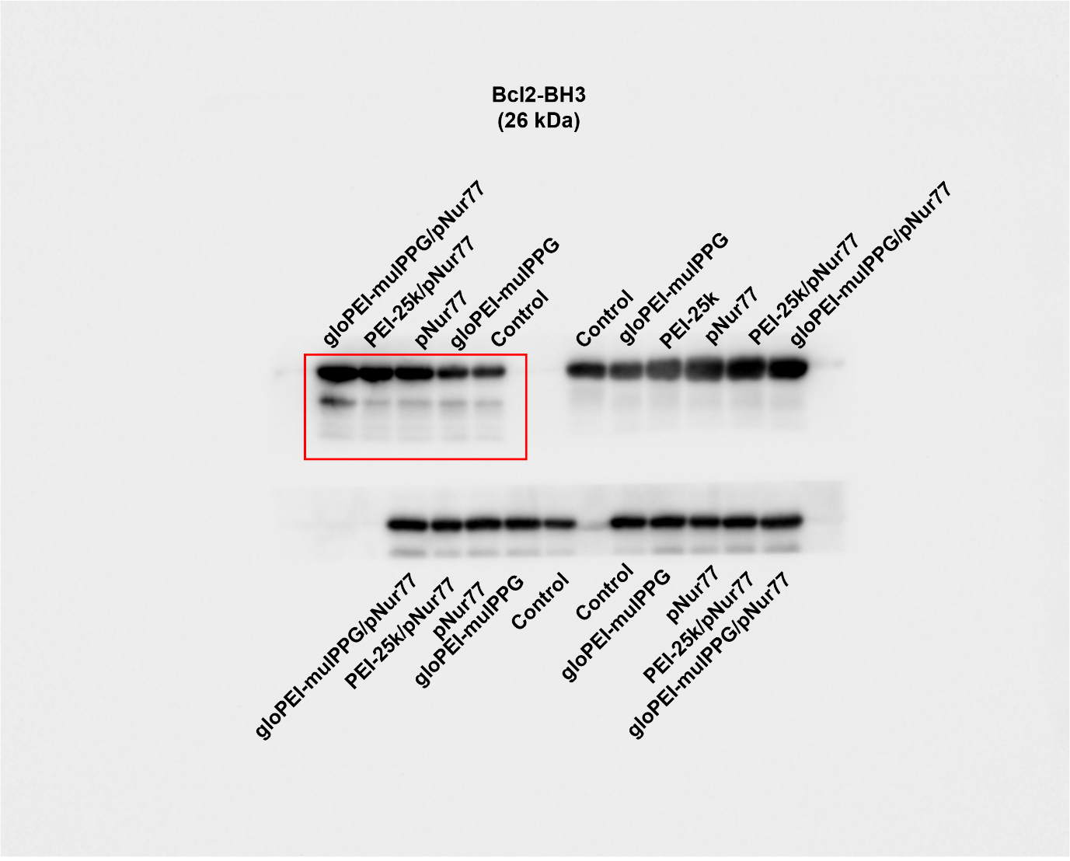
Figure S14. Uncropped and unprocessed Western blot image of Bcl2-BH3 protein production after various treatments. The red box indicates the image used in the main manuscript.

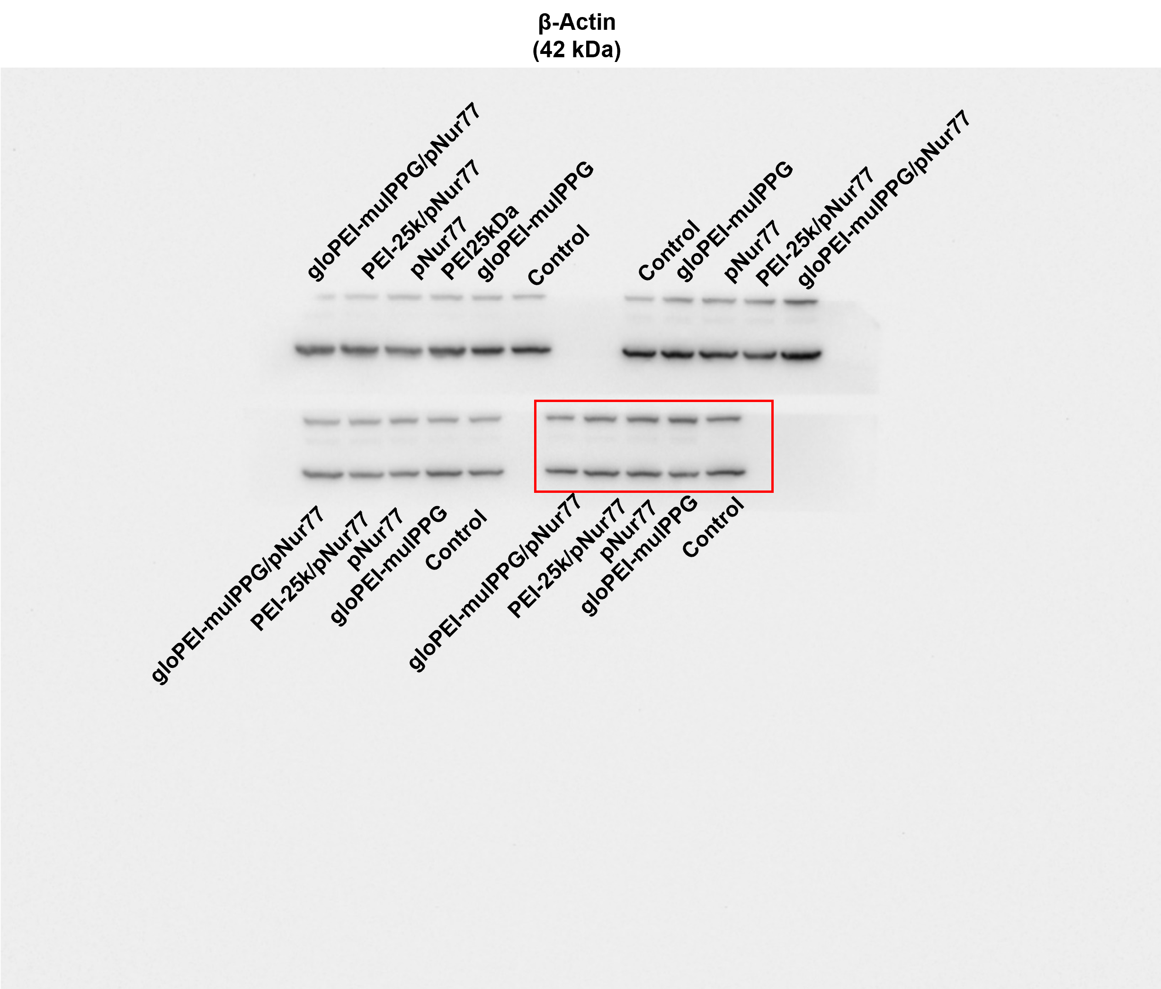
Figure S15. Uncropped and unprocessed Western blot image of β-Actin protein production after various treatments. The red box indicates the image used in the main manuscript.

