Efficient and Adaptive Semantic Segmentation of HBMs using Incremental Learning
Richard Chang¹, Namrata Thakur¹, Jie Wang¹, Yurui Li¹, Ser Choong Chong², Ramanpreet Singh Pahwa¹
¹Institute for Infocomm Research (I²R), Agency for Science, Technology and Research (A*STAR),
1 Fusionopolis Way, #21-01, Connexis South Tower, Singapore 138632, Republic of Singapore

²Institute for MicroElectronics (IME), Agency for Science, Technology and Research (A*STAR),
11 Science Park Road, Singapore Science Park II, Singapore 117685, Republic of Singapore

Abstract
Due to the increasing miniaturization of package interconnects, detecting multiple defects in buried structures is becoming more important and challenging. Recent deep learning image segmentation models have significantly improved defect detection accuracy and are now being integrated into inspection processes by major semiconductors companies. However, data preparation is very time-consuming and requires significant resources. Additionally, trained models are only applicable to the current product version and may be unable to adapt to new design when it becomes available, limiting their scalability and adaptability. Current deep learning models and processes are also still limited by their lack of flexibility and data-heavy approach. Current models are often tied to their training datasets, in turn, limiting their usability and consuming large storage resources for future retraining. In this paper, we introduce a new framework to significantly increase the model’s flexibility and adaptability to new data. We propose a generic training strategy and a new loss function that reduced the training time by 60% and the required amount of data by 48%. It will then make the training process more efficient as well as save computational and storage resources. This will also increase the reliability and flexibility of segmentation models for in-line inspections on 3D scans. Applicability of deep learning models to multiple packaging conditions and parameters will also improve the adoption by the industry.

- Introduction

Defect inspection in packages interconnects has become challenging due to the increasing miniaturization. The common approach is to cross-section the packages and use manual optical inspection to find any defect such as solder extrusions, pad misalignments or voids. Recently, a non-destructive approach based on X-Ray imaging has been introduced to improve the inspection process. The package is first scanned, and a defect analysis is performed on the scans with AI deep learning models. This approach is less time-consuming and requires less effort, but the scanning still takes 2-8 hours per sample and the AI models are heavily dependent on data acquisition and labeling.

Deep learning segmentation models are also more accurate thanks to the development of new architectures. However, current models and processes are still limited by their lack of flexibility and data-heavy approach. The training process usually applied as follows. The first step is the data acquisition from the scanners, followed by the annotation step which requires expert knowledge. Every pixel of the scans must be labeled according to their class. Finally, the segmentation model is trained on the annotated data and can be integrated into the inspection pipeline. The model will then have a good segmentation accuracy on data similar to the trained data but when there is a data shift or with new incoming data, the model may then be unable to provide an accurate segmentation. One solution could be to use the pretrained model and repeat the process to train a new model only on the new data. In this case, the model will then suffer the catastrophic forgetting phenomenon [18]. It usually occurs when a model is trained on new data different from the one used for the pre-trained model. Basically, the model will focus on new data during its training phase, and it will have a lower accuracy on older data compared that of the new data. The second solution is to completely retrain the model with old and new data but it requires the comprehensive storage of older data which takes resources and is not efficient.

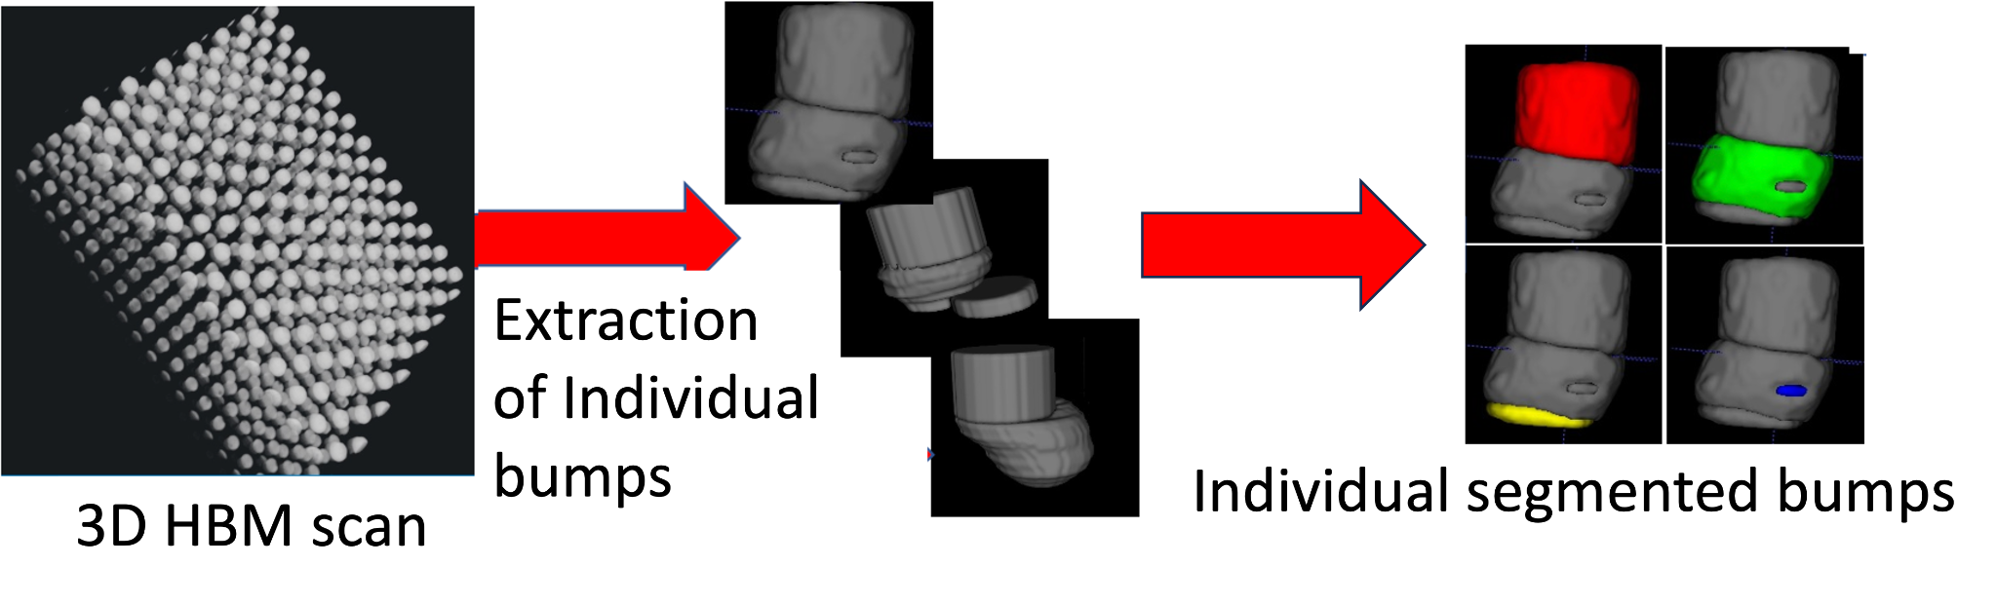
Figure 1: Semantic Segmentation Overview. The input is a 3D HBM scan, each individual bump is extracted and segmented into multiple classes (e.g., Cu-Pillar, Cu-Pad, Solder).

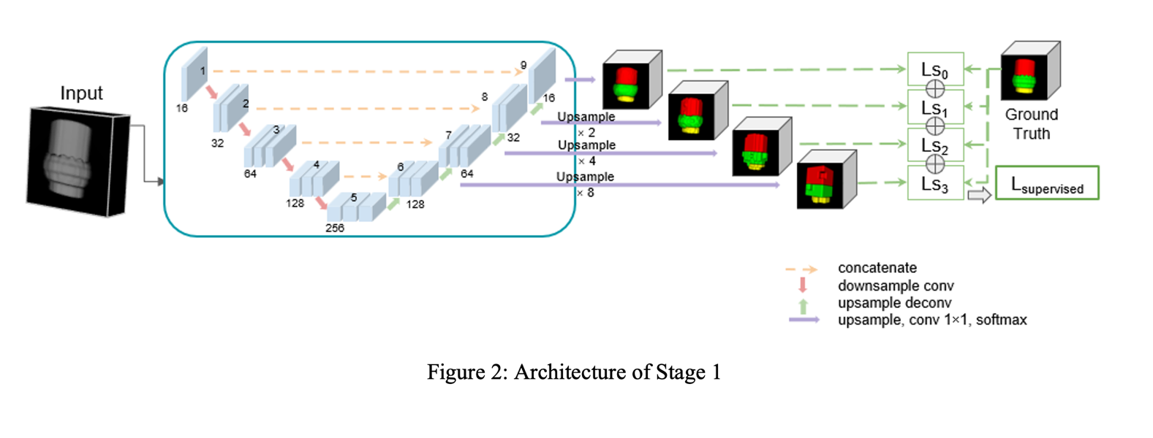
We tackle these issues by proposing a new framework that can include newly available data to existing models and remove the need to store previously trained data. We introduce a new training strategy and loss function for HBMs 3D scans to incrementally learn the new semantic classes alongside maintaining the performance on the old classes. By training the network in two stages, we reduce the overall training time for any new batch of data. Thus, we can feed any new incoming batch containing all scans of memory and logic bumps into a

single segmentation model. We will demonstrate that our framework can provide a similar performance as the reference model that is trained on fully available data while reducing the training time by 60% and the required training data by 48%.
The paper is structured as follows. Related work is presented in Section 2. We introduced our methodology in Section 3. Section 4 shows our experimental results. Finally, we conclude our work in Section 5.

- Related Work

3D semantic segmentation is a common task in computer vision for several domains such as medical imaging [5,8] or semiconductors [1-4]. It deals with generating a dense mask to identify the structures and regions in 3D samples. Several architectures have been published in the literature to perform this task such as V-Net [6]. Different aspects of data can affect the performance of segmentation models. Class imbalance is when the amount of available data is different across different classes affecting the segmentation accuracy of classes with less data. Data complexity is also an issue when there are no clear boundaries between different classes. Annotation difficulty is also a limitation because it requires expert knowledge and requires significant time and specific tools. Different approaches have been introduced to reduce the required amount of training data. Semi-supervised learning methods use a small amount of training data and raw data [9,10].
Another issue is the lack of flexibility of segmentation models. Once they are trained on a specific distribution, they are unable to seemingly adapt to newly available data suffering either catastrophic forgetting or requiring another full training process. Several methods have been introduced in computer vision [12,17]. Traditional cross-entropy has been used to propagate the probability of old classes [14]. Methods preserving feature-level spatial relationships have also been used. Alternatively, replay methods [13] with used samples of old classes during training time have also been proposed to alleviate catastrophic forgetting.

- Methodology

In our previous works [1-4], we have proposed 2D/3D semi-supervised object detection and segmentation methods on High Bandwidth memory and logic bumps (HBMs). Although they require a limited amount of labeled data for training, they can only be applied to data similar to the training samples that were used for model development. Such models are not designed to incrementally update their knowledge when new data undergoes significant changes.

To solve these issues, we propose a new two-stage framework that provides a generic segmentation model for both logic and memory that can process newly available data while maintaining its segmentation accuracy. In the first stage, the model will be trained on common classes to fully use available data. In the second stage, the model will be trained on the new classes to increase its adaptability without using the previous dataset used in stage 1 while maintaining its accuracy on all classes - old and new. Training strategies and parameters will be optimized with an improved loss function to maximize training performance and address data imbalance issues between new and old classes.

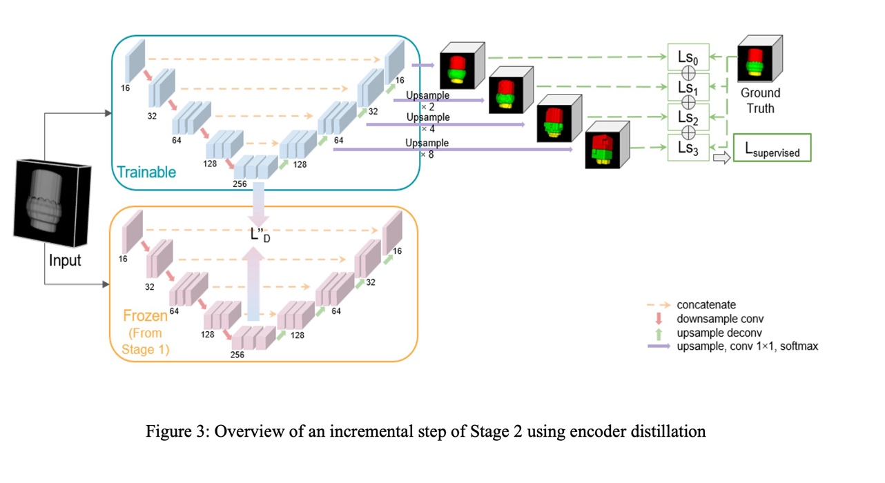
We present the new loss function designed to detect new classes while maintaining the segmentation performance on the old classes through a linear combination of the supervised loss and distillation loss. Fig. 1 shows an example of chosen classes during stage 1 and 2 for training and segmentation results. Our backbone segmentation model is Multi-Scale V-Net [6]. It consists of an encoder (left) and decoder (right). Convolution and deconvolution operations are performed at different steps to downsample and upsample the
features. The supervised loss is a linear combination of cross entropy loss and multi-class dice loss. This architecture ensures
convergence compared with non-residual learning networks such as U-Net. The overview of the architecture is shown in Fig. 2.

We first defined 2 sets of classes, $S_{1}$ includes the classes for the initial training (old classes) and $S_{2}$ includes the classes that will be added during the incremental training (new classes). Then, we train the model incrementally in two stages. First, Stage 1 will perform the training on $S_{1}$ providing the first model M1. Secondly, we load the M1 model into the Stage 2 model and continue the training on $S_{2}$ data. As the number of classes is different in $S_{1}$ and $S_{2}$, we do not load the weights from the last four upsampling layers. Only the weights from Block 1 to 9 will be loaded. With the weights loading finished, we focus on training the stage 2 model for the new classes. To do so, we use two strategies namely fine-tuning the stage 2 model only, and encoder distillation.

- Fine-Tuning: It is a simple and straightforward strategy where we load the weights of stage 1 onto stage 2 and keep iterating for too many more epochs to learn the new classes. No distillation strategies are used in this method, only the supervised loss is activated.

- Encoder Distillation: In this strategy, we first duplicate the model trained during Stage 1 into a frozen and trainable module. Fig. 3 shows the lower portion loaded from the stage 1 model that remains frozen during the training of the stage 2 model. The upper portion is the current trainable stage 2 model. As we are using Multi Scale V-Net, we have outputs at four different scales for the trainable model. We have assigned weightage to the main output as well as to the auxiliary layers.

We have also applied a distillation loss on the intermediate feature space that aims to preserve the knowledge learnt on the old seen classes by ensuring that the encoder output remains similar to the already learnt encoder of the Stage 1. Instead, we used $L_{2}$ loss on the feature space to keep the feature values similar to the stage 1. During the forward pass, we will use the outputs of both frozen and trainable model to calculate the encoder distillation loss function and during backward pass, we will propagate the errors only through the current stage (stage 2) model. Encoder distillation function is helping to mitigate the catastrophic forgetting problem.

$L^{''_{D}}=\frac{{\left|\left|E_{k-1}\left(X_{n}\right)- E_{k}\left(X_{n}\right)\right|\right|2}_{2}^{}}{\left|D_{k}tr\right|}$ (1)

In Eq. 1, $D_{k}tr$ is the training dataset at the k-th incremental step. $E_{k}\left(X_{n}\right)$ denotes the output of the encoder at incremental step ‘k’ for any input ($X_{n})$ of the training dataset $\left(D_{k}tr\right)$ available at that step. We have assigned a weightage $\left(β\right)$ with the encoder distillation. Our final loss would then become a linear combination of supervised loss and the weighted encoder distillation loss. The encoder distillation is done in two slightly different ways. In the first variant, we have taken the output of the final encoder block only (Block 5) (Fig. 3) to use in the distillation function. In the second variant, we have taken the output of last four encoder blocks (Block 2 to Block 5). We have applied L2 loss on each of these output pairs and have given reverse weightage to each pair. Reverse weightage means we have given highest weightage to the final encoder block and progressively smaller weightage to remaining three blocks.

$Loss_{final} =\sum_{X_{n}∈D_{k}tr}{L_{supervised}}+ β ⋅L_{D}^{''}$ (2)

4. Experimentation
Table 1: Per-Class Dice Score for different training strategies
Model | # Classes | Distillation / Fine-tuning | Background | Pillar | Solder | Avg Dice  (Old Classes) | Void | Pad | Avg Dice  (All Classes)
Stage 1 | 3 | - | 98.97 | 91.59 | 86.30 | 92.29 | - | - | -
Stage 2 | 5 |  | 99.05 | 92.57 | 88.14 | 93.26 | 81.41 | 88.50 | 89.93
Stage 2 | 5 | Class Weights Fine-tuning | 99.02 | 90.95 | 86.33 | 92.10 | 86.73 | 90.11 | 90.63
Stage 2 | 5 | Encoder Distillation | 98.95 | 91.88 | 88.40 | 93.08 | 89.80 | 88.61 | 91.53
Reference Model  (Fully-supervised) | 5 | - | 99.07 | 92.38 | 88.94 | 93.46 | 88.15 | 90.81 | 91.87
We collected and annotated a varied dataset consisting of logic and memory bumps to validate our incremental learning approach. We first extracted individual the bumps using our 3D object detection method [3]. In total, we have 210 3D scans of memory and logic bumps. We split each dataset into a ratio of 85% train and 15% test. So, the total training scans for Stage 1 model is 85 and for Stage 2 is 92. Memory bumps consist of 4 classes namely Cu-Pillar, Solder, Void, and Cu-Pad whereas the logic bumps consist of 3 main classes namely Cu-Pillar, Void, and Solder. Voids are present only in some bumps while other classes are present in all bumps. Rather than training 2 separate models for logic and memory [1-4], we build a single model that is capable of segmenting both. In the stage 1, the model learns the common classes (old) namely Cu-Pillar and Solder. Only the non-defective memory and logic bumps are used in this stage. Additionally, we remove the Cu-Pad class from memory bumps. This is done to make sure that we are keeping only Cu-Pillar and Solder as the classes to train the stage 1 model on. For Stage 2, we build the dataset by adding defective memory and logic bumps. This means the 3D scans of stage 2 will contain Void and Cu-Pad in addition to the two old classes.
We trained the model for 2000 iterations for every class. The
stage 1 model containing 3 classes are thus trained for 6,000
iterations and the stage 2 model containing 2 new classes are trained for 4000 iterations. This makes the total iteration for
two stages equal to the number of iterations that the reference fully supervised model is trained for. We have given optimized weights (0.1, 0.1, 0.1, 0.45, 0.25) for all the classes (Background, Cu-Pillar, Solder, Void, Cu-pad) in stage 2 model to maximize the model performance on the new classes. We see a significant improvement in the performance of the model especially for the Void class by adding the class weights. During the class weight optimization experiments, no additional distillation strategies are added.
With the best class weights decided, we proceed to do the hyper-parameter tuning for the weights of the distillation loss. For the encoder distillation, we have previously mentioned two approaches of computing the $L_{2}$ loss function. From our extensive experiments the approach where we are using only the final encoder output of both the stages is giving superior results as compared to the other approach. We found the optimal encoder distillation weight $\left(β\right)$ to be 0.5.

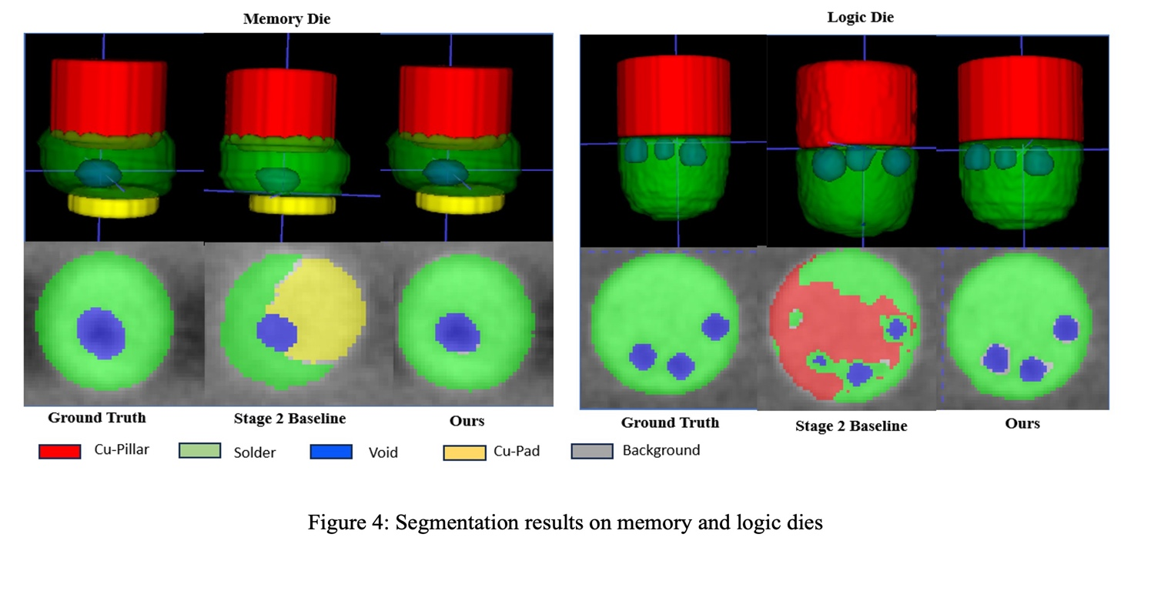
Table 1 shows that the best incremental strategy is achieved by applying our encoder distillation. Alongside, the model can learn the new classes very efficiently with the new overall dice score for all classes (new and old) being just 0.37% less than the reference model which is trained on all annotated data (upper bound). Additionally, we see that we consistently over-performed on the minority class (Void) by a margin of 1.87% with respect to the benchmark model trained on fully supervised learning (upper bound). We can also notice that our model performs better than the stage 2 base model. Figure 4 shows the segmentation results of our final model containing both the supervised and distillation losses after stage 2 for all classes. For logic bumps, the base model, some regions corresponding to Solder are wrongly classified as Cu-Pillar. For memory bumps, Solder and Cu-Pad are misclassified with the base model. Overall, segmentation results from our model shows a better accuracy with some minor errors around the void region.

To summarize, the results show segmentation accuracy (dice score) on the old classes is maintained after stage 2 with a 0.41% deviation. The model also demonstrates an overall accuracy close to the accuracy obtained from the fully supervised model with all data available (less than 1% deviation) with a 60% reduction of training time and a 48% reduction of required training data in Stage 2 thanks to the new training framework and loss function.

- Conclusions

AI and deep learning models for semantic segmentation are increasingly integrated into inspection processes for semiconductors. They can bring significant improvements as they reduce the time required for inspection, manual intervention and increase the accuracy and reliability of the process. However, those models are still data-heavy, and the training time and data preparation is time-consuming and cumbersome. One important requirement is that processing data as to be similar to training data or the model will not be able to perform well. The model cannot be quickly adapted to new data and a full training process is required. Our framework uses incremental learning to alleviate this requirement. It can adapt segmentation models to new data with an accuracy close to a full training process (1% deviation) while using only 48% less training data and 60% less training time. Future work will include additional improvements in the training strategy on the loss function as well as implementing co-training structures to further improve the accuracy of the models.

Acknowledgments

This research is supported by Career Development Fund (Grant No C210812046) and by MTC Programmatic Funds (Grant No. M23L7b0021) which are supported and administered by the Agency for Science, Technology and Research (A*STAR).

References
[1] R. Pahwa et al., "Deep Learning Analysis of 3D X-ray Images for Automated Object Detection and Attribute Measurement of Buried Package Features," in IEEE 22nd Electronic Components and Technology Conference (ECTC) 2020, pp. 221-227

[2] R. S. Pahwa et al., "Automated Attribute Measurements of Buried Package Features in 3D X-ray Images using Deep Learning," in IEEE 71st Electronic Components and Technology Conference (ECTC), 2021, pp. 2196-2204,

[3] R. S. Pahwa et al., " 3D Defect Detection and Metrology of HBMs using Semi-Supervised Deep Learning," in IEEE 73rd Electronic Components and Technology Conference (ECTC), 2023.

[4] Wang J et al., “Robust Detection, Segmentation, and Metrology of High Bandwidth Memory 3D Scans Using an Improved Semi-Supervised Deep Learning Approach,” in Sensors; 23(12):5470.
[5] S. Li, Z. Zhao, K. Xu, Z. Zeng and C. Guan, "Hierarchical Consistency Regularized Mean Teacher for Semi-supervised 3D Left Atrium Segmentation", in 43rd IEEE Engineering in Medicine & Biology Society (EMBC), 2021, pp. 3395-3398
[6] F. Milletari, N. Navab, and S-A Ahmadi. “V-net: Fully convolutional neural networks for volumetric medical image segmentation.” in IEEE 3DV, 2016, pages 565–571.
[7] U. Michieli, “Incremental Learning Techniques for Semantic Segmentation.” in arXiv.org. https://arxiv.org/abs/1907.13372
[8] W. Bai, O. Oktay, M. Sinclair, H. Suzuki, M. Rajchl, G. Tarroni, B. Glocker, A. King, P. M. Matthews, and D. Rueckert, “Semi-supervised learning for network-based cardiac mr image segmentation”,” in MICCAI. 2017.

[9] A. Tarvainen and H. Valpola, “Mean teachers are better role models: Weight-averaged consistency targets improve semi-supervised deep learning results,” in Advances in neural information processing systems, 2017.

[10] S. Li, C. Zhang, and X. He, “Shape-aware semi- supervised 3d semantic segmentation for medical images,” in MICCAI, 2020

[12] Y. Liu, Y. Su, A-A Liu, B. Schiele, and Q. Sun. “Mnemonics training: Multi-class incremental
learning without forgetting.” in IEEE CVPR, 2020

[13] A. Maracani, U. Michieli, M. Toldo, and P. Zanuttigh. “Recall Replay-based continual learning in semantic segmentation.” in ICCV, 2021, pages 7026–7035.

[14] U. Michieli and P. Zanuttigh. “Knowledge distillation for incremental learning in semantic segmentation.” in CVIU,
2021

[15] W Jie, R Chang, X Xun, C Lile, CS Foo, RS Pahwa, “Improved Bump Detection and Defect Identification for HBMs using Refined Machine Learning Approach”, in IEEE 24th Electronics Packaging Technology Conference (EPTC), 2022, pp 848-853

[16] RS Pahwa, R Chang, W Jie, X Xun, OZ Min, FC Sheng, CS Choong, “Automated Detection and Segmentation of HBMs in 3D X-ray Images using Semi-Supervised Deep Learning”, in IEEE 72nd Electronic Components and Technology Conference (ECTC), 2022, pp 1890-1897

[17] Z. Chen, Z., B. Liu. “Continual Learning and Catastrophic Forgetting”. in: Lifelong Machine Learning. Synthesis Lectures on Artificial Intelligence and Machine Learning. Springer, Cham., 2018.

