Comparison of differences in Sensory, Volatile Odour-Activity and Volatile Profile of Commercial Plant-based meats

Aaron Thong^{a*}, Vicki Wei Kee Tanª, Geraldine Chanª, Michelle Jie Ying Choyª and Ciarán G. Forde^{b}
ªSingapore Institute for Food and Biotechnology Innovation (SIFBI), Agency for Science, Technology and Research (A*STAR), 31 Biopolis Way, Singapore 138669. *E-mail: aaron_thong@sifbi.a-star.edu.sg
^{b}Wageningen University, Sensory Science and Eating Behaviour, Division of Human, Nutrition and Health, P.O. Box 17, 6700 Wageningen, The Netherlands.

Abstract
Descriptive sensory analysis was paired with temporal check-all-that-apply gas-chromatography olfactometry (TCATA GC-O) to compare differences in perceived flavour and volatile odour activity across a series of commercial plant-based meat analogues (PBMAs) versus conventional beef products. Multiple factor analysis separated PBMAs in two clusters along the first principal axis. The first cluster, rated higher in meaty flavour and odour, also showed higher citation proportions of sulfurous odourants. In contrast, the second cluster, higher in off odour and flavour, had higher citation proportions for fatty / legume odourants. Key odourants correlated with meaty flavour and odour were putatively identified as 2-methyl-3-furanthiol, dimethyl trisulfide, and furfuryl mercaptan while compounds correlated to off flavour and odour were putatively identified as (E,E)-3,5-octadien-2-one, 2-undecanol, and (E,E)-2,4-decadienal. No correspondence was found between PBMA odour-activity and source protein, suggesting that volatile flavour production in PBMAs is derived primarily from exogeneous flavouring materials or precursors rather than the base protein material. Contributions of lipid-protein interactions to overall flavour differences is further suggested by the putative discovery of 5,6-dihydro-2,4,6-trimethyl-4H-1,3,5-dithiazine odour activity in several meat samples profiled.

Introduction
Global meat consumption is rising with increasing affluence and growing populations in accordance with Bennet’s law (Bennett, 1941). Increased meat consumption has implications for health and the environment. High intakes of processed and red meats have been linked to an increased risk of colorectal cancer. Furthermore, approximately 15% of anthropogenic greenhouse gas emissions is related to livestock rearing and production, thus raising questions about its long-term sustainability (Godfray et al., 2018; Kumar et al., 2017; Tso et al., 2020). These concerns have spurred a growing trend of meat replacement products using proteins from plant, insect, microbial and even mammalian cell-cultured origins (He et al., 2020; Hwang et al., 2020; Lee et al., 2020). Of these, plant proteins are perhaps the most widely explored for formulating meat substitutes – proteins derived from soy, pea, fungi, and other seeds and grains have commonly been used to formulate PBMAs (Lee et al., 2020).
Unfortunately, the flavour quality of PBMAs has not been able to match the appeal of conventional animal-based meat products (Li & Li, 2020; Pakseresht et al., 2022). Several recent advances in product formulation have increased the ability of PBMAs to mimic the appearance and perception of plant-based product, such as the use of soybean leghemoglobin to enhance the ‘bleed’ during cooking and improve the meaty flavour (Caputo et al., 2022). Despite this, PBMAs are still regarded as less appealing and with a less authentic meaty flavour overall (Fiorentini et al., 2020).
The chemicals contributing to meaty flavours in animal meats have been studied and quantified, with several important sulfurous and carbonyl compounds identified as primary contributors to the flavour of cooked meat (Bleicher et al., 2022; Calkins & Hodgen, 2007; Mottram, 1998; Mottram & Madruga, 1994; Ueda et al., 2021). For example, 2-methyl-3-furanthiol and its disulfide, bis-(2-methyl-3-furanyl) disulfide, have been shown to be major flavour contributors for cooked beef. Several other heterocyclic Maillard reaction products such as thiazoles and pyrazines have also been reported in cooked meat. Besides Maillard reaction products, oxidation of the lipids also produces carbonyl compounds which contribute species specific aromas to the overall flavour of the meat (Calkins & Hodgen, 2007; Mottram, 1998; Wang et al., 2018).
Although volatile compositions of commercial PBMAs have been characterized (He et al., 2021; Hernandez et al., 2023), the extent of contributions of these volatile compounds to meaty odour and flavour have not been clearly established. Compounds that confer desirable aromas to animal-based meat may form undesirable off flavours when their concentrations are increased. For example, plant proteins tend to give rise to “beany” or “fresh-cut grass” aromas due to higher levels of hexanal produced by oxidation of the unsaturated fatty acids (Damodaran & Arora, 2013; Li & Li, 2020). Interestingly, a recent study on plant-based burger patties found comparable levels of volatile lipid degradation products and less Maillard reaction products in beef patties as compared to plant-based patties (He et al., 2021).
To date, few studies have combined aroma sensory evaluation and volatile flavour measurements across commercial PBMAs to investigate the extent of overlap between compounds contributing to meaty flavour in plant and animal-based meat products. In the current work, we studied a selection of commercially available plant-based and animal meat products using descriptive sensory analysis and gas chromatography coupled with mass spectrometry and olfactometry (GC-MS/O) analyses to compare perceptual sensory differences and volatile odour activities between these products.

Materials and Methods
  - Sensory Analyses
    - Sensory panel
Participants for the sensory panel were recruited from the National University of Singapore (n=21, 10 males) and had an average age of 27.3 (± 5.4) years. All participants were screened for eligibility and their sensitivity to detect and recognize the five basic tastes (sweet, salty, sour, bitter and umami). Recruitment criteria included being aged between 21 and 50 years, non-smoker, no self-reported sinus problems, not currently following a special diet, no specific food dislikes, allergies, or intolerances, not phenylketonuric, non-diabetic, and not currently pregnant. All eligible participants provided informed consent and were compensated for their time. This study received ethical approval from the A*STAR Human Bio-Medical Research Office Institutional Review Board (Reference Number: 2021-056), Singapore.
    - Sample selection and cooking
Eleven types of burger patty products were selected to represent the diversity of animal and plant-based protein products commercially available in Singapore (Table 1). These included protein ingredients from a range of sources (animal (beef), soy, pea, mycoprotein and grains) in both ready-to-cook patty and mince formats. The sensory evaluation were carried out over 3 weeks and samples were purchased at the start and middle of the evaluation period from online local marketplaces (FairPrice and Redmart).
Mince samples were shaped into 20 g (± 0.5 g) round patties, with 1 cm (± 0.1 cm) thickness, and cooked at 180-200°C for 3 min on each side. Similarly, frozen ready-to-cook patties were cooked at 180-200°C, but for 4 min on each side. Cooking times were standardized based on package instructions and we ensured that samples were cooked to a final internal temperature of 70-75ºC before serving. The samples were cooled for 1 min, cut into 20 g (± 0.5 g) portions and served warm (58 ± 2°C).
    - Descriptive sensory analysis
A provisional list of sensory vocabulary was derived from previous research that profiled the sensory differences between beef patty and plant-based meat analogues (de Angelis et al., 2020; Fiorentini et al., 2020; Piñero et al., 2008; Taylor et al., 2020). Participants completed two training sessions (1 hr each) to ensure familiarity with the descriptive analysis procedure and further refined and clarified the list of attributes to ensure consensus and clarity on the terms before moving to sample evaluations. The final list of confirmed sensory attributes and definitions is summarised in Table 2. This training procedure was in line with previous literature and participants were semi-trained prior to formal evaluation of the samples (Tan et al., 2020; Wei Kee Tan et al., 2022).
The presentation order of all samples was randomised to mitigate possible first-order and carryover effects and all samples were evaluated in triplicates across 3 sessions with replicate variance blocked to each session. The semi-trained panel was presented a standardised portion per sample, warm, in white ramekins covered with watch glass. During evaluation, participants were instructed to evaluate the odour attributes by lifting the watch glass and ortho-nasally sampling the headspace odour of each sample. Participants then consumed the sample and rated the taste/flavour, and texture/mouthfeel attributes, with perceived intensity of the attributes (Table 2) rated on a 0-100 Visual Analogue Scale (VAS) anchored from “Low” (0) to “High” (100).
All data were collected using computerised data acquisition software (Compusense Cloud, Guelph, Ontario, Canada), in sensory booths that conform to international standards for the design of test rooms (ISO, 1988). Sample ratings were separated by a one-minute inter-stimulus interval during which participants were instructed to cleanse their palate thoroughly with filtered water and plain crackers.
  - Gas Chromatography High-Resolution Mass Spectrometry and Olfactometry (GC-HRMS/O)
    - Chemical standards
All analytical standards (full list can be found in Supplementary Table 1) were purchased from Sigma Aldrich Co. (St. Louis, MO, USA). To determine retention index (RI), a mixture of hydrocarbons ranging from C7 (heptane) to C30 (triacontane) (Sigma Aldrich Co, St. Louis, MO) was used. Absolute ethanol was purchased from VWR chemicals (Radnor, PA, USA). Standards were mixed and dissolved in absolute ethanol. All standards were prepared at 100 ppm, except for 3-methyl indole (200 ppm) and 4-hydroxy-2,5-dimethyl-3-furanone (2000 ppm). Individual standards were also prepared at the same concentrations and 1 ml was dripped into a sniffing pen to prepare the training kits (Otto Hutt GmbH, Germany).
    - GC-O Panel
27 participants were recruited for GC-O panel training, and 12 participants were selected to complete the evaluation. Subsequent analysis only took into account completed datasets (n=12, 6 males). The final panel had an average age of 31.4 (± 5.2). All participants were screened for eligibility and ability to detect odours related to meat (see Table 3). The same recruitment criteria were applied for the GC-O panel as the sensory panel (Section 2.2.1). All eligible participants provided their informed consent and were compensated for their time. The GC-O study received ethical approval from the A*STAR Human Bio-Medical Research Office Institutional Review Board (Reference Number: 2021-072).
    - Sample selection and cooking
Six types of plant and animal meat products were shortlisted for further GC-O analysis (see Table 1). Minced samples were selected as they displayed lower variance in the meaty and legume odour during sensory evaluations and covered a variety of alternative protein types. Samples were thawed and cooked as described in 2.1.2. A detailed list of ingredients in each sample can be found in Supplementary Table 2.
    - Extraction of volatiles
100 g of cooked samples (from above) were ground into smaller pieces and placed into a round flat bottom flask. 800 ml of ultra-pure water was added into the flask and placed in a heating mantle attached to a hydro-distillation set up. The meat-water solution was heated to simmer for an hour to extract volatiles. 100 ml of distillate was collected for each sample, aliquoted into individual 5 ml Eppendorf tubes and stored at -20 °C until ready for analysis.
Volatiles were trapped on a sorptive extraction stir bar coated with polydimethylsiloxane (PDMS). The stir bar was conditioned at 200 °C for 30 min using a Gerstel tube conditioner (TC2, Gerstel, Mühlheim an der Ruhr, Germany) before being placed into a vial containing 2ml of distillate and stirred at 300 rpm for 30 min. The stir bar was then transferred into a sealed thermal desorption (TDU) tube and stored at room temperature before evaluation.
    - Gas Chromatography and Mass Spectrometry
Volatile compounds were separated and identified on a 7890B gas chromatography (GC) equipped with a 7200 Accurate mass (Q-TOF GC/MS) (Agilent Technologies) coupled to an olfactory detector port (ODP 3, Gerstel). Volatiles adsorbed to the stir bar was desorbed at 250ºC for 1 min and cryo-focused on the cooled injection system (CIS) at -20ºC. Finally, the volatiles were transferred to the column by raising the CIS to 250ºC for 5 min in splitless mode.
A DB-WAX Ultra Inert fused-silica capillary column (30 m x 0.25 mm x 0.25 μm, J&W) were used to analyse the volatile compounds. The carrier gas used was helium at a constant column flow rate of 1 ml/min. The oven temperature was initially held at 35 °C for 1 min, increased to 60 °C at 100 °C/min, increased to 190 °C at 8 °C/min, and increased to 250 °C at 20 °C/min and held for 6.5 min. After the volatiles had eluted from the column, they were split equally between the mass spectrometer and the odour port. Molecules which entered the MS was ionized by an electron ionization (EI) source and the electron energy was fixed at 70 eV with emission at 9.0 μA. Accurate mass information was collected in scan mode from 55 to 400 m/z and used to putatively identify odour active volatiles.
    - Temporal Check-All-That-Apply Gas Chromatography Olfactometry (TCATA GC-O)
GC-O panellists were trained on selected odour descriptors commonly associated with plant and animal protein products. Reference aromas were created by dosing sniff pens (Otto Hutt GmBh, Germany) with approximately 1 ml of standards or extracts (Table 3). Several descriptors were obtained from previous sensory trials (Table 2) while a few others were included from literature (Caputo et al., 2022; Li & Li, 2020).
GC-O panellists were trained to detect and recognize odours using odour pens to simulate the GC-O environment. Each participant attended two training sessions (1 hr each) where they were presented with a series of blank and dosed odour sniff pens in random order to mitigate potential crossover and first-order effects. Participants were tasked to select the appropriate descriptor(s) where applicable using the Compusense interface. At the end of each training session, feedback was provided to the participant to help them recognize the odours.
After training was completed, GC-O panel performance was evaluated. A mixture of nine standard compounds covering the range of odour descriptors above (2-methylpyrazine, 2,5-dimethylpyrazine, dimethyl trisulfide, furfuryl thiol, methional, (E,E)-2,4-decadienal, 2,5-dimethyl-4-hydroxy-3(2H)-furanone, bis(2-methyl-3-furyl) disulfide, 3-methylindole) was used to assess the impact of panel training on TCATA GC-O panel performance at the sniff port of the GC-O. GC-O panellists were presented with a list of 6 descriptors (from Table 3) in random order to mitigate any response-order effects. Panellists were tasked to sniff the eluent from the GC odour port (same chromatographic conditions as above, total sniffing time of 27 min per sample) and select all the descriptors which applied at any time during the GC run. A fading time of 6 seconds (duration which descriptor remains selected) was chosen based on the average chromatographic peak width.
The GC-O panel then evaluated the commercial samples (Table 1) using the same fading TCATA GC-O method. To prevent fatigue, each GC-O panellist sniffed one sample per session. In total, 72 sessions were carried out (12 panellists x 6 samples). Samples were ordered in a complete block design to eliminate any effects on presentation order on GC-O rating. Temporal profiles of eluting sensory active volatiles were generated for each product similar to how TCATA has been previously used to evaluate changes in the sensory attributes of a product over time (e.g., flavour released through the chewing process) (Castura et al., 2016; Meyners & Castura, 2018). The TCATA GC-O approach improves on detection frequency techniques in GC-O by assessing “recognition” events rather than just “detection” events (Delahunty et al., 2006; van Ruth, 2001). Odour recognition events are more reliable than odour detection events, since the former relies on trained observers positively identifying the odour quality whilst the latter typically uses untrained observers detecting a change from the background (Leonardos et al., 1969). In this work, compounds were considered as “recognised” if there was panel consensus of the associated descriptor while the compound was eluting.
  - Data analysis
    - Sensory Evaluation
Normality and intra-class correlation tests were completed to confirm the normality of data distribution and reliability of replicate results, and an average of the replicates was taken for further analysis. The estimated means for each sensory attribute were calculated using Linear Mixed Model with sample as a fixed effect, and a random subject effect. Differences in the sensory profiles of the burger patty samples were assessed using ANOVA and significant main effects were compared using post-hoc Bonferroni test, with statistical significance set at 5% (p = 0.05). All statistical analyses were completed using SPSS (Version 26, Armonk, New York). Principal Component Analysis (PCA) was used to map the estimated mean differences in sensory attributes within patty samples, with sensory intensity as loadings and samples as scores, to examine the relationship between the sensory differences and protein source (i.e., animal-beef, soy, pea, mycoprotein and grains. The PCA analyses were conducted using XLSTAT (Version 2022.1; Addinsoft, Paris, France).
    - Aroma Profiling by TCATA GC-O
Recognition events reported by GC-O panellists were first binned into time segments 0.05 min (3 seconds) wide. The number of panellists who reported a recognition event at each time segment was then summed per descriptor. A smoothed aromagram, $\left\{s_{t}\right\}$, was obtained by applying a modified exponential smoothing algorithm to the raw dataset, $\left\{x_{t}\right\}$, with a smoothing factor ($α$) of 0.8.
$$s_{0}=x_{0}$$
$$s_{t}=x_{t}∙\left(1-α\right)s_{t-1}, t>0$$
A noise filter of 2 was used as the cut-off threshold ($s_{t}>2$). This means that at least 3 participants (25% of the GC-O panel) had to report the same odour descriptor at the same time for the recognition event to be reported as a signal. The noise level applied in this work is in line with similar studies (Dussort et al., 2012; van Ruth & O’Connor, 2001; Van Ruth & O’Connor, 2001). Finally, the overall aromagram of the sample was generated by creating a stacked area plot of each descriptor cited by the GC-O panel at each time point.
    - Volatile annotation by HRMS
Six volatile fingerprints representative of the six samples were deconvoluted using an adapted multivariate curve resolution workflow based on ADAP-GC (Smirnov et al., 2018, 2019). Raw mass data was extracted (noise level = 200) and used to construct model peaks via multivariate curve resolution (deconvolution window width: 0.3 min; RT tolerance: 0.02 min; Minimum number of peaks: 3). Model peaks and their corresponding mass spectra were then matched against an in-house library based on mass spectral and retention index similarity. Unknown compounds were putatively identified by comparing their mass spectrum and accurate masses against the NIST17 database. Reconstructed MS peak areas ($x_{ij}$) were pareto scaled (${\tilde{x}}_{ij}=\frac{x_{ij}-{\overline{x}}_{i}}{\sqrt{s_{i}}}$) for each compound $i$ and sample $j$ by normalizing by its variance, $s_{i}$. Hierarchical clustering was performed in R (v 4.1.2) using the stats package. Volatile compounds which were only detected in one out of the six samples were excluded from the hierarchical clustering analysis to exclude algorithmic artefacts.
    - Multiple factor analysis of sensory and GC-O evaluations
We also performed multiple factor analysis (MFA) which combined sensory evaluation and GC-O datasets into a single plot for visualization (de Tayrac et al., 2009). For this analysis, we correlated odour activities from GC-O with sensory attributes containing a volatile component (i.e., meaty odour, meaty flavour, legume odour, legume flavour, off odour, off flavour). The analysis was performed in R (v 4.1.2) using the FactoMineR package (Lê et al., 2008).

Results
  - Sensory results
The perceptual differences between the patty samples are summarised in Figure 1 and estimated means and significant differences between samples are tabulated in Supplementary Table 3). The animal protein samples, AM and AP, were positively associated with meaty odour and flavour in contrast to the plant-based samples, GM and GP, which were positively associated with legume and off odour and flavour (Figure 1). This was supported by higher intensities of meaty aroma and meaty flavour perceived in AM and AP when compared to the other samples evaluated (Supplementary Table 3). SM-1 had a comparable meaty odour and flavour intensity to the animal protein samples while GM and GP samples had significantly higher legume odour and flavour which was similar to the other plant protein samples (PM, PP, SM-2, SP, MM and MP) (p < 0.001). In line with the perceptions of legume attributes, off odour and flavour were perceived to be at higher intensity in these samples too (Supplementary Table 3).
Given the clear overlap in flavour profiles among the samples, a subset of samples was selected to undergo further quantitative volatile flavour analyses using TCATA GC-MS/O. Minced plant-based products were chosen preferentially as these products had a slightly lower variance in their meaty and legume odour and flavour (Figure 1, Supplementary Table 3).
  - TCATA GC-O results
    - Effectiveness of panel training for TCATA GC-O
We compared attribute recognition among GC-O panellists pre- and post-training and showed that GC-O panel recognition increased following training with the odour pens, with 7 of the 9 compounds improving in their recognition scores (Table 4). Recognition remained the same for one compound (3-methyl indole) and decreased for another (2-methyl pyrazine). Overall, untrained GC-O panellists correctly described 56.6 ± 20.2 % of the odour standards, and this increased to 66.7 ± 14.1 % following training with the odour pens.
The improvement in GC-O panel accuracy was statistically significant (P(T <= t)_{one-tailed} < 0.05) based on a paired t-test of individual panellists before and after training. There was a concurrent decrease in false-positive attribute identifications, with a decrease in noise detection events (i.e., the number of times that GC-O panellists tapped on a descriptor not associated with the nine eluting standards) by almost 40% after two training sessions. The results show that training was effective to improve compound recognition over a wide range of odour thresholds, although GC-O panellists may still have problems recognizing volatile compounds such as 2-methyl pyrazine with low odour activity (i.e., high odour threshold).
    - Comparison of the odour active differences between the meat patties
TCATA GC-O results are summarised in Figure 2 and highlight the diversity in odour activities across the different patty samples. Beef aroma profiles had fewer odour recognition events than PBMAs of different protein sources. A total of 21 odorants were cited in the aroma profile of the beef patty, of which, sulfurous odours were cited 9 times and meaty odours were cited 6 times. Conversely the odour profiles of PBMAs were more complex, with over 30 cited odour recognition peaks per sample. Many compounds eluting within the first 10 min (i.e., compounds with lower boiling points) were perceived as sulfurous (SM-1, GM, and PM) and meaty (SM-2). More fatty odours were cited for the samples GM, MM, and SM-2 when compared to AM, SM-1, and PM.
The TCATA GC-O aromagrams showed a similar discrimination to the semi-trained sensory panel results, though there was little correlation between the volatile flavour of the cooked PBMAs and the underlying differences in their source protein material (Figure 2). More sulfurous and nutty odourants were described in SM-1 (soy), GM (grains), and PM (pea) as compared to beef. Moreover, a greater number of fatty and legume odourants were cited in plant-based meats (especially in GM, PM, and SM-2) versus the beef reference product.
  - GC-MS – Chemical profile of the distinct volatile signatures of each plant-based burger
The mass spectrometry (MS) data was used to fingerprint the volatile differences between commercial plant and animal-based patty products. Hierarchical cluster analysis of the MS dataset supported our findings above, revealing that the samples formed two clusters: SM-1, and PM in one and GM, MM, and SM-2 in the other. Higher levels of Maillard reaction products (MRPs) were observed in AM, SM-1, and PM samples. These products also had higher levels of meaty odour intensity perceived in these products during descriptive sensory analysis (Figure 1). The GM and MM products were rated lowest in meaty odour and had the lowest amount of MRPs.
Plant-based meats contained higher levels of pyrazines than the reference AM patty and these pyrazines were shown to be odour active (Figure 2, Supplementary Table 4). In particular, 2-ethyl-3,5-dimethyl pyrazine and 2,5-dimethyl-3-isoamyl pyrazine had a perceivable nutty odour at 9.8 min (CP_{SM-1} = 0.25, CP_{GM} = 0.6, CP_{PM} = 0.26) and 12.9 min (CP_{SM-1} = 0.25) respectively (Figure 2) which were not perceivable in AM. In contrast, sulfurous volatiles like dimethyl trisulfide and 5,6-dihydro-2,4,6-trimethyl-4H-1,3,5-dithiazine were found to be dominant in the beef reference profile. These sulfur-containing MRPs were confirmed to be odour active (Figure 2). Dimethyl trisulfide was perceptible as sulfurous (CP_{AM} = 0.3, CP_{SM-1} = 0.25, CP_{PM} = 0.75) while 5,6-Dihydro-2,4,6-trimethyl-4H-1,3,5-dithiazine was perceived as sulfurous (CP_{AM} = 0.25).
Lipid content also strongly impacted the aroma profile of meat analogues. Higher levels of saturated and unsaturated aldehydes were detected in PBMAs as compared to beef. Of these volatiles, (E,E)-2,4-decadienal gave rise to the strongest fatty odour perception in PBMAs (CP ranging from 0.25 to 0.75). Other odour active volatiles contributing to fatty odours in commercial samples were (E)-2-nonenal, 2-undecanone, and (E)-2-decenal with citation proportions ranging from 0.25 to 0.47. All these volatiles are known lipid degradation products in cooked meat (Domínguez et al., 2019), although we found that their citations were lower in the AM sample.
  - Correspondence between Sensory and GC-O/MS
Multiple Factor Analysis (MFA) was used to combine and compare the sensorial and TCATA GC-O datasets (Figure 4 and Figure 5). The first component (describing 38.15% of the variance) separated the patty samples into two groups AM, SM-1, PM from GM, MM, SM-2, which is in line with the two clusters observed in the Hierarchical Cluster Analysis (Figure 3). Results discriminate between PBMAs that were rated as more intense in meaty attributes (AM, SM-1, PM) and those rated as more intense in legume and off attributes (GM, MM, SM-2).
The meaty flavour and odour intensities rated by the semi-trained sensory panel were positively correlated with citation proportions of several sulfurous odour active volatiles (Figure 5). These sulfurous volatiles were identified as 2-methyl-3-furanthiol (RI = 1338), dimethyl trisulfide (RI = 1394), furfuryl mercaptan (RI = 1441), 2-(1-methylvinyl) thiophene (RI = 1447), methional (RI = 1464), and 2-(methoxymethyl)-furan (RI = 1243). Not all odour activities could be related to a specific compound, as many sulfurous volatiles have odour thresholds below that of the MS sensitivity. MFA also revealed the relationship between off flavour and odours with the citations of fatty and legume odourants (Figure 5). These volatiles were identified as (E,E)-3,5-octadien-2-one (RI = 1578), 2-undecanol (RI = 1717), and (E,E)-2,4-decadienal (RI = 1811).

Discussion
We explored the relationship between the sensory and volatile differences observed between commercial plant and animal-based meat products. A total of 11 burger patty samples varying in forms (i.e., mince and ready-to-eat patty) and protein sources were evaluated for a series of aroma, flavour, and texture/mouthfeel attributes. The results demonstrated differences in the sensory perception between meat and various plant-based protein products. However, the link between the product sensory profiles and their protein sources were less clear. The two PBMAs with the highest meaty flavour intensity were made from soy and pea protein respectively (SM-1 and PM). Furthermore, similar odour active volatile profiles were observed in PBMAs made from different plant protein sources as evidenced by clustering of odour activities of SM-1 and PM as well as SM-2 and MM (Figure 2). The clustering of odour activities of PBMAs made from different plant proteins strongly suggests that meaty flavour and odour in PBMAs were derived from added flavouring materials rather than the intrinsic sensory qualities of the base-protein.
Despite serving as an alternative to traditional animal protein (i.e., beef), sensory findings suggested that PBMAs were still lacking in meaty aroma and flavour attributes which were strongly associated with the animal protein samples (AM and AP). In addition, legume and off odour and flavour attributes were perceived to be stronger in PBMAs (Figure 1). This was in line with previously published work that reported notable beany and grassy off odours in soy protein products which were commonly associated with lipoxygenase activity (de Angelis et al., 2020; Fiorentini et al., 2020). In addition to flavour and taste, recreating texture and mouthfeel profiles comparable to conventional meat products has remained a significant challenge for alternative protein products (Fiorentini et al., 2020; Scholliers et al., 2020). Saponins and isoflavene compounds found in soy ingredients also contribute to unpleasant bitter taste or astringency of the product respectively (Asgar et al., 2010). However, several commercial PBMAs profiled in this work had comparable ratings in texture and mouthfeel attributes (i.e., juiciness, chewiness, and oily mouthfeel) with the animal protein samples, AP and AM (Supplementary Table 3).
We applied a novel approach to profiling odour activity differences between samples in the current study, moving away from traditional time-intensity approaches to apply TCATA to GC-O. The forced-choice approach used in TCATA GC-O is advantageous over free-choice detection frequency profiles due to its ability to generate attribute-specific responses (Dussort et al., 2012; Gerretzen et al., 2015; le Fur et al., 2003). This allows the analyst to focus on specific odour responses and reduces rater burden using the ‘fading’ method. We demonstrated the effectiveness of panel training in improving the accuracy and reducing the false positive (noise) rate of panellists in describing odours using TCATA GC-O (Table 4). The results are in line with a previous study by van Ruth and O’Connor which investigated the impact of training on GC-O panels (van Ruth & O’Connor, 2001).
We then showed that TCATA GC-O was effective in discriminating between the aroma profiles of the different plant and animal meat products. Odour activities of PBMAs mainly consisted of odorants perceived as sulfurous, fatty, and legume (Figure 2). The reported odour activities were independent of protein source, which suggested that a majority of the Maillard reaction products in PBMAs are generated from exogenous flavouring material (e.g., thiamine, yeast extracts) rather than produced from the base protein itself. Multiple factor analysis showed the correlation between overall meaty sensorial attributes and citations of sulfurous odourants. Higher citation proportions of sulfurous odourants were reported in SM-1 and PM which scored higher in meaty flavour versus other plant-based meats. However, they still fell short as compared to the reference animal meat product. Understanding differences in sulfurous volatiles between plant- and animal-based products can help to reduce the gap in meaty flavour to better recreate an authentic sensorial experience of animal products. The flavour gap may be due to the presence of off odours which were strongly linked to fatty and legume odourants as suggested by results from the semi-trained sensory panels. Balancing the profiles of sulfurous and fatty odourants is needed to improve the flavour of PBMAs and reduce the flavour gap between plant and animal-based meats.
Several of these odourants were putatively identified in these aroma active regions (Supplementary Table 4). For example, dimethyl trisulfide, furfuryl mercaptan, and 2-methyl-3-furanthiol were present at higher levels in SM-1 and PM. These compounds are known odour active volatiles in meat products (Calkins & Hodgen, 2007; Cerny, 2015; Mottram & Madruga, 1994; Ueda et al., 2021). Not all odour active compounds could be identified. High citations of meaty and legume odours were reported at RI = 1280 which corresponded with the elution of a heteronuclear volatile with a molecular fragment of C₇H₁₁NO. The data supports the discovery of an unidentified odour active oxazole in AM and SM-1. Oxazoles have previously been reported in stewed beef, contributing to a nutty and vegetable type odour (Maga, 1978). Another sulfurous odour active compound of interest putatively identified in AM and SM-1 is 5,6-dihydro-2,4,6-trimethyl-4H-1,3,5-dithiazine. This volatile has been previously identified from model reactions of 2,4-decadienal with cysteine (Whitfield & Mottram, 1992). Our findings agree with literature that lipid-derived dicarbonyls modulate Maillard activity by reacting with cysteine degradation intermediates (Elmore & Mottram, 1997; Hernandez et al., 2023; Mottram & Stephen Elmore, 2002). Interestingly, AM and SM-1, which were rated among the highest in meaty flavour and odour, also had the lowest levels of 2,4-decadienal (Supplementary Table 3 and 4). It is unclear if the dienal was depleted in secondary reactions or if it was not produced initially, but our results demonstrate the importance of accounting for interactions between lipid derivatives and Maillard products to understand flavour formation in alternative meat systems.
These findings describe the quantitative and qualitative relationship between the perceived sensory and flavour composition differences in a representative set of meat and plant-based patty samples across a range of different plant protein sources. Our findings also demonstrate the efficacy of a novel application of TCATA in a GC-O profile to help establish links between temporal sensory differences and the associated aroma composition of each sample. TCATA GC-O was valuable in uncovering positive correlations between meaty sensorial attributes with sulfurous odorants which were tentatively identified as Maillard reaction products (i.e., 2-methyl-3-furanthiol, dimethyl trisulfide, furfuryl mercaptan). PBMAs rated more highly in off flavour and odour were correlated with fatty and legume odourants which are typically derived from lipid degradation pathways such as (E,E)-3,5-octadien-2-one, 2-undecanol, and (E,E)-2,4-decadienal. While these compounds have been reported to contribute to overall meat flavour (Domínguez et al., 2019), our study showed that these odour active volatiles were perceived negatively at higher levels in commercial plant-based analogues. Future studies should build on these preliminary findings and control the formulation and production process of samples that can be dosed with the appropriate volatile compounds to test whether it is possible to use these insights to better replicate an authentic meaty flavour. In addition, future studies should focus on optimizing lipid compositions in model systems to produce not just the appropriate amount, but also the correct type of volatile compounds. Further research is needed to isolate and characterize the flavour molecules produced in different plant-protein sources with different lipid additions, to better understand flavour development in PBMAs during formulation and cooking.

Acknowledgements

The authors gratefully acknowledge funding from the SIFBI Seed Grant (Grant number: SSG20-17 -Awarded to A. Thong) and the Singapore-New Zealand Bilateral Programme on Future Food (Grant number: A20D3b0075, Awarded to C.G. Forde) for this project.

Bibliography
Asgar, M. A., Fazilah, A., Huda, N., Bhat, R., & Karim, A. A. (2010). Nonmeat protein alternatives as meat extenders and meat analogs. Comprehensive Reviews in Food Science and Food Safety, 9(5), 513–529. https://doi.org/10.1111/j.1541-4337.2010.00124.x
Bennett, M. K. (1941). Wheat in National Diets. Wheat Studies of the Food Research Institute, 18(2), 37–75.
Bleicher, J., Ebner, E. E., & Bak, K. H. (2022). Formation and Analysis of Volatile and Odor Compounds in Meat—A Review. Molecules, 27(19). https://doi.org/10.3390/molecules27196703
Calkins, C. R., & Hodgen, J. M. (2007). A fresh look at meat flavor. Meat Science, 77(1 SPEC. ISS.), 63–80. https://doi.org/10.1016/j.meatsci.2007.04.016
Caputo, V., Sogari, G., & van Loo, E. J. (2022). Do plant-based and blend meat alternatives taste like meat? A combined sensory and choice experiment study. Applied Economic Perspectives and Policy. https://doi.org/10.1002/aepp.13247
Castura, J. C., Antúnez, L., Giménez, A., & Ares, G. (2016). Temporal Check-All-That-Apply (TCATA): A novel dynamic method for characterizing products. Food Quality and Preference, 47, 79–90. https://doi.org/10.1016/j.foodqual.2015.06.017
Cerny, C. (2015). The role of sulfur chemistry in thermal generation of aroma. In Flavour Development, Analysis and Perception in Food and Beverages (Issue 1984). Elsevier Ltd. https://doi.org/10.1016/b978-1-78242-103-0.00009-6
Damodaran, S., & Arora, A. (2013). Off-flavor precursors in soy protein isolate and novel strategies for their removal. Annual Review of Food Science and Technology, 4(1), 327–346. https://doi.org/10.1146/annurev-food-030212-182650
de Angelis, D., Kaleda, A., Pasqualone, A., Vaikma, H., Tamm, M., Tammik, M. L., Squeo, G., & Summo, C. (2020). Physicochemical and sensorial evaluation of meat analogues produced from dry-fractionated pea and oat proteins. Foods, 9(12). https://doi.org/10.3390/foods9121754
de Tayrac, M., Lê, S., Aubry, M., Mosser, J., & Husson, F. (2009). Simultaneous analysis of distinct Omics data sets with integration of biological knowledge: Multiple Factor Analysis approach. BMC Genomics, 10, 32. https://doi.org/10.1186/1471-2164-10-32
Delahunty, C. M., Eyres, G., & Dufour, J. P. (2006). Gas chromatography-olfactometry. Journal of Separation Science, 29(14), 2107–2125. https://doi.org/10.1002/jssc.200500509
Domínguez, R., Pateiro, M., Gagaoua, M., Barba, F. J., Zhang, W., & Lorenzo, J. M. (2019). A comprehensive review on lipid oxidation in meat and meat products. In Antioxidants (Vol. 8, Issue 10). MDPI. https://doi.org/10.3390/antiox8100429
Dussort, P., Deprêtre, N., Bou-Maroun, E., Fant, C., Guichard, E., Brunerie, P., le Fur, Y., & le Quéré, J. L. (2012). An original approach for gas chromatography-olfactometry detection frequency analysis: Application to gin. Food Research International, 49(1), 253–262. https://doi.org/10.1016/j.foodres.2012.07.011
Elmore, J. S., & Mottram, D. S. (1997). Investigation of the Reaction between Ammonium Sulfide, Aldehydes, and α-Hydroxyketones or α-Dicarbonyls to Form Some Lipid-Maillard Interaction Products Found in Cooked Beef. Journal of Agricultural and Food Chemistry, 45(9), 3595–3602. https://doi.org/10.1021/jf970065u
Fiorentini, M., Kinchla, A. J., & Nolden, A. A. (2020). Role of sensory evaluation in consumer acceptance of plant-based meat analogs and meat extenders: a scoping review. Foods, 9(9). https://doi.org/10.3390/foods9091334
Gerretzen, J., Buydens, L. M. C., Tromp - van den Beukel, A. O., Koussissi, E., Brouwer, E. R., Jansen, J. J., & Szymańska, E. (2015). A novel approach for analyzing gas chromatography-mass spectrometry/olfactometry data. Chemometrics and Intelligent Laboratory Systems, 146, 290–296. https://doi.org/10.1016/j.chemolab.2015.05.027
Godfray, H. C. J., Aveyard, P., Garnett, T., Hall, J. W., Key, T. J., Lorimer, J., Pierrehumbert, R. T., Scarborough, P., Springmann, M., & Jebb, S. A. (2018). Meat consumption, health, and the environment. In Science (New York, N.Y.) (Vol. 361, Issue 6399). https://doi.org/10.1126/science.aam5324
He, J., Evans, N. M., Liu, H., & Shao, S. (2020). A review of research on plant-based meat alternatives: Driving forces, history, manufacturing, and consumer attitudes. Comprehensive Reviews in Food Science and Food Safety, 19(5), 2639–2656. https://doi.org/10.1111/1541-4337.12610
He, J., Liu, H., Balamurugan, S., & Shao, S. (2021). Fatty acids and volatile flavor compounds in commercial plant-based burgers. Journal of Food Science, 86, 293–305. https://doi.org/10.1111/1750-3841.15594
Hernandez, M. S., Woerner, D. R., Brooks, J. C., & Legako, J. F. (2023). Descriptive Sensory Attributes and Volatile Flavor Compounds of Plant-Based Meat Alternatives and Ground Beef. Molecules (Basel, Switzerland), 28(7). https://doi.org/10.3390/molecules28073151
Hwang, J., You, J., Moon, J., & Jeong, J. (2020). Factors affecting consumers’ alternative meats buying intentions: Plant-based meat alternative and cultured meat. Sustainability (Switzerland), 12(14). https://doi.org/10.3390/su12145662
Kumar, P., Chatli, M. K., Mehta, N., Singh, P., Malav, O. P., & Verma, A. K. (2017). Meat analogues: Health promising sustainable meat substitutes. Critical Reviews in Food Science and Nutrition, 57(5), 923–932. https://doi.org/10.1080/10408398.2014.939739
le Fur, Y., Mercurio, V., Moio, L., Blanquet, J., & Meunier, J. M. (2003). A new approach to examine the relationships between sensory and gas chromatography - Olfactometry data using generalized procrustes analysis applied to six French Chardonnay wines. Journal of Agricultural and Food Chemistry, 51(2), 443–452. https://doi.org/10.1021/jf0205458
Lê, S., Josse, J., Rennes, A., & Husson, F. (2008). FactoMineR: An R Package for Multivariate Analysis. In JSS Journal of Statistical Software (Vol. 25). http://www.jstatsoft.org/
Lee, H. J., Yong, H. I., Kim, M., Choi, Y. S., & Jo, C. (2020). Status of meat alternatives and their potential role in the future meat market - A review. Asian-Australasian Journal of Animal Sciences, 33(10), 1533–1543. https://doi.org/10.5713/ajas.20.0419
Leonardos, G., Kendall, D., & Barnard, N. (1969). Odor threshold determinations of 53 odorant chemicals. Journal of the Air Pollution Control Association, 19(2), 91–95. https://doi.org/10.1080/00022470.1969.10466465
Li, X., & Li, J. (2020). The Flavor of Plant-Based Meat Analogues. Cereal Foods World, 65(4). https://doi.org/10.1094/cfw-65-4-0040
Maga, J. A. (1978). Oxazoles and Oxazolines in Foods. Journal of Agriculture and Food Chemistry, 26(5), 1049–1050. https://pubs.acs.org/sharingguidelines
Meyners, M., & Castura, J. C. (2018). The analysis of temporal check-all-that-apply (TCATA) data. Food Quality and Preference, 67, 67–76. https://doi.org/10.1016/j.foodqual.2017.02.003
Mottram, D. S. (1998). Flavour formation in meat and meat products: A review. Food Chemistry, 62(4), 415–424. https://doi.org/10.1016/S0308-8146(98)00076-4
Mottram, D. S., & Madruga, M. S. (1994). Important Sulfur-Containing Aroma Volatiles in Meat. In Sulfur Compounds in Foods (pp. 180–187). ACS. https://pubs.acs.org/sharingguidelines
Mottram, D. S., & Stephen Elmore, J. (2002). Novel Sulfur Compounds from Lipid-Maillard Interactions in Cooked Meat. ACS Symposium Series; American Chemical Society, 07, 24. https://pubs.acs.org/sharingguidelines
Pakseresht, A., Ahmadi Kaliji, S., & Canavari, M. (2022). Review of factors affecting consumer acceptance of cultured meat. In Appetite (Vol. 170). Academic Press. https://doi.org/10.1016/j.appet.2021.105829
Piñero, M. P., Parra, K., Huerta-Leidenz, N., Arenas de Moreno, L., Ferrer, M., Araujo, S., & Barboza, Y. (2008). Effect of oat’s soluble fibre (β-glucan) as a fat replacer on physical, chemical, microbiological and sensory properties of low-fat beef patties. Meat Science, 80(3), 675–680. https://doi.org/10.1016/j.meatsci.2008.03.006
Scholliers, J., Steen, L., & Fraeye, I. (2020). Partial replacement of meat by superworm (Zophobas morio larvae) in cooked sausages: Effect of heating temperature and insect:Meat ratio on structure and physical stability. Innovative Food Science and Emerging Technologies, 66. https://doi.org/10.1016/j.ifset.2020.102535
Smirnov, A., Jia, W., Walker, D. I., Jones, D. P., & Du, X. (2018). ADAP-GC 3.2: Graphical Software Tool for Efficient Spectral Deconvolution of Gas Chromatography-High-Resolution Mass Spectrometry Metabolomics Data. Journal of Proteome Research, 17(1), 470–478. https://doi.org/10.1021/acs.jproteome.7b00633
Smirnov, A., Qiu, Y., Jia, W., Walker, D. I., Jones, D. P., & Du, X. (2019). ADAP-GC 4.0: Application of Clustering-Assisted Multivariate Curve Resolution to Spectral Deconvolution of Gas Chromatography-Mass Spectrometry Metabolomics Data. Analytical Chemistry, 91(14), 9069–9077. https://doi.org/10.1021/acs.analchem.9b01424
Tan, V. W. K., Wee, M. S. M., Tomic, O., & Forde, C. G. (2020). Rate-All-That-Apply (RATA) comparison of taste profiles for different sweeteners in black tea, chocolate milk, and natural yogurt. Journal of Food Science, 85(2), 486–492. https://doi.org/10.1111/1750-3841.15007
Taylor, J., Ahmed, I. A. M., Al-Juhaimi, F. Y., & Bekhit, A. E. D. A. (2020). Consumers’ perceptions and sensory properties of beef patty analogues. Foods, 9(1). https://doi.org/10.3390/foods9010063
Tso, R., Lim, A. J., & Forde, C. G. (2020). A Critical Appraisal of the Evidence Supporting Consumer Motivations for Alternative Proteins. Foods, 10(1), 24. https://doi.org/10.3390/foods10010024
Ueda, S., Yamanoue, M., Sirai, Y., & Iwamoto, E. (2021). Exploring the characteristic aroma of beef from japanese black cattle (Japanese wagyu) via sensory evaluation and gas chromatography-olfactometry. Metabolites, 11(1), 1–12. https://doi.org/10.3390/metabo11010056
van Ruth, S. M. (2001). Methods for gas chromatography-olfactometry: A review. Biomolecular Engineering, 17(4–5), 121–128. https://doi.org/10.1016/S1389-0344(01)00070-3
Van Ruth, S. M., & O’Connor, C. H. (2001). Evaluation of three gas chromatography-olfactometry methods: Comparison of odour intensity-concentration relationships of eight volatile compounds with sensory headspace data. Food Chemistry, 74(3), 341–347. https://doi.org/10.1016/S0308-8146(01)00142-X
van Ruth, S. M., & O’Connor, C. H. (2001). Influence of assessors’ qualities and analytical conditions on gas chromatography-olfactometry analysis. European Food Research and Technology, 213(1), 77–82. https://doi.org/10.1007/s002170100360
Wang, X., Zhu, L., Han, Y., Xu, L., Jin, J., Cai, Y., & Wang, H. (2018). Analysis of volatile compounds between raw and cooked beef by HS-SPME–GC–MS. Journal of Food Processing and Preservation, 42(2), 1–8. https://doi.org/10.1111/jfpp.13503
Wei Kee Tan, V., Lim, A. J. Y., McCrickerd, K., & Forde, C. G. (2022). Sensory profiles and mothers’ expectations and beliefs about age appropriate snacks for infants and toddlers in Singapore. Food Quality and Preference, 97. https://doi.org/10.1016/j.foodqual.2021.104474
Whitfield, F. B., & Mottram, D. S. (1992). Volatiles from interactions of maillard reactions and lipids. Critical Reviews in Food Science and Nutrition, 31(1–2), 1–58. https://doi.org/10.1080/10408399209527560

Tables and Figures
Table 1. List of burger patty samples and their main ingredients and nutritional information. × indicates which patty samples were included each study measure. Detailed information and ingredients for each product can be found in Supplementary Table 2.
S/N | Product Code | Product Image | Main ingredients (main protein in bold) | Nutritional composition (g/100 g) |  | Sensory | GC-MS/O
 |  |  |  | Protein | Fats (saturated) | Sensory | GC-MS/O
1 | AM | 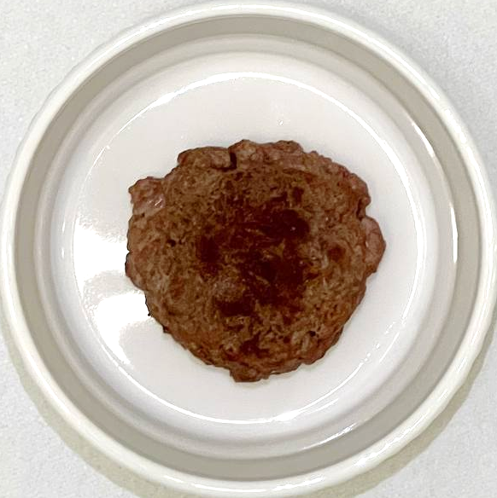 | Beef | 18 | 13 (4) | × | ×
2 | AP | 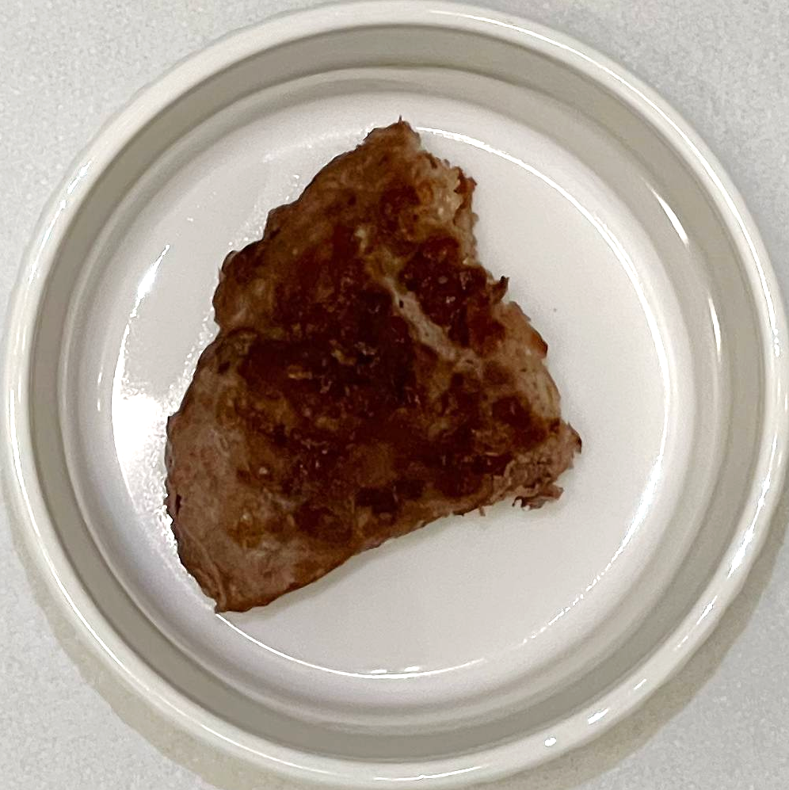 | Beef, water, egg white, seasoning | 15 | 16 (6) | ×
3 | SM-1 | 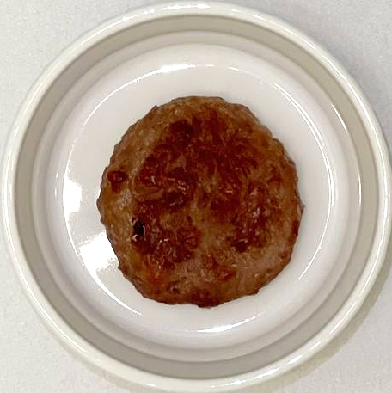 | Water, soy protein concentrate, coconut oil, sunflower oil, flavourings | 16.8 | 11.5 (5.3) | × | ×
4 | SM-2 | 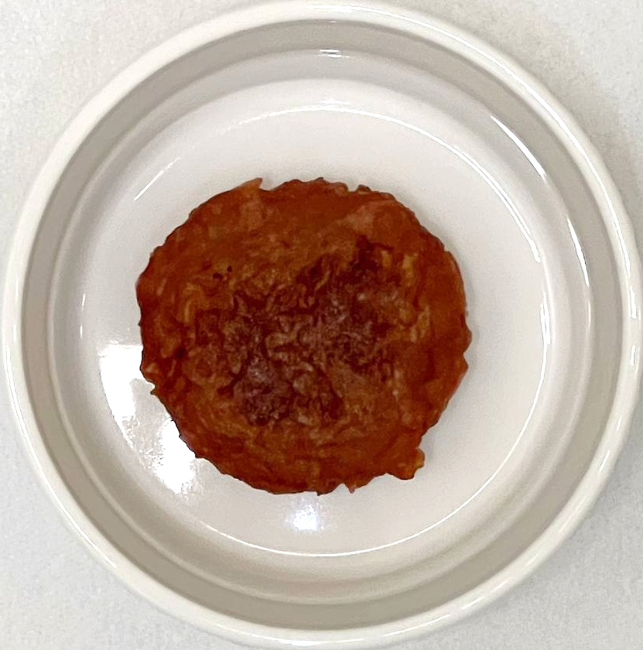 | Water, soy protein, vegetable oil, pea protein, natural flavouring | 12.2 | 13.9 (1.2) | × | ×
5 | SP | 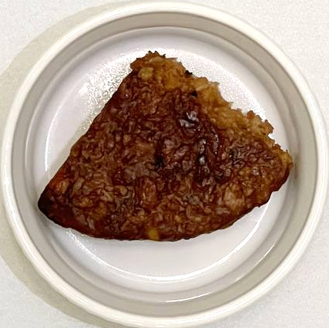 | Water, soy protein, pea protein, vegetable oil, seasoning | 14.1 | 18.8 (3.8) | ×
6 | PM | 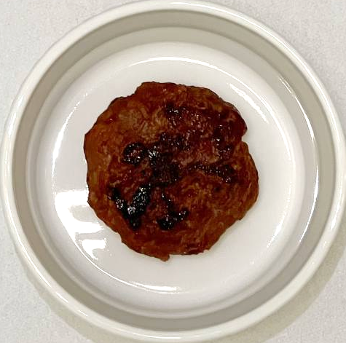 | Water, pea protein, pressed canola oil, refined coconut oil, rice protein, natural flavouring | 17.7 | 12.3 (4) | × | ×
7 | PP | 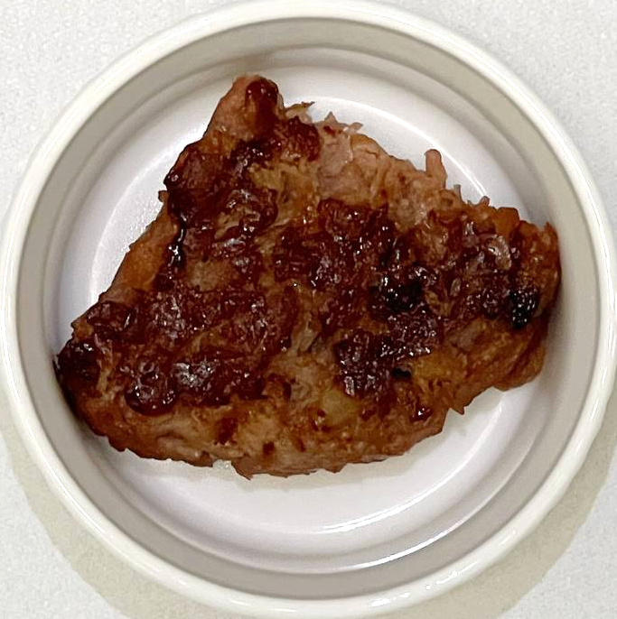 | Water, pea protein, pressed canola oil, refined coconut oil, rice protein, natural flavouring | 17.7 | 12.4 (4.4) | ×
8 | MM | 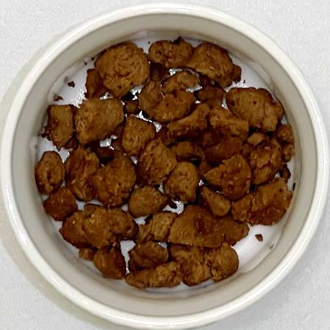 | Mycoprotein, water, egg white, wheat flour, vegetable oil, maize flour, wheat starch, textured wheat protein, natural flavouring | 14.5 | 2.0 (0.5) | × | ×
9 | MP | 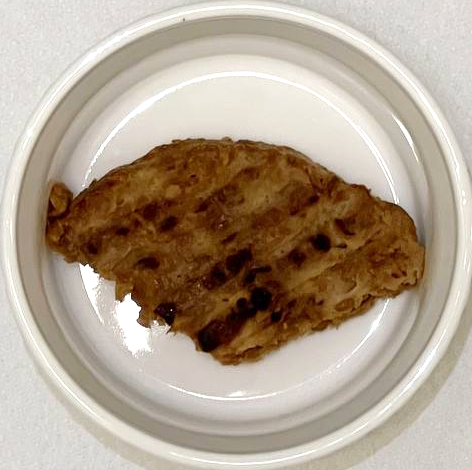 | Mycoprotein, egg white, textured wheat protein, vegetable oil, flavouring | 16 | 8.1 (3.4) | ×
10 | GM | 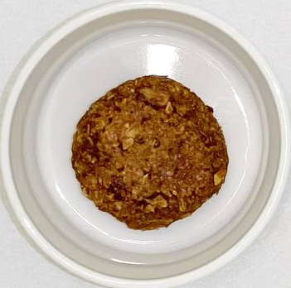 | Green spelt, whole-grain oat flakes, spelt flakes, sunflower seeds, seasoning | 15 | 9 (1) | × | ×
11 | GP | 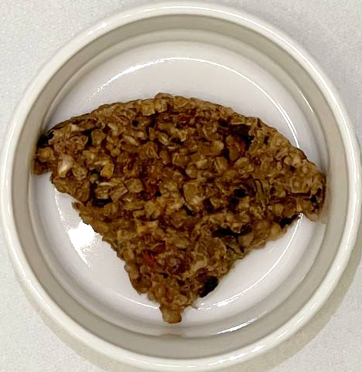 | Mushrooms, bulgur wheat, wheat gluten, sunflower oil, seasoning | 8.5 | 7.0 (0.7) | ×

Table 2. Attributes and descriptions used for sensory evaluation of burger patties.
 | Attribute | Description
 | Before Consuming
Odour | Meaty Odour Intensity | The odour intensity associated with meat (e.g., beef)
 | Legume Odour Intensity | The odour intensity associated with legumes (e.g., beans, peas, lentils)
 | Off Odour Intensity | The intensity of non-characteristic odour (chemical, rancid, metallic etc.)
 | After consuming
Taste / Flavour | Meaty Flavour Intensity | The intensity of meat flavour
 | Legume Flavour Intensity | The intensity of flavour associated with legumes (e.g., beans, peas, lentils)
 | Salty Taste Intensity | The intensity of salty taste associated with sodium chloride
 | Savoury Taste Intensity | The intensity of savoury taste associated with monosodium glutamate
 | Off Flavour Intensity | The intensity of non-characteristic tastes (chemical, rancid, metallic etc.) in the sample
Texture / Mouthfeel | ‘Juiciness’ | The amount of moisture and juices released during the chewing of the sample
 | Chewiness | The amount of chewing required
 | Oily mouthfeel | The perception of oiliness in the mouth after swallowing
 | Flavour Aftertaste Intensity | The intensity of lingering flavour of the sample

Table 3. Attributes, descriptions, and reference aromas used to familiarize and train GC-O panellists.
Descriptor | Reference | Description
Meaty | Beef extract | The odour intensity associated with animal meat (beef, chicken)
Legume | Soybean extract | The odour associated with legumes (e.g., bean, peas, lentils)
Fatty | (E,E)-2,4-decadienal | The odour associated with oils, waxes, or fat-based foods (e.g., butter)
Nutty | 2,5-dimethyl pyrazine | The odour associated with roasted nuts
Sulfurous | Furfuryl thiol | The odour associated with eggs and onions
Other | - | Any non-characteristic odours

Table 4. Citation proportions of the compound matching its descriptor(s) before and after training. GC-O panel aromagrams can be found in Supplementary Figure 1.
No. | Compound | Descriptor | Threshold | Before training | After training
1 | 2-methyl pyrazine | Nutty | 60,000 ppb | 27.3% | 9.1%
2 | 2,5-dimethylpyrazine | Nutty | 800 ppb | 27.3% | 63.6%
3 | Dimethyl trisulfide | Sulfurous | 0.01 ppb | 54.5% | 63.6%
4 | Furfuryl thiol | Sulfurous, meaty | 0.005 ppb | 72.7% | 81.8%
5 | Methional | Sulfurous, legume | 0.2 ppb | 45.5% | 54.5%
6 | (E,E)-2,4-decadienal | Fatty | 0.07 ppb | 54.5% | 63.6%
7 | 2,5-dimethyl-4-hydroxy-3(2H)-furanone | Others | 4 ppb | 81.8% | 100%
8 | Bis(2-methyl-3-furyl) disulfide | Meaty, sulfurous | 0.0007 ppt | 63.6% | 81.8%
9 | 3-methyl indole | Meaty, others | 0.05 ppb | 81.8% | 81.8%
 | Total compound recognitions ª | - |  | 223 | 203
 | Total noise detections ^{b} | - |  | 2910 | 1801
ª Total compound recognitions: the number of times the assessors correctly selected the descriptor associated with the eluting compound.
^{b} Total noise detections: Number of times assessors selected a descriptor which was not associated with the elution of the nine standard compounds.
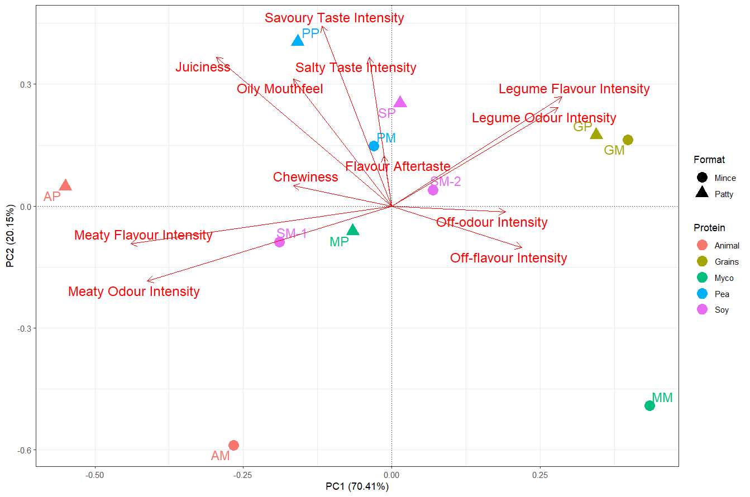
Figure 1. Principal Component Analysis (PCA) of the descriptive sensory profiles of the burger patty samples. Colours represent the protein source: AP/AM - animal (red), GP/GM – grains (yellow), MP/MM – mycoprotein (green), PP/PM – pea (blue), SP/SM – soy (purple).
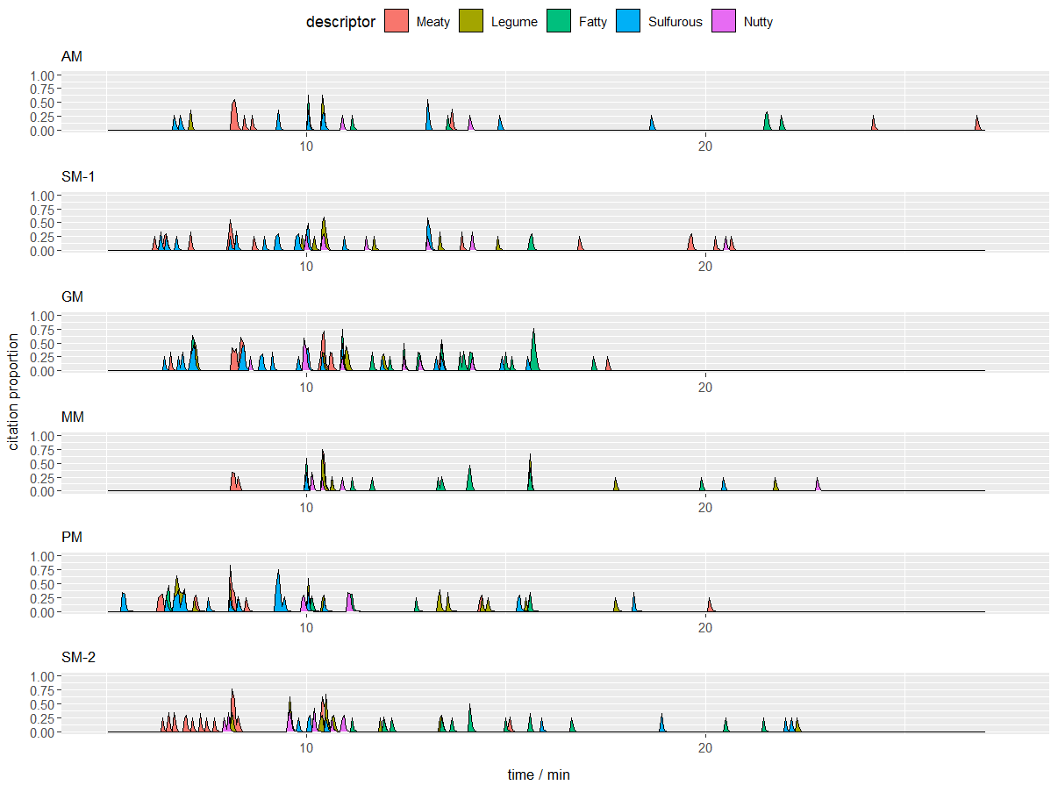
Figure 2. GC-O TCATA aromagram generated by the panel for each meat product. The citation proportion is reported at the proportion of GC-O panellists who describe the same odour descriptor at any given point in time over the course of the GC run.
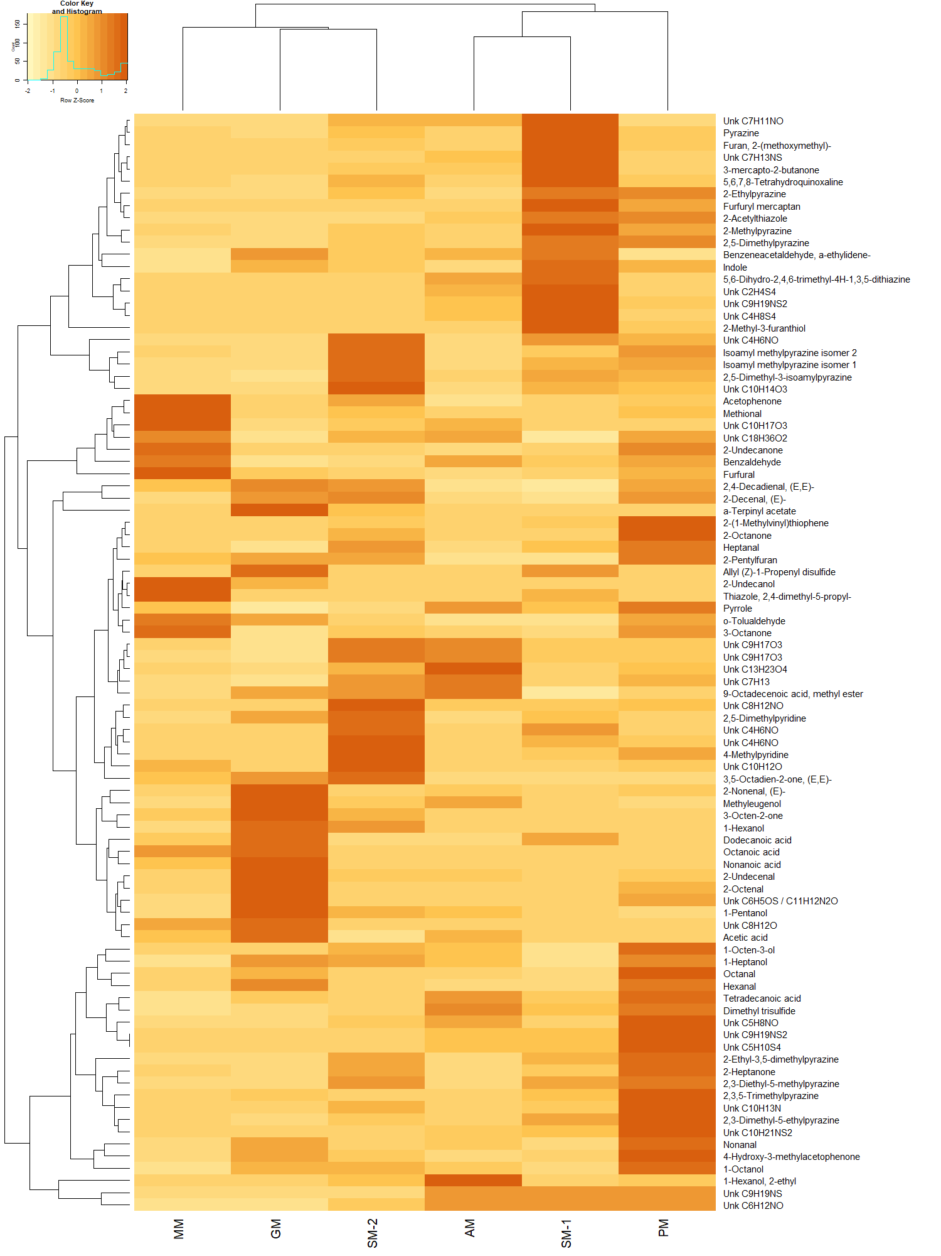
Figure 3. Hierarchical cluster analysis (HCA) heat map showing relative pareto-scaled levels of volatiles identified from the GC-HRMS chromatogram. Unidentified compounds are labelled as “Unk” followed by their (fragment) molecular formula as derived from HRMS data (The full tabulated data can be found in Supplementary Table 4)
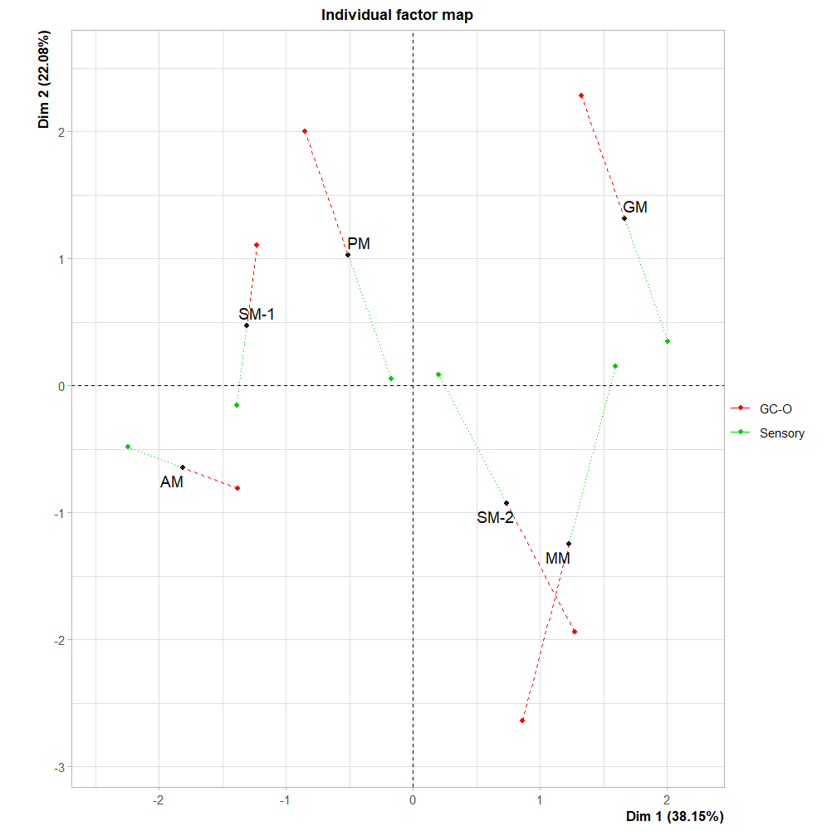
Figure 4. Multiple Factor Analysis scores plot combining the datasets from sensory (green) and TCATA GC-O (red).
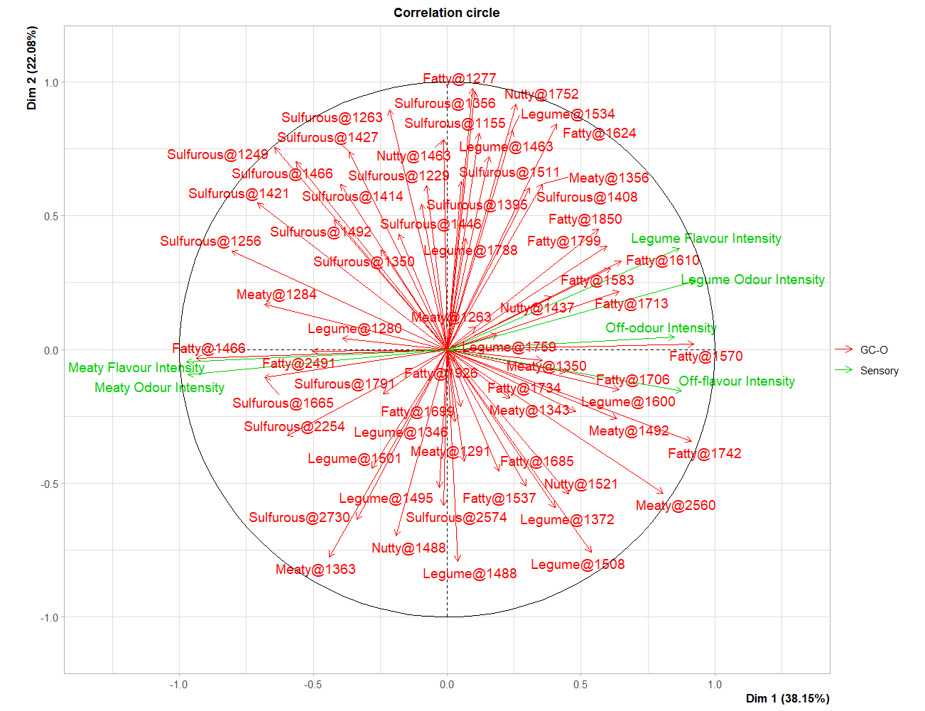
Figure 5. Multiple Factor Analysis variables plot combining the datasets from sensory and TCATA GC-O. GC-O variables are labelled as "Descriptor @ Retention Index".

