Laser powder bed fusion of crack-susceptible stainless maraging steel undergoing solid-state phase transformations

Zhongji Sun^{a*}, Binhan Sun^{b}, Verner Sohª, Coryl Leeª, Desmond Lauª, Fengxia Weiª, Alisson K.D. Silva^{c}, Ming Linª, Cheng Cheh Tanª, Pei Wang^{a*}, Upadrasta Ramamurty^{a,d}

a. Institute of Materials Research and Engineering (IMRE), Agency for Science, Technology and Research (A*STAR), 2 Fusionopolis Way, Innovis #08-03, Singapore 138634, Republic of Singapore
b. Key Laboratory of Pressure Systems and Safety, Ministry of Education, East China University of Science and Technology, Shanghai 200237, China
c. Microstructure Physics and Alloy Design, Max–Planck-Institut für Eisenforschung, Düsseldorf, Germany
d. School of Mechanical and Aerospace Engineering, Nanyang Technological University, Singapore

Corresponding authors: Zhongji Sun (sun_zhongji@imre.a-star.edu.sg), Pei Wang (wangp@imre.a-star.edu.sg)

Abstract
For alloys that experience solid-state phase transformation upon cooling, the absence of as-solidified chemical segregation information makes the elimination of hot cracking challenging. One such material is the hot-crack-susceptible high-strength maraging steel C465. Here, we resolve its hot cracking problem under the laser powder bed fusion process through the addition of titanium nitride (TiN) particles. During solidification, TiN promotes grain refinement and reduces the formation of liquid films with low solidus temperatures. Under cooling, the partial dissolution of TiN lowers the martensite start temperature and yields more retained austenite. Upon subsequent annealing, the dissolved titanium slows down the austenite reversion kinetics, while the dissolved nitrogen improves the yield strength. Materials under tensile deformation follow a three-stage work-hardening behavior, indicative of strain-induced martensitic transformations. This work highlights that besides the nucleant’s grain refinement potency, the effect of its partial dissolution during processing needs to be critically examined, when addressing the hot cracking problem for alloys prone to phase transformations.

Graphical abstract
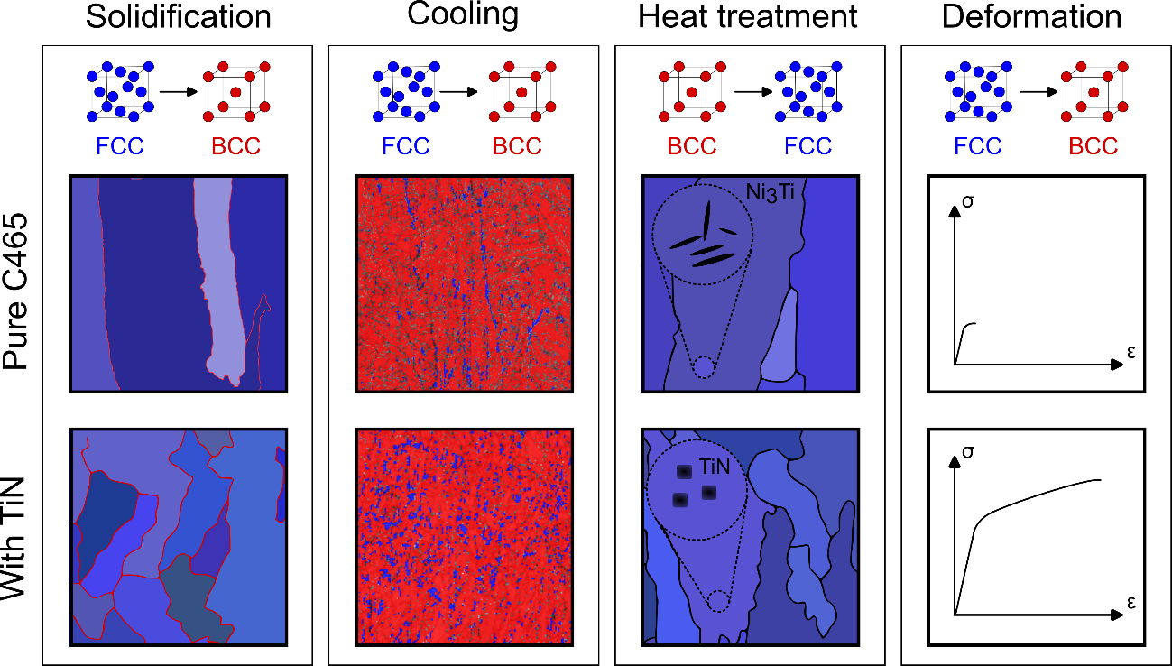

Introduction
While classical high-strength steels (HSSs) such as the precipitation-hardened stainless steel 17-4 PH (Fe-17Cr-4Ni-4Cu, wt.%) and the maraging steel 18Ni-300 (Fe-18Ni-9Co-4Mo, wt.%) have been extensively investigated and adopted by additive manufacturing (AM), the state-of-the-art HSS grades are not that well accepted [1]. One major reason for the difference in adoption rates is the occurrence of cracking during rapid solidification, like many other alloy systems [2,3]. Yet, different from most crack-susceptible materials such as Al and Ni alloys, steels often experience multiple phase transformations during fabrication, making the task of crack alleviation within them ever more arduous.
The Custom 465® (C465, Fe-11Cr-11Ni-1.5Ti-1.0Mo, wt.%) HSS has been attracting growing attention from academia and industry since 2010 [4] due to its superior corrosion resistance, compared to conventional HSSs like 18Ni-300. Since it can operate without the need for protective coatings (e.g., cadmium and chrome that are toxic), it offers a more sustainable environmental footprint [5]. Within the group of stainless HSSs, C465 is reported to have one of the highest strengths, i.e., about 50% higher than 17-4 PH (1751 vs. 1172 MPa), and at the same time possessing comparable corrosion resistance and toughness [4]. If these attributes are combined with the design freedom of AM, it is possible to envision several new applications and functionalities, e.g., impact absorbing foam on high performance cars, complex drill bits with internal cooling channels, and intricate high-thrust ship propellers, etc.
The conventional manufacturing (CM) route of C465 involves three processing steps after casting. (1) The alloy is first solution annealed (SA) around 900 °C for 1 hour, to obtain a fully austenitic face-centred cubic (FCC) phase. (2) The material is then deeply quenched to -73 °C and held for 8 hours to assist the martensitic transformation. (3) A final ageing process at temperatures between 480 and 650 °C is then carried out, to fine-tune the characteristics of the hexagonal-close-packed (HCP) η-Ni₃Ti strengthening precipitate and the reverted austenite [6]. In general, the volume fraction of the reverted austenite increases with the ageing temperature, with a maximum amount of about 14 to 19 vol.% at the peak condition that occurs around 650 °C [7,8]. These reverted austenite grains preferentially nucleate at the prior-austenite or lath boundaries of the parent martensite phase, generally having a lower dislocation density compared to their neighboring martensite [7]. The η-Ni₃Ti precipitate mainly nucleates within the martensite obeying an orientation relationship of ${\left\{011\right\}}_{α'}//{\left\{0001\right\}}_{η-Ni3Ti}$ and ${〈1\overline{1}\overline{1}〉}_{α'}//{〈11\overline{2}0〉}_{η-Ni3Ti}$ [6]. These precipitates have a rod-like morphology, and their length can range from ~5 to ~180 nm depending on the ageing treatment employed [9]. The variation in the content of reverted austenite and the morphology of precipitate can yield a wide range of tensile, corrosion, and hydrogen resistance properties [8–10].
In this study, we attempt to fabricate C465 using the laser powder bed fusion (LPBF) technique. Our first results show that this alloy is highly susceptible to hot cracking during LPBF. The presence of hot cracks (also known as hot tearing) in AM alloys is often ascribed to the partition-induced liquid film near the end of solidification, which has lower solidus temperatures than its surrounding materials [2]. Several hot-crack mitigation approaches have been formulated in prior AM works. Kontis et al. [11] prevented hot cracking in nickel-base superalloy by lowering the volumetric heat input, hence reducing elemental partition and impeding low-solidus-temperature liquid film formation. Sun et al. [12] introduced secondary precipitates along grain boundaries during solidification to facilitate dendrite bridging, hence avoiding hot cracks. Sun et al. [3] also eliminated the hot cracks in nickel-base superalloy by controlling the competitive solute partition with the assistance of thermodynamic computations. Opprecht et al. [13] resolved the hot cracks in aluminum alloy via grain refinement.
Despite these earlier successes, as will be shown later, a direct adoption of the aforementioned hot-crack mitigation methods remains problematic for hot-crack-susceptible steels. This is because modern HSSs (mostly of the maraging grade) experience multiple phase transformations (unlike Al or Ni alloys which always have an FCC matrix), which could include primary and secondary phase formations during solidification, martensitic transformation during cooling, austenite reversion upon subsequent heating, and possible deformation-induced martensitic transformation under loading. As a result, retrieval of the elemental partition information right after solidification via experimental means is not straightforward. This, in turn, significantly hampers efforts through alloy design for eliminating hot cracking during AM.
Through the experimental work reported in this paper, we highlight the intricate nature and important aspects one needs to consider, when attempting to resolve hot cracking in high strength maraging steels, by using C465 alloy as an example. We will first present the severity of hot cracks in the as-built material, and the limitations of several existing hot-crack elimination methods. Crack-free specimens were obtained after introducing TiN particles into the precursor steel feedstock powders. The effect of TiN on the microstructure and tensile properties were also investigated and discussed in detail. We believe this work will not only assist in the adoption of high-strength stainless maraging steels to AM, but could also serve as a guide for any alloy that experiences phase transformations during production involving rapid solidification.

Experiments

2.1 Sample Fabrication
Commercial C465 alloy powders (size range: 15 to 45 μm) were obtained from Carpenter Additive. The powder’s chemical composition is listed in Table 1. A Trumpf TruPrint 1000 machine equipped with a ~1070 nm wavelength laser (beam diameter of 30 μm) was used for the sample production. An initial laser parameter screening was conducted with a fixed laser power of 175 W, powder layer thickness of 30 μm, and hatch spacing of 100 μm. The laser scanning speed was varied (8 evenly spaced) from 130 to 600 mm/s, yielding a volumetric energy density that ranged from 448 to 97 J/mm³. Cubic specimens with the dimensions of 10 × 10 × 10 mm³ were built to examine the as-built sample’s microstructure and internal defects. Rectangular blocks with the dimensions of 10.6 × 26 × 10.6 mm³ were produced for subsequent tensile testing. TiN particles from Luoyang Tongrun Nano Technology were subsequently added to the C465 powders via a BMU-100-3 roller mill, that operated at a rotational speed of 180 rpm for 12 hours. Scanning electron microscopy (SEM) imaging showed that the TiN powders have a plate shape with a size range from about 100 to 500 nm. Tool steel substrates were employed for all the sample productions.
Table 1 Chemical composition of the commercial C465 powder
wt.% | Cr | Ni | Ti | Mo | Mn | Si | P | Fe
C465® | 11.31 | 11.13 | 1.59 | 0.95 | 0.01 | 0.01 | 0.01 | Bal.

Heat treatment and mechanical testing
Heat treatment was carried out in QSXL-1616 box-type electric furnace to study the austenite reversion and the effect of microstructural change on the mechanical properties. The samples were heated (at a rate of 10 ˚C/min) to annealing temperatures, T_{A}, ranging from 360 to 630 °C, held for 4 hours, and then furnace cooled. Microhardness was measured with a 300 g load and a hold time of 15 seconds, using the Innovatest Falcon 5000 machine. At least 12 indents were made on each specimen across the entire build height. Tensile specimens were machined with a gauge length of 20 mm, gauge width of 8 mm, and gauge thickness of 1 mm. The tensile tests were conducted on an Instron Mechanical Tester 5569 machine, with a nominal strain rate of 0.30 mm/min.

Microstructure characterization
The as-built specimens were removed from the substrate using the electrical discharge machining (EDM) and mounted in PloyFast carbon resin. The samples were then ground with SiC-paper in the ascending grit numbers of #220, #500, #1000, #2000, #4000. Subsequent polishing was made with 3 and 1 μm diamond suspensions, followed by vibratory polishing using a colloidal silica suspension, before optical microscopy (OM) and SEM observations. An additional step of electropolishing was performed (24 V and 0.7 A) using the Struers A2 electrolyte for the electron backscattered diffraction (EBSD) investigations. This procedure is to remove any possible grinding/polishing-induced martensite formed on the outer surface of the polished samples. By comparing the phase fraction between the EBSD results and the X-ray diffraction (XRD) data, an electropolishing duration of 2 minutes was determined as the optimum for this process.
The EBSD data was acquired using a JEOL JSM-IT500HR microscope equipped with an Oxford Symmetry detector. An accelerating voltage of 20 kV and a step size of 0.5 μm were adopted for overview scans. For detailed scans, with an area below 10 × 10 μm², a step size of 0.05 μm was used instead. All scans adopted a binning size of 156 ×128 pixels, with an acquisition speed of 246.5 Hz. The Oxford Aztec software was employed for data collection. MTEX software was used for the EBSD analysis and prior austenite grain reconstructions [14]. Backscattered electron (BSE) imaging and energy dispersive spectroscopy (EDS) mapping were also performed. The XRD characterization was performed on the Bruker D8 discover diffractometer, with a Cu Kα radiation and 2D Våntec detector. The exposure time was set to 100 seconds for each frame. Phase fraction was estimated using Rietveld refinement via TOPAS v5.
Thin lamellae for scanning transmission electron microscopy (STEM) study were prepared by the lift-out technique using a focused ion beam (FIB, ZEISS Crossbeam 540). A 1 μm-thick protection layer of platinum (Pt) was placed onto the specimen via ion beam-assisted chemical vapor deposition prior to the operation. Nanoscale microstructural characterization was performed on a FEI Titan 80-300 TEM at 200 kV. TEM EDS mapping was carried out using Tecnai-20 operating at the same condition.

Thermodynamic calculations
Thermodynamic calculations were performed using Thermo-Calc 2022b software and TCFE12 database. In-house written codes were implemented in the console mode to compute the partitioning coefficients of individual solute elements.

Results

3.1 Microstructure of the as-built C465 alloy
As mentioned earlier, all the as-built C465 specimens exhibited extensive cracking despite the wide range of laser processing parameters employed. A representative optical micrograph of an as-built sample is shown in Fig. 1 (a). The crack density is found to be 4.6 mm/mm², which is comparable to that found in LPBF Ni-base superalloy [3]. These cracks are mostly parallel to the sample’s build direction and their lengths range from ~100 μm up to ~1 mm, as seen from Figs. 1 (a) and (b). The surfaces of these cracks observed after tensile fracture are mostly smooth, and they mimic the shapes of solidification dendrites, confirming that these cracks are hot (also known as solidification) cracks, Fig. 1 (c). The origin of such crack is typically due the presence of a liquid film with a low solidus temperature, which cracks under the combined influence of tensile residual stresses upon solidification [2,3,12]. Evenly spread bright contrast lines are present within the as-built material, when observed under the BSE mode, Fig. 1 (d). These features likely arise from a distinct variation in chemical compositions due to elemental partition or segregation. Nanometer-sized particles are also observed to be distributed homogeneously across the entire cross-section.
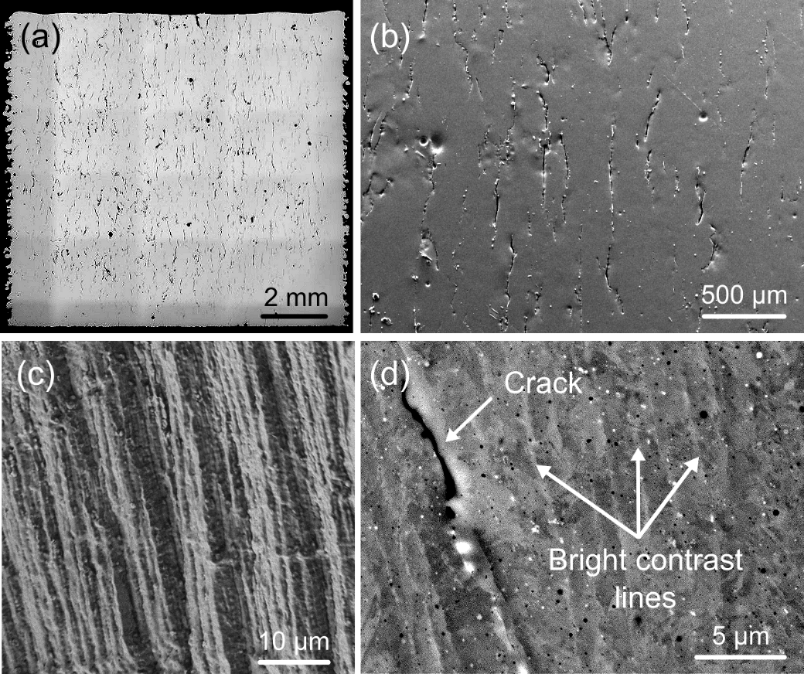
Fig. 1 Representative image of the cracks present in as-built C465® alloy under (a) OM and (b) SEM conditions. (c) After tensile fracture, these crack surfaces are found to be smooth and dendrite-like, suggesting the presence of hot (aka solidification) crack. (d) Evenly spread bright contrast lines and nano-sized precipitates were found under the BSE mode.

Through the EBSD experiments, about 4 % of retained austenite was detected in the vicinity of 2 hot cracks in the as-built C465, Fig. 2 (a). Additionally, lath martensite was frequently observed in the inverse pole figure (IPF) maps with an out-of-plane viewing direction, Fig. 2 (b). Various blocks and packets containing these laths were clearly observed. An iterative method proposed by Nyyssönen et al. [15,16] was adopted to reconstruct the prior austenite grains by using the MTEX software. In this method, the boundary misorientations between the product martensite variants are sequentially computed. These individual misorientations are then iteratively compared against an initially hypothesized orientation relationship (OR), e.g., Kurdjumov-Sachs (K-S) or Nishiyama-Wassermann (N-W). The OR is constantly updated with the aim of obtaining a best fit to the misorientations in the microstructure. There are always deviations between the theoretical and experimental misorientation values, most likely due to local plastic deformations incurred during the phase transformation process. Once the ideal OR is determined, the orientation analysis was performed by coloring all the product martensite variants based on their distinct transformation variants, Fig. 2 (c). The pole figure plot of all the martensite variants within one parent austenite grain enclosed by white solid line in Fig. 2 (c) are plotted in Fig. 2 (d), with respect to the parent austenite’s orientation. The colored data points correspond to the experimentally captured data, while the black open circles are the theoretically calculated results following the K-S OR. The high consistency between the simulated and experimentally acquired data confirms that the current alloy follows the K-S OR during the martensitic transformation. The high-angle grain boundaries (HAGBs) above 15° are highlighted in blue solid lines within the reconstructed prior austenite grain map, Fig. 2 (e). It is found that the hot cracks only exist along the prior austenite grain boundaries (PAGBs), as indicated by white arrows.

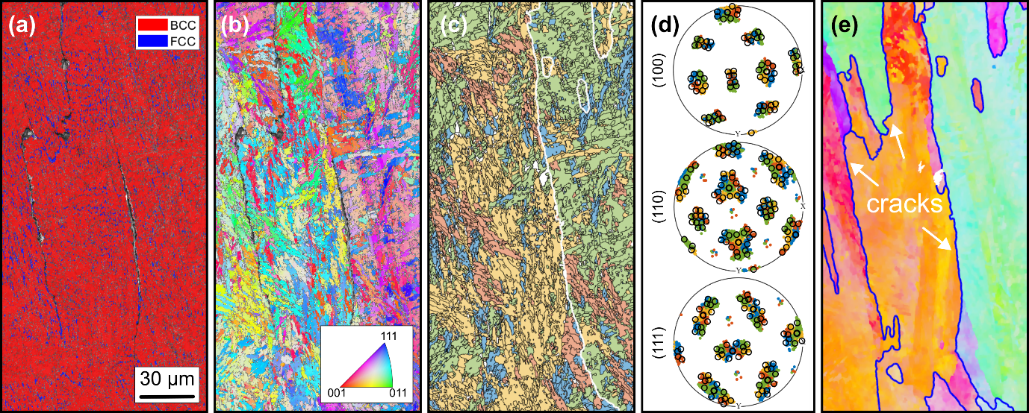
Fig. 2 EBSD study of the as-built C465 alloy in the vicinity of 2 hot cracks. (a) Phase map overlayed with the image quality map, showing the distribution of the retained austenite (FCC) in blue and the transformed martensite (BCC) in red. (b) The inverse pole figure (IPF) superimposed with the image quality map, illustrating the grain morphologies and their orientation in the out-of-plane viewing direction. (c) Classification of the martensite transformation variants during the prior austenite grain reconstruction process. (d) Pole figure plot of the martensite grains with respect to their parent austenite grain orientation enclosed by the white solid line in Fig. 2(c). Theoretical orientations following the Kurdjumov-Sachs (KS) relationship are marked with black circles. (e) The reconstructed prior austenite IPF map, with the high-angle grain boundaries (HAGBs) highlighted in blue and cracks indicated by white arrows.

At a higher magnification, the retained austenite grains are found to be elongated in shape, and they all seem to share a common alignment direction, Fig. 3 (a). Based on these features, it is speculated that the bright contrast lines observed under the BSE condition in Fig. 1 (d) are austenite grains. Most of the retained austenite grains are located along the boundaries of the martensite grains, Fig. 3 (b). A few intragranular austenite grains are also observed, circled in black dotted boxes. As expected, all retained austenite grains have the same orientation as the reconstructed prior austenite phase, Fig. 3 (c).

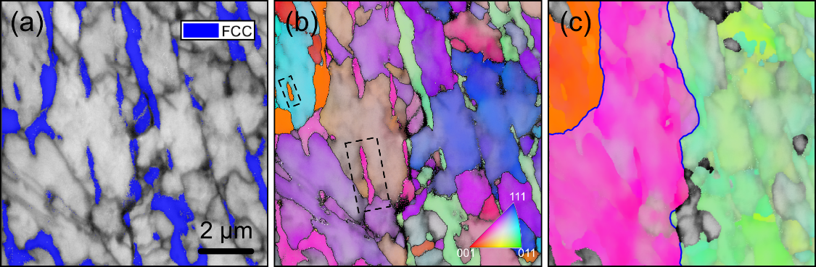
Fig. 3 Enlarged EBSD study of the as-built C465 alloy. (a) The retained austenite grains superimposed on the image quality map. (b) the IPF map of both the austenite and martensite phase, viewed in the out-of-plane direction. FCC grains located within the BCC martensite are marked in black dotted boxes. (c) The reconstructed prior austenite grains.

The depletion of Fe and enrichment of Ti close to the hot crack was identified via the EDS mapping, Fig. 4. Chemical segregation of those smaller precipitates, in the range of hundreds of nanometers was not detected here, likely due to the insufficient spatial resolution of the SEM-based characterization technique. It is well established that the hot cracking susceptibility is highly related to elemental partitioning during solidification [12]. Thus, the Ti segregation observed here is deduced to be a main contributor towards the occurrence of the cracking.
A simple and proven way to reduce such detrimental elemental partition and to prevent hot cracking is to lower the overall heat input, which has been successfully demonstrated in hot-crack-susceptible nickel-base superalloys that were fabricated using LPBF [3]. This approach, however, did not work well for the current alloy as cracks are still present even when the laser power is lowered from 175 to 130 W, and the powder thickness from 30 to 10 μm, while keeping other fabrication conditions unchanged, Fig. 5 (a). In total, 5 samples with a lower laser power of 130 W were fabricated with various scanning speeds, and all of them have a high density of hot cracks, suggesting that reducing the heat input did not help in mitigating the cracking susceptibility of the current C465 alloy. Crack-free samples were only obtained after introducing 1 wt.% TiN particles into the feedstock material, via powder blending, prior to the fabrication process, Fig. 5 (b). The amount of 1 wt.% as an optimum addition of TiN was inferred from prior literature [17]. Additional experiments with 1.5 wt.% of TiN were also carried out, and the rationale of selecting TiN particles for crack elimination will be further elaborated in the discussion section.
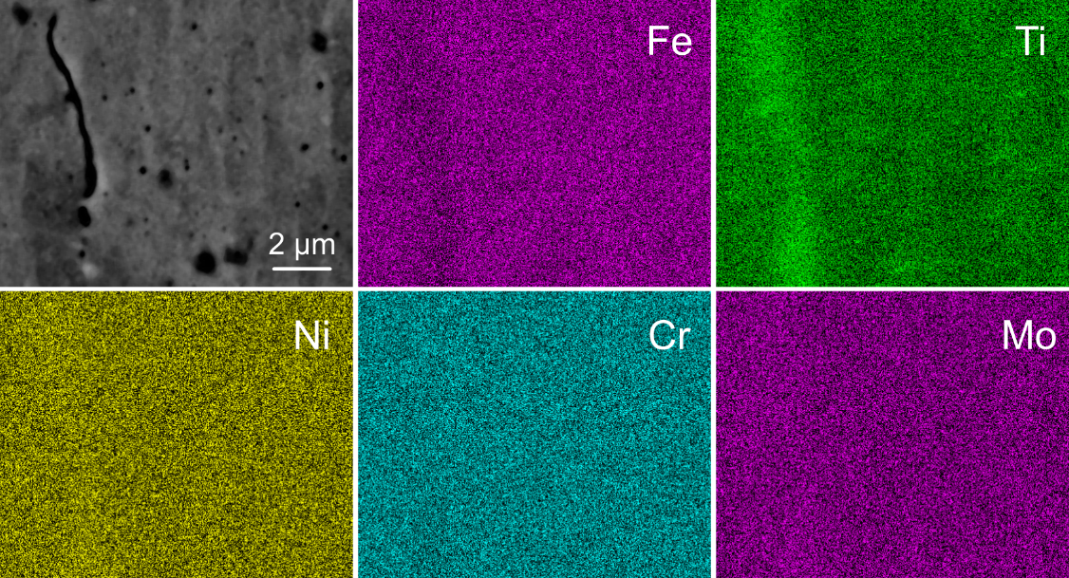
Fig. 4 EDS mapping of the as-built C465 alloy containing a hot crack. Ti enrichment along the crack was detected in conjunction with an Fe depletion. No obvious chemical segregation was found for other elements, e.g., Ni, Cr, and Mo.

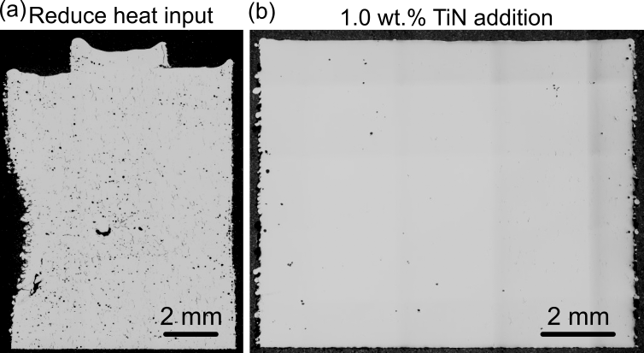
Fig. 5 Additional AM fabrications of the C465 alloy, (a) using a smaller laser power of 130 W and a thinner layer thickness of 10 μm, in contrast to the original sample made by 175 W and 30 μm powder thickness. (b) Introduce 1.0 wt.% of TiN particles via powder mixing, while keeping the laser processing conditions unchanged.

Optimization of the inter-critical annealing temperatures
All the as-built alloys (with and without TiN additions) were subjected to annealing treatments over a wide range of temperatures. After holding the specimens at the specific temperatures for 4 hours followed by furnace cooling, their microhardness values are measured, and the results are shown in Fig. 6. The materials have a similar microhardness of 302.6 ± 7.7 HV (without TiN) and 305.2 ± 8.8 HV (with TiN) in the as-built condition. The heat treated C465 alloy (without TiN) reaches a peak hardness of 517 ± 26.0 HV for a T_{A} of 420 °C; the high hardness stays relatively constant up to T_{A} of 510 °C. Further increments in T_{A} results in the reduction of the microhardness, which finally become 337 ± 12.3 HV after annealing treatment at 630 °C. In comparison, the alloy with 1 wt.% of TiN has a lower peak hardness of 470 ± 21.1 HV, achieved at a T_{A} of 450 °C, a temperature which is slightly higher than that observed for C465 without TiN addition (420 °C). Moreover, this material’s hardness value is more temperature-sensitive, a slight change in T_{A} affects its hardness. Beyond a T_{A} of 450 °C, the alloy experiences a constant decrease in the microhardness, before reaching its lowest (336.1 ± 7.0 HV) at T_{A} = 630 °C. Once again, the two alloys’ microhardness are similar to each other in the over-annealed conditions.

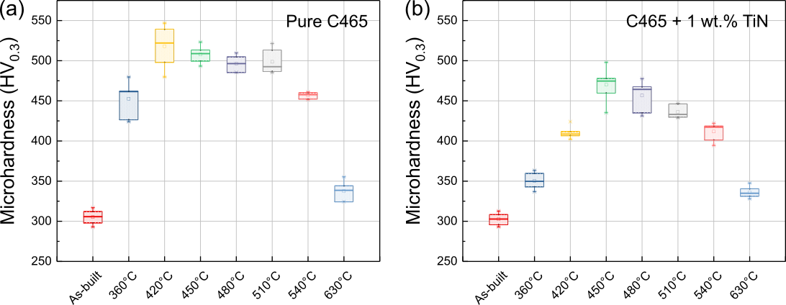
Fig. 6 Microhardness values of (a) pure C465, and (b) C465 mixed with 1 wt.% of TiN particles when subjected to different intercritical annealing temperatures for 4 hours, followed by furnace cooling.
The fractions of austenite and martensite phases present in the microstructures after annealing at different T_{A} for C465 alloy without the TiN addition is studied using the XRD technique, Fig. 7 (a). At a low T_{A} of 360 °C, a sharp increase in the austenite volume fraction, Vγ, is observed, from about 3 % in the as-built condition to around 17 %. With an increase in T_{A}, Vγ monotonously rises till about 35 % at a T_{A} of 570 °C. Beyond this point, the rate of austenite reversion seems to ramp up again, with Vγ reaching 55% at the T_{A} of 630 °C. Representative XRD profiles for the material in the as-built condition, peak-microhardness condition (420 °C), and over-annealed condition (630 °C) are shown in Fig. 7 (b). The intensity of the austenite peaks increases concurrently with T_{A}.
The estimation of phase fractions for the material with 1 wt.% of TiN is less straightforward, due to the overlap between the austenite (220) and TiN (311) peaks which results in significant peak broadening around 74° (not shown here) [18]. Hence, we relied on the EBSD technique for the quantification of phase constituents in the samples with TiN additions.

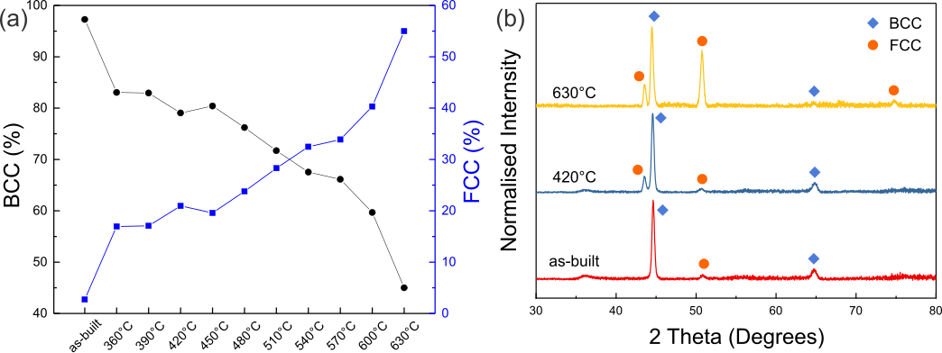
Fig. 7 (a) Quantity of the face-centred cubic (FCC) phase including both retained and reverted austenite, and the body-centred cubic (BCC) or body-centred tetragonal (BCT) martensite in vol. %. (b) Representative XRD profiles of the C465 alloy in the as-built, and annealed conditions at 420°C (peak microhardness) and 630°C (over-annealed).

Fig. 8 shows the IPF maps of the C465 without and with TiN addition. For each case, these maps show (1) the reconstructed prior austenite grains, (2) the associated as-built microstructure, and microstructures after annealing at (3) 420 and (4) 630 °C, together with the relevant phase maps. The statistics of the phase fraction and the average austenite grain sizes are given in Table 2. With the addition of 1 wt.% TiN, the grain size of the reconstructed prior austenite (diameter of about 40 μm) becomes smaller, as compared to that of the pure C465 specimen (diameter ˃ 75 μm), Fig. 8 (a₁) and (b₁). The morphology and size of the austenitic phase in the two alloys are similar in the as-built state, but the alloy with TiN particles has a higher amount of retained austenite (9.8%), in comparison to 4.1 % of the as-built pure C465, Table 2. Besides affecting the prior austenite grain size and the amount of retained austenite, TiN addition also seems to slow the kinetics of austenite reversion in the current steel. Upon annealing at 420 and 630 °C, the austenite content markedly increases to 20.2 % and 69.7 % in the pure C465, respectively. However, they only reach to 17.2 % and 38.2 % in the TiN-added counterpart, despite slightly larger austenite amount in the as-built condition. Moreover, the average grain size (in area) for the pure C465 austenite in the over-annealed condition (630 °C) is almost 5 times that of the TiN-added sample (89.6 μm² vs. 19.0 μm²), suggesting TiN severely restricts the growth of the reverted austenite grains.
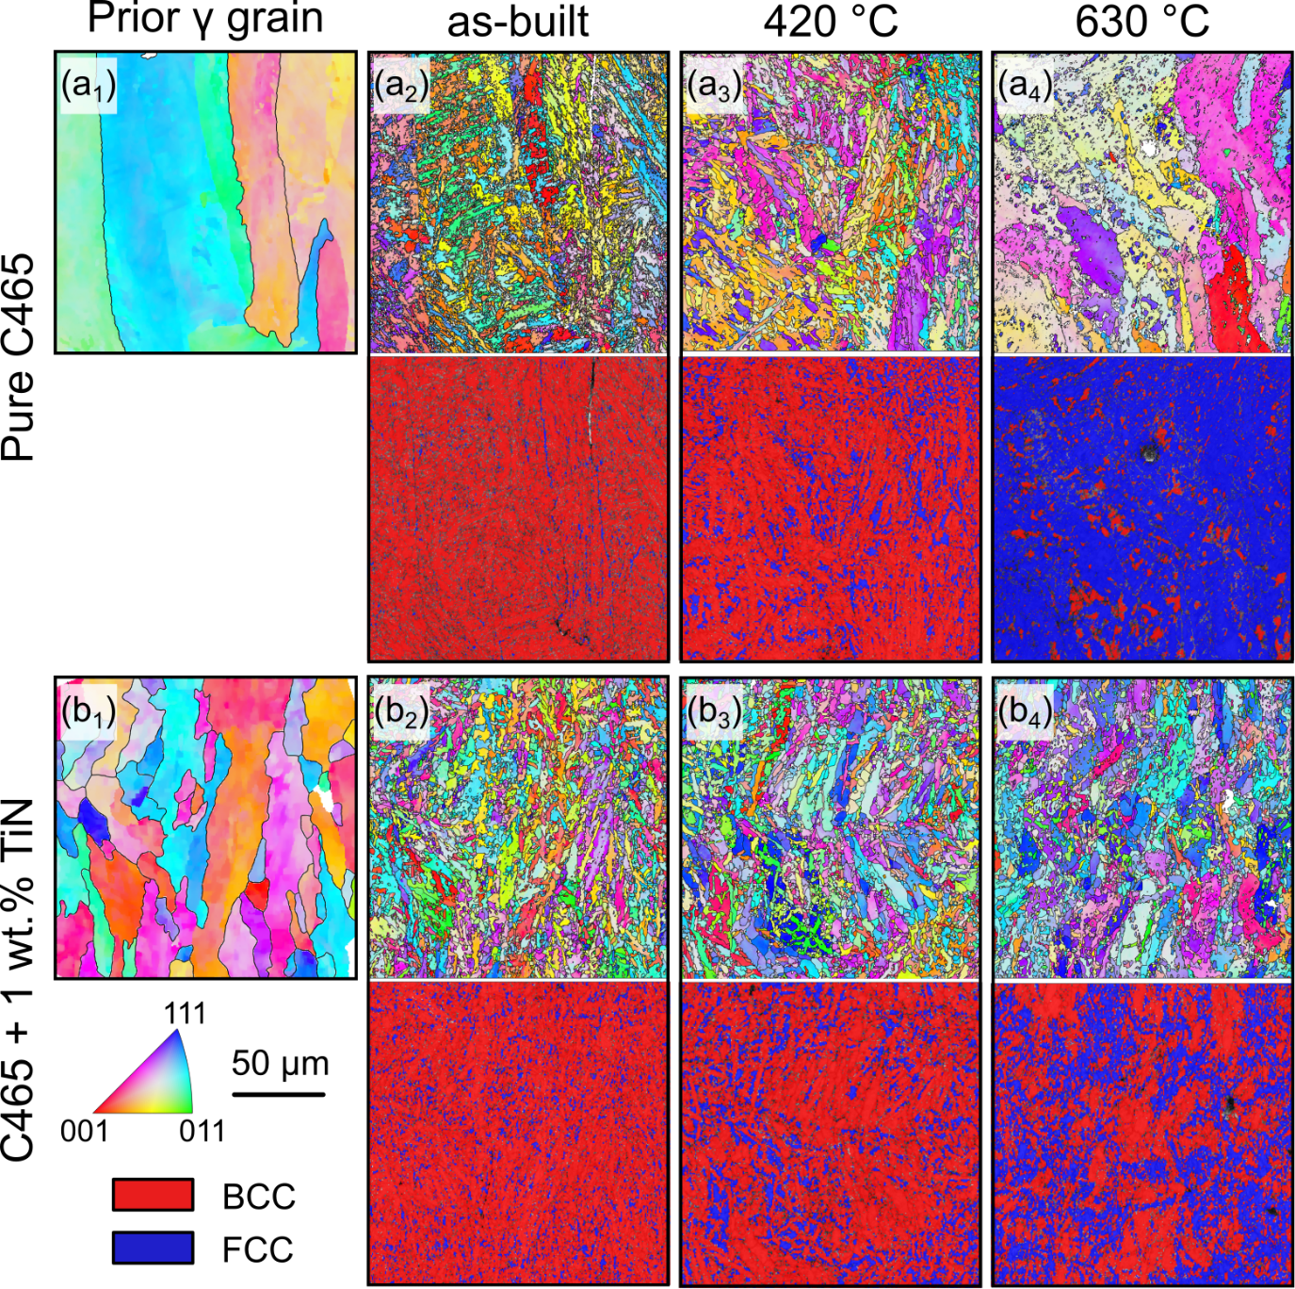
Fig. 8 IPF maps for the (a₁ to a₄) pure C465 and (b₁ to b₄) C465 with 1 wt.% of TiN, comprising of the reconstructed prior austenite grains, samples in the as-built condition, and after annealing treatment at the 420°C and 630°C, respectively. The corresponding phase maps are also placed below the relevant IPF data.
Table 2 Phase fractions and austenite grain sizes in the pure C465 and C465 with 1 wt.% TiN additions under different processing conditions.
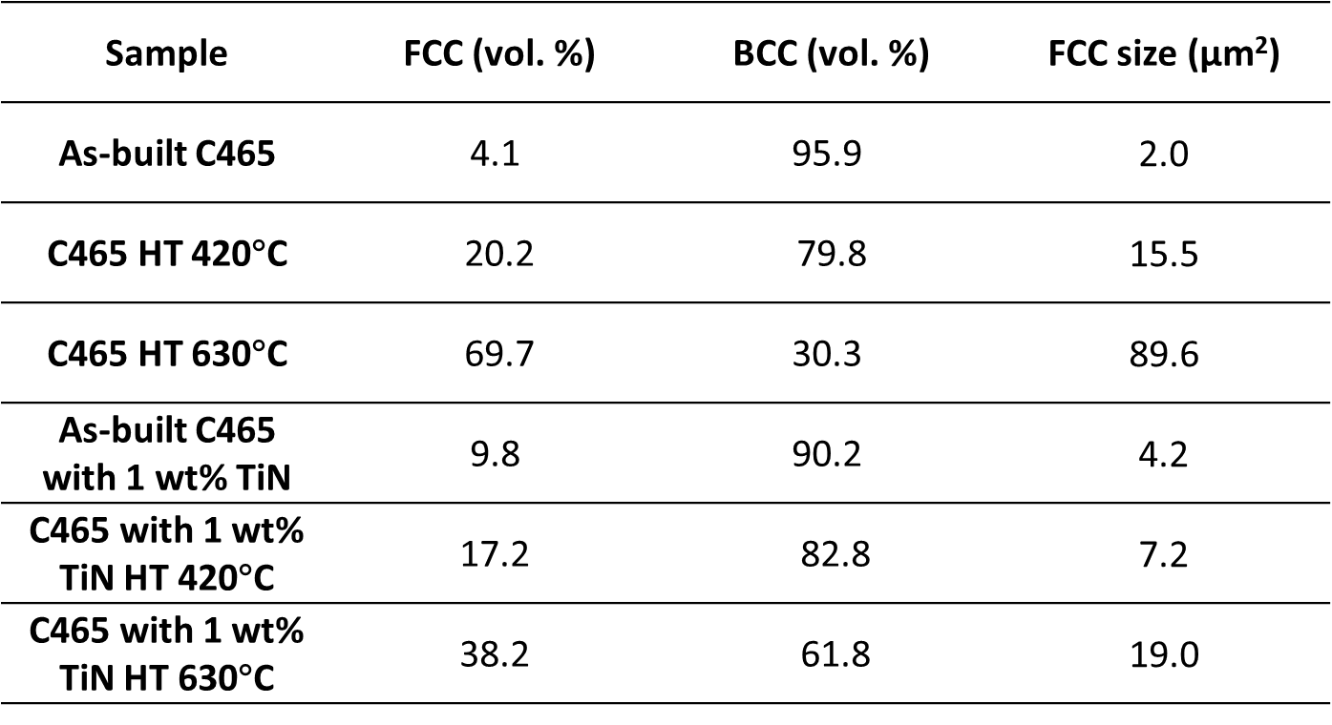
In the as-built state, the microstructure of the C465 without the TiN addition consists of a high density of dislocations and sporadically distributed particles, Fig. 9 (a₁). In it, the average width of the martensite laths was measured to be around 500 nm. Near-spherical precipitates are found to preferentially form close to the lath boundaries, as indicated by the yellow arrows. The displacive nature of the martensitic transformation necessitates shear deformation and volume expansion [19]. Since it is constrained by the surrounding austenite grains, a high density of dislocations within the martensite results [19]. Additionally, the repeated thermo-mechanical cycles that the deposited layers experience during LPBF also results in a high density of dislocations, Fig. 9 (a₂). EDX point analysis of the near-spherical particles suggests that they are mainly Ti-based oxides, with a composition of 50.1Ti-35.3O-10.1Fe-2.8Ni-1.7Cr (at.%), while the matrix remains as 72.6Fe-13Cr-12Ni-1.6Ti-0.8O (at.%), Fig. 9 (a₃). The presence of oxide particles in the LPBF steels is not uncommon, as the feedstock metal powder’s outer surface typically contains a thin layer of residual oxides [20]. After heat treatment at 630 °C, homogeneously distributed rod-like precipitates were detected within the martensite, Fig. 9 (b₁). The length of these precipitates is in the range of 20 to 100 nm, while their width varies between 5 to 15 nm, Fig. 9 (b₂). The selected area electron diffraction pattern (SAEDP) (Fig. 9 (b₃)) obtained on the matrix with precipitates shows a mixture of martensite, HCP η-Ni₃Ti, and double diffraction spots, which match well to previous computer-simulated diffraction patterns [21]. The inferred orientation relationship between the martensite and the precipitate, (011)_{BCC} // (0001)_{η}, [1-11]_{BCC} // [11-20]_{η}, agrees well with that reported on conventionally fabricated C465 after annealing [9].
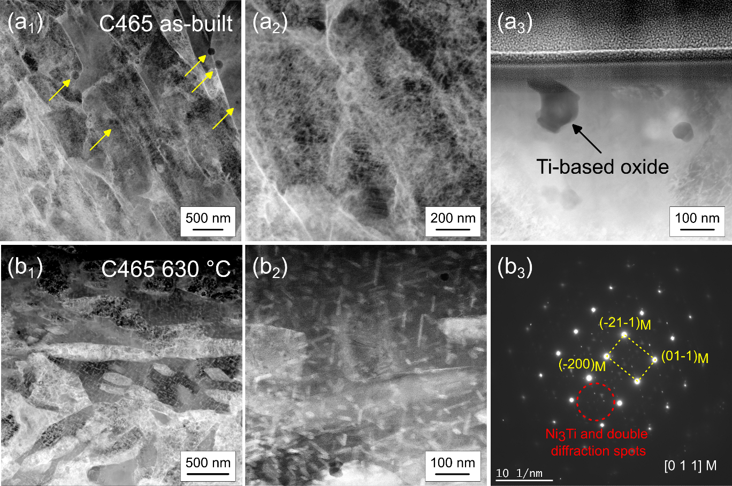
Fig. 9 Scanning transmission electron microscopy (STEM) of the (a₁ to a₃) as-built C465, and (b₁ to b₃) C465 after exposing to 630 °C for 4 hours (over-annealed condition). Yellow arrows in (a₁) indicate position of the precipitates.

With the addition of 1 wt.% of TiN, the as-built C465 also contains a high density of dislocations, Fig. 10 (a). In conjunction, nano-sized precipitates are present at both the intra- and inter-granular regions. These precipitates seem to be the residuals of those precursor TiN particles, as their size is much smaller (around 20 to 30 nm after fabrication vs about 100 to 500 nm before melting). Moreover, prior studies indicate that a full dissolution and re-precipitation event is unlikely for TiN around the melting temperature of steels [22]. After a heat treatment at 420 ˚C for 4 hours, the high density of dislocations still persists within the material, Fig. 10 (b). The average precipitate radii are found to be 22 ± 5 nm (as-built) and 31 ± 7 nm (heat-treated at 420 ˚C), by manual analysis of more than 20 individual precipitates each, Fig. 10 (c). The area fraction of precipitates decreases from 2.8 ± 0.2 % in the as-built condition to 1.7 ± 0.1 % after the heat treatment, suggesting a partial dissolution of the particles within the matrix during the heat treatment. The TEM EDS results confirm this hypothesis, as the N content within the matrix increases to about 0.83 wt.% after the heat treatment, while it was almost nonexistent prior to annealing, Table 3. While the size of TiN particles enlarges through Ostwald ripening during heat treatment, the concentration of Ti and N within the precipitate also increases by rejecting other solutes into the matrix. It is likely that the high density of dislocations observed in Fig. 10 (b) are stabilized by the dissolved N. However, a direct experimental confirmation of this phenomenon is challenging and beyond the scope of this work. EDS mapping of the precipitates indicates an enrichment of Ti and N, but a depletion of the other elements, validating that these particles are indeed TiN.

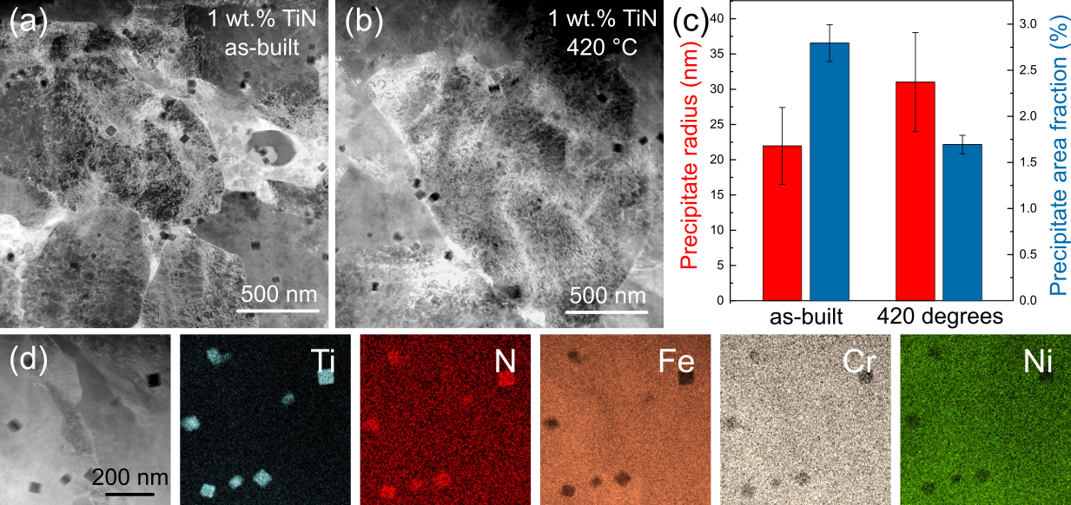
Fig. 10 Scanning transmission electron microscopy (STEM) of the (a) as-built C465 with 1 wt.% TiN and (b) C465 with 1 wt.% TiN after a 4-hour heat treatment at 420 ˚C. (c) Average precipitate radius and volume fraction at these two conditions. (d) Energy-dispersive X-ray spectroscopy (EDS) mapping of the TiN precipitates after a heat treatment of 4 hours at 420 ˚C.

Table 3 TEM EDS results of the matrix and TiN precipitate compositions for specimens doped with 1 wt.% TiN in the as-built and heat-treated conditions (4 hours at 420 °C).
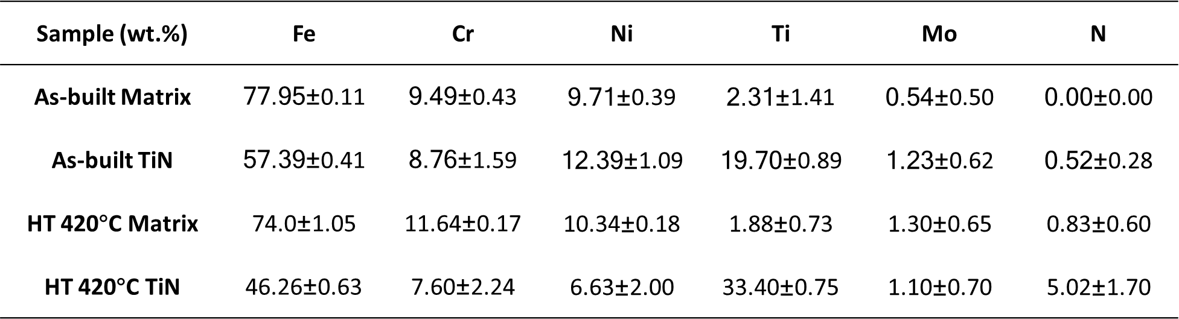

Tensile properties
As expected, the tensile properties of the LPBF C465 without TiN addition are poor (yield strength (YS) of 149 ± 20 MPa, an ultimate tensile strength (UTS) of 234 ± 23 MPa, and an elongation-to-failure value of 1.0 ± 0.1 % in the as-built condition, which remain invariant after different heat treatments) because of the presence of extensive hot cracks, Fig. 11 (a). With the addition of 1 wt.% of TiN, a significant improvement in the tensile properties was noted, Fig. 11 (b). The YS and UTS become 548 ± 21 MPa, and 952 ± 11 MPa, respectively, with the total elongation value of 11.8 ± 0.5 %. After annealing at 420 °C, further increment in strength (YS of 846 ± 31 MPa, and UTS of 1207 ± 35 MPa) with a slight drop in the ductility (9.7 ± 1.1 %) was noted. A further increase in T_{A} led to a reduction in the strength with a concomitant improvement in ductility, which can be attributed to the higher volume fraction of the reverted soft austenite.
It was found that the addition of 1 wt.% TiN to C465 does not completely eliminate crack formation during LPBF, though the crack density is much lower than pure C465 (i.e., 0.1 mm/mm² vs. 4.6 mm/mm²). To examine if more TiN content (1.5 wt.%) would result in entirely crack-free specimens, additional fabrications were conducted. Highly dense specimens without hot cracks are obtained with a density value above 99.9% (based on OM analysis), and the resulting tensile properties are presented in Fig. 11 (c). Due to the complete elimination of hot cracks, the sample with 1.5 wt.% of TiN in its as-built condition (black curve) has a better UTS and elongation value, comparing to its counterpart with 1 wt.% of TiN. Under the same annealing temperature of 450 °C (highest hardness value for C465 alloy with 1 wt.% TiN, blue curves), the samples with 1.5 wt.% TiN registers a slightly lower UTS (1111 ± 8 MPa vs. 1186 ± 37 MPa), but with a much-improved ductility (20.6 ± 2.1 % vs. 12.0 ± 0.8 %). Comparing to the peak-aged C465 made from conventional processing routes, the current 1.5 wt.% TiN-doped sample after annealing at 450 °C has a lower strength (1100 MPa vs. 1500 MPa), but a higher ductility (20 % vs. 10 %) [9]. It is postulated, that the optimal T_{A} condition should be smaller than 450 °C for the current alloy, and there is still room for improvement on its tensile strength values.
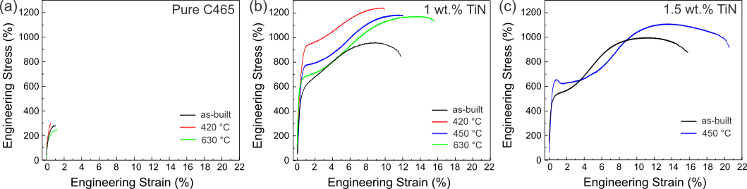
Fig. 11 Tensile properties of (a) the pure C465 alloy in the as-built 420 °C annealed, and 630 °C annealed conditions; (b) C465 alloy with 1 wt.% of TiN, in the as-built, 420 °C annealed, 450 °C annealed, and 630 °C annealed conditions; and (c) C465 alloy with 1.5 wt.% TiN, in the as-built, and 450 °C annealed conditions.

Discussion
In the current work, TiN particles are added into C465 HSS to solve the problem of hot cracking during the AM production. While crack-free samples can be obtained with excellent tensile properties through this approach, the addition of TiN also has several other implications. Here, we mainly aim to discuss three related issues, namely, (1) the mechanism of crack elimination due to the introduction of TiN, (2) the effects of TiN on the volume fraction of the retained and reverted austenite (after cooling and subsequent heating, respectively), and (3) the influence of the microstructural changes on the tensile behavior.

4.1. Mitigation strategies for hot cracking
The underlying mechanism for the occurrence of hot cracking is often ascribed to the combined effects of (1) a low-melting liquid film at the grain boundaries, triggered by solute partitioning during solidification, and (2) the inherent tensile residual stresses within the LPBF part [2]. One quick method to tackle the issue of the hot cracking is to limit the extent of solute partitioning via heat input reduction (e.g., reducing the laser power or increasing the laser scan speed). This approach has been proven to be effective in several nickel-based superalloys [11], but it did not work well for the current material (Fig. 5 (a)). The difficulty of addressing the hot cracking issue here, not only for this material, but envisioned also for other alloys experiencing solid-state phase transformation during cooling, is the absence of the as-solidified partitioning information which can be retrieved via experimental means. Such data is vital for alloy design that can either remove the hot-crack-promoting element, or reduce its detrimental effects by adjusting the contents of other solute elements [3]. It is recognized that certain computational methods (e.g., DICTRA) can help to predict this information, but they in turn require highly accurate thermal history of the material which is difficult to obtain, and typically yield a lower prediction accuracy for low-concentration elements [23]. Thus, these simulation tools are largely used only as qualitative guides.
Pertinent to the current C465 alloy, its solidification path under the Scheil-Gulliver condition is presented in Fig. 12 (a). This formulation assumes no diffusion within the solid and infinitely fast solute redistribution within the liquid [24]. Only austenite, ferrite, and liquid phases were enabled during the simulation, guided by the EBSD results (Fig. 2). The majority (about 0.67 mole fraction) of the alloy solidifies as single-phase FCC, and the BCC phase only forms towards the end of the solidification. The partition coefficients of individual elements are calculated as $k=\frac{X_{S}}{X_{L}}$, where $X_{S}$ and $X_{L}$ are the concentrations of the element within solid and liquid, respectively. Ti is found to have an extremely low partition coefficient within the current alloy, with a value ranging between 0.2 and 0.4 across the entire solidification range, Fig. 12 (b). It is therefore believed that the strong partitioning of Ti during LPBF is the root cause of hot cracking in this alloy, which agrees to our prior EDX mapping results showing Ti enrichment surrounding the hot crack, Fig. 4. With such a high partitioning tendency, it is highly likely that lowering the heat input alone is insufficient to prevent Ti from enriching the residual liquid along the prior austenite HAGBs. Thus, the residual liquid film’s solidus temperature is lowered which subsequently caused the hot cracking, as shown in Fig. 5 (a). In fact, after conducting an analysis of 13 possible substitutional solutes within steels having a primary austenite solidifying phase, Ti is likely to be the least favorable candidate within the consideration of minimizing hot cracking, Appendix 1.

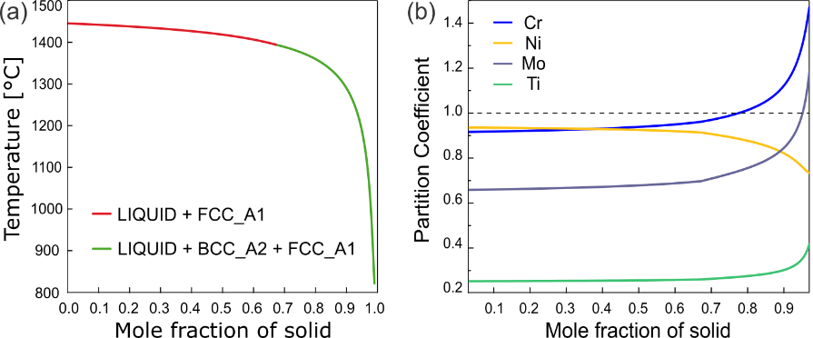
Fig. 12 (a) Scheil-Gulliver simulation of the C465 alloy using the ThermoCalc TCFE12 database. (b) The calculated partition coefficients of the elements during the Scheil solidification.

Another method to tackle the issue of hot cracking, wherein the original alloy’s composition is unaltered, is through grain refinement. This approach was demonstrated to be successful in several LPBF Al alloys [25]. A smaller grain size increases the density of HAGBs within the as-built sample, which is desirable to lower both the solute enrichment of deleterious elements and residual stresses acting on individual GBs, hence improving the material’s hot cracking resistance [12]. As the current alloy primarily solidifies into a BCC phase near the end of solidification (Fig. 12 (a)), an effective ferritic grain refiner is needed.
The classical theory for the selection of grain refiners was originally based on the “lattice disregistry” approach, where the one-dimensional disregistry is defined as $δ= \frac{Δα_{0}}{α_{0}}$, and $Δα_{0}$ is the difference in lattice constants of the low index crystal planes of the nucleus and the nucleating agent [26]. A smaller value indicates a higher potency for grain refinement. Bramfitt [27] extended this method to the two-dimensional space, and ranked several potential nucleants’ effectiveness for δ-ferrite (in an ascending order) as ZrC < WC < ZrN < SiC < TiC < TiN. The edge-to-edge matching (E2EM) model was subsequently developed to account for nucleants with crystal structures different from the base alloy [28]. Under this method, the proposed nucleants for δ-ferrite are TiC < Ce₂O₃ < TiN < CeS < NbO, with NbO being the most effective candidate [29]. Other possible nucleants such as LaB₆ and Ce₂O₂S were also considered [30,31]. TiN was selected in this study mainly due to its high grain refinement potency and its ready availability. However, in theory, other compounds mentioned above should serve the same purpose of grain refinement, and resolve, at least partially, the hot cracking issue in the current alloy.

4.2 Effects of TiN on martensite formation during cooling and austenite reversion during heating
With the addition of 1 wt.% TiN to C465, the volume fraction of retained austenite increases from 4.1 % to 9.8 % in the as-built condition, Table 2. This can be rationalized by examining the influence of Ti and N on the martensite start temperature $m_{s}$. From the thermodynamic standpoint, the martensitic phase transformation will only occur when the available driving force surpasses the transformation barrier [32]. By assuming a prior austenite grain size of 40 μm for the 1 wt.% TiN added specimen (Fig. 8 (b₁)), $m_{s}$ is found to decrease as more Ti and N are present in the alloy, Fig. 13 (a). Based on the compositions of pure C465 and TiN-doped C465 from Table 1 and Table 3 respectively, the $m_{s}$ value in the alloy would change from 60 to 30 ˚C. This, in turn, retards the martensitic transformation that results in the retention of the austenite.

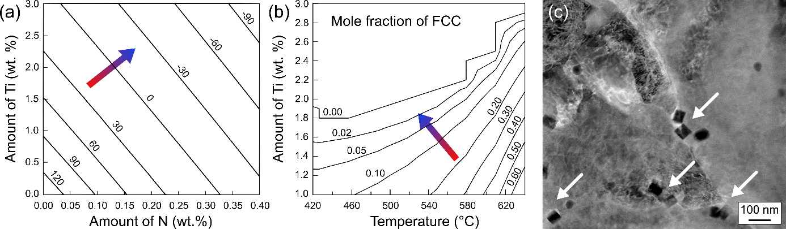
Fig. 13 (a) Martensite start temperature ($m_{s}$) for the C465 alloy with respect to the change in its Ti and N concentrations, calculated using the ThermoCalc steel model. (b) Mole fraction of FCC within the C465 alloy with respect to the Ti concentration and temperature, under the equilibrium condition. (c) The TiN precipitates are found to preferentially distribute along the grain/phase boundaries within the C465 alloy with 1 wt.% of TiN, after a heat treatment at 420 ˚C for 4 hours.

Despite a smaller amount of retained austenite in its as-built condition, C465 without TiN addition exhibits faster austenite reversion kinetics, Table 2. There are potentially two mechanisms influencing the austenite grain growth during annealing, namely, the change in the alloy’s Gibbs free energy due to compositional variation and the pinning effect from the nano-sized TiN precipitates.
Compared to the pure C465 alloy, the TiN-added sample’s matrix in its as-built condition has about 0.72 wt.% more Ti (i.e., 2.31 wt.% vs. 1.59 wt.%), Tables 1 and 3. Yet, despite the rise in the Ti content, no discernable N was detected within the alloy immediately after solidification, at least above the sensitivity of the TEM EDX technique. The dissolved nitrogen is believed to evaporate through the melt pool’s liquid/gas interface during laser melting. This is possibly because nitrogen’s solubility within steel, in both the solid and liquid states, is very low (< 0.01 wt.% [33,34]). The enhanced Ti concentration is found to severely reduce the equilibrium austenite content within the system, Fig. 13 (b). At 420 ˚C, an increment of 0.1 wt.% Ti within the matrix can reduce the austenite content by about 0.8 % volume fraction, and this value becomes around 5.7 % volume fraction at 630 ˚C. This expectation agrees with the EBSD results, Table 2. It is recognized that the increment in N arises from TiN’s partial dissolution during annealing could conversely stabilize the austenite phase. However, past in-situ synchrotron X-ray diffraction data indicates that in LPBF maraging steels, with a heat treatment temperature of 650 °C, the majority of austenite reversion occurs within the first 300 s of the annealing treatment [35]. However, even at a much higher temperature of 1250 °C, the TiN within steels shows little dissolution for the same time duration [36]. These results lead us to believe that the increasing N content during annealing has little effect on the austenite reversion kinetics, at least in the very initial period.
Besides the change in the Gibbs free energy due to TiN dissolution, the presence of TiN could also slow down grain growth through Zener pinning. Unlike the HCP η-Ni₃Ti precipitates, which only nucleate and grow within the martensitic grains during annealing (Fig. 9 (b₁)), the TiN particles are already ubiquitous within the material right through and after the solidification (Fig. 10 (a)). These nanometer-sized TiN can pin the FCC-BCC phase boundaries, and hence reduce their mobility and restrict the austenite growth, Fig. 13 (c). It is well established that carbides and nitrides of several elements (e.g., V, Nb, Mo, and Ti) are effective at impeding grain growth for various steels [37]. The grain growth kinetics under the Zener pinning model are captured in the following equation [38]:
$$\frac{dD}{dt}=M(P_{D}- P_{P})$$ | (1)
where $M$ is the GB mobility, $P_{D}$ and $P_{P}$ are the pressures for driving grain growth and pinning GB movement respectively, and
$$M= M_{0}exp⁡(\frac{-Q}{RT})$$ | (2)
$$P_{D}=β\frac{γ}{D}$$ | (3)
$$P_{P}=αγ\frac{f}{r}$$ | (4)
where $M_{0}$ is a material constant (taken as 10⁴ m⁴J⁻¹s⁻¹ [39] here), $Q$ is the activation energy for grain coalescence, $R$ is the universal gas constant and $T$ is the temperature. Zener ascertained the values of $β$ and $α$ coefficients as 4 and 1.5 [40]. Graux et al. [39] estimate the interface energy $γ$ as 0.5 Jm⁻² for the austenite grain boundaries and 0.7 Jm⁻² for TiN/matrix interfaces. The values of $D$ (the average grain diameter), $f$ (the precipitate volume fraction), and $r$ (the average precipitate radius) are listed in Table 2 and Fig. 10 (c).
Based on these data and the heat treatment duration of 4 hours used in the current study, activation energies for the austenite grain growth for the pure C465 and C465 with 1 wt.% TiN at 420 ˚C are estimated to be 103 and 111 kJ/mol, respectively. At the higher temperature of 630 ˚C, they increase to 126 and 134 kJ/mol, respectively. It is evident that the presence of TiN does increase the activation energy needed for austenite grain growth, but by a relatively small amount of 7.7% at 420 ˚C and 6.3% at 630 ˚C. On this basis, we surmise that the significantly different amounts of reverted austenite contents in C465 with and without TiN is mainly due to the change in the chemical Gibbs free energy, rather than the pinning effect from nano-sized TiN precipitates.

4.3 Microstructural effects on the tensile response
For the LPBF C465 with 1 wt.% of TiN, a 298 MPa increment in the YS ($σ_{YS}$) is obtained after annealing the as-built material for 4 hours at 420 ˚C (i.e., 548 vs. 846 MPa), Fig. 11 (b). It is hypothesized that the 0.83 wt.% (Table 3) dissolved N from the partial dissolution of TiN precipitates is the major contributor for this YS enhancement. However, as an intrinsic austenite stabilizer, literature on the quantitative effectiveness of N towards martensite strengthening is limited. A prior study shows that an additional 0.8 wt.% N (from 0.2 wt.% to 1.0 wt.%) does improve the YS of a martensitic tool steel by about 440 MPa [41]. Takana et al. [42] proposed that the strengthening effect of dissolved N in martensite is about 0.4 times of its C counterpart, which can be modeled by [43]:
$$σ_{YS}= 550 × {C_{C}}^{\frac{1}{2}} = 550 × {({0.4C}_{N})}^{\frac{1}{2}}$$ | (5)
where $C_{C}$ and $C_{N}$ are the concentrations of C and N in wt.%. According to Eqn. (5), 0.83 wt.% of dissolved N can increase the strength of the martensite by 316.9 MPa, which is close to our experimentally observed value of 298 MPa. This observation supports our hypothesis that the observed strengthening is caused by the dissolved N within martensite, in an indirect and empirical manner.
A more quantitative analysis is performed, as following. In the precipitation-hardened alloys, such as the one examined here, YS is a combination of several strengthening attributes:
$$σ_{YS}= σ_{m}+σ_{ss}+σ_{GS}+σ_{d}+σ_{p}$$ | (6)
where $σ_{m}$, $σ_{ss}$,$σ_{GS}$, $σ_{d}$, and $σ_{p}$ represent strengthening contributions from the matrix, solid solutes, grain boundaries, dislocations (that are already present in the alloy), and precipitates, respectively [44]. As the heat treatment does not change the matrix phase, grain size, and dislocation content (Table 2 and Fig. 10), it is reasonable assume that the enhancement in YS upon annealing is mainly derived from the changes in the contributions of solid solution and precipitation strengthening mechanisms:
$$∆σ_{YS}(298 MPa)={\left(σ_{ss}+σ_{p}\right)}_{420 °C}- {\left(σ_{ss}+σ_{p}\right)}_{as-built}$$ | (7)
where the $∆σ_{YS}$ is the difference in YS between the annealed (at 420 °C) and as-built specimens.
The solid solution strengthening contribution is estimated according to the Fleischer’s formula [45]:
$$∆σ_{ss}=\sum{{(β_{i}^{2}χ_{i})}^{\frac{1}{2}}}$$ | (8)
where $χ_{i}$ is the atomic fraction of the substitutional element $i$, and $β_{i}$ is the corresponding solid solution constant calculated by considering the respective element’s modulus and lattice misfit with respect to the matrix Fe [46]. The solid solution constants for the solute elements in the current material are found to be 434 ($β_{Cr}$), 334 ($β_{Ni}$), 2628 ($β_{Ti}$), and 2143 ($β_{Mo}$) [47,48]. For precipitation strengthening, the particles can impede dislocation movements by making them (i) shear through the precipitate (e.g., Friedel formula [49]); (ii) bow around the precipitate (e.g., Orowan-Ashby [50] and modified Orowan [51]); or (iii) experience both of these mechanisms (e.g., Schnitzer et al. [44]). For TiN-added C465, the mean particle radius of 22 ± 5 nm far surpasses the critical precipitate size (typically around 6.8 nm [44]), above which dislocations can no longer shear through the particles. Hence, we resort to the dislocation bypassing mechanism, (i.e., Orowan-Ashby (eqn. 9) and modified Orowan (eqn. 10) models) to calculate the precipitate strengthening component:
$$σ_{p}=0.26\frac{μb}{r}f^{\frac{1}{2}}ln⁡(\frac{r}{b})$$ | (9)
$$σ_{p}=\frac{2μbΦln⁡(\frac{d-2r}{2b})}{4π(d-2r)}$$ | (10)
where $μ$ is the shear modulus (71 GPa), $b$ is the burgers vector (0.286 nm), and $Φ$ is derived from the Poisson’s ratio (1.21) [47]. $d$ is the inter-particle spacing, calculated as $d=0.82\frac{2r}{f^{\frac{1}{3}}}$ [51].
By solving eqn. (7) to (10), the strengthening effect from dissolved N ($σ_{N}$, in blue) is obtained, and is illustrated in Fig. 14 (a). The Orowan-Ashby or modified Orowan models give the strength contribution from 0.83 wt.% of dissolved N to be about 385 to 413 MPa, respectively. During annealing, strength contributions from both the solid solution of substitutional elements and precipitation decrease. This is because as the TiN particles coalescence through Ostwald ripening, there is a reduction of the precipitate volume fraction (Fig. 10(c)) and a drop of Ti concentration within the matrix (Table 3), which is the strongest solid-solution element here with a $β_{Ti}$ of 2628. Under a linear projection assumption, 1 wt.% of dissolved N here can yield a martensite strength increment of about 464 to 496 MPa. Such a value is much smaller than those reported for microalloyed steels (3286 MPa), but is only slightly higher than the common C-Mn mild steels (354.2 MPa) [52]. As the annealing temperature is further increased, YS starts to decrease (Fig. 11 (b)), likely due to the formation of additional soft reverted austenite.

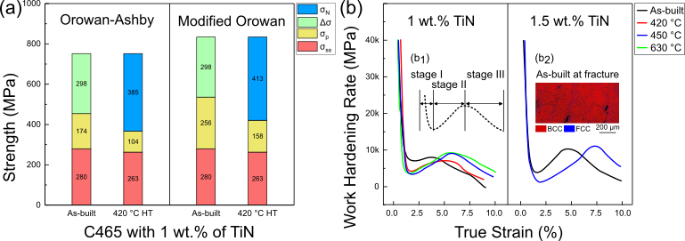
Fig. 14 (a) Computation of the yield strength contribution from dissolved nitrogen $σ_{N}$, difference in yield strength between the as-built and heat-treated C465 doped with 1 wt.% of TiN $∆σ_{YS}$, precipitation strengthening from the Orowan-Ashby and modified-Orowan model $∆σ_{p}$, and solid solution strengthening from substitutional elements $∆σ_{ss}$. (b) Work hardening curves of the tensile results from Fig. 11. (b₁) The IPF map of the as-built C465 doped with 1 wt.% of TiN at fracture. (b₂) Illustration of the typical three-stage work hardening behavior of transformation induced plasticity (TRIP) steels.

The deformation mechanism is interpreted from the alloys’ work hardening profiles, Fig. 14 (b). All curves show a three-stage work-hardening behavior, which has been observed in several transformation-induced plasticity (TRIP) steels [53]. As illustrated in Fig. 14 (b₁), stage I is usually associated with dislocation glide followed by the formation of shear bands, and the resultant flow localization is known to reduce strain hardening rates [54]. Stage II starts with the nucleation of martensite at the previously formed shear bands. The combined effects of the (a) hard martensite, (b) dislocation strengthening from transformation-induced dislocation emissions, and (c) dislocation arrest by the appearance of martensite/austenite phase boundaries, directly result in the increase of strain hardening rate [55]. In stage III, as the thickness of martensite and its nucleation rate gradually saturates, the work hardening rate reduces till fracture [54]. The extent of working hardening in stage II is directly correlated to the amount and stability of austenite prior to deformation. For both the 1 wt.% and 1.5 wt.% TiN-added alloys, the annealed specimens have a much longer work hardening regime than their as-built counterparts, as annealing yields more reverted austenite and their larger grain size favors martensitic transformation. Between the two as-built specimens, more TiN addition also results in a greater amount of work hardening, likely due to the additional retained austenite as the additionally dissolved Ti can further lower $m_{s}$ (Fig. 13(a)). This is corroborated by the post-deformation IPF map obtained on the as-built sample with 1.5 wt.% TiN (taken at about 1 mm away from the fracture site, Fig. 14 (b₂)); almost all the austenite has undergone the martensitic transformation.
Besides the difference in YS and work hardening imparted by the TiN addition, it is noteworthy that the completely crack-free samples (1.5 wt.% TiN) have a much longer post-uniform elongation than their counterparts with 1 wt.% TiN, but a negligible difference in the strength values. Quantitatively, the 0.1 mm/mm² density of cracks reduced the post-uniform elongation by about 4% and 8% in the as-built and the 450 °C annealed specimens, respectively, Fig. 11(b) and 11(c). This is not surprising finding for the failure of ductile materials, as recent computational studies show that when the material is highly dense, clustered pores mainly reduce the material’s ductility but do not affect the strength values much [56]. For the current TiN-doped samples, there is a non-linear relationship between their hardness and strength values, i.e., the highest hardness value occurs for the 450 °C annealed sample (Fig. 6(b)), but the 420 °C annealed specimen registers a higher strength (Fig. 11 (b)). Past research indicates that the overall hardness of maraging steel is mainly contributed by the strength of the matrix, but precipitation and austenite fraction do have an influence too [57]. It is not yet clear as to which factor dominates this discrepancy. A small discontinuous yielding is also observed for the 450 °C heat-treated specimen with 1.5 wt.% TiN (Fig. 11(c)), and we tend to believe that dissolved interstitial N is the root cause here, as it can segregate and pin the dislocations within the BCC metals, commonly termed as the Cottrell-Bilby effect [58]. However, more detailed experimental characterization is needed to unambiguously confirm such a hypothesis.
To summarize, the effects of TiN additions on the commercial C465 alloy during LPBF processing is schematically illustrated in Fig. 15. During solidification, TiN particles act as effective grain refiners, and the grain size of prior austenite grains is reduced to eliminate hot cracking. During cooling, the presence of mainly additional Ti in the matrix decreases the martensite start temperature, and therefore retards the martensitic transformation and yields more retained austenite. Upon subsequent heat treatment, TiN particles coalescence through Ostwald ripening, and concurrently absorb more Ti away from the matrix while dissolving more N into it. The reduction in the reverted austenite is mainly due to the change in the Gibbs free energy, and to a much lesser extent on the Zener pinning effects. The tensile properties of the LPBF C465 without any TiN addition are poor because of the presence of hot cracks. The addition of TiN significantly improves the tensile strength, enabling the material for potential industrial applications.
Fig. 15 Schematics on the effects of TiN on the microstructural and phase evolution for the commercial C465 alloy.

Summary and conclusions
In summary, this work highlights the potential considerations needed to be taken, when attempting to resolve the hot cracking issue in alloys that are susceptible to phase transformations during LPBF. The solid-state phase transformation during cooling eradicates any prior existing elemental partitioning information, which is crucial to address the hot-cracking problem. Based on the stainless maraging steel C465 examined in this study, the main takeaways are the following.
1) Despite contributing to the formation of the desired η-Ni₃Ti strengthening precipitate in steels, Ti element has strong partitioning tendency during solidification, with a partition coefficient close to 0.2. As a result, it partitions and forms the low-solidus liquid films along the HAGBs to trigger hot cracking. Simple processing modification such as reducing the heat input alone is insufficient to prevent its partition and eliminate the hot cracks.
2) Grain nucleation agent TiN can effectively reduce the grain size of prior austenite grains, and consequently resolve the issue of hot cracking in C465. However, unlike materials which do not experience phase transformation during service, the selection of grain refiners for phase-transformation materials like maraging steels needs to consider several additional factors on top of their grain refinement potency.
3) During cooling, the partial dissolution of Ti from TiN particles within the matrix reduces the alloy’s martensite start temperature, yielding more retained austenite as a result. Moreover, this change in the matrix’s composition also reduces the equilibrium austenite content at higher temperatures above 400 °C. Together with the Zener pining effect from nanometer-sized TiN, the austenite reversion process is kinetically restricted during heating.
4) The introduction of TiN also affects the tensile property of the alloy. Upon annealing the as-built specimens with TiN, the dissolved N from the partial dissolution of TiN particles contributes to the increment in yield strength. All TiN-doped materials in the current study experience the typical three-stage work-hardening behavior, indicating the occurrence of strain-induced martensitic transformation due to the lower austenite stability. To ensure a high post-uniform elongation, fully crack-free samples are needed.

Appendix
To compare the partition phenomenon between Ti and other alloying elements, and guide potential future alloy design works, partition coefficients of various substitutional elements and their corresponding melting temperatures are computed for a hypothetic steel (Fe-18Ni-1X, wt. %), Appendix Fig. 1. A high Ni content of 18 wt.% is chosen to ensure that the primarily solidified phase is austenite, and all the investigated elements are fixed at a concentration of 1 wt. %. Among the 13 candidates, Ti is having the second lowest partition coefficient (0.25) in tandem with the smallest melting point of 1475 °C. Thus, Ti is likely the most detrimental substitutional element for promoting hot cracking in these steels, as it not only promotes elemental partitioning, but also induces a large solidification interval by lowering the solidus temperature. Similarly, the element with the lowest partition coefficient (0.23), Nb, has also been reported to have a detrimental role in assisting hot crack occurrence in steels [59]. Therefore, when designing steels solidifying with a primary austenite phase, one should avoid alloying elements in the bottom left corner from Appendix Fig. 1, to minimize the likelihood of hot cracking from happening.
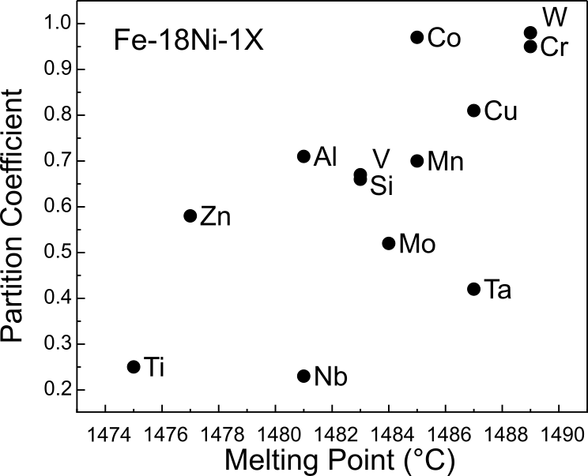
Appendix Fig. 1. The equilibrium partition coefficient vs. the melting temperature of different alloying compositions based on a hypothetical austenitic “Fe-18Ni-1X” alloy, wt.%.

Acknowledgement
Z. Sun. acknowledges financial support from the Career Development Fund (Grant reference No.: C222812017), Young Individual Research Grant (Grant reference No.: M22K3c0096); and P. Wang. acknowledges the financial support from the Individual Research Grant (Grant reference No.: A20E7c0109) from the Agency for Science, Technology and Research of Singapore.

Reference

[1] P. Bajaj, A. Hariharan, A. Kini, P. Kürnsteiner, D. Raabe, E.A. Jägle, Steels in additive manufacturing: A review of their microstructure and properties, Mater. Sci. Eng. A. 772 (2020) 138633.
[2] Z. Sun, X.P. Tan, M. Descoins, D. Mangelinck, S.B. Tor, C.S. Lim, Revealing hot tearing mechanism for an additively manufactured high-entropy alloy via selective laser melting, Scr. Mater. 168 (2019). https://doi.org/10.1016/j.scriptamat.2019.04.036.
[3] Z. Sun, Y. Ma, D. Pong, S. Zaefferer, E. Jaegle, B. Gault, A. Rollett, D. Raabe, Thermodynamics-guided alloy and process design for additive manufacturing, Nat. Commun. Accepted (2022).
[4] Q.M. Song, D. Wert, State of the Art Stainless Steel Provides Improved Properties for Widely Varying Applications, in: Adv. Mater. Res., Trans Tech Publ, 2012: pp. 341–346.
[5] Je. Gray, B. Luan, Protective coatings on magnesium and its alloys—a critical review, J. Alloys Compd. 336 (2002) 88–113.
[6] S. Ifergane, E. Sabatani, B. Carmeli, Z. Barkay, V. Ezersky, O. Beeri, N. Eliaz, Hydrogen diffusivity measurement and microstructural characterization of Custom 465 stainless steel, Electrochim. Acta. 178 (2015) 494–503.
[7] S. Ifergane, M. Pinkas, Z. Barkay, E. Brosh, V. Ezersky, O. Beeri, N. Eliaz, The relation between aging temperature, microstructure evolution and hardening of Custom 465® stainless steel, Mater. Charact. 127 (2017) 129–136.
[8] L. Wang, C. Dong, J. Yao, Z. Dai, C. Man, Y. Yin, K. Xiao, X. Li, The effect of ɳ-Ni3Ti precipitates and reversed austenite on the passive film stability of nickel-rich Custom 465 steel, Corros. Sci. 154 (2019) 178–190.
[9] C.-Y. Chen, P.-H. Chiu, W.-S. Liu, Z.-W. Chen, Y.-H. Lin, Y.-C. Kang, Interaction between η-Ni3Ti and reversed austenite within Custom 465 stainless steel: Experimental evidence and related patents investigation, Mater. Sci. Eng. A. 839 (2022) 142852.
[10] S. Ifergane, R. Ben David, E. Sabatani, B. Carmeli, O. Beeri, N. Eliaz, Hydrogen diffusivity and trapping in custom 465 stainless steel, J. Electrochem. Soc. 165 (2018) C107.
[11] P. Kontis, E. Chauvet, Z. Peng, J. He, A.K. da Silva, D. Raabe, C. Tassin, J.-J. Blandin, S. Abed, R. Dendievel, Atomic-scale grain boundary engineering to overcome hot-cracking in additively-manufactured superalloys, Acta Mater. 177 (2019) 209–221.
[12] Z. Sun, X. Tan, C. Wang, M. Descoins, D. Mangelinck, S.B.S.B. Tor, E.A.E.A. Jägle, S. Zaefferer, D. Raabe, Reducing hot tearing by grain boundary segregation engineering in additive manufacturing: example of an Al<inf>x</inf>CoCrFeNi high-entropy alloy, Acta Mater. 204 (2021) 116505. https://doi.org/10.1016/j.actamat.2020.116505.
[13] M. Opprecht, J.P. Garandet, G. Roux, C. Flament, M. Soulier, A solution to the hot cracking problem for aluminium alloys manufactured by laser beam melting, Acta Mater. 197 (2020) 40–53. https://doi.org/10.1016/j.actamat.2020.07.015.
[14] F. Bachmann, R. Hielscher, H. Schaeben, Texture analysis with MTEX–free and open source software toolbox, in: Solid State Phenom., Trans Tech Publ, 2010: pp. 63–68.
[15] T. Nyyssönen, P. Peura, V.-T. Kuokkala, Crystallography, morphology, and martensite transformation of prior austenite in intercritically annealed high-aluminum steel, Metall. Mater. Trans. A. 49 (2018) 6426–6441.
[16] F. Niessen, T. Nyysso, A.A. Gazder, R. Hielscher, computer programs Parent grain reconstruction from partially or fully transformed microstructures in MTEX, (2022) 180–194. https://doi.org/10.1107/S1600576721011560.
[17] H. Ikehata, D. Mayweg, E. Jaegle, Grain refinement of Fe--Ti alloys fabricated by laser powder bed fusion, Mater. Des. 204 (2021) 109665.
[18] B. Subramanian, C. V Muraleedharan, R. Ananthakumar, M. Jayachandran, A comparative study of titanium nitride (TiN), titanium oxy nitride (TiON) and titanium aluminum nitride (TiAlN), as surface coatings for bio implants, Surf. Coatings Technol. 205 (2011) 5014–5020.
[19] F. Christien, M.T.F. Telling, K.S. Knight, Neutron diffraction in situ monitoring of the dislocation density during martensitic transformation in a stainless steel, Scr. Mater. 68 (2013) 506–509.
[20] Z. Sun, X. Tan, S.B. Tor, Effects of chamber oxygen concentration on microstructure and mechanical properties of stainless steel 316L parts by selective laser melting, in: Proc. Int. Conf. Prog. Addit. Manuf., 2018. https://doi.org/10.25341/D4CS38.
[21] V.K. Vasudevan, S.J. Kim, C.M. Wayman, Precipitation reactions and strengthening behavior in 18 Wt Pct nickel maraging steels, Metall. Trans. A. 21 (1990) 2655–2668.
[22] J. Moon, C. Lee, S. Uhm, J. Lee, Coarsening kinetics of TiN particle in a low alloyed steel in weld HAZ: Considering critical particle size, Acta Mater. 54 (2006) 1053–1061.
[23] C.-Y. Chou, N.H. Pettersson, A. Durga, F. Zhang, C. Oikonomou, A. Borgenstam, J. Odqvist, G. Lindwall, Influence of solidification structure on austenite to martensite transformation in additively manufactured hot-work tool steels, Acta Mater. 215 (2021) 117044.
[24] G.H. Gulliver, The quantitative effect of rapid cooling upon the constitution of binary alloys, J. Inst. Met. 9 (1913) 120–157.
[25] A. Mehta, L. Zhou, T. Huynh, S. Park, H. Hyer, S. Song, Y. Bai, D.D. Imholte, N.E. Woolstenhulme, D.M. Wachs, Y. Sohn, Additive manufacturing and mechanical properties of the dense and crack free Zr-modified aluminum alloy 6061 fabricated by the laser-powder bed fusion, Addit. Manuf. 41 (2021) 101966. https://doi.org/10.1016/j.addma.2021.101966.
[26] D. Turnbull, B. Vonnegut, Nucleation catalysis., Ind. Eng. Chem. 44 (1952) 1292–1298.
[27] B.L. Bramfitt, The effect of carbide and nitride additions on the heterogeneous nucleation behavior of liquid iron, Metall. Trans. 1 (1970) 1987–1995.
[28] Y. Ji, M.-X. Zhang, H. Ren, Roles of lanthanum and cerium in grain refinement of steels during solidification, Metals (Basel). 8 (2018) 884.
[29] M. Li, J. Li, D. Qiu, Q. Zheng, G. Wang, M.-X. Zhang, Crystallographic study of grain refinement in low and medium carbon steels, Philos. Mag. 96 (2016) 1556–1578.
[30] M. Li, J.-M. Li, Q. Zheng, D. Qiu, G. Wang, M.-X. Zhang, A new grain refiner for ferritic steels, Metall. Mater. Trans. B. 48 (2017) 2902–2912.
[31] H. Feifei, L. Bo, L. Da, D.A.N. Ting, R.E.N. Xuejun, Y. Qingxiang, L.I.U. Ligang, Effects of rare earth oxide on hardfacing metal microstructure of medium carbon steel and its refinement mechanism, J. Rare Earths. 29 (2011) 609–613.
[32] A. Stormvinter, A. Borgenstam, J. Ågren, Thermodynamically based prediction of the martensite start temperature for commercial steels, Metall. Mater. Trans. A. 43 (2012) 3870–3879.
[33] N. Shohoji, Comparative study of solubilities of hydrogen, nitrogen and carbon in α-iron, J. Mater. Sci. 21 (1986) 2147–2152.
[34] J.-M. Jang, D.-H. Kim, M.-K. Paek, J.-J. Pak, Nitrogen solubility in cast iron containing C, Si and Mn, ISIJ Int. 58 (2018) 1185–1190.
[35] F.F. Conde, J.D. Escobar, J.P. Oliveira, A.L. Jardini, W.W. Bose Filho, J.A. Avila, Austenite reversion kinetics and stability during tempering of an additively manufactured maraging 300 steel, Addit. Manuf. 29 (2019) 100804.
[36] M. Maalekian, R. Radis, M. Militzer, A. Moreau, Wj. Poole, In situ measurement and modelling of austenite grain growth in a Ti/Nb microalloyed steel, Acta Mater. 60 (2012) 1015–1026.
[37] F. Najafkhani, S. Kheiri, B. Pourbahari, H. Mirzadeh, Recent advances in the kinetics of normal/abnormal grain growth: A review, Arch. Civ. Mech. Eng. 21 (2021) 1–20.
[38] P.A. Manohar, M. Ferry, T. Chandra, Five Decades of the Zener Equation, ISIJ Int. 38 (1998) 913–924. https://doi.org/10.2355/isijinternational.38.913.
[39] A. Graux, S. Cazottes, D. De Castro, D. San Martín, C. Capdevila, J.M. Cabrera, S. Molas, S. Schreiber, D. Mirković, F. Danoix, Precipitation and grain growth modelling in Ti-Nb microalloyed steels, Materialia. 5 (2019) 100233.
[40] C. Zener, Grains, phase, and interfaces: an interpretation of microstructure, Trans. Am. Inst. Min. Met. Soc. 175 (1948) 15.
[41] C. France, H. Klöcker, J. Le Coze, A. Fraczkiewicz, Nitrogen strengthening of a martensitic steel: relation between microstructure and mechanical behaviour, Acta Mater. 45 (1997) 2789–2799.
[42] K. Takano, M. Sakakibara, T. Matsui, S. Takaki, Effects of alloying elements and microstructure on corrosion resistance and hardness of martensitic stainless steels, Tetsu-to-Hagané. 86 (2000) 123–130.
[43] P.E.J. Rivera-Díaz-del-Castillo, K. Hayashi, E.I. Galindo-Nava, Computational design of nanostructured steels employing irreversible thermodynamics, Mater. Sci. Technol. 29 (2013) 1206–1211.
[44] R. Schnitzer, S. Zinner, H. Leitner, Modeling of the yield strength of a stainless maraging steel, Scr. Mater. 62 (2010) 286–289.
[45] R.L. Fleischer, Substitutional solution hardening, Acta Metall. 11 (1963) 203–209.
[46] D.R. Lide, CRC handbook of chemistry and physics, CRC press, 2004.
[47] M. Niu, G. Zhou, W. Wang, M.B. Shahzad, Y. Shan, K. Yang, Precipitate evolution and strengthening behavior during aging process in a 2.5 GPa grade maraging steel, Acta Mater. 179 (2019) 296–307.
[48] E.I. Galindo-Nava, P.E.J. Rivera-Díaz-del-Castillo, A model for the microstructure behaviour and strength evolution in lath martensite, Acta Mater. 98 (2015) 81–93.
[49] E. Nembach, Particle strengthening of metals and alloys, (No Title). (1997).
[50] B. Kim, E. Boucard, T. Sourmail, D. San Martín, N. Gey, P.E.J. Rivera-Díaz-del-Castillo, The influence of silicon in tempered martensite: Understanding the microstructure–properties relationship in 0.5–0.6 wt.% C steels, Acta Mater. 68 (2014) 169–178.
[51] P.P. Sinha, K.T. Tharian, K. Sreekumar, K. V Nagarajan, D.S. Sarma, Effect of aging on microstructure and mechanical properties of cobalt free 18% Ni (250 grade) maraging steel, Mater. Sci. Technol. 14 (1998) 1–9.
[52] A.A. Gorni, Steel forming and heat treating handbook, São Vicente, Brazil. 24 (2011).
[53] J. Shi, X. Sun, M. Wang, W. Hui, H. Dong, W. Cao, Enhanced work-hardening behavior and mechanical properties in ultrafine-grained steels with large-fractioned metastable austenite, Scr. Mater. 63 (2010) 815–818.
[54] V.S.A. Challa, X.L. Wan, M.C. Somani, L.P. Karjalainen, R.D.K. Misra, Significance of interplay between austenite stability and deformation mechanisms in governing three-stage work hardening behavior of phase-reversion induced nanograined/ultrafine-grained (NG/UFG) stainless steels with high strength-high ductility combinat, Scr. Mater. 86 (2014) 60–63.
[55] C. Zheng, H. Jiang, X. Hao, J. Ye, L. Li, D. Li, Tailoring mechanical behavior of a fine-grained metastable austenitic stainless steel by pre-straining, Mater. Sci. Eng. A. 746 (2019) 332–340.
[56] K. Joshi, P. Promoppatum, S.S. Quek, S. Raghavan, N.S. Johan, S. Shukla, S. Samudrala, S. van der Veen, M.H. Jhon, Effect of porosity distribution on the strength and strain-to-failure of Laser-Powder Bed Fusion printed Ti-6Al-4V, Addit. Manuf. (2023) 103738.
[57] E.I. Galindo-Nava, P.E.J. Rivera-Díaz-del-Castillo, Understanding the factors controlling the hardness in martensitic steels, Scr. Mater. 110 (2016) 96–100.
[58] A.H. Cottrell, B.A. Bilby, Dislocation theory of yielding and strain ageing of iron, Proc. Phys. Soc. Sect. A. 62 (1949) 49.
[59] V. Shankar, T.P.S. Gill, S.L. Mannan, S. Sundarlsan, Solidification cracking in austenitic stainless steel welds, Sadhana - Acad. Proc. Eng. Sci. 28 (2003) 359–382. https://doi.org/10.1007/BF02706438.

