Newtonian Liquid-Assisted Material Extrusion 3D Printing: Progress, Challenges and Future Perspectives

Rahul Karyappa^{1*}, Danwei Zhang¹, Zhu Qiang^{1,2,3}, Ji Rong¹, Ady Suwardi¹, Hongfei Liu^{1*}

¹Institute of Materials Research and Engineering (IMRE), Agency for Science, Technology and Research (A*STAR), 2 Fusionopolis Way, Innovis #08-03, Singapore 138634, Republic of Singapore
²Institution of Sustainability for Chemical, Energy and Environment (ISCE2), 1 Pesek Road, Jurong Island, Singapore 627833, Republic of Singapore
³School of Chemistry, Chemical Engineering and Biotechnology, Nanyang Technological University, 21 Nanyang Link, Singapore 637371, Republic of Singapore

*Corresponding authors: rahul_karyappa@imre.a-star.edu.sg, liuhf@imre.a-star.edu.sg
Abstract
Additive manufacturing has grown exponentially, led by the three-dimensional (3D) printing of materials ranging from plastics and ceramics to metals. 3D printing methods are categorized into different processes such as vat photopolymerization, material jetting, binder jetting, powder bed fusion, material extrusion, directed energy deposition, and sheet lamination, which require inks in different forms and with different rheological properties. Material extrusion has emerged as a popular and versatile method owing to its ability to print different materials. However, material extrusion in air requires ink with specific rheological characteristics such as shear thinning and finite yield stress (a Bingham plastic fluid). In recent years, material extrusion in embedding media possessing Newtonian or non-Newtonian characteristics has attracted interest for the fabrication of micro- to centimeter-scale objects in a layer-by-layer or freeform manner. The use of embedding media offers 3D printing of low-viscosity and slow-curing inks that are unsuitable for material extrusion in air. Different types of non-Newtonian (e.g., microparticulate gels and thixotropic polymer solutions) and Newtonian (e.g., water and ethanol) embedding media have been used. In this review, we focus on the existing research developments in Newtonian liquid-assisted material extrusion of soft materials, such as polyelectrolytes, hydrogels, and polymer solutions. We compared the advantages and disadvantages of non-Newtonian and Newtonian embedding media. The review begins with the role of liquid media in the interfacial stability and solidification or gelation of printed ink by different mechanisms, followed by the effect of printing parameters on print fidelity in detail. In addition, we provide a brief overview of various material systems used as Newtonian liquid-embedding media. Finally, this review highlights the challenges of this method, followed by future perspectives on the possible innovations and strategies.

Abbreviations
3D, three-dimensional; CAGR, compound annual growth rate; DIW, direct ink writing; DIW_{Air}, direct ink writing in air; DIW_{EM}, direct ink writing in embedding media; e3DP, embedded 3D printing; NL3DP, Newtonian liquid-assisted 3D printing; PAA, poly acrylic acid; PEI, polyethylenimine; PAH, polyallylamine hydrochloride; PMPTC, poly(3-(methaacryloylamino)-propyl-trimethylammonium chloride); PNaSS, poly(sodium p-styrenesulfonate); DBSA, 4-dodecylbenzenesulfonic acid; NaAlg, sodium alginate; HA, hyaluronic acid; PVA, polyvinyl alcohol; p(NIPAM-co-AAc, poly(N-isopropylacrylamide-co-acrylic acid); CS, chitosan; DBN, 1,5-diazabicyclo[4.3.0]non-5-ene; ABS, acrylonitrile butadiene styrene; PCL, polycaprolactone; PLA, polylactic acid; PZT, Lead zirconate titanate; GO, graphene oxide; CMC, carboxymethyl cellulose; POSS-NH₂, polyhedral oligomeric silsequioxanes; RT, room temperature; DCM, dichloromethane; PEC, polyelectrolyte complex; CAD, computer-aided design; CAM, computer-aided manufacturing; IPA, isopropyl alcohol; DI, deionised water; PEDOT:PSS, poly(3,4-ethylenedioxythiophene): poly(styrenesulfonate); LCE, liquid crystal elastomer; ip3DP, immersion precipitation 3D printing; SC3DP; solvent-cast 3D printing; PVDF, polyvinylidene fluoride (PVDF); PTFE, polytetrafluoroethylene.

Keywords: Material extrusion, Liquid embedding media, coagulation, immersion precipitation, interfacial stability, wettability
- Introduction
Additive manufacturing technology has allowed industries to optimize workflow processes. By building 3D geometries through the successive addition of materials, complex parts and structures can be realized with lower labor and material costs. Technology is rapidly advancing, with new machines catering to diverse sectors, such as the building, aerospace, biomedical, energy, and electronics industries. The list includes areas in which additive manufacturing is used. Additive manufacturing is extensively used in the biomedical industry and research to print organ models, microfluidic devices, and soft actuators. The need for high accuracy, resolution, and complexity has allowed several categories of additive manufacturing processes (e.g., material jetting, binder jetting, powder bed fusion, material extrusion, and vat photopolymerization) to be embraced in this field (Fig. 1a). Global healthcare additive manufacturing is forecasted to have a compound annual growth rate (CAGR) of 18.1 % from 2023 to 2030 because of the increased demand for patient-customizable dental prostheses and orthopaedic and cranial implants.[1]
Geometrically complex structures can be printed layer-by-layer and/or freeform in material extrusion and vat photopolymerization processes. Different types of ink materials such as solids (e.g., thermoplastics), viscoelasticity (yield stress fluids, e.g., pastes), and liquids (viscous inks, e.g., polysiloxanes) are used for 3D printing.[2] Depending on the state of the ink material, various 3D printing methods in the vat photopolymerization and material extrusion categories are used to print complex geometries with a high resolution (Fig. 1b-1c).[3-5] The viscosity of the ink varies over time during the fabrication of layer-by-layer and/or freeform structures when printed using different 3D printing methods (Fig. 1d).
Among various 3D printing techniques, robocasting or direct ink writing (DIW) has emerged as a popular technique, which involves controlled dispensing of the inks according to
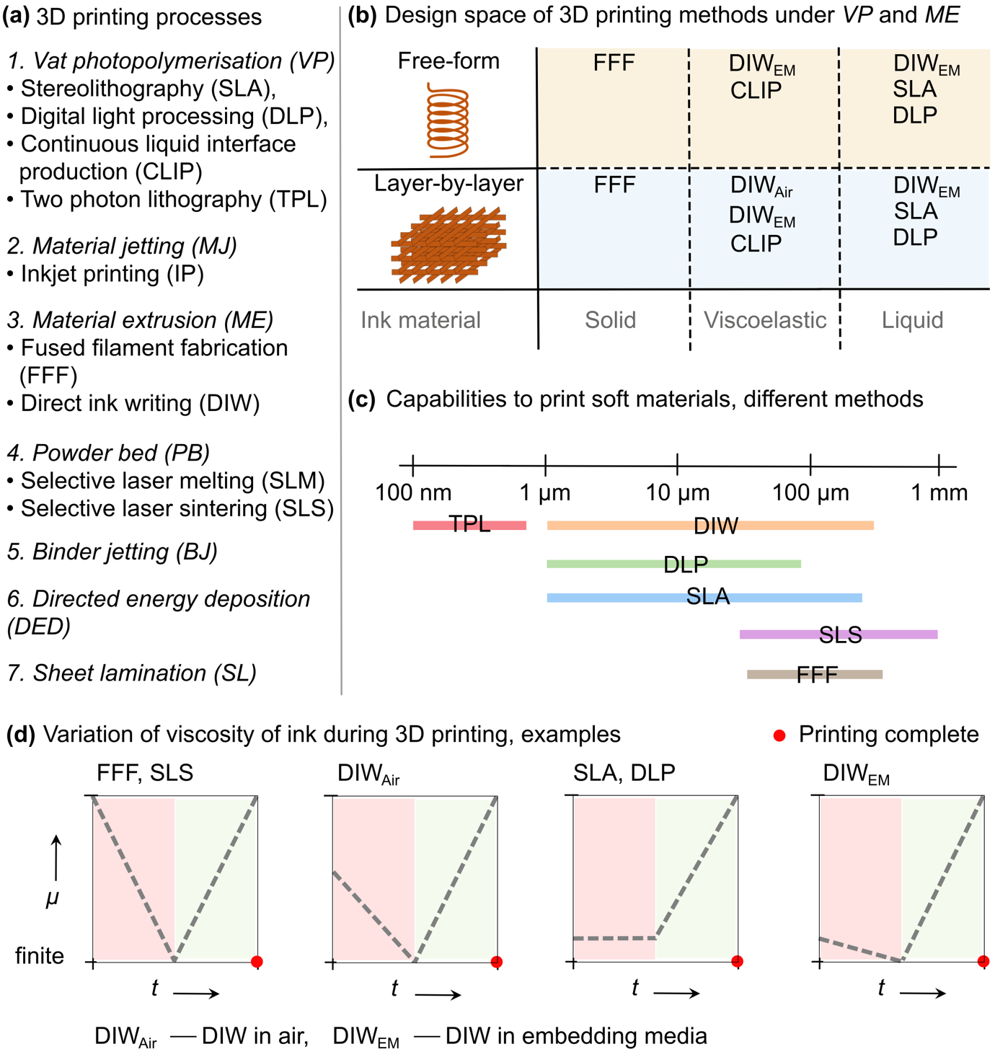
Fig. 1. Classification of different types of 3D printing processes and methods. (a) Different types of 3D printing methods grouped into seven categories. (b) Type of ink material (feedstock at the room temperature and not the ink while it is being printed) and the ability to print layer-by-layer and freeform structures by different 3D printing methods grouped into vat photopolymerization and material extrusion. (c) Comparison on the typical capability of 3D fabrication of soft materials between different 3D printing methods. (d) Qualitative representation of the variation in the viscosity of the ink over time for different 3D printing methods. DIW_{Air}: Direct ink writing in air, DIW_{EM}: Direct ink writing in embedding media.

a defined path.[6] Traditionally, DIW is performed in air (DIW_{Air}), where ink possessing shear thinning and yield stress characteristics is dispensed digitally on a substrate in the air in a layer-by-layer manner to fabricate geometrically complex structures. DIW_{Air} has been used to print ink materials, such as polymers, ceramics, cement, graphene, and metals, highlighting its applications in a wide range of industries, including biomedicine, food, and electronics.[6-9] Moreover, combinations of these materials are used to highlight the versatility of DIW_{Air} for multimaterial printing.[10, 11] Practically, although DIW_{Air} allows 3D printing of any material, many materials, such as commercial liquid polysiloxanes (e.g., Sylgard 184)[12], are unsuitable for 3D printing by DIW_{Air}; hence, it is necessary to alter their rheological characteristics, e.g., by incorporating thickening agents or filler materials.[13-15] However, such alterations in the properties of these materials do not allow their natural properties to be retained. Moreover, the fabrication of freeform structures of materials that require longer curing times for solidification or gelation (e.g., Sylgard 184) is only possible with support materials.[16, 17]
3D printing of low-viscosity and slow-curing liquids using DIW_{Air} is challenging.[18] Although low-viscosity inks facilitate easy extrusion through the nozzle, they immediately spread on the substrate upon dispensing. To address the difficulty of fabricating 3D structures of low-viscosity inks using DIW_{Air}, DIW in embedding media (DIW_{EM}) was successfully demonstrated. DIW_{EM} is a modified method of DIW_{Air}, where ink is dispensed in the liquid embedding media than in air. Newtonian liquids (e.g., water and alcohol)[19-21] and non-Newtonian microparticulate gels (e.g., Carbopol gel[16, 22] and Laponite clay[23]) with finite yield stresses have been widely explored as embedding media.[24-26] The non-Newtonian embedding media, a Bingham plastic fluid with a low elastic modulus and low yield stress, supports the printed ink and structures. This is particularly useful when the printed ink has a long curing time for solidification and gelation. When a long nozzle needle travels through the embedding media, it yields media near the tip of the needle, thereby allowing ink printing. The printed ink was then trapped by rapid recovery of the media behind the moving needle.
Overall, DIW_{EM} showcased the 3D printing of different viscous and viscoelastic inks in embedding media to fabricate layer-by-layer and freeform structures. However, it has several limitations. First, the rheological properties of both the ink and embedding media affect the dimensions and stability of the printed filament (e.g., variation in yield stress changes the yielded regions around the tip of the moving needle, affecting the dimensions of the printed filament)[22, 27-29]. Second, printing of low-viscosity inks that undergo in situ solidification is challenging; the adhesion of the ink at the tip of the nozzle in a microparticulate gel or solidification of the ink in the nozzle due to evaporation of the highly volatile solvent when the nozzle is on standby leads to clogging[27]. Third, the fabrication of freeform microstructures can be challenging because their removal from the embedding bath can damage printed structures. While there have been some recent advancements in stimuli-responsive embedding media, these limitations still exist.[30, 31]. Moreover, a needle with a small diameter can deviate from the print path because of the deformation caused by the resistance offered by the surrounding media during its movement. Finally, the fabrication of microstructures on the substrate can be challenging because the fabricated microstructures can undergo capillary-induced complex topological transformations after the removal of the liquid embedding media.[32, 33]
Certain inks require in situ gelation (e.g., by coagulation, by salting out) for the fabrication of 3D structures using DIW_{EM}.[34] For such inks, Newtonian liquid embedding media, such as highly concentrated salt solutions, are used to perform DIW_{EM}; however, the preparation of gels (as non-Newtonian embedding media) containing high concentrations of salt is challenging. The rheological properties (viscosity and yield stress) of microparticulate gels (e.g., Carbopol) exhibit interesting changes with pH.[35, 36] An increase in the concentration of salt (e.g., sodium chloride, NaCl) or ionic strength in the gels causes a decrease in the difference between the concentration of bound charges within the gel and the concentration of charges in the external salt solution, leading to the deswelling of gels and conversion to liquids.[35, 37]
Many review articles on DIW_{EM} are present in the literature mainly focusing on layer-by-layer and/or freeform fabrication in non-Newtonian embedding media.[17, 24-26, 38-40] A review article focusing exclusively on DIW_{EM} in Newtonian liquid embedding media is missing. For better clarity, we term the DIW_{EM} in Newtonian liquid embedding media as Newtonian liquid-assisted 3D printing (NL3DP), a subset of DIW_{EM}. NL3DP allows printing of low-viscosity liquids and fabricating microstructures in a layer-by-layer and freeform manner by in situ solidification or gelation of printed materials, such as polymer solutions and hydrogel precursors, with a resolution of < 1 μm[41]. The fabrication of 3D structures of such materials is demonstrated by different mechanisms of solidification or gelation of the printed ink, for example, in situ crosslinking of the monomers in the printed ink by incorporating crosslinking agents into the embedding media (Table 1). This review describes and evaluates coagulation and chemical crosslinking strategies in NL3DP for printing inks prepared with different materials, with a focus on polymers and biopolymers that represent a sustainable future.[42-44] We also discuss the effect of different printing parameters on print fidelity in NL3DP. The prevention of ink drying and its wettability were also discussed.

Table 1. Table showing printing ink materials and liquid embedding media used for Newtonian liquid-based 3D printing (NL3DP) along with mechanism of solidification or gelation of the ink or role of the liquid media.

Ink | Liquid embedding media
In situ coagulation
1. Polyelectrolyte complex mixtures consisting polyanions (polyacrylic acid, PAA) and polycations (polyethylenimine, PEI or polyallylamine hydrochloride, PAH) in an aqueous solution | Alcohol + water | [41, 45, 46]
2. Aqueous silk fibroin solution | Methanol, methanol + water | [47]
3. Poly(3-(methaacryloylamino)-propyl-trimethylammonium chloride) (PMPTC) and poly(sodium p-styrenesulfonate) (PNaSS) in saline water | Water | [21]
4. Chitosan in alkali solution | Hot water | [48]
5. PEDOT:PSS suspension | 4-dodecylbenzenesulfonic acid (DBSA) | [49]
In situ Crosslinking
1. Sodium alginate (NaAlg) solution | Calcium chloride (CaCl₂) solution | [50]
2. NaAlg + Hyaluronic acid (HA) solution | CaCl₂, CaCl₂ + PEI solution | [51]
3. Poly(N-isopropylacrylamide-co-acrylic acid) (p(NIPAM-co-AAc) + NaAlg | CaCl₂ solution | [52-54]
4. Liquid crystal elastomer solution | 1,5-diazabicyclo[4.3.0]non-5-ene(DBN) in dioxane solution | [55]
5. Polyvinyl alcohol (PVA) + Chitosan + Fe₃O₄ nanoparticles solution | Water | [56]
In situ immersion precipitation
1. Thermoplastics (e.g., ABS, PLA, PVA) in suitable solvents | Water, alcohol, acetone | [19, 20, 57-61]
Prevention from drying
1. Lead zirconate titanate (PZT) solution (pH ~ 10.35) | oil | [62]
2. Graphene oxide (GO) + ammonium carbonate ((NH₄)₂CO₃) + fumed silica | isooctane | [63]
3. Gelled TiO₂ nanoparticles | Ammonia-enriched heptane | [64]
Interfacial assembly
1. Aqueous solution containing carboxylic acid functionalized nanoparticles (pH ~ 6) | Silicone oil containing 5 %w/w PDMS-NH₂ | [65]
2. Aqueous dispersion of MXene (Ti₃C₂T_{x}) (pH ~ 6) | Silicone oil containing 1–5 %w/w n-butylamine | [66]
3. Aqueous solution of sodium carboxymethyl cellulose (CMC) | Toluene containing amine-terminated polyhedral oligomeric silsequioxanes (POSS-NH₂) | [67]
4. Aqueous graphene oxide (GO) solution | Silicone oil | [68]
Change in wettability
1. Polysiloxanes (e.g., Ecoflex 10) | Alcohol | [12]

- Direct ink writing (DIW) in air
Before delving into the strategies for NL3DP, the rheological characteristics of inks printed via DIW_{air} needs to be analysed to draw a comparison to inks printed via DIW_{EM} using the NL3DP technique, as mentioned, the DIW_{air} process often requires viscoelastic inks with specific rheological properties to maintain print fidelity.[6, 69-71]

  - Viscoelastic inks
The representative flow of ink during its extrusion through the syringe (Region 1), nozzle (Region 2), and after extrusion through the nozzle (Region 3) is shown (Fig. 2a-2b).[69] When pressure is applied to the ink, the viscoelastic ink experiences laminar flow according to Poiseuille’s law, which depends on the resistance from the tube walls and the change in the flow radius from the syringe to the nozzle tip. Once the ink enters the nozzle (Region 2), it experiences a sharp increase in the shear rate, causing a sharp decrease in viscosity (solid-to-liquid transition) owing to its shear-thinning properties (Fig. 2b). The sharp decrease in ink viscosity facilitates smooth flow through the nozzle. This shear-thinning property should follow the Herschel–Bulkley fluid model[72] (equation 1), given by
$$\begin{aligned}τ= τ_{y }+ {k\dot{γ}}^{n} \#\left(1\right)\end{aligned}$$
where τ is the applied shear stress (Pa), τ_{y} is the yield stress (Pa), $\dot{γ}$ is the applied shear rate, n is a dimensionless flow index, and K is the viscosity parameter. For fluid to flow, τ must be greater than τ_{y.} For the shear-thinning fluid, n < 1. Once the ink exits the nozzle (Region 3), the applied shear rate approaches zero, and the ink undergoes rapid recovery to a high viscosity and high elastic modulus (liquid-to-solid transition), which allows it to hold its shape and form self-supporting layers on the substrate.
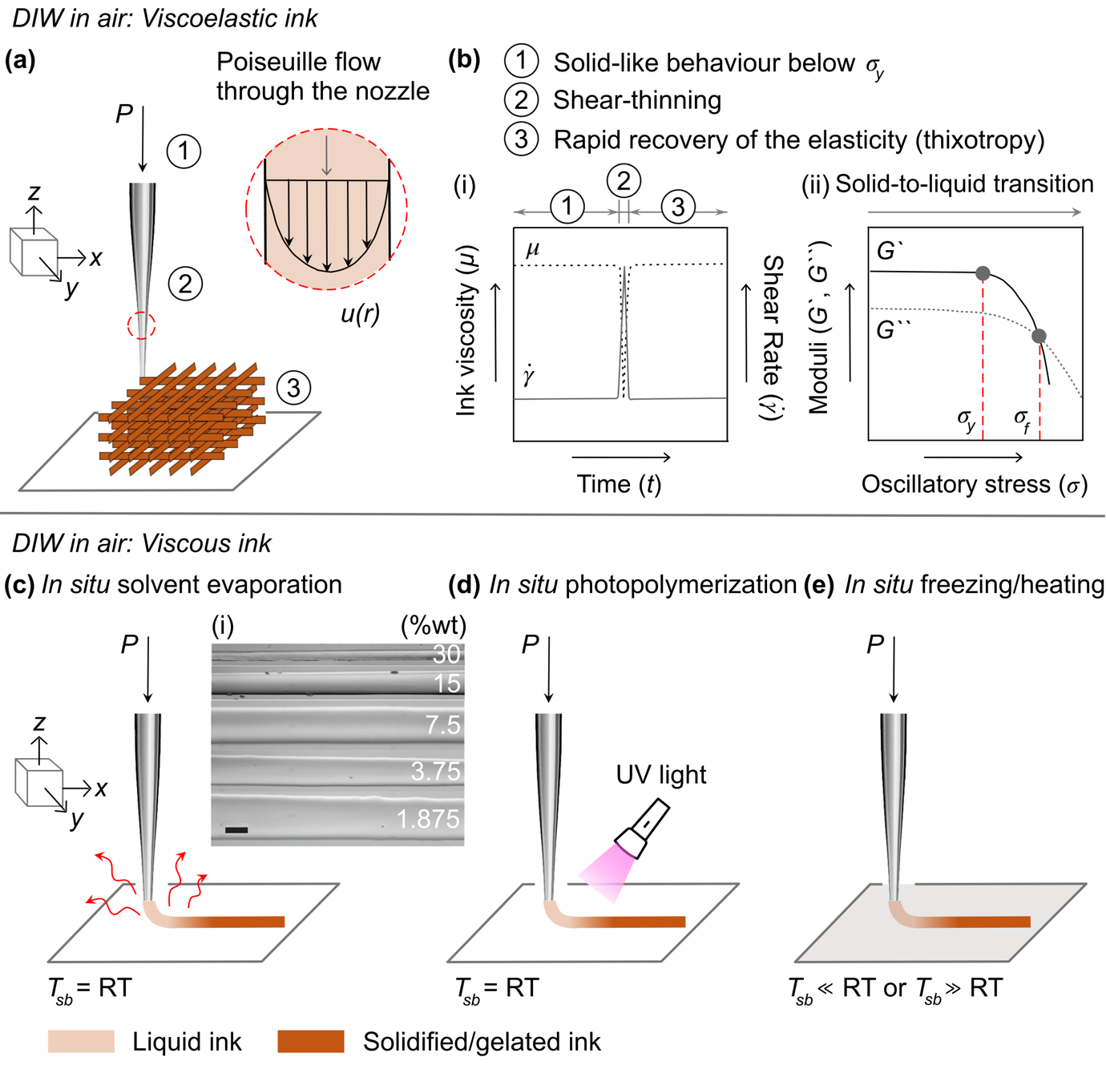

Figure 2. Direct ink writing (DIW) of viscoelastic and viscous (liquid) inks in air. (a) S illustration of DIW of viscoelastic inks in air at room temperature (RT). The ink exhibits yield stress behaviour to form self-supporting layer-by-layer structures. (b) Qualitative representation of (i) variation in viscosity of the ink (m) with the change in shear rate ($\dot{γ}$) when the ink is extruded through syringe (Region 1), through nozzle (Region 2), and after extrusion through nozzle (Region 3), and (ii) storage and loss moduli of the ink as a function of applied oscillatory shear stress. s_{f} is the yield stress at the crossover point, intersection of two curves intersect, where solid-to-liquid transition happens. Schematic illustration of DIW of viscous ink by in situ (c) solvent evaporation (high viscosity of the ink and high vapor solvent are the two major requirements) (Reprinted with permission from [73]. Copyright © 2019 American Chemical Society), (d) photopolymerization, and (e) freezing (substrate temperature, T_{sb} ≪ RT) or heating (T_{sb} ≫ RT). Scale bar = (c-i) 100 μm.

  - Viscous (liquid) inks
Compared with viscoelastic inks, although liquid inks allow easy extrusion through the nozzle, they immediately spread on the substrate after DIW_{Air}. Moreover, gravity often causes sagging of the printed structures on the substrate after printing.[17] These inks would require rapid arrest of the printed ink to retain the filament shape after deposition. Rapid solidification or gelation of the printed ink can be achieved by in situ solvent evaporation[74-76], photopolymerization[77, 78], freezing[79-81], or heating[82, 83] (Fig. 2c-2e and Table 2). Many papers have reviewed DIW_{Air} of viscous inks and their solidification methodologies.[2, 84, 85] In the solvent casting process, polymers such as poly(caprolactone) (PCL) and poly(lactic acid) (PLA) and their derivatives are dissolved in high-vapor-pressure solvents, such as acetone and dichloromethane (DCM).[86, 87] The highly volatile solvents evaporated during the extrusion process, leaving a polymer filament printed under ambient air conditions (Fig. 2c). The print fidelity depends on the concentration of the polymer in the ink; a high polymer content (e.g., 25–30 %w/w PLA) is preferred as ink containing low polymer content spreads on the substrate after extrusion (Fig. 2c-i). Solidification of inks can also be achieved via in situ photopolymerization of the printed structure by incorporating monomer precursors (e.g., acrylate monomers) and photoinitiators in the ink (Fig. 2d). In addition, sequential printing and photocuring of each extruded layer were investigated. Finally, in situ freezing[79-81] or heating[82, 83] of the printed ink was demonstrated (Fig. 2e). The substrate temperature was maintained based on the ink material used. For example, the DIW of water-soluble polyvinyl alcohol (PVA) can be achieved by dispensing PVA ink on a substrate maintained at sub-zero temperatures.

Table 2. Table showing printing ink materials by DIW_{Air} along with the mechanism of rapid solidification or gelation of the ink.

Material |  | Solvent
In situ solvent evaporation
1. Polylactic acid (PLA) | Dichloromethane (DCM) |  | [74, 76]
2. Chitosan | Acetic acid |  | [88]
3. Poly(vinylidene fluoride-trifluoroethylene) (PVDF-TrFE) | Acetone + dimethyl formamide (DMF) |  | [89]
4. poly(D,L-lactide-co-trimethylene carbonate) (PLMC) | DCM |  | [90]
5. Cellulose Acetate (CA) | Acetone |  | [91]
6. Polycaprolactone (PCL) | DCM, Acetone |  | [92]
In situ photopolymerization
1. All-aromatic polyimides | - |  | [78]
2. Polyurethane-based, epoxy-based materials | - |  | [77]
3. Polyamide acid grafted with 2-Hydroxyethyl ester (PAA-xHEMA) | - |  | [93]
4. Single walled carbon nanotubes (C-SWNT) in a polyurethane matrix | - |  | [94]
5. Polydimethylsiloxane (PDMS) | - |  | [95-97]
In situ freezing
1. Graphene oxide (GO) | Water |  | [98]
2. Polyvinyl alcohol (PVA) and PVA-based composites | Water |  | [79-81]
In situ heating
1. Polydicyclopentadine (pDCPD) | 5-ethylidene-2-norbornene (ENB) |  | [82, 83]

Similarly, a polymer dissolved in a suitable solvent when dispensed on a heated substrate allows for faster drying of the printed ink via rapid solvent evaporation. Such an arrangement is helpful if the solvent in the ink has low vapor pressure.[99] The liquid inks have been demonstrated for the fabrication of layer-by-layer and freeform structures by DIW_{air} via in situ solidification or gelation under strict requirements of ink properties and printing conditions: (1) solvent evaporation – requires high viscosity inks with high vapor pressure solvents, (2) photopolymerization – only photopolymers can be used, (3) freezing or heating – strict temperature conditions are required, and printing complex structures is challenging. Overall, limited materials are suitable for DIW_{air}. The fabrication of 3D structures of biopolymers, such as sodium alginate and polyelectrolyte complexes (PEC), by DIW_{air} is challenging unless their rheological characteristics are modified.[100, 101]

    - Capillary rise effect
When a low-viscosity ink (e.g., glycerol)[102] is dispensed through the nozzle in air (Fig. 3a-i), it can rise upward (Fig. 3a-ii), form a droplet (Fig. 3a-iii), or form a continuous filament (Fig. 3a-iv) equal to the diameter of the nozzle at the tip of the nozzle owing to the interplay between the viscous and surface forces, quantitatively explained by the capillary number (Ca)[102].
$$\begin{aligned}Ca=\frac{μ_{i}ν}{σ} \#\left(2\right)\end{aligned}$$
where μ_{i} is the ink viscosity, $ν$ is the ink speed, σ is surface tension. A high capillary effect is observed when (1) a low-viscosity and low-surface-energy ink is dispensed through a nozzle with high surface energy and (2) Ca < 10⁻¹; ink can wet the nozzle surface, inducing the capillary rise effect. The dispensed ink formed a spherical droplet and continuous filament with increasing Ca.[102, 103] The capillary rise effect can be eliminated by the use of high-viscosity yield stress materials[16] or coating the nozzle surface[104].
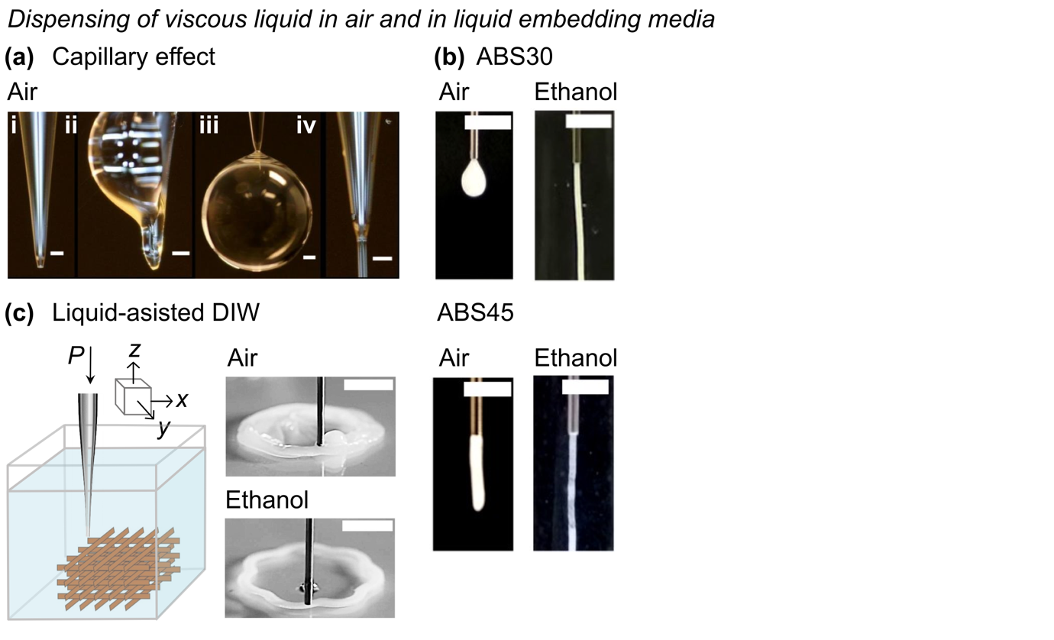

Figure 3. Effect of liquid embedding media on the stability of the dispensed ink. (a) Optical images showing capillary effect when low-viscosity ink is dispensed through a nozzle (i). With the increase in capillary number, Ca, (ii) capillary rise effect, (iii) droplet formation, and (iv) continuous filament formation are observed. (b) Effect of embedding media, air and ethanol, on the continuous filament formation of Acrylonitrile Butadiene Styrene (30 %w/w in acetone, ABS30) and ABS45, when dispensed through a nozzle. Reproduced from Ref. [19] with permission from the Royal Society of Chemistry. (c) Schematic illustration of liquid-assisted DIW at room temperature. Optical images show print fidelity is obtained when a polymer ink dispensed in ethanol than in air. In this case, the diffusion rate of solvent in ethanol is faster than in air. Reprinted with permission from Ref. [20]. Copyright © 2023 American Chemical Society. Scale bars = (a) 60 μm, and (b-c) 5 mm.

- Direct ink writing (DIW) in Newtonian liquid embedding media
Interestingly, the high capillary effect was eliminated when the low-viscosity ink was dispensed in a Newtonian liquid-embedding medium (Fig. 3b).[12, 19] The considerable decrease in the interfacial tension (adhesive forces between the two liquids at the interface are higher than the cohesive forces at the liquid-air interface) allows the formation of a continuous filament necessary for the NL3DP process. For example, when a low-viscosity polymer solution (ABS30, 30 %w/w Acrylonitrile Butadiene Styrene dissolved in acetone) was dispensed using DIW_{Air}, a droplet formed at the tip of the nozzle.[19] However, when the same ink was dispensed by NL3DP (liquid embedding media was ethanol (E)), it formed a continuous filament (Fig. 3b). The increase in the ABS content in the ink (ABS45) increased the viscosity of the ink; however, DIW_{Air} led to the die swelling effect or Barus effect[105] (the dispensed filament diameter was larger than the diameter of the nozzle) (Fig. 3b). The die-swelling effect was suppressed when ABS45 was dispensed in ethanol. In general, nonequilibrium shapes, such as the continuous filament of the liquid, break into droplets owing to Rayleigh-Plateau instability[17, 106] unless the formed shape is arrested by in situ solidification or gelation. NL3DP can facilitate in situ arrest of the printed filament of the ink along the designed print path to fabricate 3D structures (Fig. 3c). For example, a low-viscosity polymer ink (polymer dissolved in a high-vapor-pressure solvent) when printed by DIW_{air} spreads on the substrate after dispensing because of the slower diffusion rate of the solvent in air, which shows poor print fidelity.[19, 20] Moreover, the dispensed ink adhered to the nozzle surface owing to skin formation after the evaporation of the solvent from the surface of the dispensed ink (Fig. 3c).[20] In contrast, the challenges of printing low-viscosity polymer ink were avoided when the ink was printed in ethanol, facilitating in situ solidification of the ink via faster diffusion of the solvent into the surrounding liquid (immersion precipitation) than in air.[19, 20] The in situ solidification or gelation of the printed ink in the liquid embedding media can be obtained via different mechanisms, such as coagulation, crosslinking, or precipitation (Table 1).

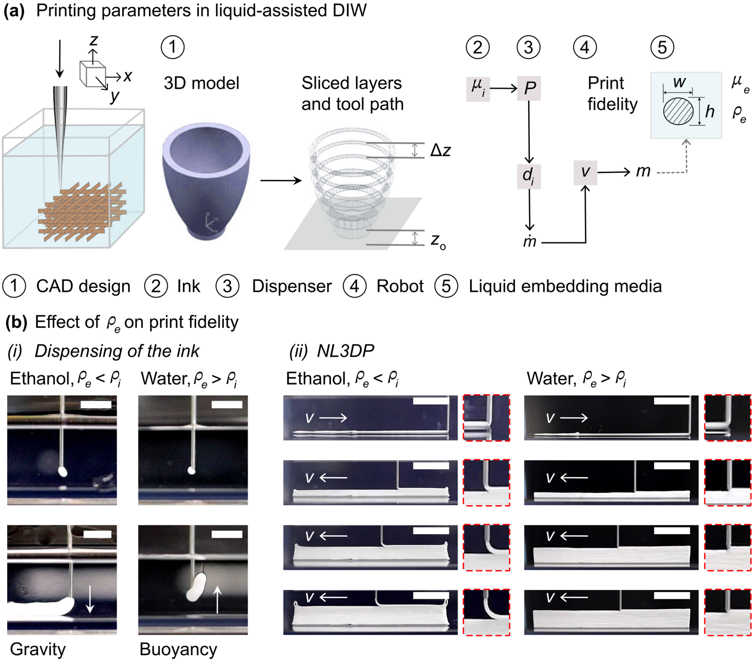

Figure 4. (a) Schematic illustration showing parameters related to CAD design, ink, dispenser, robot and liquid embedding media that affect the print fidelity. (b) Effect of density of the embedding media (ρ_{e}) on the print fidelity of a polymer ink (ρ_{i}) by NL3DP. The in situ solidification of the ink was obtained via immersion precipitation. The white arrows in: (i) show direction of the movement of the dispensed ink, and (ii) show the direction of printing. Scale bar = 5 mm.
  - Effect of printing parameters in NL3DP on print fidelity
Newtonian liquid-assisted 3D printing has five aspects to consider: (1) CAD design, (2) ink, (3) dispenser, (4) robot, and (5) liquid embedding media (Fig. 4).
(1) CAD design. A computer-aided design (CAD) model was created on a desktop and converted into a data file. The file was further fed into computer-aided manufacturing (CAM) software to slice the model layers and design a print or tool path (Fig. 4). The 3D printer digitally printed the desired model following the printing path. The printability depends on the defined printing path. In layer-by-layer printing on a substrate, the nozzle-to-substrate distance (z₀) and layer-to-layer distance (Δz) are tuned to achieve good print fidelity. If z₀ and Δz are not properly adjusted, delamination of the printed filament from the substrate and adjacent printed filaments occurs. If z₀ is extremely low, the printed filament can be excessively compressed, causing clogging or damage to the nozzle. If z₀ is too high, it increases the travel time of the printed filament through the embedding liquid medium, inducing the solidification or gelation of the ink before it reaches the substrate, leading to poor adhesion to the substrate and poor layer-to-layer adhesion. Moreover, the printed filament can undergo rope coiling or buckling instability when it reaches a substrate.[19, 107-111] In general, z₀ should be maintained equal to nozzle diameter (d_{i}) to achieve continuous dispensing of the ink allowing its proper adhesion to the substrate and improving layer-by-layer adhesion.[112] Additionally, z₀ affects the wetting of the printed filament with the substrate, which can affect print fidelity.[18, 102] Interestingly, the instability induced in the printed filament, when the ink was dispensed through a bevel tip placed far from the substrate combined with the buoyancy effects, was used to fabricate freeform structures such as helical microsprings with variable pitch.[52-54]
Successful layer-by-layer NL3DP requires proper attachment between the printed filaments in the adjacent layers. The overlap (the difference between the distance from the tip of the nozzle and the top surface of the filament and Δz) between the successively printed layers is crucial for their attachment. A suitable overlap must be obtained to overcome the disruption of NL3DP by pre-existing solidified or gelled layers. Generally, Δz should be less than d_{i}.
(2) Ink. The Viscosity (μ_{i}) of ink is a crucial parameter for printing. Once pressure (P) is applied, the ink flows easily through the nozzle. The ideal ink is shear-thinning, characterized by a decrease in μ_{i} with an increase in the shear rate ($\dot{γ}$) (controlled by P) (Fig. 4), the decrease in μ_{i} facilitates easy extrusion through the nozzle. Moreover, the solidification or gelation rate of the ink is affected by μ_{i}, which in turn affects print fidelity.[19, 20, 74, 113]
(3) Dispenser. The dispenser consisted of a pressure source, a syringe, and a nozzle. For a given ink, P and d_{i} control the mass flow rate of ink ($\dot{m}$) through the given nozzle. The nozzle attached to the syringe provided fluidic resistance to ink flow through the nozzle. The flow of a non-Newtonian ink through a cylindrical nozzle is characterized by a modified Hagen-Poiseuille equation[114]:
$$\begin{aligned}Q=\left(\frac{nπ}{3n+1}\right)\left(\frac{1}{2μ_{0}}\frac{∆P}{l}\right){R_{i}}^{\frac{3n+1}{n}} \#\left(3\right)\end{aligned}$$
where Q is the volumetric flow rate of the ink through the nozzle, R_{i} is the inner radius of the nozzle, μ₀ is the viscosity of the ink at lower $\dot{γ}$, z is the direction of the nozzle axis, and n is the flow index. For Newtonian inks, n = 1, and equation 3 is reduced to the Hagen-Poiseuille equation[75]
$$\begin{aligned}Q=\frac{π}{4}\left(\frac{1}{2μ_{0}}\frac{∆P}{l}\right)R_{i}^{4} \#\left(4\right)\end{aligned}$$
where ΔP is the pressure difference across nozzle length l. For a given ink, Q can be readily controlled by varying P. The nozzle is selected based on the viscosity of the ink. For low-viscosity inks, a small d_{i} is preferred because the use of a large d_{i} leads to the dripping of the ink under gravity. By contrast, a large d_{i} is preferred for high-viscosity inks because a decrease in d_{i} by half leads to a 16-fold increase in ΔP to obtain the same Q (Hagen-Poiseuille relationship, Equation 4). The dimensions of the printed filament, which can be controlled by d_{i}, indicate that the smaller the printed filament, the faster is the solidification or gelation rate.[74]
(4) Robot. The motion-controlled robot, which was attached to a dispensing head consisting of a syringe and nozzle, controlled the movement of the syringe during the printing process. For a given $\dot{m}$, the nozzle speed (v) controls the mass of the ink dispensed per unit length ($m={\dot{m}}/v$), which can affect print fidelity. In general, the critical nozzle speed (v_{c}) required to obtain a filament diameter equal to d_{i} at constant Q is given by[19, 20, 102, 114, 115]
$\begin{aligned}v_{c}=\frac{Q}{d_{i}z_{0}} \#\left(5\right)\end{aligned}$
Three scenarios can be obtained depending on v_{c}: (1) v < v_{c} – the printed filament is compressed, leading to forced flow of the ink through the nozzle and its spreading on the substrate or the previously printed filaments; (2) v > v_{c} – the printed filament diameter is smaller than d_{i} due to stretching of the printed filament by the moving nozzle, and (3) v $≫$ v_{c} – the stretched printed filament becomes unstable and breaks, leading to discontinuous prints. Additionally, a decrease in filament diameter promotes a faster rate of solidification or gelation. Moreover, for fixed Δz and d_{i}, the overlap between successively printed layers can be obtained by adjusting v. A higher v also leads to an increase in the turbulence in the embedding media, causing the formation of eddies behind the moving nozzle.[17] The formed eddies can cause displacement of the printed ink owing to swirling of the embedding media behind the nozzle.
(5) Liquid embedding media. Many physical properties of the liquid embedding media, such as density (ρ_{e}), viscosity (μ_{e}), and temperature, can affect print fidelity in NL3DP. For example, the difference in densities of the embedding media and printing ink affects the dimensions of the printed filament and print fidelity. For example, when a polymer ink is dispensed in a nonsolvent (ethanol) to perform layer-by-layer fabrication, the dispensed ink moves downwards because of gravitational effects as ρ_{e} < ρ_{i} (Fig. 4b-i). In contrast, when the same ink was dispensed in water, the dispensed ink moved upward owing to buoyancy effects as ρ_{e} > ρ_{i} (Fig. 4b-i). The in situ solidification of the printed ink was obtained via immersion precipitation, which depended on the solvent-nonsolvent diffusion rate.[19, 20] For the fixed printing parameters, the density difference between the ink and the embedding media, in combination with the diffusion rates between the solvent and nonsolvent (solvent-ethanol diffusion rate was lower than the solvent-water diffusion rate), affected the print fidelity (Fig. 4b-ii). It should be noted that print fidelity in ethanol can be obtained by tuning the printing parameters, for example, by lowering v or Δz. Similarly, temperature[48] and the concentration of additives[50, 55] in the embedding media affect print fidelity. The variation in temperature of the embedding media and the concentration of additives in the embedding media affect the solidification or gelation rate of the printed ink.

  - Role of liquid embedding media in NL3DP
    - Coagulation
Oppositely charged macromolecules (dilute solutions of polycations and polyanions) form polyelectrolyte complexes (PECs), depending on the water and salt content (Fig. 5a).[116] PECs acquire one of two primary structures: ladder-like or scrambled egg-like, depending on the size of the molecules and the chain arrangement (Fig. 5a).[117] When deposited in a layer-by-layer manner, these charged polyelectrolytes form films [118] and are used in many applications including catalysis, membranes, and drug delivery. PECs exhibit rich phase behavior that depends on (1) the type and architecture of polyelectrolytes, (2) the individual molecular weight and ratio of molecular weights, (3) the concentration and mixing ratio of polymers, (4) the ionic strength, (5) the pH of the solution, and (6) the mixing conditions.[119-121]

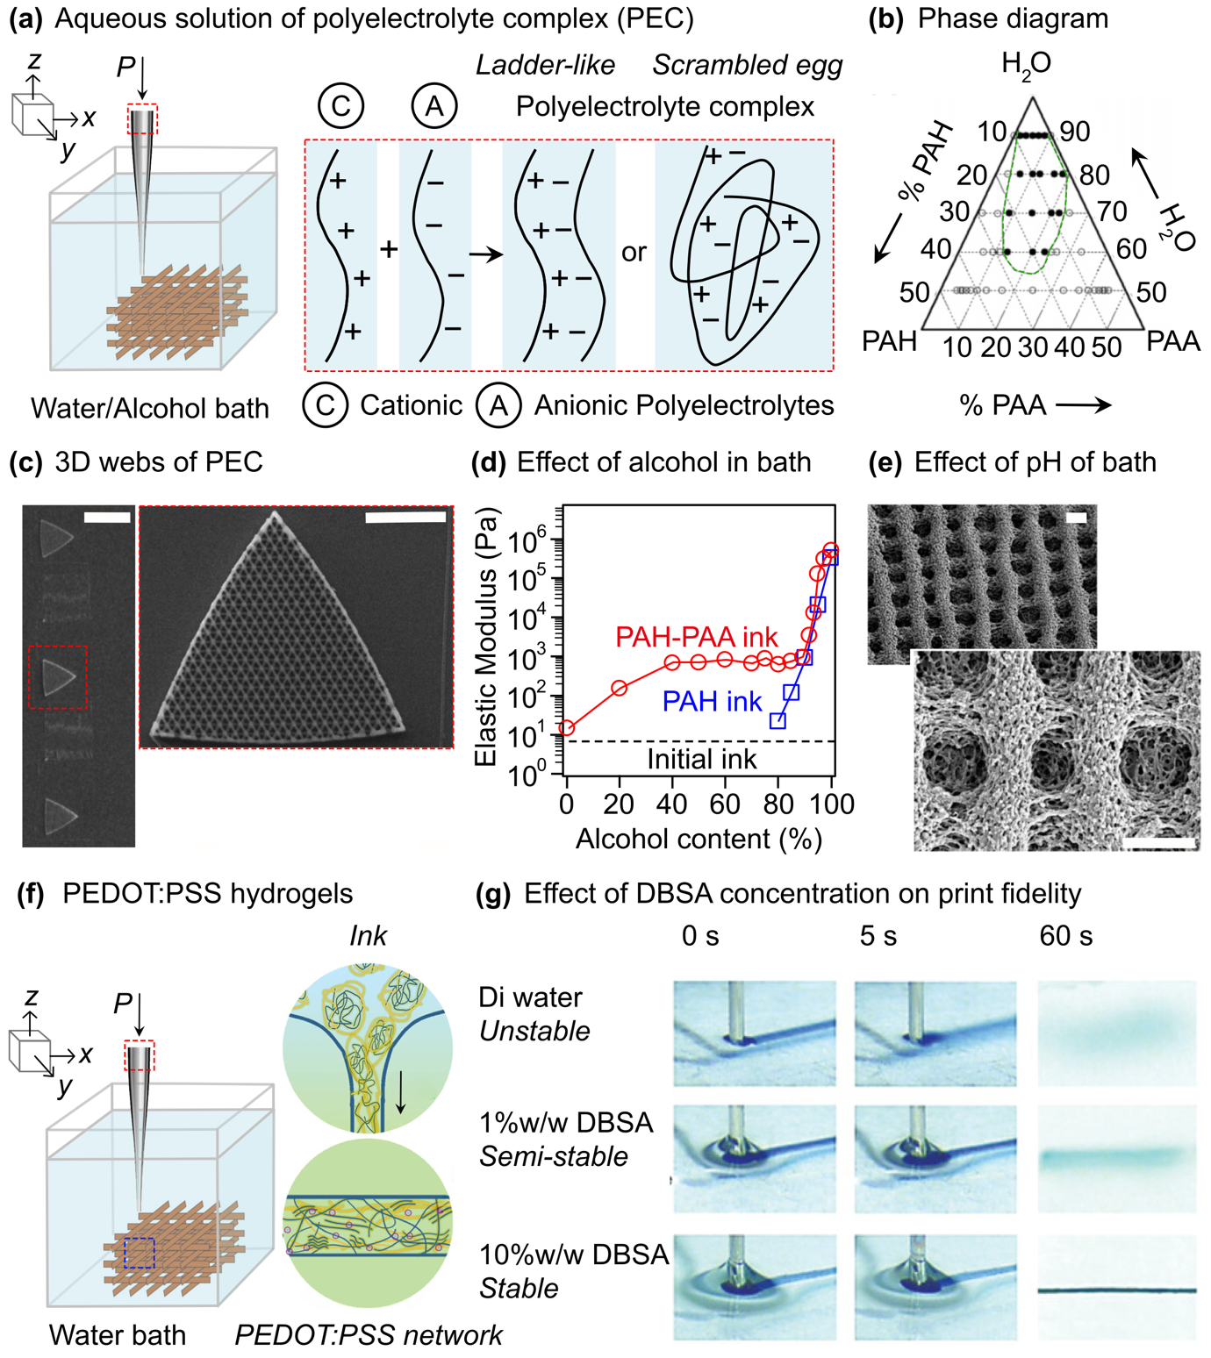

Figure 5. Newtonian liquid-assisted 3D printing by in situ coagulation of the printed ink. (a) Schematic illustration of formation of polyelectrolyte complex (PEC) when aqueous solutions of anionic and cationic polyelectrolytes are mixed in sufficient concentrations. PEC acquire either ladder-like or scrambled egg-like architectures. The PEC ink is directly dispensed in the alcohol/water bath to print self-supporting structures by in situ coagulation. (b) Ternary phase diagram of PAA-PAH-H₂O showing different phases (○: single-phase region, homogeneous soluble complexes, ●: two-phase region, a polymer-rich precipitate and a polymer-lean supernatant). (c) Liquid-assisted DIW of 3D microperiodic structures of PEC. Ink composed of PAH-PAA ink was directly dispensed in an alcohol/water bath. (d) A plot showing effect of alcohol content in the reservoir on the elastic modulus of the coagulated PAH-PAA (50 %w/w with [COO⁻Na⁺]:[NH_{x}⁺] = 1:2) and PAH (50 %w/w) inks (b-d) are Reprinted with permission from [46]. Copyright © 2007 American Chemical Society. (e) SEM images showing effect of pH on the highly porous periodic microstructures of PAA-PEI ink (40 %w/w with [COO⁻Na⁺]:[NH_{x}⁺] = 1:2.5) printed in the reservoir with pH < 3. Reprinted with permission from [45]. Copyright © 2005 American Chemical Society. (f) Schematic illustration showing DIW of PEDOT:PSS hydrogels by directly dispensing inks in a bath containing DBSA by rearrangement of the polymer chains. (g) Effect of DBSA concentration in the bath on the print fidelity. Reprinted from [49] with permission from the John Wiley and Sons. Scale bars = (c) 200 μm, 50 μm (inset), (e) 2 μm.

The liquid-assisted fabrication of 3D structures of PECs has been highlighted using inks prepared by mixing cationic poly(allylamine) hydrochloride (PAH) and anionic polyacrylic acid (PAA)[41, 46], cationic polyethylenimine (PEI) and PAA[45, 46], and cationic 3-(methacryloylamino)propyl-trimethylammonium chloride (MPTC) and anionic sodium p-styrenesulfonate (NaSS)[21]. To prepare a suitable ink, it is necessary to understand the phase behavior of polyelectrolyte1-polyelectrolyte2-water (H₂O). For example, when two oppositely charged polyelectrolytes are mixed in water, they exhibit three types of phase behavior: (1) a soluble, macroscopically homogeneous phase, (2) a turbid suspension of stable colloidal particles in a polymer-lean phase, and (3) a precipitated phase with a polymer-lean supernatant fluid. The ternary phase diagram of cationic poly(allylamine) hydrochloride (PAH, M_{w} ~ 60000) and anionic polyacrylic acid (PAA, M_{w} ~ 1200) sodium salt and water (H₂O) showed a complex phase behavior (Fig. 5b). Depending on the polymer concentration, three cases were observed: (1) low concentrations: PAA-PAH complexes phase-separated into a polymer-rich precipitate and a polymer-lean supernatant fluid; (2) intermediate concentrations (~ 20–40 %w/w): a two-phase region was observed, which was symmetrical across the charge equivalence line; and (3) high concentrations (> 45 %w/w): a single homogeneous phase region was observed (Fig. 5b).[46] Such homogeneous soluble complexes result from enhanced exchange reactions that induce structural rearrangement of the initially aggregated polymers in solution.[122, 123]
For NL3DP of PECs, the inks were prepared from concentrated PAH-PAA PECs (50 %w/w solution, μ_{i} ~ 12 Pa.s) and deposited through microcapillary nozzles (d_{i} = 0.5–5.0 μm) in alcohol/water (consisting of isopropyl alcohol (IPA), ethanol, and deionized (DI) water) liquid embedding media.[41, 46] The fabrication of the 3D structures of the PECs was achieved by in situ coagulation of the inks (Fig. 5c). The composition of the embedding media plays an essential role in the variation in the elasticity ($G^{'}$) of the ink (Fig. 5d) and the coagulation mechanism, which is driven by electrostatic effects in water-rich media and the solvent effect[45] in alcohol-rich media. As the alcohol concentration in the liquid media increased, three regions were observed: (1) 0–40 %v/v: a steady increase in $G^{'}$, (2) 40–80 %v/v: a plateau in $G^{'}$, and (3) > 80 %v/v: a sharp increase in $G^{'}$, coagulation driven solely by solvent effects, for the ink (PAA-PAH PEC, 50 %w/w with [ COO⁻Na⁺]:[NH_{x}⁺] = 1:2). Moreover, changes in the pH of the liquid media affect ink coagulation, spatial rearrangement, and assembly of the polymer chains, leading to highly porous 3D structures (e.g., PAA-PEI PEC in liquid media with pH < 3).[45]
In addition to PECs, the fabrication of 3D structures of different hydrogels, such as poly(3,4-ethylenedioxythiophene):poly(styrenesulfonate) (PEDOT:PSS), a conducting polymer,[49] and biomaterials, such as silk fibroin[47] and chitosan[48] was achieved using NL3DP by dispensing inks into suitable liquid-embedding media. For example, an aqueous solution of PEDOT:PSS was dispensed directly into a liquid medium bath containing 10 %w/w 4-dodecylbenzenesulfonic acid (DBSA), a surfactant dopant) (Fig. 5f).[49] Print fidelity was obtained by fine-tuning the concentration of DBSA in the liquid media bath (Fig. 5g) and PEDOT:PSS in the ink. Stable printed filaments were obtained by using 10 % (w/w) DBSA in a liquid bath. The fabricated PEDOT:PSS structures exhibited high electrical conductivity (~ 35 S.cm⁻¹, which increased to ~ 600 S.cm⁻¹ after postprocessing and dry annealing) and Young’s modulus (~ 1–10 MPa), which closely matched those of biological tissues.

    - Crosslinking
Many polymers such as hydrogels can be obtained by different crosslinking mechanisms, including physical (temporary), ionic (temporary), and chemical (permanent) crosslinking.[124-127] In physical crosslinking, a network between polymer chains can be formed by hydrogen bonding, hydrophobic interactions, electrostatic interactions, chain aggregation, and self-assembly or crystallization (e.g., physical crosslinking of carboxymethyl cellulose in slightly acidic solutions by hydrogen bonding). Polyelectrolytes such as sodium alginate (NaAlg) can be crosslinked with multivalent ions of opposite charges (e.g., Ca²⁺ + 2Cl⁻) via ionic crosslinking. In chemical crosslinking, permanent covalent bonds are formed between polymer chains using crosslinking agents.
3D printing of such polymer inks via NL3DP can be performed by in situ crosslinking with crosslinking agents mixed in liquid embedding media. Examples of these methods are discussed below:
(i) Ionic crosslinking: A water-soluble, naturally derived biomaterial, sodium alginate (derived from brown seaweed)[128], can be crosslinked with divalent cations such as Ca²⁺ to fabricate cell-laden hydrogels.[129, 130] Such biocompatible and biodegradable hydrogels are used in various applications, including bioprinting.[129, 131, 132] The concentration of Ca²⁺ ions plays a vital role in tuning the properties of hydrogels (e.g., porosity and swelling).[133-136] The Ca²⁺ ions preferentially bind to the blocks of guluronic acid units of alginate in a planar 2D manner to form ionic bridges between different chains, which is called the egg-box model (Fig. 6a).[137-140]
Layer-by-layer NL3DP of NaAlg- and NaAlg-based aqueous inks was performed by dispensing the inks onto a substrate in a Newtonian calcium chloride (CaCl₂) bath (Fig. 6a).[50-53] The in situ gelation of the inks by Ca²⁺ ions facilitated the fabrication of 3D structures. A bioprinting process was developed to fabricate biological scaffolds by seeding NaAlg inks with endothelial cells.[50] The print fidelity depended on the concentration of NaAlg in the ink and CaCl₂ in the bath (Fig. 6b). When the ink is dispensed in the air, it spreads immediately. In contrast, rapid gelation in the crosslinking bath arrested the spreading of ink on the substrate. [51] The fabricated hydrogel scaffolds with different concentrations of NaAlg (1–3 %w/v) and CaCl₂ (0.5–2 %w/v) showed good cell viability.[50]

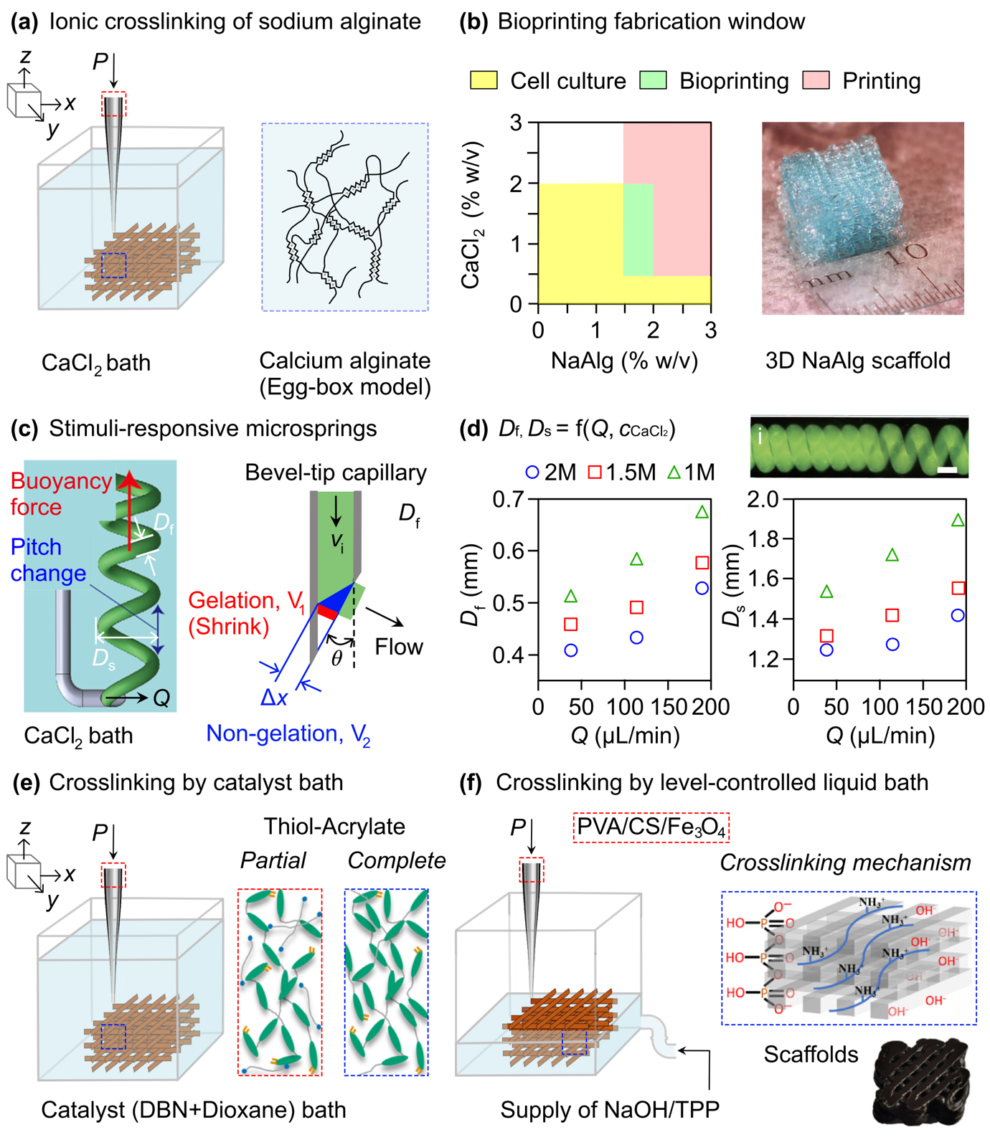
Figure 6. Newtonian liquid-assisted 3D printing by in situ crosslinking of the printed ink. (a) Schematic illustration showing DIW of sodium alginate (NaAlg) hydrogels by directly dispensing inks in calcium chloride (CaCl₂) bath. The cross-linkages in the hydrogel are formed by ionic crosslinking with Ca²⁺ ions in the bath and are represented by the egg-box model. (b) A process diagram for cell culture, 3D printing and bioprinting as a function of concentrations of NaAlg and CaCl₂, and a fabricated NaAlg scaffold. Reprinted from [50] with permission from the American Society of Mechanical Engineers. (c) Schematic illustration showing fabrication of stimuli-responsive NaAlg-based hydrogels. The ink was dispensed through bevel-tip capillary and the pitch of the formed microspring was adjusted by via buoyancy force. (d) Plots showing effect of flow rate of the ink (Q) and concentration of CaCl₂ (c_{CaCl2}) in the bath on the diameter of the spring filament (D_{f}) and diameter of the spring,(D_{s}) of the fabricated microsprings. Reprinted from [52] with permission from the Elsevier. (e) Schematic illustration showing DIW of fabrication of liquid crystal elastomers (LCE) by in situ chemical crosslinking by directly dispensing the ink in a catalyst bath. Reprinted (adapted) with permission from [55]. Copyright © 2020 American Chemical Society. (f) Schematic illustration showing DIW of fabrication of magnetic PVA/CS/Fe₃O₄ ink by dispensing the ink in a crosslinker bath, where needle of the printing nozzle was always kept outside the crosslinker bath to prevent clogging of the nozzle and poor adhesion between the printed layers. Reprinted from [56] with permission from the Elsevier. Scale bars = (d) 100 μm.

The fabrication of freeform structures such as helical spring microstructures and NaAlg overhang structures was made possible using a viscoelastic support bath.[141-143] Similarly, the fabrication of helical microspring structures were fabricated by NL3DP by extrusion of NaAlg inks at velocity v_{i} (by adjusting the flow rate Q) through a bevel-tip capillary with inner diameter d_{i} and tip angle θ in a CaCl₂ bath (Fig. 6c).[52-54] The extrusion direction of ink in the CaCl₂ bath was determined using θ. The extrusion direction and asymmetric geometry of the bevel tip (d_{i} and θ) led to a difference in the initial gelation points on both sides of the flow, causing a difference in the gelation starting time, $t= {∆x}/{v_{i}}$. Instantaneous gelation of the outer periphery of the hydrogel by Ca²⁺ near the bevel tip, controlled by t and d_{i}, dominated the formation mechanism of the microsprings, and the bevel tip with θ < 30° formed stable microsprings.
The mechanism was extended to fabricate stimuli-responsive hydrogel microsprings by mixing poly(N-isopropylacrylamide-co-acrylic acid) (p(NIPAM-co-AAc)) with pre-gel sodium alginate ink or by maintaining the co-flow of stimuli-responsive (p(NIPAM-co-AAc) + NaAlg) and non-stimuli-responsive (NaAlg) parts.[52] The microspring was formed upward because of the buoyancy force, which contributed to the varying pitch of the fabricated spring. Initially, when ink was dispensed, the pitch of the microspring was densely packed. The pitch then changes over time because of the dragging of the spring by the buoyancy force when it exceeds the deformation force of the spring. The length of the densely packed part of the microsprings decreased with increasing Q and the concentration of CaCl₂ (c) in the bath. However, the gradient in the pitch of the microsprings is approximately the same for each condition. Moreover, the dimensions of the fabricated microsprings (diameter of the spring filament, D_{f}, and diameter of the spring, D_{s}) depended on Q and the concentration of CaCl₂ (c) in the bath. D_{f} and D_{s} were directly and indirectly proportional to Q and c, respectively (Fig. 6d). The responsiveness of the fabricated actuator spring (compression, elongation, and twisting) was limited by the temperature and pH. It was tuned by optimizing the thickness and stiffness of the responsive and nonresponsive layers. Overall, the formation of the microspring depended on different parameters associated with the capillary (tip diameter, tip angle, and surface wettability), fluid (viscosity, flow velocity, and density), and reaction (temperature and solution concentration).

(ii) Chemical crosslinking: A liquid bath with crosslinkers was used to assist in the formation of in situ permanent bonds during NL3DP.[55] This approach allows the fabrication of 3D structures of liquid crystal elastomers (LCEs) by printing a precursor solution of LCE directly into a catalyst bath, followed by drying and mechanical programming of the shapes of the printed LCEs. (Fig. 6e). Specific nematic director orientation in LCEs is critical for the desired shape changes. 3D printing in air allowed for the fabrication of complex LCE structures; however, the shear alignment of the local nematic director was coupled with the print path.[144, 145] However, during NL3DP, no alignment of the liquid crystal director is imprinted into the printed filaments. The liquid crystal alignment was obtained only after the mechanical deformation of the printed LCEs. A variety of shape shifts between the printed shape and mechanically deformed shape were obtained by heating or cooling above and below the nematic-to-isotropic transition temperature.
LCEs possessing a double network were obtained through two separate crosslinking steps. Under ambient conditions, they acquired an elongated shape, whereas they returned to their initial contracted shape (obtained after the first crosslinking) after heating. Three steps were involved in the fabrication of the shape-shifting LCE process: (1) preparation of ink and oligomeric solution by partial crosslinking of the network-forming reagents; (2) fabrication of layer-by-layer cross-linked LCE structures by NL3DP of ink into a catalyst bath (2 %v/v 5-diazabicyclo[4.3.0]non-5ene (DBN) in dioxane) via in situ thiol-acrylate coupling reactions under ambient conditions; and (3) crosslinking of residual acrylate in the printed structures by UV curing after shape programming of the structures by mechanical deformation. A higher DBN concentration of > 2 %v/v resulted in clogging of the nozzle during extrusion owing to rapid crosslinking. The fabricated LCE actuators obtained after the three steps acquired programmed and printed shapes after cooling and heating, respectively.

(iii) Physical crosslinking: Chitosan (CS) contains extensive intra-and intermolecular hydrogen bonds, which prevent its solubility in organic solvents.[146] However, CS can be dissolved in acidic solutions (pH 6.5) via protonation of amino groups to form cationic polyamines.[147] The gelation can be triggered by deprotonation through neutralization with sodium hydroxide (NaOH)[148, 149] or crosslinking with sodium tripolyphosphate (TPP)[150, 151]. Interactions between amino groups and TPP ions and the limited availability of competitive hydroxyl ions in TPP solution. (iii) Physical crosslinking: Chitosan (CS) contains extensive intra-and intermolecular hydrogen bonds, preventing its solubility in organic solvents.[146] However, CS can be dissolved in acidic solutions (pH 6.5) via protonation of amino groups to form cationic polyamines.[147] The gelation can be triggered by deprotonation through neutralization with sodium hydroxide (NaOH)[148, 149] or crosslinking with sodium tripolyphosphate (TPP)[150, 151]. The interactions between amino groups and TPP ions and the limited availability of competitive hydroxyl ions in TPP solution induced the crosslinking of CS by TPP.
Recently, 3D structures of a self-healing double network magnetic hydrogel composed of CS combined with PVA (to improve the mechanical properties of the printed structures) loaded with Fe₃O₄ magnetic nanoparticles were successfully fabricated by NL3DP under ambient conditions (Fig. 6f).[56] Apart from improving the mechanical properties, the addition of PVA improved the printability of the magnetic hydrogels by enhancing the crosslinking rate. The shear-thinning nanocomposite ink (CS/PVA/Fe₃O₄) was printed layer by layer. The needle of the printing nozzle was placed outside the crosslinker bath to prevent nozzle clogging and poor adhesion between printed layers. The height of the liquid in the bath increased with upward movement of the nozzle to crosslink the freshly printed layer (Fig. 6f). The print fidelity was higher with NaOH than with TPP, and the rate of cross-linking was faster with NaOH in the bath than with TPP. The hydroxide and tripolyphosphate ions in TPP exhibited competitive cross-linking relationships. The printability improved with increasing CS concentration in the ink. The magnetic hydrogels fabricated with ink PVA/CS/Fe3O4 (PVA:CS = 1:1) crosslinked with NaOH showed the best compression resistance and a lower swelling rate.

    - Immersion precipitation
When a polymer solution (a binary solution composed of a polymer dissolved in a suitable solvent) is in contact with a nonsolvent, it undergoes nonsolvent-induced phase separation or immersion precipitation, causing in situ solidification of the polymer. For phase separation to occur via immersion precipitation, three criteria are critical: (1) the polymer must be soluble in a suitable solvent; (2) the solvent and nonsolvent must be miscible; and (3) the polymer and nonsolvent must be immiscible. 3D printing of a polymer solution (polymer ink) via immersion precipitation has been demonstrated and is termed immersion precipitation 3D printing (ip3DP). In this method, the polymer ink is directly dispensed layer-by-layer from a motion-controlled syringe under an applied pressure in a nonsolvent bath under ambient conditions (Fig. 7a). When dispensed in air, the polymer ink formed a droplet at the tip of the nozzle owing to the capillary effect. However, it forms a continuous filament, which is essential for NL3DP when dispensed in liquid embedding medium. Rapid solidification of the printed ink by the in situ exchange of the solvent and nonsolvent, faster than solvent evaporation in SC3DP, facilitated the fabrication of 3D structures (Fig. 7a). Different thermoplastics, such as Acrylonitrile Butadiene Styrene (ABS), polylactic acid (PLA), and polyvinylidene fluoride (PVDF), have been dissolved in suitable solvents (e.g., high vapor pressure solvents such as acetone and dichloromethane, and low vapor pressure solvents such as dimethyl formamide and water) and printed in nonsolvents (e.g., water and ethanol) via an immersion precipitation mechanism.
Immersion precipitation is typically analyzed using a polymer/solvent/nonsolvent ternary phase diagram, as shown in Fig. 7b. The ternary phase diagram is divided into two regions separated by a binodal boundary ( dashed black line): (1) a stable homogeneous one-phase region where ink is fluidic and (2) an unstable nonhomogeneous two-phase region where ink undergoes phase separation into polymer-rich and polymer-lean phases. When the composition of the ternary phase shifts from a homogeneous region to a nonhomogeneous region, phase separation occurs via either nucleation and growth (a region between the spinodal and binodal boundaries) or spinodal decomposition (a region within the spinodal envelope) by exchange of the solvent and nonsolvent (Fig. 7b). The line connecting point A (equilibrium polymer-rich phase) and point B (equilibrium polymer-lean phase), which is located on the binodal curve, is called the tie line. The point at which the binodal and spinodal boundaries ( continuous black line) cross each other is called the critical point. Ink in the lower and upper nucleation and growth
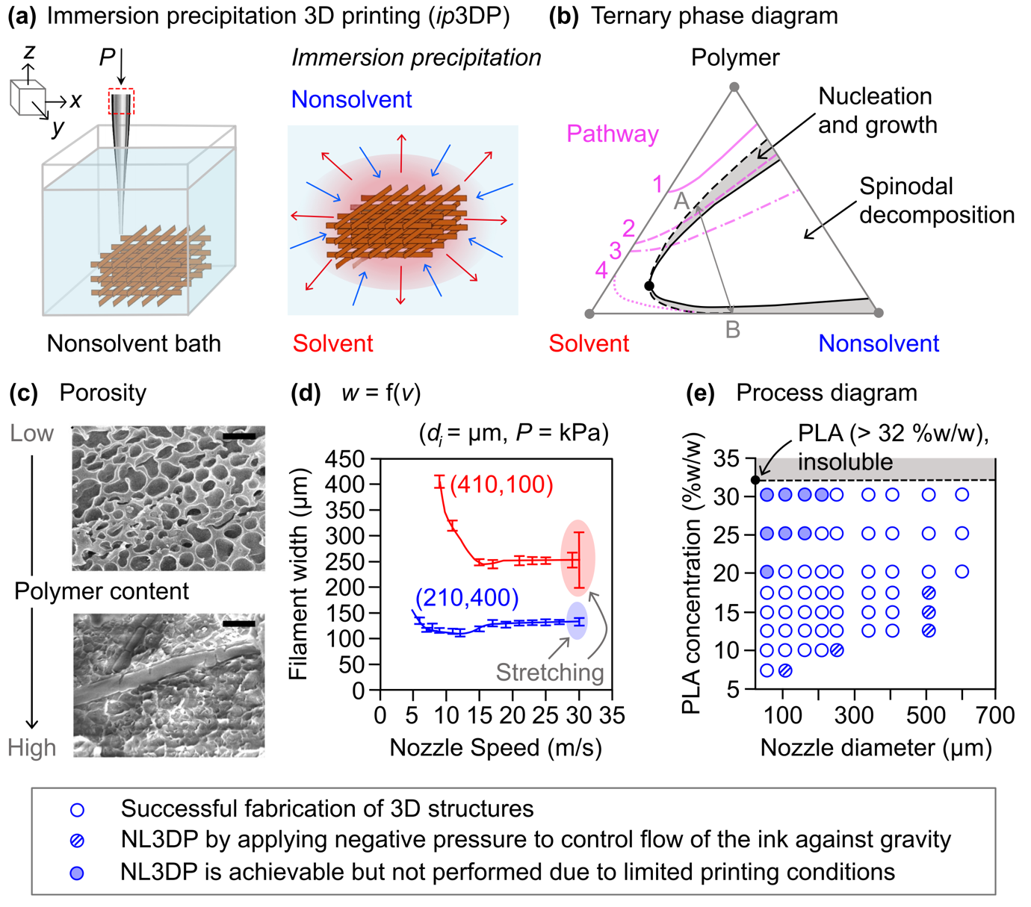

Figure 7. Newtonian liquid-assisted 3D printing by in situ immersion precipitation, termed as immersion precipitation 3D printing (ip3DP). (a) Schematic illustration showing DIW of polymer inks by directly dispensing inks in a nonsolvent bath. (b) A typical polymer-solvent-nonsolvent ternary phase diagram. The phase diagram is divided into two regions, separated by a binodal boundary (dashed line). The tie line AB represents the equilibrium compositions of the polymer-rich and polymer-lean phases. Different immersion precipitation pathways (1-4) depending on the polymer content in the solution. (c) SEM images showing effect of polymer content on the porous microstructure of the printed objects. (d) Plot showing effect of nozzle speed (v) on the width (w) of the printed filament. Reproduced from [19] with permission from the Royal Society of Chemistry. (e) Processing map of ip3DP showing the printability of a polymer (polylactic acid, PLA) inks. Reprinted (adapted) with permission from [20]. Copyright © 2023 American Chemical Society. Scale bar = (e) 2 μm.

regions had lower and higher polymer concentrations, respectively, in the ink. The polymer content of the ink affected the resulting structure. Inks with lower polymer concentrations form a dispersive polymer-rich phase in a continuous lean phase, resulting in polymer nodules or beads that connect to each other to form structures with low mechanical integrity.
In contrast, the ink with a higher polymer concentration undergoes nucleation of the dispersive polymer-lean phase, leading to relatively closed-cell structures in the polymers to form structures with high mechanical integrity. However, after phase separation, if the removal of the polymer-lean phase is delayed, it can lead to the collapse of the porosity in the structures. The ink in the spinodal decomposition region forms interpenetrated polymer-rich and polymer-lean phases. Interconnected hierarchical pores were formed in the microstructures, which allowed the rapid removal of the polymer-lean phase and prevented the collapse of pores in the microstructures. Different morphologies can be obtained depending on the immersion precipitation pathway during the solvent-nonsolvent exchange (Fig. 7b).
During the immersion-precipitation process, phase separation of the polymer-rich phase from the polymer-lean phase occurs because of the continuous exchange of the solvent and nonsolvent, which solidifies the polymer-rich phase. Interestingly, the miscibility of the solvent and nonsolvent (or the rate of demixing) dictates the resulting characteristic size and pore distribution in the microstructure of the printed objects. Rapid demixing, owing to the high mutual affinity between the solvent and nonsolvent (e.g., acetone and water), accompanied by hydrodynamic flows (e.g., Marangoni flow), occurs to form macrovoids or finger-like structures that are more prominent than the rest of the pores below the thin skin layer of the printed objects. In contrast, the printed objects formed by delayed demixing resulted in thick dense layers and a sponge-like microstructure. In addition to the miscibility of the solvent and nonsolvent, several other parameters, such as the polymer content in the ink, viscosity, composition of the nonsolvent, and additives in the ink (e.g., porogen), affect the microstructure of the printed objects. Fig. 7c shows the effect of the polymer content in the ink on the porosity of the printed object; the microstructure changed from porous to dense with increasing polymer content. 3D printing via immersion precipitation is a unique method for imparting hierarchical porosity (meso-, macro-, and micropores) to printed objects without using a templating material and can be used in various applications such as adsorption, catalysis, and membrane separation.
The dimensions of the filament were readily affected by different parameters such as the nozzle speed (v) (Fig. 7d). For example, ABS ink (45 %w/w in acetone) was printed in water through a nozzle (Case I: d_{i} = 410 μm, P = 100 kPa; Case II: d_{i} = 210 μm, P = 400 kPa) and 210 μm for v = 2–30 mm.s⁻¹ to understand the effect of v on the width of the filament (w). Four regimes were observed showing different dependence of w on v for Case I – (1) v = 1–5 mm.s⁻¹, w was nonuniform as the printed filament underwent Rayleigh-Plateau instability; ink speed (through nozzle) was ≫ v, (2) v = 5–10 mm.s⁻¹, w decreased gradually; the ink speed was ≦ v, (3) v = 10–25 mm.s⁻¹, w was nearly constant, and (4) v > 25 mm.s⁻¹, w was inconsistent with increase in variance due to stretching of the printed filament by the moving nozzle; ink speed ≪ v. Further increase in v caused breaking of the printed filament due to overstretching by the moving nozzle. When the polymer ink was dispensed through a nozzle with a small diameter (Case II), w remained constant over a wide range of v. It should be noted that the use of small-diameter nozzles is associated with clogging, especially when certain conditions are met, such as the use of a high-vapor-pressure solvent.
The main advantage of ip3DP is that it allows low-viscosity inks (μ ~ 10⁻¹ Pa.s) to fabricate 3D structures, unlike SC3DP, which requires high-viscosity inks. Moreover, it allows for the use of low-vapor-pressure solvents to prepare polymer inks, unlike SC3DP, which requires high-vapor-pressure solvents. A processing map was created by varying the polymer (PLA) concentration and inner nozzle diameter. The processing map was created by adjusting other printing parameters, including P and v. This demonstrates the printability of PLA ink in ethanol. ip3DP allows the 3D printing of low-viscosity inks with small d_{i} nozzles; however, dispensing such inks using larger d_{i} nozzles is challenging. The low-viscosity inks flowed through the large d_{i} nozzles under gravity without applying external pressure; hence, negative pressure was applied to control the flow of the ink. Two different time scales are involved in ip3DP, which contribute to print fidelity: (1) τ_{v} (associated with v) and (2) τ_{D} (associated with the solvent-nonsolvent diffusion rate). Good print fidelity is obtained when τ_{v} > τ_{D}; the printed layer solidifies faster because of the rapid exchange of the solvent and nonsolvent before printing the next layer. When low-viscosity ink (e.g., PLA12.5, 12.5 %w/w in DCM) is printed in ethanol, it immediately spreads on the substrate owing to the delayed diffusion of DCM in ethanol (τ_{v} < τ_{D}) from the interior of the printed filament. Reducing the dimensions of the filament (either by varying v, P, or d_{i}) accelerates the solvent-nonsolvent diffusion (τ_{v} > τ_{D}), leading to in situ solidification of the printed filament.
Overall, DIW via immersion precipitation is a versatile method for fabricating 3D (micron-to-centimeter-sized) thermoplastic objects at different scales (microns to centimeters). Conceptually, this method is applicable to all ternary phase systems. For successful 3D printing, careful selection of the printing parameters is required. The applicability of low-viscosity inks allows for the preparation of functional inks (e.g., electrically conducting multiwalled carbon nanotube (MWCNTs)-PVDF nanocomposites) for 3D-print functional devices used in different applications, such as flexible conductors and piezoelectric devices. Interestingly, 3D printing of PVDF via immersion precipitation in ethanol facilitated an increase in the-β-phase content of the PVDF films, which was 1.5 times larger than those fabricated with SC3DP.

  - Other roles of the Newtonian liquid embedding media
The liquid embedding media was demonstrated to provide an environment for in situ coagulation, crosslinking, or precipitation of the printed ink. Moreover, the liquid-assisted DIW of different materials is also highlighted, where the role of the embedding media is to create edible art[152], isolate the printed structures from the air to prevent its drying[62-64], alter the wettability of the printed ink to prevent its spreading on the substrate[12], and tailor the interface of the embedding liquid media and the printed ink by inducing assembly and jamming[66, 68].

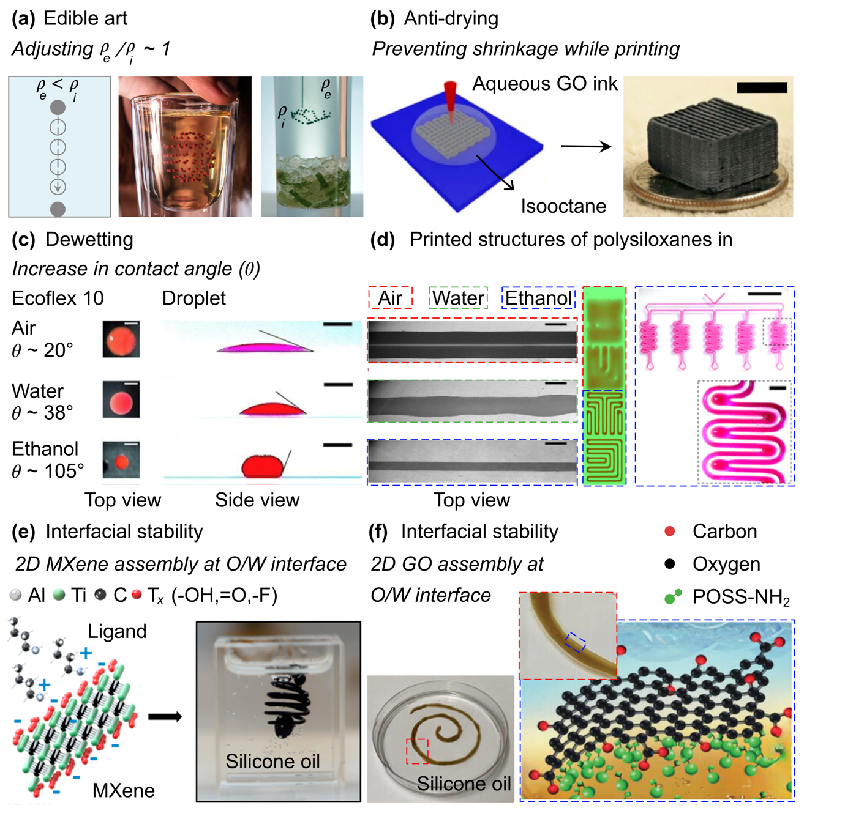
Figure 8. Newtonian liquid-assisted 3D printing by interfacial stability of the ink and the liquid media. (a) PRINT A DRINK. A slowly diffusing liquid is printed inside a drink in the form microlitre droplets to fabricate complex designs. The densities of the two liquids are matched to hold the printed droplets at the printed position. Reproduced with permission from [152]. (b) Schematic illustration showing DIW of graphene oxide (GO) aerogels by directly dispensing inks in an isooctane bath. The embedding oil media prevents the printed structure from shrinkage due to drying. (c) Optical micrographs of the Ecoflex 10 droplets showing the effect of embedding liquid media on its wettability (contact angle, q) in air, water and ethanol. (d) Optical micrographs showing the effect of wettability of printed Ecoflex 10 on the width of the dispensed ink in air, water and ethanol. Complex 2D patterns of the polysiloxane inks fabricated by dispensing inks directly into ethanol bath. Reprinted (adapted) with permission from [12]. Copyright © 2020 American Chemical Society. (e) Schematic illustration showing Newtonian liquid-assisted DIW of MXene inks in silicone oil. The print fidelity is obtained by the interfacial assembly (jamming) of MXenes at the oil-water interface. Reprinted (adapted) with permission from [66]. Copyright © 2019 American Chemical Society. (f) Schematic illustration showing Newtonian liquid-assisted DIW of GO inks in silicone oil. The print fidelity is obtained by the interfacial assembly (jamming) of GO at the oil-water interface. Reprinted from [68] with permission from the John Wiley and Sons. Scale bars = (b) 5 mm, (c) 1 mm, (d) filament = 500 μm, Open microchannels = 5 mm (inset = 200 μm).

When ink (ρ_{i}) is dispensed midway in a liquid embedding medium (ρ_{e}), where ρ_{e} < ρ_{i}, the ink settles down on the substrate owing to gravity, and if the densities are matched, ρ_{e} ~ ρ_{i}, then the printed ink can be placed in the embedding liquid at the desired positions. Drink[152] used the same concept to print a custom 3D artwork inside glass filled with a cocktail (Fig. 8a). The robot precisely injected microliter droplets of edible oil-based liquid to fabricate floating 3D artwork. The embedding liquid (e.g., vodka, whiskey, containing < 40 %v/v alcohol) should be diluted such that ρ_{e} ~ ρ_{i} to allow positioning of the ink at the desired location in the liquid media. The printed droplets lasted approximately 10 min before being dissolved in the surrounding liquid media.[153]
Aerogels are porous solids with ultralow density. Fabricating aerogels requires replacing the aqueous phase from the pores in the wet gel phase with air via a supercritical or freeze-drying process without collapsing the micropores, owing to the capillary forces generated by drying. A structure fabricated by 3D printing must be wet during printing and gelation before being converted into an aerogel. Similarly, the DIW of highly concentrated aqueous colloidal inks involves shrinkage of the printed filaments owing to drying (caused by the compressive forces generated via capillary tension)[154] during or after deposition, which affects the print fidelity.[62] Such aqueous inks are printed in oil, which is less dense than ink, immiscible, and nonreactive with the ink to avoid drying the printed filaments.[62-64] For example, graphene oxide (GO)-based aerogels have been fabricated by printing aqueous GO inks in an immiscible isooctane bath to prevent the drying of the ink in air, which can lead to clogging of the nozzle or pore collapse in the printed structure owing to capillary forces (Fig. 8b).[63] The aqueous GO inks were prepared by mixing a GO suspension with silica particles to obtain highly viscous and thixotropic properties. Finally, GO aerogels were obtained by the following post-processing steps: (1) gelation using a basic solution (e.g., ammonium carbonate), (2) supercritical drying, (3) carbonization at 1050 °C, and (4) etching in a hydrofluoric acid solution to remove silica particles.
The wettability of a liquid is its ability to interact with a solid substrate, and is controlled by the balance between intermolecular interactions, adhesion, and cohesion.[155] Wettability is generally measured by the contact angle (θ), which is the angle a liquid creates with a solid surface at the three-phase boundary, where a liquid, fluid (e.g., air), and solid intersect. For a given liquid, the wettability (i.e., the value of θ) depends on the type of surface and surrounding fluid (air, gas, or liquid). For example, θ for toluene in air on polytetrafluoroethylene (PTFE) is 43.1°[156] but increases to 122.6° ± 1.9° in water[157]. This concept has been used to pattern low-viscosity polysiloxanes (e.g., Ecoflex 10 and Sylgard 184) on different substrates.[12] The contact angle of Ecoflex 10 on a plastic (polystyrene) substrate in air was θ ~ 20°, which increased to θ ~ 38° and θ ~ 105° in water and ethanol, respectively (Fig. 8c). When Ecoflex 10 was dispensed on the substrate in air, it immediately spread, causing an increase in the width of the printed filament, w $≫$ d_{i} (Fig. 8d). When dispensed on the same substrate in water, w was lower than that in air (still w > d_{i}); however, the boundary of the printed filament became wavy after printing owing to hydrophilic-hydrophobic interactions. When printed in ethanol, w was comparable to d_{i} because of the large θ and was used to fabricate complex 2D patterns on different substrates (plastic, glass, cured Ecoflex 10, and flexible polyethylene sheets) (Fig. 8d). Ethanol was used as the embedding medium to maintain the printed shape of the polysiloxanes prior to complete curing. Moreover, the ethanol was removed by evaporation without any manual intervention after curing the printed filaments. It should be noted that the NL3DP of polysiloxanes allowed printing of up to three layers of inks (owing to slow curing); further increase in the number of layers resulted in sagging of the printed structure.[12]
For a given volume, the acquired minimum surface area shape is spherical owing to the action of the surface tension forces.[158] Therefore, nonspherical shapes, such as filaments or torus, would evolve into a single nonminimal spherical shape[159] or break into several spherical droplets via Rayleigh-Plateau instability[106, 160-162]. Stabilizing nonspherical geometries requires an opposing force to balance or overcome the forces associated with surface-tension-driven instabilities, particularly when performing NL3DP.
Different approaches were highlighted for the printed filaments of the ink, which did not undergo in situ solidification or gelation, to obtain stability between the printed ink and surrounding embedding media. One approach involves the assembly of nanoscale materials, such as nanoparticles and surfactants, at the liquid-liquid interface. The assembly of nanoscale materials suppresses the instability (e.g., Rayleigh-Plateau instability) and facilitates the fabrication of complex nonequilibrium geometries with tailored properties.[163-169] NL3DP obtained via interfacial assembly and jamming has been highlighted.[65-68] For example, the printability of aqueous suspensions containing Ti₃C₂T_{x} MXene nanosheets was investigated[66], where the nanosheets were made hydrophilic and readily dispersible in water by terminating 2D layers with functional groups (e.g., −OH, =O, −F) by a chemical etching process.[170] 3D printing of complex structures was performed by interfacial assembly and jamming of MXene nanosheets at the oil-water interface (Fig. 8e). High-viscosity silicone oil (μ = 60000 cSt) containing 1–7 %w/w n-butylamine ligand was used as the liquid embedding medium. As the MXene inks (7.5 mg.mL⁻¹) were dispensed in the liquid embedding media (containing 5 %w/w ligand), MXene sheets along with the ligands (called as MXene surfactants) formed a jammed assembly at the oil-water interface that stabilized the printed filament along the printing path (Fig. 8e). It should be noted that the printed structures sink naturally in the oil matrix, and the time scale (1 h for high-viscosity oil) is defined by the viscosity of the oil. The printed structures remained stable on a time scale ranging from hours to days depending on the size of the printed filaments. Similarly, the assembly of GO nanosheets at the oil-water interface facilitated the structuring of low-viscosity oils.[68] An aqueous GO ink with low GO content (0.04 %v/v) could be structured into complex nonequilibrium geometries only when the liquid embedding media, low-viscosity silicone oil, contained PSS-[3-(2-aminoethyl)amino] propyl-heptaisobutyl-substituted POSS (POSS-NH₂) ligands (Fig. 8f). Strong interactions (hydrogen bonding) between the functional groups of GO and the amino groups of POSS facilitated the formation of an elastic film at the oil-water interface that stabilized the printed filaments.

- Limitations, Challenges and Future Perspective
Newtonian-liquid-assisted direct ink writing has attracted increasing interest over the past few years because it facilitates 3D printing using liquid inks prepared with pristine materials. The rheological properties of the ink (e.g., viscosity), printing parameters, including nozzle diameter and print speed, and physical properties of the liquid media affect the print fidelity. All these parameters affect the dimensions of the printed filament. The 3D printing method facilitates the fabrication of microstructures by allowing the use of low-viscosity inks that are easily extrudable through micronozzles. The use of liquid embedding media facilitates the dissolution or dispersion of molecules at suitable concentrations, inducing in situ solidification or gelation of the printed ink.
Newtonian-liquid-assisted 3D printing has several limitations that must be addressed.
- The fabrication of freeform structures of low-viscosity inks (e.g., polymer solutions prepared with thermoplastics) with a support matrix is cumbersome.[27] The dispensed ink follow an upward-curve path at the exit of the nozzle due to the elasticity of the embedding media. The concave curvature of the dispensed ink causes adhesion of the ink to the tip of the nozzle owing to in situ solidification and clogging of the nozzle. NL3DP can overcome this limitation for freeform fabrication; however, strict control over printing parameters such as nozzle speed and ink flow rate is required[74]. Moreover, controlling the wettability of the nozzle (e.g., a superhydrophobic nozzle) can prevent adhesion of the printed ink at the tip of the nozzle.
- The fabrication of high-resolution three-dimensional (3D) structures is challenging. The size of the printed filament depended mainly on the nozzle size (d_{i}). Customized nozzles fabricated by pulling the microcapillaries[41] or AFM tips with microscopic channels[171-173] with d_{i} < 1 μm require the application of very high pressures to dispense the inks. If electric fields are applied between the nozzle and substrate, inks can be dispensed at lower pressures, and filament diameters smaller than the nozzle size can be obtained to achieve high-resolution electrohydrodynamic printing.[174, 175] NL3DP using electrohydrodynamically induced fluid flow through such microcapillary nozzles is an exciting area of future research for the fabrication of patterns and structures of soft materials at the submicron level.
- Slow-curing materials such as commercial polysiloxanes (e.g., Ecoflex 10 and Sylgard 184) do not possess adequate physicochemical properties to maintain the printed 3D structures by NL3DP for the duration of curing. 3D printing of polysiloxanes by DIW_{Air} involves complex ink formulations and many printing parameters causing significant challenges.[176] Different strategies can be used to fabricate 3D structures of natural polysiloxane inks by NL3DP – (i) matching the density of the embedding media to the ink; however, even if the densities are matched, inertia can still act on the printed filament, forcing it to shoot to the bottom or curl upon itself[177], (ii) printing the ink with the support material, (iii) printing the ink in a bath containing heated media for in situ curing, and (iv) printing the ink in a catalyst bath for in situ curing.
- NL3DP is primarily suitable for fabricating structures printed in a single stroke of the tool path. If the toolpath requires the movement of the nozzle from one position to another (e.g., from point A to point B, the applied pressure is OFF; hence, no ink is dispensed on path A-B) on the toolpath, it is challenging to fabricate structures because the solidification or gelation of the ink at the tip of the nozzle blocks the nozzle because of clogging. Additionally, traditional multimaterial 3D printing by material extrusion requires sequential printing of inks,[178, 179] and the use of such processes in NL3DP can be cumbersome, leading to clogging of the nozzle that is not in operation.
The use of microfluidic devices as printheads for NL3DP can overcome these limitations and facilitate switchable multimaterial 3D printing of soft materials. The microfluidic nozzle allows sequential dispensing of multiple inks through a single nozzle without any disruption.[180, 181] This approach paves the way for the fabrication of functional structures with finely controlled microstructures for various applications. For example, simultaneous or sequential printing of soft hydrogels and strong biocompatible synthetic polymers can facilitate the fabrication of mechanically robust components in tissue engineering, such as load-bearing tissues.
The fabrication of core-shell structures into non-Newtonian embedding media requires a shell fluid and a sacrificial core fluid. Moreover, the stability of the three phases (embedding media, shell liquid, and core liquid) is required for the successful 3D printing of the core-shell structures. NL3DP allows the fabrication of microchannels with tunable mechanical properties by direct ink writing without requiring a sacrificial core fluid. The fabricated core-shell structures can be used in soft robotics applications. Moreover, it enables the fabrication of functional structures by (1) in situ active mixing of the filler particles with the liquid ink, leading to local variations in the composition of the particles[182] and (2) inclusion of liquid droplets in the printed filaments[183, 184]. Additionally, the use of zero-dimensional (0D, single nozzle), 1D, and 2D nozzle arrays[185-187] and multiple nozzles as printheads[188] would facilitate the dispensing of multimaterial voxelated matter and cylindrical filaments.
Engineered biomaterials offer promising healthcare solutions. Therefore, it is essential to develop stretchable, strong, and chemically stable biomaterials with tunable properties that mimic those of tissues. Their adaptability to 3D printing is important for customizable fabrication. The development of NL3DP over the years, has enabled researchers to print soft materials (e.g., biomaterials and biopolymers) with low printability into complex structures. Exploring a broader range of soft materials for biomedical applications such as tissue engineering and drug delivery is a major step forward. NL3DP allows in situ tuning of the mechanical properties of the printed structures (e.g., by varying the concentration of the crosslinker in the embedding media). The ability to structure aqueous two-phase systems (ATPS) by NL3DP has enabled 3D printing of an unprecedented wide range of materials[189] that can be utilized in tissue engineering applications. Future research on NL3DP requires strong collaboration across different research areas including nanotechnology, materials science, physics, chemistry, and fluid mechanics.

Acknowledgement
D.Z. thanks the Manufacturing, Trade, and Connectivity (MTC) for the Young Individual Research Grant (YIRG) (SC25/22-826716).

Conflict of Interest
The authors declare no conflict of interest.
References
[1] Healthcare Additive Manufacturing Market Size, Share & Trends Analysis Report By Technology (Laser Sintering, Deposition Modeling), By Application, By Material, By Region, And Segment Forecasts, 2023 - 2030, 2023.
[2] X. Xu, J. Yang, W. Jonhson, Y. Wang, A. Suwardi, J. Ding, C. Guan, D. Zhang, Additive manufacturing solidification methodologies for ink formulation, Additive Manufacturing 56 (2022). DOI: 10.1016/j.addma.2022.102939.
[3] Q. Ge, B. Jian, H. Li, Shaping soft materials via digital light processing-based 3D printing: A review, Forces in Mechanics 6 (2022). DOI: 10.1016/j.finmec.2022.100074.
[4] J.A. Lewis, G.M. Gratson, Direct writing in three dimensions, Materials Today 7(7-8) (2004) 32-39. DOI: 10.1016/s1369-7021(04)00344-x.
[5] Y. Yang, X. Song, X. Li, Z. Chen, C. Zhou, Q. Zhou, Y. Chen, Recent Progress in Biomimetic Additive Manufacturing Technology: From Materials to Functional Structures, Advanced Materials 30(36) (2018). DOI: 10.1002/adma.201706539.
[6] M.A.S.R. Saadi, A. Maguire, N.T. Pottackal, M.S.H. Thakur, M.M. Ikram, A.J. Hart, P.M. Ajayan, M.M. Rahman, Direct Ink Writing: A 3D Printing Technology for Diverse Materials, Advanced Materials 34(28) (2022). DOI: 10.1002/adma.202108855.
[7] G. Chen, X. Liang, P. Zhang, S. Lin, C. Cai, Z. Yu, J. Liu, Bioinspired 3D Printing of Functional Materials by Harnessing Enzyme‐Induced Biomineralization, Advanced Functional Materials 32(34) (2022). DOI: 10.1002/adfm.202113262.
[8] P. Zhang, I.M. Lei, G. Chen, J. Lin, X. Chen, J. Zhang, C. Cai, X. Liang, J. Liu, Integrated 3D printing of flexible electroluminescent devices and soft robots, Nature Communications 13(1) (2022). DOI: 10.1038/s41467-022-32126-1.
[9] Y. Sun, L. Wang, Z. Zhu, X. Li, H. Sun, Y. Zhao, C. Peng, J. Liu, S. Zhang, M. Li, A 3D‐Printed Ferromagnetic Liquid Crystal Elastomer with Programmed Dual‐Anisotropy and Multi‐Responsiveness, Advanced Materials (2023). DOI: 10.1002/adma.202302824.
[10] V.G. Rocha, E. Saiz, I.S. Tirichenko, E. García-Tuñón, Direct ink writing advances in multi-material structures for a sustainable future, Journal of Materials Chemistry A 8(31) (2020) 15646-15657. DOI: 10.1039/d0ta04181e.
[11] M. Rafiee, R.D. Farahani, D. Therriault, Multi‐Material 3D and 4D Printing: A Survey, Advanced Science 7(12) (2020). DOI: 10.1002/advs.201902307.
[12] R. Karyappa, T. Ching, M. Hashimoto, Embedded Ink Writing (EIW) of Polysiloxane Inks, ACS Applied Materials & Interfaces 12(20) (2020) 23565-23575. DOI: 10.1021/acsami.0c03011.
[13] Q. Fu, E. Saiz, A.P. Tomsia, Direct ink writing of highly porous and strong glass scaffolds for load-bearing bone defects repair and regeneration, Acta Biomaterialia 7(10) (2011) 3547-3554. DOI: 10.1016/j.actbio.2011.06.030.
[14] M. Coffigniez, L. Gremillard, S. Balvay, J. Lachambre, J. Adrien, X. Boulnat, Direct-ink writing of strong and biocompatible titanium scaffolds with bimodal interconnected porosity, Additive Manufacturing 39 (2021). DOI: 10.1016/j.addma.2021.101859.
[15] L. Tabard, V. Garnier, E. Prud’Homme, E.J. Courtial, S. Meille, J. Adrien, Y. Jorand, L. Gremillard, Robocasting of highly porous ceramics scaffolds with hierarchized porosity, Additive Manufacturing 38 (2021). DOI: 10.1016/j.addma.2020.101776.
[16] T. Bhattacharjee, S.M. Zehnder, K.G. Rowe, S. Jain, R.M. Nixon, W.G. Sawyer, T.E. Angelini, Writing in the granular gel medium, Science Advances 1(8) (2015). DOI: 10.1126/sciadv.1500655.
[17] C.S. O’Bryan, T. Bhattacharjee, S.R. Niemi, S. Balachandar, N. Baldwin, S.T. Ellison, C.R. Taylor, W.G. Sawyer, T.E. Angelini, Three-dimensional printing with sacrificial materials for soft matter manufacturing, MRS Bulletin 42(08) (2017) 571-577. DOI: 10.1557/mrs.2017.167.
[18] L. Friedrich, M. Begley, In situ characterization of low-viscosity direct ink writing: Stability, wetting, and rotational flows, Journal of Colloid and Interface Science 529 (2018) 599-609. DOI: 10.1016/j.jcis.2018.05.110.
[19] R. Karyappa, A. Ohno, M. Hashimoto, Immersion precipitation 3D printing (ip3DP), Materials Horizons 6(9) (2019) 1834-1844. DOI: 10.1039/c9mh00730j.
[20] R. Karyappa, H. Liu, Q. Zhu, M. Hashimoto, Printability of Poly(lactic acid) Ink by Embedded 3D Printing via Immersion Precipitation, ACS Applied Materials & Interfaces 15(17) (2023) 21575-21584. DOI: 10.1021/acsami.3c00149.
[21] F. Zhu, L. Cheng, J. Yin, Z.L. Wu, J. Qian, J. Fu, Q. Zheng, 3D Printing of Ultratough Polyion Complex Hydrogels, ACS Applied Materials & Interfaces 8(45) (2016) 31304-31310. DOI: 10.1021/acsami.6b09881.
[22] A.K. Grosskopf, R.L. Truby, H. Kim, A. Perazzo, J.A. Lewis, H.A. Stone, Viscoplastic Matrix Materials for Embedded 3D Printing, ACS Applied Materials & Interfaces 10(27) (2018) 23353-23361. DOI: 10.1021/acsami.7b19818.
[23] Y. Jin, R. Xiong, P.J. Antonelli, C.J. Long, C.W. McAleer, J.J. Hickman, Y. Huang, Nanoclay Suspension-Enabled Extrusion Bioprinting of Three-Dimensional Soft Structures, Journal of Manufacturing Science and Engineering 143(12) (2021). DOI: 10.1115/1.4051010.
[24] A. McCormack, C.B. Highley, N.R. Leslie, F.P.W. Melchels, 3D Printing in Suspension Baths: Keeping the Promises of Bioprinting Afloat, Trends in Biotechnology 38(6) (2020) 584-593. DOI: 10.1016/j.tibtech.2019.12.020.
[25] J. Zhao, N. He, A mini-review of embedded 3D printing: supporting media and strategies, Journal of Materials Chemistry B 8(46) (2020) 10474-10486. DOI: 10.1039/d0tb01819h.
[26] D.J. Shiwarski, A.R. Hudson, J.W. Tashman, A.W. Feinberg, Emergence of FRESH 3D printing as a platform for advanced tissue biofabrication, APL Bioengineering 5(1) (2021). DOI: 10.1063/5.0032777.
[27] R. Karyappa, M. Hashimoto, Freeform Polymer Precipitation in Microparticulate Gels, ACS Applied Polymer Materials 3(2) (2021) 908-919. DOI: 10.1021/acsapm.0c01208.
[28] I.M. Lei, D. Zhang, W. Gu, J. Liu, Y. Zi, Y.Y.S. Huang, Soft Hydrogel Shapeability via Supportive Bath Matching in Embedded 3D Printing, Advanced Materials Technologies (2023). DOI: 10.1002/admt.202300001.
[29] L.M. Friedrich, R.T. Gunther, J.E. Seppala, Suppression of Filament Defects in Embedded 3D Printing, ACS Applied Materials & Interfaces 14(28) (2022) 32561-32578. DOI: 10.1021/acsami.2c08047.
[30] W. Hua, K. Mitchell, L.S. Kariyawasam, C. Do, J. Chen, L. Raymond, N. Valentin, R. Coulter, Y. Yang, Y. Jin, Three-Dimensional Printing in Stimuli-Responsive Yield-Stress Fluid with an Interactive Dual Microstructure, ACS Applied Materials & Interfaces 14(34) (2022) 39420-39431. DOI: 10.1021/acsami.2c12465.
[31] Q. Li, L. Ma, Z. Gao, J. Yin, P. Liu, H. Yang, L. Shen, H. Zhou, Regulable Supporting Baths for Embedded Printing of Soft Biomaterials with Variable Stiffness, ACS Applied Materials & Interfaces 14(37) (2022) 41695-41711. DOI: 10.1021/acsami.2c09221.
[32] B. Pokroy, S.H. Kang, L. Mahadevan, J. Aizenberg, Self-Organization of a Mesoscale Bristle into Ordered, Hierarchical Helical Assemblies, Science 323(5911) (2009) 237-240. DOI: 10.1126/science.1165607.
[33] S. Li, B. Deng, A. Grinthal, A. Schneider-Yamamura, J. Kang, R.S. Martens, C.T. Zhang, J. Li, S. Yu, K. Bertoldi, J. Aizenberg, Liquid-induced topological transformations of cellular microstructures, Nature 592(7854) (2021) 386-391. DOI: 10.1038/s41586-021-03404-7.
[34] R. Zhao, N.K. Wittig, G. De Angelis, T. Yuan, M. Hirsch, H. Birkedal, E. Amstad, Additive Manufacturing of Porous Biominerals, Advanced Functional Materials 33(37) (2023). DOI: 10.1002/adfm.202300950.
[35] O. Okay, S.B. Sariisik, Swelling behavior of poly(acrylamide-co-sodium acrylate) hydrogels in aqueous salt solutions: theory versus experiments, European Polymer Journal 36(2) (2000) 393-399. DOI: 10.1016/s0014-3057(99)00058-0.
[36] S.J. Curran, R.E. Hayes, A. Afacan, M.C. Williams, P.A. Tanguy, Properties of Carbopol Solutions as Models for Yield-Stress Fluids, Journal of Food Science 67(1) (2002) 176-180. DOI: 10.1111/j.1365-2621.2002.tb11379.x.
[37] H.H. Hooper, J.P. Baker, H.W. Blanch, J.M. Prausnitz, Swelling equilibria for positively ionized polyacrylamide hydrogels, Macromolecules 23(4) (2002) 1096-1104. DOI: 10.1021/ma00206a031.
[38] S. Chen, W.S. Tan, M.A. Bin Juhari, Q. Shi, X.S. Cheng, W.L. Chan, J. Song, Freeform 3D printing of soft matters: recent advances in technology for biomedical engineering, Biomed. Eng. Lett. 10(4) (2020) 453-479. DOI: 10.1007/s13534-020-00171-8.
[39] H. Lee, T.-S. Jang, G. Han, H.-W. Kim, H.-D. Jung, Freeform 3D printing of vascularized tissues: Challenges and strategies, Journal of Tissue Engineering 12 (2021). DOI: 10.1177/20417314211057236.
[40] S. Duraivel, V. Subramaniam, S. Chisolm, G.M. Scheutz, B.S. Sumerlin, T. Bhattacharjee, T.E. Angelini, Leveraging ultra-low interfacial tension and liquid–liquid phase separation in embedded 3D bioprinting, Biophysics Reviews 3(3) (2022). DOI: 10.1063/5.0087387.
[41] G.M. Gratson, M. Xu, J.A. Lewis, Direct writing of three-dimensional webs, Nature 428(6981) (2004) 386-386. DOI: 10.1038/428386a.
[42] J. Kinyanjui Muiruri, J. Chee Chuan Yeo, X. Yun Debbie Soo, S. Wang, H. Liu, J. Kong, J. Cao, B. Hoon Tan, A. Suwardi, Z. Li, J. Xu, X. Jun Loh, Q. Zhu, Recent advances of sustainable Short-chain length polyhydroxyalkanoates (Scl-PHAs) – Plant biomass composites, European Polymer Journal 187 (2023). DOI: 10.1016/j.eurpolymj.2023.111882.
[43] S. Sugiarto, R.R. Pong, Y.C. Tan, Y. Leow, T. Sathasivam, Q. Zhu, X.J. Loh, D. Kai, Advances in sustainable polymeric materials from lignocellulosic biomass, Materials Today Chemistry 26 (2022). DOI: 10.1016/j.mtchem.2022.101022.
[44] R. Liang, X. Yang, P.Y.M. Yew, S. Sugiarto, Q. Zhu, J. Zhao, X.J. Loh, L. Zheng, D. Kai, PLA-lignin nanofibers as antioxidant biomaterials for cartilage regeneration and osteoarthritis treatment, Journal of Nanobiotechnology 20(1) (2022). DOI: 10.1186/s12951-022-01534-2.
[45] G.M. Gratson, J.A. Lewis, Phase Behavior and Rheological Properties of Polyelectrolyte Inks for Direct-Write Assembly, Langmuir 21(1) (2004) 457-464. DOI: 10.1021/la048228d.
[46] M. Xu, J.A. Lewis, Phase Behavior and Rheological Properties of Polyamine-Rich Complexes for Direct-Write Assembly, Langmuir 23(25) (2007) 12752-12759. DOI: 10.1021/la702249u.
[47] S. Ghosh, S.T. Parker, X. Wang, D.L. Kaplan, J.A. Lewis, Direct‐Write Assembly of Microperiodic Silk Fibroin Scaffolds for Tissue Engineering Applications, Advanced Functional Materials 18(13) (2008) 1883-1889. DOI: 10.1002/adfm.200800040.
[48] L. Zhou, H. Ramezani, M. Sun, M. Xie, J. Nie, S. Lv, J. Cai, J. Fu, Y. He, 3D printing of high-strength chitosan hydrogel scaffolds without any organic solvents, Biomaterials Science 8(18) (2020) 5020-5028. DOI: 10.1039/d0bm00896f.
[49] Y. Zheng, Y. Wang, F. Zhang, S. Zhang, K.D. Piatkevich, N. Zhou, J.K. Pokorski, Coagulation Bath‐Assisted 3D Printing of PEDOT:PSS with High Resolution and Strong Substrate Adhesion for Bioelectronic Devices, Advanced Materials Technologies 7(7) (2022). DOI: 10.1002/admt.202101514.
[50] S. Khalil, W. Sun, Bioprinting Endothelial Cells With Alginate for 3D Tissue Constructs, Journal of Biomechanical Engineering 131(11) (2009). DOI: 10.1115/1.3128729.
[51] A. Rajaram, D. Schreyer, D. Chen, Bioplotting Alginate/Hyaluronic Acid Hydrogel Scaffolds with Structural Integrity and Preserved Schwann Cell Viability, 3D Printing and Additive Manufacturing 1(4) (2014) 194-203. DOI: 10.1089/3dp.2014.0006.
[52] K. Yoshida, S. Nakajima, R. Kawano, H. Onoe, Spring-shaped stimuli-responsive hydrogel actuator with large deformation, Sensors and Actuators B: Chemical 272 (2018) 361-368. DOI: 10.1016/j.snb.2018.05.174.
[53] K. Yoshida, H. Onoe, Soft Spiral-Shaped Micro-Swimmer with Propulsion Force Control by Pitch Change, 2019 20th International Conference on Solid-State Sensors, Actuators and Microsystems & Eurosensors XXXIII (TRANSDUCERS & EUROSENSORS XXXIII), 2019, pp. 217-220.
[54] K. Yoshida, H. Onoe, Functionalized core-shell hydrogel microsprings by anisotropic gelation with bevel-tip capillary, Scientific Reports 7(1) (2017). DOI: 10.1038/srep45987.
[55] M. Barnes, S.M. Sajadi, S. Parekh, M.M. Rahman, P.M. Ajayan, R. Verduzco, Reactive 3D Printing of Shape-Programmable Liquid Crystal Elastomer Actuators, ACS Applied Materials & Interfaces 12(25) (2020) 28692-28699. DOI: 10.1021/acsami.0c07331.
[56] J. Duan, T. Lin, H. Liu, J. Xu, H. Shao, 3D gel printing of magnetic hydrogel scaffolds assisted by in-situ gelation in a water level-controlled crosslinker bath, Ceramics International 49(10) (2023) 15680-15688. DOI: 10.1016/j.ceramint.2023.01.160.
[57] F. Zhang, Y. Ma, Y. Kondo, V. Breedveld, R.P. Lively, A guide to solution‐based additive manufacturing of polymeric structures: Ink design, porosity manipulation, and printing strategy, Journal of Advanced Manufacturing and Processing 2(1) (2019). DOI: 10.1002/amp2.10026.
[58] R. Tu, E. Sprague, H.A. Sodano, Precipitation-Printed High-β Phase Poly(vinylidene fluoride) for Energy Harvesting, ACS Applied Materials & Interfaces 12(52) (2020) 58072-58081. DOI: 10.1021/acsami.0c16207.
[59] R. Tu, E. Sprague, H.A. Sodano, Precipitation printing towards diverse materials, mechanical tailoring and functional devices, Additive Manufacturing 35 (2020). DOI: 10.1016/j.addma.2020.101358.
[60] B. Imtiaz, P.C. Sherrell, A.J. Barlow, N.A. Shepelin, S.E. Kentish, M.Y. Khan, A.V. Ellis, Non-templated manufacturing of patterned fluoropolymer membranes via immersion precipitation printing, Additive Manufacturing 58 (2022). DOI: 10.1016/j.addma.2022.103017.
[61] H. Li, S.-W. Jin, J.H. Lim, S. Lim, Solvent-assisted precipitation direct-write printing toward in-suit oriented β-phase polyvinylidene fluoride with tunable microarchitectures for energy harvesting and self-powered sensing, Applied Materials Today 29 (2022). DOI: 10.1016/j.apmt.2022.101633.
[62] J.E. Smay, J. Cesarano, J.A. Lewis, Colloidal Inks for Directed Assembly of 3-D Periodic Structures, Langmuir 18(14) (2002) 5429-5437. DOI: 10.1021/la0257135.
[63] C. Zhu, T.Y.-J. Han, E.B. Duoss, A.M. Golobic, J.D. Kuntz, C.M. Spadaccini, M.A. Worsley, Highly compressible 3D periodic graphene aerogel microlattices, Nature Communications 6(1) (2015). DOI: 10.1038/ncomms7962.
[64] M. Rebber, M. Trommler, I. Lokteva, S. Ehteram, A. Schropp, S. König, M. Fröba, D. Koziej, Additive‐Free, Gelled Nanoinks as a 3D Printing Toolbox for Hierarchically Structured Bulk Aerogels, Advanced Functional Materials 32(19) (2022). DOI: 10.1002/adfm.202112914.
[65] J. Forth, X. Liu, J. Hasnain, A. Toor, K. Miszta, S. Shi, P.L. Geissler, T. Emrick, B.A. Helms, T.P. Russell, Reconfigurable Printed Liquids, Advanced Materials 30(16) (2018). DOI: 10.1002/adma.201707603.
[66] J.D. Cain, A. Azizi, K. Maleski, B. Anasori, E.C. Glazer, P.Y. Kim, Y. Gogotsi, B.A. Helms, T.P. Russell, A. Zettl, Sculpting Liquids with Two-Dimensional Materials: The Assembly of Ti3C2Tx MXene Sheets at Liquid–Liquid Interfaces, ACS Nano 13(11) (2019) 12385-12392. DOI: 10.1021/acsnano.9b05088.
[67] R. Xu, T. Liu, H. Sun, B. Wang, S. Shi, T.P. Russell, Interfacial Assembly and Jamming of Polyelectrolyte Surfactants: A Simple Route To Print Liquids in Low-Viscosity Solution, ACS Applied Materials & Interfaces 12(15) (2020) 18116-18122. DOI: 10.1021/acsami.0c00577.
[68] M. Kamkar, E. Erfanian, P. Bazazi, A. Ghaffarkhah, F. Sharif, G. Xie, A. Kannan, M. Arjmand, S.H. Hejazi, T.P. Russell, G.G. Fuller, U. Sundararaj, Interfacial Assembly of Graphene Oxide: From Super Elastic Interfaces to Liquid‐in‐Liquid Printing, Advanced Materials Interfaces 9(6) (2021). DOI: 10.1002/admi.202101659.
[69] R. Karyappa, M. Hashimoto, Chocolate-based Ink Three-dimensional Printing (Ci3DP), Scientific Reports 9(1) (2019). DOI: 10.1038/s41598-019-50583-5.
[70] D.A. Rau, C.B. Williams, M.J. Bortner, Rheology and printability: A survey of critical relationships for direct ink write materials design, Progress in Materials Science 140 (2023). DOI: 10.1016/j.pmatsci.2023.101188.
[71] P. Wei, C. Cipriani, C.-M. Hsieh, K. Kamani, S. Rogers, E. Pentzer, Go with the flow: Rheological requirements for direct ink write printability, Journal of Applied Physics 134(10) (2023). DOI: 10.1063/5.0155896.
[72] W.H. Herschel, R. Bulkley, Konsistenzmessungen von Gummi-Benzollösungen, Kolloid-Zeitschrift 39(4) (1926) 291-300. DOI: 10.1007/bf01432034.
[73] M. Singh, A.P. Haring, Y. Tong, E. Cesewski, E. Ball, R. Jasper, E.M. Davis, B.N. Johnson, Additive Manufacturing of Mechanically Isotropic Thin Films and Membranes via Microextrusion 3D Printing of Polymer Solutions, ACS Applied Materials & Interfaces 11(6) (2019) 6652-6661. DOI: 10.1021/acsami.8b22164.
[74] S.-Z. Guo, M.-C. Heuzey, D. Therriault, Properties of Polylactide Inks for Solvent-Cast Printing of Three-Dimensional Freeform Microstructures, Langmuir 30(4) (2014) 1142-1150. DOI: 10.1021/la4036425.
[75] G. Vozzi, A. Previti, D. De Rossi, A. Ahluwalia, Microsyringe-Based Deposition of Two-Dimensional and Three-Dimensional Polymer Scaffolds with a Well-Defined Geometry for Application to Tissue Engineering, Tissue Engineering 8(6) (2002) 1089-1098. DOI: 10.1089/107632702320934182.
[76] S.-Z. Guo, F. Gosselin, N. Guerin, A.-M. Lanouette, M.-C. Heuzey, D. Therriault, Solvent-Cast Three-Dimensional Printing of Multifunctional Microsystems, Small 9(24) (2013) 4118-4122. DOI: 10.1002/smll.201300975.
[77] R.D. Farahani, L.L. Lebel, D. Therriault, Processing parameters investigation for the fabrication of self-supported and freeform polymeric microstructures using ultraviolet-assisted three-dimensional printing, Journal of Micromechanics and Microengineering 24(5) (2014). DOI: 10.1088/0960-1317/24/5/055020.
[78] D.A. Rau, J. Herzberger, T.E. Long, C.B. Williams, Ultraviolet-Assisted Direct Ink Write to Additively Manufacture All-Aromatic Polyimides, ACS Applied Materials & Interfaces 10(41) (2018) 34828-34833. DOI: 10.1021/acsami.8b14584.
[79] Z. Tan, C. Parisi, L. Di Silvio, D. Dini, A.E. Forte, Cryogenic 3D Printing of Super Soft Hydrogels, Scientific Reports 7(1) (2017). DOI: 10.1038/s41598-017-16668-9.
[80] H. Kim, G.H. Yang, C.H. Choi, Y.S. Cho, G. Kim, Gelatin/PVA scaffolds fabricated using a 3D-printing process employed with a low-temperature plate for hard tissue regeneration: Fabrication and characterizations, International Journal of Biological Macromolecules 120 (2018) 119-127. DOI: 10.1016/j.ijbiomac.2018.07.159.
[81] Y. Meng, J. Cao, Y. Chen, Y. Yu, L. Ye, 3D printing of a poly(vinyl alcohol)-based nano-composite hydrogel as an artificial cartilage replacement and the improvement mechanism of printing accuracy, Journal of Materials Chemistry B 8(4) (2020) 677-690. DOI: 10.1039/c9tb02278c.
[82] J.E. Aw, X. Zhang, A.Z. Nelson, L.M. Dean, M. Yourdkhani, R.H. Ewoldt, P.H. Geubelle, N.R. Sottos, Self‐Regulative Direct Ink Writing of Frontally Polymerizing Thermoset Polymers, Advanced Materials Technologies 7(9) (2022). DOI: 10.1002/admt.202200230.
[83] I.D. Robertson, M. Yourdkhani, P.J. Centellas, J.E. Aw, D.G. Ivanoff, E. Goli, E.M. Lloyd, L.M. Dean, N.R. Sottos, P.H. Geubelle, J.S. Moore, S.R. White, Rapid energy-efficient manufacturing of polymers and composites via frontal polymerization, Nature 557(7704) (2018) 223-227. DOI: 10.1038/s41586-018-0054-x.
[84] S.B. Balani, S.H. Ghaffar, M. Chougan, E. Pei, E. Şahin, Processes and materials used for direct writing technologies: A review, Results in Engineering 11 (2021). DOI: 10.1016/j.rineng.2021.100257.
[85] A.C.H. Tsang, J. Zhang, K.N. Hui, K.S. Hui, H. Huang, Recent Development and Applications of Advanced Materials via Direct Ink Writing, Advanced Materials Technologies 7(7) (2022). DOI: 10.1002/admt.202101358.
[86] J.J.C. Lee, S. Sugiarto, P.J. Ong, X.Y.D. Soo, X. Ni, P. Luo, Y.Y.K. Hnin, J.S.Y. See, F. Wei, R. Zheng, P. Wang, J. Xu, X.J. Loh, D. Kai, Q. Zhu, Lignin-g-polycaprolactone as a form-stable phase change material for thermal energy storage application, Journal of Energy Storage 56 (2022). DOI: 10.1016/j.est.2022.106118.
[87] X.Y.D. Soo, J.K. Muiruri, J.C.C. Yeo, Z.M. Png, A. Sng, H. Xie, R. Ji, S. Wang, H. Liu, J. Xu, X.J. Loh, Q. Yan, Z. Li, Q. Zhu, Polyethylene glycol/polylactic acid block co‐polymers as solid–solid phase change materials, SmartMat 4(3) (2023). DOI: 10.1002/smm2.1188.
[88] Q. Wu, D. Therriault, M.-C. Heuzey, Processing and Properties of Chitosan Inks for 3D Printing of Hydrogel Microstructures, ACS Biomaterials Science & Engineering 4(7) (2018) 2643-2652. DOI: 10.1021/acsbiomaterials.8b00415.
[89] N.A. Shepelin, V.C. Lussini, P.J. Fox, G.W. Dicinoski, A.M. Glushenkov, J.G. Shapter, A.V. Ellis, 3D printing of poly(vinylidene fluoride-trifluoroethylene): a poling-free technique to manufacture flexible and transparent piezoelectric generators, MRS Communications 9(1) (2019) 159-164. DOI: 10.1557/mrc.2019.19.
[90] X. Wan, H. Wei, F. Zhang, Y. Liu, J. Leng, 3D printing of shape memory poly(d,l‐lactide‐co‐trimethylene carbonate) by direct ink writing for shape‐changing structures, Journal of Applied Polymer Science 136(44) (2019). DOI: 10.1002/app.48177.
[91] S.W. Pattinson, A.J. Hart, Additive Manufacturing of Cellulosic Materials with Robust Mechanics and Antimicrobial Functionality, Advanced Materials Technologies 2(4) (2017). DOI: 10.1002/admt.201600084.
[92] B. Zhang, S.H. Chung, S. Barker, D. Craig, R.J. Narayan, J. Huang, Direct ink writing of polycaprolactone / polyethylene oxide based 3D constructs, Progress in Natural Science: Materials International 31(2) (2021) 180-191. DOI: 10.1016/j.pnsc.2020.10.001.
[93] Y. Guo, J. Xu, C. Yan, Y. Chen, X. Zhang, X. Jia, Y. Liu, X. Wang, F. Zhou, Direct Ink Writing of High Performance Architectured Polyimides with Low Dimensional Shrinkage, Advanced Engineering Materials 21(5) (2019). DOI: 10.1002/adem.201801314.
[94] L.L. Lebel, B. Aissa, M.A.E. Khakani, D. Therriault, Ultraviolet-Assisted Direct-Write Fabrication of Carbon Nanotube/Polymer Nanocomposite Microcoils, Advanced Materials 22(5) (2010) 592-596. DOI: 10.1002/adma.200902192.
[95] J. Holländer, R. Hakala, J. Suominen, N. Moritz, J. Yliruusi, N. Sandler, 3D printed UV light cured polydimethylsiloxane devices for drug delivery, International Journal of Pharmaceutics 544(2) (2018) 433-442. DOI: 10.1016/j.ijpharm.2017.11.016.
[96] Z. Ji, D. Jiang, X. Zhang, Y. Guo, X. Wang, Facile Photo and Thermal Two‐Stage Curing for High‐Performance 3D Printing of Poly(Dimethylsiloxane), Macromolecular Rapid Communications 41(10) (2020). DOI: 10.1002/marc.202000064.
[97] E. Shang, G. Li, Z. Zhao, N. Zhang, D. Fan, Y. Liu, Laser‐Assisted Direct Ink Writing for High‐Fidelity Fabrication of Elastomeric Complex Structures, Advanced Materials Interfaces 10(28) (2023). DOI: 10.1002/admi.202300300.
[98] Q. Zhang, F. Zhang, S.P. Medarametla, H. Li, C. Zhou, D. Lin, 3D Printing of Graphene Aerogels, Small 12(13) (2016) 1702-1708. DOI: 10.1002/smll.201503524.
[99] S.E. Hall, J.E. Regis, A. Renteria, L.A. Chavez, L. Delfin, S. Vargas, M.R. Haberman, D. Espalin, R. Wicker, Y. Lin, Paste extrusion 3D printing and characterization of lead zirconate titanate piezoelectric ceramics, Ceramics International 47(15) (2021) 22042-22048. DOI: 10.1016/j.ceramint.2021.04.224.
[100] A.A. Jurago, R.A. Viers, A.T. Nguyen, E.L. Ribeiro, A.H. Espera, E.B. Caldona, R.C. Advincula, On the 3D printing of polyelectrolyte complexes: A novel approach to overcome rheology constraints, MRS Communications (2023). DOI: 10.1557/s43579-023-00415-5.
[101] L. Li, Q. Lin, M. Tang, A.J.E. Duncan, C. Ke, Advanced Polymer Designs for Direct‐Ink‐Write 3D Printing, Chemistry – A European Journal 25(46) (2019) 10768-10781. DOI: 10.1002/chem.201900975.
[102] E.N. Udofia, W. Zhou, Microextrusion based 3D printing - A review, The 29th Annual International Solid Freeform Fabrication (SFF) Symposium - An Additive Manufacturing Conference, The University of Texas in Austin, 2018, pp. 2033-2060.
[103] B. Chang, G. Nave, S. Jung, Drop formation from a wettable nozzle, Communications in Nonlinear Science and Numerical Simulation 17(5) (2012) 2045-2051. DOI: 10.1016/j.cnsns.2011.08.023.
[104] C. Duez, C. Ybert, C. Clanet, L. Bocquet, Wetting Controls Separation of Inertial Flows from Solid Surfaces, Physical Review Letters 104(8) (2010). DOI: 10.1103/PhysRevLett.104.084503.
[105] K. Wang, Die Swell of Complex Polymeric Systems, Viscoelasticity - From Theory to Biological Applications2012.
[106] A.A. Castrejón-Pita, J.R. Castrejón-Pita, I.M. Hutchings, Breakup of Liquid Filaments, Physical Review Letters 108(7) (2012). DOI: 10.1103/PhysRevLett.108.074506.
[107] N.M. Ribe, Liquid rope coiling: a synoptic view, Journal of Fluid Mechanics 812 (2016). DOI: 10.1017/jfm.2016.836.
[108] R. Passieux, L. Guthrie, S.H. Rad, M. Lévesque, D. Therriault, F.P. Gosselin, Instability-Assisted Direct Writing of Microstructured Fibers Featuring Sacrificial Bonds, Advanced Materials 27(24) (2015) 3676-3680. DOI: 10.1002/adma.201500603.
[109] P.T. Brun, B. Audoly, N.M. Ribe, T.S. Eaves, J.R. Lister, Liquid Ropes: A Geometrical Model for Thin Viscous Jet Instabilities, Physical Review Letters 114(17) (2015). DOI: 10.1103/PhysRevLett.114.174501.
[110] S. Tottori, S. Takeuchi, Formation of liquid rope coils in a coaxial microfluidic device, RSC Advances 5(42) (2015) 33691-33695. DOI: 10.1039/c5ra01037c.
[111] A. Chakrabarti, S. Al-Mosleh, L. Mahadevan, Instabilities and patterns in a submerged jelling jet, Soft Matter 17(42) (2021) 9745-9754. DOI: 10.1039/d1sm00517k.
[112] Y. Jin, D. Zhao, Y. Huang, Study of extrudability and standoff distance effect during nanoclay-enabled direct printing, Bio-Design and Manufacturing 1(2) (2018) 123-134. DOI: 10.1007/s42242-018-0009-y.
[113] T. Ching, J. Vasudevan, S.Y. Chang, H.Y. Tan, A. Sargur Ranganath, C.T. Lim, J.G. Fernandez, J.J. Ng, Y.C. Toh, M. Hashimoto, Biomimetic Vasculatures by 3D‐Printed Porous Molds, Small 18(39) (2022). DOI: 10.1002/smll.202203426.
[114] S. Khalil, W. Sun, Biopolymer deposition for freeform fabrication of hydrogel tissue constructs, Materials Science and Engineering: C 27(3) (2007) 469-478. DOI: 10.1016/j.msec.2006.05.023.
[115] J. Wang, L.L. Shaw, Rheological and extrusion behavior of dental porcelain slurries for rapid prototyping applications, Materials Science and Engineering: A 397(1-2) (2005) 314-321. DOI: 10.1016/j.msea.2005.02.045.
[116] M. Tirrell, Polyelectrolyte Complexes: Fluid or Solid?, ACS Central Science 4(5) (2018) 532-533. DOI: 10.1021/acscentsci.8b00284.
[117] A.F. Thünemann, M. Müller, H. Dautzenberg, J.-F. Joanny, H. Löwen, Polyelectrolyte Complexes, Polyelectrolytes with Defined Molecular Architecture II2004, pp. 113-171.
[118] G. Decher, Fuzzy Nanoassemblies: Toward Layered Polymeric Multicomposites, Science 277(5330) (1997) 1232-1237. DOI: 10.1126/science.277.5330.1232.
[119] V.S. Meka, M.K.G. Sing, M.R. Pichika, S.R. Nali, V.R.M. Kolapalli, P. Kesharwani, A comprehensive review on polyelectrolyte complexes, Drug Discovery Today 22(11) (2017) 1697-1706. DOI: 10.1016/j.drudis.2017.06.008.
[120] A.M. Rumyantsev, N.E. Jackson, J.J. de Pablo, Polyelectrolyte Complex Coacervates: Recent Developments and New Frontiers, Annual Review of Condensed Matter Physics 12(1) (2021) 155-176. DOI: 10.1146/annurev-conmatphys-042020-113457.
[121] B. Philipp, H. Dautzenberg, K.-J. Linow, J. Kötz, W. Dawydoff, Polyelectrolyte complexes — recent developments and open problems, Progress in Polymer Science 14(1) (1989) 91-172. DOI: 10.1016/0079-6700(89)90018-x.
[122] K.N. Bakeev, V.A. Izumrudov, S.I. Kuchanov, A.B. Zezin, V.A. Kabanov, Kinetics and mechanism of interpolyelectrolyte exchange and addition reactions, Macromolecules 25(17) (2002) 4249-4254. DOI: 10.1021/ma00043a003.
[123] V.A. Izumrudov, A.P. Savitskii, A.B. Zezin, V.A. Kabanov, Intermacromolecular exchange reactions with the participation of water-soluble polyelectrolyte complexes of various chemical compositions, Polymer Science U.S.S.R. 26(8) (1984) 1930-1939. DOI: 10.1016/0032-3950(84)90373-3.
[124] X.J. Loh, W. Guerin, S.M. Guillaume, Sustained delivery of doxorubicin from thermogelling poly(PEG/PPG/PTMC urethane)s for effective eradication of cancer cells, Journal of Materials Chemistry 22(39) (2012). DOI: 10.1039/c2jm33777k.
[125] X.J. Loh, V.P. Nam Nguyen, N. Kuo, J. Li, Encapsulation of basic fibroblast growth factor in thermogelling copolymers preserves its bioactivity, Journal of Materials Chemistry 21(7) (2011). DOI: 10.1039/c0jm03051a.
[126] S. Wang, P.J. Ong, S. Liu, W. Thitsartarn, M.J.B.H. Tan, A. Suwardi, Q. Zhu, X.J. Loh, Recent Advances in Host‐Guest Supramolecular Hydrogels for Biomedical Applications, Chemistry – An Asian Journal 17(18) (2022). DOI: 10.1002/asia.202200608.
[127] S. Wang, W.Y. Wu, J.C.C. Yeo, X.Y.D. Soo, W. Thitsartarn, S. Liu, B.H. Tan, A. Suwardi, Z. Li, Q. Zhu, X.J. Loh, Responsive hydrogel dressings for intelligent wound management, BMEMat 1(2) (2023). DOI: 10.1002/bmm2.12021.
[128] Y.S. Khotimchenko, V.V. Kovalev, O.V. Savchenko, O.A. Ziganshina, Physical-Chemical Properties, Physiological Activity, and Usage of Alginates, the Polysaccharides of Brown Algae, Russian Journal of Marine Biology 27(suppl) (2001) 53-64. DOI: 10.1023/a:1013851022276.
[129] J. Tan, Y. Luo, Y. Guo, Y. Zhou, X. Liao, D. Li, X. Lai, Y. Liu, Development of alginate-based hydrogels: Crosslinking strategies and biomedical applications, International Journal of Biological Macromolecules 239 (2023). DOI: 10.1016/j.ijbiomac.2023.124275.
[130] F. Abasalizadeh, S.V. Moghaddam, E. Alizadeh, E. akbari, E. Kashani, S.M.B. Fazljou, M. Torbati, A. Akbarzadeh, Alginate-based hydrogels as drug delivery vehicles in cancer treatment and their applications in wound dressing and 3D bioprinting, Journal of Biological Engineering 14(1) (2020). DOI: 10.1186/s13036-020-0227-7.
[131] D. Gómez-Dı́az, J.M. Navaza, Rheology of food stabilizers blends, Journal of Food Engineering 64(2) (2004) 143-149. DOI: 10.1016/j.jfoodeng.2003.09.024.
[132] V. Hegde, U.T. Uthappa, T. Altalhi, H.-Y. Jung, S.S. Han, M.D. Kurkuri, Alginate based polymeric systems for drug delivery, antibacterial/microbial, and wound dressing applications, Materials Today Communications 33 (2022). DOI: 10.1016/j.mtcomm.2022.104813.
[133] S.K. Tam, J. Dusseault, S. Bilodeau, G. Langlois, J.-P. Hallé, L.H. Yahia, Factors influencing alginate gel biocompatibility, Journal of Biomedical Materials Research Part A 98A(1) (2011) 40-52. DOI: 10.1002/jbm.a.33047.
[134] K.Y. Lee, D.J. Mooney, Alginate: Properties and biomedical applications, Progress in Polymer Science 37(1) (2012) 106-126. DOI: 10.1016/j.progpolymsci.2011.06.003.
[135] R. Russo, M. Malinconico, G. Santagata, Effect of Cross-Linking with Calcium Ions on the Physical Properties of Alginate Films, Biomacromolecules 8(10) (2007) 3193-3197. DOI: 10.1021/bm700565h.
[136] S.F. bt Ibrahim, N.A.N. Mohd Azam, K.A. Mat Amin, Sodium alginate film: the effect of crosslinker on physical and mechanical properties, IOP Conference Series: Materials Science and Engineering 509 (2019). DOI: 10.1088/1757-899x/509/1/012063.
[137] L. Cao, W. Lu, A. Mata, K. Nishinari, Y. Fang, Egg-box model-based gelation of alginate and pectin: A review, Carbohydrate Polymers 242 (2020). DOI: 10.1016/j.carbpol.2020.116389.
[138] Y. Fang, S. Al-Assaf, G.O. Phillips, K. Nishinari, T. Funami, P.A. Williams, L. Li, Multiple Steps and Critical Behaviors of the Binding of Calcium to Alginate, The Journal of Physical Chemistry B 111(10) (2007) 2456-2462. DOI: 10.1021/jp0689870.
[139] G.T. Grant, E.R. Morris, D.A. Rees, P.J.C. Smith, D. Thom, Biological interactions between polysaccharides and divalent cations: The egg-box model, FEBS Letters 32(1) (1973) 195-198. DOI: 10.1016/0014-5793(73)80770-7.
[140] E.R. Morris, D.A. Rees, D. Thom, J. Boyd, Chiroptical and stoichiometric evidence of a specific, primary dimerisation process in alginate gelation, Carbohydrate Research 66(1) (1978) 145-154. DOI: 10.1016/s0008-6215(00)83247-4.
[141] T.J. Hinton, Q. Jallerat, R.N. Palchesko, J.H. Park, M.S. Grodzicki, H.-J. Shue, M.H. Ramadan, A.R. Hudson, A.W. Feinberg, Three-dimensional printing of complex biological structures by freeform reversible embedding of suspended hydrogels, Science Advances 1(9) (2015). DOI: 10.1126/sciadv.1500758.
[142] S.G. Patrício, L.R. Sousa, T.R. Correia, V.M. Gaspar, L.S. Pires, J.L. Luís, J.M. Oliveira, J.F. Mano, Freeform 3D printing using a continuous viscoelastic supporting matrix, Biofabrication 12(3) (2020). DOI: 10.1088/1758-5090/ab8bc3.
[143] A. Colly, C. Marquette, J.-M. Frances, E.-J. Courtial, Classification of the emerging freeform three-dimensional printing techniques, MRS Bulletin 48(1) (2022) 69-92. DOI: 10.1557/s43577-022-00348-9.
[144] A. Kotikian, R.L. Truby, J.W. Boley, T.J. White, J.A. Lewis, 3D Printing of Liquid Crystal Elastomeric Actuators with Spatially Programed Nematic Order, Advanced Materials 30(10) (2018). DOI: 10.1002/adma.201706164.
[145] X. Song, W. Zhang, H. Liu, L. Zhao, Q. Chen, H. Tian, 3D printing of liquid crystal elastomers-based actuator for an inchworm-inspired crawling soft robot, Frontiers in Robotics and AI 9 (2022). DOI: 10.3389/frobt.2022.889848.
[146] C.K.S. Pillai, W. Paul, C.P. Sharma, Chitin and chitosan polymers: Chemistry, solubility and fiber formation, Progress in Polymer Science 34(7) (2009) 641-678. DOI: 10.1016/j.progpolymsci.2009.04.001.
[147] M.N.V.R. Kumar, R.A.A. Muzzarelli, C. Muzzarelli, H. Sashiwa, A.J. Domb, Chitosan Chemistry and Pharmaceutical Perspectives, Chemical Reviews 104(12) (2004) 6017-6084. DOI: 10.1021/cr030441b.
[148] K. Ravishankar, R. Dhamodharan, Advances in chitosan-based hydrogels: Evolution from covalently crosslinked systems to ionotropically crosslinked superabsorbents, Reactive and Functional Polymers 149 (2020). DOI: 10.1016/j.reactfunctpolym.2020.104517.
[149] A.A. Enache, L. David, J.-P. Puaux, I. Banu, G. Bozga, Kinetics of chitosan coagulation from aqueous solutions, Journal of Applied Polymer Science 135(16) (2018). DOI: 10.1002/app.46062.
[150] I. Silvestro, I. Francolini, V. Di Lisio, A. Martinelli, L. Pietrelli, A. Scotto d’Abusco, A. Scoppio, A. Piozzi, Preparation and Characterization of TPP-Chitosan Crosslinked Scaffolds for Tissue Engineering, Materials 13(16) (2020). DOI: 10.3390/ma13163577.
[151] H. Yan, B. Shi, J. Ding, H. Zhu, X. Li, J. Qian, Preparation and characterization of a nontoxic cross‐linked lipase aggregate by using sodium tripolyphosphate and chitosan, Journal of Applied Polymer Science 139(13) (2021). DOI: 10.1002/app.51871.
[152] B. Greimel, J. Braumann, P. Hornung. www.printadrink.com/.
[153] C. Albrecht. https://thespoon.tech/print-a-drink-3d-prints-designs-inside-a-cocktail-develops-smaller-machine-for-corporations/.
[154] J.J. Guo, J.A. Lewis, Effects of Ammonium Chloride on the Rheological Properties and Sedimentation Behavior of Aqueous Silica Suspensions, Journal of the American Ceramic Society 83(2) (2000) 266-272. DOI: 10.1111/j.1151-2916.2000.tb01183.x.
[155] M.E. Schrader, G.I. Loeb, Modern approaches to wettability : theory and applications, Plenum Press, New York, 1992.
[156] B. Jańczuk, T. Białlopiotrowicz, Surface free-energy components of liquids and low energy solids and contact angles, Journal of Colloid and Interface Science 127(1) (1989) 189-204. DOI: 10.1016/0021-9797(89)90019-2.
[157] A. Stammitti-Scarpone, E.J. Acosta, Solid-liquid-liquid wettability and its prediction with surface free energy models, Advances in Colloid and Interface Science 264 (2019) 28-46. DOI: 10.1016/j.cis.2018.10.003.
[158] C.V. Boys, Soap bubbles and the forces which mould them, 1st American ed., Doubleday Anchor Books, Garden City, N.Y.,, 1959.
[159] E. Pairam, H. Le, A. Fernández-Nieves, Stability of toroidal droplets inside yield stress materials, Physical Review E 90(2) (2014). DOI: 10.1103/PhysRevE.90.021002.
[160] A.M.J. Edwards, É. Ruiz-Gutiérrez, M.I. Newton, G. McHale, G.G. Wells, R. Ledesma-Aguilar, C.V. Brown, Controlling the breakup of toroidal liquid films on solid surfaces, Scientific Reports 11(1) (2021). DOI: 10.1038/s41598-021-87549-5.
[161] J.D. McGraw, J. Li, D.L. Tran, A.-C. Shi, K. Dalnoki-Veress, Plateau-Rayleigh instability in a torus: formation and breakup of a polymer ring, Soft Matter 6(6) (2010). DOI: 10.1039/b919630g.
[162] J.G. Hagedorn, N.S. Martys, J.F. Douglas, Breakup of a fluid thread in a confined geometry: droplet-plug transition, perturbation sensitivity, and kinetic stabilization with confinement, Physical Review E 69(5) (2004). DOI: 10.1103/PhysRevE.69.056312.
[163] Y. Montelongo, D. Sikdar, Y. Ma, A.J.S. McIntosh, L. Velleman, Anthony R. Kucernak, J.B. Edel, A.A. Kornyshev, Electrotunable nanoplasmonic liquid mirror, Nature Materials 16(11) (2017) 1127-1135. DOI: 10.1038/nmat4969.
[164] X.W. Gu, X. Ye, D.M. Koshy, S. Vachhani, P. Hosemann, A.P. Alivisatos, Tolerance to structural disorder and tunable mechanical behavior in self-assembled superlattices of polymer-grafted nanocrystals, Proceedings of the National Academy of Sciences 114(11) (2017) 2836-2841. DOI: 10.1073/pnas.1618508114.
[165] P.-P. Fang, S. Chen, H. Deng, M.D. Scanlon, F. Gumy, H.J. Lee, D. Momotenko, V. Amstutz, F. Cortés-Salazar, C.M. Pereira, Z. Yang, H.H. Girault, Conductive Gold Nanoparticle Mirrors at Liquid/Liquid Interfaces, ACS Nano 7(10) (2013) 9241-9248. DOI: 10.1021/nn403879g.
[166] A. Toor, J. Forth, S. Bochner de Araujo, M.C. Merola, Y. Jiang, X. Liu, Y. Chai, H. Hou, P.D. Ashby, G.G. Fuller, T.P. Russell, Mechanical Properties of Solidifying Assemblies of Nanoparticle Surfactants at the Oil–Water Interface, Langmuir 35(41) (2019) 13340-13350. DOI: 10.1021/acs.langmuir.9b01575.
[167] M. Cui, T. Emrick, T.P. Russell, Stabilizing Liquid Drops in Nonequilibrium Shapes by the Interfacial Jamming of Nanoparticles, Science 342(6157) (2013) 460-463. DOI: 10.1126/science.1242852.
[168] X. Liu, S. Shi, Y. Li, J. Forth, D. Wang, T.P. Russell, Liquid Tubule Formation and Stabilization Using Cellulose Nanocrystal Surfactants, Angewandte Chemie 129(41) (2017) 12768-12772. DOI: 10.1002/ange.201706839.
[169] P.Y. Gu, Y. Chai, H. Hou, G. Xie, Y. Jiang, Q.F. Xu, F. Liu, P.D. Ashby, J.M. Lu, T.P. Russell, Stabilizing Liquids Using Interfacial Supramolecular Polymerization, Angewandte Chemie International Edition 58(35) (2019) 12112-12116. DOI: 10.1002/anie.201906339.
[170] J.L. Hart, K. Hantanasirisakul, A.C. Lang, B. Anasori, D. Pinto, Y. Pivak, J.T. van Omme, S.J. May, Y. Gogotsi, M.L. Taheri, Control of MXenes’ electronic properties through termination and intercalation, Nature Communications 10(1) (2019). DOI: 10.1038/s41467-018-08169-8.
[171] A. Meister, M. Gabi, P. Behr, P. Studer, J. Voros, P. Niedermann, J. Bitterli, J. Polesel-Maris, M. Liley, H. Heinzelmann, T. Zambelli, FluidFM: combining atomic force microscopy and nanofluidics in a universal liquid delivery system for single cell applications and beyond, Nano Lett 9(6) (2009) 2501-7. DOI: 10.1021/nl901384x.
[172] E. Berganza, M. Hirtz, Direct-Write Patterning of Biomimetic Lipid Membranes In Situ with FluidFM, ACS Applied Materials & Interfaces 13(43) (2021) 50774-50784. DOI: 10.1021/acsami.1c15166.
[173] A. Saftics, B. Turk, A. Sulyok, N. Nagy, T. Gerecsei, I. Szekacs, S. Kurunczi, R. Horvath, Biomimetic Dextran-Based Hydrogel Layers for Cell Micropatterning over Large Areas Using the FluidFM BOT Technology, Langmuir 35(6) (2019) 2412-2421. DOI: 10.1021/acs.langmuir.8b03249.
[174] J.-U. Park, M. Hardy, S.J. Kang, K. Barton, K. Adair, D.k. Mukhopadhyay, C.Y. Lee, M.S. Strano, A.G. Alleyne, J.G. Georgiadis, P.M. Ferreira, J.A. Rogers, High-resolution electrohydrodynamic jet printing, Nature Materials 6(10) (2007) 782-789. DOI: 10.1038/nmat1974.
[175] M.S. Onses, E. Sutanto, P.M. Ferreira, A.G. Alleyne, J.A. Rogers, Mechanisms, Capabilities, and Applications of High‐Resolution Electrohydrodynamic Jet Printing, Small 11(34) (2015) 4237-4266. DOI: 10.1002/smll.201500593.
[176] Y. Li, B. Li, Direct ink writing 3D printing of polydimethylsiloxane-based soft and composite materials: a mini review, Oxford Open Materials Science 2(1) (2022). DOI: 10.1093/oxfmat/itac008.
[177] L.M. Friedrich, J.E. Seppala, Simulated filament shapes in embedded 3D printing, Soft Matter 17(35) (2021) 8027-8046. DOI: 10.1039/d1sm00731a.
[178] H.-W. Kang, S.J. Lee, I.K. Ko, C. Kengla, J.J. Yoo, A. Atala, A 3D bioprinting system to produce human-scale tissue constructs with structural integrity, Nature Biotechnology 34(3) (2016) 312-319. DOI: 10.1038/nbt.3413.
[179] J. Visser, B. Peters, T.J. Burger, J. Boomstra, W.J.A. Dhert, F.P.W. Melchels, J. Malda, Biofabrication of multi-material anatomically shaped tissue constructs, Biofabrication 5(3) (2013). DOI: 10.1088/1758-5082/5/3/035007.
[180] I. Hassan, P.R. Selvaganapathy, Microfluidic Printheads for Highly Switchable Multimaterial 3D Printing of Soft Materials, Advanced Materials Technologies 7(9) (2022). DOI: 10.1002/admt.202101709.
[181] H. Mea, J. Wan, Microfluidics-enabled functional 3D printing, Biomicrofluidics 16(2) (2022). DOI: 10.1063/5.0083673.
[182] T.J. Ober, D. Foresti, J.A. Lewis, Active mixing of complex fluids at the microscale, Proceedings of the National Academy of Sciences 112(40) (2015) 12293-12298. DOI: 10.1073/pnas.1509224112.
[183] H.J. Mea, L. Delgadillo, J. Wan, On-demand modulation of 3D-printed elastomers using programmable droplet inclusions, Proceedings of the National Academy of Sciences 117(26) (2020) 14790-14797. DOI: 10.1073/pnas.1917289117.
[184] X. Li, J.M. Zhang, X. Yi, Z. Huang, P. Lv, H. Duan, Multimaterial Microfluidic 3D Printing of Textured Composites with Liquid Inclusions, Advanced Science 6(3) (2018). DOI: 10.1002/advs.201800730.
[185] M.A. Skylar-Scott, J. Mueller, C.W. Visser, J.A. Lewis, Voxelated soft matter via multimaterial multinozzle 3D printing, Nature 575(7782) (2019) 330-335. DOI: 10.1038/s41586-019-1736-8.
[186] N.M. Larson, J. Mueller, A. Chortos, Z.S. Davidson, D.R. Clarke, J.A. Lewis, Rotational multimaterial printing of filaments with subvoxel control, Nature 613(7945) (2023) 682-688. DOI: 10.1038/s41586-022-05490-7.
[187] C.J. Hansen, R. Saksena, D.B. Kolesky, J.J. Vericella, S.J. Kranz, G.P. Muldowney, K.T. Christensen, J.A. Lewis, High-Throughput Printing via Microvascular Multinozzle Arrays, Advanced Materials 25(1) (2013) 96-102. DOI: 10.1002/adma.201203321.
[188] S.G.M. Uzel, R.D. Weeks, M. Eriksson, D. Kokkinis, J.A. Lewis, Multimaterial Multinozzle Adaptive 3D Printing of Soft Materials, Advanced Materials Technologies 7(8) (2022). DOI: 10.1002/admt.202101710.
[189] C.R. Mace, O. Akbulut, A.A. Kumar, N.D. Shapiro, R. Derda, M.R. Patton, G.M. Whitesides, Aqueous Multiphase Systems of Polymers and Surfactants Provide Self-Assembling Step-Gradients in Density, Journal of the American Chemical Society 134(22) (2012) 9094-9097. DOI: 10.1021/ja303183z.

