Uncovering wear mechanism of a Fe2Ni2CrAl multi-principal elements alloy
Ling Qiao, R V. Ramanujan & Jingchuan Zhu

Abstract
Fe2Ni2CrAl multi-principal elements alloy (MPEA) has been regarded as promising candidate for engineering application due to its desirable combination of strength and plasticity. In this work, the microstructure, hardness and wear resistance of Fe2Ni2CrAl MPEA were systematically investigated. This alloy has a dual-phase structure, comprised of the FCC and BCC/+B2 phase. The average nanohardness is 4.59 GPa, and the average elastic modulus is 199.4 GPa. By performing reciprocating ball-on-flat friction tests, the Fe2Ni2CrAl MPEA shows good wear resistance, with a wear rate of 8.72 × 10⁻⁵ mm³/(Nm) and average friction coefficient of ~ 0.54. The wear mechanisms are a mixture of adhesive, abrasive and oxidation wear, accompanied by cracks and delamination. Molecular dynamics (MD) was utilized to study the wear behavior at nanoscale. The surface suffers severer deformation during the first slide. Then, the reciprocating friction contributes to the surface strain hardening in the later slide. The large displacement and shear strain region were concentrated below the rigid ball, and the atomic damage was identified. Fewer dislocations are produced during reciprocating friction, accompanied with the reduced atomic shear strain and lattice deterioration. The Shockley-type dislocation plays a dominant role in the whole nano-wear process. This work explored the friction behavior in depth and provided a deep insight into wear mechanisms for Fe2Ni2CrAl MPEAs.

Introduction
Most engineering metallic materials are based on one or two major components, with minor additions of other elements to improve their properties [1]. In recent years, multi-component alloys containing elements in nearly equiatomic amount, known as multi-principal elements alloy (MPEAs), have attracted increasing attention [2, 3]. These MPEAs usually possess higher mixing entropy and form stable solid solutions, e.g., FCC, BCC or mixed FCC + BCC structures instead of intermetallic compounds [4,5,6]. Such MPEAs can display outstanding properties, including good mechanical properties [7,8,9,10], high hardness [11, 12] and wear resistance [13, 14]. This new category of metallic alloys is a promising candidate in engineering applications.
Since the introduction of the MPEAs concept, some efforts have been pursued to explore new alloys based on multi-constituents, e.g., (fcc)-type Cu, Al, Ni; (bcc)-type Fe, Cr, Mo and (hcp)-type Ti, Co [15]. Considering the cost, Co-free MPEAs have attracted a growing scientific interest. Up to now, different combinations of alloying elements have been used to explore new HEAs with desirable properties. Taking the Al-Cr-Fe-Ni system as an example, our previous work has developed a promising new class of multi-component alloys with exceptional mechanical properties [16] and wear resistance [17]. Toward this direction, many interesting results have emerged and accelerate the diversification of multi-element alloy system. Kim et al. [18] found that the addition of Mo and Ti in AlCrFeNi high-entropy alloy can increase the volume fraction of B2 phase, then enhance the high-temperature hardness and mechanical properties of the HEAs. Since Lu et al. [19] have proposed AlCrFe2Ni2 alloy, there is increasingly research works focused on the AlCrFe2Ni2-based alloy system. Liu et al. [20] proposed that the HPT-processed AlCrFe2Ni2 high-entropy alloy has excellent UTS (~ 1650 MPa). However, most of the studies were mainly focused on the compressive and tensile mechanical properties, and many other properties require an in-depth investigation for a wide engineering application.
As the service environment becomes increasingly complicated, the friction and wear behavior with sliding contact between counterparts are of great significance for engineering applications. Among a large number of reported literature works on different properties of HEAs, there has been growing investigations focusing on the wear response. Yeh et al. [21] found that the increasing Al content can improve the wear resistance, and the mechanism changes from delamination wear to oxidative wear. Lin et al. [22] have proposed that the excellent anti-oxidation property to thermal softening contributes to the outstanding wear resistance of high-entropy alloys. Xiao et al. [23] proposed that the wear resistances of CoCrFeMnNiCx HEAs were positively correlated with the hardness, in which the main wear mechanism included the delamination wear and abrasive wear. Luo et al. [24] proposed a new route to develop the self-lubricating RHEA films with excellent tribological properties. Inspired by the above research works, the wear behavior of the MPEAs requires extensive research works.
Figure 1
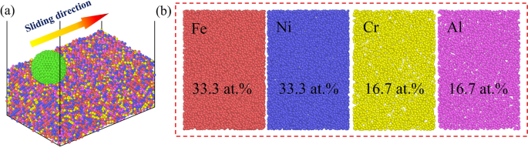
Physical model for MD simulation a 3D model b The distribution of different alloying atoms after achieving an equilibrium state
Full size image
As the understanding of nano-wear behavior is also of great importance to the nanotechnological applications, the knowledge about how MPEAs respond to nano-wear is still limited. Molecular dynamics (MD) simulation is a powerful tool to explore the wear performance in MPEAs at the nanoscale [25]. Up to now, many research works have utilized MD simulation to investigate the wear mechanism in MPEAs. For instance, the nano-tribological behavior of CrMnFeCoNi and CrFeCoNi MPEAs under different conditions was investigated by MD simulation [26]. The results showed that the wear behavior of MPEAs was significantly affected by the Bauschinger’s effect. Feng et al. [27] utilized the MD simulation to capture the correlation between mechanical properties and microstructural changes of nanocrystalline CoCrFeMnNi MPEAs under nano-wear. Zhang et al. [28] developed an improved MD model to simulate the nano-indentation and tribological tests of additively manufactured AlCoCrFe MPEAs coated on an aluminum substrate. From the simulated tribological tests, the computed wear tracks are qualitatively in agreement with experimental images. Jia et al. [29] utilized the ab initio MD simulations to distinguish the effects of structure relaxation and surface oxidation on nanoscopic wear behaviors of metallic glass. Zhou et al. [30] performed the MD simulation to reveal the effect of graphene on metallic glass, which enhanced the wear resistance during nanoscratching. Wang et al. [31] utilized MD simulation to reveal the deformation mechanism of CoCrNi alloy during nanoscratching, and Liu et al. [32] carried out the MD simulation to provide the atomistic understanding of incipient plasticity in BCC refractory HEAs. Although there are increasing reports on the mechanical properties of Fe2Ni2CrAl MPEAs, however, studies of wear behavior and related mechanisms at micro-/nanoscale have not yet been reported. Thus, it is of great importance to study the tribological response of Fe2Ni2CrAl MPEAs at small scales using MD simulation.
In this work, Fe2Ni2CrAl MPEAs were prepared, the initial microstructure, microhardness and wear resistance were characterized. The as-cast Fe2Ni2CrAl MPEAs generally form a dendrite structure consisting of FCC phase and BCC+B2 phase. Then, the nano-indentation and micro-indention were used to evaluate hardness in different scales. The wear resistance was measured by the reciprocating ball-on-flat sliding tests, and the wear behavior and mechanism were explored in depth. To reveal the atomic dynamic evolution of nano-wear, molecular dynamics (MD) simulations were conducted to provide in-depth understanding of the wear behavior. By analyzing the lattice structure, dislocation and atomic shear strain of the alloy, the materials damage and wear mechanism were revealed to facilitate the application of Fe2Ni2CrAl MPEAs.
Figure 2
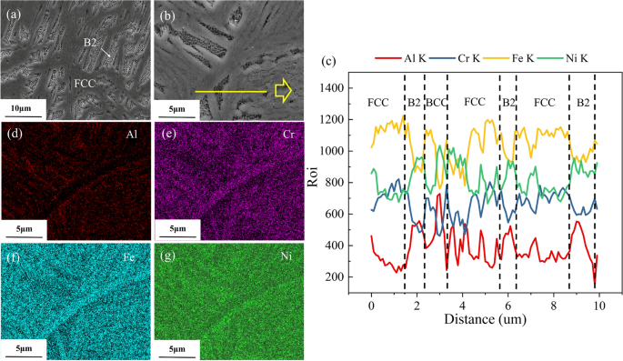
a, b Initial microstructure of Fe2Ni2CrAl MPEAs, the corresponding c EDS line results and d–g EDS mapping results
Full size image
Methodology
Experimental method
In present work, Fe2Ni2CrAl MPEAs were prepared with the nominal composition using the Fe, Cr, Ni and Al raw materials with a purity of more than 99.99% wt percent (wt.%). To avoid the oxidation, the ingot was arc melted in a high-purity argon protective atmosphere. The arc melting was repeated at least five times to ensure the chemical homogeneity. The plate samples with (10 × 10 × 6 mm³) shape were cut from the core region of the master alloy ingot. The initial microstructure was examined using scanning electron microscope (SEM). The chemical composition of the alloy was determined by the energy-dispersive X-ray spectroscopy (EDS). Prior to the examination, the sample was carefully ground with the silicon carbide sandpaper up to 2000 grit. Then, the sample was characterized by transmission electron microscope (TEM) for a further phase and structure analysis.
The Vickers microhardness was measured using HVS-1000 digital microhardness meter with an applied load of 500g and a 10s hold time. The measurement was repeated 10 times to obtain the average value. The nano-indentation tests were conducted using Nano Indenter G200 (Agilent, US). The strain rate was set as 0.05 s⁻¹ in the loading and unloading process under the continuous stiffness measurement (CSM) mode. The reciprocating wear behaviors of the alloy were tested by a reciprocating ball-on-flat sliding tribometer (CETR-UMT-3). The Al₂O₃ was utilized as the couple-pair. The wear experiment was performed under a constant normal load of 25 N with an experiment time of 30 min. The sliding speed used in this work is 10 mm/s with a friction reciprocating motion amplitude of 5mm. During the sliding process, the friction coefficient was recorded. The wear scars profile and the quantitative analysis were carried out on a three-dimensional surface topography profiler (Zeta20). The morphologies and compositions of the wear scars for the HEAs were examined by electron probe microanalysis (EPMA, JXA-8230) and EDS, respectively.
Simulation details
In this work, the MD model of Fe2Ni2CrAl MPEAs with size of 71ÅÅ × 107ÅÅ × 46ÅÅ was constructed and consisted of about 31200 atoms, as illustrated in Fig.1. Within the MD model, randomly distributed atoms accounted for (Fe:33.3 at.%, Ni: 33.3 at.%, Cr: 16.7 at.%, Al: 16.7 at.%). Large-scale Atomic/Molecular Massively Parallel Simulator (LAMMPS) [33] was used to perform MD simulations. The model assumed periodic boundary conditions along the X, Y and Z axis, corresponded to [1 0 0], [0 1 0] and [0 0 1], respectively. Interactions between metallic atoms in the HEAs were described using embedded-atom method potential [34]. To simulate the wear process, a spherical indenter with a radius of 15 ÅÅ was used as rigid object in the nano-wear simulation. The interactions between metallic atoms and rigid object were described using the Lennard-Jones (L-J) potential [35].
By using conjugate gradient algorithm, the energy of the constructed structure was minimized at first. To simulate the alloy fabrication process, the Fe2Ni2CrAl MPEAs were formed via a heating-cooling process. To achieve an equilibrium state, Canonical Ensemble (NVT) was used to set the initial temperature of the model at 300 K by Nose-Hoover hot bath method. The alloy structure was heated from room temperature to the target temperature (1500K), and then, it was cooled down to room temperature. After sufficient relaxation, the alloy model arrived at the equilibrium state. The optimal structure was acquired and the atomic distribution of different alloying elements is shown in Fig.1 (b). Subsequently, the temperature of the alloy structure was kept at room temperature for all the steps.
During the nano-wear simulation, the bottom atom layer was fixed to avoid the motion of model. The nano-wear simulation of Fe2Ni2CrAl MPEAs included two stages:
- (1)
The spherical particle indented into the model;
- (2)
The wear behavior was tested by cutting along the direction of the y axis.
The sliding velocity was 1ÅÅ/ps and scratch length denoted 70ÅÅ. For simulation results, structural analysis was carried out via Open Visualization Tool (OVITO) [36]. The wear atoms and lattice damage were analyzed by Centrosymmetry parameter (CSP) method. The dislocations generated in the nano-wear process were classified and colored using dislocation analysis (DXA) method. The displacement of atoms and atomic shear strain in the alloy were also explored in depth.
Figure 3
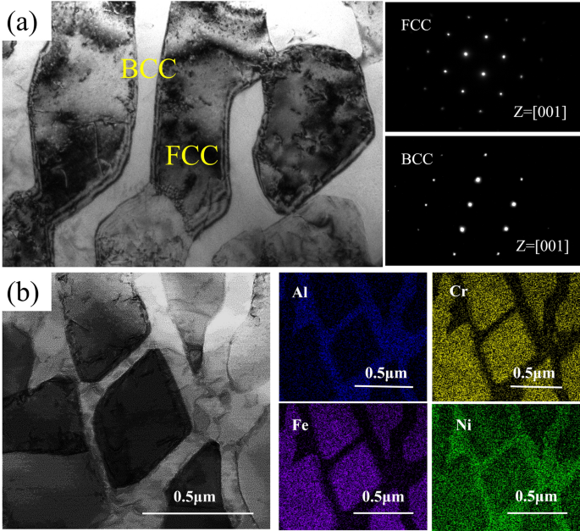
TEM analysis results of the Fe2Ni2CrAl MPEAs. a Bright field image of the microstructure and the corresponding SAED patterns of Ni-Al-rich phase and Fe-Cr-rich phase b HRTEM of the interface between B2 and BCC phases
Full size image
Results and discussion
Microstructural characterization
Figure 2 presents the initial microstructure of Fe2Ni2CrAl MPEAs and the corresponding EDS results of constituent elements consisting of the Al, Cr, Fe, Ni. As the metallographic image at low magnification illustrated in Fig. 2a, the alloy was composed of the dendrite and the inter-dendrite matrix which was differentiated by light gray and dark gray regions. This is consistent with previous reports on Fe2Ni2CrAl MPEAs. As the previous work reported [19], the Fe2Ni2CrAl alloy is composed of FCC, BCC and B2 phases. The strip-like coarse microstructure corresponds to the FCC phases and the interconnected microstructure was BCC/B2 phases. The enlarged view in Fig. 2b displays the ultrafine network-like phases corresponding to FCC+B2+BCC eutectics. Selecting a junction area, the results of linear SEM-EDS indicated that the content of Fe, Cr and Ni in the strip-like regions was remarkably higher than that in the interconnected regions. Through SEM-EDS elemental mapping, the element distribution of Fig. 1b is given in Fig. 1d–g which exhibits the inhomogeneous chemical elemental distribution in the as-cast Fe2Ni2CrAl alloy. There is no obvious defect detected in the alloy based on the SEM/EDS level. The grain boundaries (dark gray regions) are rich in Cr and Fe, while the interconnected microstructures (light gray regions) are rich in Al and Ni. In particular, the distribution of the alloying elements results in the formation of the dendrite structure in the solidification process. Fe and Cr elements give priority to form FCC phases, while more Al and Ni elements lead to the formation of ordered B2 phases.
For a further understanding on the phase structure, Fig. 3a presents the TEM bright-field images of Fe2Ni2CrAl MPEAs, as well as the corresponding selected area electron diffraction (SAED) patterns of the FCC and BCC phases. The SAED patterns indicate that an ordered B2 phase was formed in the alloy. The EDX mapping images illustrated in Fig. 1d reveals that the alloy contains both the Fe-Cr-Ni-rich FCC phase and the Ni-Al-rich BCC phase. The high melting temperature elements Fe, Cr and Ni tend to form the dendrites and are enriched in the dendritice region. Table 1 summarizes the chemical composition of each phase in the alloy. The dendritice region (region A) comprises Fe (~ 44.70 at%), Cr (~ 21.76 at%), Ni (~ 29.29 at%) and a small concentration of Al (~ 4.25 at%). The light region B consists of a large amount of Ni (~ 55.29 at%) and relatively high concentration of Al (~ 25.11 at%).
Table 1 Chemical compositions of each phase in Fe2Ni2CrAl MEAs obtained from TEM
Full size table
Nano-indentation test and wear behavior
To obtain the Vickers microhardness, indentation tests were carried out 10 times and the average value of 371.48HV was obtained. Nanohardness indents were made on the surface, and Fig. 4a presents the corresponding load-displacement (P-h) curves. Very small deviation can be observed between the three testing indents. An average nanohardness of 4.59 GPa and an average elastic modulus of 199.4 GPa were determined for the Fe2Ni2CrAl MPEAs. Since a high volume fraction of softer FCC phases was detected in the microstructure, the Fe2Ni2CrAl MPEA shows a lower hardness compared with the reported AlxCrFeNi MPEAs [17].
Along with the sliding evolution, the friction coefficient was continuously recorded. Figure 4b presents the friction coefficient of Fe2Ni2CrAl MPEAs. By sliding against the Al₂O₃ ball, the wear behavior exhibited two stages (stage 1 and stage 2). The friction coefficient increases rapidly in stage 1, in which the loss of mass began and was accompanied by wear damage in the initial contact with the friction pair. The friction coefficient mainly arose from the applied load, as well as the interaction force between the specimen surface and the friction pair. After arriving at the peak value, the friction coefficient entered a steady-state regime with irregular fluctuation as the sliding distance increases. This irregular fluctuation is mainly due to the rough tribo-faces, accumulation and elimination of the debris, as well as the formation of oxides and/or cracks during dry sliding contact. Besides, the non-uniform distribution of the soft FCC phase and the hard BCC phase also contributes to the irregular fluctuation in the value of the friction coefficient. Finally, the steady-state friction coefficients for the sample fell in the range of 0.47–0.60, and the average friction coefficient was derived as ~ 0.54.
Figure 4
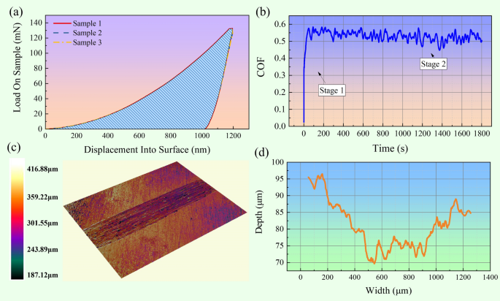
a The load–displacement (P-h) curves of Fe2Ni2CrAl MPEAs b the friction coefficient files of Fe2Ni2CrAl MPEAs c 3D-morphology of wear scar and d the wear scar profile
Full size image
To assess the wear resistance and wear mechanism, profilometry and morphology analysis of wear tracks are used to determine the wear behavior quantitatively and qualitatively. Figure 4c reveals the morphology of the wear scar characterized by a 3D surface topography profiler. A clear wear track with typical grooves can be observed on the surface. Owing to the high hardness of Al₂O₃ (~ 1845.7HV), the counter Al₂O₃ balls show better wear resistance rather than that of Fe2Ni2CrAl alloy. During sliding, the wear debris can act as polishing particles, abrasive wear also resulted in the wear on the balls. The surface of Fe2Ni2CrAl MPEAs was plowed by a diamond tip, promoting the formation of uniformly deformed grooves on the worn surface. Figure 4d presents the depth-width curve of the wear scar profile. By quantitatively analyzing the profile data, the width of wear track was found to be 996.58 μm, and the wear volume loss was 3.94 × 10⁷ μm³.
The wear process is a dynamic process which depends on many parameters, such as hardness matching, surface roughness and initial service conditions. In terms of traditional engineering metals, the wear resistance has traditionally been linked to hardness through the Archard equation, which is normally expressed as Eq. (1).
V=K×l×P/H
(1)
where K is the wear coefficient, l is the sliding distance, P is the applied load and H is the hardness. The wear volume loss (V) is inversely proportional to the hardness. The wear rate was determined as 8.72 × 10⁻⁵ mm³/(Nm) for Fe2Ni2CrAl alloy.
Figure 5 presents the EPMA images of the worn surfaces for the Fe2Ni2CrAl MPEAs under dry sliding. From Fig. 5a, the shallow and narrow grooves indicated that the Fe2Ni2CrAl MPEAs experienced mild plastic deformation during sliding. Figure 5b–e presents the surface morphology at high magnification. Due to the soft characteristic of the FCC phases, several long and deep grooves were observed along the direction of sliding, (Fig. 5b). The trapped hard wear particles result in severe cutting of the alloy surface. Some sheet-like wear debris and small particles also appeared and adhered to the worn surface, suggesting adhesive wear. From Fig. 5d and e, some delamination pits were detected on the worn surface due to the segregation of debris. The repetitive sliding results in work-hardening of the surface. Due to the shearing and pressing of the friction pair, some defects and microcracks initiate and propagate, consequently inducing materials spalling on the surface. When the wear debris was plastically deformed and compacted by the rubbing action between the slider and the flat, it can produce delamination on the worn surface. The abrasive wear and delamination wear were regarded as the main wear mechanism in this case. During the sliding process, the delamination and abrasive mechanisms have been regarded as crucial factors to produce the wear loss.
Figure 5
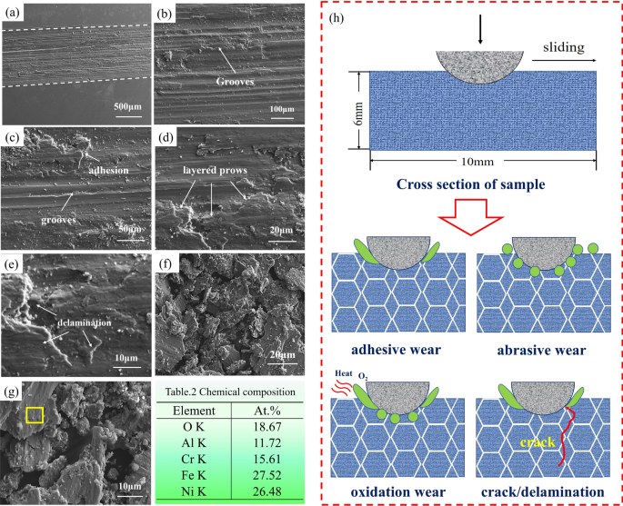
EPMA micrographs of wear tracks (a) at low magnification and b–e at high magnification; Micrographs of debris f at low magnification and g at high magnification; h The main wear mechanism; Table 2 Chemical composition of debris
Full size image
The wear debris tends to form in the plastic zones around the adhesive junctions. By collecting the wear debris after sliding, Fig.5f and g shows the morphology of the wear debris. The wear debris was characterized by the flake-like particles, produced by the delamination from the worn surface. Besides, some fine equiaxed particles were observed, and the large flake-like particles were broken into smaller particles after successive deformation and fragmentation. The fine equiaxed debris was also generated by the abrasive wear.
From the enlarged view of the wear debris, EDS analysis was conducted on the yellow rectangular region. The high concentration of O (~ 18.67 at.%) in Table 2 indicated that oxidation occurred. The interface friction heat produced in sliding leads to oxidation of the wear debris. As Fig. 5h illustrates, the main wear mechanisms of Fe2Ni2CrAl alloy show combined adhesive, abrasive and oxidation mechanisms, accompanied by cracks and delamination.
Molecular dynamics simulation
By MD simulation, scratch tests with the normal force were simulated to understand the tribology properties. The simulated wear tracks after the nano-wear are visualized using OVITO. Figure 6 presents the worn surface colored by deformations along the Z-direction after the first slide and 10th slide. From the wear track profile, our modeling results agree well with the experimental observation in wear tracks. Attributed to the force from spherical indenter, the atoms were compressed by the indenter. The nano-sliding process comprised severer spade, tearing and mechanical plowing at the atomic level, with considerable atoms protruded on the surface during the nano-wear test. The regions at both the edges of wear track possess largely deformed atoms, which is colored as red in the figure. For comparison, the surface morphology did not change greatly during the whole reciprocating friction process. The surface after the 10th slide is slightly smoother than that after the first slide.
Figure 6
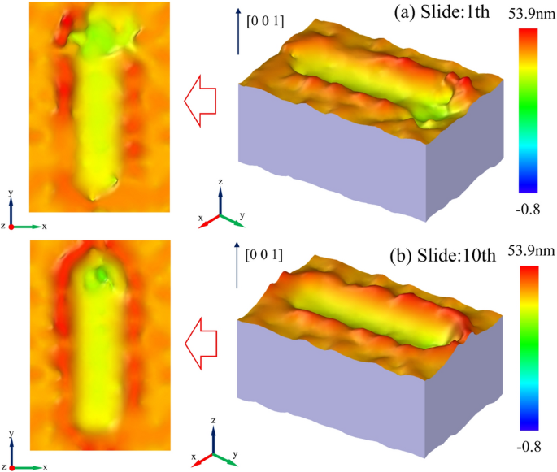
Simulated surface outline of the wear track after the nano-wear test. a After first slide b After 10th slide
Full size image
Figure 7
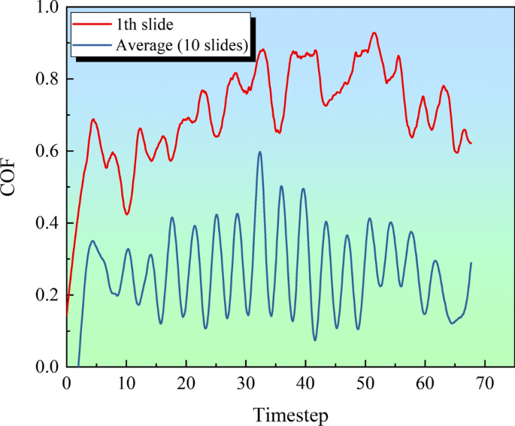
The coefficient of friction in the 1th slide and the average value among the 10 slides
Full size image
Particularly, the coefficients of friction (COF) during the nano-wear test are further analyzed. In general, the COF is calculated using the ratio of the lateral to normal forces. Figure 7 shows the evolutions of the COF in the first slide nano-wear, as well as the average value among the total 10 slides. From the plot, both the COF reach a stable stage after 5 ps. At the steady stage, the COF in the first slide nano-wear is approximately 0.7, while the average COF among the total 10 slides is only approximately 0.2, about three times less than that in the first slide. It assumes that the surface suffers severer mechanical plowing and plastic deformation during the fist slide nano-wear. After that, the reciprocating friction contributes to the surface strain hardening and enhances the wear resistance.
Figure 8 presents the MD simulation results of wear behavior for Fe2Ni2CrAl MPEAs after the first slide nano-wear. From Fig. 8a1–a4, the nano-sliding process comprised severer spade, tearing and mechanical plowing at the atomic level. Compared with macroscopic process of the wear, it is easier to peel off the atoms from a softer surface for nano-wear. Since the Fe2Ni2CrAl alloy contains high volume fraction of FCC structure, the mechanical plowing and adhesion were easily identified from the plot. Both play an important role in the wear mechanism, which is responsible for the material loss during nano-wear processes.
Figure 8b1–b4 presents the CSP value of atoms during the sliding nano-wear. It assumes that the higher CSP value indicates the severe atomic damage. As the spherical indenter is pressed into the alloy model, the atoms below the rigid ball exhibit larger CSP value, which is colored in green in Fig. 8b1. When subjected to the normal force and tangential force, the atoms on the wear track show serious lattice damage, which was colored in red in Fig. 8b2–b4. Along the sliding direction, atoms in front of the spherical indenter also show large CSP value.
As known, the adhesive force is smaller than the plowing force. The interaction between the rigid ball and the surface plays a major role in interfacial adhesion. During sliding wear under a constant normal force, the displacement of the atoms at different timesteps is plotted, Fig. 8c1–c4. Corresponding wear tracks are caused by sliding, and more atoms are removed from the original position. The atoms in the contact region exhibit a large displacement. To resist wear, less atomic displacement enables atoms to absorb more wear energy before failure. As the nano-wear proceeds, the removed atoms are stacked on both sides of the wear track.
Figure 8d1–d4 depicts the atomic shear strain distribution in the Fe2Ni2CrAl alloy during sliding as a function of time. The stress was concentrated at the contact regions before the atoms were removed from surface, resulting in large atomic strain near the contact regions. After many atoms are removed from the surface, the stress concentration becomes significant as the sliding proceeds, corresponding to a continuous increase in atomic strain. The sliding continuously increases the strain until the surface reaches the fracture strain. The region with large shear strain promotes crack initiation and propagation. In regions with smaller atomic strain, atoms approach their equilibrium positions. To break the atomic bonds, it requires more energy to be removed from the surface.
Figure 8
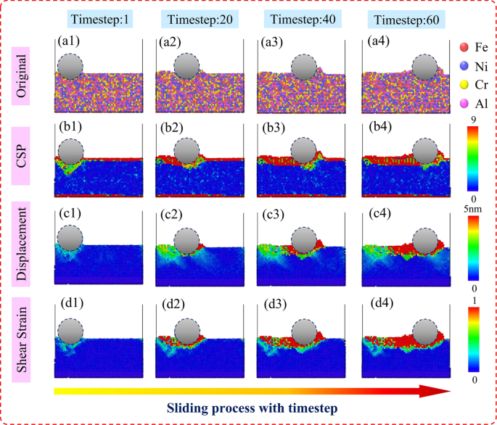
a1–a4 Original atoms distribution b1–b4 CSP value of atoms c1–c4 Displacement distribution d1–d4 Atomic shear strain distribution during the first slide nano-wear
Full size image
For a better understanding, Fig. 9 presents the lattice structure analysis diagram. By using common neighbor analysis (CNA), it can be seen that less HCP structure is formed below the spherical indenter. Different types of defects are generated in the nano-wear after the first slide, and the subsurface damage is visualized. From Fig. 9a, the stacking fault, vacancy defects, atomic cluster defects, as well as point defects, can be identified below the indentation. With the sliding, the formation of atomic cluster defects can be captured near the wear track, as shown in Fig. 9b–d. The point defects can be found during the whole nano-wear process, since the individual atoms absorb enough energy then deviate from the original position, while the stacking fault is mainly found at the initial stage of nano-wear process and disappeared in the subsequent stage. Accordingly, all types of defects have a great impact on the wear resistance of Fe2Ni2CrAl MPEAs.
Figure 9
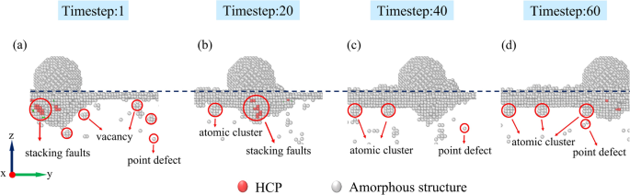
Defect generated in the first slide nano-wear at different timesteps
Full size image
To understand the plastic deformation process in the nano-wear test, dislocation analysis is carried out on the simulated wear tracks. Figure 10a1–d1 and a2–d2 plots the dislocations generated during the nano-wear along [1 0 0] and [0 1 0] direction, respectively. It can be observed that multiple types of dislocations, e.g., 1/6 < 112 > (Shockley), 1/3 < 100 > (Hirth)-type dislocations, are generated in which the indenter was applied at the initial stage of the nano-wear test, as shown in Fig. 10a1, a2, b1, b2. At the end of the nano-wear test, only 1/6 < 112 > (Shockley)-type dislocations can be identified near the indentation, as illustrated in Fig. 10d1, d2. From perspective of the whole wear track, the 1/6 < 112 > (Shockley)-type dislocation plays a dominant role in the process of nano-wear.
Figure 10
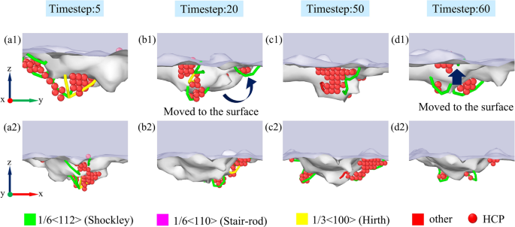
Dislocation generated in the first slide nano-wear at different timesteps
Full size image
As known, the length of dislocation plays an important role in evaluating the wear resistance of materials. According to the dislocation analysis diagram, the total length of dislocation for Fe2Ni2CrAl MPEAs during the first slide nano-wear is summarized in Fig. 11. To be noted, the total length of dislocations in Fe2Ni2CrAl MPEAs can achieve a high level at the initial stage of nano-wear process. As the sliding progresses, the length of dislocations decreases obviously until the end of nano-wear. Owing to the high-entropy effect, the sluggish dislocation movement exists in the Fe2Ni2CrAl MPEAs. The force from rigid ball can prevent the propagation of dislocation, resulting in the decreasing dislocation in the Fe2Ni2CrAl MPEAs. As Fig. 10 indicates, the dislocation lines moved to the surface and annihilated during the sliding, also leading to the decrease in the dislocation lines length.
Figure 11
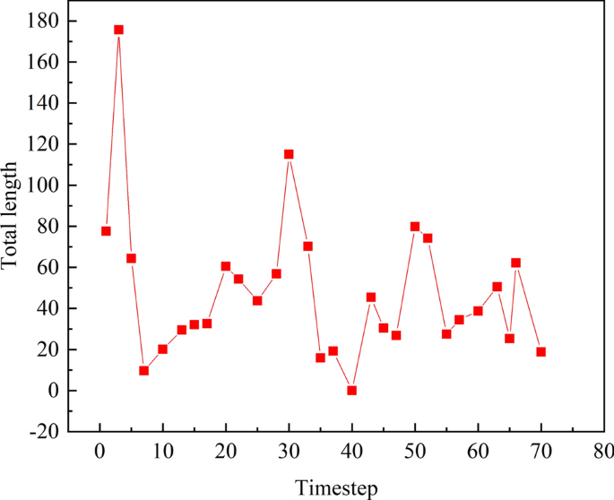
The length of dislocation for Fe2Ni2CrAl MPEAs during first slide nano-wear
Full size image
To better understand the reciprocating friction behavior, Fig. 12 presents the CSP value diagram, displacement distribution diagram and atomic shear strain distribution diagram during each slide nano-wear along [1 0 0] direction. It is of interest to notice that the atoms show large CSP value in front of indenter, as well as near the wear track area in each slide nano-wear. While, for the reciprocating sliding, the later sliding removes fewer atoms than the first slide. It assumes that the reciprocating sliding produces a more hardened surface. From Fig. 12b1, b2–b10, large deformation of atoms occurred at both ends of the wear track. The atoms near the wear track show a larger displacement after the first slide, compared to the case of later sliding. The atomic layer is easier to be peeled off from the surface in the first slide, which exhibits a softer surface. Accordingly, more plastic deformations occurred in the first slide. From the observed wear tracks, the wear volume losses are mainly generated from the first slide. According to the atomic shear strain distribution, Fig. 12c1–c10 indicates that the atoms below the indenter exhibit large shear strains, at both ends of the wear track during the reciprocating friction. Similar to the distribution of atomic displacement, the force from rigid ball produces larger shear strains to the atoms in the first slide, compared to that in the later sliding. After 10th slide, as illustrated in Fig. 12b10, c10, the atomic shear strain and deformed area decrease. The residual shear strain is primarily resulted from plastic deformation after reciprocating sliding.
Figure 12
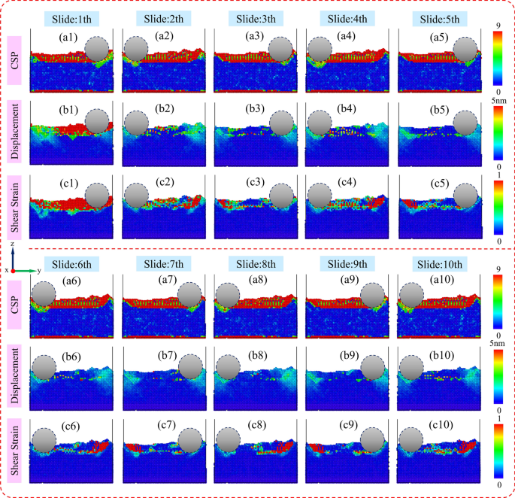
a1–a10 CSP value of atoms b1–b10 Displacement distribution c1–c10 Atomic shear strain distribution during the each slide nano-wear along [1 0 0] direction
Full size image
From the view of indentation area, Fig. 13 presents the distribution of CSP, displacement and shear strain along [0 1 0] direction. Several slides (first, fifth and ninth) are selected for in-depth analysis. The number of atoms with large CSP value is larger after the first slide by comparing Fig. 13a1–a3. It indicates severer atomic damage at the area of indentation area, and atoms are removed from the original position. As Fig. 13b1–b3 illustrated, the atoms below the indentation exhibit obviously large displacement, and a large number of atoms are piled up on both sides of the spherical balls. The shear strain distribution (Fig. 13c1–c3) also shows a similar trend that there is some shear strain at the whole interface between rigid ball and the Fe2Ni2CrAl MPEAs, and uniformly distributed at the indentation area. The shear strain is maximum at the contact area, and the large shear strain tends to induce the generation of crack. From the simulated surface outline of the wear track, as illustrated in Fig. 13d1–d3, a large number of atoms with high shear strain can be found and colored in red. During nano-wear, mechanical plowing dominates the material loss at the initial stage. As reciprocating sliding proceeds, the contribution from adhesion becomes increasingly crucial. Atoms falling off the alloy surface attached to the spherical indentor, which is colored in red, as illustrated in Fig. 13d2, d3. After several slides, the shear strain at the indentation area decreases, as shown in Fig. 13d2, d3.
Figure 13
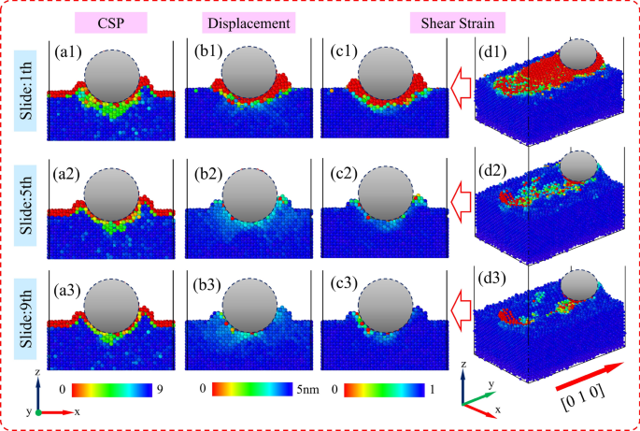
a1–a3 CSP value of atoms b1–b3 Displacement distribution c1–c3 Atomic shear strain distribution d1–d3 3D profile of atomic shear strain distribution during first, fifth and ninth slide nano-wear along [0 1 0] direction
Full size image
Figure 14
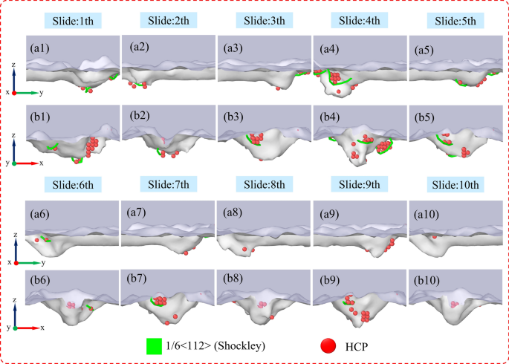
Dislocations generated during each slide nano-wear a1–a10 along [1 0 0] direction b1–b10 along [0 1 0] direction
Full size image
To better understand the reciprocating friction process, Fig. 14 captures the dislocations and HCP structures at the end of each slide nano-wear along [1 0 0] and [0 1 0] direction. From the plot, only the defect formed by1/6 < 1 1 2 > dislocation lines can be observed at the end of each slide, which were Shockley dislocation type. As Fig. 14a6–a10, b6–b10 illustrates, there are few dislocation lines after the fifth slide, indicating an obvious reduction for the dislocation network in the plastic zone. As Figs. 12 and 13 illustrate, the shear strain decreases below the indentation, which reduces the generation of dislocation to release the stress. Some remained dislocations move to the surface, resulting in the decrease in the length of the dislocation lines. To conclude, the nano-wear behavior of Fe2Ni2CrAl MPEAs is strongly associated with 1/6 < 1 1 2 > (shockley) dislocation. This study provides an insight into the wear behavior of Fe2Ni2CrAl MPEAs at nanoscale.
Conclusion
In this study, the Fe2Ni2CrAl MPEAs were prepared, and the microstructure, hardness and wear resistance were investigated and discussed. MD simulation was used to study the friction performance and wear mechanism at nanoscale. The conclusions are drawn as follows:
- (1)
The as-cast Fe2Ni2CrAl MPEAs have a dual-phase structure comprised of the FCC phase and the BCC+B2 phase. The FCC phase was rich in Fe, Cr and Ni, while the BCC based region includes the Ni-Al-rich B2 phase and the Fe-Cr-rich BCC phase.
- (2)
This alloy shows a microhardness of 371.48 HV. The nano-indentation test shows that the average nanohardness is 4.59 GPa and the average elastic modulus is 199.4 GPa.
- (3)
This alloy exhibits good wear resistance, with a wear rate of 8.72 × 10⁻⁵ mm³/(Nm). The average friction coefficient was ~ 0.54. The wear mechanisms are a mixture of adhesive, abrasive and oxidation wear, accompanied by cracks and delamination.
- (4)
MD simulation reveals the dynamic evolution of atoms in nano-wear process. During nano-wear under a constant normal force, the surface suffers severer deformation during the first slide. Different types of defects, e.g., the stacking fault, vacancy defects, atomic cluster and point defects are visualized in the nano-wear. The reciprocating friction contributes to the surface strain hardening with lower COF.
- (5)
By analyzing the atomic strain, displacement and dislocation, the large displacement and shear strain region were concentrated below the rigid ball, and the atomic damage was identified. Fewer dislocations are produced during the reciprocating friction, accompanied with the reduced atomic shear strain and lattice deterioration. The 1/6 < 112 > (Shockley)-type dislocation plays a dominant role in the whole nano-wear process.
Data availability
The data required to reproduce these findings cannot be shared at this time as the data also form part of an ongoing study.
References
- Zhang Y, Yang X, Liaw PK (2012) Alloy design and properties optimization of high-entropy alloys. JOM 64:830–838
Article CAS Google Scholar
- Yeh JW (2013) Alloy design strategies and future trends in high-entropy alloys. JOM 35(12):1759–1771
Article Google Scholar
- Yeh JW, Chen SK, Lin SJ, Gan JY, Chin TS, Shun TT, Tsau CH, Chang SY (2004) Nanostructured high-entropy alloys with multiprincipal elements-novel alloy design concepts and outcomes. Adv Eng Mater 6:299–303
Article CAS Google Scholar
- Yong Z, Ting TZ, Zhi Tang MCG, Karin AD, Peter KL, Zhao PL (2014) Microstructures and properties of high-entropy alloys. Prog Mater Sci 61:1–93
Article Google Scholar
- Qiao L, Liu Y, Zhu J (2021) A focused review on machine learning aided high-throughput methods in high entropy alloy. J Alloy Compd 877:160295
Article CAS Google Scholar
- Zhang W, Liaw PK, Zhang Y (2018) Science and technology in high-entropy alloys. Sci China Mater 61(1):2–22
Article CAS Google Scholar
- Zhang L, Zhang Y (2020) Tensile properties and impact toughness of AlCoxCrFeNi3.1-x (x = 0.4, 1) high-entropy alloys. Front Mater 2:96
Google Scholar
- Li R, Ren Z, Yuan W, He Z, Liaw PK, Ren J, Zhang Y (2021) Mechanical behaviors and precipitation transformation of the lightweight high-Zn-content Al-Zn-Li-Mg-Cu alloy. Mater Sci Eng A 802:140637
Article CAS Google Scholar
- Benbin X, Aijun Z, Jiesheng H, Junyan Z, Junhu M (2022) Enhancing mechanical properties of the boron doped Al0.2Co1.5CrFeNi1.5Ti0.5 high entropy alloy via tuning composition and microstructure. J Alloys Compd 896:162852
Article Google Scholar
- Lin D, Xi X, Li X, Jixu H, Lianyong X, Han Y, Zhang Y, Zhao L (2022) High-temperature mechanical properties of FeCoCrNi high-entropy alloys fabricated via selective laser melting. Mater Sci Eng A 832:142354
Article CAS Google Scholar
- Wang J, Shangshu W, Shu F, Liu S, Yan M, Lai Q, Lan S, Hahn H, Feng T (2020) Ultrahigh hardness with exceptional thermal stability of a nanocrystalline CoCrFeNiMn high-entropy alloy prepared by inert gas condensation. Scripta Mater 187:335–339
Article CAS Google Scholar
- Yang C, Ren C, Jia Y, Wang G, Li M, Wencong L (2022) A machine learning-based alloy design system to facilitate the rational design of high entropy alloys with enhanced hardness. Acta Mater 222:117431
Article CAS Google Scholar
- Tao Yu, Wang H, Han K, Zhang B (2022) Microstructure and wear behavior of AlCrTiNbMo high-entropy alloy coating prepared by electron beam cladding on Ti600 substrate. Vacuum 199:110928
Article Google Scholar
- Dan K, Wei W, Taoran Z, Jing G (2022) Effect of superheating on microstructure and wear resistance of Al1.8CrCuFeNi2 high-entropy alloy. Mater Lett 311:131613
Article Google Scholar
- Bo W, Zhao Y, Ali H, Chen R, Chen H, Wen J, Liu Y, Liu L, Yang K, Zhang L, He Z, Yao Q, Zhang H, Sa B, Cuilian Wen Yu, Qiu HX, Maohua Lin Yu, Liu CW, Hang S (2022) A reasonable approach to describe the atom distributions and configurational entropy in high entropy alloys based on site preference. Intermetallics 144:107489
Article Google Scholar
- Qiao L, Aorigele ZL, Jingchuan Z (2020) A promising new class of multi-component alloys with exceptional mechanical properties. J Alloy Compd 847:155929
Article CAS Google Scholar
- Qiao L, Ramanujan RV, Zhu J (2022) Effect of aluminum on the friction and wear behavior of Al x CrFeNi medium-entropy alloys. Adv Eng Mater 3:2101475
Article Google Scholar
- Jumaev E, Muhammad AA, Sang CM, Gian S, Soon-Jik H, Ki BK (2021) Nano-scale structural evolution of quaternary AlCrFeNi based high entropy alloys by the addition of specific minor elements and its effect on mechanical characteristics. J Alloy Compd 868:159217
Article CAS Google Scholar
- Dong Y, Gao X, Yiping L, Wang T, Li T (2016) A multi-component AlCrFe2Ni2 alloy with excellent mechanical properties. Mater Lett 169:62–64
Article CAS Google Scholar
- Liu X, Ding H, Huang Y, Bai X, Zhang Q, Zhang H, Langdon TG, Cui J (2021) Evidence for a phase transition in an AlCrFe2Ni2 high entropy alloy processed by high-pressure torsion. J Alloy Compd 867:159063
Article CAS Google Scholar
- Jien-Min W, Lin S-J, Yeh J-W, Chen S-K, Huang Y-S, Chen H-C (2006) Adhesive wear behavior of AlxCoCrCuFeNi high-entropy alloys as a function of aluminum content. Wear 261(5–6):513–519
Google Scholar
- Ming-Hao C, Ming-Hung T, Woei-Ren W, Su-Jien L, Jien-Wei Y (2011) Microstructure and wear behavior of AlxCo1.5CrFeNi1.5Tiy high-entropy alloys. Acta Materialia 59(16):6308–6317
Article Google Scholar
- Xiao J-K, Tan H, Chen J, Martini A, Zhang C (2020) Effect of carbon content on microstructure, hardness and wear resistance of CoCrFeMnNiCx high-entropy alloys. J Alloy Compd 847:156533
Article CAS Google Scholar
- Luo D, Zhou Q, Ye W, Ren Y, Greiner C, He Y, Wang H (2021) Design and characterization of self-lubricating refractory high entropy alloy-based multilayered films. ACS Appl Mater Interfaces 13(46):55712–55725
Article CAS Google Scholar
- Li X, Zhang R, Liu Z, Yifan P (2022) Molecular dynamics study on friction of the iron-aluminum alloy. Mater Today Commun 33:104402
Article CAS Google Scholar
- Yunqing T, Li DY (2021) Nano-tribological behavior of high-entropy alloys CrMnFeCoNi and CrFeCoNi under different conditions: a molecular dynamics study. Wear 476:203583
Article Google Scholar
- Qi Y, He T, Heming X, Yandong H, Wang M, Feng M (2021) Effects of microstructure and temperature on the mechanical properties of nanocrystalline CoCrFeMnNi high entropy alloy under nanoscratching using molecular dynamics simulation. J Alloy Compd 871:159516
Article CAS Google Scholar
- Chen K-T, Wei T-J, Li G-C, Chen M-Y, Chen Y-S, Chang S-W, Yen H-W, Chen C-S (2021) Mechanical properties and deformation mechanisms in CoCrFeMnNi high entropy alloys: a molecular dynamics study. Mater Chem Phys 271:124912
Article CAS Google Scholar
- Jia Q, He W, Hua D, Zhou Q, Yin D, Ren Y, Zhibin L, Wang H, Zhou F, Wang J (2022) Effects of structure relaxation and surface oxidation on nanoscopic wear behaviors of metallic glass. Acta Mater 232:117934
Article CAS Google Scholar
- Zhou Q, Luo D, Hua D et al (2022) Design and characterization of metallic glass/graphene multilayer with excellent nanowear properties. Friction 10:1913–1926
Article CAS Google Scholar
- Wang W, Hua D, Luo D, Zhou Q, Li S, Shi J, Wang H (2022) Molecular dynamics simulation of deformation mechanism of CoCrNi medium entropy alloy during nanoscratching. Comput Mater Sci 203:111085
Article CAS Google Scholar
- Liu X, Hua D, Wang W, Zhou Q, Li S, Shi J, He Y, Wang H (2022) Atomistic understanding of incipient plasticity in BCC refractory high entropy alloys. J Alloy Compd 920:166058
Article CAS Google Scholar
- Plimpton S (1995) Fast Parallel algorithms for short-range molecular dynamics. J Comput Phys 117:1–19
Article CAS Google Scholar
- Farkas D, Caro A (2020) Model interatomic potentials for Fe-Ni-Cr-Co-Al high-entropy alloys. J Mater Res 35:3031–3040
Article CAS Google Scholar
- Jones JE (1924) On the determination of molecular fields. I. From the equation of state of a gas. In: Proceedings of the Royal Society of London. Series A, Containing Papers of a Mathematical and Physical Character, vol 106, pp 463–477
- Stukowski A (2009) Visualization and analysis of atomistic simulation data with OVITO-the open visualization tool model. Simulat Mater Sci Eng 2:18

Acknowledgements
This work is supported by AME Programmatic Fund by the Agency for Science, Technology and Research, Singapore under Grants No. A1898b0043 and A18B1b0061 and the China Scholarship Council.
Author information
Authors and Affiliations
- School of Materials Science and Engineering, Harbin Institute of Technology, Harbin, 150001, Heilongjiang, China
Ling Qiao & Jingchuan Zhu
- School of Materials Science and Engineering, Nanyang Technological University, 50 Nanyang Avenue, 639798, Singapore City, Singapore
Ling Qiao & R V. Ramanujan
Corresponding authors
Correspondence to R V. Ramanujan or Jingchuan Zhu.

