Long-whisker type TiB phase introduced by micron-sized precursors and its prominent strengthening effect in titanium matrix composites

Qiang Li^{a,b}, Yu Chenª, Xiaoyu Huangª, Yiran Wangª, Yakai Zhao^{b,*}, Upadrasta Ramamurty^{b,c}, Yimin Gao^{a,*}

ªState Key Laboratory for Mechanical Behavior of Materials, School of Materials Science and Engineering, Xi’an Jiaotong University, Xi’an 710049, People’s Republic of China
^{b}School of Mechanical and Aerospace Engineering, Nanyang Technological University, Singapore 639798, Republic of Singapore
^{c}Institute of Materials Research Engineering, Agency for Science, Technology and Research, Singapore 138634, Republic of Singapore

*Corresponding author: ymgao@xjtu.edu.cn (Y. Gao), yakai.zhao@ntu.edu.sg (Y. Zhao)

Abstract
We developed a new strategy to obtain long whisker (LW) TiB phase (aspect ratio as high as ~150) using micron-sized AlB₂ in a series of TiB/Ti(Al) composites. While three types of TiB phases were present in the composites, microhardness and compression results show that LW-type TiB enhances yield strength dramatically.

Keywords: Titanium matrix composites; long whisker; strengthening mechanism; titanium boride.

Introduction
Titanium and its alloys are an important family of structural materials. To further enhance their specific stiffness and strength, especially at service temperatures of 600–800 ℃, Ti matrix composites (TMCs) are widely explored [1-3]. Among the various reinforcements considered, TiB is one of the most suitable candidates, because of its high elastic modulus and thermal stability, and similarity of its thermal expansion coefficient and Poisson’s ratio with those of pure Ti [4-6]. Several strategies are being explored for further enhancing the strength of TiB/TMCs. These include the utilization of different reinforcement geometries, tailoring of novel microstructures, and introducing more strengthening phases[7, 8]. For instance, a network-like microstructure in TiB/TMCs, where the TiB whiskers surround the matrix phase in a network-like manner, was shown to offer better mechanical performance than that where the TiB phase is uniformly distributed [9, 10]. The introduction of TiB whiskers with a high aspect ratio, λ, into the Ti matrix, to enhance the load-transfer between them, has been shown to be another effective strategy to increase the strength considerably [11, 12]. This can be accomplished by reducing the initial size of the boron precursors to nanoscale. It, however, requires a lengthy and tedious ball milling procedure [7, 12]. To circumvent this problem, we examine in this study the possibility of introducing long whisker TiB reinforcements with high λ into the network-like structured TMCs using micron-sized B precursor. By tailoring the type and content of the B precursor, TMCs were successfully synthesized, and the mechanical behavior and underlying strengthening mechanism are investigated.

Experimental
In this study, aluminum diboride (AlB₂, ~1–5 μm) was selected as the B precursor, as it can introduce B and Al into the alloy simultaneously, such that both the dispersoid strengthening from the TiB phase and the solid solution (SS) strengthening of the matrix by Al can be exploited. More specifically, by taking the commercially pure Ti (CP-Ti) as the matrix, the following reaction in the Ti-AlB₂ system is expected to occur in-situ during sintering at elevated temperature:
$\text{2Ti+}{\text{AlB}}_{\text{2}}\text{ →2TiB+2}\left[\text{Al}\right]$. (1)
Guided by the above equation, TiB/Ti(Al) composites with different TiB volume fractions, V_{TiB}, were designed, and the estimated weight fractions of B and Al are listed in Table 1. To obtain network-like microstructures, the following two-step synthesis approach was utilized [13]. First, AlB₂ powders and spherical Ti powders (details of the powders are provided in Fig. S1 of the supplementary material) in the designated proportions were low-energy ball milled using agate grinding balls in stainless-steel jars under a pure argon atmosphere in a planetary ball mill. The rotational speed, milling time, and ball-to-powder ratio employed were 150 rpm, 8 h, and 5:1, respectively. The mixed powders were then poured into columniform graphite molds (diameter Ф = 45 mm) and reaction-sintered by a hot-press sintering system under high vacuum conditions (10⁻³ Pa). For sintering, the powders were first pre-heated to 250 ℃ and held for 30 min to remove the moisture and any gas that may be present between the powders or graphite molds. The powders were then heated to 1200 ℃ and held for 60 min under 20 MPa pressure.

Table 1 Predesigned volume fractions (in vol.%) of TiB and weight fractions (in wt.%) of B and Al.
Sample designation | Volume fraction of TiB phase (vol.%) | Weight fraction of B (wt.%) | Weight fraction of Al (wt.%) | Ti
S0 | 0 | 0 | 0 | Bal.
S2 | 2 | 0.38 | 0.47 | Bal.
S4 | 4 | 0.78 | 0.96 | Bal.
S6 | 6 | 1.16 | 1.45 | Bal.
S8 | 8 | 1.67 | 1.96 | Bal.
S10 | 10 | 1.99 | 2.48 | Bal.

For microstructural analyses, the polished samples were etched with the Kroll's reagent (5 vol.% HF + 10 vol.% HNO₃ + 85 vol.% H₂O) for 10 s, and then characterized by X-ray diffraction (XRD; Bruker D8 ADVANCE) and scanning electron microscopy (SEM; ZEISS Gemini SEM 500). Microhardness of the fabricated composites was measured using a Vickers hardness tester (HXD 1000) with 50 gf load (at least 10 tests performed on each sample). Room temperature compression tests were conducted on 5 mm diameter cylinders (13 mm in height) using a universal testing machine (MTS CMT5305) at a constant crosshead speed of 0.5 mm/min. At least three samples were tested for each case.

Results and discussion
Fig. 1a shows the XRD patterns of all the composite samples examined in this work. The AlB₂ phase could not be detected in any of them, indicating the complete dissolution of it. Only the hexagonal close-packed (hcp) α-Ti phase was detected in the S0 sample, while diffraction peaks corresponding to both α-Ti and orthorhombic TiB phases were found in the composite samples (S2 to S10). The fact that Al is dissolved within the Ti matrix with no intermetallic formation (also see Fig. S2) agrees well with the literature [14] that Al can be completely dissolved in Ti without Ti₃Al phase formation if the Al content is less than 8 wt.% (always ≤2.5 wt.% in this study).
Figs. 1b to f show the representative SEM micrographs of S2, S4, S6, S8, and S10 composites. As seen in Fig. 1b, a network-like microstructure forms in S2, with the average network size close to the diameter of CP-Ti powder (~100 μm). This indicates that the network boundaries (NBs) originate from the particle interfaces where the AlB₂ particles adhere during ball milling [15]. In addition, most TiB whiskers are observed at NBs, while only a small fraction of them are located in the network interiors (NIs), which may have been caused by the low diffusion coefficient of B in Ti (e.g. 9.11$\text{×}$10⁻¹² m²/s in α-Ti at 1033 K) [16]. As seen from Figs. 1b and 1c, the grain boundaries (GBs) and NBs are not equivalent and do not overlap (See Fig. S3). In the S2–S8 composites (Fig. 1b–e), a quasi-continuous network of NB TiB is observed, but the average space between them decreases due to the substantial increase in the total V_{TiB} (see the detailed statistics in Fig. S4). In S10 sample (Fig. 1f), a new type of reinforcement phase with a high λ, referred to as ‘long-whisker’ (LW) type hereafter, also appears. This is in addition to the formation of a more continuous NB TiB, which is due to the further increase in V_{TiB}.
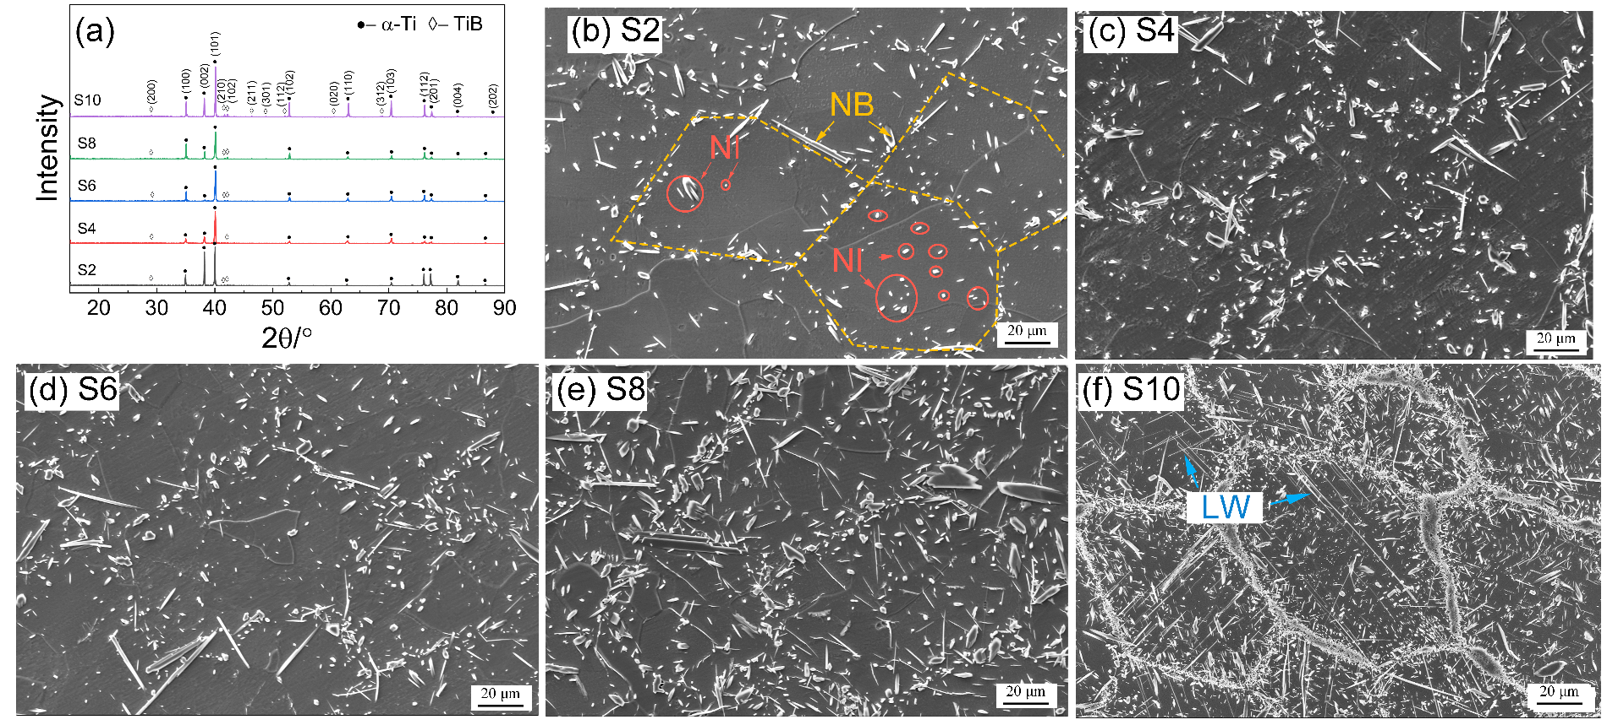
Fig. 1 (a) XRD patterns of the composites. SEM micrographs of (b) S2, (c) S4, (d) S6, (e) S8, and (f) S10 samples. (NB and NI refer to TiB located at the network boundaries and interiors, respectively. LW: long whiskers.)

High-magnification images of the three types of reinforcements (NB, NI, and LW) in the S10 composite are displayed in Fig. 2. Corresponding energy-dispersive X-ray spectroscopy (EDS) point scan results obtained from the points marked in Figs. 2e–2g are listed in Table 3. The stoichiometry of these three types of reinforcements (TiB_{1.2}, TiB_{0.8}, and TiB_{1.0}) indicates that all of them correspond to TiB.
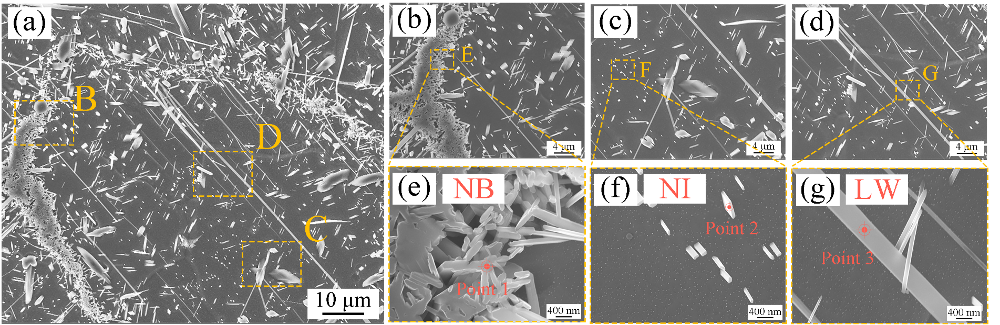
Fig. 2 High-magnification SEM images of S10 TMC with three types of TiB: (a) a typical reinforcement network cell; (b to d) representative images of NB-, Ni-, and LW-type TiB phases, with corresponding zoom-in views in (e to g), respectively. EDS were performed on three points as marked in (e–g), with the corresponding results listed in Table 2.

Table 2 EDS point chemical microanalyses results in Fig.4
 |  | B | Ti | Total | Stoichiometry
Point 1 | Wt.% | 21.28 | 78.72 | 100.00 | TiB_{1.2}
Point 1 | At.% | 54.49 | 45.51 | 100.00 | TiB_{1.2}
Point 2 | Wt.% | 14.92 | 85.08 | 100.00 | TiB_{0.8}
Point 2 | At.% | 43.73 | 56.27 | 100.00 | TiB_{0.8}
Point 3 | Wt.% | 18.08 | 80.41 | 100.00 | TiB_{1.0}
Point 3 | At.% | 49.09 | 49.27 | 100.00 | TiB_{1.0}

The LW TiB in S10 TMC was further investigated using TEM. Representative bright-field images and selected area electron diffraction (SAED) pattern are shown in Figs. 3a to c. Due to the similar coefficients of thermal expansion (CTEs) of TiB and α-Ti (CTE_{Ti} = 9 × 10⁻⁶ K⁻¹ and CTE_{TiB} = 8.6 × 10⁻⁶ K⁻¹ [17]), similar densities (ρ_{Ti} = 4.57 g/cm³ and ρ_{TiB} = 4.56 g/cm³ [6]), and the low lattice mismatch between them (< 3.6% [6]), the interface between the TiB and α-Ti is sharp (as shown in Fig. 3b). The SAED patterns demonstrate a crystallographic relationship between the LW TiB and α-Ti as (001)_{TiB} // (1-210)_{α-Ti}, which is consistent with that reported in the literature [18]. Figs. 3d to h show the bright-field image, SAED pattern, and EDS maps, respectively, of NI TiB. The SAED and EDS results are consistent with the SEM results and confirm that all the reinforcements are indeed TiB.
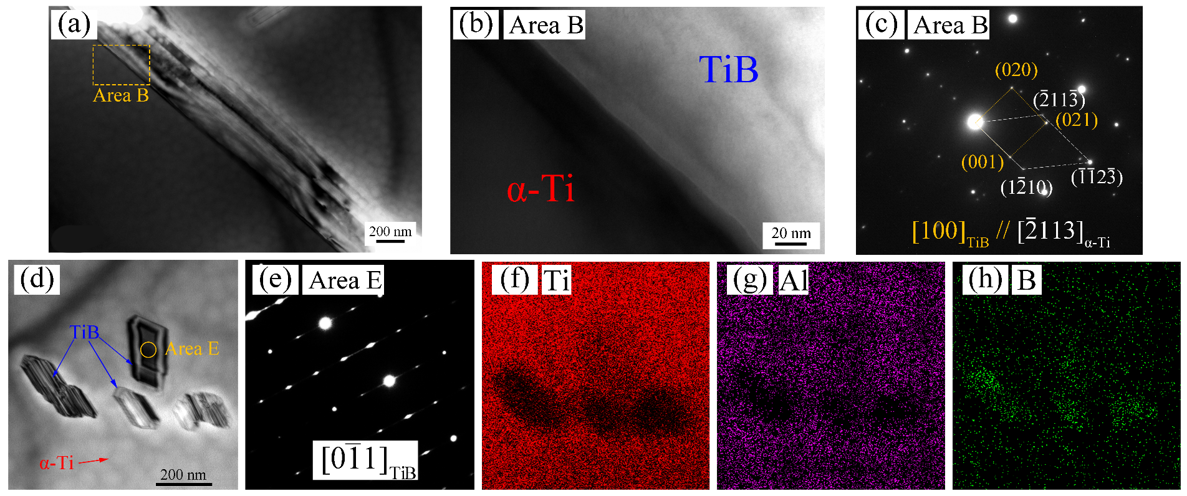
Fig. 3 (a) Bright-field TEM image of LW-type TiB. (b) Higher magnification image of the interface between α-Ti and LWs-type TiB in area B. (c) SAED pattern of the interface for area B. (d) Bright-field TEM image of NI-type TiB and(e) the corresponding SAED pattern for area E. (f–h) EDS maps of the area shown in (d).

Results of the Vickers hardness tests performed only on the matrix regions (avoiding any TiB phase on the surface, despite the possibility that there might be some NI TiB underneath the indent) of different samples are displayed in Fig. 4a along with the Al content in the α-Ti matrix (measured by SEM-EDS). With an increase in the Al content (from 0 to 2.5 wt.%), the microhardness of the α-Ti matrix increases (by 145% in the composite with 2.5 wt.% Al), indicating substantial SS strengthening caused by Al.
Fig. 4b shows the representative compressive stress-strain responses. Similar to that seen with HV, the strength of composites continuously increases with the addition of AlB₂. While this strength enhancement appears to be offset by a continuous reduction in the strain-to-failure, not much can be read into them as these are compression test results. Therefore, we focus only on the yield strength, σ_{y}. Variations of σ_{y} and Vickers hardness with Al wt.% are plotted in Fig. 4c. Both the hardness and σ_{y} show consistent linear relationships with Al concentration till ~2.0 wt.% (S8 sample). A further increase in the Al content to ~2.5 wt.% in the S10 sample leads to an abrupt increase in σ_{y} whereas the hardness value still falls in the linear relationship. Note that the Vickers hardness was measured for the matrix only, but the σ_{y} reflects the overall mechanical property of the composite.
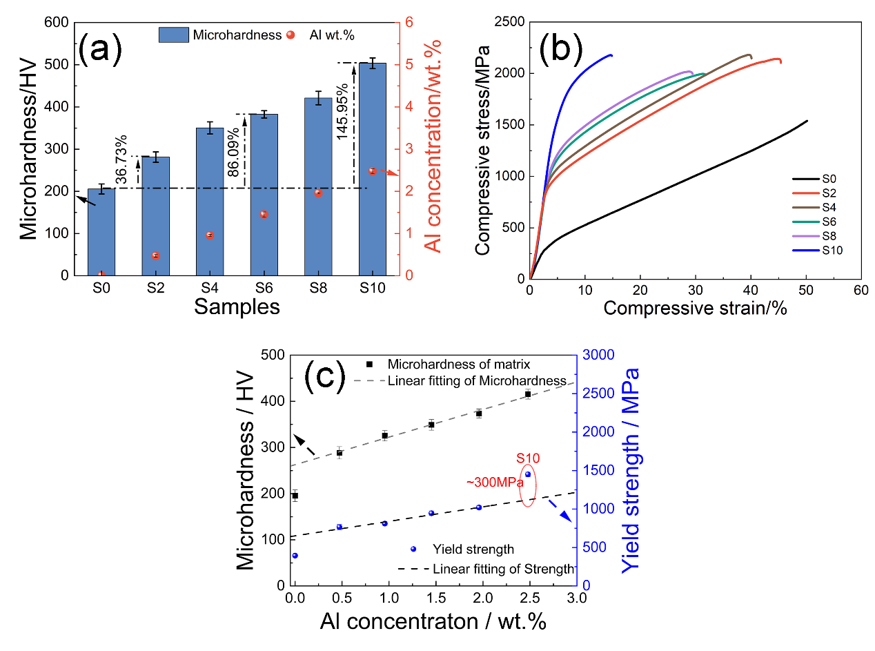
Fig. 4 (a) Microhardness and Al wt.% of the α-Ti matrix in all samples. (b) Compressive stress-strain responses of the composites. (c) Variations of the microhardness and the compressive yield strength with the Al concentration. Note that Vickers hardness was measured for only α-Ti matrix area (without TiB).

The contributions of different strengthening mechanisms to the yield strength of composites are discussed below, with a focus on the potential mechanism(s) for the abrupt strengthening in S10 sample. The following mechanisms are considered: (1) Hall–Petch strengthening ($∆σ_{H-P}$) due to the grain refinement, (2) SS strengthening ($∆σ_{ss}$) by the alloying elements, and (3) dispersoid strengthening ($∆σ_{disper}$) caused by reinforcements [19-22].
The average grain size decreases markedly (from ~150 to ~60 μm in S0 and S2, respectively) first, but does not change significantly thereafter (ranging between ~45 and 60 μm in S2–S10; see Fig. S5). Additionally, the slope of σ_{y} vs d^{-0.5} data in Ti and its alloys is rather shallow [23]. Therefore, $∆σ_{H-P}$’s contribution to the overall strengthening observed among the composite samples can be considered relatively insignificant. SS strengthening caused by the dissolved Al in α-Ti matrix is possibly the main reason for the substantial increase in hardness and strength observed in S2 sample vis-à-vis those in the S0 sample. Since the microhardness of the α-Ti matrix varies linearly with the Al content in composite samples, the observed abrupt increase in σ_{y} of the S10 sample (vis-à-vis σ_{y} of S9) cannot be due to SS strengthening.
Dispersion strengthening from the reinforcements in MMCs usually relies on the following three sources. (a) CTE mismatch ($∆σ_{CTE}$), (b) Orowan strengthening ($∆σ_{Orowan}$), and (c) load-transfer mechanism ($∆σ_{LT}$) [19, 22, 24]. Due to the similarity in the CTE values and clean interfaces between TiB and α-Ti, $∆σ_{CTE}$ would be negligible [6]. $∆σ_{Orowan}$can also be neglected as Orowan strengthening applies only when the reinforcements are nano-sized and can cause the dislocations to bow/loop around them [25]. Therefore, only $∆σ_{LT }$ from the TiB phases is likely to be predominant and is considered for the quantitative estimation the strength of the composites in the present work. For this, a modified generalized shear-lag model for estimating $∆σ_{LT}$ caused by randomly distributed cylindrical reinforcements is considered [11, 20]. According to it,
$∆σ_{LT} = 0.5 σ_{m}S_{eff} V_{Loc}$ where (2)
$S_{eff}=\int_{0}^{π/2}{ [\cos^{2}{θ}+\left(\frac{3π-4}{3π}\right)\left(1+\frac{1}{S}\right)\sin^{2}{θ}}S]d_{θ}$ and (3)
$V_{Loc}=\frac{1}{1-{(1-L/R)}^{3}} V_{n}$. (4)
In the above equations, $σ_{m}$ is the yield strength of the matrix, $S_{eff}$is the average effective aspect ratio, $V_{Loc}$ is the local volume fraction of TiB, $V_{n}$ is the nominal volume fraction of TiB, and L and R are the thickness and radius of the network, respectively. Eqn. (2) indicates that $∆σ_{LT}$ is directly proportional to the volume fraction and the aspect ratio of the reinforcements. While the volume fraction of NB-type TiB continuously increases in S2–S10 samples, the aspect ratio is always ~7–8 (see Table S2). Therefore, it cannot rationalize the abrupt increase in σ_{y} observed in S10. Indeed, estimates of $∆σ_{LT}$, induced by NBs in S8 and S10 samples using Eqns. (2–4), result in 234.9 and 305.9 MPa, respectively. The difference between them (91.0 MPa) is significantly lower than ~300 MPa measured experimentally. Therefore, it can be inferred that the abrupt strengthening observed in the S10 sample is caused by the LW-type TiB for the following reasons. (a) It possesses a high aspect ratio. (b) While V_{TiB} increases gradually from S2 to S8, LW TiB appears only in S10. The average aspect ratio of it is ~150 (45 μm / 0.3 μm, see the statistics in Table S2) and the volume fraction is ~1.5 vol%. Taking $σ_{m}$ as 394.8 MPa (σ_{y} of S0 sample), and the thickness and radius of the network as 15 and 100 μm, respectively, the strengthening contribution of the LW-type TiB, estimated using Eqns. 2 to 4, is 350.2 MPa. This estimate is in reasonable agreement with the experimentally observed difference in σ_{y} of S8 and S10 samples. Therefore, it appears that the sudden enhancement in strength in S10 composite is due to the presence of the LW-type TiB phase in it.
In prior studies on TMCs [7, 12], TiB phase with high λ (like the LW-type observed in this study) can only be introduced into the Ti matrix by using nano-sized B precursors. For example, even adding 20 wt.% TiB₂, a widely used B precursor, does not result in LW formation. TiB with an aspect ratio of ~58 was obtained only by substantially decreasing the size of TiB₂ to below ~100 nm [12, 26]. However, in this study, LW-type TiB (with very high aspect ratio as high as ~150) formed—rather unexpectedly—by merely increasing the content of different B precursors (AlB₂ in this work). The possible mechanism for the formation of this LW-type TiB is the following. When the in-situ reaction between pure Ti and AlB₂ occurs during sintering, Al atoms diffuse from the surface of the Ti powders into the core, accompanied by the TiB formation. More AlB₂ addition leads to higher chemical potential gradient, which results in a higher driving force of diffusion, and thus longer Al diffusion path. This may also accelerate the diffusion of B atoms despite the quick bonding between B and Ti atoms. In short, the formation of the LW-type TiB may be caused by the rapid and massive diffusion of Al during sintering. Further studies to understand its formation mechanism in detail are still necessary, and the focus on the type of B precursors and the B diffusivity are required based on this work.

Summary
In summary, a series of TiB/Ti(Al) composites were designed and manufactured, so as to exploit the composite strengthening from both the network-like TiB and the SS strengthening from the Al dissolved in Ti matrix. Microstructural characterization showed that there are three types of TiB phases in the composites, viz. NB-type (along network boundaries), NI-type (formed in network inside), and LW-type (with high aspect ratio of ~150). Microhardness and compression tests results show that both the SS strengthening by Al solutes and the composite strengthening by NB (and NI) TiB result in substantial strengthening. The LW-type TiB, due to its high aspect ratio, when present causes a marked enhancement in the yield strength. Our results demonstrate a novel design methodology to introduce long-whisker type reinforcement for high strengthening efficiency without utilizing nano-sized powders.

Acknowledgements
The authors would like to acknowledge the financial support from the National Key Research and Development Program of China (2021YFB3701204), the Key-Area Research and Development Program of Guangdong Province (2019B010942001), the Natural Science Basic Research Program of Shaanxi (2021JM-011), and China Scholarship Council (CSC). The work at Nanyang Technological University was supported by Agency for Science, Technology and Research (A*STAR) of Singapore via the Structural Metal Alloys Programme (No. A18B1b0061).

Data availability
The data that support the findings of this study are available from the corresponding author on reasonable request.

References

[1] X.S. Zhang, Y.J. Chen, J.L. Hu, Recent advances in the development of aerospace materials, Prog Aerosp Sci. 97 (2018) 22-34.http://dx.doi.org/10.1016/j.paerosci.2018.01.001
[2] M.D. Hayat, H. Singh, Z. He, P. Cao, Titanium metal matrix composites: An overview, Compos. Pt. A-Appl. Sci. Manuf. 121 (2019) 418-438.http://dx.doi.org/10.1016/j.compositesa.2019.04.005
[3] X. Huang, Y. Gao, Q. Li, Y. Jian, P. Xiao, B. Li, Y. Wang, Y. Yi, S. Zhao, Effect of Si element on improving the oxidation resistance of hybrid (Ti5Si3 + TiC) particles reinforced Ti6Al4V matrix composites, Corros. Sci. 181 (2021) 109235.http://dx.doi.org/10.1016/j.corsci.2021.109235
[4] K. Morsi, V.V. Patel, Processing and properties of titanium-titanium boride (TiBw) matrix composites - a review, J. Mater. Sci. 42(6) (2007) 2037-2047.http://dx.doi.org/10.1007/s10853-006-0776-2
[5] L. Geng, L.J. Huang, High Temperature Properties of Discontinuously Reinforced Titanium Matrix Composites: A Review, Acta Metall. Sin.-Engl. Lett. 27(5) (2014) 787-797.http://dx.doi.org/10.1007/s40195-014-0155-y
[6] G. Singh, U. Ramamurty, Boron modified titanium alloys, Prog Mater Sci. 111(2020) (2020) 100653.http://dx.doi.org/10.1016/j.pmatsci.2020.100653
[7] S.D. Luo, T.T. Song, B. Liu, J. Tian, M. Qian, Recent Advances in the Design and Fabrication of Strong and Ductile (Tensile) Titanium Metal Matrix Composites, Adv Eng Mater. 21(7) (2019).http://dx.doi.org/ARTN 1801331
10.1002/adem.201801331
[8] P. Kumar, O. Prakash, U. Ramamurty, Micro-and meso-structures and their influence on mechanical properties of selectively laser melted Ti-6Al-4V, Acta Mater. 154 (2018) 246-260.http://dx.doi.org/10.1016/j.actamat.2018.05.044
[9] L.J. Huang, L. Geng, A.B. Li, F.Y. Yang, H.X. Peng, In situ TiBw/Ti-6Al-4V composites with novel reinforcement architecture fabricated by reaction hot pressing, Scr. Mater. 60(11) (2009) 996-999.http://dx.doi.org/10.1016/j.scriptamat.2009.02.032
[10] L.J. Huang, Y.Z. Zhang, B.X. Liu, X.Q. Song, L. Geng, L.Z. Wu, Superplastic tensile characteristics of in situ TiBw/Ti6Al4V composites with novel network microstructure, Mat Sci Eng a-Struct. 581 (2013) 128-132.http://dx.doi.org/10.1016/j.msea.2013.05.076
[11] L.Q. Huang, L.H. Wang, M. Qian, J. Zou, High tensile-strength and ductile titanium matrix composites strengthened by TiB nanowires, Scr. Mater. 141 (2017) 133-137.http://dx.doi.org/10.1016/j.scriptamat.2017.08.007
[12] M.Y. Koo, J.S. Park, M.K. Park, K.T. Kim, S.H. Hong, Effect of aspect ratios of in situ formed TiB whiskers on the mechanical properties of TiBw/Ti–6Al–4V composites, Scr. Mater. 66(7) (2012) 487-490.http://dx.doi.org/10.1016/j.scriptamat.2011.12.024
[13] X.Y. Huang, Y.M. Gao, Z.P. Wang, Y.L. Yi, Y.R. Wang, Microstructure, mechanical properties and strengthening mechanisms of in-situ prepared (Ti5Si3 + TiC0.67)/TC4 composites, J. Alloys Compd. 792 (2019) 907-917.http://dx.doi.org/10.1016/j.jallcom.2019.04.056
[14] Y. Mishin, C. Herzig, Diffusion in the Ti-Al system, Acta Mater. 48(3) (2000) 589-623.http://dx.doi.org/Doi 10.1016/S1359-6454(99)00400-0
[15] L.J. Huang, L. Geng, H.X. Peng, In situ (TiBw + TiCp)/Ti6Al4V composites with a network reinforcement distribution, Mat Sci Eng a-Struct. 527(24-25) (2010) 6723-6727.http://dx.doi.org/10.1016/j.msea.2010.07.025
[16] S.V. Divinski, F. Hisker, T. Wilger, M. Friesel, C. Herzig, Tracer diffusion of boron in α-Ti and γ-TiAl, Intermetallics. 16(2) (2008) 148-155.http://dx.doi.org/10.1016/j.intermet.2007.08.008
[17] K.S. Ravi Chandran, K.B. Panda, S.S. Sahay, TiBw-reinforced Ti composites: Processing, properties, application prospects, and research needs, JOM. 56(5) (2004) 42-48.http://dx.doi.org/10.1007/s11837-004-0127-1
[18] D. Hill, R. Banerjee, D. Huber, J. Tiley, H.L. Fraser, Formation of equiaxed alpha in TiB reinforced Ti alloy composites, Scr. Mater. 52(5) (2005) 387-392.http://dx.doi.org/10.1016/j.scriptamat.2004.10.019
[19] M.Y. Zhou, L.B. Ren, L.L. Fan, Y.W.X. Zhang, T.H. Lu, G.F. Quan, M. Gupta, Progress in research on hybrid metal matrix composites, J. Alloys Compd. 838 (2020) 155274.http://dx.doi.org/10.1016/j.jallcom.2020.155274
[20] S. Wei, L. Huang, X. Li, Y. Jiao, W. Ren, L. Geng, Network-Strengthened Ti-6Al-4V/(TiC+TiB) Composites: Powder Metallurgy Processing and Enhanced Tensile Properties at Elevated Temperatures, Metall Mater Trans A. 50(8) (2019) 3629-3645.http://dx.doi.org/10.1007/s11661-019-05244-7
[21] A. Sanaty-Zadeh, Comparison between current models for the strength of particulate-reinforced metal matrix nanocomposites with emphasis on consideration of Hall–Petch effect, Mat Sci Eng a-Struct. 531 (2012) 112-118.http://dx.doi.org/10.1016/j.msea.2011.10.043
[22] Y. Zhao, K.B. Lau, W.H. Teh, J.J. Lee, F. Wei, M. Lin, P. Wang, C.C. Tan, U. Ramamurty, Compositionally graded CoCrFeNiTi high-entropy alloys manufactured by laser powder bed fusion: A combinatorial assessment, J. Alloys Compd. 883 (2021) 160825.http://dx.doi.org/10.1016/j.jallcom.2021.160825
[23] I. Sen, S. Tamirisakandala, D.B. Miracle, U. Ramamurty, Microstructural effects on the mechanical behavior of B-modified Ti-6Al-4V alloys, Acta Mater. 55(15) (2007) 4983-4993.http://dx.doi.org/10.1016/j.actamat.2007.05.009
[24] P. Xiao, Y. Gao, C. Yang, Y. Li, X. Huang, Q. Liu, S. Zhao, F. Xu, M. Gupta, Strengthening and toughening mechanisms of Mg matrix composites reinforced with specific spatial arrangement of in-situ TiB2 nanoparticles, Composites Part B: Engineering. 198 (2020) 108174.http://dx.doi.org/10.1016/j.compositesb.2020.108174
[25] Z. Zhang, D.L. Chen, Consideration of Orowan strengthening effect in particulate-reinforced metal matrix nanocomposites: A model for predicting their yield strength, Scr. Mater. 54(7) (2006) 1321-1326.http://dx.doi.org/10.1016/j.scriptamat.2005.12.017
[26] H. Singh, M. Hayat, H. Zhang, R. Das, P. Cao, Effect of TiB2 content on microstructure and properties of in situ Ti-TiB composites, Int. J. Miner. Metall. Mater. 26(7) (2019) 915-924.http://dx.doi.org/10.1007/s12613-019-1797-6

